**Introduction**

**How we are evaluating the impact of new care models on how people feel in Wessex**

When the New Care Models (NCM)1 evaluation team set out their priorities and expectations for vanguard evaluation in 2017/18, they described a need to strengthen the focus on evaluating patients’ experience of transformed services (New Care Models June 2017).

Wessex AHSN are working in partnership with CIS and R-Outcomes Ltd to evaluate two PACS vanguards in North East Hampshire and Farnham (NEHF) and the Isle of Wight (IoW) and a number of other new services and care models across Wessex. We have completed a number of detailed evaluations, including social prescribing and integrated care team models, with a strong focus on the impact on patients, people, carers and staff.

This short report describes the mixed-methods approach to evaluation that we have used, what we have found and how this has helped develop new care models. Our approach has been to consistently do five things to understand how people feel about new care models2:

* Collect and analyse large numbers of **R-Outcomes** from people, patients and staff
* Undertake **qualitative interviews** with patients, carers and staff
* Thematic analysis of **case** **studies**
* Observe teams at work using **Normalisation Process Theory**
* **Synthesise** this data to develop triangulated, rounded findings and evidence of impact

**Methods**

1. **R-Outcomes**

We knew we wanted self-reported outcomes to play a major role in our evaluation of new care models. We understood that an intrinsic part of new care models is changing how patients, carers and staff feel about the care they receive and deliver. The clue was in the title - in NEHF the vanguard is called *Happy, Healthy at Home* and on the Isle of Wight *My life a full life*. Logic models listed desired outcomes like improved wellbeing, confidence to self-care and staff satisfaction. We wanted to find a way to reliably measure and understand if this was happening.

A small team reviewed the self reported outcome measures available and selected R-Outcomes (R-Os). R-Os are a family of short, generic, validated3,4,5, self reported outcome measures for patients/ client, carers and staff. They have been carefully designed to be quick and easy to complete - which means that more people complete them. Being generic, they can be applied to almost any health or care setting, from support at home to acute inpatient care. They can be collected through the mechanism that best suits the service – including on paper, on-line, smart phones and tablets, or the telephone. They work as a family of measures, with the ability to select combinations from a current menu of 5 patient/ client measures, 4 measures for staff and 3 for carers. Further details are attached as an appendix and at [www.r-outcomes.com](http://www.r-outcomes.com).

At the time of writing we have collected outcomes from around **6000 patients/ people and 400 staff** in Wessex over the past two years. Typically we collect people’s outcomes on referral and once they have been supported or cared for to look for evidence of a change. Free text provides additional feedback which is often presented graphically as a word cloud.

**Example 1: Health Confidence in patients supported by new Integrated Care Teams.**  
Patients report large and statistically significant improvements in their health confidence following the support from the five Integrated Care Teams. The biggest improvements are in people reporting that they can get the right help when they need it and being involved in decisions – which is the heart of this focused and personalised care plan. Local reporting drills down into the differences between the outcomes from different teams.

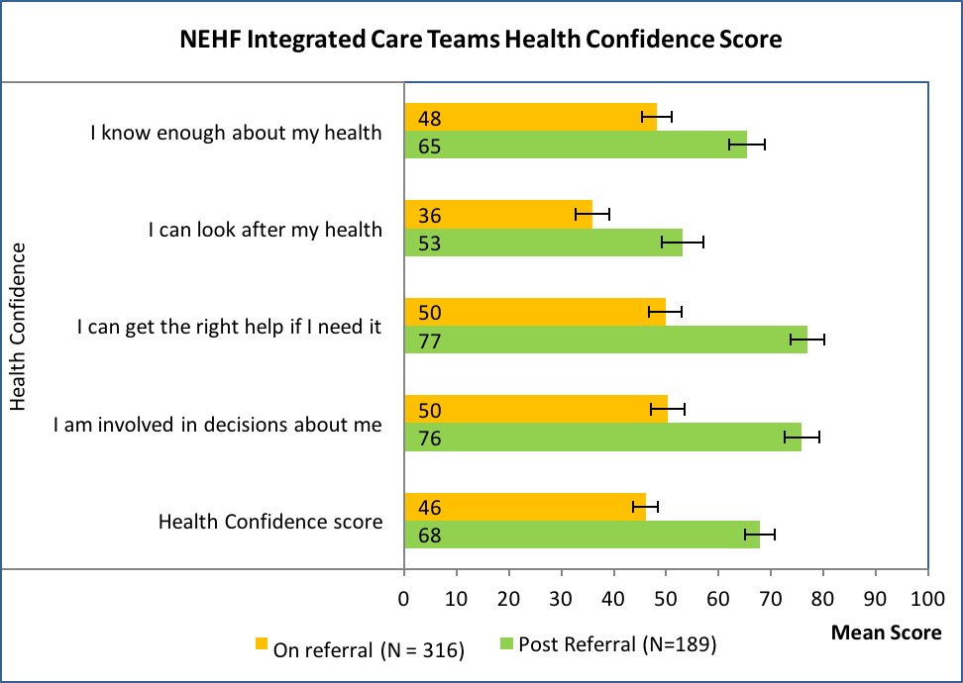

**Example 2: Health Status of patients supported by eight different social prescribing services.**

Patients reported significant improvements in their health status – particularly feeling less low or worried. Similar improvements were found in their health confidence, wellbeing and experience of care.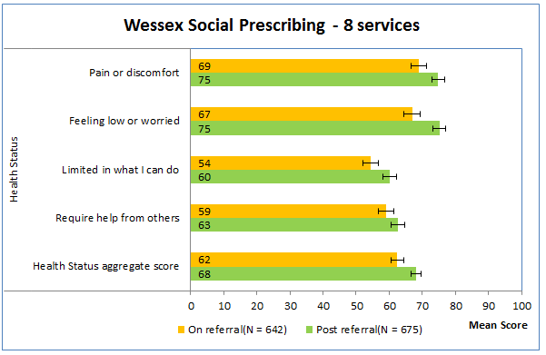

**Example 3: A team of Care Navigators.**

The team reported a high level of wellbeing at work, are very satisfied with their job and give top marks for feeling that their job is worthwhile.

They scored their confidence in delivering their roles less highly. They can get help when they need it. Very high scores were reported for the level of personal service and empathy they provide but less positive for the organisation of the service.

These surveys have been repeated to analyse changes over time.



**Example 4: Comparing the before and after patient scores for two different services.**

R-Outcomes can be used to look for changes over time and to compare services. Reference groups have been developed to help this.



**2. Qualitative interviews with patients, carers and staff**

To explore the nature and extent of a change, it’s important to use qualitative methods to ensure a good depth of investigation is achieved. In our case, we’ve used qualitative methods to explore whether new roles and new innovations have improved patients’ health and wellbeing, and health service delivery by health care professionals. Using semi-structured interviews with patients, carers and staff, we have sought the narrative of the innovation from those receiving and delivering the new role or innovation. Obtaining this narrative has helped us explain why change has or has not occurred, what impacts have been observed by patients and staff, and if any unintended consequences/impacts were observed. Questions for each interview have been developed using the logic model for each new role/innovation, in order to keep the interviews focused on the topics of interest and to allow synthesis with the quantitative evidence gathered.

**3. Themed analysis of case studies**

In most of our evaluations, case studies have been provided by staff who know the individual’s situation and journey, and are completed on a simple template that includes the situation, what happened and what the service did with the individual. We undertake thematic analysis of these case studies (see below) as part of our evaluation.

For **example**, eight case studies of patients receiving input from an Integrated Care Team revealed four key themes: a quick response, a joined up response, problem solving and the impact on patients. This evidence provided important indications that the new care model was achieving its desired outcomes. When triangulated with the findings from the R-Outcomes analysis, the evidence of impact was further strengthened.

It is also possible to use case notes to develop case studies. For an evaluation of a Recovery College, a random set of five case notes were reviewed and used to chart each student’s journey of enrolling and participating in recovery courses and their wider use of mental health services. These were displayed graphically as follows:

**Thematic analysis** of what is heard in qualitative interviews and written in case studies is an important part of our evaluation and we use a well defined and widely used approach . This method explores the semantic (explicit) themes and latent (implicit) themes within the qualitative data via a five stage process: familiarise yourself with the data, generate initial codes, search for themes, develop and refine themes, and define and name the themes. This process aims to find repeated patterns of meaning whilst also focusing on the relevance of issues in relation to the aims of the evaluation of the new care model. Importantly, as with many forms of qualitative analysis, data saturation is the goal. Once individual narratives begin to repeat, and the same themes and sub-themes are evident in the interviews, data collection is stopped6.

**4. Team observation using normalisation process theory**

As many of the NCMs being evaluated are formed of new teams of staff, we were particularly interested to find a pragmatic and validated evaluation tool to understand the extent to which the team was able to embed the implementation NCMs on a day to day basis in a way that was sustainable in the long term.

****Understanding if and how new roles, techniques and innovations for clinical and professional practice are effectively translated into practice is vital for the teams delivering them and the programmes commissioning them.

Normalisation Process Theory (NPT]7 was developed to better understand how innovations are implemented in practice and in particular how activities associated with introducing new ways of working are both enabled and constrained with in a particular setting. It is a theoretically developed and widely used sociological theory of how innovations are understood, engaged with, enacted and reflected upon. NPT has widely been used in the dynamic setting of health care.

The starting point of NPT is to understand the embedding of a practice i.e. what people actually do and how they work together. NPT provides an explanatory framework to better understand the routine embedding of healthcare interventions in their social contexts, in particular why some processes seem to lead to a practice becoming sustained over a long term while others do not (May and Finch, 2009). Although the authors make no claim of absolute predictive power, they argue that within certain limits the extent of sustainable long term embedding can be anticipated. This means that NPT can help ascertain the likelihood of the routine embedding of an intervention within certain limits.

We have conducted observations of team meetings and key interactions between staff using the four key components (Coherence, Cognitive Participation, Collective Action, Reflexive Monitoring). In addition, the NPT NoMAD questions8 have been used for a survey undertaken during the structured focus groups. The survey also included questions on feeling valued as part of the team and questions about the extent to which the expected outcomes of the service (as articulated in its logic model) were felt to have been achieved.

We have now conducted four evaluations of different teams that are working in an integrated way to implement NCMs.

**Table 1: Results for coherence**

Table 1 shows team results for coherence or how a NCM is conceptualised and held together in action. In this example coherence was rated positively. The team members had a shared understanding of the new practice and understood how it affected the nature of their work and could see potential value in it for their work. Should the results have been negative, this may have required some adjustments in relation to the implementation of the new practice.

**5. Synthesising findings**

As we have consistently applied these methods for evaluating how people experience and feel about new care models, we have also developed our method for bringing together and synthesising these findings.

The focus is a **synthesis meeting** that brings together all of the people involved in gathering the data and evidence described in this paper, as well as the quantitative elements of the evaluation, including changes in activity (e.g. A&E attendances) and economic evaluation. Before the synthesis meeting takes place, we aim to meet with representatives of the new care model to take them through it, check for accuracy and get their initial feedback or reflections. At the synthesis meeting all of the material is pooled and worked through together to triangulate the evidence and identify and agree the findings, lessons and recommendations. An important part of this synthesis is to identify the **active ingredients** that have contributed to (or hindered) the outcomes delivered by the new model of care.

**6. How the findings have been used by our clients**

We understood that NCMs, by their nature, would be likely to adapt and evolve during the Vanguard’s journey. We have tried to support teams in this creative process by providing early headlines from the evaluation findings and exploring with them the possible explanations for the emerging evidence. This feedback helps the team and the programme to understand whether an NCM is having the desired impact and if not why not, and helps the evaluation team to decide where to focus the inquiry if the results are unexpected (e.g. to examine one area in more detail, or to differentiate the data set in different ways). It has been valuable to have contemporaneous access to outcomes data that can enable timely reporting to staff with a keen interest in how their NCM is performing.

The following examples describe some of the beneficial outcomes of ‘formative’ evaluation for those involved in implementing NCMs:

**Example 1**: The evaluation of teams through semi-structured observation has influenced the design of organisational development programmes, by identifying priority areas to focus on e.g. barriers or enablers to the NCM.

**Example 2**: Evidence on the impact of a Referral Management Service has informed the business case for the development of a locality based community dermatology service.

**Example 3**: Data on patient outcomes (R-Outcomes) from a number of different integrated care teams across Wessex has initiated a new line of inquiry – do differences in case-mix account for differences in patient reported outcomes?

**Example 4:** Evidence of the different impact from different forms of social prescribing service has informed a new commissioning service specification – against which the services were re-commissioned. Patients and carers emphasised the importance of support at the weekend and this was included. The new service level agreements include quality outcomes (R-Outcomes) KPIs.

**Example 5:** Community ambassadors have been engaged in collecting R-Outcomes from people in waiting rooms using iPads and have participated in the review and discussion of all of the qualitative findings and symposium events.

**Example 6:** Bespoke measures have been incorporated into R-Outcomes to cover issues of particular interest to the service or service users e.g. to understand how people perceive ‘integration.’

**7. Our reflections on how to evaluate the impact of new care models on people**

Our evaluation vital statistics at the time of writing are:

|  |  |
| --- | --- |
| NCM evaluations completed and reported | **15** |
| R-Outcomes recorded by patients | **5,500** |
| R-Outcomes completed by staff | **400** |
| Qualitative interviews undertaken | **85** |
| Case studies analysed | **93** |
| Evaluations planned for 17/18 | **21** |

R-Outcomes have provided a reliable way of measuring the impact on patients and staff at scale and in a short period of time. They enable us to look for evidence of change during implementation of a NCM and increasingly we are using them to benchmark the impacts on different cohorts of patients and services.

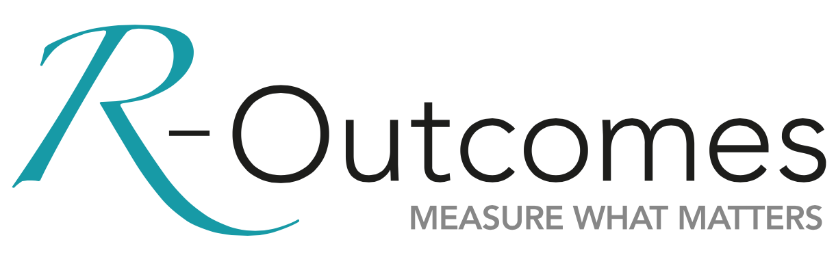cid:image001.jpg@01D1A5EC.BDCA1F20Qualitative interviews are important as they provide the most in-depth method for understanding the lived experience of patients and staff. However, whilst every lived experience reported by a patient or team member is valid in understanding the impact of NCMs, qualitative data collection can be very resource intensive for evaluators and create additional work for staff (e.g. consenting individuals for interview, scheduling interviews, Information Governance and Ethics approvals). The number of participants that are suitable for interview can be small. In our experience, we have typically identified around 6 patients and 6 staff per NCM with interview times of up to an hour each. In order to ensure we obtain an in-depth picture of patient and staff experience and also adhere to data collection timeframes, we are looking at how we gather and analyse this data to be sufficiently rigorous but more time and resource efficient.

Case studies are also a powerful way of capturing the in-depth impact for individuals. Teams that have been motivated to collect these stories have produced around 20-30 case studies for analysis. A simple template has been helpful in some instances, but the most significant enabler has been a team leader who is convinced of the value of collecting this data.

NPT has proved helpful insights into the extent to which integrated ways of working have become embedded by new care model teams. It has been used successfully with focus groups from 4 to 24. The findings have been recognised by those participating and informed team development.

**8. Looking forward**

Three new measures have recently been added to the R-Outcomes suite and will be trialled in Vanguard evaluations during the coming year, measuring:

* Patient and staff perception of **service integration**
* A short staff measure based on **Normalisation Process Theory**
* People and organisations’ **readiness to innovate**
* People’s confidence in using **digital health care solutions**

**November 2017**

**References:**

1. New Care Models. (June 2017) The local evaluation of the new care models vanguards: our expectations and offer of support for 2017/18. <http://www.england.nhs.uk/vanguards>

2. Liles A, Darnton P (2017) Social Prescribing in Wessex; Understanding its impact and supporting its spread. Wessex AHSN. https//www.r-outcomes.com/publications

3. Benson T, Potts HWW. A short generic patient experience questionnaire: howRwe development and validation (2014). BMC Health Services Research 2014, 14:499 . <http://www.biomedcentral.com/1472-6963/14/499>

4. Benson T, Whatling J, Arikan S, Sizmur S, McDonald D, Ingram D: Evaluation of a new short generic measure of HRQoL: howRu. Informatics in Primary Care 2010; 18:89-101. https://hijournal.b cs.org/index.php/jhi/article/view/758/770

5. Benson T, Bowman C, Sladen J, Liles A, Potts HWW. Health Confidence Score (HCS) – Development and Validation. Research Paper 17/02 September 2017. <https://www.r-outcomes.com/publications>

6. Braun, V. and Clarke, V. (2006) Using thematic analysis in psychology. Qualitative Research in Psychology, 3 (2). pp. 77-101. [www.eprints.uwe.ac.uk/11735/2/thematic_analysis_revised](http://www.eprints.uwe.ac.uk/11735/2/thematic_analysis_revised).

7. May, C. and Finch, T. (2009) Implementation, embedding, and integration: an outline of Normalization Process Theory. Sociology 43 (3): 535-55http://www.normalizationprocess.org

8. Finch et al. (2013) Improving the normalization of complex interventions: measure development based on normalization process theory (NoMAD): study protocol. *Implementation Science*, 8, 1, 43. [doi:10.1186/1748-5908-8-43](http://dx.doi.org/10.1186/1748-5908-8-43)

9. Completed vanguard evaluation reports for Farnham Integrated Care Team, Referral Management Service and Pre-Diabetes Education Programme and for a Recovery College; www.wahsn.org.uk

For more information, contact the authors:

**Andrew Liles, Director, R-Outcomes,** andrew.liles@r-outcomes.com

**Phlippa Darnton**, Evaluation Lead, Wessex AHSN, philippa.darnton@wessexahsn.net

**Dr Andrew Sibley**, Evaluation Programme Manager, Wessex AHSN, Andrew.sibley@wessexahsn.net

**Dr Catherine Matheson-Monnet**, Senior Research Fellow, Centre for Implementation Science, University of Southampton, c.b.matheson@soton.ac.uk

**Acknowledging the evaluation team**

Dr David Kryl, Director of Insight, Centre for Implementation Science (CIS)/ Wessex AHSN

Joe Sladen, Evaluation Programme Manager, Wessex AHSN

Sydney Anstee, Research Consultant, Wessex AHSN

Cindy Brooks, Research Fellow, CIS, University of Southampton

Tim Benson, Director, R-Outcomes

Jess Done, Project Manager, R-Outcomes

**Appendix – R-Outcome patient measures**

