24 - 26 GHz radio over fiber and free space optics for 5G systems
Jan Bohata,¹ Matěj Komanec¹, Jan Spáčil¹, Zabih ghassemlooy^{2,3}, Stanislav Zvánovec¹, Radan Slavík⁴
¹Czech Technical University in Prague, Faculty of Electrical Engineering, Technicka 2, 166 27, Prague, Czech Republic.
² Optical Communications Research Group, NCRLab, Faculty of Engineering and Environment, Northumbria University, Newcastle-upon-Tyne NE1 8ST, UK.
³ QIEM, Haixi Institutes, Chinese Academy of Sciences, Quanzhou, China
⁴ Optoelectronics Research Centre, University of Southampton, Southampton, SO17 1BJ, UK.

*Corresponding author: bohatja2@fel.cvut.cz
Received XX Month XXXX; revised XX Month, XXXX; accepted XX Month XXXX; posted XX Month XXXX (Doc. ID XXXXX); published XX Month XXXX

This paper outlines radio over fiber (RoF) combined with radio over free space optics (RoFSO) and radio frequency (RF) free-space transmission, which is of particular relevance for 5G networks. Here, the frequency band of 24 – 26 GHz is adopted to deliver high data rates and demonstrate a low-cost, compact, and high energy-efficient solution based on the direct intensity modulation and direct detection (DM-DD) scheme. For our proof-of-concept demonstration, we use 64 quadrature amplitude modulation with a 100 MHz bandwidth and a sub-carrier within 24 - 26 GHz. We assess the link performance by exposing the RoFSO section to atmospheric turbulence conditions. Further, we show that the measured minimum error vector magnitude (EVM) is 4.7 % and also verify that the proposed system with the free space optics link span of 100 m under strong turbulence can deliver an acceptable EVM of < 9% with signal-to-noise ratio levels of 22 dB and 10 dB with and without turbulence, respectively.
© 2017 Optical Society of America
OCIS codes: (060.2310) Fiber optics; (060.2605) Free-space optical communication; (010.7060) Radio frequency photonics.
http://dx.doi.org/10.1364/OL.99.099999
In order to satisfy the demand for ever-increasing data rates in the mobile networks, the new millimeter wave band (20 - 30 GHz) has been selected by 5GPPP (Public Private Partnership) [1] to be used in the emerging fifth-generation (5G) mobile networks. The vision of 5G network poses many challenges, as it plans to reach ultra-low latency of 1 ms, 10 Gbps maximal throughput and covering more than 100 billion devices [2]. A typical architecture addressing these challenges is shown in Fig. 1 - a central office services and coordinates a number of remote micro-, pico-, and femto-cells, which reduces both the energy consumption and costs [3]. For this architecture, and especially for the fronthaul network, novel fiber/optical wireless approaches are highly desirable.
The mentioned 20 - 30 GHz ‘pioneer’ spectral band is the first to be used in mobile networks above 6 GHz, requiring a number of challenges to be addressed including a significantly high attenuation (i.e. ~ 3 dB/m) when the radio frequency (RF) signal is transmitted over metallic cables, which limits the transmission span. To address this, the radio over fiber (RoF) technology was proposed [4,5], e.g. for usage between a central office and the pico- or femto-cell base stations. In [6], an alternative concept of radio over free-space optics (FSO) (RoFSO) transmission was proposed for deployment in dense urban areas, where installation of new optical fiber cables is not cost effective. For example transmission of the RF signal over a 1 km long RoFSO link was experimentally demonstrated at wavelength of 1550 nm in [7]. It was shown that RoF and RoFSO links offer the benefit of increased transmission span between the base station and the antenna while ensuring sufficient signal-to-noise ratio (SNR), which may be one of the expected mobile network requirements in the future wireless networks [8]. In any case, the key advantage of the RoFSO links is deployment flexibility, however, their performance is affected by the weather conditions (i.e., turbulence, fog, rain, snow, etc. [9).
For RoF and RoFSO applications, both the directly modulated laser (DML) and externally modulated laser (EML) can be used [10]. In [11], an integrated fiber-wireless system using EML was demonstrated, employing coherent detection and adaptive polarization-multiplexed quadrature-phase-shift-keying (PM-QPSK) modulation. The authors achieved impressive 108 Gbps data rate over 80 km of single mode fiber (SMF) and over the 1-m long wireless link at a carrier frequency of 100 GHz. Although EML (as compared to DML) gives better performance (e.g., no modulation chirp), DML represents the simplest (and thus potentially the cheapest and most compact) option with additional benefits such as high transmitter power, high energy efficiency, and linear modulation characteristics (which is of particular importance in RoF systems [12]). Apart from the modulation chirp, DML typically does not allow for operation at frequencies above 20 GHz. In [13], a 1 Gbps RoF DML link at 24 GHz over a 50 km of SMF was demonstrated with help of an erbium-doped fiber amplifier (EDFA) to compensate for the link loss. Error vector magnitude (EVM) was, however, strongly frequency-dependent, and insufficiently high at 24 GHz: while EVM as low as 3.4 % was achieved at the carrier frequency f_{c} of 3.5 GHz, it increased to 20 % at 24 GHz.
In this paper, we address the main challenge of DML RoF and RoFSO systems by means of the DML optimized to operate in the 5G-selected 20-30-GHz spectrum band. We present experimental results for the entire system composed of RoF, RoFSO, and free space RF within the frequency range of 24 - 26 GHz. To the best of authors’ knowledge, this is the first experimental investigation of the proposed scheme, which includes three technologies of (i) the optical fiber, (ii) FSO link, and (iii) RF free space link simultaneously, all in spectrum band of 24-26 GHz. We have used 64 quadrature amplitude modulation (64-QAM), which potentially facilitates transmission of a net data rate of 10 Gbps (with 20% overhead) within the used spectrum band. In addition, we assess the impact of turbulence on the RoFSO section. The presented results demonstrate the full potential of the DML-based RoFSO, RoF, and their combination in the emerging 24-26 GHz band as part of the future 5G mobile networks, as shown Fig. 1.
The experimental setup is shown in Fig. 2. The long-term evolution advanced (LTE-A) baseband signal, composed of five 20 MHz bands of evolved universal terrestrial radio access (E-UTRA) test model 3.1 [14] with 64-QAM - the largest bandwidth of the today’s mobile network standard, is generated using a signal generator (R&S SMW200A). LTE-A is then up-converted to the 24-26 GHz band using a RF signal generator (R&S SMF100A) and a RF modulator, prior to being amplified (by Wisewave AGP- 33142325-01) to a level of 12 dBm. The amplified signal is then combined in a bias tee with a DC signal and sent to the DML, which is monolithically-integrated passive feedback laser described in detail in [15]. The DC current for biasing of the DML is provided by a laser diode controller (Newport modulator controller 8000). The same controller is also used for temperature stabilization of the laser and for biasing its feedback phase section. The used DML is
Fig. 1. RoF and RoFSO deployment for connection of micro-, pico- and femto-cells in 5G architecture.
Fig. 2. The experimental set-up consisting of RoF (1 km), RoFSO (2 m), and RF over free space (3.6 m).

Table 1. Key system parameters
Parameter | Value | Parameter | Value
Radio frequency | 24 – 26 GHz | Wavelength | 1549 nm
RF bandwidth | 100 MHz | Laser power | 4.79 dBm
LTE test model | TM 3.1 | Laser current | 53 mA
Modulation | 64-QAM | FSO link length | 2 m
RF output power | - 15.3 dBm | FSO loss | 12 dB
Antenna distance | 3.6 m | Photodetector responsivity | 0.55 A/W
The fiber-coupled laser output (with the average optical power of 4.8 dBm at the wavelength of 1549 nm) is launched into the free space via the combination of a short length SMF, graded-index (GRIN) and plano-convex lenses. Following propagation over a 2 m long free space (i.e., the FSO path), the optical beam is launched into a 1 km of SMF via a plano-convex and GRIN lenses.
An optical spectrum analyzer is used for real-time monitoring of the data stream via a 99/1 tap coupler. An EDFA (Keopsys KPS-BT2-C-10-LN-SA, noise figure < 5 dB) with a 15 dB gain (5 dBm of output power) is used prior to photodetection (Optilab PD-40 photodiode with the bandwidth of 40 GHz). The photodetected RF signal is passed through two-stage amplifiers #2,3 (Miteq AMF-4F-260400-40-10p, Analog devices HMC1131), amplifying it to the power of 4 dBm prior to transmission over a 3.6 m long free space using a double ridged waveguide horn antenna (DRH40 - RFspin, s.r.o.) with a 14 dBi gain at the frequency of 24 GHz. At the Rx, we have used the same type of antenna to capture the signal and analyze it using a signal analyzer (R&S FSW). The total loss of the RF free space channel, including the gains of antennas, is 43.2 dB at 24 GHz. All the key system parameters are summarized in Tab. 1.
First, we characterized the frequency response of the entire system, depicted in Fig. 2, using a vector network analyzer (R&S ZVA67). The spectral characteristic of the link loss, described by
Fig. 3. Measured spectral characteristics of the entire link (RoF+FoFSO+RF over free-space).
the S₂₁ parameter, is shown in Fig. 3. As can be seen, the optimum frequency range (with loss below 35 dB) is 23 - 27 GHz (inset in Fig. 3). However, the proposed system can also operate in the 22 - 34 GHz spectrum band but at the cost of lower SNR. In the proposed system, the most significant noise contributor is amplified spontaneous emission (ASE) signal from EDFA detected in the photodiode. The measured EVM, with the 64-QAM LTE-A signal for carrier frequencies of 24, 25 and 26 GHz, and with no turbulence is shown in Fig. 4. Also shown is the 9 % EVM limit (dotted black line) adopted in 3GPP [14]. Note that the 24 GHz displays the best EVM performance closely followed by 25 GHz although 25 GHz evinces better S21 performance in Fig. 3. This is because the adopted modulator has been designed and optimized for 24 GHz band and the optimization has no effect on the in S21 measurement. At 26 GHz, we observe the SNR penalty of 8 dB (for EVM = 9 %) as compared to 24 GHz. At a moderate SNR of 20 dB the EVM values for all three carrier frequencies are below the limit of 9%. Also shown are the constellation diagrams for 64-QAM at the SNR values of 10 and 27 dB for 24 GHz, illustrating the quality of signal transmission at higher SNR.
Next, we characterized the entire link performance by considering the impact of the atmospheric turbulence on the FSO path. Reproducible turbulence levels were achieved using two heating fans, which generated a varying thermal distribution along the optical propagation path as described in [16]. The atmospheric turbulence induced degradation on the received signal was characterized by using the commonly used refractive index structure parameter C_{n}² and Rytov variance, which are derived from the thermal distribution along the FSO path [6,8]. We carried out system measurements for up to a strong turbulence level (i.e., C_{n}² = 2.4 x 10⁻¹⁰ m^{-2/3}) for a 2 m long FSO link. Note that this high level of turbulence for a short FSO link can be recalculated using Rytov variance [9] to reflect the turbulence values, which can be observed in longer outdoor FSO links. Thus, C_{n}² = 2.4 x 10⁻¹⁰ m^{-2/3} corresponds to the magnitudes of 1.8 x 10⁻¹³ m^{-2/3}, 9.5 x 10⁻¹⁵ m^{-2/3} and 2.7 x 10⁻¹⁵ m^{-2/3} of the refractive index structure parameter for FSO link spans of 100 m, 500 m and 1000 m, respectively, by maintaining the same level of signal variance. In further examples, we show the measured system performance recalculated for a 100 m long FSO link better illustrates real outdoor conditions. It should be noted that the impact of increased attenuation in 100 m can be neglected when assuming clear visibility, since signal attenuation is less than 0.05 dB when considering 10 km visibility. Fig. 5 depicts the EVM performance for the complete system under strong turbulence Cn² = 1.8 x 10⁻¹³ m^{-2/3}as a function of the SNR, which was measured at the output of the RF Rx antenna (i.e., using the signal analyzer). The insets for the constellation diagrams at SNRs of 10 and 27 dB are also depicted. As shown, both 24 GHz and 25 GHz bands display similar EVM performance meeting the EVM limit of 9% at the SNR values of 22 dB and 25 dB, respectively, whereas the 26 GHz band exceed the EVM profile above the EVM limit for the entire SNR range. Fig. 6 further compares the EVM performance of the link with various strengths of turbulence (recalculated to a 100 m FSO outdoor link) at the frequency of 24 GHz. The EVM limit of 9 % is achieved for all turbulence levels for the SNR range of 27 - 22 dB. However, for the strongest level of turbulence (C_{n}²=1.8 x 10⁻¹³ m^{-2/3}), the SNR penalties are 10.0, 9.0, 8.5 and 6.5 dB as compared to performance without any turbulence and turbulence corresponding to C_{n}² of 5.7 x 10⁻¹⁴ m^{-2/3}, 7.5 x 10⁻¹⁴ m^{-2/3}, and 1.2 x 10⁻¹³ m^{-2/3}, respectively.
Fig. 4. Measured EVM for various SNRs and three carrier frequencies for the entire link with no turbulence considered. The inset shows the constellation diagrams.
Fig. 5. Measured EVM for various SNRs and 3 carrier frequencies for the entire link with strong turbulence corresponding to C_{n}² = 1.8x10⁻¹³ m^{-2/3} for 100 m long link. The inset shows the constellation diagrams.
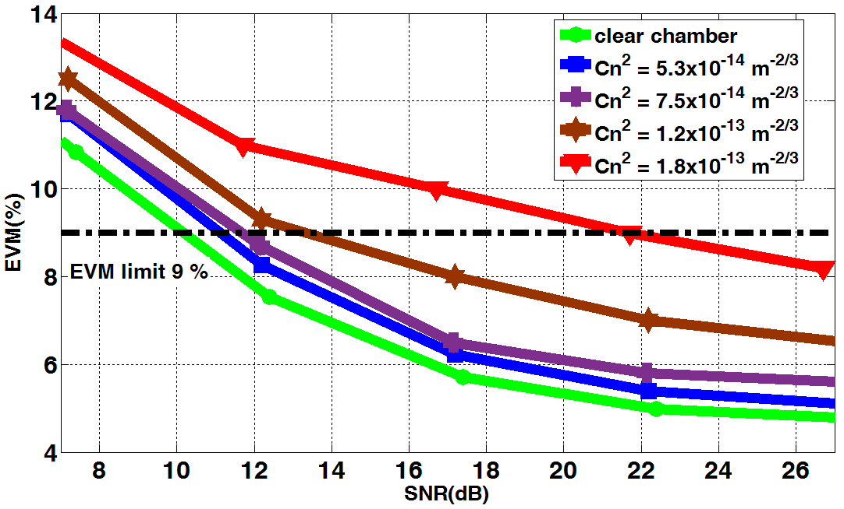
Fig. 6. Measured EVM for various SNRs and 24 GHz carrier frequency for the entire link with and without any turbulence for 100 m long FSO link.
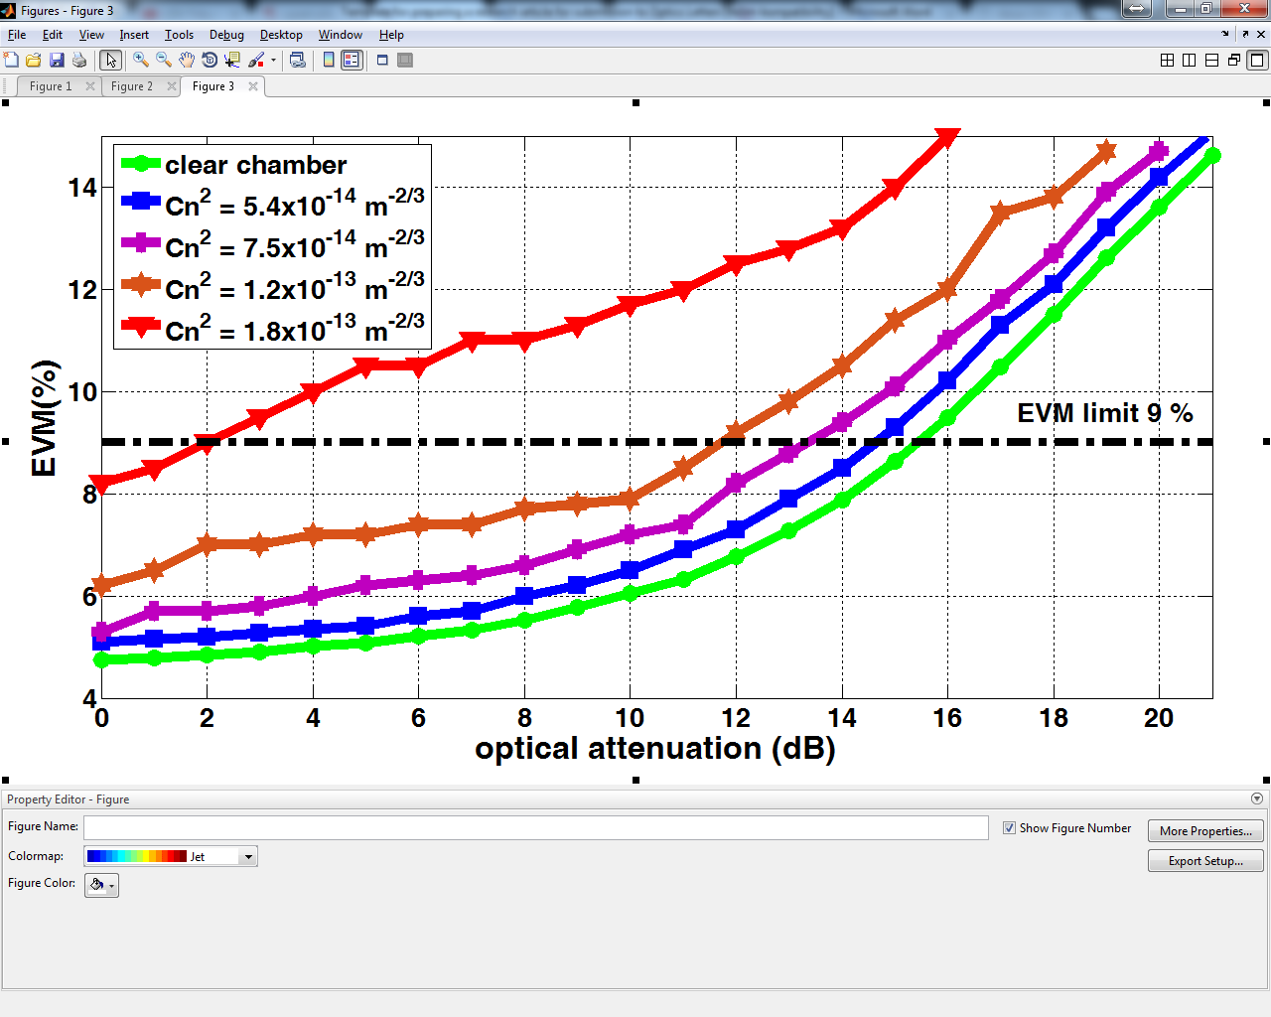
Fig. 7. Measured EVM as a function of the optical attenuation at the frequency of 24 GHz for a range of C_{n}² values corresponding to the 100 m long FSO link.
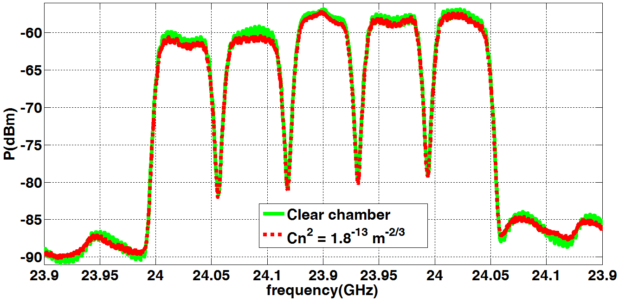
Fig. 8. LTE-A measured spectrum for the clear chamber (green) and with turbulence corresponding to the 100 m long FSO link (red).
Next, we characterized the link tolerance to the optical attenuation (using the variable optical attenuator, see Fig. 2) to determine the maximum potential transmission span. Fig. 7 illustrates the EVM as a function of the optical attenuation at 24 GHz for a range of C_{n}² values recalculated to the 100 m long FSO link. The results show that the proposed system can operate (EVM < 9%) in clear atmospheric conditions with up to a 15 dB of additional optical loss, which corresponds to increased fiber link span by 60 km (neglecting the fiber dispersion) or ~ 2 km of FSO link span under. In turbulence, we observe performance degradation due to the RoFSO section of the link. More specifically, the attenuation tolerance is reduced by 2.5 dB and 13.0 dB for the moderate (i.e., C_{n}² = 7.5 x 10⁻¹⁴ m^{-2/3}) and very strong (i.e., C_{n}² = 1.8 x 10⁻¹³ m^{-2/3}) turbulence regimes, respectively. Acceptable performance (EVM < 9%) is achieved up to the strong turbulence regime (i.e., C_{n}² = 1.2 x 10⁻¹³ m^{-2/3}) with a 4 dB of power penalty compared with no turbulence scenario, which shows about 2 % improvement in the EVM performance.
We believe that both the RoF and RoFSO EVM performance can be further improved (e.g. when the system operates close to or beyond given EVM limit) by including supplementary optical bandpass filters, which would suppress out-of-band noise (e.g., from the EDFA). As this would be at the cost of increased complexity, we have not used any filter in our system. Finally, we provide a comparison of the detected LTE-A spectra for the link with no turbulence (green) and with very strong turbulence (i.e., C_{n}² = 1.8 x 10⁻¹³ m^{-2/3}) (red), Fig. 8. Note that the decrease in the total RF power caused by turbulence is 0.4 dB. Moreover, the noise floor is increased by 1.4 dB, which results in 1.8 dB degradation of the SNR.
In this paper, we have experimentally investigated, to the best of our knowledge for the first time, the complete RoF and RoFSO mobile network scenario including transmission of the RF signal and using a wideband DML at a carrier frequency band of 24 – 26 GHz. We showed that EVM as low as 4.7 % can be reached at the frequency range of 24 – 25 GHz for the 100 MHz bandwidth with 64-QAM. Further, we verified that in a real outdoor scenario the proposed system is capable of operating over a 100 m long FSO link under strong turbulence conditions (and even for longer FSO links – 500 m, 1000 m - with correspondingly reduced turbulence level) with the EVM level kept under the 9 % limit. Moreover, we showed that the proposed system could cope with the additional 15 dB of optical loss, which allows for an additional link extension using either a fiber or a FSO link or the combination of both. Presented results therefore confirmed the feasibility of the new RoF and RoFSO system deployment, utilizing DML with broadband transmission and operating in the 24 - 26 GHz band for small mobile cells. Last but not least, we showed that the proposed scheme is capable of delivering higher data rates using the high-frequency band over longer transmission spans by means of optical transmission thus illustrating its potential in 5G networks. The proposed scheme can be extended up to 10 Gbps using the explored spectrum bandwidth, which will be part of our future experimental investigations.
Funding. CTU project SGS17/182/OHK3/3T/13 and grant COST LD15803 and within COST Actions MP1401 and CA16220, MPO TRIO project FV30427.
References
- A. Gupta and R. K. Jha, in IEEE Access. 3, 1206 (2015).
- A. Checko, H. L. Christiansen, Y. Ying, L. Scolari, G. Kardaras, M. S. Berger and L. Dittmannal, in Commun. Surveys Tuts. 17, 405 (2015).
- The 5 G Infrastructure Public Private Partnership. Online: https://5g-ppp.eu/
- H. Al-Raweshidy and S. Komaki, Radio Over Fiber Technologies for Mobile Communications Networks (Artech House, 2002).
- D. Pham Tien, A. Kanno and T. Kawanishi, in Wireless Commun., 22, 67 (2015).
- M. Uysal, C. Capsoni, Z. Ghassemlooy, A. Boucouvalas and E. Udvary, Optical wireless communications: an emerging technology (Springer, 2016).
- C. B. Naila, K. Wakamori, M. Matsumoto, A. Bekkali and K. Tsukamoto, in IEEE Commun. Mag. 50, 137 (2012).
- Radio Technologies for 5G for Dense User Environments, RAPID 5G, online: http://ec.europa.eu/information_society/newsroom/cf/dae/document.cfm?action=display&doc_id=7688
- L. C. Andrews and R. L. Phillips, Laser beam propagation through random media (SPIE Press, 2005).
- D. Wake, A. Nkansah, N. J. Gomes, G. de Valicourt, R. Brenot, M. Violas, L. Zhansheng, F. Ferreira and S. Pato, in J. Lightw. Technol. 28, 2416 (2010).
- X. Li, Z. Dong, J. Yu, N. Chi, Y. Shao and G.K. Chang, in Opt. Lett. 37, 5106 (2012).
- X. Zhang, R. Zhu, D. Shen and T. Liu, in Photonic. 1, 455 (2014).
- K. V. Gasse, J. V. Kerrebrouck, A. Abbasi, G. Torfs, H. Chen, X. Yin, J. Bauwelinck and G. Roelkens, in International Topical Meeting on Microwave Photonics (IEEE, 2016), p. 328.
- The 3rd Generation Partnership Project. Available: www.3gpp.org
- J. Kreissl, in IEEE Photon. Technol. Lett. 24, 362 (2012).
- J. Bohata, S. Zvanovec, P. Pesek, T. Korinek, M. M. Abadi and Z. Ghassemlooy, in Appl. Optics. 55, 2109 (2016).

Full references
- A. Gupta and R. K. Jha, "A Survey of 5G Network: Architecture and Emerging Technologies," IEEE Access, vol. 3, pp. 1206-1232, 2015.
- A. Checko, H. L. Christiansen, Y. Ying, L. Scolari, G. Kardaras, M. S. Berger and L. Dittmannal, " Cloud RAN for Mobile Networks - a Technology Overview", Communications Surveys & Tutorials, IEEE, vol. 17, pp. 405-426, 2015.
- "The 5 G Infrastructure Public Private Partnership," 2017. Online: https://5g-ppp.eu/
- H. Al-Raweshidy and S. Komaki, Radio Over Fiber Technologies for Mobile Communications Networks: Artech House, 2002.
- D. Pham Tien, A. Kanno and T. Kawanishi, "Radio-on-radio-over-fiber: efficient fronthauling for small cells and moving cells," Wireless Communications, IEEE, vol. 22, pp. 67-75, 2015.
- M. Uysal, C. Capsoni, Z. Ghassemlooy, A. Boucouvalas and E. Udvary, Optical wireless communications : an emerging technology. Springer, 2016.
- C. B. Naila, K. Wakamori, M. Matsumoto, A. Bekkali and K. Tsukamoto, "Transmission analysis of digital TV signals over a Radio-on-FSO channel," IEEE Communications Magazine, vol. 50, pp. 137-144, 2012.
- Radio Technologies for 5G using an Advanced Photonic Infrastructure for Dense User Environments, RAPID 5G, online: http://ec.europa.eu/information_society/newsroom/cf/dae/document.cfm?action=display&doc_id=7688
- L. C. Andrews and R. L. Phillips, Laser beam propagation through random media.SPIE Press, 2005.
- D. Wake, A. Nkansah, N. J. Gomes, G. de Valicourt, R. Brenot, M. Violas, L. Zhansheng, F. Ferreira and S. Pato, "A Comparison of Radio Over Fiber Link Types for the Support of Wideband Radio Channels," Lightwave Technology, Journal of, vol. 28, pp. 2416-2422, 2010.
- X. Li, Z. Dong, J. Yu, N. Chi, Y. Shao and G.K. Chang, "Fiber-wireless transmission system of 108 Gb/s data over 80 km fiber and 2×2multiple-input multiple-output wireless links at 100 GHz W-band frequency," Optics Letters, vol. 37, pp. 5106-5108 2012.
- X. Zhang, R. Zhu, D. Shen and T. Liu, "Linearization Technologies for Broadband Radio-Over-Fiber Transmission Systems," Photonics, vol. 1, p. 455, 2014.
- K. V. Gasse, J. V. Kerrebrouck, A. Abbasi, G. Torfs, H. Chen, X. Yin, J. Bauwelinck and G. Roelkens, "480Mbps/1 Gbps radio-over-fiber link based on a directly modulated III-V-on-Silicon DFB laser," in 2016 IEEE International Topical Meeting on Microwave Photonics (MWP), 2016, pp. 328-331.
- (2015). The 3rd Generation Partnership Project Available: www.3gpp.org
- J. Kreissl, "Up to 40-Gb/s Directly Modulated Laser Operating at Low Driving Current: Buried-Heterostructure Passive Feedback Laser (BH-PFL)," IEEE Photon. Tech. Lett, vol. 24, pp. 362-364, 2012.
15. J. Bohata, S. Zvanovec, P. Pesek, T. Korinek, M. M. Abadi and Z. Ghassemlooy, "Experimental verification of long-term evolution radio transmissions over dual-polarization combined fiber and free-space optics optical infrastructures," Applied Optics, vol. 55, pp. 2109-2116, 2016.

