Sensing of Vimentin mRNA in 2D and 3D models of wounded skin using DNA-coated gold nanoparticles.

Patrick Vilela,¹ Amelie Heuer-Jungemann,¹ Afaf El-Sagheer,^{3,4} Tom Brown,³ Otto L. Muskens,^{1,5} Neil R. Smyth,² and Antonios G. Kanaras^{*1,5}

¹Physics and Astronomy, Faculty of Physical Sciences and Engineering
² Biological Sciences, Faculty of Natural and Environmental Sciences, University of Southampton, Southampton SO17 1BJ, United Kingdom
³Department of Chemistry, University of Oxford, Chemistry Research Laboratory, 12 Mansfield Road, Oxford, OX1 3TA, UK
⁴Chemistry Branch, Department of Science and Mathematics, Faculty of Petroleum and Mining Engineering, Suez University, Suez 43721, Egypt
⁵Institute for Life Sciences, University of Southampton, Southampton, SO171BJ, UK.

Keywords: nanoparticles; wound healing; skin; mRNA sensing; DNA, gold, nanoflares

Abstract: Wound healing is a highly complex biological process, which is accompanied by changes in cell phenotype, variations in protein expression and the production of active biomolecules. Currently, the detection of proteins in cells is done by immunostaining where the proteins in fixed cells are detected by labeled antibodies. However, immunostaining cannot provide information about dynamic processes in living cells, within the whole tissue. Here, we present an easy method to detect the transition of epithelial to mesenchymal cells (EMT) during wound healing. The method employs DNA-coated gold nanoparticle fluorescent nanoprobes to sense the production of Vimentin mRNA expressed in mesenchymal cells. Fluorescence microscopy is used to achieve temporal detection of vimentin mRNA in wounds. Three-dimensional light sheet microscopy is utilized to observe the dynamic expression of Vimentin mRNA spatially around the wounded site in skin tissue. The use of DNA-gold nanoprobes to detect mRNA expression during wound healing, opens up new possibilities for the study of real-time mechanisms in complex biological processes.

1. Introduction
Wound healing is a naturally occurring process taking place in every type of tissue upon injury. The main aim is to regenerate the tissue as promptly as possible in order to avoid the risk of infection by bacteria, viruses or fungi.^{[1]} Several complex biochemical processes occur during wound healing, which involve inflammatory signals, vasodilation and vasoconstriction agents, as well as proliferation and cell regulation factors.^{[2,3]} Many of the steps in these biochemical mechanisms are controlled by the regulation of specific proteins. For example, transforming growth factor (TGF)-β and connective tissue growth factor (CTGF) are upregulated in order to induce cell proliferation,^{[3–6]} while changes in the levels of Notch expression in intercellular sites-of-contact regulate tube formation and cell alignment.^{[7]} Therefore, detection of proteins is very important. The most common method to image proteins is the staining of fixed cells with specific antibodies. However, the detection of proteins in living cells within complex systems such as tissue is still very challenging although highly significant in order to extract information of dynamic processes associated with changes in cell phenotype. Instead of detecting the actual proteins, detection of cell changes can be done prior to the expression of proteins. For the production of specific proteins the cells must express the relevant mRNAs, thus detection of these mRNAs can be used as an indirect approach (blue print) to infer the presence of specific proteins. A range of methods for the detection of mRNA have been developed ^{[8]} based on different strategies, including fluorescence in situ hybridization (FISH) ^{[8]}, molecular beacons^{[9–11]}, aptamers^{[12,13]} or genetic transfections^{[13]}. These strategies are combined with various visualization techniques such as confocal microscopy, providing information on spatial distribution^{[14]}, fluorescence microscopy to monitor expression levels^{[15]}, and cryo-electron microscopy for structural characterization.^{[16]} Despite the power of these techniques, they are mainly applicable to fixed samples using post-fixation labeling techniques, limiting the amount of real-time information which can be gathered. Furthermore their application in more complex biological systems, such as tissue or skin, is scarce.^{[17]} Pioneering work by Mirkin and co-workers as well as Tang and co-workers recently introduced a new type of fluorescent, oligonucleotide-based imaging probe immobilized on a gold nanoparticle (AuNP), the so-called nanoflares, for intracellular mRNA detection and gene regulation^{[18–24]}. Recently, our group developed this strategy further to transport drugs into cells and release them only in the presence of a specific mRNA signature.^{[25]} This approach allowed us to selectively sense model tumor cells and trigger the release of drug payloads leading to efficient cell death, whilst other cell types remained unaffected.
Furthermore, the Mirkin showed that oligonucleotide-coated gold nanoparticles were applicable to more complex biological structures, such as skin. They reported that topically applied siRNA-coated AuNPs could be successfully employed for gene regulation.^{[26,27]} Moreover, our group amongst others have systematically studied the interactions of functionalized gold nanoparticles with healthy and damaged skin tissue and found that size, surface charge as well as functional ligands on nanoparticles play key roles in penetration and interactions of nanoparticles with skin.^{[28,29]}
The wound healing process in skin is a complicated cascade involving a plethora of biochemical changes. One protein heavily involved in this process is Vimentin, an intermediate filament protein, highly expressed at the site of a skin injury. During the wound healing process stationary epithelial cells transform into highly motile mesenchymal cells in a process known as epithelial to mesenchymal transition (EMT). Here we show that nanoprobes can be utilized to monitor the onset of Vimentin mRNA expression, inferring the epithelial to mesenchymal cell phenotype change during the wound healing process.^{[30]} Expression of Vimentin mRNA in cell scratch assays and thin sections of fixed tissue were observed using conventional fluorescence microscopy. Three-dimensional distribution in ex vivo whole tissue was monitored using light sheet microscopy. Moreover, the presence of Vimentin mRNA was observed in a time lapse experiment, providing information of the time scale of the epithelial to mesenchymal transition at the edges of an open wound.

2. Results and Discussion
Nanoprobe Design
The DNA-coated gold nanoparticles used in this study were synthesized as described previously (see Experimental Section for more details).^{[18,20,25]} The principle of these probes is based on the replacement of so-called “flare” oligonucleotides hybridized to DNA-functionalized gold nanoparticles by specific mRNAs – in this case Vimentin mRNA. This displacement can be observed by the onset of a signal from a fluorescent label attached to the displaced flare strands (on state, see Scheme 1, and figures S1A and S1B). The sense strands to which the flare strands are hybridized bind the target mRNA with high affinity. The incorporation of a second fluorescent label on the sense strand serves as a self-reporting mechanism in case of degradation and thus ensures the avoidance of non-specific fluorescence signal. The close proximity of both dyes to the gold core quenches the fluorescence from both the sense and the flare strand dyes while adjacent to the nanoparticle (off state).

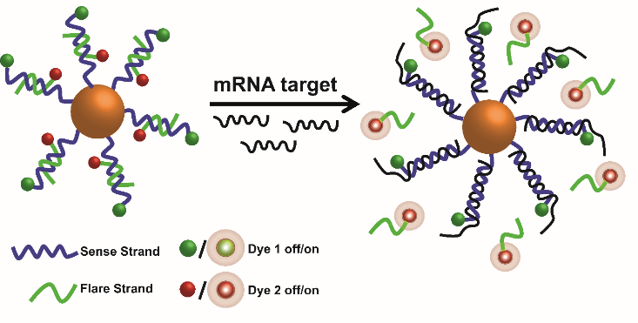

Scheme 1. Schematic representation of the working principle of the DNA-coated nanoparticles for the detection of Vimentin mRNA. The DNA-coated nanoparticles are made up of a gold nanoparticle core and fluorescently labelled DNA. The sense strand is directly linked to the nanoparticle surface via gold-thiol bond and it is designed to capture Vimentin mRNA. It is modified with a fluorescent dye as a self-reporting mechanism in the case of intracellular degradation. The short flare strand is hybridized to the sense strand and equally functionalized with a fluorescent dye, which is quenched due to the close proximity to the gold core. In the presence of Vimentin mRNA the flare strand is displaced due to competitive hybridization and the fluorescence is restored. The oligonucleotide sequences are shown in supporting information (Table S1).

Detection of Vimentin mRNA in scratch assays
Prior to testing the activity of the DNA-coated gold nanoparticles in tissue, their specificity was demonstrated in different types of cell lines (human and mouse) for the detection of Vimentin mRNA. Two different cell types were investigated: epithelial cells and mesenchyme derived fibroblasts. Both cell lines are heavily involved in EMT and while the highly motile fibroblasts show a high expression of Vimentin, stationary epithelial cells do not express this intermediate filament protein, as has been shown in previous work.^{[31,32]}

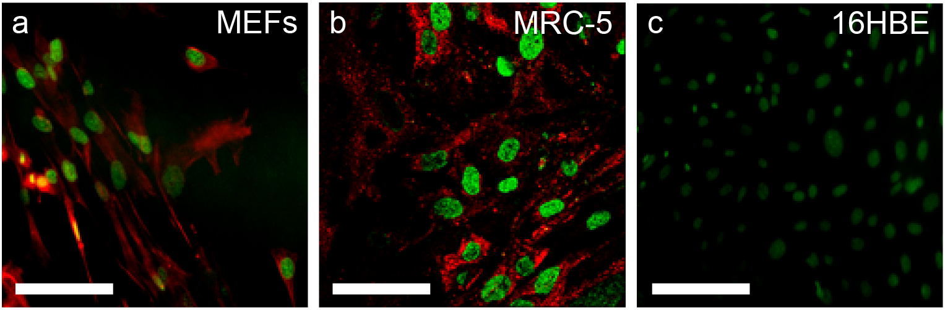

Figure 1. Detection of Vimentin mRNA in confluent layers of human (MRC-5, 16HBE) and murine (MEFs) cell lines. Fluorescence microscopy images from cell lines incubated with 10 pmol of DNA-coated Vimentin DNA gold nanoprobes over 18 h. Red fluorescence is attributed to the Cy5-flare oligonucleotide strand. Green fluorescence derives from the nuclear counterstain (DAPI). Vimentin mRNA was detected in MEFs (a) and MRC-5 (b) cells (red fluorescence), which are known to express Vimentin. In fully confluent epithelial 16HBE cells (c) no Cy5 fluorescence was detected. Scale bars are 50 µm.

Figure 1 shows confocal microscopy images of both types of cells after incubation with Vimentin DNA gold nanoprobes designed to detect Vimentin mRNA. A strong Cy5 fluorescent signal can be observed in fully confluent fibroblasts (Figure 1a and 1b) expressing high levels of Vimentin mRNA, but not in fully confluent epithelial cells (Figure 1c) lacking Vimentin expression. This is in good agreement with previously reported protein studies and confirms the specificity of the nanoprobes as it was also discussed by our group in previous work.^{[25]} While our nanoprobes showed excellent Vimentin mRNA detection in confluent cells, their application in a dynamic model (e.g. in wound healing) is of greater interest. During the wound healing process, epithelial cells are not completely static. They are mobilized through EMT, where Vimentin is upregulated to induce cell migration towards the opposite wound edge to promote wound closure, which is accompanied by a change in cell phenotype.^{[33]} A common wound healing assay involves the formation of an artificial scratch within a confluent layer of epithelial cells to promote this change in cell phenotype.^{[34]}
Figure 2a shows confocal microscopy images of the cell distribution in a typical scratch assay. The appearance of a Cy5 fluorescent signal (red) in these “wounded” epithelial cells indicates the expression of Vimentin mRNA and thus infers that cells are undergoing EMT. The most intense Cy5 fluorescent signal (red) can be observed near the wound site (Figure 2b) and a weak signal away from the wound edge (Figure 2c) indicating that up-regulation of Vimentin and thus EMT was most prominent at the wound site where cells were most
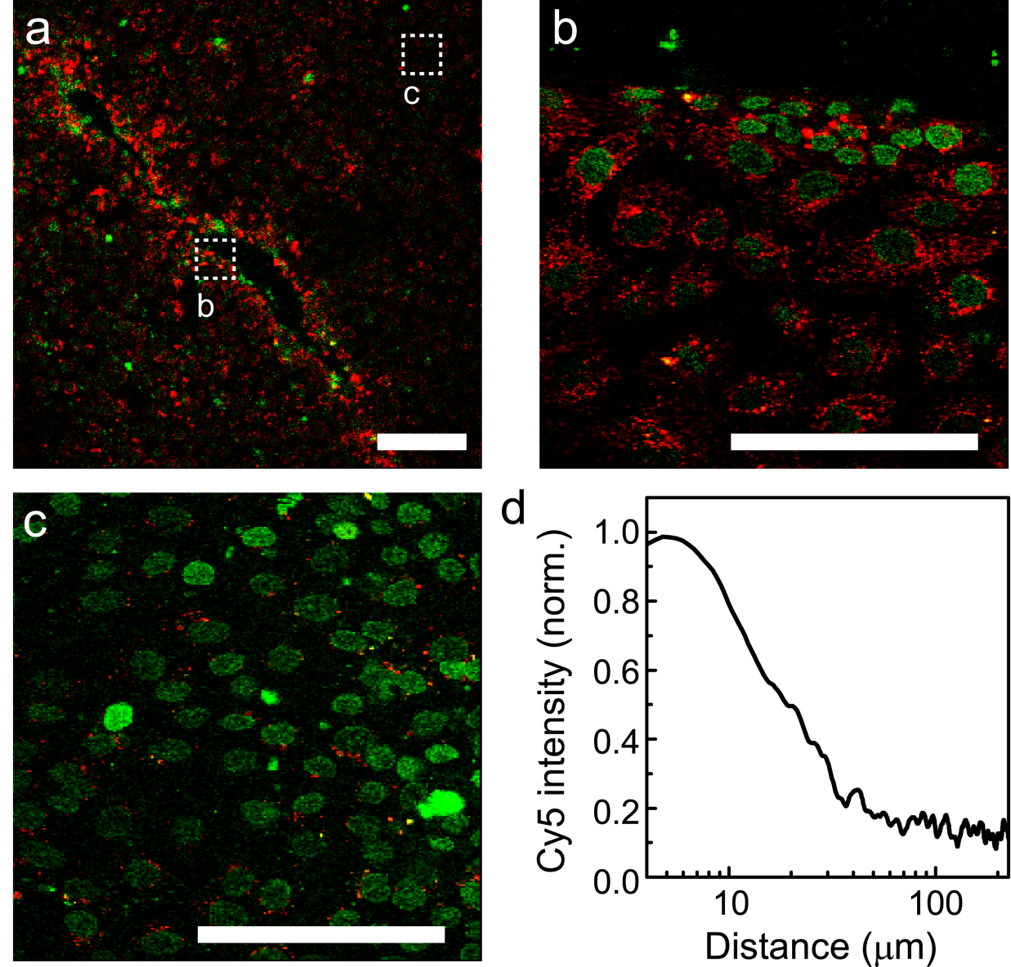

Figure 2. Detection of Vimentin mRNA in cell scratch assays. A scratch assay was performed in fully confluent epithelial cells and allowed to recover over 18 h in the presence of 10 pmol of Vimentin DNA nanoprobes. (a) Confocal microscopy images of the scratch area (green fluorescence comes from nuclear counterstain, DAPI; red fluorescence from the Cy5 flare oligonucleotide strand). Higher magnification confocal microscopy images are shown near (b) and away (c) from the scratch site (wound). As observed, strong fluorescence deriving from the flare oligonucleotide strand during Vimentin mRNA detection is obtained around the wound site. Away from the wound site, a 5-10 times weaker fluorescent signal was observed. d) Red fluorescence profile of the scratch assay obtained from the confocal image, averaged for 80 different locations along the scratch and normalized against respective DAPI fluorescence values. The fluorescence signal intensity was correlated to the distance from the wound site, with distances <20µm from the wound edge displaying a 5-10 times increase of signal comparatively to distance of >100 µm from the wound edge. Scale bars are: in (A) 200 µm and in (B), (C) 20 µm. Separate colour channels are shown in Supporting Information (Figure S3).

affected. In order to quantify the distribution of Vimentin mRNA around the wound, confocal images of the scratch assay were analyzed to extract the total fluorescence intensity against distance from the wound edge (Figure 2d.) For this purpose, traces at 80 different positions along the scratch were averaged, each trace starting from the wound edge (±4.5 mm) and in the direction perpendicular to the scratch. The average fluorescence intensity within 10 µm from the wound edge was approximately 10 times higher than the fluorescence measured >50 µm away from the wound. When comparing the wounded epithelial cells with fully confluent cells, it was possible to observe that the fluorescence intensity of wounded cells was approximately 1000 times higher than in non-wounded cells (Figure S2A). These results were further confirmed by qPCR (Figure S2B), indicating a significant upregulation of Vimentin in migrating epithelial cells undergoing EMT, which is in good agreement with literature reports.^{[32,34,35]}

Expression of Vimentin mRNA in damaged tissue ex vivo.
After demonstrating the ability of our nanoprobes to sense Vimentin mRNA in both confluent and migrating cells, we moved to a more complex structure using a damaged skin tissue model. Various types of tissue models have been used in different studies to investigate wound healing. ^{[36],[37,38]} For our studies, dorsal murine skin of new-born mice was injected with Vimentin DNA gold nanoprobes. The site of injection was also the site where the tissue was wounded (see Scheme 2).
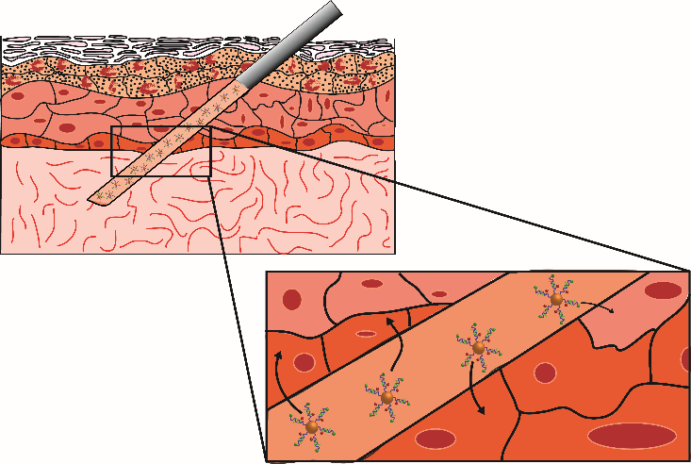

Scheme 2. Schematic illustration of the injection of Vimentin DNA gold nanoprobes into ex vivo murine skin. Nanoprobes for the detection of Vimentin mRNA were injected into dorsal murine skin samples. The injection site simultaneously creates an artificial wound and the nanoprobes are released across different regions of the tissue to achieve a comprehensive exposure.

As the syringe is retracted from the tissue sample, the nanoprobes are slowly released and can be taken up by cells in close proximity to the as-created wound. Thus the experiment had a two-fold purpose: firstly to create an artificial wound in the skin and secondly to simultaneously release the Vimentin DNA gold nanoprobes across the whole wounded region (from the dermis to the stratum corneum).
We note that the local injection of nanoprobes in the wound site results in much higher doses of fluorescent probes around the wound edge than deeper inside the tissue. Therefore, the results here serve to identify the local EMT dynamics and do not allow full quantitative mapping in the tissue sample away from the wound site. After 6 h of incubation, the skin was fixed, embedded in a polymeric matrix and sectioned (see experimental section for details). Figure 3 shows confocal microscopy images of wounded regions of the skin. After incubation with Vimentin DNA gold nanoprobes, a strong fluorescence attributed to the presence of Vimentin mRNA could be observed (Figure 3a). A higher magnification image of the wound site (Figure 3b) shows that the strongest signal is located at the wound edge, where cells were most affected by the creation of the wound and undergoing EMT. This is in agreement with cell studies from the scratch assay as discussed previously. On the other hand, when scramble DNA-coated gold nanoprobes were used (see Table S1 for the oligonucleotide sequence) no fluorescent signal from the flare strand was observable (see figure S4). This suggests that
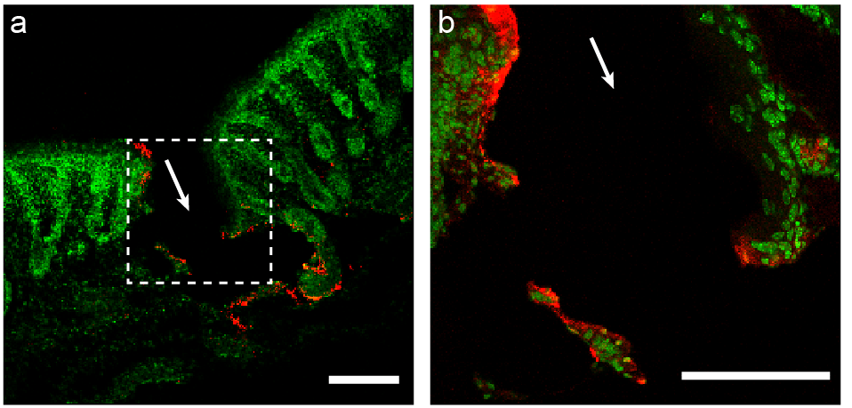

Figure 3. Detection of Vimentin mRNA in sections of a skin wound site. Confocal microscopy images of skin sections (thickness: 2 µm) 6 hours after nanoprobe injection. Skin was injected with Vimentin DNA gold nanoprobes [(a) and (b) magnified image)]. Nuclear counterstain (green), Flare strand Cy5 (red) [(Scale bars are: 1 mm for (a) and 500 µm for (b)]. White arrows indicate the direction of the injection.

Vimentin detection is specific and not a result of any non-specific interactions within the skin. Nevertheless, the use of thin sections of fixed skin taken at certain incubation times does not give access to dynamic information of the mRNA detection in a single sample. To gain spatial and dynamic information from cells containing Vimentin mRNA in the wounded site, we performed light sheet fluorescence microscopy (LSFM). In this technique, a focused sheet of light scans the sample vertically to obtain an optical sectioning image stack (see a schematic illustration in Figure S5).^{[39]} Optical sectioning allows for the qualitative extraction of the three-dimensional fluorescence profile of tissue layers, which can have thicknesses in the range of a few nanometres to micrometres. Moreover, the resulting data can be analyzed computationally in order to obtain spatial representation of the detected fluorescence signals. Most importantly, LSFM is a non-destructive technique where the skin sample does not need to be sectioned physically, thus maintaining its complete original structure.
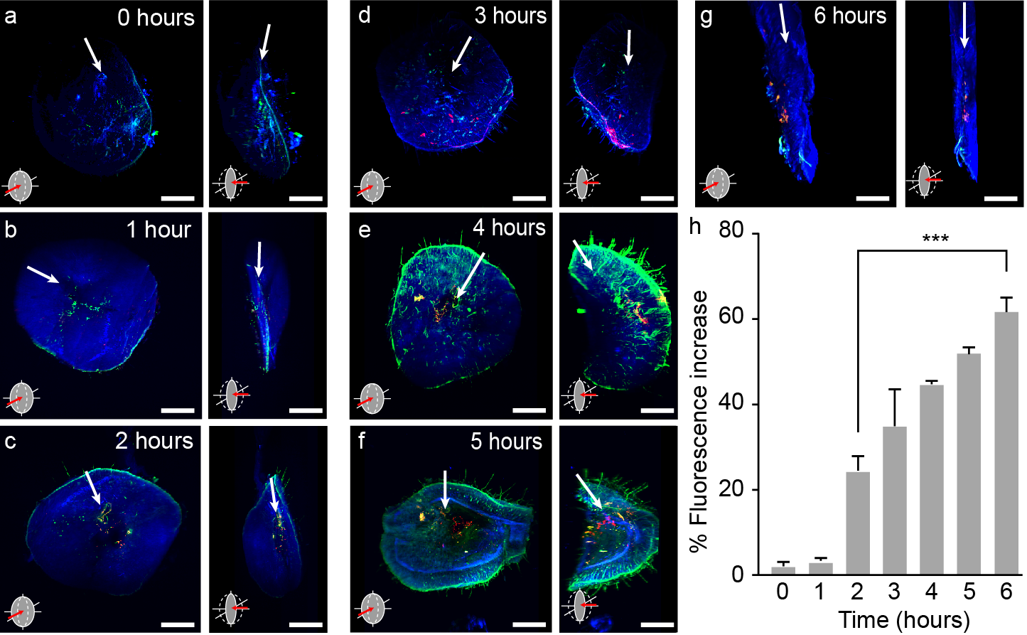

Figure 4. Time-lapse visualization of Vimentin mRNA in skin tissue using light-sheet microscopy. (a-g) Light sheet microscopy images for times ranging from 0 – 6 hours after injection with 100 pmol of the Vimentin DNA gold nanoprobes. The Cy5 signal (red) is shown together with the cellular regions of the skin (represented by the blue channel-DAPI) and RhodB (green) released at the injection site. Arrows indicate the direction of injection. Scale bars are 1 mm. (h) Relative fluorescence increase in channel corresponding to Cy5 nanoprobes integrated over the tissue volume, as obtained from light-sheet microscopy images. Final time-point (6 h) being approximately 70% higher than the initial signal. (***p<0.0001 Two-Way ANOVA).
In order to facilitate the location of the wound, we incorporated Rhodamine B (RhodB) as a marker during injection. As shown in Figure 4, the wound site was clearly detectable by a fluorescent signal immediately after injection (Figure 4a; animated reconstruction available as Supporting Information Media file). In order to visualise cellular regions of the skin, DAPI was used as a nuclear counter stain. As can be seen from Figure 4a, no fluorescent signal from the nanoprobes could be detected at this point. This was not surprising, since probes must first be internalized by cells prior to mRNA detection. With increasing time of incubation of up to 6 hours, an increasing fluorescent signal from the flare strands could be observed (Figure 4b-g, animated reconstruction available as Supporting Information Media files), indicating the presence of Vimentin mRNA. There was a good overlap between the flare strand fluorescence (red) and the cellular regions of the skin (blue) as well as the injection site (green). Furthermore, no fluorescent signal besides the nuclear counter stain DAPI and RhodB, was detected in skin samples incubated in various control conditions, which include the use of a scramble nanoprobe (Figure S6-7), confirming the specificity of the Vimentin nanoprobe signal.
Since RhodB and DAPI fluorescence intensities are stable immediately after injection, we used these as a normalisation factor to determine the relative fluorescence intensity arising from the nanoprobes at various intervals, taking into account sample to sample variations. Figure 4h shows that 2 h after the injection an increase in flare strand fluorescence (shown in red) occurred (approximately 30 % intensity) when compared to the control experiments (Figure S6-7 in Supporting Info). Moreover, after 6 h there was a relative fluorescence increase of about 70 %. It has to be noted that factors such as nanoprobe uptake time or cell to cell heterogeneity in nanoprobe uptake were not considered in this study and thus an accurate direct temporal relation between the onset of fluorescence and the emergence of EMT cannot be made at this point. Nevertheless, our data gives a good insight into the spatiotemporal expression of Vimentin mRNA in wounded skin. Furthermore, previous studies^{[33]} reported an onset of Vimentin protein expression 4h after the wound occured, suggesting that our probes are active within the biologically relevant time window.

3. Conclusions
In summary, we showed that the nanoprobes presented in this study were able to detect changes in Vimentin mRNA expression accompanying a change in cell phenotype during EMT in wound healing. The presence of Vimentin mRNA in wounds was imaged temporally, in cell scratch assays and tissue sections, utilizing confocal microscopy, as well as spatially, utilizing light sheet microscopy in whole skin tissue. A time lapse experiment showed that Vimentin mRNA was present in cells as early as 2 h after the creation of the wound and the fluorescent signal continued to increase up to 6 h after the injury. Although further studies are necessary to assess the performance of this type of nanoprobes in a quantitative aspect, our results show that advanced designs of DNA-gold nanoparticles can be employed to extract important information related to dynamic biological process even in complex systems such as the skin tissue, enabling them as a class of very promising probes for bioimaging. Furthermore, in the future it may be possible to replace the nanoparticle core for different types of nanoparticles in order to enable the direct detection of nanoparticle location in cells in respect to the mRNA detection site.

Experimental Section
Synthesis of gold nanoparticles: Spherical gold nanoparticles (13±2 nm) were synthesized according to literature protocols.^{[40,41]} Briefly, a solution of sodium tetrachloroaurate (100 mL, 1 mM) was brought to boil under stirring. Once boiling, a sodium citrate solution (5 mL, 2% w/v) was added to the gold solution and a colour change from yellow to dark red was observed. After stirring for 30 min, the solution was taken off the heat and left to cool to room temperature under stirring. An aqueous solution of Bis (p-sulfonatophenyl) phenylphosphine dihydrate dipotassium salt (BSPP) (10 ml, 0.187 mM) was added to the reaction flask and the reaction mixture was left to stir overnight. Particles were purified by centrifugation (3x, 16400 rpm) after salt-induced aggregation and finally filtration through a 0.45 μM Millipore filter. The size of AuNPs was determined via analysis of TEM micrographs (Figure S1A) – taken with a JEM-1010 electron microscope working at 75 kV equipped with a digital camera GATAN megaview II – and using Image J (National Institutes of Health, USA) software. Over 500 particles were considered for the distribution histogram (Figure S1B).
Design of oligonucleotides: Oligonucleotide sequences for Vimentin mRNA detection were obtained from the NCBI database (http://www.ncbi.nlm.nih.gov/nucleotide/). Sequences were then analysed for alignments with other sequences (i.e. similarities) using the NCBI’s Basic Local Alignment Search Tool (BLAST) (www.ncbi.nlm.nih.gov/BLAST.cgi). The following settings were applied: Database: RefSeq RNA; Entrez Query: all[filter] NOT predicted[title]; Expect threshold: 10; Match/Mismatch scores: 2/-3. Appropriate sequence targets were then chosen with the following criteria: Length of sense strand: 20-23 bases, melting temperature ~60 °C, GC content < 50 %, E value < 0.05, E value of nearest match > 1. Accordingly the flare strand was designed complementary to the sense strand with the following criteria: Length of flare strand: 10-12 bases, melting temperature ~40 °C. The oligonucleotide sequences were purchased from ATDBio.
Oligonucleotide attachment to AuNPs: The successful conjugation of thiol-terminated oligonucleotides and gold nanoparticles was achieved using a modified version of a literature protocol.^{[42,43]} Briefly, BSPP-coated AuNPs (13 nm, 1 mL, 10 nM) were incubated with 3 nmol of a thiol-modified DNA overnight. Then, BSPP (10 ml, 0.187 mM), phosphate buffer (0.1 M, pH 7.4), and sodium dodecyl sulfate (SDS) (10 %) were added to obtain final concentrations of 0.01 M phosphate and 1 % SDS. Next, drops of a NaCl solution (2 M) was added six times over a period of 8 h in order to obtain a final concentration of 0.2 M. The solution was left shaking overnight at RT. Non-specifically bound oligonucleotide strands were removed after three steps of centrifugation (16400 rpm, 4 °C, 10 min). The resultant oligonucleotide-coated AuNPs were re-dispersed in 1 mL of hybridization buffer (0.1 M NaCl, 20 mM phospate buffer, pH 6.8, 10 mM EDTA, 2 % SDS). The flare strand was then added in an excess (200 nmol) and the solution was heated to 80 °C for 2 minutes. Then, the solution was left to cool down to room temperature. Non-hybridised flare strands were removed by three steps of centrifugation (16400 rpm, 4 °C, 10 min) and the final gold nanoparticle-DNA conjugates were re-dispersed in PBS buffer and stored at 4 °C until further use.
Cell culture: The cells used for the experiments were the following – 16-Human Bronchial Epithelial cells (16-HBE), Human Foetal Lung fibroblasts (MRC-5) and primary Mouse Embryonic Fibroblasts (MEFs). Cells were cultured in cell culture flasks using Dulbecco’s Modified Eagle’s Medium (DMEM – Gibco, UK), supplemented with 1% penicillin/streptomycin (Gibco, UK), 1 mL nystatin (Gibco) and 10% foetal bovine Serum (FBS). Cells were kept at 37 °C, 5 % CO2 atmosphere in a Sanyo CO2 incubator (model MCO-17AI).
Confocal imaging of cell models: Cells were grown on square glass coverslips in 6-well plates. Once cells were ~90 % confluent, media was exchanged with fresh media containing different types of nano-probes (2 mL, 1 nM) for 18 h. For the wound assay, a 1 mL pipette tip was used to scratch off the cells in a grid pattern. Afterwards cells were incubated with Hoechst 33342 (5 μL) for 1 h to stain DNA and nuclei. For imaging, the glass coverslip was removed and washed with PBS. It was then mounted on a glass slide with a drop of PBS in order to keep cells alive. The edges around the coverslip were sealed using double-sided tape thus creating a small ‘incubation chamber’. All imaging was carried out on a Leica SP5 confocal microscope at 37°C.
Incubation of oligonucleotide coated gold nanoparticles with tissue: Ex vivo murine dorsal skin was harvested from new born hairless mice (1-4 days old) under Personal License number IC73F2D5B. Straight after harvest, the skin was washed 3 times with PBS and injected with a Micro-Fine™ syringe, 0.5 mL, 0.3mm x 4 mm (BD, Europe), in a ~30° angle with different solutions containing either the DNA-coated gold nanoparticles alone (for confocal microscopy) or a mix of DNA-coated gold nanoparticles (10 pmol) and RhodB (0.1 mg/mL, for light sheet microscopy). After 6h incubation in a transwell using MEM-L-glutamine enriched medium, the skin was removed, washed 3 times with PBS and fixed in Formalin Buffer salin fixative. Then, skin samples were incubated with DAPI (1 µg/mL) for 30 mins. The skin was then either embedded in paraffin blocks (for sectioning and confocal imaging) or in 1% agarose blocks (for light sheet microscopy imaging).
Confocal imaging of ex vivo skin sections: Each sample was embedded in paraffin blocks using a standard dehydration protocol.^{[44]} Briefly, the tissue was processed gradually in an automated Leica ASP 200S tissue processor that processed the tissue in graded alcohols (70/90/100% v/v), then in xylene and finally in paraffin. The embedding was done in a Leica HistoCore Arcadia™ instrument. The blocks were then sectioned in 2µm thick sections and the excess paraffin was removed using a standard hydration/dehydration protocol. Briefly, the paraffin was removed by subjecting the sections to various steps of first xylene and then graded alcohols (100/90/70% v/v), 10 minutes for each step. Once the final alcohol step was done, the sides were then moved back up the graded alcohols and finally to xylene, before being mounted in the slide using Sub-X mounting agent (Leica Biosystems). The slides were stored at 4° C under dark conditions until further use.
Preparation of ex vivo skin samples for light sheet fluorescence microscopy imaging: Preparation of the skin samples for the analysis in light sheet microscopy, was done following a progressive dehydration procedure.^{[45]} Briefly, each sample was embedded in 1% agarose block after the respective incubation time with the DNA-coated gold nanoparticles. The blocks were cut suitably to fit a small vial. Each block was then submerged in an increasingly hydrophobic solvent (50/50 Water: THF initially, then 80% THF, 96% THF and finally 2x 100% THF), with each step taking 6h. After the final submersion at 100% THF step, the solvent was removed and the sample was submerged in 2 mL of DCM and left until it sank to the bottom of the vial (approximately 2h). The solvent was disposed and two steps (6h each) of DBE clearing were performed. The complete clearing of the skin block was observed by the transparency of both the blocks and the samples. Finally, the block was submerged in fresh DBE and kept in the dark at 4° C until analysis.
Processing of light sheet fluorescence microscopy data: Images were taken using an Olympus MVX10, with excitation at 405 nm, 561 nm and 640 nm. Images were taken using a 1.6x magnification, with a section size of 3µm per stage step. Resulting images were processed using ImageJ to combine for a 3D projection. For fluorescence intensity analysis, the control experiments (PBS, RhodB only and scramble control) were used to measure the “background” levels of fluorescence of each channel (405nm, 561nm and 640nm). This was done using Image J to extract the gray value histogram of each pixel and have plot the average of fluorescence intensity against area of the image. The mean gray values were also taken into consideration. After that, each sample had its fluorescence of the 405 nm and 561 nm taken and used for “sample-to-sample” variation adjustment. Eventually, the final value of 640 nm fluorescence was adjusted using all the aforementioned correction values and plotted in percentage of relative fluorescence increase to the controls.
Statistical analysis: Statistical analysis was performed using GraphPad Prism 6 software, using the tests specified in each case (either student’s t-test or one-way ANOVA).

Supporting Information
Supporting Information. Materials and additional experimental protocols, Nanoparticle characterization, further confocal microscopy images.

Acknowledgements
P.V. would like to thank the University of Southampton and EPSRC for a DTA studentship. The technical team at the Biomedical Imaging Unit, Southampton General Hospital is greatly acknowledged.

References
[1] T. J. Shaw, P. Martin, J. Cell Sci. 2009, 122, 3209.
[2] S. Werner, R. Grose, Physiol. Rev. 2003, 83, 835.
[3] S. Barrientos, O. Stojadinovic, M. S. Golinko, H. Brem, M. Tomic-Canic, Wound Repair Regen. 2008, 16, 585.
[4] B. R. Klass, A. O. Grobbelaar, K. J. Rolfe, Postgrad. Med. J. 2009, 85, 9.
[5] J. M. Carvajal-Gonzalez, A. C. Roman, M. I. Cerezo-Guisado, E. M. Rico-Leo, G. Martin-Partido, P. M. Fernandez-Salguero, J. Cell Sci. 2009, 122, 1823.
[6] M. Sisco, Z. B. Kryger, K. D. O’Shaughnessy, P. S. Kim, G. S. Schultz, X. Z. Ding, N. K. Roy, N. M. Dean, T. A. Mustoe, Wound Repair Regen. 2008, 16, 661.
[7] S. Chigurupati, T. V. Arumugam, T. G. Son, J. D. Lathia, S. Jameel, M. R. Mughal, S.-C. Tang, D.-G. Jo, S. Camandola, M. Giunta, I. Rakova, N. McDonnell, L. Miele, M. P. Mattson, S. Poosala, PLoS One 2007, 2, e1167.
[8] Y. J. Chen, B. Groves, R. A. Muscat, G. Seelig, Nat. Nanotechnol. 2015, 10, 748.
[9] A. S. Boutorine, D. S. Novopashina, O. A. Krasheninina, K. Nozeret, A. G. Venyaminova, Molecules 2013, 18, 15357.
[10] D. P. Bratu, I. E. Catrina, S. A. E. Marras, Methods Mol. Biol. 2011, 714, 141.
[11] W. Tan, K. Wang, T. J. Drake, Curr. Opin. Chem. Biol. 2004, 8, 547.
[12] E. V. Dolgosheina, S. C. Y. Jeng, S. S. S. Panchapakesan, R. Cojocaru, P. S. K. Chen, P. D. Wilson, N. Hawkins, P. A. Wiggins, P. J. Unrau, ACS Chem. Biol. 2014, 9, 2412.
[13] M. Valencia-Burton, R. M. McCullough, C. R. Cantor, N. E. Broude, Nat. Methods 2007, 4, 421.
[14] Y. Wu, L. Chen, P. G. Scott, E. E. Tredget, Stem Cells 2007, 25, 2648.
[15] J. Gatlin, M. W. Melkus, A. Padgett, W. M. Petroll, H. D. Cavanagh, J. V. Garcia, J. V Jester, Exp. Eye Res. 2003, 76, 361.
[16] D. R. Garrod, M. Y. Berika, W. F. Bardsley, D. Holmes, L. Tabernero, J. Cell Sci. 2005, 118.
[17] J. A. Sherratt, J. C. Dallon, Comptes Rendus - Biol. 2002, 325, 557.
[18] D. S. Seferos, D. A. Giljohann, H. D. Hill, A. E. Prigodich, C. A. Mirkin, J. Am. Chem. Soc. 2007, 129, 15477.
[19] D. A. Giljohann, D. S. Seferos, A. E. Prigodich, P. C. Patel, C. A. Mirkin, J. Am. Chem. Soc. 2009, 131, 2072.
[20] A. E. Prigodich, P. S. Randeria, W. E. Briley, N. J. Kim, W. L. Daniel, D. A. Giljohann, C. A. Mirkin, Anal. Chem. 2012, 84, 2062.
[21] T. L. Halo, K. M. McMahon, N. L. Angeloni, Y. Xu, W. Wang, A. B. Chinen, D. Malin, E. Strekalova, V. L. Cryns, C. Cheng, C. A. Mirkin, C. S. Thaxton, Proc. Natl. Acad. Sci. U. S. A. 2014, 111, 17104.
[22] N. Li, C. Chang, W. Pan, B. Tang, Angew. Chemie Int. Ed. 2012, 51, 7426.
[23] W. Pan, Y. Li, M. Wang, H. Yang, N. Li, B. Tang, W. Tan, T. H. Zhou, S. R. Lin, Chem. Commun. 2016, 52, 4569.
[24] S. Ye, X. Li, M. Wang, B. Tang, Anal. Chem. 2017, 89 (9)
[25] A. Heuer-Jungemann, A. H. El-Sagheer, P. M. Lackie, T. Brown, A. G. Kanaras, Nanoscale 2016, 8, 16857.
[26] D. Zheng, D. A. Giljohann, D. L. Chen, M. D. Massich, X.-Q. Wang, H. Iordanov, C. A. Mirkin, A. S. Paller, Proc. Natl. Acad. Sci. 2012, 109, 11975.
[27] P. S. Randeria, M. A. Seeger, X.-Q. Wang, H. Wilson, D. Shipp, C. A. Mirkin, A. S. Paller, Proc. Natl. Acad. Sci. U. S. A. 2015, 112, 5573.
[28] R. Fernandes, N. R. Smyth, O. L. Muskens, S. Nitti, A. Heuer-Jungemann, M. R. Ardern-Jones, A. G. Kanaras, Small 2015, 11, 713.
[29] R. Gupta, B. Rai, Sci. Rep. 2017, 7, 45292.
[30] K. Vuoriluoto, H. Haugen, S. Kiviluoto, J.-P. Mpindi, J. Nevo, C. Gjerdrum, C. Tiron, J. B. Lorens, J. Ivaska, Oncogene 2011, 30, 1436.
[31] P. Laurila, I. Virtanen, V. P. Lehto, T. Vartio, S. Stenman, J. Cell Biol. 1982, 94, 308.
[32] C. Mork, B. Van Deurs, O. W. Petersen, Differentiation 1990, 43, 146.
[33] M. R. Rogel, P. N. Soni, J. R. Troken, A. Sitikov, H. E. Trejo, K. M. Ridge, FASEB J. 2011, 25, 3873.
[34] C. C. Liang, A. Y. Park, J. L. Guan, Nat. Protoc. 2007, 2, 329.
[35] C. Gilles, M. Polette, J. M. Zahm, J. M. Tournier, L. Volders, J. M. Foidart, P. Birembaut, J. Cell Sci. 1999, 112 ( Pt 2, 4615.
[36] E. Bellas, M. Seiberg, J. Garlick, D. L. Kaplan, Macromol. Biosci. 2012, 12, 1627.
[37] E. A. Gantwerker, D. B. Hom, Clin. Plast. Surg. 2012, 39, 85.
[38] A. Bayat, D. A. McGrouther, M. W. J. Ferguson, BMJ 2003, 326, 88.
[39] P. A. Santi, J. Histochem. Cytochem. 2011, 59, 129.
[40] J. Turkevich, P.C. Stevenson, J. Hiller, Discuss. Faraday Soc. 1951, 11, 55.
[41] J. Kimling, M. Maier, B. Okenve, V. Kotaidis, H. Ballot, A. Plech, J. Phys. Chem. B 2006, 110, 15700.
[42] J. J. Storhoff, R. Elghanian, R. C. Mucic, C. A. Mirkin, R. L. Letsinger, J. Am. Chem. Soc. 1998, 120, 1959.
[43] S. J. Hurst, A. K. R. Lytton-Jean, C. A. Mirkin, Anal. Chem. 2006, 78, 8313.
[44] C. Redi, Eur. J. Histochem. 2010, 54, 211.
[45] N. Renier, Z. Wu, D. J. Simon, J. Yang, P. Ariel, M. Tessier-Lavigne, Cell 2014, 159, 896.

