**A model of uranium uptake by plant roots allowing for root-induced changes in the soil**

Andrea Boghi†, Tiina Roose§ and Guy J. D. Kirk*†

†School of Water, Energy & Environment, Cranfield University, Cranfield, Bedford MK43 0AL, U.K.

§Faculty of Engineering and Environment, University of Southampton, Southampton SO17 1BJ, U.K.

**Abstract:** We develop a model with which to study the poorly-understood mechanisms of uranium (U) uptake by plants. The model is based on equations for transport and reaction of U and acids and bases in the rhizosphere around cylindrical plant roots. It allows for the speciation of U with hydroxyl, carbonate and organic ligands in the soil solution; the nature and kinetics of sorption reactions with the soil solid; and the effects of root-induced changes in rhizosphere pH. A sensitivity analysis showed the importance of soil sorption and speciation parameters as influenced by pH and CO2 pressure; and of root geometry and root-induced acid-base changes linked to the form of nitrogen taken up by the root. The root absorbing coefficient for U, relating influx to the concentration of U species in solution at the root surface, was also important. Simplified empirical models of U uptake by different plant species and soil types need to account for these effects.

**Introduction**

Increased dependence on nuclear power generation in many countries has prompted renewed interest in the behaviour of uranium (U) and other long-lived radionuclides in the environment1–3. Uranium may be accidentally released into soils, sediments and groundwater from nuclear power facilities; from geological disposal facilities; from natural geological deposits; from metal mining, milling and tailings operations; and from military uses of depleted U1–4. There is interest in the use of plants for biomonitoring or phytoremediation of contaminated soils5. But the processes controlling U uptake by plants are poorly understood. Existing models for predicting the fate and behaviour of U are mostly empirical, relying on simple transfer coefficients between concentrations in plants and concentrations in soils5. This may be satisfactory for the conditions in which models have been calibrated, but not for other conditions and predictive scenario testing.

Uranium forms a large number of chemical species of varying solubility and biological availability6,7. Hexavalent U(VI) is the stable form in oxic environments, and generally occurs in the hydrated state, for example in schoepite and related minerals, and as the soluble uranyl ion, UO22+. Under anoxic conditions, less-soluble U(IV) species are formed. The UO22+ cation is sorbed on the surfaces of soil minerals and organic matter, but complexation reactions with simple ligands such as carbonate and organic anions tend to increase its solubility8–11.

Although U is not essential or beneficial to plants, most plants will take it up and to some extent translocate it into above-ground parts5. At sufficiently large concentrations in shoots, it is toxic, causing oxidative stress12,13. Under given conditions, the extent of uptake and root:shoot translocation vary between plant species5,12–14. Concentrations in plants are generally several orders of magnitude smaller than total concentrations in the surrounding soil15–17. But there are no simple relations between uptake into plants and total soil concentrations, or how this varies with soil type5. Uptake is better correlated with concentrations of UO22+ and its complexes in the soil solution12–14. Studies in nutrient culture show that U uptake and translocation from roots to shoots are pH dependent, both being greater at low pH where the proportion of UO22+ in the external solution is greater15–17. It is not known how far these differences reflect differences between U species in root transporter specificities or accumulation in roots. Plant uptake of U is enhanced where roots are colonized by mycorrhizal fungi, but root-shoot translocation is often impeded18–20. The enhanced U uptake is thought to be due to uptake by and translocation within mycorrhizal hyphae21,22, but is possibly also due to solubilisation in the rhizosphere by fungal action23,24 and direct uptake of the solubilised U by roots. These processes are poorly understood.

In this paper we develop a mathematical model of U uptake by plants growing in soil with which to investigate the mechanisms of U uptake. The model accounts for soil transport processes, root-induced changes in soil biology and chemistry affecting U mobility, and uptake across root surfaces. We focus on U but our approach could also be applied to other radionuclides with similar complex speciation chemistries.

**the model**

Processes in the root environment affecting U uptake are summarised in Figure 1A. The rate of uptake into a root will depend on the rate of transfer from the soil solution outside the root across the root wall, versus the rate of transfer through the soil to the root surface by convection and diffusion. Rates of convection and diffusion will depend on the interchange of U between the soil solution, in which it is mobile, and the soil solid, in which it is largely immobile. This interchange is sensitive to root-induced changes in the chemistry of the rhizosphere soil. Particularly, changes in pH associated with the plant’s cation and anion intake, and, potentially, changes in CO2 pressure and the concentrations of organic ligands associated with root deposits and rhizosphere microbial activity.

Nye25 showed that, because CO2 diffuses rapidly through the soil air, processes generating CO2 in the rhizosphere will not, in fact, raise the CO2 pressure much above that in the surrounding soil. But root-induced pH changes due the plant cation-anion balance are often as much as 1–2 pH units25,26. A plant absorbing its nitrogen (N) as the nitrate anion (NO3-) will tend to take up a net excess of anions over cations, and release bicarbonate (HCO3-) into the soil to maintain charge balance across the root-soil boundary25. Whereas a root absorbing its N as ammonium (NH4+) will tend to release H+ to maintain charge balance. Given the sensitivity of U solubility in soil to pH and CO2 pressure, it is important to allow for such processes in a mechanistic description of U uptake.

In brief, the model allows for the transport of U species through the soil to an absorbing root with simultaneous desorption from the soil solid, and the simultaneous transport of acids and bases through the soil in response to acid-base changes caused by the root and by U reactions in the soil. In the model, transport equations for U species and soil acids and bases are solved, ensuing charge and mass balances in the soil and root. The equations and boundary conditions are as follows (the nomenclature is explained in Table 1).

**Interchange of U between the soil solid and solution.** Consider a soil that initially contains Ca2+ (representing exchangeable cations), H+, H2CO3, HCO3-, CO32-, Cl*-* (representing non-adsorbed inorganic anions) and L- (representing U-complexing organic ligands) in the soil solution and Ca2+ in the soil exchange complex. To avoid undue complexity we do not consider other ions, but we note that in some soils, uranyl phosphate and sulphate complexes are also important. The salt UO2Cl2 is added to the soil and allowed to equilibrate. We consider the reactions governing the equilibrium distribution of U species between the soil solid and solution as follows.

*Complexation reactions in solution.* Equilibrium speciation calculations using MINTEQ27 for typical soil solution compositions show the important U-containing species will be UO22+, UO2OH+, UO2CO3, Ca2UO2(CO3)3 , CaUO2(CO3)32- and UO2L+. The total concentration of U species in the soil solution is therefore:

|  |
| --- |
|  |

where the *K* terms are the respective conditional equilibrium constants adjusted for activity coefficients and subscript L indicates the liquid phase. [CO32-]L is found from the pH and CO2 pressure. This leaves two unknowns in eq 1 ([UO22+]L and [Ca2+]L) so we require a second equation. We use, from the requirement for electrical neutrality in the soil solution:

|  |  |
| --- | --- |
|  | (2) |

*Fast sorption reactions.* We use the generalized surface complexation model of Davis et al.8. This gives semi-empirical equations for reversible U sorption on soils in terms of the formation of bidentate complexes of UO22+ with hydroxyl groups on the soil solid:

|  |  |
| --- | --- |
| Soil–(OH)2 + UO22+ = Soil–O2UO2 + 2H+ | (3) |

Hence we describe U sorption on fast-reacting sites with the mass-action equilibrium equation

|  |  |
| --- | --- |
|  | (4) |

where [U]S1 = [Soil–O2UO2]S, [X]S1 = [Soil–(OH)2]S, *K*f is a conditional equilibrium constant and [U]S1 + [X]S1 is constant:

|  |  |
| --- | --- |
| [U]S1 + [X]S1 = [S1] | (5) |

In Davis et al.’s model8, weak, strong and very strong sorption sites are distinguished. Here we consider only a single, composite sorption site.

For a given total U concentration in the soil, soil pH and CO2 pressure, we therefore have four unknowns: [U]L, [UO22+]L, [U]S1 and [X]S1. These are found with the following four equations: eq 4; eq 5; and from eq 1:

|  |  |
| --- | --- |
|  | (6) |

where *ϕ* is the term in the curly bracket in eq 1, which is function of pH and CO2 pressure; and from the mass balance of U in the whole soil:

|  |  |
| --- | --- |
| [U] = *θ* [U]L + *ρ* [U]S1 + *ρ* [U]S2 | (7) |

where *θ* is the soil volumetric moisture content, *ρ* is the soil bulk density and [U]S2 is the concentration of slowly-reacting U in the soil solid, as calculated in the next section.

*Slow sorption reactions.* It is generally found that there is a continuing slow equilibration reaction between U in surface complexes and that in more-slowly reacting forms in the soil solid28–31. We assume reversible first order kinetics for this equilibration, and obtain for the rate of the forward reaction

|  |  |
| --- | --- |
|  | (8) |

where [U]S1 and are [U]S2 the concentrations of fast- and slow-reacting U and *k*1 and *k*2 are forward and backward rate constants, respectively.

**Continuity equations for uranium and acidity transport and reaction.** Consider a cylindrical plant root of radius *r* = *a* surrounded by a cylindrical zone of influence in the soil of radius *r* = *b*. For a regular parallel array of roots of length per unit soil volume *L*V, the mean radius of the zone of influence is .

*Uranium.* The continuity equation for U transport and reaction in the soil is:

|  |  |
| --- | --- |
|  | (9) |

where [U] and [U]L are the concentrations of U species in the whole soil and soil solution, respectively, *D*LU is the diffusion coefficient of U species in free solution, *f* is a diffusion impedance factor for the soil and *v* is the water flux through soil into the root. Combining with eqs 7 and 8:

|  |  |
| --- | --- |
|  | (10) |

The partial derivative is defined by eqs 4–7.

The boundary conditions for solving eq 10 are as follows. (1) The flux of U into the root at *r* = *a* is taken to be proportional to the total concentration of U species in the soil solution at *r* = *a*, i.e. *F*U = *α*[U]L where *F*U is positive into the root and *α* is a root absorbing coefficient for U. In reality, *α* may vary in response to growth conditions and internal plant processes. Such effects are beyond our scope but could be allowed for in a complete model of plant U relations. (2) There is no transfer across the far-field boundary *r* = *b*.

*Soil acidity.* Changes in pH in the region of a root are propagated away by diffusion of mobile acid-base pairs in the soil solution: acids move from regions of low pH to high pH and bases in the opposite direction. The two main acid-base pairs are H3O+–H2O and H2CO3–HCO3-; the concentrations of pairs containing U are small by comparison. A small portion of soil may gain acidity by access of H3O+:

|  |  |
| --- | --- |
| Soil–M + H3O+ = Soil–H + M+ + 2H2O | (11) |

or lose acidity by the arrival of HCO3- and formation of H2CO3, followed by removal of CO2 through the soil air:

|  |  |
| --- | --- |
| Soil–H + M+ + HCO3- = Soil–M + H2CO3 | (12) |

where M+ represents an exchanging cation (Ca2+ in our simulations). Note that H+ exchange in these reactions is distinct from its production in the U sorption reactions (eq 3). Therefore, the continuity equation for changes in soil acidity is (after Nye25)

|  |  |  |  |
| --- | --- | --- | --- |
| |  |  | | --- | --- | |  | (13) | | (13) |

where [HS] is the concentration of titratable acidity, as measured by the amount of strong base consumed per unit soil volume in increasing the soil solution to a standard pH; *D*LH and *D*LB are the diffusion coefficients of H+ (i.e. H3O+) and HCO3- in free solution; and *R* is the rate of H+ production in the U sorption reactions (i.e.  in the reactions in eq 3).

It is convenient to make pH the working variable in eq 13. In most soils, changes in acidity are proportional to changes in pH over wide pH ranges. Hence

|  |  |
| --- | --- |
|  | (14) |

where *b*HS is the soil pH buffer power. Combining eqs 13 and 14 and remembering and gives

|  |  |
| --- | --- |
|  | (15) |

Because CO2 diffuses rapidly through the soil air, its profile through the soil is uniform. Also, equilibration between CO2 in the soil air and dissolved CO2 in the soil solution is rapid compared with diffusion through the solution. Hence, where *K*1 is the apparent first dissociation constant of H2CO3, *K*S is the solubility of CO2 in water and isthe partial pressure of CO2.

The boundary conditions for solving eq 15 are (1) the flux of H+ across *r* = *a* (*F*HS; note, for consistency with eq 15, *F*HS is negative for H+ away from the root and positive for HCO3- away from the root), is constant; and (2) there is no transfer across *r* = *b*.

*Electrical neutrality.* We assume that the concentration of balancing anions in the soil solution – in most soils these are mainly the non-adsorbed anions Cl‑ and NO3- 32 – is constant. The profile of exchangeable cations, represented by Ca2+, in the soil solution is then found by balancing ionic charges for electrical neutrality using eq 2. The mass balance of Ca2+ in the whole soil is then implicit in eqs 11 and 12 and the mass balance of soil acidity. This approach means the problem of defining the correct equations for Ca2+ diffusion with simultaneous cation exchange on the soil solid is avoided (cf 33).

Diffusing ions are electrically coupled, such that slower ions tend to be speeded up by faster ones and vice versa. However the effects are small for ions whose concentrations are small compared with the total solution concentration34, as is the case for the U species, H+ and HCO3- in our system compared with Ca2+ and Cl-. Therefore we do not consider this further.

*Solution of the equations.*In the model, eqs 10 and 15 are solved subject to the initial and boundary conditions using the Crank-Nicolson finite-difference method. Time and distance steps were chosen such that  and the mass balances of U and soil acidity across the root and soil are conserved to within 5%. Copies of the program, written in FORTRAN, are available from the corresponding author.

**Model parameter values.** Unless otherwise stated we made runs with the following standard parameter values, discussed below. The simulated time was 5 days, during which it is reasonable to set constant bulk soil conditions.

*Root parameters.* For a graminaceous root uninfluenced by its neighbours: *a* = 0.002 dm and *b* = 0.1 dm26. The root absorbing coefficient for U, *α*, is set such that *aα* is equal to the U diffusion coefficient in the soil solution: *α* = = 2.28 × 10-6 dm s-1. This is equivalent to influx into the root being limited by diffusion through transport channels in root membranes with a diffusion coefficient comparable to that in the solution in the soil pores. Values smaller than that imply active exclusion of U; larger values imply active uptake. The flux of H+ or HCO3- across the root, *F*HS = ± 3 × 10-10 mol dm-2 s-1, which is realistic for a plant growing well and absorbing its N as either NH4+ (*F*HS negative) or NO3- (*F*HS positive) 25. To avoid undue complexity, we use *v* = 0 (i.e. no convective movement of solutes around the root).

*Basic soil parameters.* Realistic values for a well-drained, fertile, arable or grassland soil are *ρ* = 1.3 kg dm-3 (soil), *θ* = 0.3, *f* = 0.2, [Cl-]L = 20 mM, [L-]L = 0.1 mM, pHinitial = 6.5, = 0.4 kPa and *b*HS = 0.01 mol dm-3 (soil) pH-126.

*Complexation and fast U sorption reactions.* Average U concentrations in uncontaminated soils worldwide are 1–11 mg U kg-1 35. We take for a moderately contaminated soil 250 mg U kg-1, i.e. [U] = 8 × 10-4 mol dm-3, as standard. For the sorption parameters, [S1] = 0.005 mol kg-1 (soil) and *K*f = 1.26 × 10-6 mol dm-3 (solution) 8. Figures 1B and 1C show the dependence of speciation and sorption on soil pH and with these parameter values. The -dependent bell-shaped form of U sorbed vs pH plots is typical8,36,37. It is due to the combined effects of increasing UO22+ sorption as pH increases versus increasing complexation with CO32- in solution as pH increases above approx. 5.5, depending on . Complexation with organic ligands in solution also increases with pH above approx. 4.5

*Slow U sorption reactions.* Measurements of U desorption from soils28 and sediments29–31 show that after an initial rapid release lasting a matter of hours there is often a continuing slow release which may last for months. The half-time for the slow desorption reaction is(from the integral of eq 8 at constant [U]S1). Thus for  1.6 d, *k*2 = 5 × 10-6 s-1 17. At equilibrium, *k*1[U]S1 = *k*2[U]S2 (from eq 8 with ), i.e. *k*1/*k*2 = [U]S2/[U]S1. So if [U]S2/[U]S1 =1, which is realistic, *k*1 = 5 × 10-6 s-1.

With these standard parameter values the calculated influxes of U per unit root surface, *F*U, are 3 and 5 × 10-11 mol dm-2 s-1 for H+ and HCO3- efflux, respectively (Figure 2). Corresponding uptakes per unit root fresh weight (=in time *t*, assuming unit root specific density) are 3 and 5 mg U g-1. Such concentrations are typical of experiments in which plants are grown for a few days in nutrient culture at moderate U concentrations (e.g.15,17,38,39), so our parameter set is realistic.

**results and Discussion**

Figures 2 and 3 show the sensitivity of predicted U uptake, soil U depletion and soil pH to 100-fold changes in the important soil (Figure 2) and root (Figure 3) parameters for a root exporting either H+ or HCO3-, and Figure 4 shows the corresponding concentration-distance profiles around the root. The following effects are shown.

**Effects of soil parameters.**

*Initial pH.* Figure 2 show U uptake is strongly affected by the initial soil pH in the range initial pH 5.5–7.5 (i.e. 10-fold increase or decrease in [H+]L). Uptake changes non-monotonically with the initial pH, and has a minimum at pH = 6–6.5. This is the pH range in which U sorption is maximal (Figure 1B) and so a smaller proportion of total U is in the soil solution and available for root uptake. There are corresponding changes in soil U depletion at the root surface and away from it (Figure 4).

*pH buffer power.* The effect of increasing *b*HS is to lessen the pH change at the root surface and its spread into the soil (not shown). However these effects are smaller than those of the initial pH and, and the resulting changes in U uptake (Figure 2) and depletion are small (Figure 4). For a constant flux of acidity across the root (i.e. *F*HS constant, as in our simulations), the mean pH change in the soil in a given time decreases as *b*HS increases. Also, the effective soil acidity diffusion coefficient,

|  |  |
| --- | --- |
|  | (16) |

(see eq 15), is inversely proportional to it, so the spread of the pH change away from the root decreases as *b*HS increases.

*CO2 pressure.* Uranium uptake (Figure 2) and depletion (Figure 4) increase sharply as  increases in the range shown. This is because U sorption decreases with as the concentration of non-adsorbed uranyl-carbonate complexes in the soil solution increases, and so the flux of U towards the absorbing root increases. There is a further effect of on the soil pH change. The effective soil acidity diffusion coefficient increases with as [HCO3-]L increases (eq 16), therefore the spread of the pH change away from the root increases (Figure 4). So for H+ export from the root, the pH at the root surface increases with increasing, whereas with HCO3- export, it decreases. There are corresponding effects on U sorption and therefore U uptake and soil U depletion.

The range of values tested (0.04–4 kPa) is appropriate for non-submerged soils. The CO2 pressure in the soil air is generally at least an order of magnitude above atmosphericbecause, on the scale of a soil pedon – as opposed to the rhizosphere – the escape of CO2 formed in root and soil respiration is limited by rates of diffusion through the soil air spaces. The main factors influencingare therefore the soil moisture status, the soil organic C content, and root and microbial activities.

*Organic ligands.* Dissolved organic anions in the soil solution have a strong affinity for the UO22+ cation (Figure 1B) and they therefore strongly affect U sorption and mobility. Figure 2 shows that U uptake by the root is correspondingly sensitive to [L-].

Note we did not include the LH–L- acid-base pair in our treatment of soil acidity movement because its concentration will in general be far smaller than those of the H3O+–H2O, H2CO3–HCO3-pairs. Therefore [L-] does not influence the soil pH profile. Also, in reality, the concentration of organic anions in the rhizosphere is likely to be greater than in the bulk soil because of deposition of organic substrates from the root; that is, soluble exudates, insoluble secretions and detrital root material. The resulting gradient of [L-] across the rhizosphere will depend on the flux from root versus diffusion away with simultaneous sorption on the soil solid and decomposition by microbes. This could be allowed for in the model. But we considered the additional complexity unjustified. Concentrations of dissolved, metal-chelating organic ligands in the rhizosphere of the order of 1–100 μM are realistic40,41.

*Sorption parameters.* Plant uptake strongly decrease as the extent of U sorption increases and there is a near linear decrease in uptake and soil U depletion with increase in the U sorption parameter [S1] over the 100-fold range of [S1] shown in Figure 2. The smaller [S1], the greater is the proportion of total U in the soil solution, and hence the greater is root uptake and soil depletion.

The effect of U sorption on the local pH is negligible (Figure 2). This is because the rate of H+ production in the U sorption reactions (*R* in eq 15) is far smaller than addition or removal of acidity across the roots, and therefore *b*HS|ΔpH| >> 2*ρ*|Δ[U]S1|. Sorption starts influencing the local pH if *b*HS is 103 × smaller than the standard value (Supporting Information 1).

*Slow desorption*. As *k*2 decreases for a given *k*1, slow desorption contributes increasingly little to uptake. A hundred-fold decrease in *k*2 from the standard value (i.e. increasing from 1.6 d to 160 d) resulted in up to a 50% decrease in uptake (Supporting Information 2). Note the importance of slow desorption also depends on [U]S1/[U]L (eq 8), and so is sensitive to soil pH and , and their interactions. Experiments on U desorption from minerals pre-loaded with U show reactions are complete within minutes to hours, indicating kinetics limited by surface chemical reactions42–44. Whereas slower desorption kinetics are found for soils28 and sediments29–31,43 with half-times of a few to tens of days. Slow diffusive access to or from concealed sorption sites, e.g. in dead-end pores or between clay lamellae, can explain such kinetics45. Such reactions may be important on the time-scale of root uptake, and require further investigation.

*Soil moisture content.* Rates of diffusion increase with soil moisture content, *θ*, both because the cross-sectional area for diffusion increases with *θ* and the tortuosity of the diffusion pathway – represented by the inverse of the impedance factor, *f* – decreases. Hence U uptake increases with *θf*. (Figure 2). Note the direct effect of *θf* on U uptake is modified by its effect on the propagation of the pH change through the soil (Figure 2) as that affects U sorption. Note also the effect of *θf* on  discussed above (not allowed for in the model). Hence the pH change is dispersed through the soil faster as *θf* increases, diminishing its effect on U sorption and uptake.

**Effects of root parameters.**

*Root radius.* A 10-fold decrease in the root radius, *a*, produces approximately a 1.5-fold increase in U uptake per unit root surface (Figure 3). Uptake per unit root fresh weight = for unit root density. Therefore, a 1.5 fold increase in uptake per unit surface with a 10-fold decrease in radiusimplies a 30-fold increase in uptake per unit root fresh weight.

While we have not modelled mycorrhizal effects directly, the large effect of root radius on uptake per unit fresh weight shown here indicates the potential efficiency of fine mycorrhizal hyphae in absorbing U. A rule of thumb is that each doubling of root surface due to root hairs or mycorrhizal hyphae translates into a doubling of the flux of solutes into a root system46.

*Root absorbing coefficient for U.* The root absorbing coefficient, *α*, determines the influx into the root for a given concentration in the soil solution at the root surface. As influx increases, U depletion increases, so the effect of increasing *α* is limited. Values larger than the standard had little effect on influx, but a 10-fold smaller value gave 3-fold smaller influx (Figure 3). Our boundary condition for U uptake treats all U species in solution as being equally well absorbed into the root. The evidence for uptake of different species is not definite, but it appears roots will absorb U as uranyl carbonate complexes as well as UO22+ 15–17.

*Acid-base flux.* Export of HCO3- causes increased U uptake and depletion (Figures 3, 4) because the pH near the root increases making U more soluble, so that uptake increases. Note that this effect depends on the pH in the soil bulk relative to the pH at which the soil acidity diffusion coefficient is minimal (eq 16). In the case of H+ flux, the U flux has a minimum at or near the standard pH (6.5), and increases far from it. This is because of increased sorption at pH = 6–6.5.

**Corroboration.** A rigorous test of the model would require measurements of U uptake rates by plants growing in soil with independent measurements of all the model parameters. We do not have such measurements. However partial corroboration is provided by the data of Duquène et al.47 who measured U uptake by ryegrass in 38 soils with a wide range of properties governing U availability (mineralogy, pH, soil organic matter content), and found a log-log relationship between uptake – as gauged by plant U concentration – and the sum of U species in the soil solution ([U]L) measured in the unplanted soils. We found a corresponding correlation between *F*U and the initial value of [U]L using the data from our sensitivity analyses (Supporting Information 3). Given the wide range of soil conditions covered by Duquène et al.’s data, this is good evidence that the model correctly accounts for the important processes and variables.

**Implications.** The sensitivity of the model to most of its input parameters over realistic ranges indicates a model at least as complicated as this is needed to account for uptake mechanistically. Both root and soil input parameters are important. Uptake per unit root mass is sensitive to root radius, indicating root hairs and fine mycorrhizal hyphae are likely to be strong sinks for U. The sensitivity to root-induced pH changes indicates the importance of the form of N taken up by the root: for slightly acid or neutral pH soils, fast-growing plants absorbing their N as nitrate are expected to solubilise U in the rhizosphere and hence increase their root uptake. Of the soil parameters, uptake is sensitive to both and *θ* individually, so, since is sensitive to *θ*, the effect of soil moisture content on uptake is reinforced. The effects of U sorption and its kinetics are complicated and influenced by pH and. It is important to allow for pH andeffects on sorption to predict how root-induced changes in the soil will affect U uptake.

**Associated content**

**Supporting Information**

1. Effect of sorption reactions on pH
2. Effect of slow sorption reactions on U uptake
3. Experimental corroboration

**AUTHOR INFORMATION**

**Corresponding Author**

*Phone: +44 1234 758068; e-mail: g.kirk@cranfield.ac.uk.

**Notes**

The authors declare no competing financial interest.

**AcknowledgementS**

This research was funded by NERC (Grant Ref NE/L000288/1, Long-lived Radionuclides in the Surface Environment (LO-RISE) - Mechanistic Studies of Speciation, Environmental Transport and Transfer) and we thank Francis Livens and Gareth Law of the University of Manchester for leading the LO-RISE Consortium.

**References**

1. Greenberg, M. R. *Nuclear Waste Management, Nuclear Power, and Energy Choices*. Springer-Verlag, London, 2013.
2. [Imoto](https://extranet.cranfield.ac.uk/articles/,DanaInfo=www.nature.com,SSL+s41598-017-05910-z#auth-1), J.; [Ochiai](https://extranet.cranfield.ac.uk/articles/,DanaInfo=www.nature.com,SSL+s41598-017-05910-z#auth-2), A.; [Furuki](https://extranet.cranfield.ac.uk/articles/,DanaInfo=www.nature.com,SSL+s41598-017-05910-z#auth-3), G.; [Suetake](https://extranet.cranfield.ac.uk/articles/,DanaInfo=www.nature.com,SSL+s41598-017-05910-z#auth-4), M; [Ikehara](https://extranet.cranfield.ac.uk/articles/,DanaInfo=www.nature.com,SSL+s41598-017-05910-z#auth-5), R.; [Horie](https://extranet.cranfield.ac.uk/articles/,DanaInfo=www.nature.com,SSL+s41598-017-05910-z#auth-6), K.; [Takehara](https://extranet.cranfield.ac.uk/articles/,DanaInfo=www.nature.com,SSL+s41598-017-05910-z#auth-7), M.; [Yamasaki](https://extranet.cranfield.ac.uk/articles/,DanaInfo=www.nature.com,SSL+s41598-017-05910-z#auth-8), S.; [Nanba](https://extranet.cranfield.ac.uk/articles/,DanaInfo=www.nature.com,SSL+s41598-017-05910-z#auth-9), K.; [Ohnuki](https://extranet.cranfield.ac.uk/articles/,DanaInfo=www.nature.com,SSL+s41598-017-05910-z#auth-10), T.; [Law](https://extranet.cranfield.ac.uk/articles/,DanaInfo=www.nature.com,SSL+s41598-017-05910-z#auth-11), G. T. W.; [Grambow](https://extranet.cranfield.ac.uk/articles/,DanaInfo=www.nature.com,SSL+s41598-017-05910-z#auth-12), B.; [Ewing](https://extranet.cranfield.ac.uk/articles/,DanaInfo=www.nature.com,SSL+s41598-017-05910-z#auth-13), R. C.; [Utsunomiya](https://extranet.cranfield.ac.uk/articles/,DanaInfo=www.nature.com,SSL+s41598-017-05910-z#auth-14), S. Isotopic signature and nano-texture of cesium-rich micro-particles: Release of uranium and fission products from the Fukushima Daiichi Nuclear Power Plant. *Scientific Reports* **2017,** *7*, 5409.
3. [Ochiai](https://extranet.cranfield.ac.uk/articles/,DanaInfo=www.nature.com,SSL+s41598-017-05910-z#auth-2), A.; [Imoto](https://extranet.cranfield.ac.uk/articles/,DanaInfo=www.nature.com,SSL+s41598-017-05910-z#auth-1), J.; [Suetake](https://extranet.cranfield.ac.uk/articles/,DanaInfo=www.nature.com,SSL+s41598-017-05910-z#auth-4), M; Komiya, T.; Furuki, G.; [Ikehara](https://extranet.cranfield.ac.uk/articles/,DanaInfo=www.nature.com,SSL+s41598-017-05910-z#auth-5), R.; [Yamasaki](https://extranet.cranfield.ac.uk/articles/,DanaInfo=www.nature.com,SSL+s41598-017-05910-z#auth-8), S.; [Law](https://extranet.cranfield.ac.uk/articles/,DanaInfo=www.nature.com,SSL+s41598-017-05910-z#auth-11), G. T. W.; [Ohnuki](https://extranet.cranfield.ac.uk/articles/,DanaInfo=www.nature.com,SSL+s41598-017-05910-z#auth-10), T.; [Grambow](https://extranet.cranfield.ac.uk/articles/,DanaInfo=www.nature.com,SSL+s41598-017-05910-z#auth-12), B.; [Ewing](https://extranet.cranfield.ac.uk/articles/,DanaInfo=www.nature.com,SSL+s41598-017-05910-z#auth-13), R. C.; [Utsunomiya](https://extranet.cranfield.ac.uk/articles/,DanaInfo=www.nature.com,SSL+s41598-017-05910-z#auth-14), S. Uranium dioxides and debris fragments released to the environment with cesium-rich microparticles from the Fukushima Daiichi Nuclear Power Plant. Environ. Sci. Technol. **2018,** **DOI:** 10.1021/acs.est.7b06309.
4. Alexander L. E.; McKinley W. R. *Deep Geological Disposal of Radioactive Waste.* Vol. 9. Elsevier Science, Amsterdam, 2007.
5. Mitchell, N.; Pérez-Sánchez, D.; Thorne, M. C. A review of the behaviour of U-238 series radionuclides in soils and plants. *J. Radiol. Prot*. **2013,** *33*, R17–R48.
6. Langmuir, D. Uranium solution-mineral equilibria at low temperatures with applications to sedimentary ore deposits. *Geochim. Cosmochim. Acta* **1978,** *42*, 547–569.
7. Newsome, L.; Morris, K.; Lloyd, J. The biogeochemistry and bioremediation of uranium and other priority radionuclides. *Chem. Geol.* **2014,** *363*, 164–184.
8. Davis, J. A.; Meece, D. E.; Kohler, M.; Curtis, G. P. Approaches to surface complexation modeling of Uranium (VI) adsorption on aquifer sediments. *Geochim. Cosmochim. Acta* **2004,** *68*, 3621–3641.
9. Bryan, N. D.; Abrahamsen, L.; Evans, N.; Warwick, P.; Buckau, G.; Weng, L.; Van Riemsdijk, W. H. The effects of humic substances on the transport of radionuclides: recent improvements in the prediction of behaviour and the understanding of mechanisms. *Appl. Geochem.* **2012,** *27*, 378–389.
10. Geckeis, H.; Lützenkirchen, J.; Polly, R.; Rabung, T.; Schmidt, M. Mineral−water interface reactions of actinides. *Chem. Rev.* **2013,** *113,* 1016−1062.
11. Cumberland, S. A.; Douglas, G.; Grice, K.; Moreau, J. W. Uranium mobility in organic matter-rich sediments: A review of geological and geochemical processes. *Earth-Sci. Rev.* **2016,** *159*, 160–185.
12. Saenen, Elise; Horemans, N.; Vanhoudt, N.; [Vandenhove, H](https://www.ncbi.nlm.nih.gov/pubmed/?term=Vandenhove%20H%5BAuthor%5D&cauthor=true&cauthor_uid=23737149).; [Biermans, G](https://www.ncbi.nlm.nih.gov/pubmed/?term=Biermans%20G%5BAuthor%5D&cauthor=true&cauthor_uid=23737149).; [Van Hees, M](https://www.ncbi.nlm.nih.gov/pubmed/?term=Van%20Hees%20M%5BAuthor%5D&cauthor=true&cauthor_uid=23737149).; [Wannijn, J](https://www.ncbi.nlm.nih.gov/pubmed/?term=Wannijn%20J%5BAuthor%5D&cauthor=true&cauthor_uid=23737149).; [Vangronsveld, J](https://www.ncbi.nlm.nih.gov/pubmed/?term=Vangronsveld%20J%5BAuthor%5D&cauthor=true&cauthor_uid=23737149).; [Cuypers, A](https://www.ncbi.nlm.nih.gov/pubmed/?term=Cuypers%20A%5BAuthor%5D&cauthor=true&cauthor_uid=23737149). Effects of pH on uranium uptake and oxidative stress responses induced in *Arabidopsis thaliana*. *Environ. Toxicol. Chem*. **2013,** *32,* 2125–2133.
13. Saenen, Elise; Horemans, N.; Vanhoudt, N.; [Vandenhove, H](https://www.ncbi.nlm.nih.gov/pubmed/?term=Vandenhove%20H%5BAuthor%5D&cauthor=true&cauthor_uid=23737149).; [Biermans, G](https://www.ncbi.nlm.nih.gov/pubmed/?term=Biermans%20G%5BAuthor%5D&cauthor=true&cauthor_uid=23737149).; [Van Hees, M](https://www.ncbi.nlm.nih.gov/pubmed/?term=Van%20Hees%20M%5BAuthor%5D&cauthor=true&cauthor_uid=23737149).; [Wannijn, J](https://www.ncbi.nlm.nih.gov/pubmed/?term=Wannijn%20J%5BAuthor%5D&cauthor=true&cauthor_uid=23737149).; [Vangronsveld, J](https://www.ncbi.nlm.nih.gov/pubmed/?term=Vangronsveld%20J%5BAuthor%5D&cauthor=true&cauthor_uid=23737149).; [Cuypers, A](https://www.ncbi.nlm.nih.gov/pubmed/?term=Cuypers%20A%5BAuthor%5D&cauthor=true&cauthor_uid=23737149). Oxidative stress responses induced by uranium exposure at low pH in leaves of *Arabidopsis thaliana* plants. *J. Environ. Radioact*. **2015,** *150*, 36–43.
14. Ebbs, S. D.; Brady, D. J.; Kochian, L. V. Role of uranium speciation in the uptake and translocation of uranium by plants. *J. Exp. Bot.* **1998,** *49*, 1183–1190.
15. IAEA. Handbook of Parameter Values for the Prediction of Radionuclide Transfer in Terrestrial and Freshwater Environments *IAEA Technical Report Series* No. 472. International Atomic Energy Agency, Vienna, 2010.
16. Vandenhove, H.; Olyslaegers, G.; Sanzharova, N.; Shubina, O.; Reed, E.; Shang, Z.; Velasco, H. Proposal for new best estimates of the soil-to-plant transfer factor of U, Th, Ra, Pb and Po. *J. Environ. Radioact.* **2009,** [*100*,](http://dx.doi.org/10.1016/j.jenvrad.2008.10.014) 721–32.
17. Favas, P. J. C.; Prates, J.; Mitra, S.; [Sarkar, S. K](https://www.ncbi.nlm.nih.gov/pubmed/?term=Sarkar%20SK%5BAuthor%5D&cauthor=true&cauthor_uid=27314898).; [Venkatachalam, P](https://www.ncbi.nlm.nih.gov/pubmed/?term=Venkatachalam%20P%5BAuthor%5D&cauthor=true&cauthor_uid=27314898). Biogeochemistry of uranium in the soil-plant and water-plant systems in an old uranium mine. *Sci. Total Environ*. **2016,** *568*, 350–368.
18. Chen, B.; Roos, P.; Borggard, O. K.; Zhu, Y.; Jakobsen, I. Mycorrhiza and root hairs in barley enhance acquisition of phosphorus and uranium from phosphate rock but mycorrhiza decreases root to shoot uranium transfer. *New Phytol.* **2005,** *165,* 591–598.
19. De Boulois, H. D.; Joner, E. J.; Leyval, C.; Jakobsen, I.; Chen, B. D.; Roos, P.; Thiry, Y.; Rufykiri, G.; Declerck, S. Impact of arbuscular mycorrhizal fungi on uranium accumulation by plants. *J. Environ. Radioact.* **2008,** *99*, 775–784.
20. Davies, H. S.; Cox, F.; Robinson, C. H.; Pittman, J. K. Radioactivity and the environment: technical approaches to understand the role of arbuscular mycorrhizal plants in radionuclide bioaccumulation. *Front. Plant Sci*. **2015,** *6,* 580. doi: 10.3389/fpls.2015.00580.
21. Rufyikiri, G.; Thiry, Y.; Declerck, S. Contribution of hyphae and roots to uranium uptake and translocation by arbuscular mycorrhizal carrot roots under root-organ culture conditions. *New Phytol.* **2013,** *158*, 391–399.
22. Rufyikiri, G.; Thiry, Y.; Wang, L.; Delvaux, B.; Declerck, S. Uranium uptake and translocation by the arbuscular mycorrhizal fungus, *Glomus intraradices*, under root-organ culture conditions. *New Phytol*. **2013,** *156*, 275–281.
23. Milodowski, A. E.; West, J. M.; Pearce, J. M.; Hyslop, E.;K.; Basham, I. P.; Hooker, P. J. Uranium-mineralized micro-organisms associated with uraniferous hydrocarbons in SW Scotland. *Nature* **1990,** *347*, 465-467.
24. Fomina, M.; Charnock, J. M.; Hillier, S.; Alvarez, R.; Gadd, G. M. Fungal transformations of uranium oxides. *Environ. Microbiol.* **2007,** *9*, 1696–1710.
25. Nye, P. H. Changes of pH across the rhizosphere induced by roots. *Plant Soil* **2013,** *61*, 7–26.
26. Tinker, P. B.; Nye P. H. *Solute Movement in the Rhizosphere*. Oxford University Press, New York, 2000.
27. Gustafsson, J. P. *Visual MINTEQ Version 3.0*. Stockholm, Sweden: KTH, 2012.
28. Braithwaite, A.; Livens, F. R.; Richardson, S.; Howe, M. T.; Goulding K. W. T. Kinetically controlled release of uranium from soils. *Eur. J. Soil Sci*. **1997,** *48*, 661–673.
29. Qafoku, N. P.; Zachara, J. M.; Liu, C. X.; Gassman, P. L.; Qafoku, O. S.; Smith, S. C. Kinetic desorption and sorption of U(VI) during reactive transport in a contaminated Hanford sediment. *Environ. Sci. Technol.* **2005,** 39, 3157–3165.
30. Handley-Sidhu, S.; Bryan, N. D.; Worsfold, P. J.; Vaughan, D. J.; Livens, F. R.; Keith-Roach, M. J. Corrosion and transport of depleted uranium in sand-rich environments. *Chemosphere* **2009,** *77*, 1434–1439.
31. Eagling, J.; Worsfold, P. J.; Blake, W. H.; Keith-Roach, M. J. Fate of Sr-90 and U(VI) in Dounreay sediments following saline inundation and erosion. *Chemosphere* **2013,** *392,* 911-917.
32. Sposito, G. *The Chemistry of Soils*, 2nd ed. Oxford University Press, Oxford, 1988.
33. Kirk, G. J. D.; Versteegen, A.; Ritz, K.; Milodowski, A. E. A simple reactive-transport model of calcite precipitation in soils and other porous media. *Geochim. Cosmochim. Acta*, **2015,** *153*, 108–122.
34. Vinograd, J. R.; McBain, J. W. Diffusion of electrolytes and of ions in their mixtures. *J. Am. Chem Soc.* **2007,** *63*, 2008–2015.
35. Kabata-Pendias, A. [*Trace Elements in Soils and Plants*. 4th ed. CRC Press, Boca Raton,](http://refhub.elsevier.com/S0048-9697(16)31195-0/rf0340) 2011.
36. Duff, M. C.;Amrhein, C. Uranium (VI) adsorption on goethite and soil in carbonate solutions. *Soil Sci. Soc. Am. J*. **1996,** *60*, 1393–1400.
37. Fang, Y; Yabusaki, S. B.; Morrison, S. J.; Amonette, J. P.; Long, P. E.. Multicomponent reactive transport modeling of uranium bioremediation field experiments. *Geochim. Cosmochim. Acta*, **2009,** *73*, 6029–6051.
38. Straczek, A.; Duquene, L.; Wegrzynek, D.; Chinea-Cano, E.; Wannijn, J.; Navez, J.; Vandenhove, H. Differences in U root-to-shoot translocation between plant species explained by U distribution in roots. *J. Environ Rad.* **2010**, *101*, 258-266.
39. Tailliez, A.; Pierrisnard, S.; Camilleri, V.; Keller, C.; Henner, P. Do rhizospheric processes linked to P nutrition participate in U absorption by *Lupinus albus* grown in hydroponics? *J. Environ. Radioact.* **2013,** *124*, 255–265.
40. Jones, D. L. Organic acids in the rhizosphere – a critical review. *Plant Soil* **1989,** *205*, 25–44.
41. Jones, D. L.; Dennis, P. G.; Owen, A. G.; van Hees, P. A. W. Organic acid behavior in soils – misconceptions and knowledge gaps. *Plant Soil* **2003,** *248*, 31–41.
42. Giammar, D. E.; Hering, J. G. Time scales for sorption-desorption and surface precipitation of uranyl on goethite. *Environ. Sci. Technol.* **2001,** *35*, 3332−3337.
43. Liu, C.; Zachara, J. M.; Qafoku, N. P.; Wang, Z. M. Scale-dependent desorption of uranium from contaminated subsurface sediments. *Water Res. Res.* **2008,** *44* W08413.
44. Liu, C.; Shim Z.; Zachara, J. M.; Kinetics of uranium(VI) desorption from contaminated sediments: effect of geochemical conditions and model evaluation. *Environ. Sci. Technol.* **2009,** *43,* 6560–6566.
45. Ptashnyk, M.; Roose, T.; Kirk, G. J. D. Diffusion of strongly-sorbed solutes in soil: a dual porosity model allowing for slow access to sorption sites and time-dependent sorption reactions. *Eur. J. Soil Sci.* **2013,** *61*, 108–119.
46. Keyes, S. D.; Daly, K. R.; Gostling, N. J.; Jones, D. L.; Talboys, P.; Pinzer, B. R.; Boardman, R.; Sinclair, I.; Marchant, A.; Roose T. High resolution synchrotron imaging of wheat root hairs growing in soil and image based modelling of phosphate uptake. *New Phytol.* **2013,** *198*, 1023–1029.
47. Duquène, L.; Vandenhove, H.; Tack, F.; Van Hees, M.; Wannijn, J. Diffusive gradient in thin films (DGT) compared with soil solution and labile uranium fraction for predicting uranium bioavailability to ryegrass. *J. Environ. Radioact*. **2010,** *101*, 140–147.

**Table 1.** Nomenclature.

|  |  |  |
| --- | --- | --- |
| Symbol | Meaning | Units |
| *a* | radius of root | dm |
| *b* | radius of cylinder of influence of root | dm |
| *b*HS | soil pH buffer power, equal to –d[HS]/dpH | mol dm-3 (soil) pH-1 |
| *D*L | diffusion coefficient in free solution, subscripted U for UO22+, H for H3O+, B for HCO3- | dm2 s-1 |
| *F*HS | flux of acidity | mol dm-2 s-1 |
| *F*U | flux of U species | mol dm-2 s-1 |
| *f* | diffusion impedance factor |  |
| [HS] | concentration of titratable acidity in the soil | mol dm-3 (soil) |
| [ion]L | concentration of ion in the soil solution where ion = U species, Ca2+, L-, LH, H3O+, HCO3-, Cl- | mol dm-3 (solution) |
| *K*f | equilibrium constant for fast U sorption (eq 4) |  |
| *K*S | solubility of CO2 in water | mol dm-3 (solution) kPa-1 |
| *K*1 | apparent first dissociation constant of H2CO3 | mol dm-3 (solution) |
|  | CO2 pressure in soil air | kPa |
| *R* | rate of H+ production in the U sorption reactions | mol dm-3 (soil) s-1 |
| *r* | radial distance | dm |
| [S1] | concentration of fast-reacting U sorption sites in the soil solid | mol kg-1 (solid) |
| *t* | Time | s |
| [U] | concentration of U in the whole soil | mol dm-3 (soil) |
| [U]L | concentration of all U species in the soil solution | mol dm-3 (solution) |
| [U]S1 | concentration of fast-reacting U in the soil solid | mol kg-1 (solid) |
| [U]S2 | concentration of slow-reacting U in the soil solid | mol kg-1 (solid) |
| *v* | flux of water into root | dm s-1 |
| *α* | root absorbing coefficient for U | dm s-1 |
| *θ* | volume fraction of soil water | dm3 (solution) dm-3 (soil) |
| *ρ* | soil bulk density | kg dm-3 (soil) |

**Figure legends**

**Figure 1.** **A**. Processes in the root environment affecting U uptake. The processes indicated are:

1. the balance between intake by the root of nutrient cations (particularly ammonium, NH4+) over anions (particularly nitrate, NO3-) and associated release of H+ or HCO3-;
2. release of organic substrates, represented as CH2O, from the roots and their consumption in microbial respiration forming CO2, and associated carbonate equilibria;
3. release of metal-chelating ligands from the root;
4. uptake of UO22+ by the root and accompanying desorption reactions in the soil solid;
5. complexation of UO22+ with carbonate and other inorganic ligands, increasing the total concentration of U in solution and hence increasing root uptake;
6. complexation of UO22+ with organic ligands, also increasing the total concentration of U in solution and uptake.

Note the protons (H+ ions) consumed or produced in these reactions will be buffered by proton-donating or -accepting groups in the soil solid.

**B**. Concentrations of indicated U species in the soil solution ([U]Li) as a fraction of all U in the solution ([U]L) as affected by pH with= 0.4 kPa.

**C.** Concentration of U sorbed on the soil solid ([U]S) as a fraction of U in the whole soil ([U]) as affected by pH and ; numbers on curves are values of(kPa).

**Figure 2.** Sensitivity of the model to soil input parameters. **A**. H+ export from the root, as for a plant absorbing its N as NH4+; **B**. HCO3- export, as for a plant absorbing its N as NO3- (*F*HS = ± 3 × 10-10 mol dm-2 s-1). Each of the indicated parameters is varied in turn with the other variables at their standard values. [S1] = concentration of fast-reacting U sorption sites in the soil solid; = CO2 pressure in the soil air; [H+] = initial H+ concentration in the soil solution; *b*HS = soil pH buffer power; [L] = organic ligand concentration in the soil solution; *θf* = soil moisture content × impedance factor.

**Figure 3.** Sensitivity of the model to root input parameters. **A**. H+ export from the root; **B**. HCO3- export (*F*HS = ± 3 × 10-10 mol dm-2 s-1). Each of the indicated parameters is varied in turn with the other variables at their standard values. *F*HS = flux of H+ of HCO3- from the root; *a* = root radius; *α* = root absorbing coefficient.

**Figure 4.** Concentration-distance profiles around a root as affected by initial soil pH and (**---** standard value, **—** standard value × 0.1, **---** standard value × 10). **A**. H+ export from the root; **B**. HCO3- export (*F*HS = ± 3 × 10-10 mol dm-2 s-1). Other parameters values as standard.



**Figure 1.** **A**. Processes in the root environment affecting U uptake. The processes indicated are:

1. the balance between intake by the root of nutrient cations (particularly ammonium, NH4+) over anions (particularly nitrate, NO3-) and associated release of H+ or HCO3-;
2. release of organic substrates, represented as CH2O, from the roots and their consumption in microbial respiration forming CO2, and associated carbonate equilibria;
3. release of metal-chelating ligands from the root;
4. uptake of UO22+ by the root and accompanying desorption reactions in the soil solid;
5. complexation of UO22+ with carbonate and other inorganic ligands, increasing the total concentration of U in solution and hence increasing root uptake;
6. complexation of UO22+ with organic ligands, also increasing the total concentration of U in solution and uptake.

Note the protons (H+ ions) consumed or produced in these reactions will be buffered by proton-donating or -accepting groups in the soil solid.

**B**. Concentrations of indicated U species in the soil solution ([U]Li) as a fraction of all U in the solution ([U]L) as affected by pH with= 0.4 kPa.

**C.** Concentration of U sorbed on the soil solid ([U]S) as a fraction of U in the whole soil ([U]) as affected by pH and ; numbers on curves are values of(kPa).

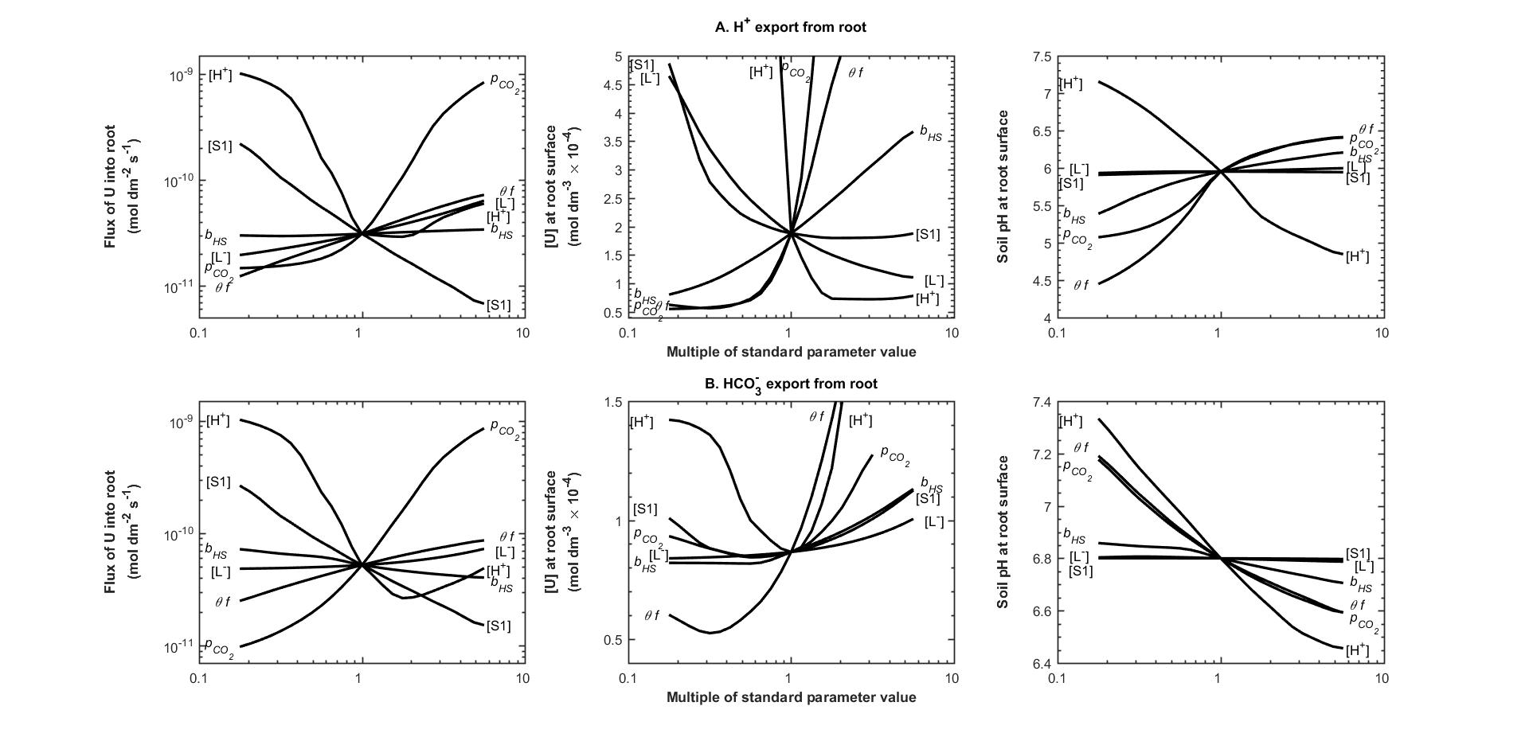

**Figure 2.** Sensitivity of the model to soil input parameters. **A**. H+ export from the root, as for a plant absorbing its N as NH4+; **B**. HCO3- export, as for a plant absorbing its N as NO3- (*F*HS = ± 3 × 10-10 mol dm-2 s-1). Each of the indicated parameters is varied in turn with the other variables at their standard values. [S1] = concentration of fast-reacting U sorption sites in the soil solid; = CO2 pressure in the soil air; [H+] = initial H+ concentration in the soil solution; *b*HS = soil pH buffer power; [L] = organic ligand concentration in the soil solution; *θf* = soil moisture content × impedance factor.

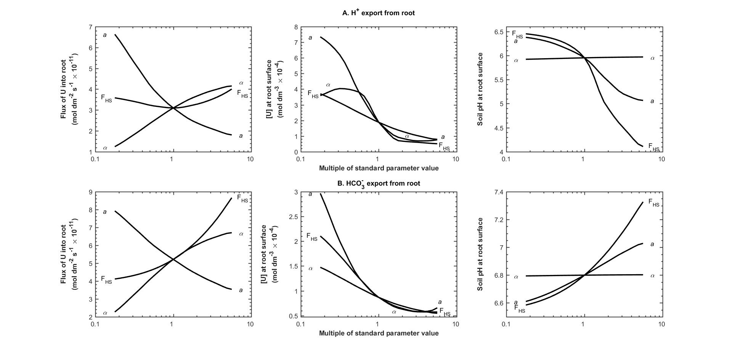

**Figure 3.** Sensitivity of the model to root input parameters. **A**. H+ export from the root; **B**. HCO3- export (*F*HS = ± 3 × 10-10 mol dm-2 s-1). Each of the indicated parameters is varied in turn with the other variables at their standard values. *F*HS = flux of H+ of HCO3- from the root; *a* = root radius; *α* = root absorbing coefficient.

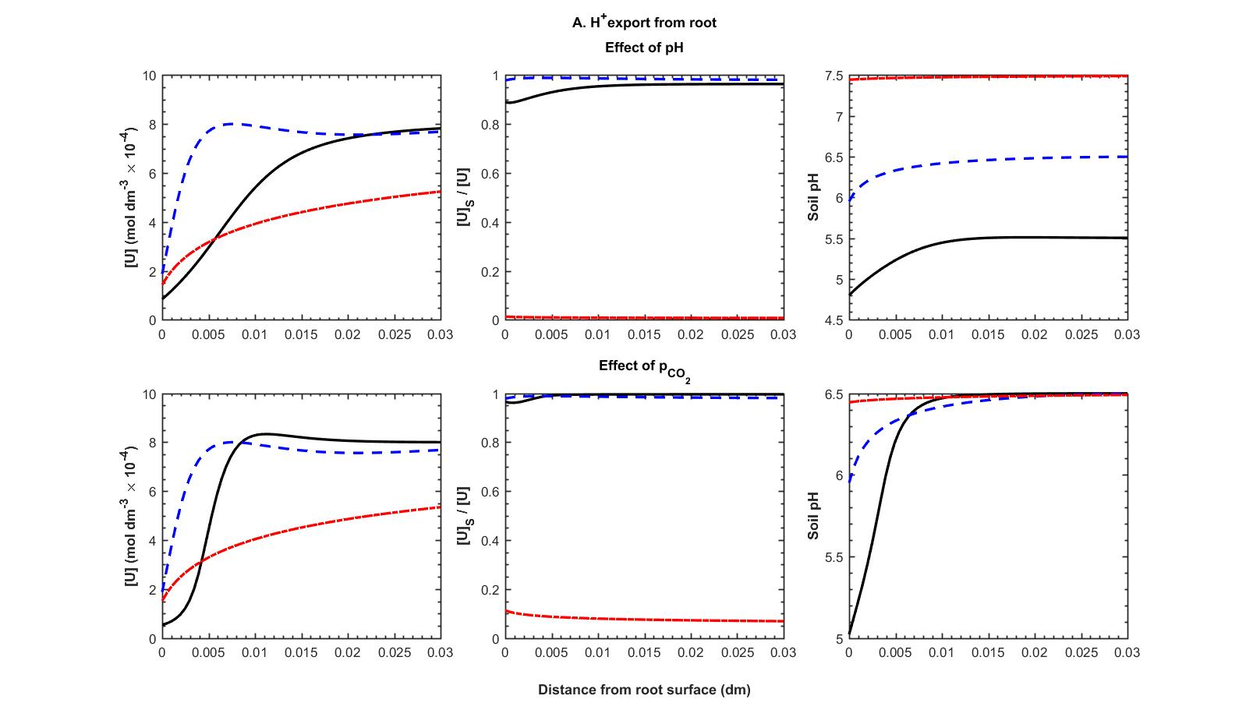

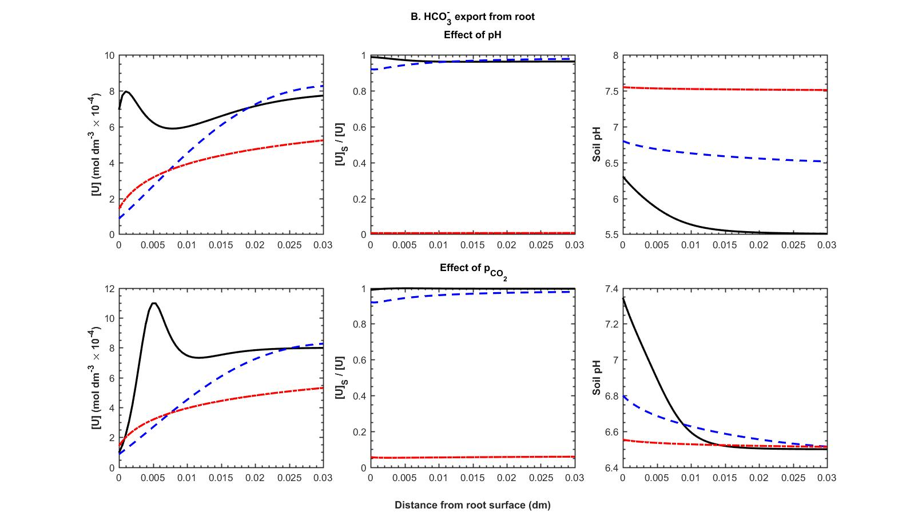

**Figure 4.** Concentration-distance profiles around a root as affected by initial soil pH and (**---** standard value, **—** standard value × 0.1, **---** standard value × 10). **A**. H+ export from the root; **B**. HCO3- export (*F*HS = ± 3 × 10-10 mol dm-2 s-1). Other parameters values as standard.

**For Table of Contents Only**

