A Finite Element Based Contact Resistance Model for Rough Surfaces: Applied to a Bi-layered Au/MWCNT Composite
Hong Liu and John W. McBride, Senior Member, IEEE
Abstract—A gold-coated multi-walled carbon nanotube composite (Au/MWCNT) is used as an electric contact material for low current (<100mA) switching. It is shown that the surface of the composite presents a much higher roughness when compared to pure gold-coated surface.
In previous studies, data from nano-indentation tests have been used to construct a finite element (FE) contact model where the Au/MWCNT composite is modeled as a bi-layered structure. In this study, the FE model is adapted to the modified nano-indenation tests with a 1 mm radius gold-coated stainless steel ball, and to enable to predict the contact resistance. Measured rough surface data are used in the modeling. From the simulated contact area, the contact resistance is calculated using established theory. The influence of contact position on the contact resistance is investigated, and an average predicted contact resistance values are shown to be good approximation to measured data.

Index Terms—Bi-layered structure, electrical contact resistance models, finite element modeling (FEM), gold-coated carbon nanotube composite (Au/CNT), roughness

INTRODUCTION
C
arbon nanotubes have excellent mechanical, electrical and thermal properties and exhibit different structures and shapes. They have been used in a range of applications [1], including MEMS capacitors [2], interconnectors [3], electromechanical probing [4] and MEMS switches [5]. A gold-coated multi-walled carbon nanotube composite (Au/MWCNT) combines the high elasticity of the vertically aligned MWCNT structure [6] and the good electrical conductivity of gold. It has been used as an electric contact material, for low current switching applications [7, 8]. Previous studies have shown that the composite provides a low and stable contact resistance, and as well as prolongs the lifetime of electrical contacts [9, 10].
The MWCNTs (abbreviated to CNTs) used in this study are vertically aligned, and grown using a thermal chemical vapor deposition (CVD) method. The resultant heights of CNTs are non-uniform. The composite surface, with a gold coating, exhibits a high roughness, around R_{a}~150 nm, which is much higher than the pure gold coated on Si wafer, R_{a}=30 nm [11]. For micro-switches, the contact force is usually low, i.e. a few tens of μN- 10 mN [4], and with only the highest asperities making actual contact, surface roughness is important to the resulting contact resistance.
It has been shown that as a result of the vertical gaps between CNTs, the sputtered gold does not form a uniform film on the top surface, but penetrates into the CNTs, forming a hybrid, mixture of Au and CNTs [11]. To determine the mechanical parameters of the composite, nano-indentation has been used. To avoid the indenter piercing into the CNTs, a 200-μm radius diamond ball was used as the indenter tip [12]. A finite element (FE) model was then developed based on the measured parameters to link to the nano-indentation tests. It was shown that the composite is best modeled as a bi-layered structure, where the top layer is a gold and MWCNT hybrid, and bottom layer, pure CNT [13].
To more realistically model the surface interactions, a rough surface was introduced in the FE modeling [14]. It was shown that the higher roughness of the Au/MWCNT surface results in a smaller contact area and reduced contact stiffness. Thus for a rough contact model to simulate the experimental results, material properties should be adjusted.
The nano-indentation system was further modified in [15] to investigate the electrical properties of the composite, where a 1 mm radius Au-coated, stainless steel (SS) hemispherical ball was used as an indenter. The results were used to determine the effective resistivity of the surface. The effective electrical resistivity was shown to be a function of the composite structure. To extend the FE model to enable the prediction of contact resistance it was necessary in [16] to use the model with 1 mm radius Au-coated, SS hemispherical ball with a rough surface. In [16] the influence of contact position and grid spacing on contact mechanics was investigated, and the smallest grid spacing used 6 µm. It was shown that the contact area continued to change with the grid spacing and that a finer spacing (< 6 µm) is required to improve the accuracy of the model. This paper investigates the application of the smaller grid spacing, down to 2 µm, and links the results to the measured contact resistances [15].
In [16] the material properties used were as defined in [13] for a smooth surface. This paper follows the arguments in [14] where the material properties were re-evaluated to account for the influence of the roughness on the contact behavior. Furthermore, the electrical resistivity under different contact force is also discussed.

Experimental Setup and Surface Characterization

Experimental Setup
A NanoTest Vantage system by Micro Materials® was used for contact resistance measurement presented in [15]. A 2 mm diameter Au coated stainless steel (SS) hemispherical probe was used as an indenter, as shown in ‎Fig. 1. The SS probe is sputtered with a 10 nm thick Cr layer, followed by a 500 nm thick Au film. Vertically aligned MWCNTs are growing using thermal chemical vapor deposition (CVD) method on a silicon wafer as reported in [12], and then gold is sputtered onto the top of the CNTs. A composite of 500 nm thick gold coated on 50 µm high MWCNT forest is investigated in the paper.
A 4-wire measurement arrangement was integrated in the indentation system, and a National Instrument Acquisition (DAQ) card was used to apply the current source and to measure the voltage drop of the contact, thus the contact resistance can be evaluated. A current source of 100 mA was applied, and the load voltage is 4V, using a battery. The sample was indented with ten gradually increasing loads from 0.2 mN to 2 mN, and each indent was at a new surface location, separated by 500 µm distance. Using this system, the contact force and the resistance can be measured simultaneously [15]. The experimental data are averages of results at 10 different locations on the surface.

Surface Characterization
The surface data used in the FE modeling was from a TaiCaan XYRIS 4000WL 3D surface profiler, which produces similar surface topography as a Park AFM, and also allows for a large area to be characterized and measured [11]. Fig. 2 shows a 3-D scan over an area of 1 mm × 1 mm, with data points of 501 ×501, thus the spacing in X/Y direction is 2 µm. The surface shows a feature of multi-scale roughness: one is the large wavelength, as shown with the green line in Fig. 2, implying the non-uniform heights of the MWCNT forest, and referred to as waviness in this paper; the other is the small asperities on top of the waviness, due to the gold clusters on the top of the individual CNTs. The surface roughness, over the scan area of 1 mm × 1 mm, is R_{a} ~0.15 µm with Gauss filter cutoff (waviness filter) of 0.08 mm. It is also shown in Fig. 2 that the size of the individual asperities on the surface is around 2-5 µm.
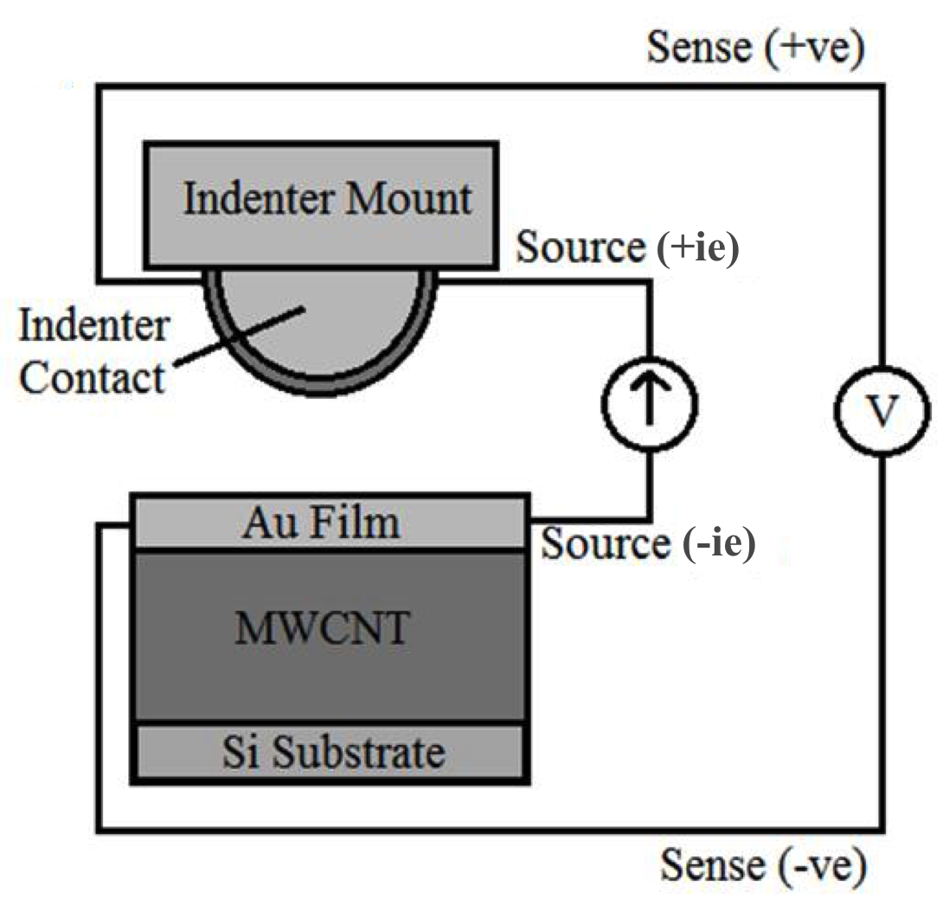
Fig. 1. Schematic of a modified nano-indentation system. The 4-wire measurement arrangement is integrated in the system [15].
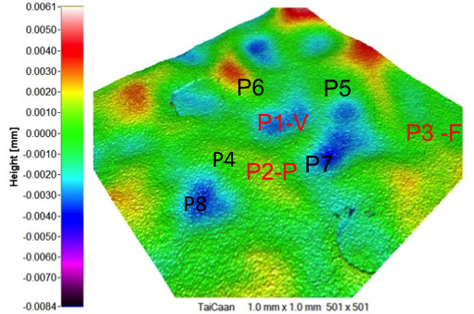
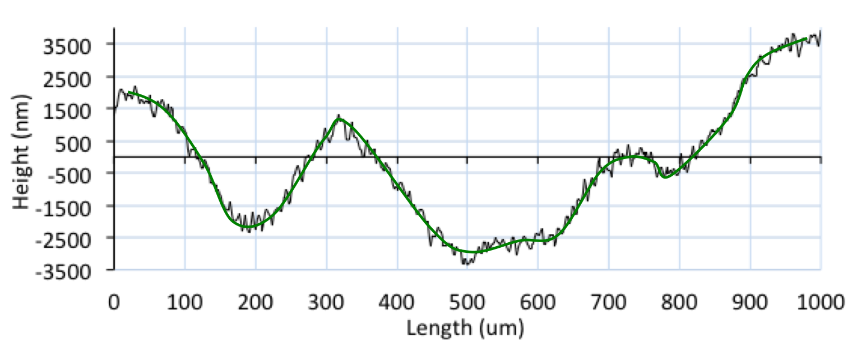
Fig. 2. TaiCaan scan profile of a 500 nm Au/ 50 µm CNT: 3-D view and cross-section view. The scan is over area of 1 mm × 1mm, with data points of 501 × 501. The green line in (b) indicates the wavelength curves with Gauss cut-off of 0.08mm.

Finite Element Modeling

Finite Element Contact Model
A finite element (FE) contact model is developed using ANSYS14.5, linked to the modified nano-indentation test (see Fig. 1). The FE contact model consists of a 2 mm diameter ball and a Au/MWCNT substrate of length and width of 1 mm. To simplify the modeling, the gold-coated stainless steel ball is modeled as a solid gold ball, and the adhesive Cr layer is not included in the modeling. For a Au-Au/MWCNT contact pair, simulation results showed little difference between a SS ball and a gold ball, as the Au/MWCNT surface is comparatively soft (see Table I).
The meshing elements are the same as in previous studies [16]. The top surface of the Au/MWCNT composite is modeled as a contact surface, and is meshed with the 3D surface-to-surface contact element CONTA174. The spherical surface of the probe ball is modeled as a target surface, and meshed with the target element TARGE170. The volumes of the substrate and the ball are modeled using 3D tetrahedral solid element SOLID187. The meshing is much refined in the local rough surface area to predict the contact accurately. A uniform pressure is applied vertically on the top surface of the hemisphere, and the force is increased gradually to 2 mN, with an increment of 0.2 mN.

Bi-layered Structure and Material Properties
It was shown in a previous study [13] that the Au/MWCNT is best modeled as a bi-layered structure. Considering the gold penetration into MWCNT, the top layer is modeled as a gold and MWCNT mixed material (AuCNT top layer), and the bottom layer is modeled as pure CNT, as shown in Fig. 3. For a composite of 500 nm Au / 50 µm CNT, the thickness of top layer, according to SEM images, is assumed to be 6 µm ±1.5 µm, and thus the thickness of CNT layer is 44 -/+ 1.5 µm [13].
The material properties of the bi-layered structure are based on the nano-indentation tests [12], and are listed in Table I for a smooth contact model. The silicon substrate and the bottom layer of the composite are modeled as an elastic material. Gold and the top layer of the composite are modeled as an elasto-plastic material, and the yield strength is defined as H/2.8, where H is the hardness of materials.
It is noted that the experiments are carried out on rough surfaces. The influence of roughness on the nano-indentation tests has been discussed in [14]. It was shown with rough contact model that a different contacting position causes a differing contact deformation and contact area. This observation was supported by the range of displacement/force curves obtained by nano-indentation tests in [13]. For a relatively flat contact position, which can be considered as an average of peak and valley positions [14], the simulations showed that the elastic modulus of both layers multiplied by 1.4 give better match to the experimental results than the default values from smooth model [13]. The adjusted material properties are also listed in Table I.
TABLE I
Material Properties in FEM
Material |  | Elastic modulus (GPa) | Hardness (GPa) | Possion’s ratio
Au |  | 80 | 1.008 | 0.42
Si |  | 162.5 | - | 0.223
Au/CNT | Top Layer | 1.242 | 4.05e-3 | 0.21 [13]
 | Bottom Layer | 50.82e-3 | - | 0 [17, 18]
Au/CNT  _Adjusted | Top Layer | 1.755 | 4.05e-3 | 0.21
 | Bottom Layer | 71.15e-3 | - | 0

Consideration for Roughness in the FE Model

Large data size
Real surface data are used in the modeling, as they provide the most relevant description to the surface in study. However, large data cause computational difficulty for a rough contact model, which is a non-linear problem. Previous simulations show that the contact is localized in a small area, thus the roughness can be modeled locally to reduce the computing time, as discussed in [19]. The concept of the model is shown in Fig. 3. Simulations have shown that the area of rough surface of 300 μm × 300 μm is sufficient to predict same results as an entire rough surface [16]. In the modeling, the TaiCaan WL data are imported into ANSYS as key points, and they are joined together using Coons patches code to generate a surface.
Furthermore, the distributed computing mode of Ansys is used to improve the computing efficiency. To save the simulation time further, a factor is applied to the scan spacing. By multiplying the scan spacing by factors, i.e. 2, 3, 5, and 10, the grid spacing in the FE modeling becomes 4 μm, 6 μm, 10 μm, and 20 μm (see Fig. 4 for some examples).
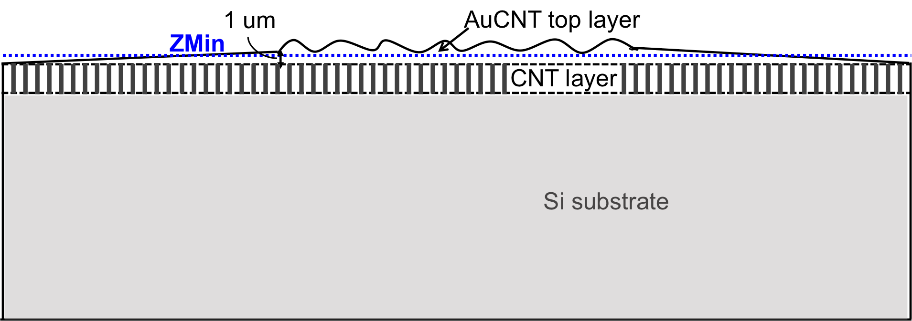
Fig. 3. Schematic of localized surface roughness modeling, the size is not to scale.
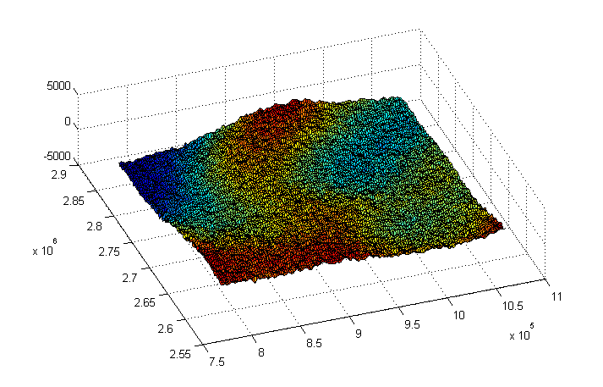
(a)
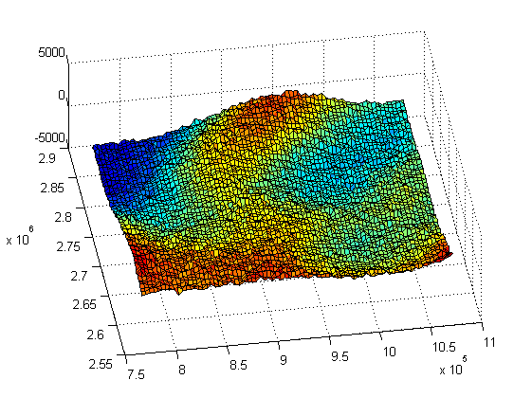
(b)
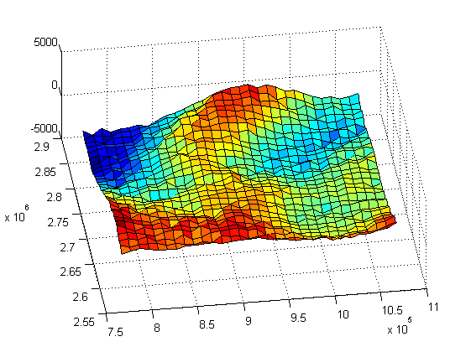
(c)
Fig. 4. Data set in the FEM for a relatively flat position. The grid spacing for (a) to (c) is 2 μm, 4 μm, and 10 μm.
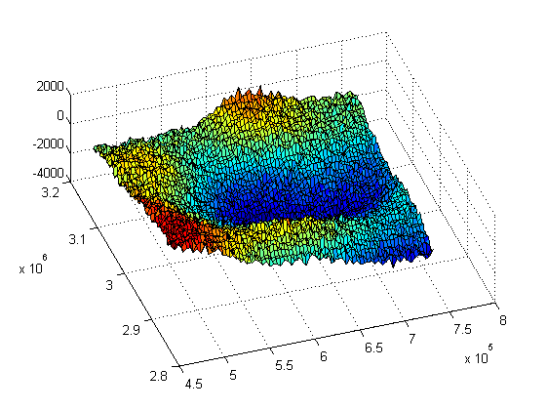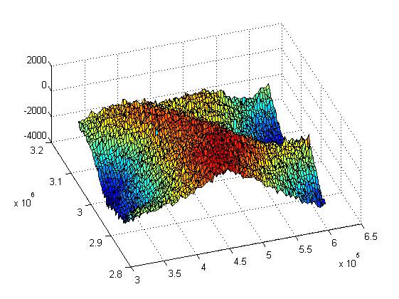
(a) (b)
Fig. 5. Data set in the FE Model, for (a) P1, valley position; and (b) P2, peak position. The grid spacing is 4 μm.

Interfacial surface
One concern for a bi-layered structure with a rough surface is the geometry of the interfacial surface. The influence of interfacial surface geometry on contact mechanics has been discussed in [13]. This is not considered in this study where we assume a flat interface in the bi-layered structure.
It should be noted that, for a rough surface with flat interface in the modeling, the thickness of top layer is not uniform (see Fig. 3). For the surfaces in the modeling (area of 300 μm × 300 μm), it is found that the peak-to-valley value is around 5 µm, thus an extra 1 µm is added beneath the lowest keypoint (ZMin as in Fig. 3). It should be kept in mind that the peak-to-valley values are varied from surface to surface, and are varied from 4.9 µm to 5.76 µm for the surfaces investigated in the paper, whereas the extra thickness is set uniformly as 1 µm. Thus, the thickness of top layer at different contacting position is different, and will have influence on the contact behavior of Au/CNT composite.

Contacting position
It has been shown in [20, 21] that the selection of peak/valley positions can influence the contact stiffness and the resulting deformation. In [16], data from different locations on the surface were chosen, defined as, a valley (P1-V) position, a peak (P2-P) and a relatively flat position (P3-F). These are shown in Fig. 2, and further details provided in Figs. 4 and 5. In this study, additional positions P4-P8 are chosen to provide a wider range of results on the surface behavior, shown in Fig. 2, in which P4-P6 are peak positions, and P7-P8 are valley positions.
In this paper, the influence of grid spacing is firstly investigated, and the simulation is performed at a relatively flat position (P3-F) as previous study [16] suggested, and the material properties are from the smooth contact model, to compare to the results in [16]. A comparison between the adjusted material properties and the default values is followed. The simulations at different contacting position are using the adjusted materials properties, and the simulation results are used to calculate the contact area and the contact resistances.

Experimental Results and Electrical Resistance Calculation

Experimental Results
The experimental results of contact force (F) vs. contact resistance (R_{C}) were reported in [15]. The curves of contact resistance and contact force are assumed to follow the Holm model in the plastic deformation regime, as in
(1)
where ρ is the electrical resistivity of the contact materials, H is the material hardness, F is the contact force. η is a coefficient used to describe the effect of contamination or insulating films, thus ρη^{0.5} can be used as the effective electrical resistivity (ρ_{eff}) of the composite with the contamination included. The effective resistivity can be determined using the Holm model (1). In [15], it was assumed that the slope of the line in Fig 6(a) was constant, and this is shown to be the case for the force below 1.2 mN. It is here shown that when the force increases above 1.2 mN the curve flattens suggesting that the conductive behavior is changed at greater force. This means that as the Au/CNT is compressed with a force greater than 1.2mN, the resistivity of the surface must change if we assume the Holm equation to hold. This is possible as the CNT fibers can collapse or buckle under the increased load, leading to a disruption in the undersurface of the bi-layer. In the study, the electrical resistivity is calculated from the experimental results using (1), and plotted in Fig. 6(b). An average value, 1.879×10⁴ nΩ×m is taken as the effective electrical resistivity for the force less than or equal to 1.2 mN, whereas corresponding resistivity value at each contact force is taken for higher force.

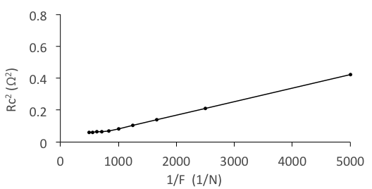
(a)
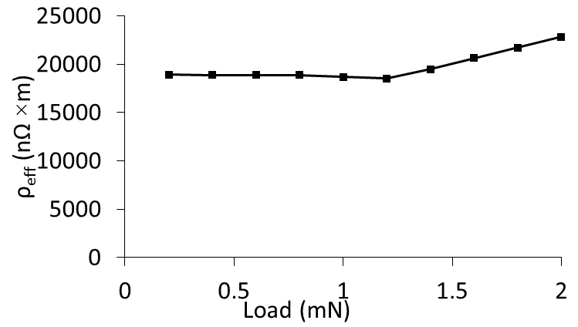
(b)
Fig. 6. Experimental results of (a), square of contact resistance vs. inverse of contact force. Re-plotted from [15]. (b), effective electrical resistivity as a function of contact force.

Contact Resistance Calculation from the FE Model
For a single contacting spot, the contact resistance is calculated with the Holm function, as in
(2)
where, a is the contact radius. In this paper, the electrical resistivity from the measured F-Rc curves is used, as discussed in the previous section. The ballistic transport regime is not included in the study, as the contact radius is found much larger than the electron mean free path of gold (38 nm).
When multiple spots are in contact, the electrical contact resistance depends on the radii of the spots and their distribution. For a large number of small spots distributed uniformly over a circular area, Holm gives a simple equation for the total contact resistance [22] as in:
(3)
where N is the number of contact spots, ā is the average radius of the contacting spots, and r is the radius of circular area. This model assumes the current constriction of the larger area is in series with a number of small constrictions of the individual points of contact. Equation (3) is used to calculate the contact resistance of multiple spots.

Simulated Results and Discussions

Influence of Grid Spacing
Data from a relatively flat position are chosen for simulations in this section, and the grid spacing are varied from 2 μm to 20 μm. A loading-unloading process is applied for all the modeling, except for the simulation with 2 μm, where the simulation is only performed for contact force of 1 mN and 2 mN.
The simulated force-displacement results are plotted in Fig. 7 (a). It is shown that for the rough surface, as the grid spacing becomes finer, the displacement decreases at given force, though the difference between different spacing is not very significant. Compared to the smooth contact model, all the rough surfaces produce a larger deformation. It is also shown that the residual deformation after unloading is small, suggesting the elastic deformation is dominant.
The total contact area vs. contact force is plotted in Fig. 7 (b). It is found that the impact of grid spacing on contact area is more significant than on the deformation, and finer grid spacing produces a smaller contact area. It is shown that the contact area with 4 μm is close to the one with 2 μm, suggesting the influence of grid spacing on the contact area is going to converge for the grid spacing less than 4 μm.
In the following simulations, the grid spacing is set as 4 μm to save computing time.
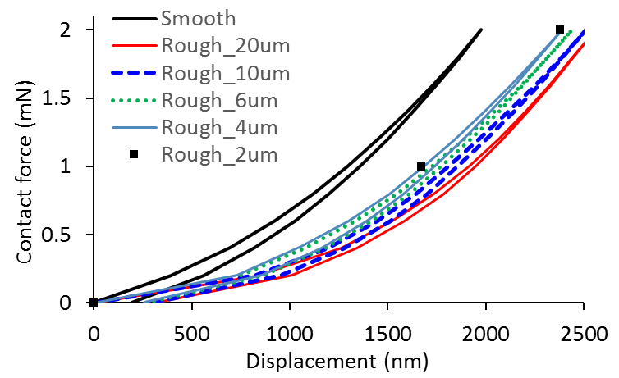
(a)
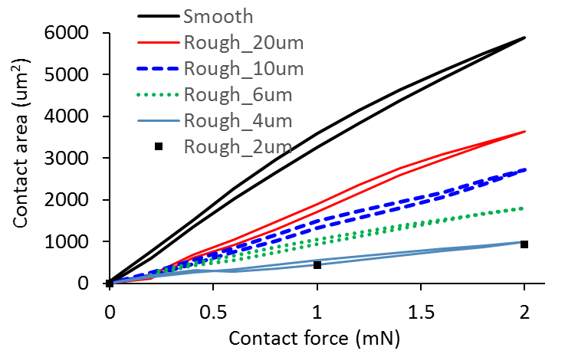
(b)
Fig. 7. Impact of grid spacing on simulated force-displacement results (a), and force-contact area (b), compared to the smooth contact results in [23].

Impact of Roughness on Material Properties
To address the impact of roughness on material properties, adjusted material properties for rough surfaces are used, as shown in Table I. The results are compared to the default material properties, and listed in Table II for two force conditions, 1 mN and 2 mN. As expected, with higher elastic modulus, the adjusted material properties produce less deformation and smaller contact area. As addressed in III.B, since the surface is rough, the adjusted material is used for the further modeling in this paper.

Influence of Contact Position
The simulated displacement results of the eight contact positions identified in Fig. 2, at contact force of 2 mN are plotted in Fig. 8(a). The valley positions (P1, 7, 8, blue round points) conform to the spherical surface, and result in a higher contact stiffness and therefore smaller deformation, as discussed in [21]. The peak positions (P2, 4-6, red triangle points) result in a smaller contact stiffness and a larger deformation. P3 is the flat position, and shows a similar characteristic to the peak positions.
Fig. 8 (b) shows contact area of the eight contacting positions. Normally, a valley position will result in a larger contact area, as it conforms to the spherical surface. This is true for the P1, but not for P7 and P8. Analyzing the contact zone, it is found that the indenter is only placed at the lowest point of the contacting surface at P1, and deviates the lowest point for the cases of P7 and P8. The remaining points P2-6 all show similar contact area.
It should be kept in mind that, due to the high roughness, the thickness of top layer is not uniform for different contact positions. The resultant simulation results are the combined effects of the contacting position and the thickness of the top layer.
In the following simulations, positions P1, P2 and P3 are chosen as the representative of valley, peak and flat positions, as the contacting position is just at the lowest, highest and relatively flat position of the contacting surface.
The simulation results for these three contact positions under a loading process are plotted in Fig. 9. Since the thickness of top layer at the peak position is higher than the flat, and the Young’s modulus and hardness of top layer is much larger than the under layer, the deformation at a peak position is smaller than that at a relatively flat position. As expected, the valley position results in a higher contact stiffness, thus a smaller deformation. Correspondingly, the results of contact area are in the order of: flat < peak < valley.
The contours of the elements in contact at contact force of 2 mN for three different positions are plotted in Fig. 10. The contacting spots are scattered in the smallest area at the peak position (Fig. 10 (b)), and in the largest area for the valley position. An animation of the evolution of the contact pressure is shown in the supported material, named ‘Evolution of Contact pressure_P3_Flat.avi’.
TABLE II
Simulated Results with Different Material Properties in FEM
Mat. properties | 1 mN |  | 2 mN
 | Dis (nm) | A_{c} (μm²) | Dis (nm) | A_{c} (μm²)
Default values | 1686 | 451 | 2387 | 985
Adjusted values | 1446 | 386 | 2031 | 855

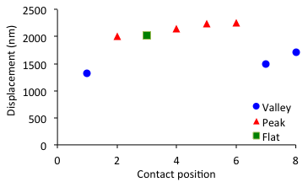
(a)
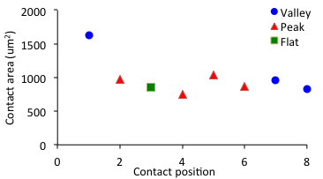
(b)
Fig. 8 Influence of contact positions on the contact area and contact deformation. The simulation is with contact force of 2 mN.
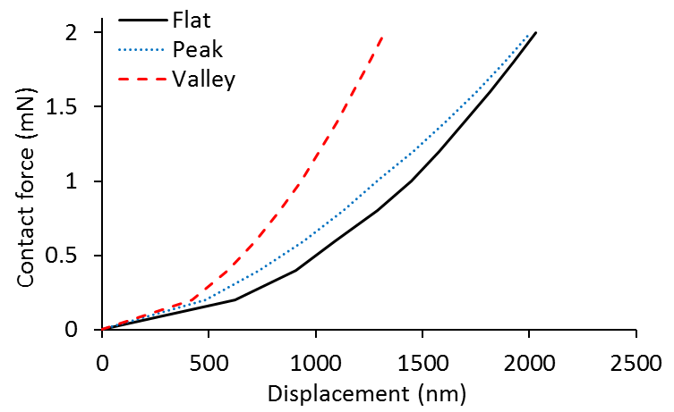
(a)
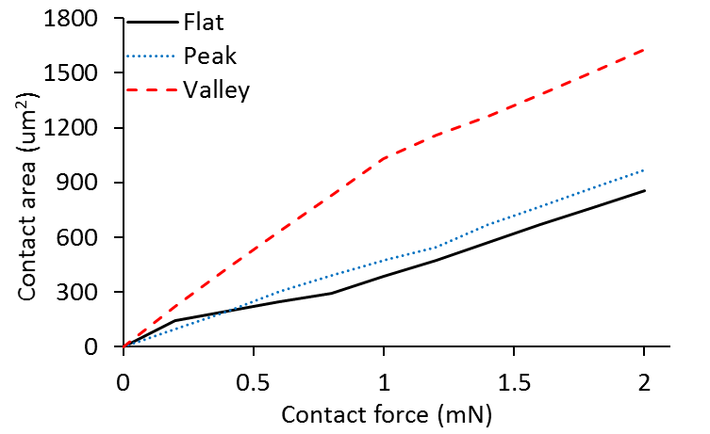
(b)
Fig. 9. Impact of contacting positions on the force-displacement results (a), and force-contact area (b). The simulations are with grid spacing of 4 μm.
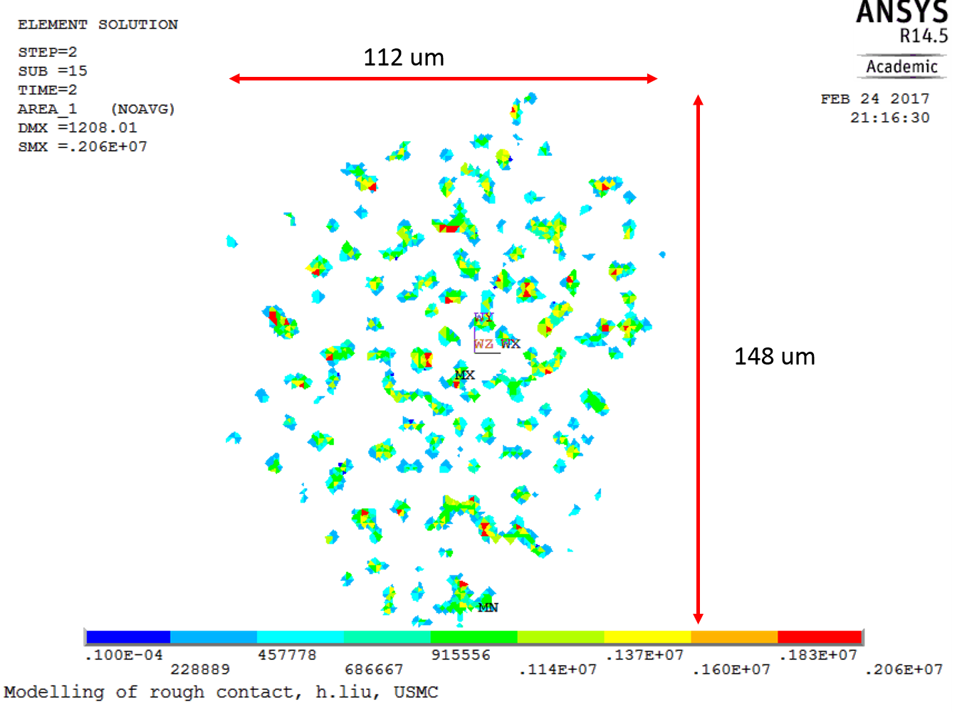
(a)
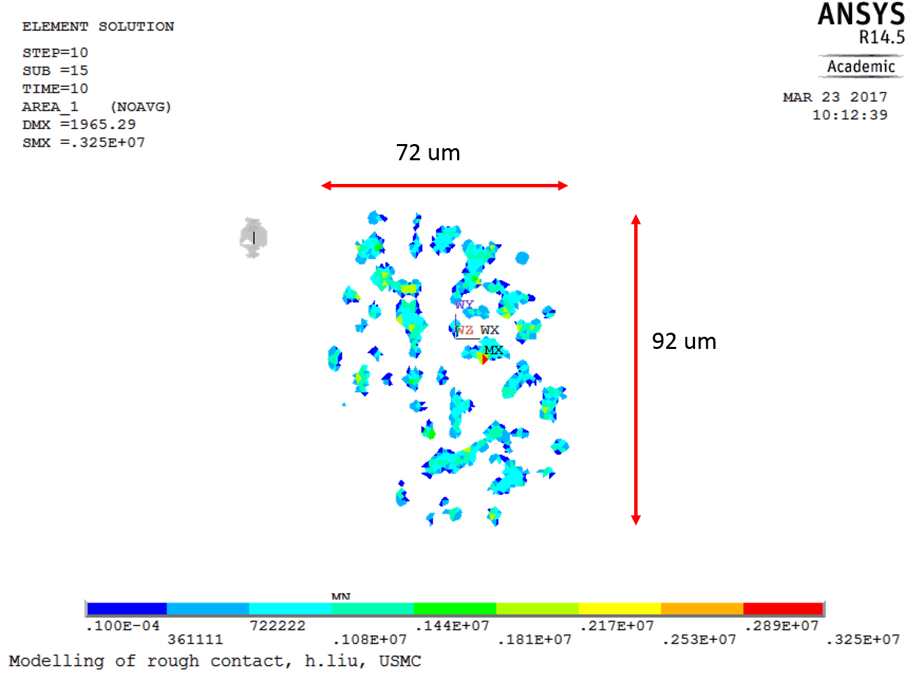
(b)
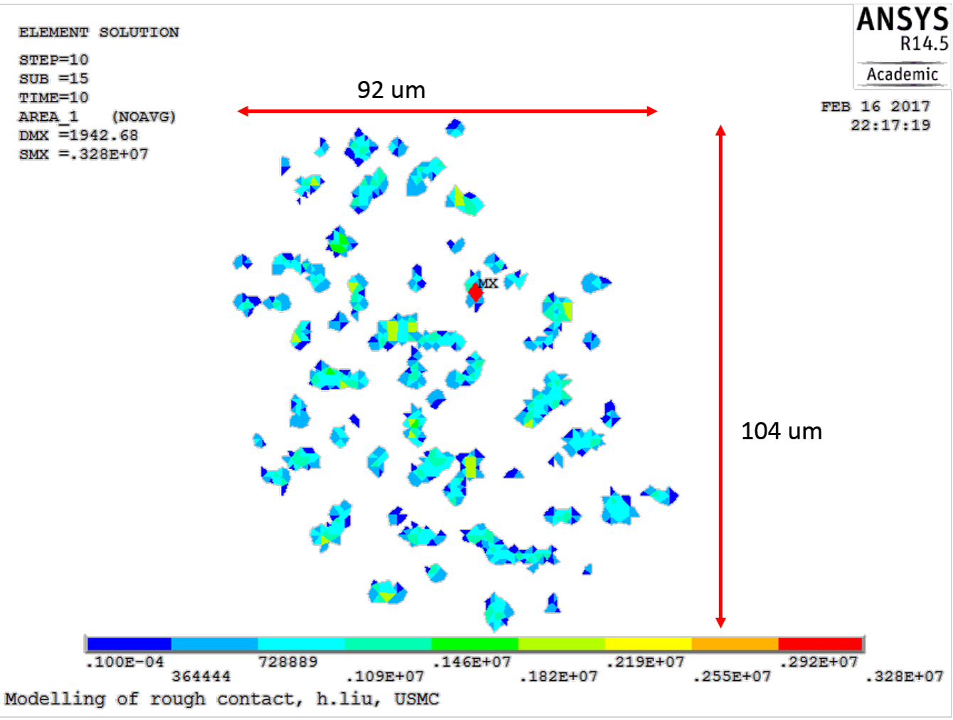
(c)
Fig. 10. Contour of the elements in contact under contact force of 2 mN, the contact position from (a) to (c) is valley, peak and flat. The simulations are with grid spacing of 4 μm.

Contact Resistance
The contact resistances are calculated using (3) based on the simulation results for three positions shown in Fig. 10, and the results are plotted in Fig. 11.
All the Fc-Rc curves show the same trend that the contact resistance decreases with the force increases, whereas the slope of curve is different at different contacting positions. In general, a valley position produces the smallest contact resistances, whereas a peak position produces the largest contact resistances. Averaged contact resistances are calculated from three positions, and plotted in Fig. 11. The averaged contact resistances are 13.8%-24.4% higher than the experimental results, but show a very similar trend, with the experimental average data lying between the valley position and the peak position. The results are matching better than those in [16], where the simulated results were mostly 30%-40% higher than the experimental results.
It is noted that the experiments are with the current of 100 mA, and it will influence the material properties, which is not included in the modeling.
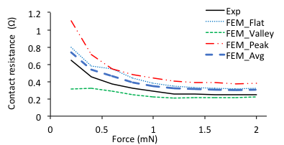
Fig. 11. Contact resistances as a function of contact forces, experimental results compared to the calculated results at different contact position in FEM. The simulations are with grid spacing of 4 μm.

Conclusion
A finite element rough contact model is developed for Au-Au/CNT contact pair, linked to the modified nano-indentation tests. The material properties for Au/CNT composite are re-evaluated for a rough contact surface, and the grid spacing is finer in the modeling than in previous studies. These two modifications in the modeling improve the ability to predict the contact area. Furthermore, the electrical resistivity is reviewed for different contact force.
The influence of contacting positions on contact resistance is investigated, with a valley position produces smallest contact resistance, and a peak position highest values. The averaged contact resistance values from the modeling are matching well with the experimental results.

Acknowledgment
Hong Liu would like to thank Mr. Yang Xu from Auburn University for the useful discussions on this work.

References
- M. F. L. D. Volder, S. H. Tawfick, R. H. Baughman, and A. J. Hart, ‘Carbon Nanotubes: Present and Future Commercial Applications’, Science, vol. 339, no. 6119, pp. 535–539, Feb. 2013.
- A. Arun et al., ‘Tunable MEMS capacitors using vertical carbon nanotube arrays grown on metal lines’, Nanotechnology, vol. 22, no. 2, p. 025203, Jan. 2011.
- J. Dijon, A. Fournier, P. D. Szkutnik, H. Okuno, C. Jayet, and M. Fayolle, ‘Carbon nanotubes for interconnects in future integrated circuits: The challenge of the density’, Diam. Relat. Mater., vol. 19, no. 5–6, pp. 382–388, May 2010.
- O. Yaglioglu, R. Martens, A. J. Hart, and A. H. Slocum, ‘Conductive Carbon Nanotube Composite Microprobes’, Adv. Mater., vol. 20, no. 2, pp. 357–362, Jan. 2008.
- B. F. Toler, R. A. Coutu, and J. W. McBride, ‘A review of micro-contact physics for microelectromechanical systems (MEMS) metal contact switches’, J. Micromechanics Microengineering, vol. 23, no. 10, p. 103001, Oct. 2013.
- A. Cao, P. L. Dickrell, W. G. Sawyer, M. N. Ghasemi-Nejhad, and P. M. Ajayan, ‘Super-Compressible Foamlike Carbon Nanotube Films’, Science, vol. 310, no. 5752, pp. 1307–1310, Nov. 2005.
- E. M. Yunus, S. M. Spearing, and J. W. McBride, ‘The Relationship Between Contact Resistance and Contact Force on Au-Coated Carbon Nanotube Surfaces Under Low Force Conditions’, IEEE Trans. Compon. Packag. Technol., vol. 32, no. 3, pp. 650–657, Sep. 2009.
- C. Chianrabutra, L. Jiang, A. P. Lewis, and J. W. McBride, ‘Evaluating the Influence of Current on the Wear Processes of Au/Cr-Au/MWCNT Switching Surfaces’, in Proceeding of 59th IEEE Holm Conference on Electrical Contacts (HOLM), Newport, RI, USA, 2013, pp. 1–6.
- M. P. Down, L. Jiang, and J. W. McBride, ‘Investigating the benefits of a compliant gold coated multi-walled carbon nanotube contact surface in micro-electro mechanical systems switching’, Appl. Phys. Lett., vol. 107, no. 7, p. 071901, Aug. 2015.
- A. P. Lewis, J. W. McBride, and L. Jiang, ‘Evolution of Voltage Transients During the Switching of a MEMS Relay With Au/MWCNT Contacts’, IEEE Trans. Compon. Packag. Manuf. Technol., vol. 5, no. 12, pp. 1747–1754, Dec. 2015.
- H. Liu, J. W. McBride, and M. Z. M. Yusop, ‘Surface characterization of a Au/CNT composite for a MEMS switching application’, in IEEE Nano 2016, Sendai, Japan, 2016, p. 1–4.
- M. P. Down, R. Cook, L. Jiang, and J. W. McBride, ‘Mechanical Characterisation and Optimisation of Carbon Nanotube Composite Surfaces for Electrical Contact’, in Proceeding of 27th International Conference on Electrical Contacts (ICEC2014), Dresden, Germany, 2014, pp. 1–6.
- H. Liu, J. W. McBride, M. P. Down, and S. H. Pu, ‘Finite Element Model of a Bilayered Gold-Coated Carbon Nanotube Composite Surface’, IEEE Trans. Compon. Packag. Manuf. Technol., vol. 5, no. 6, pp. 779–787, Jun. 2015.
- H. Liu and J. W. McBride, ‘Finite-Element Contact Modeling of Rough Surfaces Applied to Au-Coated Carbon Nanotube Composites’, IEEE Trans. Compon. Packag. Manuf. Technol., vol. 7, no. 3, pp. 329–337, Mar. 2017.
- M. P. Down, A. P. Lewis, L. Jiang, and J. W. McBride, ‘A nano-indentation study of the contact resistance and resistivity of a bi-layered Au/multi-walled carbon nanotube composite’, Appl. Phys. Lett., vol. 106, no. 10, p. 101911, Mar. 2015.
- H. Liu and J. W. McBride, ‘A Finite Element Based Electrical Resistance Study for Rough Surfaces: Applied to a Bi-layered Au/MWCNT Composite for Micro Switching Applications’, in 62nd IEEE Holm Conference on Electrical Contacts, Florida, US, 2016, pp. 1–7.
- Y. Gao, T. Kodama, Y. Won, S. Dogbe, L. Pan, and K. E. Goodson, ‘Impact of nanotube density and alignment on the elastic modulus near the top and base surfaces of aligned multi-walled carbon nanotube films’, Carbon, vol. 50, no. 10, pp. 3789–3798, Aug. 2012.
- M. R. Maschmann, Q. Zhang, F. Du, L. Dai, and J. Baur, ‘Length dependent foam-like mechanical response of axially indented vertically oriented carbon nanotube arrays’, Carbon, vol. 49, no. 2, pp. 386–397, Feb. 2011.
- F. Pennec, D. Peyrou, D. Leray, P. Pons, R. Plana, and F. Courtade, ‘Impact of the Surface Roughness Description on the Electrical Contact Resistance of Ohmic Switches Under Low Actuation Forces’, IEEE Trans. Compon. Packag. Manuf. Technol., vol. 2, no. 1, pp. 85–94, 2012.
- Z. Chen and S. Diebels, ‘Modelling and parameter re-identification of nanoindentation of soft polymers taking into account effects of surface roughness’, Comput. Math. Appl., vol. 64, no. 9, pp. 2775–2786, Nov. 2012.
- P. Berke and T. J. Massart, ‘Coupled Friction and Roughness Surface Effects in Shallow Spherical Nanoindentation’, in Trends in Computational Contact Mechanics, G. Zavarise and P. Wriggers, Eds. Springer Berlin Heidelberg, 2011, pp. 269–289.
- J. A. Greenwood, ‘Constriction resistance and the real area of contact’, Brit J. Appl Phys., vol. 17, p. 1621, 1966.
- H. Liu and J. W. McBride, ‘A finite element study of contact resistance for a flat bilayered Au/MWCNT surface’, in 28th International Conference on Electrical Contacts (ICEC 2016), Edinburgh, UK, 2016, pp. 1–6.

Manuscript submitted for review on 01/05/2017. This work was supported by the Ministry of High Education, Malaysia, under Grant FRGS-12014-TK01-USMC-1. H. Liu is with the University of Southampton-Malaysia Campus, Johor Bahru 79200, Malaysia (e-mail: hong.liu@soton.ac.uk); J. W. McBride is with the University of Southampton-Malaysia Campus, Johor Bahru 79200, Malaysia, and also with the Faculty of Engineering and the Environment, University of Southampton, Southampton SO17 1BJ, U.K. (e-mail: j.w.mcbride@soton.ac.uk).

