Mass-transfer measurements at porous 3D Pt-Ir/Ti electrodes in a direct borohydride fuel cell

Abdulaziz A. Abahussain ^{a b}, Carlos Ponce de Leon ª *, Frank C. Walshª
ª Electrochemical Engineering Laboratory, Energy Technology Research Group, Faculty of Engineering & Physical Sciences, University of Southampton SO17 1BJ, UK.
^{b} College of Engineering, King Saud University.
*Author for correspondence; C. Ponce de León; capla@soton.ac.uk

Abstract

The volumetric mass-transport coefficients (k_{m}A_{e}) for borohydride ion oxidation at various titanium 3D electrode structures in a rectangular flow channel were calculated by chronoamperometry in a three-electrode electrochemical flow cell. The 3D electrodes used for the oxidation of borohydride in alkaline media included flat, mesh, micromesh, fine mesh and felt coated with a Pt-Ir alloy catalysts. Felt, fine mesh and micromesh electrodes showed high electrochemical activity with current enhancement factors (δ) of 100, 64, 22, respectively at a mean linear flow velocity of 6 cm s⁻¹ through the electrodes. In the presence of a turbulence promoter (TP), the currents from the flat and mesh electrodes improved twice compared with no TP. The 3D electrodes were tested in a complete cell with an anolyte consisting of 2.5 mol dm⁻³ NaBH₄ in 2 mol dm⁻³ and a catholyte of 0.75 mol dm⁻³ H₂O₂ in 2 mol dm⁻³ NaOH. The power density increased in the following order: plate < micromesh < mesh < felt < mesh + 1 TP < fine mesh. The maximum power density at the fine mesh was 44.5 mW cm⁻² at a cell potential of 0.44 V and a current density of 100 mA cm⁻² at 296 K.

Keywords: borohydride oxidation, felt, fuel cell, hydrogen peroxide, mass transfer, mesh, porous electrode, titanium.

Introduction
The advantages of the direct borohydride fuel cell (DBFC, NaBH₄/H₂O₂) include high theoretical cell potential (2.11 V) ¹ and specific energy density (ca. 12 kW h kg⁻¹) from a liquid fuel at 25 ºC. The possibility of achieving a high energy density of this system has led to academic and industrial interest for applications in portable electronic devices, transportation and underwater vehicles ^{1,} ^{2,} ³. The anodic oxidation of borohydride ions in an aqueous alkaline solution can occur directly at a wide range of anode catalysts to release a maximum of eight electrons^{4,} ⁵:

${\text{BH}}_{\text{4}}^{\text{-}}\text{ + 8}{\text{OH}}^{\text{-}}\text{ → }{\text{BO}}_{\text{2}}^{\text{-}}\text{ + 6}{\text{H}}_{\text{2}}\text{O + 8}{\text{e}}^{\text{-}} {\text{E}}_{\text{anode}}^{\text{o}}\text{= -1.24 vs. SHE}$ (1)

This reaction coupled with the cathodic reduction of H₂O₂ in alkaline media, Eq. (2), can provide a theoretical cell potential of 2.11 V, Eq. (3) ^{1,} ⁶:
${\text{4H}}_{\text{2}}{\text{O}}_{\text{2}}\text{ + 8}{\text{e}}^{\text{-}}\text{ → 8}{\text{OH}}^{\text{-}} {\text{E}}_{\text{cathode}}^{\text{o}}\text{= 0.87 V vs. SHE}$ (2)
${\text{BH}}_{\text{4}}^{ \text{-}} \text{+ }{\text{4H}}_{\text{2}}{\text{O}}_{\text{2}}\text{→ }{\text{BO}}_{\text{2}}^{\text{-}}\text{ + }{\text{6H}}_{\text{2}}\text{O } {\text{E}}_{\text{cell}}^{\text{o}}\text{= 2.11 V}$ (3)

Noble metals such as gold ^{7,} ^{8,} ⁹ enable the transfer of a higher number of electrons. However, many authors have demonstrated that the oxidation of borohydride ions on Au is much slower than on Pt ^{7,} ^{10,} ^{11,} ^{12,} ¹³. Gyenge et al. ⁷ have reported that the heterogeneous rate constant was about ten times larger on Pt (1.86 cm s⁻¹) than on Au (0.14 cm s⁻¹). Finkelstein et al. ¹¹ have also observed that Pt has faster reaction kinetics than Au. On the other hand, the values of the heterogeneous rate constants were lower than those obtained by the Gyenge group for both catalysts. Olu et al. ¹³ concluded that every active catalyst for the borohydride oxidation reaction generates H₂ by the hydrolysis (Eq. 4 ) during the borohydride oxidation process. The authors suggested that one way to achieve near zero H₂ evolution is to use a catalyst (e.g. Pt) that is active towards the hydrogen oxidation reaction (Eq. 5) and optimise the operating conditions (e.g. electrolyte concentrations), or modify the anode texture such as porous materials that allow high residence time to consume the hydrogen generated in the anode.
${\text{BH}}_{\text{4}}^{\text{-}}\text{ +}{\text{ H}}_{\text{2}}\text{O }↔{\text{ BH}}_{\text{3}}{\text{(OH)}}^{\text{-}}\text{ + }{\text{H}}_{\text{2}}$ (4)
${\text{H}}_{\text{2}}\text{ + 2}{\text{OH}}^{\text{-}}\text{ → 2}{\text{H}}_{\text{2}}\text{O + 2}{\text{e}}^{\text{-}} {\text{E}}_{\text{anode}}^{\text{o}}\text{= -0.828 vs. SHE}$ (5)

Using three-dimensional (3D) electrode materials, such as reticulated metals ^{14, 15, 16}, allows full utilisation of the active sites, minimising the amount of noble metal required resulting in lower electrode costs ¹⁷. Most of the reported studies on the DBFC have used microstructured supports, the catalysts usually being supported on carbon paper, or two-dimensional electrodes ⁴. A porous 3D electrode could have a substantial contribution to increasing the rate of electrolysis as it presents a high surface area and helps develop turbulent flow which enhances the mass transport conditions close to the electrode surface ¹⁸. One of the main advantages of using 3D electrodes is that increases the space-time yield ^{19,} ²⁰ resulting in higher efficiency of the fuel utilisation. Also, they are mechanically robust and provide a remarkable performance due to the quick release of byproduct gases such as H₂ and O₂ away from the electrode surface, preventing the active sites from attracting gas bubbles and becoming blocked ^{21,} ¹⁷.

Different materials that have been reported to develop for 3D electrodes in the DBFC, including reticulated structures such as nickel ¹⁷, copper ²², reticulated vitreous carbon (RVC) ⁴ and titanium ²³. The oxidation of borohydride ions on different pore sizes (ppi 10 to 100 ppi) RVC coated with gold nanoparticles using the sputtering method was reported ⁴. The authors used a three-electrode cell and observed that the increase in gold deposition time and the porosity of the RVC electrodes lead to a higher electrode performance. The value of the charge transfer coefficient was between 0.87 and 0.98; this variation was attributed to uneven current and potential distribution on the 3D electrodes, which suggests optimising the thickness of the RVC electrode and coating quality ⁴. Gold nanoparticles supported on the nanotubular titanate oxide electrodes were considered by Low et al. ²⁴ to examine the oxidation of borohydride ions. The gold-coated titanium oxide nanotube array offered approximately twice the electrical charge when compared to that observed on a commercial Au supported by a carbon felt electrode (E-TEK), in agreement with similar studies ⁹. The use of titanate oxide nanotubes can offer a large surface area with reliable and low-cost technique ²⁴. Cheng and Scott ²³ investigated the oxidation of borohydride ions on titanium mesh coated with gold and silver (2 mg cm⁻²) anodes by thermal deposition ²⁵. The MEA was fabricated with a Nafion 117 membrane separating the anode and Pt/C cathode and assembled between two graphite blocks with parallel flow channels to provide four cm⁻² active area. Ti mesh supported Au and Ag anodes, exhibited remarkable current and power densities up to 50% and 20% higher, respectively (81.4 and 51 mW cm⁻² for Au/Ti mesh and Ag/Ti mesh, respectively) at 85 ºC, than those obtained with the same anodes supported on carbon. Titanium materials are promising alternative catalyst supporters because of their many advantages which include acceptable conductivity (2.1 × 10⁶ S m⁻¹, Alfa Aesar data sheet) compared to carbon (0.07 × 10⁶ S m⁻¹ at 293 K), high mechanical and electrochemical stability, open structure and ease of manufacturing ⁶. However, Ti should be coated to avoid developing titanium oxides creating a non-conductive layer (insulating oxide layer).

Several limitations restrict rapid further development of DBFC technology. One of the major challenges is finding cost-effective electrocatalysts for borohydride oxidation that are able to minimise the hydrolysis of borohydride and increase the selectivity and reaction rate. Another challenge is to find electrode support structures and architectures which offer improved mass transfer rates and the ability to be scaled up. In this research, titanium materials were considered as substrates due to the above advantages and have been coated with Pt-Ir to investigate the oxidation of borohydride ions on 3D electrodes. This paper seeks to improve the DBFC performance by evaluating well-defined 3D anode structures, the limiting current technique being used to characterise their mass transfer properties. The limiting current technique ^{26,} ^{27,} ^{28,} ^{29,} ³⁰ represents the maximum possible rate of the electrochemical reactions towards the electrode surface, under complete mass transport control, at a given mean linear flow velocity ³¹.

Experimental details
Performance factor and theoretical considerations
In order to evaluate the performance of an electrochemical reactor, it is useful to determine the overall rate of mass transfer, which is usually characterised by calculating the mass transport coefficient, k_{m}, by evaluating the limiting current, I_{L} (A), under mass transport controlled conditions ³²:

$${\text{k}}_{\text{m}}\text{=}\frac{{\text{I}}_{\text{L}}}{\text{zFAc}}$$ |  | (6)

Where F is Faraday’s constant (96485 C mol⁻¹), c (mol cm⁻³) is the concentration of the electroactive species (BH₄⁻) in the bulk electrolyte and z is the number of electrons exchanged in the reaction. The number of electrons was assumed to be 8 based on the stoichiometric anode electrode reaction Eq. (1).

In the case of porous electrodes, the electrode performance factor, k_{m} A_{e} (s⁻¹) is used, where A_{e} is the active electrode area per unit electrode volume, V_{e}, i.e., ^{33,} ^{34,} ³⁵.

$${\text{A}}_{\text{e}}\text{= }\frac{\text{A}}{{\text{V}}_{\text{e}}}$$ |  | (7)

The combining of Eq. (6) and Eq. (7) leads to the figure of merit (k_{m} A_{e}), which can be named as the volumetric mass transport coefficient:

$${\text{k}}_{\text{m}}{\text{A}}_{\text{e}}\text{=}\frac{{\text{I}}_{\text{L}}}{\text{zFc}{\text{V}}_{\text{e}}}$$ |  | (8)

The most common design used in industrial electrochemical reactors is a flow-through parallel plate reactor which is approximate to a rectangular channel ³³. The geometry of the rectangular flow channel is usually characterised by the equivalent (hydraulic) diameter, d_{e}, the dimensionless length group, L_{e}, and the aspect channel ratio, γ, which is the channel height, S, to its width, B ³³:

$${\text{d}}_{\text{e}}\text{=}\frac{\text{2BS}}{\text{B+S}}$$ |  | (9)
$${\text{L}}_{\text{e}}\text{=}\frac{{\text{d}}_{\text{e}}}{\text{L}}$$ |  | (10)
$$\text{γ} \text{= }\frac{\text{S}}{\text{B}}$$ |  | (11)

The mean linear electrolyte flow velocity past the electrode surface, v (cm s⁻¹), can be calculated from:

$$\text{v} \text{=}\frac{{\text{Q}}_{\text{V}}}{{\text{εA}}_{\text{x}}}$$ |  | (12)

Where ε is the volumetric porosity of the porous electrode and A_{x} (BS) is the cross-sectional area (cm²) of the electrode. The mass transport in electrochemical cells can be explicitly expressed by the dimensionless groups, named the Sherwood (Sh), Reynolds (Re) and Schmidt (Sc) ^{18,} ³³ numbers, which can be described by a dimensionless group correlation ^{18,} ³³:

$$\text{Sh=a}{\text{Re}}^{\text{b}}{\text{Sc}}^{\text{0.33}}$$ |  | (13)

Where a and b are empirical constants dependent upon both electrode geometry and flow conditions ³³. The dimensionless groups can be defined as:

$$\text{Sh=}\frac{{\text{k}}_{\text{m}}{\text{d}}_{\text{e}}}{\text{D}}$$ |  | (14)
$$\text{Re=}\frac{\text{v}{\text{d}}_{\text{e}}}{ν}$$ |  | (15)
$$\text{Sc=}\frac{ν}{\text{D}}$$ |  | (16)

Where D (cm² s⁻¹) is the diffusion coefficient of the electroactive species, and ν (cm² s⁻¹) is the kinematic viscosity of the electrolyte. One of the measurement techniques to determine the limiting current, I_{L}, is to vary the mean linear electrolyte flow velocity while the potential is held constant within the limiting current region ³³. In this work, chronoamperometry technique, at -0.2 V vs. Hg/HgO, was used to determine the I_{L} vs. different electrolyte velocities. It is useful to obtain the volumetric mass transport coefficient, k_{m} A_{e} as a function of linear flow velocities for each 3D and flat electrodes, which were then fitted to the equation of the form ²⁷, where p and q are empirical constants that can be used to characterise various electrodes:

$${\text{k}}_{\text{m}}{\text{A}}_{\text{e}}\text{=} \text{p}{\text{v}}^{\text{q}}$$ |  | (17)

Electrode preparation
Figure 1 shows Pt-Ir (20 g m⁻², 75:25 Pt-Ir) coated titanium anodes electrodes: (a) flat, (b) mesh, (c) micromesh, (d) fine mesh and (e) felt together with the counter electrode (f) Pt/Ti (20 g m⁻²) mesh used. All electrodes were constructed in-house from commercially available Ti materials and coated by a commercial supplier (Magneto Special Anodes B.V). The physical characteristics of these anodes are listed in Table 1. The porosity of the electrodes was measured volumetrically by evaluating the void volume measured from the liquid replacing the void space within the solid structures.

The Pt-Ir/Ti plate electrode in Figure 1a) was formed by a 0.9 mm thickness 99.7 wt.% purity titanium plate (Alfa Aesar Ltd., UK) coated with Pt-Ir catalyst. The electrode was tested with three stacked inert polypropylene meshes turbulence promoters (1.3 mm thickness long, a long width diameter, LWD of 8.0 mm and a short internal pore width diameter, SWD of 6.8 mm). The Pt-Ir/Ti mesh in Figure 1b) was only one mesh (3 mm mesh thickness and a strand width 2 mm, LWD 12.5 mm, SWD 7.0 mm) spot-welded to a Ti plate (0.9 mm thickness) to form an overall 19 mm × 45 mm × 3 mm electrode. An inert polypropylene mesh stacked on the surface of the Pt-Ir/Ti mesh electrode was used as turbulence promoter to evaluate its effect on the mass transport rate. Fifteen identical Ti micromeshes (170 µm thickness, LWD 1.0 mm, SWD 0.670 mm) (Dexmet Co., USA) were coated with Pt-Ir/Ti micromesh then spot-welded to a titanium plate forming a 20 mm × 45 mm × 2.4 mm in Figure 1c). The Ti fine mesh electrode (Dexmet Co., USA) was formed from 30 identical expanded titanium fine meshes that coated with Pt-Ir (50 µm thickness; strand width 0.15 mm, LWD 0.79 mm, SWD 0.46-0.61 mm) and spot-welded to a Ti plate to perform a 20 mm × 45 mm × 2 mm in Figure 1d). The Pt-Ir/ Ti felt (NV Bekaert SA, Belgium) of 3.6 mm thickness and area of 19 mm × 45 mm was also connected to a current collector Ti plate by two spot-welded points in Figure 1e). For the counter electrode, Pt/Ti mesh (3 mm mesh thickness; strand width 2 mm, LWD 12.5 mm, SWD 7.0 mm) was employed and spot-welded to a Ti plate in Figure 1f).

Preparation of a single flow cell
The electrochemical flow cell compartments shown in Figure 2 have been designed using 3D CAD (Solidworks® software) and manufactured using acrylic polymer; the cell includes two endplates, two current collector holders and two electrolyte channel frames. Interchangeable electrodes were being used with projected areas of 8.55 to 9 cm². Each 3D electrode (No. 4 in Figure 2 was spot-welded onto a titanium plate (No. 3) to ensure an adequate electrical contact. The current collector holder frame (No. 2) was grooved (1 mm in depth) to maintain the level of the electrode as equivalent to the flow level into a rectangular channel (No. 5), avoiding any causes of turbulent flow. The flow channel plate (5) has been designed to allow a smooth distribution of the electrolyte at the entrance to the rectangular channel. A black silicone sealant paste (158, Acc Silicones) was used to seal the current collector’s Ti plate and frame. In order to seal the cell compartments, a silicone gasket (PAR Group Ltd, UK), 0.5 mm thick (ca. 0.4 mm compressed) was employed between each part. The cell was divided by a Nafion® 115 (Dupont Co, USA) cation exchange membrane to separate the anode and cathode compartments. Finally, all compartments were rearranged, compressed and tightened with six M4 steel screws.

Experimental procedure
BH₄⁻ mass transfer study
The rectangular channel flow cell was used to carry out the chronoamperometry measurements of the borohydride oxidation limiting current as seen in Figure 3. An Autolab digital potentiostat (Metrohm AG, the Netherlands) was connected to the Pt-Ir/Ti working electrodes, while a platinised titanium (Pt/Ti) mesh was used as counter electrode and supported by one TP. The two compartments were separated by a cationic membrane (Nafion® 115). A PTFE tubing (1 mm internal diameter) was fitted at the anode compartment to serve as a Luggin capillary to measure the potential vs. Hg/HgO reference electrode. Small hydrogen bubbles were observed coming from the decomposing anolyte, so the gas could block the ionic contact between the working and the reference electrodes through the Luggin capillary, causing fluctuation and inconsistency in the electrode potential measurements. Therefore, the reference electrode reservoir and electrolyte tank were connected by 2 mm internal diameter PTFE tubing (the orange line in Figure 3 to circulate the electrolyte and continuously remove any gas bubbles using a peristaltic pump. The pump (323S/D, Watson-Marlow) with two heads was used to recirculate and control the electrolyte flow rate into the working and counter electrode compartments. The mean linear flow rates were the same in working and counter electrode compartments. To smooth flow pulsation during the experiments, pressure pulse dampeners were fitted into the hydraulic circuit. A thermostatic water bath was used to control the electrolyte temperature. Chronoamperometry was used on all five Pt-Ir/Ti working electrodes in Figure 1a-e, to measure the limiting current vs. time (s) at a linear flow velocity ranging from 1 to 16 cm s⁻¹. The electrode potential was stepped from the open-circuit potential (OCP) to +0.2 V vs. Hg/HgO in an electrolyte of 0.01 mol dm⁻³ NaBH₄ and 2 mol dm⁻³ NaOH at 296 K. The counter electrode compartment contained 2 mol dm⁻³ NaOH. The summary of electrolyte properties and experimental conditions are shown in Table ‎2. The limiting current values were obtained based on the average of ten records at 25 to 35 s. Each chronoamperometry measurement was repeated three times at each flow velocity and the mean limiting current was obtained vs. mean linear flow velocity.

Cell polarisation
The polarisation experiments were performed on a single flow cell. The cell potential and power density versus current density were measured for all Pt-Ir/Ti anode electrodes. The rate of applied current density was 5 mA cm⁻² min⁻¹ from 0 to 140 mA cm⁻². The cell arrangement was similar to that shown in Figure 3; the cell was connected to a BST8-A3 battery analyser (MTI, USA) and disconnected from the reference electrode. The anolyte vessel (250 cm⁻³) contained a solution of 2.5 mol dm⁻³ NaBH₄ in 2 mol dm⁻³, where, the catholyte (250 cm⁻³) had 0.75 mol dm⁻³ H₂O₂ in 2 mol dm⁻³ NaOH at 296 K. The peristaltic pump recirculated the electrolytes at 4 cm s⁻¹ linear flow velocity.

Results and discussion
Chronoamperometry of Pt-Ir/Ti electrodes
Limiting current plateaux were obtained for the oxidation of borohydride ions on all anode electrodes (see Table 1) as a function of mean linear flow velocity, for example, see Figure 4 for the Pt-Ir/Ti mesh (the large mesh is shown in Figure 1b). All the responses showed well-defined limiting current plateaux, which increased with mean linear flow velocity. When the potential stepped from the OCP (-0.97 V) to +0.2 V vs. Hg/HgO in Figure 4, the current increased rapidly for all mean linear velocities due to the charge of the double layer and the oxidation of the borohydride ions on the electrode surface ^{36,} ³³ then the current decreased to the steady state value, i.e. the limiting current value, I_{L}. The borohydride concentration for these experiments was 0.01 mol dm⁻³, higher concentration caused fluctuation (oscillation) of the limiting current measurements, attributed to the hydrogen gas, bubbling in the channel due to borohydride hydrolysis. This NaBH₄ concentration was found to be suitable for all tested electrodes. Fluctuations in the measurements were also observed at higher mean linear velocities, as can be seen from the slightly larger length of error bars in Figures 5 and 6.

Limiting current and enhancement factor
Figure 5a) shows the limiting current density as a function of mean linear flow velocities for the plate and mesh electrode in the presence and absence of a turbulence promoter, using chronoamperometry at a constant potential of +0.2 V vs. Hg/HgO in solutions consisting of 0.01 mol dm⁻³ NaBH₄ in 2 mol dm⁻³ NaOH. The data obtained for the micromesh, fine mesh and felt electrodes, in comparison to the results of the plate electrode, can be seen in Figure 5b). All curves show the expected increase in limiting current as the mean linear electrolyte flow rate increases. Felt and fine mesh electrodes showed the highest current, followed by the micromesh, as seen in Figure 5b), mesh with one TP, mesh, plate with three TPs and plate (Figure 5a), sequentially. The average limiting currents measured at a low flow velocity of 2 cm s⁻¹ were 5, 10, 24, 30, 116, 222 and 473 mA cm⁻², for plate, plate + 3TP, mesh, mesh + 1TP, micromesh, fine mesh and felt, respectively. At the highest mean flow velocity used (16 cm s⁻¹), the average limiting current values were 19, 32, 64, 84, 295, 1088 and 1254 mA cm⁻², respectively. The productivity of the porous electrodes improved dramatically even under high mass transfer conditions where a bypass of the electrolyte past the side of the electrodes might occur. The plate electrode presented a linear relationship between the limiting current and the mean linear flow velocity, while the other electrodes followed a logarithmic relationship. A change of slope was observed at v > 8 cm s⁻¹ for the felt, micromesh, plate + 3TP, mesh and mesh + 1TP, whereas at v > 12 cm s⁻¹ for the fine mesh; these phenomena appear to be due to some bypass flow in the cell. In this case, increasing the mean linear flow velocity does not improve the limiting current as the mass transport of the borohydride ions towards the electrode surface does not increase.

The enhancement factor (δ) can be used to compare the increase of the limiting current in a porous material in relation to the flat electrode ³¹ as expressed by:

$$\text{ =}\frac{{\text{I}}_{\text{L,} \text{porous}}}{{\text{I}}_{\text{L,} \text{plate}}}\text{=}\frac{{\text{k}}_{\text{m}}{\text{A}}_{\text{e, porous}}}{{\text{k}}_{\text{m}}{\text{A}}_{\text{e,} \text{plate}}}$$ |  | (18)

Figure 6a) shows the enhancement factor versus the mean linear velocity past the plate electrode enhanced with three TP, mesh electrode and the mesh promoted with one TP. Interestingly, in the presence of a turbulence promoter, the currents extracted from the plate and mesh electrodes more than doubled in comparison to the absence of TP. At low flow rates, for example at 4 cm s⁻¹, which is favourable due to the lower pumping cost, the δ values were 2.2, 4.5 and 5.6 for plate + 3TP, mesh and mesh + 1TP stack, respectively. These were the maximum values for flow rates ranging from 1 to 16 cm s⁻¹. At velocities above 8 cm s⁻¹, the enhancement factor δ decreased with increasing electrolyte velocity. This decline was observed on all 3D electrodes in Figures 6a) and 6b), which can be attributed to the bypass of electrolyte mentioned previously. It is expected that δ can reach unity at a sufficiently high electrolyte flow rate. Griffiths et al. ³¹ studied the effect of mass transport and pressure drop at higher flow velocities in the FM01-LC cell, using the reduction of ferricyanide ion to ferrocyanide ion at a nickel cathode. The authors found that δ might be expected to reach 1 at 33 cm s⁻¹, based on a linear correlation between the mass transport enhancement, and the mean linear electrolyte velocity, suggesting that there is no benefit to installing a TP in the system above this value of flow velocity.

Figure 6b) demonstrates the enhancement factor of felt, fine mesh and micromesh electrodes, where a similar decline was observed at higher velocity (v > 8 cm s⁻¹); however, these electrodes show an enormous enhancement factor. The δ values of the micromesh, fine mesh and felt were 22, 57 and 88 (at 4 cm s⁻¹), respectively. The optimal values of the enhancement factor were 23 (4 cm s⁻¹), 67 (8 cm s⁻¹) and 100 (at 6 cm s⁻¹) for these electrodes. The performance of nickel, including expanded metal grids and a nickel foam, has been investigated by Brown et al. ²⁷ using an FM01-LC cell during the oxidation of alcohols and synthesise carboxylic acids. The authors concluded that the use of 3D electrodes could enhance the overall reaction rate by a factor of up to 100 times. Similar results have been achieved in this work for the borohydride oxidation reaction in a small DBFC at 23 ºC using a felt electrode.

Volumetric mass transport coefficient, k_{m}A_{e}, and Reynolds number
A log-log plot in Figure 7a) shows a range of k_{m}A_{e} values, calculated using Eq. (8), as a function of electrolyte flow velocity for several types of Ti materials coated by Pt-Ir, in the presence and the absence of TPs. The figure also shows the data from other flow cell systems, which have been taken from the literature. Figure 7b) presents a log-log plot of the k_{m}A_{e} values against Reynolds number, using Eq. (15), where it shows a fully developed laminar flow curves for all 3D Pt-Ir/Ti electrodes in comparison with the flat electrode. The k_{m}A_{e} values obtained from Eq. (8) are under limiting current conditions in the mass transfer controlled region. In all cases, the mass-transport rate (value of k_{m}A_{e}) increases towards the electrode surface, along with electrolyte velocity and the Reynolds number. The fine mesh and felt materials show appreciably higher performance than mesh + 1 TP and plate + 3TP electrodes. However, porous electrodes suffer from non-uniform potential and current density distribution in contrast with 2D electrodes, which might cause a lack of current efficiency and selectivity, especially for reactions that are highly potential-dependent ^{33,} ³⁷.

Table ‎3 shows the values of empirical constants p and q (k_{m}A_{e} = pv^{q}) that can characterise the performance of all electrodes at steady state conditions. 10% increases the ‘q’ value of the plate electrode in the presence of turbulence promoter (3 TPs) in comparison with that obtained using an empty channel. However, the value of the mesh electrode compared to mesh + 1 TP are almost the same. The fine mesh electrode presented the highest power value, q = 0.82. Regarding ‘p’ values, which are related to the active area of electrodes, the mass transport rate of plate with three TPs, mesh, micromesh, fine mesh and felt were increased by 1.3, 4, 24, 45 and 65 times, respectively, in comparison with a plate electrode in an empty channel. This means that the electrode structure can have a strong influence on the electrode performance, which agrees with Freitas et al.³⁸ observation that not only the electrocatalyst is important, the electrode structure has a decisive influence on the borohydride oxidation process. The p value of the flat electrode (1.3) in the presence of TPs is close to the values of 1.4 and 1.7 obtained by Recio et al. ³² with a mirror polished nickel electrode in a rectangular flow cell (9 cm²) and Brown et al. ³⁹ with a nickel electrode in the FM01 electrolyser, respectively, for the reduction of ferricyanide ions.

To the authors’ knowledge, no data of mass-transport coefficient for borohydride oxidation has been found for such 3D materials (3D Ti structures, coated with Pt-Ir) that could be used in this study for comparison. From a materials perspective, several 3D electrodes have been reported using other model reactions; namely the reduction of ferricyanide to ferrocyanide ion in a laboratory-scale electrochemical cell, such as FM01-LC reactor (projected area 4 cm × 16 cm) ^{31,} ^{39,} ²⁷. The electrolytes typically contained 1 × 10⁻³ mol dm⁻³ K₃Fe(CN)₆ plus at least a fourfold excess of K₄Fe(CN)₆ in 1 mol dm⁻³ KOH ²⁷. Various materials were selected in the comparison made in Figure 7a. The performance (k_{m}A_{e} vs. v) of the Pt-Ir/Ti micromesh electrode agreed with those reported on expanded micromesh stainless steel ⁴⁰, see Figure 7a (No. 4). The data obtained with the Pt-Ir/Ti fine mesh electrode are comparable to nickel foams, particularly G100 (ε = 0.97, thickness 2.1 mm) ¹⁹ as shown in Figure 7a (No. 2). The volumetric mass transfer coefficient of Pt-Ir/Ti mesh (present work) was lower approximately by 67% than the data obtained from standard mesh metal (No. 6) ⁴⁰ and copper foam 10 ppi (No. 5) ¹⁶ at 4 cm s⁻¹. Nickel felt (ε = 0.95, thickness 1.4 mm) ¹⁵ shows the best mass-transport performance (1.7 s⁻¹) in comparison with the Ti felt of 0.45 s⁻¹ (in the present work, ε = 0.8). That may be due to the difference in the open area; however, the compressibility of the felts and its texture are misleading ¹⁹ since they can increase the pressure drop, leading to an increased pumping power requirement.

Performance of a single cell
Fuel cell tests were run on a single cell using different Pt-Ir/Ti anodes at 296 K with the typical polarisation and power density curves being displayed in Figure 8. All electrodes exhibited open circuit cell potential of about +0.97 V apart from the felt electrode, which was slightly higher at approximately 1.0 V. This is approximately 1.11 V (by more than 50%) lower than the theoretical value of the NaBH₄/H₂O₂ cell (2.11 V) ¹⁷ in an alkaline solution, see Eq. (3), and 0.64 V lower (40%) compared with the NaBH₄/O₂ cell (1.64 V) ⁴¹. The deviation can probably be attributed to a mixed potential at the two electrodes, caused by the intermediate oxidation products of BOR such as H₂ ($\text{-0.828 }\text{vs.}\text{ SHE}$), shown in Eq. (5), generated at the anode by the hydrolysis in Eq. (4).

The deviation could also be attributed to the mixed cathode potentials in its compartment, involving the reduction of oxygen, shown in Eq. (20), ($\text{0.4}\text{ V }\text{vs.}\text{ SHE}$) ⁴² that decomposed from hydrogen peroxide, Eq. (19), (particularly in an alkaline media) and the direct reduction of hydrogen peroxide, Eq. (2), ($\text{0.87 }\text{vs.}\text{ SHE}$) ¹ ⁴³.

$\text{4}{\text{H}}_{\text{2}}{\text{O}}_{\text{2}}\text{ → 4}{\text{H}}_{\text{2}}\text{O + 2}{\text{O}}_{\text{2}}$ (19)
$\text{2}{\text{O}}_{\text{2}}\text{ + 4}{\text{H}}_{\text{2}}\text{O + 8}{\text{e}}^{\text{-}}\text{ → 8}{\text{OH}}^{\text{-}} { E}_{cathode}^{O}\text{= 0.4}\text{ V} \text{vs.}\text{ SHE}$ (20)

All current vs. potential curves (Figure 8) show a nearly linear response and continuous decreasing of the cell potential with the current density, which indicates a strong dominance of ohmic resistance in the cell ¹.

From Figure 8a) and b), the power density for studied electrodes increases in the following sequence: plate < micromesh < mesh < felt < mesh + 1 TP < fine mesh. The maximum power density for Pt-Ir/Ti fine mesh was 44.5 mW cm⁻² at a current density of 100 mA cm⁻² and 0.44 V cell voltage. The felt and micromesh electrodes in Figure 8b), did not reflect their higher surface areas in comparison with the mesh electrode. For the felt electrode, significant hydrogen gas bubbles were observed during the experiment which might explain the ohmic losses. Stroman et al. ⁴⁵ developed a 2-D DBFC model to investigate the major losses (activation, ohmic and concentration). They revealed that the largest losses come from the anode concentration and the cathode activation. Moreover, the current and potential distribution of felt and micromesh electrodes might be not uniform, which affects the reaction kinetics. The main aim of this paper is to study the mass transport of BH₄⁻ to the anode surface and the effect of anode structure on DBFC despite the fact that the power achieved from the cell obtained here is relatively low compared to the reported power of such a system. However, a fine mesh substrate can be used when an efficient electroactive catalyst is found. The performance of DBFC with Pt-Ir as anode can be improved by using acidic media in the cathodic compartment and by optimising the operation conditions such as anolytes composition, which will be considered in a following paper. Another engineering design aspects that should be taking into account is the use of bipolar plate materials, flow fields and manifold design. Sanili et al. ⁴⁶ evaluated the DBFC performance by considering these design parameters. The power density was 67 mW cm⁻² using parallel flow channel bipolar plates with composite graphite, 87 mW cm⁻² with sintered graphite and 93 mW cm⁻² using a serpentine flow field.

Conclusions
- The volumetric mass-transport coefficients (k_{m}A_{e}) for five fabricated Pt-Ir/Ti working electrodes were evaluated by the limiting current technique. The mass-transport rate (value of k_{m}A_{e}) increased towards the electrode surface along with electrolyte flow velocity and the Reynolds number. The felt and fine mesh electrodes showed the highest values of the evaluated anode structures, on high volumetric porosity hence low-pressure drop of these materials together with reasonable k_{m}A_{e} performance values.
- The current enhancement factors (δ) were also evaluated for all electrodes. The optimal values of δ were 99.5 (at an electrolyte velocity of 6 cm s⁻¹), 67 (8 cm s⁻¹) and 22.6 (4 cm s⁻¹) for felt, fine mesh and micromesh, respectively. In the presence of turbulence promoters (TP), the currents extracted from plate and mesh electrodes improved by more than double in comparison with the absence of TP.
- The power density for all anode electrodes increased in the following sequence: plate < micromesh < mesh < felt < mesh + 1 TP < fine mesh. The maximum power density for Pt-Ir/Ti fine mesh was 44.5 mW cm⁻² at a current density of 100 mA cm⁻² and a cell potential of 0.44 V at 296 K.

Acknowledgements
AA gratefully acknowledges the King Saud University for granting a scholarship and the University of Southampton for providing support for the acquisition of materials. The authors express their sincere thanks to Dr Luis F. Arenas for his support and useful discussions during the experiments.

References
1. C. Ponce de León, F.C Walsh, A. Rose, J.B. Lakeman, D.J. Browning, R.W. Reeve, A direct borohydride-Acid peroxide fuel cell, J Power Sources, 164(2), 441, (2007). doi:http://dx.doi.org/10.1016/j.jpowsour.2006.10.069.
2. G.H. Miley, N. Luo, J. Mather, R. Burton, G. Hawkins, L. Gu, E. Byrd, R. Gimlin, P.J. Shrestha, G. Benavides, J. Laystrom, D. Carroll, Direct NaBH₄/H₂O₂ fuel cells, J Power Sources, 165(2), 509, (2007).
3. L. Gu, N. Luo, G.H. Miley, Cathode electrocatalyst selection and deposition for a direct borohydride/hydrogen peroxide fuel cell, J Power Sources,173(1),77, (2007). doi:10.1016/j.jpowsour.2007.05.005.
4. C. Ponce de León, A. Kulak, S. Williams, I. Merino-Jiménez, F.C. Walsh, Improvements in direct borohydride fuel cells using three-dimensional electrodes, Catal Today, 170(1), 148, (2011). doi:http://dx.doi.org/10.1016/j.cattod.2011.03.010.
5. I. Merino-Jiménez, C. Ponce de León, A.A. Shah, F.C. Walsh, Developments in direct borohydride fuel cells and remaining challenges, J Power Sources, 219, 339, (2012). doi:http://dx.doi.org/10.1016/j.jpowsour.2012.06.091.
6. J. Ma, N.A. Choudhury, Y. Sahai, A comprehensive review of direct borohydride fuel cells, Renew Sustain Energy Rev, 14(1) 183, (2010).
7. E.Gyenge, Electrooxidation of borohydride on platinum and gold electrodes: Implications for direct borohydride fuel cells, Electrochim Acta, 49(6), 965, (2004). doi:10.1016/j.electacta.2003.10.008.
8. M.H. Atwan, C.L.B. Macdonald, D.O. Northwood, E.L. Gyenge, Colloidal Au and Au-alloy catalysts for direct borohydride fuel cells: Electrocatalysis and fuel cell performance, J Power Sources, 158(1), 36, (2006). doi:10.1016/j.jpowsour.2005.09.054.
9. C. Ponce de León, D.V. Bavykin, F.C. Walsh, The oxidation of borohydride ion at titanate nanotube supported gold electrodes Electrochem Commun, 8(10), 1655, (2006). doi:10.1016/j.elecom.2006.07.031.
10. P. Krishnan, T-H. Yang, S.G. Advani, A.K. Prasad, Rotating ring-disc electrode (RRDE) investigation of borohydride electro-oxidation. J Power Sources, 182(1),106, (2008). doi:10.1016/j.jpowsour.2008.03.064.
11. D.A. Finkelstein, N.D. Mota, J.L. Cohen, H.D. Abruña, Rotating disk electrode (RDE) investigation of BH₄⁻ and BH₃OH⁻ electro-oxidation at Pt and Au: implications for BH₄⁻ Fuel Cells. J Phys Chem C., 113(45):19700, (2009). doi:10.1021/jp900933c.
12. M. Chatenet, F.H.B. Lima, E.A. Ticianelli, Gold is not a faradaic-efficient borohydride oxidation electrocatalyst: An online electrochemical mass spectrometry study. J Electrochem Soc., 157(5), B697, (2010). doi:10.1149/1.3328179.
13. P-Y. Olu, N. Job, M. Chatenet, Evaluation of anode (electro)catalytic materials for the direct borohydride fuel cell: Methods and benchmarks. J Power Sources., 327, 235, (2016). doi:10.1016/j.jpowsour.2016.07.041.
14. S. Langlois, F. Coeuret, Flow-through and flow-by porous electrodes of nickel foam. I. material characterization, J Appl Electrochem, 19(1), 43, (1989). doi:10.1007/BF01039389.
15. J.M. Marracino, F. Coeuret, S. Langlois, A first investigation of flow-through porous electrodes made of metallic felts or foams, Electrochim Acta, 32(9), 1303, (1987).
16. A. Tentorio, U. Casolo-Ginelli, Characterization of reticulate, three-dimensional electrodes, J Appl Electrochem, 8, 195, (1978).
17. K. Cheng, D. Cao, F. Yang, D. Zhang, P. Yan, J. Yin, G. Wang, Pd doped three-
dimensional porous Ni film supported on Ni foam and its high performance toward
NaBH₄ electrooxidation, J Power Sources, 242, 141,(2013). doi:10.1016/j.jpowsour.2013.05.070.
18. D. Pletcher, F.C. Walsh, Three-dimensional electrodes. In: Genders JD, Weinberg NL, eds. Industrial Electrochemistry. Electrochemistry for a Clean Environment, p. 51-100, The Electrosynthesis Company Inc, New York (1992).
19. S. Langlois, F. Coeuret, Flow-through and flow-by porous electrodes of nickel foam. II. Diffusion-convective mass transfer between the electrolyte and the foam, J Appl Electrochem, 19(1), 51, (1989). doi:10.1007/BF01039389.
20. T.R. Ralph, M.L. Hitchman, J.P. Millington, F.C. Walsh, Mass transport in an electrochemical reactor and its enhancement by turbulence promoters. Electrochim Acta., 41(4), 591, (1996).
21. D. Cao, Y. Gao, G. Wang, R. Miao, Y. Liu, A direct NaBH₄–H₂O₂ fuel cell using Ni foam supported Au nanoparticles as electrodes, Int J Hydrogen Energy, 35(2), 807, (2010). doi:10.1016/j.ijhydene.2009.11.026.
22. D.M.F. Santos, S. Eugénio, D.S.P. Cardoso, B. Šljukić, M.F. Montemor, Three-dimensional nanostructured Ni–Cu foams for borohydride oxidation, Russ J Phys Chem A, 89(13), 2449, (2015). doi:10.1134/S0036024415130336.
23. H, Cheng, K. Scott, Investigation of Ti mesh-supported anodes for direct borohydride fuel cells, J Appl Electrochem, 36(12), 1361, (2006). doi:10.1007/s10800-006-9199-7.
24. C.T.J. Low, C. Ponce de León, F.C. Walsh, A gold-coated titanium oxide nanotube array for the oxidation of borohydride ions, Electrochem commun, 22(1), 166, (2012). doi:10.1016/j.elecom.2012.06.003.
25. H, Cheng, K, Scott, P.A. Christensen, Application of a solid polymer electrolyte reactor to remove nitrate ions from wastewater, J Appl Electrochem, 35(6), 551, (2005). doi:10.1007/s10800-005-1519-9.
26. C.J. Brown, F.C. Walsh, J.K. Hammond, D. Robinson, Local mass transport effects in the FMO1 laboratory electrolyser, J Appl Electrochem, 22, 613, (1992). doi:10.1007/BF01092609.
27. C.J. Brown, D. Pletcher, F.C. Walsh, J.K. Hammond, D. Robinson, Studies of three-dimensional electrodes in the FMO1-LC laboratory electrolyser, J Appl Electrochem, 24(2), 95, (1994). doi:10.1007/BF00247779.
28. P. Trinidad, F.C. Walsh, Hydrodynamic behaviour of the FM01-LC reactor, Electrochim Acta, 41(4), 493 (1996). doi:10.1016/0013-4686(95)00335-5.
29. W.M .Taama, R.E. Plimley, K. Scott, Mass transfer rates in a DEM electrochemical cell, Electrochim Acta, 41(4), 543, (1996).
30. L.F. Arenas, C. Ponce de León, F.C. Walsh, Mass transport and active area of porous Pt/Ti electrodes for the Zn-Ce redox flow battery determined from limiting current measurements, Electrochim Acta, 221, 154, (2016). doi:10.1016/j.electacta.2016.10.097.
31. M. Griffiths, C. Ponce de León, F.C. Walsh, Mass transport in the rectangular channel of a filter-press electrolyzer (the FM01-LC reactor), AIChE J, 51(2), 682, (2005). doi:10.1002/aic.10311.
32. F.J. Recio, P. Herrasti, L. Vazquez, C. Ponce de León, F.C. Walsh, Mass transfer to a nanostructured nickel electrodeposit of high surface area in a rectangular flow channel, Electrochim Acta, 90, 507, (2013). doi:10.1016/j.electacta.2012.11.135.
33. F.C. Walsh, A First Course in Electrochemical Engineering, The Electrochemical Consultancy, Hants, England (1993).
34. C.J. Brown, F.C. Walsh, D. Pletcher, Mass transfer and pressure drop in a laboratory filterpress electrolyser, Chem Eng Res Des, 73(A2), (1995).
35. F. Walsh, G. Reade, Design and performance of electrochemical reactors for efficient synthesis and environmental treatment. Part 1. Typical reactors and their performance, Analyst, 119(5), 791, (1994).
36. D. Pletcher, A First Course in Electrode Processes, 2nd ed. Royal Society of Chemistry, Cambridge, UK, (2009).
37. F. Walsh, G. Reade, Design and performance of electrochemical reactors for efficient synthesis and environmental treatment. Part 2. Typical reactors and their performance, Analyst, 119(5), 797, (1994). doi:10.1039/AN9941900797.
38. K.S. Freitas, B.M. Concha, E.A. Ticianelli, M. Chatenet, Mass transport effects in the borohydride oxidation reaction - Influence of the residence time on the reaction onset and faradaic efficiency. Catal Today, 170(1):110, (2011). doi:10.1016/j.cattod.2011.01.051.
39. C.J. Brown, D. Pletcher, F.C. Walsh, J.H. Hammond, D. Robinson, Studies of space-averaged mass transport in the FM01-LC laboratory electrolyser, J Appl Electrochem, 23(1), 38, (1993). doi:10.1007/BF00241573.
40. F. Leroux, F. Coeuret, Flow-by electrodes of ordered sheets of expanded metal-II. Potential distribution for the diffusional regime, Electrochim Acta, 30(2), 167, (1985). doi:10.1016/0013-4686(85)80077-3.
41. D.M.F. Santos, B. Ljuki, L. Amaral, D. Maccio, A. Saccone, C.A.C. Sequeira, Nickel and nickel-cerium alloy anodes for direct borohydride fuel cells, J Electrochem Soc, 161(5), F594, (2014). doi:10.1149/2.023405jes.
42. C. Ponce de León, F.C. Walsh, C.J. Patrissi, M.G. Madeiros, D.J. Browning, J.B. Lakeman, R.W. Reeve, A direct borohydride–peroxide fuel cell using a Pd/Ir alloy coated microfibrous carbon cathode. Electrochem commun, 10(10), 1610, (2008). doi:10.1016/j.elecom.2008.08.006.
43. R.K. Raman, N.A. Choudhury, A.K. Shukla, A high output voltage direct borohydride fuel cell, Electrochem Solid-State Lett, 7(12), A488, (2004). doi:10.1149/1.1817855.
44. M. Chatenet, M.B. Molina-Concha, N. El-Kissi, G. Parrour, J.P. Diard, Direct rotating ring-disk measurement of the sodium borohydride diffusion coefficient in sodium hydroxide solutions, Electrochim Acta, 54(18), 4426, (2009). doi:10.1016/j.electacta.2009.03.019.
45. R.O. Stroman, G.S. Jackson, Modeling the performance of an ideal NaBH₄–H₂O₂ direct borohydride fuel cell,” J. Power Sources, 247, 756, (2014). 10.1016/j.jpowsour.2013.08.
46. A.E. Sanli, M. Gordesel, E.S. Yilmaz, S.K. Ozden, G. Gunlu, B.Z. Uysal, Performance improvement in direct borohydride/peroxide fuel cells, Int. J. Hydrogen Energy, 42(12), 8119, (2017). 10.1016/j.ijhydene.2016.08.105

List of Symbols
Symbol Meaning Units
A Geometrical surface area of electrode cm²
A_{e} Electrode area per unit electrode volume cm⁻¹
A_{x} Cross-sectional area of electrode cm²
B Breadth of rectangular flow channel cm
c Bulk concentration mol cm⁻³
D Diffusion coefficient of electroactive species cm² s⁻¹
d_{e} Equivalent diameter of flow channel cm
E Electrode potential V
Eº Formal potential V
$E_{cell}^{o}$ Standard cell potential V
F Faraday constant = 96485 C mol⁻¹
I_{L} Limiting current A
j Current density A cm⁻²
j_{L} Limiting current density A cm⁻²
k_{m} Mass transfer coefficient cm s⁻¹
L Electrode length cm
L_{e} Dimensionless length dimensionless
P Power density W cm⁻²
Q_{V} Volumetric flow rate cm³ s⁻¹
Re Reynolds number dimensionless
S Channel height/depth cm
Sc Schmidt number dimensionless
Sh Sherwood number dimensionless
T Temperature K
v Mean linear flow velocity of electrolyte cm s⁻¹
V_{e} Electrode volume cm³
z Stoichiometric number of electrons dimensionless

Greek
ν Kinematic viscosity of the electrolyte cm² s⁻¹
δ Limiting current enhancement factor dimensionless

Tables

Electrode type | Number of electrodes | Breadth,  B/ cm | Height,  S/ cm | Length, cm | Equivalent diameter,  d_{e}=2BS/(B+S)/ cm | Dimensionless length,  L_{e}= d_{e}/L | Aspect ratio  γ=S/B | Volumetric porosity, ε | Projected area,  A/ cm² | Electrodevolume, V_{e} / cm³
Pt-Ir/Ti plate + TP | 1 + 3 TP | 2 | 0.39 | 4.5 | 0.653 | 0.145 | 0.195 | 0.73 | 9 | 3.51
Pt-Ir/Ti mesh | 1 | 1.9 | 0.3 | 4.5 | 0.518 | 0.115 | 0.158 | 0.725 | 8.55 | 2.57
Pt-Ir/Ti mesh +TP | 1 + 1 TP | 1.9 | 0.43 | 4.5 | 0.701 | 0.156 | 0.226 | 0.683 | 8.55 | 3.68
Pt-Ir/Ti micromesh | 15 | 2 | 0.24 | 4.5 | 0.429 | 0.095 | 0.120 | 0.53 | 9 | 2.16
Pt-Ir/Ti fine mesh | 30 | 2 | 0.2 | 4.5 | 0.364 | 0.081 | 0.100 | 0.82 | 9 | 1.80
Pt-Ir/Ti felt | 1 | 1.9 | 0.36 | 4.5 | 0.605 | 0.135 | 0.189 | 0.8 | 8.55 | 3.08

Table 1. Characteristics of Pt-Ir /Ti anode electrodes used in this study.

Property | Value
Anolyte solution | 0.01 mol dm⁻³ NaBH₄  1.5 dm³ of 2.0 mol dm⁻³ NaOH
Catholyte solution | 350 cm³ of 2.0 mol dm⁻³ NaOH
Kinematic viscosity of electrolyte, ν | 0.02 cm² s⁻¹ ⁴⁴
Diffusion coefficient of BH⁻₄, D | 2.32×10⁻⁵ cm² s⁻¹ ⁴⁴
Schmidt number, Sc, ν/D | 862
Range of mean linear velocity, v | 0 to 16 cm s⁻¹
Temperature | 296 K

Table 2. Characteristics of the electrolyte and process conditions.

Electrode | p | q
Ti plate | 1.83 × 10⁻³ | 0.52
Ti plate + 3TP | 2.36 × 10⁻³ | 0.58
Ti mesh | 7.48 × 10⁻³ | 0.48
Ti mesh + 1TP | 6.43 × 10⁻³ | 0.49
Ti micromesh | 4.48 × 10⁻² | 0.48
Ti fine mesh | 8.28 × 10⁻² | 0.82
Ti felt | 1.19 × 10⁻¹ | 0.53

Table 3. Empirical constants from the measurements of the mass transport limiting currents for oxidation of borohydride in 0.01 mol dm⁻³ NaBH₄ in 2 mol dm⁻³ NaOH at 296 K for various 3D Pt-Ir/Ti electrodes, presented as an empirical power law, k_{m}A_{e} = p v^{q}.

Figure captions

Figure 1. Various electrode materials spot-welded into a Ti plate and placed in a current collector holder frame a) Pt-Ir/Ti plate, b) Pt-Ir/Ti mesh, c) Pt-Ir/Ti micromesh, d) Pt-Ir/Ti fine mesh, e) Pt-Ir/Ti felt, f) Pt/Ti mesh (counter electrode).

Figure 2. An expanded view of the single cell as a direct borohydride fuel cell.

Figure 3. Flow diagram for flow cell electrochemical measurements of limiting current at Pt-Ir/Ti electrodes.

Figure 4. Chronoamperometry (at +0.2 V vs. Hg/HgO) with different mean linear flow velocities of a half-cell operating at 23 ºC. Anolyte consisted of 0.01 mol dm⁻³ NaBH₄ in 2 mol dm⁻³ NaOH and 2 mol dm⁻³ NaOH in counter electrode compartment. Anode of Pt-Ir/Ti mesh and Pt/Ti mesh as the counter electrode.

Figure 5. Limiting current density vs. the mean linear velocity obtained from chronoamperometry (at +0.2 V vs. Hg/HgO) for various Pt-Ir/Ti anode structures. Electrolyte consisted of 0.01 mol dm⁻³ NaBH₄ in 2 mol dm⁻³ NaOH 296 K. Pt/Ti mesh as the counter electrode in 2 mol dm⁻³ NaOH.

Figure 6. Enhancement factor vs. the mean linear velocity for various Pt-Ir/Ti anode electrode materials. Electrolyte composition: 0.01 mol dm⁻³ NaBH₄ in 2 mol dm⁻³ NaOH at 296 K.

Figure 7. Electrode performance factor k_{m}A_{e} for the oxidation of borohydride ion as a function of a) electrolyte mean linear velocity and b) Reynolds number for different electrode structures (double logarithmic plot). Electrolyte consisted of 0.01 mol dm⁻³ NaBH₄ in 2 mol dm⁻³ NaOH at 296 K. Pt/Ti mesh as the counter electrode in 2 mol dm⁻³ NaOH. Comparison of the performances of some reported materials in a) where (1) nickel felt ¹⁵, (2) nickel foam G100 ¹⁹, (3) nickel foam G60 ¹⁹, (4) micromesh ⁴⁰, (5) 10 ppi copper foam ¹⁶ and (6) standard mesh ⁴⁰.

Figure8. Effect of the electrode structure on the polarisation and power density curves for a single cell employing a Pt-Ir/Ti anode of selected materials and a Pt/Ti mesh cathode. The anolyte consisted of 2.5 mol dm⁻³ NaBH₄ + 2 mol dm⁻³ NaOH and a 0.75 mol dm⁻³ H₂O₂ + 2 mol dm⁻³ NaOH catholyte. The mean linear fluid velocity was 4 cm s⁻¹ at 296 K.

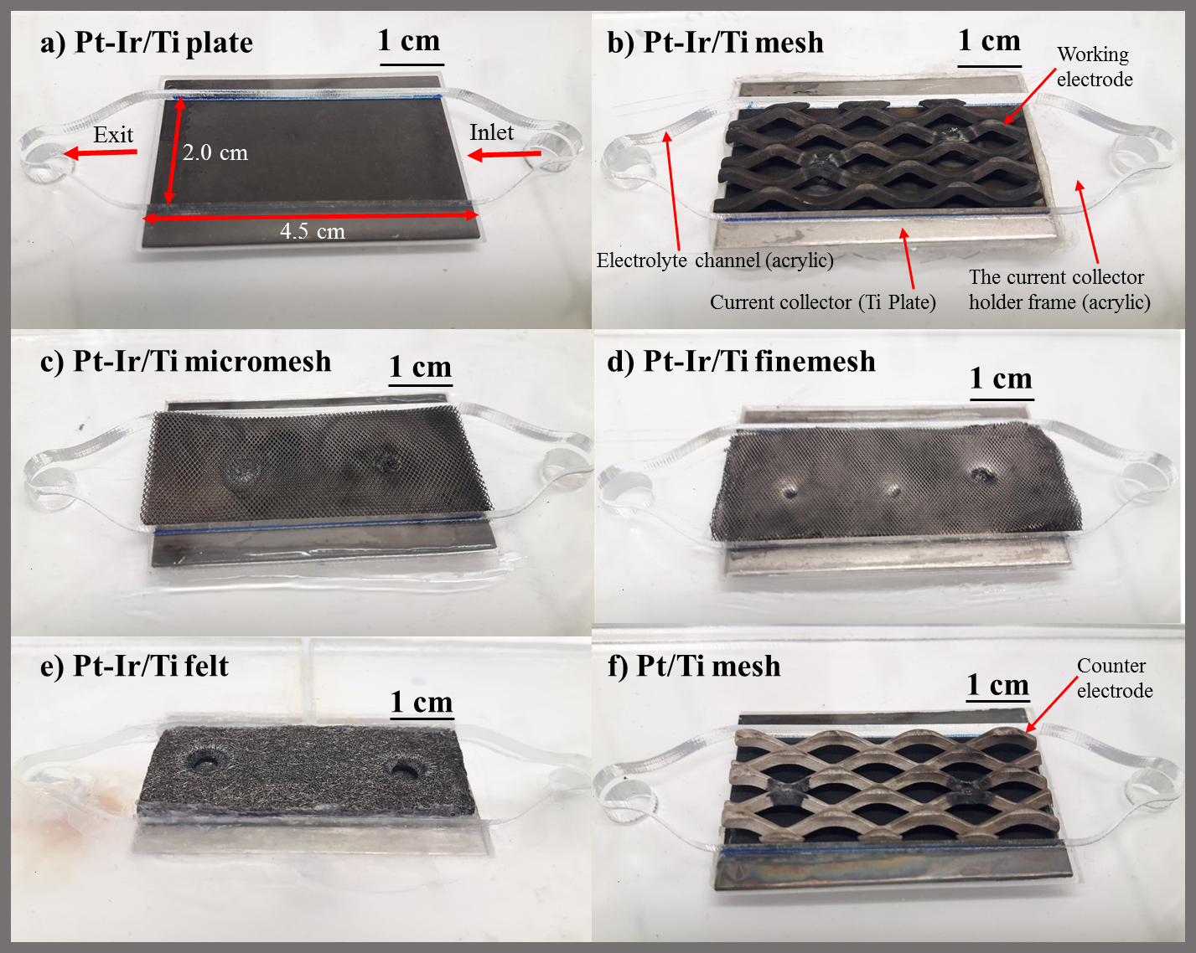
Figure 1.

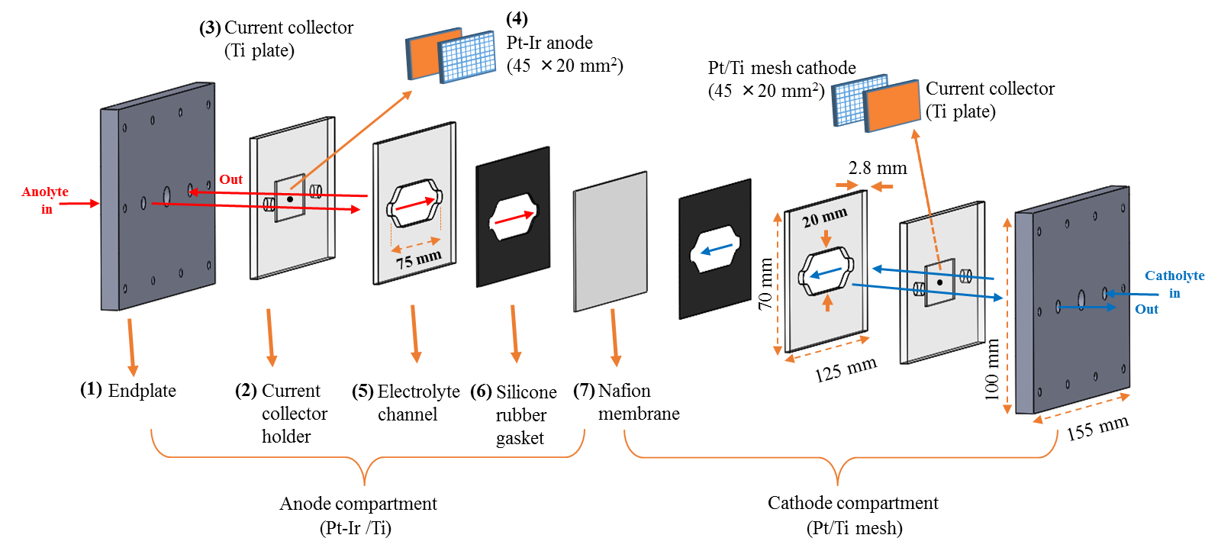
Figure 2.

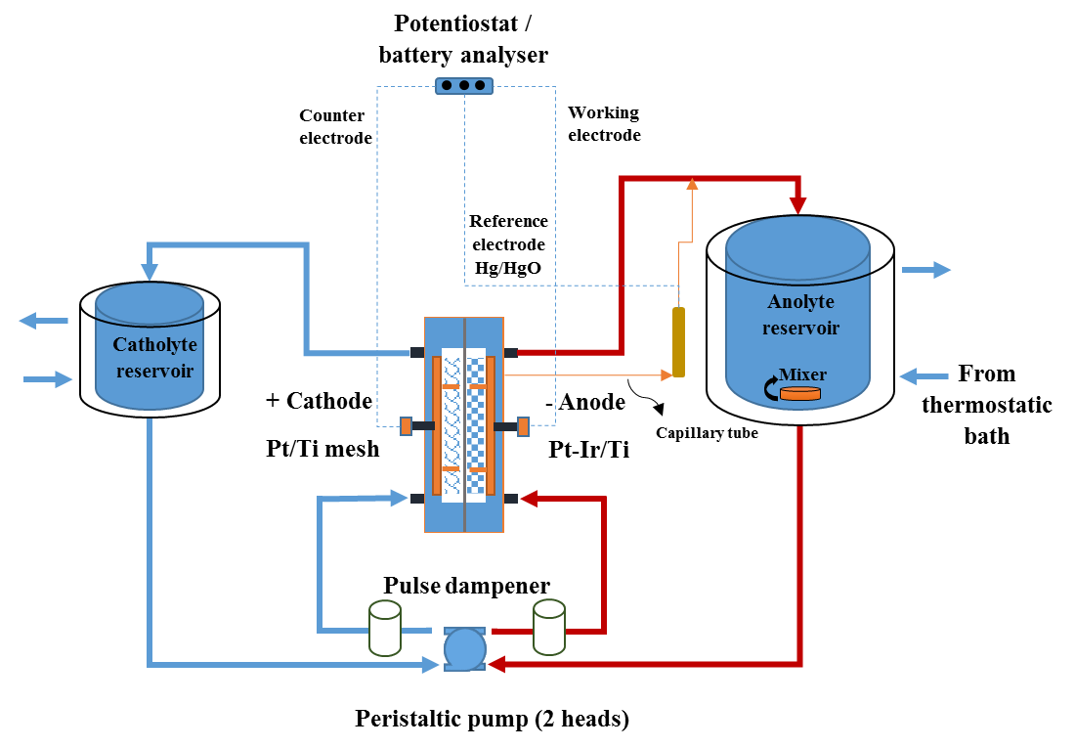
Figure 3.

Figure 4.
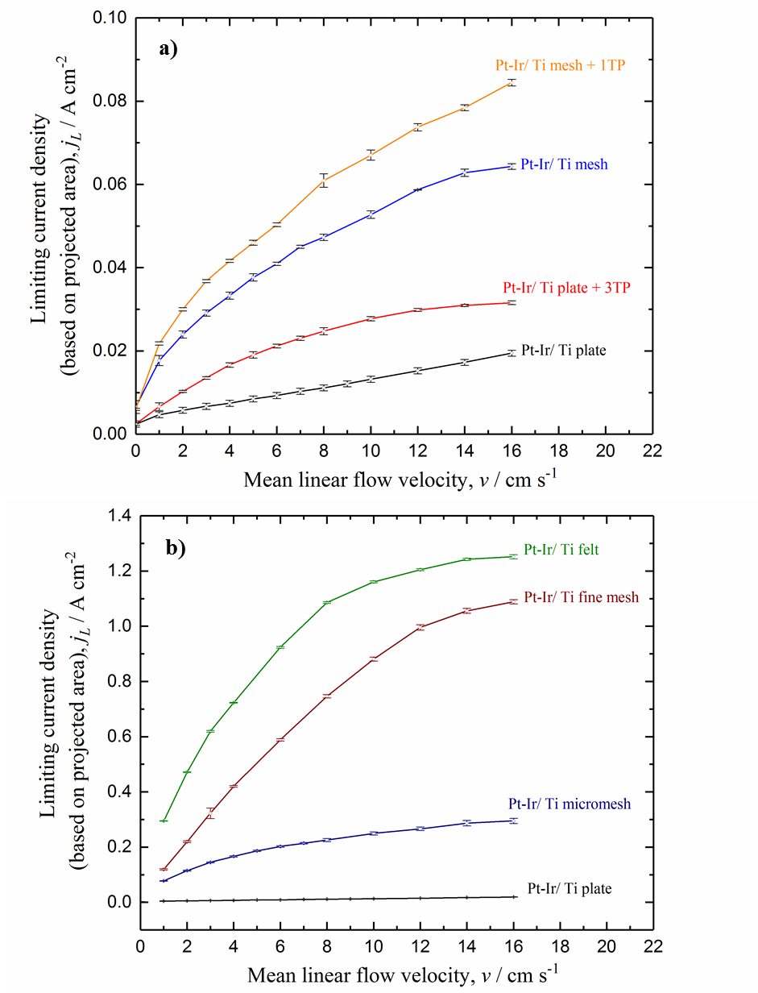
Figure 5.

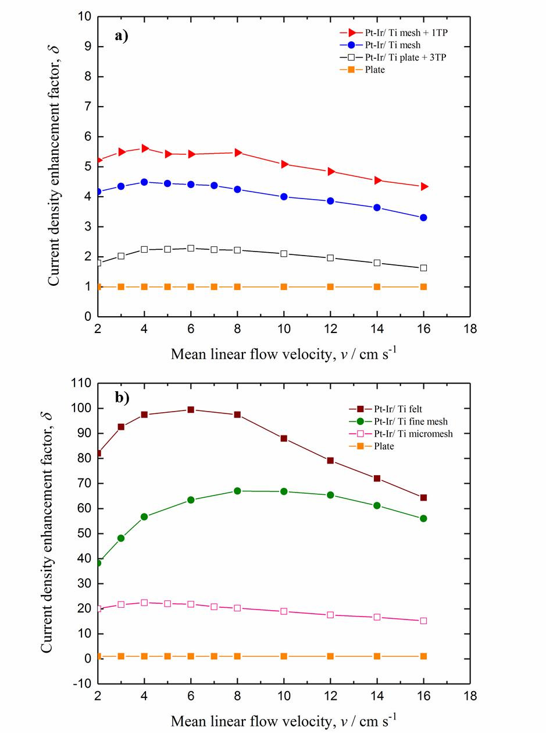
Figure 6.

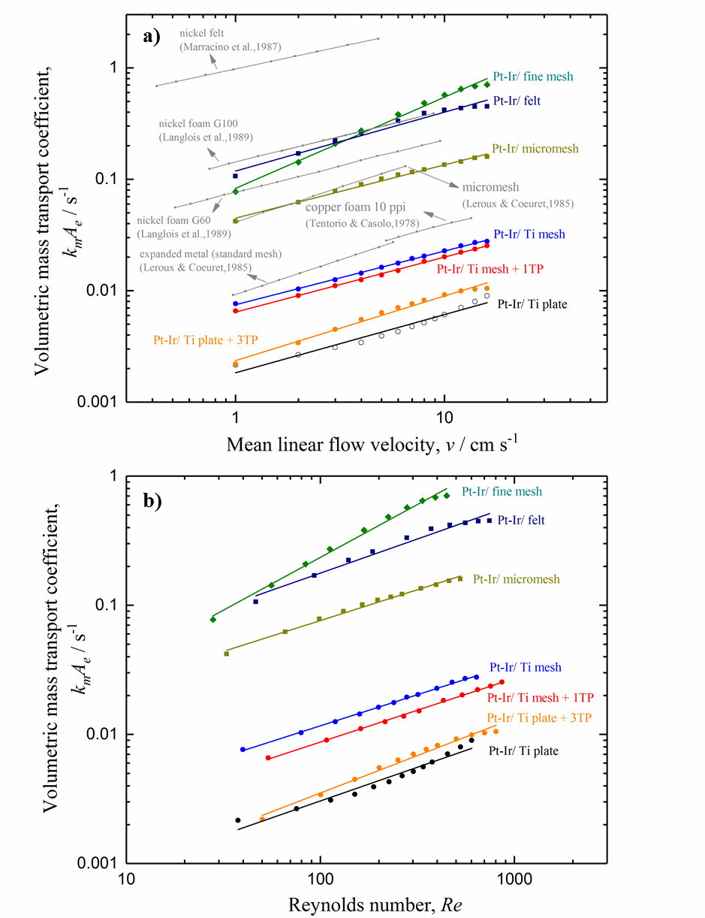
Figure 7.

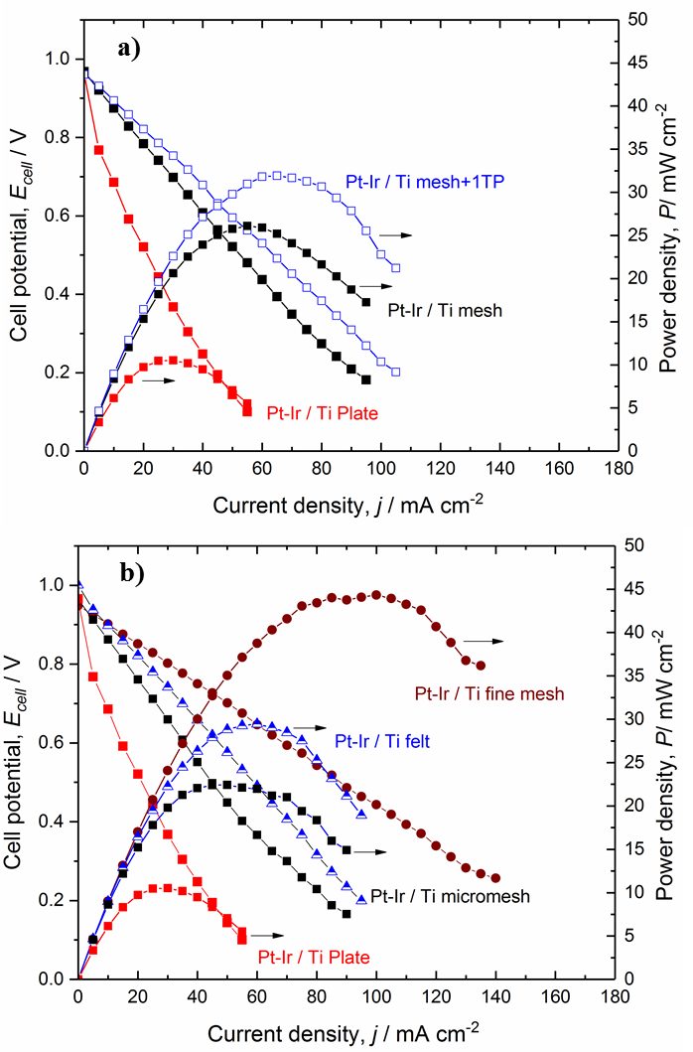
Figure 8.

