Multilayers Oil and Oil-impregnated Pressboard Electric Field Simulation based on Space Charge
Bo Huang, Zhiqiang Xu, Miao Hao and George Chen
The Tony Davies High Voltage Laboratory,
University of Southampton,
Southampton, UK

ABSTRACT
Space charge build-up has been considered as the major issue in the development of HVDC apparatus such as the converter transformer. The existence of space charge can distort the local electric field, which could lead to the degradation and even breakdown of insulation materials. Therefore, it is vital to investigate factors that can affect space charge formation and dissipation characteristics such as the temperature, moisture, ageing, thickness, multi-layered structure and electric fields. This paper mainly focuses on the effect of multilayers and thickness on space charge behaviour of oil and pressboard insulation system. Space charge was measured using the pulsed electroacoustic technique (PEA) method. The space charge results are quantitatively analysed to establish the relationship between interfacial charge density and different pressboard and oil thickness ratios. A new space charge interpolation methodology is utilized to input space charge into the multilayers oil and pressboard model using COMSOL software. The local electric field of multilayers oil-impregnated pressboard and oil could be simulated, with the emphasis on the electric field after the polarity reversal operation. From space charge results, they indicate that the increased thickness of pressboard could prohibit the interfacial charge increase while the increased oil thickness could facilitate interfacial charge increase. Moreover, from the electric field simulation results, they indicate that there is the electric field gradient caused by the space charge for multilayers oil and oil-impregnated pressboard structure. After the polarity reversal, the maximum electric field of the oil caused by the space charge is higher than electric field calculated based on the Maxwell-Wagner theory.
Index Terms — space charge, HVDC, oil and paper, multilayers, thickness, electric stress, polarity reversal time, COMSOL

INTRODUCTION
SPACE charge build-up is one of the significant issues that need to be addressed in HVDC systems. The presence of space charge can enhance the local electric field, which leads to part of the insulation materials being overstressed. In the worst situation, it may result in material degradation and possibly permanent breakdown [1]. Therefore, the influential factors on space charge formation and dissipation need to be carefully investigated such as temperature, moisture, ageing, electric field and multilayers [2-6]. In this paper, the effects of the multilayers and thickness on space charge behaviour have been investigated. Subsequently, the electric field distribution in multilayers oil and pressboard (PB) is simulated.
Multi-layered dielectric materials contain the interfaces, which are the weak points of the high voltage (HV) equipment
Manuscript received on 26 October 2018, in final form xx Month 20yy, accepted xx Month 20yy. Corresponding author: B. Huang.

[7, 8]. The interfaces are common because different insulation materials are used for the HV equipment [9]. There are two types of interfaces; the chemical interface (crossed-linked interface) and the physical interface (EPR and XLPE attached using external mechanical force). The physical interface could be regarded as the potential barrier preventing charge movement and leading to charge accumulation. Two reasons could account for this phenomenon. According to the Maxwell-Wagner theory [10], the interfacial charge forms where a discontinuity of the ratio between conductivity and permittivity occurs. Moreover, the charge accumulation at the interface is influenced by the specific characteristics of the interface itself. e.g. considering the presence of broken bonds and fold chains at the interface, the traps originated from surface states can lead to the formation of space charge at the interface [7].
Traditionally, the electric field in multilayers samples is calculated based on the Maxwell-Wagner theory. Maxwell-Wagner only works for the linear materials, which means the conductivity of insulation materials is proportional to external electric field. In reality, the insulation materials are non-linear, especially subject to high electric fields. Therefore, the space charge measurement results defy part of the Maxwell-Wagner theory [7, 11, 12]. The main difference between the electric field caused by space charge density and the Maxwell-Wagner theory can be attributed to the surface states. The effect of surface states on the interface charge formation is clearly demonstrated in [7] where space charge was observed in two layers of LDPE films. Considering imperfectly bonded different dielectric materials caused by either finite surface roughness or insufficient interfacial pressure [13], the space charge results should be added to evaluate the electric field calculation of the multilayer dielectric materials. The multi-layered structure in this paper is based on the model proposed by the CIGRE working group A2/D1.41 [14]. The working group simulated the electric field based on the Maxwell-Wagner theory previously and this paper considers the electric field calculation based on the space charge results.
In this paper, the multilayers and thickness of oil and PB effect on the space charge dynamics will be presented. A methodology that allows one to extend the space charge from thinner samples to thicker samples is proposed. With the further interpolation of the estimated space charge results in COMSOL software, the multilayer materials electric field simulation based on space charge result is compared to the Maxwell-Wagner theory, with the emphasis on the electric field after the PR operation.

Experiment Details

2.1 Sample Preparation
To analyse the thickness and multilayers effect on the space charge behaviour of oil and oil-impregnated PB, the fresh oil and oil-impregnated PB was prepared. The PB was provided by the Taizhou Weidman High Voltage Insulation Co. Ltd, and the oil was fresh mineral oil (ZXI-S3), provided by the Shell Company. The PB and the ZX-I S3 mineral oil are widely used in high voltage converter transformers. The detailed sample preparation procedures can be found in [15] and it is briefly summarised here: The PB was in a fan-assisted oven at 105 °C for three days to ensure the moisture content below 0.5%. Mineral oil is degassed at 105 °C for three hours with the water content less than 10 ppm. After that, the dried pressboard was impregnated with the degassed oil under 200 mbar/60 ℃ for three days to achieve fully impregnation. The unused samples were sealed in a desiccator under the vacuum condition to prevent the moisture absorption from the environment. The dielectric properties of the samples are shown in Table 1.

Table 1. Properties of the four dielectric materials [16].
Sample | Thickness | Permittivity | Resistivity | Moisture
Fresh oil-PB | 0.5 mm | 3.2 | 1000 TΩm | <0.5%
Fresh oil | 0.5 mm | 2.2 | 100 TΩm | 10 ppm

2.2 space charge measurement
The space charge is measured using the modified pulse electro-acoustic (PEA) system. The spatial resolution of oil and PB are around 31 μm and 44 μm, respectively. To investigate the thickness effect on the space charge behaviour, the different combination thickness of oil and PB space charge was measured using the PEA system and the thickness details are shown in Table 2.

Table 2. Thicknesses of oil and pressboard.
Number | Thickness of PB | Thickness of Oil
1 | 0.5 mm | 0.25, 0.3, 0.4, 0.5, 0.6 mm
2 | 0.3 mm | 0.3, 0.4, 0.5, 0.6, 0.7 mm

The external electric field 10 kV/mm was applied. The pulse generator provided the pulse with the waveform of 800 V, 1 kHz and 10 ns width [17]. The voltage application time is two hours. After turning off the external DC voltage supply, the decay process starts and lasts for around one hour. The experiment was conducted at the ambient room temperature.

Space charge results
Figure 1 indicates the space charge of 0.3 mm oil and 0.3 mm PB under an applied electric field of 10 kV/mm. Homocharge injection appears for two layers oil and PB. The injected positive charge accumulates adjacent to the anode. The negative charge migrates across the oil and accumulates at the oil and PB interface, leading to a decreased electric field in oil.
Figure 2 indicates the space charge of 0.6 mm oil and 0.3 mm PB under an applied electric field of 10 kV/mm. Compared to Figure 1, the increase of the oil thickness could increase the negative interfacial charge density, which is -2.6 C/m³ under 10 kV/mm compared to around 1.03 C/m³ in Figure 1.
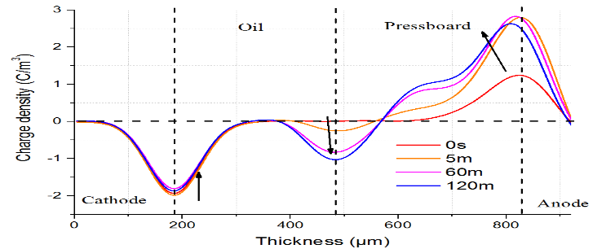
Figure 1. Space charge distribution of fresh 0.3 mm pressboard and 0.3 mm oil under electric field of 10 kV/mm,
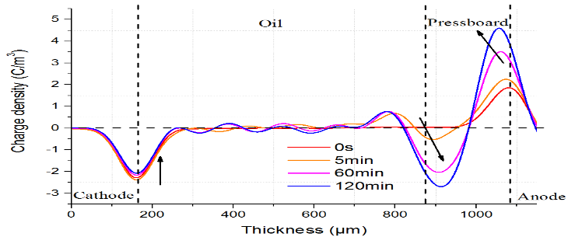
Figure 2. Space charge distribution of fresh 0.3 mm pressboard and 0.6 mm oil under the electric field 10 kV/mm.

Figure 3 shows the space charge of 0.3 mm oil and 0.5 mm PB under an electric field of 10 kV/mm. Compared to Figure 1, the increase of the PB thickness seems to facilitate the positive charge injection and lead to less negative charge accumulation at the interface. The negative interfacial charge density is around 0.6 C/m³, which is less than 1.03 C/m³, shown in Figure 1.
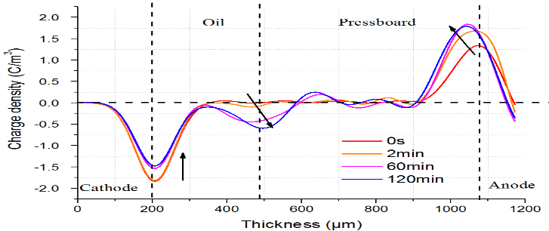
Figure 3. Space charge distribution of fresh 0.5 mm pressboard and 0.3 mm oil under electric field of 10 kV/mm.
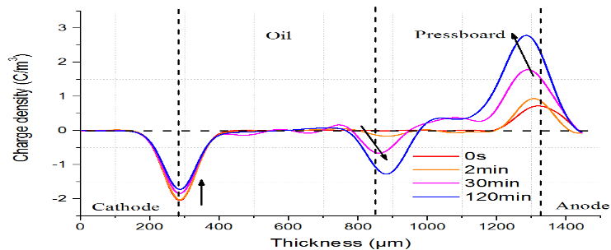
Figure 4. Space charge distribution of fresh 0.5 mm pressboard and 0.5 mm oil under the electric field of 10 kV/mm.

Figure 4 shows the space charge of 0.5 mm oil and 0.5 mm PB under the electric field of 10 kV/mm. The space charge magnitude in Figure 4 is similar to Figure 1. The interfacial charge density is around 1.27 C/m³ in Figure 4.

Discussion
A comparison of Figures 1, 2, 3 and 4 shows that the increase of the oil thickness increases the negative interfacial charge density while the increase of the PB thickness can decrease the negative interfacial charge density. There are several reasons that may account for the above observations.
Based on the Maxwell-Wagner theory, the steady-state electric field of PB in two layers oil and PB samples can be deduced, as shown in Equation (1).
$E_{PB}=\frac{R_{PB}U}{\left(R_{PB}+R_{oil}\right)d_{PB}}=\frac{U}{d_{PB}+\frac{ρ_{oil}}{ρ_{PB}}d_{oil}}≈E_{av}(\frac{d_{oil}}{d_{PB}}+1)$ | (1)
where $ρ_{oil}$ and $ρ_{PB}$ are resistivities of oil and PB respectively, and $E_{av}$ is the average electric field. Based on Table 1 as the second item $\frac{ρ_{oil}}{ρ_{PB}}d_{oil}$ is smaller compared to $d_{PB}$, the simplified equation is shown in equation (1). Equation (1) shows that with the fixed $d_{oil}$ and $E_{av}$, the $E_{PB}$ decreases with the increase of $d_{PB}$. It reflects that the magnitude of the interfacial charge density decreases with the increase $d_{PB}$. The interfacial charge density $q\left(t\right)$ (C) can be deduced, as shown in Equation (2) [18], where $γ_{oil}$and $γ_{op}$ represents the conductivity of oil and PB, S is the surface area of the electrode:
$q(t)=\left(\frac{ε_{oil}γ_{PB}-ε_{PB}γ_{oil}}{d_{oil}γ_{PB}+d_{PB}γ_{oil}}\right)US={(ε}_{oil}-ε_{PB}\frac{ρ_{PB}}{ρ_{oil}})E_{av}S\left(\frac{1+\frac{d_{oil}}{d_{PB}}}{\frac{ρ_{PB}}{ρ_{oil}}+\frac{d_{oil}}{d_{PB}}}\right)$ (2)
Equation (2) verifies the increase of $d_{PB}$ leads to the decrease of the interfacial charge density $q(t)$.
Moreover, the thickness dependence of the interfacial charge density is correlated with the charge trapping and de-trapping rate. The DC dielectric strength of the solid insulation materials decreases with the increased sample thickness [19]. It indicates that the trapping rate is higher than the de-trapping rate of the space charge with the increased sample thickness. Therefore, the increased thickness of PB leads to the increase of the trapping rate of positive charge and decrease the negative interfacial charge density at the oil PB interface [7].
Based on the above discussion, the increased thickness of oil increases the negative interfacial charge density while the increased thickness of PB decreases the negative interfacial charge density. These two opposite trends allow us to hypothesise that the same thickness ratio of the oil and PB leads to the similar space charge distribution under the same electric field.
To verify this hypothesis, the interfacial charge and maximum electric field are further investigated based on both Maxwell-Wagner theory and space charge results. The interfacial charge of oil and PB can be calculated based on Equations (3) and (4):
$$Q(t)=\left(\frac{ε_{oil}γ_{PB}-ε_{PB}γ_{oil}}{d_{oil}γ_{PB}+d_{PB}γ_{oil}}\right)US\left(1-e^{-\frac{t}{τ_{MW}}}\right)$$ | (3)
$$τ=\frac{d_{oil}ε_{PB}+d_{PB}ε_{oil}}{d_{oil}γ_{PB}+d_{PB}γ_{oil}}$$ | (4)
where $Q(t)$ (C) is surface charge and $S$ is the surface area of the electrode. Figure 5a shows the absolute value of the interfacial charge density based on Equations (3) and (4). Figure 5b is the maximum electric field within the PB based on the Maxwell-Wagner theory.
Figure 5a shows the absolute value of the interfacial charge density $Q(t)$ versus the different thickness of the oil layer. Figure 5a shows that the surface charge at the oil PB interface increases with the increased oil thickness and decreases with the increased PB thickness. Moreover, the interfacial charge is the same with the same thickness ratio between the oil and PB.
Figure 5b shows the maximum electric field of the PB with different thickness combination between the oil and PB. With the unchanged thickness of PB, it shows that the maximum electric field of the PB increases with the increased oil thickness. With the unchanged thickness of oil, the maximum electric field of the PB decreases with the increased PB thickness. The comparison of Figure 5a and Figure 5b illustrates that the increased interfacial charge leads to the increased maximum electric field in the PB.
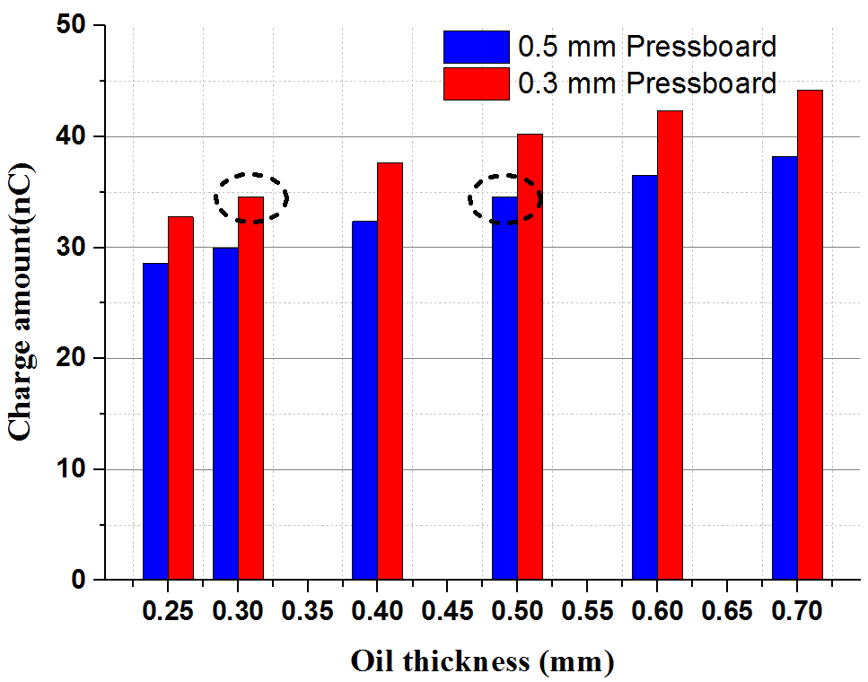 | 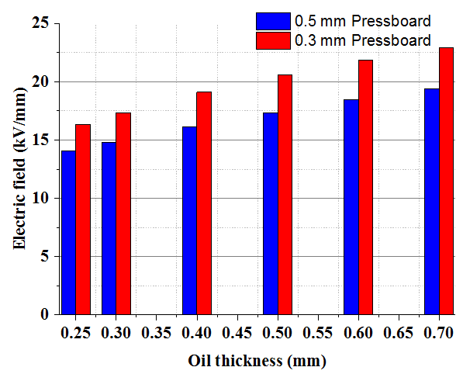
(a) Interfacial charge | (b) Electric field of PB
Figure 5. (a) The interfacial charge and (b) the electric field for two layers oil and PB with the different thickness of the oil based on Maxwell-Wagner theory.

The interfacial charge amount $q\left(t\right)$can also be calculated from Equation (5) based on the space charge results:
 | $$q=\int_{d2}^{d1}{\left|ρ(x,t)\right|Sdt}$$ | (5)
where d₁ and d₂ is the start and end point of the interfacial charge area.
Figures 6a and 6b shows the absolute value of the interfacial charge density and the maximum electric field within the PB based on the space charge results. When comparing Figure 5 to Figure 6, the same trend has been observed, namely that the interfacial charge and maximum electric field increase with the increased oil thickness. Moreover, the interface charge and the electric field is lower compared to that from the Maxwell-Wagner theory. This may relate to the fresh oil and PB, which could lead to less space charge injection and relative lower electric field enhancement. In Figure 6a, it also reflects that the interfacial charge is approximately the same with the same thickness ratio between the oil and PB.
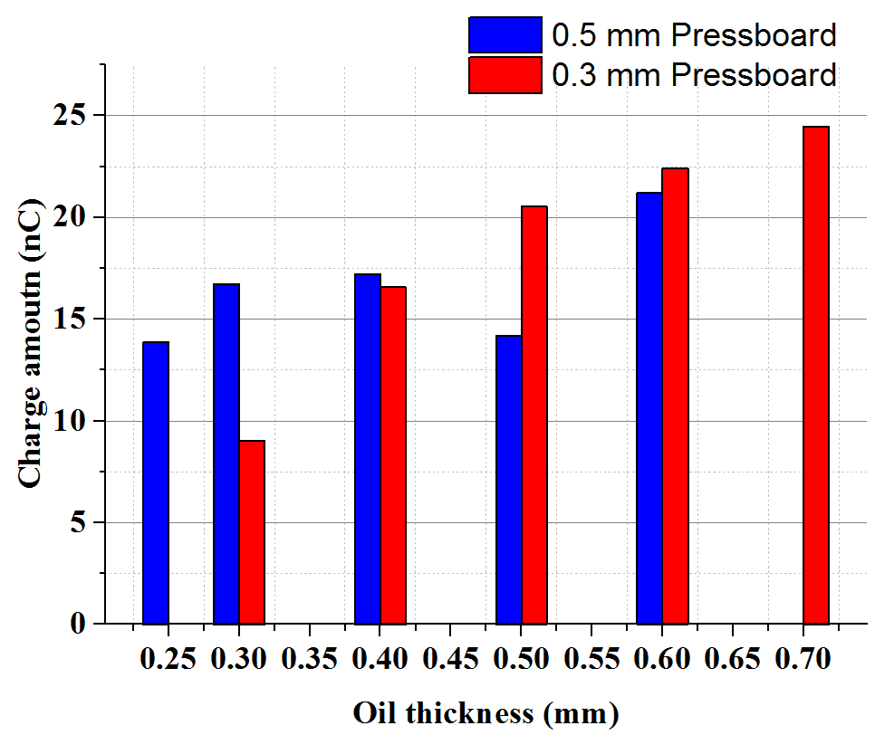 | 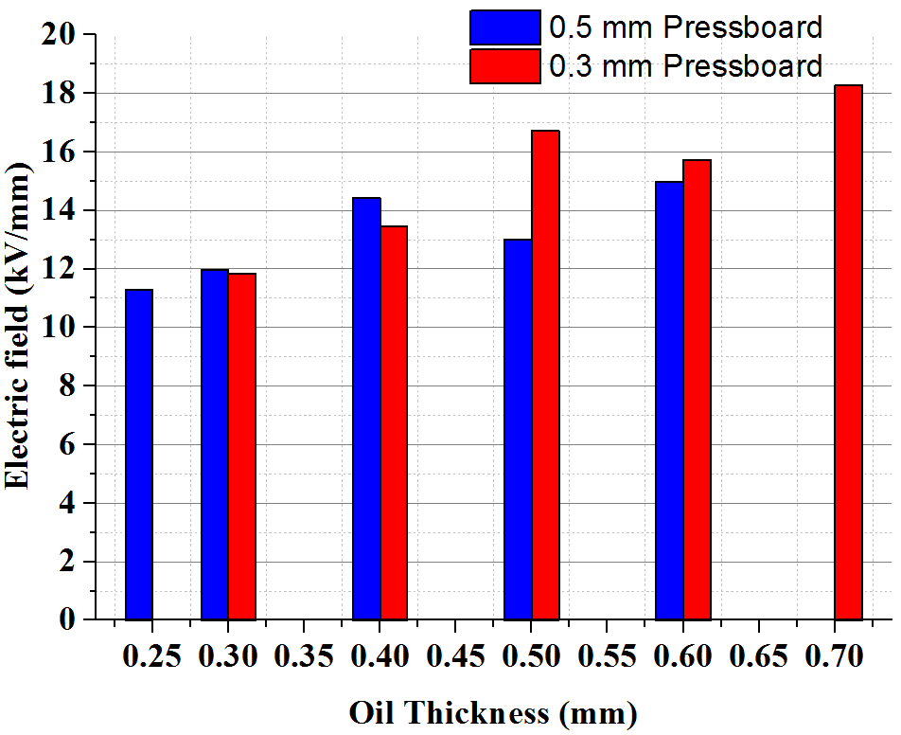
(a) Interfacial charge | (b) Electric field of PB
Figure 6. (a) The interfacial charge (b) Electric field for two layers oil and pressboard with different thickness of oil based on space charge measurement.

The interfacial negative charge is also summarised to evaluate the space charge behaviour, a C/m³, b C/m³ and c C/m³ is the maximum charge density on the cathode, interface and anode. The d C/m³, e C/m³ and f C/m³ is the sum of the charge density on the cathode, interface and anode. The g μm is the distance of the anode peak movement due to charge injection.
The summary results of different thickness combination of oil and PB are shown in Table 3. In Table 3, with the comparison of a¹, b¹, c¹ and a⁴, b⁴, c⁴, the space charge density is quite similar when the ratios of oil and PB is the same, as compared to other groups. Furthermore, the sum of d¹ and e¹, d² and e², d³ and e³, d⁴ and e⁴ is -19.995 C/m³, -64.919 C/m³, -6.917 C/m³ and -26.256 C/m³, respectively. Among them, the sum of d¹ and e¹ -19.995 C/m³ and d⁴ and e⁴ -26.256 C/m³ are approximately similar, showing that the maximum electric field in PB is approximately the same.

Table 3. Space charge behaviour for various oil and paper thickness ratios.
 | Oil 0.3 (mm) |  |  |  | Oil 0.5 (mm)
Paper 0.3  (mm) | a¹ | 0.068 | d¹ | 3.054 | a² | 0.201 | d² | 6.329
 | b¹ | -1.033 | e¹ | -23.049 | b² | -2.556 | e² | -71.248
 | c¹ | 1.459 | f¹ | 59.552 | c² | 4.027 | f² | 112.1
 |  |  | g¹ | 24.934 |  |  | g² | 55.781
Paper 0.5  (mm) | a³ | 0.359 | d³ | 8.765 | a⁴ | 0.321 | d⁴ | 7.229
 | b³ | -0.600 | e³ | -15.682 | b⁴ | -1.268 | e⁴ | -33.485
 | c³ | 0.793 | f³ | 16.150 | c⁴ | 2.206 | f⁴ | 89.365
 |  |  | g³ | 66.964 |  |  | g⁴ | 44.703

Based on the above discussion, it verifies the hypothesis that the interfacial charge is approximately the same with the same thickness ratio between the oil and PB. It will allow one to interpolate the space charge from the thinner samples to multilayer thicker samples for the electric field estimation.

Electric field distribution of four and layers oil and oil-impregnated pb
The multilayers consisting of four and six layers structure model of oil and PB, which are proposed by the CIGRE working group A2/D1.41, which is shown in Figure 7. The aim of the simple four and six layers model is to mimic the part of the electric field in the converter transformer. Considering the thick and multilayers structure of the oil and PB, it is difficult to measure the space charge directly. Therefore, the new methodology of interpolating the space charge into the model will be described in detail here.
The interpolation of space charge methodology will contain the following parts: (i) Divide the model based on different thickness ratios sections; (ii) Summarise the interfacial charge based on different thickness ratios; (iii) Estimate the interfacial charge with different thickness ratios; (iv) Interpolate the space charge into the model; and (v) Compute the electric field distribution.
Firstly, the thickness of each oil and PB layers are shown in Figure 7. The four and six layers oil and PB are divided into different thickness ratio sections based on the Equation (6):
 | $$Ratio=\frac{d_{PB}}{d_{oil}}$$ | (6)
Table 4 shows that the four and six layers model are divided into eleven and fifteen thickness ratios sections, separately.
(a) Four layers | (b) Six layers
Figure 7. Configuration of four and six layers oil and pressboard structure

Table 4. Different section of space charge different ratios.
Number | Ratio | Number | Ratio
1 | 1:2 | 1' | 1:2
2,10 | 1:5 | 2',3',13',14' | 1:5
3,8 | 1:38.5 | 4',11' | 1:32.5
4,9 | 3:2 | 5'12' | 3:2
5,7 | 1:1 | 6'8'10' | 1:1
6 | 1:3 | 7'9' | 1:3
11 | 1:40.5 | 15' | 1:34.5

Secondly, the interfacial charge density is summarised for the interfacial area for different thickness ratios of the samples. The interfacial charge density versus the different thickness ratios is presented in Table 5. Figure 8 indicates the relationship between the interfacial charge density versus different thickness ratios varied from 1:0.5 to 1:2.333.
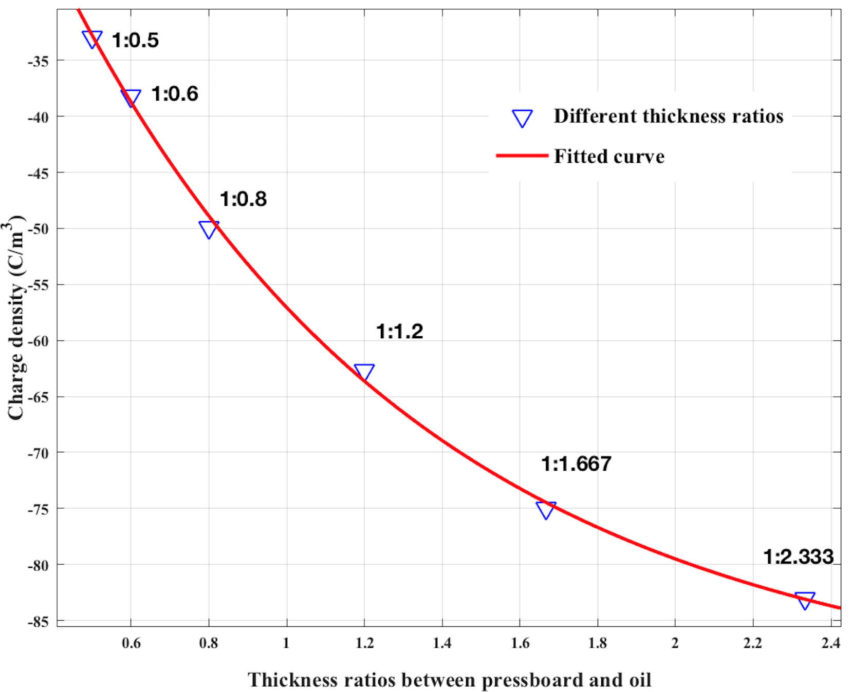
Figure 8. The interfacial charge density versus different thickness ratios between the pressboard and oil.

Thirdly, the interfacial charge density versus sample thickness can be represented using the curve fitting function in the MATLAB. The space charge density versus the sample thickness ratios is represented using two exponential functions. Based on Equation (7), the different interfacial charge density could be calculated, and the results are shown in Table 5. Moreover, the estimated interfacial charge densities are shown in Figure 9.
$f\left(x\right)=-87.91\exp\left(0.0116x\right)+97.1exp⁡(-1.114x$) | (7)

Table 5. The surface charge density versus the different thickness ratios.
Ratios | 1:0.667 | 1:1 | 1:2 | 1:3 | 1:5 | 1:32.5 | 1:34.5 | 1:38.5 | 1:40.5
Charge density(C/m³) | -42.41 | -57.06 | -79.51 | -83.07 | -87.59 | -92.79 | -131.17 | -137.4 | -140.6
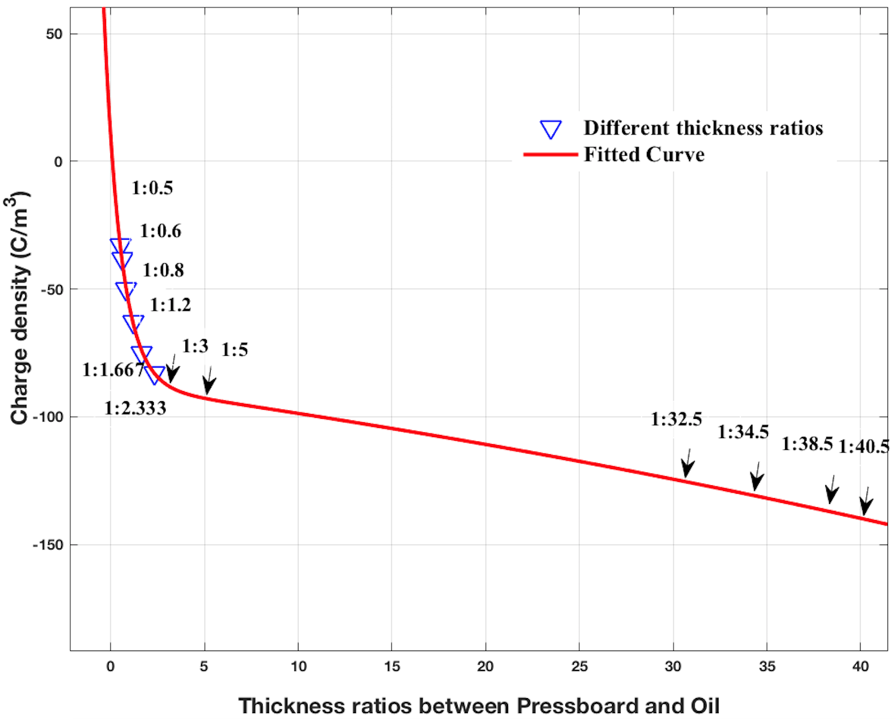
Figure 9. The interfacial charge density versus different thickness ratios between the pressboard and oil for estimation.

Fourthly, to interpolate the space charge into thick multilayer oil and oil-impregnated PB, the ratio between different interfacial charge density can be calculated using Equation (8):
 | $$Ratio=\frac{q_{1}}{q_{2}}$$ | (8)
where $q_{1}$ represents the estimated interfacial charge and $q_{2}$ indicates the measured interfacial charge. Then, the ratio should multiply the existing equations representing space charge versus time of each layer, and the space charge is interpolated into the multilayers oil and PB model in COMSOL based on the methodology described in previous work [17].
Take the space charge extended from the thickness ratio of 1:2 to 1:5 as an example, based on space charge result of 0.3 mm oil and 0.6 mm PB, the relative interfacial charge is -79.51 C/m³ (shown in Table 5) with the thickness ratio of 1:2. Based on equation (8), the ratio of 1.1 can be acquired after dividing -87.59 C/m³ and -79.51 C/m³. Then, this ratio should be used to multiply the equations representing space charge versus time with a ratio of 1:2, and the space charge can therefore be extended from the thickness ratio of 1:2 to 1:5.
The four layers section number 9, 10, 11 shown in Figure 7 (a) is selected as an example. After the interpolation of space charge into the model, the space charge distribution is shown in Figure 10a; the thinness below 20000 μm of the space charge result in Figure 10a is enlarged shown in Figure 10b.
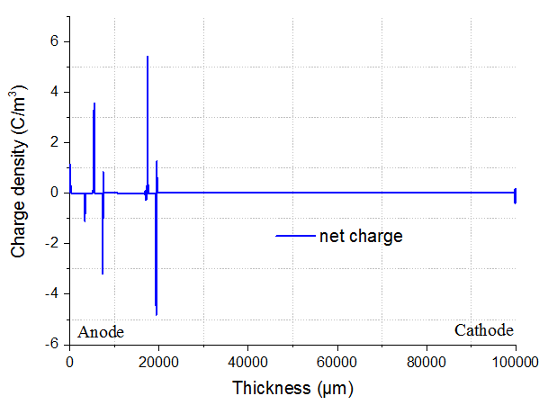 | 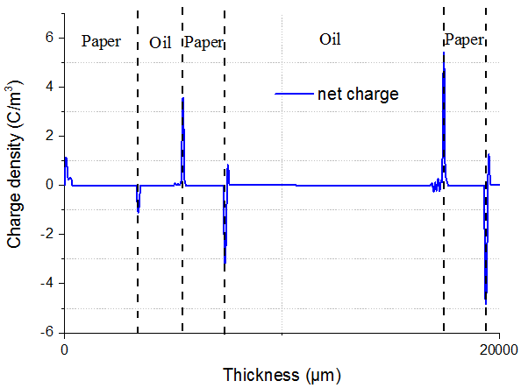
(a) Whole space charge | (b) Part of space charge
Figure 10. (a) the whole (b) part of space charge for multilayers oil and pressboard space charge density.

Finally, the electrostatic model is selected to calculate the time dependent electric field distribution of four layers oil and PB. The geometry of four layers oil and PB geometry is shown in Figure 7. The applied electric field is shown in Figure 11. As the samples have the thickness of 100 mm, 1000 kV of the PR voltage is applied on the insulation samples. In mesh level setting, the “extremely fine” level of mesh is selected to calculate the electric field and different PR time effect on the electric field will be simulated later.
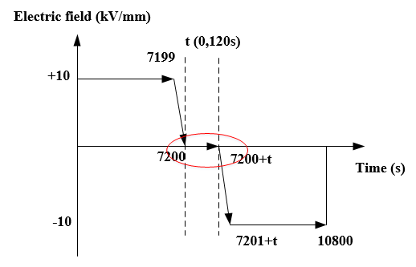
Figure 11. The PR operation voltage waveform.
The electric field distribution of four layers oil and PB are shown in Figure 12. The electric field of the PB increases from the anode to the cathode while the electric field of the oil decreases from the anode to the cathode.
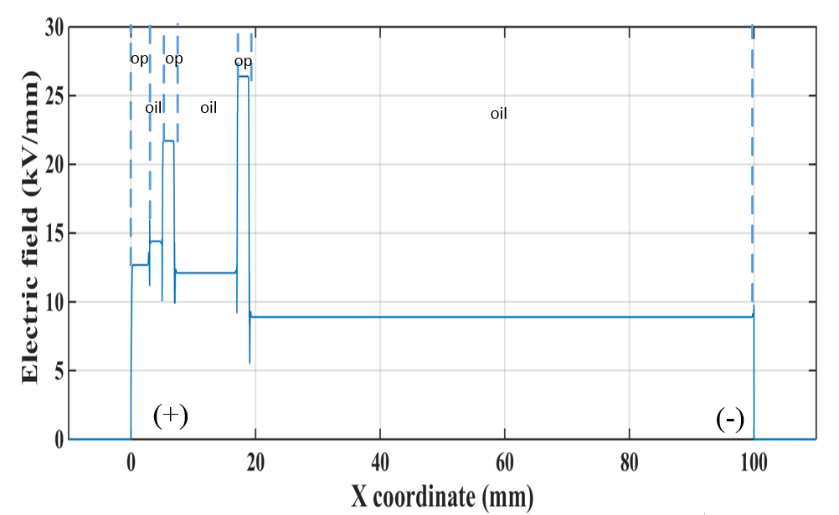
Figure 12. The electric field simulation of multilayers oil and pressboard caused by the space charge density.
Based on the above discussion, the following electric field simulation is based on the section number 1, 2 and 3 shown in Figure 7a and 1’, 2’, 3’ and 4’ shown in Figure 7b. This is due to the increased thickness of the oil gap, which leads to the higher interfacial charge density and higher electric field enhancement of the oil after the PR operation. It could be verified by the following electric field simulation.

Further analysis of the electric field for four and six layers oil and pb
After the space charge interpolation into the four and six layers model, the electric field based on the space charge can be simulated with the emphasis on the electric field after the PR operation. Moreover, four and six layers electric field based on space charge is compared to the electric field based on the Maxwell-Wagner theory.
Figure 13a and Figure 13b shows four and six layers of steady state electric field based on the Maxwell-Wagner theory. The electric field of the PB is higher compared to that of the oil due to the higher resistivity of PB. Moreover, comparing Figure 13a to Figure 13b, it indicates that the increased layers can decrease the electric field of the PB from 26.5 kV/mm to 25.9 kV/mm in PB and from 9.1 kV/mm to 8.9 kV/mm in the oil.
In order to explain this phenomenon, the steady state electric field of oil and PB could be calculated using the following Equation (9) and (10), where M represents the finite layer (M$≥4$).
 | $$\left\{\begin{aligned}γ_{1}E_{1}=γ_{2}E_{2}=γ_{3}E_{3}=γ_{4}E_{4}=σ_{M}E_{M} \\ E_{1}d_{1}+E_{2}d_{2}+E_{3}d_{3}+E_{4}d_{4}+E_{M}d_{M}=U\end{aligned}\right.$$ | (9)
 | $$E_{M}=\frac{U}{γ_{M}(\frac{d_{1}}{γ_{1}}+\frac{d_{2}}{γ_{2}}+\frac{d_{3}}{γ_{3}}+\frac{d_{4}}{γ_{4}}+\frac{d_{M}}{γ_{M}})}$$ | (10)
In Equations (9) and (10), if it is assumed that there are only two different samples with conductivities$γ_{1}$ and $γ_{2}$ and samples thickness $a$ and $b$ respectively, the above Equation (10) can be simplified into Equations (11) or (12):
 | $$E_{M}=\frac{E_{av}d}{\frac{γ_{M}}{γ_{1}γ_{2}}(γ_{1}d+(γ_{2}-γ_{1})a)}$$ | (11)
 | $$E_{M}=\frac{E_{av}d}{\frac{γ_{M}}{γ_{1}γ_{2}}(γ_{2}d+(γ_{1}-γ_{1})b)}$$ | (12)
where the $γ_{1}$ and $γ_{2}$ are conductivity of oil and PB, and $γ_{1}$ is higher than${ γ}_{2}$. The a and b represents the thickness of oil and PB. Moreover, d is the fixed sample thickness and $E_{av}$ is the external electric field.
Equations (11) indicate that the increase of $a$ can increase the electric field of each layer based on equation (11). Moreover, the increase of $b$ can decrease the electric field of the each layer based on Equation (12).
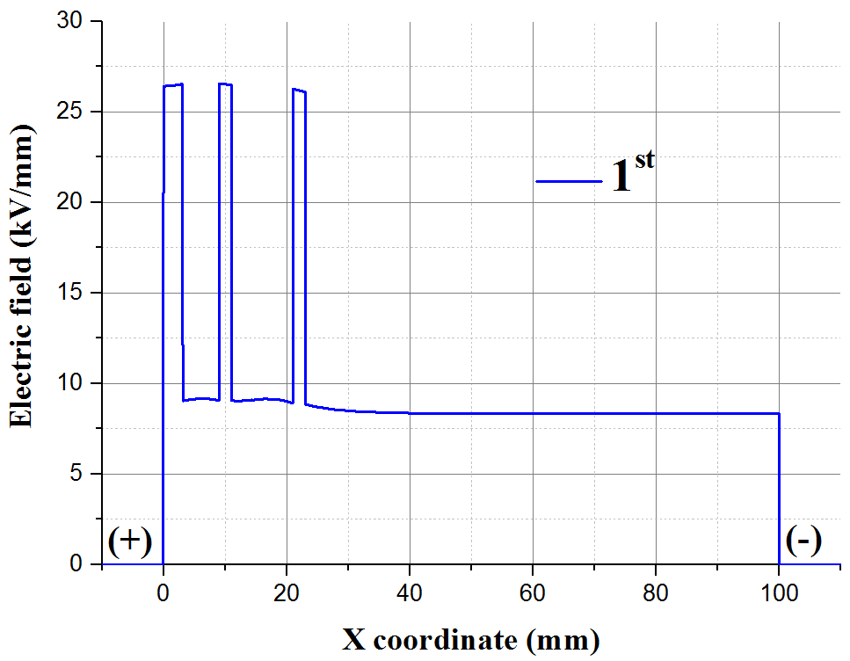 | 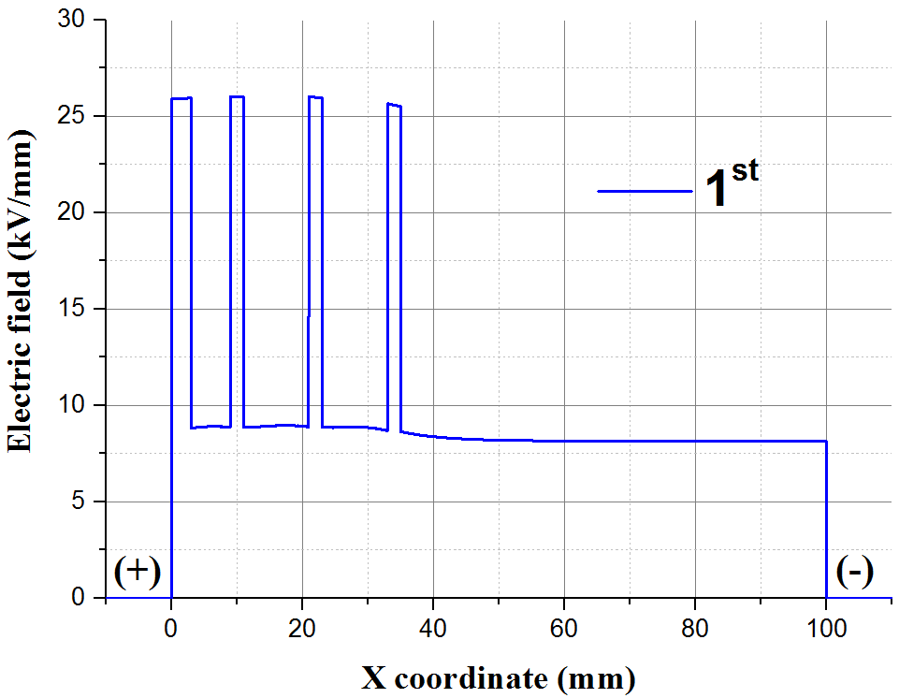
(a) Four layers | (b) Six layers
Figure 13. Electric field of 4 and 6 layers oil and pressboard caused by the Maxwell-Wagner theory for 1st position.

Figure 14a and Figure 14b show the four and six layers oil and PB electric field after the PR at the operation time of 10 s based on the Maxwell-Wagner theory. The transient electric field of the oil is correlated with the permittivity. The lower permittivity of the oil leads to the higher transient electric field compared to that of the PB. Comparing Figure 13a and Figure 13b to Figure 14a and Figure 14b. It is clear that the transient electric field of oil is higher than that under the steady state.
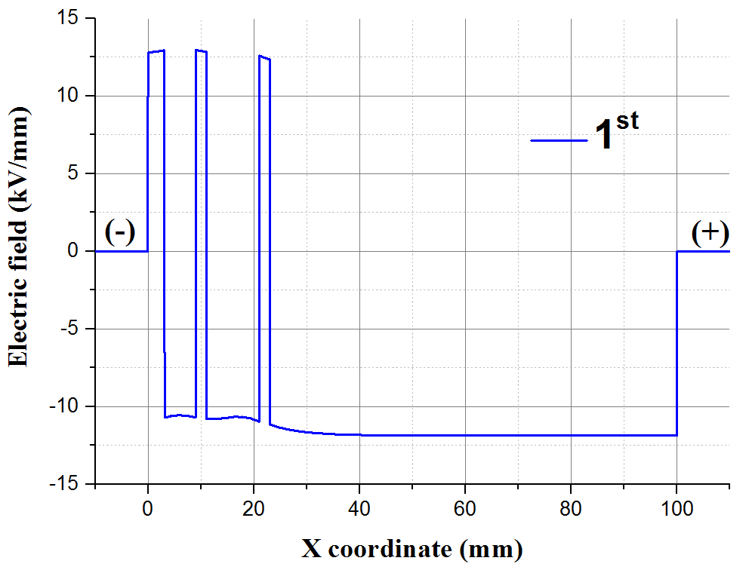 | 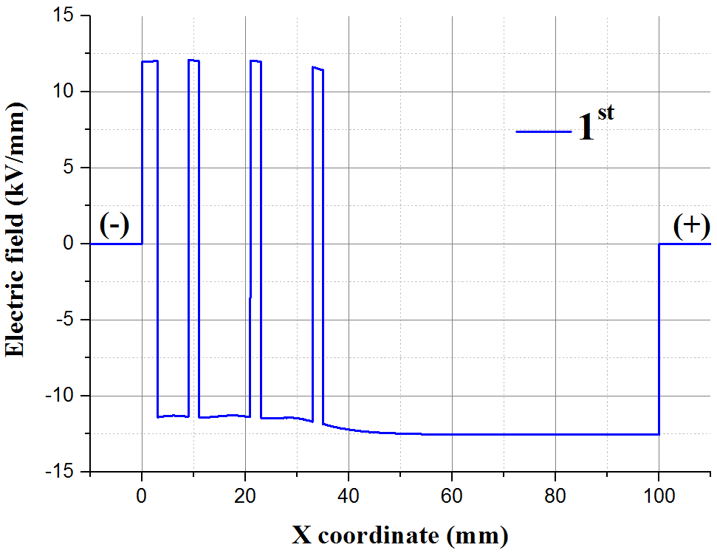
(a) Four layers | (b) Six layers
Figure 14. Electric field of 4 and 6 layers of oil and pressboard caused by the 1st position caused by the Maxwell-Wagner after the polarity reversal operation of 10 s.
Comparing Figure 14a and Figure 14b, it can be seen that the transient electric field of the oil decreases with the increased thickness of the oil. It could be explained by the Equations (13) and (14), where $ε_{1}$ represents permittivity of oil and $ε_{2}$ is the PB with $ε_{2}$ higher than $ε_{1}$. It shows that the transient electric field of each layer decreases with increased oil thickness based on Equation (13). Moreover, the transient electric field of each layer increases with the increased thickness of PB based on Equation (14).
$$E_{M}=\frac{E_{av}d}{\frac{ε_{M}}{ε_{1}ε_{2}}(ε_{1}d+(ε_{2}-ε_{1})a)}$$ | (13)
$$E_{M}=\frac{E_{av}d}{\frac{ε_{M}}{ε_{1}ε_{2}}(ε_{2}d+(ε_{1}-ε_{2})b)}$$ | (14)
Figure 15a and Figure 15b show a steady state electric field based on the space charge. It shows that the electric field of the PB is enhanced while the electric field of the oil is decreased compared to the external average electric field. This is due to the charge in the PB, which creates the electric field in the same direction as the external electric field. However, the charge in the oil can generate the electric in the opposite direction to the external electric field, leading to the decrease of the electric field in the oil.
Moreover, there is the electric field gradient in four and six layers oil and PB based on the space charge. In Figure 15a and Figure 15b, the electric field of the PB increases and the oil decreases from the anode to the cathode. This could be explained using the schematic diagram in Figure 16. Due to the different thickness ratios of the oil and PB, a large amount of space charge in PB near the cathode increases the electric field in the PB and decreases the electric field in the oil. Therefore, the electric field gradient exists in the thick multilayers oil and PB samples.
When comparing the electric field for four and six layers caused by space charge shown in Figure 15a and Figure 15b, there is no significant electric field decrease with the increase of the layers caused by the space charge.
A comparison of Figure 15a and Figure 12 indicates the minimum electric field of the oil gap is lower in Figure 15a. This is resulted from the higher interfacial charge density due to higher oil to PB thickness ratios, seen when comparing section 1 and section 9 in Figure 7a.
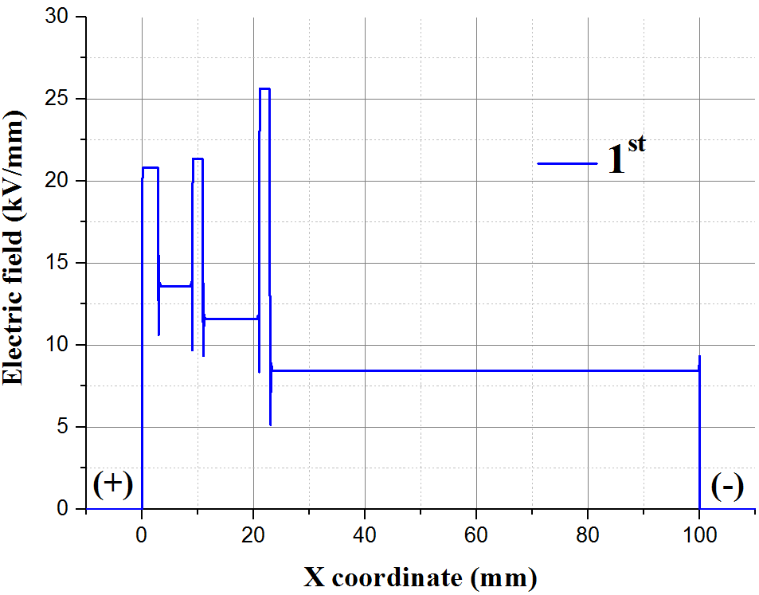 | 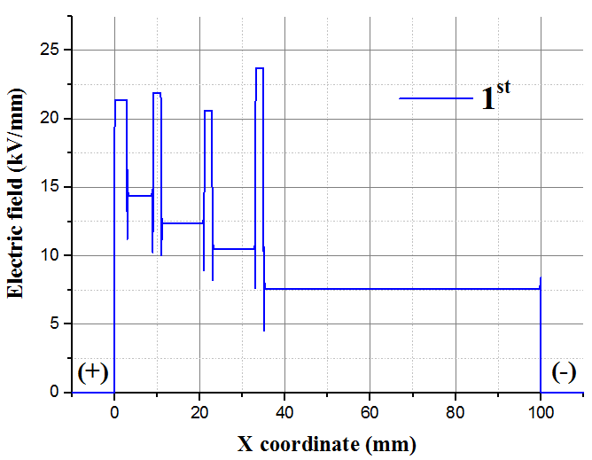
(a) Four layers | (b) Six layers
Figure 15. Electric field of 4 and 6 layers of oil and pressboard caused by the 1st position caused by the space charge.
Figure 16. Schematic diagram indicating the multilayers oil and pressboard space charge distribution.

Figure 17a and Figure 17b show the electric field of multilayers for oil and PB after the PR operation time of 10 s caused by the space charge. It shows that the electric field of the oil is enhanced while the electric field in the PB is decreased after the PR operation. The overall electric field consists of the electric field caused by both external applied voltage and space charge, shown in equation (15). The heterocharges within the oil could be converted to the homocharges after the PR, which could lead to the electric field enhancement within the oil. However, the homocharges in the previous stage of voltage application within the PB could be viewed as the heterocharges after PR operation, leading to the electric field decrease within the PB.
 | $$E_{Total}=E_{applied}+E_{Sc}$$ | (15)
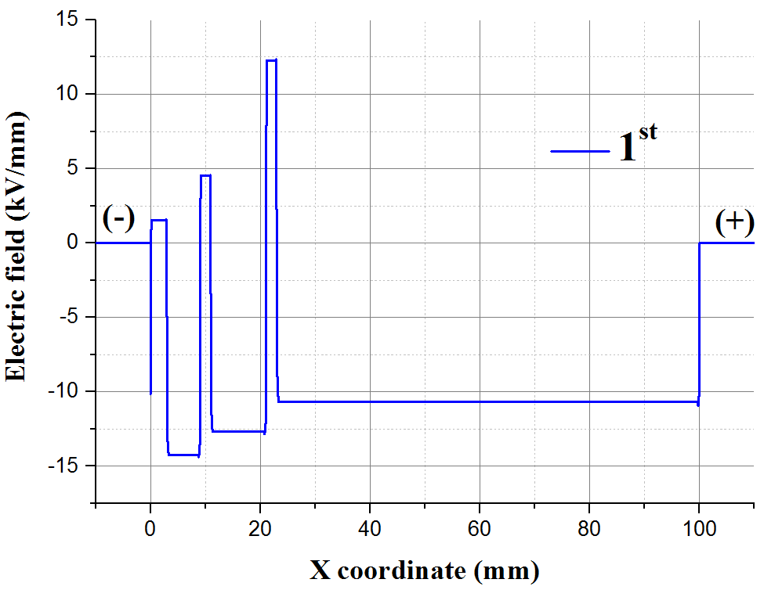 | 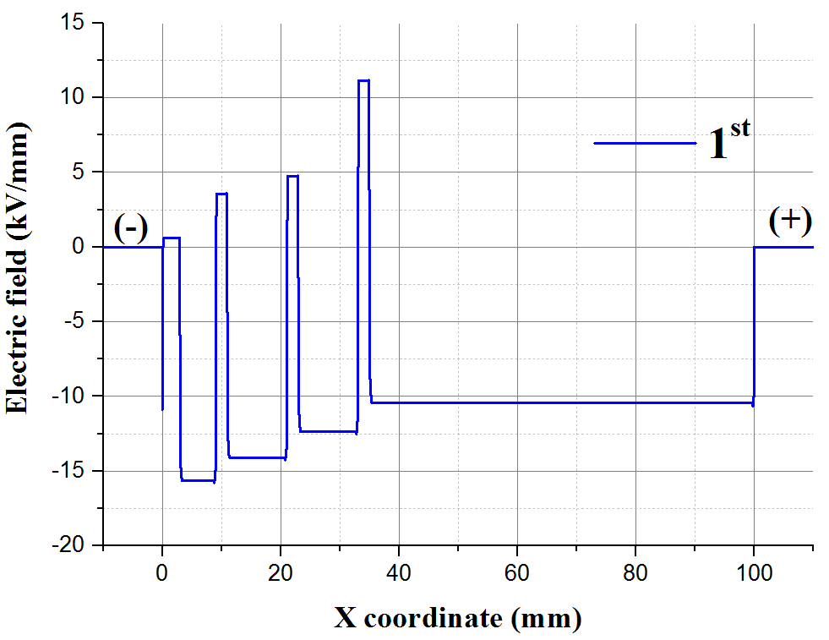
(a) Four layers | (b) Six layers
Figure 17. The 4 and 6 layers electric field of multilayers oil and pressboard after the polarity reversal operation time of 10 s.

From Figure 17a and Figure 17b, there is the electric field gradient within multilayers oil and PB after the PR operation. After the PR operation, the electric field of the oil decreases from the cathode to the anode. However, the electric field of the PB increases from the cathode to the anode. This could be explained using the schematic diagram in Figure 18. Considering different thickness ratios of the oil and PB, a significant amount of residual space charge within the PB creates the electric field with the opposite direction compared to the external electric field. This leads to the electric field of the PB increase from cathode to anode, resulting the electric field gradient across the multilayers samples.
Figure 18. Schematic diagram indicates multilayers oil and pressboard space charge distribution after the polarity reversal operation.

Figure 19 shows the summary of the electric field calculated by either space charge or the Maxwell-Wagner theory for both four and six layers of the oil layer after different PR operation time. The simulation results show that the electric field of oil caused by the space charge is higher compared to that from the Maxwell-Wagner theory. Moreover, after the PR operation, for the 1st line in four and six layers of oil and PB shown in Figure 7a and Figure 7b, the electric field of the oil for six layers is higher compared to four layers calculated by from both space charge and the Maxwell-Wagner theory.
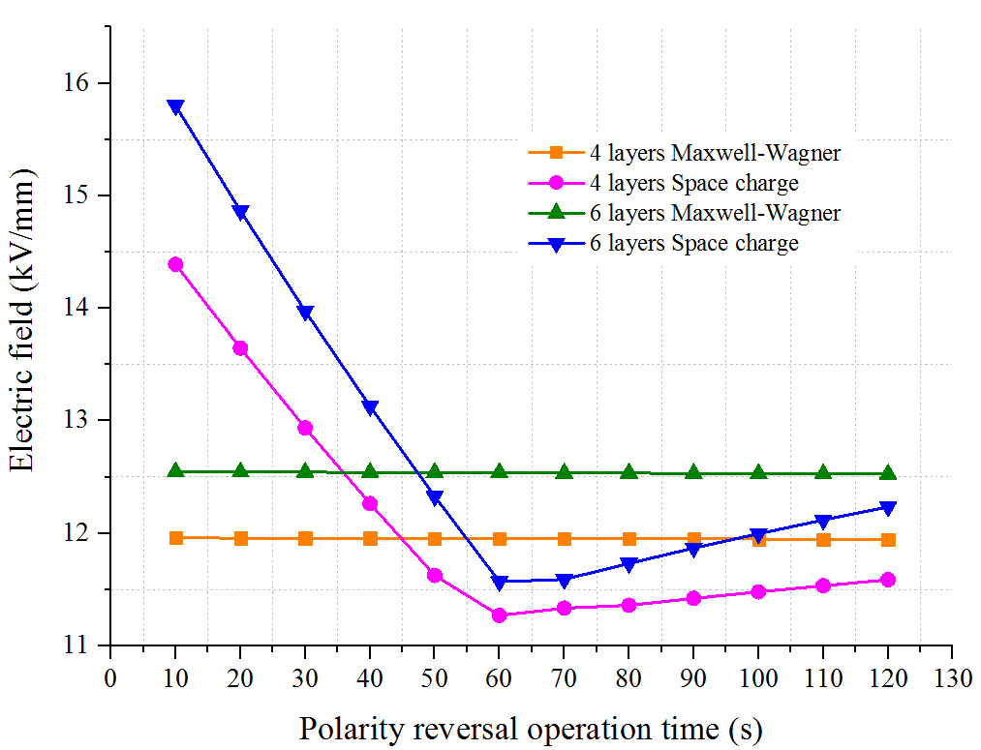
Figure 19. Summary of the electric field of the oil for 4 and 6 layers caused by the space charge and Maxwell-Wagner theory for different polarity reversal operation time.

The current standard PR operation time is two minutes [20]. The transient electric field of oil after PR is lower than its steady state electric field. The transient electric field of oil is -14.4 and -15.8 kV/mm for four and six layers after the PR operation time of 10 s. The steady state electric field of oil in four and six layers is 15.4 and 16.2 kV/mm, respectively. Moreover, in Figure 19, it shows that after the PR time of 60 s, the electric field caused by the space charge does not have the obvious decrease. These two factors show that the current 2 minutes PR operation time may be safely reduced for multilayers oil and PB under 10 kV/mm.

Conclusions
The space charge behavior of oil and PB under a DC electric field is investigated via PEA technique. The influence of the multilayer and thickness on the space charge behavior in oil and PB is investigated using an experimental approach. The space charge results are further interpolated into the COMSOL software for the electric field simulation, with the comparison on the electric field calculated by the Maxwell-Wagner theory. The following conclusions can be drawn as follows.
- The increased PB thickness results in a decrease of the interfacial charge and an increased oil thickness leads to an increase of the interfacial charge density.
- The same thickness ratio of the PB and oil shows an approximately similar space charge distribution under the same external electric field. This could allow one to extend the space charge from thinner samples to thicker samples, which could be beneficial to calculate the electric field distribution of the converter transformer and improve its design.
- There is the electric field gradient for the electric field distribution within the oil and PB caused by space charge. The electric field of the PB increases from the anode to the cathode, and the electric field of the oil decrease from the anode to the cathode. Moreover, after the PR, the electric field of the oil decreases from the cathode to the anode, and the electric field of the PB increases from the cathode to the anode.
- After PR, with the comparison of the electric field caused by the Maxwell-Wagner theory and the space charge, it indicates that the electric field in the oil caused by the space charge is higher than that based on the Maxwell-Wagner theory. Moreover, it also shows that the PR operation time may be reduced from the current two minutes for multilayers oil and PB under the electric field of 10 kV/mm.

Acknowledgment
The authors are grateful to the financial support received from UK Engineering and Physical Sciences Research Council (EP/L021560/1 - Towards Enhanced HVDC Cable Systems).

References
[1] G. Chen and Z. Xu, “Charge Trapping and Detrapping in Polymeric Materials,” J. Appl. Phys., vol. 106, no. 12, pp. 1–5, 2009.
[2] C. Tang, B. Huang, M. Hao, Z. Xu, J. Hao, and G. Chen, “Progress of Space Charge Research on Oil-Paper Insulation Using Pulsed Electroacoustic Techniques,” Energies, vol. 9, no. 1, p. 53, 2016.
[3] J. Hao, G. Chen, R. Liao, L. Yang, and C. Tang, “Influence of Moisture on Space Charge Dynamics in Multilayer Oil-Paper Insulation,” IEEE Trans. Dielectr. Electr. Insul., vol. 19, no. 4, pp. 1456–1464, 2012.
[4] K. Wu and C. Cheng, “Interface Charges between Insulating Materials,” IEEE Trans. Dielectr. Electr. Insul., vol. 24, no. 4, pp. 2633–2642, 2017.
[5] C. Tang et al, “The Space Charge Behaviors of Insulation Paper immersed by Mineral Oil and MIDEL 7131 after Thermal Ageing,” IEEE Int. Conf. Condition Monitoring and Diagnosis (CMD), 2016, pp. 44–47.
[6] C. Tang, G. Chen, M. Fu, and R. J. Liao, “Space Charge Behavior in Multi-layer Oil-paper Insulation under Different DC Voltages and Temperatures,” IEEE Trans. Dielectr. Electr. Insul., vol. 17, no. 3, pp. 775–784, 2010.
[7] G. Chen, Y. Tanaka, T. Takada, and L. Zhong, “Effect of Polyethylene Interface on Space Charge Formation,” IEEE Trans. Dielectr. Electr. Insul., vol. 11, no. 1, pp. 113–121, 2004.
[8] L. Lan, Q. Zhong, Y. Yin, and X. Li, “Effect of Surface Fluorination on Space Charge Behavior at LDPE/EPDM Interface,” IEEE Int. Conf. on Solid Dielectr. (ICSD), 2013, pp. 444–447.
[9] P. H. F. Morshuis, R. Bodega, D. Fabiani, G. C. Montanari, L. A. Dissado, and J. J. Smit, “Dielectric Interfaces in DC Constructions: Space Charge and Polarization Phenomena,” IEEE Int. Conf. on Solid Dielectr. (ICSD), 2007, pp. 450–453.
[10] R. Bodega, P. H. F. Morshuis, U. H. Nilsson, G. Perego, and J. J. Smit, “Charging and Polarization Phenomena in XLPE-EPR Coaxial Interfaces,” Int. Symp. Electr. Insul. Mat. (ISEIM), 2005, pp. 107–110.
[11] T. T. N. Vu, G. Teyssedre, B. Vissouvanadin, S. L. Roy, and C. Laurent, “Correlating Conductivity and Space Charge Measurements in Multi-dielectrics under Various Electrical and Thermal Stresses,” IEEE Trans. Dielectr. Electr. Insul., vol. 22, no. 1, pp. 117–127, 2015.
[12] R. Bodega, P. H. F. Morshuis, U. H. Nilsson, G. Perego, and J. J. Smit, “Polarization Mechanisms of Flat XLPE-EPR Interfaces,” Nordic Insulation Symposium, 2005, pp. 224–227.
[13] R. Bodega, G. Perego, P. H. F. Morshuis, U. H. Nilsson, and J. J. Smit, “Space Charge and Electric Field Characteristics of Polymeric-type MV-size DC Cable Joint Models,” IEEE Annu. Rep. Conf. Electr. Insul. Dielect. Phenom. (CEIDP), 2005, pp. 507–510.
[14] CIGRE Technical Brochure No. 646: HVDC Transformer Insulation: Oil Conductivity, CIGRE, 2016
[15] B. Huang, “Space Charge Behaviour of Thick Oil and Pressboard in a HVDC Converter Transformer”, PhD dissertation, University of Southampton, 2018.
[16] M. Hao, Y. Zhou, G. Chen, G. Wilson, and P. Jarman, “Space Charge Behaviour in Oil and Impregnated Pressboard Combined Insulation System,” IEEE Int. Conf. Dilectr. Liquids (ICDL), 2014, pp. 1–4.
[17] B. Huang, M. Hao, J. Hao, J. Fu, Q. Wang, and G. Chen, “Space Charge Characteristics in Oil and Oil-Impregnated Pressboard Insulation and Electric Field Distortion after Polarity Reversal Operation,” IEEE Trans. Dielectr. Electr. Insul., vol. 23, no. 2, pp. 881–891, 2016.
[18] K. Wu, Q. Zhu, H. Wang, X. Wang, and S. Li, “Space Charge Behavior in the Sample with Two Layers of Oil-Immersed-Paper and Oil,” IEEE Trans. Dielectr. Electr. Insul., vol. 21, no. 4, pp. 1857–1865, 2014.
[19] C. Zhou and G. Chen, “Space Charge and AC Electrical Breakdown Strength in Polyethylene,” IEEE Trans. Dielectr. Electr. Insul., vol. 24, no. 1, pp. 559–566, 2017.
[20] Convertor Transformers — Part 2: Transformers for HVDC applications, IEC Standard 61378-2, 2001.

Bo Huang was born in Xi’an, China in 1990. He received the B.Sc. degree from Xi’an University of technology, Shanxi Province, China in 2013, the M.Sc. Degree from the University of Southampton in 2014. He is a postgraduate researcher pursing the Ph.D. degree in the University of Southampton. His research area is the space charge behaviour within the converter transformer under HVDC system.

Zhiqiang Xu was born in Liaoning, China, in 1977. She received the M.Sc. (2004) degree in automation of electric power system from the Northeast Electric Power University, China. She received the Ph.D. degree in electrical engineering from University of Southampton in 2009. She has been a Research Fellow at the University of Southampton since 2009. Her research interests are in space charge, insulation materials and HVDC cables.

Miao Hao was born in China in 1987. He received his B.Eng. degree (2009) from Xi’an Jiaotong University, China and the M.Sc. degree (2011) from the University of Southampton, UK. Since 2011, he received the Ph.D. degree in electrical engineering from University of Southampton in 2014. His main research interests include space charge and ageing mechanism in the oil impregnated pressboard insulation system for HVDC converter transformer.

George Chen was born in China in 1961. He received the B.Eng. (1983) and M.Sc. (1986) degrees in electrical engineering from Xi’an Jiao tong University, China. He obtained the Ph.D. degree (1990) from the University of Strathclyde, UK. He is now the professor of high voltage engineering at the University of Southampton and a visiting professor of Xi’an Jiao tong University. Over the years, he has developed a wide range of interests in high voltage engineering and published over 500 papers.

