Targeting intracellular Staphylococcus aureus to lower recurrence of orthopaedic infection

Devendra H. Dusane¹, Douglas Kyrouac¹, Iris Petersen¹, Luke Bushrow¹, Jason H. Calhoun², Laura S. Phieffer² and Paul Stoodley^{1,2}

¹Department of Microbial Infection & Immunity and
²Department of Orthopaedics, The Ohio State University, Columbus, Ohio 43210, USA.

Disclosures: This work was supported by the Orthopaedic Trauma Association (OTA). The authors report no conflicts of interest
Author Contributions Statement: Devendra Dusane, Douglas Kyrouac, Iris Petersen, Luke Bushrow, Jason Calhoun, Laura Phieffer and Paul Stoodley made substantial contributions to research design, acquisition, analysis and interpretation of data. Dusane drafted the paper. Critical revisions were made by Stoodley. All authors have read and approved the final submitted manuscript.
Contact information:​
Paul Stoodley, PhD
Professor, Department of Microbial Infection and Immunity
Professor, Department of Orthopaedics
The Ohio State University
716 Biomedical Research Tower (BRT)
460 W 12th Ave, Columbus OH 43210
Phone: (614) 292-7826
Paul.Stoodley@osumc.edu

Abstract
Staphylococcus aureus is often found in orthopaedic infections and may be protected from commonly prescribed antibiotics by forming biofilms or growing intracellularly within osteoblasts. To investigate the effect of non-antibiotic compounds in conjunction with antibiotics to clear intracellular and biofilm forming S. aureus causing osteomyelitis.
SAOS-2 osteoblast-like cell lines were infected with S. aureus BB1279. Antibiotics (vancomycin, VAN; and dicloxacillin, DICLOX), bacterial efflux pump inhibitors (piperine, PIP; carbonyl cyanide m-chlorophenyl hydrazone, CCCP) and bone morphogenetic protein (BMP-2) were evaluated individually and in combination to kill intracellular bacteria. We present direct evidence that after gentamicin killed extracellular planktonic bacteria and antibiotics had been stopped, seeding from the infected osteoblasts grew as biofilms. VAN was ineffective in treating the intracellular bacteria even at 10x MIC, however in presence of PIP or CCCP the intracellular S. aureus was significantly reduced. Bacterial efflux pump inhibitors (PIP and CCCP) were effective in enhancing permeability of antibiotics within the osteoblasts and facilitated killing of intracellular S. aureus. Confocal laser scanning microscopy (CLSM) showed increased uptake of propidium iodide within osteoblasts in presence of PIP and CCCP. BMP-2 had no effect on growth of S. aureus either alone or in combination with antibiotics. Combined application of antibiotics and natural agents could help in the treatment of osteoblast infected intracellular bacteria and biofilms associated with osteomyelitis.

Keywords: intracellular bacteria, biofilm, osteoblast, orthopaedic infection, Staphylococcus aureus
Introduction
Staphylococcus aureus is a gram-positive facultatively anaerobic bacterium and important pathogen in bone disease. It is responsible for about 70% of cases of osteomyelitis and 80% of joint infections in patients with rheumatoid arthritis and several other bone diseases¹⁻⁴. S. aureus infection of bone is associated with rapid, localized destruction of the tissue. Studies have reported the internalization of S. aureus by both epithelial and endothelial cells^{5,6}. Internalization of S. aureus by bone cells facilitates the progression of disease, by protecting the organism from extracellular host defenses and/or antibiotic therapy. This behavior could help explain the recurrent nature of diseases such as osteomyelitis in the absence of therapies that can kill intracellular bacteria.
Orthopaedic infections by S. aureus can relapse even after apparent clearance of the initial infection. It has been shown that bacteria causing infection can enter and reside within the osteoblast cells. The intracellular bacteria proliferate and colonize adjacent areas forming biofilm aggregates. These populations of intracellular bacteria and biofilms present a complicated clinical problem⁷⁻⁹. Antibiotics that are frequently used to treat S. aureus osteomyelitis include β-lactams, clindamycin and fluoroquinolones. Vancomycin, dicloxacillin, linezolid, daptomycin and fosfomycin are applied against resistant strains, such as MRSA^{6,10,11}. Although rifampicin should not be used in monotherapy, several infection models and clinical studies have shown that it improves treatment outcomes when used in combination with other antibiotics^{12,13}. Antibiotics are generally used for the treatment of orthopaedic infections; however, in order to eliminate intracellular bacteria, high doses of the antibiotics would be required. Bacteria are known to develop antibiotic resistance following long term exposure to antibiotics; therefore, compounds that can synergistically improve the efficacy of antibiotics are needed.
We hypothesize that non-antibiotic compounds can be used to potentiate the antibacterial effect in presence of antibiotics. Therefore the non-antibiotic compounds, bone morphogenic protein (BMP-2) and the bacterial efflux inhibitors, piperine (PIP) and carbonyl cyanide m-chlorophenyl hydrazone (CCCP) were tested in conjunction with antibiotics dicloxacillin (DICLOX) and vancomycin (VAN) to clear intracellular bacteria found in osteomyelitis. PIP and CCCP have been reported to potentiate the efficacy of antibiotics by increasing permeability in S. aureus by inhibiting the bacterial efflux pumps^{14,15}. We therefore investigated whether these compounds could increase the permeability of osteoblasts so antibiotics can reach intracellularly and inhibit S. aureus. Moreover, BMP-2 has been reported to increase the differentiation of osteoblast precursor cells and effective in killing S. aureus in combination with vancomycin ^{16,17}. Therefore, whether antibiotics and non-antibiotic compounds, individually or in combination could lower the infection was studied. Moreover, whether these compounds could lower the concentration of antibiotic that would be necessary to effectively kill intracellular S. aureus.

Materials and Methods
Osteoblast culture
HTB-85 (SaOS-2) osteoblast-like cell lines were purchased from ATCC. The cells were grown for 3 days in McCoy’s modified medium supplemented with 15% Fetal Bovine Serum (FBS) in 75 cm² cell culture flasks (Corning) with 5% CO₂ atmosphere. Confluent cells formed after 3 days were trypsinized (trypsin-EDTA), cells were centrifuged and the pellet was washed with McCoy’s medium and stored in cryovials containing DMSO in liquid nitrogen. For experimentation, osteoblasts grown in 75 cm² culture flasks were used. Osteoblast cells were trypsinized and centrifuged at 1000 rpm for 10 min to pellet osteoblast cells. The pellet was washed twice with McCoy’s medium and micro-well plates were seeded. Osteoblasts were grown to 70% confluence in 24-microwell plates in McCoy’s medium supplemented with 15% FBS and Pen-Strep (Gibco, USA) antibiotic solution.

Bacterial culture and growth conditions
S. aureus BB1279 was obtained from Dr. Alexander Horswill/ Blaise Boles, University of Iowa. S. aureus strain BB1279 was generated by electroporating the S. aureus LAC (MRSA USA300-0114) to constitutively produce green fluorescent protein (GFP)¹⁸. The cells were grown in culture tubes containing 10 mL of Brain Heart Infusion broth (BHI). Tubes containing inoculated cells were placed on the shaker overnight. 1 mL of S. aureus cells were centrifuged at 10,000 rpm for 10 min. Supernatant was removed and the pellet was washed twice and re-suspended in PBS. The resulting solution was diluted (1:100 in PBS) and used for infectivity assay.

Antibiotics and non-antibiotics agents
Gentamicin (GEN, Sigma Aldrich) was used to kill extracellular bacteria, while vancomycin (VAN, Sigma Aldrich) and dicloxacillin (DICLOX, Sigma Aldrich) antibiotics were used to test their efficacy against intracellular bacteria. The bacterial efflux pump inhibitor compounds piperine (PIP, Sigma Aldrich), carbonyl cyanide m-chlorophenyl hydrazine (CCCP, Sigma Aldrich) and bone morphogenic protein (BMP-2, Gibco) were used to determine their effect on killing of intracellular bacteria in combination with antibiotics VAN and DICLOX.

Determination of minimum inhibitory concentrations (MIC) of antibiotics and non-antibiotics
MIC for antibiotic and non-antibiotic agents was determined by microdilution method in 96 well plates. S. aureus (1 x 10⁶ cells/mL) was added to the antibiotic or non-antibiotics concentrations prepared in BHI in the 96 well plate, plates were incubated for 24 h and MIC was determined as the highest dilution with no growth of S. aureus. The MIC of gentamicin was determined to be 4 μg/mL. This concentration was used to determine the concentration for the gentamicin protection assay, in which extracellular bacteria are killed but intracellular cells are protected in eukaryotic cells, which are relatively impervious to aminoglycosides. The protected cells are then released by lysis for subsequent enumeration¹⁹.

Infectivity assay
S. aureus BB1279 cells were used to infect the HTB-85 osteoblast-like cells. S. aureus (1 × 10⁶ CFU) were added to the osteoblasts (1 × 10⁵) with the multiplicity of infection of 10. S. aureus cells were incubated with osteoblasts for 1 hour at 37ºC. The osteoblast monolayer was washed 3 times with 1 mL PBS in each microwell to remove the non-adherent extracellular bacteria. Gentamicin (25 µg/mL, which was over 6X the MIC) was added to each well and incubated at 37ºC for 3 h to kill the extracellular S. aureus in the gentamicin protection assay ^{8,20}. Killing of extracellular bacteria was confirmed by performing the CFU counts on supernatants after treatment with gentamicin (data not shown). To estimate the infectivity of osteoblasts by S. aureus fluorescent microscopy was conducted, bacterial cells were detected by GFP.

Quantification of intracellular S. aureus
S. aureus infected osteoblast cells growing in micro-well plates were washed with 1 mL of PBS twice. The osteoblast cells were lysed to release intracellular S. aureus using 0.1% Triton X-100 (1 mL) for 20 min at 37ºC on ice with occasional rocking. The osteoblasts lysate was diluted and S. aureus cells were plated on BHI agar to quantify the number of bacteria. The lysate was centrifuged, cell free supernatant was washed with PBS twice, pellet was diluted with PBS in 96 well-plate and 10 µL from each dilution was spotted onto sterile BHI agar plates. The plates were incubated overnight for growth of S. aureus at 37ºC and the bacterial colonies were counted and total colony forming units (CFU) were determined.

Killing of intracellular bacteria
Media from the three day infected osteoblasts containing well-plates was removed. Cell monolayer was washed twice with McCoy’s media to remove any remaining GEN. 1 mL McCoy’s medium was added along with the antibiotic and non-antibiotic compounds and incubated further for 24 h at 37ºC. Antibiotics (VAN, DICLOX) were used at 1x and 10x MIC concentrations and non-antibiotics (PIP, CCCP and BMP-2) were used at 1x MIC. The number of intracellular bacteria with and without treatment was estimated as mentioned above in the determination of intracellular S. aureus section. Infected osteoblasts without further drug treatment serve as control.

Effect of bacterial efflux inhibitors on osteoblast cell permeability
Efflux pump inhibitor compounds such as PIP and CCCP are known to increase permeability of bacterial cells to selected antibiotics. To determine whether these compounds also increase the permeability of osteoblasts in presence of antibiotics, confocal laser scanning microscopy (CLSM) using propidium iodide (PI, Molecular Probes, USA) staining was performed. Osteoblasts were grown to confluence for 3 days in MatTek plates. Antibiotics and non-antibiotic agents were added and the plates were incubated for 24 h, and accumulation of propidium iodide was imaged using CLSM. Bacterial cells were not used in this assay.

Osteoblast cell viability and cytotoxicity assay
The effect of compounds on osteoblast cell viability was determined by measuring the WST-1 (Sigma, USA) based colorimetric assay following the procedure mentioned by the supplier and previously reported^{22,23}. WST-1 [2-(4-Iodophenyl)-3-(4-nitrophenyl)-5-(2,4-disulfophenyl)-2H-tetrazolium salt] is used for quantification of cell proliferation, cell viability and cytotoxicity measurement^{22,23}. Briefly, 1.5 × 10⁵ cells/cm² were seeded in 96 well microtiter plate wells and grown to confluency for 3 days. Chemical agents were added and the plates were incubated with WST-1 mixture for 2 h to quantitatively analyse the WST-1 activity as mentioned by the supplier. After this incubation period, the formazan dye formed is quantitated with a scanning multi-well spectrophotometer (ELISA reader). The measured absorbance directly correlates to the number of viable cells. Controls were wells containing osteoblasts without treatment with the chemical agents.

Statistical analysis
All the experiments were performed in triplicates with ± SD. Statistically significant values (Students two tailed t- test, with equal variance) were considered for P<0.05.

Results
S. aureus invades and proliferates in osteoblasts
S. aureus BB1279 infected the osteoblasts and extracellular planktonic bacteria were killed using GEN, however once the antibiotic pressure was removed, infected osteoblasts were allowed to grow for 3 days, intracellular bacterial cells proliferated from the infected osteoblasts, ruptured the osteoblasts and released S. aureus that formed dense biofilms (Figure 1).

MIC of compounds against S. aureus
The MIC of antibiotics against S. aureus with VAN was 2 µg/mL; DICLOX, 0.125 µg/mL and GEN 4 µg/mL respectively while the non-antibiotics had MIC for BMP-2 as 0.1 µg/mL; PIP was 100 µg/mL and 2 µg/mL for CCCP, respectively.

Dicloxacillin is effective against intracellular S. aureus
DICLOX (10x MIC) was able to significantly clear intracellular S. aureus (P<0.01; Figure 2) with by a 2 log reduction. VAN was ineffective in the treatment of intracellular S. aureus even at higher MIC concentrations (10x MIC) (Figure 2A). Fluorescent microscopic studies supported the reduction of intracellular S. aureus (by GFP labeling) after treatment with the antibiotic DICLOX than with VAN alone (Figure 2B). VAN (at 10x MIC) was less effective in eliminating intracellular S. aureus than in combination with PIP or CCCP (Figure 3).

Efflux pump inhibitors enhances the efficacy of antibiotics
We observed reduction in the number of intracellular bacteria in presence of antibiotics and efflux inhibitors. A decrease in the intracellular bacteria was observed with both PIP and CCCP. VAN (10x MIC) in combination with CCCP, and VAN (10x MIC) in combination with PIP (1x MIC) showed significant inhibition (P<0.01) of intracellular S. aureus. BMP-2 was not significant in killing the intracellular S. aureus present in osteoblasts (Figure 4). Antibiotics at MIC had no effect on reducing the intracellular S. aureus. At 10x MIC, significant elimination of both intracellular and extracellular S. aureus was observed. The efficacy of antibiotics was enhanced in presence of CCCP and PIP. VAN in combination with CCCP showed greater reduction (~3 log) in the number of intracellular bacteria than VAN + PIP (~2 log) (Figure 4). Osteoblasts infected with S. aureus when treated with GEN for 3 h and antibiotics + PIP and CCCP added showed ~3 log reduction (P<0.05) in the intracellular bacteria with DICLOX + CCCP (Figure 4).

Increased permeability of propidium iodide (PI) in osteoblasts
Propidium iodide (PI) is a fluorescent dye impermeable to the osteoblast cells due to its high molecular size. VAN is an extracellular antibiotic and impermeable to osteoblast cells, therefore could not reach high intracellular concentrations effective to kill the resident bacteria within osteoblast (Figure 5D). Compounds such as PIP or CCCP can enhance the permeability of osteoblasts to antibiotics and could be effective in killing intracellular bacteria. An increase in permeability was evidenced by uptake of the fluorescent PI stain in osteoblasts (Figure 5A-R). In the presence of PIP (Figure 5P and 5R) and CCCP (Figure 5J and 5L), accumulation of the red fluorescent PI was enhanced than without these compounds (Figure 5N and 5H). In combination with CCCP, DICLOX had higher cell permeability than PIP (Figure 5L, 5R and Figure 6).

Osteoblast cell viability assay
The effect of compounds on cell viability was determined by WST-1 assay with SaOS-2 cells. The measured absorbance directly correlates to the number of viable cells. It was evident from Table 1 that viability of osteoblasts decreased after treatment with 1x MIC of CCCP in combination with 10x MIC of antibiotic DICLOX. PIP at 1x MIC had no significant effect on reducing viability of osteoblasts when compared with CCCP.

Discussion
S. aureus is a human pathogen causing significant morbidity and mortality in both community and hospital acquired infections. S. aureus frequently overcomes both host defense mechanisms and most antibiotic treatments. The purpose of the present study was to examine the effect of conventional antibiotics in conjunction with non-antibiotic compounds to reduce intracellular and biofilm associated growth of S. aureus infecting osteoblasts.
S. aureus is predominant bacterium in cases of orthopaedic infections. In a recent review we have shown the role of bacterial biofilms, especially S. aureus in periprosthetic orthopaedic infections⁷. The bacterium can adhere to prosthetic components, fibrous tissues and reside within the osteoblast cells. In the absence of antimicrobial agents, proliferation of intracellular bacteria takes place. These intracellular bacteria disrupt host cells, release and can migrate to adjacent locations at the site of infection and forming biofilms. This study highlights extensive biofilm in absence of antibiotics by S. aureus that had infected osteoblasts (Figure 1).
S. aureus is often found in chronic and recurrent infections and could be responsible for such infections. The bacterium is believed to have developed several means to combat conventional antibiotic therapies, one of which is its ability to survive for long periods of time inside the host cells²⁴. When used alone, some antibiotics (such as VAN) may not attain effective intracellular concentrations, effective in killing the resident bacteria within the osteoblast. Therefore, chemical agents that can increase the permeability of osteoblasts are needed. Bacterial efflux pump inhibitors have been studied for their efficacy to enhance permeability of antibiotics in bacterial cells. A recent study has also shown enhanced permeability of antibiotics, ciprofloxacin and azithromycin in bacterial biofilms using the efflux pump inhibitor PIP and reserpine²⁵. In the present study, our hypothesis was that these bacterial efflux pump inhibitors may be effective in improving the permeability of antibiotics within osteoblasts. To test this hypothesis, the fluorescent compound propidium iodide, which is impermeable to osteoblasts, was used. We have shown significant increase in the intracellular fluorescence due to accumulation of propidium iodide in osteoblasts in presence of PIP and CCCP (Figure 5 and 6).
Reduction in intracellular S. aureus cells proved that combination of antibiotics (VAN or DICLOX) with PIP and/or CCCP improved killing of intracellular S. aureus compared with antibiotics alone. Differences in efficacy of VAN and DICLOX could be due to difference in targets or synergy with the non-antibiotic compounds. VAN has a higher molecular size that makes it impermeable to cells and therefore could be ineffective in the treatment of intracellular S. aureus. Our study highlights that high concentrations of VAN (at 10x MIC) was ineffective in killing intracellular S. aureus. Therefore, instead of administration of high concentrations of VAN alone, lower concentrations of VAN in combination with efflux pump inhibitors such as PIP or CCCP could be beneficial in lowering infection. In addition, these compounds increase the permeability of osteoblasts, and antibiotics can enter the infected osteoblasts and can kill intracellular bacteria. Furthermore, CCCP and PIP are known to inhibit bacterial efflux. The osteoblast cytotoxicity results suggests that PIP may have advantages over CCCP in clinical application. Therefore, combination of antibiotic and efflux pump inhibitors could kill intracellular, extracellular and biofilm bacterial population. The increase in inhibitory effect observed could allow clinicians to lower the concentration of antibiotic given to osteomyelitis patients, and this would help to slow the rise of antibiotic-resistant bacteria in the clinic. In conclusion, biofilms may form from infected intracellular S. aureus in the absence of antimicrobial agents. Antibiotic VAN (even at 10x MIC) was ineffective in killing intracellular S. aureus present within osteoblasts. Therefore, application of chemical agents (PIP and/or CCCP) potentiates the efficacy of antibiotics by increasing permeability of antibiotics within osteoblasts, resulting in higher intracellular accumulation of antibiotics and efficient killing of S. aureus. Combined application of antibiotics and natural compounds could therefore help in elimination of intracellular bacteria and biofilms associated with osteomyelitis.

Acknowledgements
We thank M.M. Manring, PhD and Jeffery Granger, MD, for the discussion on this project. This work was supported by the Orthopaedic Trauma Association (OTA).

References
1. Cimmino MA. Recognition and management of bacterial arthritis. Drugs 1997;54:50-60.
2. Ross AC. Infected arthroplasties. Current opinion in rheumatology 1991;3:628-33.
3. Iliadis AD, Ramachandran M. Paediatric bone and joint infection. EFORT open reviews 2017;2:7-12.
4. Ashong CN, Raheem SA, Hunter AS, Mindru C, Barshes NR. Methicillin-Resistant Staphylococcus aureus in Foot Osteomyelitis. Surgical infections 2017;18:143-8.
5. Sheehy SH, Atkins BA, Bejon P, et al. The microbiology of chronic osteomyelitis: prevalence of resistance to common empirical anti-microbial regimens. The Journal of infection 2010;60:338-43.
6. Fraimow HS. Systemic antimicrobial therapy in osteomyelitis. Seminars in plastic surgery 2009;23:90-9.
7. McConoughey SJ, Howlin R, Granger JF, et al. Biofilms in periprosthetic orthopedic infections. Future microbiology 2014;9:987-1007.
8. Hamza T, Dietz M, Pham D, Clovis N, Danley S, Li B. INTRA-CELLULAR STAPHYLOCOCCUS AUREUS ALONE CAUSES INFECTION IN VIVO(). European cells & materials 2013;25:341-50.
9. Ellington JK, Harris M, Webb L, et al. Intracellular Staphylococcus aureus. A mechanism for the indolence of osteomyelitis. The Journal of bone and joint surgery British volume 2003;85:918-21.
10. Ambrosch A, Haefner S, Jude E, Lobmann R. Diabetic foot infections: microbiological aspects, current and future antibiotic therapy focusing on methicillin-resistant Staphylococcus aureus. International wound journal 2011;8:567-77.
11. Morgan M. Treatment of MRSA soft tissue infections: an overview. Injury 2011;42 Suppl 5:S11-7.
12. Perlroth J, Kuo M, Tan J, Bayer AS, Miller LG. Adjunctive use of rifampin for the treatment of Staphylococcus aureus infections: a systematic review of the literature. Archives of internal medicine 2008;168:805-19.
13. Zimmerli W, Widmer AF, Blatter M, Frei R, Ochsner PE. Role of rifampin for treatment of orthopedic implant-related staphylococcal infections: a randomized controlled trial. Foreign-Body Infection (FBI) Study Group. Jama 1998;279:1537-41.
14. Brown AR, Ettefagh KA, Todd D, et al. A mass spectrometry-based assay for improved quantitative measurements of efflux pump inhibition. PloS one 2015;10:e0124814.
15. Kumar S, Mukherjee MM, Varela MF. Modulation of Bacterial Multidrug Resistance Efflux Pumps of the Major Facilitator Superfamily. International journal of bacteriology 2013;2013.
16. Hay E, Lemonnier J, Fromigue O, Marie PJ. Bone morphogenetic protein-2 promotes osteoblast apoptosis through a Smad-independent, protein kinase C-dependent signaling pathway. The Journal of biological chemistry 2001;276:29028-36.
17. Nguyen AH, Kim S, Maloney WJ, Wenke JC, Yang Y. Effect of Coadministration of Vancomycin and BMP-2 on Cocultured Staphylococcus aureus and W-20-17 Mouse Bone Marrow Stromal Cells In Vitro. Antimicrobial agents and chemotherapy 2012;56:3776-84.
18. Malone CL, Boles BR, Lauderdale KJ, Thoendel M, Kavanaugh JS, Horswill AR. Fluorescent reporters for Staphylococcus aureus. Journal of microbiological methods 2009;77:251-60.
19. Shen F, Tang X, Cheng W, et al. Fosfomycin enhances phagocyte-mediated killing of Staphylococcus aureus by extracellular traps and reactive oxygen species. Scientific reports 2016;6:19262.
20. Tucker KA, Reilly SS, Leslie CS, Hudson MC. Intracellular Staphylococcus aureus induces apoptosis in mouse osteoblasts. FEMS Microbiology Letters 2000;186:151-6.
21. Dusane DH, Diamond SM, Knecht CS, et al. Effects of loading concentration, blood and synovial fluid on antibiotic release and anti-biofilm activity of bone cement beads. Journal of controlled release : official journal of the Controlled Release Society 2017;248:24-32.
22. Yin L-M, Wei Y, Wang W-Q, Wang Y, Xu Y-D, Yang Y-Q. Simultaneous application of BrdU and WST-1 measurements for detection of the proliferation and viability of airway smooth muscle cells. Biological Research 2014;47:75.
23. Holthaus MG, Treccani L, Rezwan K. Osteoblast viability on hydroxyapatite with well-adjusted submicron and micron surface roughness as monitored by the proliferation reagent WST-1. Journal of biomaterials applications 2013;27:791-800.
24. Garzoni C, Kelley WL. Staphylococcus aureus: new evidence for intracellular persistence. Trends in microbiology 2009;17:59-65.
25. Dusane DH, Hosseinidoust Z, Asadishad B, Tufenkji N. Alkaloids modulate motility, biofilm formation and antibiotic susceptibility of uropathogenic Escherichia coli. PloS one 2014;9:e112093.

Figure Legends
Figure 1. S. aureus biofilm formation by intracellular bacteria present in infected osteoblasts. Fluorescent and transmission images after S. aureus (gfp labelled) cells infected osteoblasts and extracellular bacteria are killed with gentamicin treatment and further in absence of antibiotic, intracellular S. aureus proliferates, disrupts the osteoblast to release intracellular bacteria that forms extensive biofilms.
Figure 2. (A) Effect of antibiotics (GEN, DICLOX and VAN) at 10x MIC on killing of intracellular S. aureus. (B) Fluorescent microscopic images showing osteoblast infected S. aureus after treatment with 10x MIC of (1) GEN, (2) DICLOX, (3) VAN. DICLOX was effective in reducing intracellular S. aureus, however VAN showed no effect.
Figure 3. Fluorescent microscopy showing effect of (A) 10x MIC of VAN alone and in combination with (B) PIP (1x MIC) and (C) CCCP (1x MIC) on intracellular S. aureus.
Figure 4. Effect of VAN and DICLOX (10x MIC) alone and in combination with 1x MIC of CCCP and PIP on intracellular S. aureus.
Figure 5. Transmission and fluorescent images showing morphology and permeability of osteoblasts to propidium iodide after treatment with antibiotics VAN and DICLOX (10x MIC) alone and in combination with CCCP or PIP (1x MIC). The images are taken using CLSM under 10x objective, with a 5x zoom.
Figure 6. Image analysis showing percent uptake of propidium iodide (PI) within osteoblasts treated with VAN, DICLOX, CCCP, PIP alone and in combination.

Figure 1. S. aureus biofilm formation by intracellular bacteria present in infected osteoblasts. Fluorescent and transmission images after S. aureus (gfp labelled) cells infected osteoblasts and extracellular bacteria are killed with gentamicin treatment and further in absence of antibiotic, intracellular S. aureus proliferates, disrupts the osteoblast to release intracellular bacteria that forms extensive biofilms.
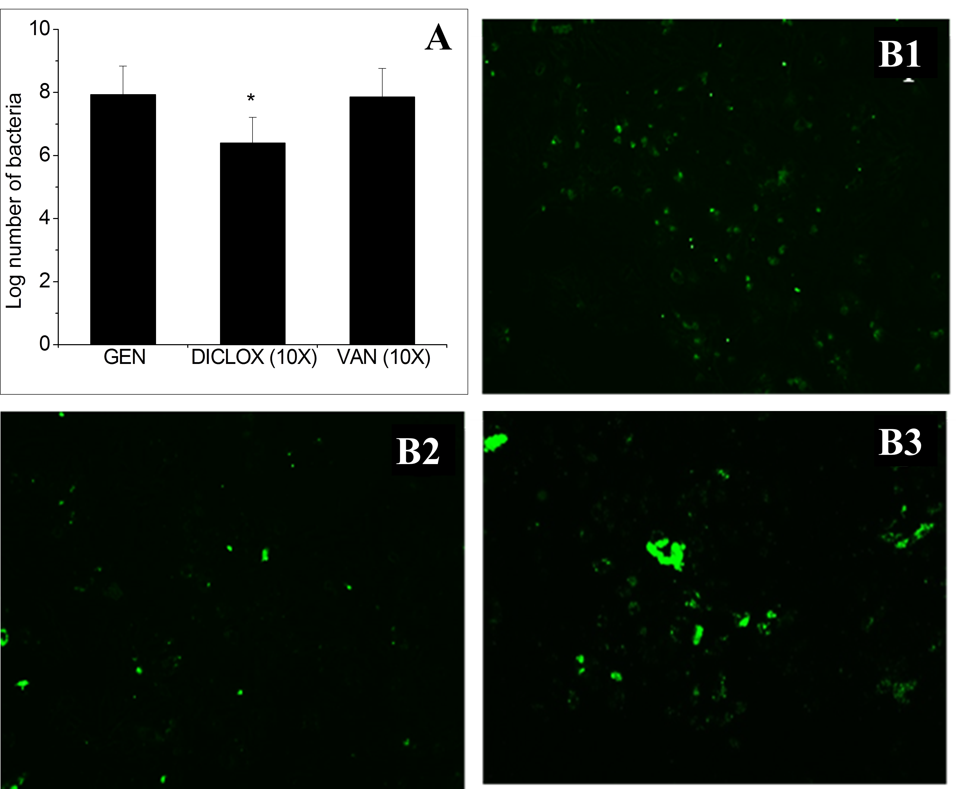
Figure 2. (A) Effect of antibiotics (GEN, DICLOX and VAN) at 10x MIC on killing of intracellular S. aureus. (B) Fluorescent microscopic images showing osteoblast infected S. aureus after treatment with 10x MIC of (1) GEN, (2) DICLOX, (3) VAN. DICLOX was effective in reducing intracellular S. aureus, however VAN showed no effect.

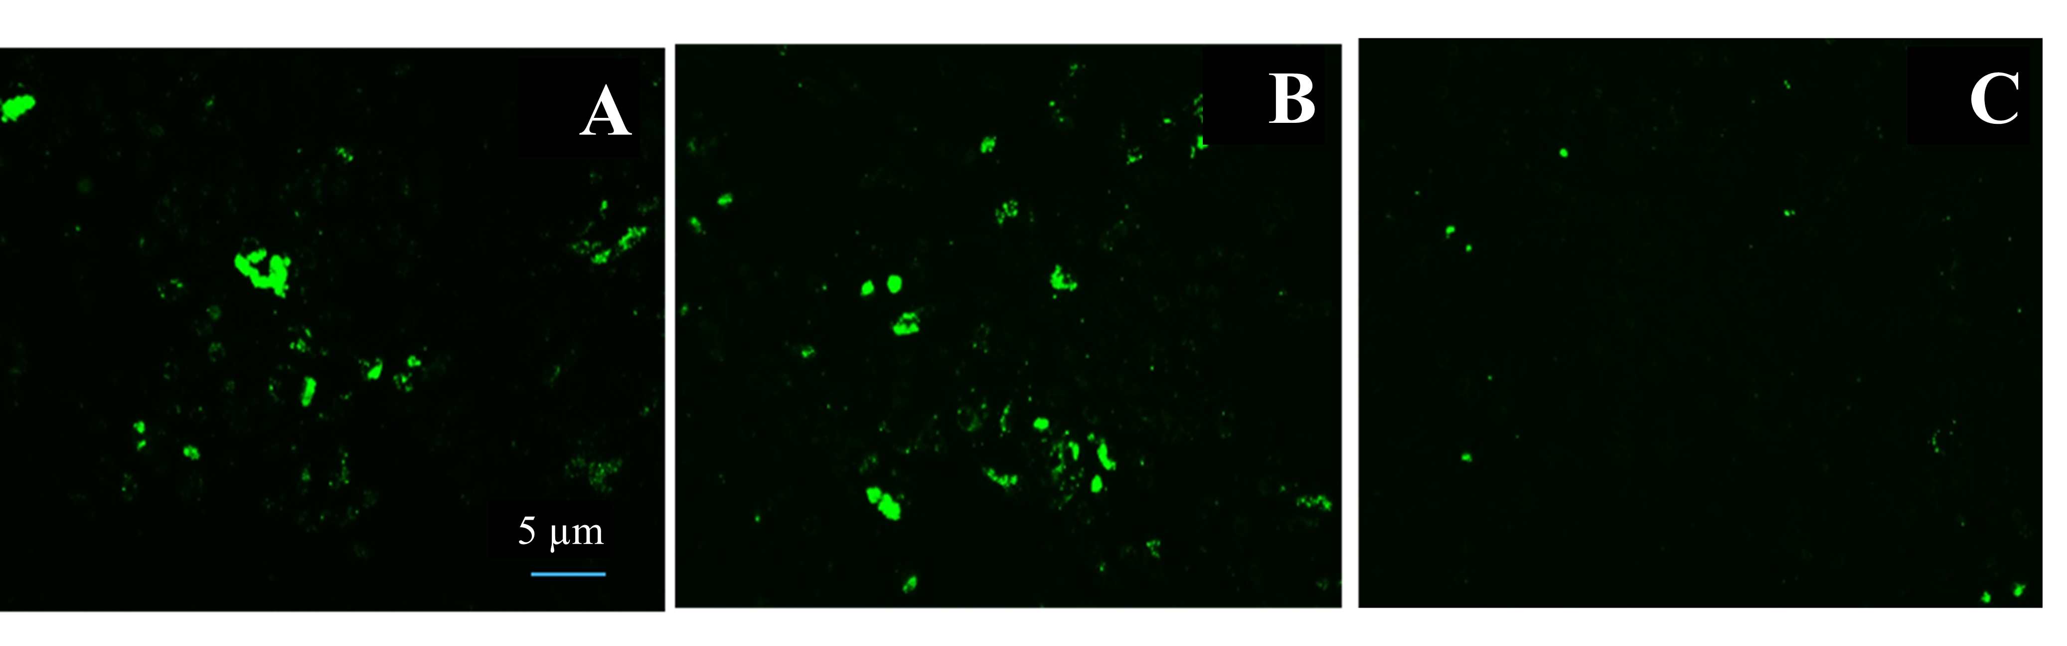
Figure 3. Fluorescent microscopy showing effect of (A) 10x MIC of VAN alone and in combination with (B) PIP (1x MIC) and (C) CCCP (1x MIC) on intracellular S. aureus.

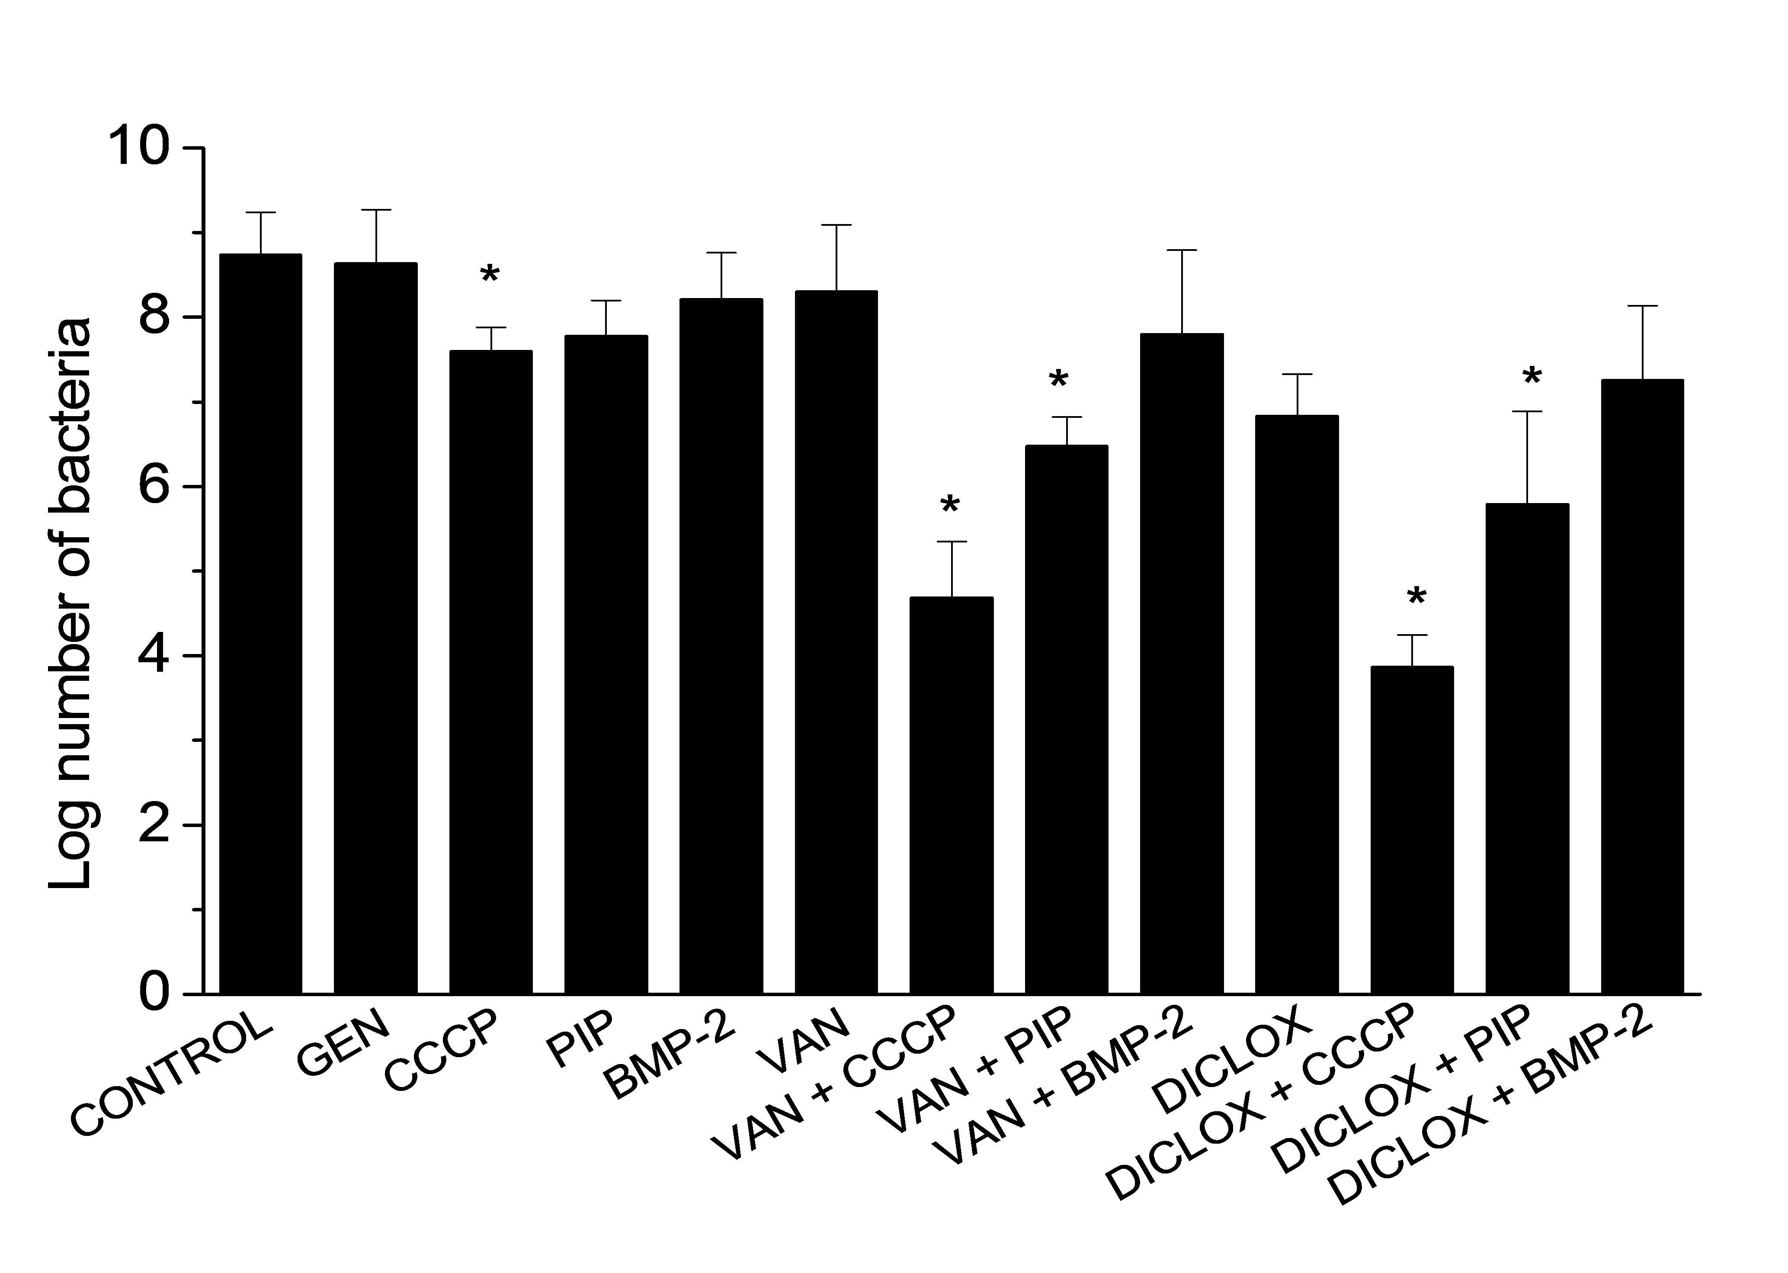
Figure 4. Effect of VAN and DICLOX (10x MIC) alone and in combination with 1x MIC of CCCP and PIP on intracellular S. aureus.

Figure 5. Transmission and fluorescent images showing morphology and permeability of osteoblasts to propidium iodide after treatment with antibiotics VAN and DICLOX (10x MIC) alone and in combination with CCCP or PIP (1x MIC). The images are taken using CLSM under 10x objective, with a 5x zoom.

Figure 6. Image analysis showing percent uptake of propidium iodide (PI) within osteoblasts treated with VAN, DICLOX, CCCP, PIP alone and in combination.

Table 1: Effect of antibiotics and chemical agents on osteoblast cell viability using WST-1 reagent. Decreasing absorbance shows decreased viability of osteoblasts.

OSTEOBLAST PROLIFERATION
(WST-1) OD₅₄₀₋₆₉₀
CONTROL | 0.56 ± 0.04
GENTAMICIN | 0.51 ± 0.09
VAN (10x MIC) | 0.47 ± 0.03
DICLOX (10x MIC) | 0.45 ± 0.01
PIP (1x MIC) | 0.55 ± 0.05
CCCP (1x MIC) | 0.51 ± 0.02
VAN (10x MIC) + PIP (1x MIC) | 0.48 ± 0.08
VAN (10x MIC) + CCCP (1x MIC) | 0.41 ± 0.06
DICLOX (10x MIC) + PIP (1x MIC) | 0.41 ± 0.07
DICLOX (10x MIC) + CCCP (1x MIC) | 0.36 ± 0.05

