An aluminium battery operating with an aqueous electrolyte

A. Holland, R.D. Mckerracher, A. Cruden and *R.G.A. Wills
Faculty of Engineering and the Environment, University of Southampton, UK

Abstract
Aluminium is an attractive active material for battery systems due to its abundance, low cost, a gravimetric energy density of 2.98 Ah g⁻¹ (c.f. lithium 3.86 Ah g⁻¹) and a volumetric energy density of 8.04 Ah cm⁻³ (c.f. lithium 2.06 Ah cm⁻³). An aqueous electrolyte-based aluminium-ion cell is described using TiO₂ nanopowder as the negative electrode, CuHCF (copper-hexacyanoferrate) as the positive electrode and an electrolyte consisting of 1 mol dm⁻³ AlCl₃ and 1 mol dm⁻³ KCl. Voltammetric and galvanostatic analysis have shown that the discharge voltage is circa 1.5 V. Both a single cell and 2-cell battery are demonstrated using 10 cm² electrodes and 126 mg and 256 mg total active material for the 1-cell and 2-cell batteries respectively. The single cell exhibits an energy density of circa 15 mW h g⁻¹ (combined positive and negative electrode masses) at a power density of 300 mW g⁻¹ with energy efficiency remaining above 70 % for over 1750 cycles. Initial characterisation shows charge storage is due to the presence of Al³⁺. Cell capacity is circa 10 mA h g⁻¹ and operates with a discharge voltage of circa 1.5 V (efficiency >80 % at 20C charge/discharge rate).

Key Words: aqueous aluminium ion battery

*Corresponding Author:
Dr Richard Wills (rgaw@soton.ac.uk)
University of Southampton, Faculty of Engineering and the Environment, Highfield, Southampton, SO17 1BJ, UK

Introduction
The consumption of renewable energy, excluding hydropower, has grown almost exponentially over the past 20 years [1]. Most of this growth has come in the form of distributed solar PV and wind power which can cause a number of problems for electricity grids. For example, cloud cover can cause output from solar PV plants to be subject to large voltage and power fluctuations. This can be alleviated through use of low energy but high power, high cycle life and fast response energy storage systems [2]. Given suitable electrode materials, the high conductivity of aqueous electrolytes mean aqueous intercalation batteries may be capable of providing these characteristics in addition to being safe, non-toxic and potentially low-cost when compared to non-aqueous systems, such as ionic liquids. This communication reports on the construction and testing of a fully functional aqueous Alion cell. It should be noted that the majority of Al-ion research focusses on room temperature ionic liquid electrolyte systems (RTILs) theoretically allowing the utilisation of aluminium metals high capacity through reversible deposition [3-10]. The primary research aim becomes the identification of positive electrode materials that will not severely limit cell capacity. Table 1 provides an overview of RTIL based Al-ion systems reported in the literature to date. Cycle life varies from just 50 to 7500. Applied currents also vary considerable between reported electrodes, form 12 mA g⁻¹ up to 5000 mA g⁻¹. The majority of studies use AlCl₃/EMICl (1-Ethyl-3-methylimidazolium chloride) or AlCl₃/BMICl (1-Butyl-3-methylimidazloium chloride) as the electrolyte. Given a suitable positive electrode, a high capacity and energy density cell could be constructed. The best-performing cell to date, with a natural graphite positive electrode, has achieved a capacity of c.a. 100 mA h g⁻¹ when cycled at 198 mA g⁻¹. However, the expense and corrosiveness of RTILs are significant disadvantages of such a battery system.

Table 1. Comparing Al-ion cells utilising room temperature ionic liquid (RTIL) electrolytes.

Paper Electrode and Specific Cyclability Coulombic Voltage range/
D.-Y Wang et al, Nat Comm  8, 2017 [9] | Natural graphite/Al.  AlCl₃/EMICl | ~60mAh g⁻¹ at 660mA g⁻¹.  100mAh g⁻¹ at 198mA g⁻¹. | 6000 cycles | ~100% | - plateaus between  2.5-1.5V
S. Wang et al,  ACS Nano 11,  2017 [23] | CuS-C composite/Al.  AlCl₃/EMICl | ~100mAh g⁻¹ at 20mA g⁻¹. | 300 cycles | ~100% | Charged between  1.3-2.V. Limited discharge plateau  between 1.05 and  0.1V.
Angell et al,  PNAS 114,  2016 [24] | Graphite/Al  metal.  AlCl₃/urea | ~73mAh g⁻¹ at  100mA g⁻¹ | 180 cycles | 100-99% | - plateaus between  2.2-1.0V
Lin et al,  Nature 520,  2015 [21] | Graphitic foam/Al metal.  AlCl₃/EMICl | ~60mAh g⁻¹ at  5000mA g⁻¹ | 7500 cycles | >95% | Plateau between  2.5-1.5V
Electrolyte Capacity Efficiency profile
 | Pyrolytic graphite/Al metal.  AlCl₃/EMICl | ~65mAh g⁻¹ at 66mA g⁻¹ | Stable over 200 cycles | ~98% | Plateau between  2.25–2.0V
Sun et al,  Chem. Comms  51, 2015 [25] | Carbon paper/Al  foil.  Molybdenum  current collector.  AlCl₃/EMICl | ~70mAh g⁻¹ at 100mA g⁻¹ | Good capacity retention over  100 cycles graphite layer spacing  increases by  ~38% | ~100% after 3rd cycle | Plateau between  1.8-1.4V under discharge
Wang et al, App. Mater.  Interfaces 7,  2015 [26] | V₂O₅ (binder free)/Al metal.  AlCl₃/EMICl | 239mAh g⁻¹ at  44.2mA g⁻¹ | Decreases to ~180mAh g⁻¹ after 5th cycle | - | Limited plateau between 0.7 and  0.5V
Geng et al,  Chem. Mater.  27, 2015 [27] | Mo₆S₈/Al metal. AlCl₃/BMICl | 70mAh g⁻¹ at 12mA g⁻¹.  40mAh g⁻¹ at  60mA g⁻¹ | Stable from 3rd – 50th cycles | >100% | Two plateaus.  Dominant plateau between 0.55-0.5V
Hudak, J.  Phys. Chem.  118, 2014 [28] | Conducting polymers/Al  metal. AlCl₃/  EMICl | 70-45mAh g⁻¹ at  20mA g⁻¹  (polypyrrole)  90-70mAh g⁻¹ at  16mA g⁻¹  (polythiophene) | 15% fade up to 100 cycles.  Negligible fade from 50th 400th. | >91% columbic  (polypyrrole)  , >96%  (polythiophe ne) | 0.6-1.9V/No plateaus.

The use of water as solvent for an aluminium salt has the potential to provide a cheap, inherently safe and more conductive electrolyte system compared to RTILs. Table 2 summarises the literature available for the aqueous aluminium ion battery. Only three electrode materials, anatase TiO₂, copperhexacyanoferrate (CuHCF) and aerogel V₂O₅ have been shown to allow the reversible intercalation of Al³⁺ in aqueous electrolytes [11-16]. The most successful negative electrode was black-anatase TiO₂, reported by He et al (He, Peng, Chu, Li, & Tong, 2014), that produced a high capacity of 270 mAh g¹, in 1 mol dm⁻³ Al(NO₃)₃, although only 300 cycles were reported. CuHCF was shown by Liu et al to give a capacity of 41 mAh g⁻¹ at 400 mA g⁻¹ in 0.5 mol dm⁻³ Al₂(SO₄)₃ (Liu, Pan, Li, & Gao, 2015). A capacity fade of 41% was measured over 1000 cycles. CuHCF has also been tested as a positive electrode for an Al-ion cell containing organic electrolyte but reversible capacity was low at 5-14 mA h g⁻¹ [13]. However, CuHCF, along with a number of other hexacyanoferrates, have also been shown to function as positive electrodes in other aqueous electrolytes containing K⁺, Na⁺, Mg²⁺ or Zn²⁺ [1417]. Specific capacities of approximately 50-60 mA h g⁻¹ are often reported. It should be noted that the capacities quoted regarding aqueous Al-ion cells are for individual electrode materials and not operational cells, where the positive and negative materials must be jointly considered. Furthermore, these studies have been limited to half-cell analysis and not operated in a battery configuration. In this paper, we discuss the electrochemical performance of a combined cell and a two-cell battery, demonstrating an operational system based on an aqueous electrolyte containing Al³⁺.

Table 2 Comparing electrodes used in aqueous aluminium electrolytes.
Paper | Electrode and Electrolyte | Specific Capacity | Cyclability | Columbic  Efficiency | Voltage range/ profile
Kazazi et al,  Solid state  Ionics 300,  2017 [18] | Half-cell – TiO₂ nano-spheres.  1M AlCl₃.  (0.785cm) | 180mAh g⁻¹ at 50.25mA g⁻¹. 105mAh g⁻¹ at 2010 mA g⁻¹. | ~6% fade over  30 cycles | ~90% from  50.25mA g⁻¹  2010 mA g⁻¹. | -0.3V - -1.2V vs Ag/AgCl. Discharge plateau at -0.95V - -0.9V.
Gonzalez et al,  RSC Advances  6, 2015 [19] | Half-cell - V₂O₅  aerogel.  1M AlCl₃.  (Swagelok-T) | 120mAh g⁻¹ at 60mA g⁻¹.  ~15mAh g⁻¹ at  200mA g⁻¹ | ~40% fade at  60mA g⁻¹ and  ~25% fade at  200mA g⁻¹ over 13 cycles | ~85% | -0.4V – 0.15V vs  MSE. Discharge plateau at -0.15V.
Liu et al, J.  Mater. Chem.  3, 2015 [12] | Half-cell –  CuHCF. 0.5M  Al₂(SO₄)₃.  (<2mg, 0.5cm²) | 41mAh g⁻¹ at 400mA g⁻¹ | 45% fade over  1000 cycles | ~100% | 1-0.2V. No plateau.
He et al, J.  Mater. Chem.  2, 2014 [11] | Half-cell – TiO₂ nano-leaves.  1M Al(NO₃)₃.  (9mg) | 271mAh g⁻¹ at 50mA g⁻¹.  141mAh g⁻¹ at 2A g⁻¹ | 8.4% fade after  300 cycles at 50mA/g | ~100% | 1.35-0.45V.  Discharge plateau at ~0.97V.²
Y. Liu et al,  Electro. Acta  143, 2014 [20] | Half-cell – TiO₂ nano-wire array.  0.5M Al₂(SO₄)₃ | 75mAh/g at 4mA/cm² | - | ~85% | 1.1-0.9V/  Discharge plateau just below 1V
Liu et al,  Energy and Environ.  Science 5,  2012 [21] | Half-cell. TiO₂ nano-tube array  film.  1M AlCl₃ | 75mAh g⁻¹ at  4mA cm⁻² | - | ~90% | 1.1-0.4V/  Discharge plateau between 1.1 -  ~0.8V

Experimental procedure
Anatase-TiO₂ nanopowder (< 25 nm) was used as received from Sigma Aldrich. Electrode inks were prepared through the addition of TiO₂, carbon black (CB) and Nafion binder, in the ratio 9:0.5:0.5 by wt%. The positive electrode consisted of CuHCF, carbon black (CB) and Nafion binder in the ratio 8:1:1. Propanol was added to form inks of suitable viscosity (approximately 3:1 propanol:active material) and mixed at 5000 rpm for 30 minutes using Silverson shear blade mixer. The resulting inks were coated onto Sigracell PV10 carbon polymer current collectors from SGL and left to dry in ambient conditions.
CuHCF was prepared through a standard precipitation method. 1.5 mol dm⁻³ solution Cu(NO₃)₂ was added to 1 mol dm⁻³ solution of K₃[Fe(CN)₆] and stirred for a minimum of 2 hours at room temperature. The precipitate was centrifuged and washed five times before drying in air at 80°C and grinding to form CuHCF powder.
Standard 3-electrode glass cells were used for cyclic voltammetry (CV) to characterise the electrochemical activity of TiO₂ in aqueous electrolytes. A saturated calomel electrode (SCE) was used as the reference electrode and a platinum wire as the counter electrode. An Ivium multi-channel electrochemical analyser was used for CV scans. The galvanostatic performance of both electrodes was investigated in full cells through oversizing of the opposing electrode so that the cell capacity was only dictated by the electrode under investigation. An SCE reference electrode was used, in connection with a National Instruments data acquisition module, for voltage measurements of individual electrodes when being operated in a full cell, see figure 1. For these 2-electrode experiments, capacities of 16 mA h g⁻¹ and 50 mA h g⁻¹ were assumed for TiO₂ and CuHCF respectively such that a 20C cycle rate corresponds to 333 mA g⁻¹ for TiO₂ and 1000 mA g⁻¹ for CuHCF. A balanced cell, where the TiO₂-electrode capacity was approximately equal to CuHCFelectrode capacity, used 10 cm² of each active material on carbon polymer, separated by an electrolyte cavity, as shown in Figure 1. Positive and negative electrode loadings were 3.8 mg cm⁻² and 8.5 mg cm⁻² for the final cell, constituting larger format electrodes than previously reported. Electrode loadings for the 2-cell battery were 3.6 mg cm⁻² and 9.2 mg cm⁻². When operated as a unit cell, the positive electrode (CuHCF) acted as the working electrode for the Ivium analyser, with the negative electrode (TiO₂) being connected to the counter and reference electrode terminals.
Neutron diffraction analysis was obtained using the GEM diffractometer via GEM Xpress operated at ISIS under project numbers (RN 1690193 & 1690194). Data sets were interpreted by the facility.

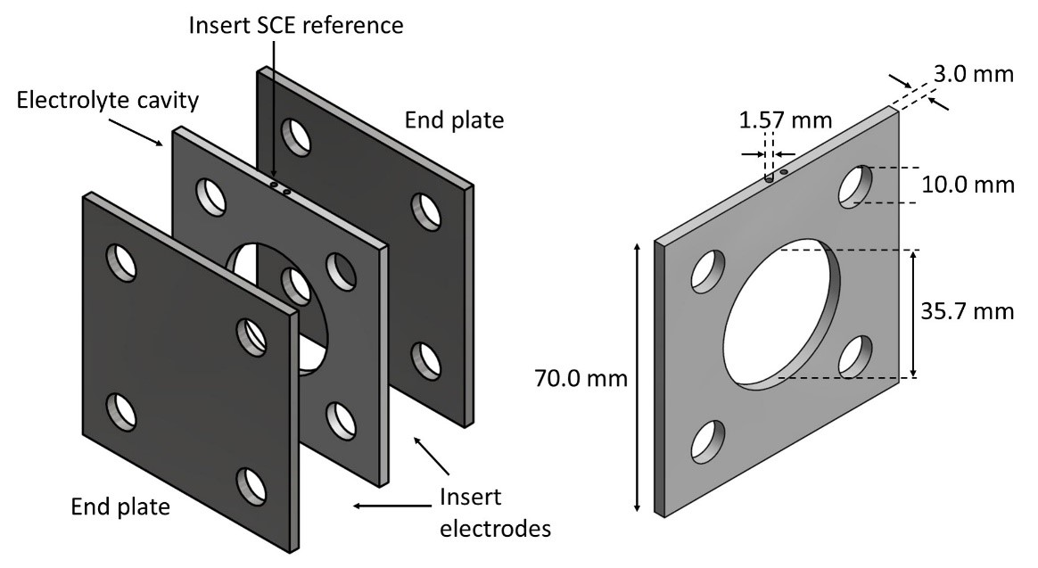
Figure 1. Schematic of the cell configuration used for the aqueous Al-ion cell. End plates were made of stainless steel and electrolyte cavity insert of PEEK.

Results and Discussion
A cyclic voltammogram was obtained at a TiO₂ electrode (cell anode) in aqueous 1 mol dm⁻³ AlCl₃, 1 mol dm⁻³ KCl and 1 mol dm⁻³ KCl/10 mmol dm⁻³ HCl. The potential was swept from 0 V to -1.5 V vs. SCE before returning to 0 V. A constant sweep rate of 10 mV s⁻¹ was maintained throughout. Figure 2 presents the voltammogram with overlaying photographic images of the electrode surface at key potentials. Towards negative potentials, a reduction wave associated with Al³⁺ interacting with the TiO₂ electrode commences at circa -0.8 V with an associated peak at circa -1.31 V. The current peaks at -9.7 A g⁻¹. On the reverse sweep, an oxidation wave is observed, with a peak of 7.2 A g⁻¹, at -0.85 V. Both reduction and oxidation waves have secondary peaks, at circa 0.98 V and circa -1.05 V respectively, indicating more than one reaction process associated with the TiO₂/Al³⁺ interaction. In 1 mol dm⁻³ AlCl₃, electrolyte stability at the electrode is good, with the onset of H₂ evolution not yet visible at -1.5 V. An electrolyte containing 1 mol dm⁻³ KCl gave rise to no discernible redox activity, however, demonstrating that the redox phenomena are linked to the presence of Al³⁺ in the electrolyte solution. With the addition of HCl, small reduction and oxidation peaks, of approximately 1 A g⁻¹, became apparent at roughly -0.9 V and -0.8 V respectively. This suggests an inherent response from anatase TiO₂ in acidic aqueous electrolyte, which is an order of magnitude smaller in capacity than the response obtained in the presence of Al³⁺.
Photographic images were periodically taken, during a scan of a TiO₂-only electrode, and have been overlaid at the appropriate potentials in Figure 2. These images graphically show the charge/discharge process at the negative electrode. In the charged state, the electrode is dark blue-grey, while in the discharged state the electrode almost returns to the original white colour associated with TiO₂. These changes could be attributed to the reduction of Ti⁴⁺ to Ti³⁺ via four possible processes: Al³⁺ surface adsorption, Al³⁺ intercalation, H⁺ surface adsorption and/or H⁺ intercalation. Further mechanistic studies are planned to fully elucidate the processes involved.
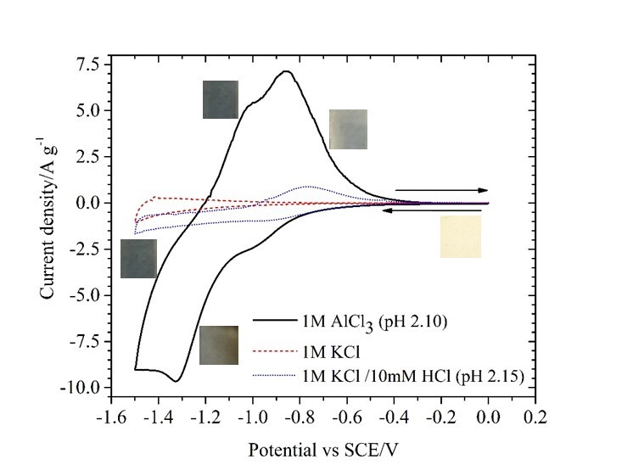
Figure 2. Cyclic voltammetry of a TiO₂ electrode in 1 mol dm⁻³ AlCl₃ as well as ‘blank’ electrolytes consisting of 1 mol dm⁻³ KCl and 1 mol dm⁻³ KCl with 10 mmol dm⁻³ HCl. A scan rate of 10 mV s⁻¹ was used.
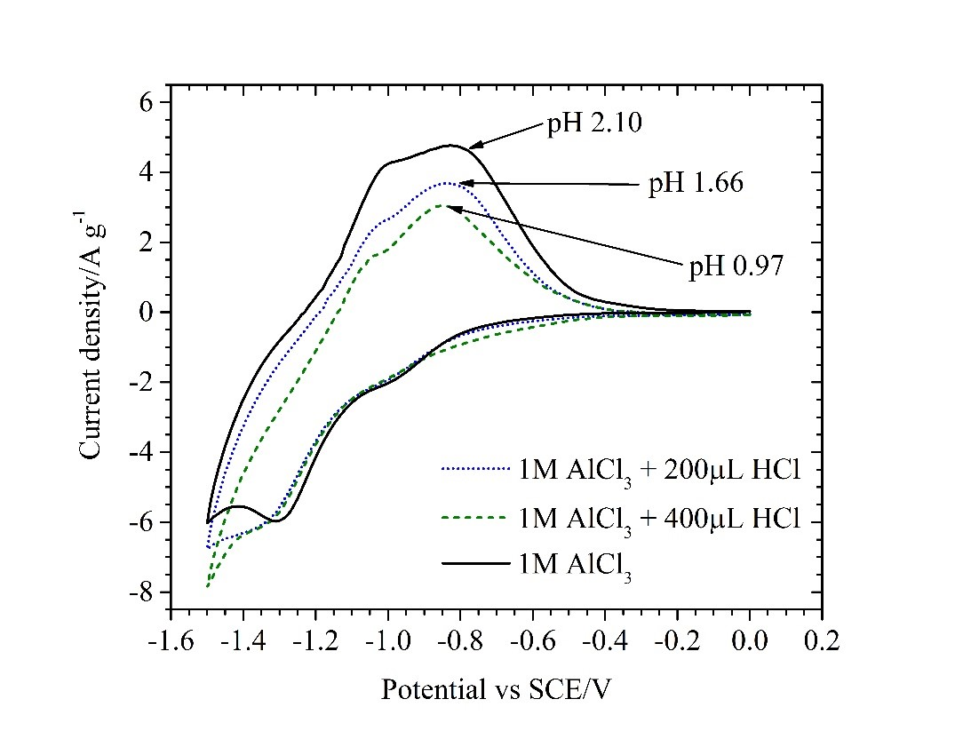
Figure 3. Cyclic voltammetry of a TiO₂ electrode in 1 mol dm⁻³ AlCl₃ electrolytes of increasing acidity. A scan rate of 10 mV s⁻¹ was used.

The effect of acidity on the response is shown in Figure 3. Anodic peak currents are seen to decrease with increasing acidity, while cathodic peaks became decreasingly prominent, due to hydrogen evolution. This suggests that increasing the acidity of the electrolyte would be detrimental to cell performance. In conjunction with Figure 1, it can be concluded that the redox activity of anatase TiO₂ is primarily due to the presence of Al³⁺ and not protons.
Neutron diffraction analysis of the negative electrode was carried out at ISIS using the General Materials Diffractometer (GEM). Two runs were undertaken: 79453 (freshly prepared electrode) and 79454 (electrode after charge/discharge cycling). The results showed a very good fit to a TiO₂ structure with the two data sets having the following lattice parameters: 79453 a @ 3.7707(9), b @ 3.7706(10), c @ 9.4631(23) and 79454 a @ 3.7697(9), b @ 3.7695(10), c @ 9.4589(24). That is a difference of 0.001 Angstroms in a, 0.002 in b and 0.004 in c. This is a very slight shift in lattice parameters between an unused electrode and one that has been exposed to Al³⁺ in a battery environment. This represents a shift higher than the measured error (by an order of magnitude in a, by a factor of 2 in b and c) and so may be significant. While this lattice expansion may be evidence of Al³⁺ intercalation, further analysis is required on in-situ electrodes over a range of states of charge to validate the mechanism.
Cyclic voltammograms were obtained at CuHCF electrodes (cell cathode) in 1 mol dm⁻³ AlCl₃ and 1 mol dm⁻³ KCl. The voltammetric response is presented in Figure 4. In 1 mol dm⁻³ AlCl₃, broad reduction and oxidation peaks are visible at 0.6 V and 1.05 V respectively. Broad shoulders are also observed during the anodic and cathodic sweeps, centred on 0.7 V and 1.0 V respectively. Bulk oxygen evolution was observed at potentials more positive than 1.3 V vs. SCE. 1 mol dm⁻³ KCl produces sharper peaks at 0.74 V and 1.0 V, suggesting more facile insertion of K⁺ than Al³⁺. The use of a mixed Al³⁺/K⁺ electrolyte may therefore provide favourable cell operation where TiO₂ and CuHCF are utilised as the negative and positive electrodes.
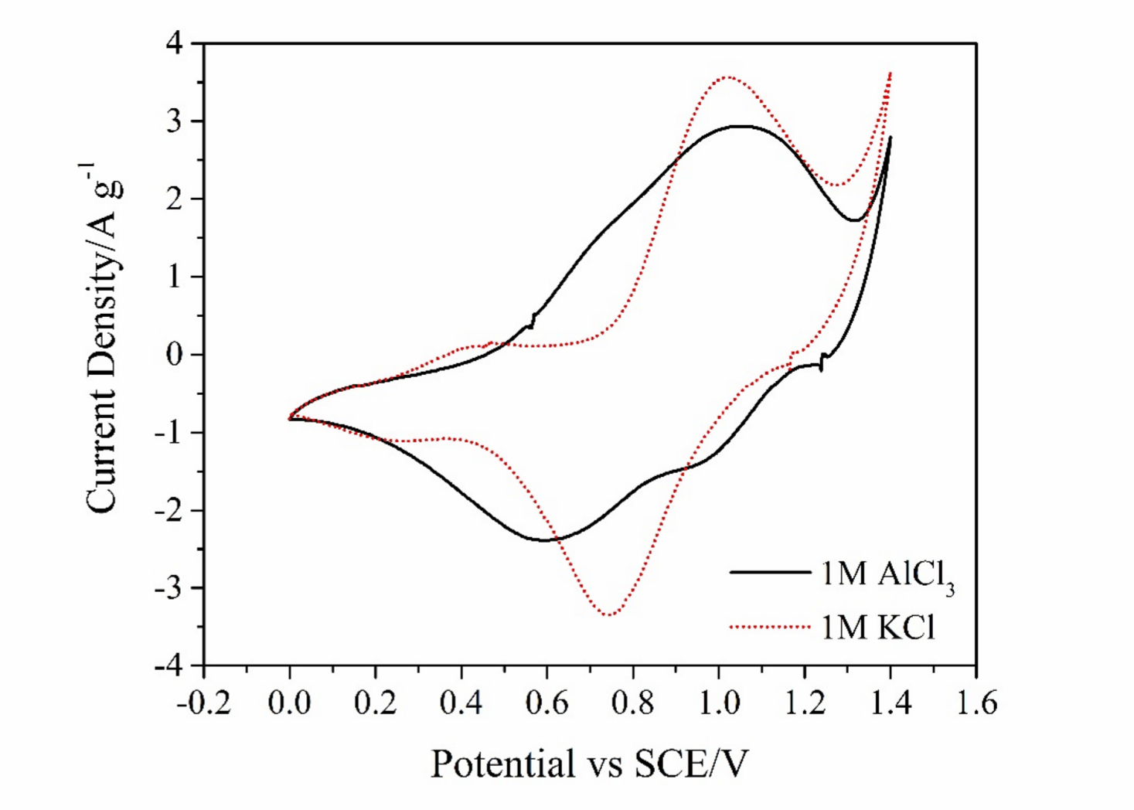
Figure 4. Cyclic voltammetry of CuHCF at 20 mV s⁻¹ in 1 mol dm⁻³ AlCl₃ and 1 mol dm⁻³ KCl. An SCE and Pt-wire were used as reference and counter electrodes.

With redox activity of TiO₂ and CuHCF in Al³⁺ containing electrolyte confirmed, the performance of these electrodes was tested in aqueous Al-ion cells. Cells were limited by a single electrode by ensuring the capacity of the opposite electrode was considerably larger. TiO₂ was galvanostatically charged to a specific capacity at a current density of 333 mA g ⁻¹. Figure 5 shows the discharge capacity and coulombic efficiency of TiO₂ as a function of charge input. Above a 16-17 mA h g⁻¹ charge input, there is limited increase in discharge capacity while the associated coulombic efficiency drops dramatically from >80% to <50% at beyond 30 mAh g⁻¹. Both TiO₂ and CuHCF limited 2electrode cells were then cycled at a charge and discharge current density of 333 mA g⁻¹ for 1000 cycles. The results are summarised in Table 3. TiO₂ produced a capacity of 14.5 mA h g⁻¹ which decreased by ~7 % after 1000 cycles (c.f. 45 % capacity fade over 1000 cycles previously reported in the literature [13]) demonstrating that while the capacity is initially low, the electrode material and architecture is robust. The TiO₂ electrode was cycled The capacity is considerably lower than would be expected from an intercalation electrode. The theoretical capacity of TiO₂ is 335 mA h g⁻¹
assuming intercalation proceeds according to reaction 1 [11], where 0<𝑥<1/3 since charge capacity is likely limited by the Ti⁴⁺/Ti³⁺ couple. This suggests Al³⁺ surface adsorption to be the most likely charge storage mechanism.

𝑇𝑖𝑂!+ 𝑥𝐴𝑙!!+3𝑥𝑒!↔ 𝐴𝑙!𝑇𝑖𝑂! (1)

The coulombic efficiency of TiO₂ remained around 80% while the energy efficiency decreased by only 5% from a maximum of 71%. The more negative voltage profile in Figure 6 corresponds to the TiO₂ electrode, vs SCE, during cycling. A very small initial voltage hysteresis shows the electrode should be capable of discharge at higher rates, however, coulombic efficiency is clearly low and may be indicative of a simultaneous self-discharge process.
Galvanostatic cycling of CuHCF at 1000 mA g⁻¹ produced a capacity of ~50 mAh g⁻¹ throughout >1000 cycles. Coulombic efficiency was 97.2% after 20 cycles and decreased to 94%; energy efficiency of the CuHCF-limited cell remained at ~66% over >1000 cycles, which surpasses the previously reported cycling of electrodes incorporating CuHCF [5]. The more positive voltage profile in Figure 6 corresponds to CuHCF during a typical cycle. During charge, two plateaus are visible at 0.75 V and 1.1 V, each accounting for approximately half of the charge capacity. Similarly, two discharge plateaus are visible at 0.98 V and 0.65 V, although the first discharge plateau accounts for only 7% of the discharge capacity. The nature of the two plateaus is not yet understood. The 0.1 V hysteresis between final charge voltage and initial discharge voltage suggests the rate capability of CuHCF may be inferior to TiO₂, although coulombic efficiency is clearly superior. The <100% efficiency is attributed to side reactions such as O₂ evolution.

Table 3. Summary of performance of TiO₂- and CuHCF- limited cells cycled in 1 mol dm⁻³ AlCl₃ and 1 mol dm⁻³ KCl at a current density of 333 mA g⁻¹ (based on the mass of the limiting electrode).
 | TiO₂ (333 mA g⁻¹) | CuHCF (1000 mA g⁻¹)
Capacity | 14 mA h g⁻¹ | 50 mA h g⁻¹
Average discharge voltage | -0.65 V vs SCE | 0.70 V vs SCE
Coulombic efficiency | 84-80% | 92-94%
Energy efficiency | 72-66% | 66%
Cycled to | >1000 | >1000

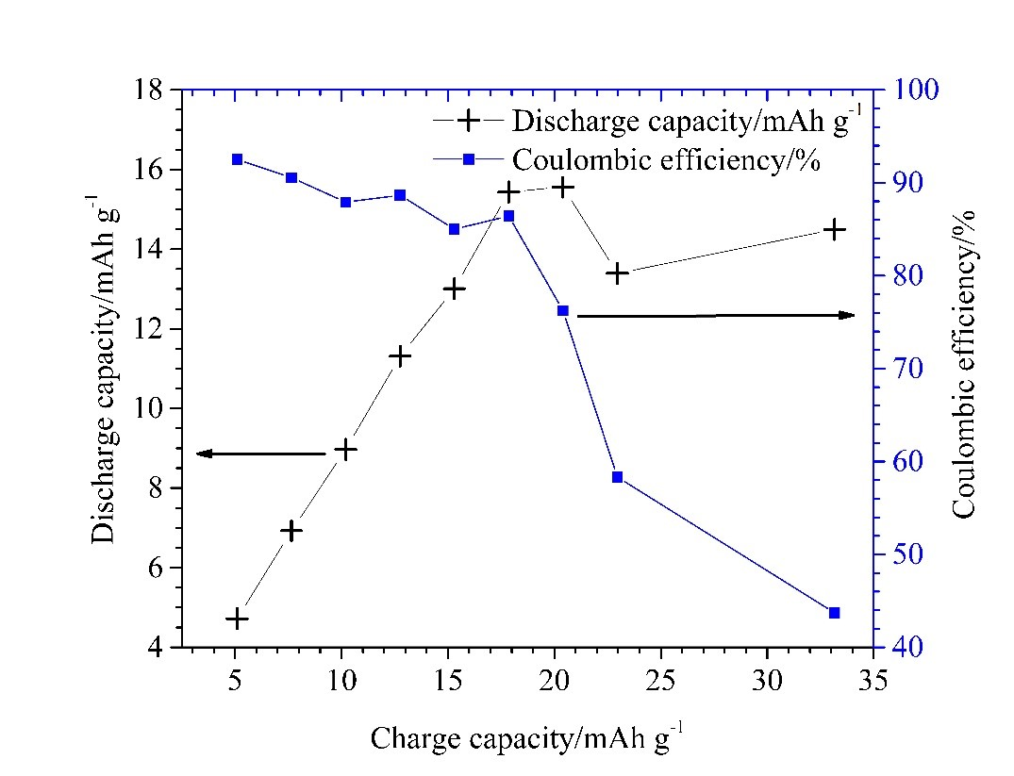
Figure 5. The discharge capacity and coulombic efficiency of a TiO₂ electrode as a function of charge capacity when cycled at 333 mA g ⁻¹ in 1 mol dm⁻³ AlCl₃/1 mol dm⁻³ KCl.
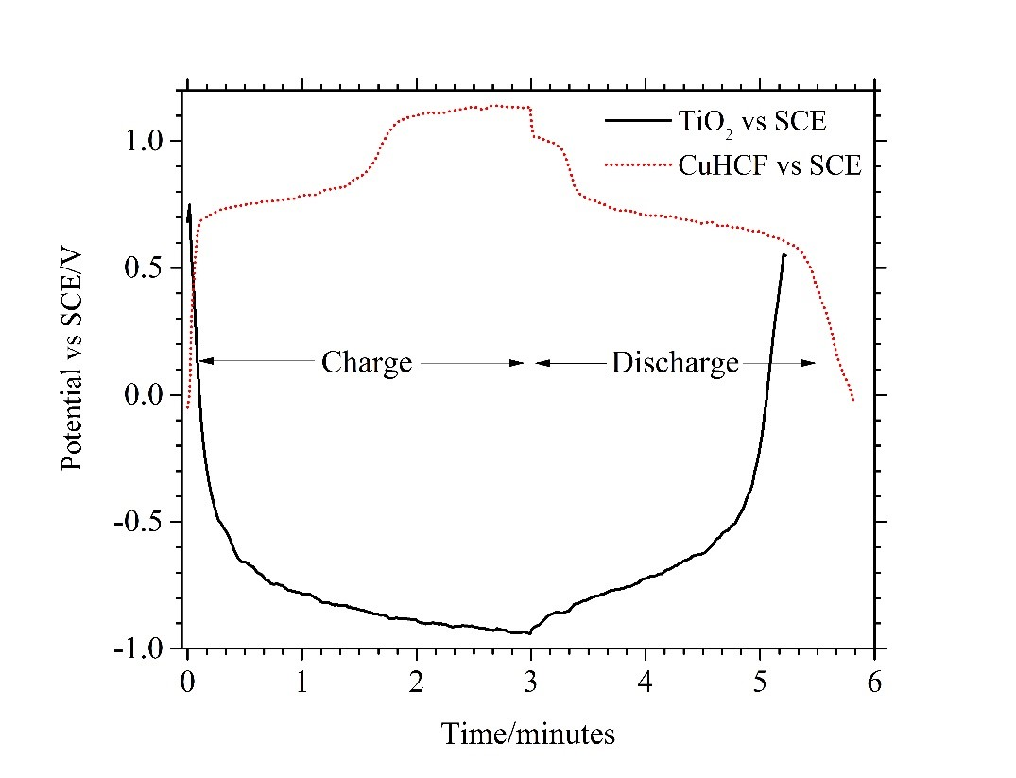
Figure 6. Top (red-dotted): typical voltage profile, vs SCE, of a CuHCF electrode under cycling at 1000 mA g⁻¹. Bottom (black-solid): typical voltage profile, vs SCE, of a TiO₂ electrode under cycling at 333 mA g⁻¹. A 1 mol dm⁻³ AlCl₃/1 mol dm⁻³ KCl electrolyte was used in both cells.
A balanced cell (85 mg TiO₂ vs 38 mg CuHCF), was cycled nearly 2000 times at a current corresponding to a 20C rate. The efficiencies and discharge capacity throughout cycling is shown in figure 7 with the evolution of the voltage profile given in figure 8. A maximum capacity, calculated from the combined mass of electrodes, of circa 10.6 mA h g⁻¹ remained above 10 mA h g⁻¹ until the 1814th cycle. An average discharge voltage which ranged between 1.49 V at cycle 100 and 1.46 V at cycle 1750, gives the cell an energy density of ca. 15 mW h g⁻¹. An initial coulombic efficiency of 96% was still above 90% by the 1900th cycle; energy efficiency decreased from ~80% to 70% at cycle number 1778. Therefore, while capacity and energy density remain low, a cell with good voltage, cycle life, efficiency and rate capability has been demonstrated.
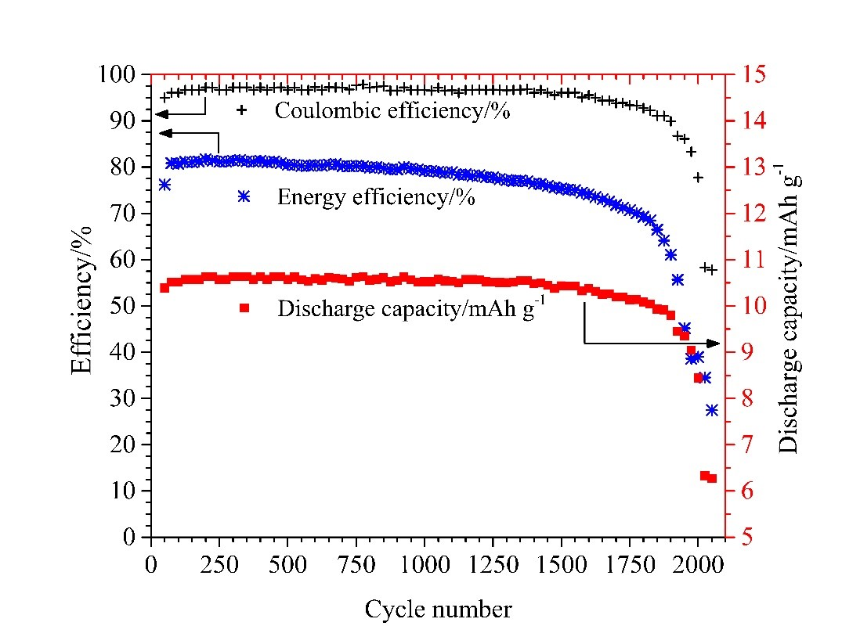
Figure 7. Performance of a balanced Al-ion cell consisting of TiO₂ negative electrode, CuHCF positive electrode and 1 mol dm⁻³ AlCl₃/mol dm⁻³ KCl electrolyte. A 20C charge/discharge rate was used.

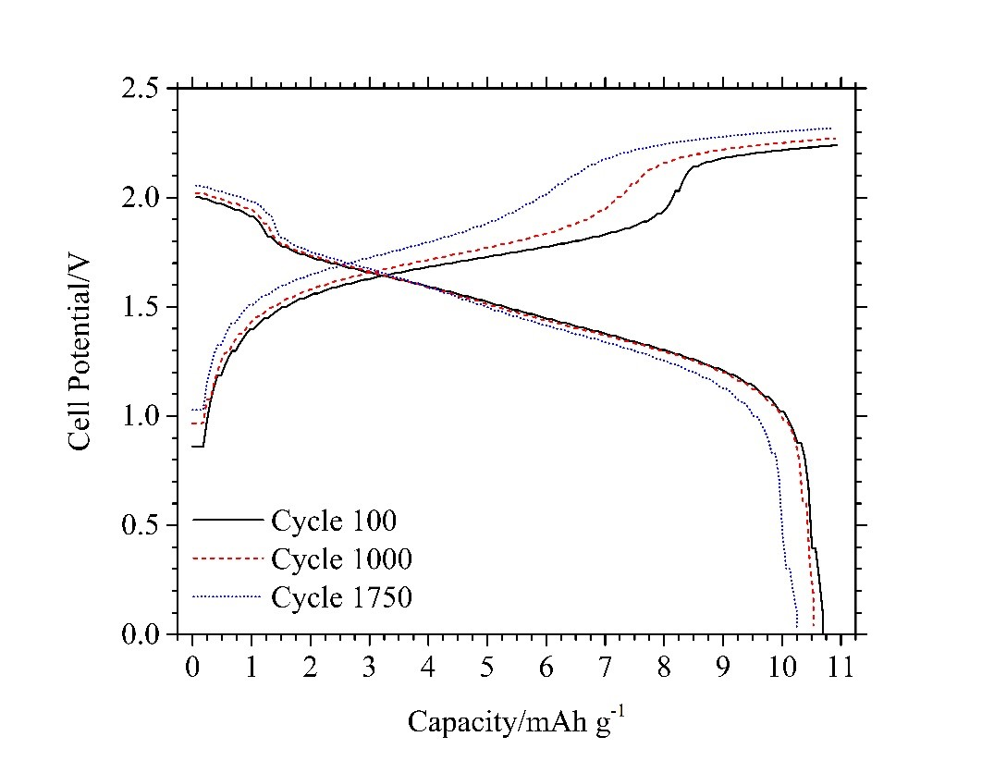
Figure 8. Evolution of the charge/discharge profile of the aqueous Al-ion cell under extended cycling at 20C in 1 mol dm⁻³ AlCl₃/1 mol dm⁻³ KCl.

A 2-cell aqueous Al-ion battery is also demonstrated using a bipolar electrode. The voltage vs. time profile is compared to a single cell in Figure 9. The charge and voltage efficiencies are comparable. Cycling at a 10C rate, the charge voltage increases steadily from circa 2.0 V to 3.5 V, at which point there is a more rapid increase in voltage to 4.1 V before a further steady increase to 4.5 V at the end of charge. During discharge, the voltage decreases steadily from 4.0 V to 3.7 V, at which point there is a rapid drop-off to 3.4 V followed by a more steady decline to 2.0 V at the end of discharge. From Figure 5, the two-voltage stages are associated with the CuHCF positive electrode. An average discharge voltage of 2.93 V was achieved, giving the battery an energy density of 14.8 mW h g⁻¹ according to total mass of active material in both electrodes.

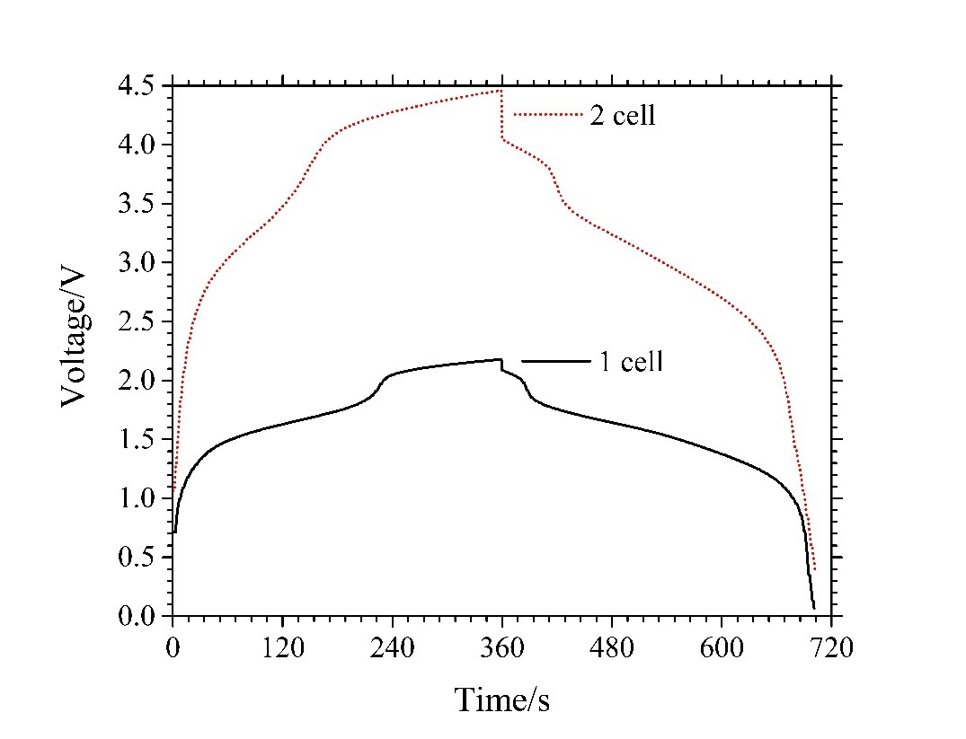
Figure 9. Typical profile of a 1-cell and 2-cell Al-ion battery cycled at a 10C charge/discharge rate in 1 mol dm⁻³ AlCl₃/1 mol dm⁻³ KCl electrolyte.

Conclusion
The first multi-cell battery based on aqueous aluminium ion chemistry is described. The battery is based on anatase (TiO₂) nanopowder, CuHCF and aqueous Al³⁺/K⁺ electrolyte, which are all widely available, cheap and non-toxic materials, providing advantages over current Li-ion and Pb-acid systems. Although the specific energy is relatively low, ca. 15 mWh g⁻¹ active material (combined positive and negative materials), a high charge and discharge rate of 20C is achievable. At the 20 C rate the energy efficiency of the cell remained above 70 % for over 1750 cycles, with only a 7 % capacity fade, demonstrating the longevity of the cell. The low specific energy is caused by the TiO₂ anode; the capacity of CuHCF is c.a. 50 mAh g⁻¹ at a current density of 333 mA g⁻¹.

The charge storage capacity of TiO₂ was shown to be due to the presence of Al³⁺ rather than the H⁺ present in the acidic electrolyte. However, the slight shift in neutron diffraction parameters is not sufficient to ascertain whether the main mechanism of charge storage is via Al³⁺ intercalation or a surface adsorption reaction. Further work on elucidating the mechanism could allow the cell capacity to be increased and the active materials to be tailored, for example towards high surface area materials for a surface process or doped materials for intercalation. Self-discharge exhibited by the TiO₂ electrode, most likely due to the presence of dissolved oxygen, needs to be minimised and investigated further.

Acknowledgments
This project has received funding from the European Union’s Horizon 2020 research and innovation programme under rant agreement No 646286. The authors would also like to thank Martin-Owen
Jones at STFC for his assistance in interpreting the GEM neutron diffraction data obtained at ISIS.

References

- BP, "BP Statistical Review of World Energy 2015," 2015.
- EPRI, "Electricity energy storage options: A white paper on applications, costs and benefits," EPRI, Palo Alto, CA, 2010.
- D.-­‐Y. W. e. al, "Advanced rechargeable aluminium ion battery with a high-­‐quality natural graphite cathode," Nature communications, vol. 8, p. 14283, 2017.
- S. W. e. al, "High-­‐Performance Aluminum-­‐Ion Battery with CuS@C Microsphere Composite Cathode," ACS Nano, vol. 11, pp. 469-­‐477, 2017.
- M. Angell, C.-­‐J. Pan, Y. Rong, C. Yuan, M.-­‐C. Lin, B.-­‐J. Hwang and H. Dai, "High Coulombic efficiency aluminum-­‐ion battery using an AlCl3-­‐urea ionic liquid analog electrolyte," PNAS, vol. 114, no. 5, pp. 834-­‐839, 2016.
- M.-­‐C. Lin, M. Gong, B. Lu, YingpengWu, D.-­‐Y. Wang, M. Guan, M. Angell, C. Chen, J. Yang, B.-­‐J. Hwang and H. Dai, "An ultrafast rechargeable aluminium-­‐ion battery," Nature, vol. 520, pp. 325-­‐
328, 2015.
- H. Sun, W. Wang, Z. Yu, Y. Yuan, S. Wang and S. Jiao, "A new aluminium-­‐ion battery with high voltage, high safety and low cost," Chemical Communications, vol. 51, pp. 11892-­‐11895, 2015.
- H. Wang, Y. Bai, S. Chen, X. Luo, C. Wu, F. Wu and J. Lu, "Binder-­‐Free V2O5 Cathode for Greener
Rechargeable Aluminum Battery," Applied Matter & Interfaces, vol. 7, pp. 80-­‐84, 2015.
- L. Geng, G. Lv, X. X. and J. Guo, "Reversible Electrochemical Intercalation of Aluminum in Mo6S8," Chemistry of Materials, vol. 27, pp. 4926-­‐4929, 2015.
- N. Hudak, "Chloroaluminate-­‐Doped Conducting Polymers as Positive Electrodes in Rechargeable
Aluminum Batteries," Journal of Physical Chemistry, vol. 118, pp. 5203-­‐5215, 2014.
- Y. J. He, J. F. Peng, W. Chu, Y. Z. Li and D. G. Tong, "Black mesoporous anatase TiO2 nanoleaves: a high capacity and high rate anode for aqueous Al-­‐ion batteries," Journal of Materials Chemistry A, vol. 2, pp. 1721-­‐1731, 2014.
- S. Liu, G. L. Pan, G. R. Li and X. P. Gao, "Copper hexacyanoferrate nanoparticles as cathode material for aqueous Al-­‐ion batteries," Journal of Materials Chemistry, vol. 3, pp. 959-­‐962, 2015.
- L. D. Reed, S. N. Ortiz, M. Xiong and E. J. Menke, "A rechargeable aluminum-­‐ion battery utilizing a copper hexacyanoferrate cathode in an organic electrolyte," Chemical Communications, vol. 51, pp. 14397-­‐14400, 2015.
- M. Pasta, C. D. Wessells, N. Liu, J. Nelson, M. T. McDowell, R. A. Huggins, M. F. Toney and Y. Cui, "Full open-­‐framework batteries for stationary energy storage," Nature Communications, vol. 5,
2014.
- D. R. Trócoli and D. F. La Mantia, "An Aqueous Zinc-­‐Ion Battery Based on Copper Hexacyanoferrate," ChemSusChem, vol. 8, pp. 481-­‐485, 2015.
- Z. Jia, B. Wang and Y. Wang, "Copper hexacyanoferrate with a well-­‐defined open framework as a positive electrode for aqueous zinc ion batteries," Materials Chemistry and Physics, Vols. 149-­150, pp. 601-­‐606, 2015.
- C. D. Wessells, S. V. Peddada and M. T. McDowell, "The Effect of Insertion Species on
Nanostructured Open," Journal of The Electrochemical Society, vol. 159, no. 2, pp. 98-­‐103, 2012.
- M. Kazazi, P. Abdollahi and M. Mirzaei-­‐Moghadam, "High surface area TiO2 nanospheres as a high-­‐rate anode material for aqueous aluminium-­‐ion batteries," Solid State Ionics, vol. 300, pp.
32-­‐27, 2017.
- J. R. Gonz´alez, M. C. F. Nacimiento, R. Alc´antar, P. Lavel and a. J. L. Tirado, "Reversible
intercalation of aluminium into vanadium pentoxide xerogel for aqueous rechargeable batteries†," RSC Advances, vol. 6, pp. 62157-­‐62164, 2016.
- Y. Liu, S. S. Q. Wu, Z. Lu, K. Liu and H. Liu, "The electrochemical behavior of Cl−assisted Al3+insertion intotitanium dioxide nanotube arrays in aqueous solution for aluminumion batteries," Electrochimica Acta, vol. 143, pp. 340-­‐346, 2014.
- S. Liu, J. J. Hu, N. F. Yan, G. L. Pan, G. R. Li and X. P. Gao, "Aluminum storage behavior of anatase TiO2 nanotube arrays in aqueous solution for aluminum ion batteries†," Energy and Environmental Science, vol. 5, pp. 9743-­‐9746, 2012.

Some coulombic efficiencies had to be estimated from charge/discharge cycles and assumed constant and accurate current densities as described.
From the charge-discharge cycle, of TiO₂/Al cell, presented in the papers supplementary material.

