FIGURES AND TABLES
Figure 1. Study design overview
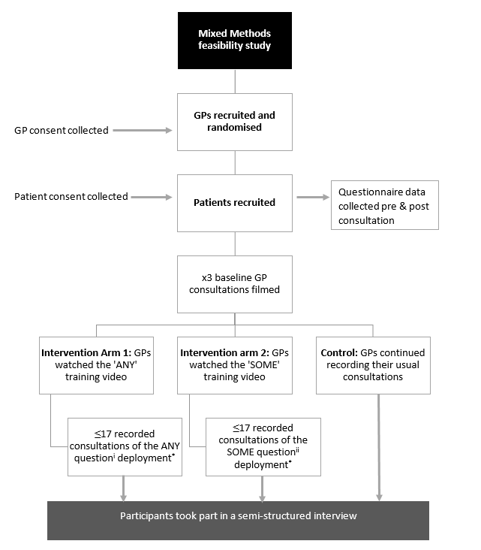

Table 1. Summary of key study outcomes and how they were collected and analysed
Research objective (RO) | Data collection method | Analysis
RO1. Can UK GPs be trained to successfully deploy the intervention questions? | Video-recorded consultations | Comparison of video data to fidelity checking framework.
RO2. How many concerns do patients plan to raise with their GPs? | Pre-consultation  questionnaires | Descriptive statistics
RO3. To what extent do patients raise their planned concerns within GP consultations? | Pre- and Post- consultation  questionnaires
RO4. Does soliciting for additional concerns increase consultation length? | Video recorded consultations
RO5. Does soliciting for additional concerns increase patient satisfaction and/or patient enablement? | Post-consultation questionnaire

Figure 2. Screening and Recruitment
1 patient withdrew leaving a total of 320

105 clinics visited

49 Morning clinics

56 Afternoon clinics

1217 Appointments

(Total No.)

907 patients invited

321 patients recruited

175 Advanced

142 On the Day

312 Total exclusions

N=132 reviews**

N=101 <18 years

N=15 Language

N=64 Considered unsuitable by GP

Table 2. Patient characteristics
 | Control | Some | Any
Gender (female) | 66/110 (60.0%) | 48/87 (55.2%) | 50/81 (61.7%)
Age | 56.0 (SD = 15.8) | 57.5 (SD = 18.9) | 57.2 (SD = 18.8)
Currently in paid work | 62/107 (57.9%) | 42/85 (49.4%) | 38/77 (49.4%)
White ethnicity | 81/110 (73.6%) | 59/87 (67.8%) | 62/81 (76.5%)
Booking type:
On the day | 44/109 (40.4%) | 62/87 (71.3%) | 30/70 (42.9%)
Advance | 65/109 (59.6%) | 25/87 (28.7%) | 40/81 (57.1%)
Number of stated concerns prior to consultation | 1.74 (SD = 0.96) | 1.61 (SD = 0.91) | 1.65 (SD = 0.82)
Reason for attending:
New problem | 35/96 (36.4%) | 43/79 (54.4%) | 40/75 (53.3%)
Long standing problem | 42/96 (43.8%) | 17/79 (21.5%) | 21/75 (28.0%)
Other (including doctor requested) | 19/96 (19.8%) | 19/79 (24.1%) | 14/75 (18.7%)
On-going health problems:
None | 20/110 (18.2%) | 16/87 (18.4%) | 12/81 (14.8%)
One | 16/110 (14.6%) | 19/87 (21.8%) | 20/81 (24.7%)
Two | 23/110 (20.9%) | 22/87 (25.3%) | 20/81 (24.7%)
Three | 20/110 (18.2%) | 14/87 (16.1%) | 12/81 (14.8%)
Four or more | 31/110 (28.2%) | 16/87 (18.4%) | 17/81 (21.0%)
Note: The denominators change because not all participants answered all of the questions.

Table 3. Planned concerns and concerns voiced in the consultation (pre- and post-consultation questionnaires)
 | Number of concerns discussed in consultation
Number of planned concerns | 1 | 2 | 3 | 4 | 5 | 6
1 | 107 (77%) | 28 (20%) | 4 (3%) | 0 | 0 | 0
2 | 2 (3%) | 58 (76%) | 13 (17%) | 3 (4%) | 0 | 0
3 | 1 (4%) | 4 (17%) | 16 (67%) | 3 (13%) | 0 | 0
4 | 0 | 0 | 1 (9%) | 10 (91%) | 0 | 0
5 | 0 | 0 | 0 | 1 (100%) | 0 | 0
6 | 0 | 0 | 0 | 0 | 0 | 1 (100%)
Colour Key: Orange=voiced planned concern(s); Purple=voiced planned concern(s) + additional unplanned concern(s); Green=did not voice planned concern(s).

Table 4. Planned concerns and concerns voiced in the consultation by trial arm
Number of concerns discussed in the consultation | Control | Some | Any
1 | 46/106 (43.4%) | 41/83 (49.4%) | 32/76 (42.1%)
2 | 34/106 (32.1%) | 30/83 (36.1%) | 28/76 (36.8%)
3 | 17/106 (16.0%) | 7/83 (8.4%) | 11/76 (14.5%)
4 or more | 9/106 (8.5%) | 5/83 (6.0%) | 5/76 (6.6%)
Number of unvoiced planned concerns
None | 80/102 (78.4%) | 58/78 (76.3%) | 54/74 (73.0%)
1 | 3/102 (2.9%) | 3/78 (4.0%) | 2/74 (2.7%)
2 | 0/102 (0.0%) | 1/78 (1.3%) | 0/74 (0.0%)

Figure 3. How additional concerns were elicited in non-intervention video recordings

Table 5. Patient enablement and satisfaction scores
 | PEI mean (SD) | MISS-21 mean (SD) | Patient satisfaction (%)
 | Range (0-12) | Range (75-145)
Control | 4.07 (3.99) | 102.52 (10.71) | 101/106 (95.28%)
Some | 5.08 (3.93) | 102.78 (10.88) | 84/86 (97.67%)
Any | 3.70 (4.13) | 101.22 (13.00) | 73/79 (92.41%)

Appendix A: Summary ANY text of training and SOME training video (see supplemental files)
Appendix B: Fidelity check for intervention arms (see supplemental file)
Appendix C: Pre- and post-consultation questionnaires (see supplemental files)
Appendix D: GP-Patient recruitment (see supplemental file)

The numbers in the intervention group exclude the baseline recordings for the intervention GPs (any/some). These provide a before/after comparison but are not included when we compare between groups. There were 14 intervention GPs who recorded 3 baseline recordings each (320-42=278 cases).

