Electro-polymerisation of 3,4-ethylenedioxythiophene on reticulated vitreous carbon in imidazolium-based chloroaluminate ionic liquid as energy storage material
T. Schoetzª, C. Ponce de Leonª, A. Bund^{b} and M. Ueda^{c}

ª Faculty of Engineering and the Environment; University of Southampton; Highfield Southampton SO17 1BJ; United Kingdom
T.Schoetz@soton.ac.uk
^{b} Electrochemistry and Electroplating Group; Technische Universität Ilmenau;
Gustav-Kirchhoff-Straße 6; 98693 Ilmenau; Germany
^{c} Faculty of Engineering; Hokkaido University; Kita-13, Nishi-8, Kita-ku, 060-8628 Hokkaido, Sapporo; Japan

Abstract
This work shows the electro-polymerisation of thin film poly(3,4-ethylenedioxythiophene) on three-dimensional reticulated vitreous carbon substrates by cyclic voltammetry and pulsed polymerisation methods from a Lewis neutral chloroaluminate ionic liquid containing 3,4-ethylenedioxythiophene monomer. The polymer composite is attractive as an energy storage electrode for sustainable and high-performance technologies due to its unique properties of battery and capacitor in one system, i.e., the redox reaction occurring simultaneously with the anion doping/de-doping of the conductive polymer with AlCl₄⁻ ionic species contained in the ionic liquid. The structure of the polymer films, their doping/de-doping mechanism and the stability in the ionic liquid were characterised by scanning electron microscopy and cyclic voltammetry and compared with films electro-polymerised on planar vitreous carbon. The typical granular and nano/micro-porous polymer structure observed on planar vitreous carbon was successfully replicated on the macro-porous reticulated vitreous carbon surface. The polymer films show approximately 45% higher capacity than films on planar substrates and similar efficient redox behaviour, proofing that the material has hybrid battery-capacitor properties enhanced by the higher area per unit volume of reticulated vitreous carbon.

Keywords
Conductive polymers, EDOT oxidation, electro-polymerisation, PEDOT, poly(3,4-ethylenedioxythiophene), reticulated vitreous carbon

- Introduction
The drive towards sustainable energy, especially electro-mobility, requires energy storage technologies, which combine high specific energy and power like a battery and capacitor in one system. Conductive polymers such as poly(3,4-ethylenedioxythiophene) (PEDOT) have the unique characteristic to undergo a redox reaction like a battery (Equation 1), generating positive charged centres (sulphur or carbon) in the polymer structure during the oxidation (charge reaction). When the polymer is reduced (discharge reaction), the charged sites return to their neutral state. In parallel to this redox reaction, the generated charged (neutral) centres are compensated/doped (decompensated/de-doped) by anions from the electrolyte and incorporated into the nano/micro-porous polymer structure as electrical charges like in a capacitor. Because of these two properties, such conductive polymers can be classified as hybrid battery-capacitors [1], [2]. In contrast with other conductive polymers such as polypyrrole and polythiophene, PEDOT has the ability to form doping/de-doping sites at high potentials, making it suitable for energy storage applications.

The amount of doped charges per monomer unit is determined by the generated and accessible charged centres in the polymer, increasing with the doping potential and the degree of doping (α, α = 0 to 1 ) [3]–[5].
${\text{EDOT}}_{\frac{1}{α}}+{AlCl}_{4}^{-}\begin{matrix}\frac{charge}{doping} \\ ⇌ \\ \frac{discharge}{de-doping}\end{matrix}{\left[EDOT\right]}_{\frac{1}{α}}{AlCl}_{4}\text{ + }{\text{e}}^{-}$ (1)
The formation of the doping/de-doping sites depends on the polymer structure, which is predetermined by the electro-polymerisation method, the applied potential and the doping anion of the electrolyte [5]. In contrast to PEDOT polymerised in aqueous solution, PEDOT films obtained in an imidazolium-based chloroaluminate ionic liquid EMIm-AlCl₃ have different morphology which influences the charge/discharge cycles (doping/de-doping) process. Since the nucleophilicity of the ionic liquid is very low, the polymer is very stable during the cycling and the formation of doping/de-doping active sites improves at high electrode potentials, leading to better battery performance [5]–[7].

The formation of a nano/micro-porous thin film structure of the conductive polymer on a high surface area three dimensional conductive substrate allows more active material (“footprint-area” [8]) to be accessible. Thus, the high area per unit volume of reticulated vitreous carbon (RVC) could result in higher energy per active electrode material [8]–[10].

- Experimental
The monomer EDOT was electro-polymerised on both planar vitreous carbon (VC; Micro-to-Nano, 0.8 cm²) and on reticulated vitreous carbon (RVC; Duocel, ERG Aerospace, 1.4 cm²) working electrodes. The experiments were carried out in a PTFE-cell fitted with an identical planar vitreous carbon disc and an aluminum wire (Alfa Aesar, Puratronic, 99.999% metal basis, diameter 2 mm) counter and reference electrodes, respectively.

A Lewis neutral imidazolium based ionic liquid (χ(EMImCl):χ(AlCl₃) = 50 mol-%:50 mol-%) was prepared using 1-ethyl-3-methylimidazolium chloride (EMImCl; Merck, purity ≥ 98%, water ≤ 1.0%) and aluminum chloride (AlCl₃; Alfa Aesar, anhydrous, ultra-dry, packed in glass ampule under argon gas, metal basis 99.99%) [5], [11]. The ionic liquid containing 0.1 mol dm⁻³ EDOT (EDOT; Alfa Aesar, purity 97%), was used as polymerisation solution.

EDOT was polymerised by three methods: cyclic voltammetry (CV) from -0.5 to 2.6 V vs. Al|Al(III) at 100 mV s⁻¹, differential pulse amperometry (DPA) and increasing pulse potentials (reverse normal pulse voltammetry; RNPV) from 0 V to 2.5 V vs. Al|Al(III) with a pulse length of 1 s and 200 pulses. A glove box with nitrogen atmosphere (< 0.5 ppm water and < 0.5 ppm oxygen) at ~25 °C was used.

The morphology of PEDOT films were investigated by scanning electron microscopy (SEM; LEO 1450VP and JEOL JSM 6500F). The samples were rinsed with dimethyl carbonate after the electro-polymerisation and dried in vacuum for at least 1 h.

- Results and Discussion
  - PEDOT electro-polymerised on planar vitreous carbon
The PEDOT film electro-polymerised by cyclic voltammetry on planar high purity vitreous carbon (Figure 1) shows anion doping sites at around 1 V and 2 V and de-doping sites at around 1.8 V, 1.3 V and 0.5 V vs. Al|Al(III). These doping sites are characteristic for PEDOT films in a Lewis neutral EMImCl-AlCl₃ ionic liquid with AlCl₄⁻ as the predominant anion. In a neutral ionic liquid, the AlCl₄⁻ anion has a wider potential stability window, making more doping/de-doping sites available, which is important for battery applications. The doping/de-doping sites were already predefined during the electro-polymerisation and play an important role in terms of the electrode performance [5]. For instance, de-doping sites at high potentials are related to high specific energy and power. The reversibility of the doping and de-doping and the redox-reaction of the polymer reaction (Q_{c}/Q_{a}) reaches a minimum coulombic efficiency of 97% within 500 cycles, considering the overall cathodic and anodic transferred charges. This high reversibility demonstrates that the doping anion AlCl₄⁻ does not remain trapped into the conductive polymer, proving that there is a good accessibility to the doping positions in the polymer during doping (charge) and de-doping (discharge) processes.

The current density between the 2nd and 500th cycle fluctuates ± 5 mA cm⁻² around the maximum value. This is caused by the typical expansion and contraction of the polymer film [2], [12] during the doping and de-doping processes, providing a varying number of accessible doping positions, which are related to the polymer capacity.

The typical porous structure of PEDOT consists of agglomerated granules with an average diameter of ≤ 1 μm (Figure 2A), which remain unchanged after 500 cycles (Figure 2B). This suggest that the polymer film was stable despite experiencing mechanical expansion and contraction in a Lewis neutral EMImCl-AlCl₃ ionic liquid.

  - PEDOT electro-polymerised on reticulated vitreous carbon
PEDOT was also electro-polymerised by pulsed potential methods and CV on RVC. The PEDOT film obtained by RNPV formed irregular shapes on the edges of the RVC struts (Figure 3A) and on the closest areas of the RVC substrate to the counter electrode (Figure 3B).
The electro-polymerisation by DPA (Figure 3C) induced the polymer formation in deeper sections of the RVC substrate rather than just on the surface closest to the counter electrode due to the higher applied potentials that can be achieved by the constant higher pulse potential. However, PEDOT was polymerised as a thick agglomerated grains with an average grain size of 5 μm only on the edges of the RVC backbone (Figure 3D). These grains are 5 times larger than PEDOT grains obtained by cyclic voltammetry on the VC. The pulsed potential polymerisation methods do not generate a uniform current distribution on the RVC substrate and as a result, a preferential polymerisation and polymer growth occurs on the edges of the struts, where the current density is higher.

The electro-polymerisation by CV on bare RVC (Figure 4A) leads to PEDOT films with the same porous structure and with an average grain diameter of ≤1 μm (Figure 4B-E) similar to those obtained on VC under the same conditions. The cross section areas (Figure 4D and Figure 4E) show that PEDOT films polymerise uniformly on the whole RVC substrate. The polymer has an overall film thickness up to 3 μm, whereas the granular structure grows on an initial thin planar PEDOT layer of ~200 nm thickness.

The PEDOT film shows that after 250 doping/de-doping cycles in monomer-free Lewis neutral EMImCl-AlCl₃ there are no appreciable structural changes (Figure 4F-H). The SEM images demonstrate the high stability of PEDOT films on the macro-porous backbone of the RVC in the imidazolium-based chloroaluminate ionic liquid over a number of cycles.

The characteristics of PEDOT films obtained by CV were compared with those polymerised on VC by CV in a monomer-free Lewis neutral EMImCl-AlCl₃ ionic liquid using cyclic voltammetry from 0 V to 2.4 V (Figure 5).
The PEDOT film polymerised on RVC by cyclic voltammetry shows a clearer formation of the de-doping sites from 0.5 V to 1.0 V vs. Al|Al(III) in comparison to PEDOT films on planar vitreous carbon. Furthermore, the obtained PEDOT film capacity on RVC (1035 mC) is about 45% higher than the capacity calculated for planar films (455 mC), whereas the coulombic efficiency of the doping/de-doping reaction is similar for the polymer films on both substrates at 94 %.
- Conclusions
The electro-polymerisation of EDOT in Lewis neutral EMImCl-AlCl₃ ionic liquid was performed by cyclic voltammetry and pulsed polymerisation methods on reticulated vitreous carbon substrate compared with PEDOT films polymerised on planar vitreous carbon.
It has been shown that:
- The doping/de-doping site potentials vs. Al|Al(III) and the typical porous granular structure of PEDOT formed on planar vitreous carbon, has been replicated with the same grain size and without blocking the macro-pores on reticulated vitreous carbon structure.
- PEDOT films were uniformly electro-polymerised by cyclic voltammetry whereas pulsed electro-polymerisation methods lead to thick PEDOT films only on the edges of the reticulated vitreous carbon struts.
- The PEDOT films on three-dimensional electrodes showed ca. 45% more capacity than those prepared on two-dimensional electrodes but on both substrates, the polymer had similar high coulombic efficiency of the doping/de-doping reaction of 94%.
- The PEDOT surface structure on the RVC surface remained unchanged after 250 cycles in monomer-free Lewis neutral EMImCl-AlCl₃, showing high stability of the polymer film in this ionic liquid.

High surface area three-dimensional redox active PEDOT composites in a Lewis neutral EMImCl-AlCl₃ ionic liquid electrolyte are potential electrodes for the next generation of high-performance energy storage devices using the advantages of a battery and capacitor in one system.

Acknowledgements
This study was supported by the Centre for Doctoral Training in Sustainable Infrastructure Systems from the University of Southampton [EP/L01582X/1] and the International Consortium of Nanotechnology of the Lloyd’s Register Foundation. We thank Dr Richard Pearce from the National Oceanography Centre and Dr Rachel McKerracher from the Energy Technology group of the University of Southampton for the assistance of the scanning electron microscopy measurements.

References
- C. Peng, S. Zhang, D. Jewell, and G.Z. Chen, "Carbon nanotube and conducting polymer composites for supercapacitors", Progress in Natural Science, 2008, 18, 777–788.
- G.A. Snook, P. Kao, and A.S. Best, "Conducting-polymer-based supercapacitor devices and electrodes", Journal of Power Sources, 2011, 196, 1–12.
- J.H. Park and O.O. Park, "Hybrid electrochemical capacitors based on polyaniline and activated carbon electrodes", Journal of Power Sources, 2002, 111, 185–190.
- P. Damlin, C. Kvarnström, and A. Ivaska, "Electrochemical synthesis and in situ spectroelectrochemical characterization of poly(3,4-ethylenedioxythiophene) (PEDOT) in room temperature ionic liquids", Journal of Electroanalytical Chemistry, 2004, 570, 113–122.
- T. Schoetz, C. Ponce de Leon, A. Bund, and M. Ueda, "Electro-polymerisation and characterisation of PEDOT in Lewis basic, neutral and acidic EMImCl-AlCl3 ionic liquid", Electrochimica Acta, 2018, 263, 176-183.
- T. Schoetz, C. Ponce de Leon, M. Ueda, and A. Bund, "State of the art of rechargeable aluminium batteries in non-aqueous systems", Journal of the Electrochemical Society, 2017, 164, A1–A4.
- N.S. Hudak, "Choroaluminate-doped conducting polymers as positive electrodes in rechargeable aluminium batteries", The Journal of Physical Chemistry, 2014, 118, 5203–5215.
- S. Chabi, C. Peng, D. Hu, and Y. Zhu, "Ideal three-dimensional electrode structures for electrochemical energy storage", Advanced Materials, 2014, 26, 2440–2445.
- F.C. Walsh, L.F. Arenas, C. Ponce de Leon, G.W. Reade, I. Whyte, and B.G. Mellor, "The continued development of reticulated vitreous carbon as a versatile electrode material: Structure, properties and applications", Electrochimica Acta, 2016, 215, 566–591.
- J.M. Friedrich, C. Ponce de Leon, G.W. Reade, and F.C. Walsh, "Reticulated vitreous carbon as an electrode material", Journal of Electroanalytical Chemistry, 2004, 561, 203–217.
- A.A. Fannin Jr., D.A. Floreani, L.A. King, J.S. Landers, B.J. Piersma, D.J. Stech, R.L. Vaughn, J.S. Wilkes and J.L. Williams, "Properties of 1,3-dialkylimidazolium chloride-aluminum chloride ionic liquids. 2. phase transitions, densities, electrical conductivities and viscosities", Journal of Physical Chemistry, 1984, 12, 2614–2621.
- J. Heinze, B.A. Frontana-Uribe, and S. Ludwigs, "Electrochemistry of conducting polymers-persistent models and new concepts", Chemical Reviews, 2010, 110, 4724–4771.

Figure captions
Figure 1: Cyclic voltammogram of a PEDOT (inset: structural formula) film on a 0.8 cm² area vitreous carbon disc, from 0 V to 2.4 V vs. Al|Al(III) at 100 mV s⁻¹. Cycles: 2nd (black line), 100th (red line), 200th (blue line), 300th (violet line), 400th (green line) and 500th (orange line) cycle in monomer-free Lewis neutral EMImCl-AlCl₃. The PEDOT film was previously polymerised in Lewis neutral EMImCl-AlCl₃ containing 0.1 mol dm⁻³ EDOT from -0.5 V to 2.6 V vs. Al|Al(IIII) at 100 mV s⁻¹, during 20 cycles and 25 °C.

Figure 2: SEM images of PEDOT on a 0.8 cm² area planar vitreous carbon after (A) electro-polymerisation by cyclic voltammetry in Lewis neutral EMImCl-AlCl₃ containing 0.1 mol dm⁻³ EDOT and (B) after 500 cycles in monomer-free Lewis neutral EMImCl-AlCl₃.

Figure 3: SEM images of PEDOT on reticulated vitreous carbon after electro-polymerisation over 200 pulses in Lewis neutral EMImCl-AlCl₃ containing 0.1 mol dm⁻³ EDOT by RNPV (A) top view, (B) cross sectional view and by DPA (C) cross sectional view lower part RVC substrate and (D) zoom on polymerised edge of the RVC backbone.

Figure 4: SEM images of (A) bare reticulated vitreous carbon, (B) and (C) PEDOT on reticulated vitreous carbon surface, (D) and (E) cross sectional area after electro-polymerisation by cyclic voltammetry in Lewis neutral EMImCl-AlCl₃ containing 0.1 mol dm⁻³ EDOT and (F-H) after 250 cycles in monomer-free Lewis neutral EMImCl-AlCl₃.

Figure 5: Cyclic voltammogram of PEDOT films from 0V to 2.4 V vs. Al|Al(III) with 100 mV s⁻¹ at 2nd cycle and 25 °C in monomer-free Lewis neutral EMImCl-AlCl₃. PEDOT films polymerised on planar vitreous carbon by cyclic voltammetry (solid line) and on reticulated vitreous carbon by cyclic voltammetry (dashed line).

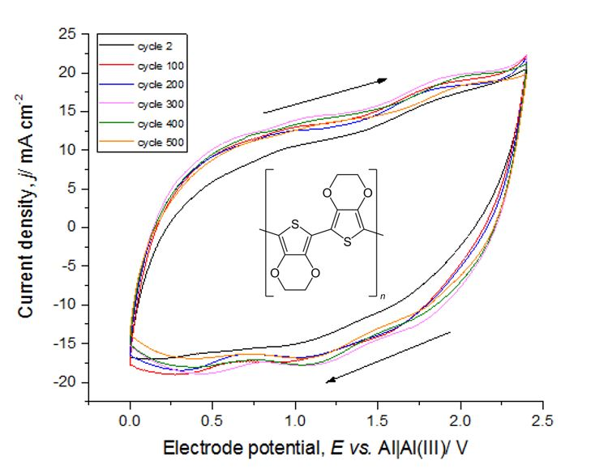
Figure 1

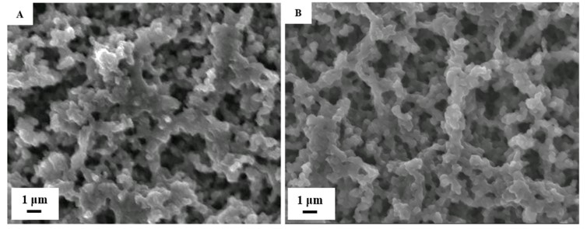
Figure 2

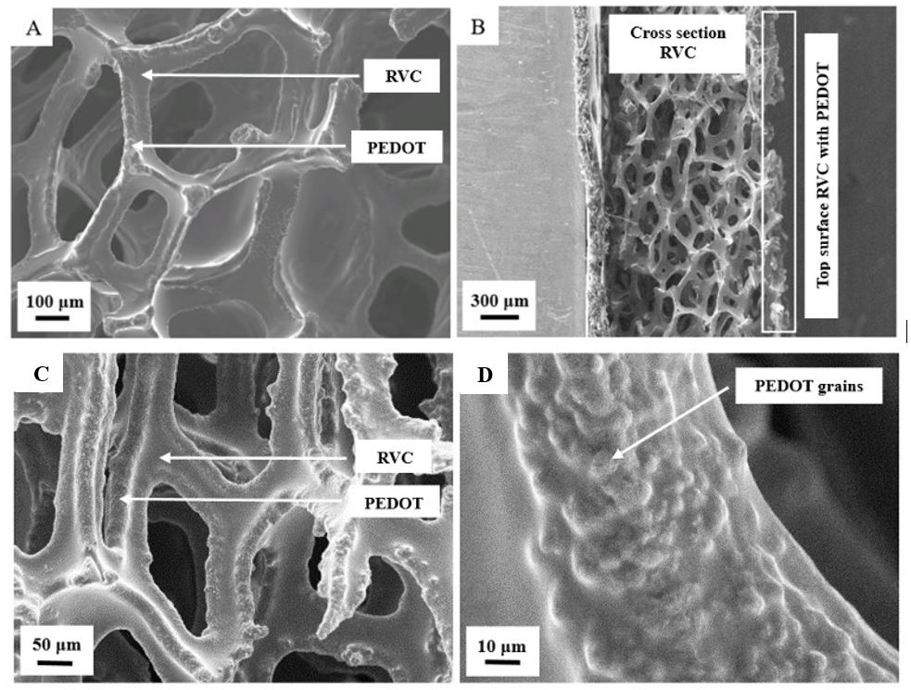
Figure 3

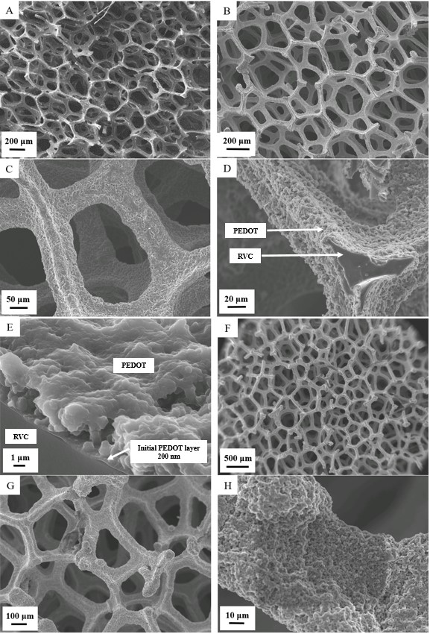
Figure 4

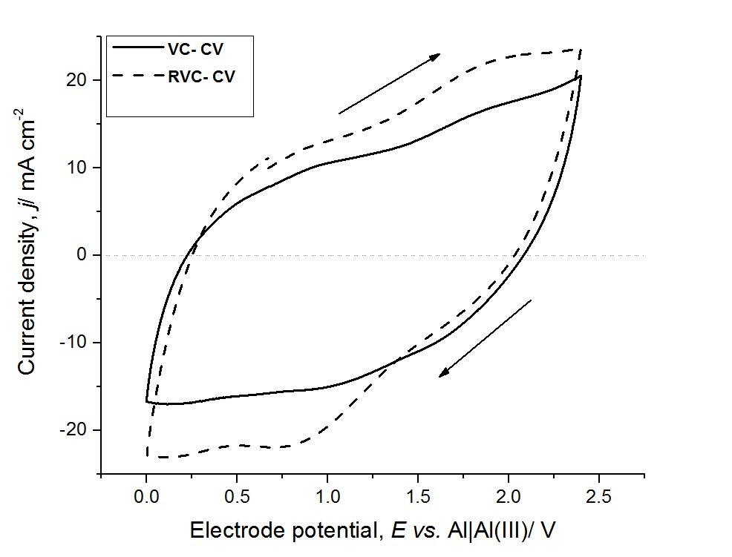
Figure 5

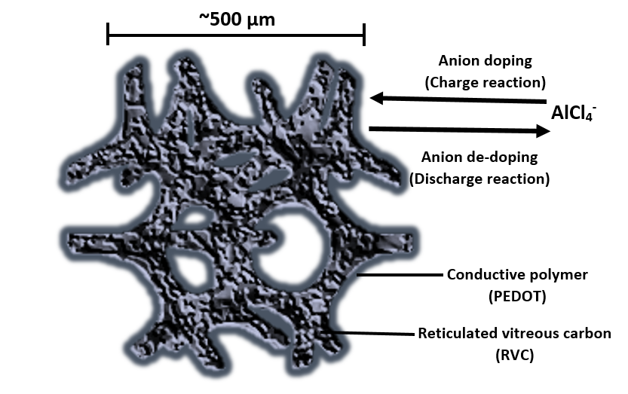
Graphical Abstract

