AC Losses of Roebel Cables with Striated 2G REBCO Strands
Y. Yang, J. Pelegrin, E. A. Young, R. Nast, A. Kario and W. Goldacker

Abstract—We present experimental data on the ac losses in Roebel cables with striated 2G REBCO strands. Electromagnetic measurements by pick-up coils were carried out at different temperatures between 10 K and 85 K at frequencies between 2 Hz and 20 kHz in transverse ac fields up to 0.5 T. The Roebel cable samples were assembled from laser cut 2G REBCO strands, which consist of striated filaments prepared with laser scribing. Measurements at different temperatures show that the Roebel cables with striated strands have a lower losses by a factor of strand filament number over the whole temperature range. For analysis, a semi-quantitative approach for unstriated Roebel was found to work satisfactorily. However the Striated Roebel cables appears to have a different field penetration from those of the unstriated Roebel. The coupling current among the filaments has a time constant shorter than 0.1 ms and do not appear to increase in the striated Roebel cables, hence insignificant for most magnets related applications.
Index Terms—REBCO 2G conductor, straition, Roebel cable, ac losses

I. INTRODUCTION
H
IGH current cables are essential for some superconducting devices such as accelerator magnets, superconducting magnetic storage coils and superconducting fault current limiters. Such cables are required to consist of several transposed superconducting strands to ensure uniform current distribution for field quality and cryogenic stability. While the sustained research and development of 2G REBCO superconducting tapes have led to impressive critical current performances in high magnetic fields, the flat geometry of these tape conductors poses significant challenges to the assembling of fully transposed cables. One of the few possibilities is that of a Roebel bar [1], [2], [3], [4] which was originally invented more than a hundred years ago for reducing the eddy current losses in high current cables/bus-bars for conventional machines .
With the growing availability of 2G REBCO tapes in long length, several laboratories [2], [3] have been producing prototype Roebel cables with punched or laser-cut strands for the important studies on the critical current performance and manufacturing optimization. In addition, there have also been studies [5], [6], [7], [8] on the magnetization and ac losses, which inform on both the effectiveness of the Roebel
Manuscript received September 19, 2017. This work was supported in part by EuCARD-2. EuCARD-2 is co-funded by the partners and the European Commission under Capacities 7th Framework Programme, Grant Agreement
312453. (Corresponding author: Y. Yang)
Y. Yang (y.yang@soton.ac.uk), J. Pelegrin, and E. A. Young are with the Institute of Cryogenics, Faculty of Engineering and the Environment, University of Southampton, Southampton SO17 1BJ, United Kingdom.
R. Nast, A. Kario and W. Goldacker are with KIT, Karlsruhe, Germany.
transposition in homogenizing the current distribution and the complex magnetic interactions among the strands.
The hysteresis loss in superconductors is most effectively reduced by subdivision into fine filaments. In addition these filaments must be twisted at a sufficiently short pitch in order to ensure that they are magnetically uncoupled under desired ac conditions. Although striated parallel filaments can be made successfully by laser scribing to reduce ac losses in short samples [9], it is topologically challenging to twist them for uncoupling over long length. The strand transposition provides a longitudinally alternating magnetic disposition, which might be an effective block [6] against the long length coupling of the striated filaments. Following on a previous promising report [10] on reduced losses in Roebel cable with striated strands, the present work reports systematic loss measurements on cable samples of different striated filaments over an extended temperature, field and frequency range. The results, together with data from single striated strands and standard Roebel cable, confirm that striated filaments are indeed uncoupled in Roebel cables with further loss reduction from that found in an earlier study [10].
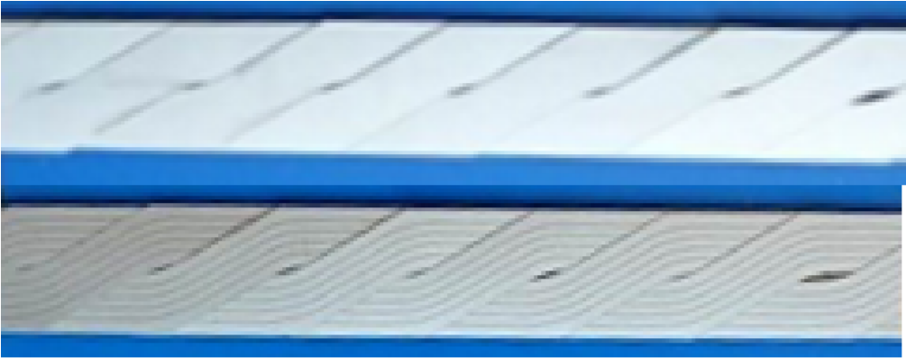
Fig. 1. Pictures of Roebel samples with the top and bottom for cables of unstriated strands and 5-filament strands respectively.

II. METHODS

A. Samples
The cable samples (Fig. 1) were made using SP-M3-675/SPKIT-20090521-1 SuperPower 12 mm wide Ag tape. The tapes were cut with laser to 5.5 mm width and Roebel shape.
Filaments were formed by laser scribing subsequently. Finally the tapes were placed in a furnace for 1 h (O₂ atmosphere, 500 °C) in order to oxidize the laser scribed tracks for an increased resistivity across the groove and the tape. The Roebel cables have a 126 mm transposition pitch and are assembled using 10 strands into 100 mm long samples. Three samples of unstriated strands, 5 (~1 mm) and 10 (~0.5 mm) filaments per Roebel strand were studied.

B. Measurements
The ac loss measurement setup allows ac magnetic fields up to 0.2 T and sample temperature down to 10 K by contact cooling. The superconductor magnetization are measured at 5 Hz where the coupling among filaments can be considered negligible. The coupling development were studied by measurement at higher frequencies.
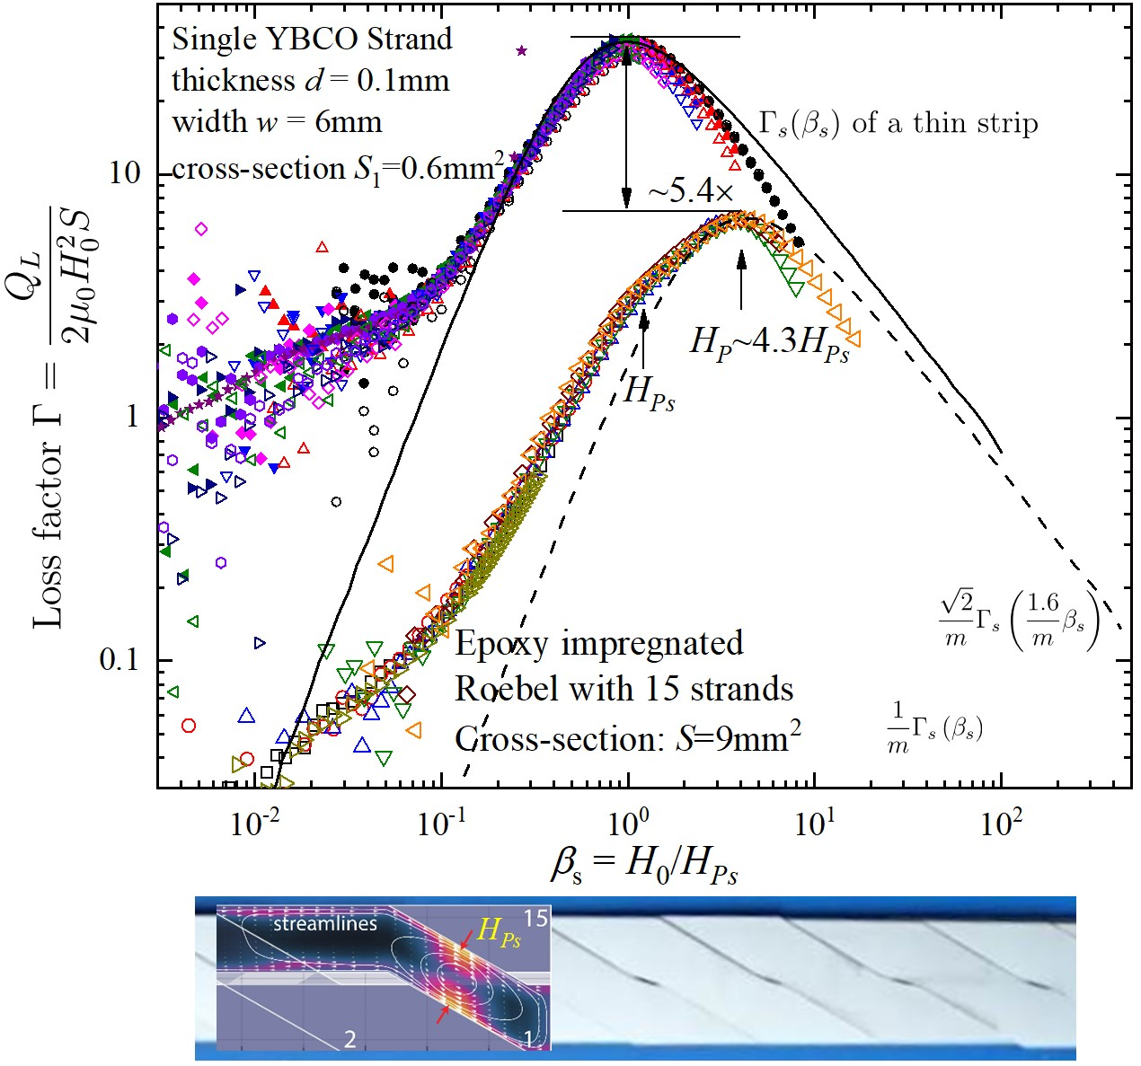
Fig. 2. Loss factor of a 15 REBCO strand Robel cable measured between 5 K and 90 K as a function of normalized field β_{s} with reference to the strand saturation field H_{Ps}. The dashed line corresponds to the prediction by the semi-quantitative calculation, as outlined in the text, for the 15-strand Roebel cable. The prominent kink in the loss factor at β_{s} ∼ 1 suggests the full saturation of a strand undergoing transposition by the saturation field H_{Ps} of a single strand instead H_{Pm} of the stack, as illustrated conceptually by the lower graph.
III. A SEMI-QUANTITATIVE APPROACH FOR LOSSES IN

“STANDARD” ROEBEL CABLES
We attempt to a semi-quantitative analysis of the ac losses of Roebel cables based on the applied field losses of a thin strip [11]. For a strip of width w, cross-section area S, line critical current density σ_{c} = ^{I}_{c}/w, and hysteretic loss per unit length Q, the peak of the loss factor 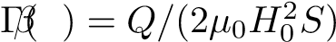 is not at H_{c} = σ_{c}/w (cf. [11]) but almost 150% higher at H_{P} = 2.46421H_{c} ∼ 2.5×⁶⁹/70H_{c}, where an effective full penetration or saturation of hysteresis can be reached. For convenience, the loss factor may be adapted approximately as
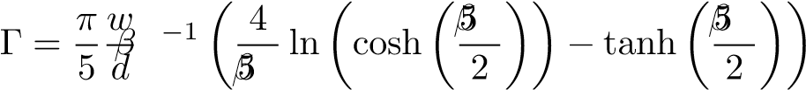
where β = ^{H}₀/H_{P} with the field amplitude H₀ normalized by H_{P} ∼ ^{5σ}_{c}/2π = ⁵/2H_{c} at a small error less than 1.5%. The loss factor is dimensionless and useful for comparing finite thickness (d) conductors of different critical current and nominal cross-section S = wd.

A. Two side-by-side strands
A previous study [8] showed that, in a perpendicular ac magnetic field, two electrically isolated Roebel strands placed closely side-by-side are coupled magnetically through the compression of magnetic flux in between. The corresponding ac loss Q_{2MC} is 40% more than the losses Q_{2UC} = 2Q_{s} of two “truly” isolated strands placed far apart. The subscript “MC” refers to magnetically coupled, “UC” to uncoupled, and “s” for a single strand. Connecting two side-by-side strands electrically results in full coupling over long length, i.e. the two strands become a single strand of twice the width with the corresponding ac loss Q_{2FC} = 2Q_{2UC}. The fully coupled (FC) and uncoupled (UC) configurations have the same saturation field H_{P} as that of a single strand as the critical current per unit width is unchanged. Despite a much increased flux density between the side-by-side strands, the saturation field for the magnetically coupled was found only about 25% lower. Hence approximately for all ac field amplitude H₀,
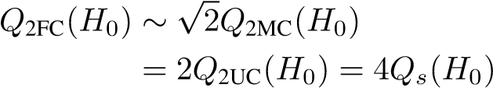
and
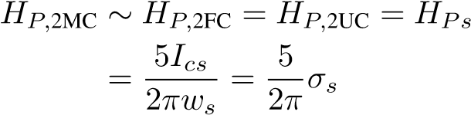
where I_{cs} is the critical current of a single strand of width w_{s} and σ_{s} is the corresponding strand critical current per unit width. Note that a magnetically coupled strand has a lower loss than that of fully coupled strand. The corresponding loss√ √ √ factors satisfy Γ_{2MC} = Γ_{2FC√}/ 2 = 2Γ_{2UC} = 2Γ_{s}. The magnetic coupling factor of 2 might change according to the distance between and the thickness of the side-by-side tape conductors, however, it can only vary within [1,2) between fully uncoupled and coupled limits.

B. Stacked strands
Roebel cables consist of two side-by-side bundles of stacked REBCO strands, which are transposed one by one between the sides. The number of stacked strands in each bundle in HTS Roebel cables is relatively small, as necessary for their suitability for coil winding. Thus such a relatively thin stack of strands tends to behave similar to a thin strip in perpendicular fields. The stack of m strands has an increase line critical current mσ_{cs} although the corresponding penetration field has been found [8] a fraction lower at
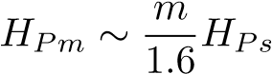
possibly due to a decreased demagnetization for the stacks. The corresponding ac loss factor of stacked strands is
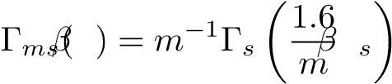
which, compared to a single strand, has a reduced peak loss factor to a fraction of m, albeit at a higher saturation field of 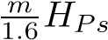. The reduction factor of 1.6 for the stack penetration field is dependent on the stacks retaining a sufficient high aspect ratio, a feature necessary for winding applications nonetheless. To establish a more precise relation between the stack geometry and penetration field would be a highly relevant investigation for future.

C. Roebel cable as two magnetically coupled stacks of tape strands
Considering a Roebel cable of 2m strands as two magnetically coupled stacks of m strands gives an estimated loss factor of
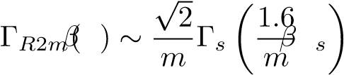
which, as shown in Fig. 2, appears to work quite well for the measured loss factor of a 15-strand (√ m = 7.5,m/1.6 = 4.68, 2/m = 1/5.3) Roebel, with the shift of the full saturation position and peak loss factor matching reasonably close to the predictions.
It should be noted that, although the peak loss factor of a√ 2m-strand Roebel cable is lower by a factor of 2/m than the peak value for a single strand or 2m uncoupled strands, the corresponding loss at the same field is not so much reduced. In fact the loss factor of a Roebel cable becomes comparable to that of uncoupled tapes at fields much higher than H_{Pm}.
The pronounced kink found in the Roebel cable at β_{s} ∼ 1 is attributable to the full penetration of a transposing strand, coinciding with the full penetration field H_{Ps} of a single strand rather than H_{Pm} of the stack (see lower image of Fig. 2). Although the 2D semi-quantitative approach does not consider transposition, its agreement with experimental results beyond single strand full penetration as well as the appearance of a kink at H_{Ps} suggest that the 3D aspects of transposition are largely confined to the transposing section of a single strand which alternates at a spatial wavelength of T_{P}/2m from one strand to another along the transposition pitch T_{P}. Therefore the corresponding magnetization loss of transposition is equivalent to that of two long single strands at the top and bottom of the cable.
The 2D approach of side-by-side magnetic coupling of two stacks of m tapes is within the scope of [12], however, a calculation based on a thin strip [11] is more straightforward and avoids the need for computer modelling.

IV. RESULTS AND DISCUSSION

A. Reduction of Roebel cable magnetization losses with striated strands
The ac loss per cycle per unit length of the three Roebel samples of 0.5 mm filaments, 1.0 mm filaments, and unstriated strands was measured at 5 Hz and at different temperatures between 10 K and 85 K, as shown in Fig. 3 (a)/(b)/(c) respectively as a function of the field amplitude H₀. All the curves at sufficiently high temperatures exhibit a distinct change in the gradient in log-log scale, marking the full penetration of the magnetic field. As the critical current density increases with
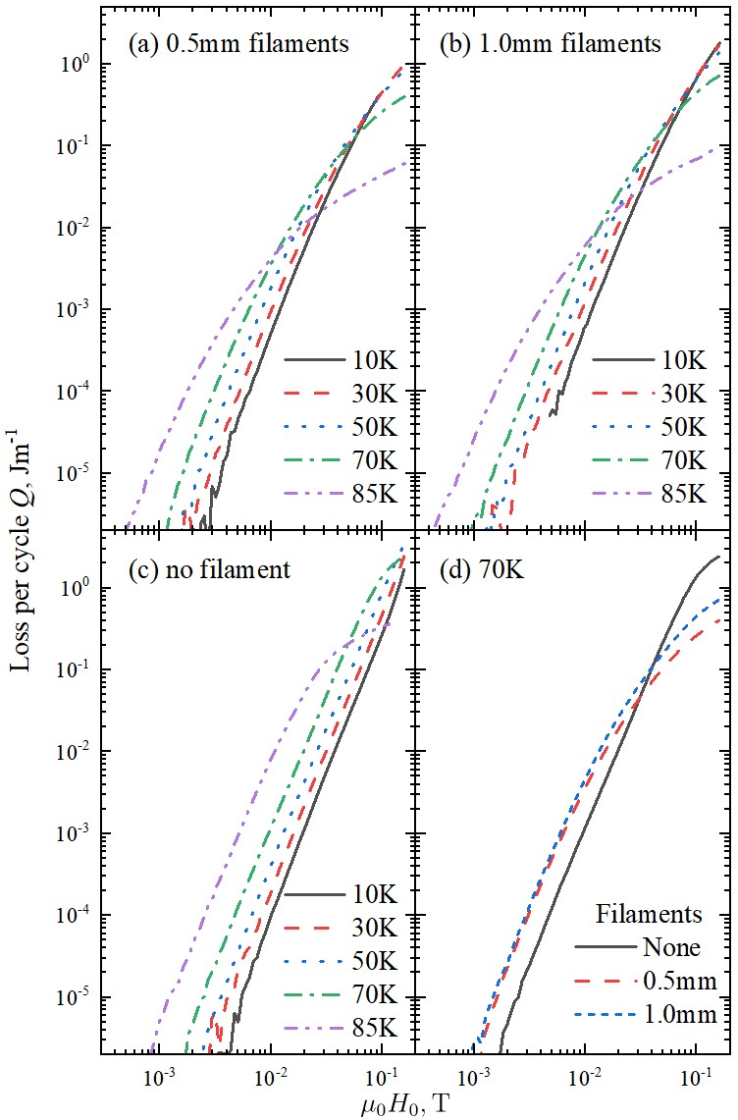
Fig. 3. Loss per unit length as a function of ac field amplitude H₀ measured at temperatures between 10 K and 85 K for Roebel cables with strands of (a) 0.5 mm filaments, (b) 1.0 mm filaments, and (c) no filaments. The losses at 75 K of three cables with different type strands shown together in (d) as a function of H₀.
reducing temperature, the full penetration field H_{P} increases accordingly with the Q(H₀) curves moving towards higher fields. Q(H₀) also becomes broader with striation, as shown in Fig. 3(d), and the losses are significantly lower than those of the unstriated beyond the full penetration.
The full penetration field of the Roebel samples at different temperatures can be determined from the peaks found in the loss factor 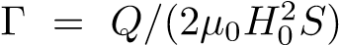, where S = 2mwd,m =
5,w = 5.5mm,d = 50µm. As shown in Fig. 4, the full saturation field of the unstriated Roebel cable is about 4 times of those for the striated strands (green inverted triangle). The significantly lower saturation field of the striated strands is not due to a reduction of the critical current by laser scribing and is somewhat more than that expected [12] by the flux compression between the filaments. Although the saturation field H_{Ps} of the transposing section in the unstriated Roebel is quite subtle for a smaller strand number of 10, it is still visible on closer inspection, as shown by the example of 50 K in the inset of Fig. 5. In contrast to the stacks in unstriated Roebe, the penetration field H_{P} of the striated Roebel samples is only marginally higher than that of the single striated strand, i.e., the stacking of striated strands does not seem to increase the saturation significantly irrespective of the filament size.
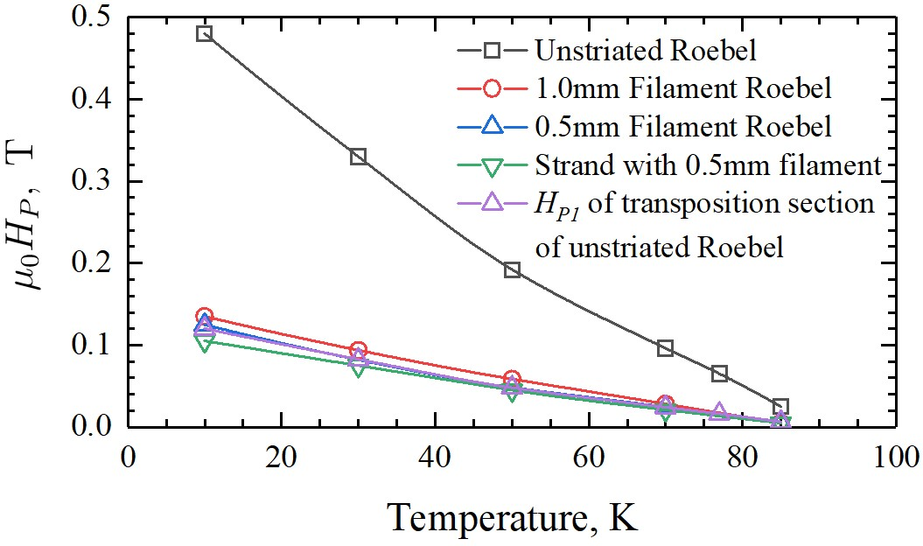
Fig. 4. Full saturation field H_{P} of the Roebel samples as a function of temperature. H_{P} of a single strand with 0.5 mm filaments is also shown
(green inverted triangle).
The main graph of Fig. 5 shows the loss factor as a function of the normalized field β = H₀/H_{P} for the striated Roebels. Although their Γ(β) is significantly broadened around the saturation field, there still remains a universal scaling by H_{P} for different temperature. The loss factor for the 0.5 mmfilament Roebel (upper filled symbols) is lower than that of the 1.0 mm-filament one by a factor of 1.5 and 2 before and after the full saturation respectively.
The loss factor of the unstriated Roebel is shown in solid lines as a function of β_{s} = H₀/H_{Ps} for comparison. Since H_{Ps} of the unstriated is almost the same as the H_{P} of the striated, the normalized field β_{s} for the striated Roebel in Fig. 5 represents nearly the same field scale as β for the striated. It becomes immediately clear that a saturated Roebel of unstriated strands has much greater losses than those of the striated by almost a factor given the number of filaments, i.e, approximately 5 and 10 times of the respective losses of Roebel cables with 1.0 mm and 0.5 mm filaments.

B. Coupling current
Although some broadening of Γ(β) for striated REBCO strands may be attributable [13] to the contribution of the coupling currents among the filaments, it does not appear to be the case for our samples. Shown on the left of Fig. 6 are the loss factors of a striated strand with 0.5 mm filaments (open symbols) and the corresponding Roebel cable (filled symbols) as a function of field amplitude H₀. Although the losses are higher at 59 Hz (red symbols) than at 5 Hz (black symbols) for both the strand and Roebel cable, the functional form of hysteresis Γ(H₀) is preserved, except at very low fields less than 2 mT where the loss factor becomes independent of H₀ as the magnetization losses becomes lower than the coupling current loss. The right pane of Fig. 6 shows the loss factors of a striated strand (dashed line) and striated cable (solid lines) as a function of frequency up to 20 kHz. The coupling current losses at 1 mT dominate in the Robel cable (black line) for the measurable range above 50 Hz but is overtaken at 10 mT by the magnetization loss at frequencies below 500 Hz. The time constant of the coupling current appears to be around 0.1 ms, due to a high inter-filament resistance attributed to the improved oxidation process after laser scribing.
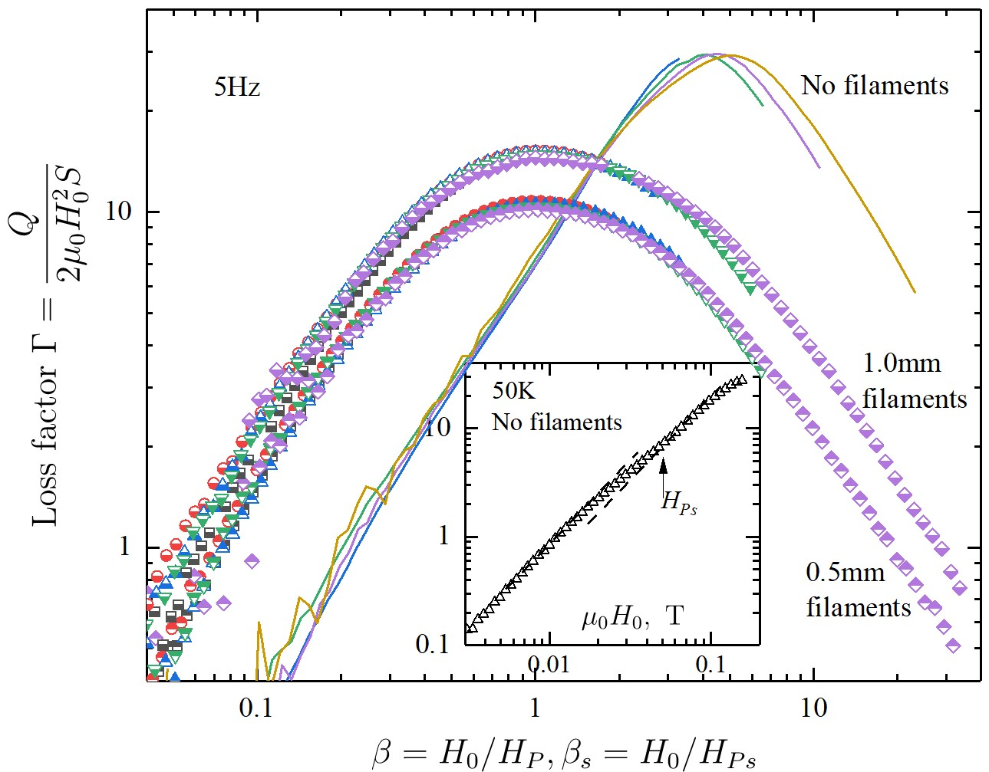
Fig. 5. Loss factor at different temperatures (10 K - 85 K) as a function of normalized field β for the Roebel samples with striated strands of 0.5 mm (upper filled symbols) and 1.0 mm (lower filled symbols) filaments. The loss factor for the Roebel sample with unstriated strands is plotted against a nominal β_{s} of the strand where transposing strand is fully penetrated (see inset as an example).
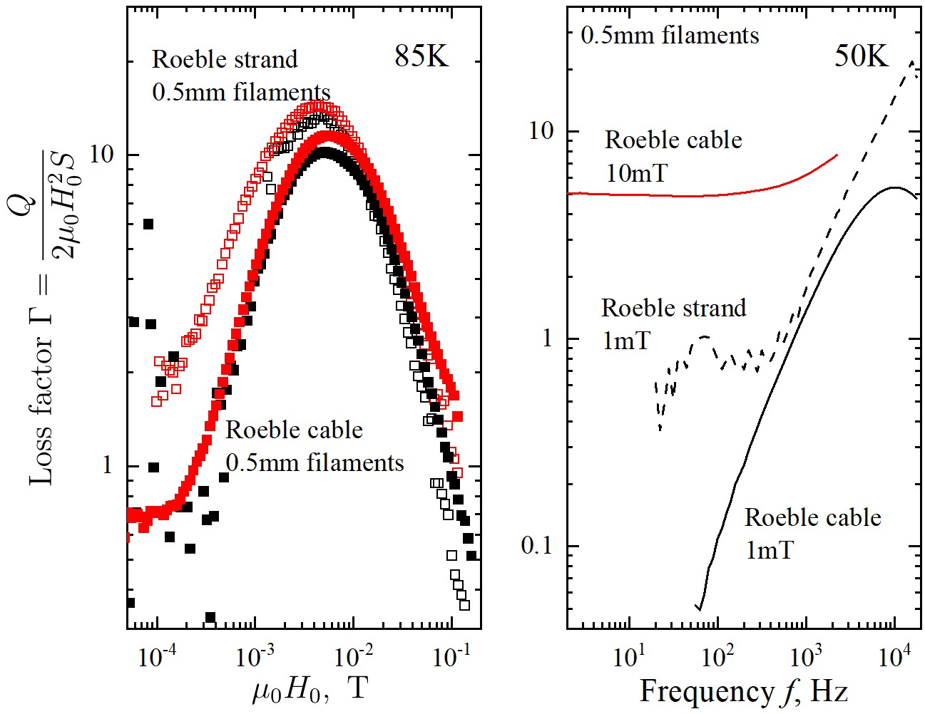
Fig. 6. Left: Loss factors of striated Roebel strand and cables as a function of field amplitude H₀at 5 Hz (black symbols) and 59 Hz (red symbols) at 85K. Right: Loss factors of striated Roebel strand and cables as a function of frequency at 50 K.

V. CONCLUSIONS
Magnetization loss of Roebel cables with striated strands is reduced approximately by a factor of the number of filaments when fully penetrated. The coupling current losses is low in high field in frequencies up to a few hundred Hz. While a semi-quantitative approach seems to work with unstriated Roebel cables, a quantitative understanding of losses in the striated Roebel cable is yet to be developed.

REFERENCES
- M. Leghissa, V. Hussennether, and H. W. Neumüller, “ka-class highcurrent HTS conductors and windings for large scale applications,” Advances in Science and Technology, vol. 47, pp. 212–219, Oct. 2006.
- N. J. Long, R. A. Badcock, K. Hamilton, A. Wright, Z. Jiang, and L. S. Lakshmi, “A treatise on electricity and magnetism development of YBCO roebel cables for high current transport and low ac loss applications,” Journal of Physics: Conference Series, vol. 234, (2010) 022021.
- W. Goldacker, A. Frank, A. Kudymow, R. Heller, A. Kling, S. Terzieva, and C. Schmidt, “Status of high transport current ROEBEL assembled coated conductor cables,” Supercond. Sci. Technol, vol. 22, (2009) 034003.
- A. Badel, A. Ballarino, C. Barth, L. Bottura, M. Dhalle, J. Fleiter,
W. Goldacker, J. Himbele, A. Kario, L. Rossi, A. Rutt, C. Scheuerlein, C. Senatore, P. Tixador, A. Usoskin, and Y. Yang, “REBCO cable for the EuCARD2 demonstrator magnet,” IEEE Trans. Appl. Supercond, vol. 26, no. 3, (2016) 4803908.
- L. S. Lakshmi, K. P. Thakur, M. P. Staines, R. A. Badcock, and N. J. Long, “Magnetic AC loss characteristics of 2G Roebel cable,” IEEE Trans. Appl. Supercond, vol. 19, pp. 3361–3364, 2009.
- S. Terzieva, M. Vojenciak, E. Pardo, F. Grilli, A. Drechsler, A. Kling, A. Kudymow, F. Gömöry, and W. Goldacker, “Transport and magnetization ac losses of ROEBEL assembled coated conductor cables: measurements and calculations,” Supercond. Sci. Technol, vol. 23, pp. 014023–014030, 2010.
- Z. Jiang, T. Komeda, N. Amemiya, N. J. Long, M. Staines, R. A. Badcock, C. Bumby, and R. G. Buckley, “Total AC loss measurements in a six strand Roebel cable carrying an AC current in an AC magnetic field,” Supercond. Sci. Technol, vol. 26, pp. 035014–035013, 2013.
- Y. Yang, J. Pelegrin, I. Falorio, E. A. Young, A. Kario, W. Goldacker, M. M. J. Dhallé, J. van Nugteren, G. Kirby, L. Bottura, and A. Ballarino, “Magnetization losses of Roebel cable samples with 2G YBCO coated conductor strands,” IEEE Trans. Appl. Supercond, vol. 26, (2016) 8202105.
- N. Amemiya, S. Kasai, K. Yoda, Z. Jiang, G. Levin, P. Barnes, and C. O. 2, “AC loss reduction of YBCO coated conductors by multifilamentary structure,” Supercond. Sci. Technol, vol. 17, pp. 1464–1471, 2004.
- S. Terzieva, M. Vojenciak, F. Grilli, R. Nast, J. Souc, W. Goldacker, A. Jung, A. Kudymow, and A. Kling, “Investigation of the effect of striated strands on the AC losses of 2G Roebel cables,” Supercond. Sci. Technol, vol. 24, (2014) 045001.
- E. H. Brandt and M. Indenbom, “Type-ii-superconductor strip with current in a perpendicular magnetic field,” Phys. Rev. B, vol. 48, (1993) 12893-12906.
- E. Pardo, A. Sanchez, and C. Navau, “Magnetic properties of arrays of superconducting strips in a perpendicular field,” Phys. Rev. B, vol. 67, (2003) 104517.
- E. Demencik, F. Grilli, A. Kario, R. Nast, A. Jung, M. Vojenciak, J. Scheiter, and W. Goldacker, “Ac magnetization loss and transverse resistivity of striated ybco coated conductors,” IEEE Trans. Appl.
Supercond, vol. 25, (2015) 8201405/1-5.

