Viable but nonculturable Listeria monocytogenes and Salmonella enterica Thompson induced by chlorine stress remain infectious

Callum J Highmoreª, Jennifer C Warnerª*, Steve D Rothwell^{b}, Sandra A Wilksª, C William Keevilª#
ªCentre for Biological Sciences, University of Southampton, Building 85, Highfield campus, Southampton, UK
^{b}Vitacress Salads Ltd, Lower Link Farm, St Mary Bourne, Andover, UK

# Address correspondence to C.W. Keevil, cwk@soton.ac.uk.
*Present Address: Rare and Imported Pathogens Lab, Public Health England, Porton Down, Salisbury, UK

Running title: Infectious chlorine-induced VBNC foodborne pathogens

Abstract word count: 200
Word count: 4661
Abstract
The microbiological safety of fresh produce is monitored almost exclusively by culture-based detection methods. However, bacterial foodborne pathogens are known to enter a viable but nonculturable (VBNC) state in response to environmental stresses such as chlorine, commonly used for fresh produce decontamination. Here, complete VBNC induction of green fluorescent protein (GFP) tagged Listeria monocytogenes and Salmonella enterica Thompson was achieved by exposure to 12 ppm and 3 ppm chlorine respectively. Pathogens were subjected to chlorine washes following incubation on spinach leaves. Culture data revealed that total viable L. monocytogenes and Salmonella Thompson populations became VBNC by 50 and 100 ppm chlorine, respectively, while enumeration by direct viable count found chlorine caused a reduction in viability of less than 1 log. The pathogenicity of chlorine-induced VBNC L. monocytogenes and Salmonella Thompson was assessed using Caenorhabditis elegans. Ingestion of VBNC pathogens by C. elegans resulted in a significant reduction of lifespan (p=0.0064 and p<0.0001), and no significant lifespan reduction was observed between VBNC and culturable L. monocytogenes treatments. L. monocytogenes was visualised beyond the nematode intestinal lumen, indicating resuscitation and cell invasion. These data emphasise the risk that VBNC foodborne pathogens could pose to public health should they continue to go undetected.

Importance
Many bacteria are known to enter a viable but nonculturable (VBNC) state in response to environmental stresses. VBNC cells cannot be detected by standard laboratory culture techniques, presenting a problem for the food industry which uses these techniques to detect pathogen contaminants. This study finds that a commonly used sanitiser for fresh produce, chlorine, induces the VBNC state in foodborne pathogens Listeria monocytogenes and Salmonella enterica. It was also found that chlorine is ineffective at killing total populations of the pathogens. A reduction in lifespan was observed in Caenorhabditis elegans that ingested these VBNC pathogens, with VBNC L. monocytogenes as infectious as its culturable counterpart. These data show VBNC foodborne pathogens can both be generated and avoid detection by industrial practices, while potentially retaining their ability to cause disease.

Introduction

Entry into the viable but nonculturable (VBNC) state has been identified in a wide range of bacterial species and environmental stressors including starvation, low temperature, antibiotic pressure and oxidative stress (1-3). This survival state allows populations to persist and endure under harsher conditions than their culturable counterparts, including antibiotic tolerance and high temperatures (4). Despite the protection that the state provides for many bacterial pathogens, there are crucial gaps in the understanding of its underlying mechanisms and uncertainty regarding the infective potential of VBNC pathogens. This is particularly relevant to foodborne pathogens, where the industry relies almost exclusively on the use of culture recovery techniques to detect microbial contamination.

Foodborne disease presents a consistent but frequently preventable threat to public health, and is responsible for an estimated 2.2 million deaths worldwide annually. In the UK, it is estimated that each year one million people suffer a foodborne illness, resulting in 500 deaths. In 2010, the bacterial foodborne pathogens Listeria monocytogenes and Salmonella spp. were responsible for more than half of these deaths following gastrointestinal infection (5). Another UK study spanning 17 years determined that of foodborne outbreaks, Salmonella spp. were responsible for the highest number of disease cases, and the greatest proportion of deaths was caused by L. monocytogenes (6).

Fresh produce such as lettuce and spinach provides an effective vehicle for these pathogens, as they are often sold as ready-to-eat foods. As consumer habits are tending towards healthier eating with more fresh produce, the risk of disease outbreaks increases (7). In 2016, an outbreak of L. monocytogenes associated with packaged salads caused 19 cases each resulting in hospitalisation across 9 states in the USA (8). In the UK, an outbreak was caused by L. monocytogenes contaminating sandwiches sold at a hospital, affecting 5 pregnant women (9). Although Salmonella spp. outbreaks are proportionally less severe, they are more far-reaching. One produce associated outbreak of Salmonella enterica serovar Saintpaul resulted in 1500 disease cases across 43 USA states, which hospitalised 21% of those affected and may have caused 2 deaths (10).

Despite their non-culturability, VBNC foodborne pathogens still pose a risk to consumers. While there is conflicting data on the pathogenicity of VBNC cells there is evidence for their resuscitation under more favourable conditions, potentially allowing pathogens to cause disease prior to or even following ingestion by humans. Research carried out on L. monocytogenes has found that VBNC cells induced by starvation were avirulent when exposed to human adenocarcinoma cells, but were resuscitated when inoculated into embryonated chicken eggs and regained virulence (11, 12). Similar results have been observed for Salmonella enterica serovar Typhimurium, where VBNC cells induced by ultraviolet irradiation were unable to cause infection in a mouse model (13), however another study using Salmonella Oranienburg induced into the VBNC by osmotic stress found that resuscitation could be achieved following injection into a mouse model (14). Other pathogens have been shown to retain aspects of their virulence while VBNC; the toxin genes of Shigella dysenteriae and Escherichia coli O157 have been detected while nonculturable (15, 16).

The parameters of the VBNC state and the infectivity of VBNC pathogens have been explored with a focus on VBNC induction via harsh conditions that bacteria are likely to encounter in a natural environment, but food production provides alternate stressors for foodborne pathogens. Chlorine is widely used to decontaminate fresh produce of both foodborne pathogens and spoilage bacteria. Previously, the efficacy of chlorine against L. monocytogenes has been measured using culture techniques, reporting that there were no viable cells recovered after using 50 ppm chlorine (17). The presence of VBNC cells was not measured. Chlorine has been shown to induce the VBNC state in Salmonella Typhimurium biofilms (18). Further work concentrating on chlorinated drinking water and wastewater found that chlorine induces the VBNC state in a range of pathogens including E. coli, Salmonella Typhimurium and Helicobacter pylori (19, 20). The relevance of the VBNC state to food safety has recently been reviewed (21). However, it has yet to be shown whether chlorine stressed pathogens remain infective in animals.

The mechanisms responsible for the antimicrobial activity of chlorine are not fully understood, though studies indicate that reactive chlorine species attack the bacterial inner membrane, where the dose of HOCl required for cell killing is similar to the dose required for ATP loss, loss of DNA replication and prevention of protein transport across the inner membrane (22, 23).
This study will simulate the passage of spinach contaminated with L. monocytogenes and Salmonella Thompson from farm and processing to ingestion. In this way, VBNC induction of the pathogens by chlorine will be assessed in situ on the spinach leaf phylloplane, comparing culture techniques to direct viable counts (enumerating both culturable and VBNC cells). The potential for infection by VBNC pathogens will then be determined by using the animal model Caenorhabditis elegans.

Results
Visualisation of pathogen adherence to spinach phylloplane
L. monocytogenes and Salmonella Thompson were visualised under EDIC/EF microscopy following 24 hour incubation on the spinach phylloplane. Green fluorescence indicates that the pathogens are primarily localised inside the spinach stomata, and at cell junctions. Compared with uninoculated control spinach leaves, both inoculated spinach samples possess a rough, uneven surface indicative of biofilm growth (Figure 1).
VBNC induction of L. monocytogenes and Salmonella Thompson in chlorinated water
L. monocytogenes became fully VBNC after 2 minutes of exposure to 12 ppm chlorine, with just under a 1-log reduction of culturability at 3 ppm (p<0.0001), and above a 4-log reduction by 6 ppm (Figure 2). Between 0 and 15 ppm, 47.64% of viable cells counted by DVC are lost (p=0.0075).
Salmonella Thompson became fully VBNC after 2 minutes of exposure to 3 ppm chlorine (p<0.0001). Each increase in chlorine concentration was met with a loss of Salmonella Thompson cells, with a 49% reduction between 0 ppm and 15 ppm chlorine (p<0.0001). There is also a 1.4 log difference between culturable cells and those enumerated by DVC (p<0.0001) at 0 ppm chlorine (Figure 3).
VBNC induction of L. monocytogenes and Salmonella Thompson adhered to the spinach phylloplane
Spinach adhered L. monocytogenes became fully VBNC after 2 minutes of exposure to 50 ppm chlorine, with a culturability reduction of 96.5% at 20 ppm. Direct viable counts declined with each increase in chlorine concentration, where only the decrease between 20 and 50 ppm was not statistically significant. Despite this, there was less than one log reduction between 0 and 100 ppm. There is also a discrepancy of 1.7 log between culture data and DVC data at 0 ppm (Figure 4).
Salmonella Thompson adhered to spinach leaves became fully VBNC after a 2 minute exposure to 100 ppm chlorine, with a mean CFU/ml of 207 at 50 ppm and 18 CFU/ml at 80 ppm (Figure 5). Consistent with L. monocytogenes, a reduction in DVC is observed with each increase in chlorine concentration, until a plateau is reached at 100 ppm. Again, there is less than a 1-log reduction in DVC between 0 ppm and 100 ppm (Figure 5).
Virulence of VBNC L. monocytogenes and Salmonella Thompson ingested by C. elegans
C. elegans that had only ingested E. coli OP50 survived for a maximum time of 22 days. All those exposed to culturable and VBNC L. monocytogenes died by day 16, with no statistical difference between the two conditions. C. elegans exposed to culturable Salmonella Thompson died by day 13, and those exposed to VBNC Salmonella Thompson by day 15. Significant reductions in nematode lifespan were found between E. coli OP50 and culturable L. monocytogenes (p=0.0012) and between E. coli OP50 and VBNC L. monocytogenes (p=0.0064), where the median lifespan of C. elegans feeding on E. coli OP50 was 12 days, and only 9 days for both L. monocytogenes treatments. Similarly, ingestion of culturable Salmonella Thompson (p<0.0001) and VBNC Salmonella Thompson (p<0.0001) significantly reduced C. elegans lifespan when compared with the E. coli OP50 control. The median lifespan of C. elegans that fed on culturable and VBNC Salmonella Thompson was 6 and 7 days respectively, with a statistical difference observed between the two treatments (p=0.0322) (Figure 6).
GFP fluorescence from each pathogen assessed was observed filling the intestinal lumen of C. elegans (Figure 7), and in the case of L. monocytogenes, permeating into the surrounding tissues (Figure 7a). Pathogen cells were still visible when nematodes were returned to E. coli OP50 plates.

Discussion
As chlorine is commonly used in the agricultural industry to decontaminate fresh produce, foodborne pathogens will be exposed to the sanitiser during food production, both adhered to the phylloplane and detached in suspension. Here we show that in both cases, exposure to chlorine can induce the VBNC state in L. monocytogenes and Salmonella Thompson (Figures 2-5). In water, L. monocytogenes becomes fully VBNC when exposed to 12 ppm chlorine, although 50 ppm is required following incubation on the spinach phylloplane (Figure 2, 4). Similarly Salmonella Thompson becomes fully VBNC following exposure to 100 ppm on the phylloplane, but only 3 ppm is required in chlorinated water (Figure 3, 5). This could largely be explained by the colonisation of the bacteria on the phylloplane. Both are primarily localised in and around stomata, and at cell junctions, potentially providing physical protection from the sanitiser.
A further benefit to phylloplane adherence is the facilitation of biofilm formation, where the production of an extracellular polysaccharide matrix presents a barrier for chlorine molecules. Previous studies have shown chlorine and hypochlorite to have limited penetrative ability in Pseudomonas aeruginosa and Klebsiella pneumoniae biofilms (24, 25), as well as in Salmonella biofilms (26). This effect could be supplemented by the autochthonous bacterial species present on the phylloplane. Non-fluorescent bacterial growth observed on the spinach cell surface indicates biofilm formation by indigenous species (Figure 1), where an agonistic interaction with the inoculated foodborne pathogen may serve to reduce chlorine efficacy. These interactions could account for the relative decrease in sensitivity to chlorine observed in Salmonella Thompson on the phylloplane, where in ddH₂O the pathogen lost culturability more easily than L. monocytogenes (Figure 2-5). It was postulated in one study that when attached to the spinach phylloplane, the biofilm forming capability of foodborne pathogen E. coli O157 may be augmented by the presence of indigenous epiphytic bacteria (27). Despite the protective effect of biofilm, 5.5 ppm chlorine exposure has previously been shown to induce the VBNC state in Salmonella biofilm (18).
This corroborates with the data in this study. The total population of L. monocytogenes and Salmonella Thompson lost culturability following exposure to 100 ppm chlorine (Figure 4, 5), where the approximate 1 log reduction in bacteria counted by DVC can be attributed to cell death by chlorine exposure. Here, that reduction resulted in 1.6 x 10⁶ CFU/ml VBNC L. monocytogenes and 1.4 x 10⁶ CFU/ml VBNC Salmonella Thompson. Typically in the agricultural industry, 90 ppm chlorine is used to wash fresh produce and is assumed to sanitise the food and the surrounding water. While these data show that an increase of chlorine concentration does result in a loss of viable bacteria, the chlorine use of industry is limited by the damage it causes to the food product, particularly leafy vegetables. Decontamination of food products by chlorination may be ubiquitous across food production; however a wealth of research has shown chlorine to be ineffective at killing foodborne pathogens, including L. monocytogenes and E. coli O157 inoculated on lettuce (28, 29).
The initial bacterial inoculum concentrations reflect both previous research assessing contamination of crop plants by foodborne pathogens (30, 31), and the level of contamination previously detected in vegetables affected by bacterial soft rot collected from a marketplace in the USA (32). From contaminated spinach, 3*10⁵ suspected Salmonella colonies per ml wash water were detected, and using enrichment broth 1.7*10⁷ and 8.6*10⁸ CFU/ml were detected in healthy and rotting spinach, respectively. In this study, biofilms were grown on the spinach phylloplane for 24 hours at room temperature, so the resulting bacterial population is indicative of the level of contamination that would be seen in the field.
In water, the relatively greater sensitivity to chlorine observed in Salmonella Thompson (Figure 2, 3) could be due to the nature of damage of reactive chlorine species in bacteria. Chlorine is thought to cause bacterial cell death by impeding the functions of the inner membrane (22). As Salmonella Thompson is Gram-negative, whereas L. monocytogenes is Gram-positive, and the Gram-positive thick peptidoglycan layer could influence susceptibility to chlorine stress. Previously, it has been shown that inactivation by exposure to singlet oxygen is affected by the presence of the peptidoglycan layer (33).
The data obtained shows a pronounced difference between untreated cells quantified by culture and by DVC, particularly in Figure 4. In this case, it could be that the osmotic stress placed upon L. monocytogenes in ddH₂O resulted in some loss of culturability without having been exposed to chlorine. It is also possible that the discrepancy is a consequence of the assumption that cells are evenly distributed across each microscope slide.
The data obtained in this study suggest that chlorine-mediated killing of bacteria observed in previous research can in part be attributed to VBNC induction by chlorine. In the food industry, the use of chlorine to decontaminate minimally processed food results in the inability of ‘gold standard’ culture techniques to detect foodborne pathogens, which may then go on to cause disease outbreaks. As similar work has not yet been carried out on alternative methods of fresh produce decontamination, their efficacies may also be reduced by VBNC induction. Studies assessing the efficacy of sanitisers such as ozone (34, 35), gamma (36) or ultraviolet irradiation (37), and ultrasound (38-40) routinely use culture-based bacterial enumeration exclusively, so VBNC contribution has not been explored. However, previous work has observed that these exposures to ultraviolet irradiation and ultrasound can also result in VBNC induction in different pathogens (41, 42). In finding alternative decontamination treatments, industry is further restricted as it must effectively kill bacteria without inducing the VBNC state, and without compromising the quality of the food product.
The nematode killing assay revealed that there is no difference between the virulence of L. monocytogenes in culturable and VBNC states, and that both cause a reduction in C. elegans lifespan (Figure 6). Previous work on L. monocytogenes has provided evidence that in the VBNC state, the pathogen is avirulent (11). The results in this study could contradict this for several reasons; this study focuses on VBNC induction by chlorine exposure, where Cappelier et al. (11) generated VBNC cells via starvation. Using human cell lines as a model, virulence was previously measured by assessing the invasive properties of L. monocytogenes, and was injected into the bloodstream of a mouse model. In this study, infection is modelled in C. elegans by ingestion and infection of the gastrointestinal tract. It has been shown that VBNC E. coli O157 maintains expression of its Shiga-like toxin genes once VBNC (15), so while there is limited research on L. monocytogenes, it is possible that toxin expression causes disease in the digestive tract, while cell invasion in the VBNC state is impaired.
The suggestion that there are differences in the VBNC states of the same pathogen dependent on method of VBNC induction has not been explored, but could present further challenges for the food industry. Prior to harvest, the phylloplane is a harsh environment for bacteria, with exposure to ultraviolet radiation and limited moisture, providing conditions that could induce the VBNC survival state in foodborne pathogens before exposure to chlorination. There is evidence for this as VBNC induction has been shown to occur in E. coli O157 on the lettuce phylloplane in response to low temperatures (2). While these data show that VBNC L. monocytogenes induced by chlorine can cause disease, VBNC pathogens induced by physical stimuli on the phylloplane may require a separate assessment, comparing VBNC expression profiles where the fundamental mechanisms of the state have yet to be fully understood.
Corroborating with previous studies (43), C. elegans feeding on Salmonella Thompson was also found to significantly reduce lifespan, where worms fed on culturable Salmonella Thompson died within 13 days and those fed on VBNC Salmonella Thompson died within 15 days (Figure 6). When compared to one another, it was determined that a significantly greater reduction in C. elegans lifespan is achieved using culturable Salmonella Thompson (p=0.0322). This indicates that while still virulent to the animal model, the pathogen in the VBNC state does lose some infectivity. Research carried out on the cell invasion ability of VBNC Salmonella Typhimurium has indicated that VBNC cells have an impaired ability to invade epithelia (44), and those induced by antibiotic pressure are unable to cause disease in mice (45). Conversely, immunocompromised mice that ingested VBNC Salmonella Oranienburg were affected by the pathogen, suggesting that there is still risk of infection by VBNC Salmonella under certain conditions (14). The relative success of VBNC L. monocytogenes in reducing C. elegans lifespan to a similar degree as its culturable counterpart could be due to the ability of the pathogen to grow at lower temperatures (46). VBNC Salmonella Thompson may require a higher temperature, such as the mammalian core temperature of 37ºC, to more effectively resuscitate and establish infection.
Both pathogens in the VBNC state could be seen fluorescing inside the intestinal lumen of C. elegans (Figure 7). L. monocytogenes completely fills the intestinal tract and has invaded the surrounding tissues, with the ovary of the nematode masking the terminal end of the tract (Figure 7a). The high level of fluorescence observed, even when nematodes are removed from the pathogen food source, provides evidence that they have colonised the gut which may suggest resuscitation once inside a host. This is supported by the fluorescence extending beyond the intestine, which is consistent with the cell invasion that occurs with L. monocytogenes infection (47). A similar phenomenon has been observed in L. monocytogenes, where resuscitation occurred following introduction to embryonated eggs but not in non-embryonated eggs (12).
The differences observed between C. elegans infection by S. enterica and L. monocytogenes have also been observed in Tetrahymena (48). Salmonella Thompson was released in vesicles from the protozoan while L. monocytogenes was digested. In this case, the authors observed that ingestion by Tetrahymena protects Salmonella Thompson from environmental stresses. In this study Salmonella Thompson accumulates in the intestine at the pharyngeal-intestinal valve (Figure 7b), resembling Salmonella infection in vertebrate hosts where attachment to the apical surface of epithelial cells takes place (49). The different interactions of both foodborne pathogens with the C. elegans host may indicate that resuscitation has also taken place in VBNC Salmonella Thompson, resulting in its virulence in the nematode. As such, these data support the use of the C. elegans invertebrate model for the study of VBNC foodborne pathogens: it is more cost and space efficient than the use of vertebrate models, and free from ethical constrains. In addition, the presence of a well-defined nervous system and digestive tract, with a mouth, pharynx that pumps the food into the intestines, a digestive system that enables them to process the food, and an excretory system, make this animal model more applicable to higher organisms than others such as the unicellular amoebal or wax moth larvae infectivity models.
Preliminary work conducted in this study is consistent with resuscitation of VBNC pathogens inside the host; when assessed using a nematode killing assay, GFP-tagged Salmonella Thompson strain RM2311 was not found to reduce C. elegans lifespan. However, C. elegans that fed on Salmonella Thompson died rapidly from day 12, which could be a result of colonisation and in the case of VBNC cells, resuscitation (data not shown). Conversely, Salmonella Thompson strain NCTC 2252 was shown to reduce C. elegans lifespan (Figure 6), where the difference in infectivity may be a result of the fitness cost of GFP expression by the pathogen (50).
The data obtained in this study does not discern whether VBNC L. monocytogenes and Salmonella Thompson cause disease by resuscitation stimulated by ingestion into a host, or by continued expression of virulence factors while in the VBNC state. However, they do provide evidence that the use of chlorine to decontaminate fresh produce is not only ineffective, but permits virulent foodborne pathogens to reach the public undetected by standard methods. Outbreaks of foodborne disease where no food vehicle can be identified do occur (51), and it is possible that the VBNC state plays an important role. Consequently, new methods are required to rapidly detect VBNC pathogens which are still capable of causing disease, despite accepted sanitisation procedures, to protect public health. Indeed, it may be better to not sanitise foodstuffs and rely instead on rapid pathogen detection methods and positive release of those foodstuffs deemed safe for human consumption.

Materials and Methods
Bacterial strains
Bacteria used were Listeria monocytogenes Scott A, expressing green fluorescent protein (GFP) on plasmid pPL3-GFP, and Salmonella enterica serovar Thompson strains NCTC 2252 and RM2311. Salmonella Thompson RM2311 expresses GFP on plasmid pWM1007 which also contains a kanamycin resistance gene (52, 53). Both were cultured for 18 hours at 37ºC in brain heart infusion broth (BHIB) (Oxoid, UK). L. monocytogenes was cultured on agar using the selective medium PALCAM (Oxoid, UK) with Listeria selective supplement (Sigma-Aldrich, USA), and S. enterica was cultured on agar using CHROMagarTM Salmonella Plus with its cognate supplement (CHROMagar, France). Escherichia coli OP50 was used as a non-pathogenic control for the nematode killing assay. It was cultured in Luria-Bertani broth (Formedium, UK) for 18 hours at 37ºC prior to use.
Leaf samples
Leaf samples used were raw unwashed spinach leaves supplied by Vitacress Salads Ltd, UK. Leaves were inoculated within 48 hours of delivery: 25 g leaf sample were placed in a Stomacher® bag (Interscience, France) and inoculated with 1 ml bacteria in BHIB at a concentration of 5 x 10⁷ colony forming units (CFU)/ml. Inoculated samples were shaken vigorously and incubated at 22ºC for 24 hours prior to washing with chlorine.Chlorine washing
Water
A stock solution of 2500 ppm free chlorine was produced by dissolving one Haz-Tab (Guest Medical, UK) in 1 litre of ddH₂O, which was further diluted in ddH₂O to generate working solutions. Bacterial suspensions of 10⁸ CFU in phosphate buffered saline (PBS) (Oxoid, UK) were inoculated into 50 ml ddH₂O in a Stomacher® bag, to which 50 ml of the appropriate chlorine dilution was added. The sample was shaken vigorously for 2 minutes and then filtered through a 0.22 µm pore, mixed cellulose ester membrane (Millipore, USA) using vacuum filtration. Bacteria were removed from the membrane by placing in another Stomacher® bag with 100 ml PBS and shaken using a Pulsifier® (Microgen, UK) for 30 seconds, producing a final concentration of 10⁶ CFU/ml. Samples were then taken for culture and direct viable counts (DVC).
Spinach
Following 24 hour incubation, 225 ml ddH₂O containing the appropriate volume of chlorine solution was added to inoculated spinach samples. Samples were vigorously shaken for 2 minutes and the liquid was discarded, retaining the leaf samples; 225 ml PBS was then added and the bag was shaken in the Pulsifier® for 30 seconds. Samples of the resulting bacterial suspension were then taken for culture and DVC.
DVC and visualisation of samples
Samples taken for DVC were concentrated by centrifuging 10 ml sample for 15 minutes at 4000 rpm using a Heraeus Megafuge 1.0. The sample was then resuspended in 1 ml PBS. To aid visualisation, samples were subjected to cell elongation, carried out using a modification of the method by Juhna et al (54). The 1 ml sample was added to 4 ml ddH₂O and 5 ml R2 broth (0.1% w/v peptone, 0.05% w/v yeast extract, 0.05% w/v glucose, 0.05% w/v starch, 0.03% w/v potassium dihydrogen phosphate, 0.03% w/v sodium pyruvate and 0.0024% w/v magnesium sulphate), with 10 µl pipemidic acid at a concentration of 10 µg/ml. The suspension was incubated for 18 hours at 22ºC in darkness. The suspension was concentrated prior to DVC in the same manner as before.
All samples were imaged using episcopic differential interference contrast (EDIC) and epifluorescent (EF) microscopy (55) and a QImaging Retiga EXi camera. Bacteria were quantified by counting visible cells across at least 30 fields of view per sample. Images were merged using ImageJ.

Caenorhabditis elegans killing assay
C. elegans were maintained on 5 cm nematode growth medium (NGM) agar plates, prepared according to standard methods (56) with a lawn of E. coli OP50. To prepare experimental plates, 50 µl of E. coli OP50, L. monocytogenes, or Salmonella Thompson cultures were added to the centre of the plates and incubated at 22ºC for 24 hours. To produce VBNC cells, cultures of L. monocytogenes and Salmonella Thompson were pelleted by centrifugation and resuspended in 10 ml 200 ppm chlorine solution for 30 minutes. Chlorinated water was removed by vacuum filtration as described above, and bacteria were removed from the membrane by vortexing in 1 ml PBS for 2 minutes (57), concentrating the sample to compensate for the growth of their culturable counterparts on the NGM plate. Plates were then inoculated with 50 µl VBNC cells and incubated at 22ºC for 24 hours. VBNC cells were plated on selective media to verify the VBNC state.
C. elegans were transferred to experimental plates at the L4 stage; 20 animals were used per plate and each condition was tested with at least 4 replicates. Nematodes were counted daily and transferred to fresh plates every other day. Nematodes that did not respond to being prodded with a pick were considered dead.
Statistical analyses
Culture data and DVC were separately analysed using a one-way ANOVA with Tukey’s multiple comparisons test. Comparisons between culture data and DVC data were carried out using multiple t-tests. Nematode killing assay was analysed using the survival curve comparison Mantel-Cox test. All statistical analyses were carried out using GraphPad Prism 7.

Acknowledgements
We thank Dr Markus Schuppler for the gift of GFP-tagged Listeria monocytogenes, and Professor Lindy Holden-Dye and Euan Scott for providing Caenorhabditis elegans and for helpful discussions. This work was supported by grant BB/K012797/1 from the Biotechnology and Biological Sciences Research Council, UK.

Conflict of Interest
Dr Rothwell is employed by Vitacress Salads ltd, which contributed funding to this work.

References
1. Pasquaroli S, Zandri G, Vignaroli C, Vuotto C, Donelli G, Biavasco F. 2013. Antibiotic pressure can induce the viable but non-culturable state in Staphylococcus aureus growing in biofilms. Journal of Antimicrobial Chemotherapy 68:1812-1817.
2. Dinu LD, Bach S. 2011. Induction of viable but nonculturable Escherichia coli O157:H7 in the phyllosphere of lettuce: a food safety risk factor. Applied and environmental microbiology 77:8295-8302.
3. Lin H, Ye C, Chen S, Zhang S, Yu X. 2017. Viable but non-culturable E. coli induced by low level chlorination have higher persistence to antibiotics than their culturable counterparts. Environmental pollution (Barking, Essex : 1987) 230:242-249.
4. Nowakowska J, Oliver JD. 2013. Resistance to environmental stresses by Vibrio vulnificus in the viable but nonculturable state. FEMS microbiology ecology 84:213-222.
5. Anon. 2011. Foodborne Disease Strategy 2010-2015. Food Standards Agency.
6. Gormley FJ, Little CL, Rawal N, Gillespie IA, Lebaigue S, Adak GK. 2011. A 17-year review of foodborne outbreaks: describing the continuing decline in England and Wales (1992-2008). Epidemiol Infect 139:688-699.
7. Lynch MF, Tauxe RV, Hedberg CW. 2009. The growing burden of foodborne outbreaks due to contaminated fresh produce: risks and opportunities. Epidemiol Infect 137:307-315.
8. Anon. 2016, posting date. Multistate Outbreak of Listeriosis Linked to Packaged Salads Produced at Springfield, Ohio Dole Processing Facility (Final Update). Centers for Disease Control and Prevention. [Online.]
9. Dawson SJ, Evans MR, Willby D, Bardwell J, Chamberlain N, Lewis DA. 2006. Listeria outbreak associated with sandwich consumption from a hospital retail shop, United Kingdom. Euro surveillance : bulletin Europeen sur les maladies transmissibles = European communicable disease bulletin 11:89-91.
10. Barton Behravesh C, Mody RK, Jungk J, Gaul L, Redd JT, Chen S, Cosgrove S, Hedican E, Sweat D, Chávez-Hauser L. 2011. 2008 outbreak of Salmonella Saintpaul infections associated with raw produce. New England Journal of Medicine 364:918-927.
11. Cappelier JM, Besnard V, Roche S, Garrec N, Zundel E, Velge P, Federighi M. 2005. Avirulence of viable but non-culturable Listeria monocytogenes cells demonstrated by in vitro and in vivo models. Veterinary research 36:589-599.
12. Cappelier JM, Besnard V, Roche SM, Velge P, Federighi M. 2007. Avirulent viable but non culturable cells of Listeria monocytogenes need the presence of an embryo to be recovered in egg yolk and regain virulence after recovery. Veterinary research 38:573-583.
13. Smith RJ, Kehoe SC, McGuigan KG, Barer MR. 2000. Effects of simulated solar disinfection of water on infectivity of Salmonella typhimurium. Letters in applied microbiology 31:284-288.
14. Asakura H, Watarai M, Shirahata T, Makino S. 2002. Viable but nonculturable Salmonella species recovery and systemic infection in morphine-treated mice. The Journal of infectious diseases 186:1526-1529.
15. Liu Y, Wang C, Tyrrell G, Li XF. 2010. Production of Shiga-like toxins in viable but nonculturable Escherichia coli O157:H7. Water research 44:711-718.
16. Rahman I, Shahamat M, Chowdhury MA, Colwell RR. 1996. Potential virulence of viable but nonculturable Shigella dysenteriae type 1. Applied and environmental microbiology 62:115-120.
17. Brackett RE. 1987. Antimicrobial Effect of Chlorine on Listeria monocytogenes. Journal of food protection 50:999-1003.
18. Leriche V, Carpentier B. 1995. Viable but nonculturable Salmonella typhimurium in single-and binary-species biofilms in response to chlorine treatment. Journal of food protection 58:1186-1191.
19. Gião MS, Azevedo NF, Wilks SA, Vieira MJ, Keevil CW. 2010. Effect of chlorine on incorporation of Helicobacter pylori into drinking water biofilms. Applied and environmental microbiology 76:1669-1673.
20. Oliver JD, Dagher M, Linden K. 2005. Induction of Escherichia coli and Salmonella typhimurium into the viable but nonculturable state following chlorination of wastewater. Journal of water and health 3:249-257.
21. Ayrapetyan M, Oliver JD. 2016. The viable but non-culturable state and its relevance in food safety. Current Opinion in Food Science 8:127-133.
22. Gray MJ, Wholey W-Y, Jakob U. 2013. Bacterial Responses to Reactive Chlorine Species. Annual review of microbiology 67:141-160.
23. Rosen H, Orman J, Rakita RM, Michel BR, VanDevanter DR. 1990. Loss of DNA-membrane interactions and cessation of DNA synthesis in myeloperoxidase-treated Escherichia coli. Proceedings of the National Academy of Sciences of the United States of America 87:10048-10052.
24. De Beer D, Srinivasan R, Stewart PS. 1994. Direct measurement of chlorine penetration into biofilms during disinfection. Applied and environmental microbiology 60:4339-4344.
25. Stewart PS, Rayner J, Roe F, Rees WM. 2001. Biofilm penetration and disinfection efficacy of alkaline hypochlorite and chlorosulfamates. Journal of applied microbiology 91:525-532.
26. Lapidot A, Romling U, Yaron S. 2006. Biofilm formation and the survival of Salmonella Typhimurium on parsley. International journal of food microbiology 109:229-233.
27. Carter MQ, Xue K, Brandl MT, Liu F, Wu L, Louie JW, Mandrell RE, Zhou J. 2012. Functional metagenomics of Escherichia coli O157:H7 interactions with spinach indigenous microorganisms during biofilm formation. PLoS One 7:e44186.
28. Beuchat LR, Brackett RE. 1990. Survival and Growth of Listeria monocytogenes on Lettuce as Influenced by Shredding, Chlorine Treatment, Modified Atmosphere Packaging and Temperature. Journal of Food Science 55:755-758.
29. Niemira B. 2008. Irradiation compared with chlorination for elimination of Escherichia coli O157: H7 internalized in lettuce leaves: influence of lettuce variety. Journal of food science 73.
30. Islam M, Morgan J, Doyle MP, Phatak SC, Millner P, Jiang X. 2004. Fate of Salmonella enterica Serovar Typhimurium on Carrots and Radishes Grown in Fields Treated with Contaminated Manure Composts or Irrigation Water. Applied and environmental microbiology 70:2497-2502.
31. Lapidot A, Yaron S. 2009. Transfer of Salmonella enterica serovar Typhimurium from contaminated irrigation water to parsley is dependent on curli and cellulose, the biofilm matrix components. Journal of food protection 72:618-623.
32. Wells J, Butterfield J. 1997. Salmonella contamination associated with bacterial soft rot of fresh fruits and vegetables in the marketplace. Plant Disease 81:867-872.
33. Dahl TA, Midden WR, Hartman PE. 1989. Comparison of killing of gram-negative and gram-positive bacteria by pure singlet oxygen. Journal of bacteriology 171:2188-2194.
34. Ölmez H, Temur SD. 2010. Effects of different sanitizing treatments on biofilms and attachment of Escherichia coli and Listeria monocytogenes on green leaf lettuce. LWT - Food Science and Technology 43:964-970.
35. Karaca H, Velioglu YS. 2014. Effects of ozone treatments on microbial quality and some chemical properties of lettuce, spinach, and parsley. Postharvest Biology and Technology 88:46-53.
36. Rajikowski KT, Thayer DW. 2000. Reduction of Salmonella spp. and Strains of Escherichia coli O157:H7 by Gamma Radiation of Inoculated Sprouts. Journal of food protection 63:871-875.
37. Guo S, Huang R, Chen H. 2017. Application of water-assisted ultraviolet light in combination of chlorine and hydrogen peroxide to inactivate Salmonella on fresh produce. International journal of food microbiology 257:101-109.
38. Goodburn C, Wallace CA. 2013. The microbiological efficacy of decontamination methodologies for fresh produce: A review. Food Control 32:418-427.
39. Zhou B, Feng H, Luo Y. 2009. Ultrasound Enhanced Sanitizer Efficacy in Reduction of Escherichia coli O157 : H7 Population on Spinach Leaves. Journal of Food Science 74:M308-M313.
40. Seymour IJ, Burfoot D, Smith RL, Cox LA, Lockwood A. 2002. Ultrasound decontamination of minimally processed fruits and vegetables. International Journal of Food Science & Technology 37:547-557.
41. Declerck P, Vanysacker L, Hulsmans A, Lambert N, Liers S, Ollevier F. 2010. Evaluation of power ultrasound for disinfection of both Legionella pneumophila and its environmental host Acanthamoeba castellanii. Water research 44:703-710.
42. Zhang S, Ye C, Lin H, Lv L, Yu X. 2015. UV disinfection induces a VBNC state in Escherichia coli and Pseudomonas aeruginosa. Environmental science & technology 49:1721-1728.
43. Labrousse A, Chauvet S, Couillault C, Léopold Kurz C, Ewbank JJ. 2000. Caenorhabditis elegans is a model host for Salmonella typhimurium. Current Biology 10:1543-1545.
44. Passerat J, Got P, Dukan S, Monfort P. 2009. Respective roles of culturable and viable-but-nonculturable cells in the heterogeneity of Salmonella enterica serovar typhimurium invasiveness. Applied and environmental microbiology 75:5179-5185.
45. Smith RJ, Newton AT, Harwood CR, Barer MR. 2002. Active but nonculturable cells of Salmonella enterica serovar Typhimurium do not infect or colonize mice. Microbiology (Reading, England) 148:2717-2726.
46. Walker SJ, Archer P, Banks JG. 1990. Growth of Listeria monocytogenes at refrigeration temperatures. The Journal of applied bacteriology 68:157-162.
47. Cossart P, Pizarro-Cerda J, Lecuit M. 2003. Invasion of mammalian cells by Listeria monocytogenes: functional mimicry to subvert cellular functions. Trends in cell biology 13:23-31.
48. Brandl M, Rosenthal B, Haxo A, Berk S. 2005. Enhanced survival of Salmonella enterica in vesicles released by a soilborne Tetrahymena species. Applied and environmental microbiology 71:1562-1569.
49. Aballay A, Yorgey P, Ausubel FM. 2000. Salmonella typhimurium proliferates and establishes a persistent infection in the intestine of Caenorhabditis elegans. Current Biology 10:1539-1542.
50. Rang C, Galen JE, Kaper JB, Chao L. 2003. Fitness cost of the green fluorescent protein in gastrointestinal bacteria. Can J Microbiol 49:531-537.
51. McFarland N, Bundle N, Jenkins C, Godbole G, Mikhail A, Dallman T, O'Connor C, McCarthy N, O'Connell E, Treacy J. 2017. Recurrent seasonal outbreak of an emerging serotype of Shiga toxin-producing Escherichia coli (STEC O55: H7 stx 2a) in the south west of England, July 2014 to September 2015. Eurosurveillance 22.
52. Dell'Era S, Buchrieser C, Couvé E, Schnell B, Briers Y, Schuppler M, Loessner MJ. 2009. Listeria monocytogenesl-forms respond to cell wall deficiency by modifying gene expression and the mode of division. Molecular Microbiology 73:306-322.
53. Miller WG, Bates AH, Horn ST, Brandl MT, Wachtel MR, Mandrell RE. 2000. Detection on surfaces and in Caco-2 cells of Campylobacter jejuni cells transformed with new gfp, yfp, and cfp marker plasmids. Applied and environmental microbiology 66:5426-5436.
54. Juhna T, Birzniece D, Larsson S, Zulenkovs D, Sharipo A, Azevedo NF, Menard-Szczebara F, Castagnet S, Feliers C, Keevil CW. 2007. Detection of Escherichia coli in biofilms from pipe samples and coupons in drinking water distribution networks. Applied and environmental microbiology 73:7456-7464.
55. Keevil CW. 2003. Rapid detection of biofilms and adherent pathogens using scanning confocal laser microscopy and episcopic differential interference contrast microscopy. Water science and technology : a journal of the International Association on Water Pollution Research 47:105-116.
56. Brenner S. 1974. The genetics of Caenorhabditis elegans. Genetics 77:71-94.
57. Highmore CJ, Rothwell SD, Keevil CW. 2017. Improved sample preparation for direct quantitative detection of Escherichia coli O157 in soil using qPCR without pre-enrichment. Microbial biotechnology 10:969-976.

Figures
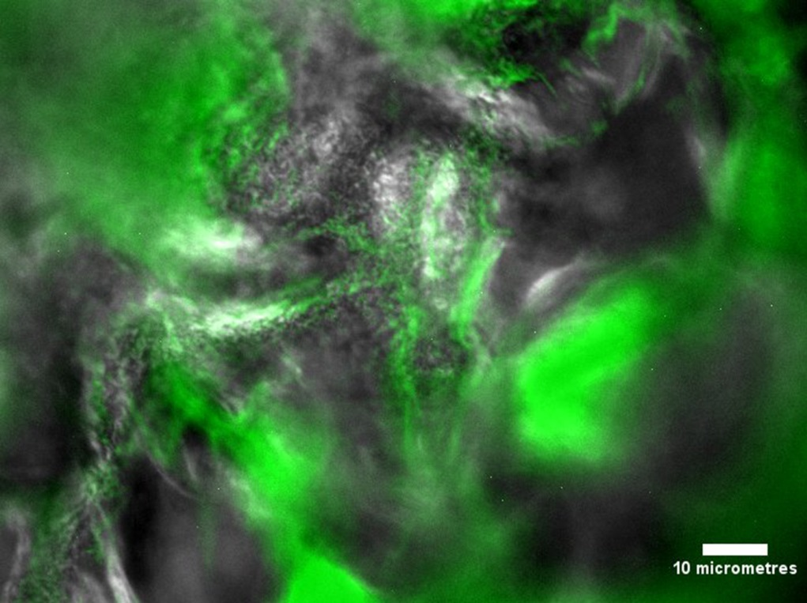
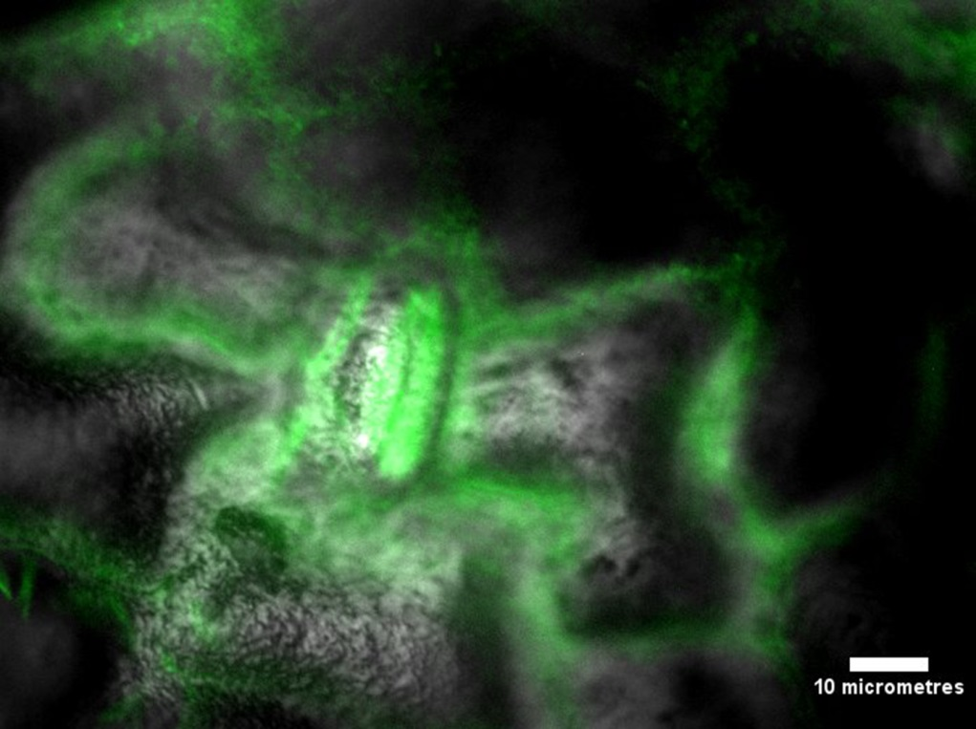
Figure 1a. Overlayed EDIC/EF micrographs of fluorescent L. monocytogenes adhered to the spinach phylloplane after 24 hours incubation. 1b. Overlayed EDIC/EF micrographs of fluorescent Salmonella Thompson adhered to the spinach phylloplane after 24 hours incubation. Scale indicates 10 µm.
Figure 2. L. monocytogenes exposed to chlorinated water cultured on selective media (black) and quantified using DVC (grey). Error bars indicate SEM for 2 replicates.
Figure 3. Salmonella Thompson exposed to chlorinated water cultured on selective media (black) and quantified using DVC (grey). Error bars indicate SEM for 2 replicates.
Figure 4. L. monocytogenes adhered to spinach leaves washed in chlorinated water, cultured on selective media (black) and quantified using DVC (grey). Error bars indicate SEM for 4 replicates.
Figure 5. Salmonella Thompson adhered to spinach leaves washed in chlorinated water, cultured on selective media (black) and quantified using DVC (grey). Error bars indicate SEM for 4 replicates.
Figure 6. Survival of C. elegans exposed to culturable (solid line) and VBNC (broken line) L. monocytogenes (green) and Salmonella Thompson (red). E. coli OP50 (black) is used as a non-pathogenic control.
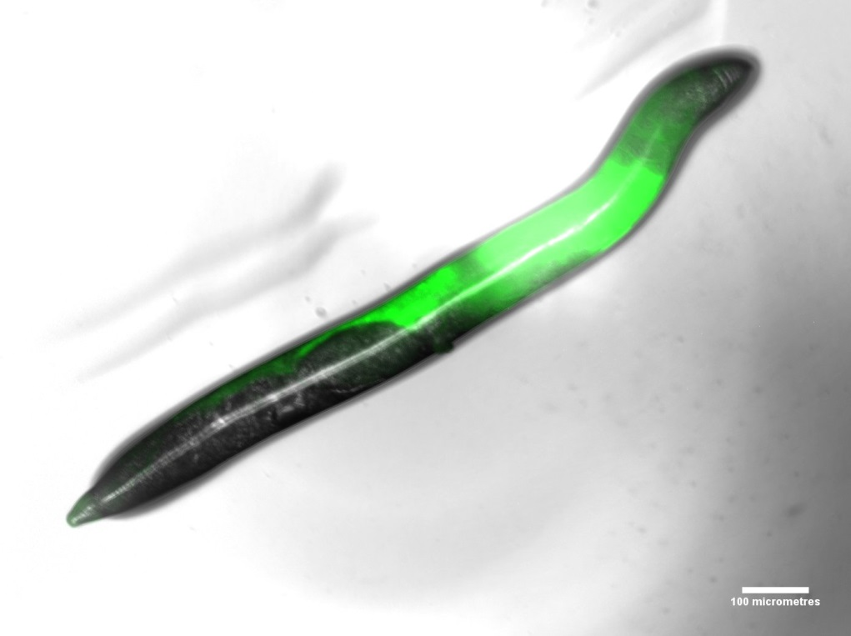
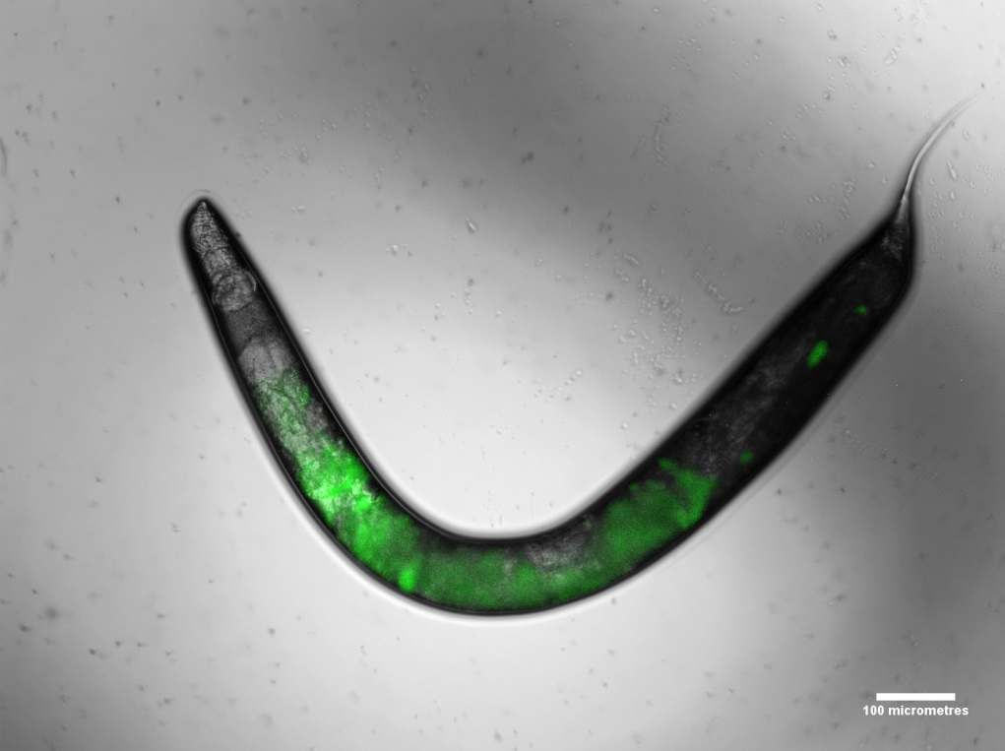
Figure 7a. Overlayed EDIC/EF micrographs of fluorescent VBNC L. monocytogenes ingested by C. elegans. 7b. Overlayed EDIC/EF micrographs of fluorescent VBNC Salmonella Thompson ingested by C. elegans. Scale indicates 100 µm. 7c. Overlayed EDIC/EF micrographs of fluorescent VBNC Salmonella Thompson ingested by C. elegans at the head of the nematode. Scale indicates 20 µm.

