A Genetically Selected Cyclic Peptide Inhibitor of BCL6 Homodimerization
Eliot L. Osher,ª Francisco Castillo,ª Nagarajan Elumalai,ª Michael J. Waring,^{b} Garry Pairaudeau^{c} and Ali Tavassoli^{a,}*
ªChemistry, University of Southampton, Southampton, SO17 1BJ, U.K.
^{b}Northern Institute for Cancer Research, Chemistry, Bedson Building, Newcastle University, Newcastle upon Tyne, NE1 7RU, U.K.
^{c}AstraZeneca, Cambridge Science Park, 310 Milton Rd. Cambridge, CB40FZ, U.K.
*e-mail: a.tavassoli@soton.ac.uk

We report an inhibitor of the homodimeric protein-protein interaction of the BCL6 oncoprotein, identified from a genetically encoded SICLOPPS library of 3.2 million cyclic hexpeptides in combination with a bacterial reverse two-hybrid system. This cyclic peptide is shown to bind the BTB domain of BCL6, disrupts its homodimerization, and subsequent binding of the SMRT2 corepressor peptide.

Introduction
The B-cell lymphoma 6 (BCL6) transcription factor[1, 2] is a master regulator of the germinal centre, which acts by repressing a plethora of critical genes involved in the DNA damage response and cell cycle checkpoints.[3-6] Aberrant expression of BCL6 is associated with the uncontrollable growth and proliferation of B-cells, driving the malignant diffuse large B-cell lymphoma (DLBCL) phenotype. The BCL6 proto-oncogene encodes a 706 amino acid (79 kDa) zinc finger transcription factor, which is comprised of three distinct domains.[2] The N-terminal bric-a-brac, tramtrack and broad-complex (BTB) domain (residues 5-129) plays a fundamental role in the activity of BCL6 by mediating obligate homodimerization and subsequently recruiting co-repressor molecules that repress target genes in multi-protein histone deacetylase complexes.[7] Thus BTB homodimerization is an absolute requirement and critical for BCL6 repressor functions; upon dimerization, each BTB monomer forms a tight intertwined butterfly like homodimer in which approximately a quarter of the monomer surface is masked upon dimer formation.[8] The only prerequisite for the correct folding of the BTB domain of BCL6 is homodimerization, and the interaction is obligate in nature, with an unmeasurable affinity.[9] Dimerization generates a symmetrical binding site at the interface of the two domains known as the lateral groove. This groove creates a docking site that allows specific binding of three co-repressor proteins, nuclear-receptor co-repressor 1 (NCoR1), and silencing mediator for retinoid and thyroid receptor (SMRT) and BCL6-co-repressor (BCoR) to bind exclusively.[10-12] Over the past decade, BTB-SMRT/BCoR heterodimerization has been extensively explored and a number of inhibitors of this Protein-protein interaction (PPI) have been reported.[13-17] There are currently no BTB inhibitors in the clinic, and there are no molecules reported that inhibit BTB homodimerization. Given our prior successes with a genetically encoded high-throughput screening platform,[18-21] we sought to probe the limits of our methodology by aiming to identify inhibitors of BTB homodimerization using this system.

Results
Constructing the BTB RTHS and SICLOPPS screening
We began by constructing a bacterial reverse two-hybrid system (RTHS),[22] where survival and growth of the host E. coli would be dependent on inhibition of BTB homodimerization (Figure 1a). In this RTHS, the targeted protein is expressed as a fusion with the 434 repressor protein; homodimerization of the targeted protein (BTB in this case) results in formation of a functional 434 repressor that binds to engineered chromosomal operators, and prevents reporter-gene expression (Figure 1a). Disruption of the target PPI will also disrupt the 434 repressor complex, leading to reporter gene expression and growth of the host strain on selective media (Figure 1a). Performance of the constructed BTB RTHS was initially assessed by the function of protein encoded by the LacZ reporter gene (ß-galactosidase) using an o-nitrophneyl-ß-D-galactopyranoside (ONPG) assay. In line with repressor formation, an IPTG-dependent reduction in LacZ activity was observed in this assay (Figure 1b). We further assessed the BTB RTHS by ten-fold serial dilution drop-spotting on selective media; formation of a functional repressor would be expected to lead to cell death on selective media (due to the absence of expression of the first and second reporter genes HIS3 and KanR). We observed significant inhibition of growth at 5 µM IPTG (Figure 1c), confirming the formation of a functional repressor. We next used this BTB RTHS in combination with a 3.2 million member SICLOPPS CX₅ cyclic peptide library (where X = any proteinogenic amino acid); a cyclic peptide inhibitor of BTB homodimerization would also disrupt the 434 repressor, and consequently result in survival of a bacterial host on selective media (Figure 1a). After transformation with the SICLOPPS plasmid library, approximately 10⁷ E. coli transformants were plated onto selective media plates supplemented with L-arabinose (inducer of cyclic peptide production). Around 4000 surviving colonies were observed, and these were individually assessed for their ability to disrupt the BTB homodimer using the BTB RTHS.[23] Activity of the selected peptides were ranked by drop spotting, with a single peptide illustrating significantly more potent activity (Figure 1C, bottom row). The identity of this peptide was deconvoluted as cyclo-CIYYCV by isolating and sequencing the parent SICLOPPS plasmid. This cyclic peptide was subsequently synthesized by solid-phase peptide synthesis for use in the following in vitro assays.

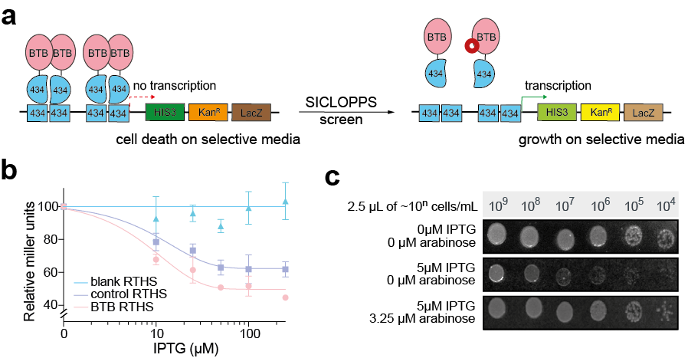
Figure 1: Screening a SICLOPPS library with the BTB RTHS. (a) BTB is expressed as a fusion with the 434 bacteriophage repressor protein. Homodimerization of BTB reconstitutes the repressor, preventing transcription of three reporter genes. An inhibitor of BTB homodimerization will also disrupt repressor formation, enabling expression of the reporter genes, leading to survival and growth of the BTB RTHS on selective media. (b) ONPG assay shows a loss of β-galactosidase activity (LacZ reporter gene product) in response to an increase in IPTG concentrations, indicating formation of a functional repressor. Data presented as Mean ± SEM, n=3. (c) Drop-spotting 10-fold serial dilutions (2.5 μL of 10^{n} cells/mL) of the BTB RTHS. In the absence of IPTG and arabinose, full growth is observed, whereas in the presence of 5 μM IPTG growth of the RTHS is repressed by ~4 spots. In the presence of 3.25 μM arabinose (inducing SICLOPPS) and 5 μM IPTG growth of the RTHS is restored, due to disruption of the BTB PPI.

Assessing the binding of cyclo-CIYYCV to BTB in vitro
The ability of cyclo-CIYYCV (figure 2a) to bind to the BTB homodimer was probed in vitro using two recombinant proteins. The first was a BTB₅₋₁₂₉ wild-type (WT) protein that required a non-cleavable glutathione S-transferase (GST) tag to enhance its solubility. The second variant of the BTB protein was a previously reported triple cysteine mutant C8Q, C67R and C84N (3CysMut from herein); these mutations have been shown to significantly enhance solubility and prevented aggregation when expressed with a His₆ tag.[9, 24, 25] The GST-BTB WT and 3CysMut proteins were used in parallel to characterize the identified inhibitor, to ensure that neither the GST tag, nor the 3 cysteine mutations were significantly altering the native state of the protein. Given that our inhibitor contains two cysteines, it may also be forming disulfide bonds with the protein. We initially quantified the binding affinity of cyclo-CIYYCV to BTB by microscale thermophoresis (MST). We observed an apparent K_{D} value of 142 ± 25 µM when using GST-BTB (figure 2b) and 50 ± 11 µM when using 3CysMut BTB (Figure 2c). The difference observed in these values is likely a consequence of steric hindrance by the large GST affinity tag partially blocking the binding site of cyclo-CIYYCV on BTB. We next probed the effect of cyclo-CIYYCV on protein stability by a thermal shift assay; the resulting data suggests that cyclo-CIYYCV increasingly stabilizes BTB with a dose-dependent increase in melting temperature observed for both GST-BTB (Supplemental Figure 1) and 3CysMut BTB (Figure 2d). We therefore sought to assess the role of potential disulfide bonds in the activity of our inhibitor.

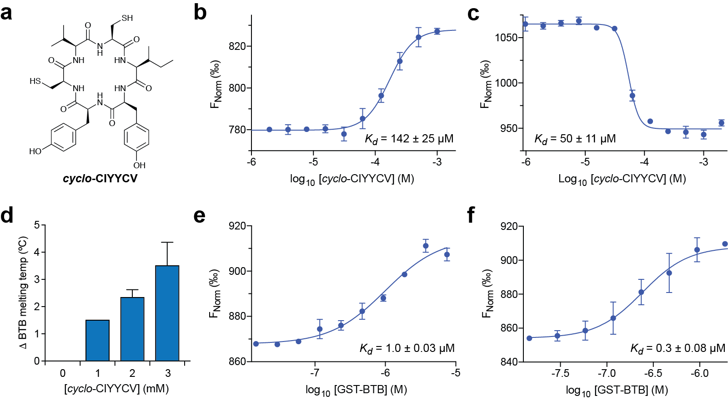
Figure 2: in vitro analysis of the binding of cyclo-CIYYCV to BTB. (a) Structure of cyclo-CIYYCV. (b) cyclo-CIYYCV binds to GST-BTB with a K_{D} of 142 ± 25 µM by MST. (c) cyclo-CIYYCV binds to 3CysMut BTB with a K_{D} of 50 ± 11 µM by MST. (d) cyclo-CIYYCV causes a dose dependent change in the melting temperature of 3cysMut BTB. (e) GST-BTB binds to fluorescently labelled SMRT2 peptide in the presence of 2.5 mM DTT, with a K_{D} of 1.0 ± 0.03 µM by MST. (f) GST-BTB binds to fluorescently labelled SMRT2 peptide with a K_{D} of 0.3 ± 0.08 µM by MST. All data presented as Mean ± SEM, n=3.

Probing the requirement of disulfide bonds for cyclo-CIYYCV activity
To investigate this, the binding of our cyclic peptide inhibitor to BTB was assessed by MST in the presence of 2.5 mM DTT, which would be expected to disrupt disulfide bonds. We observed loss of all activity for cyclo-CIYYCV, against both the WT and 3CysMut protein (Supplemental Figure 2). To determine whether this observed loss of activity was due to the DTT-mediated unfolding of BTB, we assessed the binding of the SMRT2 peptide to this protein in the presence and absence of DTT. It is well established that the SMRT2 corepressor peptide binds to the lateral groove of the BTB homodimer and cannot bind if the protein is misfolded, unfolded or in a monomeric state.[9] We synthesized a fluorescent derivative of the SMRT2 peptide (carboxyfluorescein-LVATVKEAGRSIWEIPR). This peptide was found to bind GST-BTB in the presence of DTT with a K_{D} of 1 ± 0.03 µM (Figure 2e) by MST. Repeating this experiment in the absence of DTT, we observed a K_{D} of 0.3 ± 0.08 µM for the same interaction (Figure 2f). This observed lack of effect from DTT on the binding of SMRT2 to GST-BTB indicates that DTT is unlikely to be affecting the tertiary and quaternary structure of BTB.
To ascertain whether the loss of cyclo-CIYYCV binding to BTB in the presence of DTT was dependent on intramolecular disulfide interactions between the two cysteins of the cyclic peptide, an Ellman’s assay was performed, which may be used to determine the number of free cysteines in a molecule. We observed an absorbance approximately double that of a control containing one free cysteine residue (Supplemental Figure 3), indicating that in the absence of DTT and under assay conditions, both cysteine reisudes of cyclo-CIYYCV were in a reduced state. Together, this data indicates that the observed loss of activity associated with the presence of DTT is likely due to the disruption of disulfide interactions between the cyclic peptide and BTB. However, it is possible that despite the presence of DTT, an intramolecular disulfide bond persists in cyclo-CIYYCV and is required for its activity. One of the cysteins in such a species may still form a disulfide bond to BTB via disulfide shuffling.

Disruption of BTB homodimerization by cyclo-CIYYCV in vitro
We next used size exclusion chromatography (SEC) to assess the effect of cyclo-CIYYCV on the BTB dimer to monomer equilibrium. The 3CysMut protein was used in this experiment to avoid false negatives with BTB-GST arising from GST homodimerization. We observed a small shift in the 3CysMut BTB protein elution volume (from 2.18 mL to 2.22 mL) in the presence of our cyclic peptide inhibitor. This corresponded to a potential 12 kDa shift towards monomeric BTB (Figure 3a), consistent with data from the BTB RTHS (Figure 1c) that cyclo-CIYYCV disrupts the BTB homodimer. We further sought to verify the effect of our inhibitor on the dimerization status of BTB using an indirect assay; the SMRT2 corepressor peptide is known to bind to the lateral groove formed at the interface of the BTB homodimer, thus a BTB homodimerization inhibitor would be expected to reduce the apparent affinity of this interaction. We therefore used a competitive MST assay to measure the affinity of SMRT2 for 3CysMut BTB in the presence and absence of cyclo-CIYYCV. We observed a K_{D} of 25 ± 10 µM for SMRT2 binding to BTB in the absence of our cyclic peptide (Figure 3b), consistent with previously published data.[9, 13, 26] In line with our hypothesis, we observed a ~3-fold reduction in the affinity of this interaction in the presence of cyclo-CIYYCV (300 µM), with a K_{D} of 81 ± 14 µM measured for SMRT2 binding to BTB in the presence of our cyclic peptide (Figure 3c).

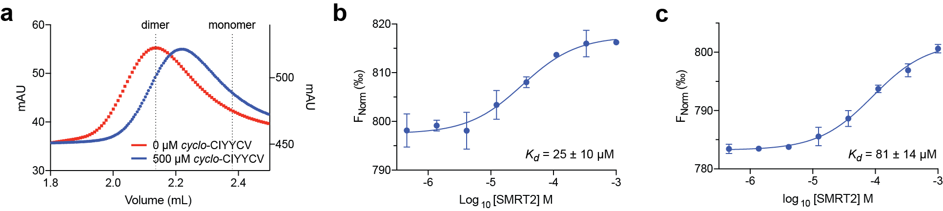
Figure 3: Assessing the ability of cyclo-CIYYCV to disrupt BTB dimerization. (a) Size exclusion chromatography of 3CysMut BTB incubated in the presence and absence of cyclo-CIYYCV, the data shows BTB shifts towards monomer in the presence of the inhibitor. (b) 3CysMut BTB binds to the SMRT2 peptide with a K_{D} of 25 ± 10 µM by MST. (c) 3CysMut BTB binds to the SMRT2 peptide in the presence of cyclo-CIYYCV (300µM) with a K_{D} of 81 ± 14 µM by MST, a 3-fold reduction in affinity in the presence of the inhibitor.

Identifying the critical residues of cyclo-CIYYCV by alanine scanning
The residues of cyclo-CIYYCV that are critical for binding to BTB were identified by alanine scanning. We synthesized six derivatives of the parent cyclic peptide, each with a single amino acid replaced with alanine. The relative activity of each of these molecules (1 mM) was assessed by single-point MST; with a drop or loss of signal amplitude relative to the parent molecule, indicating reduced affinity or lack of binding. The data indicated that each of the two cysteines was critical for activity, with replacement of either with alanine resulting in loss of binding (Figure 4a). Surprisingly, only the second tyrosine was critical to activity of the cyclic peptide, whereas replacement of the first tyrosine only resulted in minor activity loss (Figure 4a). Replacement of either the isoleucine or valine with alanine also didn’t affect binding to BTB (Figure 4a). Overall 3 of the 6 amino acids in cyclo-CIYYCV were found to be essential for its activity (Figure 4b). This data provides further evidence for disulphide bonding playing an important role in the activity of this molecule.

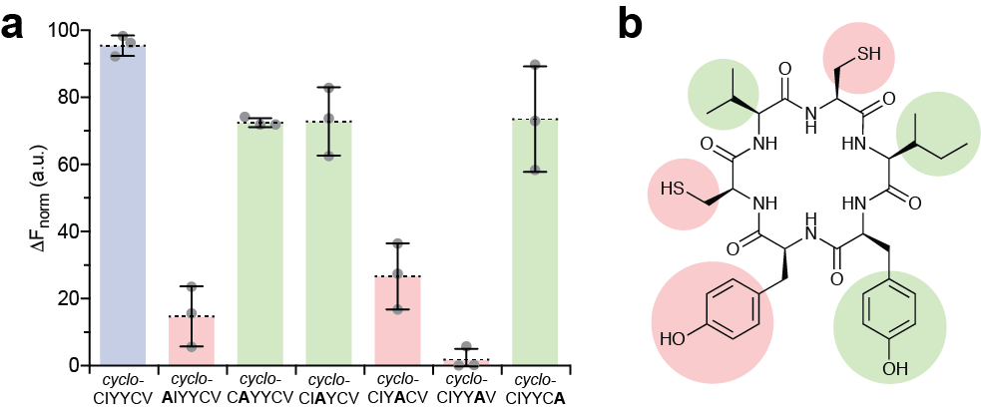
Figure 4: The critical residues of cyclo-CIYYCV. (a) Comparing the effect of 1mM of cyclo-CIYYCV with its 6 alanine-scanning analogues on the MST signal of fluorescently labelled BTB protein. Binding affinity of each molecule for BTB correlates to signal amplitude (i.e. low signal = weaker binding). (b) The structure of cyclo-CIYYCV with residues critical for its activity highlighted in red. Residues whose replacement with alanine did not have a large effect on binding to BTB are highlighted in green.

Conclusions
Taken together, the above data demonstrates that cyclo-CIYYCV binds to BTB and disrupts its homodimerization. The disparity between the apparent affinity of BTB monomers for each other, versus the binding constant of our cyclic peptide to BTB, suggests either a non-reversible mechanism of inhibition, or targeting of an allosteric site. We observed that DTT abrogates the activity of this molecule, and our data suggests that this may be due to the disruption of an intermolecular disulphide bond between the inhibitor and BTB. It is interesting to note that the reducing intracellular environment of the E. coli host used in our screen is likely to disfavour disulphide bond formation, yet cyclo-CIYYCV was selected in this screen and disrupts BTB homodimerization in the RTHS. Regardless of its mechanism of action, the moderate potency of the identified inhibitor limits its further characterization (both in vitro and in cells), and there is a need to improve the potency of our inhibitor. This may be achieved by improving non-covalent affinity via incorporation of non-natural amino acids, as we have previously demonstrated for other peptides.[19, 27, 28] Alanine-scanning of the cyclic peptide identified the two cysteines and the second tyrosine as critical to the activity of our BTB inhibitor. These residues, particularly the tyrosine may be substituted with non-natural analogues, while one or both cysteines may be replaced with a cysteine-trapping residue such as an acrylamide. Thus, this first in class inhibitor, identified from a genetically encoded SICLOPPS library provides a good foundation for development of future BTB homodimerization inhibitors, which may serve as tools or lead molecules for the development of therapeutic agents targeted toward DLBCL.

Acknowledgements
The authors thank Dr. Nichole O’Connell for helpful discussions, and AstraZeneca and the Engineering and Physical Sciences Research Council for funding this work via a PhD studentship to E.L.O.

Supplementary Information
Supplementary Figures 1, 2 and 3; Supplementary Tables 1 and 2; and Material and Methods.

References
[1] K. Offit, F.L. Coco, D.C. Louie, N.Z. Parsa, D. Leung, C. Portlock, B.H. Ye, F. Lista, D.A. Filippa, A. Rosenbaum, M. Ladanyi, S. Jhanwar, R. Dalla-Favera, R.S.K. Chaganti, Rearrangement of the bcl-6 Gene as a Prognostic Marker in Diffuse Large-Cell Lymphoma, New England Journal of Medicine, 331 (1994) 74-80.
[2] B.H. Ye, F. Lista, F. Lo Coco, D.M. Knowles, K. Offit, R.S. Chaganti, R. Dalla-Favera, Alterations of a zinc finger-encoding gene, BCL-6, in diffuse large-cell lymphoma, Science, 262 (1993) 747-750.
[3] R.T. Phan, R. Dalla-Favera, The BCL6 proto-oncogene suppresses p53 expression in germinal-centre B cells, Nature, 432 (2004) 635-639.
[4] R.T. Phan, M. Saito, K. Basso, H. Niu, R. Dalla-Favera, BCL6 interacts with the transcription factor Miz-1 to suppress the cyclin-dependent kinase inhibitor p21 and cell cycle arrest in germinal center B cells, Nature immunology, 6 (2005) 1054-1060.
[5] S.M. Ranuncolo, J.M. Polo, J. Dierov, M. Singer, T. Kuo, J. Greally, R. Green, M. Carroll, A. Melnick, Bcl-6 mediates the germinal center B cell phenotype and lymphomagenesis through transcriptional repression of the DNA-damage sensor ATR, Nature immunology, 8 (2007) 705-714.
[6] A.L. Shaffer, X. Yu, Y. He, J. Boldrick, E.P. Chan, L.M. Staudt, BCL-6 represses genes that function in lymphocyte differentiation, inflammation, and cell cycle control, Immunity, 13 (2000) 199-212.
[7] C. Lemercier, M.P. Brocard, F. Puvion-Dutilleul, H.Y. Kao, O. Albagli, S. Khochbin, Class II histone deacetylases are directly recruited by BCL6 transcriptional repressor, The Journal of biological chemistry, 277 (2002) 22045-22052.
[8] S. Parekh, G. Prive, A. Melnick, Therapeutic targeting of the BCL6 oncogene for diffuse large B-cell lymphomas, Leukemia Lymphoma, 49 (2008) 874-882.
[9] K.F. Ahmad, A. Melnick, S. Lax, D. Bouchard, J. Liu, C.L. Kiang, S. Mayer, S. Takahashi, J.D. Licht, G.G. Prive, Mechanism of SMRT corepressor recruitment by the BCL6 BTB domain, Mol Cell, 12 (2003) 1551-1564.
[10] K.D. Huynh, V.J. Bardwell, The BCL-6 POZ domain and other POZ domains interact with the co-repressors N-CoR and SMRT, Oncogene, 17 (1998) 2473-2484.
[11] K.D. Huynh, W. Fischle, E. Verdin, V.J. Bardwell, BCoR, a novel corepressor involved in BCL-6 repression, Genes & development, 14 (2000) 1810-1823.
[12] C.W. Wong, M.L. Privalsky, Components of the SMRT corepressor complex exhibit distinctive interactions with the POZ domain oncoproteins PLZF, PLZF-RARalpha, and BCL-6, The Journal of biological chemistry, 273 (1998) 27695-27702.
[13] M.G. Cardenas, W.B. Yu, W. Beguelin, M.R. Teater, H.M. Geng, R.L. Goldstein, E. Oswald, K. Hatzi, S.N. Yang, J. Cohen, R. Shaknovich, K. Vanommeslaeghe, H.M. Cheng, D.D. Liang, H.J. Cho, J. Abbott, W. Tam, W. Du, J.P. Leonard, O. Elemento, L. Cerchietti, T. Cierpicki, F.T. Xue, A.D. MacKerell, A.M. Melnick, Rationally designed BCL6 inhibitors target activated B cell diffuse large B cell lymphoma, J Clin Invest, 126 (2016) 3351-3362.
[14] L.C. Cerchietti, S.N. Yang, R. Shaknovich, K. Hatzi, J.M. Polo, A. Chadburn, S.F. Dowdy, A. Melnick, A peptomimetic inhibitor of BCL6 with potent antilymphoma effects in vitro and in vivo, Blood, 113 (2009) 3397-3405.
[15] A. Chattopadhyay, S.A. Tate, R.W. Beswick, S.D. Wagner, P. Ko Ferrigno, A peptide aptamer to antagonize BCL-6 function, Oncogene, 25 (2006) 2223-2233.
[16] Y. Kamada, N. Sakai, S. Sogabe, K. Ida, H. Oki, K. Sakamoto, W. Lane, G. Snell, M. Iida, Y. Imaeda, J. Sakamoto, J. Matsui, Discovery of a B-Cell Lymphoma 6 Protein-Protein Interaction Inhibitor by a Biophysics-Driven Fragment-Based Approach, J Med Chem, 60 (2017) 4358-4368.
[17] W. McCoull, R.D. Abrams, E. Anderson, K. Blades, P. Barton, M. Box, J. Burgess, K. Byth, Q. Cao, C. Chuaqui, R.J. Carbajo, T. Cheung, E. Code, A.D. Ferguson, S. Fillery, N.O. Fuller, E. Gangl, N. Gao, M. Grist, D. Hargreaves, M.R. Howard, J. Hu, P.D. Kemmitt, J.E. Nelson, N. O'Connell, D.B. Prince, P. Raubo, P.B. Rawlins, G.R. Robb, J. Shi, M.J. Waring, D. Whittaker, M. Wylot, X. Zhu, Discovery of Pyrazolo[1,5-a]pyrimidine B-Cell Lymphoma 6 (BCL6) Binders and Optimization to High Affinity Macrocyclic Inhibitors, J Med Chem, 60 (2017) 4386-4402.
[18] K.R. Lennard, A. Tavassoli, Peptides come round: using SICLOPPS libraries for early stage drug discovery, Chemistry, 20 (2014) 10608-10614.
[19] A.L. Male, F. Forafonov, F. Cuda, G. Zhang, S. Zheng, P.C.F. Oyston, P.R. Chen, E.D. Williamson, A. Tavassoli, Targeting Bacillus anthracis toxicity with a genetically selected inhibitor of the PA/CMG2 protein-protein interaction, Sci Rep, 7 (2017) 3104.
[20] E. Miranda, I.K. Nordgren, A.L. Male, C.E. Lawrence, F. Hoakwie, F. Cuda, W. Court, K.R. Fox, P.A. Townsend, G.K. Packham, S.A. Eccles, A. Tavassoli, A cyclic peptide inhibitor of HIF-1 heterodimerization that inhibits hypoxia signaling in cancer cells, J Am Chem Soc, 135 (2013) 10418-10425.
[21] A. Tavassoli, SICLOPPS cyclic peptide libraries in drug discovery, Curr Opin Chem Biol, 38 (2017) 30-35.
[22] A. Tavassoli, S.J. Benkovic, Genetically selected cyclic-peptide inhibitors of AICAR transformylase homodimerization, Angew Chem Int Edit, 44 (2005) 2760-2763.
[23] E.L. Osher, A. Tavassoli, Intracellular Production of Cyclic Peptide Libraries with SICLOPPS, Methods in molecular biology, 1495 (2017) 27-39.
[24] A.F. Ghetu, C.M. Corcoran, L. Cerchietti, V.J. Bardwell, A. Melnick, G.G. Prive, Structure of a BCOR corepressor peptide in complex with the BCL6 BTB domain dimer, Mol Cell, 29 (2008) 384-391.
[25] M.A. Stead, G.O. Rosbrook, J.M. Hadden, C.H. Trinh, S.B. Carr, S.C. Wright, Structure of the wild-type human BCL6 POZ domain, Acta crystallographica. Section F, Structural biology and crystallization communications, 64 (2008) 1101-1104.
[26] J.M. Polo, T. Dell'Oso, S.M. Ranuncolo, L. Cerchietti, D. Beck, G.F. Da Silva, G.G. Prive, J.D. Licht, A. Melnick, Specific peptide interference reveals BCL6 transcriptional and oncogenic mechanisms in B-cell lymphoma cells, Nat Med, 10 (2004) 1329-1335.
[27] D.J. Asby, F. Cuda, M. Beyaert, F.D. Houghton, F.R. Cagampang, A. Tavassoli, AMPK Activation via Modulation of De Novo Purine Biosynthesis with an Inhibitor of ATIC Homodimerization, Chem Biol, 22 (2015) 838-848.
[28] I.B. Spurr, C.N. Birts, F. Cuda, S.J. Benkovic, J.P. Blaydes, A. Tavassoli, Targeting tumour proliferation with a small-molecule inhibitor of AICAR transformylase homodimerization, Chembiochem, 13 (2012) 1628-1634.

