The Euler-Bernoulli Beam on a Tensionless Winkler Foundation: A Simple Problem of Receding Contact
N G Stephen^{a, b} and S Y Ch’ng^{b}
ª Mechanical Engineering, Faculty of Engineering and the Environment,
University of Southampton, SO17 1BJ, UK
and
^{b} University of Southampton Malaysia Campus
3, Persiaran Canselor 1, Kota Ilmu Educity@Iskandar, 79200 Iskandar Puteri, Johor, Malaysia

Abstract
A steel ruler supported by a flexible foam foundation, modelled as an Euler-Bernoulli beam on a Winkler foundation, exhibits receding contact when subjected to a point load. The system is analysed using simple beam theory and Laplace transformation – both of which are typically covered in the first two years of a UK Mechanical Engineering undergraduate programme. The design of a simple experiment is described.

Key words: Receding contact; Euler-Bernoulli beam; Winkler foundation; Laplace transformation

1. Introduction
Despite the immense importance of contact mechanics within mechanical and related engineering disciplines, the typical undergraduate programme might only consider the Hertzian contact between two spherical or cylindrical objects; for many other contact problems, the mathematical tools required are those relevant to integral equations, which are beyond a typical undergraduate engineering programme. Contact zones are often the most highly stressed region of a component, and any relative movement can give rise to fretting, with high rates of wear and possible fatigue.
If two elastic bodies initially touch at just a point, or along a line, then the bodies are said to be non-conforming, and the contact area will generally increase upon loading [1, 2], as in Hertzian contact. On the other hand, if the unloaded bodies exactly fit one another or are in contact over an appreciable area, then they are said to be conforming; upon loading, the contact area may reduce in size, when contact is said to be receding [3].
The present work considers the receding contact between an Euler-Bernoulli beam resting upon a tensionless Winkler foundation. The analysis is compatible with the mathematical skills developed within a typical undergraduate (UG) programme, requiring just a knowledge of elementary bending theory and Laplace transformation (LT), both of which are typically covered within the first one or two years of a UK UG programme. LT is ideally suited to the problem as the “initial condition” terms that so arise are related to the geometric and natural boundary conditions for an Euler-Bernoulli beam – displacement, slope, bending moment and shearing force, and three of these can immediately be set equal to zero. The derived expression for the contact region is in agreement with an alternative analysis by Weitsman [4]. The design of a simple experiment to demonstrate receding contact is also described; however, the ability to test the accuracy is more challenging. Nevertheless, this example consists of a simple theoretical model which predicts receding contact, and which can be demonstrated easily in a classroom setting with some foam and a ruler.
Within small displacement linear elasticity and solid mechanics, one generally makes no distinction between the geometry before and after the load is applied; exceptions include elastic buckling and contact mechanics. For the present contact problem there is no logical origin of coordinates, or indeed scale, until the beam is loaded and deformation has taken place. Further, the length of the contact zone after loading is independent of the magnitude of the applied load, implying an almost immediate change from the initial to the final contact length.

2. Theory
We consider an initially straight uniform massless Euler-Bernoulli beam of arbitrary (possibly infinite) length resting upon an elastic foundation of modulus k. A point load of magnitude P is applied at the “mid-point” of the beam, 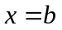 as depicted in Figure 1. The origin of the coordinate system is taken to coincide with the location where the beam lifts from the foundation; the length of the contact zone 2b is unknown. The vertical displacement v is zero at  and 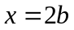; the bending moment and the shearing force are also zero at and , but only because the beam is regarded as massless. For 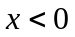 and 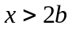, the beam remains straight (again because it is massless) and there is loss of contact between the beam and the foundation.
The governing equation for 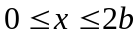 is
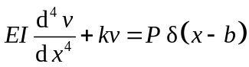 (1)
where  is the flexural rigidity and is the Dirac delta function. (The derivation requires bending moment 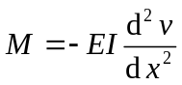 , shearing force 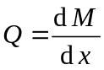 , and distributed load 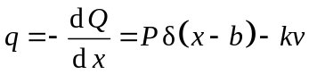 for the sign convention employed.) Introduce 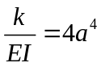, and this becomes
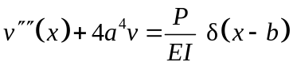 (2)
where prime denotes 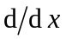. Now Laplace transform Eq. (2) to give
(3)
where bar denotes the transformed variable. However, we know that 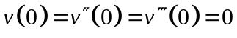, so this immediately reduces to
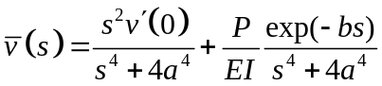. (4)
Last, inverse Laplace transform to give
(5)
where H is the Heaviside (unit) step function.
We also have boundary conditions 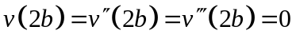, and substituting the first of these into Eq. (5) allows one to determine the slope 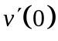 as
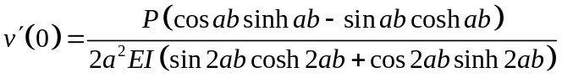 (6)
although for brevity, this substitution is not yet employed; indeed, it will simplify further. We note that this slope is proportional to the applied load P. Application of the second and third boundary conditions at , that is 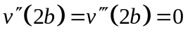 is less straightforward, at least for the second term in Eq. (5), so it is convenient to consider the derivatives separately. For the first term in Eq. (5), denoted with subscript 1, the derivatives are straightforward, and are
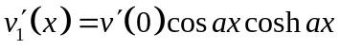 (7)
(8)
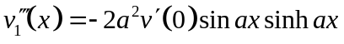. (9)
For the second term in Eq. (5), a degree of subtlety is required: one is differentiating a product of a function of x with the Heaviside function, which is also a function of x; the differential of the latter is the Dirac delta function 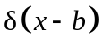, which has the sifting property that 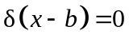 for 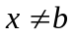. Accordingly, one has
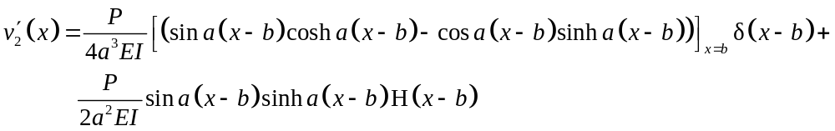
(10)
where the subscript on the first term is a consequence of the sifting property, and implies that that term is to be evaluated at . The first term of Eq. (10) is immediately zero, so this reduces to
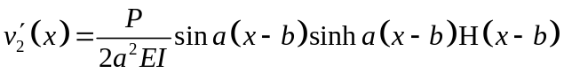. (11)
The higher derivatives of the second term are
(12)
and
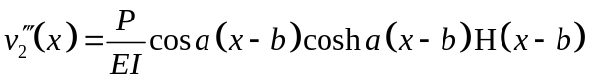 (13)
so we have
(14)
(15)
and
. (16)
The boundary conditions 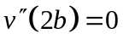 and 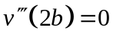 respectively lead to
(17)
or more succinctly
, (18)
and
(19)
which reduces to
; (20)
in the above, Eq. (6) has been employed within Eqs. (15,16).
Besides the trivial solution 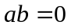, Eqs. (18) and (20) are both satisfied by 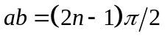 for 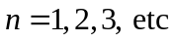. However, only the smallest root 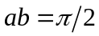 is consistent with a tensionless foundation; for 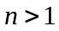, displacement of the beam can be negative (upwards), when the governing Eq. (1) is only applicable for a foundation that can withstand tension. Accordingly, the length of the contact zone 2b is then
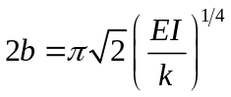 (21)
which is independent of the applied load P.
The slope at reduces to
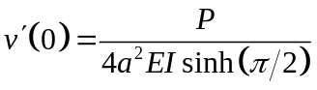 (22)
The slope of the beam beneath the load is
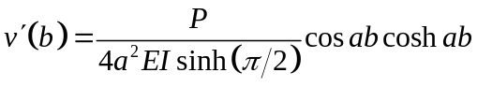 (23)
which is zero for . The deflection of the beam beneath the load becomes
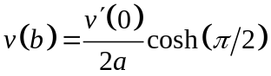 (24)
which can be expressed as
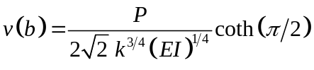; (25)
numerically, this is
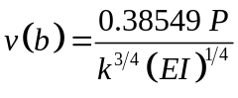. (26)

3. Experiment Design
The design of a simple experiment to illustrate receding contact is relatively straightforward. An obvious choice for the Euler-Bernoulli beam is a spring-steel ruler of rectangular cross-section which already has the means to measure the length of the contact zone marked upon its surface.
The realisation of a point-load becomes a line-load at mid-span, and can be applied simply by means of a small diameter circular section rod carrying weights at either end, or even a wire as employed here; a more sophisticated arrangement might consist of a welded weight-hanger with a knife edge replacing the rod. Despite the foundation being depicted in Figure 1 as a collection of independent discrete springs in parallel, each of which would have units N/m, in reality the foundation is closer to a continuum strip and its modulus k is the spring stiffness per unit length; in turn, k has units 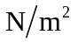. A solid foam material is a suitable choice, and that employed in Plate 1 is Pick N PluckTM open cell polyurethane with a density of 1.3 lb per cubic foot (20.82 kg/m³), and is slightly wider (30 mm) than the ruler. The bulk material consists of a two-dimensional array of 15 mm square cross-section foam columns which are loosely attached to one another, and was supplied with a packing case purchased for the transport of sensitive scientific equipment. Individual columns can easily be plucked from the array to create a cavity shaped to accommodate a particular item, such as a camera; accordingly, the shear stiffness and strength between each column is small and this, to some limited extent, approaches the idealised Winkler foundation. Such foams generally have non-linear stress-strain curves in compression and are typically anisotropic; since they are often employed in mattresses and upholstery, where comfort and support is the main requirement, testing is by Indentation Force Deflection – in the American ASTM standard D3574, it is the force required to indent an eight-inch steel plate into a standard size specimen to a stated percentage of the original thickness, normally 4 inches. In order to determine k, a simple compression test was performed on a six by four array of connected columns; weights were placed on a plate of the same planform area as the array, and vertical deflections measured with a height gauge. The force-deflection curve was near linear, with a slight hardening characteristic. From a best-fit linear assumption, the Young’s modulus was calculated to be 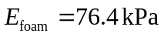. For an arbitrary bar in compression, the stiffness would be 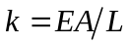, where A is the cross-sectional area and L is the length; adapting this expression, the required stiffness per unit length becomes 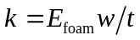 N/mm² where w is the width of the foundation strip (30 mm) and t is the thickness, or depth (length L = 58 mm), leading to a foundation modulus of 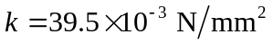.
The spring-steel ruler employed has breadth 26.1 mm, depth 0.63 mm, and assumed Young’s modulus of 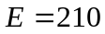 GPa, leading to a flexural rigidity of 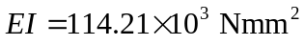. The contact length calculated from Eq. (21) as 2b = 183.2 mm compares very favourably with the observed contact length of 2b = 201 mm.
On the other hand, the predicted slope at of about four degrees compares with the experimentally observed eight degrees, while the deflection under the point load (a mass of 2 kg was applied) is predicted as about 5 mm, compared to the observed 12 mm. For the contact length, slope and deflection, all of the predicted values are less than those obtained experimentally, which at first sight implies that the numerical value employed for k within the theory is too large; this could be attributed to the fact that the width of the foundation (30 mm) was slightly greater than the width of the ruler (26.1 mm); indeed, this ratio (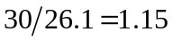) is very close to the ratio of the observed and predicted contact lengths (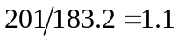). However, such reasoning would be false: contact length is proportional to 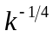, so a 15% error in k, when raised to the power of 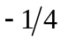, would only account for a 3.6% difference in contact length. Similarly, the slope at is proportional to 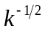, and the deflection under the point load to 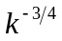, so again differences in these observations cannot be attributed to error in k. These remarks serve to emphasise that the Winkler foundation model is but the simplest available, a so-called one-parameter model of mutually independent vertical springs; more sophisticated models [5] contain up to three parameters (two layers of springs, either side of a shear layer) and provide continuity in displacement of the foundation. However, this simple model does serve to illustrate the non-linear nature of a particular problem in contact mechanics, and does predict the contact length with fairly good accuracy.

4. Concluding remarks
A force can be applied to a solid elastic body by just two means: a body force, such as gravity or magnetism, or by contact with a fluid or another solid body at its surface. (This distinction is often overlooked in simple beam bending problems that are met in First Year undergraduate engineering programmes when self-weight, a body force, is often treated as a uniformly distributed load, which is a surface force; this may not matter as far as determination of the bending moment is concerned but conceptually, it misleadingly suggests that the two are more generally interchangeable.) When the surface load is applied by means of a fluid, the pressure would generally be known, while the surface displacement would be unknown. However, when a surface load is applied through contact with a second solid body, one has a problem in Contact Mechanics, and both the interface pressure and displacements would be unknowns. The second solid body may be regarded as rigid, when it would be known as a punch, or it may be elastic.

References
1. JR Barber, M Ciavarella. Contact mechanics. International Journal of Solids and Structures 37, 29-43, 2000.
2. KL Johnson. Contact Mechanics. Cambridge University Press, 1985.
3. LM Keer, J Dundurs, KC Tsai. Problems involving a receding contact between a layer and a half space. ASME Journal of Applied Mechanics 39, 1115-1120, 1972.
4. Y Weitsman. On foundations that react in compression only. ASME Journal of Applied Mechanics 37, 1019-1031, 1970.
5. AD Kerr. A study of a new foundation model. Acta Mechanica 1, 135-147, 165.

x
P
2b
y, v
k
Figure 1. Receding contact of an Euler-Bernoulli beam on a tensionless elastic foundation.

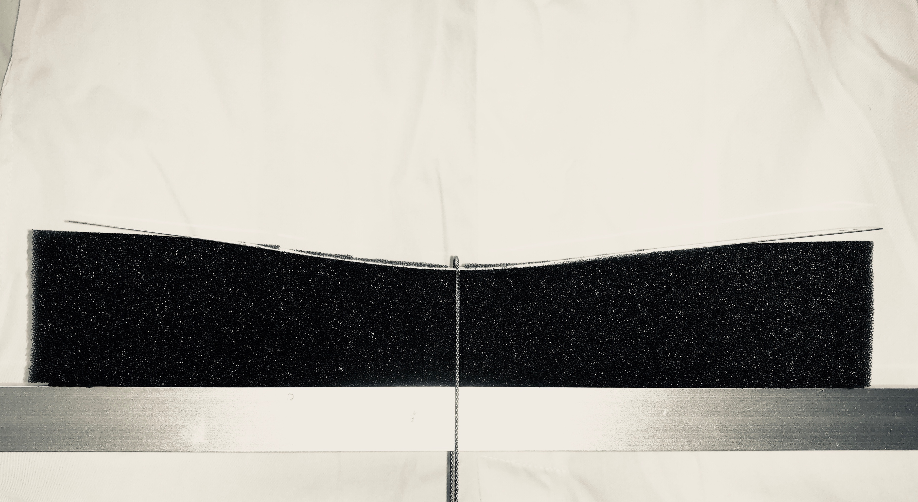

Plate 1. Receding contact demonstration experiment.

