Antibiotic Loaded Calcium Sulfate Bead and Pulse Lavage Eradicates Biofilms on Metal Implant Materials in vitro
Cory S. Knecht,^{1, *} James P. Moley,^{2, *} Mary S. McGrath,^{2, *} Jeffrey F. Granger,³ Paul Stoodley^{2,3,4, †} Devendra H. Dusane ²
¹Department of Orthopaedics, Cleveland Clinic, Akron General, Akron, Ohio.
²Department of Microbial Infection and Immunity, The Ohio State University, Columbus, Ohio 43210, USA
³Department of Orthopaedics; The Ohio State University, Columbus, Ohio 43210, USA
⁴National Centre for Advanced Tribology at Southampton (nCATS), University of Southampton, Southampton SO17 1BJ, United Kingdom.
* Equal contribution
Running title: Biofilm Removal from Implant Materials
Disclosures: One or more of the authors (PS) has received funding from, or consults for, Biocomposites Ltd., Zimmer-Biomet and Smith and Nephew.
Contact information:​
Paul Stoodley, PhD
Professor, Department of Microbial Infection and Immunity
Professor, Department of Orthopaedics
The Ohio State University
716 Biomedical Research Tower (BRT)
460 W 12th Ave, Columbus OH 43210
Phone: (614) 292-7826
Paul.Stoodley@osumc.edu
Author Contributions Statement: CK, JM, MM, JFG, PS and DHD made substantial contributions to research design, analysis and interpretation of data. CK, JM, MM and DHD conducted the experiments. DHD supervised the experimental protocols. All authors contributed to generating the figures, writing portions of the manuscript and have read and approved the final submitted manuscript.

ABSTRACT: Pulse lavage (PL) debridement and antibiotic loaded calcium sulfate beads (CS-B) are both used for the treatment of biofilm related periprosthetic joint infection (PJI). However, the efficacy of these alone and in combination for eradicating biofilm from orthopaedic metal implant surfaces is unclear. The purpose of the study was to understand the efficacy of PL and antibiotic loaded CS-B in eradicating bacterial biofilms on 316L stainless steel (SS) alone and in combination in vitro. Biofilms of bioluminescent strains of Pseudomonas aeruginosa Xen41 and a USA300 MRSA Staphylococcus aureus SAP231 were grown on SS coupons for 3 days. The coupons were either, a) debrided for 3s with PL, b) exposed to tobramycin (TOB) and vancomycin (VAN) loaded CS-B for 24 h, or c) exposed to both. An untreated biofilm served as a control. The amount of biofilm was measured by bioluminescence, viable plate count and confocal microscopy using live/dead staining. PL alone reduced the CFU count of both strains of biofilms by approximately 2 orders of magnitude, from an initial cell count on metal surface of approximately 10⁹ CFU/cm². The antibiotic loaded CS-B caused an approximate 6 log reduction and the combination completely eradicated viable biofilm bacteria. Bioluminescence and confocal imaging corroborated the CFU data. While PL and antibiotic loaded CS-B both significantly reduced biofilm, the combination of two was more effective than alone in removing biofilms from SS implant surfaces.

Keywords: infection; biofilm; antibiotic loaded calcium sulfate; pulse lavage; Staphylococcus; Pseudomonas

INTRODUCTION
Orthopaedic periprosthetic joint infections (PJI) place significant economic, emotional, and clinical burdens on patients and medical providers resulting from extended hospitalizations, significant morbidity, increased antibiotic exposure and the high medical costs associated with revision surgeries. ¹ Approximately one million total knee and hip arthroplasties occur each year in the United States and 1-4% of these become infected. Biofilms, aggregates of bacteria cells embedded in an extracellular polymeric substances (EPS) matrix, has become a recognized virulence factor in PJI and biofilm formation confers high levels of antibiotic tolerance and protection against host immunity to the pathogens within. ² Staphylococcus epidermidis, Staphylococcus aureus and Pseudomonas aeruginosa have been associated with almost 75% of biofilms from PJI. ^{3; 4} Once a PJI is established the prognosis for resolution is poor, ^{5; 6} with failure rates following irrigation and debridement (I&D) in knees reported between 53 and 84%, ⁷ suggesting I&D does not remove all of the infecting biofilm. Often pulse lavage (PL) is utilized as a method to mechanically disrupt and remove bacterial biofilm established on bone, soft tissue, and prosthetic devices; however an in vitro study by Urish et al. showed that pulse lavage only removed 90% of biofilm from materials commonly used in arthroplasty. ⁸
In addition to physical removal, antibiotic loaded cements are used in order to control infecting bacteria that may remain or subsequently enter the surgical site. ⁹ In addition to PMMA laden cement in various forms such as spacers, rods and beads, pharmaceutical grade calcium sulfate beads (CS-B) loaded with antibiotics are also used. ¹⁰ Mineral beads such as CS-B do not play a structural role but have the advantage that they completely dissolve when implanted in soft tissues releasing all antibiotic and thus also negate need for subsequent removal and their small size can be conducive to obtaining high packing density in terms of dead space management in the vicinity of the prosthesis. ^{10; 11} Previously we have assessed CS-B loaded with vancomycin hydrochloride (VAN) and tobramycin sulfate (TOB) to prevent or kill biofilms from various Gram positive and negative biofilm forming PJI pathogens using a polystyrene culture dish as a substrate. ^{12; 13} Here we extend our study to biofilms grown on 316L stainless steel (SS) as a representative orthopaedic metal and compare the efficacy of eradicating Pseudomonas aeruginosa and Staphylococcus aureus biofilms using PL alone, CS-B loaded with VAN and TOB alone and the two treatments (PL and CS-B) in combination. Biofilm was assessed by bioluminescence, plate counts and confocal microscopy.

MATERIAL AND METHODS

Bacteria and growth conditions
Bioluminescent strains of S. aureus (SAP231, a transformed USA 300 MRSA strain) ¹⁴ and a P. aeruginosa PAO1 derivative (Xen 41, PerkinElmer, USA) were used in this study, as previously described. ¹⁵ S. aureus SAP231 was grown in Brain Heart Infusion broth (BHI; Sigma Aldrich, USA) and P. aeruginosa Xen41 was grown in Lysogeny Broth (LB; Sigma Aldrich, USA) respectively at 37°C overnight on shaker conditions set at 200 rpm. The overnight cultures were used as an inoculum for biofilm formation on coupons.

Biofilm formation on SS coupons
Biofilms were grown on SS coupons (BioSurface Technologies, Bozeman, MT). The coupons had a diameter of 1.27 cm, surface area of 1.27cm², and roughness of 0.51µm measured at 20 °C by contact profilometry (MAHR PS-1) according to standard methods ISO4288/ASME B461. Briefly, sterile SS coupons were aseptically transferred to 24 well clear bottom microtiter plates (Corning Inc, USA). Overnight cultures of S. aureus SAP231 or P. aeruginosa Xen41 were added to 2 mL of growth media (BHI or LB broth respectively) to achieve the final cell concentration of approximately 1 × 10⁵ CFU/mL. The aliquots were added to microtiter plate wells containing SS coupons and incubated for 3 days at 37°C, 5% CO₂ for biofilm formation with daily media exchanges.

Preparation of antibiotic loaded calcium sulfate beads (CS-B)

The CS-B were loaded with TOB) and VAN (Sigma-Aldrich, USA) powder to match a formulation of 240 mg of TOB and 1000 mg of VAN per 10CC of calcium sulfate (CaSO₄) for clinical relevance. ¹⁰ These were prepared by combination of sterile water, the respective antibiotic powder, and calcium sulfate hemihydrate (Sigma-Aldrich, USA) powder. The dry powders and water were manually stirred for thirty seconds until a smooth paste was produced. The smooth paste was pressed and shaped into a flexible mold (Biocomposites Ltd., Keele, UK) containing 4.8mm-wide hemispherical depressions. After being left for 24 h at 20°C to harden, the beads were released from the mold prior to use.

Debridement and antibiotic exposure
Coupons were either exposed to a) debridement with PL, b) an antibiotic loaded CaSO₄ bead (CS-B), or c) both. Those coupons exposed to PL were irrigated with sterile ultrapure distilled water (Invitrogen) using a Stryker Interpulse hand piece set (Stryker) with a coaxial high flow tip and suction tube on high flow setting. The nozzle was kept perpendicular to the surface of the coupon at 3 cm distance and moved randomly over the entire surface for 3s by a single operator. The diameter of the jet stream was approximately 5 mm traveling at a maximum velocity of approximately 3.45 m/s during the initial high velocity pulse (measured by video capture) which generated a maximum of 330N force (measured by weight by impinging the water jet on an analytical balance). From these values we calculated an impact pressure of 8.1 × 10³ N/m² as previously described. ¹⁶ Biofilm colonized coupons exposed to a single CS-B bead were incubated in BHI broth for S. aureus or LB for P. aeruginosa for a further 24 h (37 °C, 5% CO₂). Those coupons exposed to both conditions were first debrided with PL and then immediately a single CS-B bead was added to the culture well. A control group of 3 day biofilms with no treatments were included for statistical comparison. Experiments were performed in triplicate.

Bioluminescent IVIS imaging
Prior to biofilm removal for cell count enumeration bioluminescent imaging was performed using an IVIS 100 (Xenogen) on one representative coupon from each treatment and control group as previously described. ¹⁵ IVIS provides a non-destructive method of assessing the relative amount of actively growing biofilm. ⁸ The images were captured in grayscale of intensity where white was the most active areas and black indicative inactive or not present. The relative amount of biofilm was quantified by activity intensity using FIJI image analysis ¹⁷ software measuring a region of interest (ROI) corresponding to the position of the coupon. The data were also presented with a heat-map color scale for visual clarity, where red represents most metabolically active cells and blue/black color indicates inactive/dead bacterial cells.

Viable cell count
Following exposure to the treatment arms, each coupon was rinsed with sterile phosphate buffered saline (PBS; Dulbecco’s, Gibco, USA). The biofilm was removed by sonicating into 10 mL of PBS at a frequency of 35 kHz for 15 min. Sonication was repeated three times total with a 10s vortex period in between each time. A 10-fold serial dilution was prepared and plated onto a solid agar for enumeration of colony forming units (CFU) after 24 h incubation (37°C, 5% CO₂) and expressed as CFU/cm².

Confocal laser scanning microscopy (CLSM)
For conformation of the CFU data confocal laser scanning microscopy (CLSM, Olympus FV10i) was performed on SS coupons in control and treatment arms. The bacterial biofilms were observed using Live-Dead staining (Invitrogen, USA). Live-Dead kit contains SYTO-9 that stains bacterial DNA green and Propidium Iodide (PI) that enters compromised bacterial cell membranes and stains dead or dying cells red.

Statistical analysis
CFU data was first log₁₀ transformed. Statistical comparisons between the geometric means of CFU/cm² from control and experimental arms were performed using Excel software (Microsoft) using an unpaired, two tailed Student’s t-test assuming equal variance. Differences were considered significant for p<0.05.

RESULTS
Bioluminescent IVIS imaging
To make an initial and rapid assessment on the efficacy of biofilm eradication IVIS images of the bioluminescent intensity were taken and compared for coupons in each arm (Fig. 1). In the control (untreated arm) biofilm was clearly present and active on the coupons (Fig. 1A and 1B). Interestingly, for S. aureus SAP231, there was more biofilm attached to the edges of the coupon, illustrating the potential importance of large scale geometric features on biofilm accumulation. For biofilms exposed to PL, a CS-B and a combination there was successively less signal respectively (Fig. 1A and 1B). For the PL of the SAP231 it was noted that some biofilm remained around the coupon edges suggesting that not only was there more biofilm at this location but that it was more firmly attached (Fig. 1B).

Viable cell count
Bacterial quantification on coupons in each experimental arm was accomplished with CFU counts. The control arm showed that after 3 days that the biofilms had grown to approximately 10⁹ CFU/cm² (Fig. 2). There were no significant difference (p>0.05) between coupons harboring P. aeruginosa and S. aureus biofilms. PL debridement resulted in an approximate 2 log reduction in CFU/cm² from the control set (p<0.05), whereas 24 h exposure to antibiotic loaded CS-B showed an approximate 6 log reduction (p<0.05). Both debridement and antibiotic exposure resulted in non-detectable levels of bacteria after the 24 h incubation period, accounting for a 9 log reduction (p<0.05).

Confocal microscopy
To confirm the quantitative findings with the cell counts and to assess the influence of the treatment of both removal and viability of biofilm bacteria, CLSM was performed (Fig. 3). For the control P. aeruginosa Xen41 biofilms, the structure showed a heterogeneous distribution with denser aggregates of cells separated by areas where there was a monolayer of cells (Fig. 3A). The vast majority of cells were live (green) and diffuse staining between the cells in the aggregates (arrow) was likely extracellular DNA (eDNA) present in the EPS matrix. After PL the biofilm had been reduced to a monolayer of cells on the surface with the majority of these cells being live (Fig. 3B). The coupon exposed to the CS-B showed even more reduction of surface attached bacteria and in this case most of the cells were either dead (red) or membrane compromised (yellow) (Fig. 3C). The combination of PL and CS-B showed the least cells remaining on the surface and they were almost all dead (red) (Fig. 3D).
For the control S. aureus SAP231 biofilm, there was less clustering and the biofilm was more of a thin layer of live cells (Fig. 3E). The cells appeared to line up with polish marks on the coupon surface as evidenced by concentric striations of cells (Fig. 4). PL, CS-B and a combination (Fig. 3F-H) showed a similar trend to that of Xen41, with the combination of PL and CS-B having few cells and those that were remaining were almost all dead or cell membrane compromised (Fig. 3H).

DISCUSSION

Bacterial colonization of the surface and subsequent biofilm development can lead to refractory infection of the implants. Since the greatest risk of infection occur perioperatively, effective strategies to remove bacterial biofilms are needed. ^{2; 18} Here we investigated biofilm formation by two bioluminescent strains, P. aeruginosa Xen41 and S. aureus SAP231 on SS-316 and the effect of PL and antibiotic loaded CS-B on eradication of biofilm formed on a SS metal surface.

Stainless steel 316L (SS-316) is a common material used in the manufacturing of orthopaedic implants. Biofilm formation by Xen41 and SAP231 was heterogeneous over the surface of SS-316. Interestingly, biofilm colonization was evident over multi-scalar topographical features with enhanced growth and adherence at the edges and polish marks of the coupons (Fig. 4A-C). A previous report has shown that bacterial adhesion can be influenced by surface roughness of Ra even as low as 30 nm. ¹⁹ In the same study, SS showed a similar or even higher degree of adhered S. epidermidis compared to the other biomaterials despite having the lowest surface roughness in each group. ¹⁹ Although the roughness of our coupons was 0.51 μm, which is higher than that found for articulating surface finishes, metal implants generally have a wide range of roughness and topographies and apart from cemented surfaces any of these surfaces might have the potential for biofilm colonization. ²⁰

Pulse lavage (PL) irrigation is a routinely used technique in the operating room for debridement. Our results suggested that PL reduced bacterial colonization by approximately 2 log number of cells. Urish et al. (2014) showed slightly lower (1 log) reduction with PL, but these differences could be due to the bacterial strain; growth conditions and implant materials used in the study. Nevertheless, both the studies illustrate that even after PL irrigation, significant amount of biofilm remains. Part of the inability to remove biofilms may be due to the recent discovery that biofilms can fluidize and flow over surfaces when exposed to high velocity water sprays and jets. ²¹

Antibiotic loaded CS-B are utilized as an augment to deliver locally high concentrations of antibiotics at periprosthetic infection sites. Previous studies have demonstrated the effectiveness of CS-B as a carrier for antibiotics against a lawn of bacterial biofilm. ¹⁵ Antibiotic loaded CS-B reduced biofilms upto six log in the present study with a 24 h exposure period. In a previous study, we had reported a one order of magnitude reduction after 24 h, however after 72 h a 5- log reduction was observed. ¹² A number of factors could affect the observed differences in the two studies, the initial concentration of biofilm was higher in our study, 10¹⁰ CFU/cm², as compared with 10⁶ CFU/cm², the bacteria and strains of S. aureus were different, also there were differences in materials, polystyrene as opposed to SS. The type of material has been shown to be important in bacterial attachment and biofilm formation. ^{22; 23} Moreover, in vitro studies demonstrate that the level of antibiotic, the exposure time, and the bacterial strain are all important considerations influencing whether biofilms can be eradicated, and caution should be made when extrapolating such findings to the clinical situation. ^{24; 25}

Clinically, antibiotic loaded resorbable calcium sulphate based beads have shown good potential in the treatment of PJIs ^{2; 10}, and osteomyelitis. ^{26; 27} However, antibiotic loaded calcium sulfate beads were not shown to improve outcomes over I&D alone in treating knee and hip PJI with implant retention. ²⁸ The study found that at a mean follow-up of 13 months, there was a 48% failure rate, as a result of recurrence or failure to eradicate infection. However, when compared to other published studies on the outcomes of I&D procedures alone which reported overall failure rates of 63% ⁷and 65%, ²⁹ the results achieved may indicate some improvement in a challenging indication. A 2016 systematic review on the use of antibiotic loaded resorbable bone graft cements to treat osteomyelitis concluded that early results of the eradication of infection with low complication rates were “promising” although the limited number of studies and the potential for bias did not allow for definitive conclusions to be drawn.³⁰ A clinical concern with using resorbable mineral beads to treat PJI is third body wear of articulating surfaces. While we did find one report of third body wear in 6 patients associated with hydroxy apatite acetabular cup coating, ³¹ in vitro tribological and hip simulator testing suggest that calcium sulfate has the potential to be used as an antibiotic carrier, without resulting in excessive third body wear. ^{32; 33} Another concern associated with localized antibiotic therapy is that of the development of antibiotic resistance if the infecting bacteria are exposed to sub-MIC concentrations for prolonged periods. In vitro data shows that when bacteria are in biofilms often, depending upon the strain, much higher concentrations of antibiotics are required to achieve clinically relevant reductions than can be achieved systemically, ^{12; 13; 34} thus localized delivery via impregnated bone cements is a mechanism commonly used by surgeons to increase the antibiotic concentration at the site of infection. A concern with any diffusion based release in which the reservoir is not replenished is that the concentration will inevitably fall below the MIC as a function of time and distance from the reservoir. Resorbable materials have the advantage over non-resorbable materials (such as PMMA) that eventually all the antibiotic is released and there is less of a ‘burst” effect in which the concentration falls off rapidly. Although a limitation of our study was that we did not assess the development of resistance, a recent in vitro study showed the emergence of resistance occurred when strains of S. aureus, Streptococcus agalactiae, Enterococcus faecalis and Escherichia coli ²⁵ were exposed to 24h gentamicin depleted biphasic calcium sulfate-hydroxyapatite beads. ²⁵ This demonstrates the importance in improving our understanding of how antibiotic loading level, the number of beads and their packing density and packing pattern influences the long term release in models which more closely mimic the mass transport and physiological conditions of a human joint.
In conclusion, although PL and a 24 h exposure to antibiotic loaded CS-B alone did not completely eradicate the biofilms in our model system, the combination did (Fig. 1 and 2). Bacterial cells in biofilms are protected within a slimy EPS and penetration of antimicrobial agents into the biofilm may be limited by diffusion and binding interactions. ³⁵ Even though PL did not remove all of the biofilm, it did reduce the load of bioburden and it is possible that it caused disruption to the biofilm structure which may allow antimicrobial agents to more effectively eradicate biofilms, as has been reported in dental biofilms. ²¹ In future work we will consider the application of antimicrobials in PL irrigation fluids for the eradication of biofilms. Also, while the present study focused on SS, ongoing work is being conducted on actual implants, and other materials common to orthopaedic implants to widen the range of materials and representative surface finishes and topographical features.

ACKNOWLEDGEMENTS
This work was supported by The Ohio State University College of Medicine and The Ohio State University Department of Microbial Infection and Immunity. We thank Dr. Roger Plaut of the U.S. Food and Drug Administration Washington, D.C., for supplying bacterial strain SAP231. We thank Maurice Manring, PhD (Dept. Orthopaedics, OSU) for proofing the manuscript.

REFERENCES
1. Gutowski CJ, Chen AF, Parvizi J. 2016. The incidence and socioeconomic Impact of periprosthetic joint infection: United States perspective. Periprosthetic Joint Infections: Springer; pp. 19-26.
2. McConoughey SJ, Howlin R, Granger JF, et al. 2014. Biofilms in periprosthetic orthopedic infections. Future microbiology 9:987-1007.
3. Jamsen E, Huhtala H, Puolakka T, et al. 2009. Risk factors for infection after knee arthroplasty. A register-based analysis of 43,149 cases. The Journal of bone and joint surgery American volume 91:38-47.
4. Peersman G, Laskin R, Davis J, et al. 2001. Infection in total knee replacement: a retrospective review of 6489 total knee replacements. Clinical orthopaedics and related research 392:15-23.
5. Marculescu C, Berbari E, Hanssen AD, et al. 2006. Outcome of prosthetic joint infections treated with debridement and retention of components. Clinical infectious diseases 42:471-478.
6. Hansen EN, Zmistowski B, Parvizi J. 2012. Periprosthetic joint infection: what is on the horizon? International Journal of Artificial Organs 35:935.
7. Fehring TK, Odum SM, Berend KR, et al. 2013. Failure of irrigation and debridement for early postoperative periprosthetic infection. Clin Orthop Relat Res 471:250-257.
8. Urish KL, DeMuth PW, Craft DW, et al. 2014. Pulse lavage is inadequate at removal of biofilm from the surface of total knee arthroplasty materials. The Journal of arthroplasty 29:1128-1132.
9. Hansen EN, Adeli B, Kenyon R, et al. 2014. Routine use of antibiotic laden bone cement for primary total knee arthroplasty: impact on infecting microbial patterns and resistance profiles. The Journal of arthroplasty 29:1123-1127.
10. McPherson E, Dipane M, Sherif S. 2013. Dissolvable Antibiotic Beads in Treatment of Periprosthetic Joint Infection and Revision Arthroplasty-The Use of Synthetic Pure Calcium Sulfate (Stimulan®) Impregnated with Vancomycin & Tobramycin. Reconstructive Review 3.
11. Oliver RA, Lovric V, Yu Y, et al. 2015. Development of a novel model for the assessment of dead-space management in soft tissue. PloS one 10:e0136514.
12. Howlin R, Brayford M, Webb J, et al. 2015. Antibiotic-loaded synthetic calcium sulfate beads for prevention of bacterial colonization and biofilm formation in periprosthetic infections. Antimicrobial agents and chemotherapy 59:111-120.
13. Howlin RP, Winnard C, Frapwell CJ, et al. 2016. Biofilm prevention of gram-negative bacterial pathogens involved in periprosthetic infection by antibiotic-loaded calcium sulfate beads in vitro. Biomedical Materials 12:015002.
14. Plaut RD MC, Prabhakara R, Merkel TJ, Stibitz S. 2013. Stably Luminescent Staphylococcus aureus Clinical Strains for Use in Bioluminescent Imaging. PloS one 8:3.
15. Dusane DH, Diamond SM, Knecht CS, et al. 2017. Effects of loading concentration, blood and synovial fluid on antibiotic release and anti-biofilm activity of bone cement beads. Journal of controlled release : official journal of the Controlled Release Society 248:24-32.
16. Rmaile A, Carugo D, Capretto L, et al. 2015. An experimental and computational study of the hydrodynamics of high-velocity water microdrops for interproximal tooth cleaning. Journal of the mechanical behavior of biomedical materials 46:148-157.
17. Schindelin J, Arganda-Carreras I, Frise E, et al. 2012. Fiji: an open-source platform for biological-image analysis. Nature methods 9:676-682.
18. Kurtz SM, Lau E, Watson H, et al. 2012. Economic burden of periprosthetic joint infection in the United States. The Journal of arthroplasty 27:61-65.e61.
19. Yoda I, Koseki H, Tomita M, et al. 2014. Effect of surface roughness of biomaterials on Staphylococcus epidermidis adhesion. BMC Microbiology 14:234.
20. Dibartola AC, Swearingen MC, Granger JF, et al. 2017. Biofilms in orthopedic infections: a review of laboratory methods. APMIS : acta pathologica, microbiologica, et immunologica Scandinavica 125:418-428.
21. Fabbri S, Li J, Howlin RP, et al. 2017. Fluid-driven Interfacial instabilities and turbulence in bacterial biofilms. Environmental microbiology.
22. Arciola CR, Alvi FI, An YH, et al. 2005. Implant infection and infection resistant materials: a mini review. Int J Artif Organs 28:1119-1125.
23. Al-Ahmad A, Wiedmann-Al-Ahmad M, Faust J, et al. 2010. Biofilm formation and composition on different implant materials in vivo. Journal of biomedical materials research Part B, Applied biomaterials 95.
24. Castaneda P, McLaren A, Tavaziva G, et al. 2016. Biofilm Antimicrobial Susceptibility Increases With Antimicrobial Exposure Time. Clinical orthopaedics and related research 474:1659-1664.
25. Butini ME, Cabric S, Trampuz A, et al. 2018. In vitro anti-biofilm activity of a biphasic gentamicin-loaded calcium sulfate/hydroxyapatite bone graft substitute. Colloids and Surfaces B: Biointerfaces 161:252-260.
26. Raglan M, Dhar S, Scammell B. 2015. Is Stimulan (synthetic calcium sulphate tablets impregnated with antibiotics) superior in the management of diabetic foot ulcers with osteomyelitis compared with standard treatment? Bone Joint J 97:1-1.
27. Fleiter N, Walter G, Bösebeck H, et al. 2014. Clinical use and safety of a novel gentamicin-releasing resorbable bone graft substitute in the treatment of osteomyelitis/osteitis. Bone and Joint Research 3:223-229.
28. Flierl MA, Culp BM, Okroj KT, et al. 2017. Poor outcomes of irrigation and debridement in acute periprosthetic joint infection with antibiotic-impregnated calcium sulfate beads. The Journal of arthroplasty 32:2505-2507.
29. Koyonos L, Zmistowski B, Della Valle CJ, et al. 2011. Infection control rate of irrigation and debridement for periprosthetic joint infection. Clinical Orthopaedics and Related Research® 469:3043.
30. Van Vugt T, Geurts J, Arts J. 2016. Clinical application of antimicrobial bone graft substitute in osteomyelitis treatment: a systematic review of different bone graft substitutes available in clinical treatment of osteomyelitis. BioMed research international 2016.
31. Morscher E, Hefti A, Aebi U. 1998. Severe osteolysis after third-body wear due to hydroxyapatite particles from acetabular cup coating. J Bone Joint Surg Br 80:267-272.
32. Heuberger R, Wahl P, Krieg J, et al. 2014. Low in vitro third-body wear on total hip prostheses induced by calcium sulphate used for local antibiotic therapy. Eur Cell Mat 28:246-257.
33. Cowie RM, Carbone S, Aiken S, et al. 2016. Influence of third-body particles originating from bone void fillers on the wear of ultra-high-molecular-weight polyethylene. Proceedings of the Institution of Mechanical Engineers, Part H: Journal of Engineering in Medicine 230:775-783.
34. Castaneda P, McLaren A, Tavaziva G, et al. 2016. Biofilm antimicrobial susceptibility increases with antimicrobial exposure time. Clinical Orthopaedics and Related Research® 474:1659-1664.
35. Stewart PS. 2015. Antimicrobial Tolerance in Biofilms. Microbiology spectrum 3:10.1128/microbiolspec.MB-0010-2014.

FIGURE LEGENDS
Figure 1. IVIS live cell imaging showing emitted bacterial bioluminescence as an indicator of the amount of biofilm for the control and experimental arms for A) P. aeruginosa Xen41 and B) S. aureus SAP231. The heat-map scale is an indicator of relative intensity with red being the highest, blue being low intensity and black indicating no activity. The intensity values measured as relative intensity units (RIUs) measured from the grayscale data are shown below their respective image. Bars are 1-SD of the mean and the high values indicate a highly heterogenous distribution of the biofilm distribution on the surface of the coupon.

Figure 2. Biofilm cell density of control, pulse lavage (PL) and antibiotic loaded CS beads (CS-B) treatment arms for A) Xen41 and B) SAP231. *, **, and *** indicate statistically significant log reductions compared to successive arms.

Figure 3. Confocal laser scanning microscopic images showing Xen41 (A-D) and SAP231 (E-H) of control, pulse lavage (PL) and antibiotic loaded CS beads (CS-B) treatment arms. Live cells are stained green and dead cells are stained red. In the control Xen41 biofilm there was a heterogeneous distribution of dense biofilm aggregates with evidence of eDNA (shown by arrow) suggesting the presence of EPS. The images were taken using 63× oil immersion objective, and scale bar represents 20 µm magnification.

Figure 4. Biofilm formation on stainless steel (SS) coupons (A) by Xen41 (B) and SAP231 (C). Arrows show concentric polishing rings on SS as potential sites for bacterial attachment and biofilm formation on the coupons.
FIGURES
Figure 1.
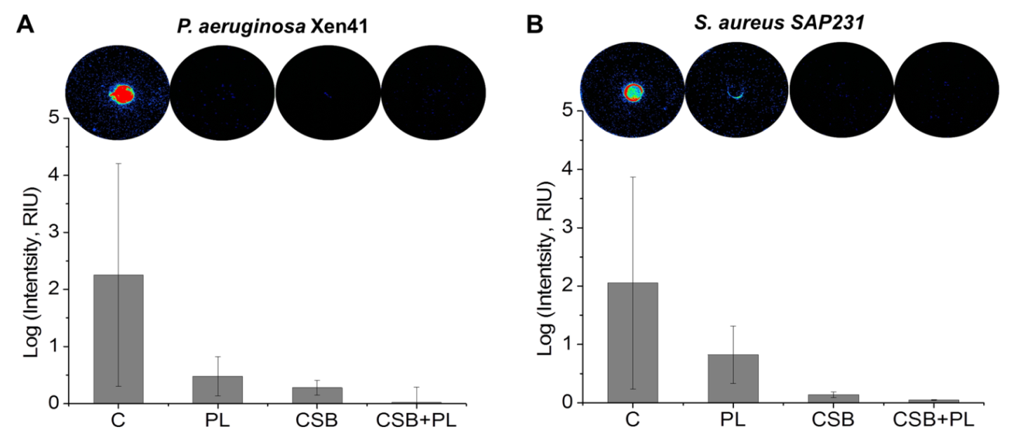

Figure 2.
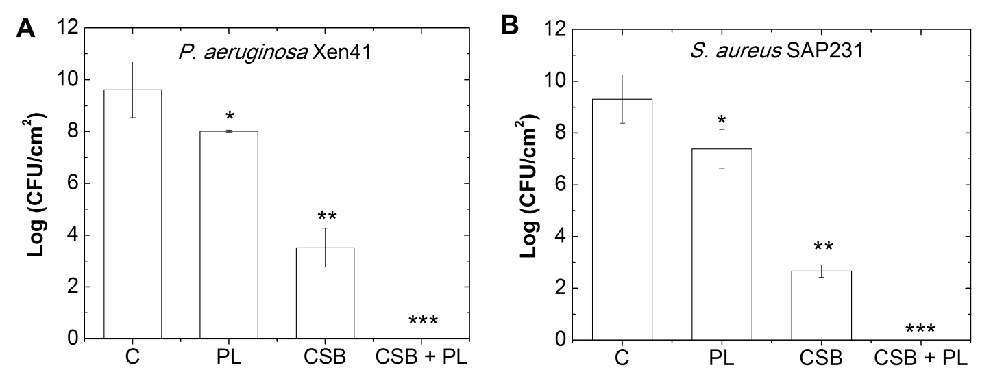
Figure 3.
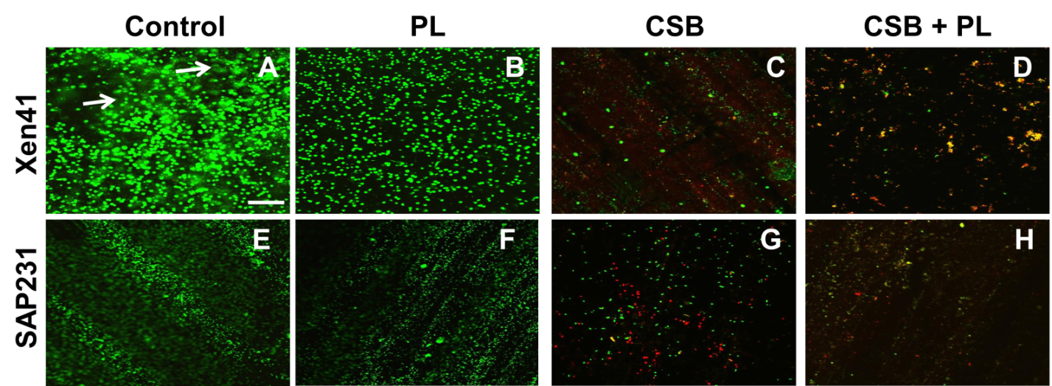

Figure 4.
