Shifts in tree functional composition amplify the response of forest biomass to climate

Tao Zhang (co-corresponding author)
Ülo Niinemets
Justin Sheffield
Jeremy W. Lichstein (co-corresponding author)

Abstract
Forests play a key role in global ecosystems, hosting much of terrestrial biodiversity and acting as a net sink for atmospheric carbon¹. These and other ecosystem services provided by forests may be sensitive to climate change as well as climate variability on shorter time scales (e.g., annual to decadal)²⁻⁴. Previous studies have documented responses of forest ecosystems to climate change and variability²⁻⁴, including drought-induced increases in tree mortality rates⁵. However, relationships between forest biomass, tree species composition, and climate variability have yet to be quantified across a large region using systematically sampled data. Here, we use systematic forest inventories from the 1980s and 2000s across the eastern USA to show that forest biomass responds to decadal-scale changes in water deficit and that this biomass response is amplified by concurrent changes in community-mean drought-tolerance (a functionally important aspect of tree species composition). The amplification of the direct effects of water stress on biomass occurs because water stress tends to induce a shift in tree species composition towards more drought-tolerant but slower-growing species. These results demonstrate concurrent changes in forest species composition and biomass carbon storage across a large, systematically sampled region, and highlight the potential for climate-induced changes in forest ecosystems across the globe due to both the direct effects of climate on forest biomass, as well as indirect effects mediated by shifts in species composition.

Main Text
How forests respond to climate variability has important implications for their future provisioning of ecosystem services, including carbon storage, timber, wildlife habitat, and regulation of the hydrological cycle^{1,2}. Long-term demographic and geographic responses of tree species to climate change have been documented in some cases^{6,7}, and numerous studies have documented effects of drought and other extreme events on tree growth and mortality²⁻⁵. However, we have limited understanding of how the functional composition of tree communities responds to climate variability. Thus, it is unknown how fast functional shifts occur or how such shifts affect the response of forest biomass (a key component of terrestrial carbon storage) to climate variability. Is one or two decades of relatively dry or wet conditions sufficient to shift tree communities towards more or less drought-tolerant species? If so, do functional shifts moderate drought-induced biomass loss (as suggested by ecosystem model projections that demonstrate how functional shifts can increase forest resilience to climate change⁸), or do functional shifts amplify drought-induced biomass loss (e.g., if competition under water-limited conditions drives plants to invest more in roots than is optimal for biomass production⁹)?

The eastern USA has experienced substantial climate variability over recent decades, with some areas becoming wetter and others drier¹⁰ (Fig. 1a and Extended Data Fig. 1a-d). This variability – combined with systematically sampled Forest Inventory and Analysis¹¹ (FIA) data spanning millions of individual-tree records over multiple decades – provides a valuable opportunity to quantify climate-induced changes in forest biomass and species composition. Eastern USA forests are influenced by a variety factors, including regrowth and successional dynamics following agricultural abandonment and logging¹², fire suppression¹³, introduced pathogens and insects¹⁴, increases in deer (Odocoileus virginianus) populations¹⁵, and natural disturbances¹⁶. Despite the importance of these non-climatic factors, correlations between precipitation change and recent shifts in tree species abundances and geographic ranges¹⁷ suggest that climate variability has a tangible impact on forest dynamics in the eastern USA, as observed elsewhere¹⁸. However, there is limited understanding of how shifts in forest functional composition affect the response of ecosystem properties such as forest biomass to climate variability.

To gain insights into how functional shifts affect ecosystem responses to climate variability, we quantified relationships among tree functional composition, forest biomass, and water availability. We used the Palmer Drought Severity Index (PDSI, an index of soil moisture based on the balance between precipitation and modeled evapotranspiration and runoff¹⁹) to quantify changes in mean growing season water availability (ΔPDSI) from the 1980s to 2000s in 1° latitude × 1° longitude grid cells (Fig. 1a). A one-unit decrease in growing-season PDSI is equivalent, on average, to a 23% reduction in growing-season precipitation in the eastern USA (Extended Data Fig. 1i-k). To quantify changes in community-mean drought tolerance ($\text{Δ}\overline{\text{DT}}$, a functional component of tree species composition) and aboveground biomass (ΔAGB; Fig. 1 and Extended Data Figs. 2-3), we used FIA data while controlling for changes in forest stand age due to recovery from previous disturbance. Specifically, $\text{Δ}\overline{\text{DT}}$ and ΔAGB were calculated for each grid cell by comparing inventory plots in a given age class in the 1980s to plots in the same age class in the 2000s. $\text{Δ}\overline{\text{DT}}$ was calculated by combining FIA data in each decade, grid cell, and age class with a species-specific drought-tolerance ranking (DT²⁰; Supplementary Information 1), which increases from 1 (very intolerant) to 5 (very tolerant); thus, $\text{Δ}\overline{\text{DT}}$ > 0 indicates a shift in tree species composition towards a more drought-tolerant community (see examples in Supplementary Information 2). Although the DT scale is somewhat arbitrary, such rankings are widely used by plant ecologists and foresters^{10,17,21}, and modifying the scale would not qualitatively affect our results (Supplementary Information 1). DT has been estimated for most of the common tree species in the eastern USA²⁰, enabling a systematic, community-level analysis of ~3,000,000 individual tree records from ~100,000 FIA plot inventories (Extended Data Fig. 4a).

Relationships among $\text{Δ}\overline{\text{DT}}$, ΔAGB, and ΔPDSI were statistically significant (P ≤ 0.05) in most of the 15 cases (3 pairwise correlations × 5 age classes). Specifically, from the 1980s to the 2000s, community-mean drought tolerance tended to increase with increasing water stress (negative correlation between $\text{Δ}\overline{\text{DT}}$ and ΔPDSI; Fig. 2a), biomass tended to increase with water availability (positive correlation between ΔAGB and ΔPDSI; Fig. 2b), and biomass tended to decrease with increasing community-mean drought tolerance (negative correlation between ΔAGB and $\text{Δ}\overline{\text{DT}}$; Fig. 2c). These correlations suggest concerted changes in forest functional composition and biomass in response to changes in water availability.

To determine if the above correlations (Fig. 2) were robust, we performed additional analyses to quantify relationships among $\text{Δ}\overline{\text{DT}}$, ΔAGB, and ΔPDSI while controlling for changes in forest stand age and other potentially confounding variables (growing season length, community-mean shade tolerance, tree harvesting, and/or spatial autocorrelation that may arise from factors not included in our statistical models; Extended Data Figs. 5-6 and Supplementary Information 3). We explored three statistical methods (Spatial Autoregressive Models, Structural Equation Modeling, and Independent Effects Analysis), all of which yielded consistent results (compare Extended Data Figs. 4, 6, and 7) and demonstrate that the correlations (Fig. 2) are qualitatively robust. The analyses also revealed variation among forest age classes in terms of the relative importance of different variables affecting $\text{Δ}\overline{\text{DT}}$ and ΔAGB (Extended Data Fig. 7), highlighting the need to study forest dynamics across successional and life stages (e.g., seedling vs. adults). However, in all age classes, $\text{Δ}\overline{\text{DT}}$ had a strong negative correlation with changes in community-mean shade tolerance ($\overline{\text{ST}}$; Extended Data Fig. 7d), as expected from the interspecific tradeoff between tolerances to shade and drought²⁰. Shifts in $\overline{\text{ST}}$ within forest age classes may reflect changing disturbance regimes¹³ or may simply be a consequence of PDSI-induced changes in $\overline{\text{DT}}$. Although our methods cannot determine if changes in $\overline{\text{ST}}$ are a cause or consequence of changes in $\overline{\text{DT}}$, our analyses demonstrate significant relationships among $\text{Δ}\overline{\text{DT}}$, ΔAGB, and ΔPDSI that are independent of $\text{Δ}\overline{\text{ST}}$ and other potentially confounding variables. These results are further corroborated by a stand-level analysis that tracks the dynamics of individual FIA plots that were measured and remeasured since the 1990s (Supplementary Information 4). This stand-level analysis shows that the qualitative patterns that emerge at the 1° grid-cell scale over two decades are also detectable at the stand-level over shorter time periods (5-year mean remeasurement interval; Extended Data Fig. 4d-e).

PDSI effects on AGB in some grid cells were of a similar magnitude as other important global change drivers. For example, compared to the case of no PDSI change, a decrease of two PDSI units (which was exceeded in 11% of grid cells; Extended Data Fig. 1c-d) would cause an AGB reduction of 8.6-14.3 Mg ha^{–1} over two decades (based on the slopes in Fig. 2b), or 7-19% of mean AGB in different forest age classes (Extended Data Fig. 3). This AGB response (equivalent to 0.21-0.36 Mg C ha⁻¹ yr⁻¹) is similar to the estimated effects of nitrogen (N) deposition on AGB in the USA²² (0.12-0.37 Mg C ha⁻¹ yr⁻¹), as well as the AGB component of the USA forest carbon sink²³ (0.30-0.46 and 0.37-0.56 Mg C ha⁻¹ yr⁻¹, for the 1990-99 and 2000-07 periods, respectively), which reflects the combined effects of multiple drivers (e.g., forest regrowth, N deposition, and CO₂ fertilization). Our analyses suggest that in the absence of climate variability, the eastern USA carbon sink would have been even stronger over recent decades, because the mean ΔPDSI across the eastern USA was −0.61 (Extended Data Fig. 1d), which implies a weakening of the eastern USA forest carbon sink by approximately 0.07-0.11 Mg C ha⁻¹ yr⁻¹.

The response of AGB to PDSI includes not only ‘direct’ effects of ΔPDSI (i.e., AGB changes that would occur in the absence of changes in community-mean drought tolerance, $\overline{\text{DT}}$), but also ‘indirect’ effects of ΔPDSI (i.e., AGB changes caused by PDSI-induced changes in $\overline{\text{DT}}$; Extended Data Fig. 8a-b). Our analysis reveals that direct and indirect effects both work in the same direction, which means that changes in species composition (indirect effects) amplify the AGB response to PDSI (Fig. 3). Indirect effects accounted for roughly 20-30% of the total response of ΔAGB to ΔPDSI in 40-100 year-old forests, significantly amplifying AGB responses in these age classes (Extended Data Fig. 8c-d).

The amplification of the biomass response to climate variability (Fig. 3) is likely driven by competitive shifts in the traits of the dominant tree species. For example, as water availability declines, competition may favor tree species that allocate more carbon to fine roots and less to leaves and wood than is optimal for biomass production⁹. This shift in allocation amplifies the ecosystem response to decreasing water availability because the most competitive species under dry conditions have lower biomass than other species that could have persisted were they not outcompeted.

Shifts in community composition towards more or less drought-tolerant species may be caused by changes in relative species rankings in one or more demographic parameters (mortality, growth, and recruitment), and do not necessarily imply die-offs due to physiological stress. We decomposed stand-level $\text{Δ}\overline{\text{DT}}$ into different components using data from remeasured inventory plots (Supplementary Information 4-5). Mortality, growth, and recruitment all contributed substantially to $\text{Δ}\overline{\text{DT}}$ (Fig. 4a), with the vast majority of $\text{Δ}\overline{\text{DT}}$ accounted for by shifts in the abundance of species present at both measurement times (as opposed to species additions or losses; Fig. 4b). Mortality and species loss were most important in old stands, and recruitment and species additions were most important in young stands (Fig. 4). These age-dependent trends likely reflect the larger size but lower density of trees in older forests; e.g., the death of a single large tree can substantially affect $\overline{\text{DT}}$ (a size-weighted community average), whereas juvenile recruitment would have little immediate effect on $\overline{\text{DT}}$ in a mature forest.

Consistent with the importance of abundance shifts at the stand-level, grid-cell-scale relationships among $\text{Δ}\overline{\text{DT}},$ ΔAGB, and ΔPDSI reflect the collective responses of many species, without major changes in regional species diversity. Analysis of the influence of individual species on the community-level $\overline{\text{DT}}$ and AGB changes revealed no systematic differences between angiosperms and gymnosperms (Extended Data Fig. 9), and no systematic relationships between species influence and either shade tolerance or wood density (Supplementary Information 6-8). Thus, the $\text{Δ}\overline{\text{DT}}$ and ΔAGB responses reflect the collective responses of both angiosperm and gymnosperm species spanning a wide range of ecological strategies. Species abundance distributions and the number of common species within sub-regions (north-central, northeastern, and southeastern USA) were similar between the 1980s and 2000s (Extended Data Fig. 10) despite substantial changes in the abundance of some individual species (Supplementary Information 9). Some of these species-level changes were inconsistent with the overall community-level $\text{Δ}\overline{\text{DT}}$ and ΔAGB responses, and may reflect long-term changes in disturbance regimes rather than climate responses¹³. For example, increases in abundance of two widespread maple species, Acer rubrum and A. saccharum, are likely due to fire suppression and the resulting ‘mesophication’ of eastern USA forests¹³, rather than a response to ΔPDSI. Thus, our study does not imply that climate-driven functional shifts are the primary mode of change in eastern USA forests. Nevertheless, our results support recent evidence that climate-induced shifts in species abundances and geographic ranges have occurred over recent decades in the eastern USA¹⁷, and we here demonstrate for the first time that these shifts have significant ecosystem-level consequences.

The response of eastern USA forests to climate variability, evident from shifts in both forest biomass and species composition, has global significance for several reasons. First, these shifts − quantified from systematic, regional-scale forest inventories − suggest that even greater changes may be underway in other regions where recent drought and climate change have been more severe than in the eastern USA; e.g., in Amazonia and western North America, where drought-induced increases in tree mortality have already been reported^{4,24,25}. Second, projected increases in the frequency and severity of extreme weather events in many regions of the globe²⁶ – combined with the sensitivity of forest biomass and species composition to climate variability documented here and elsewhere²⁷ – implies potential changes in global forests over the next century that are both ecologically and economically important. Finally, amplification of the biomass-climate response due to shifts in species composition (temporal beta diversity²⁸) contrasts with evidence that local (alpha) diversity increases ecosystem stability²⁹, including increased resistance to climate extremes^{30.} These contrasting effects of alpha and beta diversity highlight the need to better understand how different components of biodiversity, including changes in species composition, affect ecosystem functioning at different spatial and temporal scales.

References

In Main Text:
- Bonan, G. B. Forests and climate change: Forcings, feedbacks, and the climate benefits of forests. Science 320, 1444–1449 (2008).
- Anderegg, W. R. L., Kane, J. M. & Anderegg, L. D. L. Consequences of widespread tree mortality triggered by drought and temperature stress. Nature Climate Change 3, 30–36 (2013).
- Frank, D. A. et al. Effects of climate extremes on the terrestrial carbon cycle: concepts, processes and potential future impacts. Global Change Biology 21, 2861–2880 (2015).
- Clark, J. S. et al. The impacts of increasing drought on forest dynamics, structure, and biodiversity in the United States. Global Change Biology 22, 2329–2352 (2016).
- Allen, C. D. et al. A global overview of drought and heat-induced tree mortality reveals emerging climate change risks for forests. Forest Ecology and Management 259, 660–684 (2010).
- Davis, M. B. & Shaw, R. G. Range shifts and adaptive responses to Quaternary climate change. Science 292, 673–679 (2001).
- Parmesan, C. & Yohe, G. A globally coherent fingerprint of climate change impacts across natural systems. Nature 421, 37–42 (2003).
- Sakschweski, B. et al. Resilience of Amazon forests emerges from plant trait diversity. Nature Climate Change 6, 1032–1036 (2016).
- Farrior, C. E., Dybzinski, R., Levin, S. A. & Pacala, S. W. Competition for water and light in closed-canopy forests: a tractable model of carbon allocation with implications for carbon sinks. American Naturalist 181, 314–330 (2013).
- Peters, M. P., Iverson, L. R. & Matthews, S. N. Long-term droughtiness and drought tolerance of eastern US forests over five decades. Forest Ecology and Management 345, 56–64 (2015).
- Bechtold, W. A. & Patterson, P. L. (Eds.) The Enhanced Forest Inventory and Analysis Program – National Sampling Design and Estimation Procedures. Gen Tech Rep: SRS-80, U.S. Department of Agriculture, Forest Service, Southern Research Station, Asheville, NC, 85 pages (2005).
- Houghton, R. A., Hackler, J. L. & Lawrence, K. T. The U.S. carbon budget: contributions from land-use change. Science 285, 574-578 (1999).
- Nowacki, G. J., & Abrams, M. D. Is climate an important driver of post-European vegetation change in the Eastern United States? Global Change Biology 21, 314–334 (2015).
- Hicke, J. A. et al. Effects of biotic disturbances on forest carbon cycling in the United States and Canada. Global Change Biology 18, 7–34 (2012).
- Côté, S. D., Rooney, T. P., Tremblay, J.-P., Dussault, C. & Waller, D. M. Ecological impacts of deer overabundance. Annual Review of Ecology, Evolution, and Systematics 35, 113–147 (2004).
- Vanderwel, M. C., Coomes, D. A. & Purves, D. W. Quantifying variation in forest disturbance, and its effects on aboveground biomass dynamics, across the eastern United States. Global Change Biology 19, 1504–1517 (2013).
- Fei, S. et al. Divergence of species responses to climate change. Science Advances 3, e1603055, 9 pages (2017).
- Ruiz-Benito, P. et al. Climate- and successional-related changes in functional composition of European forests are strongly driven by tree mortality. Global Change Biology 23, 4162–4176 (2017).
- Sheffield, J., Wood, E. F. & Roderick, M. L. Little change in global drought over the past 60 years. Nature 491, 435–438 (2012).
- Niinemets, Ü. & Valladares, F. Tolerance to shade, drought, and waterlogging of temperate northern hemisphere trees and shrubs. Ecological Monographs 76, 521–547 (2006).
- Cornwell, W. K. & Grubb, P. J. Regional and local patterns in plant species richness with respect to resource availability. Oikos 100, 417–428 (2003).
- Pinder, R.W. et al. Climate change impacts of US reactive nitrogen. PNAS 109, 7671–7675 (2012).
- Pan, Y. et al. A large and persistent carbon sink in the world’s forests. Science 333, 988–993 (2011).
- Phillips, O. L. et al. Drought sensitivity of the Amazon rainforest. Science 323, 1344–1347 (2009).
- Peng, C. et al. A drought-induced pervasive increase in tree mortality across Canada’s boreal forests. Nature Climate Change 1, 467–471 (2011).
- IPCC. Managing the Risks of Extreme Events and Disasters to Advance Climate Change Adaptation. A Special Report of Working Groups I and II of the Intergovernmental Panel on Climate Change. Field et al. (eds.). Cambridge University Press, New York, NY, 582 pages (2012).
- Hanewinkel, M., Cullmann, D. A., Schelhaas, M.-J., Nabuurs, G.-J. & Zimmermann, N. E. Climate change may cause severe loss in the economic value of European forest land. Nature Climate Change 3, 203–207 (2013).
- Dornelas, M. et al. Assemblage time series reveal biodiversity change but not systematic loss. Science 344, 296–299 (2014).
- Hooper, D. U. et al. Effects of biodiversity on ecosystem functioning: A consensus of current knowledge. Ecological Monographs 75, 3–35 (2005).
- Isbell, F. et al. Biodiversity increases the resistance of ecosystem productivity to climate extremes. Nature 526, 574–577 (2015).

In Methods:
- Lichstein, J. W., Simons, T. R., Shriner, S. A. & Franzreb, K. E. Spatial autocorrelation and autoregressive models in ecology. Ecological Monograph 72, 445–463 (2002).
- Bivand, R. S., Hauke, J., & Kossowski, T. Computing the Jacobian in Gaussian spatial autoregressive models: An illustrated comparison of available methods. Geographical Analysis 45, 150–179 (2013).
- Grace, J. B. Structural Equation Modeling and Natural Systems. Cambridge University Press, Cambridge, UK, 365 pages (2006).
- Chevan, A. & Sutherland, M. Hierarchical partitioning. The American Statistician 45, 90–96 (1991).
- Sheffield, J., Goteti, G. & Wood, E. F. Development of a 50-yr high-resolution global dataset of meteorological forcings for land surface modeling. Journal of Climate 19, 3088–3111 (2006).
- O’Connell, B. M. et al. The Forest Inventory and Analysis Database: Database Description and User Guide version 5.1.5 for Phase 2. U.S. Department of Agriculture, Forest Service, 537 pages (2013).
- USDA. Forest Inventory and Analysis National Core Field Guide. Volume 1: Field data collection procedures for phase 2 plots, version 6.0. Forest Inventory and Analysis Program, U.S. Department of Agriculture, Forest Service, 427 pages (2012).
- Jenkins, J. C., Chojnacky, D. C., Heath, L. S. & Birdsey, R. A. National-scale biomass estimators for United States tree species. Forest Science 49, 12–35 (2003).
- R Core Team. R: A Language and Environment for Statistical Computing. https://www.R-project.org. R Foundation for Statistical Computing (2015).
- Rosseel, Y. lavaan: An R Package for structural equation modeling. Journal of Statistical Software 48(2), DOI: 10.18637/jss.v048.i02, (2012).

In Supplementary Information:
- Chaves, M. M. et al. How plants cope with water stress in the field. Photosynthesis and growth. Annals of Botany 89, 907–916 (2002).
- McDowell, N. et al. Mechanisms of plant survival and mortality during drought: why do some plants survive while others succumb to drought? New Phytologist 178, 719–739 (2008).
- Choat, B. et al. Global convergence in the vulnerability of forests to drought. Nature 491, 752–755 (2012).
- Abrams, M. D. Adaptations and responses to drought in Quercus species of North America. Tree physiology 7, 227-238 (1990).
- Hacke, U. G., Sperry, J. S., Pockman, W. T., Davis, S. D., & McCulloh, K. A. Trends in wood density and structure are linked to prevention of xylem implosion by negative pressure. Oecologia 126, 457–461 (2001).
- Fox, J. & Weisberg, S. An R Companion to Applied Regression. Second Edition. Sage, Thousand Oaks, CA, 472 pages (2011).

Supplementary Information is linked to the online version of the paper at www.nature.com/nature.

Acknowledgements: Funding was provided by USDA Forest Service agreements 11-JV-11242306-059 and 16-JV-11242306-050 to JL, and by the European Regional Development Fund (Centre of Excellence EcolChange) and the Estonian Ministry of Science and Education (institutional grant IUT-8-3) to ÜN.

Author Contributions: TZ and JL designed the research. JS and ÜN provided data and advice. TZ performed the analysis. TZ and JL drafted the first version of the paper, and all authors contributed to subsequent versions of the paper.

Author Information: Reprints and permissions information is available at www.nature.com/reprints. The authors have no competing financial interests. Correspondence and requests for materials should be addressed to t.zhang05@outlook.com or jlichstein@ufl.edu.
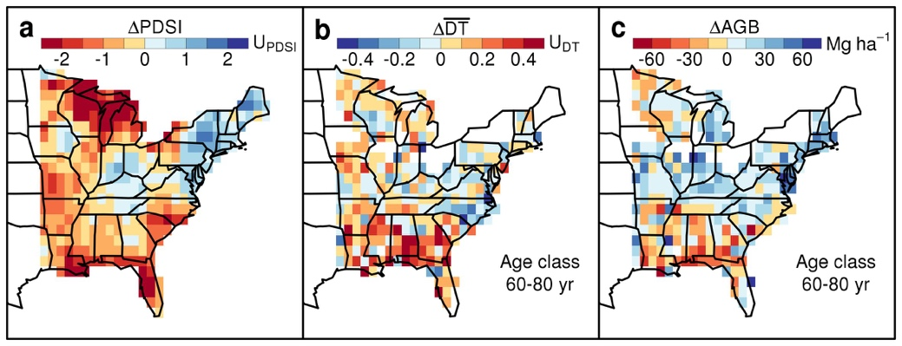
Figure 1 | Changes in (a) growing-season Palmer Drought Severity Index (PDSI), (b) community-mean drought tolerance ($\overline{\text{DT}}$), and (c) aboveground biomass (AGB) between the 1980s and 2000s in the eastern USA. $\text{Δ}\overline{\text{DT}}$ and ΔAGB were calculated by comparing forest inventory plots that were 60-80 years old in the 1980s to plots in the same age class in the 2000s (other age classes in Extended Data Figs. 2-3). Color scales are oriented so that red corresponds to decreased moisture (in PDSI units; U_{PDSI}), increased $\overline{\text{DT}}$ (in DT units; U_{DT}), and decreased AGB. White grid cells lack sufficient inventory data.
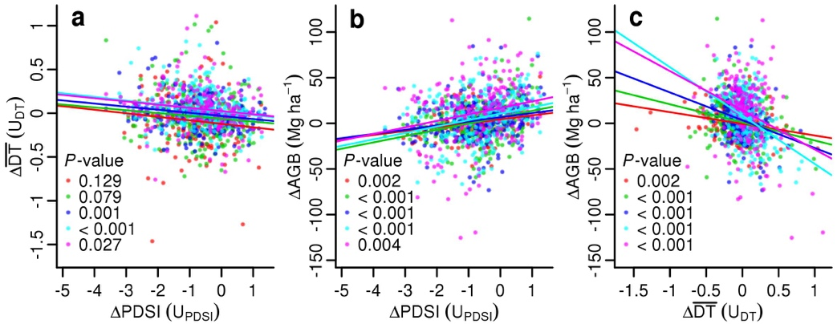
Figure 2 | Relationships between changes in community-mean drought tolerance ($Δ\overline{\text{DT}}$), water availability (ΔPDSI), and aboveground biomass (ΔAGB) within forest age classes from the 1980s to 2000s. Each point represents a forest age class within a 1° grid cell. Lines are ordinary least squares regressions. P-values (two-sided) for regression slopes are for the following age classes (from top to bottom): 0-20, 20-40, 40-60, 60-80, and 80-100 years. Pearson correlation ranges are (a) 0.11-0.16, (b) 0.22-0.30, and (c) 0.24-0.40. With outliers removed (not shown), all correlations have P < 0.05. Sample sizes are in Extended Data Fig. 4a.
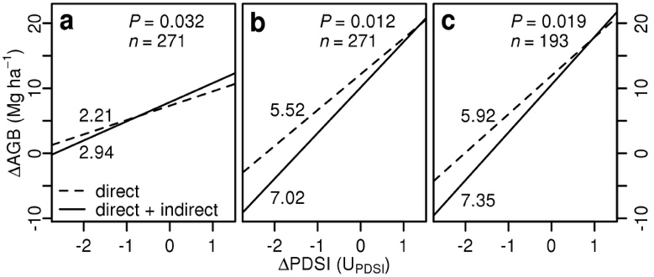
Figure 3 | Changes in species composition (community-mean drought tolerance, $\text{Δ}\overline{\text{DT}}$) amplify the response of biomass (AGB) to climate variability (ΔPDSI). Results are for the three forest age classes with significant responses of $\text{Δ}\overline{\text{DT}}$ to ΔPDSI: (a) 40-60, (b) 60-80, and (c) 80-100 years. Dashed lines show direct effects of ΔPDSI on ΔAGB (controlling for $\text{Δ}\overline{\text{DT}}$); solid lines show total (direct + indirect) effects (including $\text{Δ}\overline{\text{DT}}$; Extended Data Fig. 8). Lines are labeled with slopes (Mg ha⁻¹ U_{PDSI}⁻¹). P-values are based on s.e. of slope differences; n is number of grid cells. The x-axes span the mean ± 2 s.d. from Fig. 1a.
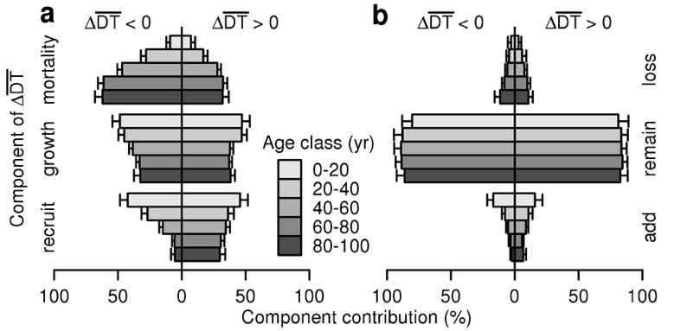
Figure 4 | Contributions to changes in community-mean drought tolerance ($\text{Δ}\overline{\text{DT}}$). Component contributions are shown to the left of zero for negative $\text{Δ}\overline{\text{DT}}$ (lower quartile of $\text{Δ}\overline{\text{DT}}$ distribution), and to the right of zero for positive $\text{Δ}\overline{\text{DT}}$ (upper quartile). Error bars show one side of each 95% CI. (a) Contributions of mortality, growth, and recruitment to $\text{Δ}\overline{\text{DT}}$. (b) Contributions of species additions, losses, and abundance shifts (‘remain’) to $\text{Δ}\overline{\text{DT}}$. Sample sizes (number of remeasured plots within each quartile) are 300 (0-20 years), 588 (20-40 years), 1173 (40-60 years), 1390 (60-80 years), and 650 (80-100 years). See Supplementary Information 5 for details.

