Coherent averaging of pseudorandom binary stimuli: is the dynamic cerebral autoregulatory response symmetrical?

Emmanuel Katsogridakis¹, David M. Simpson⁴ , Glen Bush², Lingke Fan², Anthony A. Birch³, Robert Allen⁴, John F. Potter⁵, Ronney B. Panerai^{1,6}

¹Department of Cardiovascular Sciences, University of Leicester, United Kingdom.
²Department of Medical Physics, Leicester Royal Infirmary, University Hospitals of Leicester NHS Trust, Leicester, United Kingdom
³Neurological Physics Group, Department of Medical Physics and Bioengineering, University Hospital Southampton NHS Foundation Trust, Southampton, United Kingdom
⁴Institute of Sound and Vibration Research, University of Southampton, United Kingdom
⁵School of Medicine, Health Policy and Practice, University of East Anglia, Norwich, United Kingdom
⁶Leicester NIHR Biomedical Research Unit in Cardiovascular Sciences, Glenfield Hospital, Leicester, United Kingdom

Abbreviated title: The symmetry of the autoregulatory response.

Corresponding author:
Ronney B. Panerai
Department of Cardiovascular Sciences
Level 1, Sandringham Building
Leicester Royal Infirmary, LE15WW
Leicester, UK
E-mail: rp9@le.ac.uk
Tel: +44(0)1162585511
Fax: +44(0)1162586070

ABSTRACT
Cerebral autoregulation acts to buffer changes in cerebral perfusion pressure. Previous studies have demonstrated that autoregulatory responses display hemispheric symmetry, which may be altered in stroke and traumatic brain injury. There is a paucity of data however on whether the response is symmetrical between those disturbances that cause cerebral hyperperfusion, to those that cause hypoperfusion. Using a previously described assessment method, we employed coherent averaging of the cerebral blood flow velocity (CBFV) responses to thigh cuff inflation and deflation, as driven by pseudorandom binary sequences, whilst simultaneously altering the inspired CO₂. The symmetry of the autoregulatory response was assessed with regards to two parameters, its speed and gain. Using the first harmonic method, critical closing pressure (CrCP) and resistance area product (RAP) were estimated, and the gain of the autoregulatory response was calculated by performing linear regression between arterial blood pressure (ABP) and CBFV, ABP and CrCP, and finally ABP and RAP. A two-way repeated measures ANOVA was used to assess the effect of the direction of change in ABP and the method of CO₂ administration. Our results suggest that whilst the direction of ABP does not have a significant effect, the effect of CO₂ administration method is highly significant (p<10⁻⁴). We conclude that the autoregulatory response is symmetric, and that coherent averaging can be combined effectively with our novel assessment method to elucidate the role of CrCP and RAP in the autoregulatory response.

INTRODUCTION
Cerebral autoregulation (CA) is the complex homeostatic mechanism through which the cerebrovascular bed maintains control over regional blood flow in response to blood pressure changes. [1 2].
Assessment of its functional status has become a topic of interest as it was demonstrated that dynamic cerebral autoregulation (dCA) may be impaired in stroke, carotid stenosis and traumatic brain injury [3-11]. Two main ensembles of methods have been proposed for the assessment of the functional status of dynamic CA [2].
The first set of assessment methods relies on the induction of a haemodynamic stimulus that will elicit an autoregulatory response [12-17]. The second ensemble capitalizes on the spontaneous variability of arterial blood pressure (ABP) and cerebral blood flow velocity (CBFV) from spontaneous fluctuations of ABP as well as from ectopic heart beats [18-23].
We have recently proposed a new method for the integrated assessment of cerebral haemodynamics that relies on the use of pseudorandom binary sequences to drive the inflation of thigh cuffs and the administration of CO₂ [24]. The method was shown to be capable of augmenting ABP and CBFV variability without distorting dCA estimates as a result of causing sympathetic excitation [24 25].
In this paper we use the intermittent nature of the stimuli used in our assessment method to test the hypothesis that the autoregulatory response is symmetrical to hypertensive or hypotensive stimuli, using coherent averaging synchronized to the automatic inflation or deflation of bilateral thigh cuffs.

METHODS
Hardware and software. For the purposes of this study, a modification of the thigh cuff method was used, combined with the intermittent and constant administration of CO₂, at a concentration of 5%. The operating principles and controlling software of the device used to achieve this have been described in greater detail in previous communications [24-27].
Volunteers and experimental set-up. Volunteers were recruited if their medical history was free of known cardiovascular and neurological disorders and were above 18 years of age. Upon their arrival, volunteers were reminded of the protocol, the instrumentation was demonstrated, its function explained and written informed consent was obtained. The study was approved by the Nottingham Research Ethics Committee, United Kingdom.
The participants were asked to assume a supine position on the experimental couch. Following a brief settling down period, brachial ABP was measured by means of automatic sphygmomanometry and the thigh cuffs and face mask were attached. A trial inflation / deflation cycle was performed to familiarize participants with the procedure and to ensure the uninterrupted flow of air to the cuffs.
Arterial blood pressure was monitored noninvasively using the arterial volume clamp method (Finometer, Finapres Measurement Systems, The Netherlands). Freehand transcranial Doppler (Companion III, Viasys Healthcare) identification of both middle cerebral arteries (MCA) was performed using two 2MHz probes, held in place with a custom built headframe. The mask was connected to the CO₂ delivery system and a capnograph (Datex, Normocap 200) to measure end-tidal CO₂ (EtCO₂) levels. A three-lead surface electrocardiogram (ECG) was also recorded.
Following a brief period of supine rest which was required for the setup and connection of all monitoring devices the participants underwent a five minute baseline recording to familiarize themselves further with the protocol. The recordings undertaken under baseline conditions were not used for the purposes of this study. Subsequently, all participants underwent three more five minute recordings, administered in random order, corresponding to the pseudorandom application of the thigh cuffs under normocapnic, intermittent / pseudorandom hypercapnic and constant hypercapnic conditions. In the latter two cases CO₂ was administered via the face mask at a concentration of 5% in air.
Data analysis. All signals were sampled at a rate of 500Hz and recorded in real time on a dedicated personal computer. Offline, signals were visually inspected, spikes and artifacts were removed and the ABP signal was calibrated. The recorded signals were then filtered with an eighth order Butterworth low-pass filter with a cut-off frequency of 20Hz, applied in a forward and reverse direction to avoid time-shift.
The beginning and end of each cardiac cycle were detected from the ECG signal, to estimate heart rate (HR) and mean beat-to-beat values were calculated for the recorded signals. For each cardiac cycle, the instantaneous relationship between CBFV and ABP was used to estimate the critical closing pressure (CrCP) and resistance-area product (RAP) of the cerebral circulation using the first harmonic method [35].
CrCP reflects the cerebral perfusion pressure at which flow becomes zero whilst RAP is the inverse slope of the best fit linear relationship between CBFV and ABP. Estimates were then interpolated using a third order polynomial and resampled at 5Hz to create time series with a uniform time base.
The resistance area product was estimated for each cardiac cycle from the raw data, using the first harmonic of the ABP (A₁) and CBFV (V₁) signals [28] as:
$$RAP= \frac{A_{1}}{V_{1}}$$
Having estimated RAP, the critical closing pressure (CrCP) was then calculated from the relationship:
$$CrCP= {ABP}_{m}-{RAP.CBFV}_{m}$$
where ABP_{m} and CBFV_{m} are the mean values of ABP and CBFV for that particular cardiac cycle.
The numerical derivative of the thigh cuff pressure transducer (TCPT) signal was calculated from the recorded time series and a peak detection algorithm was used to identify the times points at which the thigh cuffs were inflated. The time series of the numerical derivative of the TCPT signal was then inverted and the peak detection procedure was repeated to identify the time points at which the thigh cuffs were deflated.
The sample indices were used as reference points for the alignment of the ABP, CBFV, CrCP and RAP signals. To avoid overlap between transients resulting from inflation/deflation cycles, the shortest inflation /deflation cycle interval (5s) was taken before and after the sample indices resulting in signals of 10s duration, to be used for the coherent averaging.
After subtracting the mean value from each ABP, CBFV, CrCP and RAP 10s segment, coherent averages were calculated for every parameter for that particular recording. Left and right sided estimates were also averaged.
The symmetry of the autoregulatory response was assessed with respect to its two components: the gain and speed of the transient response [26]. To obtain an estimate of gain that does not rely on the subjective selection of points from the time series, linear regression was performed between the individual ABP and CBFV, CrCP, and RAP coherent averages. The estimates of the regression line slope were averaged to obtain one estimate for every volunteer across the transients of that recording. Similarly, left and right sided estimates were again averaged.
To visually assess the differences in the speed of the response to stimuli of different direction, the CBFV coherent average response to thigh cuffs deflation under normocapnic, intermittent and constant hypercapnic conditions were inverted and plotted on the same graphs as the average responses to thigh cuff inflation.
Statistics. The Shapiro-Wilk test was used to test for normality. All non-normally distributed data were log-transformed. A two-way repeated measures ANOVA was performed to test for differences in the linear regression slope estimates obtained from the inflation and those obtained from the deflation of the thigh cuffs, for different EtCO₂ levels. Values of p < 0.05 were considered to represent statistical significance.

RESULTS
A total of 30 volunteers (17 male) aged 22-55 years were recruited into the study. Mean age was 31.4 ± 12 years.
Population estimates for the coherent averages of ABP and CBFV are presented in Figure 1. ABP coherent averages appear to remain largely unaffected by changes in EtCO₂ levels for both thigh cuff inflation and deflation (Figure 1, subplots A and B). Similar results were observed with the CBFV coherent averages, where the effect of CO₂ in dampening the response to both thigh cuff inflation and release was not apparent (Figure 1, subplots C and D).
Population estimates for the coherent averages of CrCP and RAP are presented in Figure 2, whilst the population estimates for the CBFV responses to thigh cuff inflation and release (inverted CBFV) are presented in Figure 3. Though a small difference is observed in the magnitude of the CBFV transient response in the form of an overshoot in subplots A and B, the speed of the response appears to be relatively similar.
The group averaged values for the slope of the regression line between ABP and CBFV, ABP and CrCP and ABP and RAP are presented in Table 1. Slope estimates for all parameters (CBFV, CrCP and RAP) were not affected by the direction of changes in blood pressure, however the effect of CO₂ was statistically significant (p – values are presented in Table 1).

DISCUSSION
This study confirms our earlier reports with respect to the effectiveness of the new method in amplifying ABP and CBFV variability to facilitate the comprehensive assessment of cerebral haemodynamics [24 25]. It also demonstrates the usefulness of coherent averaging in extending our understanding of the dynamics of dCA, as it provides new insights about the symmetry of the autoregulatory response and the effect of varying EtCO₂ levels on the cerebrovascular bed [29].
The effect of the random and constant administration of CO₂ on the transient response of CBFV was not clearly illustrated, possibly due to the small window size used, which was not long enough to detect the increase in the amount of time required for CBFV to return to baseline values, following the inflation and release of thigh cuffs. As described in the methods section however, the size of the data segment used was the shortest one to ensure that there is no overlap between manoeuvres. Though not presented in this paper, using a larger data window, even if the 5s, 10s and 20s coherent averages were treated separately, a clear effect from the previous cycle deflation could be seen.
Recent investigations have demonstrated the nonlinear coupling between ABP and EtCO₂ levels in the very low frequency range [30 31]. An interaction between ABP and EtCO₂ was not observed in this study, as can be seen in Figure 1. Though the reasons for this are not immediately clear, we believe it to be due to the short window duration used, which was not long enough to detect the increase in the amount of time required for CBFV to return to baseline values, following the inflation and release of thigh cuffs.
Our findings suggest that the effects of CO₂ on dCA are dose dependent, as the intermittent administration resulted in a partial impairment of the autoregulatory response. This is illustrated not only by the dose dependent delay of CBFV in returning to baseline levels but also by the effect EtCO₂ levels had on the response of the attributes of the cerebrovascular bed (RAP and CrCP) as seen in Figure 2.
The RAP is an index used to represent the relationship between ABP and flow velocity [20 32]. Its involvement in the regulation of CBF was recently demonstrated and it is believed to be achieved through myogenic actuators [33]. Critical closing pressure on the other hand, has been shown to be representative of the cerebrovascular tone and the influences of ICP [34 35], and correlates strongly with EtCO₂ levels [17 34 36-38].
We decided to use both CrCP and RAP to investigate the effect of different methods of administering CO₂ on the tone and resistance of the cerebrovascular bed using coherent averaging. Our findings suggest that the method of CO₂ administration had a dose dependent effect on both the CrCP and RAP, for both directions of changes in ABP. In particular, hypercapnia appears to prolong the duration and decrease the amplitude of the response of both covariates.
To the best of our knowledge, this is the first time that a partial impairment of dCA, secondary to the intermittent administration of CO₂, has been demonstrated, as seen by its effects on the tone and resistance of the cerebrovascular bed.
The use of coherent averaging also revealed that of the two parameters, CrCP appears to be reacting much faster, for both directions of ABP transients, with a very sharp transition, whilst the response of RAP appears to be slower and more gradual. This would suggest that dCA first acts by adjusting the tone of the cerebral arterioles as a crude means of compensating for the CBFV transient, and then modulates resistance for a finer adjustment of the resting levels of CBFV. This finding may have significant implications for the assessment of dCA as it suggests that CrCP may be used to assess dCA in its own right [39].
To investigate the symmetry of autoregulatory response, we decided to use linear regression. The use of the term symmetry warrants further clarification at this point, as it has been employed in the literature to denote different things by different authors. Typically, symmetry is used in the literature in the context of investigations of hemispheric differences in dCA [40].
Using conventional metrics of dCA, it was found that no side to side differences exist in healthy adult volunteers at rest [40], with differences observed following brain activation [33], traumatic brain injury in adults [41-43] and paediatric patients [44]. In a recent report however, Aaslid et al. defined symmetry as the absence of marked differences in the speed and gain of the CBFV transient response to cyclical stimuli of different directions [26] and found strongly asymmetric responses in a population of neurosurgical patients, whilst no significant asymmetries were seen in the control group. A critical appraisal of that report would suggest however, that the study may not have been optimally set up to answer the question of asymmetries.
Aaslid et al. (2007() defined asymmetry as any discrepancy in the gain or the speed of the autoregulatory response. Speed however, was not investigated in their report. It is therefore unknown if any discrepancies exist, that would be indicative of asymmetries even in a healthy population. The metric that the authors used, termed in their study ’the autoregulatory gain’ was defined as the ratio between the difference in critical closing pressure to the difference in arterial blood pressure. No information is provided however on the selection of the points used to calculate the differences, and it is thus unknown if bias has been introduced in the analysis through the subjective selection of points. The observation of strongly asymmetric responses in the neurosurgical population is more compatible with it resulting from the traumatic brain injury itself, rather than it being reflective of an inherent physiological mechanism. Lastly, the authors do not address the possibility of the discrepancy between the control and patient groups being due to the difference in EtCO₂ levels due to the need for the neurosurgical patients to be kept at a state of moderate hypocapnia.
To address some of the aforementioned limitations we performed linear regression analysis between ABP and CrCP. Our finding of a symmetrical dCA response under normocapnic and random hypercapnic conditions is in agreement with their report of an absence of significant asymmetries in the autoregulatory gain observed in healthy volunteers. This is further supported by the similarity in the speed of the CBFV responses to transient changes of ABP in different direction and by the absence of significant differences in the slopes of the linear regression.
Constant hypercapnia was then used to simulate a state of impaired autoregulation. Though no difference was observed in the slope of the linear regression, differences in the speed and magnitude of the CBFV transient could be considered indicative of an asymmetry of the autoregulatory response under constant hypercapnia (see Figure 3). This finding is in agreement with the secondary finding of the aforementioned study with respect to the existence of strong asymmetries observed in volunteers with impaired autoregulation.
Study limitations. Measurements of CBFV can reflect changes in CBF as long as the diameter of the insonated vessel remains constant. Several studies have demonstrated that the cross-sectional area of the MCA changes minimally [45 46] which supports the use of CBFV as a surrogate of CBF.
Due to the sensitivity of CrCP and RAP to ABP measurement inaccuracies [47] and to the method that was employed for their estimation [35], comparison of results should be done with caution. For the purposes of this study, we used ABP estimates measured with a different device (Finometer) to that used in the study of Aaslid et al. (2007). The influence that the different ABP measurement methods used may have on estimates of CrCP, and therefore on those of the autoregulatory gain is not known. However, both devices have a similar operating principle, and therefore differences would be expected to be minimal.
Lastly, we performed linear regression between ABP and CrCP as an estimate of gain with respect to the tone and resistance of the cerebrovascular bed. Linear regression however, operates under the assumption that measurement errors exist only on the independent variable. As CrCP and RAP are estimated using ABP, irrespective of the estimation method, this assumption is not entirely true.

CONCLUSIONS
We have demonstrated that our new assessment protocol can be combined effectively with analytical methods such as coherent averaging to obtain new insights into cerebral haemodynamics. The autoregulatory response, under normocapnic conditions, was found to be symmetrical to stimuli of different directions. dCA appears to act by first adjusting the tone and then the resistance of the cerebral arterioles. More investigations are required to verify our results.

REFERENCES
1. Lassen NA. Cerebral blood flow and oxygen consumption in man. Physiological reviews 1959;39(2):183-238
2. Panerai RB. Assessment of cerebral pressure autoregulation in humans--a review of measurement methods. Physiological measurement 1998;19(3):305-38
3. Brady KM, Shaffner DH, Lee JK, et al. Continuous monitoring of cerebrovascular pressure reactivity after traumatic brain injury in children. Pediatrics 2009;124(6):e1205-12 doi: 10.1542/peds.2009-0550[published Online First: Epub Date]|.
4. Castellani G, Zweifel C, Kim DJ, et al. Plateau waves in head injured patients requiring neurocritical care. Neurocritical care 2009;11(2):143-50 doi: 10.1007/s12028-009-9235-7[published Online First: Epub Date]|.
5. Dagal A, Lam AM. Cerebral autoregulation and anesthesia. Current opinion in anaesthesiology 2009;22(5):547-52 doi: 10.1097/ACO.0b013e32833020be[published Online First: Epub Date]|.
6. Greene SA. Anesthesia for patients with neurologic disease. Topics in companion animal medicine 2010;25(2):83-6 doi: 10.1053/j.tcam.2009.12.001[published Online First: Epub Date]|.
7. Guendling K, Smielewski P, Czosnyka M, et al. Use of ICM+ software for on-line analysis of intracranial and arterial pressures in head-injured patients. Acta neurochirurgica. Supplement 2006;96:108-13
8. Joshi B, Brady K, Lee J, et al. Impaired autoregulation of cerebral blood flow during rewarming from hypothermic cardiopulmonary bypass and its potential association with stroke. Anesthesia and analgesia 2010;110(2):321-8 doi: 10.1213/ANE.0b013e3181c6fd12[published Online First: Epub Date]|.
9. Panerai RB. Cerebral autoregulation: from models to clinical applications. Cardiovascular engineering (Dordrecht, Netherlands) 2008;8(1):42-59 doi: 10.1007/s10558-007-9044-6[published Online First: Epub Date]|.
10. Rasulo FA, De Peri E, Lavinio A. Transcranial Doppler ultrasonography in intensive care. European journal of anaesthesiology. Supplement 2008;42:167-73 doi: 10.1017/s0265021507003341[published Online First: Epub Date]|.
11. Sharma D, Bithal PK, Dash HH, et al. Cerebral autoregulation and CO2 reactivity before and after elective supratentorial tumor resection. Journal of neurosurgical anesthesiology 2010;22(2):132-7 doi: 10.1097/ANA.0b013e3181c9fbf1[published Online First: Epub Date]|.
12. Aaslid R, Lindegaard KF, Sorteberg W, et al. Cerebral autoregulation dynamics in humans. Stroke 1989;20(1):45-52
13. Birch AA, Neil-Dwyer G, Murrills AJ. The repeatability of cerebral autoregulation assessment using sinusoidal lower body negative pressure. Physiological measurement 2002;23(1):73-83
14. Blaber AP, Bondar RL, Stein F, et al. Transfer function analysis of cerebral autoregulation dynamics in autonomic failure patients. Stroke 1997;28(9):1686-92
15. Dawson SL, Panerai RB, Potter JF. Critical closing pressure explains cerebral hemodynamics during the Valsalva maneuver. Journal of applied physiology (Bethesda, Md. : 1985) 1999;86(2):675-80
16. Diehl RR, Linden D, Lucke D, et al. Phase relationship between cerebral blood flow velocity and blood pressure. A clinical test of autoregulation. Stroke 1995;26(10):1801-4
17. Reinhard M, Hetzel A, Hinkov V, et al. Cerebral haemodynamics during the Mueller manoeuvre in humans. Clinical physiology (Oxford, England) 2000;20(4):292-303
18. Eames PJ, Potter JF, Panerai RB. Assessment of cerebral autoregulation from ectopic heartbeats. Clinical science (London, England : 1979) 2005;109(1):109-15 doi: 10.1042/cs20050009[published Online First: Epub Date]|.
19. Panerai RB, Kelsall AW, Rennie JM, et al. Cerebral autoregulation dynamics in premature newborns. Stroke 1995;26(1):74-80
20. Panerai RB, Kelsall AW, Rennie JM, et al. Analysis of cerebral blood flow autoregulation in neonates. IEEE transactions on bio-medical engineering 1996;43(8):779-88 doi: 10.1109/10.508541[published Online First: Epub Date]|.
21. Panerai RB, Rennie JM, Kelsall AW, et al. Frequency-domain analysis of cerebral autoregulation from spontaneous fluctuations in arterial blood pressure. Medical & biological engineering & computing 1998;36(3):315-22
22. Panerai RB, White RP, Markus HS, et al. Grading of cerebral dynamic autoregulation from spontaneous fluctuations in arterial blood pressure. Stroke 1998;29(11):2341-6
23. Zhang R, Zuckerman JH, Levine BD. Deterioration of cerebral autoregulation during orthostatic stress: insights from the frequency domain. Journal of applied physiology (Bethesda, Md. : 1985) 1998;85(3):1113-22
24. Katsogridakis E, Bush G, Fan L, et al. Detection of impaired cerebral autoregulation improves by increasing arterial blood pressure variability. Journal of cerebral blood flow and metabolism : official journal of the International Society of Cerebral Blood Flow and Metabolism 2013;33(4):519-23 doi: 10.1038/jcbfm.2012.191[published Online First: Epub Date]|.
25. Katsogridakis E, Bush G, Fan L, et al. Random perturbations of arterial blood pressure for the assessment of dynamic cerebral autoregulation. Physiological measurement 2012;33(2):103-16 doi: 10.1088/0967-3334/33/2/103[published Online First: Epub Date]|.
26. Aaslid R, Blaha M, Sviri G, et al. Asymmetric dynamic cerebral autoregulatory response to cyclic stimuli. Stroke 2007;38(5):1465-9 doi: 10.1161/strokeaha.106.473462[published Online First: Epub Date]|.
27. Fan L, Bush G, Katsogridakis E, et al. Adaptive feedback analysis and control of programmable stimuli for assessment of cerebrovascular function. Medical & biological engineering & computing 2013;51(6):709-18 doi: 10.1007/s11517-013-1040-y[published Online First: Epub Date]|.
28. Michel E, Hillebrand S, vonTwickel J, et al. Frequency dependence of cerebrovascular impedance in preterm neonates: a different view on critical closing pressure. J Cereb Blood Flow Metab 1997;17(10):1127-31 doi: 10.1097/00004647-199710000-00015[published Online First: Epub Date]|.
29. Katsogridakis E, Simpson DM, Bush G, et al. Revisiting the frequency domain: the multiple and partial coherence of cerebral blood flow velocity in the assessment of dynamic cerebral autoregulation. Physiological measurement 2016;37(7):1056-73 doi: 10.1088/0967-3334/37/7/1056[published Online First: Epub Date]|.
30. Mitsis GD, Markakis MG, Marmarelis VZ. Nonlinear modeling of the dynamic effects of infused insulin on glucose: comparison of compartmental with Volterra models. IEEE transactions on bio-medical engineering 2009;56(10):2347-58 doi: 10.1109/tbme.2009.2024209[published Online First: Epub Date]|.
31. Mitsis GD, Zhang R, Levine BD, et al. Cerebral hemodynamics during orthostatic stress assessed by nonlinear modeling. Journal of applied physiology (Bethesda, Md. : 1985) 2006;101(1):354-66 doi: 10.1152/japplphysiol.00548.2005[published Online First: Epub Date]|.
32. Evans DH, Levene MI, Shortland DB, et al. Resistance index, blood flow velocity, and resistance-area product in the cerebral arteries of very low birth weight infants during the first week of life. Ultrasound in medicine & biology 1988;14(2):103-10
33. Panerai RB, Moody M, Eames PJ, et al. Dynamic cerebral autoregulation during brain activation paradigms. American journal of physiology. Heart and circulatory physiology 2005;289(3):H1202-8 doi: 10.1152/ajpheart.00115.2005[published Online First: Epub Date]|.
34. Panerai RB. The critical closing pressure of the cerebral circulation. Medical engineering & physics 2003;25(8):621-32
35. Panerai RB, Salinet AS, Brodie FG, et al. The influence of calculation method on estimates of cerebral critical closing pressure. Physiological measurement 2011;32(4):467-82 doi: 10.1088/0967-3334/32/4/007[published Online First: Epub Date]|.
36. Garnham J, Panerai RB, Naylor AR, et al. Cerebrovascular response to dynamic changes in pCO2. Cerebrovascular diseases (Basel, Switzerland) 1999;9(3):146-51 doi: 15944[published Online First: Epub Date]|.
37. Panerai RB, Deverson ST, Mahony P, et al. Effects of CO2 on dynamic cerebral autoregulation measurement. Physiological measurement 1999;20(3):265-75
38. Weyland A, Buhre W, Grund S, et al. Cerebrovascular tone rather than intracranial pressure determines the effective downstream pressure of the cerebral circulation in the absence of intracranial hypertension. Journal of neurosurgical anesthesiology 2000;12(3):210-6
39. Dewey RC, Pieper HP, Hunt WE. Experimental cerebral hemodynamics. Vasomotor tone, critical closing pressure, and vascular bed resistance. Journal of neurosurgery 1974;41(5):597-606 doi: 10.3171/jns.1974.41.5.0597[published Online First: Epub Date]|.
40. Schmidt EA, Piechnik SK, Smielewski P, et al. Symmetry of cerebral hemodynamic indices derived from bilateral transcranial Doppler. Journal of neuroimaging : official journal of the American Society of Neuroimaging 2003;13(3):248-54
41. Lang EW, Yip K, Griffith J, et al. Hemispheric asymmetry and temporal profiles of cerebral pressure autoregulation in head injury. Journal of clinical neuroscience : official journal of the Neurosurgical Society of Australasia 2003;10(6):670-3
42. Schmidt EA, Czosnyka M, Smielewski P, et al. Asymmetry of cerebral autoregulation following head injury. Acta neurochirurgica. Supplement 2002;81:133-4
43. Schmidt EA, Czosnyka M, Steiner LA, et al. Asymmetry of pressure autoregulation after traumatic brain injury. Journal of neurosurgery 2003;99(6):991-8 doi: 10.3171/jns.2003.99.6.0991[published Online First: Epub Date]|.
44. Vavilala MS, Tontisirin N, Udomphorn Y, et al. Hemispheric differences in cerebral autoregulation in children with moderate and severe traumatic brain injury. Neurocritical care 2008;9(1):45-54 doi: 10.1007/s12028-007-9036-9[published Online First: Epub Date]|.
45. Newell DW, Aaslid R, Lam A, et al. Comparison of flow and velocity during dynamic autoregulation testing in humans. Stroke 1994;25(4):793-7
46. Serrador JM, Picot PA, Rutt BK, et al. MRI measures of middle cerebral artery diameter in conscious humans during simulated orthostasis. Stroke 2000;31(7):1672-8
47. Panerai RB, Sammons EL, Smith SM, et al. Cerebral critical closing pressure estimation from Finapres and arterial blood pressure measurements in the aorta. Physiological measurement 2006;27(12):1387-402 doi: 10.1088/0967-3334/27/12/010[published Online First: Epub Date]|.

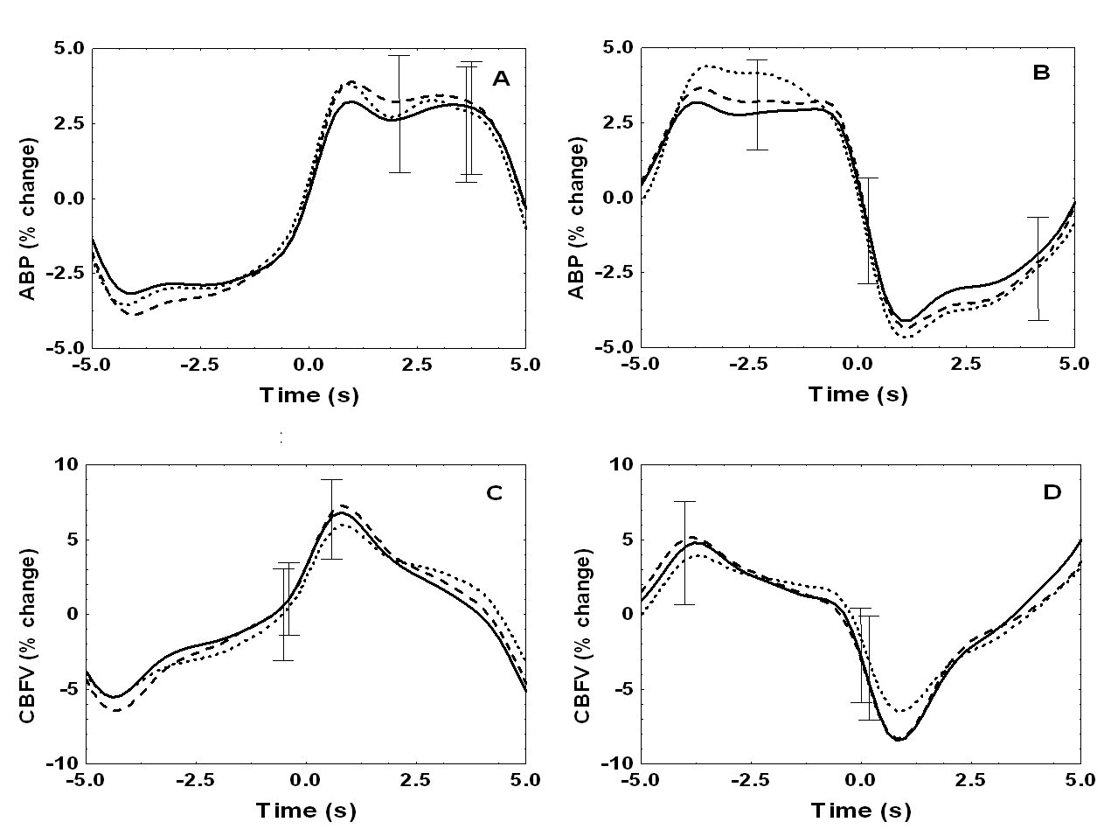
Figure 1. Population estimates for the ABP (A,B) and CBFV (C,D) coherent averages. Signals expressed as % change from the mean. Solid line: Normocapnia, Dashed line: Intermittent hypercapnia, Dotted line: Constant hypercapnia. The left column shows coherent averages obtained using the thigh cuff inflation signals to align all segments, whilst in the right column segments are aligned using the deflation signals. Error bars represent the largest ± 1 SEM.

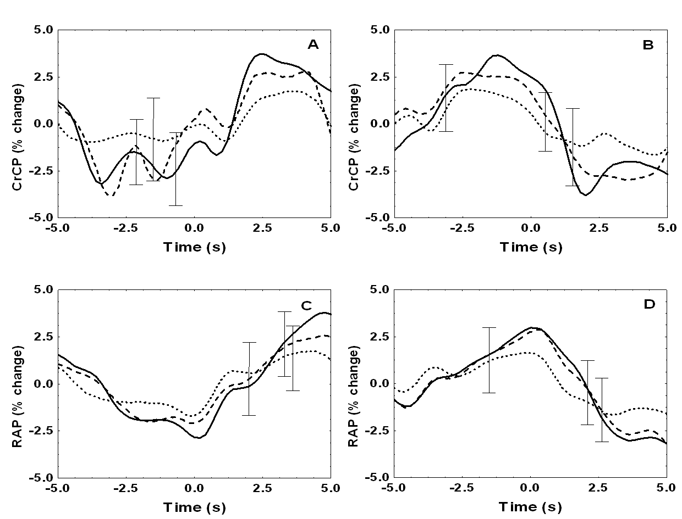

Figure 2. Population estimates for the CrCP (A,B) and RAP (C,D) coherent averages. Signals expressed as % change from the mean. Solid line: Normocapnia, Dashed line: Intermittent hypercapnia, Dotted line: Constant hypercapnia. The left column shows coherent averages obtained using the thigh cuff inflation signals to align all segments, whilst in the right column segments are aligned using the deflation signals. Error bars represent the largest ± 1 SEM.

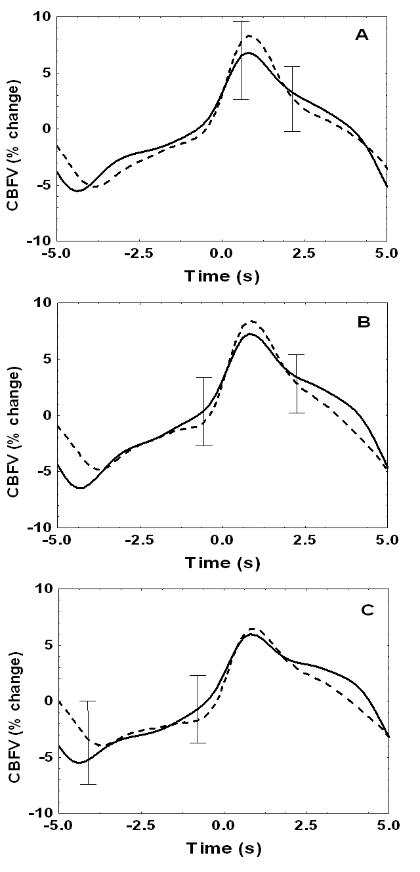
Figure 3. Population estimates for the averaged and inverted CBFV responses under normocapnic (A), intermittent hypercapnia (B) and constant hypercapnic conditions (C). Signals expressed as % change from the mean. Solid line: CBFV response, dashed line: inverted CBFV response. Error bars represent the largest ± 1 SEM.

Table 1: Population averaged slope coefficients (± SD) for the linear regression between ABP & CBFV, ABP & CrCP and ABP & RAP. The p-values listed are those obtained from the 2-way ANOVA and the post-hoc analyses.

Direction

Parameter Up Down p-values

CBFV

Normocapnia 0.50 ± 0.32 0.48 ± 0.35 p = 0.002 (effect of CO₂)
Intermittent hypercapnia 0.57 ± 0.33 0.58 ± 0.31 p = 0.369 (effect of direction)
Constant hypercapnia 0.71 ± 0.45 0.69 ± 0.42 p = 0.510 (effect of interaction)

CrCP

Normocapnia 0.85 ± 0.31 0.90 ± 0.30 p < 10⁻⁴ (effect of CO₂)
Intermittent hypercapnia 0.38 ± 0.34 0.41 ± 0.34 p = 0.105 (effect of direction)
Constant hypercapnia -0.12 ± 0.39 -0.09 ± 0.39 p = 0.135 (effect of interaction)

RAP

Normocapnia 0.003 ± 0.008 0.003 ± 0.008 p < 10⁻⁴ (effect of CO₂)
Intermittent hypercapnia 0.005 ± 0.006 0.006 ± 0.010 p = 0.481 (effect of direction)
Constant hypercapnia 0.010 ± 0.014 0.016 ± 0.013 p = 0.643 (effect of interaction)

