Dispenser printed sound emitting fabrics for applications in the creative fashion and smart architecture industry
Yi Li*, Russel Torah, Yang Wei, Neil Grabham and John Tudor
Department of Electronics and Computer Science, Faculty of Physical Sciences and Engineering, University of Southampton, Southampton, UK, SO17 1BJ
E-mail: Yi.Li@Soton.ac.uk

Abstract
This paper presents a printing technology for the design and manufacture of interactive planar speakers. With this technology, sound emission can be easily integrated into various textiles at the design stage with minimal assembly after printing. This paper reports direct write dispenser printed sound emitting smart fabrics, aimed at creative fashion and smart architecture applications opening up new opportunities in product design.
Planar spiral speakers generate a membrane vibration and so emit sound when driven from an a.c. audio source if a magnet is in close proximity to the spiral. These speakers are simpler to manufacture than conventional electromagnetic speakers and can be integrated on fabrics to form the basis of clothing in fashion applications.
The speaker designs were printed on woven polyester fabric and produced a measured peak sound output level of 85 dB referenced to a reference sound pressure in air of 2×10⁻⁵ Pa. The printed fabric speakers demonstrate a wide frequency response from 20 Hz to 20 kHz. This research demonstrates a straightforward fabrication method, based on dispenser printing, to achieve sound emission from a fabric. The fabrication process requires a processing temperature of 130 ºC for 10 minutes which is compatible with the majority of fabrics which are used in the fashion and architecture industries. This fabrication method is a direct write technique offering no waste and achieves a conductor resistivity of 7.69×10⁻⁶ Ω·m. This paper reports on the theory and the manufacturing technology to achieve direct write dispenser printed planar spiral speakers on fabrics.
Keywords: Creative industry, spiral speaker, fabric speaker, dispenser printing, direct write, smart fabrics, creative fashion, smart architecture.
- Introduction
Fabrics are lightweight, flexible, omnipresent in our lives, and provide a large surface area which can be exploited by integrating electronic functionality for various applications, for example within the fashion or architecture industries. Smart fabrics or textiles have embedded electronic functionality such as sensors or actuators within them. Smart fabrics is a dominant trend in future textile development, especially targeting interactive, wearable textiles for the creative industries. Examples date back to 1991 when researchers investigated interactive clothing with one famous example being ‘Hypercolor’ a fabric which changes colour when in heated (Nogaki, 1992). Further within the field of architecture, textiles are finding an increasing number of applications within which smart electronic functions may be integrated such as solar cells to supply power (Wilson, Mather, Lin and Divaf, 2012). Printed electronics has been development in the last few decades to reduce the manufacturing cost and provide more flexible solution enabling electronics functionality to be realised on fabrics. Printed smart fabrics research, in particular based on screen printing, has been growing significantly and a range of devices have been achieved. A range of low temperature (<150 ºC) processable functional materials, compatible with fabrics, facilitate the fabrication of functional devices. Functions achieved so far are: conductive (Locher and Troster, 2007), dielectric (Nerak, Turk and Voncina, 2006), piezoelectric (Almusallam, Torah, Zhu, Tudor and Beeby, 2013), electroluminescent (Sloma, Fanczak, Wroblewski, Mlozniak, Fakubowska, 2014), sacrificial (Wei, Torah, Yang, Beeby and Tudor, 2013) and strain sensing (Perc, Kuscer, Holc, Belavic, Svetec, Guermonprez and Kosec, 2010). However, sound emission, achieved by directly printing on fabric, has not been previously reported. The challenge of printing functional layers of around 20 µm thickness on widely used woven fabrics, such as polyester cotton of surface roughness ~150 µm, is met by printing a suitably thick, primer interface layer on the fabrics, before additional functional layers are printed, to overcome the barrier of the high roughness of woven fabrics (Whittow, Li, Torah, Yang, Beeby and Tudor, 2014).
The fabrication technique used in this current research is direct write pneumatic dispenser printing which has been under research within the EU project CREATIF (CREATIF Project, 2013-2017). The direct-write dispenser printing method provides design flexibility and is suitable for the low-volume production often required by the fashion industry; this is otherwise costly to achieve using the alternative technique of screen printing which requires a bespoke set of screens for each new design. Dispenser-based deposition is a mature manufacturing technology commonly used in applications such as dispensing adhesives to bond electronic devices to substrates or sealants and lubricants for mechanical parts. To date, in manufacturing applications, the materials being dispensed are not electronically functional nor printed in layers to achieve devices on fabric. Dispenser printing can realise multilayer electronic components/devices on a substrate by printing each successive layer on top the previous one hence building up multiple functional layers.
Dispenser printed electronic devices are, however, still at a very early stage of research. Dispenser printing of electronic devices on non-fabric substrates was comprehensively studied at the University of California, Berkeley (Ho, 2010). They demonstrated the operational principle of the dispenser mechanism and the physical dispensing of functional materials. In addition, a dispenser printed micro-battery and thermoelectric generator, both on glass substrates, have been reported (Ho, Evans and Wright, 2010; Madan, Chen, Wright and Evans, 2011). Reference (Li, 2013) mentioned preliminary work dispenser printing electronics on both rigid alumina tiles and flexible polyimide (Kapton from DuPont). Researchers have used dispenser printing to make complex structures, such as, direct write printed 3D silk/hydroxylapatite scaffolds (Sun, Parker, Syoji, Wang, Lewis and Kaplan, 2012) on a rigid substrate for the medical industry and direct write printed ITO microelectrodes (Ahn, Lorang, Duoss and Lewis, 2010) on a silicon wafer for electronics manufacturing. A pneumatic dispenser printed zinc microbattery on nickel foil (Ho, Steingart, Evans and Wright, 2008; Ho, Evans and Wright, 2010) achieved a milestone in dispenser printed electronics in 2008, being the first fully dispenser printed electronic device. Since then, a thermoelectric energy harvester on a glass substrate (Madan, Chen, Wright and Evans, 2011) and the proof mass of a MEMS vibration energy harvester on a silicon wafer (Miller, Chen, Wright and Evans, 2010) have been dispenser printed.
When dispenser printing on fabrics, a dispenser printed interface layer on polyester cotton fabrics has been optimised to enable dispenser printed smart fabrics (Ahmed, Torah and Tudor, 2015). A dispenser printed 2.4 GHz dipole antenna on polyester cotton fabric substrate has been recently reported for RF applications (Li, Torah, Beeby and Tudor, 2015). A dispenser printed proximity sensor on polyester cotton fabric substrate has been reported for creative applications (Wei, Torah, Li and Tudor, 2016).
A sound emitting textile has been realised by conventional embroidery to achieve the very first prototype of a textile speaker (Fabric Speaker, 2016). Preliminary work on a dispenser printed sound emitting textile has been reported (Li, Torah, Yang, Wei and Tudor, 2015); this proved that sound emission can be dispenser printed on fabric substrates ranging from industrial heavily coated architectural fabrics to everyday woven polyester cotton fabrics. This present research paper explains the dispenser printer system used to achieve sound emitting fabrics and provides a quantitative comparison between the performance of the dispenser printed fabric speaker and commercially available speakers.
The creative industry refers to a range of economic activities which are concerned with the generation of knowledge and information. UK Government official statistics state the UK creative industries alone are now worth £71.4 billion per year to the UK economy (Department for Culture, Media & Sport and The Rt Hon Maria Miller, 2010-2015). A future vision of the creative industries, is that interactive fabric products are designed and printed locally in the designer’s studio. Direct write dispenser printing facilitates this by printing directly from the computer design and offers complete design freedom and integration with inkjet printed colour patterns on standard commercially available fabrics. This paper reports in detail the fabrication and performance of direct write dispenser printed interactive sound emitting smart fabrics targeting creative industry fashion applications and smart architecture. For example, a fashion designer can add a custom designed sound emission function to existing clothing or to textiles at the design stage of a fashion garment. This method can also be used by designers, to achieve sound emission from wearable fashion textiles or rigid panels. In architecture, fabrics are used for example to create tensile structures (BASE Structure, 2016) within which smart functions may be integrated.
The reported planar sound emitting devices are more flexible and simpler than conventional non-planar electromagnetic and electrostatic sound emitting devices. Furthermore, the spiral based planar electromagnetic speaker allows interaction since the sound output level can be changed by varying the distance between a magnet and the speaker. This paper firstly explains the details of the dispenser printer system and the theory of the sound emitting textiles. Then, the fabrication and process parameters are discussed for each of the required functional inks. Finally, the frequency response and sound level measurements for the printed fabric speakers are compared to commercially available speakers.
- Direct write dispenser printing
The dispenser printer used in this research is a bespoke pneumatic dispensing system operated by a pre-programmed three axis motorised system with the ability to change the dispensing nozzles depending on the requirements of the functional materials and the desired pattern. Dispenser printing is a straightforward and versatile method for additively depositing a variety of materials, including slurries, solutions and suspensions, generally referred to as ‘inks’. The method offers the ability to deposit inks at room temperature and under ambient conditions, while generating negligible materials waste. Dispenser printing offers the benefit that, unlike screen printing or stencil printing, a screen or mask is not needed; layers are printed directly from the computer design. Moreover, it accepts a much broader rheological range for each functional ink compared to the major alternative fabrication techniques of screen or inkjet printing. Dispenser printing also allows adjustable print resolution by changing the nozzle size or the spacing between dispensed lines. Also, as dispensing pressure is increased, for a specific nozzle gauge, the printed layer becomes wider and thicker.
  - Dispenser printing on fabrics
The fabrication flow diagram, shown in Figure 1, represents the steps to direct write, by dispenser printing, multiple functional layers on a woven fabric substrate; three different functional materials are shown in this example. The interface layer deposition step, shown in Figure 1(b), is a critical deposition step to smooth woven and rough fabrics allowing them to subsequently support the functional layers. However, this interface layer deposition step is not always required; the pre-coated fabrics often used with inkjet printing already have a sufficiently smooth surface. The interface is printed on the fabric only where subsequent functional layers are required thereby maintaining the overall breathability of the fabric.

Figure 1. Cross sectional view: fabrication flow diagrams of direct write dispenser printed three different functional layers on woven fabrics:
(a) cross sectional view of the untreated woven fabric;
(b) dispenser printing the interface layer on the untreated woven fabric substrate;
(c) UV curing to solidify the printed interface layer;
(d) dispenser printing the 1st functional layer on top;
(e) thermal curing to solidify the 1st functional layer;
(f) dispenser printing the 2nd functional layer on top;
(g) thermal curing to solidify the 2nd functional layer;
(h) dispenser printing the 3rd functional layer on top;
(i) thermal curing to solidify the 3rd functional layer on top and complete the example three layer device fabrication process.

  - Dispensing Printing Process
The dispenser printing system used in this research work is based on the Nordson Ultimus V High Precision Pneumatic Dispenser (Nordson EFD, 2016). The operating principle of the Nordson pneumatic dispenser controller is that the ink inside the dispenser syringe is pushed out by a pre-programmed dispensing pressure and time setting, through a hollow nozzle and deposited onto a substrate via a succession of dots or extruded lines. The syringe and substrate are mounted on three axis stages (X, Y and Z). With an assortment of nozzle sizes (0.1 µm to 2 mm), precise dispensing time (0.01 sec to 999.9 sec) and a broad range of pneumatic pressures (1 kPa to 800 kPa), the dispenser printer is able to print a variety of inks in a range of printed feature sizes. The printed line width is generally 1.5 times wider than the inner diameter of the nozzle.
When the pneumatic dispenser dispenses individual droplets of ink via the nozzle, the operating principle is very similar to that of a commercial inkjet printer. A schematic diagram of this droplet mode dispenser printing is shown in Figure 2(a). It shows the droplets coalescing after printing to form a printed film. For droplet mode dispensing, both X and Y axes resolutions have to be set based on optimisation of each active ink. In droplet mode, the printed dot volume is equal to one half the volume of a droplet, since half the volume remains within the nozzle. The droplet volume is determined by the nozzle’s diameter, ink rheology, applied pressure and dispensing time. The pneumatic dispenser operates by air pressure impact similar to the way that PZT bimorph displacement in inkjet printing is used to produce a droplet. The dispenser vacuum level allows the pressure inside the barrel to hold the ink at the meniscus point at the end of the dispensing nozzle in the same way as an inkjet printer meniscus. The fundamental principle in pneumatic dispensing is that air is compressible and liquid is incompressible. This explains why a liquid can be dispensed: if the liquid were compressible, accurate dispensing could never be achieved. The principle also explains why there is a delay in liquid flow when using an air pulse as the air must first be compressed before impacting on the liquid.
Dispenser printing can alternatively be used in a continuous filament mode. Figure 2(b) shows the filament mode forming a film. For continuous filament mode, the spacing between the individual filaments needs to be considered, to ensure they are close enough to coalesce. The effect of infill patterns on dispenser printing functional inks has been discussed based on using 3D printer auto routing methods (Vos, Torah and Tudor, 2015).
- (b)
Figure 2 Schematic of direct write dispenser printing using (a) droplet mode and (b) filament mode.
In both dispensing modes, the dispenser requires an accurately controlled dispensing gap which is the distance between the nozzle tip and the substrate, shown in figure 3. If the dispense gap is too large, the extruded liquid will not properly wet the substrate while part of the dispensed functional material will suffer from stringing from the nozzle tip to the substrate, resulting in a poor resolution pattern. However, if the dispense gap is too small, the extruded liquid will spread, also resulting in a poor resolution pattern. Additionally, contamination will occur around the edge of the dispensing nozzle tip, potentially also negatively affecting the final print definition. Brewin, Zou and Hunt (2001) indicateed that the dispensing gap should be about 30 to 50 % of the inner diameter of the dispensing nozzle.
Figure 3. Comparison between different dispensing gaps to help to choose the optimum dispensing gap for depostion.
The maximum dispense speed is constrained by the rate of material wetting to the substrate. The ink’s wettability, representing the interaction between the ink and substrate, defines the pattern resolution before the curing stage. If the material has not sufficiently wetted the substrate it will stay attached to the nozzle rather than printing on the substrate resulting in an incompletely dispensed pattern. Therefore, the surface energy of the nozzle tip needs to be low to avoid functional materials sticking to the tip during printing.
In summary, the fundamental requirements for the pneumatic dispensing of inks are similar to inkjet printing but with a much wider acceptable rheological range. The following requirements could restrict functional materials selection, but each requirement has a very broad acceptable range:
- Liquid evaporation: the dispensed liquid must not dry quickly at the nozzle/air interface in the ambient environment.
- Viscosity: the pneumatic dispenser accepts a broad range of liquid viscosity, from 1 mPa.s to 1000 Pa.s.
- Surface tension: due to the operating principle of the pneumatic dispenser, surface tension has less impact on dispensing compared to the applied air pressure. Typically, gravity, and the substrate surface energy forces, are higher than the ink surface tension force at the dispensing nozzle thus reducing the impact on the print quality.
- Suspensions: particles must not settle rapidly or agglomerate, so a stable suspension is required.

  - Effects of ink viscosity on printability
The viscosity of the ink has the most significant effect on the printability of an ink. The flow rate (m³/s) of an ink through a nozzle is approximated by measuring the volume of ink (m³) extruded for a given dispensing time and can be calculated from Equation 1 (Ho, 2010):
$$\int_{0}^{R}{V_{z}r2πdr}=\left[\frac{\left(P_{top}-P_{bottom}\right)}{L}+ρg\right]\left(\frac{πR^{4}}{8μ}\right)=Flow rate$$ | (1)
Where
V_{z} is the velocity in m/s;
${ P}_{top}-P_{bottom}$ is the pressure applied to the ink $P_{∆}$ in Pa;
$L$ is the needle length in m;
$ρ$ is the density of the ink in kg/m³;
$g$ is the gravitational force in m/s²;
π is the mathematical constant Pi, 3.14159;
$R$ is the inner diameter of the dispensing needle in m;
µ is the viscosity of the dispensing liquid in Pa·s;
Flow rate is measured in m³/s.

As can be seen from Equation (1), the differential pressure applied to the dispensing nozzle divided by the length of the nozzle will linearly proportionally affect the flow rate with an offset related to the paste density value. The dispensing flow rate is inversely linearly proportional to the viscosity. However, the key parameter, which significantly effects the flow rate, proportionally in a quartic relationship, is the diameter of the dispensing nozzle.

- Theory and design of the printed speaker
There are two types of sound emitting devices which can potentially be printed as planar structures on fabric. The first option is a piezoelectric buzzer comprised of three functional layers in a sandwich structure with the piezoelectric layer in between two conductive electrode layers (Wei et al., 2016). The piezoelectric layer deforms when excited electrically causing the substrate to vibrate, thus creating sound. It has a limited frequency response of 4±2 kHz and can therefore only be used as a tweeter-like device (Sound Consideration, 2016). The sound volume performance depends on the piezoelectric properties, typically the d33, of the piezoelectric layer and the total area of the device. The attraction of this approach, for design applications, is that any pattern of piezoelectric buzzer can be achieved, providing the device sandwich structure is maintained. However, it typically has low acoustic performance even with the best printed piezoelectric materials (Almusallam, Yang, Cao, Zhu, Tudor and Beeby, 2014) and has a slightly more complex three layer structure than the planar spiral speaker approach selected, so the piezoelectric buzzer is not selected in this work.
The second option is a planar electromagnetic spiral speaker consisting of a conductive coil on a fabric membrane combined with a magnet (Li et al., 2015), as shown in Figure 4(a) and Figure 4(b). The sound emission is generated by an audio signal applied to the coil and the electromagnetic coupling with the magnet results in vibration of the membrane. The conductive coil is implemented as a planar equivalent to a wired coil, with the fabric substrate acting as the speaker vibrational membrane as shown in Figure 4(c). The design can be any looped conductor pattern but this will affect the level of sound produced. This design is analogous to a conventional electromagnetic speaker which can emit a wide frequency bandwidth.

- (b) (c)
Figure 4. Cross sectional and plan view of the schematic diagrams:
(a) Cross sectional view of a conventional electromagnetic speaker;
(b) Cross sectional view of a planar spiral speaker on a fabric substrate based on a conventional electromagnetic speaker;
(c) Plan view of a planar spiral speaker design;. the red area is an insulating layer above the bottom conductive track to act as a bridge allowing the top silver track to lead out for connection.

- Fabrication of the printed speaker
The chosen fabric is Back Lighttex FR, a 100 % polyester woven fabric supplied by Berger with a fabric weight of 260 g/m² and thickness of 340 µm (http://www.bergertextil.com). This fabric is chosen because it has a tighter more uniform weave structure and is less porous compared the one used for our previous spiral speaker. This used 65/35 polyester cotton fabric (Li et al., 2015) supplied by Klopman International with fabric weight of 210 g/m² and thickness of 300 µm (http://www.klopman.com/). This polyester cotton fabric has a high porosity and a mean deviation of surface roughness of 143.3 µm, which requires the deposition of an additional interface layer to fill in the weave and present a smooth surface to subsequently printed layers. The Back Lightex fabric, is smoother, with mean deviation of surface roughness of 83.0 µm, and does not require an interface layer, thus simplifying fabrication. A micrographical comparison of both fabrics is shown in Figure 5. It can be seen, in Figure 5, that the polyester cotton has a higher porosity with more openings between the woven yarns, which will reduce sound emission due to a smaller compressive effect on the surrounding air since the air will pass through the openings. The fabrication approach, and speaker design, can be applied to those fabrics commonly used in the fashion industry, with the requirement for the interface layer depending on the surface roughness of the fabric. The functional printing pastes are supplied by Smart Fabric Inks (www.fabinks.com): Fabink-TC-C4001 silver paste was chosen for the conductive tracks in the spiral coil and Fabink-TC-D9001 dielectric paste was chosen for the metal-insulator-metal crossover in the spiral speaker. The metal-insulator-metal crossover is used to route the conductor from the spiral centre allowing external connection without interfering with the vibrating centre of the speaker.
300 µm
300 µm
(a) (b)
Figure 5. Plan view of micrographs:
(a) Back Lighttex FR, a 100 % polyester woven fabric supplied by Berger;
(b) 65/35 polyester/cotton fabric supplied by Klopman International.

A 25 gauge and 250 µm inner diameter tapered nozzle from Fisnar (www.fisnar.com) was used to dispense the bottom conductive silver layer with a dispensing pressure of 20 kPa and a vacuum level of 0.7 kPa. Using a tapered nozzle allows increased fluid volumetric flow rate compared to straight un-tapered dispensing tips. The gap between the dispenser nozzle and the substrate is 100 µm. The positional XY stages moved at a stage speed of 10 mm/s. The silver layer was thermally cured for 10 minutes at 130° C in a box oven after printing was complete. The dielectric layer was dispensed with the same tapered nozzle as the silver paste but with a dispensing pressure of 40 kPa and vacuum level of 1.0 kPa. The dielectric layer has the same curing parameters as the silver layer. Finally, the top silver layer is printed to form a metal-insulator-metal (MIM) crossover structure needed to couple the centre of the spiral to the outside border so both audio connections can be adjacent, as shown in the cross sectional schematic view of figure 6 (a). Figure 6 (b) shows a plan view of the spiral speaker, which includes the MIM crossover.
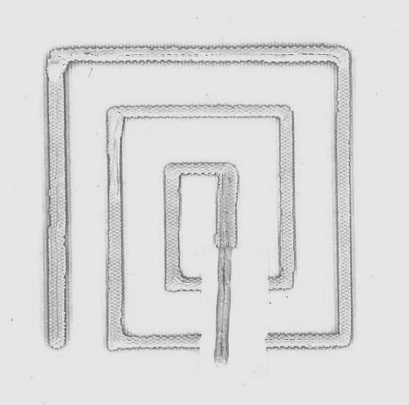
2 cm
- (b)
Figure 6 (a) Schematic cross section view of the spiral speaker on the woven fabric substrate, (b) Plan view of the dispenser printed spiral speaker on woven fabrics with dimension side length of 5 cm.

The functional layer thicknesses were measured using a Mitutoyo micrometer. The printed silver layer is 250 µm thick, the fabric substrate 350 µm thick and the dielectric layer 80 µm thick. The resistivity of the printed coils is 7.69×10⁻⁶ Ω·m; obtained by measuring the resistance of the printed tracks with a Fluke 73 multimeter and the thickness of the layer.

- Demonstration of the printed fabric speaker
Dispenser printed spiral speakers were realised on the target fabric substrate. 6 spiral speaker designs were printed with different side lengths of 5 to 10 cm, successively increasing each size by 1 cm. Two examples of dispenser printed speakers with 8 and 10 cm side lengths are shown in figure 7.
The spiral speakers were tested by connecting an audio source through a 20 W audio amplifier (PULSE-Audio Ltd SDA20, www.pulse-audio.co.uk). In addition, a magnet is needed to vary the sound volume by changing the local magnetic flux; an NdFeB magnet was used to achieve a high magnetic flux. Significant noticeable sound pressure level can be produced in a typical office environment. Both high and a low frequency sounds can be generated with a clear output. Therefore, a speaker cone is not needed to support the typical frequency range of human voice, the bandwidth of which is 85 Hz to 255 Hz.
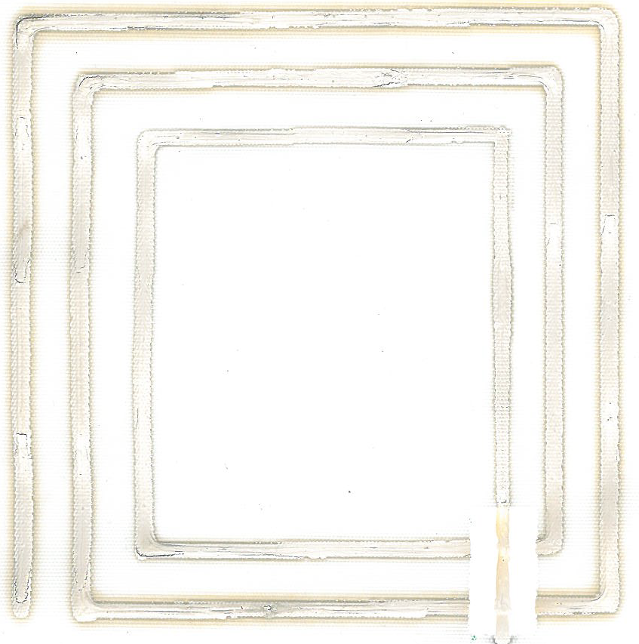
2 cm
2 cm
- (b)
Figure 7. An isometric view of the dispenser printed spiral speaker on woven fabric with dimension: (a) side length of 8 cm, and (b) side length of 10 cm.

A frequency spectrum response measurement was performed to quantify the output performance of the printed fabric speaker. This was then compared to two commercially available speakers using a Brüel & Kjær (www.bksv.co.uk) Type 2250 sound level meter with frequency analysis function in the frequency range of 20 Hz to 20 kHz. The test distance was 5 cm from the printed speaker to the detector. The test set up is illustrated in Figure 8.
Figure 8. Frequency reponse measurement set up diagram to measure the sound output level of the printed fabric speaker, iPhone 6 handset speaker and the Logitech H390 headphone.
The audio source emits all frequencies in the audible range from 20 Hz to 20 kHz in the sine sweep mode over a 20 second time span. The audio source output level is -3 dBFS. The unit of dBFS is equivalent to the decibel level relative to the full scale sine wave showing the maximum peak value. Sine sweeps are used as reference tones to observe the frequency response or identify the adverse effects of room modes; for example, the room background noise is typically in the range of 20 Hz to 200 Hz. The sine sweep produces frequencies with a much higher energy compared to pink noise or white noise. A sine sweep produces only one frequency at a time unlike pink or white noise which produces many frequencies simultaneously. The advantage of the sine sweeps is that it ignores the ambient noise in the room offering better immunity for measuring the frequency response at each fixed frequency value.
Eight speakers were tested in this work: 6 different sized dispenser printed speakers and 2 commercial conventional speakers for comparison, one being an Apple iPhone 6 handset speaker and the other a Logitech H390 headset speaker. These two speakers are chosen because they are widely used indoor state of the art sound emitting devices. A background noise measurement is also made as a reference. Figure 9 shows the frequency response of the printed fabric spiral speakers for a sine sweep from 20 Hz to 20 kHz over a 20 s period. The same magnet is used on top of each different fabric speaker. The sound output level is measured in decibels (dB) relative to a reference sound pressure in air of 2×10⁻⁵ Pa, with the maximum sound level using ‘Z’ frequency and fast time weighting. The background noise of the test environment is shown in Figure 10 with two tests being performed to quantify random variations. Comparing Figure 9 and Figure 10, the frequency response of the printed fabric speakers covers the full band of frequency range from 20 Hz to 20 kHz, as it can be seen that the sound emission from the fabrics is greater than the background noise frequency response plot throughout the range from 20 Hz to 20 kHz. The sound output level measurement shows that between 250 Hz and 5 kHz frequency range, the sound output level is above 70 dB, which is a significant sound emission and comparable to a normal speech at 1 m in an indoor environment. (Portland International Jetport Noise Exposure Map, 2004)
The same sound emission test was repeated for the two commercially available speakers and the frequency response was compared with the printed fabric speakers. Figure 11 shows the measured sound output level of the Apple iPhone 6 speaker and a Logitech H390 headset to provide a comparison of the commercial speaker outputs. The distance between the detector and speaker is 5 cm, and is the same for each speaker. The audio source is the sine sweep signal in the frequency range of 20 Hz to 20 kHz. Comparing figure 10 and figure 11, below 125 Hz, the outputs of the commercial speakers are almost identical and therefore it is difficult to know if this is the background noise or the speaker output. The plots however demonstrate that the output performance of the commercially available speakers is limited at a frequency range below 125 Hz; the plot matches with the background noise plot suggesting commercial speakers cannot emit sound below 125 Hz.
The measured sound output levels of the two commercially available speakers are around 20 – 30 dB higher than the printed fabric speaker in the frequency range above 200 Hz. The commercial speakers use a driven coil mechanism rather than the printed spiral mechanism which has less electromagnetic force therefore resulting in less vibrating amplitude. There is a frequency response drop in dB towards 20 kHz for both of the commercially available speakers and this was also observed for the printed fabric speakers. The commercial speakers have sound output from 200 Hz to 20 kHz with better output performance in the range of 200 Hz to 10 kHz, whereas they did not respond to the frequency under 200 Hz and showed a slight drop above a frequency of 10 kHz. The dispenser printed fabric speakers therefore cover a wider bandwidth over the range 20 Hz to 20 kHz.

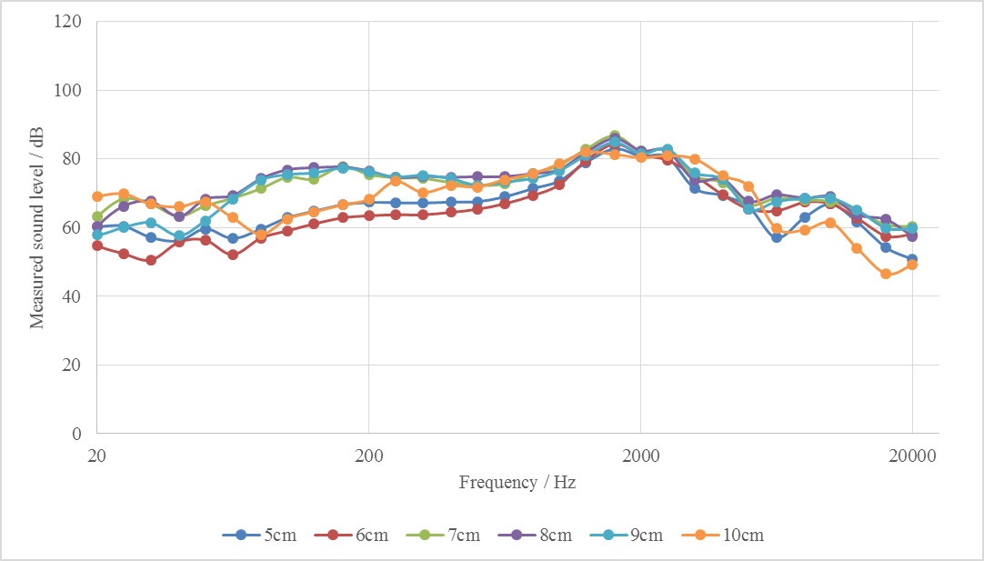
Figure 9. Measured sound output level of the dispenser printed fabric spiral speaker with different side length against the frequency response of the sine sweeping audio input in the frequency range of 20 to 20 kHz in log scale.

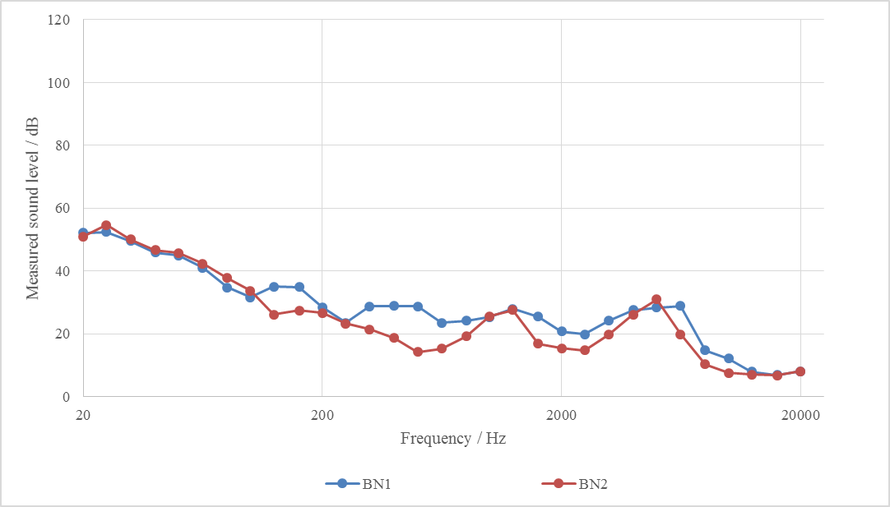
Figure 10. Measured background noise level of the testing environment against the frequency response of the sine sweeping audio input in the frequency range of 20 to 20 kHz in log scale.

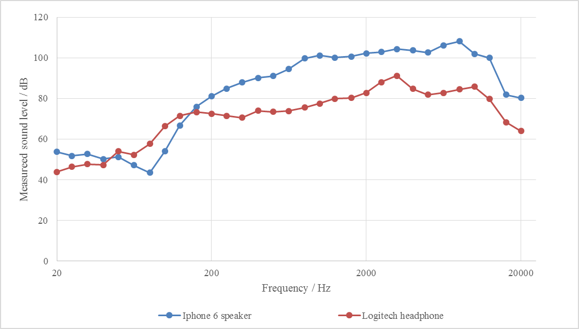
Figure 11. Measured sound output level of the Iphone 6 speaker and Logitech H390 headphones to compare with the frequency response of the printed fabric speakers when the sine sweeping audio input is used with a frequency range of 20 to 20 kHz in log scale.

- Conclusions
This paper describes a novel fabrication technique of dispenser printing to create sound emitting smart fabrics. A dispenser printed sound emitting device on a woven polyester fabric substrates was used to demonstrate the dispenser printing technique. The printed spiral speaker shows a sound output within the range of 55 to 85 dB and a broader frequency response compared to the commercially available speakers assessed in this work. The printed speaker demonstrates the advantages of direct write printing functional devices on fabrics with designs following a computer-defined pattern without needing a pre-made mask or screen. The dispenser printed fabric speakers are not limited by fabric texture or location on a garment which provides a full design freedom to add sound emission to a broad range of fabrics. This printing system can be used to realise interactive smart fabrics locally in the creative workshop for fashion applications with a higher degree of personalisation for rapid prototyping.

Acknowledgement: This work has been supported by the EU under FP7 project CREATIF grant number CP-FP-INFSO-FP7-610414. All data supporting this study is openly available from the University of Southampton repository at http://dx.doi.org/10.5258/SOTON/388764.
References
Ahmed, Z., Torah, R. and Tudor, M. J. (2015). Optimisation of a novel direct write dispenser printer technique for improving printed smart fabric device performance, Symposium on Design Test Integration and Packaging of MEMS and MOEMS, DTIP 2015, France. doi: 10.1109/DTIP.2015.7160978

Ahn, B. Y., Lorang, D. J., Duoss, E. B. and Lewis, J. A. (2010). Direct write assembly of microperiodic planar and spanning ITO microelectrodes, Chemical Communications, 46, 7118-7120. doi: 10.1039/C0CC01691H

Almusallam, A., Torah, R. N, Zhu, D., Tudor, M. J. and Beeby, S. P. (2013). Screen printed piezoelectric shoe-insole energy harvester using an improved flexible PZT-polymer composites, IOP Publishing, Journal of Physics: Conference Series 476, PowerMEMS 2013, 012108.

Almusallam, A., Yang, K., Cao, Z., Zhu, D., Tudor, M. J. and Beeby, S. P. (2014). Improving the dielectric and piezoelectric properties of screen-printed low temperature PZT/polymer composite using cold isostatic pressing. Journal of Physics: Conference Series, 557, 012083.

BASE Structure, (2016). http://www.basestructures.com/, 2016, access date: 09/08/2016.

Brewin, A., Zou, L. and Hunt, C. (2001). A guide to best practice for electronic materials dispensing, National Physics Laboratory, 2001, NPL Report MATC(A)82.

Sound Consideration, Sonitron (2016) http://sonitron.be/site/contentpage.php?primid=11, access date: 01/03/2016.

CREATIF Project, EU, Framework 7 European Union, http://www.creatif.ecs.soton.ac.uk/, 2013-2017, access date: 05/08/2016.

Department for Culture, Media & Sport and The Rt Hon Maria Miller, Press Release on Creative Industries worth £8 million an hour to UK economy, part of Media and creative industries, under the 2010 to 2015 Conservative and Liberal Democrat coalition government.

Fabric Speakers, (2016), under section of Actuators, http://www.kobakant.at/DIY/?p=2936, access date: 01/03/2016.

Ho, C. C. (2010). Dispenser printed zinc microbattery with an ionic liquid gel electrolyte, PhD thesis in Materials Science & Engineering UC Berkeley.

Ho, C. C., Evans, J. W., and Wright, P. K. (2010). Direct write dispenser printing of a zinc microbattery with an ionic liquid gel electrolyte, Journal of Micromechanics and Microengineering, 20, 104009.

Ho, C. C., Steingart, D., Evans, J. and Wright, P. (2008). Tailoring electrochemical capacitor energy storage using direct write dispenser printing, ECS Transactions, 16(1), 35-47. doi: 10.1149/1.2985625

Ho, C. C., Evans, J. W. and Wright, P. K. (2010). Direct write dispenser printing of a zinc microbattery with an ionic liquid gel electrolyte, Journal of Micromechanics and Microengineering, 20, 104009.

Li, Y. (2013). Direct write printed flexible electronics devices on fabrics, Ph.D. thesis in Electronics and Computer Science at the University of Southampton.

Li, Y., Torah, R. N., Yang, K., Wei, Y. and Tudor, M. J. (2015). Fully direct write dispenser printed sound emitting smart fabrics, Electronics Letters, 51(16), 1266-1268. doi: 10.1049/el.2015.0235

Li, Y., Torah R., Beeby, S. P. and Tudor, M. J. (2015). Fully direct-write dispenser printed dipole antenna on woven polyester cotton fabric for wearable electronics applications, Electronics Letters, 51(17), 1306-1308. doi:10.1049/el.2014.4156

Locher, I. and Troster, G. (2007). Screen printed textile transmission lines, Textile Research Journal, 77(11), 837-842. doi:10.1177/0040517507080679

Madan, D., Chen, A., Wright, P. K. and Evans, J. W. (2011). Dispenser Printed Composite Thermoelectric Thick Films for Thermoelectric Generator Applications. Journal of Applied Physics, 108, 034904. http://dx.doi.org/10.1063/1.3544501

Miller, L. M., Chen, A., Wright, P. K. and Evans, J. W. (2010). Resonance Frequency Customization for MEMS Vibration Energy Harvesters Using Dispenser Printed Proof Mass, Proceedings of PowerMEMS 2010 Leuven, 411-414.

Nogaki, S. W. (1992). Generra, Hot start, then cold reality, Company reflects industry’s woes, http://community.seattletimes.nwsource.com/archive/?date=19920703&slug=1500289, access date: 03/08/2016.

Neral, B., Turk, S. S. and Voncina, B. (2006). Properties of UV-cured pigment prints on textile fabric, Dyes and Pigments, 68(2-3), 143-150. http://dx.doi.org/10.1016/j.dyepig.2005.01.022

Nordson EFD, (2016). Ultimus V High Precision Dispenser Controller Datasheet, http://www.nordson.com/en/divisions/efd/products/fluid-dispensing-systems/ultimus-v-high-precision-dispenser, access date: 01/03/2016.

Perc, B., Kuscer, D., Holc, J., Belavic, D., Svetec, D. G., Guermonprez, P. and Kosec, M. (2010). The processing and characterisation of a strain sensor on a textile, 41th International Symposium on Novelties in Textiles, May 2010, Ljubljana, Slovenia.

Portland International Jetport Noise Exposure Map, (2004). Appendix A: Noise metrics and acoustic terminology, Portland International Jetport Noise Exposure Map, HMMH Report No. 298410, March, 2004.
Sloma, M., Fanczak, D., Wroblewski, G., Mlozniak, A. and Fakubowska, M. (2014). Electroluminescent structures printed on paper and textile elastic substrates, Circuit World, 40(1), 13-16. http://dx.doi.org/10.1108/CW-10-2013-0037

Sun, L., Parker, S. T., Syoji, D., Wang, X., Lewis, J. A. and Kaplan, D. L. (2012). Direct write assembly of 3D silk/hydroxyapatite scaffolds for bone co-cultures, Advanced Healthcare Materials, 1, 729-735. doi:10.1002/adhm.201200057

Vos, M., Torah, R. N. and Tudor, M. J. (2015). Effect of infill patterns on print quality of dispenser printed electronic ink, Symposium on Design Test Integration and Packaging of MEMS and MOEMS, DTIP 2015, France. doi: 10.1049/el.2015.0628

Wei, Y., Torah, R., Yang, K., Beeby, S. and Tudor, M. J. (2013). A screen printable sacrificial fabrication process to realise a cantilever on fabric using a piezoelectric layer to detect motion for wearable applications, Sensors and Actuators, 203, 241-248. http://dx.doi.org/10.1016/j.sna.2013.08.041

Wei, Y., Torah, R., Li, Y. and Tudor, M. J. (2016). Dispenser printed capacitive proximity sensor on fabric for applications in the creative industries, Sensors and Actuators A: Physical, 247, 239-246. http://dx.doi.org/10.1016/j.sna.2016.06.005

Whittow, W., Li, Y., Torah, R., Yang, K., Beeby, S. P. and Tudor, M. J. (2014). Printed frequency selective surface on textiles, Electronics Letters, 50(13), 916-917. doi: 10.1049/el.2014.0955

Wilson, J. I. B., Mather, R. R., Lind, H. and Diyaf, A.G. (2012). Flexible Solar Cells on Textiles, Modern Energy Review, 4(1), 68–69.

