Fano resonance and Rabi splitting in MDM side-coupled
cavities systems

Liwei Zhang¹, Xinliang Wang^{1*}, Wentao Qiao¹, Jun-Yu Ou^{2**}, Qiulei Gu¹,

Li He³, Qin Wang¹, Yujin liu¹, Yingying Zhu¹, Weibin Li¹
¹ School of Physics and Electronic Information Engineering, Henan Polytechnic University, Jiaozuo, Henan 454000, PR China
2 Optoelectronics Research Centre & Centre for Photonic Metamaterials, University of Southampton, Southampton, SO17 1BJ, UK
3 School of Physics Science and Engineering, Tongji University, Shanghai 200092, China
* wangxl@hpu.edu.cn, ** jo2c09@orc.soton.ac.uk
Abstract: We theoretically investigate the Fano resonance and Rabi splitting in the metal-dielectric-metal plasmonic waveguides with stub resonators. The proposed nanostructure waveguide consists of bulb-like resonators and a thin Metamaterial (MM) baffle. The bulb-like resonator with low Q factor can work as a continuum state, and the plasmonic waveguide inserted with a MM baffle can work as a discrete state. Fano resonances are obtained because of the interaction between the two states in the structure and the Fano resonance can be tuned by changing the separation between the resonator and the MM baffle. In the plasmonic waveguide system with two resonators and a MM baffle, Rabi splitting occurs because of the strong coupling between the narrow spectral response of MM baffle and the Fabry-Perot resonance caused by the two bulb-like resonators. The pronounced anticrossing behavior of the splitting peaks can be modified by varying the resonant frequency of MM baffle, the bulb-like resonator’s radius and the stub height. Furthermore, it is also found that the Rabi splitting can also be tuned by the separation between resonator and the MM baffle. Such plasmonic waveguide system may have potential applications in providing a stimulating insight to explore new fundamental physics in analogous atomic systems.
Key words: Surface plasmon; Fano resonance; Rabi splitting
1 Introduction
Quantum interferences such as Rabi splitting and Fano resonance in an atomic system have led to several fascinating and extraordinary effects[1-4]. Rabi splitting is of strong interest for studies on light-material interaction effects in recent years and the strong coupling can be observed in the optical spectra with a clear anticrossing behavior [5,6]. Compared with normal mode couplings, Rabi splitting refers in particular to strong coupling in which the coupling strength exceeds the dissipation rates of the system and the energy is therefore coherently exchanged between atom and cavity[7]. As a fundamental resonant effect, the Fano resonance discovered by Ugo Fano, appears as an interference effect between a localized state and a continuum band in quantum or classical systems[4,8-10]. The shape of Fano resonance is distinctly asymmetric, different from conventional symmetric Lorentzian resonance curves. Many parameters of the quantum interference effects are challenging to test in atomic and molecular systems that need sophisticated experimental condition and techniques. Although Rabi splitting and Fano resonance were initially proposed, observed and used in atomic and molecular systems, recently they are among many quantum phenomena that have classical and, more importantly, all optical analogues[8,9,11]. Rabi splitting and Fano resonances have been observed in different systems, including coplanar waveguide[12,13], plasmonic nanoparticles[14], photonic crystals[9], plasmonic nanostructures [4], and electromagnetic metamaterials[8,15]. Many experiments about Rabi splitting have been reported because it has promising applications in the atom detector and infrared photodetectors[16] and it is of great importance for many possible applications in quantum information processing[17]. The specific asymmetric feature of the Fano resonance promises applications in sensors[18], photoluminescence enhancement[19], and so on. The fundamental criterion for a Fano resonance is the interference between a spectrally overlapping broad resonance or continuum and a narrow discrete resonance. These conditions can be easily satisfied using tunable coupled plasmonic structures made of conventional plasmonic materials[8,11]. As an important plasmonic waveguide, metal-dielectric-metal (MDM) configurations attract more and more attention due to their deep subwavelength confinement of light based on surface plasmon polaritons (SPPs) [20-22]. MDM waveguides are regarded as one of the most promising candidates for the nanoscale manipulation and transmission of light and offer a pathway for the realization of photonic and quantum functionality in nanostructures[23-25]
In this paper, Fano resonance and Rabi splitting are numerically investigated in a compact plasmonic system, which consists of a MDM waveguide coupled with side cavities and a MM slab baffle. Simulation results show that the side-coupled cavity provides a broadband resonant state and the MM baffle supports a local discrete resonance state, the Fano resonance happens due to the interaction between the two resonant states. For the plasmonic waveguide system with two resonators and one MM baffle, Rabi splitting can occur because of the strong coupling between the narrow spectral response of MM baffle and the Fabry-Perot resonance caused by the two bulb-like resonators. The Fano and Rabi splitting peaks can be easily tuned by varying the resonant frequency of MM, the bulb-like resonator’s radius and the stub height. Moreover, Rabi splitting can also be tuned by the separation between resonators and the MM slab baffle without changing the other parameters. The new Rabi splitting formation mechanism, based on the different resonant states, may pave a new route to realize Rabi splitting in the plasmonic structure and may have possible applications in quantum information processing.

2 Bulb-like resonator

The proposed two-dimensional plasmonic waveguide is schematically shown in the inset of Fig.1(a), consisting of a bulb-like stub side-coupled with the MDM waveguide. The slit width W of waveguide and stub are set to be equal, the radius of the bulb and the length of the stub are denoted by rs and hs, respectively. The blue area represents the insulator dielectric and the circumambience (gray area) is silver, the permittivity of silver as a function of wavelength λ is taken from Johnson and Christy[26] and expanded by using the interpolation method. The transmission spectra of the proposed plasmonic structure are carried out using the commercial finite element method package COMSOL Multiphysics. In the simulations, the fundamental TM mode of the MDM plasmonic waveguide is excited at the left-end of the bus waveguide, shown in inset of Fig.1(a). As is well known, SPP waves are formed on the two metal interfaces in the two-dimensional MDM waveguide and the dispersion relation of the fundamental TM mode is given by[20]:
(1)
where , , β is the propagation constant of SPP, k₀=2π/λ is the wave number of light in the air, λ is the wavelength of incident wave. ε_{d} and ε_{m} are the permittivities of the dielectric core and metal material, respectively. In all of the structures, the dielectric core is assumed to be air. The effective refraction index of the MDM waveguide is defined as n_{eff} =β/k₀, which can be calculated by Eq. (1). In all the simulations, the width of the MDM waveguide is fixed at W=50nm (much smaller than the wavelength) to ensure that only the fundamental transverse magnetic mode is supported[27]. For a MDM waveguide with a bulb-like stub, the localized resonance can be excited when the incident light approaches the intrinsic resonance frequency, which works as a Fabry-Perot resonator or cavity[25]. The resonance condition is 2n_{eff}L_{eff} ≈mλ, where m is the resonance order, e.g. m=1, 2, 3 correspond to the first, second and third order resonance mode, L_{eff} is the effective length of the bulb-like resonator which changes with hs and rs.
Fig.1 (a) shows the transmission spectra of the bulb-like resonator with different radius rs. The transmission spectra plotted in black short dash dot, blue short dot, magenta, and olive short dash lines correspond to the radii of 25 nm, 30 nm, 35 nm and 40 nm, respectively, where hs=60nm. These single stub resonators yield a broadband stop spectrum with a resonant wavelength of λ=608nm, 731nm, 823nm, 906nm, respectively, which exhibit red shift as the radius increases. And the bandwidth of Δλ_{FWHM} is about 303nm, 400nm, 468nm, 460nm, respectively, which indicates that the resonant modes possess large damping. In addition, the loss of the metal is inevitable, so all the transmittances don’t reach unity. Fig. 1(b) shows the transmission spectra of the waveguide cavities with various stub heights of hs=40nm, 50nm, 60nm, 70nm and 80nm respectively, where rs=35nm, the maximum transmittance is about 85% in the wavelength of interesting. It is found that the wavelength of the transmission dips also exhibit red shift as hs increases. The characteristics of the single stub resonator typically exhibit broadband transmission spectra with nearly symmetric Lorentzian-like line shapes[25]. At the resonant wavelength (such as λ=731nm, the blue short dot line in Fig.1(a)), the magnetic field distribution as shown in the inset of Fig.1 (b) demonstrates a typical first order resonance mode of the bulb-like stub resonator, where there is anti-phase between the resonator and MDM waveguide.

3 Fano resonance with two different resonators
The results aforementioned indicate that the resonant modes exist in the bulb-like resonator and their resonance wavelengths can be changed by altering the geometric parameters such as the hs and rs. For such a plasmonic structure involving coupling of one or several cavities to a waveguide, the Fano resonance effect naturally exists[18,28]. The sharp Fano resonances in the coupling systems, sometimes behaving like coupled resonator induced transparency[29,30], where the Lorentzian line shape can be dramatically deformed by coupling the two individual microcavities. In general, the coupled resonator structures have two typical geometries: directly and indirectly coupled resonators[31]. To investigate the Fano resonance, a coupling system consist of two bulb-like stub resonators is proposed as shown in the inset of Fig.2(a), where the geometric parameters rx and hx can be used to tune the resonant wavelength of the second resonator which is on the other side of the bus waveguide. When the two resonators exist, a narrow transmission resonance peak with an asymmetric line shape is formed in the broad stopband of the MDM waveguide with a single stub resonator, namely, a clear Fano resonance appears in such structure because of the direct coupling mechanism [31,32]. The Fano resonance in our proposed system results from destructive interference between the resonance modes of the two resonators, which is similar to the formation mechanisms of PIT in the reported coupled resonator structures[23]. In other words, the broad resonant mode of the stub resonator can be split into two resonant modes, one of which is blue shifted while the other is red shifted. What’s more, the resonance peak can be tuned by changing the geometric parameters such as the rs and rx, which are clearly shown in Fig. 2(a). In Fig.2(a), hs=hx=60nm, the detuning of the two resonant wavelength can be modified by changing the radius of rx. It is evident that the detuning plays an important role in the evolution of Fano resonance induced by the direct coupling, such as the line shape and the peak transmissivity. Fig.2(b)-(d) are the magnetic field distributions of the proposed system corresponding to the wavelengths of λ₁=720nm, λ₀=866nm, λ₂=923.5nm respectively as shown in Fig.2(a). It is obvious that the light was prevented from passing through this structure at λ₁ and λ₂, however, it can pass through the coupling structure at λ₀.
It is evident that the direct coupling structure that’s the two resonators side-coupled to the waveguide at the same position, can exhibit Fano resonance. If separate the two resonators with Lc as shown in the inset of Fig.3(a), the two cavities would affect and couple with each other through the connection part. A Fano resonance can also be achieved based on the indirectly coupling mechanism [33,34], where the indirect interaction between the two resonator plays the center role in obtaining the asymmetric Fano line shape of the system, and the Fano resonance dip strongly relies on the cavity-cavity separation Lc[18]. In our specific structure, the indirect coupling intensity is approximately determined by the two bulb-like resonators and the coupling distance Lc between them. In this section, we investigate the influence of the coupling distance Lc on the Fano resonance transmission spectra. Here, we set hx=hs=60nm, rx=40nm, rs=30nm. By changing the separation of the two resonators Lc, the transmission spectra as a function of wavelength for different Lc are plotted in Fig. 3(a). It is found that the Fano resonance transmission peaks change with the separation between the two stub resonators. Usually a Fabry-Perot resonance with narrowband spectral response exists between the two resonators, the formation of Fano resonance can also be understood by the coupling of the Fabry-Perot resonances and the broadband spectral response in the bulb-like resonator[18]. When Lc=303nm, there is a high Fano resonance peak. The inset is the contour profiles of |Hz| of the proposed structure at the Fano resonance peak λ₀=816.8nm, which shows that the typical first Fabry-Perot resonance between the two resonantors under this condition. From the Fabry-Perot model, the transmission will be enhanced if the resonant condition is satisfied[35], , where n_{eff} is the effective refractive index of the SPP mode in the waveguide, m is the resonance order, ϕ₁ and ϕ₂ are the phase shifts caused by the two bulb-like resonantors, respectively. As ϕ₁ and ϕ₂ are are very small, the distance difference of the adjacent period is about ΔL_{c}≈λ/2n_{eff}. That is to say, the resonance peak will appears periodically [31,33]. At λ₀=816.8nm, the transmission spectra of our structure versus the separation Lc is plotted in Fig. 3(b); it is obvious that the transparency peaks appear periodically while changing the separation Lc, and the period is about 303nm. So an obvious Fabry-Perot resonance can be achieved by manipulating the separation between the two stub resonators.

4 Rabi splitting in the simulation model
This asymmetric Fano resonance profile essentially results from the interference between a broad resonance or continuum and a narrow discrete resonance. In order to get a resonant state with much smaller bandwidth, a thin Metamaterial (MM) slab baffle (with thickness dx) is introduced in the bus waveguide. The reflection coefficient can be controlled by the optical property and thickness of the baffle. Metamaterials[36], artificial electromagnetic media that are structured on the subwavelength scale with different effective permittivity and permeability. Here the MM slab is described by Drude Lorenz model[37,38] with , where f_{e0} is the electronic resonance frequency, f_{em} is electronic plasma frequency andis the collision losses, λ_{em}=c/ f_{em}, λ_{e0}=c/ f_{e0}, c is the speed of light in vacuum. To move the MM slab position in the bus waveguide conveniently and to reduce the effect of MM slab baffle on the waveguide mode, here we choose the MM slab scale dy=0.9×W=45nm in y direction and dx=2nm in x direction as shown in Fig.4 (a) (orange area). Because of the resonance property of MM, the plasmonic waveguide embedded with a MM baffle behaves as a special resonator with a very narrow bandwidth. For the sake of convenience, a plasmonic waveguide embedded with a MM baffle is termed MM baffle resonator. The resonnat property of the MM baffle resonator is plotted (red solid line) in Fig.4(c), where λ_{em}=λ_{e0}=831nm, γ=0 are chosen for simplicity. While for the resonator side-coupled and a MM slab embedded MDM waveguide as shown in Fig.4 (a), we know that the SPPs propagate along the bus waveguide, one portion of them coupled to the upper resonator, the other pass through the baffle, both of them interference with each other and Fano resonance will appear. Fig.4 (b) is the schematic illustration of the Fano resonance, |g> represents the ground state, the interference between a continuum |a> and a discrete state |b> results in a Fano resonance with asymmetric line shape, where the broadband spectral response of the resonator works as a continuum state |a>, and the narrowband spectral response of the MM baffle works as a discrete state |b>. Fano resonance appears in the coupling system results from interference effect, so the the separation L1 between the resonator and the MM slab plays very important role. Fig.4 (c) is the calculated transmittance of the resonance structure with different L1, L1=100nm, 120nm, 140nm, 160nm, 180nm, 200nm respectively. From Fig.4(c), it is clearly shown that Fano resonance can be tuned by the phase which is determined by the separation L1, the Fano parameter q can be negative or positive[9]. And the Fano resonance spectrum describes a coupled resonator-MM baffle hybrid state in the specific plasmonic structure.
If a MM baffle is putted in the bus waveguide between the two resonators (for the sake of simplicity, the resonator which locate in the left and right side of MM slab baffle are termed as left resonator and right resonator, respectively ), Rabi splitting can be induced by the strong coupling between the narrow spectral response of MM baffle and the Fabry-Perot resonance. Fig.5. (a) shows the schematic of the proposed Rabi splitting MDM plasmonic waveguide structure, which consists of two bulb-like stub resonators and one thin MM baffle, where L1=150nm, the distance between the two resonator is L_{c}=303nm which is large enough, so the two stub resonators do not interact with each other directly. If the Fabry-Perot resonance caused by the two bulb-like resonantors approach the resonant mode of the MM baffle resonator, strong interaction between them can happen, and the signature of this strong interaction can be seen in the transmission spectra of the left resonator-MM baffle-right resonator system. Since the positions of the two resonance states can be varied easily by changing the resonance frequency f_{em} of the MM baffle or the parameters of the bulb-like resonators, we can spectrally overlap the Fabry-Perot resonance with the MM baffle resonator.
In the Rabi splitting study, we foucus on the anticrossing properties under different parameters, such as λ_{em}, rx and hx. Fortunately, f_{em} can be tuned by the structure parameters in Metamaterial[38]. In Fig.5. (b), the dispersion relation (reflectivity plots vesus λ and λ_{em}) of the MM baffle resonator is given, one of the reflectivity spectra (brown solid line) with λ_{em}=830nm is ploted for clarity. The blue and red corlor reprent the minmun and maxmum of the refelectivity, respectively. It is evident that, the resonance wavelength of the MM baffle resonator increases with λ_{em}, at the same time, the Fabry-Perot resonance is nearly fixed. When tune λ_{em}, the resoance frequncy of MM baffle resonator can approach Fabry-Perot resonance, then the strong coupling between them will occur. In Fig.5(c), we plot the dispersion relation, that’s the transmission plots vesus λ and λ_{em}, of the left resonantor-MM baffle-right resonantor structures, which shows an obvious anti-crossing, thus forming an interesting phenomenon of Rabi splitting. To intuitively describe the Rabi splitting property, one transmission spectrum is also ploted, the black solid circles, blue statrs and red solid circle denote some speaks of the splitting modes and the MM baffle resonator mode, respectively. λ_{L} and λ_{H} represent the lower and upper peak wavelengths of the splitting modes, The blue and red corlor reprent different tansimission magnitude. The splitting is always symmetric when the MM baffle resonator is in resonance with the Fabry-Perot cavity, while the splitting and spectra shape become asymmetric at off resonance. Seen from Fig.5(c), it is clear that when decrease λ_{em} from 860nm to about 830nm, the upper peak λ_{H} shifts to low wavelength more quickly than that of the lower peak λ_{L}, while the λ_{L} shifts faster than λ_{H} as λ_{m} decreases further from 830nm, which is clear anticrossing behavior in Rabi splitting. The property of double peaks behaves like multiple EIT-like peaks observed in the transmission spectrum of a derived structures based on the plasmonic waveguide with stub resonator coupled ring resonator[39]. It is worth to note that the presence of MM baffle will have some influences on the Fabry-Perot cavity, and the resonant wavelength of the cavity should be 828nm. There are some deviations compared with λ₀=816.8nm as shown in Fig.3(a), where MM baffle is absent.
Unlike Rabi splitting involving a real cavity-atom system, where the state is robust, in our model, the Fabry-Perot cavity mode are mainly determined by the bulb-like resonators and the seperation between them, so we can easily change some parameters (such as hx and rx) of one bulb-like resonantor and study their influences on the Rabi splitting. In Fig.6(a), the dispersion relation (transmission plot vesus λ and hx) of the Fabry-Perot resonance is plotted, in addition, two transmission spectra with hx=60nm, 70nm are also ploted for clarity. It is found that the resonance wavelength of the Fabry-Perot cavity incresases with hx. When change rx, the similar properties of the cavity mode can also obtained (not shown here). The two dimensional transmission spectra (vesus λ, hx and rx) of the left resonantor-MM baffle-right resonantor structures is plotted in Fig.6(b) and (c), where λ_{L} and λ_{H} represent the lower and upper peak wavelengths of the splitting modes, respectively. It can be seen that as rx and hx is varied, an obvious anticrossing feature of the splitting mode is observed and the Rabi splitting is about Δλ=11.5nm for the two cases.
Furthermore, the MM baffle is moveable, which allows us to tune the performance at different frequencies without optimizing or reconstructing the plasmonic waveguide and the resonators. This is highly desirable in many practical applications since it is very problematic to change the physical structure after fabrication. To demonstrate the frequency tunability of the Rabi splitting in a certain frequency band using the proposed nanostructures, we simulated the transmission spectra of the proposed structure by changing the separation L1 between left resonator and MM baffle and keep the plasmonic waveguide and all the resonator’s parameters unchanged. In the simulations shown in Fig. 7, L1 varies from 150nm to 230nm, it is found that the two Rabi splitting mode separations can be adjusted, and the splitting can be 39.4nm when L1=230nm. This behavior can be interpreted through the change of the cavity modes or the hybrid states influenced by the MM baffle[8]. Moreover it is also found that the volume of the MM baffle has some influences on the magnitude and wavelength position of Fano resonance and Rabi splitting, while the proposed plasmonic system keeps the similar property.
5 Conclusion
In summary, we have designed a plasmonic waveguide resonator structure embedded a MM baffle to realize the Fano resonance and Rabi splitting. Fano resonance occurs due to the interferece between the resonator and the MM baffle channel, which can be tuned by changing the separation between the resonator and the MM baffle. Rabi splitting can be induced in the plasmonic waveguide system with two resonators and one MM baffle due to the strong coupling between the MM baffle resonant mode and the Fabry-Perot resonance. By tuning the resonant frequency of MM slab, the bulb-like resonator’s radius and the stub height, the pronounced anticrossing behavior of the splitting peaks can be obtained with the splitting of Δλ=11.5nm.
Acknowledgements
This research was supported by NSFC (No.11405045), by Natural Science Foundation of Henan Educational Committee (Nos.15A416007, 15B416001 and No.NSFRF140132), by Henan Polytechnic University Programs (Nos. 2016XQG-14 and J2013-09), by the Innovation Scientists and Technicians Troop Construction Projects of Henan Province (CXTD2017089) and by University of Southampton Zepler Institute Research Collaboration Stimulus Fund (Grant 517719105) enabled by the 2017/18 UK Higher Education Innovation Fund.

Reference
[1] G. Khitrova, H. Gibbs, F. Jahnke, M. Kira, S. Koch, Rev. Mod. Phys., 71 (1999) 1591.
[2] A.E. Miroshnichenko, S. Flach, Y.S. Kivshar, Rev. Mod. Phys., 82 (2010) 2257.
[3] Y. Zhang, Q.S. Meng, L. Zhang, Y. Luo, Y.J. Yu, B. Yang, Y. Zhang, R. Esteban, J. Aizpurua, Y. Luo, Nat. Commun., 8 (2017) 15225.
[4] B. Luk'yanchuk, N.I. Zheludev, S.A. Maier, N.J. Halas, P. Nordlander, H. Giessen, C.T. Chong, Nat. Mater., 9 (2010) 707.
[5] K. Santhosh, O. Bitton, L. Chuntonov, G. Haran, Nat. Commun., 7 (2016) 11823.
[6] D. Melnikau, R. Esteban, D. Savateeva, A. Sánchez-Iglesias, M. Grzelczak, M.K. Schmidt, L.M. Liz-Marzán, J. Aizpurua, Y.P. Rakovich, J. Phys. Chem. Lett, 7 (2016) 354.
[7] T. Yoshie, A. Scherer, J. Hendrickson, G. Khitrova, H. Gibbs, G. Rupper, C. Ell, O. Shchekin, D. Deppe, Nature, 432 (2004) 200.
[8] Z. Liu, J. Li, Z. Liu, W. Li, J. Li, C. Gu, Z.-Y. Li, Sci. Rep., 7 (2017) 8010.
[9] M.F. Limonov, M.V. Rybin, A.N. Poddubny, Y.S. Kivshar, Nat. Photon., 11 (2017) 543.
[10] B. Peng, S.K. Ozdemir, W. Chen, F. Nori, L. Yang, Nat. Commun., 5 (2014) 2082.
[11] Z. Chen, X. Song, G. Duan, L. Wang, L. Yu, IEEE Photonics J, 7 (2015) 1.
[12] S. Fan, Appl. Phys. Lett., 80 (2002) 908.
[13] A.A. Abdumalikov Jr, O. Astafiev, Y. Nakamura, Y.A. Pashkin, J. Tsai, Phys. Rev. B, 78 (2008) 180502.
[14] L. Lin, M. Wang, X. Wei, X. Peng, C. Xie, Y. Zheng, Nano Lett., 16 (2016) 7655.
[15] L. Zhang, Y. Zhang, Y. Yang, H. Chen, Phys. Rev. E, 83 (2011) 046604.
[16] E. Dupont, H. Liu, A. SpringThorpe, W. Lai, M. Extavour, Phys. Rev. B, 68 (2003) 245320.
[17] C. Monroe, Nature, 416 (2002) 238.
[18] J. Chen, Z. Li, Y. Zou, Z. Deng, J. Xiao, Q. Gong, Plasmonics, 8 (2013) 1627.
[19] S. Yuan, X. Qiu, C. Cui, L. Zhu, Y. Wang, Y. Li, J. Song, Q. Huang, J. Xia, ACS nano, 11 (2017) 10704.
[20] J. Dionne, L. Sweatlock, H. Atwater, A. Polman, Phys. Rev. B, 73 (2006) 035407.
[21] R.F. Oulton, V.J. Sorger, D. Genov, D. Pile, X. Zhang, Nat. Photon., 2 (2008) 496.
[22] J. Pitarke, V. Silkin, E. Chulkov, P. Echenique, Reports on progress in physics, 70 (2006) 1.
[23] G. Cao, H. Li, Y. Deng, S. Zhan, Z. He, B. Li, Opt. Express, 22 (2014) 25215.
[24] S. Savasta, R. Saija, A. Ridolfo, O. Di Stefano, P. Denti, F. Borghese, ACS nano, 4 (2010) 6369.
[25] X.-S. Lin, X.-G. Huang, Opt. Lett., 33 (2008) 2874.
[26] P.B. Johnson, R.-W. Christy, Phys. Rev. B, 6 (1972) 4370.
[27] R.D. Kekatpure, A.C. Hryciw, E.S. Barnard, M.L. Brongersma, Opt. Express, 17 (2009) 24112.
[28] H. Lu, X. Liu, D. Mao, G. Wang, Opt. Lett., 37 (2012) 3780.
[29] S. Zhan, H. Li, G. Cao, Z. He, B. Li, H. Yang, J. Phys. D: Appl. Phys., 47 (2014) 205101.
[30] Q. Wang, H. Meng, B. Huang, H. Wang, X. Zhang, W. Yu, C. Tan, X. Huang, S. Li, Opt. Commun., 380 (2016) 95.
[31] G. Cao, H. Li, S. Zhan, H. Xu, Z. Liu, Z. He, Y. Wang, Opt. Express, 21 (2013) 9198.
[32] H. Yang, G. Li, L. Wang, H. Li, X. Chen, Opt. Commun., 364 (2016) 83.
[33] R.D. Kekatpure, E.S. Barnard, W. Cai, M.L. Brongersma, Phys. Rev. Lett., 104 (2010) 243902.
[34] Y.F. Xiao, M. Li, Y.-C. Liu, Y. Li, X. Sun, Q. Gong, Phys. Rev. A, 82 (2010) 065804.
[35] H. Liu, G. Ren, Y. Gao, Y. Lian, Y. Qi, S. Jian, Appl. Opt., 54 (2015) 3918.
[36] Y.S. Kivshar, Nanosystems: Phys. Chem. Math. , 6 (2015) 346.
[37] C.M. Watts, X. Liu, W.J. Padilla, Adv. Mater., 24 (2012) OP98.
[38] C. X. Zhao, Z.L. Mei, J. Phys. D: Appl. Phys., 50 (2017) 505001.
[39] Z. Zhang, R. Wang, Z. Zhang, J. Tang, W. Zhang, C. Xue, S. Yan, Plasmonics, 12 (2017) 1007.

Figures and Figure captions

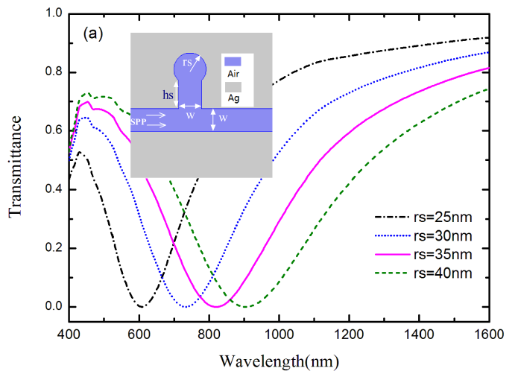
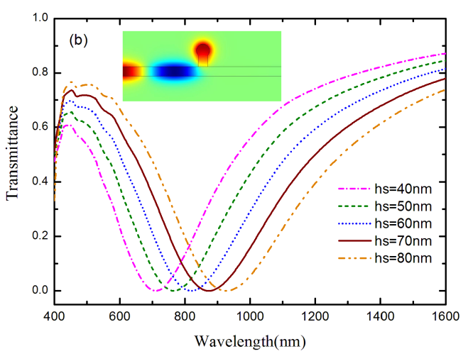
Fig.1. Transmission spectra of the plasmonic MDM waveguide side-coupled a bulb-like resonator with various radius of rs (a) and different stub height of hs (b), where the slit width is of W=50 nm, in (a) hs=60nm and rs=35nm in (b). The inset in Fig.1(a) is the schematic of the resonator, the inset in Fig.1(b) is the magnetic field distribution of the resonator system at the resonant wavelength λ=731nm.
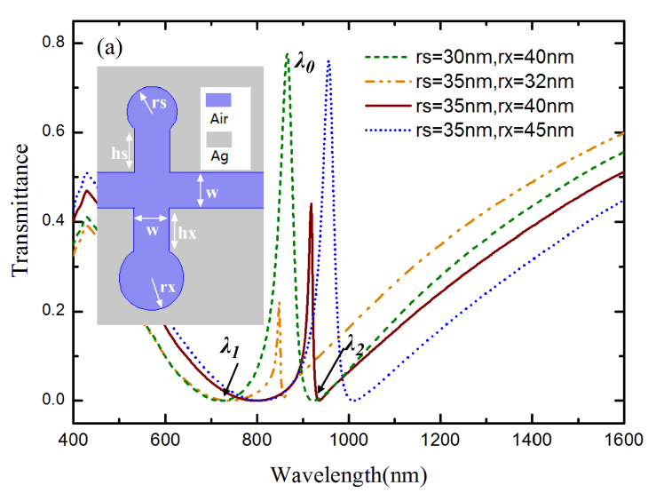
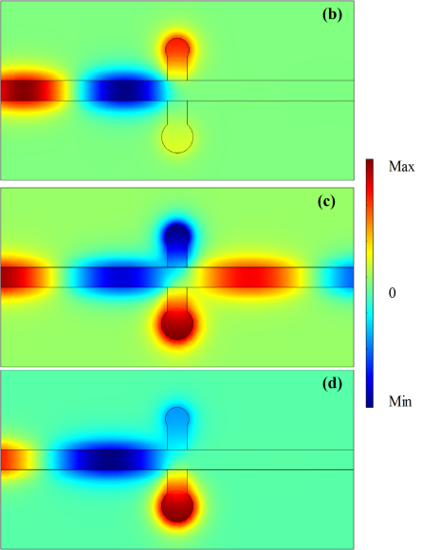

Fig.2. (a)Transmission spectra of the plasmonic MDM waveguide side-coupled with two different bulb-like resonantors at opposite side with different rs and rx, where the stub height hs=hx=60nm, (b)-(d) are the magnetic field distributions of the proposed system corresponding to the wavelengths of λ₁=720nm, λ₀=866nm, λ₂=923.5nm, respectively.
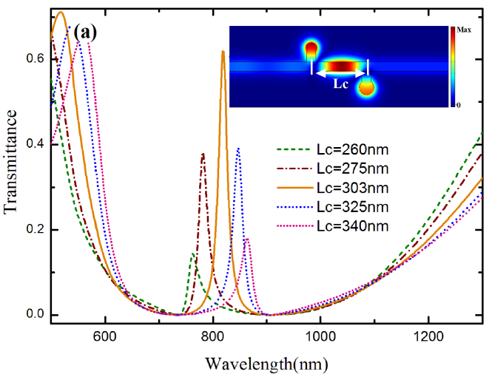
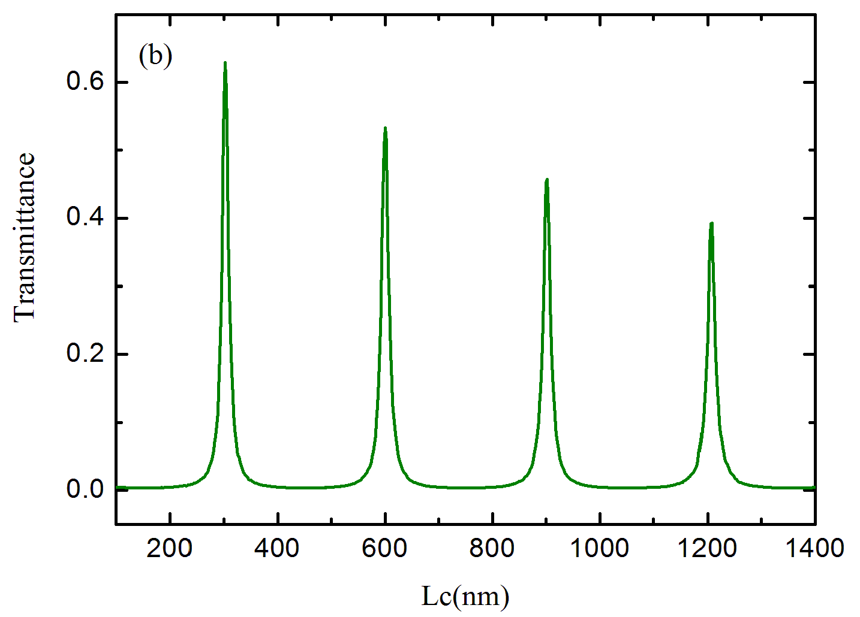

Fig. 3. (a) Transmission spectra of MDM waveguide side-coupled with two different bulb-like resonators at different inter spaces, Lc=260nm, 275nm, 303nm, 325nm and 340nm respectively, where W=50nm, hx=hs=60nm, rx=40nm, rs=30nm. The inset is the |Hz| distribution with L_{c}=303nm. (b) Transmission spectra versus L_{c} at λ₀=816.8nm.

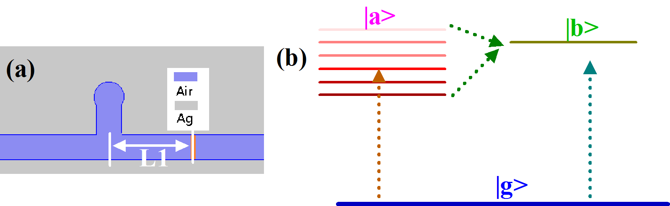
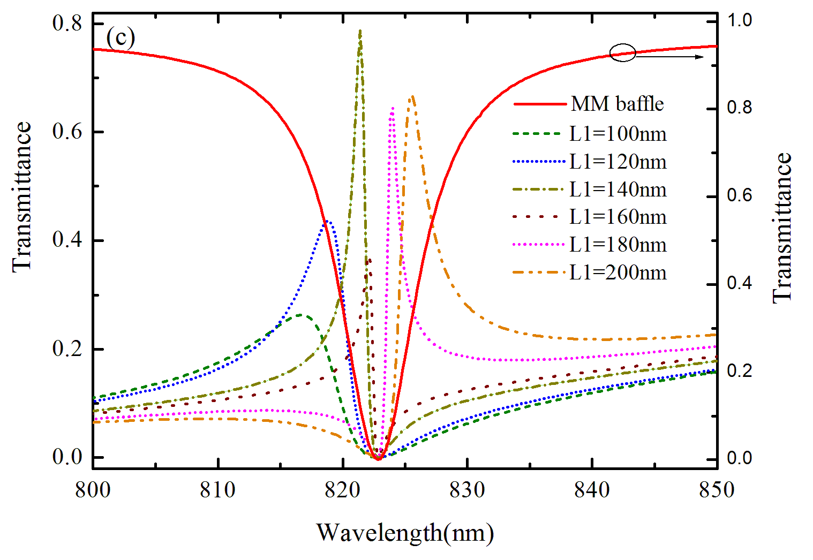

Fig.4. (a) Schematic of the proposed MDM plasmonic waveguide, which consists of one side-coupled bulb-like resonator and one MM baffle (orange area), where L1 is the distance between the resonator and the MM baffle. (b)Schematic illustration of the Fano resonance, the interference between a continuum |a> and a discrete state |b> results in the Fano resonance with asymmetric line shape. (c) The calculated transmittance of the plasmonic structure with different L1, L1=100nm, 120nm, 140nm, 160nm, 180nm, 200nm respectively, where the resonant property of the MM baffle resonator is also plotted (red solid line), which works as a discrete state |b> as shown in (b).

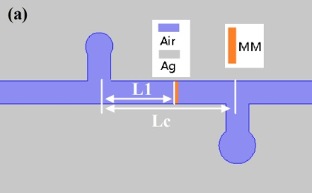
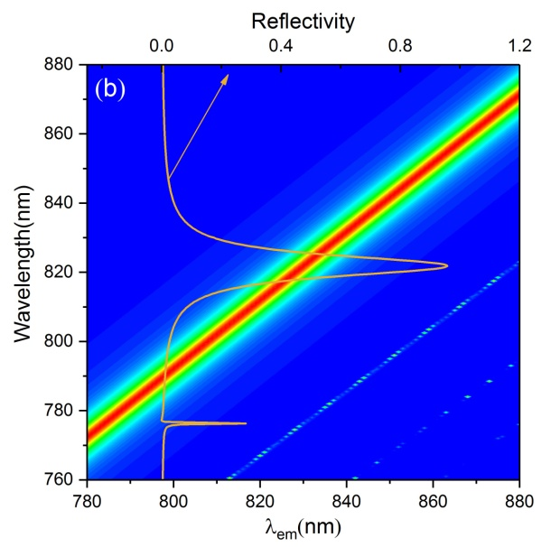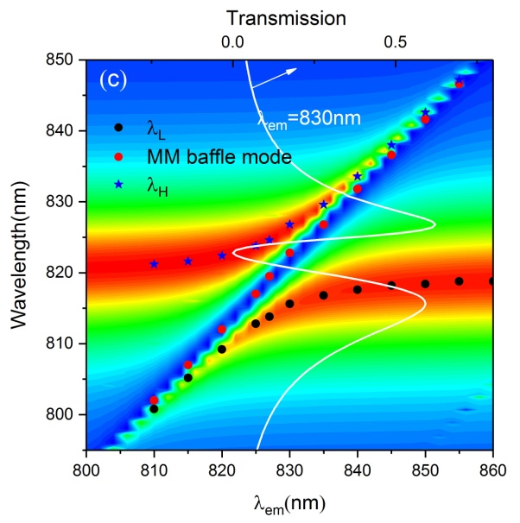

Fig.5. (a) Schematic of the proposed Rabi splitting MDM plasmonic waveguide structure, which consists of two bulb-like stub resonators and one MM baffle, where Lc=303nm, L1=150nm. (b) Dispersion relation (reflectivity plot vesus λ and λ_{em}) of the MM baffle resonator, one reflectivity spectrum (brown solid line) with λ_{em}=830nm is ploted for clarity. (c) Dispersion relation (transmission plot vesus λ and λ_{em}) of the left resonantor-MM baffle- right resonantor structures, the white solid line is one transmission spectrum, where λ_{em}=830nm, λ_{L} and λ_{H} represent the lower and upper peak wavelengths of the splitting modes, respectively. The blue and red corlor reprent the minmun and maxmum of the refelectivity or tansimission respectively.
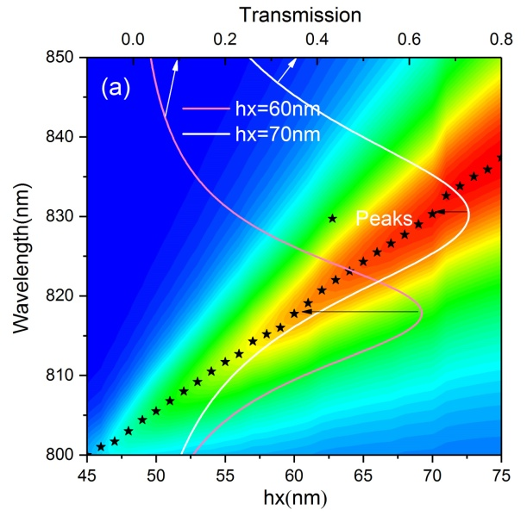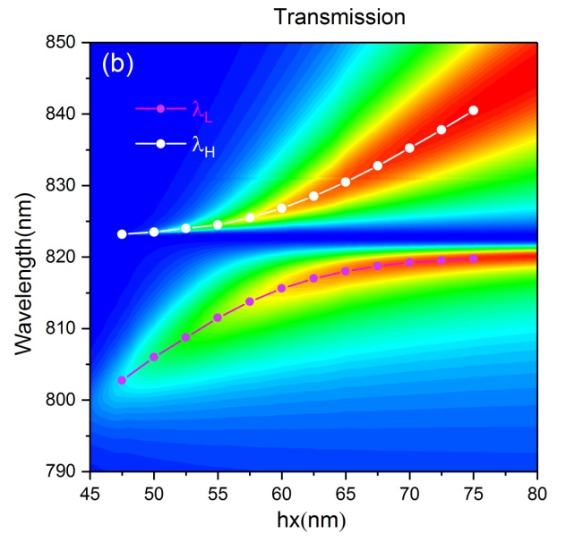
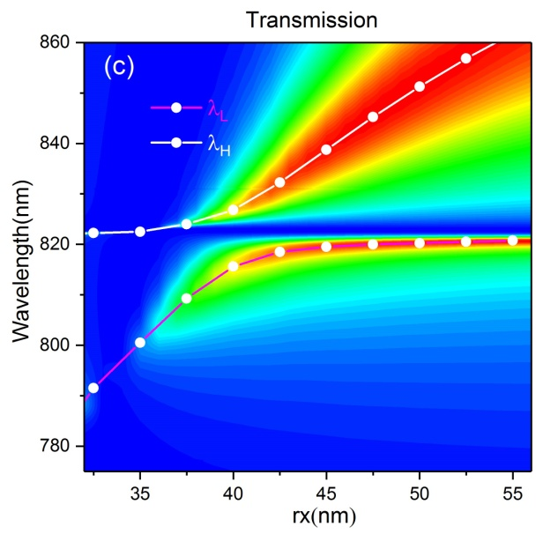
Fig. 6. (a)Dispersion relation (transmission plot vesus λ and hx) of the Fabry-Perot resonance, two solid lines represent the transmission spectra with hx=60nm, 70nm respectively. (b) The Transmission plots (vesus λ and hx) of the left resonantor-MM baffle-right resonantor structures. (c) The Transmission plots versus λ and rx, where λ_{L} and λ_{H} represent the lower and upper peak wavelengths of the splitting modes respectively.
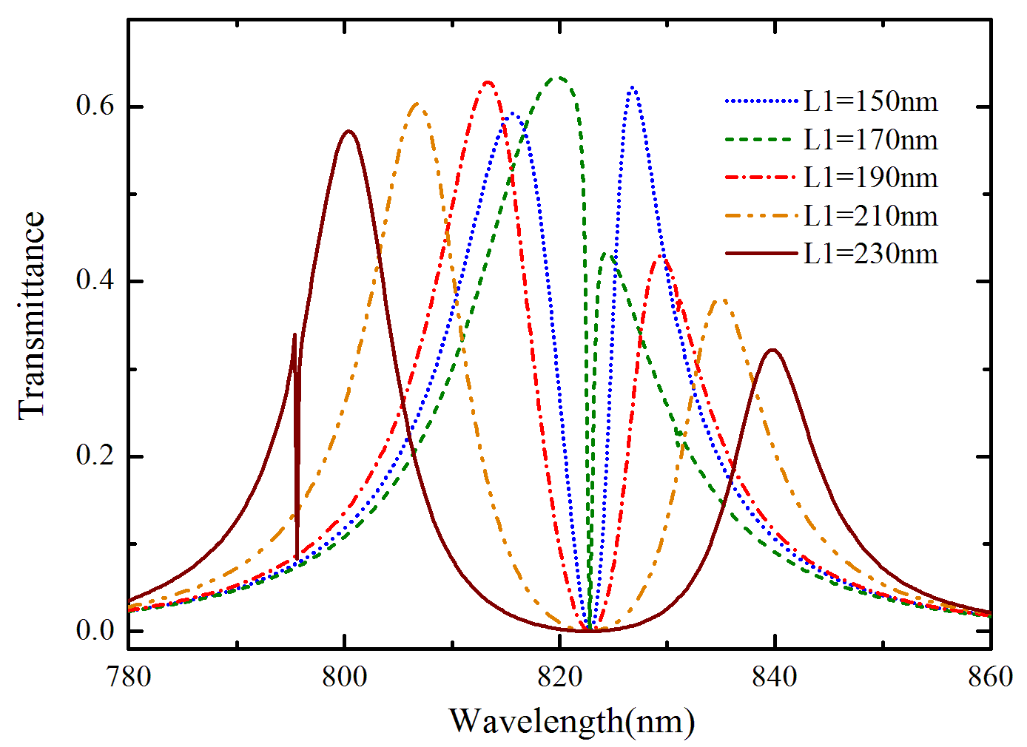
Fig. 7. Rabi splitting of the plasmonic waveguide with two bulb-like resonators and one MM baffle, where Lc=303nm, L1=150nm, 170nm, 190nm, 210nm, 230nm, respectively.

