Electric Vehicle Fast Charging Station Usage and Power Requirements

Thomas S. Brydenª*, George Hiltonª, Andrew Crudenª, Tim Holton^{b}
ª Department of Engineering and the Environment, University of Southampton, Southampton, SO14 1BJ, United Kingdom
^{b} Jaguar Land Rover Limited: Abbey Road, Whitley, Coventry, CV3 4LF, United Kingdom
* Corresponding author
E-mail addresses: t.s.bryden@soton.ac.uk (T.S. Bryden), g.hilton@soton.ac.uk (G. Hilton), a.j.cruden@soton.ac.uk (A. Cruden), tholton2@jaguarlandrover.com (T. Holton)
Keywords: Electric vehicle; Fast charging; Fast charging station; GPS data logger; Electricity demand
Highlights:
- Gasoline vehicle data is used to predict electric vehicle requirements.
- Fast charging station usage is predicted for different times of day, week and year.
- A fast charging station usage peak exists between 15:00 and 19:00 in the evening.
- Fast charging rates are determined that will satisfy drivers’ current habits.
- A charging rate of 20 miles/minute will satisfy 80% of long distance journeys.

Abstract
The anticipated usage and power requirements of future fast charging points is critical information for organisations planning the rollout of electric vehicle charging infrastructure. This paper presents two novel methods to assist in such planning, one method to predict the time of day fast charging points will be used and one method to estimate the fast charging power required to satisfy electric vehicle driver requirements. The methods involve taking data from instrumented gasoline vehicles and assuming that all the journeys are instead conducted using full battery electric vehicles. The methods can be applied to any dataset of gasoline vehicle journeys that have key data, namely journey start and end times and distance travelled. The methods are demonstrated using a dataset from the United States. It is predicted that for long distance journeys, when the electric vehicle range is exceeded, fast charging point usage will peak in the evening, with 45% of daily fast charges occurring between the hours of 3pm and 7pm. It is also estimated that to satisfy 80% of long distance journeys a charging rate of 20 miles/minute is required, equating to a charging power of 400kW assuming the electric vehicles achieve a driving efficiency of 3 miles/kWh.

Introduction
Electric Vehicles (EVs) can play an important role in efforts to combat climate change as well as providing health benefits to the population by reducing air pollution, particularly in urban areas. It is estimated that transport accounts for 24% of CO₂ emissions [1] and road transport accounts for three quarters of these emissions, meaning the use of EVs could significantly reduce CO₂ emissions. It is also estimated that outdoor air pollution causes 3.7 million deaths worldwide annually [2], where vehicular transport is a major source of this outdoor air pollution, meaning the use of EVs could prevent many deaths each year.
Despite these emission reduction advantages EVs are currently only a small proportion of the number of vehicles on the road, around 0.9% in the USA and 1.4% in the UK in 2016 [3]. Primary concerns of consumers preventing the sales of more EVs include the limited driving range, the length of time to recharge the battery, the high cost of the vehicle and safety concerns [4]. Automakers are however working to overcome these issues and most have plans to sell significant numbers of EVs in the future, with the International Energy Agency (IEA) predicting anywhere from 40 million to 70 million EVs on the road globally in 2025, compared to 2 million EVs in 2016 [3].
Along with these primary concerns regarding the vehicle technology, secondary concerns relate to the lack of charging infrastructure, both local and long distance. Local charging infrastructure generally refers to slow charging, up to 22 kW [5], which may occur when the EV is parked for long durations, such as at home or at work. Long distance charging infrastructure generally refers to fast charging points, over 22 kW, which can recharge EVs quickly during long distance journeys, defined here as journeys where the EV range is exceeded. In 2016 there were 210,000 public slow chargers and 110,000 public fast chargers installed in the world [3]. The focus of this study is on public fast chargers.
At the time of writing, the fastest charging EVs are the Tesla Model S and Model X, which can be charged at up to 120 kW [6]. The majority of fast chargers installed worldwide are currently limited to 50 kW, however several projects have recently been announced to install fast charging points up to 350 kW [7]. There are currently no EVs capable of accepting a 350 kW charge. These stated powers are the maximum charging power, which can only be delivered to the EV for a short period when the EV battery is at low state of charge and the charging rate slows the longer the EV is connected to the fast charging point. These charging powers can be converted to a miles per minute rate depending on how efficient the EV is at converting stored energy into movement. This value depends on the EV, for example for the large Tesla Model X SUV the figure is 3.4 miles/kWh [8] while for the smaller BMW i3 the value is 5.2 miles/kWh [9].

Fast Charging Point Usage
The first part of this paper presents a method to estimate how many fast charge events will be required in the future for a given number of EVs and at what time of day, week and year these fast charges are more likely to occur. Knowing the frequency of fast charges will be useful for organisations planning how many fast charging points are required in the future, and for electricity grid operators to understand when the electricity demand from a fast charging point will tend to peak.

Number of fast charges
Knowing how many fast charging points are required and ensuring there are sufficient fast charging points are essential to assist with the uptake of EVs by allaying users concerns over driving range anxiety. If too few fast charging points are installed, queues will develop at fast charging points and the EV drivers will worry there will not be a fast charging point when they need to charge their EV. These issues increase the ‘range anxiety’ an EV driver may feel and mean consumers are less likely to purchase an EV in the first place [10].
The IEA has predicted the number of fast charging points required in the future using historical ratios between the number of EVs on the road and the number of fast charging points [11]. There is however high variability in this historical ratio and so the IEA assessment takes into account wide uncertainty margins. A second issue with this analysis is that it does not consider EV range improvements in the future, which are likely to occur through the use of larger batteries. Higher EV driving ranges will mean EV drivers will have to stop at fast charging points less often as more of their journeys could be completed without recharging on route. The research in this paper uses current driving habits to predict how many fast charges will be required in the future. These results could be used along with the IEA ratio method to plan how many fast charging points will be required in the future.
As well as the number of fast charging points, the exact location of fast charging points is important. Ref. [12] suggested a method for optimising the placement of fast charging points based on current electricity distribution network and charging station setup costs. Ref. [13] proposes a method of discretising the road network and then generating EV drive routes to optimally place the fast charging points. The methods presented in this research paper could be used as inputs to similar future studies looking at where to locate fast charging points.

Variation by time of day, week and year
The demand variation for a fast charging point by time of day, week and year can help with the planning of fast charging points as the number of fast charging points can be designed to cope with the peak demand. A second group who will be interested in knowing how fast charging point usage varies are the electricity grid operators. Currently there is little storage available on electricity grids and so electricity must be generated at the same rate it is demanded [14]. Demand for electricity is not constant throughout the day, week and year and generally peaks on weekday evenings as people arrive home from work. When demand is highest, additional gas power stations are brought online [15] and the price of electricity increases, hence reliable forecasting of the time when electricity demand from fast charging points will peak will assist the grid operators to know how much further generation capacity will be required.
EV charging infrastructure and its impact on the electricity grid are topics currently gaining much research interest due to the predicted increase in EVs on the road. On a local level, Ref. [16] found that, depending on the level of EV penetration, overloading of local transformers is a possibility if EV owners charge their EVs without control. Using charging control algorithms where charging is delayed was found to mitigate these issues. In Ref. [17] the impact of EV charging on two power distribution transformers was assessed and it was found that only relatively high levels of EV penetration would have an impact on the life of the transformers. In Ref. [18] smart charging was investigated and electricity grid benefits were found from shifting peak levels of electricity demand from EV charging, this however will not be applicable to fast chargers as when an EV driver arrives at a fast charging point the charging power will be needed instantly.
The grid challenges associated with fast charging are that the grid connection power may not be sufficient to provide the required power for fast charging. In Ref. [19] flow battery energy storage, utilising existing gasoline tanks, was suggested as a local stationary energy storage to buffer the energy between the grid and EV. The methods and results described in this paper could provide information to help in the sizing of the stationary energy storage.
Although previous studies have predicted the variation in demand at fast charging points throughout the day, the research focus of these studies is often not the fast charging point usage itself. Ref. [20] predicted fast charging point usage based on the number of cars on the road. Ref. [21] based the usage on the current usage of gas stations. Both of these studies do not take into account that most EVs will utilise overnight slow charging and as such a usage peak was predicted in the morning and evening when there are most vehicles on the road, the method proposed in this paper improves upon these methods by including overnight slow charging. Ref. [22] used a questionnaire to estimate the charging time, the method proposed in this paper has the advantage over the questionnaire method that actual driving data is used. Ref. [23] predicted the demand based on commuters using the fast charging station, however it is thought unlikely people would want to use a fast charging station everyday on the way to or from work. Ref. [24] based the demand on people forgetting to charge their EV overnight and hence using fast charging points in the morning. Importantly, these studies do not take into account long distance journeys, which is the focus of this paper, and all the studies also assume low EV battery capacities, between 10 and 54 kWh, despite the fact that some low cost EVs will soon have battery capacities over 60 kWh. Ref. [25] showed the high importance to the customer of being able to drive occasional long distance journeys, to avoid dissatisfaction with their EV purchase.
The studies mentioned above use the fast charging point daily usage profile as an input to investigate the impact on the electricity grid and it is therefore envisaged that the results presented in this paper using the methods suggested will provide a more accurate assessment of daily fast charging point usage that can be used by similar future studies. The method adopted in this paper is novel as the fast charging point usage is predicted based on current driving habits, regular slow charging is taken into account, larger EV battery capacities are assumed and this paper looks solely at long distance journeys.

Fast Charging Point Power Requirements
The second part of this paper outlines a method to determine the power requirements of the fast charging point. This information is critical to organisations installing fast charging points to ensure the fast charging point is future proof, meaning it does not have to be regularly replaced as charging powers increase, and also critical for automakers, informing them of the charging powers that EVs should be able to achieve to satisfy consumer requirements. Currently this may be dictated by charging standards. The two most important fast charging standards outside China are the Combined Charging System (CCS) and CHAdeMO standards. The majority of fast chargers installed currently are 50 kW, however both the aforementioned standards have stated their intention to support 350kW charging in the future [7]. 350kW charging is chosen based on the technical specifications, such as voltage and current equipment limits, rather than what potential EV owners require. The method suggested in this paper, instead of looking at how fast the charging can technically be, looks at the problem from a different angle, how fast might people want the charging to be.
For example the electrical power required for an EV charging rate to be equivalent to that of a gasoline vehicle refilling at a petrol station has been determined as around 5MW [26]. EV drivers may accept slower refill times as they may have to visit fast charging points less than they currently visit gas stations since the majority of their charging will be conducted at home or work. This is because on the majority of days the daily distance travelled in a car does not exceed the range of the EV, Swedish and German data showed the average daily distance travelled to be less than 35 miles [27]. When charging an EV, EV drivers are also free to do other activities whereas at a gas station they must operate the gas pump. As stated previously, despite these advantages, recharging time is still seen as a major hurdle to overcome before the widespread consumer adoption of EVs.
The United States Advanced Battery Consortium (USABC) [28] creates battery targets required for a commercially successful, mass market full battery EV. The USABC target for fast charging is 80% state of charge to be delivered in 15 minutes [29]. For a 100 kWh EV this is equal to a charging rate of 320 kW or, assuming the EV achieves 3 miles/kWh, a charging rate of 16 miles/min. This is a similar rate to a recent target set by the White House to achieve 350 kW charging [30]. In both examples the reasons for choosing the charging targets are not clear, the method suggested in this paper can be used as an alternative means of setting charging targets. Since this method is based on real world driver behaviour is may be applied to markets with very different traveller needs to those of the USA, for example in Asian mega cities or in European conurbations.
The method suggested in this paper looks at current driving habits to determine the charging rate required to enable EV drivers to complete their long distance journeys in the same time that they currently do in gasoline vehicles. From GPS journey data, long distance journeys are identified, the duration of inter journey stops and the distance travelled after the stop are examined to determine the required charging power to satisfy a journey.
Ref [26] also looked at how much range an EV needs to satisfy current driving habits. This study states the number of daily adaptations drivers would have to accept to meet their driving habits depending on the assumed range of the EV. An adaptation day is a day on which the driver would have to do something different to what they normally do, such as rent a vehicle capable of driving long distances or take longer over their journey, charging their EV along the way. These adaptations could potentially be avoided if fast charging were available, meaning the driver could complete the journey in an EV in the same time as in a gasoline vehicle. This paper examines current driving habits to define a fast charging rate that avoids driver adaptations.

Methodology
Two novel methods are introduced in this section to predict the future time of day usage of fast charging stations and to predict the fast charging power required to satisfy consumer requirements. The methods involve the input of GPS data from existing instrumented gasoline vehicles, the required data includes: start and end date and time of the trips, the distance travelled for each trip and whether the trip begins or ends at home or at work, some sample data from one car for three days can be seen in Table 1.
Vehicle Identifier | Trip start | Trip end | Distance travelled (miles) | Does the trip end at home or work?
311 | 21/08/2005 06:51 | 21/08/2005 07:03 | 3.078272885 | no
311 | 21/08/2005 08:43 | 21/08/2005 09:38 | 25.67754314 | no
311 | 21/08/2005 11:58 | 21/08/2005 12:05 | 1.951105543 | no
311 | 21/08/2005 13:43 | 21/08/2005 14:12 | 24.44847092 | no
311 | 21/08/2005 14:16 | 21/08/2005 17:02 | 178.1172949 | no
311 | 21/08/2005 17:06 | 21/08/2005 18:21 | 80.26313824 | no
311 | 21/08/2005 19:00 | 21/08/2005 22:34 | 233.3845342 | yes
311 | 22/08/2005 06:44 | 22/08/2005 07:05 | 9.648030498 | yes
311 | 22/08/2005 10:41 | 22/08/2005 10:50 | 4.312316072 | no
311 | 22/08/2005 10:56 | 22/08/2005 11:09 | 4.230295075 | no
311 | 22/08/2005 12:31 | 22/08/2005 12:40 | 4.23278056 | yes
311 | 22/08/2005 15:55 | 22/08/2005 16:18 | 9.681584543 | yes
Table 1 Required data format for models, this table shows 12 trips while the whole study consists of over 750,000 trips
One aspect missing from the data is the exact location, for example was the journey conducted on a small road or a motorway. The use of location data could improve the accuracy of the study by providing additional confidence that the driver of the vehicle was on a long distance journey. This data however is not commonly available due to privacy constraints and so is not used for these methods.
The main assumptions are that all gasoline cars will be replaced with pure battery EVs and that people will continue to make the same journeys in EVs as they currently do in gasoline cars. The methods subsequently use this historical gasoline driving data to predict fast charging point usage and charger power ratings assuming all the trips are conducted in such EVs.
The use of cars is likely to change significantly in the future, with connectivity, autonomous driving, shared ownership as well as the growing number of EVs likely to change driving patterns. Attempting to consider all these aspects in models predicting future driving patterns will undoubtedly result in inaccuracies and so, similarly to other studies [31], the assumption that people will continue to make the same journeys in the EVs as they currently do in gasoline cars is made. This assumption is taken because people will still need to go from one location to another at a certain time. The assumption that all gasoline cars will be replaced by EVs is applicable for a time in the far future however also represents a worst case scenario. The first gasoline cars to be replaced by EVs are likely to be cars that go on fewer long distance journeys, therefore in the intermediate years between the present and a time when all gasoline cars are replaced by EVs the method will produce a conservative estimate for the number of fast charges required. However, it is also likely that geo-fenced regions will become fully electrified in the near future, and the methods provided here will be applicable in those markets. In this regard the methods will be useful for both the designers of infrastructure and the designers of EVs.

Method to predict fast charging station point usage
Initially the method to predict fast charging point usage is described. It is assumed that a slow charge to a fully charged state will occur whenever the car is at home or work or whenever the car is parked for more than 8 hours. This assumption is made as the analysis is regarding the future when there are significantly more EVs on the road and as such slow chargers, to charge EVs when stopping for long periods or at home or work, will be common. It is further assumed that after a vehicle has been driven greater than an assumed distance after a slow charge a fast charge is required, this assumed distance is varied throughout the analysis.
The assumed distance, hereafter referred to as driving range, is not the automaker’s advertised EV range but the distance that the EV driver will drive before requiring a fast charge. This distance is equal to the range of the EV minus the buffer energy in the EV battery that the driver leaves to feel comfortable that their EV will not run out of energy. For analyses later in this section 200 miles is taken as a base case for the driving range. Many affordable EVs being released now have ranges of over 200 miles, for example the Chevrolet Bolt, 238 miles $37,495 [32], and the Tesla Model 3, 215 miles $35,000 [33]. Although it is unlikely drivers of these EVs would be comfortable driving 200 miles between charges the trend for larger battery capacities and greater ranges is clear so 200 miles is a reasonable assumption for the future driving distance between charges.
To estimate the fast charging station usage variation throughout the day it is assumed that the fast charge occurs once the EV has driven the assumed driving range after a slow charge, when it is assumed the EV will be fully charged. The average speed during the trip is used to determine the time of day that the fast charge occurs (FC_{time}), as seen in Equation 1 this is calculated using the trip start (t_{s}) and end time (t_{e}), the assumed driving range (d_{r}), the length of the trip (d_{t}) and the cumulative distance travelled since the previous slow charge (d_{c}). An example is shown in Figure 1, where the driving range has been assumed to be 200 miles, where two fast charges are required in the day shown, one at around 4:30pm and one at around 8pm.
$$if d_{c}>d_{r}:{ FC}_{time}=t_{s}+\left(t_{e}-t_{s}\right)\frac{d_{c}-d_{r}}{d_{t}}$$
Equation 1
One issue with this strategy for fast charge analysis is that with use of detailed journey planners, EV drivers may know how many fast charges are required for a journey and so may not always drive their maximum distance before using a fast charging point. For example, assuming a 200 mile driving range and a 300 mile journey, the driver would know one fast charge is required and so may use a fast charging point 150 miles into the 300 mile journey, while for this case the model would assume the fast charge occurred after 200 miles. However, as more fast charging points are installed the EV driver will have more options of charge locations and so it is likely that the driver would want to go as far as possible before recharging. If the EV driver uses the fast charging point earlier in their trip it will not affect the number of fast charges required per day but may move the fast charge point usage peak slightly earlier in the day.
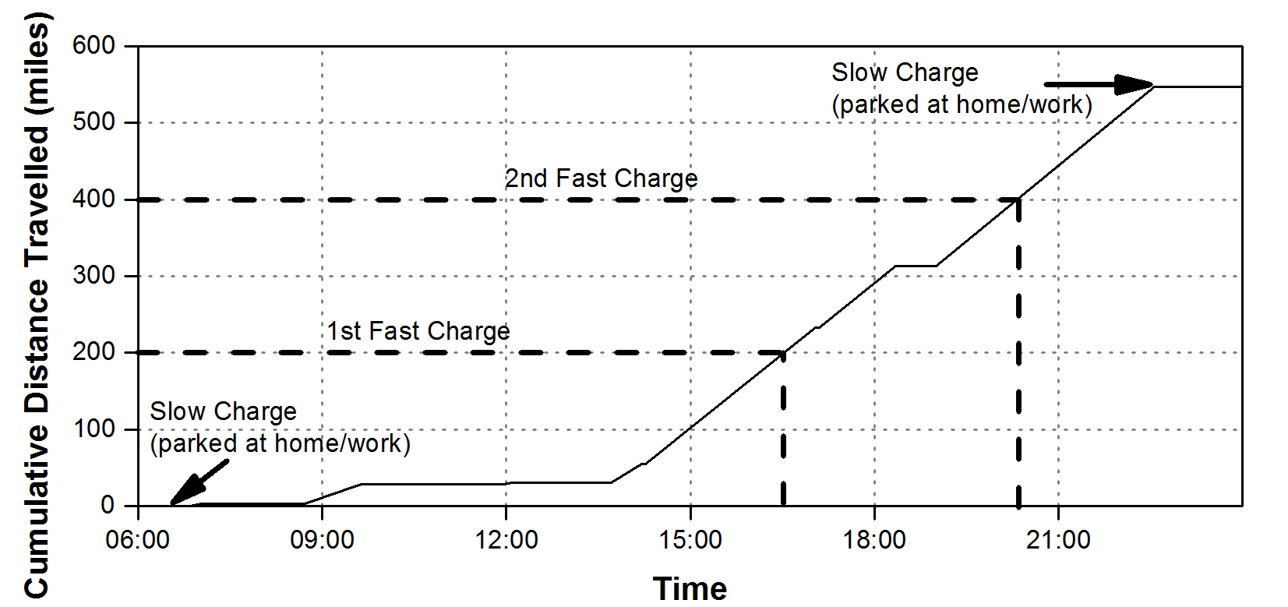
Figure 1 – Example of assumed fast charge usage during daily driving

Method to predict required charging power
This section describes the method to determine the fast charging rate required to satisfy consumer requirements, by considering the length of time drivers stop while on long distance journeys. As the GPS locations of the journeys are not known, long distance journeys are found in the data by finding instances where the car travels a long time (t₁), stops for a short time (t_{b}) not at home or work and then drives again for a further long time (t₂), in consecutive trips, as seen in Table 2.
Description | Constraint
Trip 1 | > t₁
Stationary period between trip 1 and 2 | < t_{b} not at home or work
Trip 2 | > t₂
Table 2 Constraints for data, all three conditions must be met in consecutive journeys
These constraints are designed to capture long distance journeys made by the gasoline vehicles. The stationary period in between the two trips signifies a break the driver may take during a long distance journey. This break may be at a service station where, if the driver was driving an EV, they could recharge their vehicle. The stopping time is therefore the length of time that a fast charger could be connected to the EV. The distance travelled after the stop in trip 2 dictates how much energy needs to be transferred to the EV during the stop.
The distance travelled in trip 2 (d₂) can then be divided by the stopping time (t_{b}) to determine the charging rate (FC_{rate}) in miles per minute that needs to be applied to the EV during the stop to satisfy the trip, seen in Equation 2.
$${FC}_{rate}=\frac{d_{2}}{t_{b}}$$
Equation 2
Under these assumptions the driver may in fact not be stopping at a service station while on a long journey because the exact location of the stop is not known. The method could be improved if exact GPS data was available and it could be confirmed that the driver was stopping at a service station during a long distance journey. As stated above, for many GPS surveys the exact location is not available due to privacy constraints and so the assumptions proposed here give the best guess as to when the driver is stopping during a long distance journey. The duration of the trips before and after the stop can be varied, if shorter journeys are included there are more instances of long distance stops in the data but there is less confidence that the driver is on a long distance journey, while for longer trip durations the opposite is true. In the results section values of 1.5 hours, 1 hour and 1.5 hours are chosen for t₁, t_{b} and t₂ respectively.

Results
The methods described are demonstrated using data from the Puget Sound Regional Council 2004-2006 Traffic Choices Study [34]. The data is freely available from the National Renewable Energy Laboratory (NREL) Transportation Secure Data Center website [35]. Although the dataset is from 2004-2006 the data is for gasoline powered vehicles and so remains relevant as driving habits have not changed drastically since 2004-2006 and it is assumed that people would conduct the same number of long distance journeys by car today as they would have done in 2004-2006.
The Puget Sound region is in Washington State, USA and includes the city of Seattle. The data was collected by placing GPS data loggers in gasoline cars and recording all trips. The data involves 750,000 individual trips made by about 275 different households using a range of vehicles. This data was chosen over other GPS surveys as each car in the Puget Sound study was recorded for a long duration, an average of approximately 18 months.
The exact location of the start and end of each trip was not made available due to privacy constraints, however notable data available for each trip includes the start and end date and duration of the trip, the distance travelled for each trip, the vehicle identifier and whether the trip begins or ends at home or at work. An example of the distance travelled each day for one vehicle in the study for one year is shown in Figure 2.
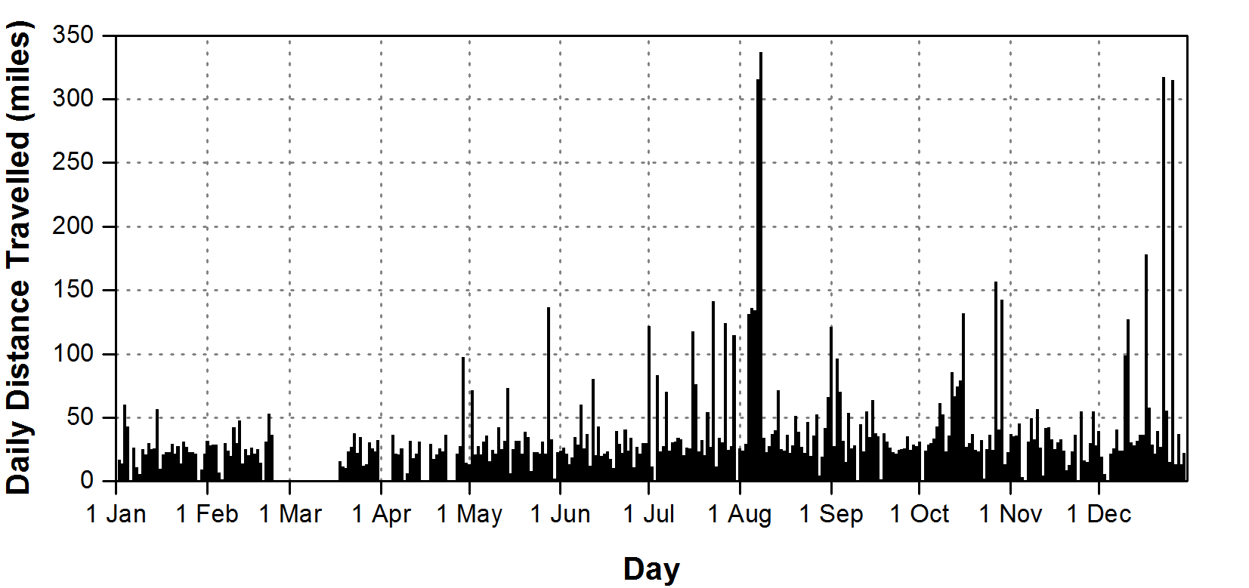
Figure 2 – Daily distance travelled for a single car from the Puget Sound study

Fast Charging Point Usage Results
Using the method described in Section ‎2.1 the average number of fast charges per day versus driving range is shown in Figure 3, where the results have been scaled to convert the outputs to values for one million vehicles. The curve in Figure 3 has been created by counting all instances in the data where the vehicle travels over the driving range between stops of greater than 8 hours or stops at home or work. For the case described above where the driving range of EVs is 200 miles, it can be seen that 5,000 fast charges per million EVs will be required each day. It should be noted that these results will vary depending on the user population and the results displayed in Figure 3 are specific to the participants of the Puget Sound survey. As can be seen in Figure 3, as the range of EVs increases the number of fast charges decreases.
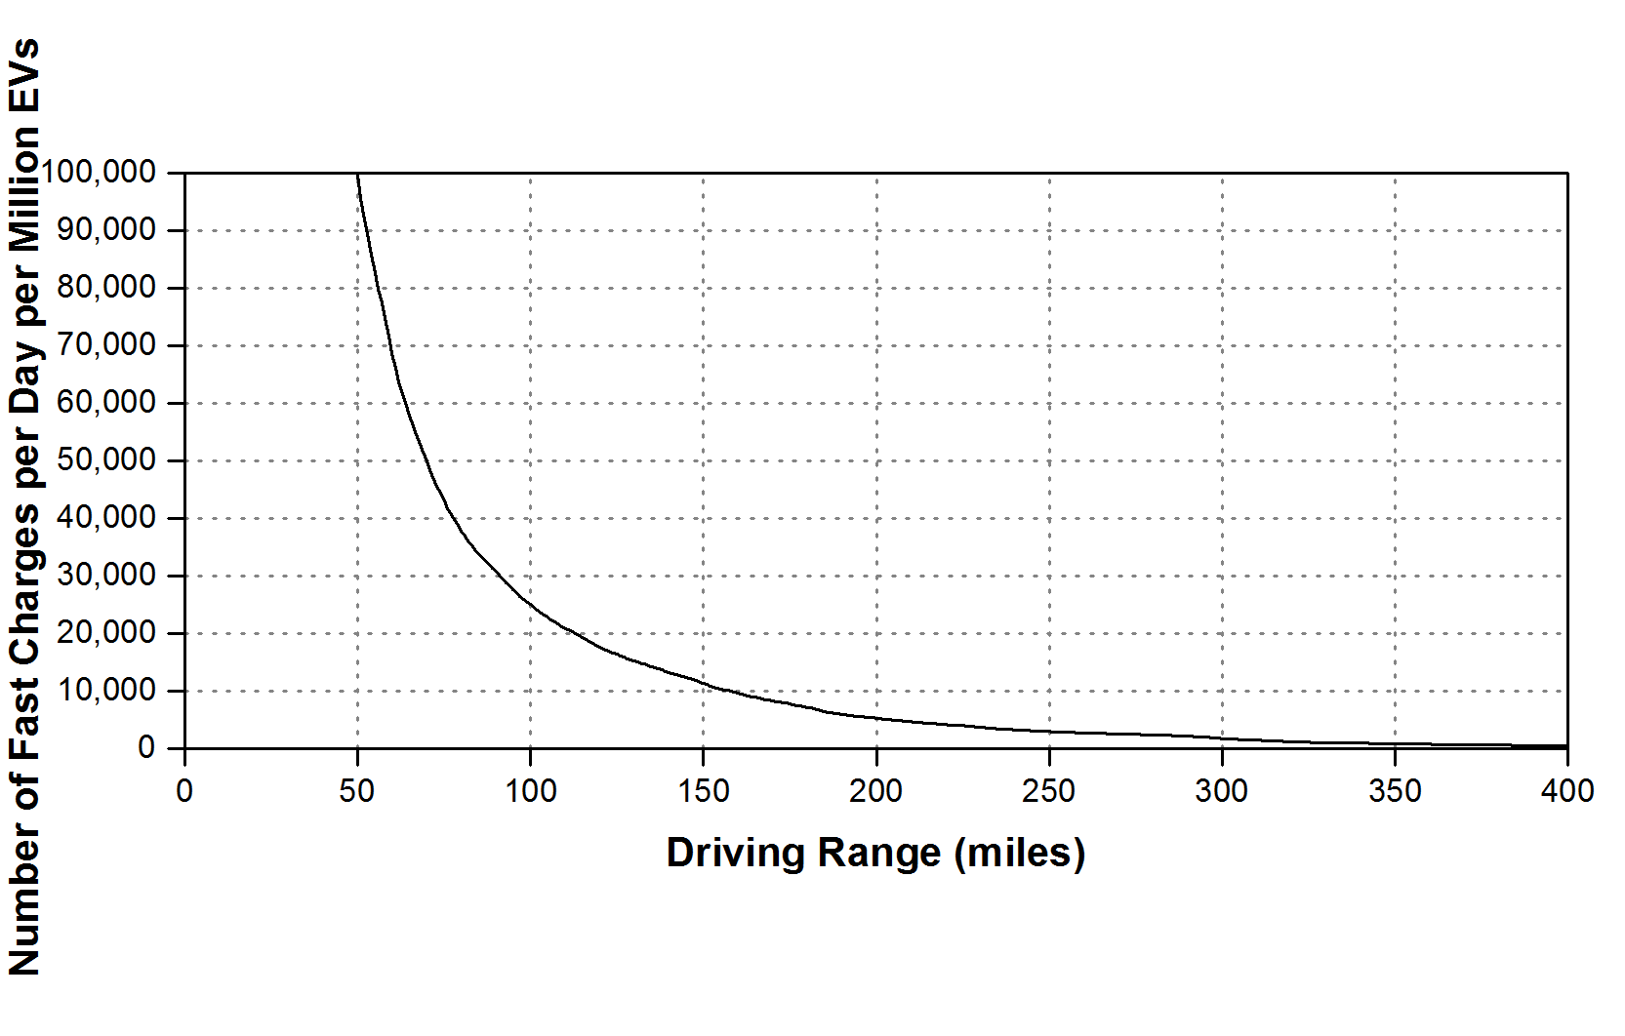
Figure 3 – Number of fast charges required per day for various assumed EV driving ranges
The results displayed in Figure 3 are the average number of fast charging point uses per day but the fast charging point usage will itself vary throughout the course of a day. By assuming a driving range (d_{r}) of 200 miles and using Equation 1 the average predicted time of use of fast charging points throughout a day is shown in Figure 4.
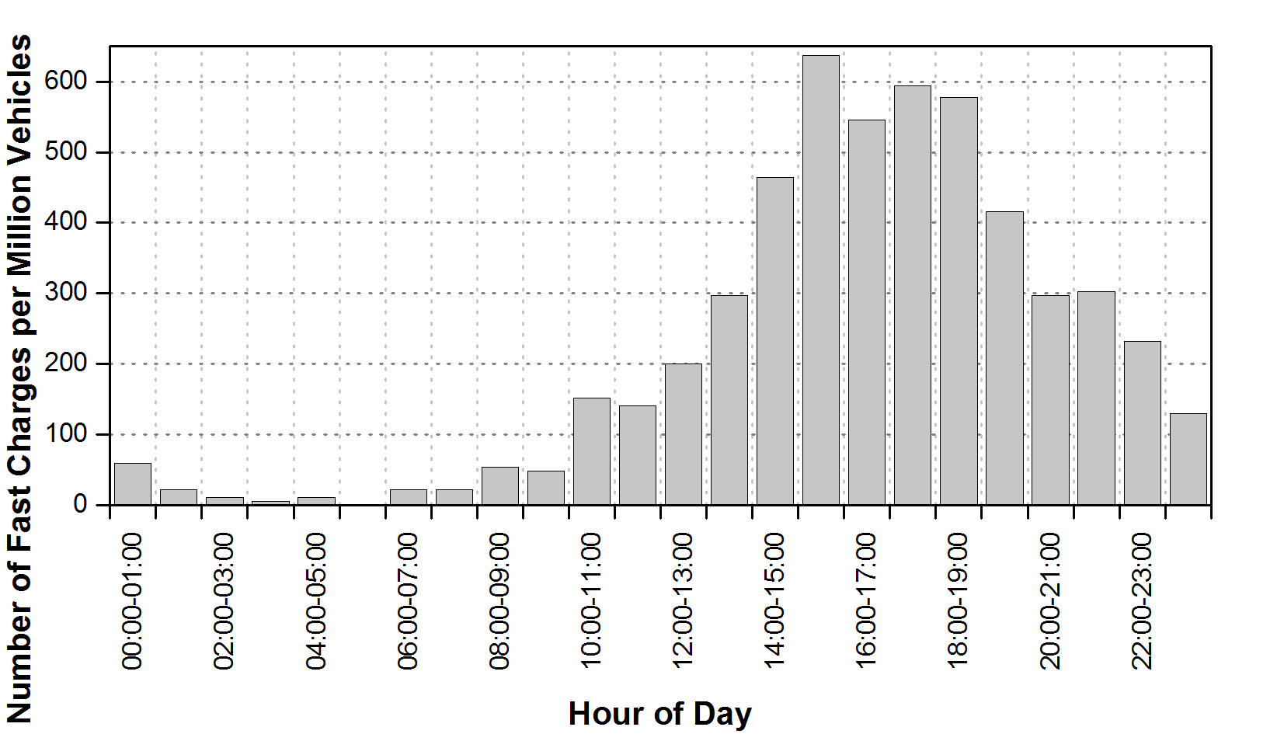
Figure 4 – Time of day variation in number of fast charges, averaged over the study period
From Figure 3, a lower EV driving range means more fast charges are required. The effect of varying the driving range between 150 and 300 miles was therefore investigated, the results are shown in Figure 5. Figure 5b has been normalised by converting the number of fast charges per hour into a probability that the fast charge will occur within that hour. The results show the shape of the distribution is similar for all three cases, giving confidence that even though the number of fast charges may vary, the shape of the distribution will be the same. It can be seen that the results predict that fast charging stations will be used less in the night and morning and more in the afternoon and evening.
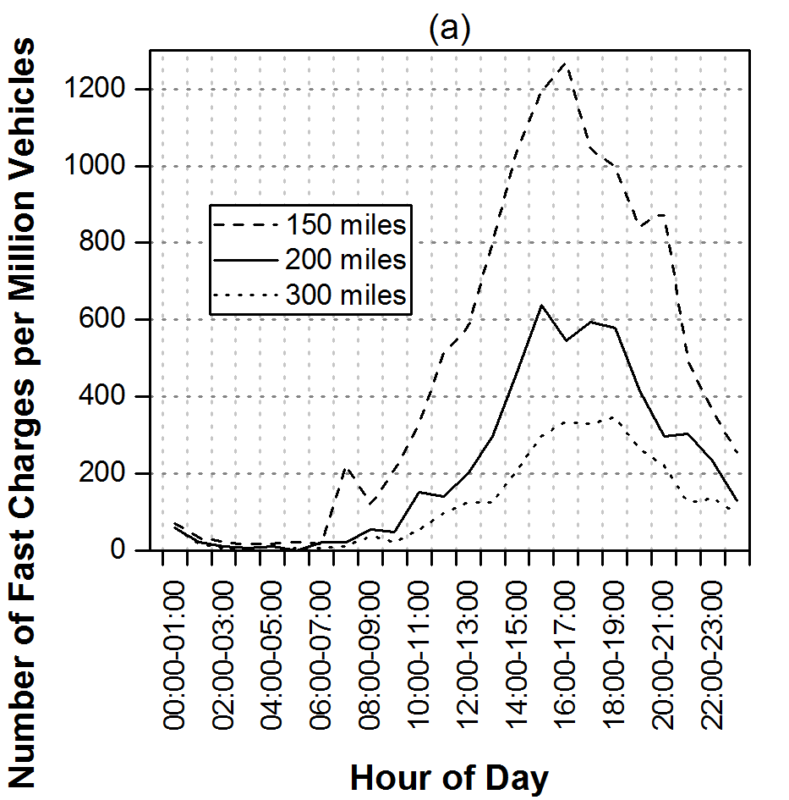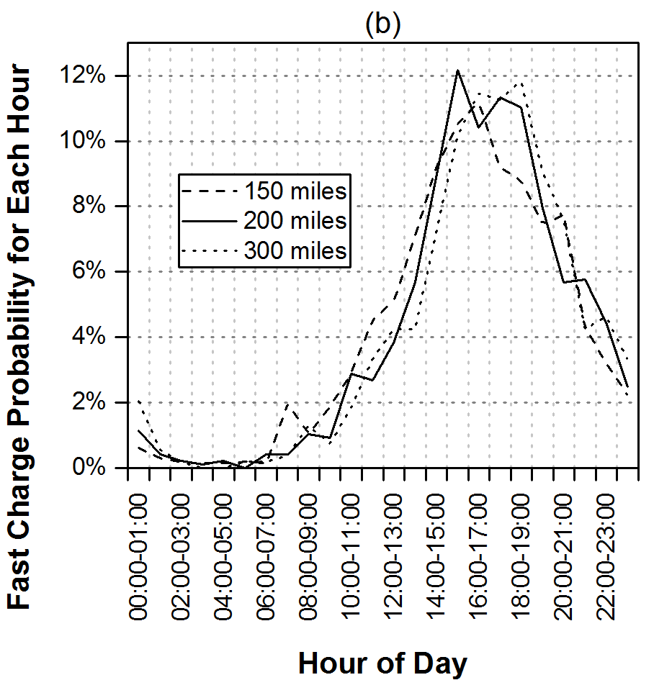
Figure 5 – Sensitivity study varying the driving range between 150 and 300 miles, absolute results (left) and normalised results (right)
As well as a time of day variation, the variation by day of week has also been investigated. Figure 6 shows the variation of number of fast charges by day of week on the left and also the same plot as Figure 4 for a Sunday, the day when most fast charges are required, on the right. It makes sense for usage to peak over the weekend with people travelling longer distances to get away for the weekend. It is clear from Figure 6b that for the assumed conditions fast charging point usage peaks at 1,400 fast charges per hour per million EVs.
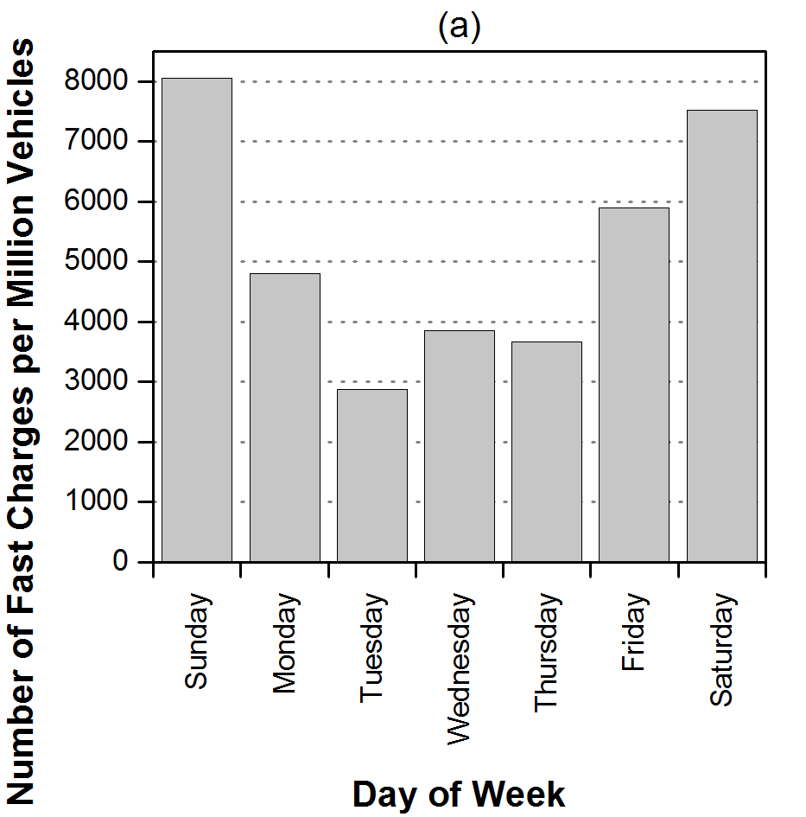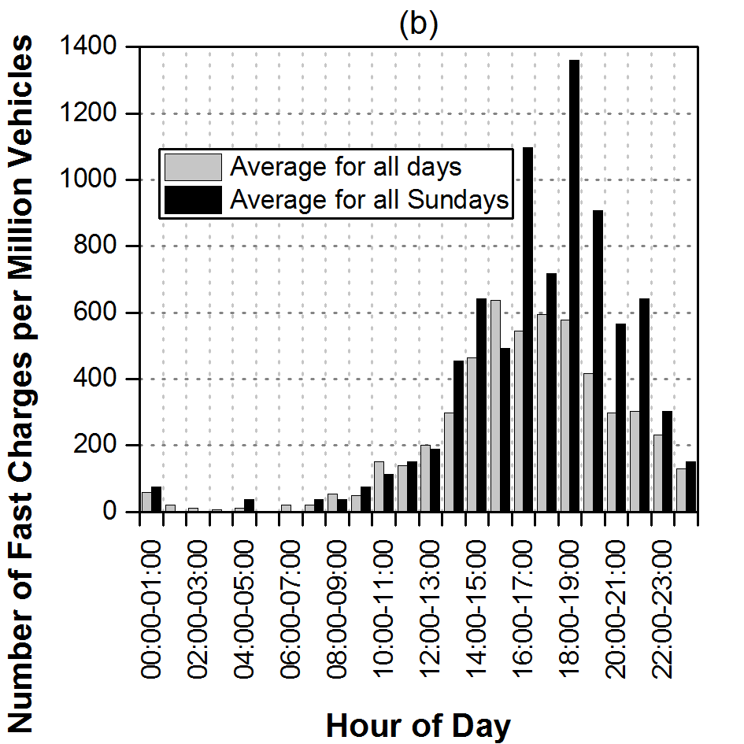
Figure 6 – Day of week variation in number of fast charges (left) and fast charges by time of day on Sundays (right)
To estimate the required number of fast charging points, a basic assumption could assume that 1,400 fast charging points are required per million EVs, as per the maximum value from Figure 6b. This assumes that a fast charging point only charges 1 EV per hour, though it is likely that in the future multiple EVs could be charged per hour there would also need to be additional fast charging points to avoid queuing.
When designing a fast charging point, the usage should be designed to cope with the worst case scenario, which is the period around Christmas or Thanksgiving in the USA when the highest number of long distance journeys are conducted. The predicted fast charging point usage around Christmas and Thanksgiving is shown in Figure 7. From the data available there are not enough instances of fast charges being required around holidays to draw definitive conclusions, with only 29 and 53 fast charges required over the one Thanksgiving week and two Christmas weeks respectively. It does however make sense that more long distance journeys would be made around holidays and so when deciding the number of fast charging points to be installed holiday periods should be considered.
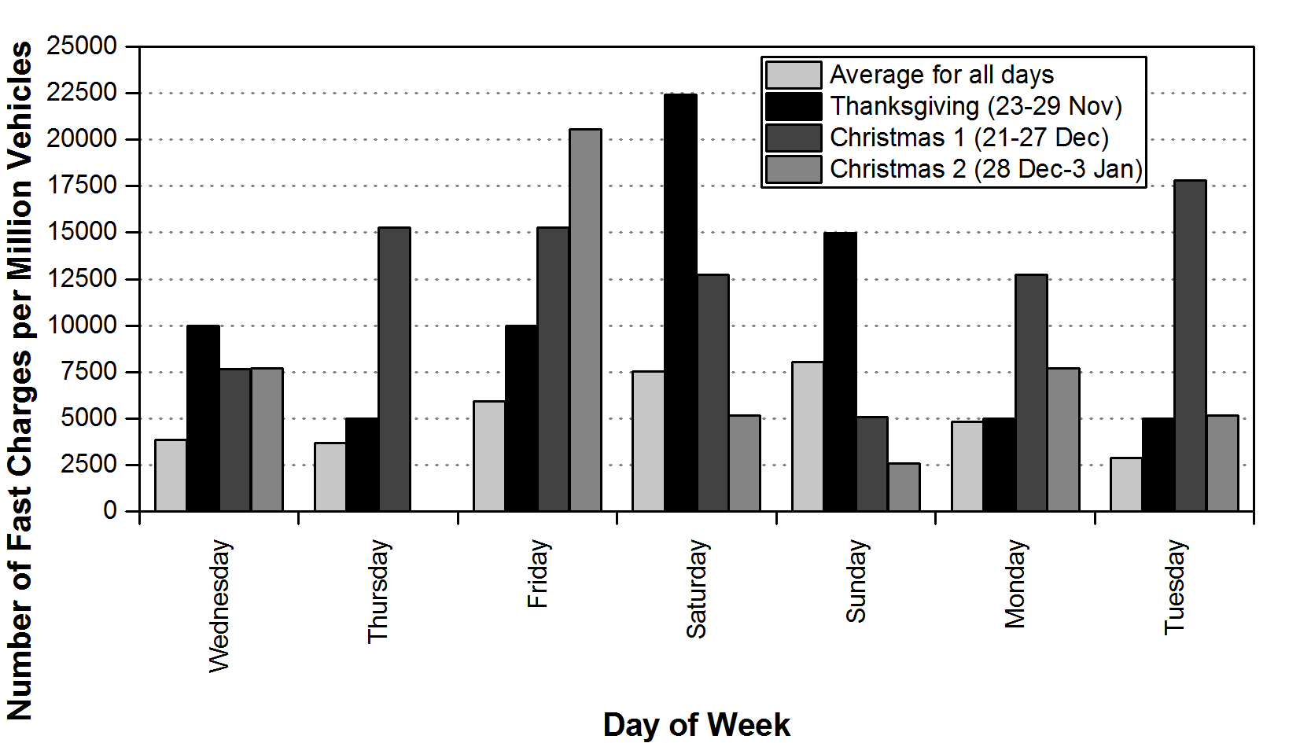
Figure 7 – Fast charges by day of week around holiday times

Fast Charging Point Power Requirements Results
Using the methodology described in Section ‎2.2, the power requirements to charge the EVs on long distance journeys are displayed in this section. The stopping time (t_{b}) is chosen to be less than 1 hour, this time length is chosen because longer stops may mean the driver has reached a destination and hence are not considered. The base case for trip durations is chosen as an initial 1.5 hour trip (t₁) followed by a 1.5 hour trip (t₂). It should be noted that these 1.5 hour trip times do not relate directly to the long distance definition given previously, a journey where the EV range is exceeded, with a base case of 200 miles, as in a 1.5 hour trip it would not be possible to drive 200 miles. 1.5 hour trips have been chosen because 1.5 hours is long enough to give confidence that the driver is on a long distance journey but short enough to give enough data points for the analysis.
With these criteria, Figure 8 shows how long people stopped during long distance journeys and how far they travelled after this stop in the subsequent journey. It is clear from Figure 8a that people often stop for short periods of time during long distance journeys, with 60 percent of stops being for less than 12 minutes.
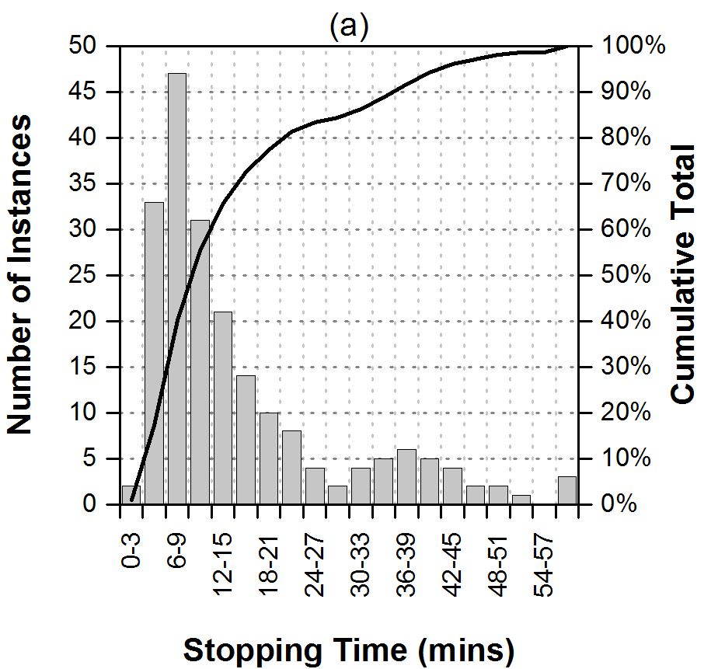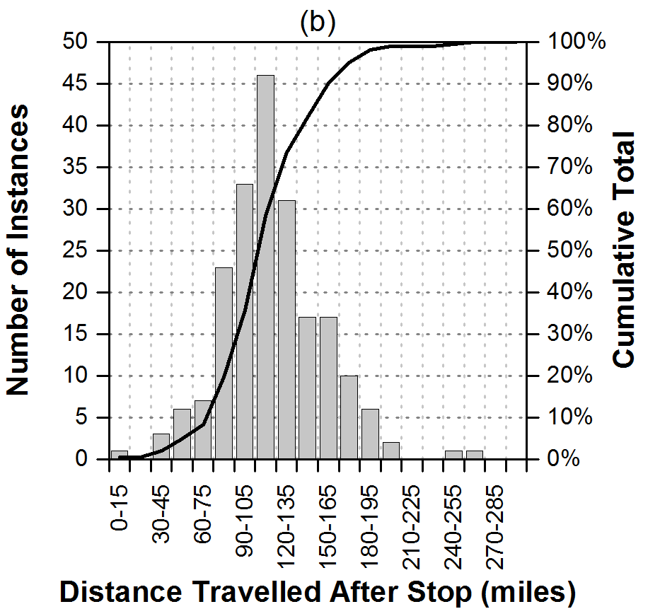
Figure 8 – How long people stop during long distance journeys (left) and how far they travel after the stop (right)
Using Equation 2 the charging rate required to satisfy the journey is found and the results of this are shown in Figure 9. To give an idea of charging powers, if an EV achieves 3 miles/kWh then 10 miles/min is the equivalent of 200 kW. From Figure 9a, to satisfy 80% of journeys the charging rate must be 20 miles/min or 400 kW.
The trip durations used in this analysis can be varied, for example Figure 9b shows the extreme curves when the trip before the stop (t₁) and the trip after the stop (t₂) were varied between 1 hour and 2 hours. From this graph it is clear that to satisfy 80% of journeys the charging rate must be between 18 and 23 miles/min, i.e. between 360 to 460 kW.
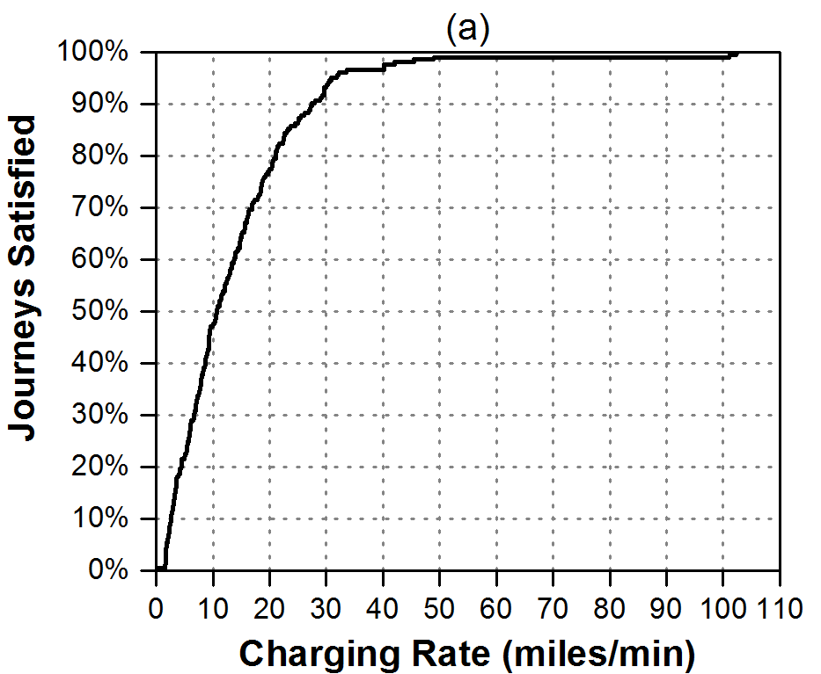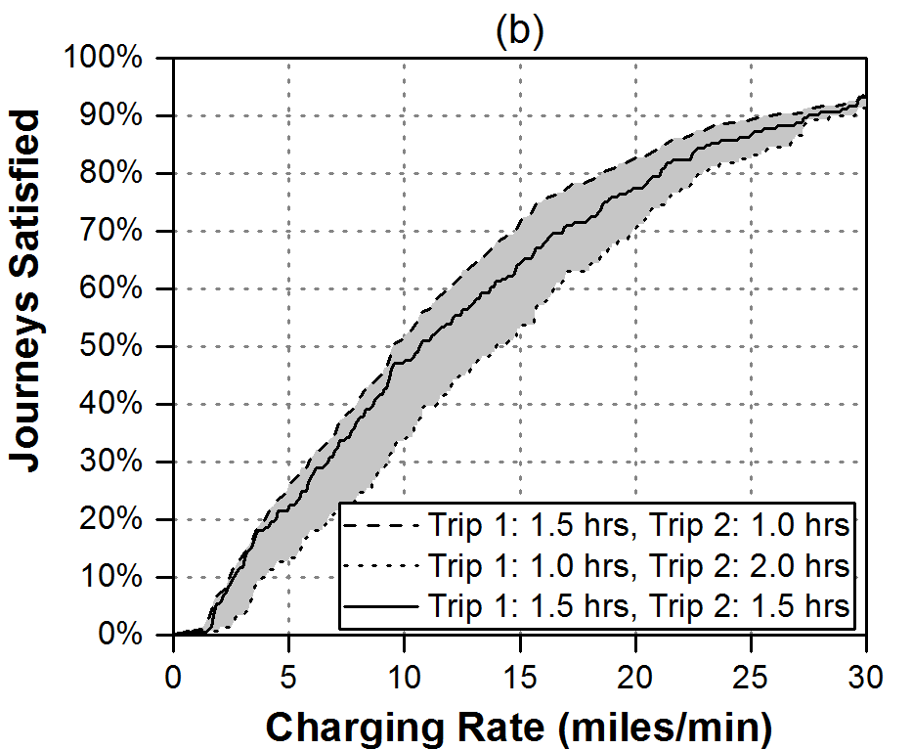
Figure 9 – Journeys satisfied for various charging rates (left) and sensitivity study (right – different axis)

Discussion
The method described in this paper produces interesting results for the time of day usage of fast charging stations. The method in this paper focuses on fast charging point usage specifically during long distance journeys and takes into account slow overnight charging, while other methods mentioned in the literature review do not. The method could be applied by organisations planning the roll out of fast charging points to predict demand or by electricity grid operators to predict future daily power variations from fast charging points.
Contrary to other studies, which predict fast charging usage peaks in the morning and evening, the results shown in this paper predict fast charging point usage will peak between 3pm to 7pm in the evening, with 45% of all daily fast charges occurring in these 4 hours. This evening peak is apparent from the method described in this paper as EV drivers charging their EVs overnight are considered meaning that fast charging point usage during the morning is less likely in the results in this paper.
A peak between 3pm and 7pm in the evening means the peak power demand from the fast charging points will coincide with the peak power demand of the electricity grid. Hence additional electricity generation capacity will be required to cope with the electricity demand from fast charging points. The fast charging usage peak also occurs around the same time of day as the slow charging peak, for this reason, smart charging solutions, where slow charging events are shifted to other parts of the day or night to reduce peak demand, may be required. From Figure 5 the electricity demand is not constant throughout the day and so the use of electricity storage could be used to store energy from earlier in the day to when it is required in the evening, which could be used to reduce the peak power demand from the fast charging station both locally and nationally.
In terms of estimating the number of charging points, the results suggested 1,400 fast charging points per million EVs may be required. The IEA previously predicts a ratio of between 8,000 and 40,000 fast charging points would be required per million EVs (between 0.1 and 0.5 million fast charging points for 12.9 million EVs in 2020 [11]). For Japan this value is 5,000 fast charging points per million EVs in 2020, over three times higher than the 1,400 fast charging points predicted from the authors’ study.
The IEA estimates are from historical ratios and do not include improvements in EV range and so possibly overestimate the number of fast charging points required. Historical ratios are also likely to be higher than the future case as in the past more fast charging points may have been installed to try and encourage the uptake of EVs. There are however several reasons why the analysis in this paper may underestimate the number of fast charges required, which need to be taken into account when planning the rollout of fast charging stations:
- This research only considers fast charging point usage for long distance journeys. There may be other people who use fast charging points, such as people who do not have access to slow charging at home or work or people who forget to charge their EV overnight.
- It has also been assumed that the EV will be fully charged when stopping for 8 hours or stopping at home or work. This may not be the case, especially if the EV driver is staying away from home overnight. Less slow charging would increase the usage of fast charging points.
- As seen in Figure 5a the actual number of fast charges is very sensitive to the distance the EV travels between fast charges. The actual number is therefore highly variable depending on the future range capability of EVs and the buffer energy that EV drivers will leave in the battery to give them confidence that they will not run out of energy during their trip.
User convenience may also dictate that additional fast charging points are required to ensure the geographical spread of fast charging points is sufficient to meet EV driver needs.
The method used here to determine the fast charging point power requirements produces new results. The method suggests a new way to estimate how fast future fast charging should be to meet driver requirements and as such could be used as an alternative means to set future fast charging targets. The method could be applied by automakers and charging standard agencies to determine if the fast charging targets they are currently working towards will satisfy potential EV owner requirements.
In terms of stopping times, it was found that the majority of stops while on long distance journeys are for a short period, 60% being less than 12 minutes. This presents a problem for fast charging as people are accustomed to short duration stops during long distance journeys. This means the fast charger can only be connected to the EV for a short time period, meaning the required energy must be delivered at high power.
For current fast charging levels of 50 kW, i.e. around 2.5 miles/min, Figure 9b shows this satisfies only about 10% of long distance journeys. As stated in the introduction, several projects have recently been announced looking at installing charging points capable of up to 400 kW charging power and so these new charging points are likely to satisfy the 80% of driver’s requirements. Providers of charging infrastructure should be looking to couple their charging services with other retail services which facilitate naturally longer stopping times. One issue is that the charging rates in Figure 9 are the average charging rates. To achieve an average charging power of 400 kW the charging rate must start off higher than 400 kW as current batteries charge at a slower rate the longer they are plugged into a charging point.
The methods described in this paper are based purely on EV energy analysis, while in reality psychological factors must also be taken into account. Further work could look to include these psychological factors, such as variations in the way EV drivers will use their battery, i.e. some will recharge when 60% full while others will wait until 10% full before recharging. The impact of autonomous driving, connected vehicles and automobile ownership factors could also be considered in future analysis.
The results in this paper were produced using data from the Puget Sound region of the USA, it would be interesting to conduct similar analyses with other datasets from other areas/countries to study how the usage and journey stopping times vary. People from the USA are known for driving long distances in larger cars compared to consumers in Europe or Japan, meaning people from the USA may require more fast charges and may stop for less time during long distance journeys.

Conclusions
In this paper two new methods to predict future EV fast charging point usage and the future power requirements of fast charging based upon analysis of existing gasoline vehicle driving data have been described. The methods will be useful for organisations planning the roll out of fast charging points, electricity grid operators and EV manufacturers. The three key outcomes that can be obtained using the methods are:
- Predicting the future fast charging point usage and the number of fast charging points required.
- Predicting the future daily demand profile at a fast charging point which can be used by electricity grid operators to predict daily power variations.
- Estimating the required charging rate to satisfy consumer requirements.
By using data from the Northwest United States the methods have been demonstrated and results produced. It is predicted that in the future, if all cars are EVs and EV drivers are able to travel for up to 200 miles between charges, then there will be an average of 5,000 fast charging point uses per day per million EVs. The usage of fast charging points is predicted to peak on Sunday evening at 1,400 uses per hour per million EVs. These results are however sensitive to the assumed distance between charges and are also based on assumptions that EV drivers will fully charge their EV when parked at home or work or for longer than 8 hours.
It is predicted that fast charging point usage will vary throughout the day, with the peak usage occurring between the hours of 3pm and 7pm. This coincides with the current electricity grid demand peak as well as the predicted slow EV charging peak electricity demand. This means additional electricity generation capacity will be required and smart charging solutions should be utilised for slow charging of EVs to reduce electricity grid maximum power demand.
It is also predicted that an average charging rate of 20 miles/min, or the equivalent of 400 kW if an EV achieves 3 miles/kWh, is required to satisfy 80% of people’s journeys. This value is similar to that of many projects currently announced to install fast charging points with charger powers of up to 400 kW. It is therefore predicted that if sufficient numbers of these 400 kW charging points are installed and EVs are developed capable of charging at these rates, one current perceived disadvantage of EVs, the slow charging time, may be overcome. This result also suggests that 400 kW is a good power rating for new fast charging points to ensure the fast charging point is future proof and will not have to be updated as EV battery sizes increase. It should however be noted than 400 kW is the average required charging power and, due to the physical properties of batteries, current EVs charge at a slower rate the longer they are plugged into a charging point meaning a higher initial charging power may be required.
In general, the planning of fast charging infrastructure is difficult because the precise usage patterns and cost-effectiveness of long range EVs in the mass market is currently unknown. Autonomous driving, connected vehicles, vehicle ownership as well as psychological factors of driving EVs will change the way consumers use vehicles in the future. This paper presents two methods to predict the usage and power requirements of fast charging stations, which could be used in conjunction with other methods when planning the rollout of fast charging stations.

Acknowledgements
This research was supported by funding from the EPSRC through two grants “EPSRC Centre for Doctoral Training in Energy Storage and its Applications” [grant number EP/L016818/1] and “ELEVATE (ELEctrochemical Vehicle Advanced TEchnology)” [grant number EP/M009394/1]. The vehicle data was obtained from the NREL Transportation Secure Data Center website [35].

References
1. IEA, 2017. CO2 Emissions From Fuel Combustion Highlights (2017 edition). International Energy Agency. Accessed Dec 2017. <https://www.iea.org/publications/freepublications/publication/CO2EmissionsfromFuelCombustionHighlights2017.pdf>.
2. WHO, 2015. Reducing Global Health Risks Through Mitigation of short-lived climate pollutants - Scoping report for policy makers. World Health Organization. Accessed Dec 2017. <http://apps.who.int/iris/bitstream/10665/189524/1/9789241565080_eng.pdf>.
3. IEA, 2017. Global EV Outlook 2017 - Two million and counting. International Energy Agency. Accessed Nov 2017. <https://www.iea.org/publications/freepublications/publication/GlobalEVOutlook2017.pdf>.
4. Crabtree, G., 2016. Energy Storage at the Threshold. In: NAATBatt Global Charge Conference 2016, Indian Wells, CA, Dec 2017. Accessed on Dec 2017. <http://naatbatt.org/wp-content/uploads/2016/03/JCESR.pdf>.
5. Falvo, M.C., Sbordone, D., Bayram, I.S., Devetsikiotis, M., 2014. EV charging stations and modes: International standards. In: 2014 International Symposium on Power Electronics, Electrical Drives, Automation and Motion, Ischia, Italy, Jun 2014. doi: 10.1109/SPEEDAM.2014.6872107
6. Bryden, T.S., Cruden, A.J., Hilton, G., Dimitrov, B.H., León, C.P.d., Mortimer, A., 2016. Off-vehicle energy store selection for high rate EV charging station. In: 6th Hybrid and Electric Vehicles Conference (HEVC 2016), London, UK, Nov 2016. doi: 10.1049/cp.2016.0986
7. Rubino, L., Capasso, C., Veneri, O., 2017. Review on plug-in electric vehicle charging architectures integrated with distributed energy sources for sustainable mobility. Applied Energy doi: 10.1016/j.apenergy.2017.06.097
8. Tesla, 2017. Model X. Tesla Motors. Accessed Nov 2017. <https://www.tesla.com/en_GB/modelx>.
9. BMW, 2017. Technical Data. BMW Group. Accessed Nov 2017. <http://www.bmw.com/com/en/newvehicles/i/i3/2016/showroom/technical_data.html>.
10. Vassileva, I., Campillo, J., 2017. Adoption barriers for electric vehicles: Experiences from early adopters in Sweden. Energy 120 632-641. doi: 10.1016/j.energy.2016.11.119
11. IEA, 2016. Global EV Outlook 2016 - Beyond one million electric cars. International Energy Agency. Accessed Nov 2017. <https://www.iea.org/publications/freepublications/publication/Global_EV_Outlook_2016.pdf>.
12. Awasthi, A., Venkitusamy, K., Padmanaban, S., Selvamuthukumaran, R., Blaabjerg, F., Singh, A.K., 2017. Optimal planning of electric vehicle charging station at the distribution system using hybrid optimization algorithm. Energy 133 70-78. doi: 10.1016/j.energy.2017.05.094
13. Davidov, S., Pantoš, M., 2017. Stochastic expansion planning of the electric-drive vehicle charging infrastructure. Energy 141 189-201. doi: 10.1016/j.energy.2017.09.065
14. Akhil, A.A., Huff, G., Currier, A.B., Kaun, B.C., Rastler, D.M., Chen, S.B., Cotter, A.L., Bradshaw, D.T., Gauntlett, W.D., 2015. DOE/EPRI Electricity Storage Handbook in Collaboration with NRECA. Sandia National Laboratories. Accessed Oct 2017. <http://www.osti.gov/scitech/servlets/purl/1170618>.
15. Nunes, P., Brito, M.C., 2017. Displacing natural gas with electric vehicles for grid stabilization. Energy 141 87-96. doi: 10.1016/j.energy.2017.09.064
16. Shokrzadeh, S., Ribberink, H., Rishmawi, I., Entchev, E., 2017. A simplified control algorithm for utilities to utilize plug-in electric vehicles to reduce distribution transformer overloading. Energy 133 1121-1131. doi: 10.1016/j.energy.2017.04.152
17. Godina, R., Rodrigues, E.M.G., Paterakis, N.G., Erdinc, O., Catalão, J.P.S., 2016. Innovative impact assessment of electric vehicles charging loads on distribution transformers using real data. Energy Conversion and Management 120 (Supplement C), 206-216. doi: 10.1016/j.enconman.2016.04.087
18. Luo, Y., Zhu, T., Wan, S., Zhang, S., Li, K., 2016. Optimal charging scheduling for large-scale EV (electric vehicle) deployment based on the interaction of the smart-grid and intelligent-transport systems. Energy 97 359-368. doi: 10.1016/j.energy.2015.12.140
19. Cunha, Á., Brito, F.P., Martins, J., Rodrigues, N., Monteiro, V., Afonso, J.L., Ferreira, P., 2016. Assessment of the use of vanadium redox flow batteries for energy storage and fast charging of electric vehicles in gas stations. Energy 115 1478-1494. doi: 10.1016/j.energy.2016.02.118
20. Höimoja, H., Vasiladiotis, M., Rufer, A., 2012. Power interfaces and storage selection for an ultrafast EV charging station. In: 6th IET International Conference on Power Electronics, Machines and Drives (PEMD 2012), Bristol, United Kingdom, doi: 10.1049/cp.2012.0309
21. Yunus, K., De La Parra, H.Z., Reza, M., 2011. Distribution grid impact of Plug-In Electric Vehicles charging at fast charging stations using stochastic charging model. In: Proceedings of the 2011 14th European Conference on Power Electronics and Applications, Birmingham, UK, Nov 2017. Accessed on Nov 2017. <http://ieeexplore.ieee.org/document/6020302/>.
22. Fathabadi, H., 2017. Novel wind powered electric vehicle charging station with vehicle-to-grid (V2G) connection capability. Energy Conversion and Management 136 (Supplement C), 229-239. doi: 10.1016/j.enconman.2016.12.045
23. Celli, G., Soma, G.G., Pilo, F., Lacu, F., Mocci, S., Natale, N., 2014. Aggregated electric vehicles load profiles with fast charging stations. In: 2014 Power Systems Computation Conference, doi: 10.1109/PSCC.2014.7038402
24. Simpson, M., Markel, T., 2012. Plug-In Electric Vehicle Fast Charge Station Operational Analysis with Integrated Renewables: Preprint. In: International Battery, Hybrid and Fuel Cell Electric Vehicle Symposium 26 (EVS26), Los Angeles, CA, Nov 2017. Accessed on Nov 2017. <http://www.nrel.gov/docs/fy12osti/53914.pdf>.
25. Franke, T., Günther, M., Trantow, M., Krems, J.F., 2017. Does this range suit me? Range satisfaction of battery electric vehicle users. Applied Ergonomics 65 191-199. doi: 10.1016/j.apergo.2017.06.013
26. Pearre, N.S., Kempton, W., Guensler, R.L., Elango, V.V., 2011. Electric vehicles: How much range is required for a day’s driving? Transportation Research Part C: Emerging Technologies 19 (6), 1171-1184. doi: 10.1016/j.trc.2010.12.010
27. Jakobsson, N., Gnann, T., Plötz, P., Sprei, F., Karlsson, S., 2016. Are multi-car households better suited for battery electric vehicles? – Driving patterns and economics in Sweden and Germany. Transportation Research Part C: Emerging Technologies 65 1-15. doi: 10.1016/j.trc.2016.01.018
28. USCAR, 2017. U.S. Advanced Battery Consortium LLC. USCAR. Accessed Oct 2017. <http://www.uscar.org/guest/teams/12/U-S-Advanced-Battery-Consortium>.
29. Neubauer, J., Pesaran, A., Bae, C., Elder, R., Cunningham, B., 2014. Updating United States Advanced Battery Consortium and Department of Energy battery technology targets for battery electric vehicles. Journal of Power Sources 271 614-621. doi: 10.1016/j.jpowsour.2014.06.043
30. The White House, 2016. FACT SHEET: Obama Administration Announces Federal and Private Sector Actions to Accelerate Electric Vehicle Adoption in the United States. The White House. Accessed Oct 2017. <https://obamawhitehouse.archives.gov/the-press-office/2016/07/21/fact-sheet-obama-administration-announces-federal-and-private-sector>.
31. Khan, M., Kockelman, K.M., 2012. Predicting the market potential of plug-in electric vehicles using multiday GPS data. Energy Policy 46 225-233. doi: 10.1016/j.enpol.2012.03.055
32. Chevrolet, 2017. Bolt EV. General Motors Company. Accessed Nov 2017. <http://www.chevrolet.com/bolt-ev-electric-vehicle>.
33. Tesla, 2017. Model 3. Tesla Motors. Accessed Oct 2017. <https://www.tesla.com/en_GB/model3>.
34. PSRC, 2008. Traffic Choices Study – Summary Report. Puget Sound Regional Council. Accessed Nov 2017. <http://mrsc.org/getmedia/8905d073-65f4-4395-9cff-2090dbf66d68/PSRCtrafficChoicesStudy.aspx>.
35. NREL, 2017. Transportation Secure Data Center. National Renewable Energy Laboratory. Accessed Nov 2017. <http://www.nrel.gov/transportation/secure_transportation_data.html>.

