In situ TEM observations on the structural evolution of a nanocrystalline W-Ti alloy at elevated temperatures
M. Callisti ^{a, *}, F. D. Tichelaar ^{b}, T. Polcar ^{c}

ª Department of Materials Science and Metallurgy, Cambridge University, 27 Charles Babbage Road, Cambridge, CB3 0FS, United Kingdom
^{b} Kavli Institute of Nanoscience, Delft University of Technology, 2628 CJ, Delft, The Netherlands
^{c} National Centre for Advanced Tribology at Southampton, Faculty of Engineering and the Environment, University of Southampton, Southampton SO17 1BJ, United Kingdom

* Corresponding author
Dr Mauro Callisti
Email: mc2057@cam.ac.uk
Department of Materials Science and Metallurgy
University of Cambridge
27 Charles Babbage Road
Cambridge, CB3 0FS
United Kingdom

Abstract
The thermal stability and nanoscale structural evolution at elevated temperatures of a sputter deposited W-Ti alloy thin film were studied by a combination of ex situ and in situ techniques. XRD, FIB, SEM-EDX and STEM-EDX were used to characterise the film annealed ex situ in vacuum at 1373 K for 48 hrs. In situ TEM heating experiments were conducted at various temperatures up to 923 K to capture transitional phenomena occurring in the alloy upon heating and cooling. At a microscopic level, the alloy annealed at 1373 K for 48 hrs transformed from a single-phase β-(WTi) solid solution into a two-phase alloy consisting of Ti-rich grains in equilibrium with Ti-depleted β-(WTi) solid solution grains. In situ TEM observations revealed initial Ti segregations along columnar grain boundaries at T $\sim$ 423 – 573 K, followed by Ti-rich clusters formation in the grains interior at T $\sim$ 573 – 773 K. The microstructure observed at 923 K remained stable upon cooling to room temperature and consisted of Ti-rich segregations along the columnar grain boundaries and of alternate Ti-rich and Ti-depleted nanoscale domains in the grains interior, which formed a stable dual-phase nanocrystalline structure.

Keywords: Physical vapour deposition (PVD), High-temperature alloys, Phases separation, In situ TEM heating.

1. Introduction
Development of metallic alloys with tailored properties has been and still is one of the main objectives in materials science due to the continuous progress in materials processing and characterisation techniques. Advances in materials fabrication technologies accelerated the progress in this traditional field of physical metallurgy. In particular, a development of far-from-equilibrium processing techniques opened up a new branch in materials science related to development of alloys with immiscible elements (i.e. elements with positive heat of mixing ΔH_{mix} at solid or both solid and liquid state) [1]. A number of single-phase alloys such as supersaturated crystalline solid solutions, metastable intermediate compounds and amorphous structures were produced by physical vapour depositions, mechanical alloying, laser ablation, rapid quenching, etc. [1]. Examples of binary systems with positive ΔH_{mix} are: Cu-Cr [2, 3], Cu-Ta [4], W-Cu [4], Mg-Ti [5], W-Ti [6], and many other [1]. Some of these alloys exhibit a nanocrystalline structure in as-produced condition with exceptional electrical, magnetic, insulating and mechanical properties at ambient temperature. In spite of the large progress in developing alloys between immiscible elements, there are still several challenges to be addressed such as resistance against the thermodynamic driving forces leading to phase separation as well as to maintain a nanocrystalline structure when the alloy is subjected to thermal cycles [7, 8]. W-Ti alloys were reported to be promising alloy candidates for microelectronics (as diffusion barrier layer between metal contacts and silicon) due to the low electrical resistance and adhesive strength of the layer, for the development of gas sensors [9], as functional coatings for smart windows [10] and as anticorrosive and oxidation resistant coating [11-13]. Also, tungsten is receiving considerable attention as potential plasma-facing material in fusion reactors [14-16] due to its high melting point, strength at high temperatures, high sputtering threshold energy, good thermal conductivity and low thermal expansion coefficient. However, tungsten as pure metal presents some limitations mostly connected to its poor fracture toughness [17]. Therefore, alloying W with other metallic elements is being investigated as a possible rout for improving its physical properties [18].
Although the W-Ti alloy system is being investigated from more than two decades, the thermal stability and related thermodynamic and kinetic aspects of this immiscible system only recently received some attention. Schuh et al. [7] developed a thermodynamic approach to identify the conditions under which a nanocrystalline system with positive heat of mixing is stable against grain growth and phase separation. Based on this approach, a nanostructure stability map was proposed and three different regions delineated: GB segregation of Ti without achieving a stable nanocrystalline structure, macroscopic phase separation with a nanocrystalline structure stable against grain growth, and the nanocrystalline state stable against grain growth and phase separation. In this regard, W alloyed with 20 at.% of Ti was used as model material to investigate its thermodynamic stability [19]. The alloy was produced by high-energy ball milling and subsequently annealed at 1373 K for two days. STEM-EDX and APT analyses revealed a nanoscale grain structure consisting of W nanograins surrounded by Ti segregations at intergranular regions. Segregation of solute at GBs was considered responsible for the observed stable nanocrystalline state [19]. In spite of the significant breakthrough on this specific alloy system gained by combining thermodynamic models and advanced characterisation techniques, there are still many aspects to be further investigated and clarified experimentally. These range from fundamental aspects (e.g. kinetic of solute segregation at GBs) to the possibility of producing thermodynamically stable nanocrystalline alloys via different processing technologies suitable for specific industrial applications (e.g. thin films for microelectronics, bulk alloys for aerospace and nuclear industry, etc.).
In this study, thermal stability and structural changes of W-Ti alloys at elevated temperatures were investigated by ex situ experiments to assess the stability over a long period of time, and by in situ experiments to shed light on kinetic processes taking place at small scales at high temperature. W-Ti alloys were synthesised by magnetron sputtering, as this technique provides a more homogeneous distribution of the elements compared to high-energy ball milling, where small fluctuations in compositions can be observed due to the tendency of immiscible elements to avoid mixing [19]. Experimental observations are discussed in combination with semi-quantitative and qualitative analyses.

2. Experimental methods
W-Ti thin films were deposited by magnetron sputtering on different substrates (single crystal (100) Si wafer, glass and Al₂O₃) for different purposes. A 2-inch target for W (99.99% purity) and Ti (99.99% purity) were used to perform the depositions. The chamber was pumped down to a base pressure of ${3×10}^{-5}$ Pa and the depositions were carried out in a partial pressure condition (pressure $<$ 1 Pa) with an Ar gas flow of 4 sccm. The substrate holder was rotated at 10 revolutions per minute to obtain composition homogeneity across the substrates. No deliberate heating of the substrate was used during depositions. The deposition was performed by using a direct current (DC) power of 280 W for Ti and of 300 W for W cathode.
W-Ti films deposited on Al₂O₃ substrates were annealed at 1373 K for 48 hrs in high vacuum (pressure below $4 ×{10}^{-6}$ mbar). In order to further limit oxidation, sacrificial materials were placed around the sample in the vacuum chamber. Samples were first heated up to 673 K at a rate of $\sim$ 0.7 K/s to achieve the adequate vacuum conditions and then up to 1373 K at a rate of $\sim$ 0.3 K/s. The cooling process was performed in vacuum with a cooling rate of $\sim$ 0.3 K/s down to a temperature of 423 K. Samples were left to cool down to ambient temperature in vacuum at a slower cooling rate.
The microstructure of the films was investigated by grazing incidence (GI-XRD) and symmetric θ/2θ X-ray diffraction (XRD). The grazing angle was set to 5° with a scan step size of 0.02° over an angle range of 2θ = 35 – 80°. The diffraction data were collected by using the Rigaku SmartLab diffraction system (Rigaku Corporation, Japan) with Cu Kα radiation, while the XRD data were analysed by the PDXL software together with a ICDD PDF-2 database.
Surface morphology and cross-section of the as-deposited and annealed films were observed by using a Zeiss NVision40 Focused Ion Beam (SEM/FIB) system. Finer structural analyses were carried out by analytical transmission electron microscopy. Thin foils for TEM studies were prepared by FIB (in situ lift-out method) and thinned down to achieve electron transparency by mean of a Ga ion gun operated with a current of 40 pA at 30 kV. A JEOL JEM-3010 transmission electron microscope TEM (300 kV) was used to perform preliminary structural characterisation of the as-deposited films. In situ TEM experiments were carried out by using a FEI Tecnai F20UT/STEM microscope (200 kV) for the film deposited on glass substrate, and a FEI Titan Cs-corrected cubes (300 kV) for the film deposited on Al₂O₃ substrate. Both TEMs are equipped with an Oxford Instruments X-Max^{N} 100TLE windowless EDX detector. The TEM lamellae ($\sim$ 80 nm thick) were prepared in a FIB (FEI Strata DB 235) and mounted on a heater chip for in situ heating experiments by using a dedicated heating holder developed at TU Delft [20]. Bright Field (BF) TEM and High-Angle Annular Dark Field (HAADF) STEM observations were performed at different temperatures (ambient temperature, 423, 573, 773 and 923 K) with a heating rate of $\sim$ 5 K/s for T $≤$ 573 K and $\sim$ 1.6 K/s for T $≥$ 573 K. The TEM lamella was annealed at each test temperature for about 20 minutes before imaging/analysis. Fig. 1 shows the thermal cycles along with the temperatures where EDX acquisitions were carried out during the in situ TEM experiment performed on the film deposited on glass. For test temperatures $>$ 573 K, EDX mapping was performed at a temperature of 573 K so as to evaluate the effects of cooling on structure and chemical distribution of W and Ti as well as to avoid saturation and false readings of the EDX detector induced by the heat radiation. TEM/STEM imaging was performed at each test temperature during both heating and cooling at various temperatures down to ambient temperature. It is worth mentioning that the highest annealing temperature applied during the in situ TEM study lies just above the solvus line ($\sim$ 870 K for the specific alloy composition studied here) according to the bulk phase diagram for W-Ti [21]. Therefore, in the cooling step from 923 to 573 K the alloy system was taken across the solvus line. In this case, a cooling rate of $\sim$ 11 K/s was used.

3. Results and discussion

3.1 As-deposited films: structure and morphology
W-Ti thin films with a Ti content of 18 $±$ 1 at.% were deposited with a thickness of $\sim$ 1 µm on Si wafers, glass and Al₂O₃ substrates. Although the solubility of Ti in W is below 12 at.% (that of W in Ti is much more limited) [22], a solid solution in the as-deposited W-Ti film was produced by magnetron sputtering, an energetically unbalanced method allowing formation of solid solutions not achievable by conventional metallurgical routes [1]. The as-deposited films exhibited a homogenous distribution of W and Ti assessed by SEM-EDX on the surface and STEM-EDX on cross-section (see Fig. S1). The as-deposited films exhibited a bcc structure (Fig. 2a) with a dominant (110) peak (d₁₁₀-spacing $\sim$ 0.2236 nm corresponding to a lattice parameter a_{β(WTi)} = 0.3177 nm).
Films deposited on Si wafers and glass showed a dense structure with columnar grains densely packed (Fig. 3a) and a nanostructured surface decorated by needle-like features (Fig. 4a) as reported elsewhere [23]. Conversely, films deposited on Al₂O₃ exhibited a mushroom-like structure due to the much less regular surface morphology of the substrate (Fig. 4b). Every mushroom consisted of several columnar grains (see inset in Fig. 4b) forming on the surface the same needle-like features reported in Fig. 4a. It worth mentioning that columnar grains in each mushroom were not always extended across the entire film thickness (inset in Fig. 4b), thus increasing the GB density in the film. In spite of the difference in surface morphology, according to XRD and TEM analyses the microstructure in the columnar grains was identical regardless of the type of substrate (Si, glass and Al₂O₃). Fig. 3b shows the typical atomic arrangement observed inside the columnar grains, where a single-phase polycrystalline nanostructure is observed with a d-spacing (0.2225 nm measured on the FFT in Fig. 3b) matching well with that measured by XRD. In Fig. 3b about 10 randomly oriented crystallites are identified with an average size (assuming a circular shape) of $\sim$ 12 nm. In the as-deposited films, no evidence of precipitation at GBs and in the grains interior was found (see Fig. S2).
Hereinafter, grain boundary (GB) is referred to the boundary between adjacent columnar grains (or just grains), while a boundary between crystallites (formed in the columnar grains) will be appositely specified.
Due to its more homogeneous morphology and lower roughness, the film deposited on Si wafer was only used to measure mechanical properties by nanoindentation. The film exhibited a hardness of $\sim$ 12.5 $±$ 1.3 GPa and an elastic modulus of $\sim$ 241 $±$ 21 GPa; the latter is not far away from the theoretical value (274 GPa) calculated by density function theory (DFT) for a W-Ti alloy with a similar composition [24]. By using the rule-of-mixture and considering the mechanical properties of monolithic W (H_{w} = 14.5 GPa, E_{w} = 218 GPa) [25] and Ti (H_{Ti} = 6.5 GPa, E_{Ti} = 116 GPa) [26, 27] sputtered layers, a composite hardness and elastic modulus of $\sim$ 13 GPa and $\sim$ 200 GPa, respectively, is calculated, which is comparable to the properties measure in this study.

3.2 Structural evolution at elevated temperatures
To investigate the high temperature behaviour of sputtered W-Ti alloys, only films deposited on Al₂O₃ (for ex situ annealing and preliminary in situ TEM) and glass (for in situ TEM) were considered. The XRD pattern of the annealed film (Fig. 2a) shifted towards higher 2θ angles, thus suggesting a decrease in lattice parameter (a_{β(WTi)} = 0.3163 nm) attributable to both residual stress relaxation and Ti depletion in the β-(WTi) lattice structure. The crystallite size, calculated by the Sherrer equation, based on the β-(WTi) (110) peak, increased from $\sim$ 30 to 50 nm upon annealing. Fig. 2b shows an enlarged view of the diffractogram around the (110) β-(WTi) peak. Beside the formation of very limited TiO₂ on the film surface, some additional peaks appeared after annealing. Some of these peaks were associated with β-Ti (a_{β-Ti} = 0.3302 nm) and α-Ti phases (Fig. 2b). A previous study reported the coexistence of both crystal structures for Ti-rich phases formed in a W-Ti 30 at.% alloy cooled at 10°C/s [28]. Other minor peaks (2θ $≈$ 42 – 46°) were difficult to be identified unambiguously; they are most likely related to tungsten and/or tungsten oxides phases formed on the film surface. Fig. 5a shows the surface morphology of the film (on Al₂O₃ substrate) annealed ex situ. The surface did not present any appreciable difference compared to that observed for the as-deposited film (Fig. 4b) and the needle-like structure was maintained. However, structural changes were observed on the polished (FIB) cross-section of the film (Fig. 5b). The columnar grains in the as-deposited film had a diameter of 70 $±$ 12 nm (measured by TEM), while the annealed film exhibited columnar grains with diameter of 110 $±$ 36 nm (Fig. 5b). In addition, a strong contrast was clearly seen between different grains (Fig. 5b), which is not attributable to the different crystallographic orientations (i.e. in-plane rotation of the columns). It is related to compositional changes as will be discussed later. By a close inspection of the polished cross-section, it appeared that the phase with dark contrast started forming along GBs. The native phases exhibited both a spherical shape with a size as small as 10 nm (see inset in Fig. 5b) as well as elongated shapes (a few hundreds of nm in length) formed between columnar grains. These observations may lead to the conclusion that the classical precipitation process (nucleation and growth of solute-rich precipitates at GBs) may have taken place. However, large domains with a columnar structure (up to 200 nm in diameter and 400 500 nm in length) comparable to the main grain structure (columns with lighter contrast) also formed (highlighted in Fig. 5b) especially at triple junctions in the inner regions of the film (Fig. 5). The substrate/film interface also resulted to be another favourable nucleation site for the native phase. This scenario indicates formation of a microscopic dual-phase structure, where Ti-rich grains (dark features) grew at the expenses of W-rich grains (light in appearance). To shed light on the composition of the phases formed following ex situ annealing, STEM-EDX analyses were carried out on a cross-sectional TEM sample (Fig. 6). A strong HAADF contrast is observed in Fig. 6a, which suggests formation of a Ti-rich phase (dark domains) along GBs (tens or hundreds of nm in size) and in the grains interior (down to a few nm in size). The large difference in size for the observed Ti-rich phases is attributed to the fact that different structural features (e.g. triple junctions, GBs with different misorientations, defects, etc.) exhibit different energy barriers against nucleation and growth of new phases [29]. Triple junctions were energetically more favourable compared to the boundary between columnar grains for nucleation and grow of the Ti-rich phase (Fig. 5b). As a consequence, larger Ti-rich phases preferentially formed at these sites rather than at the boundaries between two columns. A good match between the HAADF-STEM image (Fig. 6a) and the corresponding EDX map (Fig. 6b) is found. The quantitative analysis reported in Fig. 6c shows a significant Ti enrichment in the formed phase ($\sim$ Ti 80at.% - W) with a consequent Ti depletion in the surrounding structure.
The microstructure illustrated in Fig. 5b and Fig. 6a was considered to be in an equilibrium condition, consistent with diffusion rate. The diffusion distance (L) for annealing at 1373 K was approximated by $L=\overline{D}×t$ [19], where $\overline{D}$ is the interdiffusivity of the binary alloy (calculated by the Darken’s equation [30, 31]) and $t$ is the annealing time (48 hrs). In particular, by using the intrinsic diffusivity for Ti ($4.1×{10}^{-13}$m²/s [19]) and W (${10}^{-15}$m²/s for a grain size of 80 nm [19]) at 1373 K a diffusion distance L well above the film thickness was calculated, thus suggesting that the heat-treatment adopted in this study was sufficient for the system to reach the equilibrium.
In order to shed light on the thermal stability of the W-Ti alloy at high temperatures and on the structural phenomena leading to the microstructure illustrated in Fig. 5b and Fig. 6, in situ TEM heating experiments were carried out on the W-Ti alloy. In situ TEM results presented and discussed below were acquired on the film deposited on glass substrate. Fig. 7 shows some representative cases of the in situ TEM heating experiments performed in the top region of the film, where the TEM lamella was thinner. Small columnar grains were selected to observe a higher number of GBs within the horizontal field of view. By considering the large difference in atomic number between W (Z = 74) and Ti (Z = 22), in situ monitoring was preferentially performed by using the HAADF detector, as the intensity in the image is proportional to $\sim$ $Z^{1.7}$ (with Z corresponding to the atomic number) and therefore sensible to the spatial distribution of W and Ti. Fig. 7 shows the structural evolution at different test temperatures of the film in a region comprising two GBs. At 423 K, a homogeneous elemental distribution of W and Ti was found by EDX mapping (see Fig. S3), although very small particles with a dark contrast were observed close to the columnar grain boundaries (highlighted in Fig. 7a for T = 423 K). Kaub et al. [32] showed by using atom probe tomography (APT) that Ti segregation at GBs occurs even during room temperature deposition of W-Ti films. Therefore, the small domains highlighted in Fig. 7a (T = 423 K) may be attributed to Ti-rich clusters formed either upon cooling after the deposition process or due to in situ heating. At 573 K, more pronounced changes in contrast started to occur and dark rounded Ti-rich domains became more evident in the grains interior along with some changes at GBs. Significant structural changes became evident after annealing for about 20 minutes at 773 K. Specifically, larger Ti-rich domains (20 – 30 nm in size) appeared in the grains interior and close to GBs (see GB 2 for T = 773 K in Fig. 7a), while GBs became enriched in Ti (see GB 1 in Fig. 7a at 773 K). With a further increase of temperature to 923 K, features observed at 773 K became slightly sharper, which may suggest a further Ti enrichment, although the size of these Ti-rich clusters did not change significantly. Fig. 7b shows the microstructure on a larger area of the film along with the elemental distribution for Ti and W (acquired at 573 K after annealing for 20 minutes at 923 K). Although the columnar grain boundaries were not very sharp in the HAADF-STEM micrograph (Fig. 7b), they could be identified by looking at the corresponding EDX maps, where domains depleted in W and enriched in Ti were observed approximately in line with GBs (highlighted by arrow). The HAADF contrast formed in Fig. 7b in combination with the EDX maps for Ti and W further corroborated the Ti segregated at GBs, while the grains interior showed an inhomogeneous Ti distribution (Fig. 7b – Ti EDX map) as will be discussed later. It should be mentioned that some Ti segregation occurred on the free surface of the TEM sample and at the interface with the substrate. Also, the thin area of the TEM sample tended to retract slowly (left edge of the sample in Fig. 7) due to surface diffusion driven by surface energy minimisation from the thin to the thick regions of the lamella. Such diffusion could have caused some thickness variations across the TEM sample. However, based on the analyses reported in Fig. 6, simultaneous diffusion of Ti and W occurred leaving the left edge of the lamella (where in situ TEM observations were performed) thin and with negligible local thickness fluctuations.
Inhomogeneous solute distribution was also reported by Chookajorn and Schuh [19] on ball milled W-Ti alloys annealed at 1373 K and subsequently quenched to room temperature. In our study, alternate nano-sized Ti-rich/Ti-depleted domains were found to form in the grains, as it is evident in Fig. 8a (particularly in the grain G2 and G3). Fig. 8c shows the intensity profile (dashed arrow in Fig. 8a – same region at ambient temperature of the one in Fig. 7b) of the HAADF-STEM image along the grain 2 (G2). Beside the increasing trend due to the non-uniform thickness of the lamella, a clear oscillating intensity is observed which reflects the heterogeneous Ti distribution in the grains. The nano-structure formed in the grains was retained upon cooling (after the in situ annealing at 923 K) as can be better observed in Fig. 8b. Domains about 50 nm in size or smaller were observed (highlighted in Fig. 8b) as predicted by XRD (crystallite size $\sim$ 50 nm).
To summarise the in situ TEM observations, when the temperature was raised to 423 K, no significant changes occurred. Further increase in temperature (573 K) led to Ti segregation at GBs and small Ti-rich domains started to form in the grains. At 773 K, Ti-rich domains (both in the grains and close to GBs) increased in size and Ti enrichment occurred at GBs. At 923 K, the structural features observed at 773 K exhibited a negligible growth. According to the intensity variation in HAADF-STEM images and EDX maps, Ti mostly segregated at GBs or formed clusters next to GBs. A smaller amount of Ti was retained in the grains interior with an inhomogeneous distribution, which caused formation of alternate Ti-rich/Ti-depleted nanoscale domains. This nano-structure was retained when the TEM sample was cooled down to ambient temperature.
According to the bulk phase diagram for W-Ti [21], a large miscibility gap exists between these elements with a critical temperature of $\sim$ 1470 K. From a thermodynamic perspective, when a miscibility gap is present in the phase diagram, there are two different routes that conduct the system towards a more stable state consisting of the same final product: (i) nucleation and growth of new phases and (ii) spinodal decomposition. In the latter case, different scenarios on the free energy vs composition diagram can be thought. In particular, if the decomposition involves formation of phases with small differences in lattice parameter, then the energy provided to the system upon cooling may be sufficient to promote short range diffusion needed for spinodal decomposition. Conversely, when the native phases exhibit significantly different lattice parameters, large interfacial strain energy between different phases builds up leading to an increase of the energy barrier to be overcome to trigger spinodal decomposition. In the latter case, if not sufficient undercooling is provided to the system, the route (i) may become energetically more favourable for the system to reach the equilibrium [29]. In this study, after cooling from the annealing temperature (ex situ annealing at 1373 K – well above the solvus line), XRD data showed no evidence of splitting of XRD peaks into two (it may also be due to the small lattice mismatch $\sim$ 4.5% between α-Ti and β-(WTi) phases) or sidebands formation around the (110) peak, likely suggesting that no spinodal decomposition has taken place upon cooling. These considerations lead to the conclusion that the system followed the route (i) upon cooling, where the new Ti-rich phase nucleated at GBs in the form of small precipitates which coalesced to form larger solute-rich grains in equilibrium with solvent-rich grains (Fig. 5b). The in situ TEM study showed formation of prominent Ti segregations at GBs, but revealed also finer details, particularly in the grains interior. In the first case, STEM-EDX analyses showed that a certain amount of Ti segregated along columnar grain boundaries. By considering the large presence of Ti at GBs and the very limited solubility of W in Ti, it is very likely that Ti segregations at GBs presented a hexagonal structure (α-Ti). Furthermore, stress relief at GBs upon annealing could have also encouraged formation of the α-Ti phase [32].
In the grains interior, inhomogeneous Ti distribution (Fig. 7b) caused formation of alternate Ti-rich/Ti-depleted domains. The presence of the β-Ti phase (Fig. 2b) is very likely associated with the formation of Ti-rich domains inside the grains. The cubic structure for the Ti-rich phase can be stabilised by the coherency strain at the interface with the β-(WTi) phase (depleted in Ti after annealing) as well as by dissolution of limited amount of W in Ti. In fact, it was reported that elements such as tantalum have a stabilising effect on α-Ti [33, 34]. Interfacial coherency strain was also reported to stabilise the α-Ti in Ti/V multilayers [35]. Recently, in situ TEM heating experiments (T $≈$ 873 K) showed a thermally-induced hcp-to-fcc phase transformation in Ti thin films, where the native fcc phase remained stable upon cooling to ambient temperature [36]. Also, stable (fcc)-Ti was occasionally associated with high levels of plastic deformation. In this study, a synergetic contribution of coherency strain at β-Ti/β-(WTi) interfaces and the stabilising effect of W on β-Ti formation were considered responsible for the formation of β-Ti in the grains interior.
In order to provide a more quantitative analysis describing the structural changes illustrated in Fig. 7 and 8, HAADF-STEM images acquired at different temperatures were analysed by ImageJ to extract information about GBs thickness (i.e. the thickness of the Ti enrichment at GBs showing up as dark in the HAADF-STEM images), and Ti-rich clusters size in relation to the temperature. For example, GB 1 in Fig. 7a is seen to increase in width with temperature. The GB thickness was assumed to be equal to the FWHM of the intensity line profile across the GB. Further details about the methodology used to perform the measurements mentioned above are illustrated in Fig. S4. In order to limit overestimation of the GB thickness, narrow GBs appearing sharp and dark in HAADF contrast (indicating that GB is close to be parallel to the electron beam) were selected for quantitative analyses as a function of the temperature. At least 5 series of measurements were performed for each GB, while a higher number of measurements was performed for Ti-rich clusters. Only clean GBs (i.e. GBs without clusters formed next to them) were considered in the quantitative analysis.
Fig. 9a shows the GBs thickness (red) and clusters area (blue) as a function of the temperature. It was observed that GBs exhibited a higher growth rate for T $≤$ 573 K, while Ti-rich clusters growth became significant only for temperatures comprised between 573 – 773 K. To understand the kinetic processes that took place at GBs and in the grains interior during the in situ TEM heating experiments, the solution of the Fick’s second [37] law was used:
$D= D_{o} exp\left(-\frac{Q}{RT}\right)$ (1)
$l=2\sqrt{Dt}$ (2)
Where D is the diffusion coefficient, D_{o} is a temperature pre-exponential frequency factor, Q is the activation energy for diffusion and R is the gas constant (8.3145 J mol⁻¹ K⁻¹). The diffusion coefficient D can be calculated by using equation (2), where l represents the diffusion distance and t the annealing time for each temperature T (1080 s at 423 K and 573 K, 1020 s at 773 K, and 1140 s at 923 K). By considering that solute clusters formed in the grains interior at high temperature (Fig. 7) exhibited irregular shapes, the area (A) of clusters was measured by ImageJ and converted into an equivalent circular shape of radius $l=\sqrt{A/π}$. On the other hand, for GBs, l represented the GB thickness. Values for D_{o} and Q were extracted from a linear fitting (Arrhenius plot) of D vs 1/T plot in a semi-logarithmic scale as shown in Fig. 9b. It was found that the activation energy for Ti diffusion at columnar grain boundaries (CGB) was $\sim$ 3 times smaller than the one for Ti diffusion in the grains interior (CGI) – Q_{CGI}/Q_{CGB} $≈3$. It is an indication that a higher defect density distribution formed at GBs compared to the interfaces formed between crystallites in the grains interior, thus providing easier diffusion paths for solute. By combining the information extracted from Fig. 9a - b and Fig. 7, it appears that, in regions close to GBs, Ti quickly segregated at GBs, mostly for T $<$ 573K. Conversely, in the grains interior a higher energy barrier for Ti diffusion was calculated, and therefore more energy (i.e. higher temperature) was needed for solute to diffuse and form Ti-rich clusters in the grains.
The alloy studied here was subjected to a phase separation at the nanometre scale by maintaining a nanocrystalline state stable against coarsening. The microstructure observed in the grains interior is close to the dual-phase nanocrystalline structure predicted by Murdoch and Schuh in an alloy system with a high heat of mixing but not sufficient to produce amorphous structures [7]. Specifically, these models predicted a structure consisting of solvent-rich solid solution and solute-rich nanocrystalline phase with grain boundary segregation. In our study, in the columnar grains a dual-phase nanocrystalline structure consisting of β-(WTi) solid solution alternated to Ti-rich domains formed upon annealing and remained stable at ambient temperature, while excess Ti segregated along columnar GBs.

Conclusions
The thermal stability and structural evolution at elevated temperatures of a sputter deposited W-Ti alloy thin film was investigated by ex situ annealing and in situ TEM heating experiments. After ex situ annealing at 1373 K for 48 hrs, the originally homogeneous β-(WTi) solid solution transformed, at a microscopic level, into a two-phase alloy consisting of Ti-rich grains in equilibrium with Ti-depleted β-(WTi) solid solution grains. This separation proceeded via Ti enrichment along columnar grain boundaries. Finer structural details and the physical phenomena that led to formation of this structure were revealed by in situ TEM heating experiments and STEM-EDX analyses. Ti rich clusters nucleated and grew along columnar grain boundaries for T $≤$ 573 K. Ti-rich clusters formation in the grains interior was sluggish and became prominent only at temperatures between 573 – 773 K. At temperatures $≥$ 773 K, while large amount of Ti segregated along columnar grain boundaries, the grains interior consisted of a nanocomposite structure composed of alternate Ti-rich and Ti-depleted (i.e. Ti-depleted β-(WTi) phase) domains with a size $≤$ 50 nm and stable upon cooling to ambient temperature.

Acknowledgements

This work was supported by H2020 FET OPEN Icarus project (No. 713514). MC acknowledges Innovate UK (reference number: 113072) for financial support.

Appendix A. Supplementary data

References
[1] E. Ma. Alloys created between immiscible elements. Prog. Mater Sci. 50 (2005) 413-509.
[2] T.P. Harzer, M.J. Duarte, G. Dehm. In-situ TEM study of diffusion kinetics and electron irradiation effects on the Cr phase separation of a nanocrystalline Cu-4at.%Cr thin film alloy. J. Alloys Compd. 695 (2017) 1583-1590.
[3] TP Harzer, S. Djaziri, R. Raghavan, G. Dehm. Nanostructure and mechanical behaviour of metastable Cr-Cr thin films grown by molecular beam epitaxy. Acta Mater. 83 (2015) 318-332.
[4] M. Nastasi, FW Saris, LS Hung, JW Mayer. Stability of amorphous Cu/Ta and Cu/W alloys. J. Appl. Phys. 58, 3052 (1985)
[5] G. Liang G, R. Schulz. Synthesis of Mg-Ti alloy by mechanical alloying. J Mater Sci 38:1179 (2003).
[6] T. Chookajorn, HA Murdoch, CA Schuh. Design of Stable Nanocrystalline Alloys. Science 337, 951 (2012).
[7] H. A. Murdoch, C. A. Schuh. Stability of binary nanocrystalline alloys against grain growth and phase separation. Acta Mater. 61 (2013) 2121-2132.
[8] A. R. Kalidindi, C. A. Schuh. Stability criteria for nanocrystalline alloys. Acta Mater. 132 (2017) 128-137.
[9] S. Petrovic, D. Perusko, B. Gakovis, M. Mitric, J. Kovac, A. Zalar, V. Milinovic, I. Bogdanovic-Radovic, M. MilosavLjevic. Effects of Thermal Annealing on Structure and Electrical Properties of Sputtered W-Ti Thin Films. Surf. Coat. Technol. 2010, 204 (12-13), 2099-2102.
[10] M.A. Arvizuab, A.Trianaa, I. Stefanova, G. Granqvista, G.A. Niklasson. Electrochromism in sputter-deposited W–Ti oxide films: Durability enhancement due to Ti. Sol. Energy Mater. Sol. Cells 125 (2014), 184-189.
[11] J.M. Oparowski, R.D. Sisson, R.R. Biederman. The effects of processing parameters on the microstructure and properties of sputter-deposited TiW thin film diffusion barriers. Thin Solid Films 153 (1987) 313-328.
[12] R.S. Nowicki, J.M. Harris, M.A. Nicolet, I.V. Mitchell. Studies of the Ti-W/Au metallization on aluminium. Thin Solid Films 53 (1978) 195-205.
[13] H. Ramarotafika, G. Lemperier. Influence of a d.c. substrate bias on the resistivity, composition, crystallite size and microstrain of WTi and WTi-N films. Thin Solid Films 266 (1995) 267-273.
[14] X Yi, K. Arakawa, D. Nguyen-Manh, F. Ferroni, P. Liu, W. Han, F. Wan, S. G. Roberts. A study of helium bubble production in 10 keV He+ irradiated tungsten. Fusion Eng. Des. 125 (2017) 454-457.
[15] M. Rieth et al. Recent progress in research on tungsten materials for nuclear fusion applications in Europe. J. Nucl. Mater. 432 (2013) 482-500.
[16] M. Klimenkova, U. Jäntsch, M. Rieth, H.C. Schneider, D.E.J. Armstrong, J. Gibson, S.G. Roberts. Effect of neutron irradiation on the microstructure of tungsten. Nuclear Materials and Energy 9 (2016) 480-483.
[17] J. Ast, M. Goken, K. Durst, Size-dependent fracture toughness of tungsten. Acta Mater. 138 (2017) 198-211.
[18] S. Antusch, D.E.J. Armstrong, T. B. Britton, L. Commin, J. S.K.-L. Gibson, H. Greuner, J Hoffmann, Wolfram Knabl, G. Pintsuk, M. Rieth, S. G. Roberts, T. Weingaertner. Mechanical and microstructural investigations of tungsten and doped tungsten materials produced via powder injection moulding. Nuclear Materials and Energy 3-4 (2015) 22-31.
[19] T. Chookajorn, C. A. Schuh. Nanoscale segregation behaviour and high-temperature stability of nanocrystalline W-20at.%Ti. Acta Mater. 73 (2014) 128-138.
[20] M. A. van Huis, N. P. Young, G. Pandraud, J. F. Creemer, D. Vanmaekelbergh, A. I. Kirkland, H. W. Zandbergen. Atomic Imaging of Phase Transitions and Morphology Transformations in Nanocrystals. Adv. Mater. 21, 48 (2009), 4992-4995.
[21] A. Hiraki. Titanium-Tungsten Target Material and Manufacturing Method Thereof, United States Patent: 5298338, 1994.
[22] J. L. Murray, Bull. Alloy Phase Diagrams 2, 192 (1981).
[23] H. Jiao, Q. X. Wang, Z. K. Fan. A Study on the Nanostructured W–Ti Thin Films
Deposited on Si. Synthesis and Reactivity in Inorganic, Metal-Organic, and Nano-Metal Chemistry, 42:671–677, 2012.
[24] D.Y. Jiang, C.Y. Ouyang, S.Q. Liu. Mechanical properties of W-Ti alloys from first-principles calculations. Fusion Energy and Design 106 (2016) 34-39.
[25] K. Thomas, A.A. Taylor, R. Raghavana, V. Chawla, R. Spolenak, J. Michler. Microstructure and mechanical properties of metastable solid solution copper‑tungsten films. Thin Solid Films 642 (2017) 82-89.
[26] Y.Y. Lu, R. Kotoka, J.P. Ligda, B.B. Cao, S.N. Yarmolenko, B.E. Schuster,Q. Wei. The microstructure and mechanical behavior of Mg/Ti multilayers as a function of individual layer thickness. Acta Mater. 63 (2014) 216-231.
[27] Z.Q. Hou, J.Y. Zhang, J. Li, Y.Q. Wang, K. Wu, G. Liu, G.J. Zhang, J. Sun. Phase transformation-induced strength softening in Ti/Ta nanostructured multilayers: Coherent interface vs phase boundary. Mater. Sci. Eng., A 648 (2017) 78-83.
[28] W. Dai, S. Liang, Q. Yang, J. Zou, L. Zhuo. Microstructures and properties of W-Ti alloys prepared under different cooling conditions. JMEPEG (2016) 25:2626-2634.
[29] R. E. Smallman, R. J. Bishop. Modern Physical Metallurgy and Materials Engineering. Sixth Edition, 1999.
[30] L.S. Darken. Diffusion, mobility and their interrelation through free energy in binary metallic systems. Trans. Aime 1948, 175:41.
[31] R. E. Rudd, W. H. Cabot, K. J. Caspersen, J. A. Greenough, D. F. Richards, F. H. Streitz, P. L. Miller. Self-diffusivity and interdiffusivity of molten aluminum-copper alloys under pressure, derived from molecular dynamics. Phys. Rev. E 85, 031202.
[32] T. Kaub, G.B. Thompson. Ti segregation in regulating the stress and microstructure evolution in W-Ti nanocrystalline films. J. Appl. Phys. 122, 085301 (2017).
[33] G. Lutjering, J.C. Williams. Titanium (2nd edition), Springer, Heidelberg (2007).
[34] D. Banerjee, J.C. Williams. Acta Mater. 61 (3) (2013), pp. 844-879.
[35] L. Wan, G. Thompson. BCC stabilization and growth stress behavior in Ti/V multilayers. Thin Solid Films 616 (2016) 555-561.
[36] Q. Yu, J. Kacher, C. Gammer, R. Traylor, A. Samanta, Z. Yang, A. M. Minor. In situ TEM observation of FCC Ti formation at elevated temperatures. Scripta Mat. 140 (2017) 9-12.
[37] R. W. Cahn, P. Haasen. Physical Metallurgy. Fourth, Revised and Enhanced Edition, Volume III, 1996.

Figure captions
Fig. 1. Thermal cycles applied to the W-Ti film deposited on glass during the in situ TEM heating experiment. Red dots indicate where EDX acquisitions were performed before heating and upon final cooling. T_{EDX} indicate the temperature where EDX acquisitions were performed during heating cycles (see text for details).

Fig. 2. XRD analysis of the W-Ti alloy in as-deposited and annealed (1373 K for 48 hrs) conditions. (b) shows an enlargement of the diffractogram in (a) around the (110) β-(WTi) peak.

Fig. 3. TEM analysis of the as-deposited W-Ti thin film on glass: (a) cross-sectional BF-TEM image of the as-deposited film (top region of the film was partially milled away during TEM sample preparation by FIB); (b) HR-TEM image of the typical nanocrystalline structure observed in the columnar grains (in the inset the FFT of the high-resolution image showing the polycrystalline nature of the film).

Fig. 4. SEM images of the W-Ti thin films deposited on (a) glass and (b) Al₂O₃ substrates. The scale bar in the inset in (b) is 500 nm.
Fig. 5. W-Ti thin film (deposited on Al₂O₃) after annealing at 1373 K for 48 hrs: (a) surface morphology showing the mushroom-like structure decorated with needle-like features; (b) polished cross-section produced by FIB, where grains rich in solute are highlighted by arrow. The area highlighted in (b) by the dashed window is shown at higher magnification in the inset where solute-rich precipitates (darker domains) are seen to form along a columnar grain boundary (GB).

Fig. 6. STEM-EDX analysis of the W-Ti thin film (deposited on Al₂O₃) after ex situ annealing at 1373 K for 48 hrs. (a) HAADF-STEM image comprising several columnar grain boundaries (GBs). (b) Colour mixed EDX map (red: W, green: Ti) of the region shown in (a). (c) EDX linescan across a grain indicated in (b).

Fig. 7. Structural evolution of the W-Ti thin film (deposited on glass) as a function of the temperature investigated by in situ TEM. In (a) the HAADF-STEM images for the same region imaged at different temperatures (423, 573, 773 and 923K); solute clusters formed in the columnar grains and along columnar grain boundaries (GBs) are highlighted. In (b) the HAADF-STEM image of a different region at 573 K after that the lamella was annealed for 20 minutes at 923 K; EDX maps for W and Ti (acquired at 573K after annealing for 20 minutes at 923K) are also shown, where Ti-rich and W-depleted clusters are highlighted.

Fig. 8. Microstructure of the W-Ti thin film (deposited on glass) at ambient temperature after the in situ annealing cycles in the TEM. In (a) the HAADF-STEM image where columnar grain boundaries (GBs) are highlighted and marked by red arrows. In (b) the BF-TEM image of the same region shown in (a), where columnar GBs are highlighted by red dashed lines, while white lines highlight small grains. In (c) the intensity line profile along the white dashed line in (a) showing regions alternate Ti-rich/Ti-depleted domains inside the columnar grain G2. For a better interpretation of the contrast, the reader is referred to the web version of this article.

Fig. 9. In (a) the variation of the columnar grain boundary thickness and clusters size in the columnar grains interior is reported as a function of the annealing temperature during the in situ TEM heating experiments. Fittings of experimental data are reported by dashed lines. In (b) the Arrhenius plot of the temperature dependence of solute diffusion at columnar grain boundaries (CGB) and in the columnar grains interior (CGI). Q_{CGB}/R and Q_{CGI}/R represent the activation energy for solute diffusion at CGB and CGI.

Figures

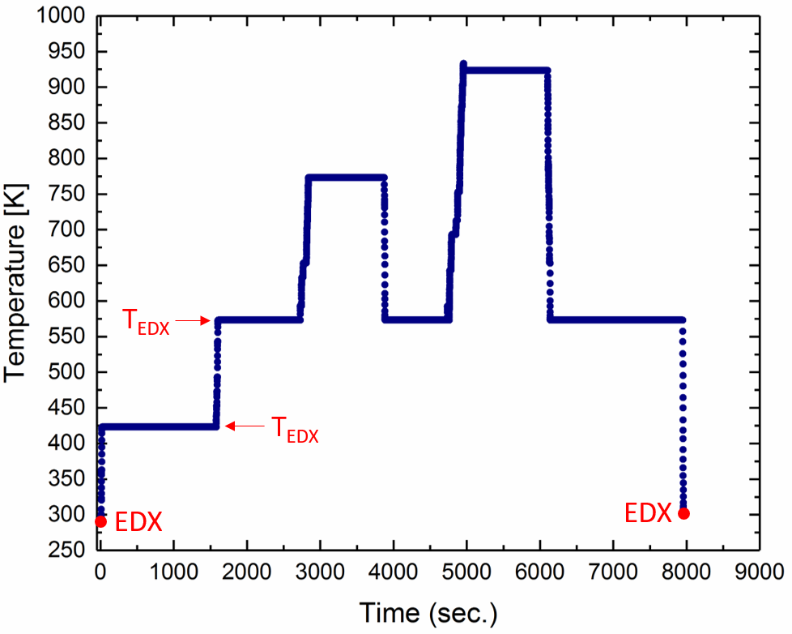

Fig. 1

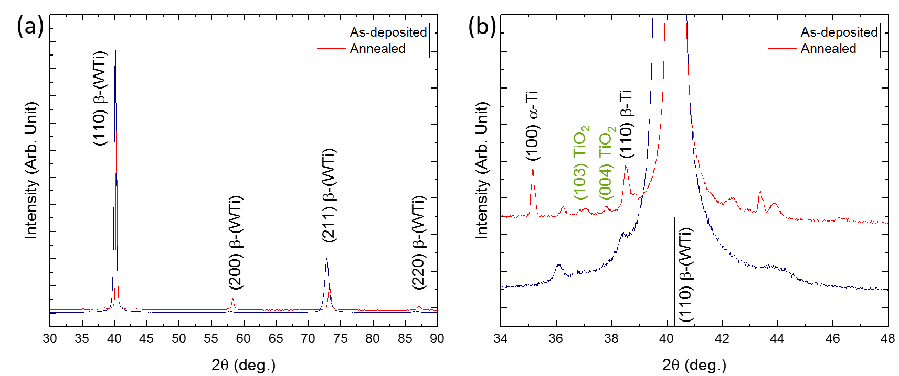

Fig. 2

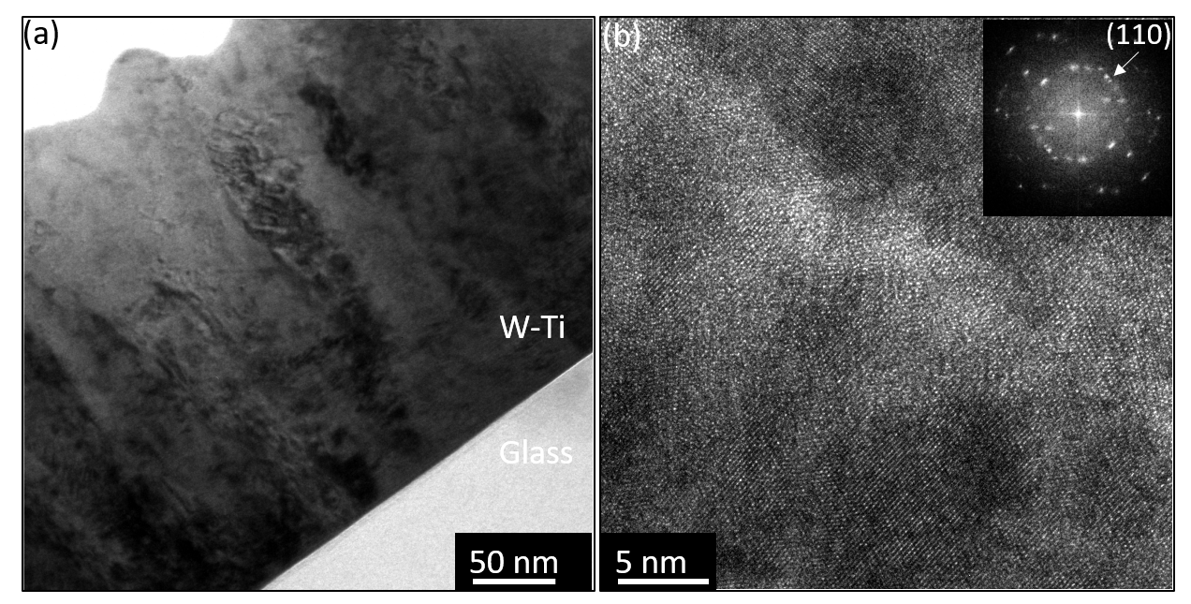

Fig. 3

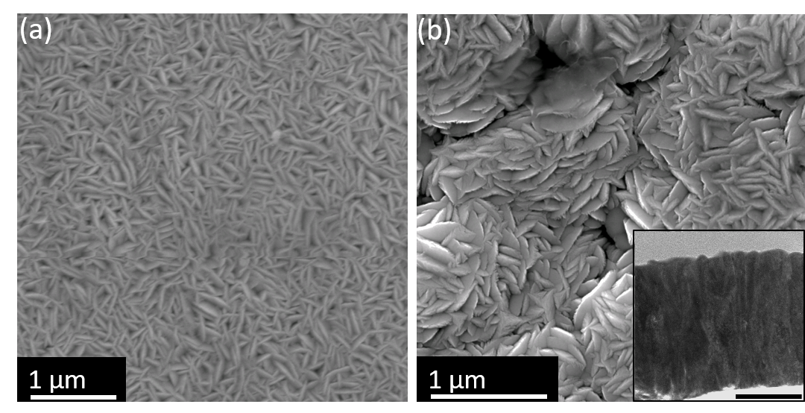

Fig. 4

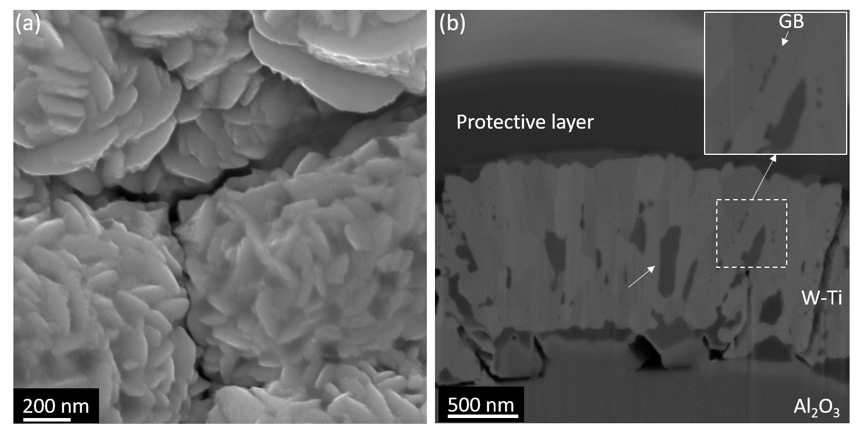

Fig. 5

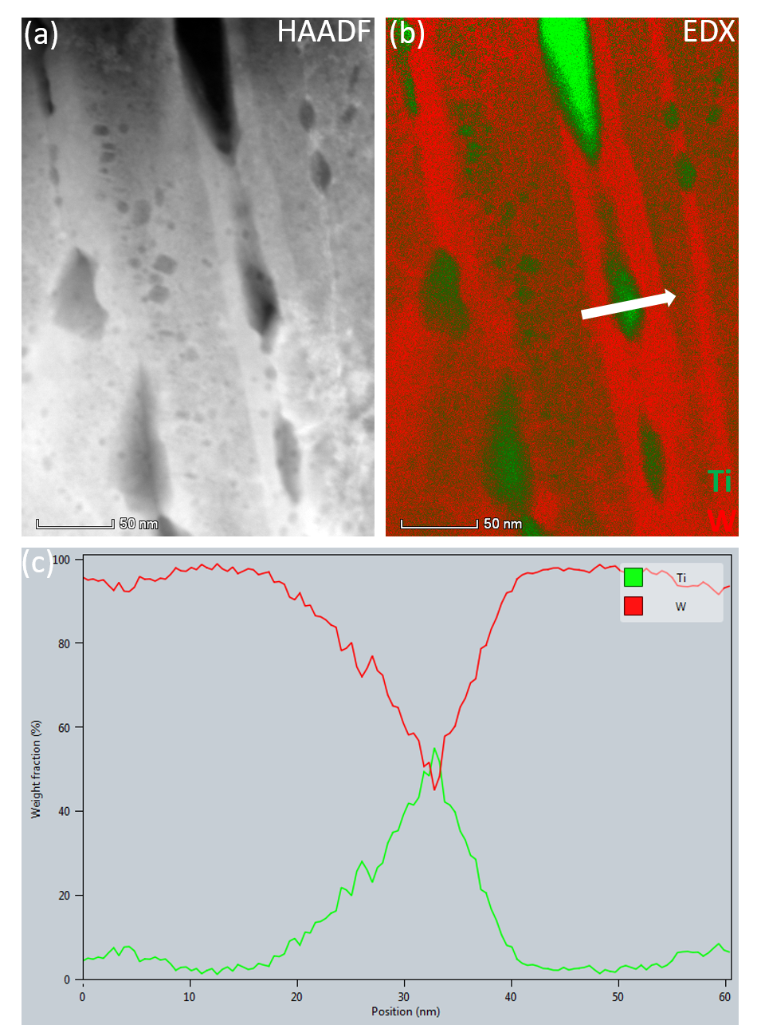

Fig. 6

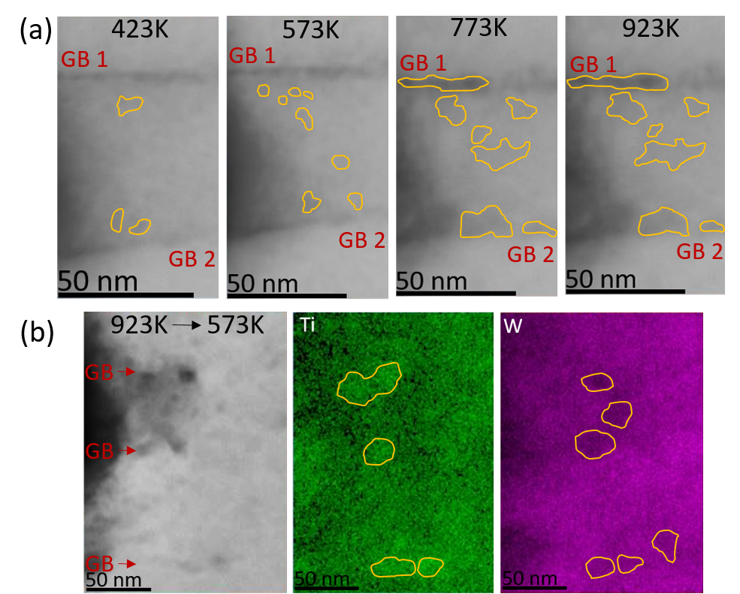

Fig. 7
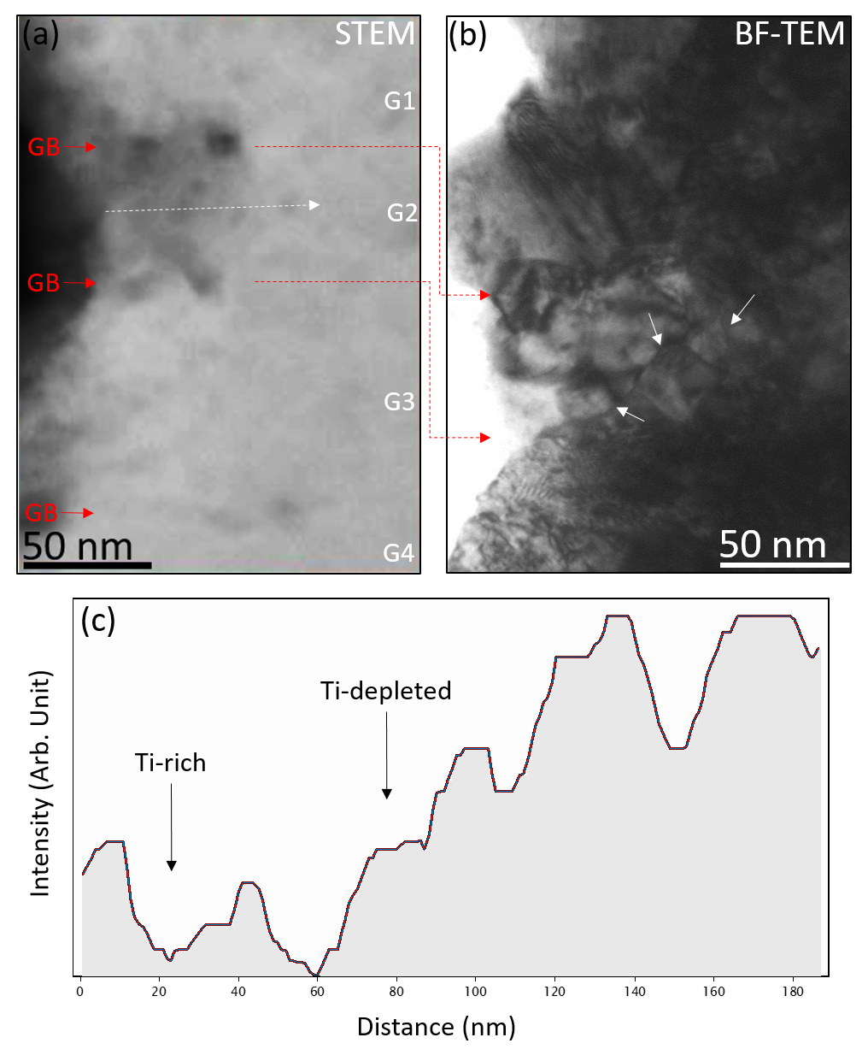
Fig. 8
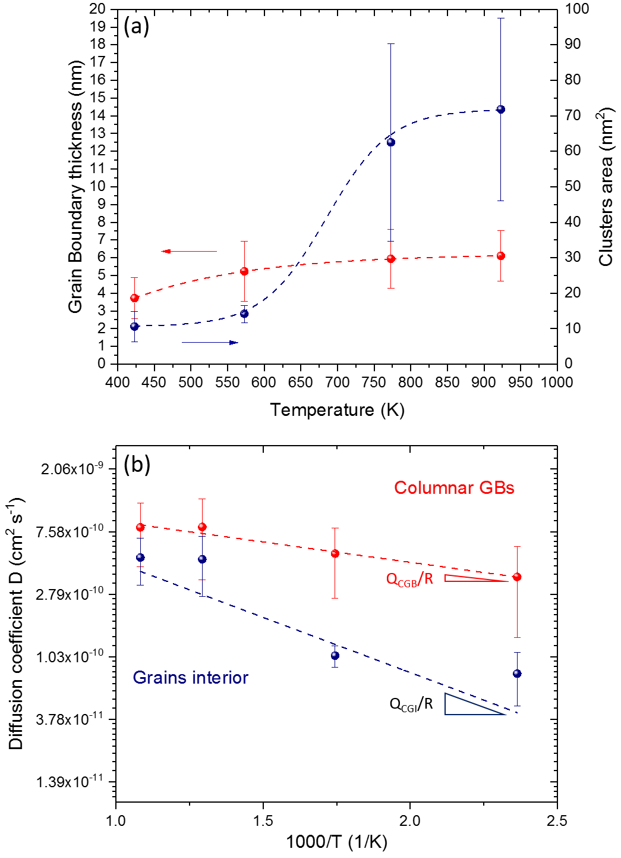

Fig. 9

