A low-angle detachment fault revealed: Three-dimensional images of the S-reflector fault zone along the Galicia passive margin
C. Nur Schuba^{1,*}, Gary G. Gray¹, Julia K. Morgan¹, Dale S. Sawyer¹, Donna J. Shillington², Tim J. Reston³, Jonathan M. Bull⁴, and Brian E. Jordan^{1, 5}
¹Department of Earth, Environmental and Planetary Sciences, Rice University, MS-126 Main Street, 77005, Houston, TX, USA.
²Lamont-Doherty Earth Observatory, Columbia University, 61 Route 9W, PO Box 1000, 10964-8000, Palisades, NY, USA.
³School of Geography, Earth and Environmental Sciences, University of Birmingham, Edgbaston, Birmingham, B15 2TT, UK.
⁴National Oceanography Centre Southampton, University of Southampton, Southampton, S014 3ZH, United Kingdom.
⁵BP America Inc., 501 WestLake Park Blvd., 23.126C, 77079, Houston, TX, USA.
*nur.schuba@rice.edu

ABSTRACT
A new 3-D seismic reflection volume over the Galicia margin continent-ocean transition zone provides an unprecedented view of the prominent S-reflector detachment fault that underlies the outer part of the margin. This volume images the fault's structure from breakaway to termination. The filtered time-structure map of the S-reflector shows coherent corrugations parallel to the expected paleo-extension directions with an average azimuth of 107°. These corrugations maintain their orientations, wavelengths and amplitudes where overlying faults sole into the S-reflector, suggesting that the parts of the detachment fault containing multiple crustal blocks may have slipped as discrete units during its late stages. Another interface above the S-reflector, here labelled S', is identified and interpreted as the upper boundary of the fault zone associated with the detachment fault. This layer, named the S-interval, thickens by tens of meters from SE to NW in the direction of transport. Localized thick accumulations also occur near overlying fault intersections, suggesting either non-uniform fault rock production, or redistribution of fault rock during slip. These observations have important implications for understanding how detachment faults form and evolve over time. 3-D seismic reflection imaging has enabled unique insights into fault slip history, fault rock production and redistribution.

- INTRODUCTION
Detachment faults are major structures in many extensional settings, accommodating many kilometers of displacement, particularly in regions of extreme crustal thinning (i.e. rift zones and continent-ocean transitions)(e.g. Davis and Lister, 1988; Escartín et al., 2008; John and Cheadle, 2010). Despite their importance, our knowledge of such large-displacement faults is incomplete. 2-D seismic profiles over passive margins (Lister et al., 1991; Reston, 2007; Osmundsen and Ebbing, 2009) and active rift zones (Flotté et al., 2005; Goodliffe and Taylor, 2007) confirm that these faults are widespread features characterized by pronounced reflections denoting significant property contrasts, but offer little insight into the internal structures and properties of such faults. Limited surface exposures and outcrops, in both subaerial and submarine settings, provide local windows into these faults (e.g. John, 1987; Cann et al. 1997, Florineth and Froitzheim, 1994; Manatschal and Nievergelt, 1997; Manatschal, 1999), revealing fault zone structure and morphology, but typically provide poor constraints on fault extents or spatial variability. In the absence of more comprehensive views of detachment faults and their variations, we are challenged to understand the full role that detachment faults play during crustal extension.
A new 3-D seismic reflection volume was collected in 2013 over the Galicia margin (Fig. 1), with the goal of imaging the structure of the continent-ocean transition zone. This area is underlain by the prominent S-reflector detachment fault (Reston, 1996). This new seismic volume has improved resolution compared to older 2-D data. It also covers the S-reflector detachment fault in full 3-D over a ~600 km² area. Thus, for the first time ever, we have the opportunity to peer into an extensive detachment fault to examine its first order 3-D structure, as well as variations in its characteristics, from breakaway to termination. These unique observations enable us to assess deformation processes, fault properties and evolution, with implications for extensional processes in similar settings around the world.

- GEOLOGIC SETTING AND THE S-REFLECTOR
The Deep Galicia passive margin was generated by amagmatic rifting and break-up between southern Europe and North America in three phases between Late Triassic to Aptian time (Boillot et al., 1989; Péron-Pinvidic et al., 2013; Tucholke et al., 2007). Rift-related structures are well preserved and readily imaged within this relatively sediment-starved margin (Reston et al., 1996; Dean et al., 2000; Whitmarsh et al., 2001; Borgmeyer, 2010). The majority of the late stage crustal thinning was accommodated by slip along the regional low-angle S-reflector detachment fault (Reston et al., 1996), which can be mapped over an area of ~2100 km² on 2-D seismic lines that span the margin (Borgmeyer, 2010). The S-reflector cuts through continental crust to the east, and places upper continental crust over serpentinized upper mantle to the west (Boillot et al., 1989; Reston, 1996; Reston et al., 1996; Bayrakci et al., 2016). The continental crustal blocks overlying the S-reflector show similarities to the rider blocks observed by Reston and Ranero (2011) and modeled by Choi et al. (2013).
The seismic character of the S-reflector has been constrained by waveform and trace analyses of 2-D reflection data (Reston, 1996; Leythaeuser et al., 2005). The continuous high reflection amplitude, positive polarity reflector denotes a sharp step increase in impedance, consistent with continental crust over serpentinized peridotite, further supporting the detachment fault interpretation (Reston, 1996). Leythaeuser et al. (2005) used 1-D full waveform inversion to tentatively identify a ~50-m-thick low-velocity zone immediately overlying the S-reflector. They interpreted this zone to represent serpentinized peridotite derived from the footwall and/or intensely damaged and brecciated hanging wall rocks.
The new seismic volume permits examination of this fault zone in 3-D and at higher resolution to ascertain if the characteristics noted above hold true over its entire extent, and what might account for any variations. In addition, the 3-D imaging provides a rare view into the 3-D morphology of a detachment fault zone over an extremely large area, something that has never been seen before.

- SEISMIC DATA AND RESULTS
The study area and footprint of the seismic survey are shown in Figure 1. The prestack time-migrated and noise-reduced 3-D seismic volume is 68 km wide (E-W) and 20 km long (N-S) with a 13 second record window. The data were collected using four 6-km streamers with a receiver spacing of 12.5 m. The acquisition azimuth was 87º. The polarity of the data is American-standard (a downward increase in acoustic impedance is displayed as a peak). Additional information about data acquisition and processing can be found in the supplementary information.
A representative section through the 3-D seismic volume is shown in Figure 2a. The S-reflector stands out prominently from its eastern breakaway that cuts through continental crust to where it abruptly loses reflection amplitude beneath a broad basin to the west. Rotated fault blocks above the S-reflector record crustal thinning accommodated by slip along the S-reflector. The S-reflector was interpreted in the time domain along the peak reflection amplitude of the deepest continuous high amplitude positive polarity reflection (Fig. 2b). This is consistent with other workers (de Charpal et al., 1978; Boillot et al., 1989; Reston et al., 1996; Leythaeuser et al., 2005; Borgmeyer et al., 2010). All interpretations were carried out with the Schlumberger software PetrelTM on every fifth inline and crossline. The resulting grids of horizon interpretation was then interpolated into continuous surfaces.
The time structure map of the resulting S fault surface reveals two distinct characteristics (Fig. 3a). Broad NNE-SSW oriented highs and lows correlate with the presence of rotated continental blocks that overlie the detachment fault. These high velocity crystalline rocks create velocity pull-up beneath them, in contrast to the lower velocity sedimentary units that lie in between the crustal blocks. These time-structure highs, therefore, are generally located between intersections with the overlying faults. In addition, smaller scale undulations, generally oriented NW-SE, are also present across the entire extent of the S fault surface. Their trends differ noticeably from the acquisition azimuth of 87°, confirming that they are not simply acquisition artifacts.
A spatial bandpass filter was applied to the surface to visually enhance the prominent NW-SE undulations on the S-reflector. This filter, with lower and higher limits of 80 m and 500 m, was used to remove both large wavelength fluctuations due to the velocity pull-up effect, and high frequency noise. The resulting map (Figs. 3b, S1) reveals the prominent NW-SE undulations, as linear corrugations in the S-reflector time structure. These corrugations are present across the entire S surface. The trends of the corrugations vary from 95° in the south, to 115° in the northwest, with an average azimuth of 107º. The crest-to-crest wavelengths of these corrugations range between 200-600 m, and their crestal lengths are 3-7 km. Interestingly, many of the corrugations appear to be co-linear and/or continuous across mapped fault intersections (Fig. 3b). The peak-to-trough heights of the corrugations are within the limits of detectability without being fully resolved (Sheriff, 1985; Simm and Bacon, 2004). They range from 10 to 20 ms, which correspond to ~25-50 m using the velocity determined by Leythaeuser et al. (2005).
A second interface associated with the S-reflector is also recognizable across the 3-D volume. This surface, here named S’, occurs as a more or less continuous negative polarity reflection above the S-reflector. The S’ reflection is seismically less coherent than S, because the absolute reflection amplitude is more variable and can be as little as one third of the S reflection amplitudes (Fig. 2b). The S and S’ surfaces while roughly conformable, are not parallel, with notable divergence in certain areas. The S-reflector seismic response is asymmetric, which strongly supports the interpretation that S’ is a distinct and independent reflection (Fig. 2b). In addition, locally there are resolvable internal reflectors in between the S and S’ reflections. We define the region between the S and S’ surfaces as the “S-interval”.
Figure 4 displays a close up of the S and S’ reflections and demonstrates how the S-interval thickness varies in profile view. Parallel to the corrugations, the lower reflection S remains relatively flat whereas S’ shows small divergences (Fig. 4a), causing variations in the S-interval thickness. The most notable divergence between the two reflections occurs at an overlying fault intersection at the detachment where S stays smooth and S’ has a broad undulation. This appears as an increase in the thickness of S-interval on the footwall side of the overlying fault. This is not always the case, the data reveal some areas where the hanging wall side contains thicker S-interval accumulation (Fig. S2). Perpendicular to the corrugation direction, both reflections show conformable undulations (Fig. 4b). As the surfaces are conformable, yet not parallel, S-interval thicknesses also show the striped corrugation pattern in map view.
The S-interval layer (Fig 3c) has an average time thickness of 22 ms, with a maximum of 90 ms, corresponding to ~60 m and ~230 m respectively, depth converted using the 5100 m/s interval velocity of Leythaeuser et al. (2005). The S-interval map displays subtle thickening from ~60 m in the east to ~75 m in the west. The eastern portion of the S-interval is at the limit of seismic resolution, based on the average instantaneous frequencies of 20 ± 5 Hz at the S-reflector (Widess, 1973). Thus, the thickness of the eastern zone of the S-interval may not be fully resolved and therefore might be thinner than 60 m. However, application of the wedge modeling by Widess (1973) indicates that an S-interval as thin as 1/20 of the resolution limit can be detected with these data.
In addition, the S-interval layer increases in thickness to the northwest, passing the seismic resolution limit, and demonstrates a statistically significant thickening with distance from the breakaway fault. The apparent thickening resolved by the data is on the order of tens of meters from east to west. Greater than average thicknesses are also observed in several localized areas. These typically occur in proximity to overlying fault intersections, as well as aligned with some of the more prominent corrugations (Figs 2b and 4).

- DISCUSSION
  - Fault surface morphology
Many fault exposures reveal distinct corrugations at many scales (Cann et al., 1997; Sagy et al., 2007; Collettini et al., 2014). Such grooves and ridges are thought to result from non-uniform abrasive wear during slip (e.g. de Saracibar and Chiumenti, 1999). As such, these corrugations are interpreted to be slip indicators, at least for the most recent phase of slip (Roberts and Ganas, 2000; Ganas et al., 2004). Although it is commonly assumed that such corrugations also occur on the unexposed fault surface, we now have compelling evidence that this is true across the entire imaged portions of the S-reflector (Figs 3 and 4). For the first time, we have gained a view of a coherent fault zone, for which both hanging wall and footwall are preserved, and that exhibits corrugations across its entire breadth.
The NW-SE trending corrugations on the S surface seem analogous to those described on exposed detachment fault surfaces within both continental and oceanic core complexes (e.g. John, 1997; Cann et al., 1997). The geometric characteristics of the S-reflector corrugations (length, amplitude, wavelength) fall into the ranges that are observed in continental and oceanic core complexes (e.g. John and Cheadle, 2010; Whitney et al., 2012), suggesting that they may have formed in similar ways.
Similar to core complex corrugations, we interpret the corrugations on the S-reflector to define the local slip directions on the detachment fault. As expected, the mean azimuth of 107º is parallel to the paleo-extension direction based on the orientation of the M0 marine magnetic anomaly (~125 Ma)(Whitmarsh et al., 1990; Shipboard Scientific Party, 2004). However, we see slight variations in the azimuths of the corrugations, from 95° south to 115° northwest, which suggest that the slip directions of the overlying fault blocks varied spatially (Fig 3b), as has been noted by others (e.g.. Lymer et al., 2017).
In several regions (in particular, areas A and B on Fig 3b), the S-reflector corrugations span the interpreted intersections with the overlying faults. The corrugations maintain their orientations, wavelengths and amplitudes, and are continuous and co-linear on either side of the fault intersections. This characteristic suggests that portions of the S-reflector detachment fault, containing multiple east-west neighboring crustal blocks in the hanging wall, slipped as a singular unit, at least during the final stages of the fault’s history.

  - “S-interval”
The structure and composition of major fault zones is of significant interest, as they provide insights into fault evolution (e.g. Cowan et al., 2003; Strating and Vissers, 1994), as well as constraints on fault strengths (Marone et al., 1990; Morrow et al., 2000). Previous studies (Reston et al., 1996) demonstrated that the prominent S-reflector defines a distinct compositional boundary, marked by a local low-velocity zone (Leythaeuser et al., 2005), consistent with a layer of serpentinized peridotite and/or damaged and brecciated hanging wall. The existence of the negative polarity S’ reflection above the S-reflector in the new seismic volume confirms that this low-velocity material is sandwiched between higher velocity rocks, perhaps analogous to the “fault core” of Caine et al. (1996), which can contain gouge, cataclasites and mylonites. Outcrops regarded as examples of fossil continent-ocean transition zones (e.g., Florineth and Froitzheim, 1994; Manatschal and Nievergelt, 1997) demonstrate a similar structure within their detachment fault zones.
The S-interval thickens subtly westward with distance away from the breakaway fault (Fig. 3c). To first order, this observation is consistent with models that call for increased gouge production with increased fault slip (Scholz, 1987; Shipton et al., 2006). However, the rate of thickening suggested by these data is considerably less than previous theoretical estimates that suggest fault zone thickening should be on the order of hundreds of meters for a fault cutting the entire crust and soling into a brittle-ductile transition (Handy et al., 2007; John and Cheadle, 2010; Whitney et al., 2012). In contrast, our data suggest an apparent increase in the average S-interval thickness of less than 20 meters over a 40 km distance (Fig. 5). The low fault zone thickening observed here may reflect lower magnitudes of brittle shear strain along this detachment fault than found in other settings. If the S-reflector formed along a rolling hinge (Spencer, 1984; Buck, 1988; Reston et al., 2007), then the brittle shearing responsible for fault rock production would be concentrated along shallower portions of the fault zone, possibly resulting in lower rates of fault zone thickening. In addition, low frictional resistance of serpentinite underneath the S-reflector may also have reduced the generation of fault rocks in this setting (Morrow, et al., 2000; Boulton et al., 2009).
Areas with greater than average fault rock thicknesses are present locally, however, particularly near the intersections of overlying faults (Figs 2b, 3c, and 4a). This suggests two possible scenarios: constant fault rock production coupled with redistribution during slip, or non-uniform, more localized fault rock production. In the first case, fault rock produced all along the detachment fault may have been mobilized during slip along the S-reflector, and subsequently concentrated near the intersections with overlying faults. Alternatively, fault rock production may have varied along the fault surface due to varying degrees of off-fault damage, or perhaps due to enhanced serpentinization of the footwall related to high rates of fluid flow along faults cutting the upper plate (e.g. Bayrakci et al., 2016).
As an accumulation of fault rock, the S-interval should preserve significant information about the full slip history along the S-reflector detachment fault, in contrast to the corrugations that may record largely the latest stages of slip. We suggest that during the early stages of slip along the S-reflector detachment, fault rock was produced somewhat uniformly along the fault, by plucking of material from the surrounding walls and comminution during shear strain (Scholz, 1984). Subsequently, local processes along the fault, such as uplift of the fault surface due to a rolling-hinge type mechanism, and with localized serpentinization enhanced by fluid flow along hanging wall fault zones (Bayrakci et al., 2016), may have served to concentrate the fault rocks in the thick zones that we observe in the S-interval map.

- IMPLICATIONS FOR GLOBAL DETACHMENT FAULTS
The well-developed corrugations on the S-reflector detachment fault record the kinematics of fault slip, although possibly biased toward the latest slip events. The alignment of the corrugations, their small and systematic variations in azimuth, and their continuity across some fault intersections, all suggest that large portions of the fault containing multiple crustal blocks likely slipped as discrete units. Lymer et al. (2017) also see evidence that packets of overlying crustal faults experienced coordinated slip, which could have produced these patterns. Such slip along a low-angle fault would have required very low shear strength, perhaps due to serpentinization or high pore fluid pressures along the fault. The apparent redistribution of fault zone material during slip, resulting in S-interval thickening parallel to corrugations and near fault intersections, also supports the low strength assumption. Weak, and possibly fluidized, fault rocks would be readily mobilized during shear to concentrate in regions of reduced stress (Cowan et al., 2003). We now see that this process can occur at very large scales as well as outcrop scale.
The gradient in fault zone thickening that we document along the S-reflector contrasts with the thickness predictions of Handy et al. (2007), John and Cheadle (2010), and Whitney et al. (2012), who estimate the fault rock thickening of crust-cutting detachment faults to be on the order of hundreds of meters. One factor that may account for the unusually thin fault rock is the presence of weak serpentinite in the footwall. This would reduce the frictional resistance along the detachment fault (Morrow, et al., 2000; Boulton et al., 2009), and decrease the plucking and damage of the wall rocks necessary to generate fault rocks. Thus, detachment faults that cut serpentinized mantle rocks may evolve differently than elsewhere, as serpentinite can create weaker faults, longer durations of activity, and relatively low thickening gradient of fault zones.
Large scale views such as provided here are necessary to resolve the details of fault slip history, fault rock production and distribution, and the controls on these factors. Importantly, our findings from this study of the 3-D seismic volume over the Deep Galicia margin can be paired with outcrop data to refine our understanding of low-angle fault evolution.

ACKNOWLEDGEMENTS
Support for this project was provided by National Science Foundation award OCE-1031769, UK Natural Environment Research Council award 276 NE/E016502/1 and GEOMAR Helmholz Centre for Ocean Research. We thank the crew of R/V Marcus G. Langseth. We are grateful for Repsol S.A. for preprocessing and prestack time migration of the dataset, Chevron E.T.C., especially Ranjan Dash and James Gibson, for carrying out the noise reduction of the data cube. We thank Schlumberger for providing Petrel licenses to Rice University. We also thank Roger W. Buck and one anonymous reviewer for their suggestions on improving this paper. C.N.S. would especially like to thank Mari Tesi Sanjurjo, Jonathan P. Schuba, John Cornthwaite and Tim Minshull for helpful discussions.

REFERENCES
Bayrakci, G., Minshull, T.A., Sawyer, D.S., Reston, T.J., Klaeschen, D., Papenberg, C., Ranero, C., Bull, J.M., Davy, R.G., Shillington, D.J., Pérez-Gussinyé, M., and Morgan, J.K., 2016. Fault-controlled hydration of the upper mantle during continental rifting. Nature Geoscience 9, 384-388, doi: 10.1038/ngeo2771.
Boillot, G., Feraud, G., Recq, M., and Girardeau, J., 1989. Undercrusting by serpentinite beneath rifted margins. Nature 341, 523-525, doi: 10.1038/341523A0.
Borgmeyer, A.L., 2010. Three-dimensional geometries of rifting on a hyperextended margin: Interpretation of seismic reflection profiles from the Deep Galicia Bargin, Iberia [MSc Thesis]: Rice University, 60 p.
Buck, W.R., 1988, Flexural rotation of normal faults. Tectonophysics 7, p. 959-973, doi: 10.1029/TC007i005p00959.
Caine, J.S., Evans, J.P., and Forster, C.B., 1996. Fault zone architecture and permeability structure. Geology 24, 1025-1028, doi: 10.1130/0091-7613(1996)024<1025:FZAAPS>2.3.CO;2.
Cann, J.R., Blackman, D.K., Smith, D.K., McAllister, E., Janssen, B., Mello, S., Avgerinos. E., Pascoe, A.R., and Escartín, J., 1997. Corrugated slip surfaces formed at ridge-transform intersections on the Mid-Atlantic Ridge. Nature 385, 329-332, doi: 10.1038/385329A0.
Collettini, C., Carpenter, B.M., Viti, C., Cruciani, F., Mollo, S., Tesei, T., Trippetta, F., Valoroso, L., and Chiaraluce, L., 2014. Fault structure and slip localization in carbonate-bearing normal faults: An example from the Northern Apennines of Italy. J. Struct. Geol. 67, 154-166, doi: 10.1016/J.JSG.2014.07.07.
Cowen, D.S., Cladouhos, T.T., and Morgan, J.K., 2003. Structural geology and kinematic history of rocks formed along low-angle normal faults, Death Valley, California. Geol. Soc. Am. Bull. 115, 1230-1248, doi: 10.1130/B25245.1.
Davis, G.A. and Lister, G.S., 1988. Detachment faulting in continental extension: Perspectives from the southwestern US Cordillera. Spec. Pap. Geol. Soc. Am., 218, 133-159, doi: 10.1130/SPE218-p133.
de Charpal, O., Guennoc, P., Montadert, L., and Roberts, D.G., 1978. Rifting, crustal attenuation and subsidence in the Bay of Biscay. Nature 275, 705-711, doi: 10.1038/275706A0.
de Saracibar, C.A. and Chiumenti, M., 1999. On the numerical modeling of frictional wear phenomena. Comput. Methods in App. Mech. Eng. 177, p. 401-426, doi: 10.1016/S0045-7825(98)00390-0.
Dean, S.L., Sawyer, D.S., Morgan, J.K., 2015. Galicia Bank ocean-continent transition zone: New seismic reflection constraints. Earth Planet. Sci. Let. 413, 197-107, doi: 10.1016/j.epsl.2014.12.045.
Dean, S.M., Minshull, T.A., Whitmarsh, R.B., and Louden, K.E., 2000. Deep structure of the ocean-continent transition zone in the Iberia Abyssal Plain from seismic refraction profiles: The IAM-9 transect at 40°20’N. J. Geophys. Res. 105, 5859-5885, doi: 10.1029/1999JB900301.
Escartín, J., Smith, D.K., Cann, J., Schouten, H., Langmuir, C.H., and Escrig, S., 2008. Central role of detachment faults in accretion of slow-spreading oceanic lithosphere. Nature 421, 790–794, doi: 10.1038/nature07333.
Florineth, D. and Froitzheim, N., 1994. Transition from continental to oceanic basement in the Tasna nappe (Engadine window, Graubünden, Switzerland): evidence for Early Cretaceous opening of the Valais ocean. Schweiz. Mineral. Petrogr. Mitt. 74, 473-448.
Flotté, N., Sorel, D., Müller, C., Tensi, J., 2005. Along strike changes in the structural evolution over a brittle detachment fault: Example of the Pleistocene Corinth–Patras rift (Greece). Tectonophysics 403, 77-94, doi: 10.1016/j.tecto.2005.03.015.
Ganas, A., Pavlides, S.B., Sboras, S., Valkaniotis, S., Papaioannou, S., Alexandris, G.A., Plessa, A., Papadopoulos, G.A., 2004. Active fault geometry and kinematics in Parnitha Mountain, Attica, Greece. J. Struct. Geol. 26, 2103-2118, doi: 10.1016/J.JSG.2004.02.015.
Goodliffe, A.M. and Taylor, B., 2007. The boundary between continental rifting and sea-floor spreading in the Woodlark Basin, Papua New Guinea, in Karner G.D. Manatschal, G., and Pinheiro, L.M. (Eds.), Imaging, Mapping and Modelling Continental Lithosphere Extension and Breakup. Geological Society, London, Special Publications 282, pp. 217-238, doi: 10.1144/SP282.11.
Handy, M.R., Hirth, G., and Bürgmann, R., 2007. Continental Fault Structure and Rheology from the Frictional-to-Viscous Transition Downward, in Tectonic Faults: Agents of Change on a Dynamic Earth, Cambridge, MA, p. 139-181.
John, B.E., 1987. Geometry and evolution of a mid-crustal extension fault system: Chemehuevi Mountains, southeastern California. Geol. Soc. London Spec. Pap. 28, 313-335, doi: 10.1144/GSL.SP.1987.028.01.20.
John, B.E. and Cheadle, M.J., 2010. Deformation and Alteration Associated with Oceanic and Continental Detachment Fault Systems: Are They Similar?, in: Rona, P.A., Devey, C.W., Dyment, J., and Murton, B.J. (Eds.), Diversity of Hydrothermal Systems on Slow Spreading Ocean Ridges. Geophys. Monogr. Ser. 188, Washington D.C., pp. 175-205, doi: 10.1029/2008GM000772.
Leythaeuser, T., Reston, T.J. and Minshull, T.A., 2005. Waveform inversion of the S reflector west of Spain: Fine structure of a detachment fault. Geophys. Res. Let. 32, L22304, doi: 10.1029/2005GL024026.
Lister, G.S., Etheridge, M.A., and Symonds, P.A., 1991. Detachment models for the formation of passive continental margins. Tectonics 10, 1038–1064, doi: 10.1029/90TC01007.
Lymer, G., Cresswell, D., Reston, T., Stevenson, C., Bull, J., Sawyer, D., Morgan, J, and the Galicia 3D working Team, 2017. The Continent-Ocean transition across the Galicia margin: First observations from the Galicia 3D volume. In EGU General Assembly, v. 19, EGU2017-16059.
Manatschal, G. and Nievergelt, P., 1997. A continent-ocean transition recorded in the Err and Platta nappes (Eastern Switzerland). Eclogae Geol. Helv. 90, p. 3-27.
Manatschal, G., 1999. Fluid- and reaction-assisted low-angle normal faulting: Evidence from rift-related brittle fault rocks in the Alps (Err Nappe, eastern Switzerland): J. Struct. Geol. 21, p. 777-793, doi: 10.1016/S0191-8141(99)00069-3.
Marone, C., Raleigh, C.B., and Scholz, C.H., 1990. Frictional Behavior and Constitutive Modeling of Simulated Fault Gouge. J. Geophys. Ress. 95, 7007-7025, doi: 10.1029/JB095iB05p07007.
Morrow, C.A., Moore, D.E., and Lockner, D.A., 2000. The effect of mineral bond strength and absorbed water on fault gouge frictional strength. Geophys. Res. Let. 27, 815-818, doi: 10.1029/1999GL008401.
Osmundsen, P.T. and Ebbing, J., 2009. Detachment faults at passive margins: examples from Norway. In EGU General Assembly Conference Abstracts 11, p. 5828.
Péron-Pinvidic, G., Manatschal, G. and Osmundsen, P.T., 2013. Structural comparison of archetypal Atlantic rifted margins: A review of observations and concepts. Mar. Pet. Geol. 43, 21-47, doi:10.1016/j.marpetgeo.2013.02.002.
Ranero, C.R. and Pérez-Gussinyé, M., 2010. Sequential faulting explains the asymmetry and extension discrepancy of conjugate margins. Nature 468, 294-299, doi: 10.1038/nature09520.
Reston, T.J., 1996. The S reflector west of Galicia: the seismic signature of a detachment fault. Geophys. J. Int. 127, 230-244, doi: 10.1111/j.1365-246X.1996.tb01547.x
Reston, T.J., Krawczyk, C.M. and Klaeschen, D., 1996. The S reflector west of Galicia (Spain): Evidence from prestack depth migration for detachment faulting during continental breakup. J. Geophys. Res. 101, 8075-8091, doi: 10.1029/95JB02466.
Reston, T.J., 2005. Polyphase faulting during the development of the west Galicia rifted margin. Earth Planet. Sci. Let. 237, 561-576, doi: 10.1016/j.epsl.2005.06.019.
Reston, T.J., 2007. The formation of non-volcanic rifted margins by the progressive extension of the lithosphere: the example of the West Iberian margin, in: Karner, G.D, Manatschal, G., and Pinheiro, L.M. (Eds.), Imaging, Mapping and Modelling Continental Lithosphere Extension and Breakup. Geological Society, London, Special Publications 282, pp .77-110, doi: 10.1144/SP282.5.
Reston, T.J., Leythaeuser, T., Booth-Rea, G., Sawyer, D, Klaeschen, D., and Long, C., 2007. Movement along a low-angle normal fault: The S reflector west of Spain. Geochem. Geophys. 8, 1-14, doi: 10.1029/2006GC001437.
Reston, T.J. and Ranero, C.R., 2011. The 3-D geometry of detachment faulting at mid-ocean ridges. Geochem. Geophys. 12, 1-19, doi: 10.1029/2011GC003666.
Roberts, G.P., and Ganas, A., 2000. Fault-slip directions in central and southern Greece measured from striated and corrugated fault planes: Comparison with focal mechanism and geodetic data: J. Geophys. Res. 105, 23443–23462, doi: 10.1029/1999JB900440.
Sagy, A., Brodsky, E.E., and Axen, G.J., 2007. Evolution of fault-surface roughness with slip. Geology 35, 283-286, doi: 10.1130/G23235A.1.
Scholz, C.H., 1987. Wear and gouge formation in brittle faulting. Geology 15, 493-495, doi: 10.1130/0091-7613(1987)15<493:WAGFIB>2.0.CO;2.
Sheriff, R. E., 1985. Aspects of Seismic Resolution: Chapter 1 in Seismic Stratigraphy II: An Integrated Approach to Hydrocarbon Exploration in: Berg O.R. and Woolverton D.G. (Eds.), AAPG Memoir 39, p. 1-10.
Shipboard Scientific Party, 2004. Leg 210, in: Tucholke, B.E. and Sibuet, J.C. (Eds.), Proceedings of the Ocean Drilling Program 210, Initial Reports: College Station, TX, p. 1-78.
Shipton, Z.K., Soden, A.M., Kirkpatrick, J.D., Bright, A.M., and Lunn, R.J., 2006. How thick is a fault? Fault displacement-thickness scaling revisited in Abercrombie, R., McGarr A., DiToro, G., and Kanamori, H. (Eds.), Earthquakes: Radiated energy and the physics of faulting, pp. 193-198, doi: 10.1029/170GM19.
Simm, R. and Bacon, M., 2004. Seismic Amplitude: An Interpreter's Handbook: Cambridge, Cambridge University Press, 283 p.
Spencer, J.E., 1984. The role of tectonic denudation in the warping and uplift of low-angle normal faults. Geology 12, 95-98, doi: 10.1130/0091-7613(1984)12<95:ROTDIW>2.0.CO;2.
Strating, E.H.H. and Vissers, R.L.M., 1994. Structures in natural serpentinite gouges. J. Struct. Geol. 16, 1205-1215, doi: 10.1016/0191-8141(94)90064-7.
Tucholke, B.E., Sawyer, D.S. and Sibuet, J.C., 2007. Breakup of the Newfoundland Iberia rift, in: Karner, G.D., Manatschal, G., and Pinheiro, L.M. (Eds.), Imaging, Mapping and Modelling Continental Lithosphere Extension and Breakup: Geological Society, London, Special Publication 282, p. 9-46, doi: 10.1144/SP282.2.
Whitmarsh, R.B., Miles, P.R., and Mauffret, A., 1990. The ocean-continent boundary off the western continental margin of Iberia, I. Crustal structure at 40°30'N. Geophys. J. Int. 103, 509-531, doi: 10.1111/j.1365-246X.1990.tb01788.x.
Whitney, D.L., Teyssier, C., Rey. P., and Buck, W.R., 2012. Continental and oceanic core complexes, Geol. Soc. Am. Bull. 125, p. 273-298, doi: 10.1130/B30754.1.
Widess, M. B., 1973. How thin is a thin bed?, Geophysics 38, 1176-1180, doi: 10.1190/1.440403.
FIGURE CAPTIONS
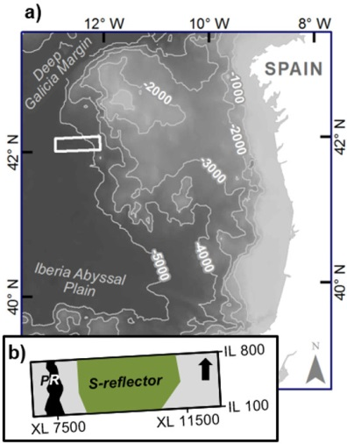

Figure 1. a) Survey location over Galicia margin located west of Spain. White box shows the location of 3-D seismic reflection survey. b) Enlarged view of survey area, showing 600 km² areal extent of S-reflector within seismic volume. PR: peridotite ridge, IL: inline, XL: crossline. [1 COLUMN]
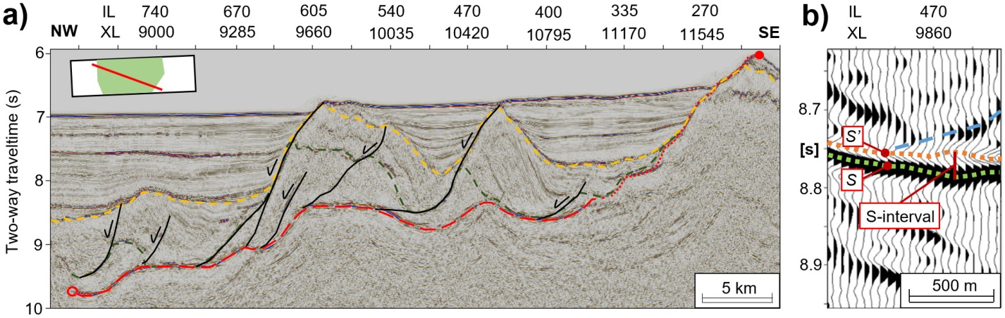
Figure 2. a) Representative seismic reflection profile across 3-D volume. Dashed red line denotes S-reflector. Black lines are major normal faults that offset crustal blocks and sole into S-reflector. Dashed green lines are interpreted top of continental crust, and dotted yellow line separate syn-rift and post-rift sediments. Closed red circle in the SE denotes S-reflector breakaway, open red circle denotes S-reflector termination. Top left inset shows location of seismic line. b) Trace display of S-reflector-related surfaces. The S-interval shows two distinct reflections with varying spacing. Deepest coherent reflection (positive polarity, green) correlates with S-reflector detachment fault of Reston (1996). Shallower negative polarity reflection (orange), S’, defines top of S-interval fault zone. Section shows S-interval thickening beneath footwall side of overlying fault block. Overlying fault interpreted in blue dashed line. IL: inline, XL: crossline. [2 COLUMNS]
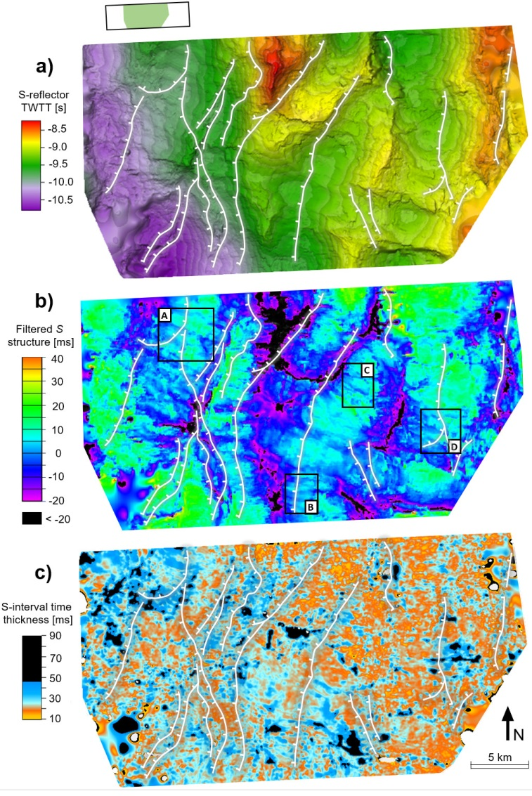
Figure 3. a) Shaded-relief time structure map of S surface illuminated from the northwest. b) Bandpass-filtered time structure of S surface with wavelengths >500 m and <80 m removed. Color values cropped at -20 ms. Negative values denote shallower structures. Boxes labeled A-D show examples of areas where corrugations are well defined. Corrugations maintain their continuity across fault intersections in bands A, B and D. See Fig. S1 for detail. c) S-interval time thickness map. Mean time thickness is 22 ms with a corresponding average thickness of ~60 m. S-interval is thinner over eastern half of the zone compared to western portion. Dotted white lines denote interpreted intersections between overlying faults and S-reflector. Inset at top left shows location of mapped surface in 3-D volume. Arrow denotes north. [FULL PAGE]
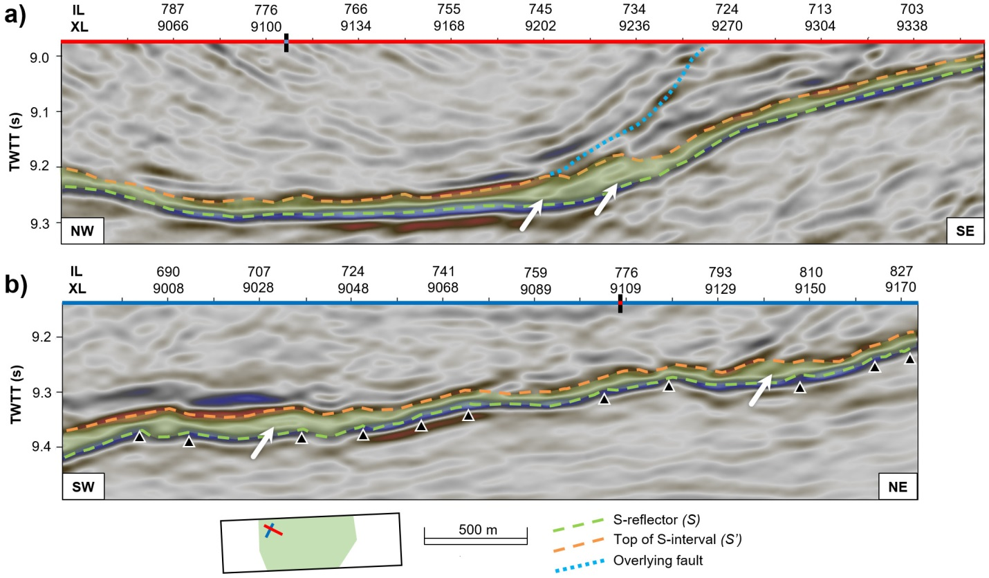
Figure 4. Representative seismic reflection profiles across NW portion of S-reflector in orientations parallel (a) and perpendicular (b) to the corrugations. Dashed green and orange lines represent S and S’ surfaces, respectively. Shaded green area denotes S-interval. Dotted blue line represent normal faults that sole into S-reflector. (a) displays fault zone thickening in the footwall side of the overlying fault. Black triangles are crests of corrugations. White arrows show internal reflections within S-interval. Inset shows location of seismic lines. IL: inline, XL: crossline, TWTT: two-way traveltime. [LANDSCAPE FULL PAGE]

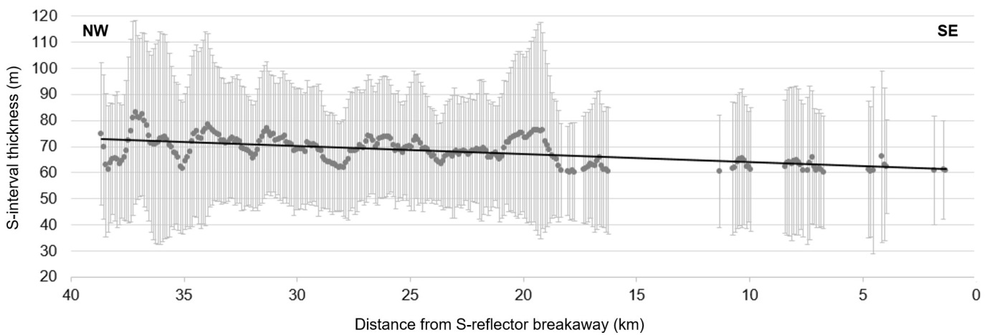
Figure 5. S-interval thicknesses projected onto the direction of transport, determined from average corrugation azimuth of 107º (orientation of seismic line in Fig 2a). Gray points denote values binned at every 200 m interval, including all data points. Error bars show standard deviation within each bin. The thicknesses displayed are only those above calculated seismic resolution. Black line shows the best linear fit across all data points. An interval velocity of 5100 m/s (Leythaeuser et al., 2005) was used to convert time-thicknesses to true thickness. There is an apparent resolvable thickening of ~15 m. [2 COLUMNS]

