A Bayesian Analysis of Design Parameters in Survey Data Collection

Barry Schouten¹, Nino Mushkudiani², Natalie Shlomo³, Gabi Durrant⁴, Peter Lundquist⁵ and James Wagner⁶
¹ Statistics Netherlands, PO Box 24500, 2490 HA The Hague, The Netherlands (email:
jg.schouten@cbs.nl) & University of Utrecht, Padualaan 14, 3584 CH Utrecht, The Netherlands
² Statistics Netherlands, PO Box 24500, 2490 HA The Hague, The Netherlands (email: n.mushkudiani@cbs.nl)
³ Social Statistics, School of Social Sciences, University of Manchester, Humanities
Bridgeford Street, Manchester, M13 9PL, United Kingdom (e-mail:
natalie.shlomo@manchester.ac.uk)
⁴ Department of Social Statistics and Demography, School of Social Sciences, University of Southampton, Building 58, Highfield, Southampton, SO17 1BJ (email: g.durrant@soton.ac.uk)
⁵ Statistics Sweden, Box 24300, 104 51 Stockholm (email: peter.lundquist@scb.se)
⁶ Survey Research Center, Institute of Social Research, University of Michigan, 500 S. State St., Ann Arbor, Michigan, 48109, United States (email: jameswag@umich.edu)

Abstract: In the design of surveys a number of input parameters, such as contact propensities, participation propensities and costs per sample unit, play a decisive role. In on-going surveys, these survey design parameters are usually estimated from previous experience and updated gradually with new experience. In new surveys, these parameters are estimated from expert opinion and experience with similar surveys. Although survey institutes have a fair expertise and experience, the postulation, estimation and updating of survey design parameters is rarely done in a systematic way. This paper presents a Bayesian framework to include and update prior knowledge and expert opinion about the parameters. This framework is set in the context of adaptive survey designs in which different population units may receive different treatment given quality and cost objectives. For this type of survey, the accuracy of design parameters becomes even more crucial to effective design decisions. The framework allows for a Bayesian analysis of the performance of a survey during data collection and in between waves of a survey. We demonstrate the utility of the Bayesian analysis using a simulation study based on the Dutch Health Survey.

Number of words: 7678 (excluding abstract, acknowledgements, tables, figures, appendices, references)

Acknowledgements
This work was supported by the United Kingdom Leverhulme Trust International Network Grant (reference number: IN-2014-046): Bayesian Adaptive Survey Design Network (BADEN) (January 2015 to December 2017). The participating institutions are the Universities of Manchester (coordinator), Michigan and Southampton, and RTI, Statistics Sweden, US Census Bureau and Statistics Netherlands.

1. Introduction
Over the last two decades, there has been an increasing interest in survey data collection monitoring, analysis, and intervention or adaptation. The main drivers for this are the diversification of data collection that followed the emergence of online communication, the lack of predictability of survey response propensities despite years of research into survey design, the gradual increase in costs per respondent when response rates are kept at traditional levels, and the availability of a wide range of data collection process data (termed paradata). See, for instance, Kreuter (2013) to get a view on research aiming at a deeper understanding of data collection processes. In a changing survey data collection environment with unpredictable, and, hence, only partially controllable outcomes, a close watch at the progress of data collection is imperative. For this purpose, timely and accurate estimates of survey design parameters, such as contact propensities, participation propensities, costs per contact and costs per interview, are needed.
These developments paved the way for survey designs that adapt or tailor strategies and effort to known and relevant characteristics of sampled units from the target population. Such designs we term adaptive, see Groves and Heeringa (2006), Wagner (2008) and Schouten, Calinescu and Luiten (2013). In order to adapt, accurate estimates of survey design parameters are needed at the deeper level of population subgroups. This higher resolution puts a pressure on the accuracy of such parameter estimates. Burger, Perryck and Schouten (2016) analysed the performance of adaptive survey designs under inaccurate design parameter estimates and concluded, not surprisingly, that biased parameter estimates may lead to suboptimal, and, consequently, inefficient designs.
A natural approach to evaluate inaccuracy of survey design parameters and to account for the uncertainty in the optimization of survey design is through Bayesian analysis (Gelman et al 2014). In such an analysis, survey design parameters are treated as random variables and are assigned prior distributions, which are then updated and transformed to posterior distributions during data collection. These posterior distributions may be used as prior distributions in new waves of the same survey. The added benefit is that prior distributions may also be elicited from expert judgment, so that historic survey data in one survey may also be re-used in other surveys. Other advantages of using a Bayesian approach is that we are able to account for the uncertainty in survey design parameters and any function of these parameters. In addition, we are able to obtain distributional estimates, such as percentiles, which can be used to develop other types of quality indicators for monitoring adaptive survey designs.
Despite these advantages, Bayesian analysis of survey data collection is rarely done and literature is very thin. An exception is Schafer (2013). Reasons for this absence may be that a Bayesian analysis is not straightforward, conceptually and/or computationally, that the added value may be unclear to survey designers and that the elicitation of prior distributions is complex and cumbersome in practice. Therefore, we have the following objectives:
- To set up (sufficiently general) models for survey design parameters;
- To introduce a Bayesian analysis of survey design parameters;
- To introduce a Bayesian analysis of quality and cost indicators based on survey design parameters, and;
- To evaluate under what conditions a Bayesian analysis has added value;
We show that a Bayesian analysis can be set up and can be applied to a variety of survey designs. Our focus on overall quality and cost indicators is motivated by the desire to ultimately adapt data collection strategies to different population subgroups. To reach this goal, we include linked auxiliary data and paradata in models for survey design parameters. The main objective here, however, is to showthat Bayesian analysis can be effective in monitoring and analysis of survey data collection and demonstrate how a Bayesian approach can be used through a particular set of model assumptions. We emphasize the generalizability of the methodology where other model assumptions can be used.
A Bayesian analysis of data collection is by itself not novel. There is a vast literature in biostatistics and medical statistics that presents methodology to monitor and optimize treatments using prior knowledge or beliefs. There is a close resemblance to dynamic treatment regimes and continual re-assessment methods in clinical trials (e.g. Heyd and Carlin 1999, O’Quigley and Shen 1996, Murphy 2003 and 2005, Scharfstein, Daniels and Robins 2003, and Schulte et al 2014). An application to survey data collection is, however, novel and introduces three specific elements: a multi-dimensionality of survey target variables, a very explicit focus on data collection costs, and a multitude of quality indicators describing different survey errors. In the analysis, we assume that survey data collection consists of a series of phases for which costs and quality are evaluated separately and cumulatively, including all outcomes up to a current phase. Per phase, survey design parameters are defined and are assigned prior distributions. A Gibbs sampler with data augmentation is applied to derive posterior distributions.
The explicit presentation of uncertainty in survey design parameter values is an advantage of Bayesian analysis by itself. However, a Bayesian analysis has even more added value when the inclusion of prior knowledge from historic survey data and expert knowledge provides stronger guidance to design decisions than a non-Bayesian analysis. In order to prove this, we take two approaches in a simulation study linked to the Dutch Health Survey: We gradually misspecify the locations of the prior distributions and gradually increase the variance of the prior distributions. We do this to analyze if, and when, the prior information is too weak to be of use, and may just as well be replaced by a fully non-informative prior distribution.
A natural subsequent step is to adapt survey design within the Bayesian analysis framework. In order to be able to do so, a range of strategies needs to be randomized and available. We discuss randomization of strategies in the Bayesian analysis and we distinguish contact and participation in obtaining response, but we leave actual optimization to future papers.
We focus in this paper on adaptive survey design with the objective to minimize nonresponse error. Survey design parameters associated with measurement error, e.g. the adjusted mode effect, are out of scope in this paper. We refer to Calinescu (2013) and Calinescu and Schouten (2015) for designs incorporating both types of survey errors.
This paper has three main sections: In section 2, we describe the various adaptive survey design strategies and link them to response propensities and costs, the survey design parameters of interest. In section 3, we break down the response propensities and costs into their basic components, e.g. contact propensities and cost components per call, present models for these components and assign prior distributions. Apart from the survey design parameters themselves, we also consider a number of functions of these parameters like the response rate, overall costs and coefficient of variation of the response propensities. In section 4, we investigate the utility of Bayesian analysis through a simulation study on the Dutch Health Survey and close with a discussion in section 5.

2. Adaptive strategies and design parameters
In this section, we provide the necessary background for the models of section 3.

2.1 Types of strategies and notation
The design of each survey has a range of features, e.g. sample design, advance letter, contact protocol, screener interview, number of phases, reminder protocol, use of incentive, mode of administration, interviewer, refusal conversion procedure and type of questionnaire. The total of choices made for the design features is called a data collection strategy or simply strategy. In non-adaptive survey designs, these features are implemented uniformly over the whole sample, i.e. there is one strategy. In adaptive survey designs, part of the design features may be implemented differently for different sample units, i.e. there is a set of strategies. See for example Groves and Heeringa (2006), Wagner (2008), Coffey, Reist and White (2013) and Schouten, Calinescu and Luiten (2013).
Different sample units may be distinguished based on linked auxiliary data from the sampling frame or administrative data, from paradata obtained during data collection, and/or from survey data from previous waves in longitudinal or panel settings. In analogy to clinical trials, e.g. Scharfstein, Daniels and Robins (2003) and Murphy (2003 and 2005), an adaptive strategy based on auxiliary data available at the start of data collection is called static and an adaptive strategy based (also) on auxiliary data collected during data collection is called dynamic. In our implementation, it is decided beforehand what strategy is applied to each sample case when all auxiliary data are available. Hence, at the start of data collection, we may not know the exact strategy since it depends on paradata, but once it becomes available the action is fixed. As an example, we may make the decision a priori that young males that do not respond to the web questionnaire should receive a face-to-face interview only if there was an attempt to respond to the web questionnaire. We only know if there was such an attempt after the start of the data collection.
For a subject $i$ in the sample, we let $x_{i}$ be the vector of auxiliary variables. We suppose the auxiliary vector of subject $i$ consists of the following entries
$x_{i}=(x_{0,1,i},…,x_{{0,m}_{0},i},…,x_{T,1,i},…,x_{T,m_{T},i})^{'}$,
where $x_{0,i}=(x_{0,1,i},…,x_{{0,m}_{0},i})'$ contains the $m_{0}$ auxiliary variables available at the start of data collection, and $x_{t,i}=(x_{t,1,i},…,x_{t,m_{t},i})^{'}$ are the auxiliary variables that are observed for the sample units in phase $t$. Typical auxiliary variables available at the start of data collection are those variables that may be linked to the sample frame from a register, such as age and gender. Auxiliary variables that are observed for sample units in phase t are typically paradata that have been collected to inform the data collection process, such as the number of contact attempts or whether the respondent ‘broke-off’ connection when responding to a web questionnaire.
Let the survey design consist of a maximum of $T$ phases, labelled $t=1,2,…,T$. (The use of the character $t$ for the phase does not necessarily indicate it is related to time.) We define $S_{t}$ as the collection of all possible actions in phase $t$ and let $s_{t}$ represent the action taken in phase $t$. Possible actions may include: moving from a web questionnaire to a face-to-face interview or stopping contact attempts. We define the total collection of possible actions: $S≔\bigcup_{t=1}^{T}{S_{t}}$. The action sets may contain $s_{∅}$, which, if selected, implies that no attempt is made to obtain a response. We define the collection of survey strategies from phase 1 to $T$
$$S_{1,T}:=\left\{\left(s_{1},…,s_{T}\right):s_{t}∈S_{t},t=1,2,…,T\right\}$$
and let $s_{1,T}∈S_{1,T}$ denote one possible strategy, i.e. sequence of actions from phase 1 through phase T.

2.2 Survey design parameters
Adaptive survey designs either maximize a quality objective subject to cost constraints and other quality constraints or minimize a cost objective subject to quality constraints. The quality and cost constraints depend on the setting in which the survey is conducted, but may concern any survey error. Three sets of survey design parameters suffice to compute most of the quality and cost constraints:
- Response propensities, $ρ_{T,i}(s_{1,T})$, per unit $i$ and strategy $s_{1,T}$;
- Costs, $C_{T,i}(s_{1,T})$, per unit $i$ and strategy $s_{1,T}$;
- Strategy-specific bias on a specified key survey outcome variable, $D_{i}\left(s_{1,T}\right)$, per unit $i$ and strategy $s_{1,T}$ relative to a benchmark strategy;
In this paper, we concentrate on nonresponse and costs and, to keep the scope manageable, we do not model key survey variables. For this reason, we do not consider the third set of parameters, the strategy-specific biases relative to a benchmark strategy. We leave this to future research.
There are two options in defining and modeling survey design parameters: the stratum or subgroup level, and the individual sample unit level. The first option implies that the average response and costs in a stratum are modeled, i.e. addressing variation within such strata, whereas the second option implies that models for individual units are created. The two options, essentially, represent two main approaches in adaptive design, stratum allocation and case prioritization, e.g. Peytchev et al (2010), Wagner et al (2013), Rosen et al (2014), Luiten and Schouten (2013), Särndal and Lundquist (2014) and Schouten and Shlomo (2015). In this paper, we model individual design parameters, since it offers more flexibility. Any stratification may still be applied afterwards and stratum design parameters may be derived from the individual propensities and cost functions.

3. Modeling survey design parameters
We construct hierarchical Bayes models for response propensities and costs per sample unit and assign prior distributions to the parameters in these models.

3.1 Decomposition of survey design parameters
We give basic models for response propensities and costs. We break down these parameters into their basic components: contact propensities and costs and participation propensities and costs. Other outcomes than contact, non-contact, and refusal/participation are possible and can be included in a relatively straightforward way. However, the number of parameters to be estimated increases with each outcome that we include.
We make two general assumptions: First, we assume that making contact, obtaining participation and the costs associated with an individual sample unit are independent of contact, participation and the costs of any other individual sample unit. We, thus, ignore any effect that clustering of sample units may have on response or costs. Second, we assume that there is a stable workload, i.e. we ignore any impact of scale, i.e. sample size, on data collection.
However, we do allow for associations between contact propensities over phases, between participation propensities over phases, and between cost functions over phases.
We introduce some further notation. We let $κ_{t,i}(s_{1,T})$ be the propensity of a contact in phase $,$ $t=1,2,…,T$, under strategy $s_{1,T}$ given that the unit did not respond in earlier phases and is eligible for follow-up. We let $λ_{t,i}(s_{1,T})$ be the propensity of a participation in phase $t$ of subject $i$ under strategy $s_{1,T}$ given contact.
We assume that propensities do not depend on the future actions after phase $t$, i.e. for all $s_{t+1,T}$ and an alternative ${\tilde{s}}_{t+1,T}$ it holds that
$${κ_{t,i}\left(s_{1,t},s_{t+1,T}\right)=κ}_{t,i}\left(s_{1,t},{\tilde{s}}_{t+1,T}\right), t=1,2,…,T,$$
$${λ_{t,i}\left(s_{1,t},s_{t+1,T}\right)=λ}_{t,i}\left(s_{1,t},{\tilde{s}}_{t+1,T}\right), t=1,2,…,T,$$
and we omit the dependence on the future actions in the notation. Furthermore, $s_{1,,1}=s_{1}$.
The response propensity through phase $t$ of a subject $i$ under strategy $s_{1,t}$, is denoted by $ρ_{t,i}(s_{1,t})$. When in subsequent phases all nonresponse receives a follow-up, then the response propensity through all $T$ phases of data collection equals
$ρ_{T,i}\left(s_{1,T}\right)= κ_{1,i}\left(s_{1,}\right) λ_{1,i}\left(s_{1}\right)+\sum_{t=2}^{T}{\left(\left(\prod_{l=1}^{t-1}{\left(1-κ_{l,i}\left(s_{1,l}\right) λ_{l,i}(s_{1,l})\right)}\right)κ_{t,i}\left(s_{1,t}\right) λ_{t,i}(s_{1,t})\right)}.$ (1)
When in subsequent phases only noncontacts receive a follow-up, i.e. refusal conversion is not allowed, then this response propensity is
$ρ_{T,i}\left(s_{1,T}\right)=κ_{1,i}\left(s_{1}\right) λ_{1,i}\left(s_{1}\right) +\sum_{t=2}^{T}{\left(\left(\prod_{l=1}^{t-1}{\left(1-κ_{l,i}\left(s_{1,l}\right) \right)}\right)κ_{t,i}\left(s_{1,t}\right) λ_{t,i}(s_{1,t})\right)}.$ (2)
In general, the costs per sample depend on the phase, the sample unit and the strategy. We define for a sample unit $i$ with auxiliary vector $x_{i}$ in phase $t$, following strategy $s_{1,t}∈S_{1,t}$
- $C_{0,i}(s_{1,t})$ as the cost to make a contact attempt (visit or call);
- $C_{R,i}\left(s_{1,t}\right)$ as the cost for the response given contact in phase $t$;
- $C_{NR,i}\left(s_{1,t}\right)$ as the cost for a nonresponse given contact in phase $t$.
For some actions, these functions may be identical to zero, e.g. a response or nonresponse to a web survey. In this paper, we make the simplification that cost functions do not depend on the phase and history of actions but only on the current action, i.e.
$C_{0,t,i}\left(s_{1,t}\right)=C_{0,i}(s_{t})$, $C_{R,t,i}\left(s_{1,t}\right)=C_{R,i}\left(s_{t}\right)$, $C_{NR,t,i}\left(s_{1,t}\right)=C_{NR,i}(s_{t})$. (3)
The cost parameters $C_{i}(s_{1,T})$ can be written using these components and the contact and participation propensities. Under (3), when all nonresponse receives follow-up, we get
$C_{T,i}\left(s_{1,T}\right)= C_{0,i}\left(s_{1}\right)+ { κ}_{1,i}\left(s_{1}\right) (1-λ_{1,i}\left(s_{1}\right)) C_{NR,i}\left(s_{1}\right)+ { κ}_{1,i}\left(s_{1}\right) λ_{1,i}\left(s_{1}\right) C_{R,i}\left(s_{1}\right)$ $+\sum_{t=2}^{T}{\left(\left(\prod_{l=1}^{t-1}{\left(1-κ_{l,i}\left(s_{1,l}\right) λ_{l,i}\left(s_{1,l}\right)\right)}\right)\left(C_{0,i}\left(s_{1,t}\right)+ { κ}_{t,i}\left(s_{1,t}\right) \left(1-λ_{t,i}\left(s_{1,t}\right)\right)C_{NR,i}\left(s_{1,t}\right)+ { κ}_{t,i}\left(s_{1,t}\right) λ_{t,i}\left(s_{1,t}\right) C_{R,i}\left(s_{1,t}\right)\right)\right)},$ (4)
For self-administered modes, like Web or mail, we are unable to discern a noncontact from a refusal in most cases. For this reason, for these modes, we model only one binary indicator for response/nonresponse, and we model only contact costs and response costs.

3.2 Models for survey design parameter components
General models for $κ_{t,i}\left(s_{1,t}\right)$ and $λ_{t,i}\left(s_{1,t}\right)$ accounting for all possible associations with the full set of actions $s_{1,t}$, the auxiliary vector $x_{i}$ and the phase $t$ would be very complicated and cumbersome to write down and may lead to confusion rather than to clarity in the context of this paper. We refer to Durrant et al (2011, 2013, 2015) who describe multi-level models and hazard rate models for such general settings. We, therefore, make a number of simplifications to present the model specification.
We consider the model for contact propensities, which we model using a probit model, i.e. using a binomial link function. Each sample unit has a contactability represented as a continuous latent variable $Z_{t,i}^{C}(s_{1,t})$ and contact is obtained when this latent variable is larger than zero
$$u_{t,i}^{C}\left(s_{1,t}\right)=\left\{\begin{aligned} 1, &Z_{t,i}^{C}\left(s_{1,t}\right)>0, \\ 0, &Z_{t,i}^{C}\left(s_{1,t}\right)≤0,\end{aligned}\right.$$
where $u_{t,i}^{C}\left(s_{1,t}\right)$ is the indicator of contact of subject $i$ in phase $t$ following strategy $s_{1,t}$ and $Z_{t,i}^{C}\left(s_{1,t}\right)\sim N\left(μ(s_{1,t}),σ(s_{1,t})\right)$, for some $μ_{t,i}(s_{1,t}), σ_{t,i}(s_{1,t})$ so that
$$κ_{t,i}\left(s_{1,t}\right)=P\left(Z_{t,i}^{C}\left(s_{1,t}\right)>0\right).$$
For $m≤m_{k}$, let $α_{t,k,m}^{C}\left(s_{1,t}\right)$ be the regression coefficient in phase $t$ corresponding to the $m$-th entry in the auxiliary vector $x_{k,i}$ given that $s_{1,t}$ is applied to a unit. Obviously, $α_{t,k,m}^{C}\left(s_{1,t}\right)=0$, when $k≥t$. Let $α_{t,k}^{C}\left(s_{1,t}\right)=(α_{t,k,1}^{C}\left(s_{1,t}\right),…,α_{t,k,m_{k}}^{C}\left(s_{1,t}\right))^{'}$ be the coefficients corresponding to $x_{k,i}$ in phase $t$. The model can be written as
$$Z_{t,i}^{C}\left(s_{1,t}\right)=\sum_{k=0}^{t-1}{α_{t,k}^{C}\left(s_{1,t}\right)x_{k,i}}+ε_{t,i}^{C},$$
where $ε_{t,i}^{C}\sim N\left(0,1\right)$ is an error term for the uncertainty of contact of the subject.
Now, the number of coefficients in all contact propensity models is $\sum_{k=0}^{T}{\left(T-k\right)m_{k}}$ for one specific strategy $s_{1,T}$. The total number of coefficients depends on the sizes $|S_{t}|$ of the action sets. It is clear that this number can become very large; too large to be feasible in estimation. Hence, in practice, usually, models are simplified by lowering the number of coefficients.
We evaluate a model that has all important features for adaptive survey designs, but that is as simple as possible. First, to be able to include dynamic adaptive survey designs, we need to include paradata. To keep the model simple, we assume, however, there is just one phase, say $t_{1}$, in which paradata is collected. Up to phase $t_{1}$ only the auxiliary variables in $x_{0,i}$ can be used to model the propensities. After phase $t_{1}$, the auxiliary variables obtained in phase $t_{1}$ can also be included in the model. Second, we account for dependence of success in a certain phase on past actions, which can be included by introducing a fixed or random effect per possible history. We add the history as a random effect here. Since we add a dependence on the history of actions, the regression coefficients become necessarily dependent on the phase. The model becomes
$Z_{t,i}^{C}\left(s_{1,t}\right)=\left\{\begin{aligned} α_{t,0}^{C}\left(s_{t}\right)x_{0,i}+{ε_{t,i}^{C}+ δ}_{t}^{C}\left(s_{1,t}\right), &t≤t_{1}, \\ α_{t,0}^{C}\left(s_{t}\right)x_{0,i}+α_{t,1}^{C}\left(s_{t}\right)x_{t_{1},i}+{ε_{t,i}^{C}+ δ}_{t}^{C}\left(s_{1,t}\right), t>t_{1},\end{aligned}\right.$ (5)
where $δ_{t}^{C}\left(s_{1,t-1}\right)$ is a random effect.
The model for the participation propensity can be derived analogously and is not given. The $α_{t,k}^{C}$, $ε_{t,i}^{C}$ and $δ_{t}^{C}\left(s_{1,t}\right)$ are replaced by $α_{t,k}^{P}$, $ε_{t,i}^{P}$ and $δ_{t}^{P}\left(s_{1,t}\right)$.
We make the simplification that cost functions do not depend on the phase and design features in previous phases, but only on the current phase and design features. A model for the costs functions is
$C_{g,i}\left(s\right)=γ_{g}(s)x_{i}+ε_{g,i}\left(s\right), s∈S$ (6)
where $g∈\left\{\text{0},\text{R},\text{NR}\right\}$, $γ_{g}(s)$ are regression parameters allowing for interaction between the current action $s$ and the auxiliary vector $x_{i}$ and the $ε_{g,i}(s)$ are error terms that again allow for an interaction with the current action. The error terms are modeled as independent normal but other distributions may be considered depending on the application when costs components are skewed or attain values close to zero:
$ε_{g,i}\left(s\right)\sim N\left(0,σ_{g}^{2}\left(s\right)\right)$, (7)

3.3 A Bayesian analysis of survey design parameters
We make the analysis Bayesian by assigning prior distributions to the regression coefficients and random effects of section 3.2. Our aim is the derivation of the posterior distributions of the individual response propensities $ρ_{T,i}\left(s_{1,T}\right)$ and the individual cost parameters $C_{T,i}\left(s_{1,T}\right)$ per strategy given observed data. These propensities and costs are, in general, complex functions of the underlying survey design parameters per phase. We derive expressions for the full conditionals of the regression coefficients and random effects, but we propose to rely on numerical approximations and Markov Chain Monte Carlo methods to generate draws from the posterior distributions.

3.3.1 Prior distributions
We assign prior distributions to the model parameters in (5), (6) and (7). We assume that regression slope parameters and dispersion parameters are independent over different data collection phases, but they may be dependent within a phase.
For the regression slope parameters and random effects in contact and participation models, we choose normal prior distributions. Despite being based on normal distributions themselves, probit models do not allow for conjugate pairs of prior and posterior distributions for the regression parameters, e.g. Albert and Chib (1993). The normal distributions are an obvious choice, see Gelman et al (2014), but may also be replaced by other distributions. Let $h∈\{\text{"C","P"\}}$. The contact and participation regression slope parameters are modeled as
$α_{t}^{h}\left(s\right)\sim N\left(μ^{h}\left(s\right),Σ^{h}\left(s\right)\right)$, (8)
and the contact and participation random effects are modeled as
$δ_{t}^{h}\sim N\left(0, {(τ_{t}^{h})}^{2}\right)$, (9)
where ${(τ_{t}^{h})}^{2}$ are specified covariance matrices.
The models for the cost functions are linear. Here, conjugate prior-posterior pairs are possible. We choose normal distributions for the regression slope parameters and inverse Gamma for the regression dispersion parameters. Inverse Gamma distributions are suggested for random effect variance parameters, see Gelman (2006), as they lead to conditionally conjugate prior-posterior pairs. Let again $g∈\left\{\text{0},\text{R},\text{NR}\right\}$.The cost regression slope parameters are modeled as
$γ_{g}\left(s\right)\sim N\left(μ_{g}\left(s\right),Σ_{g}\left(s\right)\right)$, (10)
and the cost error term variances are modeled as
$σ_{g}^{2}\left(s\right)\sim Γ^{-1}\left(a_{g}\left(s\right),b_{g}\left(s\right)\right)$. (11)
The contact, participation and costs models are hierarchical Bayes, because different individuals share parameters and because random effects spread out over phases $t$ and actions $s_{t}$. The normal and inverse Gamma probability distributions for the regression parameters and random effects are then called hyperpriors. The hyperparameters in (8) to (11) need to be elicited from historic survey data and/or expert knowledge.

3.3.2 Posterior distributions
The aim is to derive the posterior distributions of response propensities and cost parameters given the observed data. The observed data consist of
- The response outcome per phase per sample unit: $u_{t,i}$;
- The realized costs per phase per sample unit: $c_{0,t,i}$, $c_{R,t,i}$ and $c_{NR,t,i}$. Per phase $c_{R,t,i}$ or $c_{NR,t,i}$ is observed only when contact is made. Contact costs are always observed in every phase. Since we do not model variation in costs for contact, response and non-response when the same action is applied in multiple phases, we average realized costs over all phases that employed the same actions;
- The complete auxiliary vector: $x_{i}$;
Additionally, data collection may apply randomization of data collection strategies in order to learn about multiple strategies simultaneously. There is a vast literature on efficient randomization in adaptive or dynamic treatment regimes, e.g. Murphy (2003), Chakraborty and Murphy (2014) and Laber et al (2014). In general, designs are called SMART (sequential multiple assignment randomized trial), e.g. Lei et al (2012), when the randomization is independent of future outcomes and, hence, allows for disentangling the outcomes for different strategies. As mentioned in Section 2.1, we assume that randomization is only at the outset; strategy allocation probabilities may depend on auxiliary information known at the start of data collection, but not on paradata. In addition to the above, we also observe
- The series of actions, or simply strategy, that were applied per sample unit: $s_{1,T}^{i}$;
In the following, we use $ρ(s_{1,T})$ and $C(s_{1,T})$ as shorthand for the vector of response propensities and cost parameters over all sample units for a particular strategy. In the same fashion, we use $u_{t}$, $c_{0}$, $c_{R}$, $c_{NR}$ and $x$ to denote the vectors of outcomes, realized costs components and auxiliary variables over sample units. With $\{s_{1,T,i}\}$ we denote the vector of used strategies for all sample units. To shorten expressions, we use $α,δ,γ,σ^{2}$ for the vectors of regression slope parameters, random effects and regression dispersion parameters over phases and actions. For convenience, we use $p$ to express joint and marginal density functions; we omit the reference to the random variables to which they apply and ignore differences between discrete and continuous probability distributions. Finally, in the density functions, we omit the dependence on the hyperparameters.
The joint posterior distribution of interest is:
$p\left(ρ\left(s_{1,T}\right), C\left(s_{1,T}\right)\right|u_{t},c_{0}, c_{R},c_{NR},x,{\{s}_{1,T}^{i}\})$. (12)
This joint density follows from integration over all possible combinations of regression parameters $α,β,δ,γ,σ^{2}$ and cannot be written in closed form. A straightforward solution is to perform a Gibbs sampler to the joint density of the regression parameters $α,β,δ,γ,σ^{2}$
$p\left(α,δ,γ,σ^{2}\right|u_{t},c_{0}, c_{R},c_{NR},x,{\{s}_{1,T}^{i}\})$. (13)
An approximation to the joint density in (12) comes as an important by-product of a Gibbs sampler applied to (13); per draw the response propensities and cost parameters can be computed by (5) and (6) and inserting them into (1) or (2) and (4).
A Gibbs sampler for (13) requires repeated draws from the conditional densities of each regression parameter given the observed data and the other regression parameters, the so-called full conditionals. Appendix A contains expressions for the full conditionals per regression parameter. There are a range of options for sampling from these conditional distributions, see for example Albert and Chib (1993) and Gelman et al (2014). We choose the approach proposed by Albert and Chib (1993), where we include draws of the latent variables for contact and participation in the Gibbs sampler as a form of data augmentation. In order to carry out the data augmentation, we programmed the Gibbs sampler in R and did not make use of standard libraries in R (e.g. mcmc or gibbs.met) or SAS (e.g. PROC MCMC). The code is available upon request.

3.4 A Bayesian analysis of functions of survey design parameters
For monitoring and optimization of data collection, the focus is on functions of the design parameters that correspond to overall quality or cost objectives. We consider three such functions here: the response rate, the total costs and the coefficient of variation of the response propensities; the analysis of other functions can often be done in an analogous way. See Nishimura, Wagner and Elliott (2016) for a discussion of indicators.
Let $d_{i}$ represent the design or inclusion weight for sample unit $i$, $i=1,2,…,n$. The weighted response rate, RR, for strategy $s_{1,T}$ can be written as
$RR(s_{1,T})=\frac{1}{\sum_{i=1}^{n}{d_{i}}}\sum_{i=1}^{n}{d_{i}ρ_{T,i}}(s_{1,T})$, (14)
the total costs, or required budget, B, associated with $s_{1}^{T}$ are
$B(s_{1,T})=\sum_{i=1}^{n}{c_{T,i}}(s_{1,T})$, (15)
and the coefficient of variation of the response rate, CV, is
$CV\left(X,s_{1,T}\right)=\frac{\sqrt{\frac{1}{\sum_{i=1}^{n}{d_{i}}}\sum_{i=1}^{n}{d_{i}(ρ_{T,i}}\left(s_{1,T}\right)-RR(s_{1,T}))^{2}}}{RR(s_{1,T})}$, (16)
where $\sum_{i=1}^{n}{d_{i}}=N$ for many customary sampling designs.
For the CV (Schouten, Cobben and Bethlehem 2009 and De Heij, Schouten and Shlomo 2015), we explicitly denote the dependence on the covariate vector $X$; for any other choice of auxiliary variables it will, generally, attain a different value.

Obviously, the prior and posterior distributions for these three functions are determined by the prior and posterior distributions of the components of the response propensities and cost functions. The posteriors have even more complex forms than the posteriors for individual response propensities and cost parameters. However, (14) – (16) can again be approximated as a by-product of the Gibbs sampler in section 3.3.2.

3.5 Model and prior specification
We specified a sufficiently general model for nonresponse and costs over a sequence of data collection phases and added a Bayesian component. The model choices consist of the types of nonresponse, the covariates included in the various nonresponse and cost models, the potential inclusion of interactions between covariates in these models, the link function to transform the latent propensity to a binary nonresponse outcome, the normality of the cost error terms, the random effects to introduce dependency on historic actions, and, on top of this, the prior specifications of the various regression parameters. The efficacy of the analysis, and more specifically that of a Bayesian analysis, relies heavily on these specifications, so that exploratory model checks and data analysis are imperative. See Chapters 6 and 7 in Gelman et al (2014). For example, some costs components may be skewed, so that a log transformation is needed to justify a normal error model. Some costs components may also attain values close to zero so that a distribution with support $[0,∞)$ may need to be favored over a normal distribution.
It goes beyond the scope of this paper to discuss nonresponse and cost model specification in full detail. We refer to Groves (1989), Bethlehem, Cobben and Schouten (2011) and Kreuter (2013). However, we recommend to keep models parsimonious and only add elements that are, or may be, varied in (adaptive) survey design. More specifically, add those cost components that vary between design choices and consider those nonresponse types, covariate and design feature combinations that are known to be effective and matter to the survey key variables.
The Bayesian modelling has two elements: the hierarchy/levels and the prior distributions. Hierarchy introduces dependence between parameters such as the random effects in our models. This is done because parameters are known to be associated and again for reasons of parsimony. We recommend to follow empirical results in the literature and to perform model checking when historic survey data are available. The choice of prior distributions and their associated hyperparameters can be influential. We investigate the sensitivity of the specification of the prior distributions in Section 4. Sensitivity analyses, such as in this paper, are imperative to find the right level of prior variance when experts are consulted and to select the right amount of historic survey data when parameters change over time.

4. A simulation study to investigate the utility and sensitivity of Bayesian analysis
In the simulation study, we investigate the impact of prior distribution specification and of survey sample size. Specifically, we look at the added value of the prior information and the sensitivity to prior specification. More generally, we aim to demonstrate the use of the Bayesian approach and the importance of a sensitivity analysis. First, we present the specifics of the simulation study and discuss how we attempt to prove the efficacy of a Bayesian analysis. Next, we show results of the simulation study and discuss the conditions under which the analysis is useful

4.1 Design of the simulation study
To evaluate the utility and sensitivity of a Bayesian analysis, we compare posterior distributions of response rates, coefficients of variation of response propensities and total costs starting from different prior distributions for the survey design parameters, more specifically for the regression slope and dispersion parameters in contact, participation and cost models per data collection phase. The prior distributions that we compare to are fully non-informative priors, which have (arbitrary) large variances and expectations that are the same for all population subgroups. These priors conform to lack of knowledge at the start of data collection which we view as a benchmark choice. Thus, we still make use of the benefit of a Bayesian analysis in that it allows for an easy display of uncertainty during and after data collection. We make two comparisons that both start from “true” priors. The true priors have expectations that exactly match the simulation model and have variances that correspond to the standard errors for a historic dataset of sample size 10000, i.e. as if we have already observed a fairly large and unbiased realization of the survey. In the first comparison, we gradually misspecify expectations of the true priors in order to mimic bias due to time change and/or a change of survey design. However, the variances of the priors remain the same. In the second comparison, we gradually increase variances, but keep expectations constant, in order to mimic imprecision. The two comparisons allow us to see how much gain comes from the prior knowledge. Note that in our implementation of adaptive survey design, the information in the prior determines only the optimization of the choice of actions in between waves but not during data collection, even if the design is dynamic.
We quantify this gain by the root mean square error (RMSE) of the posterior distribution relative to the simulation model values. Let $p_{π}(Θ|u_{t},c_{0}, c_{R},c_{NR},x,{\{s}_{1,T}^{i}\})$ be a posterior for a data collection quality or cost indicator $Θ$ of interest, e.g. the response rate, CV or total costs, using prior $π$. The RMSE for this indicator and prior is then defined as
$RMSE\left(Θ;π\right)=\sqrt{(E_{p_{π}}\left(Θ\right)-Θ_{0})^{2}+{var}_{p_{π}}(Θ)}$, (18)
where $Θ_{0}$ is the simulation model value.
We base our simulation study on the 2015 Dutch Health Survey (HS). The HS has a sequential mixed-mode survey design with Web followed by face-to-face interviewing, i.e. non-respondents to a Web survey invitation are re-allocated to interviewers. We consider three data collection phases: Web, short face-to-face, and extended face-to-face. The extended face-to-face corresponds to an additional round of face-to-face visits for those sample units that have not been contacted or that are soft refusals after three face-to-face visits. Two auxiliary variables, gender and age, are linked from administrative data, and one variable, web break-off, is added from phase 1 paradata. Gender and age are crossed to form six strata, {0-29 years, 30-59 years, 60 years and older}×{female, male}. Web break-off is a binary indicator for a broken-off Web response; it is not crossed with the gender-age variable but added as a main effect. We refer to the variables as GenderAge and BreakOff. From 2015 HS data, contact propensities, participation propensities and costs per sample unit are derived for the three phases and used to simulate analysis data sets of sample size 1250, 2500, 5000 and 10000. The simulation probabilities and costs are given in appendix C. To model contact and participation, we use a probit regression with GenderAge in phase 1 and GenderAge + BreakOff in phases 2 and 3. For phase 1, online data collection, we set participation propensities equal to response and participation costs are set to zero. We do this, because for online surveys costs are only associated with contact and not with interview. For phases 2 and 3, we do distinguish contact and participation propensities. To model costs, we use a linear regression with GenderAge in all phases. Table 1 gives simulation response rates, coefficients of variation and total costs cumulatively for all phases based on the true simulation model values in the top row of each section.
We chose prior distributions as specified in section 3.3.1 and applied the Gibbs sampler of section 3.3.2. We refer to appendix B for details about prior elicitation.

Table 1: Expected response rates (RR), coefficients of variation (CV) and total costs (B) cumulatively based on the 2015 HS simulation model, and based on the three misspecified priors (Missp light; Missp medium; Missp strong).
 | Data | Web | Face-to-face short | Face-to-face extended
RR | True | 30.2% | 57.6% | 60.5%
 | Missp light | 32.2% | 57.2% | 59.7%
 | Missp medium | 35.2% | 56.8% | 58.8%
 | Missp strong | 40.2% | 56.8% | 58.2%
CV | True | 0.277 | 0.069 | 0.102
 | Missp light | 0.260 | 0.061 | 0.094
 | Missp medium | 0.238 | 0.049 | 0.082
 | Missp strong | 0.208 | 0.036 | 0.063
B | True | 3.0 | 15.2 | 19.4
 | Missp light | 3.0 | 14.5 | 19.5
 | Missp medium | 3.0 | 13.6 | 19.8
 | Missp strong | 3.0 | 12.1 | 20.3

Misspecification was introduced by shifting contact and participation propensities for each subgroup in the same direction. For the online phase 1 they were increased by 2%, 5% and 10%. For the face-to-face phases, they were decreased by 2%, 5% and 10% for the remaining nonrespondents. We denote the 2% as ‘Missp light’, the 5% as ‘Missp medium’ and the 10% as ‘Missp strong’. Hence, we mimic an overestimation of online response and an underestimation of subsequent face-to-face response, which essentially leads to an underestimation of required budget. Table 1 also contains the expected response rates, coefficients of variation and costs based on the three sets of misspecified priors.
The convergence properties of the Gibbs Sampler are presented in appendix D.

4.2 Simulation results
We discuss the two comparisons to evaluate the utility of the Bayesian analysis: increasing the variances of prior distributions and shifting their expectations.

4.2.1 Variance of the prior distributions
In the first evaluation, we focus on the variance term of the RMSE of the posterior distributions and vary the sample size of the observed data. The true prior is compared with the fully non-informative prior.
Table 2 shows the RMSE values for the non-informative and the true priors for four sample sizes: 1250, 2500, 5000 and 10000 units. Three variance levels are used to misspecify the true prior according to its scale as follows: the variance is obtained corresponding to a historic data set of a modest size of 1250 units leading to a large prior variance (denoted ‘V large’); the variance is obtained corresponding to a historic data set of a moderate size of 2500 units leading to a moderate prior variance (denoted ‘V mod’); the variance is obtained corresponding to a historic data set of a large size of 10000 units leading to a small prior variance (denoted ‘V small’).
We note that the RMSE depends on the scale of the population parameters of interest; RMSE values for costs are, therefore, larger.
Table 2: RMSE for fully non-informative and true priors for response rates (RR), coefficients of variation (CV) and costs (B) cumulatively after each phase and for a dataset of sample sizes 1250, 2500, 5000 and 10000. The true priors have a variance corresponding to historic sample units of size 1250 (V large), 2500 (V mod) and 10000 (V small). F2F and F2FE are short for face-to-face in phase 2 and extended face-to-face in phase 3.
Size | Prior | RR |  |  | CV |  |  | B
 |  | Web | F2F | F2FE | Web | F2F | F2FE | Web | F2F | F2FE
1250 | Non-informative | 0.014 | 0.019 | 0.015 | 0.046 | 0.045 | 0.037 | 0.010 | 0.316 | 0.374
 | True V large | 0.010 | 0.012 | 0.010 | 0.021 | 0.023 | 0.018 | 0.010 | 0.218 | 0.273
 | True V mod | 0.008 | 0.009 | 0.008 | 0.014 | 0.015 | 0.012 | 0.010 | 0.178 | 0.223
 | True V small | 0.004 | 0.005 | 0.005 | 0.007 | 0.008 | 0.008 | 0.010 | 0.116 | 0.142
2500 | Non-informative | 0.010 | 0.010 | 0.010 | 0.012 | 0.055 | 0.041 | 0.009 | 0.239 | 0.298
 | True V large | 0.008 | 0.008 | 0.008 | 0.010 | 0.035 | 0.025 | 0.009 | 0.204 | 0.247
 | True V mod | 0.007 | 0.007 | 0.007 | 0.008 | 0.025 | 0.017 | 0.009 | 0.181 | 0.217
 | True V small | 0.004 | 0.004 | 0.004 | 0.006 | 0.009 | 0.007 | 0.009 | 0.128 | 0.148
5000 | Non-informative | 0.006 | 0.007 | 0.007 | 0.009 | 0.023 | 0.016 | 0.009 | 0.156 | 0.183
 | True V large | 0.006 | 0.006 | 0.006 | 0.008 | 0.018 | 0.013 | 0.008 | 0.143 | 0.166
 | True V mod | 0.005 | 0.006 | 0.006 | 0.007 | 0.015 | 0.010 | 0.008 | 0.134 | 0.157
 | True V small | 0.004 | 0.004 | 0.004 | 0.005 | 0.007 | 0.006 | 0.009 | 0.105 | 0.121
10000 | Non-informative | 0.005 | 0.005 | 0.005 | 0.007 | 0.008 | 0.009 | 0.010 | 0.120 | 0.135
 | True V large | 0.004 | 0.005 | 0.005 | 0.006 | 0.008 | 0.009 | 0.009 | 0.114 | 0.130
 | True V mod | 0.004 | 0.005 | 0.005 | 0.006 | 0.008 | 0.010 | 0.009 | 0.111 | 0.125
 | True V small | 0.003 | 0.004 | 0.004 | 0.005 | 0.008 | 0.009 | 0.010 | 0.010 | 0.108

The RMSE values under the true priors are always lower than for the non-informative prior, as expected. The gap gets larger when the sample size decreases and/or the true prior variance decreases. However, for a sample size of 10000, the added value of prior information is already quite small. For even larger sample sizes, it will not make much difference whether the prior knowledge is added or not.
The most advantageous setting is where both prior variance and the observed data sample size are smallest. The biggest gap in RMSE is indeed found for a prior with variance ‘V small’ and sample size 1250. The RMSE values of this combination are comparable to that of the non-informative prior with sample size 10000.
In the analysis, we consider the population as a whole. However, once subpopulations are of interest and statistics are detailed to such subpopulations, then, obviously, sample sizes get smaller and the prior distributions will still have added value. Table 2 should then be evaluated as the sample sizes of such subpopulations.
The results of the first evaluation suggest that a Bayesian analysis is advantageous for small to modest size samples of (sub)populations and where historic survey data and expert knowledge lower the variances of the posterior distributions.

4.2.2 Misspecification of the prior distributions
In the second evaluation, we gradually misspecify the prior distributions for the contact and participation regression slope parameters, and compare the RMSE to a fully non-informative prior. We view the non-informative prior again as a the analysis benchmark.
Table 3 contains the RMSE values for non-informative and misspecified priors estimated using the Gibb sampler. Again, we have chosen three variance levels, corresponding to a historic dataset of 1250 (‘V large’), 2500 units (‘V mod’) and 10000 units (‘V small’). Furthermore, we evaluate four sample sizes: 1250, 2500, 5000 and 10000. Recall from Table 1 that, for phase 1, the misspecification leads to a growing overestimation of the response rate and a growing underestimation of the coefficient of variation, whereas costs are fixed. The cumulative response rates after phases 2 and 3 are affected only little, but the coefficient of variation is underestimated. The cumulative costs after phase two are underestimated, but after phase 3 they are slightly overestimated.
Table 3: RMSE for fully non-informative and misspecified priors for response rates (RR), coefficients of variation (CV) and costs (B) cumulatively after each phase and for a dataset of sample sizes 1250, 2500, 5000 and 10000. The misspecified priors have a variance corresponding to historic sample units of size 1250 (V large), 2500 (V mod) and 10000 (V small). F2F and F2FE are short for face-to-face in phase 2 and extended face-to-face in phase 3.
Size | Prior | RR |  |  | CV |  |  | B
 |  | Web | F2F | F2FE | Web | F2F | F2FE | Web | F2F | F2FE
1250 | Non-informative | 0.014 | 0.019 | 0.015 | 0.046 | 0.045 | 0.037 | 0.010 | 0.316 | 0.374
 | Missp light V large | 0.012 | 0.014 | 0.012 | 0.019 | 0.020 | 0.016 | 0.010 | 0.398 | 0.265
 | Missp light V mod | 0.014 | 0.011 | 0.011 | 0.012 | 0.013 | 0.012 | 0.010 | 0.459 | 0.284
 | Missp light V small | 0.018 | 0.007 | 0.009 | 0.006 | 0.013 | 0.015 | 0.010 | 0.549 | 0.356
 | Missp medium V large | 0.023 | 0.026 | 0.026 | 0.016 | 0.020 | 0.016 | 0.010 | 1.061 | 0.719
 | Missp medium V mod | 0.032 | 0.027 | 0.030 | 0.010 | 0.014 | 0.015 | 0.010 | 1.360 | 0.964
 | Missp medium V small | 0.044 | 0.029 | 0.036 | 0.006 | 0.023 | 0.028 | 0.010 | 1.767 | 1.295
 | Missp strong V large | 0.046 | 0.010 | 0.010 | 0.013 | 0.015 | 0.016 | 0.010 | 1.346 | 0.689
 | Missp strong V mod | 0.063 | 0.008 | 0.008 | 0.008 | 0.019 | 0.026 | 0.010 | 1.768 | 0.942
 | Missp strong V small | 0.087 | 0.005 | 0.005 | 0.008 | 0.033 | 0.047 | 0.010 | 2.324 | 1.281
2500 | Non-informative | 0.010 | 0.010 | 0.010 | 0.012 | 0.055 | 0.041 | 0.009 | 0.239 | 0.298
 | Missp light V large | 0.008 | 0.009 | 0.008 | 0.009 | 0.032 | 0.024 | 0.009 | 0.213 | 0.196
 | Missp light V mod | 0.010 | 0.008 | 0.008 | 0.008 | 0.021 | 0.015 | 0.009 | 0.286 | 0.203
 | Missp light V small | 0.030 | 0.008 | 0.005 | 0.006 | 0.010 | 0.014 | 0.009 | 0.706 | 0.543
 | Missp medium V large | 0.014 | 0.015 | 0.017 | 0.009 | 0.032 | 0.022 | 0.009 | 0.619 | 0.441
 | Missp medium V mod | 0.022 | 0.019 | 0.022 | 0.008 | 0.019 | 0.012 | 0.009 | 0.959 | 0.702
 | Missp medium V small | 0.053 | 0.015 | 0.022 | 0.005 | 0.015 | 0.022 | 0.009 | 1.787 | 1.379
 | Missp strong V large | 0.029 | 0.008 | 0.008 | 0.009 | 0.023 | 0.015 | 0.009 | 0.819 | 0.440
 | Missp strong V mod | 0.045 | 0.007 | 0.007 | 0.009 | 0.012 | 0.012 | 0.009 | 1.251 | 0.682
 | Missp strong V small | 0.077 | 0.008 | 0.004 | 0.009 | 0.028 | 0.037 | 0.009 | 2.065 | 1.151
5000 | Non-informative | 0.006 | 0.007 | 0.007 | 0.009 | 0.023 | 0.016 | 0.009 | 0.156 | 0.183
 | Missp light V large | 0.007 | 0.006 | 0.006 | 0.008 | 0.017 | 0.012 | 0.009 | 0.164 | 0.155
 | Missp light V mod | 0.009 | 0.006 | 0.006 | 0.008 | 0.013 | 0.009 | 0.009 | 0.217 | 0.168
 | Missp light V small | 0.014 | 0.005 | 0.006 | 0.006 | 0.008 | 0.009 | 0.009 | 0.399 | 0.267
 | Missp medium V large | 0.011 | 0.009 | 0.010 | 0.009 | 0.016 | 0.011 | 0.009 | 0.407 | 0.308
 | Missp medium V mod | 0.017 | 0.012 | 0.014 | 0.009 | 0.012 | 0.009 | 0.009 | 0.669 | 0.504
 | Missp medium V small | 0.033 | 0.021 | 0.027 | 0.008 | 0.013 | 0.016 | 0.009 | 1.323 | 0.994
 | Missp strong V large | 0.020 | 0.006 | 0.006 | 0.009 | 0.012 | 0.009 | 0.009 | 0.520 | 0.300
 | Missp strong V mod | 0.032 | 0.006 | 0.006 | 0.010 | 0.010 | 0.011 | 0.009 | 0.864 | 0.488
 | Missp strong V small | 0.065 | 0.007 | 0.004 | 0.010 | 0.027 | 0.031 | 0.009 | 1.736 | 0.984
10000 | Non-informative | 0.005 | 0.005 | 0.005 | 0.007 | 0.008 | 0.009 | 0.010 | 0.120 | 0.135
 | Missp light V large | 0.005 | 0.005 | 0.005 | 0.007 | 0.009 | 0.010 | 0.009 | 0.106 | 0.116
 | Missp light V mod | 0.005 | 0.005 | 0.005 | 0.006 | 0.009 | 0.011 | 0.009 | 0.128 | 0.116
 | Missp light V small | 0.010 | 0.005 | 0.006 | 0.006 | 0.012 | 0.013 | 0.009 | 0.287 | 0.196
 | Missp medium V large | 0.006 | 0.008 | 0.008 | 0.007 | 0.009 | 0.010 | 0.009 | 0.216 | 0.176
 | Missp medium V mod | 0.010 | 0.010 | 0.011 | 0.007 | 0.010 | 0.011 | 0.010 | 0.386 | 0.297
 | Missp medium V small | 0.024 | 0.019 | 0.023 | 0.007 | 0.016 | 0.018 | 0.009 | 0.988 | 0.752
 | Missp strong V large | 0.011 | 0.005 | 0.005 | 0.007 | 0.010 | 0.013 | 0.009 | 0.275 | 0.169
 | Missp strong V mod | 0.019 | 0.005 | 0.005 | 0.007 | 0.013 | 0.016 | 0.009 | 0.500 | 0.287
 | Missp strong V small | 0.048 | 0.004 | 0.004 | 0.009 | 0.026 | 0.029 | 0.009 | 1.288 | 0.739

The main observation from the RMSE values in Table 3 is that a misspecified prior can be worse than a non-informative prior, but the misspecified prior will outperform a non-informative prior when the misspecification is modest and/or the variance of the prior is relatively large. Furthermore, in close analogy to the results in the previous subsection, it holds that the larger the sample of the observed data, the smaller the misspecification must be to outperform the non-informative prior.
The 2% shift in propensities under misspecified light is small enough for the CV to get RMSE values that are similar or smaller than those for the non-informative prior. This holds also to some extent for the 5% and 10% shifts under misspecified moderate and large, when the variance of the prior is large.
For the response rate and costs, RMSE values are almost always larger for the misspecified priors, unless the variance of the prior is relatively large.
Decreasing the sample size of the observed data leads to higher RMSE values, as expected, for all priors. When sample sizes are lowered, in general, the misspecified priors will ultimately perform better than the non-informative prior according to the RMSE shown in (18) since the infinite variance of the non-informative prior will dominate over the misspecification. The (pathological) exception is where the expectation of the non-informative prior happens to be close to the true value, e.g. true contact or participation propensities do not vary between subpopulations and are also close to 50%.
The results of this second evaluation suggest turning points for the utility of a Bayesian analysis that depend on the size of the misspecification, the size of the sample and the variance of the prior distributions. This is a complex function that requires further study. However, the results under the current simulation model show that misspecification may be very influential and may quickly reduce the added value of a Bayesian analysis.
To give a further impression, Figure 1 shows empirical posterior distributions produced by the Gibbs sampler for a selection of the regression slope parameters over the three phases. Next to the empirical posterior densities, the densities of the selected priors are also shown as well as the density of the true prior assuming a historic dataset of 10000 sample units. The empirical posterior densities clearly have different modi and variances, depending on the prior specification and the data sample size. However, in most cases, the posterior densities overlap with the true prior and often have very similar support.

Figure 1: Empirical posterior densities for the slope parameters for the Gibbs sampler runs of the misspecified and non-informative priors for different phases and different data sets.
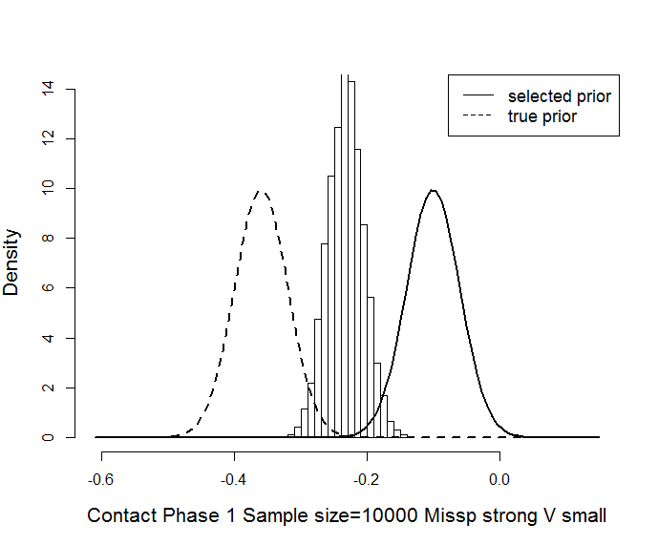 | 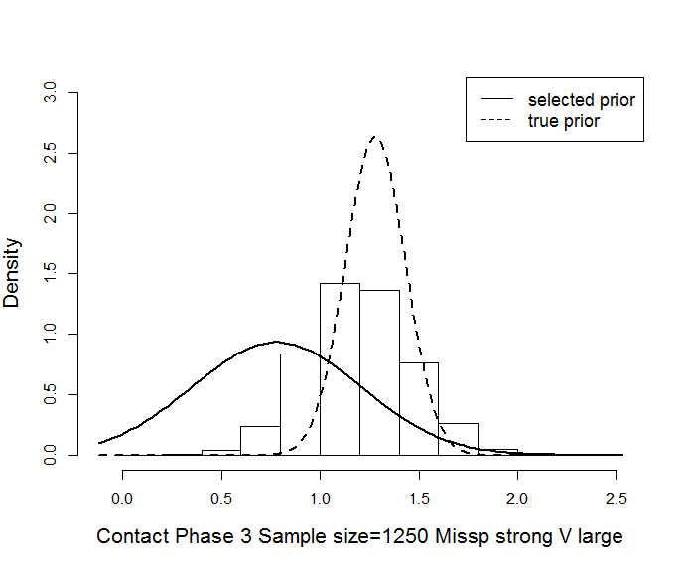
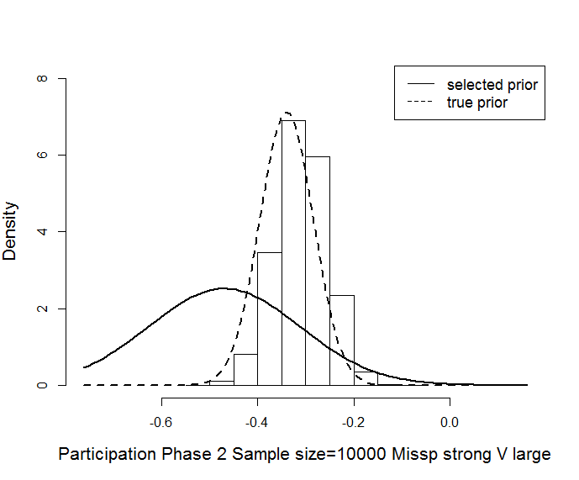 | 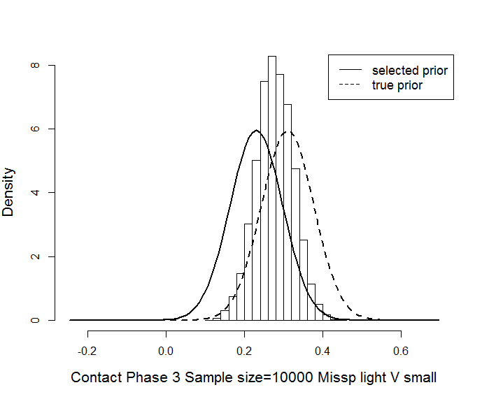
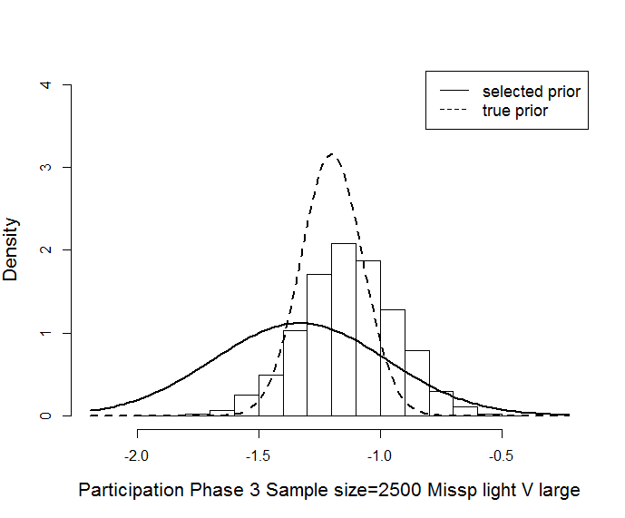 | 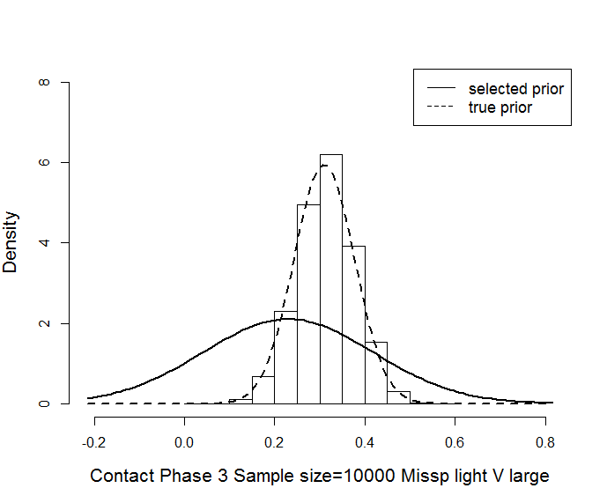
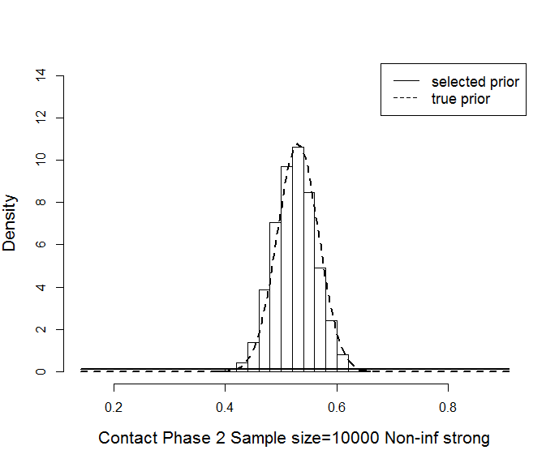 | 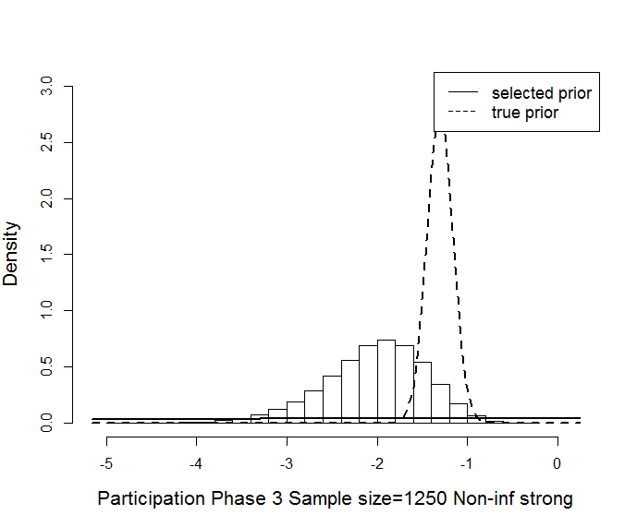

5. Discussion
We introduced a Bayesian model for survey design parameters related to response and costs. The model is general in that it describes multiple data collection phases, includes both auxiliary variables that are available before data collection starts and auxiliary variables that become available during data collection (paradata), acknowledges multiple nonresponse outcomes, accounts for dependence on previous actions and enables the inclusion of randomization over different data collection strategies. Many surveys conducted by statistical institutes can fit into this framework. Furthermore, we constructed an analysis strategy based on a Gibbs sampler in which all model parameters are repeatedly drawn. The Gibbs sampler provides estimates for the posterior distributions of the contact and participation propensities and the costs per sample unit. From the Gibbs sampler, the posterior distributions for overarching quality indicators, such as the response rate or coefficient of variation of the response propensities, and cost indicators can easily be derived as an important by-product. Under this particular model, the computational time of the Gibbs sampler was manageable and sufficiently short to run overnight for a range of scenarios. We are, thus, able to meet the first three objectives of the paper as stated in the introduction to set up a Bayesian analysis for survey data collection monitoring and analysis.
The fourth, and most, important objective is to show the added value and sensitivity of a Bayesian analysis. In the evaluation, we viewed a fully non-informative prior as the benchmark in which no historic survey data or expert knowledge is incorporated. The evaluation is based on a simulation study using realistic contact propensities and costs, and participation propensities and costs from a multi-mode survey. The evaluation shows that the Bayesian analysis is sensitive to misspecification in the propensities and costs; shifts in propensities and costs should be relatively modest to outperform an analysis with a non-informative prior. The corresponding turning point does depend on the variance of the informative prior, and, consequently, hints at some form of moderation of historic/expert knowledge. The evaluation also shows that without misspecification the Bayesian analysis is to be favored to a ‘non-Bayesian’ analysis, especially, for smaller sample sizes of observed data. More generally, the evaluation provides an appreciation for the Bayesian approach and the need to carry out a sensitivity analysis.
What are the implications of these findings for prior elicitation? In general, it warrants sensitivity analyses. When priors are based on historic survey data, then careful consideration is needed of the timeliness and the amount of historic survey data that are available. Such a sensitivity may be partially overcome by moderating the strength of historic survey data over time, i.e. the more timely the data and knowledge, the more power is attached. Such moderation can be done using so-called power priors (Ibrahim and Chen 2000 and Ibrahim et al 2015). However, moderation may also be achieved by adding a hierarchical level to the Bayesian models representing change in time, which comes at the cost of extra model parameters. In retrospective Bayesian analyses, we are currently investigating the use of moderation in time. When priors are based on expert knowledge, then it is to be recommended to vary the prior variance level, i.e. to explore the weight that is given to the experts.
We touched only briefly on the elicitation of prior distributions from expert knowledge. In models with many auxiliary variables, such elicitation may be difficult to conduct. Furthermore, data collection experts will, generally, not be able to provide values for slope and dispersion parameters in regression models, but only for propensities and costs at the subgroup level. An effective elicitation of expert knowledge, therefore, will require some interpolation or proportional fitting of detailed models to marginal distributions that are given by experts. This trade-off holds, especially, for settings where priors are elicited from different, but similar, surveys. In order to develop effective prior elicitation procedures, we currently apply the Bayesian analysis framework to a broad set of case studies.
We see three conceptual limitations to our study that deserve future research and extension. First, although our model for monitoring of response and costs has general features, it does not fit all possible data collection designs and analyses, and particular designs and analyses may require adaptations of the model. In addition, we assumed normal distributions based on our dataset, although it is straightforward to specify the models according to the distributions found in the data. We believe that such changes are relatively modest given the exposition in this paper. Second, we have not yet considered the (key) survey variables. Such variables may be modeled and monitored simultaneously, and design decisions may be based on a mix of overall quality and cost indicators and key survey estimates. Such an extension is fairly easy to include, see Schouten, Bruin and Mushkudiani (2016), but does introduce new modeling choices because values of survey variables are unknown for nonrespondents. For this reason, we leave this extension to future research. Third, and strongly related to the previous point, we focused on nonresponse and have not yet considered strategy-dependent measurement biases. In multi-mode surveys, such an extension and broader look is inevitable. Extending the Bayesian analysis to measurement error implies modeling survey variables, and, hence, may best be picked up simultaneously with extending the scope to key survey estimates.
Ultimately, the Bayesian analysis framework should support adaptive survey design decisions. Such an application means that historic survey data and expert knowledge should comprise of multiple, possibly randomized, strategies, and that observed data may be used to learn and update strategies for which information is weak or missing. Extension of our simulation scenarios to adaptation is imperative and should include the estimation and nonresponse adjustment stages.

References
Albert, J.H. and Chib, S. (1993), “Bayesian analysis of binary and polychotomous response data”, Journal of the American Statistical Association, 88, 669 – 680.
Burger, J., Perryck, K.H. and Schouten, B. (2016), “Assessing the impact of inaccuracy in design parameters on the performance of adaptive survey designs”, under review with JOS.
Calinescu, M. (2013), Optimal Resource Allocation in Adaptive Survey Designs, PhD Thesis, VU University Amsterdam, available at http://dare.ubvu.nl .
Calinescu, M. and Schouten, B. (2015), “Adaptive survey designs to minimize mode effects. A case study on the Dutch Labour Force Survey”, Survey Methodology, 41 (2), 403 – 425.
CBS (2016), Short description of Dutch Health Survey, Statistics Netherlands, Den Haag, The Netherlands, available at https://www.cbs.nl/en-gb/our-services/methods/surveys/korte-onderzoeksbeschrijvingen/health-survey-from-2010-2013.
Chakraborty, B. and Murphy, S.A. (2014), “Dynamic Treatment Regimes”, Annual Review of Statistics and Its Applications, 1, 447 – 464.
Coffey, S., Reist, B. and White, M. (2013), “Monitoring Methods for Adaptive Design in the National Survey of College Graduates”, In JSM Proceedings, Survey Methods Research Section, Alexandria, VA: American Statistical Association, 3085-3099.
Durrant, G.D., D’Arrigo, J. and Steele, F. (2011), “Using paradata to predict best times of contact, conditioning on household and interviewer influences”, Journal of the Royal Statistical Society A, 174 (4), 1029 – 1049.
Durrant, G.D., Maslovskaya, O. and Smith, P.W.F. (2015), “Modelling final outcome and length of call sequence to improve efficiency in interviewer call scheduling”, Journal of Survey Statistics and Methodology, 3, 397 – 424.
Durrant, G.D. and Steele, F. (2013), “Analysing interviewer call record data by using a multilevel discrete time event history modelling approach”, Journal of the Royal Statistical Society A, 176 (1), 251 – 269.
Gelman, A. (2006), “Prior distributions for variance parameters in hierarchical models”, Bayesian Analysis, 1 (3), 515 – 534.
Gelman, A., Carlin, J. B., Stern, H. S. and Rubin, D. B. (2014), Bayesian Data Analysis. London: Chapman and Hall, second edition.
Groves, R.M. and Heeringa, S.G. (2006), “Responsive design for household surveys: tools for actively controlling survey errors and costs”, Journal of the Royal Statistical Society: Series A, 169, 439 – 457.
Heyd, J.M. and Carlin, B. (1999), “Adaptive design improvements in the continual reassessment method for phase I studies”, Statistics in Medicine, 18, 1307 – 3121.
Ibrahim, J.G. and Chen, M.H. (2000), “Power prior distributions for regression models”, Statistical Science 15 (1), 46 – 60.
Ibrahim, J.G., Chen, M.H., Gwon, Y. and Chen, F. (2015), “The power prior: theory and applications”, Statistics in Medicine, 34 (28), 3724 – 3749.
Kreuter, F. (2013), Improving Surveys with Paradata. Analytic Uses of Process Information, Edited monograph, John Wiley and Sons, Hoboken, New Jersey, USA.
Laber, E.B., Lizotte, D.J., Qian, M., Pelham, W.E. and Murphy, S.A. (2014), “Dynamic Treatment Regimes: technical challenges and applications”, Electronic Journal of Statistics, 8 (1), 1125 – 1272.
Lei, H., Nahum-Shani, I., Lynch, K., Oslin, D. and Murphy, S.A. (2012), “A SMART design for building individualized treatment sequences”, Annual Review of Clinical Psychology, 8, 21 – 48.
Luiten, A. and Schouten, B. (2013), “Adaptive fieldwork design to increase representative household survey response: A pilot study in the Survey of Consumer Satisfaction”. Journal of Royal Statistical Society, Series A, 176 (1), 169 – 190.
Lundquist, P. and Särndal, C.E. (2013), “Aspects of responsive design with applications to the Swedish Living Conditions Survey”, .Journal of Official Statistics, 29 (4), 557 – 582.
Murphy, S.A. (2003), “Optimal dynamic treatment regimes”, Journal of the Royal Statistical Society: Series B, 65, 331 – 355.
Nishimura, R., Wagner, J. and Eliott, M.R. (2016), “Alternative indicators for the risk of nonresponse bias. A simulation study”, International Statistical Review, 84 (1), 43 – 62.
O’Quigley, J. and Shen, L.Z. (1996), “Continual reassessment method: A likelihood approach”, Biometrics, 52 (2), 673 – 684.
Peytchev, A., Riley, S., Rosen, J., Murphy, J. and Lindblad, M. (2010), “Reduction of nonresponse bias in surveys through case prioritization”. Survey Research Methods, 4, 21 – 29.
Raftery, A.E. and Lewis, S. (1992), “How many iterations in the Gibbs sampler”, In Bayesian Statistics 4 (eds. J.M. Bernardo, J. Berger, A.P. Dawid and A.F.M. Smith), Oxford University Press, Offord, 763 – 773.
Rosen, J. A., Murphy, J. J., Peytchev, A., Holder, T. E., Dever, J. A., Herget, D. R. and Pratt, D. J. (2014), “Prioritizing low-propensity sample members in a survey: Implications for nonresponse bias”, Survey Practice, 7(1), 1–8.
Särndal, C.E. and Lundquist, P. (2014), “Accuracy in estimation with nonresponse: A function of degree of imbalance and degree of explanation”. Journal of Survey Statistics and Methodology, 2, 361 – 387.
Schafer, J.L. (2013), “Bayesian penalized spline models for statistical process monitoring of survey paradata quality indicators”, Chapter 13, 311 – 340, In Improving surveys with paradata. Analytic uses of process information, ed. F. Kreuter, Wiley, New Yor, USA.
Scharfstein, D.O., Daniels, M.J. and Robins, J.M. (2003), “Incorporating prior beliefs about selection bias into the analysis of randomized trials with missing outcomes”, Biostatistics, 4 (4), 495 – 512.
Schouten, B., Calinescu, M. and Luiten, A. (2013), “Optimizing quality of response through adaptive survey designs”. Survey Methodology, 39 (1), 29 – 58.
Schouten, J.G., Cobben, F. and Bethlehem, J. (2009), “Indicators for the representativeness of survey response”. Survey Methodology, 35 (1), 101 – 113.
Schouten, B. and Shlomo, N. (2015), “Selecting adaptive survey design strata with partial R-indicators”, International Statistical Review, available on early view.
Schulte, P.L., Tsiatis, A.A., Laber, E.B. and Davidian, M. (2014), “Q- and A-learning methods for estimating optimal dynamic treatment regimes”, Statistical Science, 29 (4), 640 – 661.
Wagner, J. (2008), Adaptive survey design to reduce nonresponse bias, PhD thesis, University of Michigan, USA.
Wagner, J. (2012), “A comparison of alternative indicators for the risk of nonresponse bias”, Public Opinion Quarterly, 76 (3), 555 – 575.
Wagner, J., West, B.T., Kirgis, N., Lepkowski, J.M., Axinn, W.G. and Kruger Ndiaye, S. (2013), “Use of paradata in a responsive design framework to manage a field data collection”. Journal of Official Statistics, 28 (4), 477 – 499.

Appendix A: The Gibbs sampler and corresponding full conditionals

The Gibbs sampler has the following steps:
- Set the random effects for the contact and participation equations to zero, $δ_{t}^{C}=0$ and $δ_{t}^{P}=0$, and fit regression models to all contact, participation and cost equations and use the resulting estimated parameter values as starting values for the regression parameters $α^{C},α^{P},γ$;
- For each unit (i) in each phase (t), sample the latent variables $Z_{t,i}^{C}$ and $Z_{t,i}^{P}$ from $p\left(Z_{t,i}^{C}\right|α^{C},δ,u_{t,i},x_{i},{\{s}_{1,T}^{i}\})$ and $p\left(Z_{t,i}^{P}\right|α^{P},δ,u_{t,i},x_{i},{\{s}_{1,T}^{i}\})$;
- For each phase, sample the contact slope parameters $α_{t}^{C}$ from $p\left(α_{t}^{C}\right|Z_{t}^{C},δ_{t}^{C},x_{i},{\{s}_{1,T}^{i}\})$;
- Sample the random effects $δ_{t}^{C}$ from $p\left(δ_{t}^{C}\right|Z_{t}^{C},α_{t}^{C},x_{i},{\{s}_{1,T}^{i}\})$;
- For each phase, sample the participation slope parameters $α_{t}^{P}$ from $p\left(α_{t}^{P}\right|Z_{t}^{p},δ_{t}^{P},x_{i},{\{s}_{1,T}^{i}\})$;
- Sample the random effects $δ_{t}^{P}$ from $p\left(δ_{t}^{P}\right|Z_{t}^{P},α_{t}^{P},x_{i},{\{s}_{1,T}^{i}\})$;
- For the three cost components, sample the variance parameters $σ^{2}$ from $p\left(σ^{2}\right|γ,c_{0}, c_{R},c_{NR},x,{\{s}_{1,T}^{i}\})$;
- For the three cost components sample the slope parameters $γ$ from $p\left(γ\right|σ^{2},c_{0}, c_{R},c_{NR},x,{\{s}_{1,T}^{i}\})$;
- Return to step 1;
In the remainder of this appendix, we provide expressions for the full conditionals of the various regression model parameters for response and costs that are sampled in the Gibbs sampler

A.1 Full conditionals for regression parameters in response propensity models
Contact propensity and participation propensity models have the following form
$Z_{t,i}\left(s_{1,t}\right)=α_{t}\left(s_{t}\right)x_{t,i}+ε_{t,i}+δ_{t}\left(s_{1,t-1}\right)$,
where $Z_{t,i}(s_{1,t})$ is a latent variable and $x_{t,i}$ is a column vector of baseline and paradata covariates of length $m$. The regression parameters are the slope parameters in the vector $α_{t}$, and the random effect $δ_{t}$. Apart from these, also the latent variable $Z_{t,i}$ is updated in the Gibbs sampler, although it is not of direct interest. In a survey, we only observe whether $Z_{t,i}\left(s_{1,t}\right)>0$ occurs or not. In the main text, the superscripts “C” and “P” are added to distinguish contact and participation models, but for the derivation of full conditionals this distinction is not important; it is fully analogous.
In the following, the vector of random effects in phase $t$ for all possible histories of actions, $s_{1,t-1}$, is denoted by $δ_{t}$. Obviously, each survey sample unit received just one treatment series of actions. We add the subscript $i$ to indicate the strategy that was assigned to unit $i$, i.e. $s_{i,1,t}$ is the series of actions assigned to unit $i$ in phases 1 to $t$. We let $δ_{t,i}$ be the random effect that applies to unit $i$.

A.1.1 Slope parameters in contact model
For $α_{t}\left(s\right)$, the prior distribution is normal $α_{t}\left(s\right)\sim N(μ\left(s\right),Σ\left(s\right))$. The full conditional distribution is also normal, and we denote it as
$\left(α_{t}\left(s\right)\right|u_{t},z_{t}, δ_{t},x,s_{1,t})\sim N\left(μ_{FULL}\left(s\right),Σ_{FULL}\left(s\right)\right)$. (A1)
To derive the expectation and covariance of the full conditional distribution for action $s$, we need to restrict to sample units that reached phase $t$ and for which $s_{i,t}=s$. Let this number be $n_{t}(s)$. For convenience, we label the units $i=1,2,…,n_{t}(s)$. Let $z_{t,i}^{*}=z_{t,i}-δ_{t,i}$ and let $z_{t}^{*}=(z_{t,1}^{*},…,z_{t,n_{t}(s)}^{*})^{T}$. Furthermore, let $X$ be the $n_{t}(s)×m$ covariate matrix with sample units as rows.
It follows that the parameters in (A1) can be written as
$Σ_{FULL}\left(s\right)={\left({\left(Σ\left(s\right)\right)}^{-1}+X^{T}X\right)}^{-1}$, (A2)
$μ_{FULL}\left(s\right)=Σ_{FULL}\left(s\right)\left({\left(Σ\left(s\right)\right)}^{-1}μ\left(s\right)+X^{T}z_{t}^{*}\right)$. (A3)

A.1.2 Random effects
We will now derive the posterior distribution of $δ_{t}\left(s_{1,t}\right)$ for all possible strategies up to phase $t$, $s_{1,t}$. We assume that the prior distribution is the same for all strategies, $δ_{t}\left(s_{1,t}\right)\sim N\left(0, τ_{t}^{2}\right)$. Furthermore, we assume that the random effects are independent. Hence, the full conditional distribution depends only on the outcomes of all sample units that reached phase $t$ and that have exactly the strategy $s_{1,t}$, i.e. ${s_{1,t}=s}_{i,1,t}$. Let there be ${n_{t}(s}_{1,t})$ such units, labelled $i=1,2,…,{n_{t}(s}_{1,t})$. The full conditional distribution
$\left(δ_{t}\left(s_{1,t}\right)\right|α_{t}\left(s_{t}\right),u_{t},z_{t},x,s_{1,t})\sim N\left(μ_{FULL}\left(s\right),Σ_{FULL}\left(s\right)\right)$. (A4)
Let ${\tilde{z}}_{t,i}(s_{1,t})=z_{t,i}(s_{1,t})-α_{t}\left(s_{t}\right)x_{t,i}$, then it follows that the parameters in (A4) can be written as
$Σ_{FULL}\left(s\right)={\left({\left(τ_{t}^{2}\right)}^{-1}+{n_{t}(s}_{1,t})\right)}^{-1}$, (A5)
$μ_{FULL}\left(s\right)=Σ_{FULL}\left(s\right)\sum_{i=1}^{{n_{t}(s}_{1,t})}{{\tilde{z}}_{t,i}(s_{1,t})}$. (A6)

A.1.3 Latent response propensity
The last variables to update for the propensity models are the latent variables $Z_{t,i}$ for the sample units that reached phase $t$. It holds that $\left(Z_{t,i}\right|α_{t}, δ_{t},x,s_{1,t})\sim N(α_{t}\left(s_{i,t}\right)x_{i}+δ_{t,i},1)$ distributed. When $u_{t,i}=1$, then $Z_{t,i}>0$ and $\left(Z_{t,i}\right|u_{t},α_{t}, δ_{t},x,s_{1,t})$ is the normal distribution restricted to the positive real axis. For $u_{t,i}=0$, $\left(Z_{t,i}\right|u_{t},α_{t}, δ_{t},x,s_{1,t})$ is the normal distribution restricted to the non-positive real axis.
There are no explicit expressions for this distribution. When the outcome is $u_{t,i}=1$, draws from $N(α_{t}\left(s_{i,t}\right)x_{i}+δ_{t,i},1)$ are repeated until a draw is positive. For $u_{t,i}=0$, draws are repeated until a non-negative value is found.

A.2. Full conditionals for regression parameters in costs models
We will derive the parameters of the posterior distributions of the parameters in the costs models. There are three such models, one for contact, one for participation and one for refusal. The derivation of full conditionals is fully analogous, so that we omit reference to the specific type of costs. The model has the form
$C_{i}\left(s\right)=γ\left(s\right)x_{i}+ε_{i}\left(s\right),$ (A7)
$ε_{i}\left(s\right)\sim N\left(0,σ^{2}\left(s\right)\right)$, (A8)
where $x_{i}$ is the column vector of baseline covariates of length $m$ and $ε_{i}\left(s\right)$ is action-dependent error term. In this paper, the costs depend on the action that is applied but not on the phase in which it is applied. For actions that are applied in multiple phases, we, therefore, consider the average costs over all phases. The parameters that need to be updated and that require full conditional distributions are the slope parameters $γ\left(s\right)$ and the dispersion parameters $σ^{2}\left(s\right)$.
In updating regression parameters for a specific action $s$, we need to restrict ourselves to sample units that were treated by action $s$ at least once during the survey. Let there be $n(s)$ such units. The observed $c_{i}$ then is the average cost for the sample unit over all phases in which the action has been applied. We let $c$ be the column vector of length $n(s)$ containing the values of the sample units.

A.2.1 Slope parameters
The prior distribution for the slope parameters is multivariate normal, $γ\left(s\right)\sim N\left(μ\left(s\right),Σ^{2}\left(s\right)\right)$. The full conditional distribution is also normal, and we denote it as
$\left(γ\left(s\right)\right|c,x,σ^{2})\sim N\left(μ_{FULL}\left(s\right),Σ_{FULL}\left(s\right)\right)$. (A9)
Let $X$ be the $n(s)×m$ covariate matrix with sample units as rows.
It follows for the parameters in (A9) that
$Σ_{FULL}\left(s\right)={\left(\frac{1}{σ^{2}(s)}X^{T}X+{\left(Σ^{2}\left(s\right)\right)}^{-1}\right)}^{-1},$ (A10)
$μ_{FULL}\left(s\right)=Σ_{FULL}\left(s\right)\left(\frac{1}{σ^{2}(s)}X^{T}c_{R}+{\left(Σ^{2}\left(s\right)\right)}^{-1}μ\left(s\right)\right).$ (A11)

A.2.2 Variance of error term
The prior distribution is inverse gamma $σ^{2}(s)\sim Γ^{-1}\left(a\left(s\right),b\left(s\right)\right)$. The full conditional is also inverse gamma
$\left(σ^{2}(s)\right|γ,c,x)\sim Γ^{-1}\left(a_{FULL}\left(s\right),b_{FULL}\left(s\right)\right)$. (A12)
Given the notation introduced earlier, we have for the parameters in (A12)

$a_{FULL}\left(s\right)=a\left(s\right)+\frac{n(s)}{2}$ (A13) $b_{FULL}\left(s\right)=b\left(s\right)+\frac{1}{2} {\left(c\left(s\right)-Xγ\left(s\right)\right)}^{T}\left(c\left(s\right)-Xγ\left(s\right)\right).$ (A14)

Appendix B: Elicitation of hyperparameters in the Health Survey simulation study
In the simulation study, we have probit regression models for contact and participation and linear regression models for costs. In phase 1 there is only a contact model whereas in phases 2 and 3 there are also models for participation. Hence, in total there are ten models. For an informative prior, hyperparameters are needed for all regression coefficients in all models. We elicited informative priors by assuming that a historic Health survey data set of sample size $n=10000$ was available. Per type of regression coefficient, we explain how we proceeded in constructing priors.
Regression slope parameters in cost models: The slope parameters $γ_{C}(s)$ and $γ_{R}(s)$ are normally distributed and a saturated model with variable AgeGender is applied. In a saturated linear model, each parameter is estimated using only the sample units in the corresponding population stratum. Consider the parameter $γ_{C}$ for a particular stratum and a particular strategy. Based on historic data, the parameter is estimated as the average of the observed individual costs $c_{C,i}$ for sample units in the stratum that received the specified strategy. The average stratum costs is approximately normally distributed with expectation equal to the true $γ_{C}$ and variance equal to $\frac{σ_{R}^{2}}{n}$. Given that we simulate data ourselves in this paper, we can derive hyperparameters directly from the simulation model values.
Regression dispersion parameters in cost models: The dispersion parameters $σ_{C}^{2}(s)$ and $σ_{R}^{2}(s)$ have an inverse Gamma distribution and are constant over population strata. Consider $σ_{C}^{2}$ for a particular strategy. Given historic data, it is estimated as the sample variance over the observed individual costs $c_{C,i}$ for sample units that received the specified strategy. The sample variance divided over the true variance $σ_{C}^{2}$ and multiplied with $n-1$ is approximately $χ_{n-1}^{2}$ distributed. The expectation and variance of a $χ_{n-1}^{2}$ distribution are, respectively, $n-1$ and $2(n-1)$. This means that the sample variance has an expectation and variance equal to, respectively, $σ_{C}^{2}$ and ${2σ}_{C}^{4}/(n-1)$. An inverse Gamma distribution, $Γ^{-1}(α,β)$, has expectation and variance equal to, respectively, $β/(α-1)$ and $β^{2}/((α-1)^{2}\left(α-2\right))$. Hence, $α$ and $β$ can be derived as $α=2+\frac{1}{2}(n-1)/σ_{C}^{2}$ and ${β=σ}_{C}^{2}+\frac{1}{2}(n-1)$. Again under the simulation model, these hyperparameters can be derived directly from the simulation values.
Regression slope parameters in contact/participation models: The elicitation of hyperparameters is analogous for contact and participation models. Because of the probit link function, there is no explicit expression for estimators for the regression slope parameters. Given that we include only main effects for baseline covariates, $x_{0}$, and paradata, $x_{1}$, it is, therefore, not straightforward how to choose hyperparameters based on historic data in an analytic way. For this reason, we simulated 2000 datasets of size 10000 and fitted probit regression models to each dataset. Over the 2000 fitted vectors of parameters, means and variances were computed for single slope parameters and covariances for pairs of slope parameters. These means, variances and covariances were used as hyperparameters. Somewhat surprisingly, absolute covariances were sometimes quite large, especially between the slope parameters of the two vectors $x_{0}$ and $x_{1}$. Obviously this approach can only be applied in a simulation study; for a real historic dataset another approach is needed.

Appendix C: Simulation study propensities and costs
Tables C.1 and C.2 present the contact propensities, participation propensities and contact and participation costs, respectively, per phase and AgeGender × Break-off subgroup for the simulation study in Section 4.
Table C.1: Contact and participation propensities per phase and subgroup.
 | Phase 1 | Phase 2 |  | Phase 3
 | Response | Contact | Participation | Contact | Participation
15-24, F, no break-off | 0.30 | 0.70 | 0.58 | 0.50 | 0.30
15-24, F, break-off | 0 | 0.70 | 0.87 | 0.50 | 0.59
15-24, M, no break-off | 0.28 | 0.70 | 0.64 | 0.50 | 0.36
15-24, M, break-off | 0 | 0.70 | 0.93 | 0.50 | 0.65
25-44, F, no break-off | 0.33 | 0.74 | 0.49 | 0.62 | 0.22
25-44, F, break-off | 0 | 0.74 | 0.94 | 0.62 | 0.66
25-44, M, no break-off | 0.31 | 0.74 | 0.44 | 0.62 | 0.16
25-44, M, break-off | 0 | 0.74 | 0.94 | 0.62 | 0.66
45-65, F, no break-off | 0.35 | 0.80 | 0.38 | 0.90 | 0.10
45-65, F, break-off | 0 | 0.80 | 0.95 | 0.90 | 0.72
45-65, M, no break-off | 0.40 | 0.80 | 0.36 | 0.90 | 0.08
45-65, M, break-off | 0 | 0.80 | 0.95 | 0.90 | 0.69

Table C.2: Contact and participation costs per unit per phase and subgroup. Standard deviations are given within brackets.
 | Phase 1 | Phase 2 |  | Phase 3
 | Response | Contact | Participation | Contact | Participation
15-24, F, no break-off | 3 (1) | 11 (1) | 16 (1) | 14 (1) | 16 (1)
15-24, F, break-off | 3 (1) | 11 (1) | 12 (1) | 14 (1) | 12 (1)
15-24, M, no break-off | 3 (1) | 12 (1) | 14 (1) | 15 (1) | 14 (1)
15-24, M, break-off | 3 (1) | 12(1) | 10 (1) | 15 (1) | 10 (1)
25-44, F, no break-off | 3 (1) | 10 (1) | 21 (1) | 13 (1) | 21 (1)
25-44, F, break-off | 3 (1) | 10 (1) | 19 (1) | 13 (1) | 19 (1)
25-44, M, no break-off | 3 (1) | 10 (1) | 20 (1) | 13 (1) | 20 (1)
25-44, M, break-off | 3 (1) | 10 (1) | 18 (1) | 13 (1) | 26 (1)
45-65, F, no break-off | 3 (1) | 8 (1) | 26 (1) | 11 (1) | 18 (1)
45-65, F, break-off | 3 (1) | 8 (1) | 21 (1) | 11 (1) | 21 (1)
45-65, M, no break-off | 3 (1) | 9 (1) | 24 (1) | 12 (1) | 24 (1)
45-65, M, break-off | 3 (1) | 9 (1) | 20 (1) | 12(1) | 20 (1)

Appendix D: Convergence properties of the Gibbs sampler
The Gibbs sampler produces a draw of a Markov chain that has the posterior distribution of interest as its stationary distribution. The Markov chain is initiated from one or more starting values. Under certain conditions, the Markov chain converges to its stationary distribution but at a certain speed. For this reason, usually a burn-in period is discarded where the Markov chain has not yet reached its stationary distribution. After the burn-in period, the Markov chain moves through its parameter space at a certain “speed”. This speed is termed the mixing property of the chain and determines the required length of the Markov chain, i.e. the number of iterations in the Gibbs sampler. Both the burn-period and the mixing of the Gibbs sampler cannot be determined with certainty, since the stationary distribution is unknown. However, various diagnostics have been developed to make an empirical assessment. We checked the burn-in period and convergence of the Gibbs sampler using the Raftery Lewis convergence diagnostic (Raftery and Lewis 1992) as implemented in the R package CODA. We required that the 2.5%-quantile of the posterior distribution could be approximated with a specified precision. We apply the Raftery and Lewis convergence diagnostic on the first 5000 iterations to determine the number of iterations that are needed for convergence.
Somewhat surprisingly, we found for all scenarios, that the burn-in period is very short and below 100 iterations. Nonetheless, we always discard the first 5000 iterations. We then carried out the second part of iterations. The starting values here are the parameters obtained after 5000 iterations in the first run. The number of iterations in the second run is derived from the Raftery and Lewis convergence diagnostic. Convergence was usually reached within 4500 iterations, however we had some cases where up to 10000 iterations were required. Computation times in R were roughly 5000 iterations in 20 minutes. Figures D1, D2 and D3 show Gibbs sampler runs for regression slope parameters in the phase 1 and 3 for contact model and phase 2 for participation model under the non-informative, true and misspecified strong prior. The plots Gibbs iteration (I) are the first 1000 runs from the originally discarded 5000 runs under the burn-in, and in the plots Gibbs iteration (II) the first 1000 runs from the second set of runs to convergence. Figure D4 shows the regression parameters in the phase 2 for contact model for the second run to convergence. Here 10000 iterations were required by the Raftery and Lewis convergence diagnostic.

Figure D1: Phase 1 contact slope parameters Gibbs sampler draws for the non-informative prior.
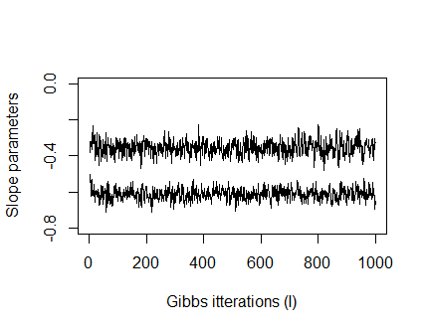 | 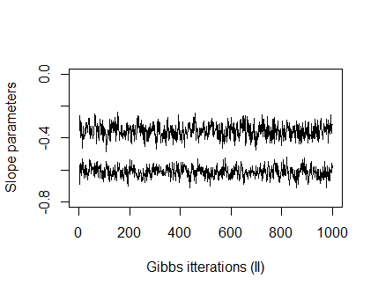

Figure D2: Phase 3 contact slope parameters Gibbs sampler draws for the true prior.
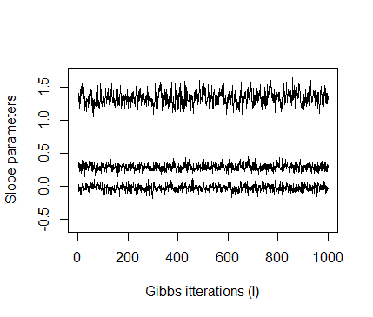 | 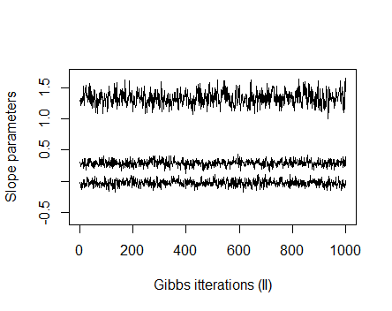

Figure D3: Phase 2 participation slope parameters Gibbs sampler draws for the misspecified prior strong.
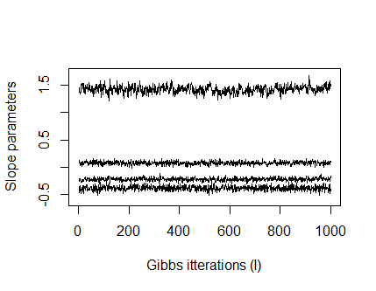 | 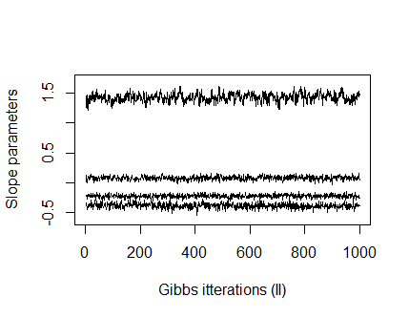

Figure D4: Phase 2 contact slope parameters Gibbs sampler draws for the non-informative prior.
