CNTs-added PMNT/PDMS flexible piezoelectric nanocomposite for energy harvesting application
Napatporn Promsawat¹, Methee Promsawat², Phatthanapong Janphuang³, Zhenhua Luo⁴, Steve Beeby⁵, Catleya Rojviriya³, Phakkhananan Pakawanit³ and Soodkhet Pojprapai¹
¹School of Ceramic Engineering, Institute of Engineering, Suranaree University of Technology, Nakhon Ratchasima,30000, Thailand
²Department of Materials Science and Technology, Faculty of Science, Prince of Songkla University, Songkhla, 90112, Thailand
³Synchrotron Light Research Institute, 111 University Avenue, Muang District, Nakhon Ratchasima, 30000, Thailand
⁴School of Water, Energy and Environment, Cranfield University, Cranfield MK43 0AL, UK
⁵Electronics and Computer Science, University of Southampton, SO17 1BJ, UK
*Corresponding author. Email: soodkhet@g.sut.ac.th (S. Pojprapai)
Abstract
The flexible piezoelectric nanocomposites based on lead magnesium niobate titanate [Pb(Mg_{1/3}Nb_{2/3})_{0.65}Ti_{0.35}O₃; PMNT] particles in polydimethylsiloxane (PDMS) matrix were fabricated and characterized. PMNT powders are synthesized using the columbite precursor method. PMNT/PDMS flexible nanocomposites are then prepared by spin casting technique, where a small amount of carbon nanotubes (CNTs) is added into the PMNT/PDMS composite to enhance cross-links between PMNT particles and PDMS matrix. The phase and microstructure of the nanocomposite are investigated by using X-ray diffraction and scanning electron microscope (SEM). The electromechanical behavior is evaluated by using an autonomous pneumatic actuator. The flexible composite, occupying approximately 300 mm², is capable of generating an open-circuit voltage (V_{oc}) of 2.83±0.24 V and a short-circuit current (I_{sc}) signal of 0.33±0.01 µA across 10 Ω resistor under mechanical load of 300 N. The generated electrical charges are 29026 pC. The relative dielectric constant is measured at 10 kHz and found to be 6.76±1.15. The piezoelectric PMNT/PDMS composite can be potentially used in a variety of applications such as wearable sensors, actuators, and energy harvesting for converting kinetic energy into useful electrical energy.

Keywords: PMNT, polydimethysiloxane (PDMS), carbon nanotube, nanocomposite, energy harvesting

- Introduction
Nowadays, renewable energy such as solar, vibrations, electromagnetic wave and thermal energy are widely used in technological applications. These ambient energies have been received much attention from many researchers for applications in the energy conversion technology. The ambient energy sources can be converted to electrical energy via energy conversion processes, i.e. electromagnetic induction [1-2], triboelectric generator [3], electrostatic transduction [4], or using energy conversion materials, e.g., electroactive ferroelectret [5] and piezoelectric materials [6]. Piezoelectric materials are one of the energy conversion materials that can convert kinetic energy from mechanical vibrations to electrical energy via direct piezoelectric effect. Vice versa, they can convert electrical energy to mechanical strain, which is called the converse piezoelectric effect. Using the direct effect, piezoelectric materials can be used to harvest kinetic energy generated from human activities (e.g. walking and running). To date Pb-based piezoelectric materials are the most used in applications due to their high electromechanical coupling factor (k) and stimulating at resonance frequencies could realize an energy conversion efficiency above 80% [7]. Of these, lead magnesium niobate titanate (PMNT) materials is of great interest due to their high electromechanical coupling coefficient which make them as one of promising solution for piezo-sensors and actuators applications [8-9]. The composition of PMNT are typically Pb(Mg_{1/3}Nb_{2/3})_{1-x}Ti_{x}O₃ and it is well-known as relaxor-based ferroelectric material. The composition with x = 0.30-0.35 is at morphotropic phase boundary (MPB) region demonstrating best piezoelectric properties [10]. However, the ceramic form of these PMNT materials is brittle and heavy, making them unsuitable for flexible devices. This disadvantage can be overcome by flexible piezoelectric ceramic-polymer composite [11-12]. The particle size of ceramic powder in the composite is one of the main factors that could affect the piezoelectric properties of the composite. Nevertheless, there were a few works studying the effect of the size of piezoelectric particles on piezoelectric properties of the flexible piezoelectric composites. For example, the work studied by Lee et al. reported that the dielectric and piezoelectric constants of the piezoelectric composite with PbTiO₃ as the piezoelectric phase increased as the size of the piezoelectric particle increased [13]. Although most polymers exhibit poor piezoelectric properties and dielectric constant, their high flexibility, and forming and shaping abilities make them suitable to be a matrix phase for piezoelectric composites [14-15]. To fabricate piezoelectric ceramic-polymer composite, Polydimethylsiloxane (PDMS) was frequently used as a polymeric matrix due to its flexibility, biocompatibility, and optical transparency. Importantly, it is cost-effective, low toxicity, low permeability to water, high oxidative and high thermal stability [16-18]. Recently, Park et al. developed a flexible nanocomposite generator based on PZT particles distributing in a PDMS matrix with added CNTs [19]. The output voltage and current signals of the device were 10 V and 1.3 μA. Furthermore, NaNbO₃ nanowires-PDMS composites with output voltage and current of 3.2 V and 72 nA have been synthesized by Jung et al. [20]. Chen et al. fabricated piezoelectric nanogenerators based on PZT nanofibers which generated the output voltage and power under periodic stress application of 1.63 V and 0.03 μW, respectively [21]. Jeong et al. successfully produced lead-free flexible nanocomposite generators by a simple spin-casting method. The output voltage and current signals, which were generated during repeated bending and unbending motions with a maximum displacement of 5 mm at a rate of 0.2 m s⁻¹, were 12 V and 1.2 μA, respectively [22]. To date, based on our knowledge, only few studies have been reported on flexible piezoelectric composite based on PMNT in PDMS matrix [23-25].
In this work, flexible piezoelectric composites based on Pb(Mg_{1/3}Nb_{2/3})_{0.65}Ti_{0.35}O₃ (PMNT) particles dispersed in PDMS polymeric matrix were fabricated. 1wt% CNTs was added into the composite in order to improve the electrical conductivity path between micron-sized piezoelectric particles while maintaining the domain switching during poling process. Physical and electromechanical properties such as phase, microstructure, dielectric properties, and power output of the fabricated composite were then characterized in order to obtain more detailed description of the piezoelectric nanocomposite.
- Experimental Details

Pb(Mg_{1/3}Nb_{2/3})_{0.65}Ti_{0.35}O₃ (PMNT) powders employed as the dispersed phase in this research were prepared by the columbite precursor method from PbO, MgO, Nb₂O₅ and TiO₂ precursors [25]. Firstly, MgO and Nb₂O₅ powders were mixed and then calcined at 900 °C for 4 hr to produce columbite (MgNb₂O₆) powders. The MgNb₂O₆ powder was then mixed with PbO and TiO₂ powders and calcined at 850 °C for 2 h to produce PMNT powders. Polydimethysiloxane (PDMS) Sylgard 184 from Dow Corning was used as the matrix phase. PDMS elastomer was mixed with a curing agent using the weight ratio between the elastomer and the curing agent of 10:1. The mixture was exposed to thermal curing in order to harden PDMS. 12 wt% PMNT particles were dispersed in the PDMS elastomer in a beaker. After that, 1 wt% CNTs (NANOCYLTM NC7000) was added into the mixture and desiccated under vacuum for 20-30 min to remove air bubbles formed during the mixing process. The layered composites, as shown in Fig. 1(a), were fabricated by the following steps; (i) spinning PDMS polymer onto a glass plate and then curing at 85 °C for 1 h in an oven (ii) spinning CNTs-added PMNT/PDMS mixture onto the PDMS layer and then curing at 85 °C for 1 h in an oven and (iii) spinning PDMS polymer onto the mixture layer and then curing at 85 °C for 24 h in an oven. After these steps, a flexible piezoelectric composite with a thickness in the range of 200-300 μm was achieved as illustrated in Fig. 1(b). Both sides of the layered composite were etched by oxygen plasma before electrodes were deposited. The silver electrodes were sputtered on plastic substrates (200 μm in thickness) and attached onto the etched surfaces using unsolidified PDMS as a binder. The composite electrodes were cured in an oven at 85 °C for 1 h. Each composite sample was poled under an applied DC electric field of 2.5 kV/mm at 80 °C for 15 h in silicon oil bath. An electrical poling process was required to align the dipole moment to the same direction and to enhance piezoelectric properties of flexible nanocomposite devices. The phases of samples were identified by X-ray diffraction (XRD) technique (Bruker D8 Advance) with Cu K_{α} radiation wavelength of 1.54 Å. Frequency dependence of a dielectric constant (ε_{r}) and loss tangent (tanδ) was measured using a LCR meter (GW INSTEK LCR-821). Microstructure was observed by a field emission scanning electron microscope (FE-SEM, JEOL JSM-7800F). Chemical composition was analyzed by an energy dispersive X- ray spectroscopy (EDX). The internal distribution of the dispersed and matrix phases was investigated using synchrotron X-ray computed tomography. The synchrotron X-ray beam with energy range of 2-18 keV (white beam) was scanned on the sample. The Electromechanical behavior of the composites was investigated using an in-house developed autonomous pneumatic actuator. The output voltage and current under mechanical load were measured using an oscilloscope (Tektronix MSO 3034) and a multi-meter (Agilent 34461A).
- Results and Discussion

X-ray diffraction patterns of PMNT powder, PDMS polymer, and PMNT/PDMS nanocomposite are shown in Fig. 2. It is obvious that the XRD pattern of the PMNT powder was well-matched with the ICSD file No. 157487 of Pb(Mg_{1/3}Nb_{2/3})_{0.65}Ti_{0.35}O₃ compound with tetragonal P4mm space group. No secondary phase was observed on the pattern. The XRD pattern of the PDMS indicated an amorphous phase of the sample. A broad peak at 2θ ≈ 12° was found, which is consistent with the previous observation of Niu et al. [27]. In addition, for the composite, unknown peaks were observed at 2θ ≈ 28°. The unknown peaks were believed to be possessed by Pb_{1.83}Nb_{1.71}Mg_{0.29}O_{6.39} pyrochlore phase (JCPDS file No. 33-0769). The splitting of (002) and (200) peaks at 2θ ≈ 45° was also presented. None of CNTs pattern was observed in the composite. Since only 1 wt% CNTs was added, it is likely that such small amount was below the detection limit of the XRD apparatus.
SEM images of a cross-sectional view of a composite is shown in Fig. 3(a). The layer of the CNTs-added PMNT/PDMS material with 203.58±1.96 μm of thickness was observed in the middle region of the composite sandwiched by the PDMS layers. It can be seen from Fig. 3(b) that the particle size of PMNT phase was about 3 μm. It was clear that CNTs bridged PMNT particles to the matrix, as indicated by the arrow in Fig. 3(b) and (c). This contributed to an improvement of a transportation of charge carriers between the dispersed phase and the matrix phase while maintaining domain switching in a poling process. This could be confirmed by a result observed by Gong et al., that the applied field amplitude used in poling CNTs-added composite was lower than the composition without CNTs [28]. A synchrotron X-ray image of CNTs added PMNT/PDMS composite is shown in Fig. 3(d). The different contrast is depended on the level of X-ray absorption of each phase composed in the composite. As shown in the figure, the dark and bright regions represented the locations of the PMNT and PDMS phases, respectively. The brightest region indicated the position at which voids or porosities were located, resulting in a reduction of X-ray absorption at those positions of materials. By using the synchrotron X-ray imaging technique, the dispersion of PMNT particles in PDMS polymer matrix can be determined. It was also found from the figure that the average size of the dark region was about 30 μm. This indicated the agglomeration of PMNT particles. Although the particle size of PMNT was small, the agglomeration of the PMNT particles and the bridging between the dispersed and the matrix phases of CNTs could contribute to a good piezoelectric properties of the composite. Energy dispersive X-ray spectroscopy (EDX) of CNTs-added PMNT/PDMS nanocomposite was shown in Fig. 4(a) and (b). The results clearly showed the present of Pb, Mg, Nb, Ti and O peak in the PMNT particles and showed C peak representing local CNTs.
Frequency dependences of relative permittivity (ε_{r}) and dielectric loss (tanδ) measured at room temperature of CNTs-added PMNT/PDMS nanocomposite is shown in Fig. 5. The result showed that ε_{r} of the composite suddenly decreased while tanδ increased when frequency increased from 1 kHz to 10 kHz and it decreases when the frequency is greater than 10 kHz. The decreasing tendency with frequency of dielectric constant could be caused by an interfacial relaxation. The interfacial polarization arise as a result of difference in conducting phases, but was interrupted at grain boundaries due to lower conductivity. Generally, in polycrystalline materials, the grain exhibits semi-conducting behavior while the grain boundary is insulator. At higher frequency, the charge carriers will no longer be able to rotate sufficiently rapidly, so their oscillation will be laid behind the field resulting in a decrease of dielectric permittivity [29]. The dielectric losses at low frequencies are much higher than those occurring at high frequencies. However, the permittivity of the composite is still above 5. It was found in a previous result observed by Du et al. that a monolithic PDMS and PDMS based materials showed dielectric constant in the range of 2.32-2.40 [30]. Furthermore, Romasanta et al. [31] reported that the nanocomposite containing 1.0 wt% of CNT influenced to electrical insulator behavior with a permittivity constant of 1.5 times. It is ascribed to the motion of free charge carriers due to the formation of a continuous conductivity pathway throughout the medium between CNTs. Therefore, it could imply that an addition of PMNT and CNTs improves dielectric properties of PDMS polymers.
The electrical characterization of PMNT/PDMS nanocomposites with an area of 30 mm × 10 mm is illustrated in Fig. 6(a). The output voltage and generated current under an applied mechanical load of 300 N were about of 2.83±0.24 V and 0.33±0.01 µA. The calculated output power of this device is 0.934 µW at load resistance of 10 ohm. As compared to the piezoelectric generators in literature [20,32,33], it was found that the output power of our nanocomposite was lower than that of the flexible PZT-based composite, which is equal to 13 µW, but higher than those of the BaTiO₃ thin film and NaNbO₃ nanowires-PDMS composite piezoelectric generators, which are equal to 0.026 and 0.23 µW. Fig. 6(b) showed the output current versus time of the composite. The charge generated by the composite can be determined by integrating the current over the time. Using an applied force of 300 N, the average generated charge was equal to 29026 pC. By dividing the charge with the force, the piezoelectric constant (d₃₃) of the composite was calculated which was about 97 pC/N. Moreover, with the permittivity measured at 1 kHz of 10.5, the piezoelectric voltage constant (g₃₃) was calculated to be about 1.04 V⋅m/N. As compared to PZT/PDMS composites prepared in the previous works by Babu et al. [33] and Sharma et al. [34] at the equivalent amount of the piezoelectric elements (∼ 2 vol%), it was found that our CNTs-added PMNT/PDMS nanocomposite showed higher d₃₃ and g₃₃. The d₃₃ and g₃₃ values of the PZT/PDMS composites were below 40 pC/N and 50 mV⋅m/N, respectively. The greater of piezoelectric properties of CNTs-added PMNT/PDMS nanocomposite is possibly due to two contributions; 1) low coercive field (E_{c} ∼ 7 kV/cm) with large remanent polarization (P_{r} ∼ 31 µC/cm²) of the PMNT material [26] and 2) bridging a PMNT particle to the neighboring particles and PMNT particles to PDMS matrix by added CNTs. These could allow most dipole moments of PMNT phase to switch their directions to the direction of applied field in the poling process.
- Conclusion
CNTs-added PMNT/PDMS flexible nanocomposites have been successfully fabricated. The electrode was prepared by sputtering silver onto plastic substrate. Both sides of the composite were etched by oxygen plasma before electrodes were attached. XRD pattern of the composite indicated PMNT phase and PDMS phase. PMNT particles were dispersed around in PDMS polymer matrix and bridged the neighboring particles and PDMS polymer by CNTs. Dielectric permittivity and loss tangent of the composite almost decreased with an increase in frequency. The voltage and current output were found to be 2.83±0.24 V and 0.33±0.01 µA, equivalent to 0.934 µW. Under an applied force of 300 N, the composite generated the electrical charge of 29,026 pC. The calculated piezoelectric and voltage constants were 97 pC/N and 1.04 V⋅m/N, respectively. The use of CNTs as a bridging conductive material could facilitate a poling performance, thereby improving piezoelectric properties of CNTs-added PMNT/PDMS nanocomposites which are suitable for flexible electronic devices and sensor applications.

Acknowledgments
This work was supported by Suranaree University of Technology (SUT) and the Higher Education Research Promotion and National Research University Project of Thailand, Office of the Higher Education Commission. The technologies have been developed at School of Ceramic Engineering – SUT in collaboration with BL6a: Deep X-ray Lithography and BL1.2W: X-ray Imaging & Microtomography, Synchrotron Light Research Institute (Public Organization).

References
- Beeby SP, Torah RN, Tudor MJ, Glyne-Jones P, O’Donnell T, Saha CR and Roy S: A micro electromagnetic generator for vibration energy harvesting. J Micromech Microeng. 2007;17: 1257-1265.
- Niroomand M and Foroughi HR: A rotary electromagnetic microgenerator for energy harvesting from human motions. J Appl Res Technol. 2016;14: 259-267.
- Wang ZL: Triboelectric Nanogenerators as New Energy Technology for Self-Powered Systems and as Active Mechanical and Chemical Sensors. ACS NANO. 2013;14: 9533-9557.
- Arya S, Khan S and Lehana P: Design and fabrication of electrostatic micro-cantilever array as audible frequency generator. J Electrostat. 2015;76: 145-151.
- Shi J, Zhu D and Beeby SP: An investigation of PDMS structures for optimized ferroelectret performance. J Phys Conf Ser. 2014;557: 012104.
- Cho JY, Jeong S, Jabbar H, Song Y, Ahn JH, Kim JH, Jung HJ, Yoo HH and Sung TH: Piezoelectric energy harvesting system with magnetic pendulum movement for self-powered safety sensor of trains. Sens Actuators A. 2016;250: 210-218.
- Wang X: Piezoelectric nanogenerators-Harvesting ambient mechanical energy at the nanometer scale. Nano Energy. 2012;1: 13-24.
- Arai T, Ohno T, Matsuda T, Sakamoto N, Wakiya N and Suzuki H: Synthesis and electrical properties of Pb(Mg_{1/3}Nb_{2/3})O₃-PbTiO₃ epitaxial thin films on Si wafers using chemical solution deposition. Thin Solid Films. 2016;603: 97-102.
- Liang Z, Pei S, Qin F, Zheng Y, Zhao H, Zhang Z, Zeng J, Ruan W, Li G and Cao W: Er³⁺ doped ferroelectric Pb(Mg_{1/3}Nb_{2/3})O₃-0.25PbTiO₃ ceramic used as a linear response fluorescent temperature sensor. J Lumin. 2017;181: 128-132.
- La-Orauttapong D, Noheda B, Ye ZG, Gehring MP, Toulouse J, Cox DE and Shirane G: Phase diagram of the relaxor ferroelectric (1-x)Pb(Zn_{1/3}Nb_{2/3})O₃-xPbTiO₃. Phys Rev B. 2002;65: 144101.
- Janas VF and Safari A: Overview of Fine-Scale Piezoelectric Ceramic/Polymer Composite Processing. J Am Ceram Soc. 1995;78: 2945-2955.
- Banerjee S and Cook-Chennault KA: An investigation into the influence of electrically conductive particle size on electromechanical coupling and effective dielectric strain coefficients in three phase composite piezoelectric polymers. Composites, A. 2012;43: 1612-1619.
- Lee MH, Halliyal A and Newnham RE: Poling of Coprecipitated Lead Titanate-Epoxy 0-3 Piezoelectric Composites. J Am Ceram Soc. 1989;72: 986-990.
- Di C, Xue S, Tong J and Shi X: Study on electromechanical characterization of piezoelectric polymer PVDF in low-frequency band. J Mater Sci Mater Electron. 2014;25: 4735-4742.
- Wang T, Farajollahi M, Choi YS, Lin IT, Marshall JE, Thompson NM, Kar-Narayan S, Madden JDW and Smoukov SK: Electroactive polymers for sensing. Interface Focus. 2016;6: 20160026.
- Zhang H and Chiao M: Anti-fouling Coatings of Poly(dimethysiloxane) Devices for Biological and Biomedical Applications. J Med Biol Eng. 2015;35: 143-155.
- Dahiya R, Gottardi G and Laidani N: PDMS residues-free micro/macrostructures on flexible substrates. Microelectron. Eng. 2015;136: 57-62.
- Chenoweth K, Cheung S, Duin ACTV, Goddard III WA and Kober EM: Simulations on the Thermal Decomposition of a Poly(dimethylsiloxane) Polymer Using the ReaxFF Reactive Force Field. J Am Chem Soc. 2005;127: 7192-7202.
- Park KI, Jeong CK, Ryu J, Hwang GT and Lee KJ: Flexible and Large-Area Nanocomposite Generators Based on Lead Zirconate Titanate Particles and Carbon Nanotubes. Adv Energy Mater. 2013;3: 1539-1544.
- Jung JH, Lee M, Hong JL, Ding Y, Chen CY, Chou LJ and Wang ZL: Lead-Free NaNbO₃ Nanowires for a High Output Piezoelectric Nanogenerator. ACS NANO. 2011;12: 10041-10046.
- Chen X, Xu S, Yao N and Shi Y: 1.6 V Nanogenerator for Mechanical Energy Harvesting Using PZT Nanofibers. Nano Lett. 2010;10: 2133-2137.
- Jeong CK, Park KI, Ryu J, Hwang GT and Lee KJ: Large-Area and Flexible Lead-Free Nanocomposite Generator Using Alkaline Niobate Particles and Metal Nanorod Filler. Adv Funct Mater. 2014;24: 2620-2629.
- Xu S, Yeh YW, Poirier G, McAlpine MC, Register RA and Yao N: Flexible Piezoelectric PMN-PT Nanowire-Based Nanocomposite and Device. Nano Lett. 2013;13: 2393-2398.
- Sen S and Mishra SK: Electrical behavior of PMN-PT-PVDF nanocomposite. J Phys D: Appl Phys. 2008;41: 165305.
- Hwang GT, Park H, Lee JH, Oh S, Park KI, Byun M, Park H, Ahn G, Jeong CK, No K, Kwon H, Lee SG, Joung B and Lee KJ: Self-Powered Cardiac Pacemaker Enabled by Flexible Single Crystalline PMN-PT Piezoelectric Energy Harvester. Adv Mater 2014;26: 4880-4887.
- Promsawat M, Watcharapasorn A, Ye ZG and Jiansirisomboon S: Enhanced Dielectric and Ferroelectric Properties of Pb(Mg_{1/3}Nb_{2/3})_{0.65}Ti_{0.35}O₃ Ceramics by ZnO Modification. J Am Ceram Soc. 2015;98: 848-854.
- Niu R, Gong J, Xu DH, Tang T and Sun ZY: The Effect of Particle Shape on the Structure and Rheological Properties of Carbon-based Particle Suspensions. Chin J Polym. Sci. 2015;33: 1550-1561.
- Gong H, Zhang Y, Quan J and Che S: Preparation and properties of cement based piezoelectric composites modified by CNTs. Curr Appl Phys. 2011;11: 653-656.
- Kondawar SB, Dahegaonkar AD, Tabhane VA and Nandanwar DV: Thermal and frequency dependence dielectric properties of conducting polymer/ fly ash composites. Adv Mat Lett. 2014;5: 360-365.
- Du P, Lin X and Zhang X: Dielectric constants of PDMS nanocomposites using conducting polymer nanowires. Proc Int Conf on Solid-State Sensors, Actuators and Microsystems (TRANSDUCERS). 2014;11: 645-648.
- Romasanta LJ, Hernández M, López-Manchado MA and Verdejo R: Functionalised grapheme sheets as effective high dielectric constant fillers. Nanoscale Res Lett. 2011;6: 508.
- Park KI, Xu S, Liu Y, Hwang GT, Kang SJL, Wang ZL and Lee KJ: Piezoelectric BaTiO₃ Thin Film Nanogenerator on Plastic Substrates. Nano Lett. 2010;10: 4939-4943.
- Babu I, Hendrix MMRM and With GD: PZT-5A4/PA and PZT-5A4/PDMS piezoelectric composite bimorphs. Smart Mater Struct. 2014;23: 025029.
- Sharma SK, Gaur H, Kulkarni M, Patil G, Bhattacharya B and Sharma A: PZT-PDMS composite for active damping of vibrations. Compos Sci Technol. 2013;77: 42-51.

Figure captions
Fig. 1 (a) Schematic of layered CNTs-added PMNT/PDMS nanocomposite and (b) showing high flexibility of the composite.
Fig. 2 XRD patterns of monolithic PMNT particles and PDMS polymer, and a CNTs-added PMNT/PDMS nanocomposite.
Fig. 3 SEM images of microstructures of (a) cross-section (b) an agglomerated PMNT particles (c) CNTs bridging PMNT particles and PDMS polymer of a layered CNTs-added PMNT/PDMS nanocomposite and (d) tomographic of the particles distributed in the polymer phase using synchrotron X-ray tomography.
Fig. 4 Energy dispersive X-ray spectra of (a) CNTs phase and (b) PMNT phase indicated by arrows in the CNTs-added PMNT/PDMS nanocomposite.
Fig. 5 Frequency dependence of dielectric constant (black line) and dielectric loss (red line) of CNTs-added PMNT/PDMS nanocomposites.
Fig. 6 Cycling output (a) voltage and (b) current under an applied mechanical force of 300 N of CNTs-added PMNT/PDMS nanocomposite.

Fig. 1
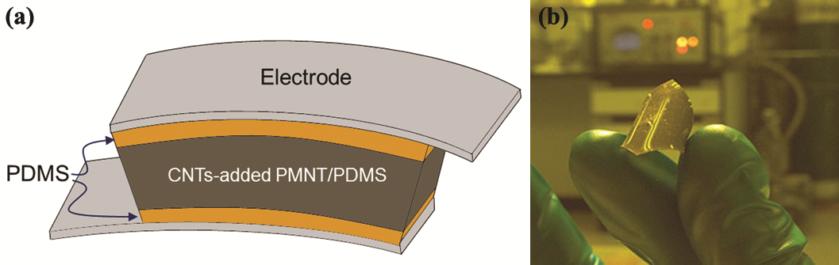

Fig. 2

Fig. 3
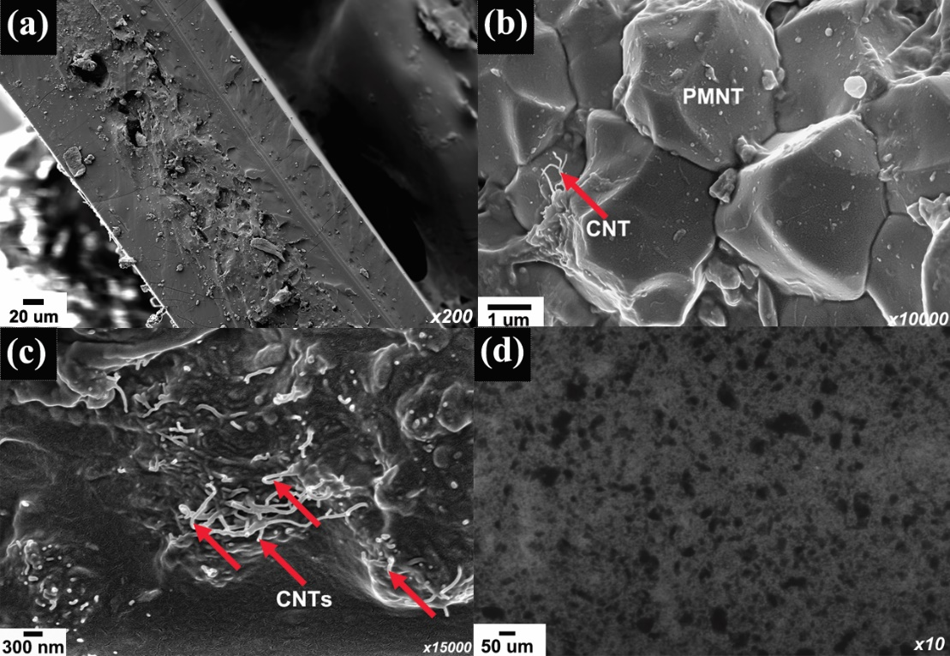

Fig. 4
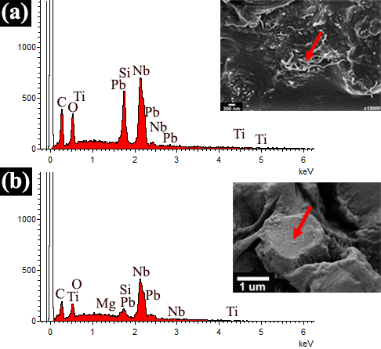
Fig. 5
Fig. 6
