Nehrlich, A. D., Gebauer, J. E., Sedikides, C., & Schoel, C. (2018). Agentic narcissism, communal narcissism, and prosociality. Journal of Personality and Social Psychology. Advance online publication. doi:10.1037/pspp0000190

2018, American Psychological Association. This paper is not the copy of record and may not exactly replicate the final, authoritative version of the article. Please do not copy or cite without authors permission. The final article will be available, upon publication, via its DOI: 10.1037/pspp0000190

Agentic Narcissism, Communal Narcissism, and Prosociality

Andreas D. Nehrlich  University of Mannheim | Jochen E. Gebauer  University of Mannheim
Constantine Sedikides  University of Southampton | Christiane Schoel  University of Mannheim

We acknowledge support from the German Research Foundation (DFG; Grant GE 2515/2-1) and the John Templeton Foundation (The Character Project at Wake Forest University; Grant ID #15519-11-011). We thank Katharina Demin, Markus Klingel, Elisa Lopper, Josephine Meyfarth, Le Vy Phan, Jonas Schemmel, and Laura Werkmeister for their help with data collection. We also thank Tanja Lischetzke and Manfred Schmitt for statistical advice. Corresponding author: Andreas Nehrlich, who is now at University Koblenz-Landau, Fortstr. 7, D-76829 Landau; email: nehrlich@uni-landau.de.

ABSTRACT
Grandiose narcissism and prosociality are important topics in personality and social psychology, but research on their interplay is lacking. We present a first large-scale, systematic, and multi-method investigation linking the two. In two studies (N₁ = 688, N₂ = 336), we assessed grandiose narcissism comprehensively (i.e., agentic and communal narcissism) and examined its relations with instantiations of prosociality, namely, objective prosociality (actual behavior in Study 1; round-robin informant-reports in a real-life setting in Study 2) and subjective prosociality (self-perceptions in Studies 1 and 2). We obtained a consistent set of results. Agentic narcissism was related to lower objective prosociality and lower subjective prosociality. Communal narcissism, by contrast, was unrelated to objective prosociality, but was related to higher subjective prosociality. Additionally, we tested for prosociality self-enhancement among agentic and communal narcissists. Agentic narcissists evinced the same (and modest) level of prosociality self-enhancement as their non-narcissistic counterparts. Communal narcissists, by contrast, evinced substantial levels of prosociality self-enhancement, whereas their non-narcissistic counterparts did not enhance their prosociality at all. We discuss implications of the findings for the literature on narcissism and antisociality, and for the concept of prosocial personality.

Keywords: grandiose narcissism, agentic narcissism, communal narcissism, prosociality, informant reports

Agentic Narcissism, Communal Narcissism, and Prosociality
Grandiose narcissism is one of the most intensely studied topics in personality and social psychology (Campbell & Miller, 2011; Thomaes, Brummelman, & Sedikides, in press), as is prosociality (Davis, 1980; Dovidio, Piliavin, Schroeder, & Penner, 2006). Yet, little programmatic research has addressed their interrelation (Konrath & Tian, in press). To close the gap, we report a systematic investigation of the relation between grandiose narcissism and prosociality, making use of large samples and sophisticated methods. We capture the full range of grandiose narcissism, complementing its agentic form (Campbell & Foster, 2007) with its communal form (Gebauer, Sedikides, Verplanken, & Maio, 2012).¹ Also, we conceptualize prosociality broadly, distinguishing between objective prosociality (actual behavior, round-robin informant-reports in a real-life setting) and subjective prosociality (self-perceptions).² In the remainder of the Introduction, we discuss grandiose narcissism (agentic and communal) and prosociality (objective and subjective), before reviewing the sparse and largely inconclusive literature on their interrelation. After that, we derive hypotheses and provide an overview of our research.
Grandiose Narcissism
Grandiose narcissists’ global self-evaluations are characterized by an excessively exalted sense of self-importance, entitlement, and social power (Campbell & Foster, 2007; Gebauer & Sedikides, in press-a; Krizan & Herlache, 2017; Morf, Horvath, & Torchetti, 2011; Pincus et al., 2009).³ According to the agency-communion model of grandiose narcissism, there are two types of grandiose narcissism: agentic and communal (Gebauer et al., 2012; see also Gebauer & Sedikides, in press-b; Gebauer, Żemojtel-Piotrowska, et al., 2018).
Agentic narcissists, by definition, grossly overstate their agentic attributes (e.g., intelligence, creativity, scholastic aptitude), but not their communal attributes (e.g., agreeableness, fairness, cooperativeness). This exacerbated level of agentic self-enhancement is responsible for the label “agentic narcissism,” and it also accounts for how agentic narcissists subjectively justify or rationalize their global self-evaluations (i.e., their excessively exalted sense of self-importance, entitlement, and social power). Communal narcissists, by definition, grossly overestimate their communal, but not their agentic, attributes. That heightened level of communal self-enhancement is responsible for the label “communal narcissism,” while also accounting for how communal narcissists subjectively justify or rationalize their global self-evaluations (again: excessively exalted sense of self-importance, entitlement, and social power).
The Narcissistic Personality Inventory (NPI; Raskin & Terry, 1988) is the most popular measure of grandiose narcissism, employed in over three-quarters of empirical studies (Cain et al., 2008). In fact, the labels “grandiose narcissism” and “NPI-narcissism” have often been used synonymously (Miller & Campbell, 2008). According to the agency-communion model, however, the NPI is not a measure of grandiose narcissism per se, but rather a measure of agentic narcissism (Gebauer et al., 2012; Gebauer, Żemojtel-Piotrowska, et al., 2018). This assertion has received empirical backing. A meta-analysis of 171 correlations from 36 studies found that NPI-narcissists grossly overemphasize their agentic attributes, but not their communal attributes (Grijalva & Zhang, 2016; see also Gebauer & Sedikides, in press-a,b). Face validity considerations also speak for the NPI as a measure of agentic narcissism: Sample-items are “I will be a success,” “I rarely depend on anyone else to get things done,” and “I am more capable than other people.” In contrast, the Communal Narcissism Inventory (CNI; Gebauer et al., 2012) is a psychometrically sound measure of communal narcissism (Gebauer et al., 2012; Gebauer, Żemojtel-Piotrowska, et al., 2018; Żemojtel-Piotrowska, Czarna, Piotrowski, Baran, & Maltby, 2016). Face validity considerations also speak for the CNI as a measure of communal narcissism: Sample-items are “I am the most caring person in my social surrounding,” “I will be well known for the good deeds I will have done,” and “I greatly enrich others’ lives.”
Prosociality
Prosociality has received center stage in sociology (Fetchenhauer, 2006), economics (Fehr & Fischbacher, 2003), evolutionary science (Axelrod, 2006), and psychology (Batson & Powell, 2003; Dovidio et al., 2006). In personality psychology the focus has been on person-level predictors (the “prosocial personality;” Davis, 1980; Oliner & Oliner, 1988; Penner, Escarrez, & Ellis, 1983), whereas in social psychology the focus has been on situational predictors (social norms: Schwartz, 1977; affect: Cialdini, Darby, & Vincent, 1973; time pressure: Darley & Batson, 1973; social exclusion: Twenge, Baumeister, DeWall, Ciarocco, & Bartels, 2007). Robust personality predictors have proven harder to pinpoint than situational ones (Batson & Powell, 2003; Erez, Mikulincer, van Ijzendoorn, & Kroonenberg, 2008; Omoto & Snyder, 1995), probing some scholars to characterize the search for the prosocial personality as unsuccessful (Gergen, Gergen, & Meter, 1972; Hartshorne & May, 1928; Piliavin, Dovidio, Gaertner, & Clark, 1981). Recent findings are more hopeful, pointing to agreeableness (Graziano & Tobin, 2013) and empathy (Paciello, Fida, Cerniglia, Tramontano, & Cole, 2013) as predictors of prosociality. Those findings notwithstanding, evidence for the potency of personality to predict prosociality remains in demand.
We conceptualize prosociality as objective (i.e., prosocial behavior, informant-reported prosociality) and subjective (i.e., prosocial self-perception or self-reports). Objective prosociality is important to social relationships (Wentzel & McNamara, 1999) and carries interpersonal benefits such as harmony (Mikulincer & Shaver, 2010). Subjective prosociality is an important part of the self-concept (Nehrlich, Gebauer, Sedikides, & Abele, 2018), and carries personal benefits such as higher well-being (Gebauer, Riketta, Broemer, & Maio, 2008). Objective and subjective prosociality are related: Prosocial behavior feeds into prosocial self-perceptions (Bem, 1972), and prosocial self-perceptions motivate prosocial behavior (Gebauer, Sedikides, Lüdtke, & Neberich, 2014). The two types of prosociality also differ: They can have divergent antecedents (Norenzayan & Shariff, 2008), with subjective (compared to objective) prosociality being more strongly influenced by self-enhancement (Paulhus & Holden, 2010). Regardless, a thorough analysis ought to take into account both forms of prosociality as well as their links with grandiose (i.e., agentic and communal) narcissism.
Grandiose Narcissism and Prosociality: A Literature Review
Does grandiose narcissism predict prosociality? We will review the literature separately for agentic and communal narcissism (for a recent review, see also Konrath & Tian, in press).
Agentic narcissism. One stream of evidence on the link between agentic narcissism and prosociality is indirect, addressing antisociality rather than prosociality. Agentic narcissism positively predicts multiple indicators of objective antisociality (aggression―Bushman & Baumeister, 1998; Jones & Paulhus, 2010; Twenge & Campbell, 2003; exploitativeness―Konrath, Corneille, Bushman, & Luminet, 2014; sexual coercion―Bushman, Bonacci, Van Dijk, & Baumeister, 2003; punitiveness―Böckler, Sharifi, Kanske, Dziobek, & Singer, 2017) and multiple indicators of subjective antisociality (vengefulness―Brown, 2004; exploitativeness―Menon & Sharland, 2011; delinquency―Barry, Grafeman, Adler, & Pickard, 2007; Barry, Pickard, & Ansel, 2009; aggression―Lawrence, 2006). Although antisociality and prosociality should not be regarded as endpoints of a continuum (Krueger, Hicks, & McCue, 2001), this body of work highlights agentic narcissism as a promising predictor of (low) prosociality.
Another stream of evidence for the link between agentic narcissism and prosociality is direct, addressing prosociality rather than antisociality. This body of work has examined the relation between agentic narcissism on the one hand and objective prosociality as well as subjective prosociality on the other. The evidence, however, is sparse and inconclusive. To begin, few studies have addressed the relation between agentic narcissism and objective prosociality, and those studies yielded inconsistent results: Agentic narcissism is sometimes related to higher objective prosociality (informant-reports―Kauten & Barry, 2016), sometimes to lower objective prosociality (economic game behavior―Böckler et al., 2017), and sometimes unrelated to it (informant-reports―Barry, Lui, Lee-Rowland, & Moran, 2017; Kauten & Barry, 2014). One potential reason for this inconclusiveness is that prior studies relied entirely on small samples (mean sample size: N = 135, range: 122 to 155), thus failing to meet the sample size requirements for stable correlation estimates (Schönbrodt & Perugini, 2013). In a similar vein, few studies have addressed the link between agentic narcissism and subjective prosociality, and they have also yielded inconsistent results: Agentic narcissism is sometimes related to higher subjective prosociality (Barry, Lui, & Anderson, 2017; Barry, Lui, Lee-Rowland, & Moran, 2017; Eberly-Lewis & Coetzee, 2015; Kauten & Barry, 2014, 2016; Konrath, Ho, & Zarins, 2016), sometimes to lower subjective prosociality (Brunell, Tumblin, & Buelow, 2014; Jonason, Li, & Teicher, 2010), and sometimes unrelated to it (Brunell et al., 2014; Eberly-Lewis & Coetzee, 2015; Jonason et al., 2010; Konrath et al., 2016). Again, one potential reason for the inconclusiveness is reliance on small samples (Barry, Lui, & Anderson, 2017; Barry, Lui, Lee-Rowland, & Moran, 2017; Kauten & Barry, 2014, 2016). Taken together, agentic narcissism is a credible predictor of antisociality, but not of prosociality, be it objective or subjective. The extant evidence is scarce and inconclusive.
Communal narcissism. Most of the research on grandiose narcissism and prosociality has been concerned with agentic narcissism. However, communal narcissism may be more relevant to prosociality, given that prosociality is a manifestation of communion (Abele & Wojciszke, 2014; Gebauer et al., 2014). Thus, we wondered whether communal narcissism qualifies as a predictor of objective and subjective prosociality.
The scant literature on the link between communal narcissism and prosociality has yielded direct, albeit partially inconclusive, evidence. Communal narcissism is sometimes negatively related to objective prosociality (Gebauer et al., 2012, Study 5) and sometimes unrelated to it (Barry, Lui, Lee-Rowland, & Moran, 2017; Yang et al., 2018). Specifically, Gebauer et al. (2012) assessed communal narcissism and prosociality informant-reports in a sample of 106 first-year psychology students. Communal narcissists evinced lower objective (i.e., informant-reported) prosociality than their non-narcissistic counterparts. Barry and colleagues (Barry, Lui, Lee-Rowland, & Moran, 2017) assessed communal narcissism and prosociality informant-reports in a sample of 136 adolescents in a residential program. In contrast to the Gebauer at al. findings, communal narcissists did not differ from their non-narcissistic counterparts in their objective (i.e., informant-reported) prosociality. Likewise, Yang et al. (2018) assessed communal narcissism and ultimatum-game giving in samples totaling 143 undergraduate students across two studies. Communal narcissists did not differ from their non-narcissistic counterparts in their objective prosociality (i.e., ultimatum-game giving). Together, the evidence on the relation between communal narcissism and objective prosociality appears inconclusive.
The evidence on the link between communal narcissism and subjective prosociality is consistent, but sparse. Communal narcissism was related to higher subjective prosociality across two, small-scale investigations (Barry, Lui, Lee-Rowland, & Moran, 2017; Yang et al., 2018). Barry, Lui, Lee-Rowland, and Moran (2017) found a modest, positive relation between communal narcissism and subjective prosociality in their sample of 136 adolescents in a residential program. Yang et al. (2018) found a similar positive relation in their Study 1 sample of 81 undergraduate students.
The literature on communal narcissism and prosociality has some weaknesses. First, it has relied entirely on small samples (mean sample size: N = 103, range: 62 to 136), falling short of adherence to sample size requirements for stable correlation estimates (Schönbrodt & Perugini, 2013). Second, some of the literature (Barry, Lui, Lee-Rowland, & Moran, 2017) has focused on rather specific participants, namely, at-risk adolescents who dropped out of school; as such, it is unclear whether the results are generalizable to normative, adult populations. Finally, and more broadly, given the positive relation between agentic and communal narcissism (Fatfouta, Zeigler-Hill, & Schröder-Abé, 2017; Gebauer et al., 2012; Gebauer, Żemojtel-Piotrowska, et al., 2018), it is imperative that researchers control for one form of grandiose narcissism when examining the presumed “outcomes” of the other form. This way, researchers can insure that apparent outcomes of agentic narcissism are not spuriously caused by communal narcissism, and vice-versa (Paulhus & Williams, 2002). To concretize, the inconsistent relations between agentic narcissism and prosociality may be partly due to spurious “effects” of communal narcissism, and the somewhat inconsistent relations between communal narcissism and prosociality may be partly due to agentic narcissism. We implemented this control in the current research. In all, the state of literature on grandiose narcissism and prosociality calls for more systematic and methodologically rigorous testing, a call to which the present article responds.
Hypotheses and Competitive Testing
We were concerned with four relations: (1) Agentic narcissism and objective prosociality, (2) agentic narcissism and subjective prosociality, (3) communal narcissism and objective prosociality, and (4) communal narcissism and subjective prosociality.
Agentic narcissism and objective prosociality. Two perspectives provide contradictory hypotheses. Although the relation between agentic narcissism and objective prosociality is mixed (negative: Böckler et al., 2017; Konrath et al., 2016; positive: Kauten & Barry, 2016; null: Barry, Lui, Lee-Rowland, & Moran, 2017; Kauten & Barry, 2014), the relation between agentic narcissism and objective antisociality (i.e., indirect evidence) is consistent: Agentic narcissism is linked to antisociality (Böckler et al., 2017; Bushman & Baumeister, 1998; Bushman et al., 2003; Jones & Paulhus, 2010; Konrath et al., 2014; Twenge & Campbell, 2003). Antisociality is not necessarily the opposite of prosociality (Krueger et al., 2001), but the two are substantially and negatively related (Eisenberg & Miller, 1987; Miller & Eisenberg, 1988). Based on the agentic narcissism and antisociality literature, then, it appears reasonable to assume a negative relation between agentic narcissism and objective prosociality. The agency-communion model of grandiose narcissism, though, posits that agentic narcissists are indifferent to communion, including prosociality (Gebauer et al., 2012; see also Paulhus & John, 1998). Also, as mentioned previously, agentic narcissism is sometimes unrelated to objective prosociality (Barry, Lui, Lee-Rowland, & Moran, 2017; Kauten & Barry, 2014) and sometimes related to higher objective prosociality (Kauten & Barry, 2016). Hence, this perspective would arguably anticipate no relation between agentic narcissism and objective prosociality. Given the plausibility of the two perspectives, we refrained from hypothesizing and pit them against each other (i.e., competitive testing; Platt, 1964; see also Sedikides, Gaertner, Luke, O’Mara, & Gebauer, 2013).
Agentic narcissism and subjective prosociality. The literature does not inform the relation between agentic narcissism and subjective prosociality. This relation has been erratic: sometimes positive (Barry, Lui, & Anderson, 2017; Barry, Lui, Lee-Rowland, & Moran, 2017; Eberly-Lewis & Coetzee, 2015; Kauten & Barry, 2014, 2016; Konrath et al., 2016), sometimes negative (Jonason et al., 2010), sometimes null (Eberly-Lewis & Coetzee, 2015; Jonason et al., 2010; Konrath et al., 2016). The agency-communion model, however, makes a nuanced prediction: Agentic narcissists are not any more or less biased in their communal/prosociality self-perception than their non-narcissistic counterparts (see also Paulhus & John, 1998). Hence, we hypothesize that the relation between agentic narcissism and subjective prosociality will be similar to the relation between agentic narcissism and objective prosociality (whatever the latter might be—see above).
Communal narcissism and objective prosociality. The scarce literature on the relation between communal narcissism and objective prosociality is inconclusive, as it was found to be negative (Gebauer et al., 2012) and null (Barry, Lui, Lee-Rowland, & Moran, 2017; Yang et al., 2018). Two theoretical perspectives lead to opposing hypotheses. According to various forms of the consistency perspective (e.g., symbolic self-completion theory―Wicklund & Gollwitzer, 1982; self-verification theory―Swann, 2011), people behave in ways consistent with their self-perceptions in an effort to validate them. Given that communal narcissists hold particularly prosocial self-perceptions (Barry, Lui, Lee-Rowland, & Moran, 2017; Yang et al., 2018), this perspective predicts that communal narcissists will also behave (at least somewhat) more prosocially than their non-narcissistic counterparts (i.e., positive relation between communal narcissism and objective prosociality). In contrast, the agency-communion model postulates that narcissists are invested in their (prosocial) self-perceptions, but not in their actual (prosocial) behavior. Given that communal narcissists are convinced of their exceptional prosociality, they will see no need to behave prosocially (moral licensing―Miller & Effron, 2010), resulting in a null relation between communal narcissism and objective prosociality. Again, we refrained from hypothesizing and engaged in competitive testing (Platt, 1964; Sedikides et al., 2013).
Communal narcissism and subjective prosociality. A core tenet of the agency-communion model is that communal narcissists unduly self-enhance their communal attributes, including their prosociality. One consequence of that tenet is that the relation between communal narcissism and subjective prosociality should be significantly larger (i.e., more positive or less negative; cf. Gebauer, Bleidorn et al., 2014) than the relation between communal narcissism and objective prosociality. Indirect evidence is in line with that prediction. Specifically, the relation between communal narcissism and subjective prosociality appears to be positive (Barry, Lui, Lee-Rowland, & Moran, 2017; Yang et al., 2018), whereas the relation between communal narcissism and objective prosociality does not appear to be positive and is perhaps even negative (see previous paragraph). In short, we hypothesize that communal narcissism will be more positively (less negatively) related to subjective prosociality than objective prosociality (whatever the relation between communal narcissism and objective prosociality might be—see above).
Overview
We present two large-scale and multi-method studies on the relation between grandiose narcissism and prosociality. Both studies include measures of agentic narcissism, communal narcissism, objective prosociality, and subjective prosociality. Also, both studies use complementary and established indices of objective prosociality. In Study 1, a laboratory investigation, we assessed objective prosociality with different instantiations of prosocial behavior (i.e., dictator game, ultimatum game, charity donation). In Study 2, a round-robin design, we assessed objective prosociality with informant-reports. Here, participants evaluated themselves and their peers in student work-groups.
Study 1
Study 1 was a large-scale (N = 688) laboratory investigation with three assessment waves. In each wave, we measured grandiose narcissism (agentic and communal) and subjective prosociality via self-reports. Also in each wave, we measured objective prosociality with three behavioral instantiations of prosociality: the dictator game (Kahneman, Knetsch, & Thaler, 1986), the ultimatum game (Güth, Schmittberger, & Schwarze, 1982), and charity donations (Verplanken & Holland, 2002). We consider the behavioral assessment of objective prosociality a strength. Behavioral measures are ecologically valid (Baumeister, Vohs, & Funder, 2007), unaffected by introspective limitation (Wilson, 2002), and immune to self-report biases (Paulhus & Vazire, 2007). Also, the use of multiple behavioral facets allowed us to operationalize objective prosociality as those facets’ common core (g-factor; Spearman, 1904), thus bypassing criticism of single behavioral measures being too specific for capturing suitably the influence of broad personality variables such as grandiose narcissism (Fleeson, 2004).
Method
The ethics committee at Humboldt-University of Berlin’s Institute of Psychology approved this study (title of ethics application: Self-enhancement and Religiosity; protocol number: 2012-44). The data were collected with the intent to address several independent questions (see online supplement S1 for all additional scales included in the study).
Participants. As we stated above, the study comprised three assessment waves. 688 participants completed assessment 1 (age: M = 24.63, SD = 4.27; sex: 62.4% women, 34.6% men, 3.1% non-responders), 521 participants completed assessment 2, and 505 participants completed assessment 3.⁴ Time lags between assessments were about six months. Participants were recruited through flyers and emails at the Humboldt-University of Berlin, Germany. The resulting sample consisted predominantly of students from diverse topic areas. They received either course credit or monetary compensation (10€ for assessment 1, 14€ for assessment 2, 18€ for assessment 3) and were also paid out their winnings from the economic games.
Measures and procedure. Participants reported for the study in groups of up to 10, but completed all measures in individual booths. In each assessment wave, they completed the following measures (in that order):⁵ Dictator game, ultimatum game, three subjective prosociality measures (randomized), two narcissism measures (randomized), charity donation. We administered all self-report measures on PCs.
Agentic narcissism. The 16-item version of the Narcissistic Personality Inventory (NPI; Ames, Rose, & Anderson, 2006; for the German translation, see Schütz, Marcus, & Sellin, 2004) is the abbreviated version of the 40-item NPI (Raskin & Terry, 1988), the most common measure of agentic narcissism (Miller & Campbell, 2011). Each item contains two statements, one narcissistic and one non-narcissistic. Participants choose the statement that describes them best. Sample items are: “I am more capable than other people” (narcissistic statement) versus “There is a lot I can learn from other people” (non-narcissistic statement), and “I like having authority over other people” (narcissistic statement) versus “I don’t mind following orders” (non-narcissistic statement). Cronbach’s α is an unsuitable reliability coefficient for broad, multifaceted measures (Cronbach, 1951; Schmitt, 1996). Yet, our three assessment waves allowed us to estimate the retest-reliability (r_{tt}), indicating high reliability (r_{tt} = [r₁₂ × r₂₃] / r₁₃ = [.780 × .837] / .764 = .85; Heise, 1969; see also Robins, Hendin, & Trzesniewski, 2001).⁶
Communal narcissism. The 16-item Communal Narcissism Inventory (Gebauer et al., 2012) assesses grandiose self-thoughts in the communal domain. Sample items are “I will bring freedom to the people” and “I am generally the most trustworthy person” (1 = absolutely wrong, 7 = absolutely right). Retest-reliability was high (r_{tt} = [r₁₂ × r₂₃] / r₁₃ = [.749 × .779] / .705 = .83).
Subjective prosociality. We assessed subjective prosociality with three scales. The 20-item Self-Report Altruism Scale (Rushton, Chrisjohn, & Fekken, 1981) measures everyday prosocial behaviors. Sample items are “I have helped an acquaintance to move households” and “I have given directions to a stranger.” Participants reported how often they engaged in the prosocial behavior during the last 12 months, relative to opportunity (1 = about 0%, 2 = about 25%, 3 = about 50%, 4 = about 75%, 5 = about 100% of the time; an additional response-option allowed them to indicate that they had no opportunity at all). Retest-reliability was high (r_{tt} = [r₁₂ × r₂₃] / r₁₃ = [.630 × .709] / .599 = .75).
The 10-item Civic Engagement Scale (adapted from Shah, 1998) measures civic engagement activities at the community level and the (inter-)national level. Sample items are “Do you regularly donate money for local or neighborly charitable causes?” (community level) and “Are you a member of (at least) one national or international charity organization?” ([inter-]national level) (1 = yes, 0 = no). Retest-reliability was high (r_{tt} = [r₁₂ × r₂₃] / r₁₃ = [.758 × .761] / .693 = .83).
Finally, four moral quandaries (adapted from Tanyi & Bruder, 2014) measure prosocial orientation in the form of hypothetical scenarios. For each moral quandary, participants choose between benefitting others (i.e., prosocial decision) and benefitting themselves (i.e., non-prosocial decision). In one scenario, for example, participants imagine that they inherited a considerable amount of money, and need to choose between donating the money (prosocial) versus buying themselves a house (non-prosocial). We assessed subjective prosociality via the number of prosocial choices (between 0-4). Retest-reliability was acceptable (r_{tt} = [r₁₂ × r₂₃] / r₁₃ = [.568 × .621] / .585 = .60).
Objective prosociality. We assessed objective prosociality with three measures: the dictator game (Kahneman et al., 1986), the ultimatum game (Güth et al., 1982), and a charity donation task (adapted from Verplanken & Holland, 2002). The dictator game is a classic measure of prosociality in economic contexts. Participants received ten 10-cent coins to distribute between themselves and another participant in the room (i.e., their “game partner”). Participants did not know which other person in the room was their game partner. They were free to distribute the money in any way they wanted. The amount of money they gave to the game partner (from 0-100 cent) served as our first measure of objective prosociality (i.e., the higher the amount, the higher objective prosociality). Retest-reliability was high (r_{tt} = [r₁₂ × r₂₃] / r₁₃ = [.580 × .717] / .505 = .82).
The ultimatum game is another classic measure of prosociality in economic contexts. Participants again received ten 10-cent coins to distribute between themselves and a game partner. As before, they did not know which other person in the room was their game partner (only that it was a different person than in the dictator game). They were free to distribute the money in any way they wanted. Unlike in the dictator game, however, they knew that their game partner had the opportunity to reject their offer. In that case, neither the participant nor the game partner would receive any money. The amount of money that the participant gave to the game partner (from 0-100 cent) served as our second measure of objective prosociality (i.e., the higher the amount, the higher objective prosociality). Retest-reliability was high (r_{tt} = [r₁₂ × r₂₃] / r₁₃ = [.460 × .654] / .408 = .74).
The charity donation task gave participants the option to donate money to charity. After debriefing, participants were told that the Psychology Department is involved in a charity program, donating money to two leading humanitarian help organizations (“Greenpeace” and “Brot für die Welt” [“Bread for the World”]). Participants had the opportunity to donate money anonymously in their booths. They received their winnings in the economic games prior to the donation task, so that even those who did not carry money had the opportunity to donate. Their donations (in cent) served as the third measure of objective prosociality.⁷ Retest-reliability was high (r_{tt} = [r₁₂ × r₂₃] / r₁₃ = [.722 × .648] / .568 = .82).
Analysis strategy. We used structural equation modeling (lavaan; Rosseel, 2012) and accounted for missing data via full information maximum likelihood estimation (FIML; Arbuckle, 1996). As described in the Method section, agentic and communal narcissism were highly stable across the three assessment waves. Therefore, we operationalized agentic narcissism as a latent variable with three indicators: agentic narcissism at assessments 1, 2, and 3 (Figure 1, top left). Likewise, we operationalized communal narcissism as a latent variable with three indicators: communal narcissism at assessments 1, 2, and 3 (Figure 1, top right). As further described in the Methods section, all three objective prosociality measures were highly stable across the three assessment waves. Therefore, we operationalized each objective prosociality facet as a latent variable with three indicators: that prosociality facet at assessments 1, 2, and 3. To estimate the g-factor of the three objective prosociality facets, we specified a second-order latent variable (Gustafsson & Balke, 1993) with the three objective prosociality facets (first-order latent variables) as indicators (Figure 1, bottom left). We proceeded similarly regarding subjective prosociality, given that, as we describe in the Method section, all three subjective prosociality measures were also highly stable across the three assessments (Figure 1, bottom right). The resultant structural equation model allowed us to examine simultaneously the relations among the variables of interest: agentic and communal narcissism, objective and subjective prosociality. Put differently, we were able to examine all hypotheses concurrently, in a single model (Figure 1).
To assess the model’s goodness of fit, we inspected four common indices (Hu & Bentler, 1999): chi-square to degrees of freedom ratio (χ²/df; Wheaton, Muthén, Alwin, & Summers, 1977), comparative fit index (CFI; Bentler, 1990), root mean square of approximation (RMSEA; Steiger & Lind, 1980), standardized root mean square residual (SRMR; Bentler, 1995). For all results, we report standardized path coefficients together with their bootstrapped 95% confidence intervals (number of bootstrap re-samples: 10,000; Efron, 1979).
Finally, we used model comparison techniques to gauge the empirical plausibility of the four hypotheses. As a reminder, we refrained from formulating strong hypotheses regarding some relations between grandiose narcissism and prosociality, opting for competitive testing. We thus adopted a model comparison strategy: Starting from our structural equation model (Figure 1), we added specific constraints in accordance with the theoretical predictions at hand. We then compared the constrained versus the unconstrained models on the basis of their model fit and Akaike Information Criteria (AIC; Akaike, 1973). Notably, AIC-differences between two models can be transformed into evidence ratios or approximate Bayes Factors (via the formula BF_{approx} = exp[-0.5 × ΔAIC]; Burnham, Anderson, & Huyvaert, 2011, p. 26). Those ratios compare directly the empirical plausibility of one model versus its alternative model. In other words, evidence ratios allow interpreting directly the empirical plausibility of our competing hypotheses. To illustrate, a BF_{approx} of 5 signifies that the favored model is five times more likely than the alternative model, given the data. We adhered to recommended standards for interpreting evidence ratios (Schönbrodt, 2015). A BF_{approx} under 2.7 is commonly considered as indecisive evidence for either model, and, in such cases, we favored the more parsimonious model (Burnham & Anderson, 2002).
Results and Discussion
Our model fit the data very well (Figure 1): χ²/df = 549.54 / 256 = 2.15, CFI = .96, RMSEA = .04, 95% CI [.04, .05], SRMR = .05 (Hu & Bentler, 1999). We proceeded to examine relations among the two forms of grandiose narcissism (agentic and communal) and the two types of prosociality (objective and subjective). As Figure 1 shows, agentic and communal narcissism were moderately and positively related, r(688) = .35, 95% CI [.27, .43] (Cohen, 1988). This finding replicates past research on the agency-communion model (Fatfouta et al., 2017; Gebauer et al., 2012). Moreover, in our model objective and subjective prosociality were strongly and positively related, r(688) = .51, 95% CI [.38, .65]. (Note that, in our model, this relation is akin to a partial correlation, which controls for agentic and communal narcissism.) The size of the latter relation indicates that objective prosociality and subjective prosociality share a considerable amount of variance, while being non-redundant. Next, we turned to our key hypotheses.
Agentic narcissism and objective prosociality. We tested whether agentic narcissism and objective prosociality would be either negatively related (empirically-derived perspective based on the agentic narcissism-antisociality literature) or unrelated (theoretically-derived perspective based on the agency-communion model). We obtained a small-to-moderate negative relation, r(688) = -.20, 95% CI [-.31, -.10] (Figure 1). Moving towards a competitive test of the two hypotheses, we constrained the path between agentic narcissism and objective prosociality to zero. Adding this constraint significantly worsened the fit of the model, Δχ² = 14.27, p < .001. Likewise, the AIC comparison revealed a ΔAIC of 12.26 and, thus, a BF_{approx} of 460.4 in favor of the unconstrained model. In other words, given the data, a negative relation between agentic narcissism and objective prosociality is 460.4 times more likely than no relation. Agentic narcissists are objectively less prosocial than non-narcissists. The results are consistent with the empirically derived perspective at the expense of the agency-communion model.
Agentic narcissism and subjective prosociality. We tested whether the size of the relation between agentic narcissism and subjective prosociality would equal the size of the relation between agentic narcissism and objective prosociality, as predicted by the agency-communion model. We obtained a small-to-moderate negative relation between agentic narcissism and subjective prosociality, r(688) = -.26, 95% CI [-.37, -.13] (Figure 1). To find out if this relation was of equal size to the relation between agentic narcissism and objective prosociality, we set an equality constraint to the two relevant paths (agentic narcissism → objective prosociality and agentic narcissism → subjective prosociality). Adding this equality constraint did not affect model fit, Δχ² < 0.001, p = .99. Likewise, the AIC comparison revealed a ΔAIC of 2 and, thus, a BF_{approx} of 1 (Burnham & Anderson, 2002). This indicates that the two models were equally plausible, in which case we favor the constrained model due to its greater parsimony: The negative relation between agentic narcissism and subjective prosociality equals the negative relation between agentic narcissism and objective prosociality. The results were consistent with the agency-communion model.
Communal narcissism and objective prosociality. We tested whether communal narcissism and objective prosociality were positively related (consistency perspective) or unrelated (agency-communion model). We obtained a small and non-significant relation, r(688) = .11, 95% CI [-.01, .22] (Figure 1). To test competitively the two perspectives, we constrained the path between communal narcissism and objective prosociality to zero. Adding this constraint significantly worsened the fit of the model, albeit not by far, Δχ² = 4.03, p = .04. Likewise, the AIC comparison revealed a ΔAIC of 2.03 and, thus, a BF_{approx} of 2.8 in favor of the unconstrained model. At best, such a small evidence ratio is considered only tentative evidence for the favored model (cf. Schönbrodt, 2015). In all, the results were somewhat ambiguous regarding the relation between communal narcissism and objective prosociality, and, by implication, the viability of the two theoretical perspectives.
Communal narcissism and subjective prosociality. Finally, we tested whether the relation between communal narcissism and subjective prosociality is more positive than that between communal narcissism and objective prosociality. The relation between communal narcissism and subjective prosociality was comparatively large, r(688) = .38, 95% CI [.26, .48] (Figure 1). To find out if the two relations were of unequal size, we set an equality constraint to the two relevant paths (communal narcissism → objective prosociality, and communal narcissism → subjective prosociality). Adding the equality constraint significantly worsened the fit of our model, Δχ² = 9.61, p = .002. Likewise, the AIC comparison revealed a ΔAIC of 7.61 and, thus, a BF_{approx} of 45.0 in favor of the unconstrained model. In support of the agency-communion model, communal narcissism was more positively related to subjective than objective prosociality.
Additional models. Above we presented the results for the full model, including both agentic and communal narcissism. This full model allowed us to investigate unique effects of agentic narcissism (controlling for communal narcissism) and of communal narcissism (controlling for agentic narcissism). Such controls are important, because agentic and communal narcissism are interrelated (Figure 1). At the same time, including simultaneously agentic and communal narcissism increases the complexity of the model, thereby potentially hampering concise answers regarding links between grandiose narcissism and prosociality. Thus, we supplemented the results of our full model by computing two additional models, repeating all analyses. Those additional models can help to clarify ambiguous results from the full model, including the relation between communal narcissism and objective prosociality. Our additional “agentic narcissism only model” is depicted in Figure 2a. This model did not include communal narcissism, but was otherwise identical to the full model. Our additional “communal narcissism only model” is depicted in Figure 2b. That model did not include agentic narcissism, but was otherwise identical to the full model.
Like the full model, the two additional models fitted our data very well (agentic narcissism only model: χ²/df = 436.24 / 194 = 2.25, CFI = .96, RMSEA = .04, 95% CI [.04, .05], SRMR = .06; communal narcissism only model: χ²/df = 443.98 / 194 = 2.29, CFI = .95, RMSEA = .04, 95% CI [.04, .05], SRMR = .05). Most important, results of the two additional models were conceptually identical to those of the full model (Figure 1). Of particular interest, the communal narcissism only model (Figure 2b) helped to clarify the somewhat ambiguous relation between communal narcissism and objective prosociality in the full model. As a reminder, the full model examined this relation using three complementary statistical tests (CI, Δχ²-test, and BF_{approx}) and the three tests did not fully converge on the same conclusion. By contrast, in the communal narcissism only model the same three statistical tests did converge on a single conclusion: Communal narcissism was unrelated to objective prosociality as evidenced by a non-significant relation, r(688) = .04, 95% CI [-.07, .14], a non-significant drop in model fit when constraining this relation to zero, Δχ² = 0.59, p = .44, and a BF_{approx} of 2.0 (ΔAIC of 1.41), favoring the constraint model (i.e., the model where the path from communal narcissism to objective prosociality was constrained to zero).
Prosociality self-enhancement. A core tenet of the agency-communion model is that prosociality self-enhancement should be particularly pronounced among communal narcissists, but not among agentic narcissists. Gebauer et al. (2012) provided evidence in support of this tenet, and the present data afforded us to further scrutinize it. Hence, we examined the relations between agentic and communal narcissism and prosociality self-enhancement. We operationalized prosociality self-enhancement as the latent difference score between subjective and objective prosociality (cf. Geiser, Eid, West, Lischetzke, & Nussbeck, 2012; McArdle & Hamagami, 2001). Latent difference scores overcome psychometric problems of manifest difference scores (McArdle, 2009). For example, latent difference scores are typically not subject to insufficient reliability (Gollwitzer, Christ, & Lemmer, 2014). Figure 3 depicts our latent difference model. That model is a variant/extension of our full model (Figure 1), with identical model fit (χ²/df = 549.54 / 256 = 2.15, CFI = .96, RMSEA = .04, 95% CI [.04, .05], SRMR = .05). Figure 3 shows that agentic narcissism was unrelated to prosociality self-enhancement (i.e., the latent difference score), r(688) = .00, 95% CI [-.14, .14]. Communal narcissism, by contrast, was positively related to prosociality self-enhancement, r(688) = .21, 95% CI [.08, .36]. This pattern of results is fully in line with the tenet that prosociality self-enhancement should be particularly pronounced among communal narcissists, but not among agentic narcissists.

Conclusion. The results painted a clear picture concerning three of the four relations. First, agentic narcissism was negatively related to objective prosociality, favoring the empirically derived perspective at the expense of the agency-communion model. Second, and in support of the agency-communion model, agentic narcissism was also negatively related to subjective prosociality. Third, and again in support of the agency-communion model, communal narcissism was positively related to subjective prosociality. In addition, communal narcissism was largely unrelated to objective prosociality (agency-communion model), although we could not rule out the possibility that there might be a very small, positive relation, which we were unable to detect—a possibility we examine in Study 2.
Additionally, agentic narcissism was unrelated to prosociality self-enhancement, whereas communal narcissism was positively related to it―a core tenet of the agency-communion model. Of note, this study’s self-enhancement results rest on an untested assumption, namely, that subjective prosociality in our sample was at least as high as objective prosociality. Unfortunately, we were unable to test this assumption, because we measured subjective and objective prosociality with differently scaled metrics (e.g., objective prosociality: amount of money donated; subjective prosociality: true-false response regarding retrospectively reported behavior) (cf. West & Kenny, 2011). Nonetheless, our self-enhancement results are telling, given that subjective prosociality is almost always higher than objective prosociality (Alicke & Sedikides, 2009; Nehrlich, Gebauer, Sedikides, Schrade, et al., 2018; Sedikides, Gaertner, & Cai, 2015). Still, a study is needed that examines the relation between grandiose narcissism (agentic and communal) and prosociality self-enhancement using a design that allows a direct test of whether subjective prosociality is at least as high as objective prosociality. Study 2 served that purpose.
Study 2
In Study 2, we tested the replicability of Study 1’s findings with a different methodology. Also, we sought to clarify the relation (or lack thereof) between communal narcissism and objective prosociality. Finally, we use identically scaled metrics to assess subjective and objective prosociality (West & Kenny, 2011). In particular, we used a round-robin design (Warner, Kenny, & Stoto, 1979) and informant-reports, which are free of self-perception biases (Vazire & Carlson, 2011), accurate and valid (Vazire, 2006), as well as objective when aggregated (Kolar, Funder, & Colvin, 1996). The content of our informant-report items (e.g., “Person X expressed reassurance”) was identical to that of our self-report items (i.e., “I expressed reassurance”). Likewise, informant-report items and self-report items were administered with identical rating scales.
Method
Ethics guidelines at Humboldt-University of Berlin’s Institute of Psychology did not require ethics approval for this non-experimental, non-intrusive, and anonymous study. As for Study 1, Study 2’s data were collected with the intend to address several independent questions (see online supplement S2 for all additional scales included in the study).⁸
Participants. We recruited three full cohorts of first-year undergraduate students at the Humboldt-University of Berlin, Germany (2011-2013).⁹ In total, 336 students participated for course credit (age: M = 23.70, SD = 5.83; sex: 58.0% women, 32.4% men, 9.5% non-responders).
Measures and procedure. Participants were recruited in a first year introductory psychology practical (i.e., laboratory exercise). The study consisted of three assessment waves: one self-report and two round-robin. 1-2 weeks (depending on cohort) into the semester, participants filled out the self-report assessment (i.e., agentic and communal narcissism). Subsequently, they were randomly assigned to work-groups/round-robin groups of up to 10 students (number of group members: M = 6.10, SD = 1.90). Random assignment to round-robin groups is rare but important, because it rules out homophily (McPherson, Smith-Lovin, & Cook, 2001), which refers to people’s tendency to form round-robin groups with those they like. People who like each other may provide biased informant-reports (Leising, Erbs, & Fritz, 2010).
The first (second) round-robin assessment occurred approximately four (11) weeks after the work-groups were formed. Thus, before the work-group members provided their informant-reports, they interacted for approximately four (11) weeks. The group-work was extensive. Members met at least once a week for several hours in order to conduct a common research project (i.e., generating ideas, formulating hypotheses, designing a study, setting up the study, collecting data, writing a report). Hence, the work-group members had ample opportunity to observe the objective prosociality of their fellow members in an ecologically valid context. Hence, the study’s set-up ensured maximal validity of informant-reports.
Agentic narcissism. We assessed agentic narcissism using the Narcissistic Personality Inventory in its original 40-item version (Raskin & Terry, 1988; German adaptation by Schütz et al., 2004).¹⁰ The reliability (estimated via omega; McDonald, 1999) was high (ω = .89).
Communal narcissism. As in Study 1, we assessed communal narcissism with the 16-item Communal Narcissism Inventory (Gebauer et al., 2012; 1 = absolutely wrong to 7 = absolutely right). The reliability was high (ω = .94).
Trait prosociality. We assessed trait prosociality with five adjectives from Gebauer, Paulhus, and Neberich (2013): “warm,” “compassionate,” “honest,” “caring,” “understanding” (1 = not at all, 7 = very much). Participants rated trait prosociality for all work-group members (round-robin informant-report) and for themselves (self-report). Retest reliability across the two round-robin assessments was high (rr_{informant-report} = .72, rr_{self-report} = .72).
Prosocial behavior. We assessed prosocial behavior with five items from Moskowitz (1994): “Person X...” “...listened attentively to the others,” “...complimented or praised group members,” “...smiled and laughed with others,” “...made concessions to avoid unpleasantness,” “...expressed reassurance” (0 = does not apply at all, 4 = applies very well). Participants rated the prosocial behavior of all work-group members (round-robin informant-report) and of themselves (self-report). Retest reliability across the two assessments was acceptable (rr_{informant-report} = .74, rr_{self-report} = .50).
Analysis strategy. We calculated four indicators of objective prosociality: (1) informant-reported trait prosociality at the first round-robin assessment, (2) informant-reported prosocial behavior at the first round-robin assessment, (3) informant-reported trait prosociality at the second round-robin assessment, and (4) informant-reported prosocial behavior at the second round-robin assessment. To calculate those four indicators, we applied social relations analyses (Kenny, 1994), using the R-package TripleR (Schönbrodt, Back, & Schmukle, 2012). Specifically, we calculated four target effects, with each effect corresponding to one indicator of objective prosociality. Such an effect captures how the target (here: participant) is generally perceived by others (here: work-group members). Target effects are well-suited as indicators of objective prosociality, because they control for (1) the target’s own evaluation of others (i.e., perceiver effect in round-robin terminology) and (2) specific others’ idiosyncratic perceptions of the target (i.e., relationship effect in round-robin terminology). Moreover, prosociality target effects (for both, trait prosociality scores and prosocial behavior scores) captured significant and meaningful variance in the dyadic ratings: On average, those target effects captured 23% of the variance in the dyadic ratings (range: 18% to 30%; all ps < .001).
We tested the same relations as in Study 1, and so we employed the same analysis strategy. In short, we used structural equation modeling with the R-package lavaan and accounted for missing data via FIML. Following recommendations by Little, Cunningham, Shahar and Widaman (2002), we operationalized agentic narcissism as a latent variable with three item-parcels as indicators (Figure 4, top left). We also operationalized communal narcissism as a latent variable with three item-parcels as indicators (Figure 4, top right). Furthermore, we operationalized objective prosociality as the second-order latent variable of informant-reported prosocial behavior (a latent variable defined by two indicators: [1] target effect of prosocial behavior at the first round-robin assessment, [2] target effect of prosocial behavior at the second round-robin assessment) and of informant-reported trait prosociality (another latent variable defined by two indicators: [1] target effect of trait prosociality at the first round-robin assessment, [2] target effect of trait prosociality at the second round-robin assessment) (Figure 4, bottom left). Finally, we operationalized subjective prosociality as the second-order latent variable of self-reported prosocial behavior (a latent variable defined by two indicators: [1] self-reported prosocial behavior at the first round-robin assessment, [2] self-reported prosocial behavior at the second round-robin assessment) and of self-reported trait prosociality (another latent variable defined by two indicators: [1] self-reported trait prosociality at the first round-robin assessment, [2] self-reported trait prosociality at the second round-robin assessment) (Figure 4, bottom right). Whenever a (second-order) latent variable was defined by two indicators only, we fixed the factor loadings of those indicators to unity (Eid et al., 2008). The resultant structural equation model allowed us to test simultaneously the relations among all four variables of interest (agentic and communal narcissism, objective and subjective prosociality). We examined the same fit indices as in Study 1 and used the same model comparison strategy (i.e., Bayes factor approximation).
Results and Discussion
All indices revealed that our structural equation model fit the data sufficiently well (Figure 4): χ²/df = 222.25 / 71 = 3.13, CFI = .93, RMSEA = .08, 95% CI [.07, .09], SRMR = .05 (Hu & Bentler, 1999).¹¹ We started again by examining the relation between the two forms of grandiose narcissism and the relation between the two types of prosociality. Figure 4 depicts a moderate and positive relation between agentic and communal narcissism, r(336) = .39, 95% CI [.26, .51]. This finding replicates the corresponding finding from Study 1 and is consistent with prior research (Fatfouta et al., 2017; Gebauer et al., 2012). Figure 4 also depicts a moderate and positive relation between objective and subjective prosociality, r(336) = .39, 95% CI [.15, .59]. (Note that, in our model, this relation is akin to a partial correlation, which controls for agentic and communal narcissism.) In replication of Study 1, objective prosociality and subjective prosociality share a considerable amount of variance, while being non-redundant.
Agentic narcissism and objective prosociality. As in Study 1, we obtained a small-to-moderate negative relation between agentic narcissism and objective prosociality, r(336) = -.30, 95% CI [-.45, -.09] (Figure 4). Moving toward competitive testing of the two hypotheses (empirically-derived one vs. agency-communion model), we constrained the path between agentic narcissism and objective prosociality to zero. The addition of this constraint significantly worsened model fit, Δχ² = 13.21, p < .001. Likewise, the AIC comparison revealed a ΔAIC of 11.20 and, thus, a BF_{approx} of 271.1 in favor of the unconstrained model, lending support to the empirically-derived perspective: Agentic narcissists are objectively less prosocial than non-narcissists. The results replicated Study 1’s findings.
Agentic narcissism and subjective prosociality. As in Study 1, we obtained a small-to-moderate negative relation between agentic narcissism and subjective prosociality, r(336) = -.33, 95% CI [-.49, -.15] (Figure 4). To find out if this relation equaled in size the relation between agentic narcissism and objective prosociality, we set an equality constraint to the two relevant paths (agentic narcissism → objective prosociality and agentic narcissism → subjective prosociality). Adding this equality constraint did not significantly worsen the fit of the model, Δχ² = 0.67, p = .41. Likewise, the AIC comparison revealed a ΔAIC of 1.33 and, thus, a BF_{approx} of 1.9 in favor of the constrained model: The relation between agentic narcissism and subjective prosociality equals that between agentic narcissism and objective prosociality. Thus, results replicated Study 1’s findings.
Communal narcissism and objective prosociality. Study 1 yielded somewhat inconclusive results on whether communal narcissism and objective prosociality are positively related or unrelated. In Study 2, the relation between communal narcissism and objective prosociality was again null, r(336) = .08, 95% CI [-.09, .23] (Figure 4). We constrained the path between communal narcissism and objective prosociality to zero, and this constraint did not significantly worsen the model fit, Δχ² = 1.28, p = .26. Similarly, the AIC comparison revealed a ΔAIC of 0.72 and, thus, a BF_{approx} of 1.4, favoring the constrained model. Thus, extending Study 1, the current results favor the view that communal narcissists are objectively no more or less prosocial than non-narcissists, consistent with the agency-communion model.
Communal narcissism and subjective prosociality. Finally, we tested whether the relation between communal narcissism and subjective prosociality is more positive than that between communal narcissism and objective prosociality. The relation between communal narcissism and subjective prosociality was comparatively large, r(336) = .49, 95% CI [.33, .63] (Figure 4). To determine if the two relations were of unequal size, we set an equality constraint to the two relevant paths (communal narcissism → objective prosociality, and communal narcissism → subjective prosociality). The addition of that equality constraint significantly worsened the fit of our model, Δχ² = 21.34, p < .001. Likewise, the AIC comparison revealed a ΔAIC of 19.34 and, thus, a BF_{approx} of 15,803.7 in favor of the unconstrained model. The results replicated Study 1.
Additional models. As in Study 1, we computed an agentic narcissism only model (Figure 5a: communal narcissism not included, but otherwise identical to the full model) and a communal narcissism only model (Figure 5b: agentic narcissism not included, but otherwise identical to the full model). Like the full model, the two separate models fitted the data sufficiently well (agentic narcissism only model: χ²/df = 152.65 / 41 = 3.72, CFI = .92, RMSEA = .09, 95% CI [.08, .11], SRMR = .05; communal narcissism only model: χ²/df = 165.49 / 41 = 4.04, CFI = .92, RMSEA = .10, 95% CI [.08, .11], SRMR = .05). Most important, results of both additional models were conceptually very similar to the results of the full model (Figure 4). There was only one conceptual difference. In the agentic narcissism only model (Figure 5a), the relation between agentic narcissism and subjective prosociality was again descriptively negative (like in the full model), but non-significant (unlike in the full model), r(336) = -.14, 95% CI [-32, .06]. We next repeated model comparisons with the equality constraint (setting equal the paths between agentic narcissism → objective prosociality and agentic narcissism → subjective prosociality). The constraint addition did not significantly worsen the fit of the model, Δχ² = 1.49, p = .22. Although the relation between agentic narcissism and subjective prosociality was not significant, the data still favored the constrained model (ΔAIC = 0.51, BF_{approx} = 1.3). Agentic narcissism is negatively related (and to an equal extent) to both objective and subjective prosociality.
Prosociality self-enhancement. As in Study 1, we computed a latent difference score model (Figure 6). Our modeling strategy was identical to the strategy employed in Study 1. The model fit of the latent difference score model was identical to the model fit of our full model (Figure 4): χ²/df = 222.25 / 71 = 3.13, CFI = .93, RMSEA = .08, 95% CI [.07, .09], SRMR = .05. Figure 6 shows that agentic narcissism was unrelated to prosociality self-enhancement, r(336) = -.07, 95% CI [-.28, .12]. Communal narcissism, by contrast, was positively related to prosociality self-enhancement, r(336) = .41, 95% CI [.22, .59]. Study 1’s self-enhancement results were firmly replicated.
Additionally, the present study afforded us to compare mean levels of objective and subjective prosociality and to interpret our prosociality self-enhancement relations in light of those mean level comparisons (cf. West & Kenny, 2011). To compare mean levels of objective and subjective prosociality, it was vital to preserve the original, identically scaled measurement units of our objective and subjective prosociality scales. To this end, we used manifest, raw (i.e., non-centered, non-standardized) means (Gosling, John, Craik, & Robins, 1998). Specifically, we operationalized objective prosociality as the mean of all informant-reported trait prosociality items and all informant-reported prosocial behavior items, aggregated across all informants and both round-robin assessments. Likewise, we operationalized subjective prosociality as the mean of all self-reported trait prosociality items and all self-reported prosocial behavior items, aggregated across self-reports from both round-robin assessments. Finally, we compared mean levels of objective and subjective prosociality by calculating manifest prosociality difference scores (subjective prosociality – objective prosociality). For consistency reasons, we also operationalized grandiose narcissism (agentic and communal) as manifest mean scores.
Figure 7a depicts prosociality difference scores for agentic narcissists and their non-narcissistic counterparts. The figure shows that prosociality difference scores were overall positive. In other words, subjective prosociality in our sample was higher than objective prosociality. That is, our participants as a whole evidenced prosociality self-enhancement, much in line with past research (Alicke & Sedikides, 2009; Nehrlich, Gebauer, Sedikides, Schrade, et al., 2018; Sedikides et al., 2015). Moreover, prosociality self-enhancement did not vary as a function of agentic narcissism: agentic narcissists and non-narcissists alike evinced similarly strong prosociality self-enhancement. Figure 7b depicts prosociality difference scores for communal narcissists and their non-narcissistic counterparts. Communal narcissists evinced particularly strong prosociality self-enhancement. Their non-narcissistic counterparts, by contrast, did not evince any prosociality self-enhancement (i.e., subjective prosociality ≈ objective prosociality). Figure 7’s overall results pattern squares firmly with the hypotheses of the agency-communion model of grandiose narcissism.

Conclusion. Study 2’s results replicated and clarified those of Study 1. First, agentic narcissism was again negatively related to objective prosociality, favoring the empirically derived perspective at the expense of the agency-communion model. Second, and in support of the agency-communion model, agentic narcissism was again negatively related to subjective prosociality. Third, and in further support of the agency-communion model, communal narcissism was positively related to subjective prosociality. Fourth, communal narcissism was unrelated to objective prosociality. This latter null relation helps to clarify Study 1’s somewhat ambiguous results on the relation between communal narcissism and objective prosociality. Specifically, in Study 1 three complementary statistical methods yielded somewhat inconsistent results. This raised doubts about the robustness of the relation between communal narcissism and objective prosociality. In Study 2, by contrast, the same three statistical methods yielded highly consistent results―namely, communal narcissists are no more prosocial than their non-narcissistic counterparts. The weight of the evidence is on communal narcissists objectively not being any more or less prosocial than non-narcissists. Finally, Study 2’s participants as a whole evinced prosociality self-enhancement. Agentic narcissists did not enhance their prosociality any more or less than their non-narcissistic counterparts. Communal narcissists, by contrast, enhanced their prosociality particularly strongly, whereas their non-narcissistic counterparts did not enhance their prosociality at all―their subjective prosociality matched their objective prosociality.
General Discussion
Personality and social psychology has long searched for predictors of prosociality, and grandiose narcissism is a plausible candidate due to its close relation with antisociality. We engaged in programmatic, large-scale, and multi-method research on the relation between grandiose narcissism and prosociality. We carried out two studies that capture the full range of grandiose narcissism (agentic, communal) and a broad conceptualization of prosociality (objective, subjective). We proposed and tested four theoretically derived hypotheses on the relations between the four constructs. Finally, we used model-comparison techniques to gauge the evidence for those hypotheses. The studies produced consistent results that we review next.
Summary of Key Findings
Agentic narcissism and objective prosociality. Agentic narcissism was negatively related to objective prosociality. Across both studies, agentic narcissists were objectively less prosocial than non-narcissists. This finding aligns with the literature on the relation between agentic narcissism and objective antisociality (Böckler et al., 2017; Bushman & Baumeister, 1998; Jones & Paulhus, 2010; Konrath et al., 2014). Nonetheless, the finding is far from trivial. Prosociality and antisociality are not necessarily endpoints of the same continuum (Krueger et al., 2001). Also, an alternative perspective anticipated a null relation between agentic narcissism and objective prosociality (Gebauer et al., 2012). Finally, the sparse literature has reported inconsistent relations between agentic narcissism and objective prosociality (Barry, Lui, Lee-Rowland, & Moran, 2017; Kauten & Barry, 2014, 2016; Konrath et al., 2016). In contrast, our studies yielded consistent evidence for a negative relation between agentic narcissism and objective prosociality. Furthermore, we approximated Bayes factors to gauge the weight of the evidence for the negative relation between agentic narcissism and objective prosociality, favoring a negative relation (over a null relation) by factors 460 (Study 1) and 271 (Study 2). The results converge in documenting that agentic narcissists are objectively less prosocial than their non-narcissistic counterparts.
Agentic narcissism and subjective prosociality. Agentic narcissism was also negatively linked to subjective prosociality. Across both studies, the size of this relation was not different from the size of the relation between agentic narcissism and objective prosociality. In other words, agentic narcissists did not enhance their prosociality any more (or less) than their non-narcissistic counterparts (Figure 7a). The present finding is in line with much narcissism theory, predicting a null relation between agentic narcissism and communal forms of self-enhancement (here: prosociality self-enhancement) (Campbell & Foster, 2007; Gebauer et al., 2012; Paulhus, 2001). The present finding adds substantially to the literature, because most relevant evidence is indirect. For example, Campbell, Rudich, and Sedikides (2002) examined the relation between agentic narcissism and communal better-than-average perceptions and found a null relation (see also Gebauer et al., 2012). However, better-than-average tasks measure self-enhancement at the group-level rather than the individual-level (Alicke, 1985; Gebauer, Nehrlich, et al., 2018). Hence, this null relation does not speak conclusively to the relation between agentic narcissism and communal self-enhancement. In contrast, our results do so, reinforcing the agency-communion model.
Communal narcissism and objective prosociality. Communal narcissism was largely unrelated to objective prosociality. In Study 1, the relation between communal narcissism and objective prosociality was non-significant, and model comparisons favored equally the null-relation and the positive relation perspectives. In Study 2, the relation between communal narcissism and objective prosociality was again non-significant, and model comparisons favored the view that communal narcissism is unrelated to objective prosociality. Taken together, the results suggest that communal narcissists are not any more (or less) prosocial than non-narcissists. Additionally, the results demonstrate a functional equivalence between agentic and communal narcissism. It is well documented that agentic narcissists are objectively no more intelligent or creative (agentic attributes) than non-narcissists (Sedikides & Campbell, 2017). Similarly, we found that communal narcissists are objectively no more prosocial (communal attribute) than their non-narcissistic counterparts. Such functional equivalence between agentic and communal narcissism further buttresses the agency-communion model’s conceptualization of grandiose narcissism.
Communal narcissism and subjective prosociality. Communal narcissism was related to higher subjective prosociality. The relation between communal narcissism and subjective prosociality was the strongest one between any form of grandiose narcissism and any form of prosociality in our studies. The following finding is of particular interest: The relation between communal narcissism and subjective prosociality was much larger than the null relation between communal narcissism and objective prosociality. The results further support the agency-communion model.
Grandiose narcissism and prosociality self-enhancement. People typically overstate their prosociality (Alicke & Sedikides, 2009; Nehrlich, Gebauer, Sedikides, Schrade, et al., 2018; Sedikides et al., 2015). Our data replicated that robust finding (Figure 7). More important, we found that people high on agentic narcissism enhanced their prosociality neither more nor less than people low on agentic narcissism (Figures 3, 6, and 7a). People high on communal narcissism, by contrast, enhanced their prosociality particularly strongly (Figures 3, 6, and 7b), whereas people low on communal narcissism did not evince any prosociality self-enhancement at all (Figure 7b). These findings are important for two reasons. First, they buttress a core tenet of the agency-communion model of grandiose narcissism: prosociality self-enhancement should be particularly pronounced among communal narcissists, but not among agentic narcissists. Second, they identify the first group of well-adjusted people who refrain from prosociality self-enhancement: people low on communal narcissism.
Strengths and Limitations
This is the first large-scale, systematic, and multi-method investigation of the relation between grandiose narcissism and prosociality. Study 1 had methodological strengths. The design included a relatively large laboratory sample (N = 688). Also, grandiose narcissism (agentic and communal) was operationalized as the time-invariant variance of the narcissism measures across three assessment waves. That is, we truly assessed trait narcissism, devoid of state fluctuations (Steyer, Schmitt, & Eid, 1999). This is important, because measures of grandiose narcissism partly capture state variance when assessed at a single temporal point (Gebauer, Nehrlich, et al., 2018; Giacomin & Jordan, 2015a). In addition, we used multiple indicators of objective and subjective prosociality. We assessed objective prosociality with a broad range of actual behaviors, and our latent modeling strategy allowed us to operationalize objective prosociality as the g-factor of those behaviors (i.e., “pure” objective prosociality, devoid of task specific idiosyncrasies). In doing so, we circumvented the specificity problem of single behavioral measures as criteria for broad personality variables (Fleeson, 2004). Furthermore, we included agentic and communal narcissism in a single model, testing for the unique relations of agentic versus communal narcissism with prosociality (objective and subjective). That way, we were able to rule out that relations of agentic (communal) narcissism are spuriously caused by communal (agentic) narcissism. Finally, Study 1 took place in a controlled laboratory setting, maximizing data quality by reducing extraneous factors. However, the prosociality content of the objective prosociality measure was not identical to that of the subjective prosociality measure. Likewise, measurement units for objective and subjective prosociality were not identical, prohibiting examination of absolute levels of prosociality self-enhancement in Study 1. Study 2 was designed, in part, to overcome those limitations.
Study 2 also investigated agentic and communal narcissism concurrently, and assessed objective and subjective prosociality with multiple indicators (i.e., trait prosociality, prosocial behavior). Contrary to Study 1, however, Study 2 implemented indicators of objective and subjective prosociality that were identical in content and that used identical measurement units. In particular, we implemented a round-robin design and used the same item content and the same rating scales to assess prosociality informant-reports (i.e., objective prosociality) and prosociality self-reports (i.e., subjective prosociality). Furthermore, the round-robin groups consisted of university students who worked together on a course assignment for approximately 4-11 weeks. Thus, we conducted the study in a naturalistic setting, maximizing ecological validity. We randomly assigned students to their work-group (i.e., round-robin group). Random assignment is rarely used in round-robin designs, but it helps to rule out self-selection effects (Leising et al., 2010). Moreover, prosociality informant-reports came from highly knowledgeable informants: Before informants provided their reports, they met with their fellow work-group members for many hours, working together intensively on a common research project. Finally, the sample size (N = 336) was large compared to most other round-robin studies (Gebauer et al., 2012). On average, the work-groups consisted of six group-members. Consequently, prosociality informant-reports were typically based on five informants, assuring high reliability of the prosociality informant-reports.
Implications for the Conceptualization of Grandiose Narcissism
Our findings have implications for the conceptualization of grandiose narcissism. The findings provide additional―and much needed―evidence that grandiose narcissism is not limited to agentic narcissism. Instead, communal narcissism is a complementary, and arguably equally important, form of grandiose narcissism. Our research buttresses this conclusion by refuting two potential concerns regarding the communal narcissism construct.
One concern is that communal narcissists are actually not narcissistic at all, but are simply people high on subjective communion, including subjective prosociality. However, the relation between subjective prosociality and objective prosociality was very different from the relation between communal narcissism and objective prosociality. Specifically, subjective prosociality was a strong and consistent predictor of objective prosociality (Study 1: r = .51; Study 2: r = .40), whereas communal narcissism was an unreliable predictor of objective prosociality (Study 1: r = .11; Study 2: r = .09). Gebauer, Żemojtel-Piotrowska, et al. (2018) provided converging evidence that communal narcissism and subjective communion are conceptually distinct. More precisely, they sought to assure empirically that the Communal Narcissism Inventory (CNI; Gebauer et al., 2012) is not simply a measure of subjective communion that uses very difficult items. To this end, Gebauer, Żemojtel-Piotrowska, et al., devised a non-narcissistic version of the CNI. This “non-narcissistic CNI” retained the communal content of the CNI-items, but removed their narcissistic notion. For example, the CNI-item “I am the most helpful person I know” was changed to “I am generally very helpful.” Likewise, the CNI-item “I will be able to solve world poverty” was changed to “I will do what I can to help reduce world poverty.” If CNI-items simply assessed subjective communion with high item difficulty, the variance of the CNI would overlap (almost) completely with the variance of the non-narcissistic CNI. This, however, was not the case. Only about 25% of the CNI variance overlapped with the non-narcissistic CNI. Likewise, the nomological networks of the CNI and the non-narcissistic CNI were very different. For example, the CNI was moderately-to-strongly related to agentic narcissism, grandiosity, and entitlement. The non-narcissistic CNI, by contrast, was (at best) weakly related to those constructs. Conversely, the non-narcissistic CNI was very strongly related to three well-validated measures of subjective communion. The CNI, by contrast, was only moderately related to those measures (the size of those relations was similar to the size of the relations between the CNI and subjective prosociality in the present studies). Communal narcissism is distinct from subjective communion, including subjective prosociality.
Another validity concern regarding communal narcissism is that communal narcissism is not distinct from agentic narcissism. However, in both of our studies, the relations between agentic narcissism and prosociality (objective and subjective) were very different from the relations between communal narcissism and prosociality (objective and subjective). Likewise, we found no evidence for exaggerated prosociality self-enhancement among agentic narcissists, but obtained clear evidence for exaggerated prosociality self-enhancement among communal narcissists. In short, agentic and communal narcissism showed meaningful differences in their nomological networks with prosociality (objective, subjective, enhancement). Communal narcissism is distinct from agentic narcissism.
Implications for the Prosocial Personality
The search for the prosocial personality has been long and winding (Batson & Powell, 2003; Gergen et al., 1972; Hartshorne & May, 1928; Piliavin et al., 1981). The literature has identified only two key personality predictors of prosociality: agreeableness (Graziano & Tobin, 2013) and empathy (Paciello et al., 2013). We reasoned that grandiose narcissism is a third viable predictor. The results from both studies support this reasoning. Agentic narcissism was consistently related to lower objective prosociality as well as to lower subjective prosociality. Communal narcissism, too, was important for understanding the prosocial personality in our studies, albeit in a somewhat different way. On the one hand, communal narcissism was no potent predictor of objective prosociality. On the other hand, communal narcissism was a particularly potent predictor of subjective prosociality. Finally, communal narcissism was also a particularly potent predictor of discrepancies between objective and subjective prosociality, that is, prosociality self-enhancement.
Broader Implications
Our research has broader implications beyond its direct empirical findings. To begin, it informs the debate on the nature of prosociality (Batson, 1987; Gebauer et al., 2015b). Although there is some evidence for prosociality as an antidote to egotism (Giacomin & Jordan, 2014), there is also evidence for egoistic motives underlying prosociality. For example, people are prosocial in order to achieve pleasure (Gebauer et al., 2008), to restore positive mood (Cialdini et al., 1973), or to protect self-esteem (Brown & Smart, 1991). Our results are consistent with the idea of egoistic motivation, providing evidence for another egoistic motive, self-enhancement (Gebauer, Sedikides, & Schrade, 2017; Sedikides & Gregg, 2008, 2018). Prosociality may not invariably be an antidote to egotism; instead, it can be a solid vessel for egoistic self-enhancement.
Our research also has implications for the consistency between self-perception and behavior in the prosociality domain. The consistency perspective (Swann, 2011; Wicklund & Gollwitzer, 1982) predicts that communal narcissists behave particularly prosocially in order to validate their especially prosocial self-perceptions. Contrary to this perspective, however, communal narcissists in our studies did not act upon their particularly prosocial self-perceptions. Why is this? One possibility is that communal narcissists might make use of their prosociality in a strategic manner (Konrath & Tian, in press; Giacomin & Jordan, 2015b). For instance, communal narcissists might act particularly prosocially only if such prosocial acts ultimately benefit themselves, for instance, via increased reputation or social power. Another possibility is that communal narcissists make use of moral licensing (Merritt, Effron, & Monin, 2010). Communal narcissists perceive themselves as exceptionally moral, even saint-like (Gebauer et al., 2012; Yang et al., 2018). As such, they may feel that they typically act so prosocially that they have every right (or license) to refrain from any prosocial behavior in the here and now. Given that communal narcissism is a widespread personality trait (Gebauer et al., 2012; Gebauer, Żemojtel-Piotrowska, et al., 2018), moral licensing might be fairly prevalent as well. That said, the relations between communal narcissism, strategic prosociality, and moral licensing are yet to be investigated.
Finally, our research has implications for the assessment of prosociality. Assessing objective prosociality is difficult (Caprara, Steca, Zelli, & Capanna, 2005; Rushton et al., 1981; Schroeder, Penner, Dovidio, Piliavin, 1995), and that is why most relevant literature involves prosociality self-reports (i.e., measures of subjective prosociality). Even when objective prosociality is assessed, studies are usually limited to single assessments, stemming from very specific prosocial behaviors (Konrath et al., 2016) or very specific informants (Caprara & Pastorelli, 1993). Consequently, prosociality assessments are limited in generalizability. Here, we implemented two complementary approaches to assess objective prosociality. In Study 1, we measured objective prosociality with three divergent prosocial behaviors, and assessed each behavior three times over the course of one year. This approach allowed us to focus on the core of prosociality (i.e., shared variance between divergent prosociality measures) as a personality trait (i.e., shared variance across three time-points over a one-year period). In Study 2, we assessed objective prosociality as reports from multiple informants in a round-robin design. Importantly, our round-robin design used random assignment of participants to their round-robin group. Moreover, the round-robin study took place in a natural setting, and the prosociality items were specifically tailored to this setting, gauging prosocial behaviors that fellow work-group members could readily observe (Vazire, 2010). We hope that our approach proves useful for researchers who seek to assess objective prosociality as a broad, pure, and stable trait.
Conclusions
Personality and social psychologists have long searched for predictors of prosociality. We identified grandiose narcissism as a viable candidate. We examined, in two studies, the relation between grandiose narcissism (agentic and communal) and prosociality (objective and subjective). The results converged in suggesting that grandiose narcissism deserves a prominent place among predictors of prosociality. Agentic narcissists lacked objective and subjective prosociality. Communal narcissists, by contrast, were neither more nor less prosocial than their non-narcissistic counterparts. Yet communal narcissists’ prosociality self-perception was grossly inaccurate: Communal narcissists perceived themselves as overly prosocial and, thus, evinced particularly high prosociality self-enhancement. The results have implications for the conceptualization of grandiose narcissism and improve understanding of the prosocial personality.

REFERENCES
Abele, A. E., & Wojciszke, B. (2014). Communal and agentic content in social cognition: A dual perspective model. Advances in Experimental Social Psychology, 50, 195-255.
Ackerman, R. A., Witt, E. A., Donnellan, M. B., Trzesniewski, K. H., Robins, R. W., & Kashy, D. A. (2011). What does the Narcissistic Personality Inventory really measure?. Assessment, 18, 67-87.
Akaike, H. (1973). Information theory and an extension of the maximum likelihood principle. In B. N. Petrov & F. Csáki (Eds.), Proceedings of the 2nd International symposium on information theory (pp. 267-281). Budapest, Hungary: Akadémia Kiadó.
Alicke, M. D., & Sedikides, C. (2009). Self-enhancement and self-protection: What they are and what they do. European Review of Social Psychology, 20, 1-48.
Alicke, M. D. (1985). Global self-evaluation as determined by the desirability and controllability of trait adjectives. Journal of Personality and Social Psychology, 49, 1621-1630.
American Psychiatric Association (1994). Diagnostic and statistical manual of mental disorders (4th ed., Revised). Washington, DC: Author.
Ames, D. R., Rose, P., & Anderson, C. P. (2006). The NPI-16 as a short measure of narcissism. Journal of Research in Personality, 40, 440-450.
Arbuckle, J. L. (1996). Full information estimation in the presence of incomplete data. In G. A. Marcoulides & R. E. Schumacker (Eds.), Advanced structural equation modeling (pp. 243-277). Mahwah, NJ: Lawrence Erlbaum Associates, Inc.
Aron, A., Aron, E. N., & Smollan, D. (1992). Inclusion of Other in the Self Scale and the structure of interpersonal closeness. Journal of Personality and Social Psychology, 63, 596–612.
Asendorpf, J. B., Van De Schoot, R., Denissen, J. J., & Hutteman, R. (2014). Reducing bias due to systematic attrition in longitudinal studies: The benefits of multiple imputation. International Journal of Behavioral Development, 38, 453-460.
Axelrod, R. (2006). The evolution of cooperation. New York, NY: Basic Books.
Back, M. D., Küfner, A. C., Dufner, M., Gerlach, T. M., Rauthmann, J. F., & Denissen, J. J. (2013). Narcissistic admiration and rivalry: Disentangling the bright and dark sides of narcissism. Journal of Personality and Social Psychology, 105, 1013-1037.
Back, M. D., Schmukle, S. C., & Egloff, B. (2011). A closer look at first sight: Social relations lens model analysis of personality and interpersonal attraction at zero acquaintance. European Journal of Personality, 25, 225–238.
Barry, C. T., Grafeman, S. J., Adler, K. K., & Pickard, J. D. (2007). The relations among narcissism, self-esteem, and delinquency in a sample of at-risk adolescents. Journal of Adolescence, 30, 933-942.
Barry, C. T., Lui, J. H., & Anderson, A. C. (2017). Adolescent narcissism, aggression, and prosocial behavior: The relevance of socially desirable responding. Journal of Personality Assessment, 99, 46-55.
Barry, C. T., Lui, J. H., Lee-Rowland, L. M., & Moran, E. V. (2017). Adolescent communal narcissism and peer perceptions. Journal of Personality, 85, 782-792.
Barry, C. T., Pickard, J. D., & Ansel, L. L. (2009). The associations of adolescent invulnerability and narcissism with problem behaviors. Personality and Individual Differences, 47, 577-582.
Batson, C. D. (1987). Prosocial motivation: Is it ever truly altruistic? Advances in Experimental Social Psychology, 20, 65-122.
Batson, C. D., & Powell, A. A. (2003). Altruism and prosocial behavior. In T. Millon, M. J. Lerner, & I. B. Weiner (Eds.), Handbook of psychology: Vol. 5. Personality and social psychology (pp. 463- 484). Hoboken, NJ: Wiley.
Baumeister, R. F., Vohs, K. D., & Funder, D. C. (2007). Psychology as the science of self-reports and finger movements: Whatever happened to actual behavior? Perspectives on Psychological Science, 2, 396-403.
Bem, D. (1972). Self-perception theory. In L. Berkowitz (Ed.), Advances in experimental social psychology (Vol. 6, pp. 1-62). New York, NY: Academic Press.
Bentler, P. M. (1990). Comparative fit indexes in structural models. Psychological Bulletin, 107, 238-246.
Bentler, P. M. (1995). EQS structural equations program manual. Encino, CA: Multivariate Software.
Berg, J., Dickhaut, J., & McCabe, K. (1995). Trust, reciprocity, and social history. Games and Economic Behavior, 10, 122–142.
Birgegard, A., & Granqvist, P. (2004). The correspondence between attachment to parents and God: Three experiments using subliminal separation cues. Personality and Social Psychology Bulletin, 30, 1122–1135.
Böckler, A., Sharifi, M., Kanske, P., Dziobek, I., & Singer, T. (2017). Social decision making in narcissism: Reduced generosity and increased retaliation are driven by alterations in perspective-taking and anger. Personality and Individual Differences, 104, 1-7.
Brown, J. D., & Smart, S. A. (1991). The self and social conduct: Linking self-representations to prosocial behavior. Journal of Personality and Social Psychology, 60, 368-375.
Brown, R. P. (2003). Measuring individual differences in the tendency to forgive: Construct validity and links with depression. Personality and Social Psychology Bulletin, 29, 759–771.
Brown, R. P. (2004). Vengeance is mine: Narcissism, vengeance, and the tendency to forgive. Journal of Research in Personality, 38, 576-584.
Brunell, A. B., Tumblin, L., & Buelow, M. T. (2014). Narcissism and the motivation to engage in volunteerism. Current Psychology, 33, 365-376.
Burnham, K. P., & Anderson, D. R. (2002). Model selection and multimodel inference: A practical information-theoretic approach. New York, NY: Springer Science & Business Media.
Burnham, K. P., Anderson, D. R., & Huyvaert, K. P. (2011). AIC model selection and multimodel inference in behavioral ecology: Some background, observations, and comparisons. Behavioral Ecology and Sociobiology, 65, 23-35.
Bushman, B. J., & Baumeister, R. F. (1998). Threatened egotism, narcissism, self-esteem, and direct and displaced aggression: Does self-love or self-hate lead to violence? Journal of Personality and Social Psychology, 75, 219-229.
Bushman, B. J., Bonacci, A. M., Van Dijk, M., & Baumeister, R. F. (2003). Narcissism, sexual refusal, and aggression: testing a narcissistic reactance model of sexual coercion. Journal of Personality and Social Psychology, 84, 1027-1040.
Cain, N. M., Pincus, A. L., & Ansell, E. B. (2008). Narcissism at the crossroads: Phenotypic description of pathological narcissism across clinical theory, social/personality psychology, and psychiatric diagnosis. Clinical Psychology Review, 28, 638-656.
Campbell, W. K., & Foster, J. D. (2007). The narcissistic self: Background, an extended agency model, and ongoing controversies. In C. Sedikides & S. J. Spencer (Eds.), The self (pp. 115-138). New York, NY: Psychology Press.
Campbell, W. K., & Miller, J. (Eds.) (2011). The handbook of narcissism and narcissistic personality disorder: Theoretical approaches, empirical findings, and treatments. Hoboken, NJ: John Wiley and Sons, Inc.
Campbell, W. K., Rudich, E. A., & Sedikides, C. (2002). Narcissism, self-esteem, and the positivity of self-views: Two portraits of self-love. Personality and Social Psychology Bulletin, 28, 358-368.
Caprara, G. V., & Pastorelli, C. (1993). Early emotional instability, prosocial behaviour, and aggression: Some methodological aspects. European Journal of Personality, 7, 19-36.
Caprara, G. V., Steca, P., Zelli, A., & Capanna, C. (2005). A new scale for measuring adults' prosocialness. European Journal of Psychological Assessment, 21, 77-89.
Cialdini, R. B., Darby, B. L., & Vincent, J. E. (1973). Transgression and altruism: A case for hedonism. Journal of Experimental Social Psychology, 9, 502-516.
Cohen J. (1988). Statistical power analysis for the behavioral sciences. New York, NY: Routledge Academic.
Coke, J. S., Batson, C. D., & McDavis, K. (1978). Empathic mediation of helping: A two-stage model. Journal of Personality and Social Psychology, 36, 752–766.
Costa, D. L., & Kahn, M. E. (2003). Civic engagement and community heterogeneity: An economist's perspective. Perspectives on Politics, 1, 103–111.
Cronbach, L. J. (1951). Coefficient alpha and the internal structure of tests. Psychometrika, 16, 297-334.
Curran, P. J., & Hussong, A. M. (2009). Integrative data analysis: the simultaneous analysis of multiple data sets. Psychological Methods, 14, 81-100.
Darley, J. M., & Batson, C. D. (1973). "From Jerusalem to Jericho": A study of situational and dispositional variables in helping behavior. Journal of Personality and Social Psychology, 27, 100-108.
Davis, M. H. (1980). A multidimensional approach to individual differences in empathy. JSAS: Catalog of Selected Documents in Psychology, 10, 85.
Dovidio, J. F., Piliavin, J. A., Schroeder, D. A., & Penner, L. A. (2006). The social psychology of prosocial behavior. Mahwah, NJ: Erlbaum.
Dufner, M., Leising, D., & Gebauer, J. E. (2016). Which basic rules underlie social judgments? Agency follows a zero-sum principle and communion follows a non-zero-sum principle. Personality and Social Psychology Bulletin, 42, 677-687.
Eberly-Lewis, M. B., & Coetzee, T. M. (2015). Dimensionality in adolescent prosocial tendencies: individual differences in serving others versus serving the self. Personality and Individual Differences, 82, 1-6.
Efron, B. (1979). Bootstrap methods: another look at the jackknife. Annals of Statistics, 7, 1-26.
Eid, M., Nussbeck, F. W., Geiser, C., Cole, D. A., Gollwitzer, M., & Lischetzke, T. (2008). Structural equation modeling of multitrait-multimethod data: Different models for different types of methods. Psychological Methods, 13, 230-253.
Eisenberg, N., & Miller, P. A. (1987). The relation of empathy to prosocial and related behaviors. Psychological Bulletin, 101, 91-119.
Erez, A., Mikulincer, M., van Ijzendoorn, M. H., & Kroonenberg, P. M. (2008). Attachment, personality, and volunteering: Placing volunteerism in an attachment-theoretical framework. Personality and Individual Differences, 44, 64-74.
Fatfouta, R., Zeigler-Hill, V., & Schröder-Abé, M. (2017). I’m merciful, am I not? Facets of narcissism and forgiveness revisited. Journal of Research in Personality, 70, 166-173.
Fehr, E., & Fischbacher, U. (2003). The nature of human altruism. Nature, 425, 785-791.
Fetchenhauer, D. (2006). Solidarity and prosocial behavior: An integration of sociological and psychological perspectives. New York, NY: Springer Science & Business Media.
Fleeson, W. (2004). Moving personality beyond the person-situation debate: The challenge and the opportunity of within-person variability. Current Directions in Psychological Science, 13, 83-87.
Funder, D. C. (1995). On the accuracy of personality judgment: A realistic approach. Psychological Review, 102, 652-670.
Gebauer, J. E. (2016, December). On the discriminant validity of the Rosenberg Self-Esteem Scale: Do lay people distinguish between global self-esteem and psychological adjustment? Talk presented at the 2nd GESIS Expert Meeting on Advances in Scale Development in the Social Sciences, Mannheim, Germany.
Gebauer, J. E., Bleidorn, W., Gosling, S. D., Rentfrow, P. J., Lamb, M. E., & Potter, J. (2014). Cross-cultural variations in Big Five relationships with religiosity: A sociocultural motives perspective. Journal of Personality and Social Psychology, 107, 1064-1091.
Gebauer, J. E., & Maio, G. R. (2012). The need to belong can motivate belief in God. Journal of Personality, 80, 465–501.
Gebauer, J. E., Nehrlich, A. D., Stahlberg, D., Sedikides, C., Hackenschmidt, A., Schick, D., … Mander, J. V. (2018). Mind-body practices and the ego: Yoga and mindfulness mediation do not quiet the ego, but boost self-enhancement. Unpublished manuscript, University of Mannheim, Germany.
Gebauer, J. E., Paulhus, D. L., & Neberich, W. (2013). Big Two personality and religiosity across cultures: Communals as religious conformists and agentics as religious contrarians. Social Psychological and Personality Science, 4, 21-30.
Gebauer, J. E., Riketta, M., Broemer, P., & Maio, G. R. (2008). Pleasure and pressure based prosocial motivation: Divergent relations to subjective well-being. Journal of Research in Personality, 42, 399-420.
Gebauer, J. E., Riketta, M., Maio, G. R., & Haddock, G. (2018). There’s more to belongingness than whether it’s high or low: An unconditional belongingness model of anxiety and depression. Unpublished manuscript, University of Mannheim, Germany.
Gebauer, J. E., & Sedikides, C. (in press-a). Agency and communion in grandiose narcissism. In A. E. Abele & B. Wojciszke (Eds.), Agency and communion in social psychology. London, UK: Routledge.
Gebauer, J. E., & Sedikides, C. (in press-b). Communal narcissism: On the theoretical and empirical support for a new form of grandiose narcissism. In A. D. Hermann, A. Brunell, & J. Foster (Eds.), The Handbook of trait narcissism: Key advances, research methods, and controversies. New York, NY: Springer.
Gebauer, J. E., Sedikides, C., Leary, M. R., & Asendorpf, J. B. (2015a). Lay belief in the existence of true altruism. Manuscript in preparation, University of Mannheim, Germany.
Gebauer, J. E., Sedikides, C., Leary, M. R., & Asendorpf, J. B. (2015b). Lay beliefs in true altruism versus universal egoism. In C. B. Miller, R. M. Furr, A. Knobel, & W. Fleeson (Eds.), Character: New directions from philosophy, psychology, and theology (pp. 75–99). Oxford, UK: Oxford Press.
Gebauer, J. E., Sedikides, C., Lüdtke, O., & Neberich, W. (2014). Agency-communion and interest in prosocial behavior: Social motives for assimilation and contrast explain sociocultural inconsistencies. Journal of Personality, 82, 452-466.
Gebauer, J. E., Sedikides, C., & Schrade, A. (2017). Christian self-enhancement. Journal of Personality and Social Psychology, 113, 786-809.
Gebauer, J. E., Sedikides, C., Verplanken, B., & Maio, G. R. (2012). Communal narcissism. Journal of Personality and Social Psychology, 103, 854-878.
Gebauer, J. E., Żemojtel-Piotrowska, M. A., Sedikides, C., et al. (2018). Grandiose narcissism comprises agentic and communal narcissism: Theoretical and empirical review and implications for narcissism theory. Unpublished manuscript, University of Mannheim, Germany.
Geiser, C., Eid, M., West, S. G., Lischetzke, T., & Nussbeck, F. W. (2012). A comparison of method effects in two confirmatory factor models for structurally different methods. Structural Equation Modeling: A Multidisciplinary Journal, 19, 409-436.
Gergen, K. J., Gergen, M. M., & Meter, K. (1972). Individual orientations to prosocial behavior. Journal of Social Issues, 28, 105-130.
Geukes, K., Nestler, S., Hutteman, R., Dufner, M., Küfner, A. C., Egloff, B., ... Back, M. D. (2017). Puffed-up but shaky selves: State self-esteem level and variability in narcissists. Journal of Personality and Social Psychology, 112, 769-786.
Giacomin, M., & Jordan, C. H. (2014). Down-Regulating narcissistic tendencies communal focus reduces state narcissism. Personality and Social Psychology Bulletin, 40, 488-500.
Giacomin, M., & Jordan, C. H. (2015a). The wax and wane of narcissism: Grandiose narcissism as a process or state. Journal of Personality, 84, 154-164.
Giacomin, M., & Jordan, C. H. (2015b). Validating power makes communal narcissists less communal. Self and Identity, 14, 583-601.
Goldberg, L. R. (1999). A broad-bandwidth, public-domain, personality inventory measuring the lower-level facets of several five-factor models. In I. Mervielde, I. J. Deary, F. De Fruyt, & F. Ostendorf (Eds.), Personality psychology in Europe (Vol. 7, pp. 7–28). Tilburg, The Netherlands: Tilburg University Press.
Gollwitzer, M., Christ, O., & Lemmer, G. (2014). Individual differences make a difference: On the use and the psychometric properties of difference scores in social psychology. European Journal of Social Psychology, 44, 673-682.
Gosling, S. D., John, O. P., Craik, K. H., & Robins, R. W. (1998). Do people know how they behave? Self-reported act frequencies compared with on-line codings by observers. Journal of Personality and Social Psychology, 74, 1337-1349.
Graziano, W. G., & Tobin, R. M. (2013). The cognitive and motivational foundations underlying agreeableness. In M. D. Robinson, E. Watkins, & E. Harmon-Jones (Eds.), Handbook of cognition and emotion (pp. 347-364). New York, NY: Guilford Press.
Grijalva, E., & Zhang, L. (2016). Narcissism and self-insight: A review and meta-analysis of narcissists’ self-enhancement tendencies. Personality and Social Psychology Bulletin, 42, 3-24.
Gustafsson, J. E., & Balke, G. (1993). General and specific abilities as predictors of school achievement. Multivariate Behavioral Research, 28, 407-434.
Güth, W., Schmittberger, R., & Schwarze, B. (1982). An experimental analysis of ultimatum bargaining. Journal of Economic Behavior & Organization, 3, 367-388.
Hartshorne, H., & May, M. A. (1928). Studies in the nature of character: Vol. 1. Studies in deceit. New York, NY: Macmillan.
Heise, D. R. (1969). Separating reliability and stability in test-retest correlation. American Sociological Review, 34, 93-101.
Hendin, H. M., & Cheek, J. M. (1997). Assessing hypersensitive narcissism: A re-examination of Murray’s Narcissism Scale. Journal of Research in Personality, 31, 588-599.
Hoyt, W. T., Fincham, F. D., McCullough, M. E., Maio, G., & Davila, J. (2005). Responses to interpersonal transgressions in families: Forgivingness, forgivability, and relationship-specific effects. Journal of Personality and Social Psychology, 89, 375–394.
Hu, L. T., & Bentler, P. M. (1999). Cutoff criteria for fit indexes in covariance structure analysis: Conventional criteria versus new alternatives. Structural Equation Modeling: A Multidisciplinary Journal, 6, 1-55.
John, O. P., & Robins, R. W. (1994). Accuracy and bias in self-perception: Individual differences in self-enhancement and the role of narcissism. Journal of Personality and Social Psychology, 66, 206-219.
Jonason, P. K., Li, N. P., & Teicher, E. A. (2010). Who is James Bond? The Dark Triad as an agentic social style. Individual Differences Research, 8, 111-120.
Jones, D. N., & Paulhus, D. L. (2010). Different provocations trigger aggression in narcissists and psychopaths. Social Psychological and Personality Science, 1, 12-18.
Kahneman, D., Knetsch, J., Thaler, R., (1986). Fairness and the assumption of economics. Journal of Business, 59, 285-300.
Kauten, R. L., & Barry, C. T. (2014). Do you think I’m as kind as I do? The relation of adolescent narcissism with self-and peer-perceptions of prosocial and aggressive behavior. Personality and Individual Differences, 61, 69-73.
Kauten, R. L., & Barry, C. T. (2016). Adolescent narcissism and its association with different indices of prosocial behavior. Journal of Research in Personality, 60, 36-45.
Kenny, D. A. (1994). Interpersonal perception: A social relations analysis. New York, NY: Guilford Press.
Kernis, M. H., & Goldman, B. M. (2006). A multicomponent conceptualization of authenticity: Theory and research. Advances in Experimental Social Psychology, 38, 283–357.
Kolar, D. W., Funder, D. C., & Colvin, C. R. (1996). Comparing the accuracy of personality judgments by the self and knowledgeable others. Journal of Personality, 64, 311-337.
Konrath, S., Ho, M. H., & Zarins, S. (2016). The strategic helper: Narcissism and prosocial motives and behaviors. Current Psychology, 35, 182-194.
Konrath, S., Corneille, O., Bushman, B. J., & Luminet, O. (2014). The relationship between narcissistic exploitativeness, dispositional empathy, and emotion recognition abilities. Journal of Nonverbal Behavior, 38, 129-143.
Konrath, S. & Tian, Y. (in press). Narcissism and prosocial behavior. In T. Hermann, A. Brunell, & J. Foster (Eds.) Handbook of trait narcissism: Key advances, research methods, and controversies. New York, NY: Springer.
Krizan, Z., & Herlache, A. D. (2017). The narcissism spectrum model: A synthetic view of narcissistic personality. Personality and Social Psychology Review, Online first.
Krueger, R. F., Hicks, B. M., & McGue, M. (2001). Altruism and antisocial behavior: Independent tendencies, unique personality correlates, distinct etiologies. Psychological Science, 12, 397-402.
Lang, F. R., Lüdtke, O., & Asendorpf, J. B. (2001). Testgüte und psychometrische Äquivalenz der deutschen Version des Big Five Inventory (BFI) bei jungen, mittelalten und alten Erwachsenen. [Validity and psychometric equivalence of the German version of the Big Five Inventory in young, middle-aged and old adults]. Diagnostica, 47, 111–121.
Lawrence, C. (2006). Measuring individual responses to aggression-triggering events: Development of the situational triggers of aggressive responses (STAR) scale. Aggressive Behavior, 32, 241-252.
Leising, D., Erbs, J., & Fritz, U. (2010). The letter of recommendation effect in informant ratings of personality. Journal of Personality and Social Psychology, 98, 668-682.
Lewinsohn, P. M., Seeley, J. R., Roberts, R. E., & Allen, N. B. (1997). Center for Epidemiologic Studies Depression Scale (CES-D) as a screening instrument for depression among community-residing older adults. Psychology and Aging, 12, 277–287.
Little, T. D., Cunningham, W. A., Shahar, G., & Widaman, K. F. (2002). To parcel or not to parcel: Exploring the question, weighing the merits. Structural Equation Modeling: A Multidisciplinary Journal, 9, 151-173.
McArdle, J. J. (2009). Latent variable modeling of differences and changes with longitudinal data. Annual Review of Psychology, 60, 577-605.
McArdle, J. J., & Hamagami, F. (2001). Latent difference score structural models for linear dynamic analysis with incomplete longitudinal data. In L. M. Collins & A. G. Sayer (Eds.), New methods for the analysis of change (pp. 137-175).Washington, DC: American Psychological Association.
McDonald, R.P. (1999). Test theory: A unified treatment. Hillsdale, MI: Erlbaum.
McPherson, M., Smith-Lovin, L., & Cook, J. M. (2001). Birds of a feather: Homophily in social networks. Annual Review of Sociology, 27, 415-444.
Menon, M. K., & Sharland, A. (2011). Narcissism, exploitative attitudes, and academic dishonesty: An exploratory investigation of reality versus myth. Journal of Education for Business, 86, 50-55.
Merritt, A. C., Effron, D. A., & Monin, B. (2010). Moral self-licensing: When being good frees us to be bad. Social and Personality Psychology Compass, 4, 344-357.
Mikulincer, M., & Shaver, P. R. (Eds.). (2010). Prosocial motives, emotions, and behavior: The better angels of our nature. Washington, DC: American Psychological Association.
Miller, D. T., & Effron, D. A. (2010). Psychological license: When it is needed and how it functions. Advances in Experimental Social Psychology, 43, 115-155.
Miller, J. D., & Campbell, W. K. (2008). Comparing clinical and social-personality conceptualizations of narcissism. Journal of Personality, 76, 449-476.
Miller, J. D., & Campbell, W. K. (2011). Addressing criticisms of the Narcissistic Personality Inventory (NPI). In W. K. Campbell & J. D. Miller (Eds.), The handbook of narcissism and narcissistic personality disorder: Theoretical approaches, empirical findings, and treatments (pp. 146–152). Hoboken, NJ: Wiley.
Miller, P. A., & Eisenberg, N. (1988). The relation of empathy to aggressive and externalizing/antisocial behavior. Psychological Bulletin, 103, 324-344.
Morf, C. C., & Rhodewalt, F. (2001). Unraveling the paradoxes of narcissism: A dynamic self-regulatory processing model. Psychological Inquiry, 12, 177-196.
Morf, C. C., Horvath, S., & Torchetti, L. (2011). Narcissistic self-enhancement: Tales of (successful?) self-portrayal. In M. D. Alicke & C. Sedikides (Eds.), Handbook of self-enhancement and self-protection (pp. 399-424). New York, NY: Guilford Press.
Moskowitz, D. S. (1994). Cross-situational generality and the interpersonal circumplex. Journal of Personality and Social Psychology, 66, 921–933.
Nehrlich, A. D., Gebauer, J. E., Sedikides, C., & Abele, A. (2018). Individual self > relational self > collective self—but why? Processes driving the self-hierarchy in self- and person-perception. Unpublished manuscript, University of Mannheim, Germany.
Nehrlich, A. D., Gebauer, J. E., Sedikides, C., Schrade, A., Bleidorn, W., Rentfrow, P. J., Potter, J., & Gosling, S. D. (2018). Christian Social Comparison Bias: Cross-Cultural Evidence from 16 Western Countries, 46 Countries Worldwide, and 51 US States. Unpublished manuscript, University of Mannheim, Germany.
Norenzayan, A., & Shariff, A. F. (2008). The origin and evolution of religious prosociality. Science, 322, 58-62.
Oliner, S. P., & Oliner, P. M. (1988). The altruistic personality: Rescuers of Jews in Nazi Europe. New York, NY: Free Press.
Omoto, A. M., & Snyder, M. (1995). Sustained helping without obligation: motivation, longevity of service, and perceived attitude change among AIDS volunteers. Journal of Personality and Social Psychology, 68, 671-686.
Paciello, M., Fida, R., Cerniglia, L., Tramontano, C., & Cole, E. (2013). High cost helping scenario: The role of empathy, prosocial reasoning and moral disengagement on helping behavior. Personality and Individual Differences, 55, 3-7.
Paulhus, D. L. (1991). Measurement and control of response bias. In J. P. Robinson, P. R. Shaver, & L. S. Wrightsman (Eds.). Measures of personality and social psychological attitudes (Vol. 1, pp. 17–59). San Diego, CA: Academic Press.
Paulhus, D. L. (2001). Normal narcissism: Two minimalist accounts. Psychological Inquiry, 12, 228-230.
Paulhus, D. L., Harms, P. D., Bruce, M. N., & Lysy, D. C. (2003). The over-claiming technique: measuring self-enhancement independent of ability. Journal of Personality and Social Psychology, 84, 890–904.
Paulhus, D. L., & Holden, R. R. (2010). Measuring self-enhancement: From self-report to concrete behavior. In C. R. Agnew, D. E. Carlston, W. G. Graziano, & J. R. Kelly (Eds.), Then a miracle occurs: Focusing on behavior in social psychological theory and research (pp. 227–246). New York, NY: Oxford University Press.
Paulhus, D. L., & John, O. P. (1998). Egoistic and moralistic bias in self-perceptions: The interplay of self-deceptive styles with basic traits and motives. Journal of Personality, 66, 1025-1060.
Paulhus, D. L., & Vazire, S. (2007). The self-report method. In R. W. Robins, R. C. Fraley, & R. Krueger (Eds.), Handbook of research methods in personality psychology (pp. 224 –239). New York, NY: Guilford Press.
Paulhus, D. L., & Williams, K. M. (2002). The dark triad of personality: Narcissism, Machiavellianism, and psychopathy. Journal of Research in Personality, 36, 556-563.
Penner, L. A., Escarraz, J., & Ellis, B. B. (1983). Sociopathy and helping: Looking out for number one. Academic Psychology Bulletin, 5, 195-209.
Piliavin, J. A., Dovidio, J. F., Gaertner, S. L., & Clark, R. D., III. (1981). Emergency intervention. New York, NY: Academic Press.
Pincus, A. L., Ansell, E. B., Pimentel, C. A., Cain, N. M., Wright, A. G. C., & Levy, K. N. (2009). Initial construction and validation of the pathological narcissism inventory. Psychological Assessment, 21, 365-379.
Platt, J. R. (1964). Strong inference. Science, 146, 347-353.
Rammstedt, B., & John, O. P. (2007). Measuring personality in one minute or less: A 10-item short version of the Big Five Inventory in English and German. Journal of Research in Personality, 41, 203–212.
Raskin, R., & Terry, H. (1988). A principal-components analysis of the Narcissistic Personality Inventory and further evidence of its construct validity. Journal of Personality and Social Psychology, 54, 890-902.
Robins, R. W., Hendin, H. M., & Trzesniewski, K. H. (2001). Measuring global self-esteem: Construct validation of a single-item measure and the Rosenberg Self-Esteem Scale. Personality and Social Psychology Bulletin, 27, 151-161.
Rosenberg, M. (1965). Society and the adolescent self-image. Princeton, NJ: Princeton University Press.
Rosseel, Y. (2012). lavaan: An R package for structural equation modeling. Journal of Statistical Software, 48, 1-36.
Rushton, J. P., Chrisjohn, R. D., & Fekken, G. C. (1981). The altruistic personality and the self-report altruism scale. Personality and Individual Differences, 2, 293-302.
Schmitt, N. (1996). Uses and abuses of coefficient alpha. Psychological Assessment, 8, 350-353.
Schönbrodt, F. D. (2015, April 17). Grades of evidence – a cheat sheet. [Web log post]. Retrieved from http://www.nicebread.de/grades-of-evidence-a-cheat-sheet/
Schönbrodt, F. D., Back, M. D., & Schmukle, S. C. (2012). TripleR: An R package for social relations analyses based on round-robin designs. Behavior Research Methods, 44, 455-470.
Schönbrodt, F. D., & Perugini, M. (2013). At what sample size do correlations stabilize? Journal of Research in Personality, 47, 609-612.
Schroeder, D. A., Penner, L. A., Dovidio, J. F., & Piliavin, J. A. (1995). The psychology of helping and altruism: Problems and puzzles. New York, NY: McGraw-Hill.
Schütz, A., Marcus, B., & Sellin, I. (2004). Die Messung von Narzissmus als Persönlichkeitskonstrukt: Psychometrische Eigenschaften einer Lang- und einer Kurzform des deutschen NPI. [The measurement of narcissism as a personality construct: Psychometric properties of a long and a short version of the German Narcissistic Personality Inventory]. Diagnostica, 50, 202-218.
Schwartz, S. H. (1977). Normative influences on altruism. In L. Berkowitz (Ed.), Advances in experimental social psychology (Vol. 10, pp. 221-279). New York, NY: Academic Press.
Sedikides, C., & Campbell, W. K. (2017). Narcissistic force meets systemic resistance: The Energy Clash Model. Perspectives on Psychological Science, 12, 400-421.
Sedikides, C., Gaertner, L., & Cai, H. (2015). On the panculturality of self-enhancement and self-protection motivation: The case for the universality of self-esteem. Advances in Motivation Science, 2, 185-241.
Sedikides, C., Gaertner, L., Luke, M. A., O’Mara, E. M., & Gebauer, J. (2013). A three-tier hierarchy of motivational self-potency: Individual self, relational self, collective self. Advances in Experimental Social Psychology, 48, 235-295.
Sedikides, C., & Gregg, A. P. (2008). Self-enhancement: Food for thought. Perspectives on Psychological Science, 3, 102-116.
Sedikides, C., & Gregg, A. P. (2018). Essential self-evaluation motives: Caring about who we are. In M. van Zomeren & J. Dovidio (Eds.), The handbook of the human essence. Oxford, UK: Oxford University Press.
Shah, D. V. (1998). Civic engagement, interpersonal trust, and television use: An individual-level assessment of social capital. Political Psychology, 19, 469-496.
Spearman, C. (1904). “General intelligence” objectively determined and measured. American Journal of Psychology, 15, 201-293.
Steiger, J. H., & Lind, J. C. (1980, May). Statistically based tests for the number of common factors. Paper presented at the annual meeting of the Psychometric Society, Iowa City, IA.
Steyer, R., Schmitt, M., & Eid, M. (1999). Latent state–trait theory and research in personality and individual differences. European Journal of Personality, 13, 389–408.
Swann, W. B., Jr. (2011). Self-verification theory. In P. Van Lang, A. Kruglanski, & E. T. Higgins (Eds.), Handbook of theories of social psychology (pp. 23–42). Thousand Oaks, CA: Sage.
Tanyi, A., & Bruder, M. (2014). Consequentialism and its demands: A representative study. The Journal of Value Inquiry, 48, 293-314.
Templer, D. I. (1970). The construction and validation of a death anxiety scale. Journal of General Psychology, 82, 165–177.
Thomaes, S., Brummelman, E., & Sedikides, C. (in press). Narcissism: A social-developmental perspective. In V. Zeigler-Hill & T. Shackelford (Eds.), The SAGE Handbook of Personality and Individual Differences. New York, NY: Sage.
Twenge, J. M., Baumeister, R. F., DeWall, C. N., Ciarocco, N. J., & Bartels, J. M. (2007). Social exclusion decreases prosocial behavior. Journal of Personality and Social Psychology, 92, 56-66.
Twenge, J. M., & Campbell, W. K. (2003). “Isn’t it fun to get the respect that we’re going to deserve?”: Narcissism, social rejection, and aggression. Personality and Social Psychology Bulletin, 29, 261-272.
Vazire, S. (2006). Informant reports: A cheap, fast, and easy method for personality assessment. Journal of Research in Personality, 40, 472-481.
Vazire, S. (2010). Who knows what about a person? The self–other knowledge asymmetry (SOKA) model. Journal of Personality and Social Psychology, 98, 281-300.
Vazire, S., & Carlson, E. N. (2011). Others sometimes know us better than we know ourselves. Current Directions in Psychological Science, 20, 104-108.
Verplanken, B., & Holland, R. W. (2002). Motivated decision making: Effects of activation and self-centrality of values on choices and behavior. Journal of Personality and Social Psychology, 82, 434-447.
Warner, R. M., Kenny, D. A., & Stoto, M. (1979). A new round robin analysis of variance for social interaction data. Journal of Personality and Social Psychology, 37, 1742-1757.
Wentzel, K. R., & McNamara, C. C. (1999). Interpersonal relationships, emotional distress, and prosocial behavior in middle school. The Journal of Early Adolescence, 19, 114-125.
West, T. V., & Kenny, D. A. (2011. The truth and bias model of judgment. Psychological Review, 118, 357-378.
Wheaton, B., Muthén, B., Alwin, D. F., & Summers, G. F. (1977). Assessing reliability and stability in panel models. Sociological Methodology, 8, 84-136.
Wicklund, R. A., & Gollwitzer, P. M. (1982). Symbolic self-completion. Hillsdale, NJ: Erlbaum.
Wilson, T. D. (2002). Strangers to ourselves: Discovering the adaptive unconscious. Cambridge, MA: Harvard University Press.
Yang, Z., Sedikides, C., Gu, R., Luo, Y., Wang, Y., & Cai, H. (2018). Communal narcissism: social decisions and neurophysiological reactions. Unpublished manuscript, Chinese Academy of Sciences.
Zeigler-Hill, V., & Besser, A. (2013). A glimpse behind the mask: Facets of narcissism and feelings of self-worth. Journal of Personality Assessment, 95, 249-260.
Żemojtel-Piotrowska, M., Czarna, A. Z., Piotrowski, J., Baran, T., & Maltby, J. (2016). Structural validity of the Communal Narcissism Inventory (CNI): The bifactor model. Personality and Individual Differences, 90, 315–320.
Zwingmann, C., Hellmeister, G., & Ochsmann, R. (1994). Intrinsische und extrinsische Orientierung: Fragebogenskalen zum Einsatz in der empirisch-religionspsychologischen Forschung [Intrinsic and extrinsic religious orientation: Questionnaire scales in use for psychological studies of religion]. Zeitschrift für Differentielle und Diagnostische Psychologie, 15, 131–139.

Footnotes
1 We do not capture the full range of narcissism, but the full range of grandiose narcissism―namely, agentic and communal narcissism. Besides those forms of grandiose narcissism, there also exist various forms of vulnerable narcissism, including hypersensitive narcissism (Hendin & Cheek, 1997), pathological narcissism (Pincus et al., 2009), and narcissistic personality disorder (American Psychiatric Association, 1994). We had two reasons to focus on grandiose narcissism rather than on vulnerable narcissism. First, grandiose narcissism is the form of narcissism typically examined in the personality and social psychology literature (Cain, Pincus, & Ansell, 2008; Morf & Rhodewaldt, 2001). Second, and more important, our research was motivated by evidence for a relation between grandiose (not vulnerable) narcissism and antisociality (Bushman & Baumeister, 1998; Jones & Paulhus, 2010; Twenge & Campbell, 2003).
2 In line with much previous research (John & Robins, 1994; Kenny, 1994), the terms “objective prosociality” and “subjective prosociality” refer to two complementary forms of prosociality. The terms do not refer to an objective and a subjective measure of the same construct. In fact, it is doubtful that any psychological measure is truly objective, including our measures of objective prosociality. More precisely, all psychological measures probably include some subjective element (Funder, 1995; Vazire, 2010). Having said that, we did our best to assess objective prosociality as objectively (i.e., non-subjectively) as possible (see our Method sections for details).
3 Grandiose narcissism is a continuous personality trait. For the sake of expositional simplicity, however, we use dichotomous labels in this article. We follow Back et al. (2013) in referring to individuals who score relatively high (low) on the narcissism continuum as “narcissists” (“non-narcissists”).
4 Gebauer, Sedikides, Leary, and Asendorpf (2015b) as well as Gebauer, Sedikides, and Schrade (2017) reported some analyses based on this data set. However, they tested none of the hypotheses or relations with which this study is concerned.
5 We combined two samples (Studies 2A and 2B from Gebauer, Sedikides, & Schrade, 2017) that used the same study set-up. The only difference between the two samples was that Gebauer et al.’s Study 2B included a few additional self-report measures.
6 We used the R-package lavaan (Rosseel, 2012) to calculate rs₁₂, rs₁₃, and rs₂₃, allowing us to handle missing data via full information maximum likelihood estimation (Asendorpf, Van De Schoot, Denissen, & Hutteman, 2014).
7 Participants donated 1,081.45€ (approximately US$1,200) across the three assessment waves. We transferred this monetary sum to Greenpeace Germany and Brot für die Welt.
8 Some data from this study were also reported in Dufner, Leising, and Gebauer (2016). However, these authors were concerned with prosociality self-perceptions and prosociality target effects, not with narcissism. Further, Gebauer et al. (2012) also used a round-robin design in their Study 5 (N = 106) examining relations among communal narcissism, self-reported communion, and informant-reported prosociality. The current study differs from Gebauer et al.’s in that it assessed prosociality self-reports in the round-robin assessments (i.e., our measure of subjective prosociality) and included the analysis of agentic narcissism.
9 We did not include data from Gebauer et al.’s (2012) Study 5 in order to avoid double reporting and because their study did not include all measures of interest (see footnote 7). Nevertheless, we repeated our analyses, combining the data from Gebauer et al.’s Study 5 with those we currently report (N_{total} = 474). To account for missing values (in particular the missing measures of interest), we used FIML estimation. The results of this “integrative data analysis” (Curran & Hussong, 2009) were virtually identical to the currently reported ones.
10 Following Miller and Campbell (2011), we argue that the full 40-item NPI is best suited to assess agentic narcissism (see also Study 1). That said, the NPI consists of distinguishable facets (i.e., leadership-authority, grandiose exhibitionism, entitlement-exploitativeness; Ackerman et al., 2011). Some scholars believe that some of those facets may be conceptually closer to agentic narcissism than other facets. The literature, however, lacks a clear consensus on which facets might best capture agentic narcissism (Gebauer et al., 2012; Geukes et al., 2017; Krizan & Herlache, 2017; Zeigler-Hill & Besser, 2013). The lack of consensus notwithstanding, we considered two possibilities. We repeated Study 2’s main model assessing agentic narcissism with either a combination of the leadership-authority and the grandiose-exhibitionism facets (in line with Zeigler-Hill & Besser, 2013) or the leadership-authority facet only (in line with Geukes et al., 2017; see also Gebauer et al., 2012). Those additional models can be found in the online supplements Figure S1 (for a combination of leadership-authority and grandiose-exhibitionism) and Figure S2 (for leadership-authority). For both models, results were conceptually identical to those we report in the main text. For completeness reasons, we also repeated Study 2’s main model for the two remaining NPI facets, and those additional models can be found in the online supplements Figure S3 (for grandiose exhibitionism) and Figure S4 (for entitlement-exploitativeness). We note that the results for communal narcissism remained conceptually identical with the results we report in the main text across all additional models (Figures S1-S4).
11 Despite the sufficient fit, we encountered a measurement issue in Study 2’s model: The factor loading of trait prosociality on objective prosociality was > 1 (Figure 4; see also Figure 6). Yet, we regard the results from the full model as most appropriate, because this model is most comparable to Study 1’s. Regardless, we conducted two supplementary models. The first model operationalized objective prosociality as a first-order latent variable with two indicators: (1) informant-reported trait prosociality from the first round-robin assessment and (2) informant-reported trait prosociality from the second round-robin assessment. The second model operationalized objective prosociality as a first-order latent variable with two indicators: (1) informant-reported prosocial behavior from the first round-robin assessment and (2) informant-reported prosocial behavior from the second round-robin assessment. We had no measurement issues with those two models, and their results were virtually identical to those of the full model (Figure 4). The one difference was that the full model’s negative path from agentic narcissism on subjective prosociality remained significant in the first supplementary model, r(336) = -.34, 95% CI [-.49, -.19], but it fell short of significance in the second supplementary model, r(336) = -.14, 95% CI [-.33, .04].

Table 1. Overview of the relations of interest, hypotheses, evidence from Studies 1-2, and conclusions.

Relation of interest | Hypotheses | Evidence from Study 1 | Evidence from Study 2 | Conclusion
Agentic narcissism → objective prosociality | H_{1A}: negative relation (cf. research on agentic narcissism and antisociality)  H_{1B}: null relation (cf. agency-communion model) | - r(688) = -.20,  95% CI [-.31, -.10]  - strong support in favor of H_{1A} over H_{1B} (BF_{approx} ≈ 460) | - r(336) = -.30,  95% CI [-.45, -.09]  - strong support in favor of H_{1A} over H_{1B} (BF_{approx} ≈ 271) | Agentic narcissists are less prosocial than non-narcissists
Agentic narcissism → subjective prosociality | H₂: relation will be similar to the one between agentic narcissism and objective prosociality (cf. agency-communion model) | - r(688) = -.26,  95% CI [-.37, -.13]  - support for H₂ (model parsimony) | - r(336) = -.33,  95% CI [-.49, -.15]  - support for H₂ (model parsimony) | Agentic narcissists’ prosociality self-perceptions are not particularly biased (Figures 3, 6, and 7a)
Communal narcissism → objective prosociality | H_{3A}: positive relation (cf. consistency perspective)  H_{3B}: null relation (cf. agency-communion model) | - r(688) = .11,  95% CI [-.01, -.22]  - somewhat ambiguous support in favor of H_{3B} over H_{3A} (model parsimony) | - r(336) = .08,  95% CI [-.09, -.23]  - support in favor of H_{3B} over H_{3A} (model parsimony) | Communal narcissists are, by and large, not any more or less prosocial than non-narcissists
Communal narcissism → subjective prosociality | H₄: relation of larger size to the one between communal narcissism and objective prosociality (cf. agency-communion model) | - r(688) = .38,  95% CI [.26, .48]  - strong support for H₄ (BF_{approx} ≈ 45) | - r(336) = .49,  95% CI [.33, .63]  - strong support for H₄ (BF_{approx} ≈ 15,800) | Communal narcissists’ prosociality self-perceptions are particularly biased, reflecting excessive prosocial self-enhancement (Figures 3, 6, and 7b)

Figure 1. Study 1’s results: Relations between grandiose narcissism (agentic and communal) and prosociality (objective and subjective).
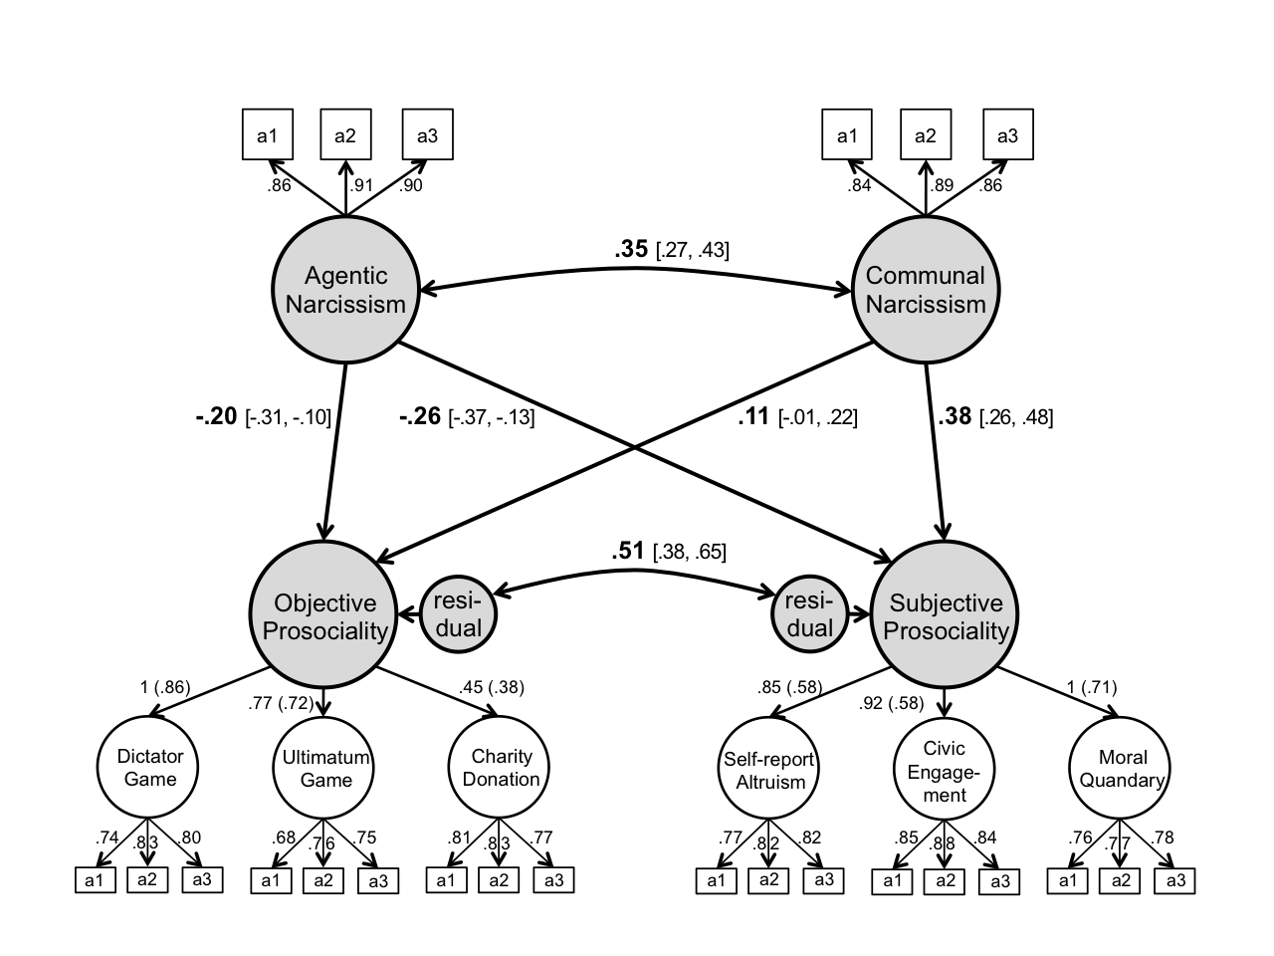

Note. a1–a3 = assessments 1–3.

Figure 2. Study 1’s results: Relations between (a) agentic narcissism and prosociality (without communal narcissism) and (b) communal narcissism and prosociality (without agentic narcissism).
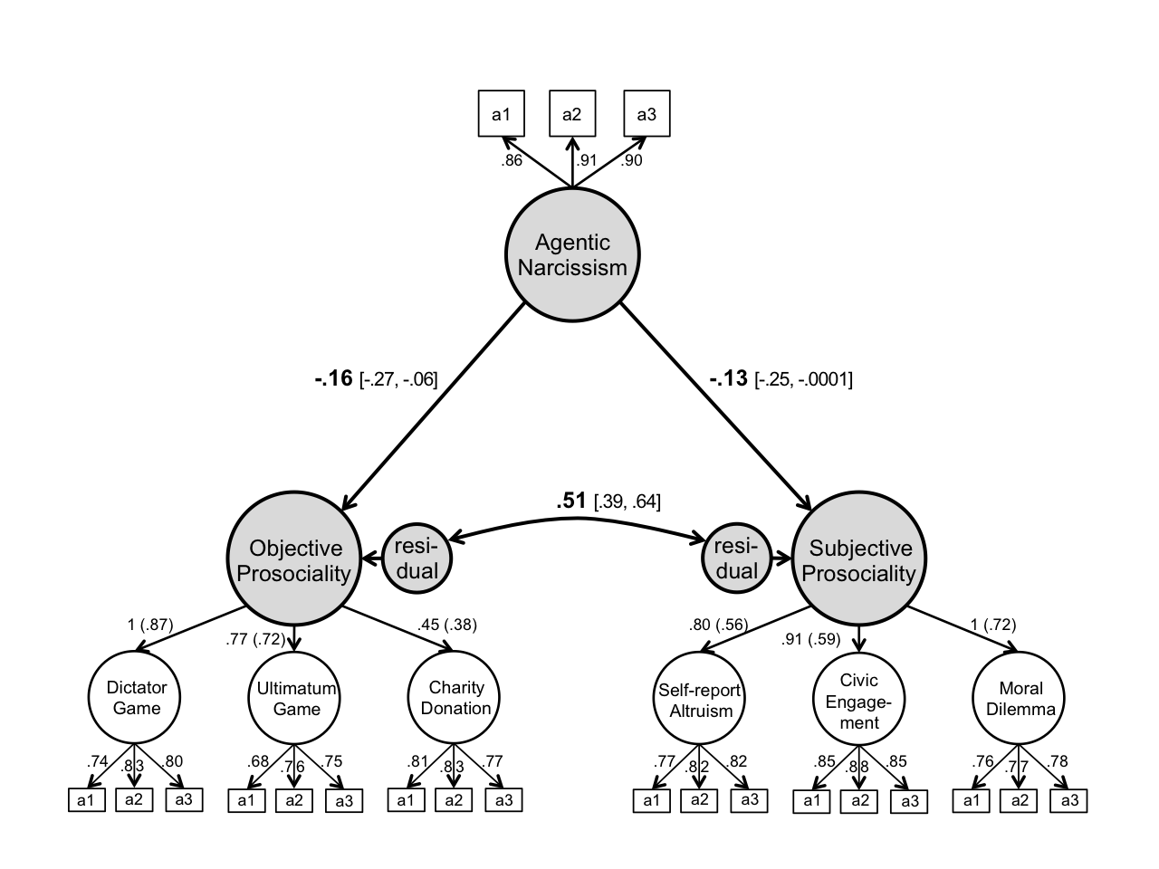
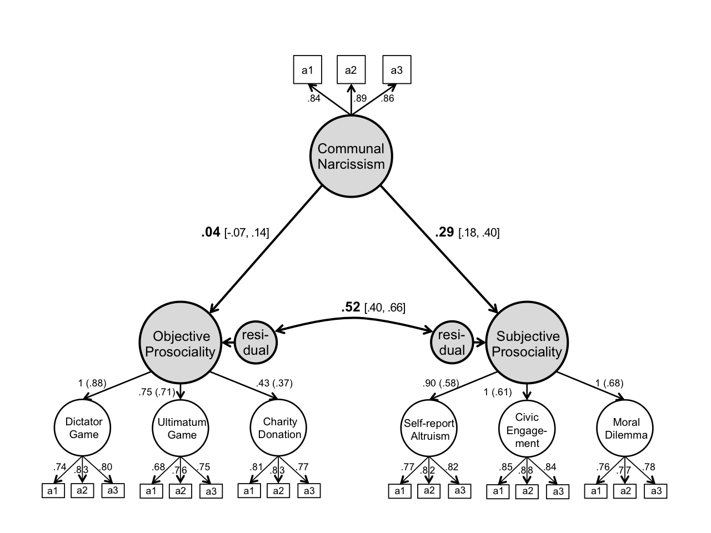
a.
b.

Note. a1–a3 = assessments 1–3.
Figure 3. Study 1’s results: Relations between grandiose narcissism (agentic and communal) and prosociality self-enhancement (i.e., latent prosociality difference scores) as well as objective prosociality.
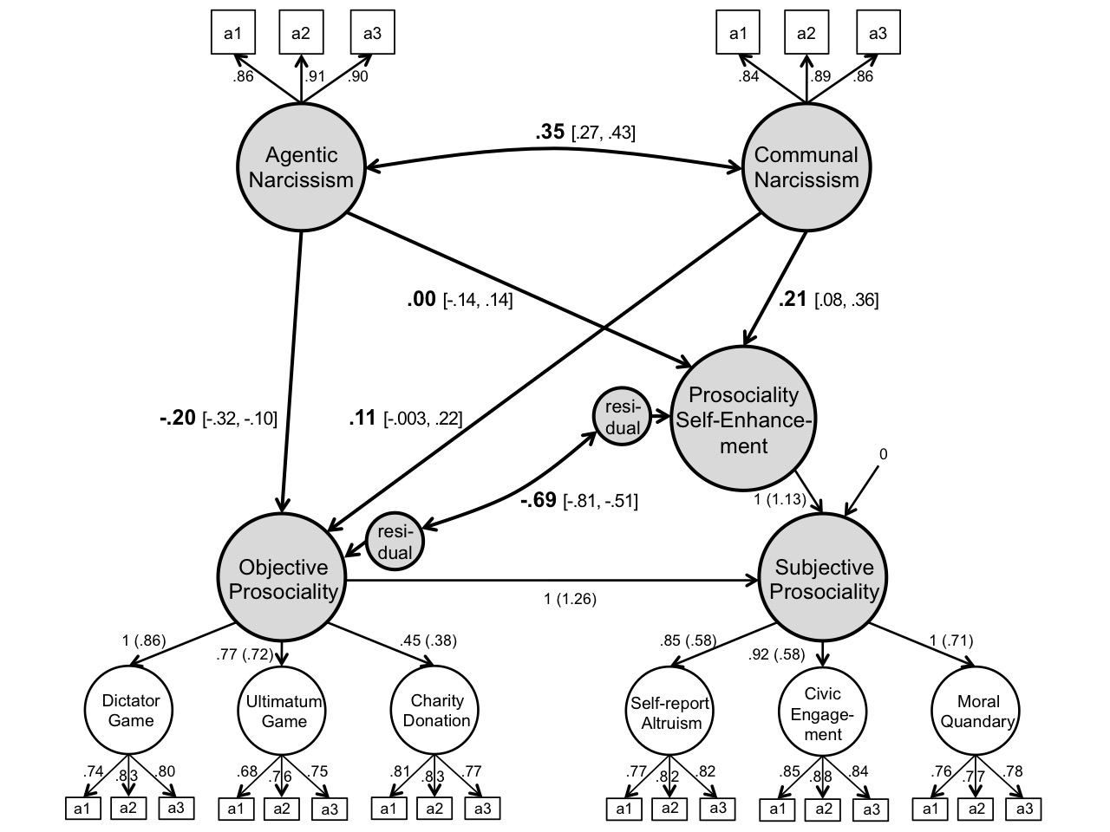

Note. pcl1–pcl3 = parcels 1–3; a1–a2 = round-robin assessments 1–2.

Figure 4. Study 2’s results: Relations between grandiose narcissism (agentic and communal) and prosociality (objective and subjective).
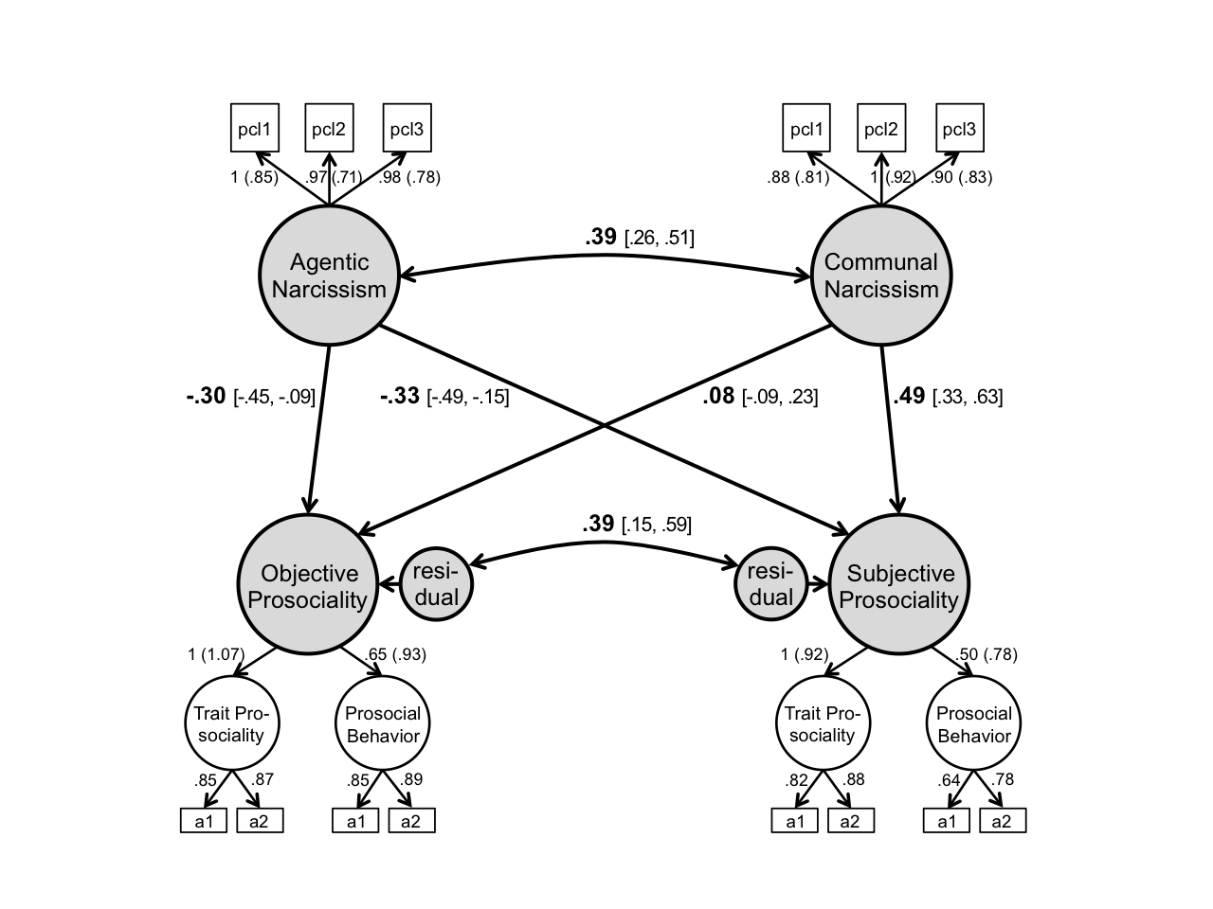

Note. pcl1–pcl3 = parcels 1–3; a1–a2 = round-robin assessments 1–2.

Figure 5. Study 2’s results: Relations between (a) agentic narcissism and prosociality (without communal narcissism) and (b) communal narcissism and prosociality (without agentic narcissism).
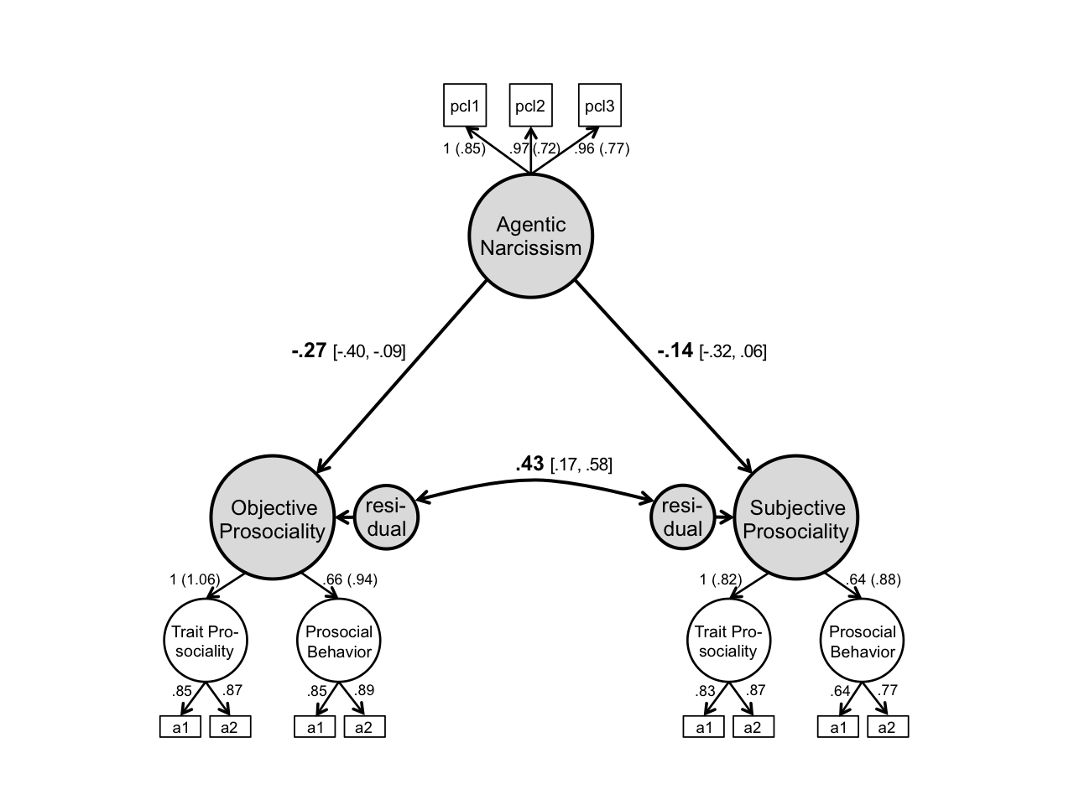
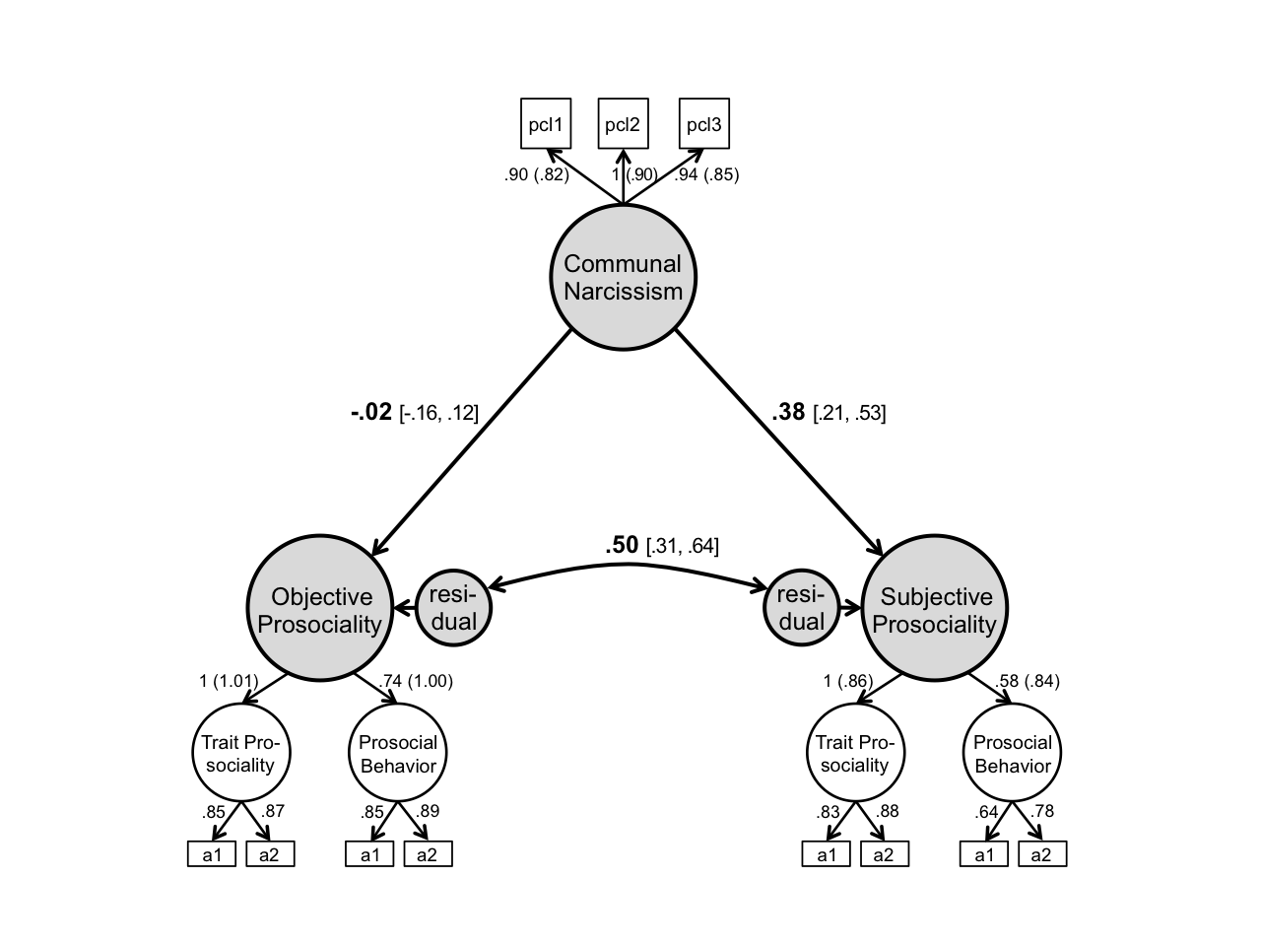
a.

b.

Note. pcl1–pcl3 = parcels 1–3; a1–a2 = round-robin assessments 1–2.

Figure 6. Study 2’s results: Relations between grandiose narcissism (agentic and communal) and prosociality self-enhancement (i.e., latent prosociality difference scores) as well as objective prosociality.
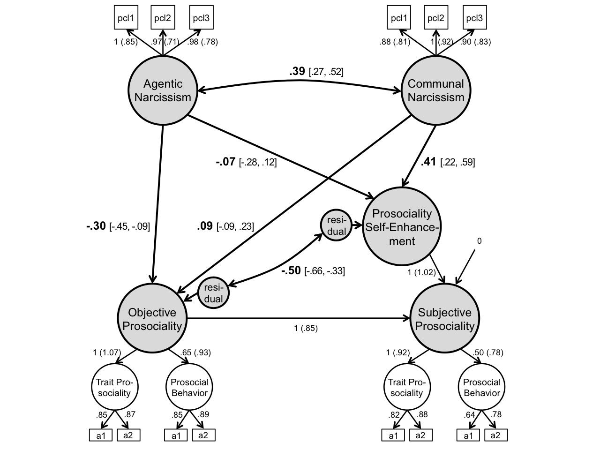

Note. pcl1–pcl3 = parcels 1–3; a1–a2 = round-robin assessments 1–2.

Figure 7. Prosociality self-enhancement (i.e., absolute prosociality difference scores, subjective – objective) as a function of (a) agentic narcissism and (b) communal narcissism.
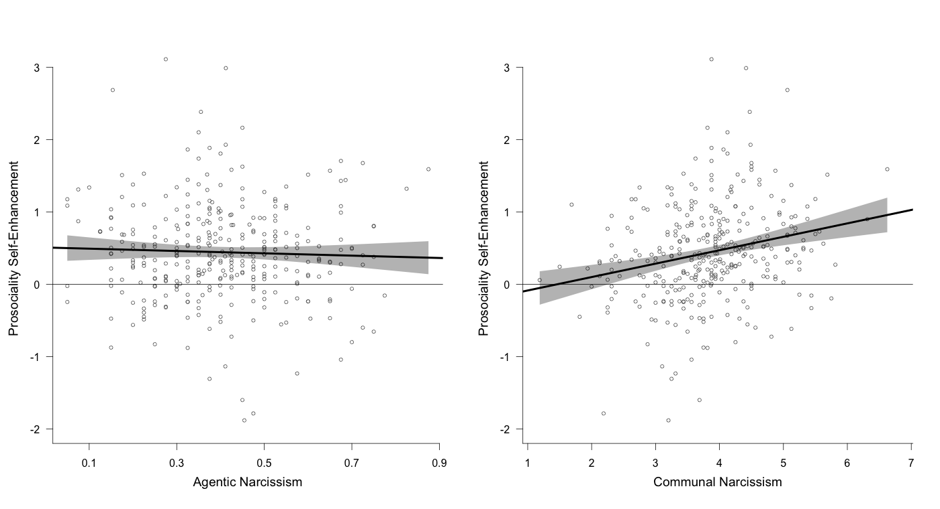
a.
b.

Note. Shaded bands denote 95% confidence intervals
Online Supplement
S1. Study 1 also included the following measures that we did not analyze: Rosenberg Self-Esteem Scale (Rosenberg, 1965), Contingent Self-Esteem Scale (Kernis & Goldman, 2006), Two-Dimensional Self-Esteem Scale (designed for this data collection), Global Psychological Adjustment Scale (Gebauer, 2016), Anxiety subscale from the IPIP 16PF (Goldberg, 1999), Death Anxiety Scale (Templer, 1970), Center for Epidemiologic Studies Depression Scale (Lewinsohn, Seeley, Roberts, & Allen, 1997), Agency-Communion Scale (Gebauer, Paulhus, & Neberich, 2013), Tendency to Forgive Scale (Brown, 2003), Transgression-Related Interpersonal Disposition Inventory (Hoyt, Fincham, McCullough, Maio, & Davila, 2005), Empathic Concern subscale of Multidimensional Individual Difference Measure of Empathy (Davis, 1980), Pleasure and Pressure Based Prosocial Motivation Scale (Gebauer, Riketta, Broemer, & Maio, 2008; revised and extended version), Volunteering in an Online Study Paradigm (adapted from Coke, Batson, & McDavis, 1978), Trust Game (Berg, Dickhaut, & McCabe, 1995), Political-Engagement Scale (adapted from Costa & Kahn, 2003), Belief in the Existence of True Altruism Scale (Gebauer, Sedikides, Leary, & Asendorpf, 2015a; as cited in Gebauer, Sedikides, Leary, & Asendorpf, 2015b), Dehumanization Scale (designed for this data collection), Balanced Inventory of Socially Desirable Responding (Paulhus, 1991), Agentic and Communal Overclaiming Scale (adapted from Gebauer, Sedikides, Verplanken, & Maio, 2012), Agency-Communion Better-Than-Average Scale (Gebauer, Sedikides, & Schrade, 2017), Global Religiosity Scale (Gebauer & Maio, 2012), Intrinsic Religiosity Scale (Zwingmann, Hellmeister, & Ochsmann, 1994), Christian Better-Than-Average Scale (designed for this data collection), Christian Overclaiming Scale (Gebauer et al., 2017), Amount and Conditionality of Belongingness Scale (Gebauer, Riketta, Maio, & Haddock, 2018), Inclusion of Others in the Self Scale (Aron, Aron, & Smollan, 1992), Parental Attachment History Prototypes (Birgegard & Granqvist, 2002), Two-Dimensional Ideal-Versus-Actual Partnership Quality Scale (designed for this data collection). Although we did not analyze any of these measures, two appear relevant: The Volunteering in an Online Study Paradigm and the Trust Game. However, there is an important difference between these two additional measures and the objective prosociality measures reported in the main text. The two additional measures evidenced insufficient temporal stability to qualify as trait indicators of objective prosociality (volunteering: r_{tt} = [r₁₂ × r₂₃] / r₁₃ = [.290 × .395] / .465 = .25; trust game: r_{tt} = [r₁₂ × r₂₃] / r₁₃ = [.279 × .301] / .458 = .42). We thus decided against using these two measures. This decision is consistent with Gebauer et al. (2015a; as cited in Gebauer et al., 2015b), who used the same dataset.
S2. Study 2 also included the following measures that we did not analyze. Self-report assessment: Rosenberg Self-Esteem Scale (Rosenberg, 1965), Global Psychological Adjustment Scale (Gebauer, 2016), Big Five Inventory (Lang, Lüdtke, & Asendorpf, 2001), Agency-Communion Scale (Gebauer et al., 2013), Balanced Inventory of Socially Desirable Responding (version 6; Paulhus, 1991), and a variant of the Overclaiming Questionnaire, concerning six psychological subfields (adapted from Paulhus, Harms, Bruce, & Lysy, 2003). Round-robin assessments: Agency Scale (adapted from Gebauer et al., 2013), Agentic Behavior Scale (adapted from Moskowitz, 1994; see also Dufner, Leising, & Gebauer, 2016); Big Five Inventory Short-Form (Rammstedt & John, 2007); Liking Scale (Back, Schmuckle, & Egloff, 2011), Meta-Perceptions of Being Liked Scale (Back et al., 2011), Study Course Knowledge Scale (designed for this data collection), Influence on Group Decisions Scale (designed for this data collection).
Supplement References
Aron, A., Aron, E. N., & Smollan, D. (1992). Inclusion of Other in the Self Scale and the structure of interpersonal closeness. Journal of Personality and Social Psychology, 63, 596–612.
Back, M. D., Schmukle, S. C., & Egloff, B. (2011). A closer look at first sight: Social relations lens model analysis of personality and interpersonal attraction at zero acquaintance. European Journal of Personality, 25, 225–238.
Berg, J., Dickhaut, J., & McCabe, K. (1995). Trust, reciprocity, and social history. Games and Economic Behavior, 10, 122–142.
Birgegard, A., & Granqvist, P. (2004). The correspondence between attachment to parents and God: Three experiments using subliminal separation cues. Personality and Social Psychology Bulletin, 30, 1122–1135.
Brown, R. P. (2003). Measuring individual differences in the tendency to forgive: Construct validity and links with depression. Personality and Social Psychology Bulletin, 29, 759–771.
Coke, J. S., Batson, C. D., & McDavis, K. (1978). Empathic mediation of helping: A two-stage model. Journal of Personality and Social Psychology, 36, 752–766.
Costa, D. L., & Kahn, M. E. (2003). Civic engagement and community heterogeneity: An economist's perspective. Perspectives on Politics, 1, 103–111.
Davis, M. H. (1980). A multidimensional approach to individual differences in empathy. JSAS: Catalog of Selected Documents in Psychology, 10, 85.
Dufner, M., Leising, D., & Gebauer, J. E. (2016). Which basic rules underlie social judgments? Agency follows a zero-sum principle and communion follows a non-zero-sum principle. Personality and Social Psychology Bulletin, 42, 677–687.
Gebauer, J. E. (2016, December). On the discriminant validity of the Rosenberg Self-Esteem Scale: Do lay people distinguish between global self-esteem and psychological adjustment? Talk presented at the 2nd GESIS Expert Meeting on Advances in Scale Development in the Social Sciences, Mannheim, Germany.
Gebauer, J. E., & Maio, G. R. (2012). The need to belong can motivate belief in God. Journal of Personality, 80, 465–501.
Gebauer, J. E., Paulhus, D. L., & Neberich, W. (2013). Big Two personality and religiosity across cultures: Communals as religious conformists and agentics as religious contrarians. Social Psychological and Personality Science, 4, 21–30.
Gebauer, J. E., Riketta, M., Broemer, P., & Maio, G. R. (2008). Pleasure and pressure based prosocial motivation: Divergent relations to subjective well-being. Journal of Research in Personality, 42, 399-420.
Gebauer, J. E., Riketta, M., Maio, G. R., & Haddock, G. (2018). There’s more to belongingness than whether it’s high or low: An unconditional belongingness model of anxiety and depression. Unpublished manuscript, University of Mannheim, Germany.
Gebauer, J. E., Sedikides, C., Leary, M. R., & Asendorpf, J. B. (2015a). Lay belief in the existence of true altruism. Manuscript in preparation, University of Mannheim, Germany.
Gebauer, J. E., Sedikides, C., Leary, M. R., & Asendorpf, J. B. (2015b). Lay beliefs in true altruism versus universal egoism. In C. B. Miller, R. M. Furr, A. Knobel, & W. Fleeson (Eds.), Character: New directions from philosophy, psychology, and theology (pp. 75–99). Oxford, UK: Oxford Press.
Gebauer, J. E., Sedikides, C., & Schrade, A. (2017). Christian self-enhancement. Journal of Personality and Social Psychology, 113, 786-809.
Gebauer, J. E., Sedikides, C., Verplanken, B., & Maio, G. R. (2012). Communal narcissism. Journal of Personality and Social Psychology, 103, 854-878.
Goldberg, L. R. (1999). A broad-bandwidth, public-domain, personality inventory measuring the lower-level facets of several five-factor models. In I. Mervielde, I. J. Deary, F. De Fruyt, & F. Ostendorf (Eds.), Personality psychology in Europe (Vol. 7, pp. 7–28). Tilburg, The Netherlands: Tilburg University Press.
Hoyt, W. T., Fincham, F. D., McCullough, M. E., Maio, G., & Davila, J. (2005). Responses to interpersonal transgressions in families: Forgivingness, forgivability, and relationship-specific effects. Journal of Personality and Social Psychology, 89, 375–394.
Kernis, M. H., & Goldman, B. M. (2006). A multicomponent conceptualization of authenticity: Theory and research. Advances in Experimental Social Psychology, 38, 283–357.
Lang, F. R., Lüdtke, O., & Asendorpf, J. B. (2001). Testgüte und psychometrische Äquivalenz der deutschen Version des Big Five Inventory (BFI) bei jungen, mittelalten und alten Erwachsenen. [Validity and psychometric equivalence of the German version of the Big Five Inventory in young, middle-aged and old adults]. Diagnostica, 47, 111–121.
Lewinsohn, P. M., Seeley, J. R., Roberts, R. E., & Allen, N. B. (1997). Center for Epidemiologic Studies Depression Scale (CES-D) as a screening instrument for depression among community-residing older adults. Psychology and Aging, 12, 277–287.
Moskowitz, D. S. (1994). Cross-situational generality and the interpersonal circumplex. Journal of Personality and Social Psychology, 66, 921–933.
Paulhus, D. L. (1991). Measurement and control of response bias. In J. P. Robinson, P. R. Shaver, & L. S. Wrightsman (Eds.). Measures of personality and social psychological attitudes (Vol. 1, pp. 17–59). San Diego, CA: Academic Press.
Paulhus, D. L., Harms, P. D., Bruce, M. N., & Lysy, D. C. (2003). The over-claiming technique: measuring self-enhancement independent of ability. Journal of Personality and Social Psychology, 84, 890–904.
Rammstedt, B., & John, O. P. (2007). Measuring personality in one minute or less: A 10-item short version of the Big Five Inventory in English and German. Journal of Research in Personality, 41, 203–212.
Rosenberg, M. (1965). Society and the adolescent self-image. Princeton, NJ: Princeton University Press.
Templer, D. I. (1970). The construction and validation of a death anxiety scale. Journal of General Psychology, 82, 165–177.
Zwingmann, C., Hellmeister, G., & Ochsmann, R. (1994). Intrinsische und extrinsische Orientierung: Fragebogenskalen zum Einsatz in der empirisch-religionspsychologischen Forschung [Intrinsic and extrinsic religious orientation: Questionnaire scales in use for psychological studies of religion]. Zeitschrift für Differentielle und Diagnostische Psychologie, 15, 131–139.

Figure S1. Additional results of Study 2: Relations between the grandiose facets of the NPI (leadership-authority and grandiose exhibitionism), communal narcissism, and prosociality (objective and subjective).

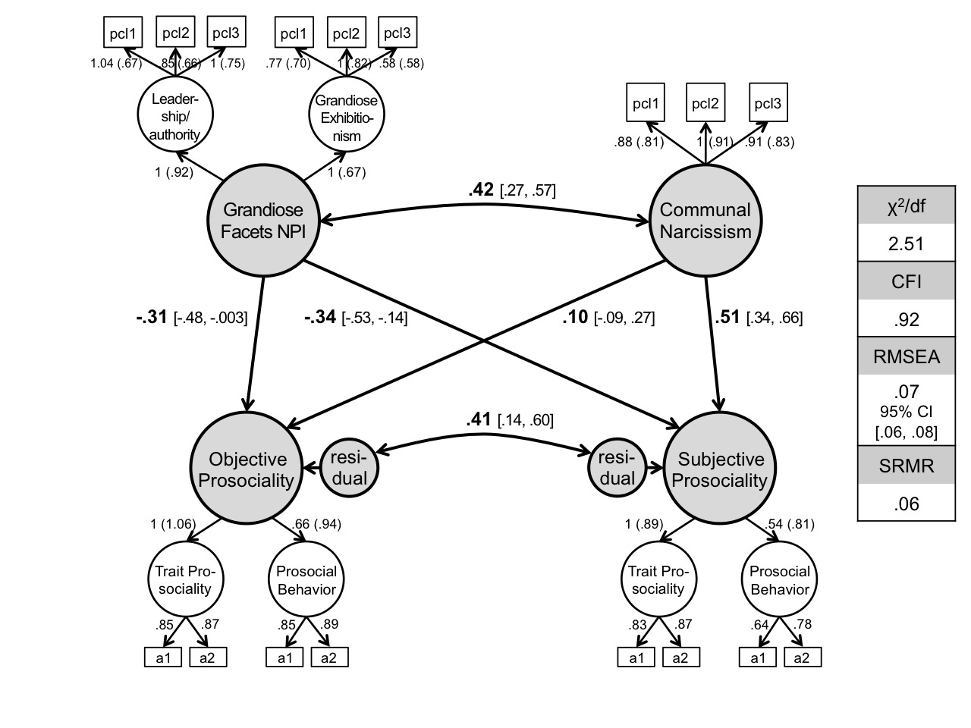

Note. pcl1–pcl3 = parcels 1–3; a1–a2 = round-robin assessments 1–2.

Figure S2. Additional results of Study 2: Relations between the leadership-authority facet of the NPI, communal narcissism, and prosociality (objective and subjective).

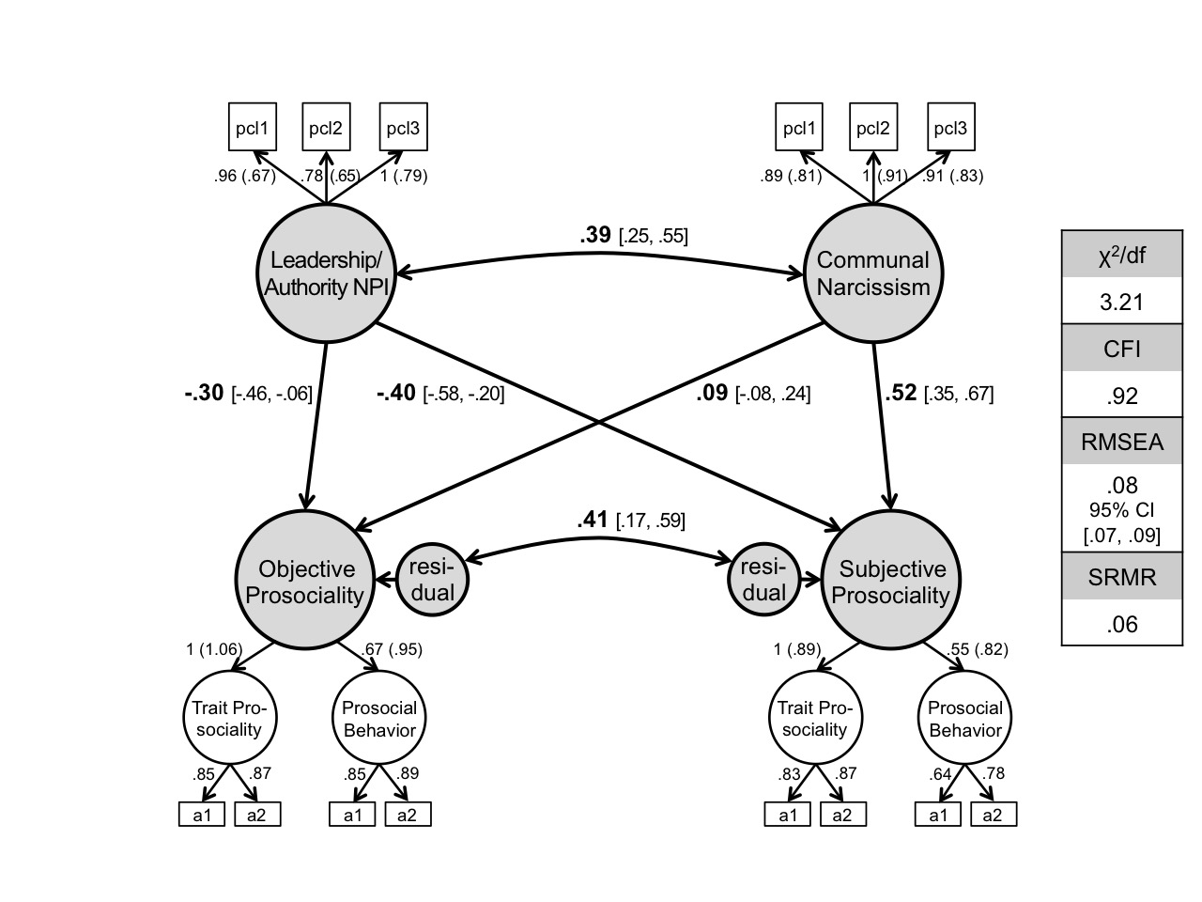

Note. pcl1–pcl3 = parcels 1–3; a1–a2 = round-robin assessments 1–2.

Figure S3. Additional results of Study 2: Relations between the grandiose-exhibitionism facet of the NPI, communal narcissism, and prosociality (objective and subjective).

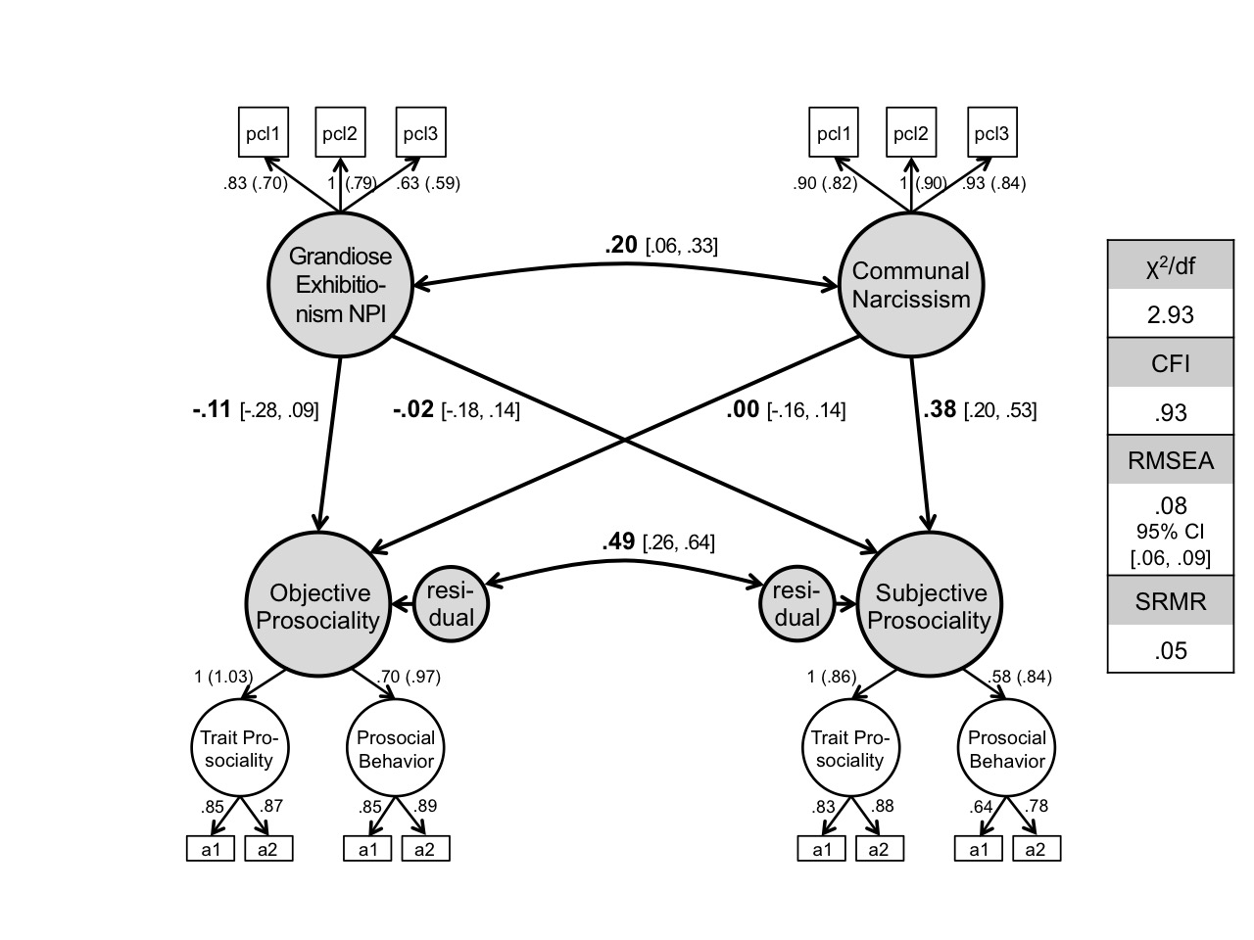

Note. pcl1–pcl3 = parcels 1–3; a1–a2 = round-robin assessments 1–2.

Figure S4. Additional results of Study 2: Relations between the entitlement-exploitativeness facet of the NPI, communal narcissism, and prosociality (objective and subjective).

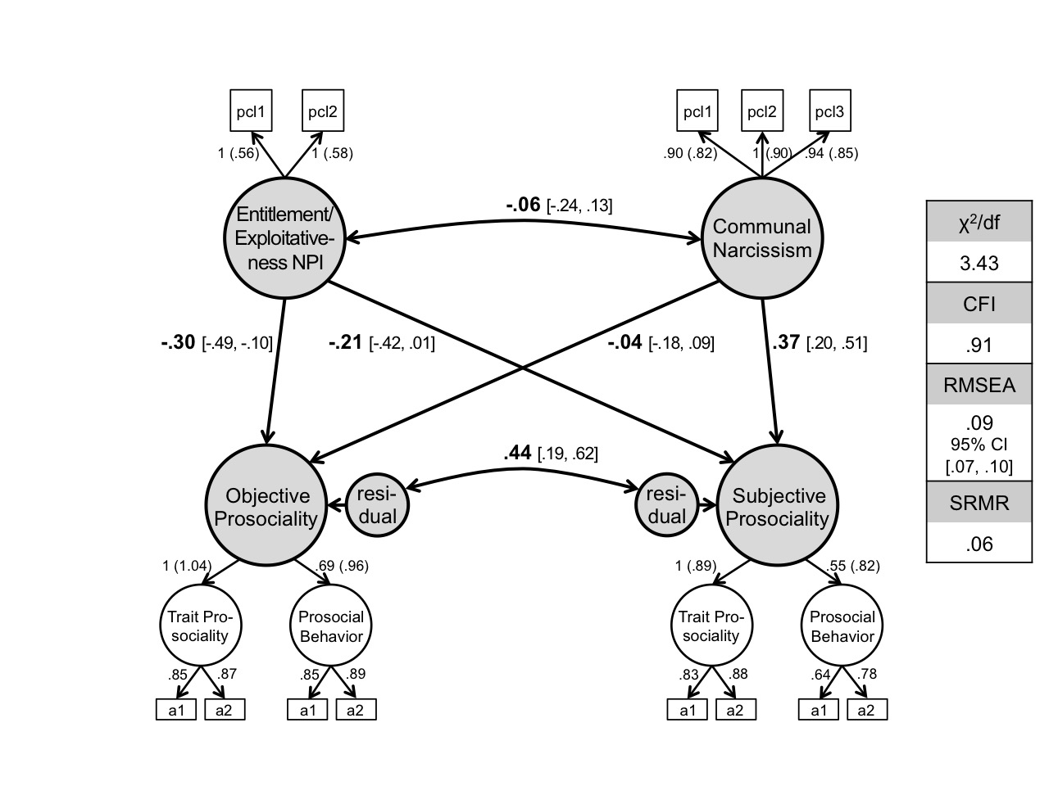

Note. pcl1–pcl3 = parcels 1–3; a1–a2 = round-robin assessments 1–2.

