Bias-correction of historical and future simulations of precipitation and temperature for China from CMIP5 models
X. Yang
State Key Laboratory of Hydrology-Water Resources and Hydraulic Engineering, Hohai University, Nanjing, China.
E.F. Wood
Department of Civil and Environmental Engineering, Princeton University, Princeton, New Jersey, USA.
J. Sheffield
Geography and Environment, University of Southampton, Southampton, UK.
L Ren, M Zhang, Y Wang
State Key Laboratory of Hydrology-Water Resources and Hydraulic Engineering, Hohai University, Nanjing, China.
Corresponding author address: State Key Laboratory of Hydrology-Water Resources and Hydraulic Engineering, Hohai University, Nanjing, China.
E-mail: rll@hhu.edu.cn
ABSTRACT
In this study, the equidistant quantile-based mapping method (EDCDF) method was used to develop downscaled monthly precipitation and temperature over China at 0.5°×0.5° spatial resolution for eight CMIP5 GCM simulations. The downscaled dataset was constructed by combining observations from 756 meteorological stations in China with the monthly GCM outputs for the historical (1961-2005) and future (2031-2090) periods under the lower (RCP2.6), medium (RCP4.5) and high (RCP8.5) representative concentration pathway emission scenarios. The Jackknife method was used to cross validate the performance of the EDCDF method. We chose 1961-1990 as the baseline training period and then took one year moving as the projection test period and the remaining years as validation period. The average of 16 experiments suggested that CDF and EDCDF methods were comparable when applied to the historical period (1961-2005), but EDCDF was more efficient in reducing biases than the traditional CDF method in China. Both methods produced a dramatic reduction in the MAE of temperature for January and July. The EDCDF method had a slight advantage over the traditional CDF for precipitation, reducing the MAE by about 0.83% and 1.2% at a significance level of 95% in January and July, respectively. For future projection, both methods exhibited similar spatial patterns for longer period (2061-2090) under RCP8.5 scenario. However the EDCDF was more sensitive to a reduction in variability.
Keywords: CMIP5; China; bias correction; EDCDF; precipitation; temperature
- Introduction
Global climate change leads to the rise of temperature along with changes in precipitation patterns, which are highly variable at the regional or local scale (Tomillo et al. 2015). Under the impacts of climate change, precipitation in China has increased by 2% and the frequency of precipitation events has decreased by 10% from 1960 to 2000 (Liu et al. 2005). Meanwhile, near surface air temperature has increased by 0.5-0.8 °C during the twentieth century, with an accelerated warming of 1.1 °C during the second half of the century, which is slightly higher than the global temperature trend for the same period (Ding et al. 2007; Chen and Frauenfeld 2016). The warming trend and variability of changing precipitation patterns have likely led to more flood and drought hazards (Wang et al. 2011; Field et al. 2012). The changes of precipitation patterns especially will directly affect regional water resources and availability of food supply (Dore 2005). Especially, China may become more vulnerable to climate change in the future as agriculture plays a central role in ensuring the food security for supporting about 1.3 billion people (Piao et al. 2010). The China National Committee for Disaster Reduction (CNCDR) reported that 748 flooding events occurred from 2000 to 2008 in China which led to 3.6 million houses damaged, over 50 million hectares of crops destroyed, and over US$ 43 billion incurred as an economic cost (Li et al. 2012). Especially, the flood of 1996 caused material loss of about US$26 billion and the 1998 flood about US$ 30 billion, and are considered as the top two costliest flood events globally (Jiang et al. 2008). Wang and Zhai (2003) found that the severe droughts in 1997, 1999 to 2002 over many areas of northern China and devastating drought over Yunnan in 2010 caused large economic and societal losses. Therefore, better understanding the climate changes in the future is essential for water and food security that China faces in the twenty-first century.
The Coupled Model Intercomparison Project Phase 5 (CMIP5) multi-model datasets used for the IPCC Fifth Assessment Report (AR5) are widely used in climate studies, in particular to evaluate potential future changes. The CMIP5 models have higher horizontal and vertical resolution than models from the previous CMIP phases and include more comprehensive treatments of physical process, which offers unprecedented opportunities to analyze the attribution of climate change and generate regional and continental projections for the twenty-first century (Taylor et al. 2012). However, the outputs of general circulation models (GCMs) remain relatively coarse in terms of their spatial and temporal resolutions, on the order of tens of kilometers at daily or monthly resolutions, which is very coarse compared to that of hydrologic processes and would be unable to resolve significant sub-grid scale features (Grotch and MacCracken 1991; Cloke et al. 2012). Moreover, GCM simulations are biased in both the spatial and temporal scales due to the uncertainty in the parameterization of unresolved processes, which prevents their direct use in climate change impact and adaptation studies (Xu and Singh 2004; Wood et al. 2004; Randall et al. 2007; Ojha et al. 2012). Therefore, it is necessary to downscale and bias-correct long-term GCM simulations to obtain fine spatial-scale information (Wood et al. 2004; Fowler et al. 2007; Tereza and Sarahí 2012; Wang and Chen 2014).
Both dynamical downscaling and statistical downscaling approaches can be used to remove systematic biases in models and transform simulated climate fields from coarse resolution to a finer spatial resolution (Castro et al. 2005; Maurer and Hidalgo 2007; Rockelet al. 2008; Maraun et al. 2010;). The statistical downscaling approach offers a relatively fast and efficient way to formulate the statistical relationship between coarse-resolution climate variables (from climate model outputs) and fine-resolution observations (Fowler and Wilby 2007; Tereza and Sarahí 2012; He et al. 2016). Several bias correction methods have been developed to downscale climate variables from climate models, such as the linear-scaling approach (Lenderink et al. 2007), variance scaling (Chen et al. 2011), distribution mapping (Teutschbein and Seibert, 2012), and delta-change correction (Graham et al. 2007). In general, bias correction methods assume the statistical relationship between the historic model simulation and observations will remain stable in the future period, while it has been shown that the distribution is expected to change in the future, especially for the higher-order moments (Wood et al. 2004; IPCC 2007). Compared to conventional bias correction methods, the equidistant quantile-based mapping method (EDCDF), developed by Li et al. (2010), uses the distribution of the model output to match all statistical moments with respect to the observations, and explicitly incorporates changes in the distribution of the future climate data. This method can incorporate both the GCM climatological mean and variance by taking into account the changes of climate fields in the future period (Watanabe et al. 2012; Aloysius et al. 2016).
We apply the EDCDF method for CMIP5 simulated precipitation and temperature based on the observational data in China. The aim is to evaluate the performance of this bias-correction method in capturing the temporal and spatial pattern of climate fields in China. Another aim is to increase confidence in predicting future changes of precipitation and temperature, which has direct effects on socio-economic development in China. In this study, section 2 describes the datasets used, a description of the statistical downscaling approach, and methods to assess the model performance. The performances of the traditional CDF method, EDCDF method, and original CMIP5 models for seven sub-regions as well as the whole of China are shown in section 3, while features of the climate change projections in the future during the near and long term under three RCP scenarios are also discussed in section 3. Section 4 summarizes the main findings.
- Materials and methods

a. Datasets
Daily precipitation and temperature data covering the period from 1961-2005 from 756 stations over China are used in this study, which are obtained from the National Climate Center of the China Meteorological Administration. The locations of these stations and the Digital Elevation Model (DEM) are shown in Fig. 1. Due to the data for most stations are available from 1960, our analysis is conducted from 1961 to 2005, during which all of the stations are in operation and have the same record periods for both variables. The observed data are interpolated to 0.5°×0.5° grid cells using bilinear interpolation but with adjustments for differences in elevation between the two grids, taking into account the lapse rate of -0.65 °C for every 100 m increase in elevation.
In this study, the whole territory of China is divided into seven climatic regions according to Wang (2011): Northeast China (NE), Northern China (N), Southeast China (SE), Eastern Northwest China (ENW), Southwest China (SW), Western Northwest China (WNW), and Tibetan Plateau (Tibet). (Note: Taiwan and Hainan both belong to SE).
We focused on the application of the EDCDF method for CMIP5 models in China and for future projections under the RCP2.6, RCP4.5 and RCP8.5 scenarios. Limited by data availability, we only obtained monthly precipitation and surface air temperature for eight climate models for the climate change projections under three scenarios (Table 1). Due to the different spatial resolutions adopted by different GCMs, all model outputs were first bi-linearly interpolated into a common 0.5°×0.5° grid and matching the spatial resolution of the gridded observations. Meanwhile, we categorized the eight CMIP5 model simulations at the monthly time scale for the training period (1961-1990) for calibrating the model parameters and the validation period is from 1991 to 2005. For future projections, we analyzed the near term (2031-2060) and long term (2061-2090) changes compared with the reference period (1961-1990) for the three RCPs.

b. The equidistant quantile-based mapping method (EDCDF)
The cumulative distribution function (CDF) quantile mapping method, based on the statistical moments of the probability density function (PDF) of observations and GCM simulations, maps the projected climate variables to the observed CDF with Eq. (1) (Panofsky and Brier 1958; Gudmundsson et al. 2012).
$x_{m-p}=F_{o-c}^{-1}\left(F_{m-c}\left(x_{m-c}\right)\right)$ (1)
where $F_{o-c}^{-1}$ is the quantile function corresponding to observations (o) for a historic training period (c), $F_{m-c}$ is the PDF of model simulated fields (m) for a historic training period, and p is the future projection climate fields.
This method assumes that the relationship between the model simulated and observed values during the training (historic) period also applies to the future period. However, IPCC (2007) found that this assumption may not true because of the non-stationarity of the climate change process that has a profound influence on climate impact studies. Considering the difference between the PDF for the future and reference periods, Li et al. (2010) developed an equidistant CDF matching (EDCDF) method. This method applies a quantile-based mapping of the PDF between both the historic and projection period and matching the climatic fields during the future.
For temperature the projection period ($x_{{m-p}_{_adjust}}$) is bias corrected with Eq. (2):
$x_{{m-p}_{_adjust}}=x_{m-p}+F_{o-c}^{-1}\left(F_{m-p}\left(x_{m-p}\right)\right)-F_{m-c}^{-1}\left(F_{m-p}\left(x_{m-p}\right)\right)$ (2)
This method uses a four-parameter beta function [see Eq. (3)] to fit the temperature fields.
$f\left(x;a,b,p,q\right)=\frac{1}{{B\left(p,q\right)\left(b-a\right)}^{p+q-1}}{\left(x-a\right)}^{p-1}∙{\left(b-x\right)}^{q-1}$ (3)
$$a≤x≤b;p,q>0$$
where B is the beta function, a and b are the range parameters as the extreme values from the data, σ is the standard deviation, and p and q are the shape parameters determined by the maximum likelihood estimation method.
For precipitation, the quantile-based mapping of the PDF between both the historic and projection period and matching the climatic fields during the future with Eq. (4):
$x_{{m-p}_{_adjust}}=x_{m-p}\frac{F_{o-c}^{-1}\left(F_{m-p}\left(x_{m-p}\right)\right)}{F_{m-c}^{-1}\left(F_{m-p}\left(x_{m-p}\right)\right)}$ (4)
A two-parameter gamma distribution is used for the portion of a given time series with precipitation [see Eq. (5)].
$f\left(x;k,θ\right)=x^{k-1}\frac{e^{-x/θ}}{θ^{k}Г(k)} for x>0 and k,θ>0$ (5)
In addition, taking into account the intermittent nature of precipitation, a mixed gamma distribution is used to model the distribution of precipitation [see Eq. (6)].
$F_{m-p}(x_{m-p})=\frac{G_{m-p}\left(x_{m-p}\right)-\left(1-P\right)H}{P}$ (6)
where P is the percentage of months with precipitation and H is a step function having a value of zero when there is no precipitation and a value of 1 when there is precipitation. G_{m-p} is the two-parameter gamma distribution of the climatic fields during the future projection period.
In this method, the parametric distributions fit to both the temperature and precipitation fields at each grid point and the distribution range parameters were taken as the extreme values from the data extended by half of one standard deviation of each grid point Fig. 2 illustrates how the two bias-corrected methods works. The CDFs for the observations (OBS, Gray solid line) and model are constructed from the temperature field for a point near 24°N, 98°E. For the CDF method (Fig. 2a), a value of 15 °C in a future projection time series corresponds to MODc (Cyan dotted-dashed line) value of 0.15 under the current climate, which can be transferred to the observed value according to the quantile function of the observations (the black circle). However, in the EDCDF method (Fig.2b), the value of 15 °C corresponds to 0.05 in the CDF of the future model projection (MODp), which is different from that estimated by the CDF method. In the EDCDF method, the difference between the model (MODc) and observations (OBS) under current climate is subtracted from the model projection (MODp) to get the bias-corrected value. The future projection time series, which can then be used to construct the CDF for the bias-corrected future projection time series (EDCDF, the pink dashed line). Figure 2 is solely for the purpose of illustration and more details can be found in Li et al. (2010).

c. Statistical assessment method
We compare the results of traditional CDF method and EDCDF method against to the observation by cross validating with Jackknife method (Lafon et al., 2012, Wang and Chen, 2014). First, we take the period 1961–1990 as the training period to calibrate the parameters, and then bias correct of temperature and precipitation for the remaining 15 years as one experiment. Then, the training period is repeatedly moved one year forward and the bias correction and validation are carried out for the remaining years. This procedure is repeated 15 times. Therefore, 16 continuous 30 years periods are chosen as training periods and the corresponding remaining years as validation periods. The followed analyses of the performance of two bias-corrected methods all are based on the mean of the 16 Jackknife experiments for minimizing the effects of the choice of training period and to guarantee the robustness of the assessment. Furthermore, based on the baseline period (1961-1990), we bias correct the near term (2031-2060) and long term (2061-2090) for the future period.
In this study, the multi-model ensemble average (MME) is calculated with equal weight, a method that is commonly used for reducing noise in the predictions (Aloysius et al. 2016). We first analyze the bias and MAE of two bias-corrected method compared to the raw models for cross validation. Subsequently, we evaluate the performance of EDCDF using the root mean squared error (RMSE), correlation coefficient, Quantile-Quantile (Q-Q) plots, and normal distribution of the extreme values. The RMSE is defined as:
$RMSE=\sqrt{\frac{\sum_{i=1}^{n}{{(P_{i}-O_{i})}^{2}}}{n}}$ (6)
where P_{i} and O_{i} are the simulation and observed fields, respectively, and n is the number of spatial points or temporal fields.
- Discussion and results

a. Cross validation of EDCDF method
We compare the spatial patterns of bias from the raw models and the mean of 16 Jackknife experiments using CDF and EDCDF methods against the observations in Figs 3 and 4. Compared to observations, the raw CMIP5 model ensemble underestimates the temperature around Tibet and over predicts temperature along the coastal regions and in some northeastern and northwestern regions, while overestimating the precipitation by more than 90% in most western parts of China, due to the lower precipitation in these regions, which lead to larger percentage bias than other wetter sub-regions (Fig. 3). The spatial patterns for bias using the EDCDF and CDF methods show a dramatic reduction in the mean and range of the biases. The spatial bias of precipitation and temperature for the EDCDF and CDF methods are very similar. This indicates that the CDF and EDCDF methods exhibit comparable skill in terms of reducing the biases of the original models, which is similar to the results of Li et al. (2010). However, there are still some differences in the spatial distribution of biases between the two bias-corrected methods relative to the observation (Fig. 4). The EDCDF method has a lower bias of about 1mm month⁻¹ in the northwest part of NE and southeast part of N sub-regions for precipitation than that of the CDF. For temperature, lower temperature biases for the EDCDF method are found in mostly parts of WNW, ENW, N, and NE, while higher biases are located parts of SW sub-region.
Furthermore, we compare the 5th (95th) percentiles of MAE for the CDF and EDCDF methods in January and July. In general, both methods show significant reduction and very similar MAE, especially for temperature. Thus, we only present the results for precipitation in Table 2. Overall, both methods show considerably smaller MAE, but less skill in January compared to July. In particular, they show very similar skill for the 5th percentile in July. However, the EDCDF method has a slight advantage over the CDF method for the 95th percentile of January and July. The former shows further reduction in MAE, varying from 0.01 to 0.37 less than that of the CDF method in January. Thus, the EDCDF applied for China seems more skillful in bias correction than the CDF method. These results are consistent with Li et al. (2010) and Aloysius et al. (2016).

b. Performance of EDCDF method
To further evaluate the performance of EDCDF method in China, we analyze the RMSE and Quantile-Quantile (Q-Q) plots of EDCDF simulations against to the observations. Fig. 5 shows the RMSE for monthly precipitation and temperature in seven sub-regions of China. The EDCDF method outputs exhibit closer similarity for all climate fields to the actual observed data than to the raw model simulations. The bias-corrected mean RMSE is improved dramatically with a mean value of 38.82 mm, while that of raw model is about 56 mm for all models in seven sub-regions. The performance of bias-corrected precipitation in winter is better than summer, which is generally better in wetter regions than that of drier regions. The best performance of EDCDF simulated precipitation occurred in WNW and ENW with a mean value of 10.72 mm and 17.92 mm, respectively. The highest RMSE value is found in the SE (92.44mm) after downscaling, especially in the months of June, July, and August. This probably due to the difficulty in resolving small scale processes in the driest regions, which is similar to the findings of Goodess et al. (2007) and Wetterhall et al. (2006).
The temperature of all eight models is well matched with observations with lower RMSE than that of the raw models across the seven sub-regions. The overall RMSEs among the bias-corrected models vary from 0.9 °C to 4.5 °C, while those of the raw models vary from 1.52 °C to 16.3 °C. The lowest RMSEs of temperature are occurred in June, July, and August for all models, whereas the highest values are in January, February, and December. Meanwhile, SW (1.68 °C) and SE (1.93 °C) sub-regions have the lowest RMSE for all seasons, but WNW (2.68 °C) and NE (2.53 °C) regions have the highest RMSEs. In general, the eight CMIP5 models bias-corrected by the EDCDF method are able to capture the seasonal pattern of climate fields in China.
Fig. 6 compares the monthly precipitation in terms of the full distribution over the whole study domain using Quantile-Quantile (Q-Q) plots in January and July. The Q-Q plots of precipitation show reasonable bias-corrected performance compared with observations over the whole study domain area, yielding data points very close to the reference line in January. However, EDCDF underestimates the precipitation less than 105 mm in July. For temperature, the Q-Q plots indicate that all bias-corrected models have satisfactory skill in downscaling temperature in January. Whereas, all downscaled models overestimate the temperature in July.
In addition, we use the ensemble spread of inter annual value and the normal distribution of the extreme monthly values to analyze the uncertainty of EDCDF bias-corrected precipitation and temperature. Fig. 7 shows the domain-averaged bias-corrected annual precipitation and temperature of individual bias-corrected models and the multi-model ensemble compared to the observations. Results demonstrate that the individual model simulations deviate more from the observations, whose spread varies from 28.68 mm to 187.67 mm. For temperature, the deviation of individual model simulations from the observation varies from 0.44 to 0.90 °C, which is smaller than that of precipitation. This indicates that the bias-corrected precipitation shows large inter annual variations and larger uncertainties compared to that of temperature.
Fig. 8 presents the normal distribution of the extreme values for the seven sub-regions during wet and dry year, according to the climatology for all seven sub-regions. During the wet years, the bias-corrected MME results in greater extreme values than the observation in all sub-regions above 0.9 probability level. In contrast, the bias-corrected MME results in smaller extreme precipitation during the dry years in NE and N, but greater values in other five sub-regions. Notably, EDCDF has more precipitation for wet/dry years under than 0.2 probability level in SE. This indicates that the gamma distribution for the precipitation in SE does not match the extreme low value of observation as well. Meanwhile, the normal distributions of temperature during the wet and dry years show good agreement with the observation for all sub-regions, which illustrate that the EDCDF method has better skill in simulating the temperature than precipitation.

c. Future projections
For the future projection, we compare the mean and standard deviation of the raw model simulation and outputs after bias correction using the EDCDF and CDF methods under the RCP8.5 scenario (Fig. 9 and Fig. 10). In general, the CDF and EDCDF methods give similar spatial patterns for the mean and standard of temperature as compared to the raw model output (Fig. 9). For the mean value of temperature, the EDCDF method shows a different range (higher than 25 °C) compared to that of the CDF method (lower than 25 °C). CDF has a colder mean temperature for most parts of China in January than the other two results. Both methods show higher temperatures in July, which is consistent with the correction of the model cold bias in the observational period. In July, the mean temperature of the CDF method shows a colder value in the SE, N, and NE sub-regions than that of EDCDF. A colder northern and warmer southeast are expected in January at the end of the 21st century under the RCP8.5 scenario. On the other hand, the two methods show a clear reduction in variability of temperature for most parts of China in January and July. However, there are some subtle differences in the variability of the two methods: the EDCDF method shows smaller variability for the southeast and southwest compared to that from the CDF method.
In terms of the precipitation, the spatial patterns for the mean and standard deviation from 2061 to 2090 are very similar for the two methods in January and July (Fig. 10). The variability of precipitation is substantially reduced by both methods. Notably, there are some differences between the two bias-correction methods. In January, EDCDF has a higher value of mean precipitation for the WNW and SE sub-regions and lower variability for the WNW and NE sub-regions than that of CDF and the raw model. In July, CDF shows higher variability for the WNW and ENW sub-regions and lower mean precipitation for the Tibet and NE sub-regions than that of EDCDF.
Furthermore, we analyze the relative changes in precipitation and temperature during the near term (2031-2060) and long term (2061-2090) compared to the reference period (1961-1990) under the RCP2.6, RCP4.5, and RCP8.5 scenarios in China. The spatial patterns of the MME changes are illustrated in Fig. 11, Fig. 12, and Table 3. The changes in precipitation and temperature exhibit similar increasing changes under the three different RCP scenarios in the future. However, both precipitation and temperature in the MME display different spatial patterns of change under the three RCPs. Relative to the reference period (1961-1990), the regionally averaged precipitation in China and the seven sub-regions will continue to increase from 2031 to 2090 with increasing spatial variation (Fig. 11), especially for the difference between the northwest and southeastern regions. In general, changes in China vary from 4.1% to 4.6% in the near term and from 5.0% to 10.2% in the long term under three RCP scenarios. In the near term, the MME projects a clear increase in precipitation in the WNW, ENW and Tibet regions and a slight decrease in the SE, SW, and NE regions. The precipitation in the WNW region was found to increase by 10.7%, 13%, and 14% in the near term relative to the reference period under RCP2.6, RCP4.5, and RCP8.5, respectively. Meanwhile, these increases will be more obvious in the WNW region over the long term with values of 16.7%, 14%, and 21.5% under the three RCPs, respectively. Over the long term, RCP8.5 projections exhibit a larger spatial variability in precipitation than the RCP2.6 and RCP4.5 projections. The precipitation in the NE, N, and SE regions and Tibet will increase under RCP8.5 but will slightly decrease in some parts of China under RCP2.6 and RCP4.5.
For temperature, the MME projects similar and significant changing patterns for the area-averaged annual mean values under three scenarios for the future period (Fig. 12, Table 3). The projected annual temperature is similar across the emission pathways over China and most of the sub-regions except Tibet. RCP8.5 projects the highest rise in temperature and RCP4.5 projects a lower increase, while RCP2.6 projects the lowest increase. In the near term, RCP8.5 drives temperature increases across China in excess of 0.8 °C and 1.1 °C, significantly warmer than the increases projected under RCP2.6 and RCP4.5. RCP2.6 and RCP4.5 project similar spatial patterns, but RCP4.5 projects a greater change in temperature than RCP2.6 in the SE region. Meanwhile, differences in the simulated temperature changes are clearly observed in Tibet and the SW region between the three RCPs. In Tibet, the temperature change in the near term is projected to be -0.6 °C and -0.1 °C for RCP2.6 and RCP4.5, respectively, but a 1.3 °C increase under RCP8.5.
For the long term, the temperatures under RCP2.6 and RCP4.5 follow patterns of change similar to those of the near term. RCP2.6 projects decreasing temperatures varying from -5 °C to -1 °C in the northern part of China, while it projects a slightly increasing change in the NE, N, SE, and WNW regions. One interesting result is that RCP8.5 projects a remarkable increase, while RCP2.6 and RCP4.5 project a nearly equivalent decrease in Tibet and SW. Particularly in Tibet, the RCP2.6 projects a temperature decrease of about -0.7 °C, while the RCP4.5 and RCP8.5 project increases of approximately 0.4 °C and 3.2 °C, respectively.
- Conclusion
In this study, we apply the EDCDF statistical downscaling method for eight CMIP 5 models in China and presented the climate change projections in the twenty-first century under the RCP2.6, RCP4.5 and RCP8.5 emission scenarios. The Jackknife method is used for cross validating the performance of EDCDF and traditional CDF. For removing the effect of training period choice, we repeat the Jackknife experiment 16 times with one year moving. The result of the average of 16 experiments shows that the EDCDF and CDF methods are able to reduce biases in eight CMIP 5 models temperature and precipitation fields significantly. EDCDF has slight advantage in reducing the bias of precipitation in NE and N sub-regions. EDCDF has lower bias of temperature in WNW, ENW, N, and NE than that of CDF. Meanwhile, EDCDF seems more skillful in reducing the MAE of precipitation in the 95th percentile of January and July. These results indicate that CDF and EDCDF are well in downscaling climate fields of CMIP 5 models, but the later has slight advantage to reducing the extreme value. It should be noted that, EDCDF has smaller extreme values in precipitation during the wet years for all sub-regions and southern parts of China during dry years, which indicates that EDCDF has lower skill in capturing extreme precipitation with higher seasonal variability. On the other hand, EDCDF shows superior skill in reducing the variability of temperature and precipitation from 2061 to 2090 under RCP8.5 scenario than that of CDF method.
Compared to the reference period (1961-1990), precipitation will increase about 4.1% - 4.6%, in the near term and 5.0% - 10.2% in the long term under three RCP scenarios. Meanwhile, temperature under RCP 8.5 scenario shows dramatic increasing for the near term (2031-2060) and long term (2016-2090) than other two scenarios. RCP8.5 drives temperature increases about 2.0 °C and 3.8 °C for tow future periods, respectively. The warming trend and variability of precipitation changes probably lead to more uncertainty in changes of water resources in China. China’s responses to climate change, including the institutional and political structures and legal framework, should consider the potential implications for water resources, and associated sectors such as agriculture, when taking action on climate change mitigation and adaptation measures.
Due to the data limitation, we only bias-corrected eight CMIP5 models for the historical period (1961-2005) and future projections under RCP2.6, RCP4.5, and RCP8.5 scenarios. In the future, we will focus on downscaling a larger set of CMIP5 models to produce a more complete dataset over China, which can be used in hydrologic and ecosystem modeling, and to develop diagnostic tools for analyzing threats of climate change to water and food security.
Acknowledgments. This research was financially supported by the National Key Research and Development Program under Grant No. 2016YFA0601504 approved by Ministry of Science and Technology, the People’s Republic of China. This research has been also funded by the National Natural Science Foundation of China (51579066) and the Fundamental Research Funds for the Central Universities (2015B14514). We would like to thank Haibin Li (Department of Earth and Planetary Sciences, Rutgers University) for providing the help with the downscaling analysis and Xiaogang He (Department of Civil and Environmental Engineering, Princeton University) for helpful discussions.

REFERENCES
Andréasson, J., S. Bergström, B. Carlsson, L. P. Graham, and G. Lindström, 2004: Hydrological change–climate change impact simulations for Sweden. A J. Hum. Environ., 33, 228-234, doi:10.1579/0044-7447-33.4.228.
Aloysius, N. R., J. Sheffield, J. E. Saiers, H. Li, and E. F. Wood, 2010: Evaluation of historical and future simulations of precipitation and temperature in central Africa from CMIP5 climate models. J. Geophys. Res. Atmos., 121, 130-152, doi:10.1002/2015JD023656.
Cavazos, T., and S. Arriaga-Ramírez, 2012: Downscaled climate change scenarios for Baja California and the North American monsoon during the twenty-first century. J. Climate., 25, 5904-5915, doi:10.1175/JCLI-D-11-00425.1.
Castro, C. L., R. A. Pielke, and G. Leoncini, 2005: Dynamical downscaling: Assessment of value retained and added using the Regional Atmospheric Modeling System (RAMS). J. Geophys. Res. Space., 110, 1-21. doi:10.1029/2004JD004721.
Chen, J., F. P. Brissette, and R. Leconte, 2011: Uncertainty of downscaling method in quantifying the impact of climate change on hydrology. J. Hydrol., 401, 190-202, doi: 10.1016/j.jhydrol.2011.02.020.
Chen, L., and O.W. Frauenfeld, 2016: Impacts of urbanization on future climate in China. Climate Dyn., 47, 345-357, doi:10.1007/s00382-015-2840-6.
Ding, Y., G. Ren, Z. Zhao, Y. Xu, Y. Luo, Q. Li, and J. Zhang, 2007: Detection, causes and projection of climate change over China: an overview of recent progress. Adv. Atmos. Sci., 24, 954-971, doi:10.1007/s00376-007-0954-4.
Dore, M. H., 2005: Climate change and changes in global precipitation patterns: what do we know? Environ. Int., 31, 1167-1181, doi: 10.1016/j.envint.2005.03.004.
Field, C. B., and Coauthors, 2012: Managing the risks of extreme events and disasters to advance climate change adaptation: special report of the intergovernmental panel on climate change. Cambridge University Press, 581pp.
Fowler, H. J., S. Blenkinsop, and C. Tebaldi, 2007: Linking climate change modelling to impacts studies: recent advances in downscaling techniques for hydrological modelling. Int. J. Climatol., 27, 1547-1578, doi: 10.1002/joc.1556.
Fowler, H. J., and R. L. Wilby, 2007: Beyond the downscaling comparison study. Int. J. Climatol., 27, 1543-1545, doi:10.1002/joc.1616.
Goodess, C. M., and Coauthors, 2007: An intercomparison of statistical downscaling methods for Europe and European regions – assessing their performance with respect to extreme temperature and precipitation events. Climate Change, [Available online at: https://www.researchgate.net/publication/ 267248617].
Graham, L. P., J. Andréasson, and B. Carlsson, 2007: Assessing climate change impacts on hydrology from an ensemble of regional climate models, model scales and linking methods - a case study on the Lule River basin. Climate Change, 81, 293-307, doi:10.1007/s10584-006-9215-2.
Grotch, S. L., and M. C. MacCracken, 1991: The use of general circulation models to predict regional climatic change. J. Climate., 4, 286-303, doi:10.1175/1520-0442(1991)004<0286:TUOGCM>2.0.CO;2.
Gudmundsson, L., J. B. Bremnes, and J. E. Haugen, and T. E. Skaugen, 2012: Technical Note: Downscaling RCM precipitation to the station scale using statistical transformations–a comparison of methods. Hydrol. Earth Syst. Sci. Disscuss., 16, 3383-3390, doi:10.5194/hess-16-3383-2012.
Hay, L. E., R. L. Wilby, and G. H. Leavesley, 2000: A comparison of delta change and downscaled GCM scenarios for three mounfainous basins in the United States. J. Am. Water Resour. Assoc., 36, 387-397, doi:10.1111/j.1752-1688.2000.tb04276.x.
He, X., N. Chaney, M. Schleiss, and J. Sheffield, 2016: Spatial downscaling of precipitation using adaptable random forests. Water Resour. Res., 52, 8217-8237, doi:10.1002/2016WR01903.
IPCC (2013) Climate change 2013: the physical science basis. Contribution of working group I to the fifth assessment report of the intergovernmental panel on climate change. Cambridge University Press, 1537pp.
Jiang, T., Z. W. Kundzewicz, and B. Su, 2008: Changes in monthly precipitation and flood hazard in the Yangtze River Basin, China. Int. J. Climatol., 28, 1471-1481, doi:10.1002/joc.1635.
Knutson, T. R., and Coauthors, 2013: Dynamical downscaling projections of twenty-first-century Atlantic hurricane activity: CMIP3 and CMIP5 model-based scenarios. J. Climate., 26, 6591-6617, doi:10.1175/JCLI-D-12-00539.1.
Lafon, T., S. Dadson, G. Buys, C. Prudhomme, 2012: Bias correction of daily precipitation simulated by a regional climate model: a comparison of methods. Int. J. Climatol., 33, 1367-1381, doi:10.1002/joc.3518.
Lenderink, G., A. Buishand, and W.V. Deursen, 2007: Estimates of future discharges of the river Rhine using two scenario methodologies: direct versus delta approach. Hydrol. Earth Syst. Sci., 11, 1145-1159, doi:10.5194/hess-11-1145-2007.
Li, K., S. Wu, E. Dai, and Z. Xu, 2012: Flood loss analysis and quantitative risk assessment in China. Nat. hazards., 63, 737-760, doi:10.1007/s11069-012-0180-y.
Li, H., J. Sheffield, and E. F. Wood, 2010: Bias correction of monthly precipitation and temperature fields from Intergovernmental Panel on Climate Change AR4 models using equidistant quantile matching. J. Geophys. Res. Atmos., 115, 985-993, doi:10.1029/2009JD012882.
Liu, B., M. Xu, M. Henderson, and Y. Qi, 2005: Observed trends of precipitation amount, frequency, and intensity in China, 1960–2000. J. Geophys. Res. Atmos., 110, 211-211, doi:10.1029/2004JD004864.
Mann, H. B., 1945: Nonparametric tests against trend. Econometrica., 13, 245-259, doi:10.2307/1907187.
Maraun, D., and Coauthors, 2010: Precipitation downscaling under climate change: Recent developments to bridge the gap between dynamical models and the end user, Rev. Geophys., 48, doi:10.1029/2009RG000314.
McBean, G., 2004: Climate change and extreme weather: a basis for action. Nat. Hazards., 31, 177-190, doi:10.1023/B:NHAZ.0000020259.58716.0d.
Moss, R. H., and Coauthors, 2010: The next generation of scenarios for climate change research and assessment. Nature., 463, 747-756, doi:10.1038/nature08823.
Maurer, E. P., and H. G. Hidalgo, 2007: Utility of daily vs. monthly large-scale climate data: an intercomparison of two statistical downscaling methods. Hydrol. Earth Syst. Sci. Discuss., 4, 3413-3440, doi:10.5194/hessd-4-3413-2007.
Ojha, R., D. N. Kumar, A. Sharma, and R. Mehrotra, 2012: Assessing severe drought and wet events over India in a future climate using a nested bias-correction approach. J. Hydrol. Eng., 18, 760-772, doi:10.1061/(ASCE)HE.1943-5584.0000585.
Panofsky, H. A., G. W. Brier, and W. H. Best, 1958: Some application of statistics to meteorology. Pennsylvania State University-University Park, 224 pp.
Repetto, R., and R. Easton, 2010: Climate change and damage from extreme weather events. Environ, 52, 22-33, doi:10.1080/00139151003618183.
Piao, S., and Coauthors, 2010: The impacts of climate change on water resources and agriculture in China. Nature, 467, 43-51, doi:10.1038/nature09364.
Rockel, B., C.L. Castro, R.A. Pielke, H. von Storch, and G. Leoncini, 2008: Dynamical downscaling: Assessment of model system dependent retained and added variability for two different regional climate models. J. Geophys. Res. Atmos., 113, D21107, doi: 10.1029/2007JD009461.
Solomon, S., and Coauthors, 2007: Climate change 2007-the physical science basis. Working group I contribution to the fourth assessment report of the Intergovernmental Panel on Climate Change. Cambridge University Press, 94pp.
Sheffield, J., and E. F. Wood, 2008: Global trends and variability in soil moisture and drought characteristics, 1950-2000, from observation-driven simulations of the terrestrial hydrologic cycle. J. Climate., 21, 432-458, doi:10.1175/2007JCLI1822.1.
Solomon, S., 2007: Climate change 2007-the physical science basis: Working group I contribution to the fourth assessment report of the IPCC. Cambridge University Press, 119pp.
Sun, Q., C. Miao, and Q. Duan, 2015: Projected changes in temperature and precipitation in ten river basins over China in 21st century. Int. J. Climatol., 35, 1125-1141, doi: 10.1002/joc.4043.
Taylor, K. E., R. Stouffer, and G. Meehl, 2012: An overview of CMIP5 and the experiment design, Bull. Amer. Meteor. Soc., 93, 485-98, doi:10.1175/BAMS-D-11-00094.1.
Tomillo, P. S., and Coauthors, 2015: Global analysis of the effect of local climate on the hatchling output of leatherback turtles. Sci. rep., 5, 16789, doi:10.1038/srep16789.
Teutschbein, C., and J. Seibert, 2012: Bias correction of regional climate model simulations for hydrological climate-change impact studies: Review and evaluation of different methods. J. Hydrol., 456, 12-29, doi:10.1016/j.jhydrol.2012.05.052.
Villarini, G., W. F. Krajewski, and J. A. Smith, 2009: New paradigm for statistical validation of satellite precipitation estimates: application to a large sample of the TMPA 0.25° 3-hourly estimates over Oklahoma. J. Geophys. Res., 114, doi: 10.1029/2008JD011475.
Wang, A., D. P. Lettenmaier, and J. Sheffield, 2011: Soil moisture drought in China, 1950–2006. J. Climate., 24, 3257-3271, doi:10.1175/2011JCLI3733.1.
Wang, L., and W. Chen, 2014: A CMIP5 multimodel projection of future temperature, precipitation, and climatological drought in China. Int. J. Climatol., 34, 2059-2078, doi:10.1002/joc.3822.
——, 2014: Equiratio cumulative distribution function matching as an improvement to the equidistant approach in bias correction of precipitation. Atmos. Sci. Lett., 15, 1-6.
Wang, Z. W., and P. M. Zhai, 2003: Climate change in drought over northern China during 1950-2000. Acta Geogr. Sin., 58, 61-68, doi:10.3321/j.issn:0375-5444.2003.z1.007 (in Chinese).
Watanabe, S., S. Kanae, S. Seto, P. J. F. Yeh, Y. Hirabayashi, and T. Oki, 2012: Intercomparison of bias-correction methods for monthly temperature and precipitation simulated by multiple climate models. J. Geophys. Res., 117, D23114, doi:10.1029/2012JD018192.
Wetterhall, F., A. Bárdossy, D. Chen, S. Halldin, and C. Y. Xu, 2006: Daily precipitation-downscaling techniques in three Chinese regions. Water Resour. Res., 42, W11423, doi:10.1029/2005WR004573.
Wood, A. W., L. R. Leung, V. Sridhar, and D. P. Lettenmaier, 2004: Hydrologic implications of dynamical and statistical approaches to downscaling climate model outputs. Climate Change, 62, 189-216, doi:10.1023/B:CLIM. 0000013685.99609.9e.
Xu, C. Y., and V. P. Singh, 2004: Review on regional water resources assessment models under stationary and changing climate. Water Resour. Manage., 18, 591-612, doi:10.1007/s11269-004-9130-0.
Xu, Y., and C. H. Xu, 2012: Preliminary assessment of simulations of climate changes over China by CMIP5 multi-models. Atmos. Oceanic Sci. Lett., 5, 489-94, doi:10.1080/16742834.2012.11447041.
Yumul, G. P., N. A. Cruz, N. T. Servando, and C. B. Dimalanta, 2011: Extreme weather events and related disasters in the Philippines, 2004–08: a sign of what climate change will mean? Disasters, 35, 362-382, doi:10.1111/j.14677717.2010.01216.x.
Zhang, Q., P. Sun, V. P. Singh, and X. Chen, 2012: Spatial-temporal precipitation changes (1956–2000) and their implications for agriculture in China. Global Planet. Change, 82, 86-95, doi:10.1016/j.gloplacha.2011.12.001.
Zhou, T., and R. Yu, 2006: Twentieth-century surface air temperature over China and the globe simulated by coupled climate models. J. Climate, 19, 5843-5858, doi:10.1175/JCLI3952.1.

TABLES
TABLE 1. Information on eight global coupled climate models.
Model name | Country | Modeling Center (or group) | Resolution (Lat×Lon)
bcc-csm1-1 | China | Beijing Climate Center, China Meteorological Administration, China | 2.8°×2.8°
CanESM2 | Canada | Canadian Centre for Climate Modeling and Analysis | 2.8°×2.8°
CCSM4 | USA | National Center for Atmospheric Research | 1.25°×0.9°
CSIRO-Mk3-6-0 | Australia | Common wealth Scientific and Industrial Research Organization in collaboration with Queensland Climate Change Centre of Excellence | 1.875°×1.875°
GISS-E2-R | USA | National Aeronautics and Space Administration | 2.5°×2°
MRI-CGCM3 | Japan | Meteorological Research Institute | 1.125°×1.125°
MPI-ESM-LR | Germany | Max Planck Institute for Meteorology | 1.875°×1.875°
NorESM1-M | Norway | Norwegian Climate Centre | 2.5°×1.875°

TABLE 2. The 5% and 95% of MAE of monthly precipitation from CDF and EDCDF methods compared to observation from 1061-2005.
 | January |  |  |  |  |  | July
 | 5% |  |  | 95% |  |  | 5% |  |  | 95%
 | CDF | EDCDF |  | CDF | EDCDF |  | CDF | EDCDF |  | CDF | EDCDF
bcc-csm1-1 | 0.53 | 0.55 |  | 21.78 | 21.64 |  | (0.02) |  |  | 0.62 | 0.61
CanESM2 | (0.20) |  |  | 8.61 | 8.36 |  | (0.01) |  |  | 1.22 | 1.21
CCSM4 | (0.08) |  |  | 9.48 | 9.47 |  | (0.03) |  |  | 2.29 | 2.28
CSIRO-MK3-6-0 | 0.23 | 0.21 |  | 13.52 | 13.44 |  | (0.04) |  |  | 1.93 | 1.91
GISS-E2-R | 0.62 | 0.61 |  | 10.36 | 10.20 |  | (0.03) |  |  | 2.55 | 2.51
MPI-ESM-LR | 0.41 | 0.35 |  | 45.63 | 45.26 |  | (0.01) |  |  | 1.82 | 1.77
MRI-CGCM3 | 0.24 | 0.23 |  | 18.70 | 18.63 |  | (0.05) |  |  | 2.07 | 2.06
NorESM1-M | 0.15 | 0.14 |  | 10.66 | 10.69 |  | (0.03) |  |  | 2.11 | 2.09
Only one value is given in brackets when they are the same.
TABLE 3. Multi-model ensemble mean change in precipitation (%) and temperature (°C) for the near term (2031-2060) and long term (2061-2090) in relation to the reference period (1961-1990) under three RCPs in seven sub-regions in China.
 | Near Term (2031-2060) |  |  |  |  |  |  |  | Long Term (2061-2090)
 | Precipitation (%) |  |  |  | Temperature (°C) |  |  |  | Precipitation (%) |  |  |  | Temperature(°C)
 | RCP  2.6 | RCP  4.5 | RCP  8.5 |  | RCP  2.6 | RCP  4.5 | RCP  8.5 |  | RCP  2.6 | RCP  4.5 | RCP  8.5 |  | RCP  2.6 | RCP  4.5 | RCP  8.5
China | 4.1 | 4.6 | 4.4 |  | 0.9 | 1.2 | 2.0 |  | 5.2 | 5.0 | 10.2 |  | 0.8 | 1.8 | 3.8
NE | 5.3 | 7.2 | 6.2 |  | 1.5 | 1.7 | 2.4 |  | 7.3 | 7.8 | 16.0 |  | 1.4 | 2.4 | 4.2
N | 6.1 | 5.9 | 8.0 |  | 1.6 | 1.9 | 2.4 |  | 5.6 | 5.7 | 13.4 |  | 1.6 | 2.5 | 4.2
SE | 3.3 | 3.5 | 2.3 |  | 1.2 | 1.5 | 1.9 |  | 5.2 | 3.1 | 6.7 |  | 1.2 | 2.0 | 3.5
ENW | 6.8 | 6.6 | 7.7 |  | 1.3 | 1.7 | 2.3 |  | 5.7 | 7.0 | 14.7 |  | 1.3 | 2.3 | 4.1
SW | 1.9 | 1.8 | 1.1 |  | 0.4 | 0.7 | 1.6 |  | 2.4 | 3.7 | 6.4 |  | 0.5 | 1.3 | 3.3
WNW | 10.7 | 13.0 | 14.0 |  | 1.4 | 1.8 | 2.5 |  | 16.7 | 14.0 | 21.5 |  | 1.4 | 2.4 | 4.4
Tibet | 6.0 | 7.5 | 8.6 |  | -0.6 | -0.1 | 1.3 |  | 5.5 | 7.8 | 15.2 |  | -0.7 | 0.4 | 3.2

FIGURE CAPTION LIST
FIG. 1 Elevation map of China showing the distribution of the 756 meteorological stations and seven climatic sub-regions.
FIG. 2 Illustration of methodology of (a) CDF and (b) EDCDF using synthetic generated temperature data for a grid point. Solid gray line shows observations (OBS). Cyan Dotted-dashed line shows model simulation for current climate (MODc). Blue solid line shows model simulation for future projection (MODp). Pink dashed line shows CDF in Fig.2a and EDCDF in Fig. 2b. See text for details.
FIG. 3. Spatial distribution of mean biases between observed and raw ensemble of eight CMIP5 models (modeled minus observed) in monthly mean (a) precipitation (P) and (b) temperature (T).
FIG. 4. Spatial distribution of mean biases for the two bias-corrected methods (CDF and EDCDF) (modeled minus observed) for monthly mean precipitation (P) and temperature (T).
FIG. 5. The Root Mean Square Error of precipitation (mm month⁻¹) and temperature (°C) of eight CMIP5 models against to the observations for seven sub-regions (the left panel is the results of raw models and the right panel is the results of EDCDF bias-corrected models).
FIG. 6. Quantile-Quantile (Q-Q) plot comparing the relationship between observed and bias-corrected by EDCDF method monthly precipitation and temperature in January and July over the whole study domain from 1961 to 2005. If the model curves lie on the dashed line, the modelled data have the same distribution as the observed data.
FIG. 7 Time series of the domain averaged precipitation and temperature of the observation (black solid line) and EDCDF bias-corrected ensemble (black dotted line). Gray shading represents the uncertainty of the individual models.
FIG. 8. Probability plot of extreme values of precipitation and temperature for wet/dry years for the seven sub-regions.
FIG. 9 Mean and stand deviation (SD) of the original model temperature projection (2061–2090) and after bias correction using the EDCDF and CDF methods in (top) January and (bottom) July.
FIG. 10 Same as FIG. 9 but for precipitation.
FIG. 11. Multi-model ensemble changes in precipitation (%) in relation to the reference period (1961-1990) for the near term (2031-2060, left panel) and long term (2061-2090, right panel) under the three scenarios over China.
FIG. 12. Same as Fig. 11, but for temperature (°C).

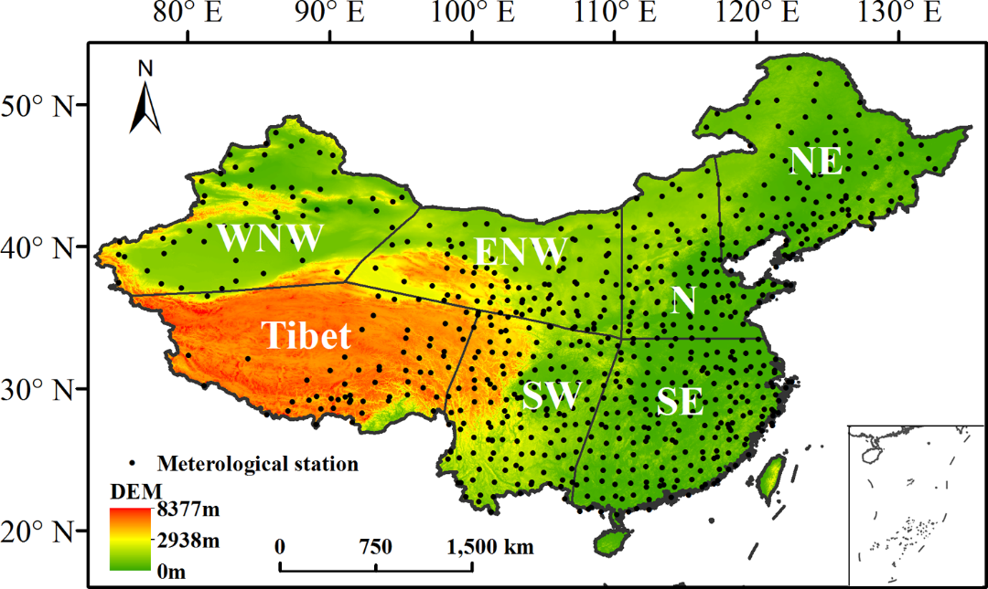
FIG. 1 Elevation map of China showing the distribution of the 756 meteorological stations and seven climatic sub-regions.
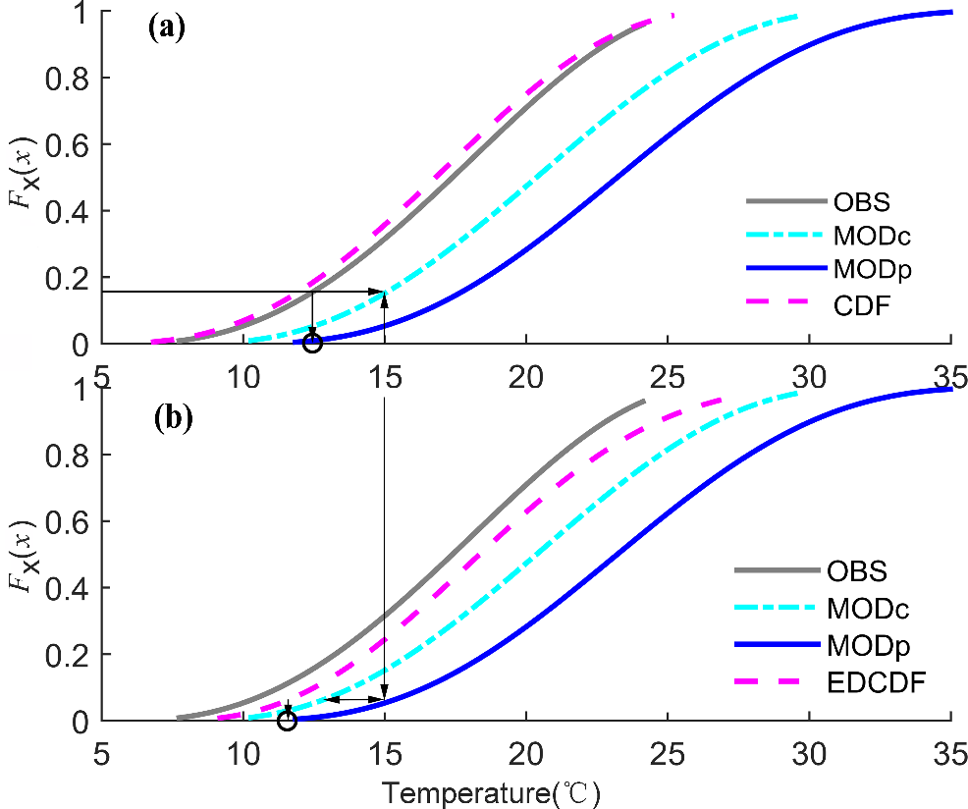
FIG. 2 Illustration of methodology of (a) CDF and (b) EDCDF using synthetic generated temperature data for a grid point. Solid gray line shows observations (OBS). Cyan Dotted-dashed line shows model simulation for current climate (MODc). Blue solid line shows model simulation for future projection (MODp). Pink dashed line shows CDF in Fig.2a and EDCDF in Fig. 2b. See text for details.
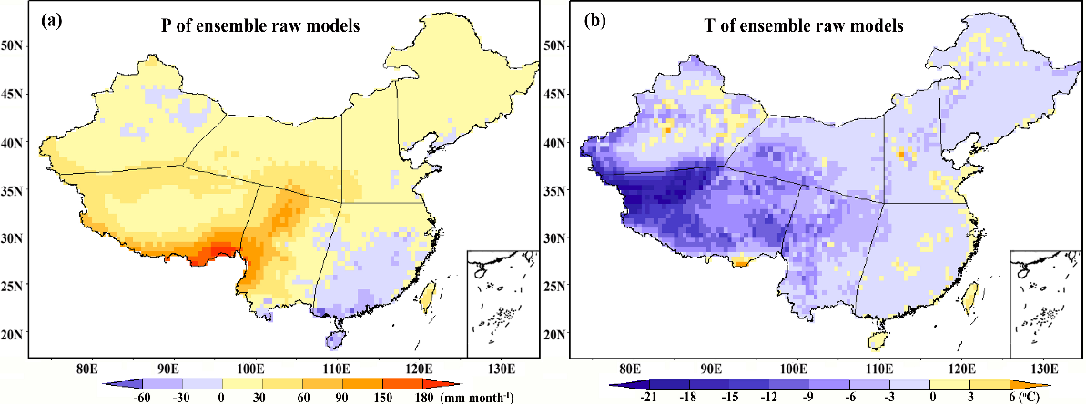
FIG. 3. Spatial distribution of mean biases between observed and raw ensemble of eight CMIP5 models (modeled minus observed) in monthly mean (a) precipitation (P) and (b) temperature (T).
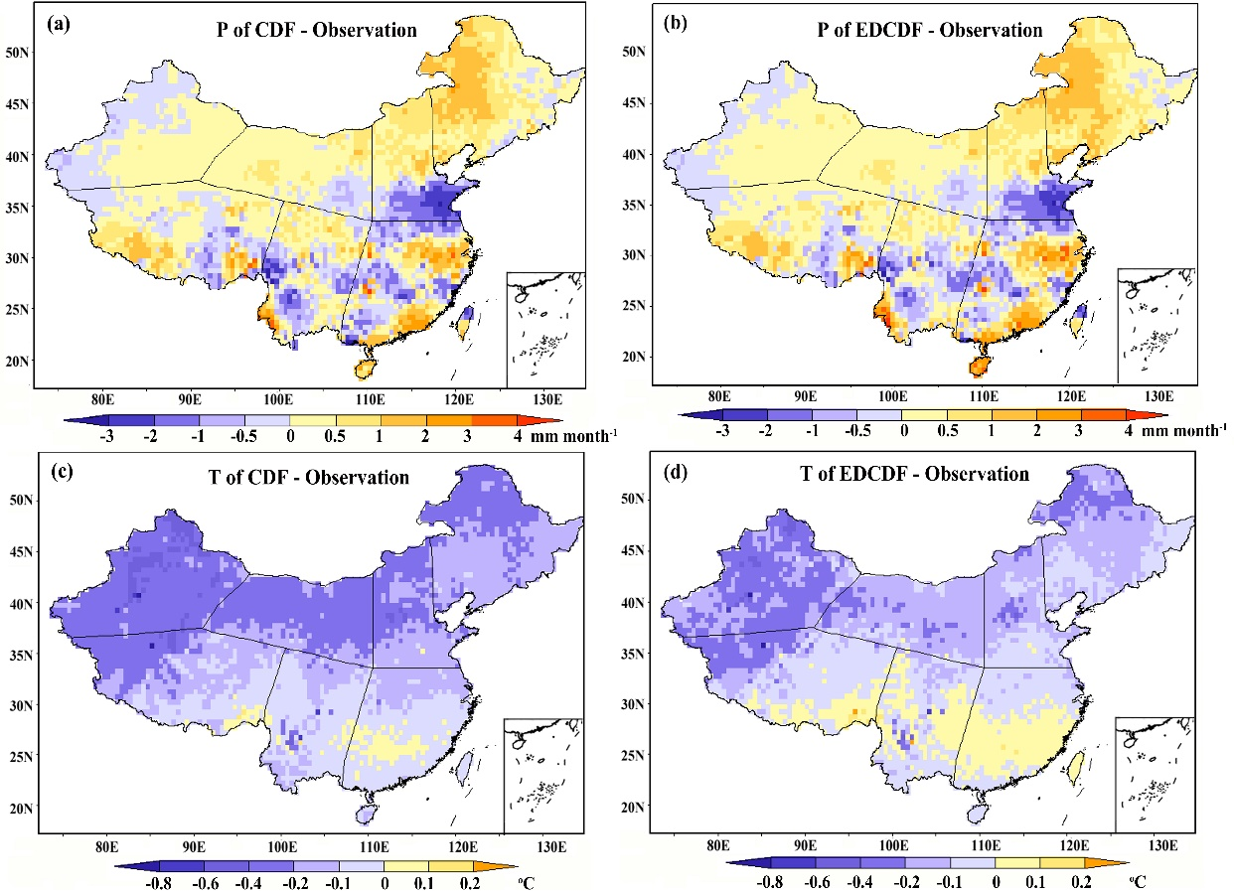
FIG. 4. Spatial distribution of mean biases for the two bias-corrected methods (CDF and EDCDF) (modeled minus observed) for monthly mean precipitation (P) and temperature (T).
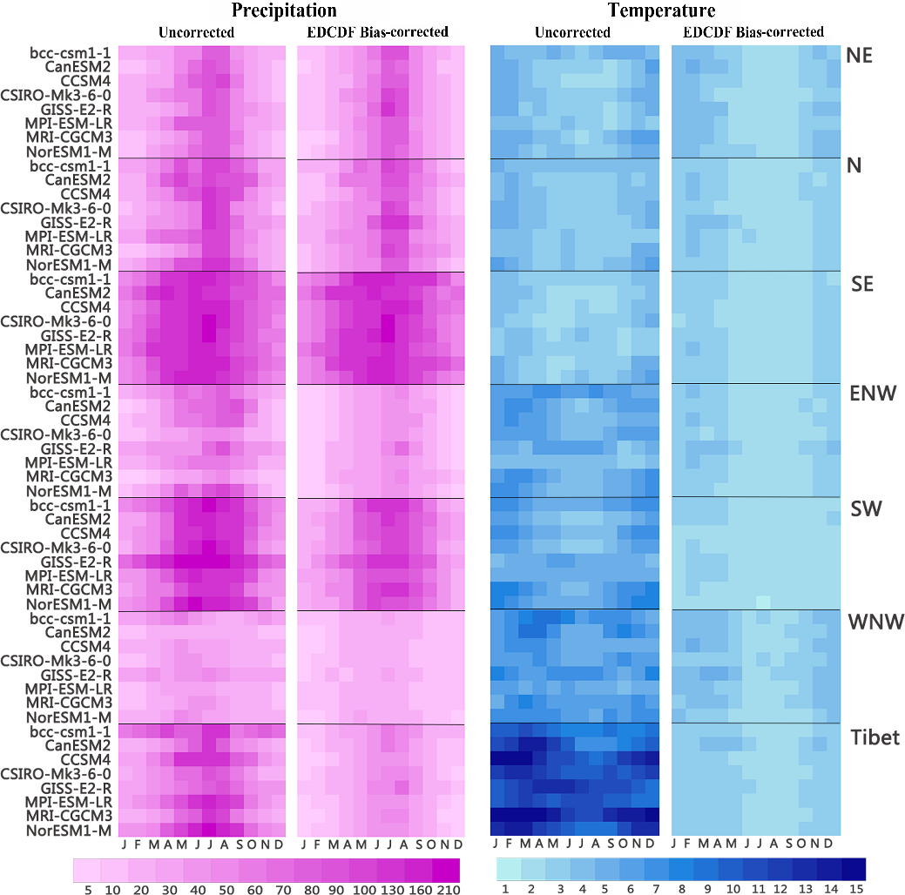
FIG. 5 The Root Mean Square Error of precipitation (mm month⁻¹) and temperature (°C) of eight CMIP5 models against to the observations for seven sub-regions (the left panel is the results of raw models and the right panel is the results of EDCDF downscaled models).
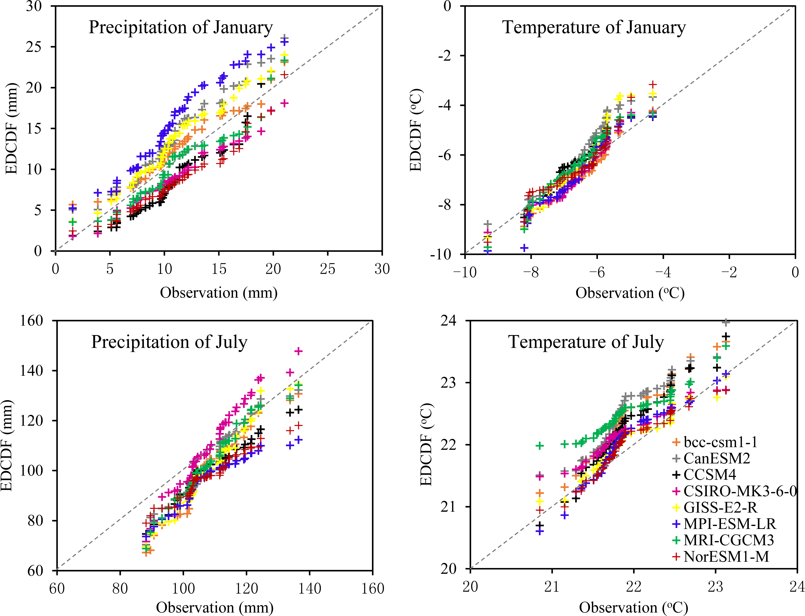
FIG. 6 Quantile-Quantile (Q-Q) plot comparing the CDFs of the observed and EDCDF bias-corrected monthly precipitation and temperature in January and July over the whole study domain from 1961 to 2005. If the model curves lie on the dashed line, the modelled data have the same distribution as the observed data.

FIG. 7 Time series of the domain averaged precipitation and temperature of the observation (black solid line) and EDCDF bias-corrected ensemble (black dotted line). Gray shading represents the uncertainty of the individual models.
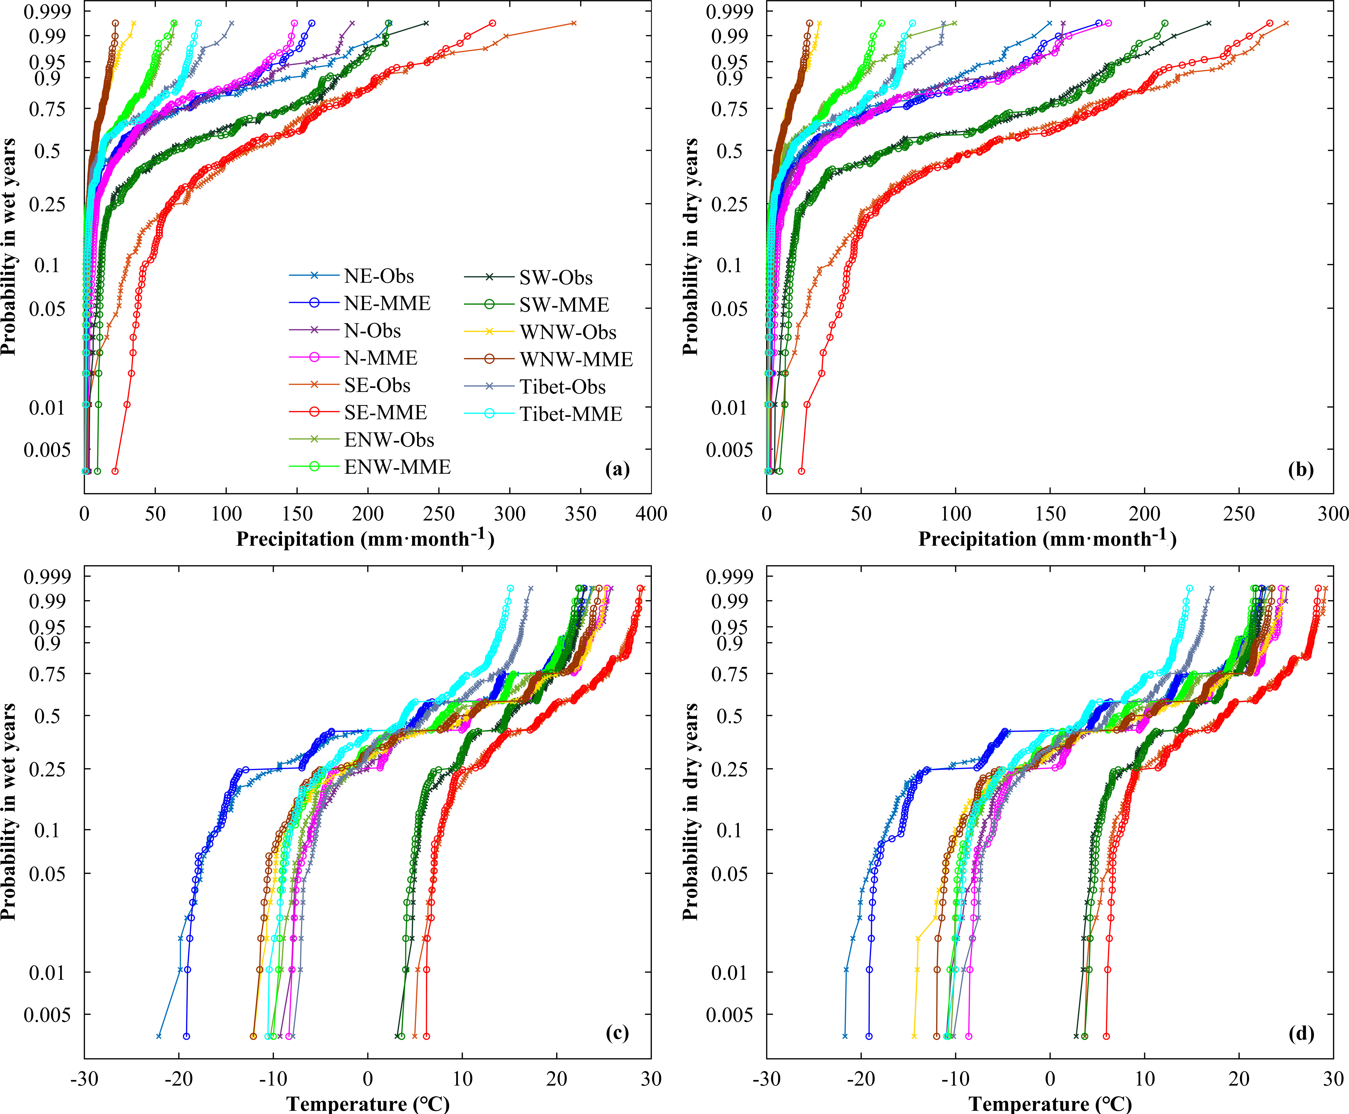
FIG. 8. Probability plot of extreme values of precipitation and temperature for wet/dry years for the seven sub-regions.
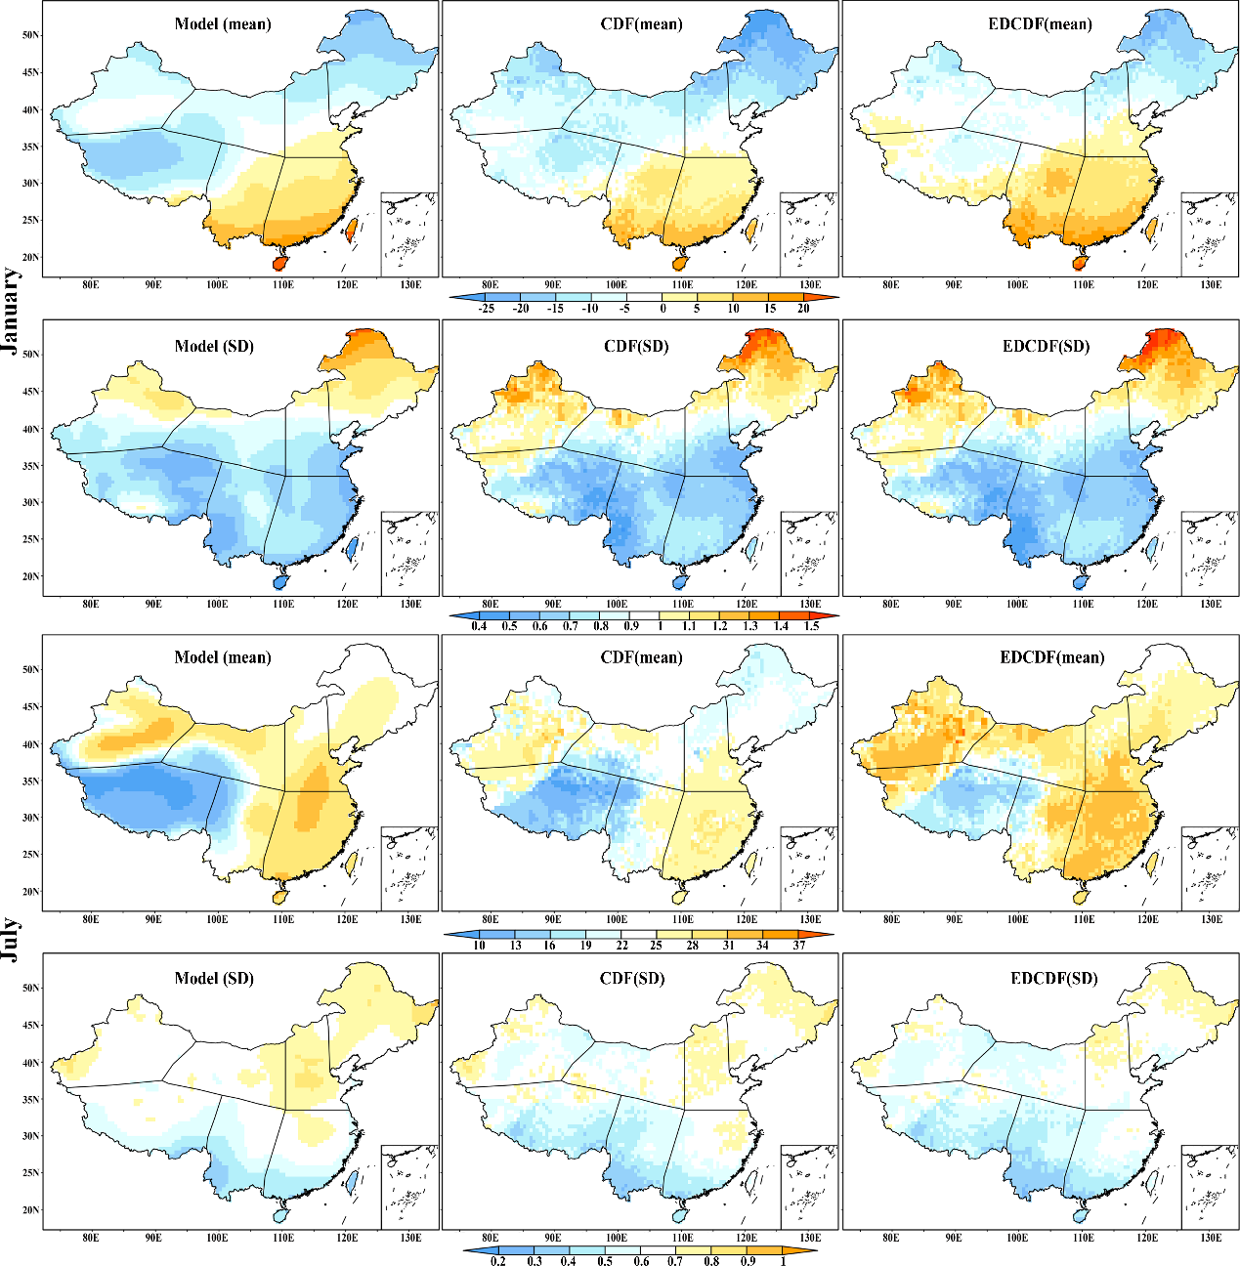
FIG. 9 Mean and stand deviation (SD) of the original model temperature projection (2061–2090) and after bias correction using the EDCDF and CDF methods in (top) January and (bottom) July.
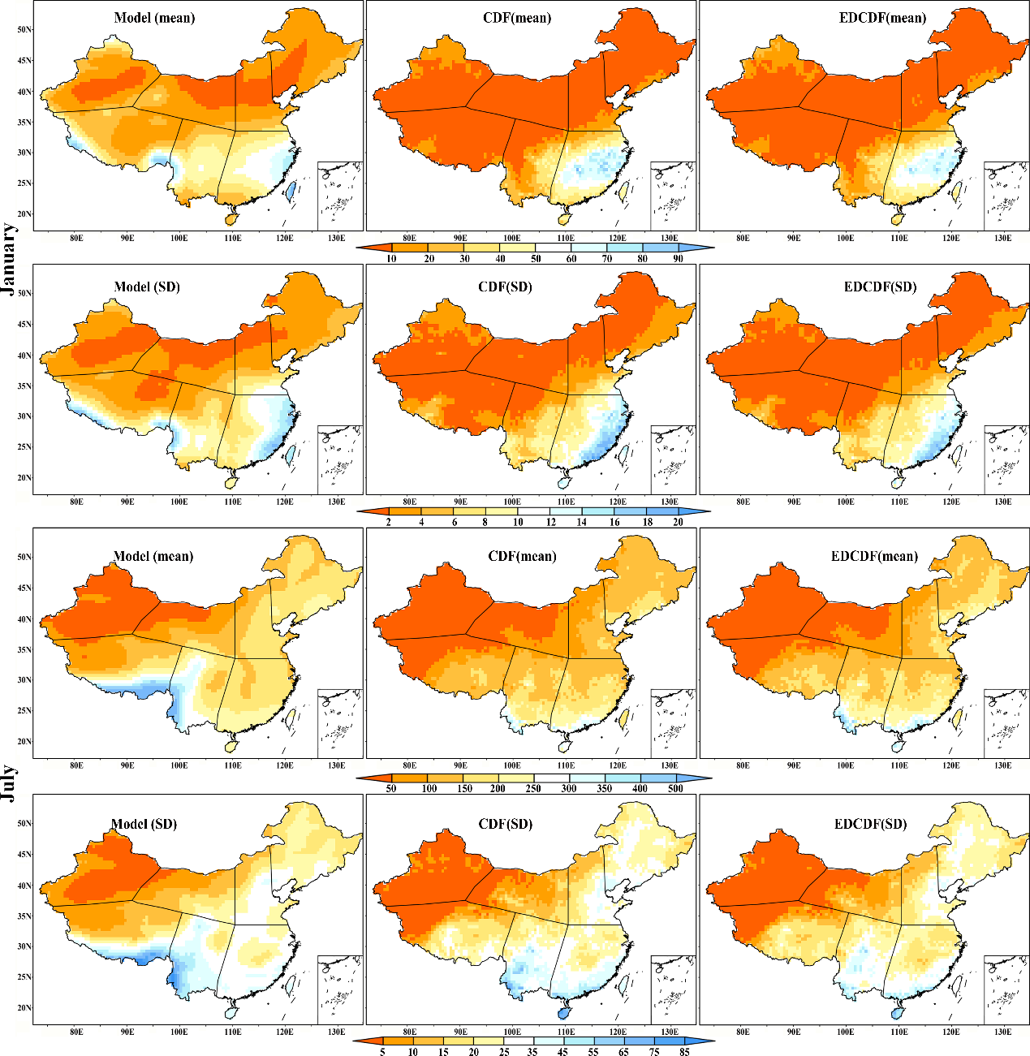
FIG. 10 Same as FIG. 9 but for precipitation
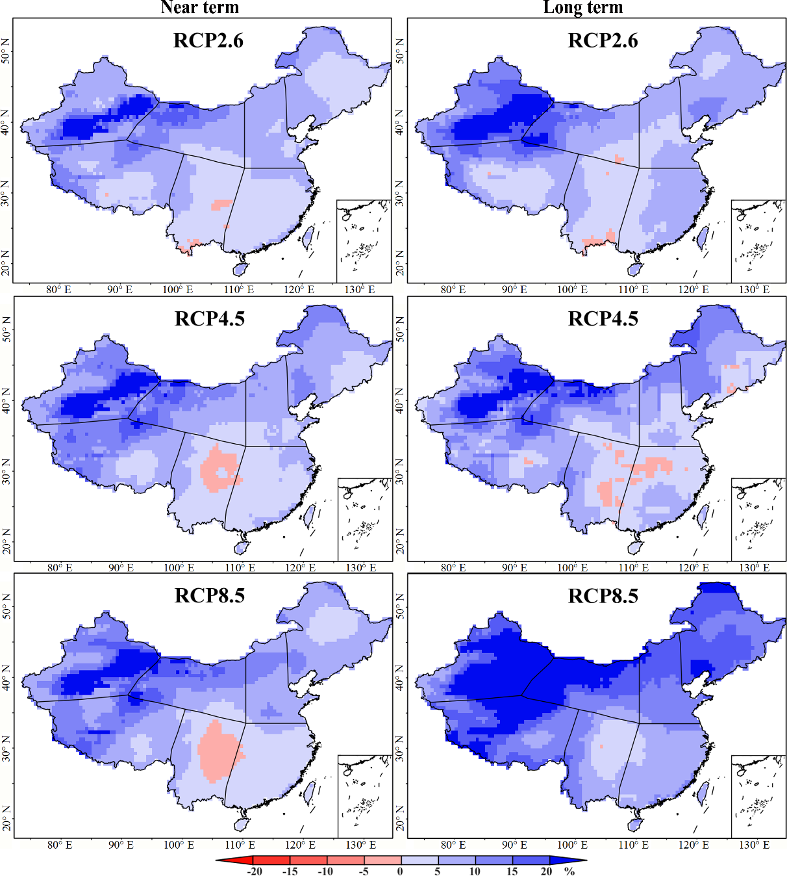
FIG. 11. Multi-model ensemble changes in precipitation (%) in relation to the reference period (1961-1990) for the near term (2031-2060, left panel) and long term (2061-2090, right panel) under the three scenarios over China.
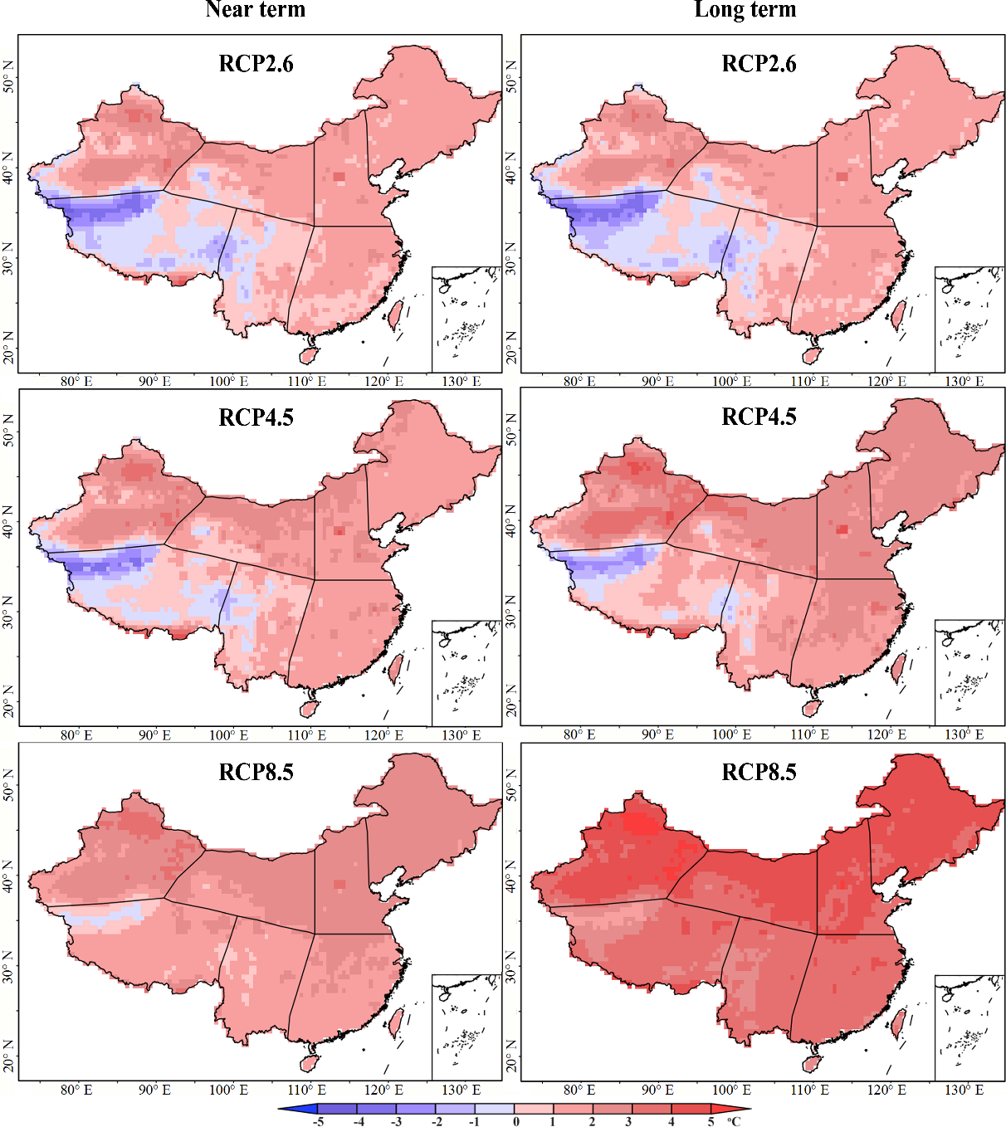
FIG. 12. Same as Fig. 11, but for temperature (°C).

