Burden of liver disease in Europe: epidemiology and analysis of risk factors to identify prevention policies
Authors names: Laura Pimpin¹, Helena Cortez-Pinto², Francesco Negro³, Emily Corbould¹, Jeffrey V Lazarus^{4,5}, Laura Webber¹, Nick Sheron⁶
Affiliations:
¹ UK Health Forum, London, United Kingdom
² Departamento de Gastrenterologia, CHLN, Laboratório de Nutrição, Faculdade de Medicina, Universidade de Lisboa, Portugal.
³ Divisions of Gastroenterology and Hepatology and Clinical Pathology, University Hospitals of Geneva, Geneva, Switzerland.
⁴ Barcelona Institute for Global Health (ISGlobal), Hospital Clinic, University of Barcelona, Barcelona, Spain
⁵ CHIP, Rigshospitalet, University of Copenhagen, Øster Alle 56, 5. sal, DK-2100, Copenhagen, Denmark.
⁶ University of Southampton, Southampton SO17 1BJ, United Kingdom
Corresponding author: Professor Nick Sheron, CES Academic Unit University of Southampton Level E, MP(811), South Academic Block, University Hospital Southampton Tremona Road, Southampton, SO16 6YD, United Kingdom
Tel: 02381 205232; nick.sheron@soton.ac.uk.
Keywords: Liver disease, alcohol, obesity, viral, hepatitis, epidemiology, policy
Electronic word count: 10,046 words
N figures: 9; N tables: 2
Conflict of interest statements: Helena Cortez-Pinto received lecture and advisory board fees from Intercept, Genfit, and Gilead. Francesco Negro received a research grant from Gilead and AbbVie, and is advising Gilead, AbbVie, and Merck. Jeffrey Lazarus declares speaker fees and research grants from AbbVie, Gilead Sciences and MSD, outside of this study. The other authors declare no conflict of interest.
Financial support statement: This work was funded by EASL funding.

Authors contributions:
Laura Pimpin was responsible for the overall management of the project, analysed data, designed and consolidated the scope, led the review of the literature, conducted qualitative interviews, and drafted the final report.
Helena Cortez-Pinto advised on the HEPAHEALTH project and drafted the Obesity/type 2 diabetes and liver disease section of the manuscript.
Francesco Negro advised on the HEPAHEALTH project and drafted the viral hepatitis section of the manuscript.
Emily Corbould collected, collated and analysed data, participated in the review of the literature and contributed to the write-up of the report.
Jeffrey V Lazarus advised on the HEPAHEALTH project and revised the full manuscript.
Laura Webber advised on the design of the project, conducted qualitative interviews, participated in the review of the literature and contributed to the write-up of the report.
Nick Sheron advised on the HEPAHEALTH project and drafted the introduction, Alcohol and liver disease, and discussion sections of the manuscript.

Collaborators: Members of the EASL HEPAHEALTH Steering Committee:
Patrizia Burra, Gastroenterology, Department of Surgery, Oncology and Gastroenterology, Padova University Hospital, Padua, Italy;
Olav Dalgard, Akershus University Hospital, Lørenskog, Norway;
Goran Jankovic, Clinic for Gastroenterology and Hepatology, Clinical Centre of Serbia, School of Medicine, University of Belgrade, Serbia
Jerzy Jaroszewicz, Department of Infectious Diseases and Hepatology, Medical University of Silesia, Katowice, Poland;
Jeffrey V Lazarus, Barcelona Institute for Global Health (ISGlobal), Hospital Clínic, University of Barcelona, Barcelona, Spain;
Ansgar W. Lohse, Department of Medicine, University Medical Center Hamburg-Eppendorf,Hamburg, Germany;
Valery Lunkov, Department of Hepatology, Vasilenko Clinic of Internal Diseases, Department of Internal Medicine,
Marina Mayevskaya, Department of Internal Medicine, I.M. Sechenov First Moscow State Medical University of the Ministry of Health of the Russian Federation (Sechenov University), Moscow, Russia;
Alexander Nersesov, National Research Institute of Cardiology and Internal Diseases, Almaty, Kazakhstan;
Marieta Simonova, Department of Gastroenterology, HPB Surgery and Transplantology, Military Medical Academy, Sofia, Bulgaria

Abstract
Background & Aims: The burden of liver disease in Europe continues to grow. We aimed to describe the epidemiology of liver diseases and their risk factors in European countries, and identify public health interventions that could impact on these risk factors to reduce the burden of liver disease.
Methods: As part of the HEPAHEALTH project, commissioned by EASL, we extracted information on historical and current prevalence and mortality from national and international literature and databases on liver disease in 35 countries in the WHO European region, as well as historical and recent prevalence data on their main determinants; alcohol consumption, obesity and hepatitis B and C virus infections. We extracted information from peer-reviewed and grey literature to identify public health interventions targeting these risk factors.
Results: The epidemiology of liver disease is diverse and countries cluster with similar pictures, although the exact composition of diseases and the trends in risk factors which drive them is varied. Prevalence and mortality data indicate that increasing cirrhosis and liver cancer may be linked to dramatic increases in harmful alcohol consumption in Northern European countries, and viral hepatitis epidemics in Eastern and Southern European countries. Countries with historically low levels of liver disease may experience an increase in non-alcoholic fatty liver disease in the future, given the rise of obesity across the majority of European countries. Interventions exist for curbing harmful alcohol use, reducing obesity, preventing or treating viral hepatitis, and screening for liver disease at an early stage.
Conclusions: Liver disease in Europe is a serious issue, with increasing cirrhosis and liver cancer. The public health and hepatology communities are uniquely placed to implement measures aimed at reducing their causes: harmful alcohol consumption, child and adult obesity prevalence and chronic infection with hepatitis viruses, which will in turn reduce the burden of liver disease.

Lay summary
The European region has seen dramatic increases in liver disease mortality and morbidity in recent decades as a result of changes in the underlying risk factors: excessive alcohol consumption, obesity and viral hepatitis. However, there are highly effective ways to combat these, for example increasing the price of alcohol, making it less readily available, reducing the number of calories, sugar and fat in foods we consume, or screening people earlier to treat them more effectively. The time is now for governments, the health system and individuals to implement the changes required to substantially reduce the burden of liver disease.

Introduction
Europe has the largest burden of liver disease in the world,(1) and this burden is expected to grow across many countries. However, the current and historical epidemiology of liver disease varies between countries within Europe. For example, the Finland and the United Kingdom (UK) have observed staggering increases in liver disease mortality over the last 40 years while the inverse is true for countries such as France and Italy, where liver disease mortality began declining in the 1970s and has kept falling, largely due to effective policy and population level measures.
Differences in liver disease epidemiology occur in part because of the prevalence of modifiable risk factors, such as harmful alcohol consumption, obesity, and viral hepatitis. Worryingly, Europe has the highest per capita alcohol consumption and alcohol-related loss of disability adjusted life years of any of the global WHO regions.(2) Obesity has increased markedly over the past four decades,(3, 4) and as a result, non-alcoholic fatty liver disease (NAFLD) is an increasingly prevalent liver disease in Europe.(2) The prevalence of viral hepatitis is less well documented.(2) Prevention of these risk factors and types of liver disease is important in order to stop progression to other forms of liver disease such as liver cancer. Liver disease principally affects working age people; therefore tackling risk factors will have impacts not just to the individual and health system, but to the economy and business sectors.
Differences in demographics, geography, and historical factors need to be considered when trying to understand the variance in liver disease risk factors, morbidity, mortality in and the interventions that best reduce the burden of liver disease. Importantly, liver disease risk factors are amenable to prevention and treatment, so liver disease can be reduced and deaths can be averted. Understanding the magnitude of liver disease prevalence, how and why it has changed over time, and what works to reduce the population’s risk is imperative if countries are to learn from each other and take action to reduce the burden.

Aim
The EASL HEPAHEALTH project, summarised in a report was commissioned to: 1) collect and analyse data in order to best describe the burden of liver disease across 35 European countries (including all 28 European Union (EU) countries); 2) collect data on the largest, modifiable determinants for liver disease (alcohol, obesity and viral hepatitis) and describe their changes over time; and 3) review the evidence on policies or interventions that could reduce the exposure to these risk factors at a population level.

Methods
In order to maximise comparability across countries, and to use a standardised definition of liver disease, the majority of data on the epidemiology of liver disease and its risk factors was obtained for 35 countries (see Table 1 from online databases. It was beyond the scope of this study to include all 53 World Health Organization (WHO) European Region countries. The EU-28 countries were chosen plus additional countries where the study team had particular expertise and interest.

Data collection
When insufficient data were available, additional sources of information were collected from a comprehensive review of the peer-reviewed and grey literature (that is, resources produced outside of the traditional academic publishing, such as reports from non-academic organisations) and identifying experts through the referral of other experts (“snowballing” of contacts) in the field of liver disease.
The WHO European Detailed Mortality Data (5) database combined raw mortality rates for 1994 to 2015 into eight broad liver disease categories (including alcoholic liver disease, NAFLD and viral hepatitis). This data was supplemented with data from WHO European Health for All database for broader categories of liver disease (1970 to 2015).(6)
The Global Burden of Disease (GBD) study (2016) (1) provided estimates of prevalence of cirrhosis and other chronic liver diseases and liver cancer, due to alcohol, hepatitis B, hepatitis C or other causes for the years 1990 to 2016.
Data on liver transplantation in Europe was obtained from the European Liver Transplantation Registry (ELTR).(7)
Chronic hepatitis B and C prevalence data were obtained from the European Centres for Disease Prevention and Control (ECDC) (8) and were complemented by hepatitis B and C modelled prevalence estimates from the Polaris Observatory.(9, 10) In addition published reviews of the latest data were used to triangulate infection prevalence, and data on prevalence of hepatitis B and C in persons who inject drugs (PWID) were obtained from the European Monitoring Centre for Drugs and Drug Addiction (EMCDDA).(11)
Average annual current consumption in litres of pure alcohol for total alcohol, beer, wine and spirits was extracted from the WHO European Health for All databases, for 1970 to 2015. Obesity prevalence data from 1993 to 2015 was obtained from a previous report commissioned by the WHO.(3, 12) This project collected historical national prevalence data from a variety of national or regional sources. The sources for this can be found in the online database.
Country-level type 2 diabetes prevalence data for 2007 to 2015 in adults was obtained from the International Diabetes Federation Diabetes Atlas project.(13) Information on injecting drug use, as one of the modes of transmission for hepatitis B and C was also collected from the European Monitoring Centre for Drugs and Drug Addiction.(11)

Analysis
Data on the prevalence and mortality of liver disease, and on the distribution of the largest modifiable risk factors for liver disease were analysed to present time trends, differences across sub-regions (UN Eastern, Northern, Southern and Western regions) and individual countries within these sub-regions. The historical trends in mortality and prevalence were overlaid with plots of alcohol consumption and obesity prevalence.
A comprehensive review of PubMed, Embase, and Google Scholar was conducted to identify peer-reviewed and grey literature reviews that provided evidence on public health interventions aimed at reducing or preventing risk factors for liver disease, in particular, alcohol consumption, obesity and diabetes and chronic viral hepatitis. No language restrictions were applied.

General data

Present situation
Data on prevalence of liver disease was collected using the GBD 2016 project data (1). The categories of liver disease present in the dataset are cirrhosis and chronic liver disease, the other being liver cancer. Cirrhosis and chronic liver disease are further breakdown in four etiologic categories: alcohol use, hepatitis B infection, hepatitis C infection and other causes. The age-adjusted prevalence for the latest year in the 35 countries for males and females, ranged from 447 (Iceland) to 1100 (Romania) cases per 100,000, with a median of 833 (Figure 1) relative contribution of these aetiologies follows a geographical pattern, with alcohol being predominant in Western countries and viral hepatitis B and C more prevalent in Eastern countries. In Central European countries, alcohol and virus contribute equally. Hepatitis C is most prevalent in most countries with the exception of Kazakhstan and Uzbekistan, where hepatitis B is more frequent.
Interestingly, when it concerns liver cancer, a north-south gradient is found, as illustrated in the wider HEPAHEALTH report, ranging from less than 2 cases per 100,000 to 15 cases per 100,000. Regarding the year 2015, the predominant aetiology of the underlying liver disease was viral hepatitis in the majority of countries, followed by alcohol use (see the wider HEPAHEALTH report).
Another useful source of information regarding the burden of liver disease is mortality data. However, using WHO raw mortality ICD-10, that uses the primary cause of death, there is probably an underestimation of the true liver disease associated mortality. Notwithstanding, as seen in Figure 2, there is a good correlation with the prevalence data, again showing Romania with the highest (36 per 100,000), and Iceland and Norway with the lowest death rates (below 10 per 100,000). In total number of deaths, the rates shown in Figure 2represent a total of 151,513 deaths fro liver disease in the last year available deaths for all European countries combined, ranging from 33 in Iceland in 2015 to 23533 in Germany in 2014.
When looking at the consequent years of life lost, a very specific pattern is shown for liver diseases, with a higher rate of working life years lost vs non-working life years lost, than most frequent chronic diseases such as ischaemic heart disease. This is mostly due to the fact that two-third of liver disease patients die before 65 years of age.

Trends
The analysis of trends of cirrhosis and chronic liver disease, in different countries may help understand the utility or disadvantages of different political and public health measures. Concerning the 34 HEPAHEALTH countries (not including Russia), diverse patterns of evolution in mortality rate were observed in the timeframe of 1970-2015, as shown in Figure 3. Countries of Southern and Eastern Europe displayed a significant decrease in mortality rate (Austria, Croatia, France, Germany, Greece, Italy, Luxembourg, Portugal, Slovenia, Spain and Switzerland), while conversely, countries such as Bulgaria, Estonia, Finland, Hungary, Kazakhstan, Latvia, Lithuania, Romania and the United Kingdom faced a significant increase. Yet, another group of countries remained stable-high (Slovakia and Uzbekistan), while others remained stable-low (Belgium, Cyprus, Czech Republic, Denmark, Iceland, Ireland, Malta, Netherlands, Norway, Poland, Serbia and Sweden).
In what concerns trends in liver cancer mortality rates, it is recognizable an increase in the large majority of countries (Austria, Czech Republic, Finland, France, Germany, Greece, Ireland, Italy, Luxembourg, Portugal, Romania and the United Kingdom), although some countries have experienced small decreases in related-mortality (Bulgaria, Hungary, Kazakhstan, Poland and Spain). Again, other countries remained stable, either high or low (available in the HEPAHEALTH report).
In the next sections, more detailed information regarding epidemiological data, risk factors and political interventions will be described for each of the major liver diseases: alcohol-related, non-alcoholic fatty liver and viral hepatitis.

Alcohol consumption and liver disease
According to WHO, alcohol is a dose related risk factor for more than 200 diseases. It causes 5.9% of all deaths globally and more than 25% of deaths in the age group 20–39 years.(14) For most diseases including cancer and hypertension, the dose relationship is linear starting at zero, i.e. there is no safe threshold for alcohol consumption.(15) Importantly for liver disease the relationship is exponential, with very heavy drinkers or extreme drinkers comprising a large proportion of patients with alcohol related cirrhosis.(15, 16) In addition to this, alcohol synergises with other risk factors for liver disease such as obesity and viral infections. For a BMI over 35kg/m², the hepatotoxicity of alcohol doubles: two bottles of wine per week effectively becomes four bottles as far as the liver is concerned.(17) Similarly, with hepatitis C virus (HCV) infection, alcohol consumption of more than 20g per day (17.5 cl per week) increases mortality by 2.5-fold.(18) In a Danish series of 5,779 HCV infected individuals, 57% of patients with cirrhosis also had evidence of alcohol misuse.(19)
The European region has the highest levels of reported per capita consumption of any other region.(20) Total alcohol consumption is summarised in the WHO European Health for All database (HFA-DB) as annual total litres of pure alcohol consumed per capita in individuals aged over 15 years. Four groups of countries emerged based on time trends for this consumption: Increasing trend, decreasing trend, stable high trend and stable low trend (Figure 3). Although these trends are seen at national levels, alcohol consumption patterns are clustered within countries. For example the share of total alcohol consumed by the top 20% heaviest drinkers ranges from 50% in France and Switzerland, to above 80% in Hungary, based on national survey estimates by the Organisation for Economic Co-operation and Development (OECD).(20) Demographic patterns in alcohol consumption are changing too: consumption amongst younger people and women is growing while age of taking up drinking is decreasing. Patterns of drinking, including frequency, average consumption and type of alcohol consumed, have differential effects on mortality and risk of disease.(21)

The relationship between alcohol consumption and liver mortality
The strong relationship between population level alcohol consumption and population level liver mortality, was detailed in a seminal paper by Milton Terris in 1967(22), who demonstrated that dramatic falls in cirrhosis mortality followed some world events, such as alcohol rationing in both world wars (Figure 4).
An important aspect of this analysis that only recently received the attention it deserves (23) was that the link was between strong alcohol (wine and spirits) and cirrhosis mortality. For example, in the UK the consumption of weak beer in pubs could be excluded from the model (Figure 4).(23, 24) This makes sense as by the time most patients with alcohol related liver disease have graduated to cirrhosis, the majority are drinking strong alcohol.(16)
These two principles are critical to understanding the relationship between alcohol consumption and cirrhosis mortality today. Substantial falls in overall alcohol consumption in France were associated with equally substantial falls in cirrhosis mortality, with no real differential impact by beverage type (Figure 5). Similar changes have occurred in Italy and Spain.
While four-fold increases in mortality from chronic liver disease in the UK have followed relatively modest increases in overall alcohol consumption, the key difference is that consumption has shifted from weak beer consumed in pubs, to stronger alcohol (wine, spirits and strong cider) bought cheaply and drunk at home.(15, 25)
The ecological correlation between alcohol consumption trends and mortality from alcoholic liver disease and mortality from any chronic liver disease and cirrhosis also holds for countries with stable patterns of alcohol intake. For example the Czech Republic, has a relatively high alcohol consumption trend which is apparently unchanged over time.
In Sweden, although total alcohol consumption has been stable over 40 years, there have been shifts in the types of drink consumed, with a clear decrease in beer and spirits and an increase in wine consumption up to 2014. The steady increase in mortality from alcoholic liver disease appears to mirror the increase in wine consumption, while total intake appears to be stable but relatively low in Sweden, see Figure 5.

Interventions to reduce alcohol consumption and harm from alcohol
The evidence on the effectiveness of alcohol policy is strong and consistent in reviews by the WHO,(26) OECD,(20) Public Health England (15) and others.(27, 28) Public health approaches include population-level policies such as fiscal policies, policies regulating the marketing of alcohol and policies managing the drink environment and availability of alcohol, and individual-level interventions like screening, brief interventions and alcohol treatment.(25, 29-34)

Fiscal Policy
As with tobacco, the most effective and costs effective means to reduce alcohol related harm is by decreasing the affordability of alcohol through fiscal policy.(35-37) The OECD report on Tackling Harmful Alcohol Use highlights excise duties and value added taxes as the most common combined approach.(20) The effect of increased alcohol taxation on consumption depends on the degree to which the tax is passed on to consumers and the most recent development in alcohol policy is the concept of setting a minimum price for a unit of alcohol (MUP).(20, 29, 33) This model was implemented in the Canadian province of British Columbia and as a result there have been dramatic reductions in liver disease mortality, despite increasing densities of private liquor stores during the same period.(38)
Legislation enabling the introduction of MUP was passed in Scotland in 2012, despite legal challenges by the Scotch Whiskey Association, as justification of strong public health grounds overruled the commercial considerations. MUP legislation was specifically targeted at the very cheap alcohol preferred by the extreme drinker who develop cirrhosis, and thus is more likely to be effective than tax or duty increases.(39, 40)
In-depth summaries of studies estimating the effect of alcohol policy scenarios, modelling studies, natural experiments and case-studies, on alcohol consumption, hospital admissions and liver disease mortality are available in the wider HEPAHEALTH report.

Marketing restriction
After tobacco, the marketing of which has been regulated, alcohol is the most dangerous and unhealthy commodity currently marketed in Europe.(41) The landscape for alcohol marketing is changing and uses multiple avenues (radio, television sports events, celebrity endorsements, websites, product placement, social media, and others).(41) The marketing of alcoholic beverages is one of the 10 areas for policy action in the WHO Global strategy to reduce the harmful use of alcohol.
The evidence was reviewed recently by Babor and colleagues(41) who find positive associations between exposure to marketing and some measure of subsequent drinking behaviour and/or negative consequences of drinking.(42) For digital marketing there was a need ‘for policies to control and restrict alcohol promotion, and especially to protect underage youth from commercial incentives to engage in drinking behaviour’.(43) This suggests that current systems of self-regulation would need major modifications if they are to serve public health objectives.(44, 45) They concluded that regulations should be statutory, enforced not by the alcohol industry, but by a public health agency and that global agreement on the marketing of alcoholic beverages would support country efforts to move towards a comprehensive ban on alcohol advertising, promotion and sponsorship.

Screening and behavioural interventions
A recent narrative review of 24 systematic reviews was conducted on the effect of brief alcohol intervention effects. The authors reported that brief interventions were consistently reported to be effective for addressing hazardous and harmful drinking in primary healthcare, and particularly in middle-aged, male drinkers.(46)
A recent review of 20 trials in public healthcare settings and eight in emergency departments confirmed that brief interventions to reduce alcohol consumption are associated with reducing weekly alcohol consumption among hazardous and harmful drinkers at 6 and 12 month follow-up.(47) In primary health care, brief interventions resulted in 31g/week reduction in alcohol intake after 12 months, and 18g/week for interventions in emergency departments.
The Lancet Liver Commission identified late diagnosis of liver disease as perhaps the most important clinical issue, and estimated that around 75% of patients with fatal cirrhosis were unaware of their disease until presenting as an emergency with acute chronic liver failure or variceal bleeding. A liver disease admission can have a profound impact on alcohol misuse, with around 40% of subjects becoming abstinent as a result (48, 49) and some evidence that earlier primary care based liver diagnosis may also promote behaviour change.(50) As a result screening for liver disease in harmful and dependent drinkers has been recommended by the UK based National Institute for Health and Care Excellence,(51) further research will be needed to judge whether this approach can reduce liver mortality and morbidity.

Obesity, diabetes and non-alcoholic fatty liver disease

The current and historical burden
The main risk factors that have been associated with NAFLD are obesity (predominantly central adiposity) as well as type 2 diabetes. Figure 6 presents the time trend in NAFLD/NASH (non-alcoholic steatohepatitis) mortality from WHO detailed data.(5) NAFLD/NASH represents only a very small proportion of liver-related-deaths in Europe, when analysing as the primary cause of death, although it is unlikely that these codes represent the current understanding on NAFLD or NASH.
In fact, the attributed codes do not allow recognizing of NASH-related cirrhosis. Also, in the presence of other concomitant diagnosis such as alcohol or viral hepatitis these are recorded as the first cause of disease. Furthermore, the major cause of death in NAFLD/NASH patients is cardiovascular, (52). NAFLD coded as the cause of death is only starting to appear in Ireland, Luxembourg, Hungary and the United Kingdom, countries where obesity is high (>23%).
It is difficult to ascertain the true prevalence of NAFLD, which is often diagnosed at a pre-cirrhotic stage, since the GBD (1) database does not discriminate it.However, one meta-analysis, combining data from 2000 to 2015, pointed out for an estimated prevalence of NAFLD in Europe of 23.71% [95% CI: 16.12: 33.45 %].(53)
Again, NAFLD/NASH related cirrhosis is not discriminated in data from the ELTR. (7) Since “cryptogenic cirrhosis” and “other cirrhosis” are probably cases of burned-out NASH, this would represent a percentage of 11.9% (8427/71007) of liver transplantations for cirrhosis from 1988 to 2016.
Given the drawbacks in obtaining reliable data on NAFLD/NASH prevalence, data may be mostly inferred from the prevalence of obesity and diabetes. There is evidence that for every 1 unit increase in BMI, the odds of forming NAFLD increase by 13% to 38% and per 1cm increase in waist circumference, they increase by 3% to 10%.(54) It is also of note that excess body-weight is a significant co-factor for the progression of liver disease from all aetiologies.(55)

Trends in obesity and type 2 diabetes in Europe
An upwards shift in population BMI has been observed in males and females across all regions in Europe. The majority of the data collected came from self-reported sources (only four countries had measured data), which are likely to be under-reported and therefore underestimate obesity prevalence.(56, 57) Nevertheless, the increase in obesity for countries in all regions is matched by the increase in NAFLD mortality, with a slight delay in peaks of obesity and peaks of NAFLD.
Regarding prevalence of obesity (BMI > 30kg/m²), a large variation among countries is observed, ranging from below 10% of the total adult population in Norway, Italy and Switzerland, to above 25% in Uzbekistan and the UK (Figure 7).
Time trends from 2007 in the prevalence of adult type 2 diabetes in countries, by region, are shown in Figure 8. Northern European countries showed a trend towards increasing prevalence of type 2 diabetes in adults, with some country exceptions. Similarly for Eastern Europe, prevalence decreased between 2011 and 2013 in all countries but Slovenia and the Czech Republic, but all countries have experienced a recent increase between 2013 and 2015. In Southern Europe, prevalence was increasing for the majority of countries,. Diabetes prevalence levels have generally remained stable in Western European countries, except for Germany where a sharp decrease followed by an increase was seen.
There are also large differences in the prevalence of type 2 diabetes across Europe. In 2015, European countries range from <4% of the total population with type 2 diabetes, to countries such as Serbia with more than 10% of individuals diagnosed with type 2 diabetes (Figure 9).

Policies and interventions aimed at reducing obesity and diabetes

Interventions to reduce obesity
Given that obesity is a major risk factor for NAFLD and liver cancer, interventions that prevent or reduce obesity will have important impacts on subsequent incidence of obesity-related liver diseases. Obesity is a complex problem requiring multi-level and multi-sectorial action.(58, 59) We summarised work by the WHO,(60) Harvard university,(61) the Heart Foundation Australia (62) and the United Kingdom National Institute for Health and Care Excellence (NICE).(63) These reviews assess the effectiveness and cost-effectiveness of a range of interventions to reduce childhood and/or adult obesity as well as other systematic reviews found in the academic literature.

Policy/population level approaches

Marketing of unhealthy foods and non-alcoholic beverages to children
Marketing of food predominantly promotes the purchase of high fat, salt, and sugary foods, (64) given their long shelf life and cheap production(65) In their review, WHO concluded that the impact of limiting food and beverage advertising on television may be one of the most cost-effective public health approaches to reducing the prevalence of childhood obesity (66, 67) and related NCDs.(68) The WHO framework for implementing the set of recommendations on the marketing of foods and non-alcoholic beverages to children provides guidance on how to implement these recommendations.(69)

Nutrition labelling - provision of nutrition information, in a standardised format, on foods sold
Evidence suggests that nutrition labelling enables consumers to make healthier food choices.(70) Nutritional labelling that guides a consumer’s understanding, in particular ‘traffic light labelling’ was cited by WHO as a promising measure to tackle obesity. This labelling system uses colours (green, amber and red) to indicate the relative levels (low, medium or high) of fat, saturated fat, sugar and salt in the product. The labelling of calories on menus in fast food restaurants has also been identified as a promising obesity prevention measure.(71)

Food taxes and subsidies
There is strong evidence that price influences consumer patterns. Experimental studies have indicated that increasing price reduces purchase and subsequent energy intake.(72, 73) The WHO carried out a meta-review of 11 recent systematic reviews on the effectiveness of fiscal policies to reduce weight, improve diet and prevent NCDs.(74) They concluded that the strongest evidence was for sugar sweetened beverage (SSB) taxes, reducing consumption in the range of 20-50%. Fruit and vegetable subsidies increase consumption in the range of 10-30%, though evidence is mixed for their impact on BMI, net calorie intake and disease outcomes.
The UK Health Forum, in collaboration with Cancer Research UK modelled a 20% tax on SSB in the UK, estimated to prevent 3.7 million cases of obesity and 25,498 cases of BMI-related disease over the next 10 years (2015-2025), and avoid £10million in National Health Service costs in 2025 alone.(75)

Food reformulation
Food reformulation is the reduction of salt and calories from sugar and saturated fat in processed foods or the increase of beneficial nutrients such as fibre, fruit, vegetables, and whole grains. These adjustments may be effective in reducing calories consumed and potentially reduce (or halt) rising obesity. However, a slow decrease (or increase) in nutrients is required to successfully shift population tastes.(76) Several studies explored the effectiveness of food reformulation as a strategy to improve population health and found that besides providing health benefits, such reformulation programmes have been shown to be cost-effective.(77-79)

School-based interventions
Interventions in schools were found to have mixed results, according to Amini et al. (80) in their review of eight reviews of the impact of school-based interventions to control or reduce obesity. While multi-component interventions in a school setting were found to be the most promising approach to preventing obesity (i.e. consisting of diet, activity, education/cognitive components), programmes that concentrate on single components (e.g. diet or physical activity) were sometimes effective in reducing adiposity measures.

Individual and family-based interventions
Both WHO and NICE recommend the use of multi-component lifestyle interventions (MCLI) which typically include components such as diet, physical activity, and educational/cognitive.(81, 82) One meta-analysis examined the clinical effectiveness of different types of interventions: diet or exercise alone versus combined behavioural weight management programs (BWMP).(83) They found only a significantly greater weight-loss in the combined BWMPs (-1.72 kg, 95% CI -2.80; -0.64) at 12 months. In relation to childhood obesity, NICE found strong evidence from eight randomised controlled trials that child/adolescent and parent weight management interventions result in significant decreases in BMI, and are more favourable than child-only programmes. (84)

Interventions to reduce type 2 diabetes and liver cancer
Type 2 diabetes accounts for 90-95% of all diabetes cases,(85) and the majority of patients with type 2 diabetes are obese and/or have high abdominal body fat. According to the International Diabetes Federation, 80% of type 2 diabetes cases are preventable with a healthy diet and physical activity.(86)
The diabetes prevention programme (DPP) (87) has been well evaluated and implemented in a number of countries. The initial RCT (88) found that receiving a lifestyle intervention was more effective than Metformin or placebo. in decreasing the risk of developing type 2 diabetes (58% vs 31% vs 11).
The role of Metformin in diabetes has been investigated in relation to its impact on liver cancer mortality yielding mixed results, with some studies suggesting that metformin reduced the risk of liver cancer in type 2 diabetic patients (89-92) while others (93-96) found no significant impact of metformin on the risk of liver cancer, as recently reviewed by Fujita et al.(2016).(97) A recent meta-analysis, found diabetic metformin users have a 76% lower risk of hepatocellular carcinoma compared to non-users.(98)

Interventions to reduce NAFLD
Since obesity is a key risk factor for NAFLD, the above-mentioned interventions, if successful, might be assumed to have an impact on the subsequent reduction in NAFLD. However, on a population basis, the impact of successful obesity interventions on reducing NAFLD prevalence will be a slow process. A study from Vreman et al.(99) using a microsimulation model with Markov chains for NAFLD (including steatosis, NASH, cirrhosis and hepatocellular carcinoma (HCC)) estimated that a 20% reduction in added sugar consumption is projected to annually avert 0.767 million (M) DALYs (95% CI 0.757M to 0.777M) and a total of US$10.3 billion (B) (95% CI 10.2B to 10.4B).

Viral hepatitis-related liver disease

Current prevalence of hepatitis B virus and historic trends
Estimates of population hepatitis B virus (HBV) prevalence are limited by the lack of high-quality, representative nationwide prevalence estimates, especially in younger age groups.
Two of the most comprehensive studies into national level prevalence estimates of chronic HBV infection in the general European population provided inconsistent results. (100, 101) However, both showed regional variation with higher rates in Eastern and Southern European countries compared to Northern and Western European countries.(100-102) These prevalence estimates in both reviews are likely to be an underestimation (in part due to inclusion of estimates among blood donors as a proxy for the general population in the absence of other evidence). These two datasets were compared to the modelled estimates of HBsAg prevalence from the Polaris Observatory (10, 103) and showed how HBsAg prevalence was fairly stable or slightly decreasing in Northern Europe between 2007 and 2017, with prevalence below 1.5%. Southern and Western Europe showed decreasing trends (< 2% and 1% HBsAg prevalence, respectively), while Eastern Europe had stable or decreasing trends with less than 5% HBsAg prevalence (Uzbekistan had < 10% prevalence in 2007 and < 8% prevalence in 2017). Overall, estimates indicate that approximately 15 million people are living with HBV in the European Union.
A time-trend analysis of the WHO seroprevalence showed HBV prevalence decreasing globally, but trends varied between countries in Europe (104): HBsAg prevalence increased over time in Poland and Russia, potentially as a consequence of strong political and social changes since 1963, resulting in increased access to injectable drugs. Historically low endemicity countries, such as France, Germany and Spain, showed little reduction over time, while other countries have seen large annual reductions (>5% annual change), for instance the UK, Greece and Slovenia where trends mirror those of high income Eastern Mediterranean states. A fourth group of countries are those with medium to low endemicity, with a relative decrease of around 5% per year.
Variation in HBV prevalence between countries can be partly explained by vaccination policies, although the majority of data shown is in adults so it is not clear if there has been a shift in mean age at infection after the implementation of hepatitis B vaccination in some countries in the late 1990s. Other factors that could explain the changes include improvements in infection control (blood donation screening, medical settings prevention, health worker vaccination, awareness and health promotion around disease and transmission) and changes in hepatitis B case reporting. More focussed assessment of the prevalence of hepatitis B exists for specific risk groups, in particular PWID, may reveal differences in Hepatitis B prevalence across European countries.

Current prevalence of Hepatitis C virus and historic trends
Estimates of HCV prevalence from representative anti-HCV surveys (100) were available for the general population for 13 countries in a recent ECDC review, ranging from 0.1% (Belgium, Ireland and the Netherlands) to 5.9% (Italy). A recent global estimation of HCV prevalence of 1.8% in Europe, suggests over 13 million estimated cases.(105) Overall, the Polaris estimates seem lower than previously published data. For the EU, the number of viremic HCV infections total to approximately 3.2 million persons.(106) However, non-EU countries considered in the present report contribute an additional 6.0 million viremic hepatitis C patients.(9)

Interpretation of hepatitis B and C data
Interpretation of both hepatitis B and C data is difficult, as trends are likely a reflection of both testing and screening practices. The mix of acute and chronic cases, the lack of availability of good quality, timely and nationally-representative, general-population level data are limitations to the use of hepatitis B and C incidence and prevalence data. The lack of gender and age-stratified data makes it difficult to evaluate the impact of hepatitis B vaccination policies and practices. Surveillance systems are heterogeneous, coverage varies and several case definitions are used for both hepatitis B and C. More robust prevalence estimates are needed with regard to both the general population in countries and in specific risk groups.

HBV and HCV-related liver disease burden
The 2017 WHO Global hepatitis report (107) states that HBV and HCV infections account for 96% of the global mortality from hepatitis-related end-stage liver disease,
Although the majority of prevalent cases of cirrhosis and other chronic liver disease are accounted for by alcohol use and HBV and HCV infections in the GBD (1), countries vary in the relative contributions of these aetiologies. Thus, in many Western countries (such as Ireland, Germany and Portugal), where alcohol is the most important risk factor, viral hepatitis B and C combined contribute to a lesser extent, while a smaller proportion of cirrhosis and liver disease cases are due to other undefined causes. In Central European countries however, viral hepatitis and alcohol contribute approximately equally to the burden of liver disease. Viral hepatitis is the main determinant of disease for all ages and genders when considering countries further east. In Eastern Europe, HCV generally accounts for a greater proportion of liver disease cases than HBV, however in Kazakhstan and Uzbekistan hepatitis B accounts for more cases than hepatitis C (Figure 5 at page 25 of the report).
GBD (1) shows a North-South gradient in the modelled data of hepatocellular carcinoma (HCC) – with the highest rates being reported for Italy (see main HEPAHEALTH report). Viral hepatitis was the predominant aetiology, followed by alcohol use, with the exception of Sweden, where non-viral, non-alcohol-related aetiologies accounted for the majority of HCC cases. HCC cases associated with HBV infection were more prevalent in Eastern European countries, whereas HCV was more frequent in Western Europe and Mediterranean countries
Viral hepatitis mortality seems to play a minor role in overall liver-related mortality.In most countries, alcohol is the most important determining factor with the exception of Italy, where viral hepatitis predominates. However, a significant proportion of deaths due to unknown factors or HCC, raise the question about the completeness of death certificates. A recent linkage study from Switzerland estimated under-reporting of HCV infection in up to 45% of death certificates among deaths from HCV-related complications,(108) while a US study reported even higher rates of underreporting.(109) Viral hepatitis leads to HCC, and this might instead be the cause of death recorded, among other complications such as sepsis, encephalopathy or digestive bleeding.

Historic trends of HBV- and HCV-related morbidity and mortality
While the increase in prevalence of end-stage liver disease in Northern and Eastern Europe seems significantly driven by increased alcohol use, time trends observed in Western and Southern countries underline a major role of hepatitis B and C viral infections. HBV and HCV, together with alcohol, account for a major proportion of liver cancers in Northern and Western European countries. The modest increase observed in Russia is driven mostly by alcohol use (the other aetiologies remaining almost unmodified over time), while the HCC increases in Southern Europe were largely due to increases in liver disease due to hepatitis B and especially hepatitis C.
Regarding mortality, viral hepatitis remains a high priority throughout Europe. Increases were observed in most Northern European countries, Hungary, Italy, Croatia, and Portugal (see main HEPAHEALTH report), whereas in the remaining countries (such as France and Germany), rates have remained stable or even decreased slightly over time. This is possibly related to the high antiviral treatment uptake reported for those countries.(110)

Interventions for the prevention and treatment of chronic viral hepatitis B and C
The global burden of viral hepatitis has been highlighted by the WHO with activities such as the publication of the first guidelines for the prevention, care and treatment of persons living with chronic hepatitis B infection (111) and guidelines on the screening, care and treatment of persons infected with hepatitis C (74) (to be updated in 2018), as well as the World Health Assembly (WHA)’s endorsement of the Global Health Sector Strategy on viral hepatitis 2016–2021.(112) This strategy aims at reducing new HBV and HCV infections by 90% and mortality by 65%. The baseline situation detailed in the WHO report (113) and elsewhere (106) shows how the European region is well positioned to easily reach most of its goals, with the notable exception of effective testing strategies and treatment, where more aggressive policies are needed.

Prevention through vaccination
HBV vaccination of newborns or adults at high risk is effective in preventing long-term chronic HBV infection,(114) and cost-effective regardless of endemicity (115, 116) As of August 2017, all countries in the HEPAHEALTH project include hepatitis B vaccination as part of their vaccination schedule, with the UK being the last EU country to introduce it.
An effective HCV vaccine is currently not available. Despite HCV vaccine development efforts being hampered by several immune evasion strategies, (117) several vaccines are currently being developed, and a few are in human studies.(118, 119)
The current costs of DAAs, compared to traditional vaccination costs make HCV vaccination a much cheaper transmission control strategy: a recent modelling study in the UK (120) estimated that even low efficacy HCV vaccines would have considerable impact on prevalence and incidence among PWID over 40 years.. They found that similar reductions in prevalence or incidence could be achieved with 4-16 or 2-11 times fewer HCV treatments, respectively.

Improvement in access to testing and diagnosis of hepatitis B and C
The cost-effectiveness of screening the general population for viral hepatitis is a matter of debate, and affected primarily by the high cost of DAAs (in the case of HCV) and the rate of referral (notoriously poor for both viruses). A 2013 systematic review of the cost-effectiveness of HBV and/or HCV screening included 29 publications with varying eligible populations and implementation of screening.(121) Overall, HBsAg screening of the baby-boomer generation, universal HBsAg antenatal screening, HBsAg screening of migrants, HCV screening and treatment of the general population and in PWID were found to be cost-effective. There was limited evidence on the effectiveness of HCV antenatal screening, or screening of migrants, prisoners, MSM, or sexual health clinic attendees in UK. Strategies to increase the cost-effectiveness of screening for viral hepatitis include: targeting birth cohorts,(122-125) or using point-of-care assays followed by nucleic acid testing done reflexively.(126, 127) In countries where a high prevalence of infection is associated with widespread use of low-cost generic DAAS, these hurdles are easily overcome allowing for generalized screening.(128) No consensus currently exists as to the optimal screening strategy. Data on access to and uptake of DAAs was only available for a selection of European countries.(129) There are persisting, significant variations in access of patients to DAAs across European countries: by January 2017, Portugal, Belgium and Germany have now treated over a quarter of their estimated prevalent patients. By contrast, the trend in the UK has been one of slower and lower levels of access.

Harm reduction
Among PWID, sharing needles/syringes and other paraphernalia is the main risk factor for HCV infection. Needle syringe exchange programmes (NSP) provide clean syringes and needles to prevent onwards transmission.. They operate through fixed sites, outreach, peer PWID networks, vending machines and pharmacies, and include opioid substitution therapy (OST), psychosocial approaches and residential rehabilitation. In a systematic review,(130) OST reduced HCV incidence by between 32% and 73% in European countries, with little variation due to study design considerations and by 74% (95% CI: 11- 93), when combined with high coverage of NSP. This confirmed findings of large protective effects of NSP and OST on injecting risk behaviours associated with blood borne virus transmission.(131) Another systematic review however found limited evidence of a effect.(132)A modelling study predicted that scaling up OST and NSP combined with antiviral therapy, i.e. by applying the concept of treatment as prevention would reduce incidence and prevalence of HCV among PWID.(87, 133)
Variation in findings may be due to limitations intrinsic to NSP programs: the need for a large number of syringes per heroin user per year, the increased survival of HCV in injection paraphernalia compared to other blood-borne pathogens, and the fact that HCV infections often occur early in the injection career, before injectors get into contact with appropriate services.(134, 135)

A modelling study, has predicted that significantly reducing both incidence and prevalence of HCV among PWID could only be achieved by scaling up OST and NSP combined with antiviral therapy, i.e. by applying the concept of treatment as prevention.(87, 133) given that a sustained virological response (SVR) is tantamount to clearance in the vast majority of persons even among high risk populations. Although sexual transmission of HCV is infrequent among monogamous, serodiscordant couple,(136) a high transmission rate has been recently reported among men having sex with men (MSM) engaged in high-risk sexual practices.(137) Risk factors for transmission of HCV among MSM are coinfection with HIV (137) and sexualized drug use ("chemsex").(138) HIV-negative MSM may become infected with HCV if engaged in high-risk sex practices. (139) Strategies aimed to eliminate HCV in HIV-positive MSM should include aggressive awareness campaigns to promote the correct and consistent use of condoms, and, possibly, the implementation of a treatment as prevention approach.(140) A modelling study, however, has pointed out how reducing high-risk sexual behaviour would be the most effective intervention for controlling the HCV epidemic among MSM, independent of treatment interventions .

Achieving the WHO targets in Europe for HBV and HCV
A simulation model of the global HBV epidemic was recently developed,(113) Western European countries would be capable of reducing HBV-related mortality below a threshold of 50 deaths per 100,000 by the early 2020’s with comparatively smaller interventions (essentially increasing the treatment uptake to 80%), while Central and Eastern Europe may reach the same goal before 2030.
For HCV, another modelling study estimated the level of intervention required to achieve WHO targets of 65% reduction in liver-related deaths, a 90% reduction of new viral hepatitis infections, and 90% of patients with viral hepatitis infections being diagnosed by 2030.(106) Their model suggests that to achieve the WHO targets, treatment would need to increase from 150,000 patients annually using DAAs at 95% SVR in 2015 to 187,000 in 2025, with expansion of treatment age to 15-74 years old, and treatment of all fibrosis stages. Screening should also be expanded from 88,800 new cases annually in 2015 to 180,000 by 2025. EASL clinical practice guidelines currently recommend that all persons with HCV infection should be considered for treatment.(141)

Discussion and Interpretation

Liver disease epidemiology is changing and can be changed
Evidence gathered across this study presents liver disease as a complex, diverse and important disease in Europe. Very significant shifts in liver mortality have occurred since 1970. There have been up to four-fold decreases in Southern Europe countries as a result of decreased wine consumption. In other countries there have been increases in liver mortality of equal magnitude. Experience from earlier in the 20th century illustrates how rapidly liver mortality can change in response to the factors that influence behaviour at a population level, despite the fact that it takes between 10 and 50 years of progressive fibrosis to develop cirrhosis, liver failure and hepatocellular carcinoma. The rationing of alcohol during warfare, prohibition in the US or or Gorbachov’s 1980s policy in the Soviet Union led to dramatic changes in liver mortality within a few years, with the maximum changes occurring within 5 years (22, 142) The explanation for this paradox probably lies in the fact that much of the mortality from alcohol-related liver disease is a result of acute on chronic liver failure related to recent drinking.
HBV and HCV are important drivers of liver disease, and may be the most important driver in certain countries. Rising prevalence of obesity throughout the vast majority of Europe is likely to further shift the distribution of the burden of liver disease, and in some countries, is already a significant cause of cirrhosis and HCC. These risk factors are synergistic, for example a BMI greater than 35kg/m² doubles the hepatotoxicity of alcohol.(17, 143) Similarly an alcohol intake of more than 17.5 cl per week can increase the mortality of hepatitis C by 2.5 times.(144) Therefore, it is probably unhelpful to think of liver disease within independent disease silos , but to consider liver disease at a population level as the outcome of a multifactorial process, with an important role for health inequality.(145)

Strategies for reducing the risk factor for liver disease exist
Several strands of evidence, from empirical, epidemiological and modelling work have shown the potential for reducing the principal risk factors for liver disease within a population. These strategies will vary in administrative cost and impact, depending on the risk factor in question, a country’s epidemiology and the context in which they are implemented, but they can be broadly categorised into population and individual-level approaches.
For alcohol the most effective and cost-effective intervention is to increase the price of alcohol.(15, 20) This measure has the additional advantage that it increases treasury revenues, thus increasing the capacity of health systems to tackle the adverse impacts of alcohol misuse. There is a wealth of evidence that alcohol marketing has a deleterious impact on young people.(42) Modelling studies suggest that marketing regulations would be effective and cost-effective.(146) Evidence from natural experiments is ever increasing, with the French Loi Evin as an excellent example of practical and effective regulation of alcohol marketing.(146, 147) India and Russia have banned alcohol advertising, joined most recently by Lithuania. Policies regulating the availability, the marketing of alcohol and the drink environment and availability of alcohol have been identified, as well as screening and brief interventions and alcohol treatment.
Several policy options have been examined with the aim of reducing obesity and diabetes , with recommendations including adjusting the food environment through regulation of marketing to children, improvement of nutritional labelling and reformulation, fiscal measures, such as the (now defunct) Danish tax on saturated fat (148), the UK’s upcoming levy on sugar-sweetened beverages (149) or Hungary’s 2011 “chips tax” on food high in salt, sugar or caffeine (150), as well as subsidies to dissuade consumption of harmful commodities or persuade consumption of healthy commodities. Individual-level interventions to increase physical activity, or reduce obesity through behavioural lifestyle interventions were also noted as likely to reduce obesity rates in specific population groups.
The European region is uniquely positioned to achieve the WHO target of elimination of viral hepatitis as a public health threat by 2030.(151) Vaccination against HBV, DAAs for HCV, increased testing for both HCV and HBV and harm reduction through needle-exchange and opioid substitution therapy are likely to reduce the burden of viral hepatitis infection in both general and high-risk population groups. Commitment to integrated action of multiple interventions across the spectrum of the varied epidemiological, demographic and socio-political landscape of Europe is key to any successful elimination of hepatitis. Indeed, screening for hepatitis C in the general population in the US was estimated to be cost-effective and reducing HCV-related morbidity and mortality, but the authors noted that this effectiveness would be contingent on improved rates of referral, treatment, and cure.(152)
Extending screening for other chronic diseases to reduce late diagnosis is also likely to have a large impact on mortality, as screening helps to identify patients at genetic risk for alcoholic or other liver diseases; can prompt behaviour change (abstinence, weight control) and form the basis for further screening programs to prevent life-threatening complications.

Challenges and potential limitations
One of the factors that can enhance the effort to reduce liver disease is the relevant, timely, standardised data collection for programmatic monitoring and evaluation. The data used for this study was extracted from standardised databases, in order to increase comparability between countries and across time for historical trends. This reduced the granularity of the data available, as definitions and categorisation of diseases available in international databases (i.e. WHO and GBD) were far broader than clinical classifications traditionally used. Nevertheless, using this standardised data avoided the complications arising from countries’ different use of terminology, diagnosis, data recording and reporting practices, which creates uncertainty when comparing national-level data, or historical data. While the European-level perspective of the project included a large number of countries, not all countries were included due to time and resource limitations, thus data and trends in some Eastern and Central Asian countries were not explored. Although the reviews focussed on upstream drivers of liver diseases, infection with hepatitis virus, obesity and harmful alcohol use, this review did not cover other rarer origins of liver disease (i.e. genetics, drug use) in any detail. However, the focus on determinants that can be modified or reduced through health policies provides some concrete options for national and international policy makers to tackle the rising burden of liver disease in Europe.
While previous reports and analyses also described the burden of liver disease in Europe, we did not restrict the focus on one risk factor, and included historical trend data in order to better inform on the context in which policies need to be implemented for different countries. The international focus also allows situations between countries to be compared, but can help policy makers identify evidence and experience from culturally, politically and epidemiologically similar European neighbours. The initial review describing the burden of the liver disease across Europe, coupled with trends in risk factors, serve to illustrate the magnitude of the problem, and hopefully, identify liver disease as an important priority for European policy makers, clinicians and health researchers.
Even for a developed region such as Europe we have noted throughout that epidemiological data on the burden of liver disease is in many areas of insufficient quality, comparability and relevance/
This work therefore serves as a call to action on surveillance and data collection of analysis on liver disease, highlighting that further work is needed in collecting, harmonising, defining and reporting data. Further research is required to refine and update the dose-response relationships between risk factors and disease, as well as further inform the cost-effectiveness of existing and potential interventions aimed at reducing the risk factors and the burden of liver disease.

Conclusions
The progressing and increasing profile of liver disease in Europe is a concerning issue. The uncertainties in the sources of data do not detract from the overall picture of liver disease as a growing public health problem across Europe. This study highlights that the governance and public health tools to reverse this trend exist, and should be implemented and integrated to have a timely and significant impact on liver disease morbidity and mortality. The time for action is now.

Acknowledgements
- Fiona Godfrey (EASL) for her invaluable help in coordinating this work
- Jennifer Saxton, Jessica Flood and Holly Prudden (UKHF) for their work collecting, collating and analysing data and participation in the review of the literature.
- Center for Disease Analysis (CDA) Foundation for preparation of Polaris Observatory data

Discussion and Interpretation

Liver disease epidemiology is changing and can be changed
Evidence gathered across this study presents liver disease as a complex, diverse and important disease in Europe. Significant shifts in liver mortality have occurred since 1970, with nearly a four-fold decrease in mortality in Southern Europe as a result of decreased wine consumption. In other countries there have been increases in liver mortality of equal magnitude. Population level behavioural changes, in particular alcohol consumption, may have rapid and marked effects on liver mortality, despite the fact that it takes between 10 and 50 years of progressive fibrosis to develop cirrhosis, liver failure and hepatocellular carcinoma. The rationing of alcohol during warfare or Gorbachov’s 1980s policy in the Soviet Union led to dramatic changes in liver mortality within a few years, with the maximum changes occurring within 5 years (22, 144) The explanation for this paradox probably lies in the fact that much of the mortality from alcohol-related liver disease is a result of acute on chronic liver failure related to recent drinking.
HBV and HCV are important drivers of liver disease, and may be the most important driver in certain countries. Rising prevalence of obesity throughout the vast majority of Europe is likely to further shift the distribution of the burden of liver disease, and in some countries, is already a significant cause of cirrhosis and HCC. These risk factors are synergistic, for example a BMI greater than 35kg/m² doubles the hepatotoxicity of alcohol.(17, 145) Similarly an alcohol intake of more than 17.5 cl per week can increase the mortality of hepatitis C by 2.5 times.(146) Therefore, it is probably unhelpful to think of liver disease within independent disease silos , but to consider liver disease at a population level as the outcome of a multifactorial process, with an important role for health inequality.(147)

Strategies for reducing the risk factor for liver disease exist
Several strands of evidence, from empirical, epidemiological and modelling work have shown the potential for reducing the principal risk factors for liver disease within a population. These strategies will vary in administrative cost and impact, depending on the risk factor in question, a country’s epidemiology and the context in which they are implemented, but they can be broadly categorised into population and individual-level approaches.
For alcohol the most effective and cost-effective intervention is to increase the price of alcohol.(15, 20) This measure has the additional advantage that it increases treasury revenues, thus increasing the capacity of health systems to tackle the adverse impacts of alcohol misuse. There is a wealth of evidence that alcohol marketing has a deleterious impact on young people.(42) Modelling studies suggest that marketing regulations would be effective and cost-effective.(148) Evidence from natural experiments is ever increasing, with the French Loi Evin as an excellent example of practical and effective regulation of alcohol marketing.(148, 149) India and Russia have banned alcohol advertising, joined most recently by Lithuania. Policies regulating the availability, the marketing of alcohol and the drink environment and availability of alcohol have been identified, as well as screening and brief interventions and alcohol treatment.
Several policy options have been examined with the aim of reducing obesity and diabetes , with recommendations including adjusting the food environment through regulation of marketing to children, improvement of nutritional labelling and reformulation, fiscal measures, such as the (now defunct) Danish tax on saturated fat (150), the UK’s upcoming levy on sugar-sweetened beverages (151) or Hungary’s 2011 “chips tax” on food high in salt, sugar or caffeine (152), as well as subsidies to dissuade consumption of harmful commodities or persuade consumption of healthy commodities. Individual-level interventions to increase physical activity, or reduce obesity through behavioural lifestyle interventions were also noted as likely to reduce obesity rates in specific population groups.
The European region is uniquely positioned to achieve the WHO target of elimination of viral hepatitis as a public health threat by 2030.(153) Vaccination against HBV, DAAs for HCV, increased testing for both HCV and HBV and harm reduction through needle-exchange and opioid substitution therapy are likely to reduce the burden of viral hepatitis infection in both general and high-risk population groups. Commitment to integrated action of multiple interventions across the spectrum of the varied epidemiological, demographic and socio-political landscape of Europe is key to any successful elimination of hepatitis. Indeed, screening for hepatitis C in the general population in the US was estimated to be cost-effective and reducing HCV-related morbidity and mortality, but the authors noted that this effectiveness would be contingent on improved rates of referral, treatment, and cure.(154)
Extending screening for other chronic diseases to reduce late diagnosis is also likely to have a large impact on mortality, as screening helps to identify patients at genetic risk for alcoholic or other liver diseases; can prompt behaviour change (abstinence, weight control) and form the basis for further screening programs to prevent life-threatening complications.
In order to establish which interventions are likely to have the largest impact on disease, further research is required to refine and update the dose-response relationships between risk factors and disease, as well as further inform the cost-effectiveness of existing and potential interventions aimed at reducing the risk factors and the burden of liver disease.

Challenges and potential limitations
One of the factors that can enhance the effort to reduce liver disease is the relevant, timely, standardised data collection for programmatic monitoring and evaluation. The data used for this study was extracted from standardised databases, in order to increase comparability between countries and across time for historical trends. This reduced the granularity of the data available, as definitions and categorisation of diseases available in international databases (i.e. WHO and GBD) were far broader than clinical classifications traditionally used. Nevertheless, using this standardised data avoided the complications arising from countries’ different use of terminology, diagnosis, data recording and reporting practices, which creates uncertainty when comparing national-level data, or historical data. While the European-level perspective of the project included a large number of countries, not all countries were included due to time and resource limitations, thus data and trends in some Eastern and Central Asian countries were not explored. Although the reviews focussed on upstream drivers of liver diseases, infection with hepatitis virus, obesity and harmful alcohol use, this review did not cover other rarer origins of liver disease (i.e. genetics, drug use) in any detail. However, the focus on determinants that can be modified or reduced through health policies provides some concrete options for national and international policy makers to tackle the rising burden of liver disease in Europe.
While previous reports and analyses also described the burden of liver disease in Europe, we did not restrict the focus on one risk factor, and included historical trend data in order to better inform on the context in which policies need to be implemented for different countries. The international focus also allows situations between countries to be compared, but can help policy makers identify evidence and experience from culturally, politically and epidemiologically similar European neighbours. The initial review describing the burden of the liver disease across Europe, coupled with trends in risk factors, serve to illustrate the magnitude of the problem, and hopefully, identify liver disease as an important priority for European policy makers, clinicians and health researchers.
Even for a developed region such as Europe we have noted throughout that epidemiological data on the burden of liver disease is in many areas of insufficient quality, comparability and relevance/
This work therefore serves as a call to action on surveillance and data collection of analysis on liver disease, highlighting that further work is needed in collecting, harmonising, defining and reporting data. While no specific Europe wide guidelines exist on the collection of liver disease surveillance data, any plan to enhance surveillance of liver disease in Europe should incorporate elements of continuity (data collection should be ongoing); practicality (implementation should be feasible, but also should be useful for onwards action); uniformity (standardisation of notifications, and reporting practices within and across countries); and should be timely to allow prompt programmatic action. Based on mortality data reported to international organisations, more work needs to be done to clarify and codify the aetiology and causes of death. One prime example of this is in NAFLD/NASH, which is under-represented in the causes of death and in the proportion of prevalent cases of liver disease, in part due to historical coding and data collection. Future efforts in elaborating ICD-10 and other codes for liver disease should take into account the current picture of the disease.

Conclusions
The progressing and increasing profile of liver disease in Europe is a concerning issue. The uncertainties in the sources of data do not detract from the overall picture of liver disease as a growing public health problem across Europe. This study highlights that the governance and public health tools to reverse this trend exist, and should be implemented and integrated to have a timely and significant impact on liver disease morbidity and mortality. The time for action is now.

References
1. Global Burden of Disease project, Institute for Health Metrics and Evaluation. Global Health Data Exchange. Available from: http://ghdx.healthdata.org/.
2. European Association for the Study of the Liver. Prospects for liver disease in the EU. Available from: http://www.easl.eu/medias/EASLimg/News/EASL_HEPAMAP_Full_Report.pdf.
3. Webber L, Divajeva D, Marsh T, McPherson K, Brown M, Galea G, et al. The future burden of obesity-related diseases in the 53 WHO European-Region countries and the impact of effective interventions: a modelling study. BMJ Open. 2014;4(7):e004787.
4. Ng M, Fleming T, Robinson M, Thomson B, Graetz N, Margono C, et al. Global, regional, and national prevalence of overweight and obesity in children and adults during 1980-2013: a systematic analysis for the Global Burden of Disease Study 2013. The Lancet.384(9945):766-81.
5. World Health Organization Regional Office for Europe. European Detailed Mortality Database. 23 August 2016.
6. World Health Organization. European Health for All Database (HFA-DB). 23 August 2017.
7. European Liver and Intestine Tranplant Association. European Liver Transplant Registry 2017 [cited 2017]. Available from: www.eltr.eu.
8. European Centre for Disease Prevention and Control. Viral Hepatitis Ausgust 2017. Available from: https://ecdc.europa.eu/en/viral-hepatitis.
9. The Polaris Observatory HCV Collaborators. Global prevalence and genotype distribution of hepatitis C virus infection in 2015: a modelling study. The Lancet Gastroenterology & Hepatology. 2017;2(3):161-76.
10. The Polaris Observatory Collaborators. The Global Prevalence, Cascade of Care, and Prophylaxes Coverage of Hepatitis B in 2016. Lancet Gastroenterology Hepatology (submitted).
11. European Monitoring Centre for Drugs and Drug Addition. Statistical Bulletin 2017. Available from: http://www.emcdda.europa.eu/emcdda-home-page_en.
12. Pineda E, Sanchez-Romero L, Brown M, Jaccard A, Jewell J, Galea G, et al. Feasibility of achieving the 2025 WHO global targets for body mass index: predicting obesity trends in 53 countries in the WHO European Region. Submitted to Obesity Facts. 2017.
13. International Diabetes Federation. IDF Diabetes Atlas.
14. World Health Organisation. WHO factsheet 2015. Available from: http://www.who.int/mediacentre/factsheets/fs349/en/.
15. Burton R, Henn C, Lavoie D, O'Connor R, Perkins C, Sweeney K, et al. A rapid evidence review of the effectiveness and cost-effectiveness of alcohol control policies: an English perspective. Lancet. 2017;389(10078):1558-80.
16. Sheron N, Chilcott F, Matthews L, Challoner B, Thomas M. Impact of minimum price per unit of alcohol on patients with liver disease in the UK. ClinMed. 2014;14(4):396-403.
17. Hart CL, Morrison DS, Batty GD, Mitchell RJ, Davey SG. Effect of body mass index and alcohol consumption on liver disease: analysis of data from two prospective cohort studies. BMJ. 2010;340:c1240.
18. Younossi Z, Henry L. Systematic review: patient-reported outcomes in chronic hepatitis C--the impact of liver disease and new treatment regimens. AlimentPharmacolTher. 2015;41(6):497-520.
19. Hallager S, Ladelund S, Christensen PB, Kjaer M, Thorup Roege B, Gronbaek KE, et al. Liver-related morbidity and mortality in patients with chronic hepatitis C and cirrhosis with and without sustained virologic response. Clinical epidemiology. 2017;9:501-16.
20. Organisation for Economic Co-operation and Development. Tackling Harmful Alcohol Use: Economics and Public Health Policy. OECD Publishing, 2015.
21. Rehm J, Roerecke M. Patterns of drinking and liver cirrhosis–What do we know and where do we go? Journal of Hepatology. 2015;62(5):1000-1.
22. Terris M. Epidemiology of cirrhosis of the liver: national mortality data. American Journal of Public Health and the Nations Health. 1967;57(12):2076-88.
23. Roizen RMF, K.; Kerr, W. . Overlooking Terris: a speculative reconsideration of a curious spot-blindness in the history of alcohol-control scienc. Contemporary Drug Problems. 1999;26:577-606.
24. Roizen R, Kerr WC, Fillmore KM. Cirrhosis mortality and per capita consumption of distilled spirits, United States, 1949-1994: trend analysis. West J Med. 1999;171(2):83-7.
25. Sheron N, Gilmore I. Effect of policy, economics, and the changing alcohol marketplace on alcohol related deaths in England and Wales. BMJ. 2016;353:i1860.
26. Bloom D, Chisholm D, Llopis E, Prettner K, Stein A, Feigl A. From burden to" best buys": reducing the economic impact of non-communicable disease in low-and middle-income countries. 2011.
27. Academy of Medical Sciences. Calling time - The nation's drinking as a major health issue. Academy of Medical Sciences, London, 2004.
28. Eurocare European Alcohol Policy Alliance. Taxation 2017. Available from: ww.eurocare.org/resources/policy_issues/taxation.
29. Sheron N, Hawkey C, Gilmore I. Projections of alcohol deaths—a wake-up call. The Lancet. 2011;377(9774):1297-9.
30. Nelson JP, McNall AD. Alcohol prices, taxes, and alcohol-related harms: a critical review of natural experiments in alcohol policy for nine countries. Health policy. 2016;120(3):264-72.
31. Williams R, Horton R. Liver disease in the UK: a Lancet Commission. The Lancet. 2013;382(9904):1537.
32. Hadland SE, Xuan Z, Blanchette JG, Heeren TC, Swahn MH, Naimi TS. Peer Reviewed: Alcohol Policies and Alcoholic Cirrhosis Mortality in the United States. Preventing Chronic Disease. 2015;12.
33. Rowe IA. Lessons from epidemiology: The burden of liver disease. Digestive Diseases. 2017;35(4):304-9.
34. Sheron N. Alcohol and liver disease in Europe - simple measures have the potential to prevent tens of thousands of premature deaths. JHepatol. 2015.
35. Chisholm D, Doran C, Shibuya K, Rehm J. Comparative cost-effectiveness of policy instruments for reducing the global burden of alcohol, tobacco and illicit drug use. Drug Alcohol Rev. 2006;25(6):553-65.
36. Wagenaar AC, Salois MJ, Komro KA. Effects of beverage alcohol price and tax levels on drinking: a meta‐analysis of 1003 estimates from 112 studies. Addiction. 2009;104(2):179-90.
37. Yach D. The origins, development, effects, and future of the WHO Framework Convention on Tobacco Control: a personal perspective. Lancet. 2014;383(9930):1771-9.
38. Zhao J, Stockwell T, Martin G, Macdonald S, Vallance K, Treno A, et al. The relationship between minimum alcohol prices, outlet densities and alcohol‐attributable deaths in British Columbia, 2002–09. Addiction. 2013;108(6):1059-69.
39. Lord Neuberger LH, Lord Mance, Lord Kerr, Lord Sumption, Lord Reed, Lord Hodge. Scotch Whisky Association and others (Appellants) v The Lord Advocate and another (Respondents) (Scotland). In: Court US, editor. https://www.supremecourt.uk/cases/uksc-2017-0025.html2017.
40. Justice ECo. Judgment of the Court (Second Chamber) of 23 December 2015,Scotch Whisky Association and Others v The Lord Advocate and The Advocate General for Scotland. 2015.
41. Monteiro MG, Babor TF, Jernigan D, Brookes C. Alcohol marketing regulation: from research to public policy. Addiction. 2017;112(S1):3-6.
42. Jernigan D, Noel J, Landon J, Thornton N, Lobstein T. Alcohol marketing and youth alcohol consumption: a systematic review of longitudinal studies published since 2008. Addiction. 2017;112(S1):7-20.
43. Lobstein T, Landon J, Thornton N, Jernigan D. The commercial use of digital media to market alcohol products: a narrative review. Addiction. 2017;112(S1):21-7.
44. Noel JK, Babor TF. Does industry self‐regulation protect young people from exposure to alcohol marketing? A review of compliance and complaint studies. Addiction. 2017;112(S1):51-6.
45. Noel JK, Babor TF, Robaina K. Industry self‐regulation of alcohol marketing: a systematic review of content and exposure research. Addiction. 2017;112(S1):28-50.
46. O'donnell A, Anderson P, Newbury-Birch D, Schulte B, Schmidt C, Reimer J, et al. The impact of brief alcohol interventions in primary healthcare: a systematic review of reviews. Alcohol and alcoholism. 2013;49(1):66-78.
47. Elzerbi C, Donoghue K, Drummond C. A comparison of the efficacy of brief interventions to reduce hazardous and harmful alcohol consumption between European and non-European countries: a systematic review and meta-analysis of randomized controlled trials. Addiction. 2015;110(7):1082-91.
48. Altamirano J, Lopez-Pelayo H, Michelena J, Jones PD, Ortega L, Gines P, et al. Alcohol abstinence in patients surviving an episode of alcoholic hepatitis: Prediction and impact on long-term survival. Hepatology. 2017;66(6):1842-53.
49. Verrill C, Markham H, Templeton A, Carr NJ, Sheron N. Alcohol-related cirrhosis--early abstinence is a key factor in prognosis, even in the most severe cases. Addiction. 2009;104(5):768-74.
50. Sheron N, Moore M, O'Brien W, Harris S, Roderick P. Feasibility of detection and intervention for alcohol-related liver disease in the community: the Alcohol and Liver Disease Detection study (ALDDeS). BrJGenPract. 2013;63(615):e698-e705.
51. Nice. Assessment and management of cirrhosis2016.
52. Ekstedt M, Hagstrom H, Nasr P, Fredrikson M, Stal P, Kechagias S, et al. Fibrosis stage is the strongest predictor for disease-specific mortality in NAFLD after up to 33 years of follow-up. Hepatology. 2015;61(5):1547-54.
53. Younossi ZM, Koenig AB, Abdelatif D, Fazel Y, Henry L, Wymer M. Global epidemiology of nonalcoholic fatty liver disease-Meta-analytic assessment of prevalence, incidence, and outcomes. Hepatology. 2016;64(1):73-84.
54. Pang Q, Zhang J-Y, Song S-D, Qu K, Xu X-S, Liu S-S, et al. Central obesity and nonalcoholic fatty liver disease risk after adjusting for body mass index. World Journal of Gastroenterology: WJG. 2015;21(5):1650.
55. Berzigotti A, Garcia‐Tsao G, Bosch J, Grace ND, Burroughs AK, Morillas R, et al. Obesity is an independent risk factor for clinical decompensation in patients with cirrhosis. Hepatology. 2011;54(2):555-61.
56. Visscher TL, Viet A, Kroesbergen H, Seidell JC. Underreporting of BMI in adults and its effect on obesity prevalence estimations in the period 1998 to 2001. Obesity. 2006;14(11):2054-63.
57. Gosse M. How accurate is self‐reported BMI? Nutrition Bulletin. 2014;39(1):105-14.
58. Huang TT, Drewnowski A, Kumanyika SK, Glass TA. A systems-oriented multilevel framework for addressing obesity in the 21st century. Preventing Chronic Disease. 2009;6(3).
59. Government Office for Science. Tackling obesities: future choices - obesity system atlas. 2007.
60. World Health Organization. Population-based approaches to childhood obesity prevention. 2012.
61. Harvard T.H. Chan School of Public Health. Childhood Obesity Intervention Cost Effectiveness Study (CHOICES). Available from: www.choicesproject.org/.
62. National Heart Foundation of Australia Effectiveness of food reformulation as a strategy to improve population health. Rapid Review of the Evidence. 2012.
63. National Institute for Health and Care Excellence. NICE Guidance Diet, nutrition and obesity. Available from: www.nice.org.uk/guidance/lifestyle-and-wellbeing/diet--nutrition-and-obesity.
64. Cairns G, Angus K, Hastings G, Caraher M. Systematic reviews of the evidence on the nature, extent and effects of food marketing to children. A retrospective summary. Appetite. 2013;62:209-15.
65. Stuckler D, McKee M, Ebrahim S, Basu S. Manufacturing epidemics: the role of global producers in increased consumption of unhealthy commodities including processed foods, alcohol, and tobacco. PLoS Medicine. 2012;9(6):e1001235.
66. Council On Communications And Media. Policy Statement - Children, Adolescents, and the Media. Pediatrics. 2013;132(5):958.
67. Haby M, Vos T, Carter R, Moodie M, Markwick A, Magnus A, et al. A new approach to assessing the health benefit from obesity interventions in children and adolescents: the assessing cost-effectiveness in obesity project. International Journal of Obesity. 2006;30(10):1463-75.
68. World Health Organization. Scaling up action against NCDs: How much will it cost? Geneva: 2011.
69. World Health Organization. A framework for implementing the set of recommendations on the marketing of foods and non-alcoholic beverages to children. 2012.
70. World Health Organization. Global status report on noncommunicable diseases 2010. . Geneva, 2011.
71. Sacks G, Swinburn B, Lawrence M. Obesity Policy Action framework and analysis grids for a comprehensive policy approach to reducing obesity. Obesity Reviews. 2009;10(1):76-86.
72. Epstein LH, Dearing KK, Roba LG, Finkelstein E. The influence of taxes and subsidies on energy purchased in an experimental purchasing study. Psychological Science. 2010;21(3):406-14.
73. Epstein LH, Handley EA, Dearing KK, Cho DD, Roemmich JN, Paluch RA, et al. Purchases of food in youth: influence of price and income. Psychological Science. 2006;17(1):82-9.
74. World Health Organization. Fiscal policies for diet and prevention of noncommunicable diseases: technical meeting report, 5-6 May 2015, Geneva, Switzerland. 2016.
75. Cancer Research UK, UK Health Forum. Short and sweet: why the government should introduce a sugary drinks tax. 2016.
76. Webster J. Reformulating food products for health: context and key issues for moving forward in Europe. Sydney: The George Institute for International Health, 2009.
77. Selmer RM, Kristiansen IS, Haglerød A, Graff-Iversen S, Larsen HK, Meyer HE, et al. Cost and health consequences of reducing the population intake of salt. Journal of Epidemiology & Community Health. 2000;54(9):697-702.
78. Joffres MR, Campbell NR, Manns B, Tu K. Estimate of the benefits of a population-based reduction in dietary sodium additives on hypertension and its related health care costs in Canada. Canadian Journal of Cardiology. 2007;23(6):437-43.
79. Cobiac LJ, Vos T, Veerman JL. Cost-effectiveness of interventions to reduce dietary salt intake. Heart. 2010:hrt. 2010.199240.
80. Amini M, Djazayery A, Majdzadeh R, Taghdisi M-H, Jazayeri S. Effect of school-based interventions to control childhood obesity: a review of reviews. International Journal of Preventive Medicine. 2015;6.
81. National Institute for Health and Care Excellence. Weight management: lifestyle services for overweight or obese adults - Public Health Guideline 2014. Available from: www.nice.org.uk/guidance/ph53.
82. World Health Organization. Interventions on diet and physical activity: what works: summary report. Geneva: 2009.
83. Johns DJ, Hartmann-Boyce J, Jebb SA, Aveyard P. Diet or exercise interventions vs combined behavioral weight management programs: a systematic review and meta-analysis of direct comparisons. Journal of the Academy of Nutrition and Dietetics. 2014;114(10):1557-68.
84. National Institute for Health and Care Excellence. Weight management: lifestyle services for overweight or obese children and young people. Public health guideline [PH47]. 2013. Available from: https://www.nice.org.uk/guidance/ph47/chapter/9-The-evidence.
85. American Diabetes Association. Type 2. Available from: www.diabetes.org.
86. Tuomilehto J, Lindström J, Eriksson JG, Valle TT, Hämäläinen H, Ilanne-Parikka P, et al. Prevention of type 2 diabetes mellitus by changes in lifestyle among subjects with impaired glucose tolerance. New England Journal of Medicine. 2001;344(18):1343-50.
87. Vickerman P, Martin N, Turner K, Hickman M. Can needle and syringe programmes and opiate substitution therapy achieve substantial reductions in hepatitis C virus prevalence? Model projections for different epidemic settings. Addiction. 2012;107(11):1984-95.
88. Diabetes Prevention Program Research Group. Reduction in the incidence of type 2 diabetes with lifestyle intervention or metformin. New England Journal of Medicine. 2002;2002(346):393-403.
89. Hassan MM, Curley SA, Li D, Kaseb A, Davila M, Abdalla EK, et al. Association of diabetes duration and diabetes treatment with the risk of hepatocellular carcinoma. Cancer. 2010;116(8):1938-46.
90. Donadon V, Balbi M, Ghersetti M, Grazioli S, Perciaccante A, Della Valentina G, et al. Antidiabetic therapy and increased risk of hepatocellular carcinoma in chronic liver disease. World Journal of Gastroenterology. 2009;15(20):2506.
91. Donadon V, Balbi M, Mas MD, Casarin P, Zanette G. Metformin and reduced risk of hepatocellular carcinoma in diabetic patients with chronic liver disease. Liver International. 2010;30(5):750-8.
92. Lee M-S, Hsu C-C, Wahlqvist ML, Tsai H-N, Chang Y-H, Huang Y-C. Type 2 diabetes increases and metformin reduces total, colorectal, liver and pancreatic cancer incidences in Taiwanese: a representative population prospective cohort study of 800,000 individuals. BMC Cancer. 2011;11(1):20.
93. Ferrara A, Lewis JD, Quesenberry CP, Peng T, Strom BL, Van Den Eeden SK, et al. Cohort study of pioglitazone and cancer incidence in patients with diabetes. Diabetes Care. 2011;34(4):923-9.
94. Gandini S, Puntoni M, Heckman-Stoddard BM, Dunn BK, Ford L, DeCensi A, et al. Metformin and cancer risk and mortality: a systematic review and meta-analysis taking into account biases and confounders. Cancer Prevention Research. 2014.
95. Stevens R, Ali R, Bankhead C, Bethel M, Cairns B, Camisasca R, et al. Cancer outcomes and all-cause mortality in adults allocated to metformin: systematic review and collaborative meta-analysis of randomised clinical trials. Diabetologia. 2012;55(10):2593-603.
96. Tsilidis KK, Capothanassi D, Allen NE, Rizos EC, Lopez DS, van Veldhoven K, et al. Metformin does not affect cancer risk: a cohort study in the UK Clinical Practice Research Datalink analyzed like an intention-to-treat trial. Diabetes Care. 2014;37(9):2522-32.
97. Fujita K, Iwama H, Miyoshi H, Tani J, Oura K, Tadokoro T, et al. Diabetes mellitus and metformin in hepatocellular carcinoma. World Journal of Gastroenterology. 2016;22(27):6100.
98. Zhang H, Gao C, Fang L, Zhao H-C, Yao S-K. Metformin and reduced risk of hepatocellular carcinoma in diabetic patients: a meta-analysis. Scandinavian journal of gastroenterology. 2013;48(1):78-87.
99. Vreman RA, Goodell AJ, Rodriguez LA, Porco TC, Lustig RH, Kahn JG. Health and economic benefits of reducing sugar intake in the USA, including effects via non-alcoholic fatty liver disease: a microsimulation model. BMJ Open. 2017;7(8):e013543.
100. European Centre for Disease Prevention and Control. Systematic review on hepatitis B and C prevalence in the EU/EEA. Stockholm: 2016.
101. Schweitzer A, Horn J, Mikolajczyk RT, Krause G, Ott JJ. Estimations of worldwide prevalence of chronic hepatitis B virus infection: a systematic review of data published between 1965 and 2013. The Lancet. 2015;386(10003):1546-55.
102. World Health Organization. Estimations of worldwide prevalence of chronic hepatitis B virus infection: a systematic review of data published between 1965 and 2017 2017. Available from: http://www.who.int/immunization/diseases/hepatitisB/HBsAg_estimates_and_methods_final_V3.pdf?ua=1.
103. Polaris OC. Global prevalence, treatment, and prevention of hepatitis B virus infection in 2016: a modelling study. The lancet Gastroenterology & hepatology. 2018.
104. Ott JJ, Horn J, Krause G, Mikolajczyk RT. Time trends of chronic HBV infection over prior decades–A global analysis. Journal of Hepatology. 2017;66(1):48-54.
105. Petruzziello A, Marigliano S, Loquercio G, Cozzolino A, Cacciapuoti C. Global epidemiology of hepatitis C virus infection: An up-date of the distribution and circulation of hepatitis C virus genotypes. World Journal of Gastroenterology. 2016;22(34):7824.
106. The European Union HCV Collaborators. Hepatitis C virus prevalence and level of intervention required to achieve the WHO targets for elimination in the European Union by 2030: a modelling study. The Lancet Gastroenterology & Hepatology. 2017;2(5):325-36.
107. World Health Organization. Global Hepatitis Report 2017. Geneva: 2017.
108. Keiser O, Giudici F, Mullhaupt B, Junker C, Dufour JF, Moradpour D, et al. Trends in hepatitis C-related mortality in Switzerland. J Viral Hepat. 2017.
109. Mahajan R, Xing J, Liu SJ, Ly KN, Moorman AC, Rupp L, et al. Mortality among persons in care with hepatitis C virus infection: the Chronic Hepatitis Cohort Study (CHeCS), 2006–2010. Clinical Infectious Diseases. 2014;58(8):1055-61.
110. Wedemeyer H, Duberg AS, Buti M, Rosenberg WM, Frankova S, Esmat G, et al. Strategies to manage hepatitis C virus (HCV) disease burden. J Viral Hepat. 2014;21 Suppl 1:60-89.
111. World Health Organization. Guidelines for the Prevention Care and Treatment of Persons with Chronic Hepatitis B Infection: World Health Organization; 2015.
112. World Health Organization. Draft global health sector strategies. Viral hepatitis, 2016–2021. Report by the Secretariat. Geneva, 2016.
113. Nayagam S, Thursz M, Sicuri E, Conteh L, Wiktor S, Low-Beer D, et al. Requirements for global elimination of hepatitis B: a modelling study. The Lancet Infectious Diseases. 2016;16(12):1399-408.
114. Poorolajal J, Mahmoodi M, Majdzadeh R, Nasseri-Moghaddam S, Haghdoost A, Fotouhi A. Long-term protection provided by hepatitis B vaccine and need for booster dose: a meta-analysis. Vaccine. 2010;28(3):623-31.
115. Chaiyakunapruk N et al. Hepatitis B vaccination: an updated systematic review of economic evaluations in low and middle income countries. 2017.
116. La Torre G, Mannocci A, Saulle R, Colamesta V, Meggiolaro A, Mipatrini D, et al. Economic evaluation of HBV vaccination: a systematic review of recent publications (2000–2013). Human vaccines & immunotherapeutics. 2016;12(9):2299-311.
117. Drummer HE. Challenges to the development of vaccines to hepatitis C virus that elicit neutralizing antibodies. Frontiers in microbiology. 2014;5.
118. Houghton M. Hepatitis C: the next 25years. Antiviral Res. 2014;110:77-8.
119. Swadling L, Capone S, Antrobus RD, Brown A, Richardson R, Newell EW, et al. A human vaccine strategy based on chimpanzee adenoviral and MVA vectors that primes, boosts, and sustains functional HCV-specific T cell memory. Science translational medicine. 2014;6(261):261ra153-261ra153.
120. Stone J, Martin NK, Hickman M, Hellard M, Scott N, McBryde E, et al. The potential impact of a hepatitis c vaccine for people who inject drugs: is a vaccine needed in the age of direct-acting antivirals? PloS one. 2016;11(5):e0156213.
121. Hahné SJ, Veldhuijzen IK, Wiessing L, Lim T-A, Salminen M, van de Laar M. Infection with hepatitis B and C virus in Europe: a systematic review of prevalence and cost-effectiveness of screening. BMC infectious diseases. 2013;13(1):181.
122. Brouard C, Le Strat Y, Larsen C, Jauffret-Roustide M, Lot F, Pillonel J. The undiagnosed chronically-infected HCV population in France. Implications for expanded testing recommendations in 2014. PloS one. 2015;10(5):e0126920.
123. Bruggmann P, Negro F, Bihl F, Blach S, Lavanchy D, Müllhaupt B, et al. Birth cohort distribution and screening for viraemic hepatitis C virus infections in Switzerland. Swiss medical weekly. 2015;145:w14221.
124. McGarry LJ, Pawar VS, Panchmatia HR, Rubin JL, Davis GL, Younossi ZM, et al. Economic model of a birth cohort screening program for hepatitis C virus. Hepatology. 2012;55(5):1344-55.
125. Rein DB, Smith BD, Wittenborn JS, Lesesne SB, Wagner LD, Roblin DW, et al. The cost-effectiveness of birth-cohort screening for hepatitis C antibody in US primary care settings. Annals of internal medicine. 2012;156(4):263-70.
126. Chapko MK, Dufour DR, Hatia RI, Drobeniuc J, Ward JW, Teo CG. Cost‐effectiveness of strategies for testing current hepatitis C virus infection. Hepatology. 2015;62(5):1396-404.
127. Sehr MA, Joshi KD, Fontanesi JM, Wong RJ, Bitmead RR, Gish RG. Markov modeling in hepatitis B screening and linkage to care. Theoretical Biology and Medical Modelling. 2017;14(1):11.
128. Kim DD, Hutton DW, Raouf AA, Salama M, Hablas A, Seifeldin IA, et al. Cost-effectiveness model for hepatitis C screening and treatment: Implications for Egypt and other countries with high prevalence. Global public health. 2015;10(3):296-317.
129. ABPI Viral Hepatitis Initiative. Access and Uptake of Direct Acting Antiviral Medicines in the UK and selected European countries based on data from IMS Health report for ABPI VHI: Hepatitis C Treatment in Europe, AXDoF162070 2017 [Accessed: January 2017]. Available from: http://www.abpi.org.uk/our-work/library/medical-disease/Documents/Access_and_Uptake_of_Direct_Acting_Antiviral_Medicines.pdf.
130. Platt L, Minozzi S, Reed J, Vickerman P, Hagan H, French C, et al. Needle syringe programmes and opioid substitution therapy for preventing hepatitis C transmission in people who inject drugs. The Cochrane Library. 2017.
131. Turner KM, Hutchinson S, Vickerman P, Hope V, Craine N, Palmateer N, et al. The impact of needle and syringe provision and opiate substitution therapy on the incidence of hepatitis C virus in injecting drug users: pooling of UK evidence. Addiction. 2011;106(11):1978-88.
132. Davis SM, Daily S, Kristjansson AL, Kelley GA, Zullig K, Baus A, et al. Needle exchange programs for the prevention of hepatitis C virus infection in people who inject drugs: a systematic review with meta-analysis. Harm reduction journal. 2017;14(1):25.
133. Martin NK, Vickerman P, Hickman M. Mathematical modelling of hepatitis C treatment for injecting drug users. Journal of Theoretical Biology. 2011;274(1):58-66.
134. Castro-Sanchez A, Shkedy Z, Hens N, Aerts M, Geskus R, Prins M, et al. Estimating the force of infection for HCV in injecting drug users using interval-censored data. Epidemiology & Infection. 2012;140(6):1064-74.
135. Pouget ER, Hagan H, Des Jarlais DC. Meta‐analysis of hepatitis C seroconversion in relation to shared syringes and drug preparation equipment. Addiction. 2012;107(6):1057-65.
136. Terrault NA, Dodge JL, Murphy EL, Tavis JE, Kiss A, Levin T, et al. Sexual transmission of hepatitis C virus among monogamous heterosexual couples: the HCV partners study. Hepatology. 2013;57(3):881-9.
137. Wandeler G, Gsponer T, Bregenzer A, Günthard HF, Clerc O, Calmy A, et al. Hepatitis C virus infections in the Swiss HIV Cohort Study: a rapidly evolving epidemic. Clinical Infectious Diseases. 2012;55(10):1408-16.
138. Pufall E, Kall M, Shahmanesh M, Nardone A, Gilson R, Delpech V, et al. Sexualized drug use (‘chemsex’) and high‐risk sexual behaviours in HIV‐positive men who have sex with men. HIV medicine. 2018.
139. Charre C, Cotte L, Kramer R, Miailhes P, Godinot M, Koffi J, et al. Hepatitis C virus spread from HIV-positive to HIV-negative men who have sex with men. PloS one. 2018;13(1):e0190340.
140. Scott N, Stoové M, Wilson DP, Keiser O, El‐Hayek C, Doyle J, et al. Eliminating hepatitis C virus as a public health threat among HIV‐positive men who have sex with men: a multi‐modelling approach to understand differences in sexual risk behaviour. Journal of the International AIDS Society. 2018;21(1).
141. EASL Recommendations on Treatment of Hepatitis C 2018. J Hepatol. 2018.
142. Nemtsov AV. Alcohol‐related human losses in Russia in the 1980s and 1990s. Addiction. 2002;97(11):1413-25.
143. Liu B, Balkwill A, Reeves G, Beral V. Body mass index and risk of liver cirrhosis in middle aged UK women: prospective study. Bmj. 2010;340:c912.
144. Younossi Z, Zheng L, Stepanova M, Venkatesan C, Mir H. Moderate, excessive or heavy alcohol consumption: each is significantly associated with increased mortality in patients with chronic hepatitis C. Alimentary pharmacology & therapeutics. 2013;37(7):703-9.
145. Mackenbach JP, Kulhanova I, Bopp M, Borrell C, Deboosere P, Kovacs K, et al. Inequalities in Alcohol-Related Mortality in 17 European Countries: A Retrospective Analysis of Mortality Registers. PLoS Med. 2015;12(12):e1001909.
146. Anderson P, Chisholm D, Fuhr DC. Effectiveness and cost-effectiveness of policies and programmes to reduce the harm caused by alcohol. The Lancet. 2009;373(9682):2234-46.
147. Regaud A, Craplet M. The 'Loi Evin': a French exception [Feb 2017]. Available from: http://www.ias.org.uk/What-we-do/Publication-archive/The-Globe/Issue-2-2004-amp-1-2004/The-Loi-Evin-a-French-exception.aspx.
148. Vallgårda S, Holm L, Jensen JD. The Danish tax on saturated fat: why it did not survive. European journal of clinical nutrition. 2015;69(2):223-6.
149. Briggs AD, Mytton OT, Kehlbacher A, Tiffin R, Elhussein A, Rayner M, et al. Health impact assessment of the UK soft drinks industry levy: a comparative risk assessment modelling study. The Lancet Public Health. 2017;2(1):e15-e22.
150. Bíró A. Did the junk food tax make the Hungarians eat healthier? Food Policy. 2015;54:107-15.
151. Duffell EF, Hedrich D, Mardh O, Mozalevskis A. Towards elimination of hepatitis B and C in European Union and European Economic Area countries: monitoring the World Health Organization’s global health sector strategy core indicators and scaling up key interventions. Eurosurveillance. 2017;22(9).
152. Coffin PO, Scott JD, Golden MR, Sullivan SD. Cost-effectiveness and population outcomes of general population screening for hepatitis C. Clinical Infectious Diseases. 2012;54(9):1259-71.

Table 1. List of countries included in the HEPAHEALTH project
Austria | Belgium | Bulgaria | Croatia | Cyprus
Czech Republic | Denmark | Estonia | Finland | France
Germany | Greece | Hungary | Iceland | Ireland
Italy | Kazakhstan | Latvia | Lithuania | Luxembourg
Malta | Netherlands | Norway | Poland | Portugal
Romania | Russia | Serbia | Slovakia | Slovenia
Spain | Sweden | Switzerland | United Kingdom | Uzbekistan

Table 2. Summary of main findings of meta-review of systematic reviews on fiscal policies on diet (reproduced with permission)
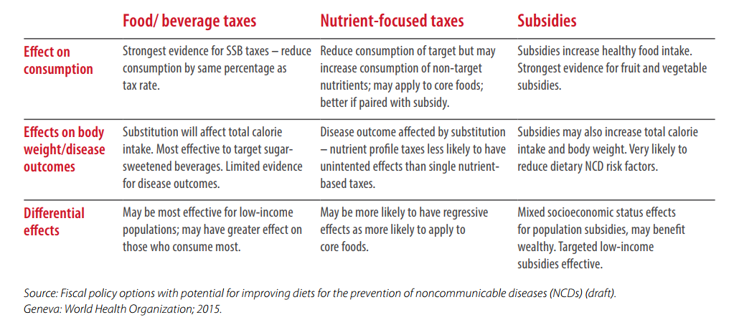

Figure Legends
Fig1. Age-standardised prevalence of cirrhosis and other liver diseases by aetiology in 2016 – modelled data(1)
Fig 2. Age-standardised mortality for all liver diseases – in most recent year(5)
Fig 3. Total mortality from cirrhosis (left) and alcohol consumption (right) over time, for ages >15 years for countries in different trend groups: a) decreasing, b) increasing, c) stable-high, d) stable-low(6)

Fig 4. Death rates, cirrhosis of the liver and alcohol consumption from Terris (1967)(22)
Fig 5. Alcohol consumption and age-standardised mortality from cirrhosis and chronic liver diseases (blue filled) on the left and alcoholic liver disease mortality (blue dashed) (left) and total consumption of alcohol by type of alcohol ages >15y (right) in four countries: a) France, b) United Kingdom, c) Czech Republic, d) Sweden(6)
Fig 6. Time trends in age-standardised mortality from NAFLD/NASH - both genders by region a) Northern b) Eastern, c) Southern, d) Western Europe(5)
Fig 7. Prevalence of obesity (BMI>30kg/m²) in Females and Males in the most recent year available Estimates come from measured BMI, all other data points used self-reported. Note: Uzbekistan estimates come from surveys in separate years and so are presented separately
Fig 8. Age-standardised prevalence of type 2 diabetes in adults aged 20-79 years over time by region a) Northern b) Eastern, c) Southern, d) Western Europe Estimation methodology was revised in 2011(13)
Fig 9. Map of the age-adjusted prevalence of type 2 diabetes in adults, both genders (2015)(13)

Figures

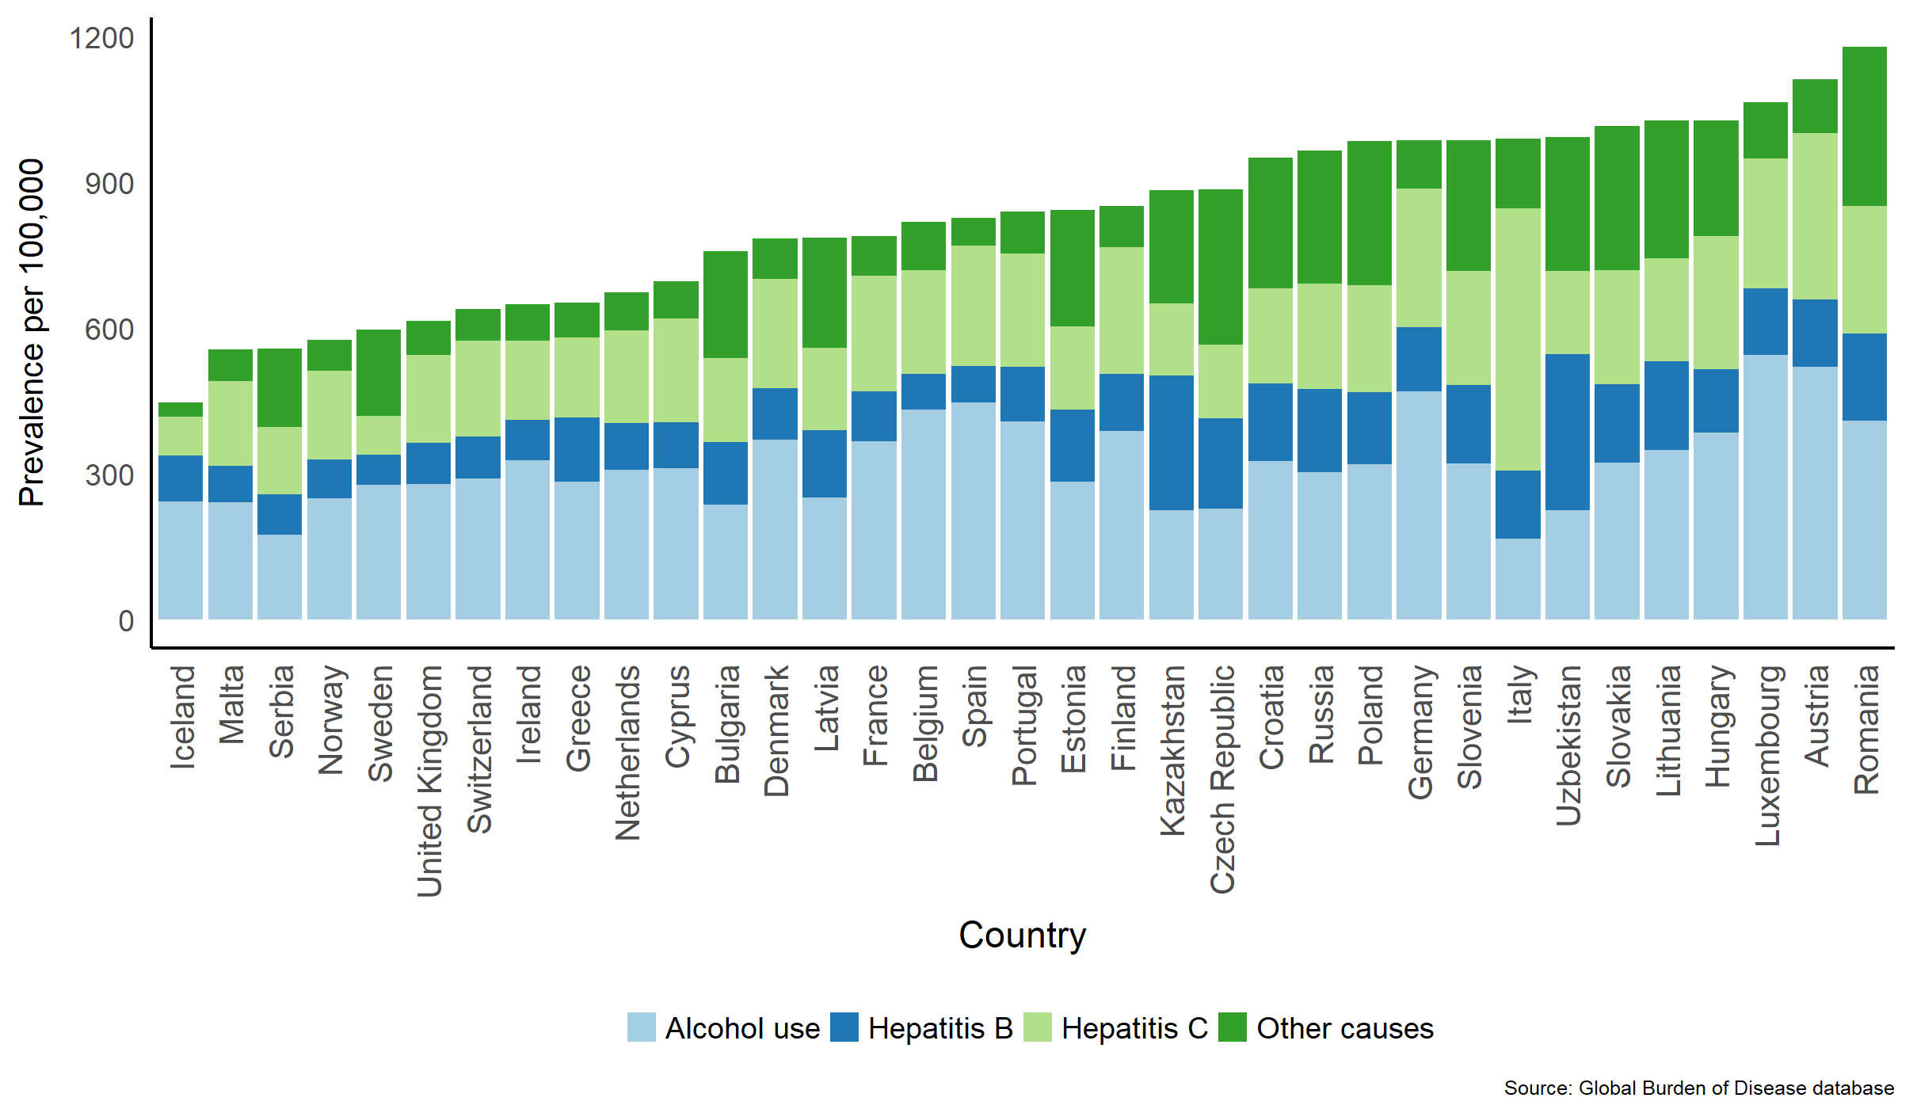
Figure 1. Age-standardised prevalence of cirrhosis and other liver diseases by aetiology in 2016 – modelled data(1) Median prevalence for alcohol use: 312 per 100,000; median prevalence for hepatitis B 130 per 100,000; median prevalence for hepatitis C: 212 per 100,000, median prevalence for other causes 116 per 100,000.

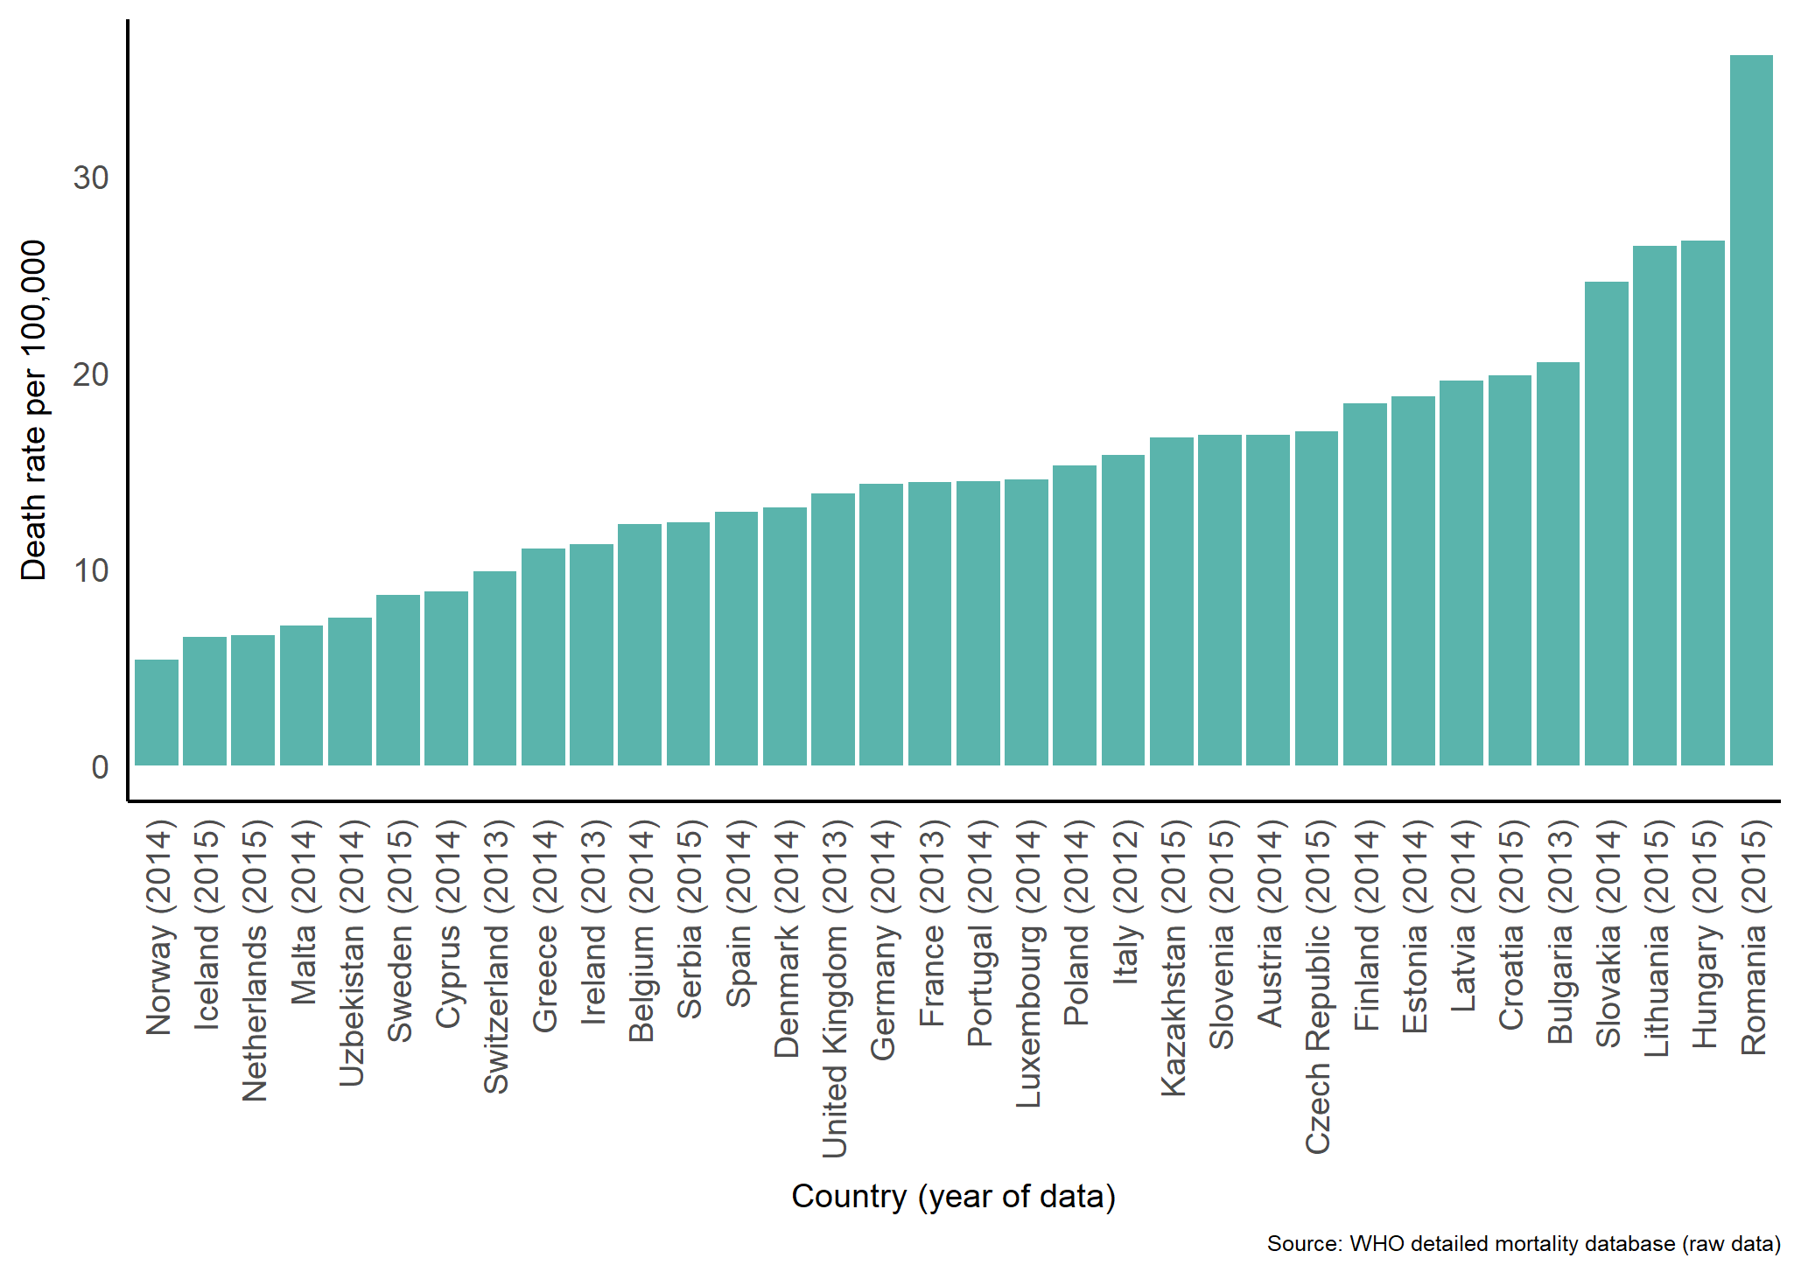
Figure 2. Age-standardised mortality for all liver diseases – in most recent year(5)

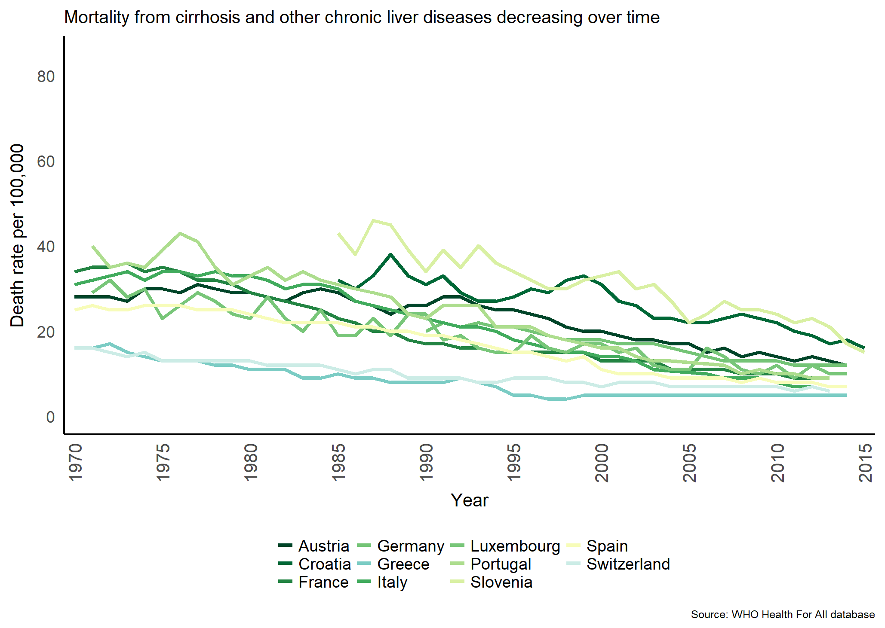a) | 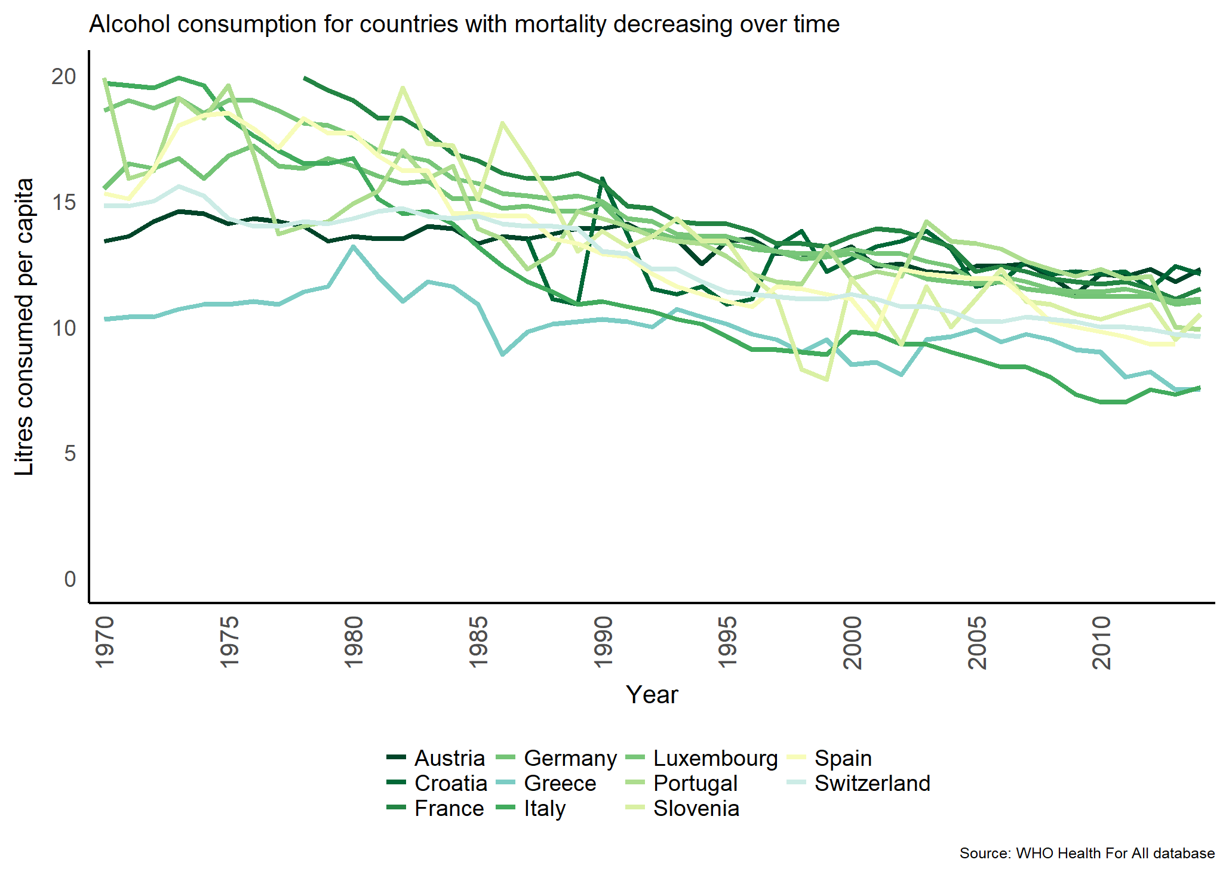a)
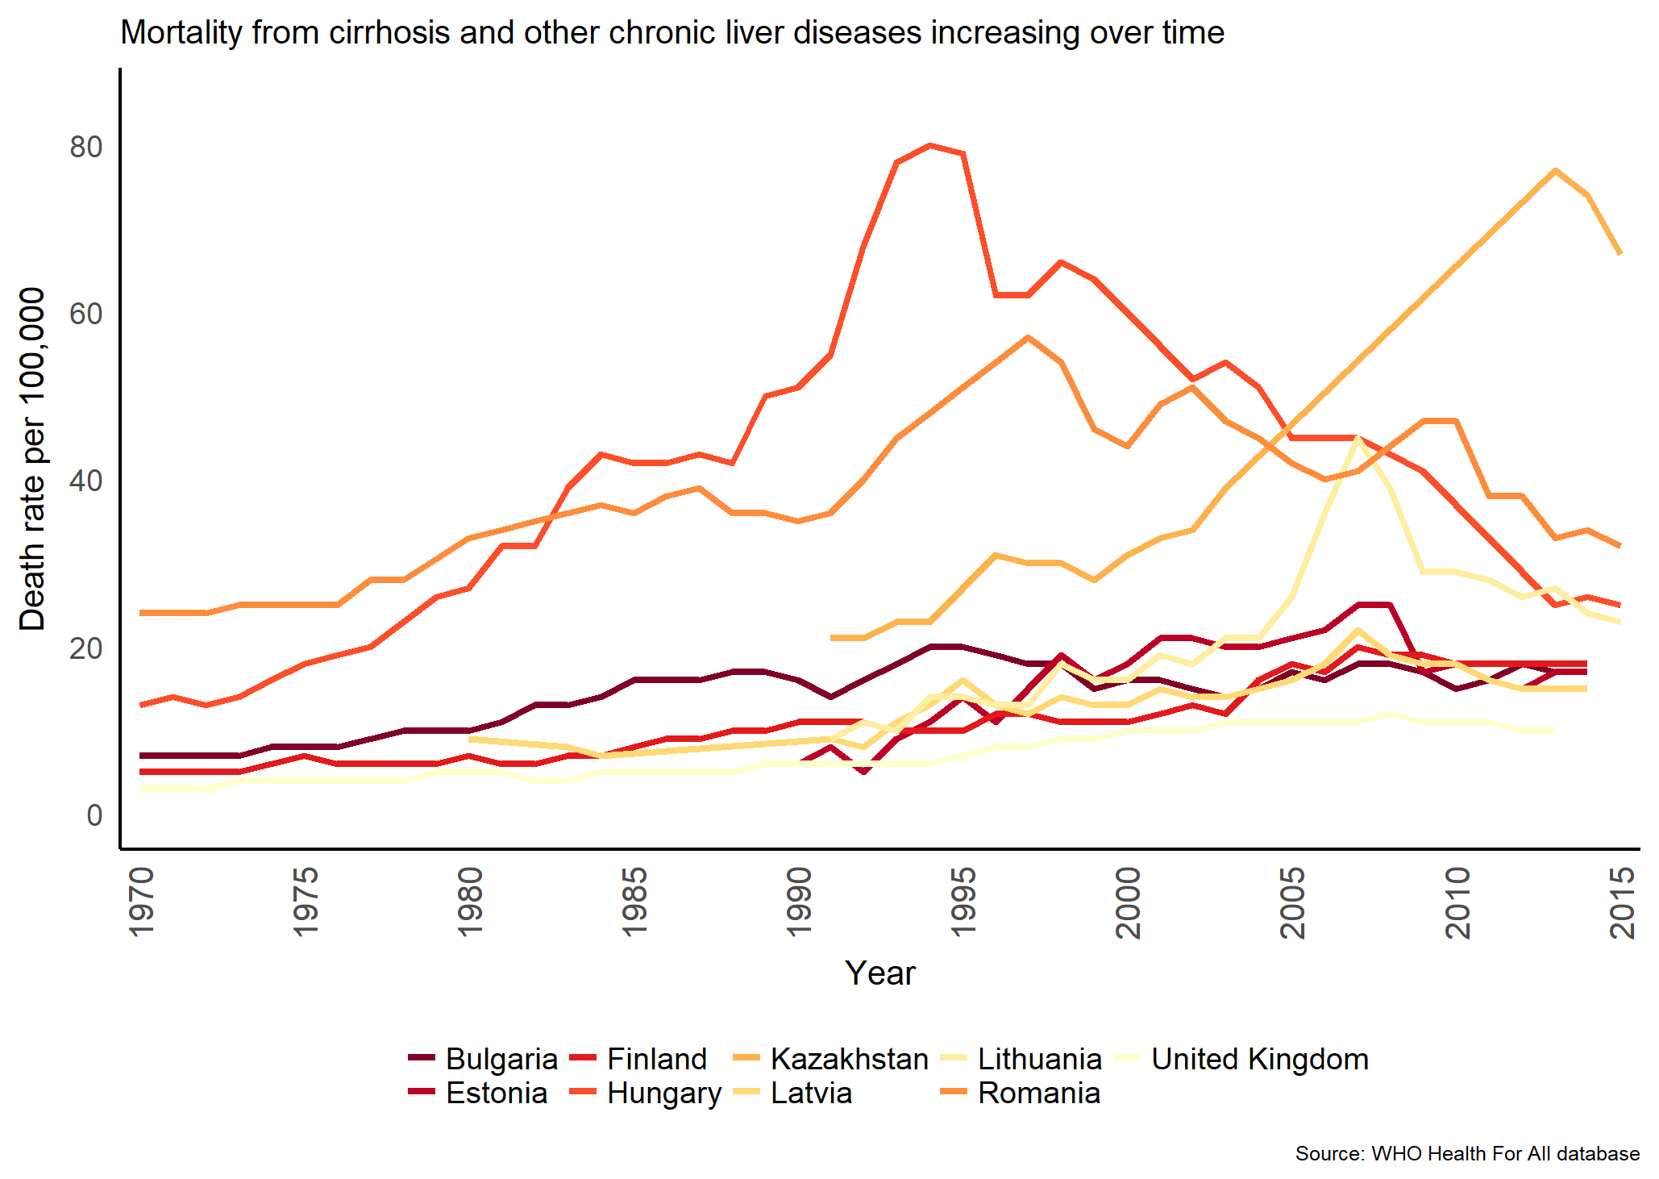b) | 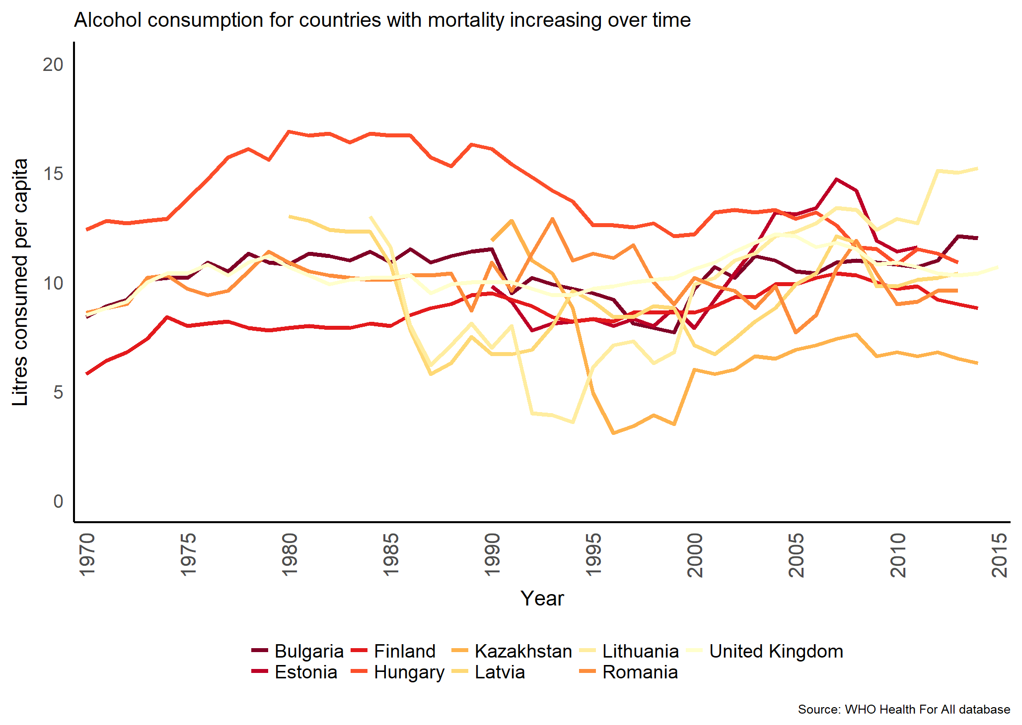b)
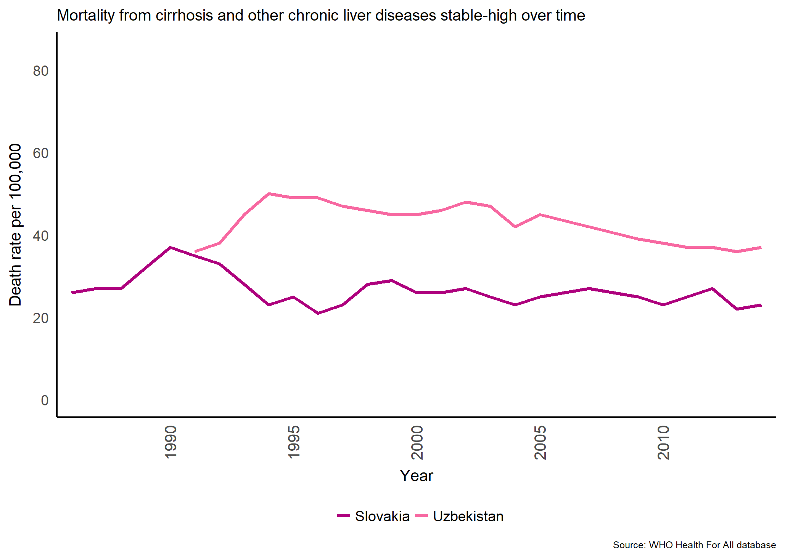c) | 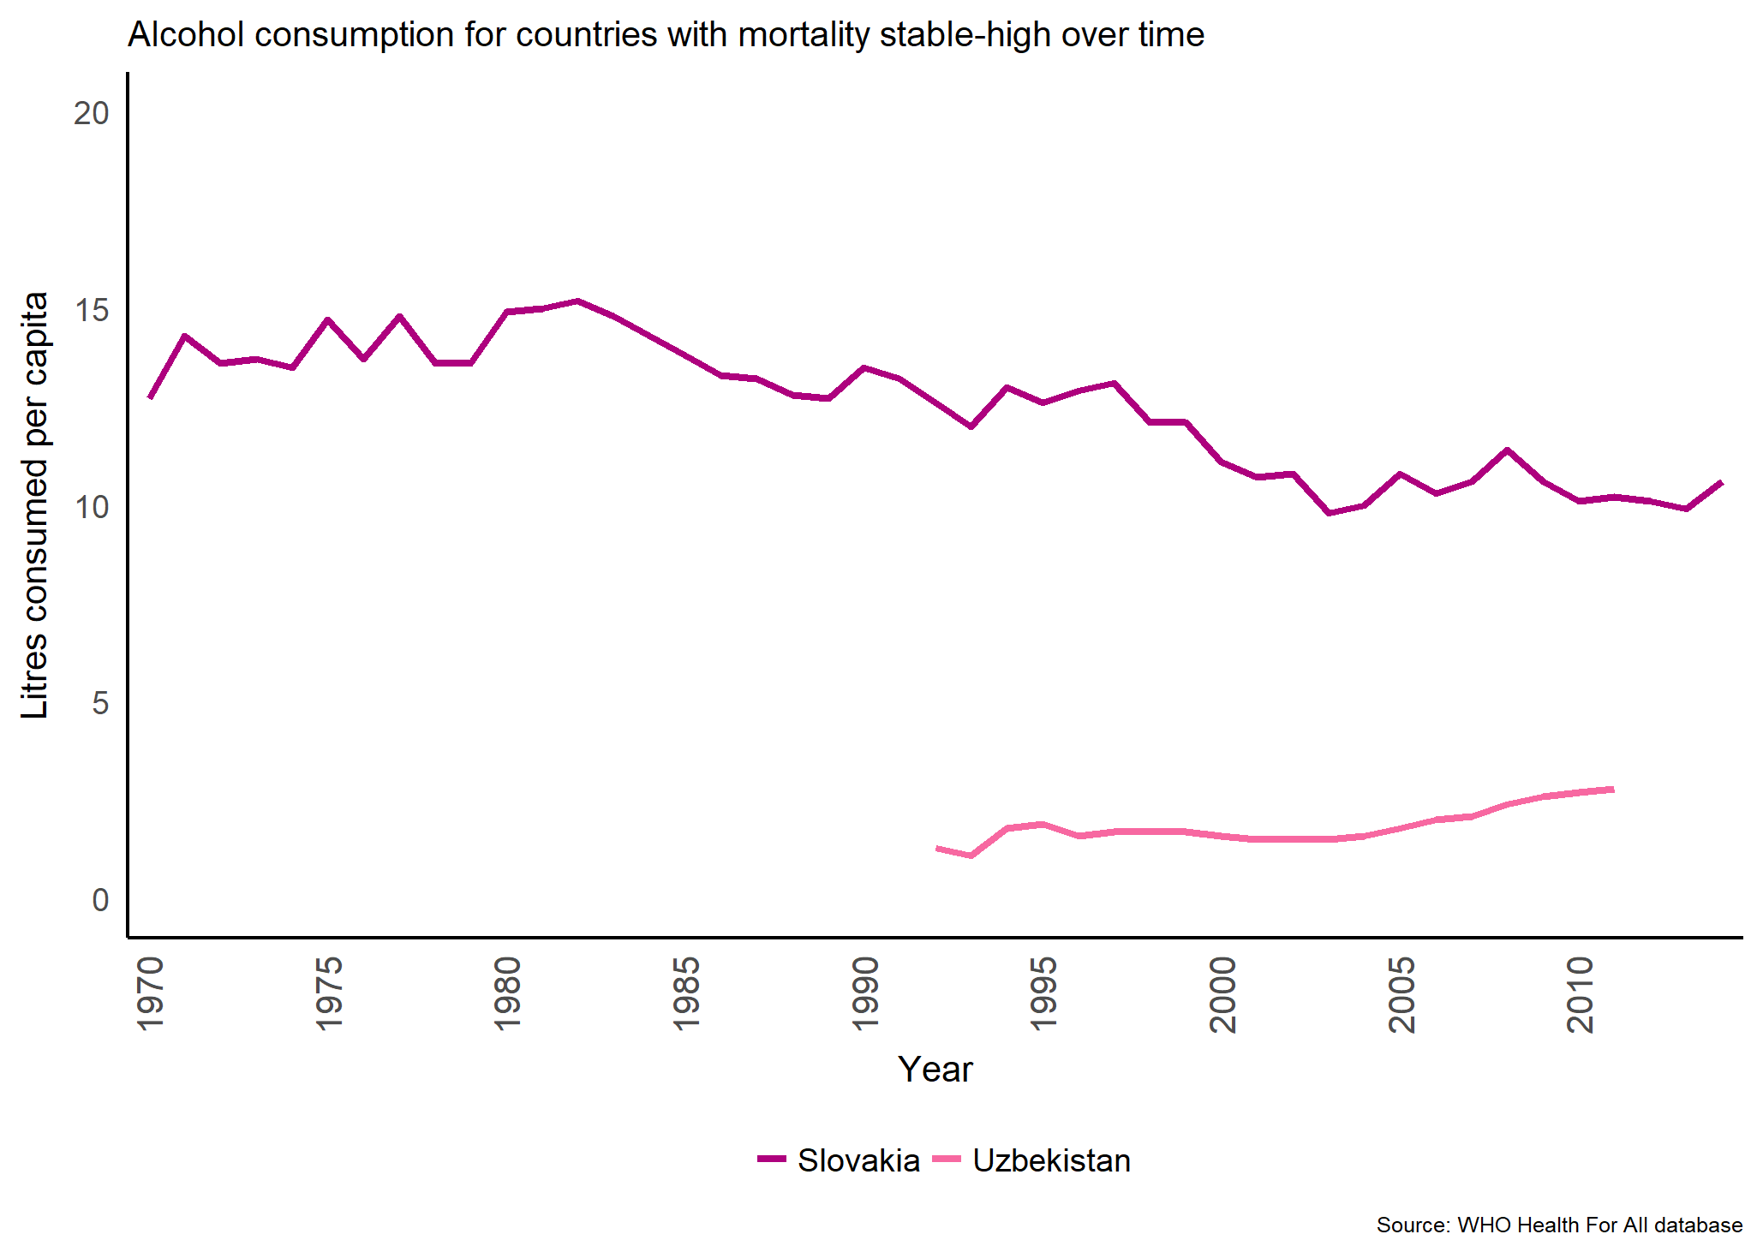c)
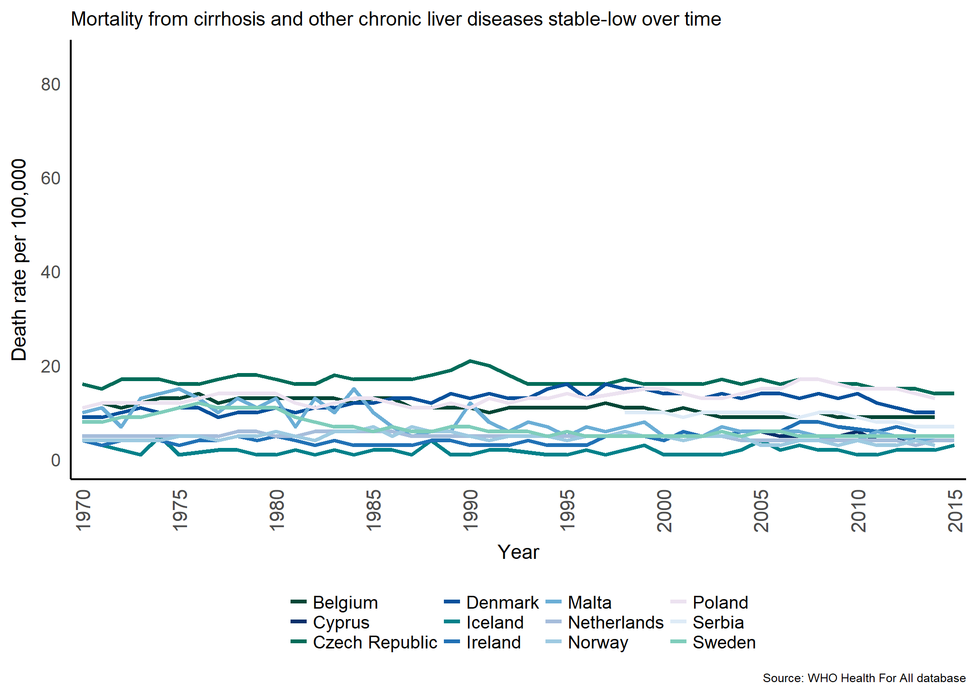d) | 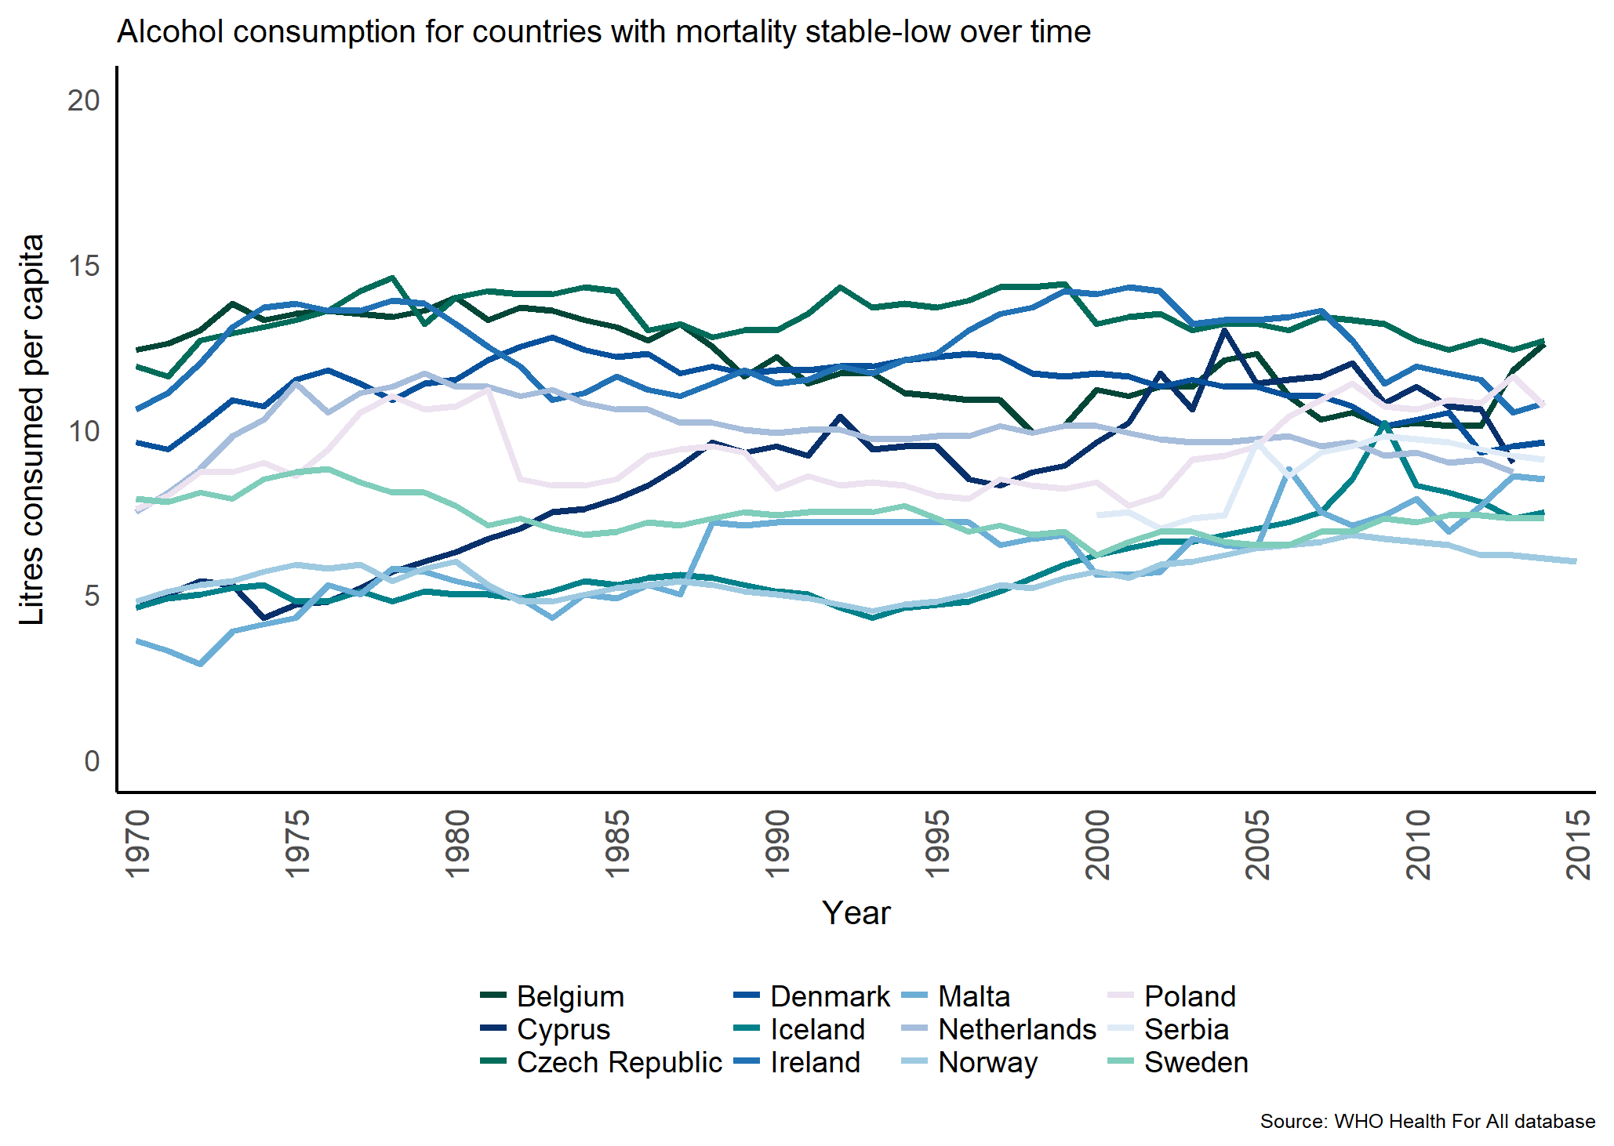d)
Figure 3. Total mortality from cirrhosis (left) and alcohol consumption (right) over time, for ages >15 years for countries in different trend groups: a) decreasing, b) increasing, c) stable-high, d) stable-low(6)

Figure 4. Death rates, cirrhosis of the liver and alcohol consumption from Terris (1967)(22)

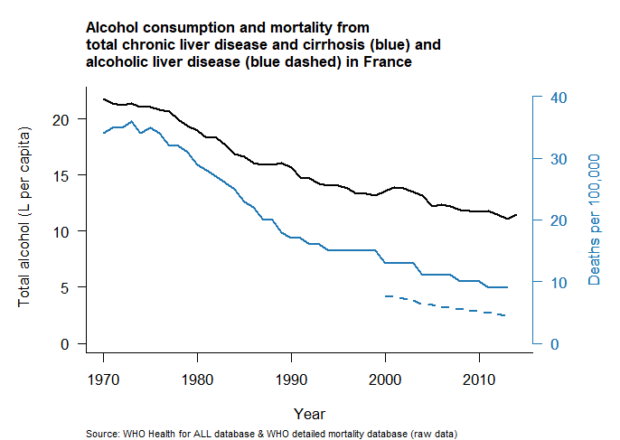a) | 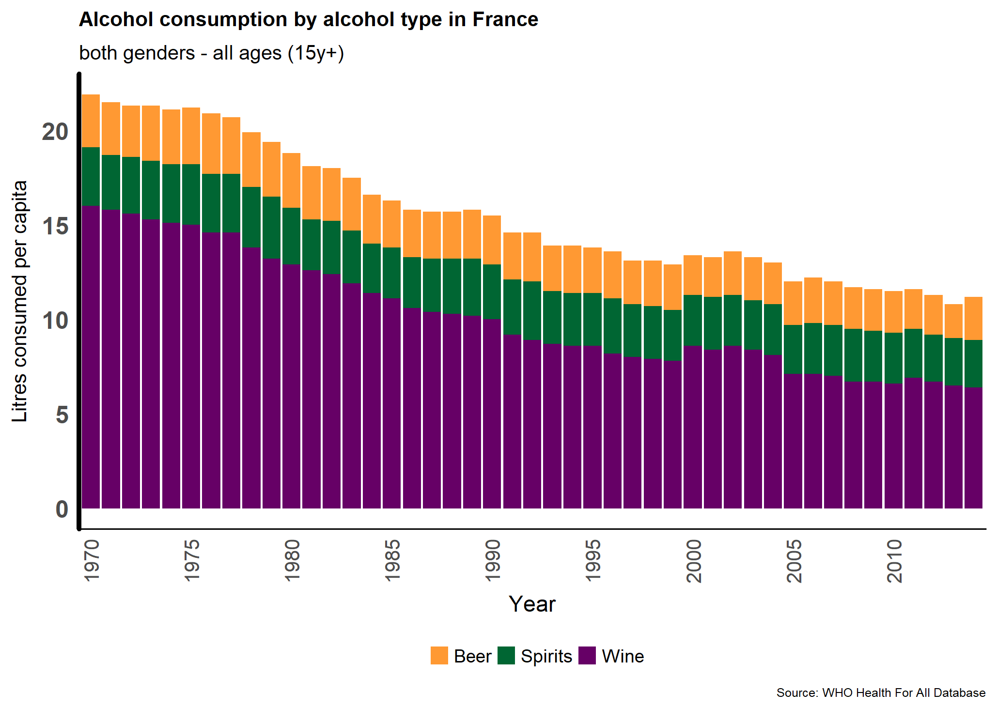a)
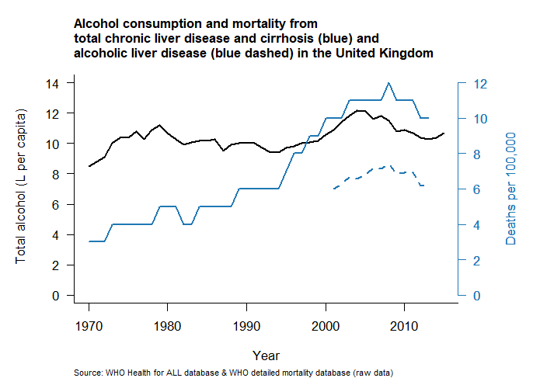b) | 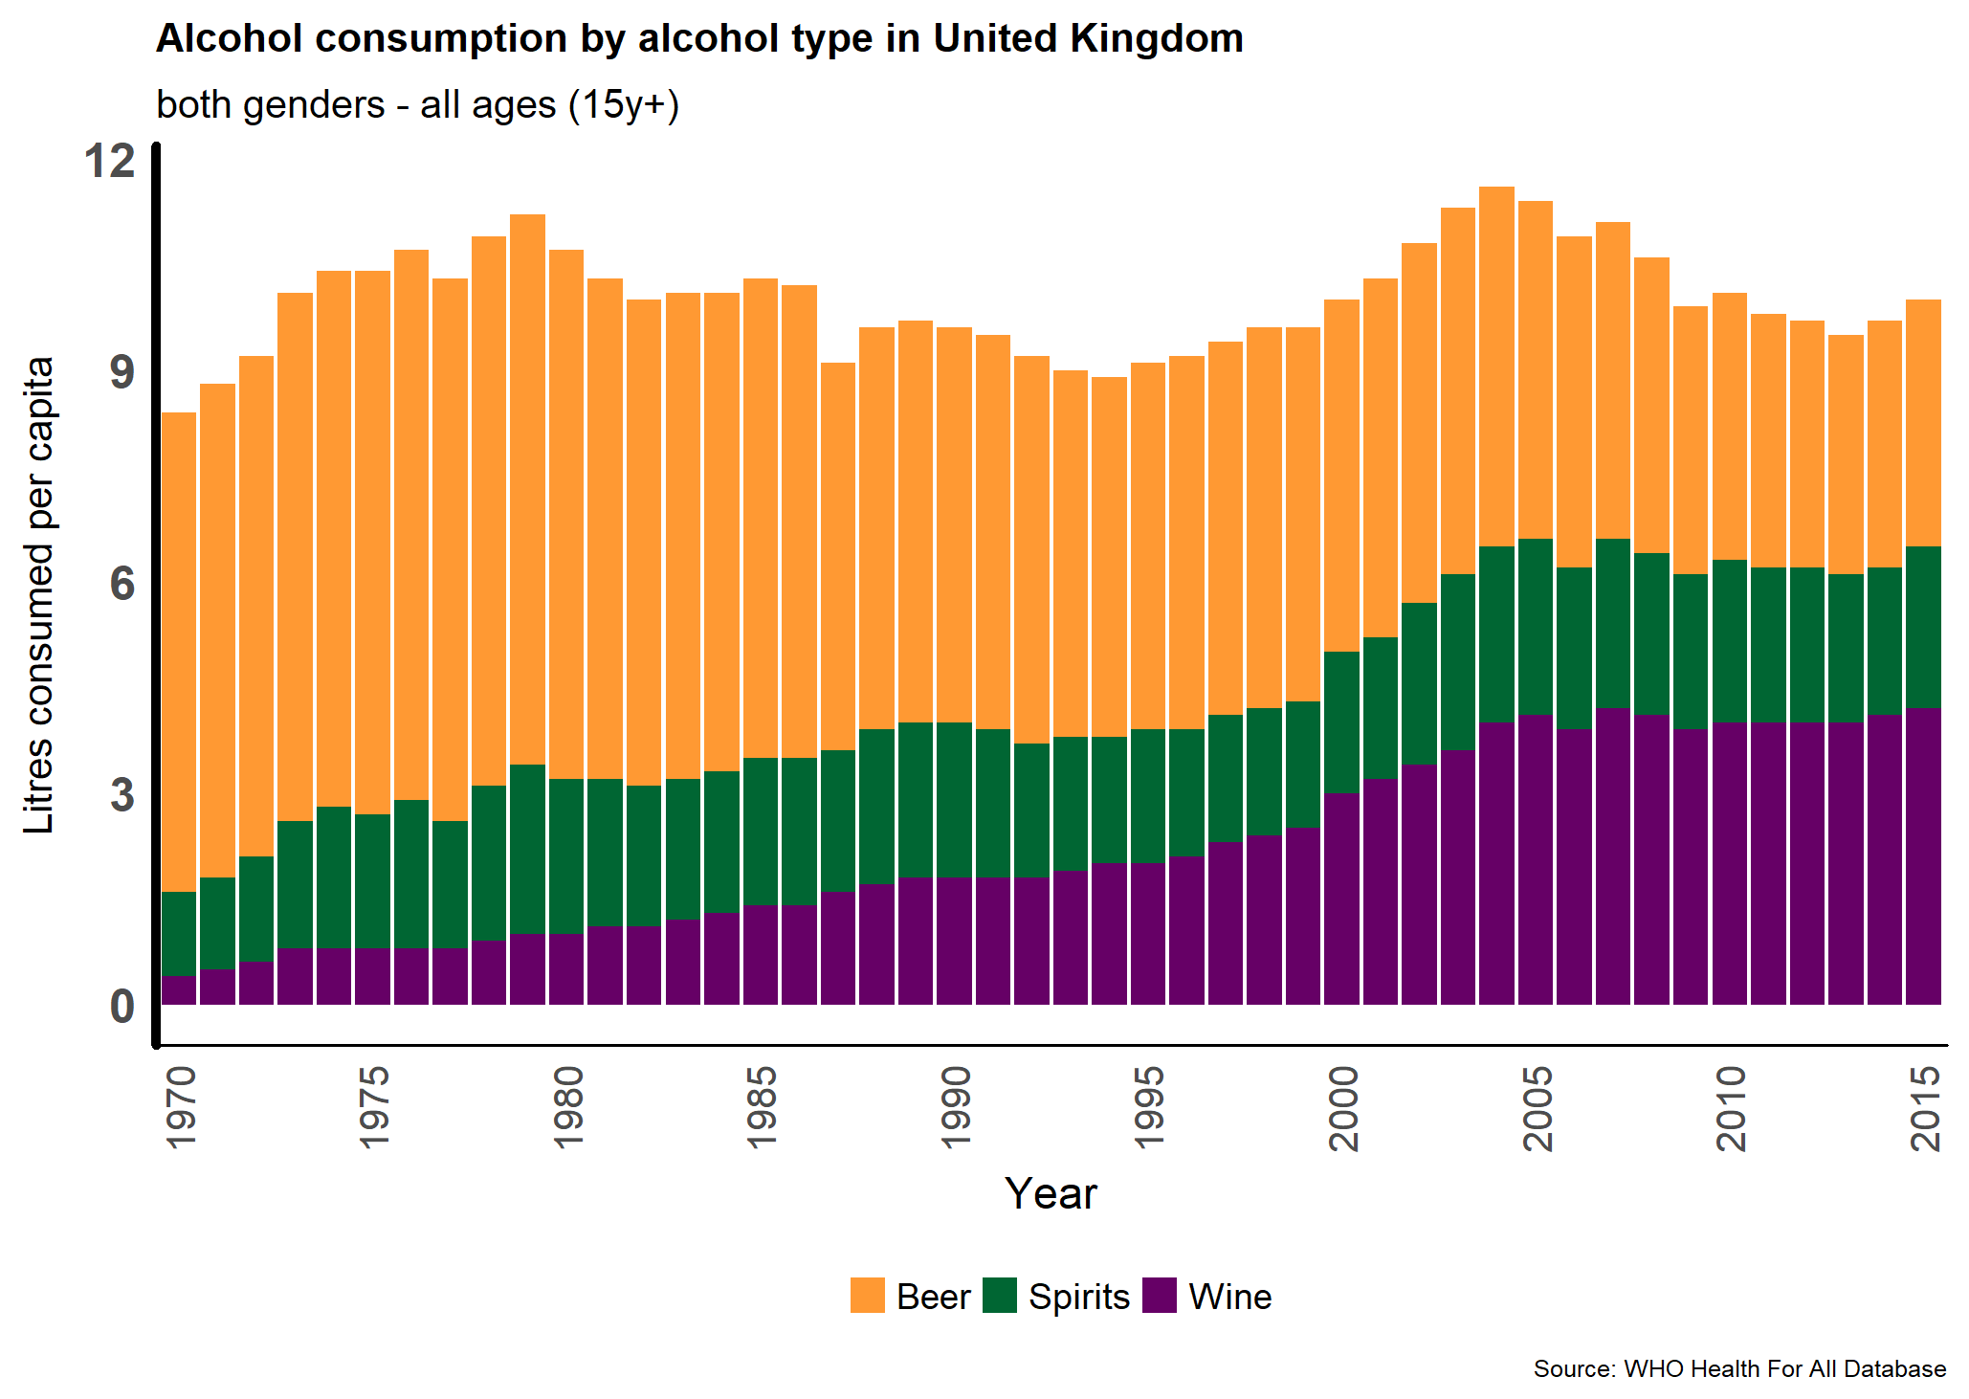b)
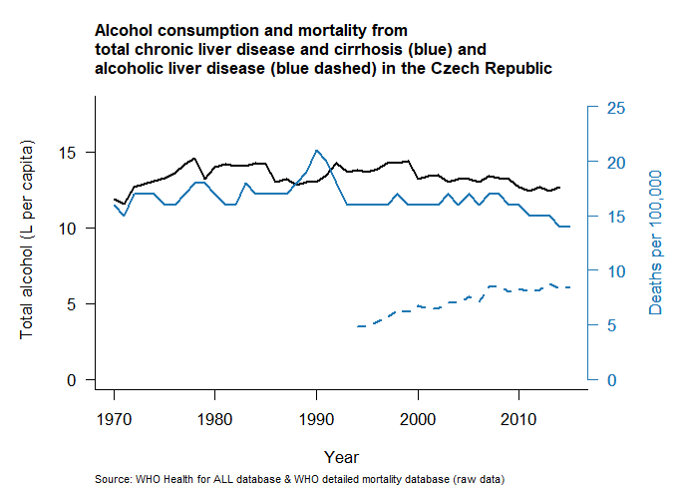c) | 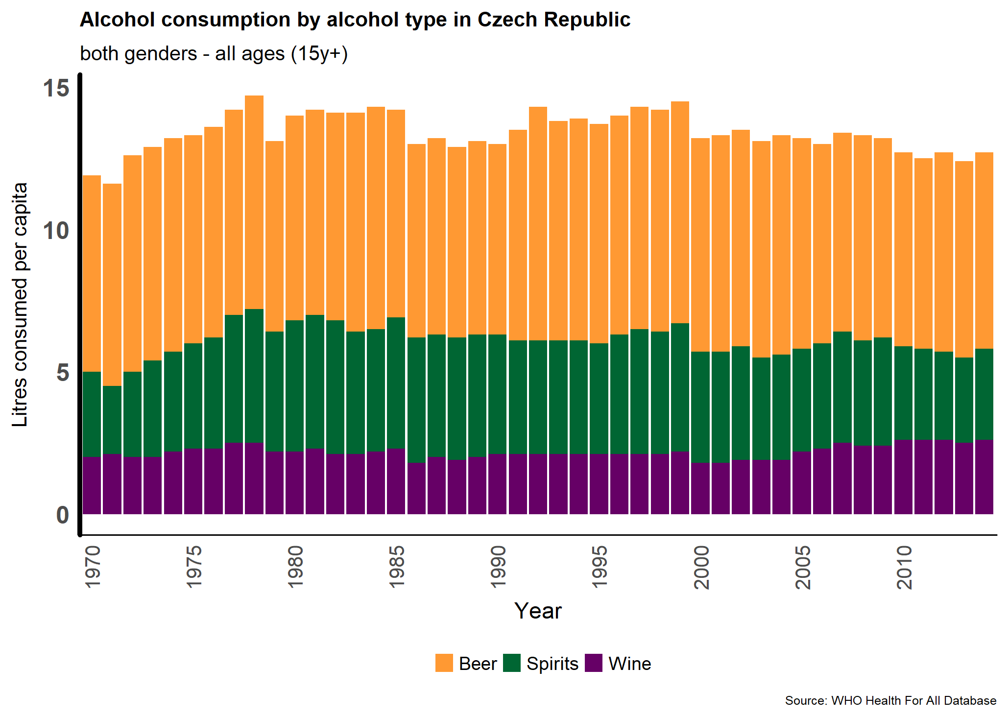c)
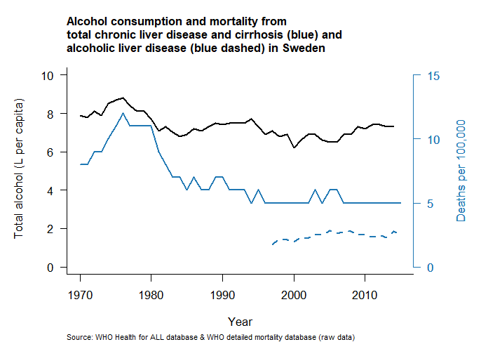d) | 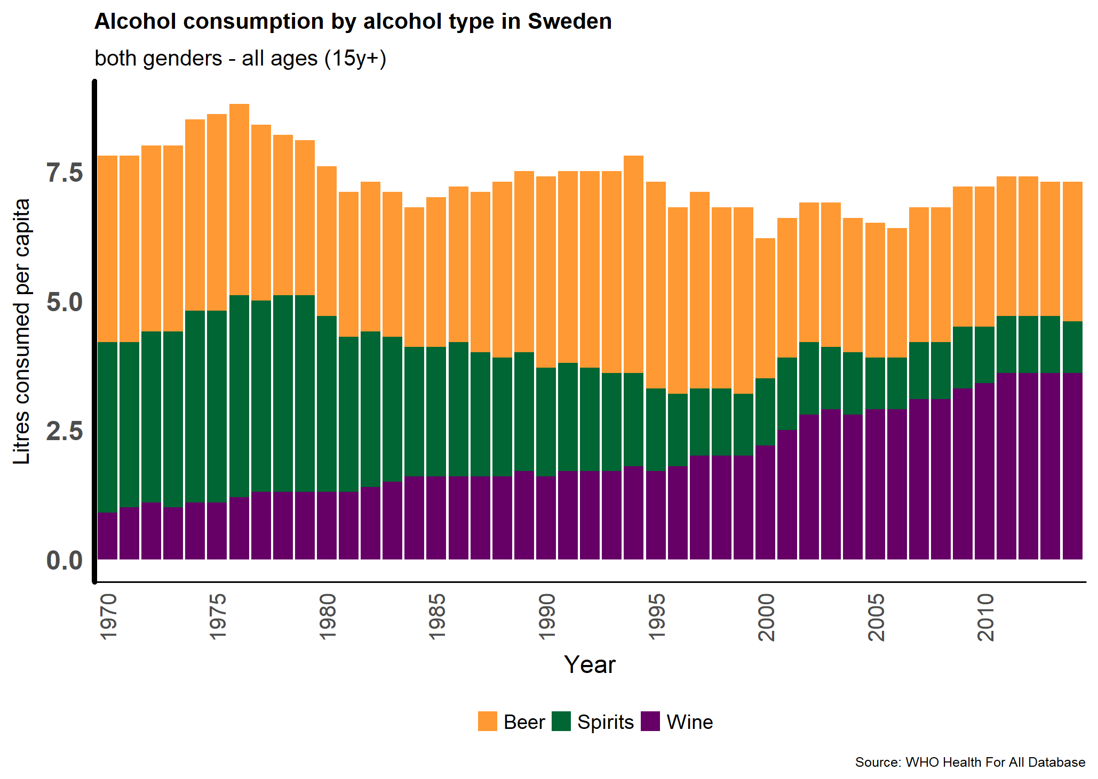d)
Figure 5. Alcohol consumption and age-standardised mortality from cirrhosis and chronic liver diseases (blue filled) on the left and alcoholic liver disease mortality (blue dashed) (left) and total consumption of alcohol by type of alcohol ages >15y (right) in four countries: a) France, b) United Kingdom, c) Czech Republic, d) Sweden(6)

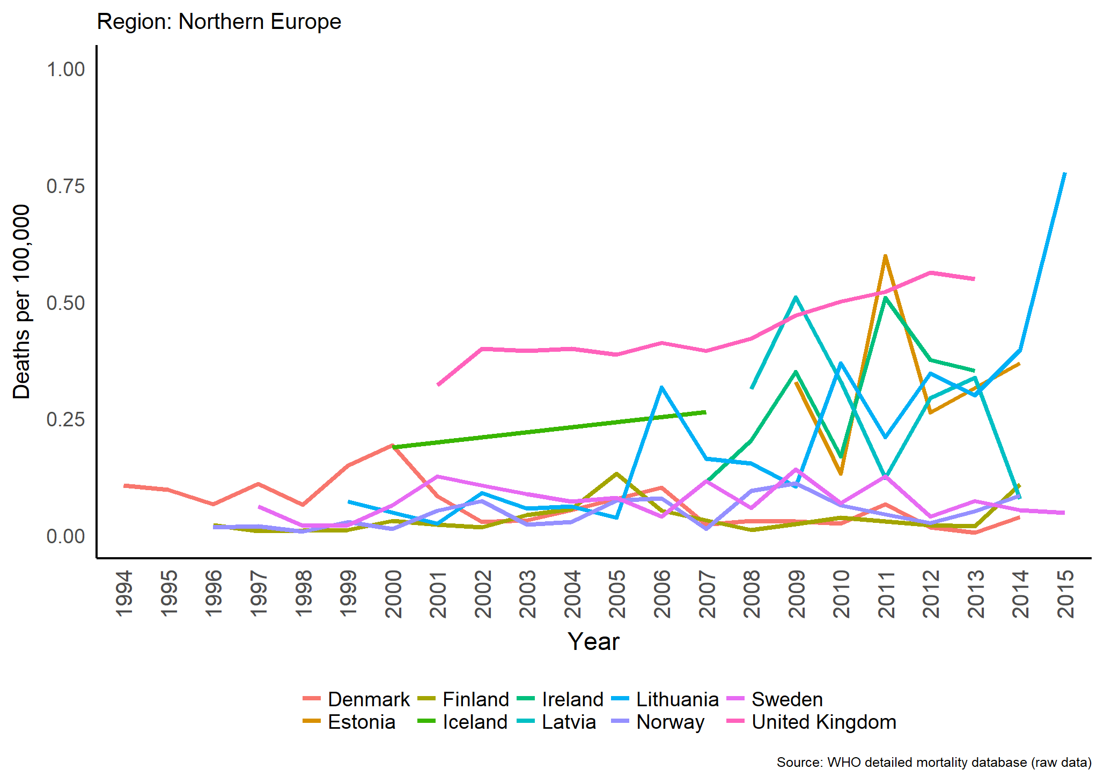a) | 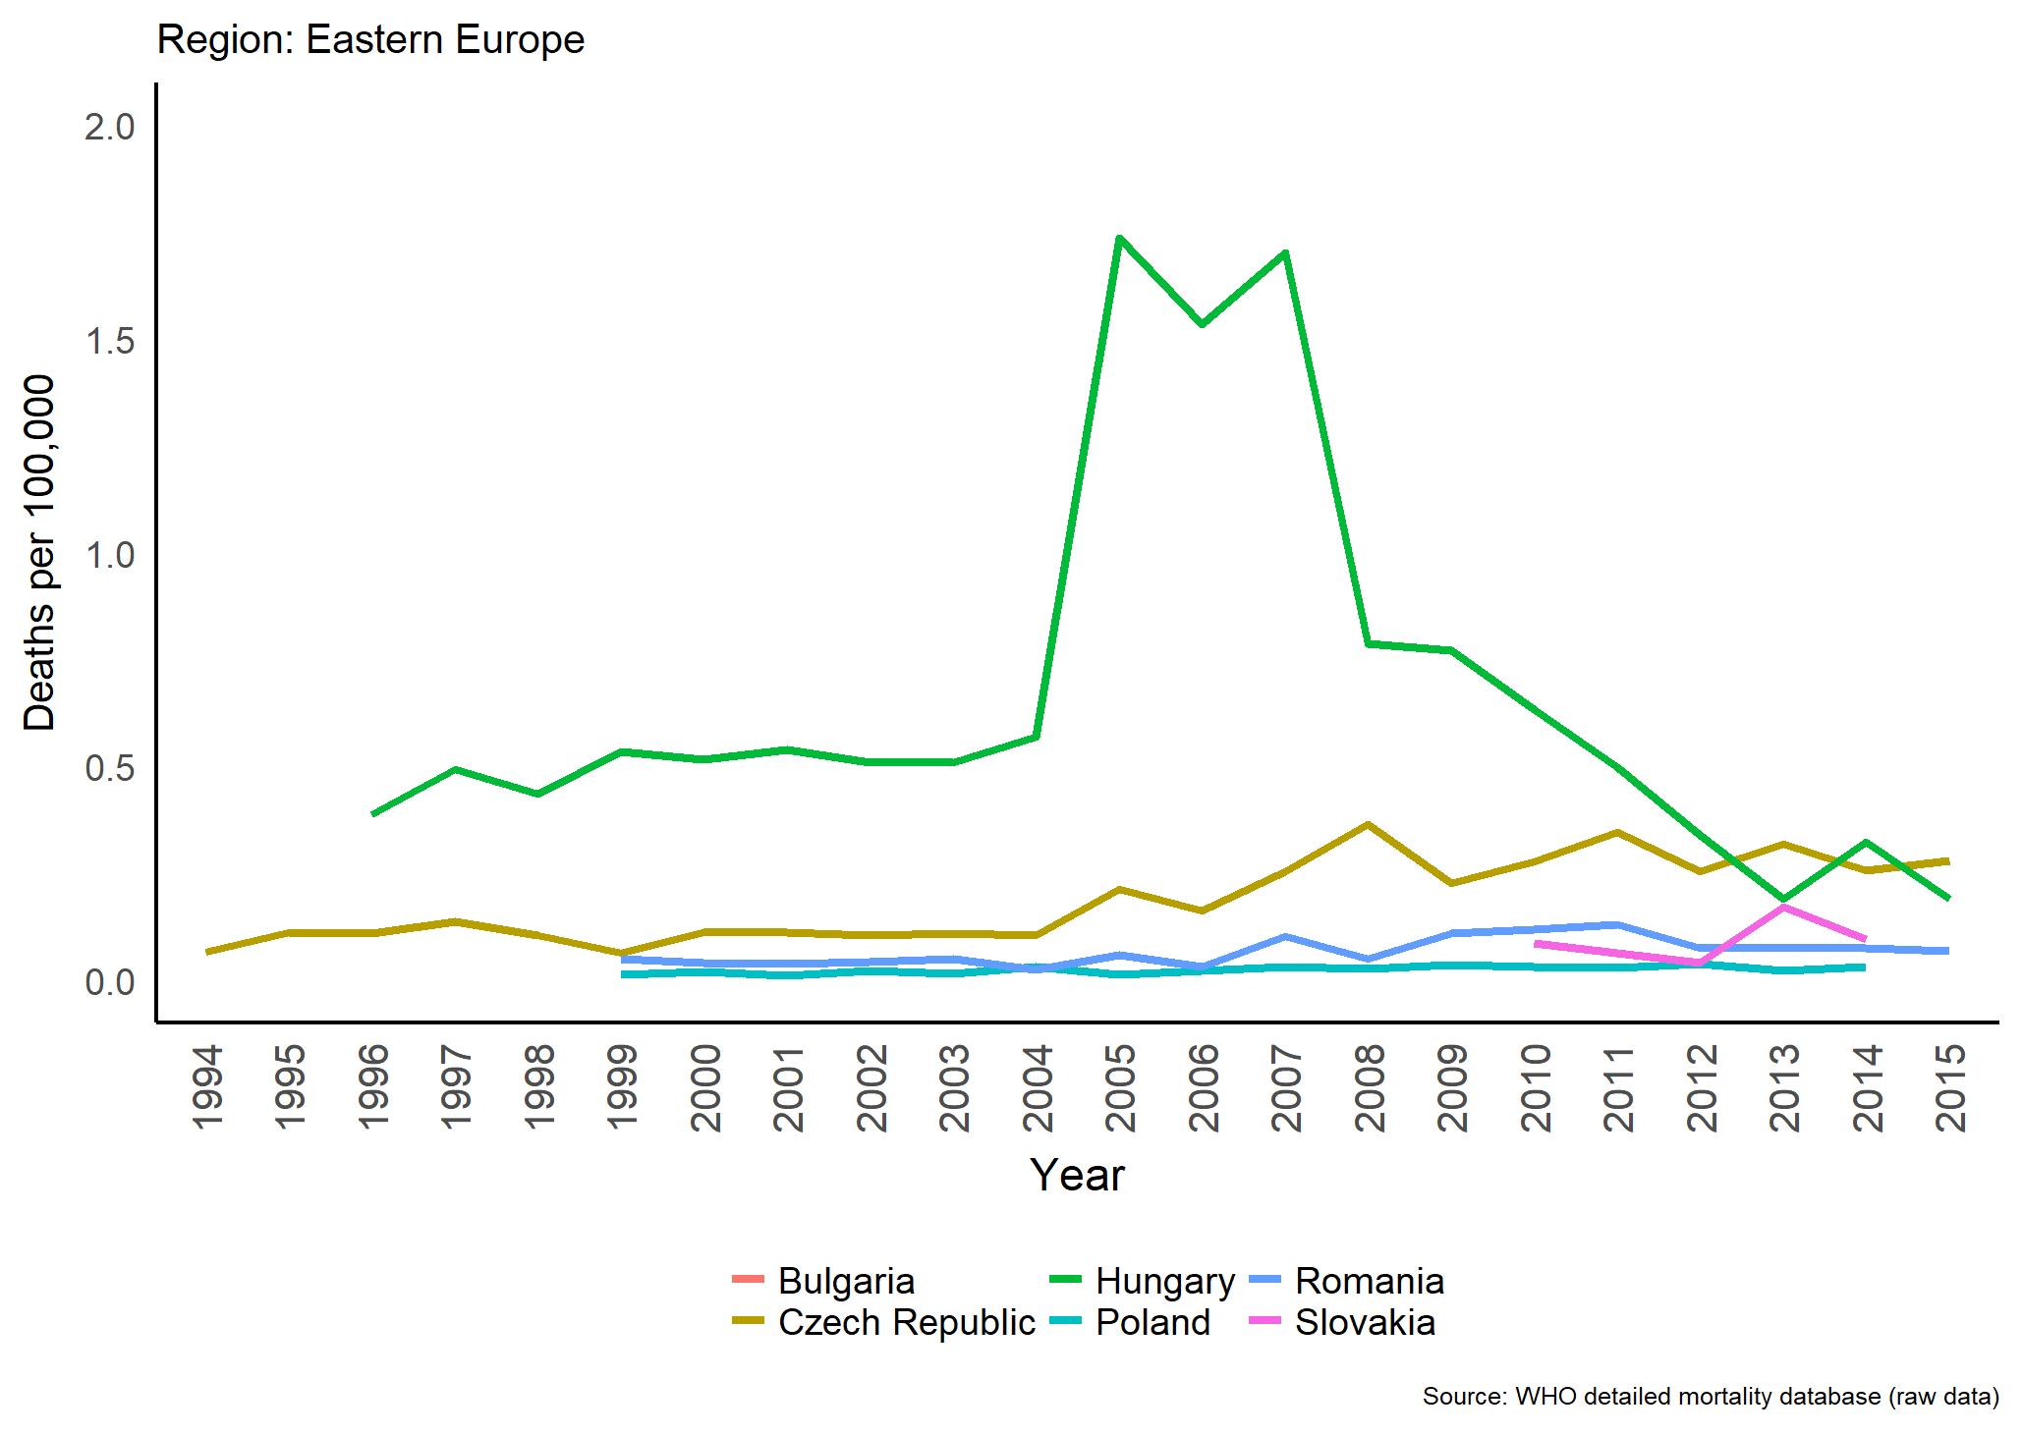b)
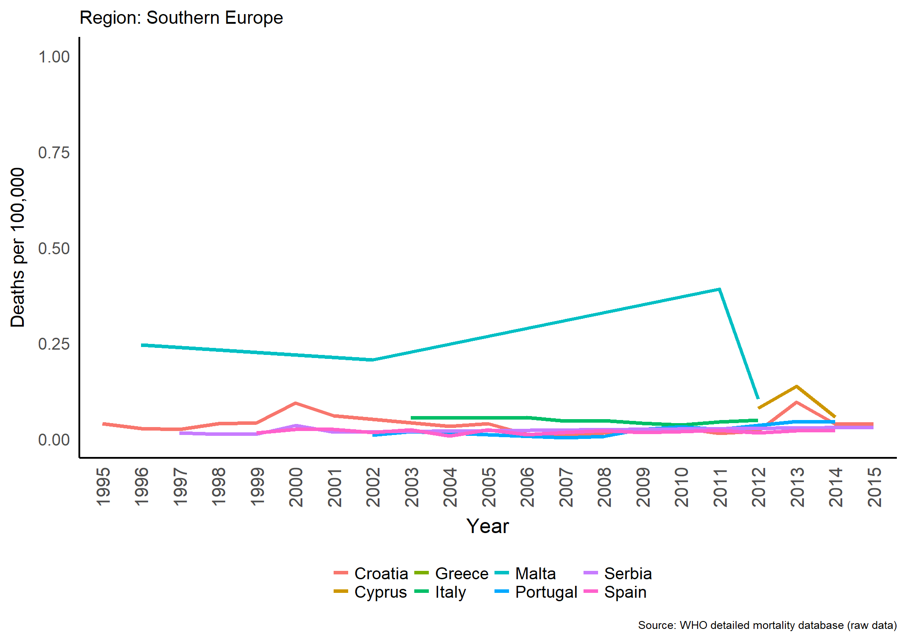c) | 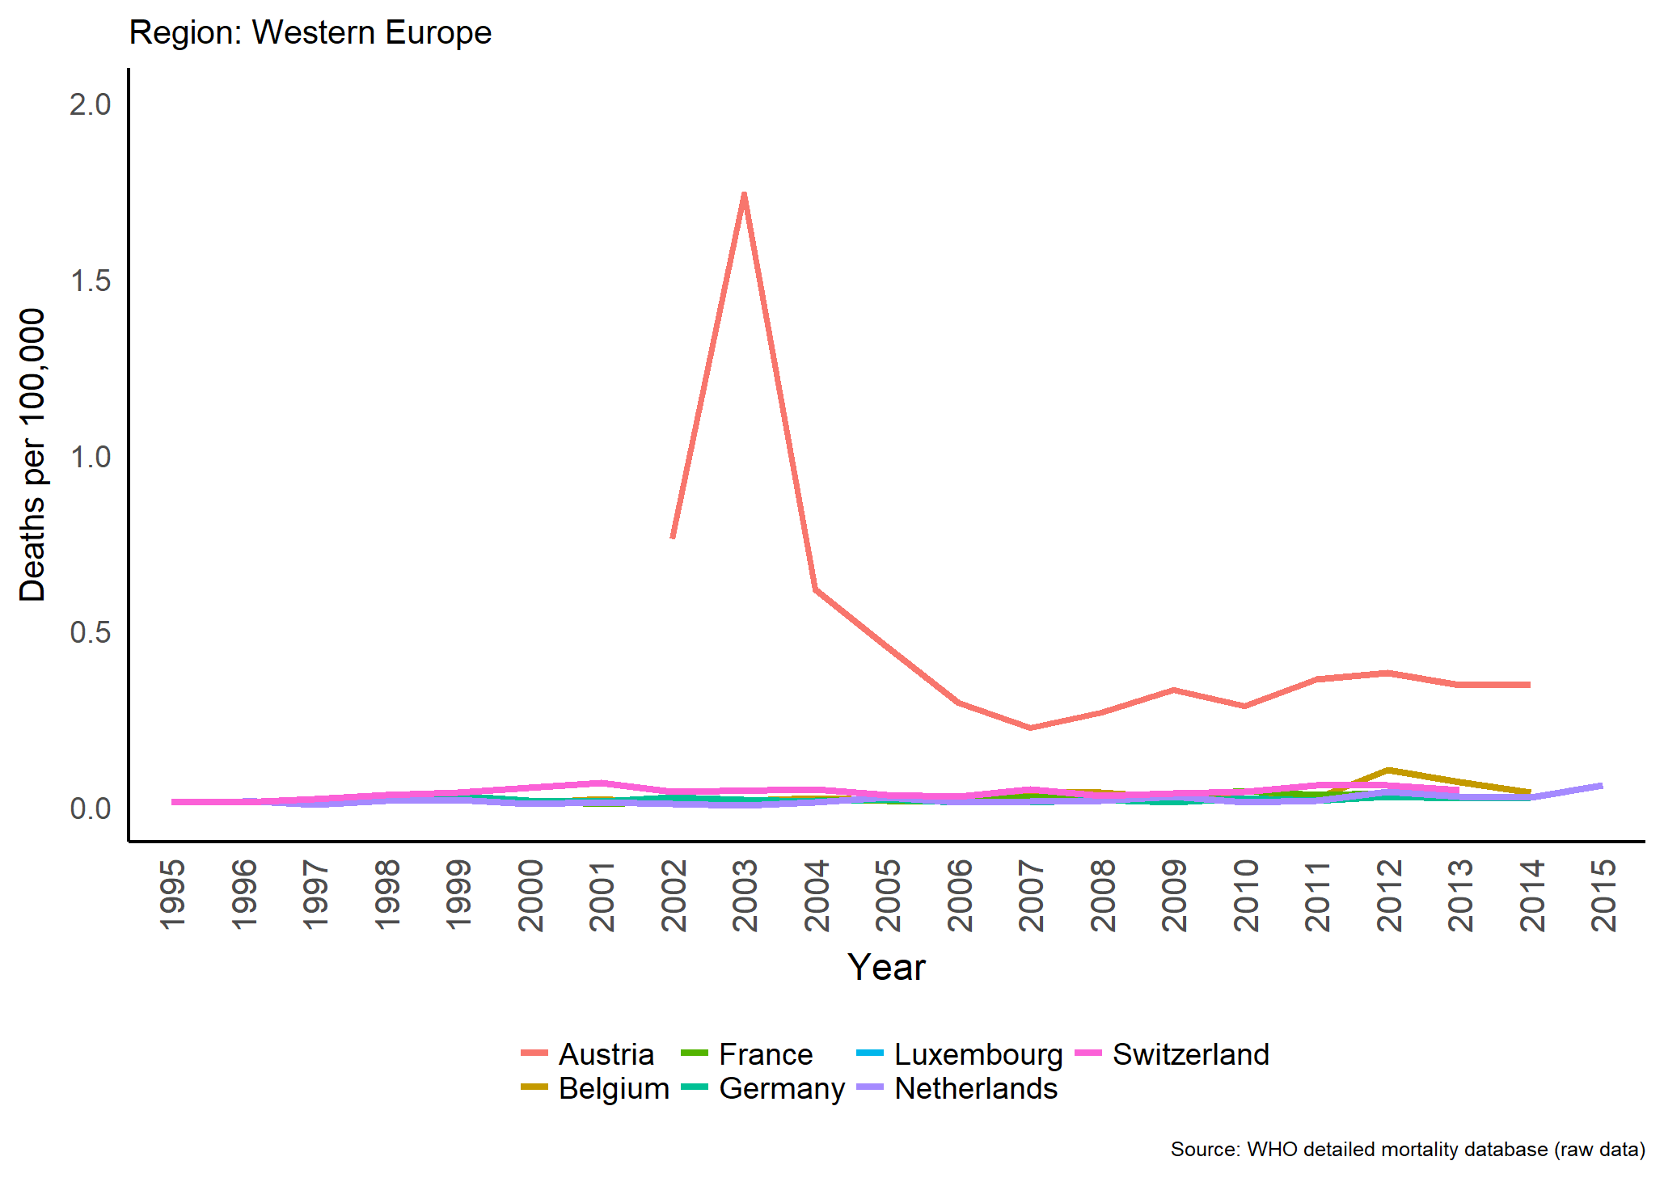d)
Figure 6. Time trends in age-standardised mortality from NAFLD/NASH - both genders by region a) Northern b) Eastern, c) Southern, d) Western Europe(5)

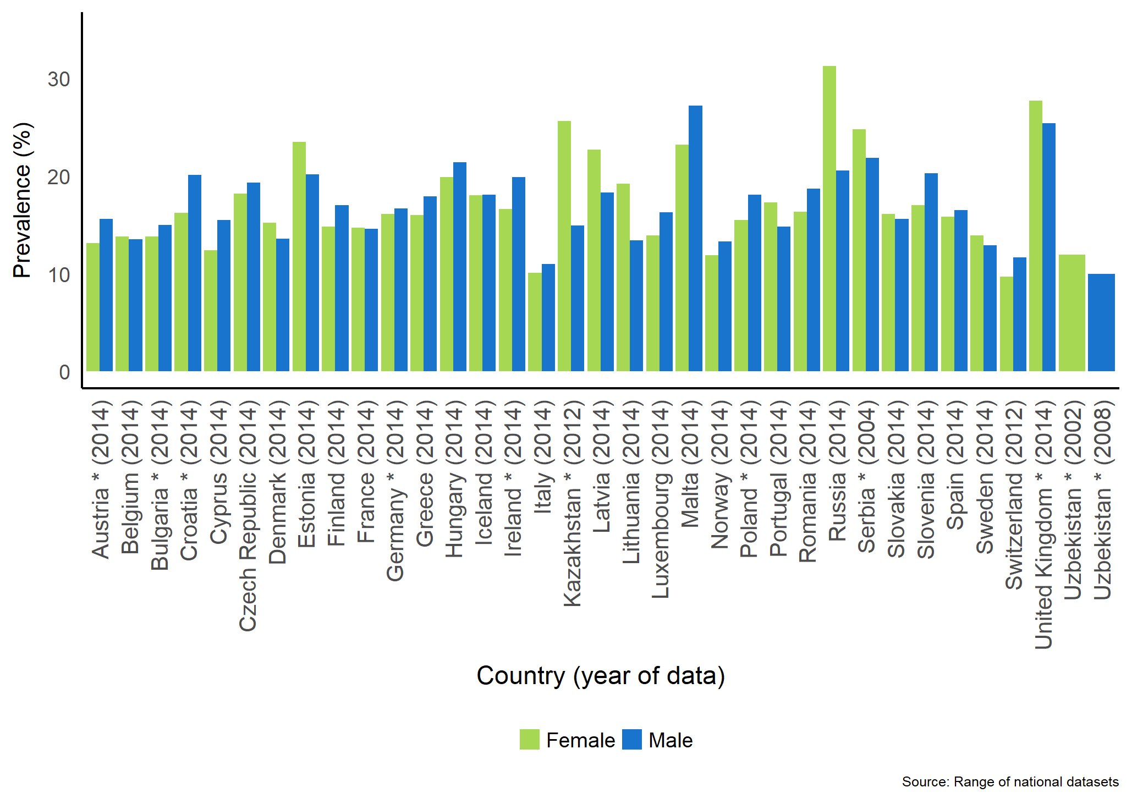
Figure 7. Prevalence of obesity (BMI>30kg/m²) in Females and Males in the most recent year available Estimates come from measured BMI, all other data points used self-reported. Note: Uzbekistan estimates come from surveys in separate years and so are presented separately

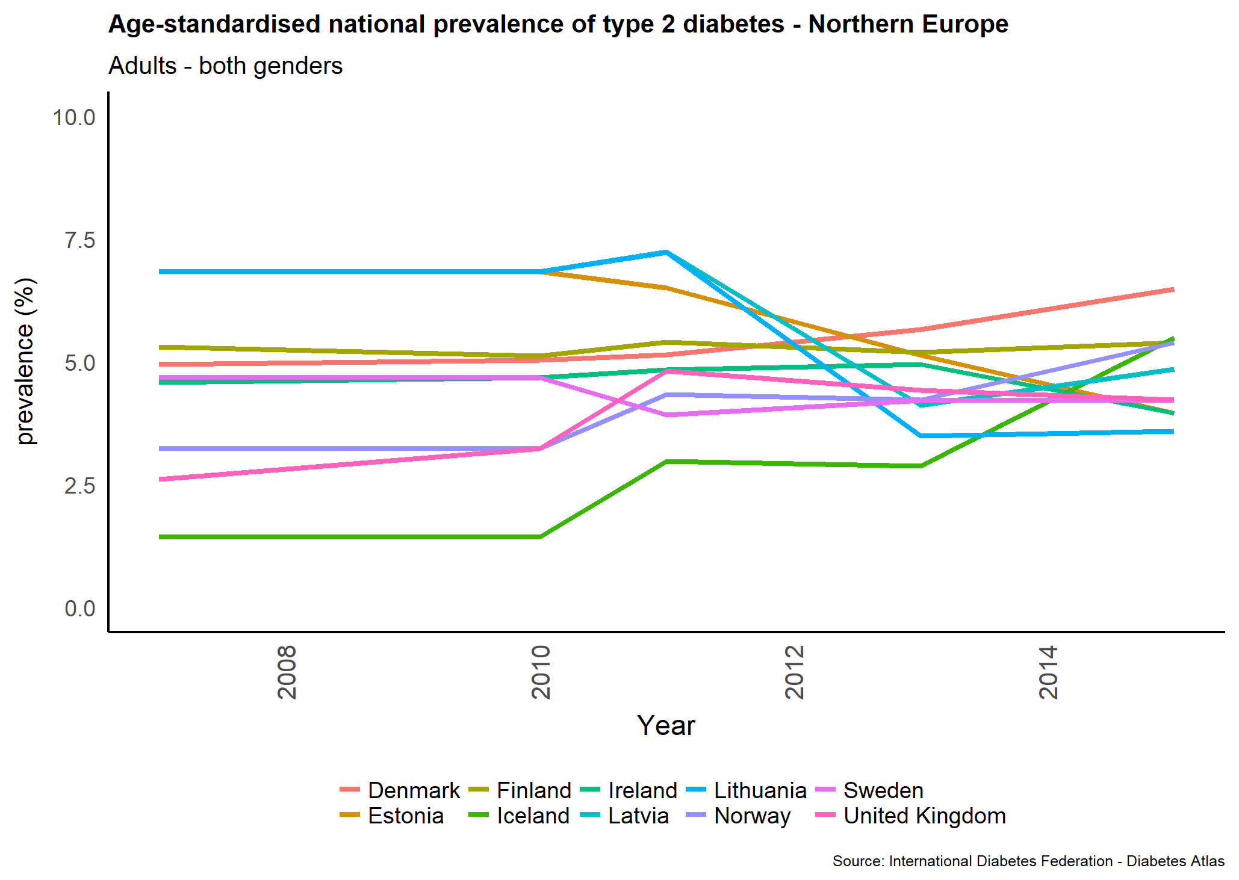a) | 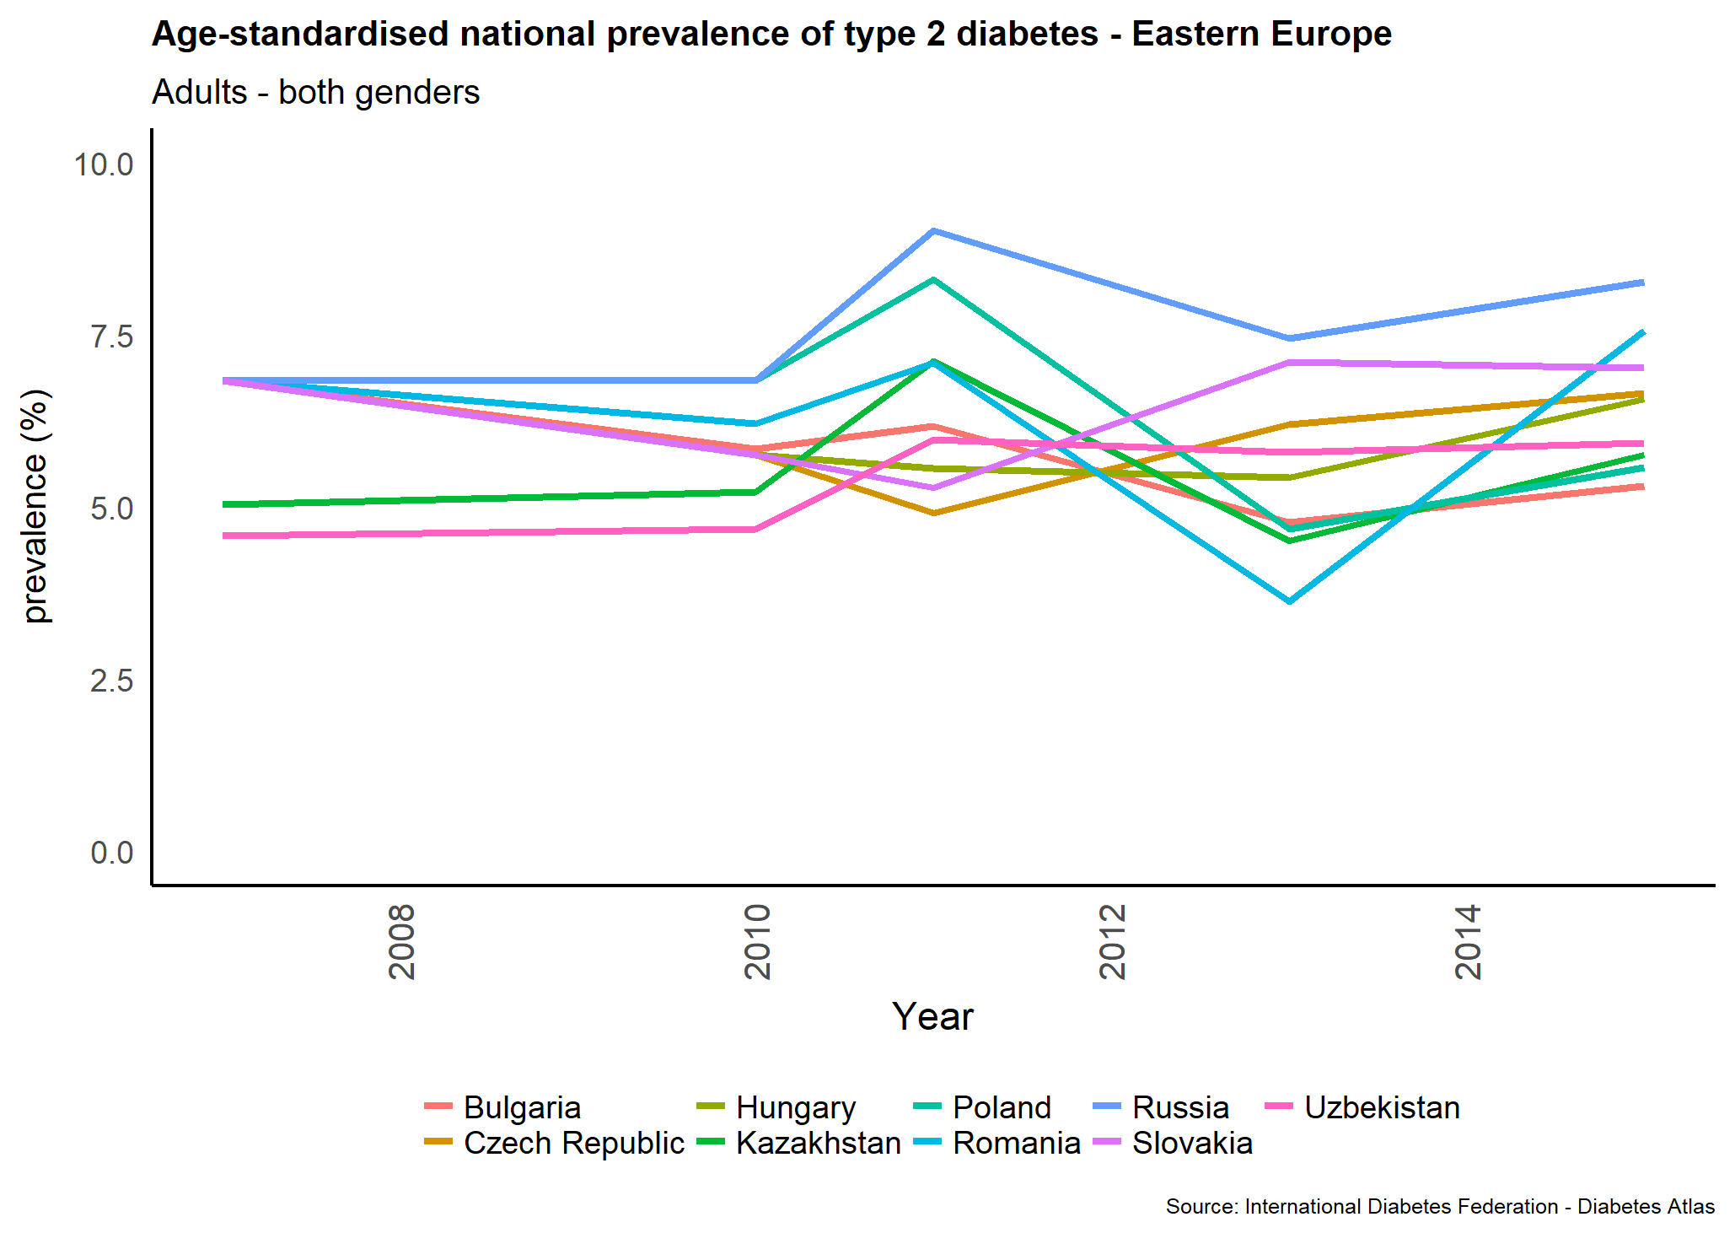b)
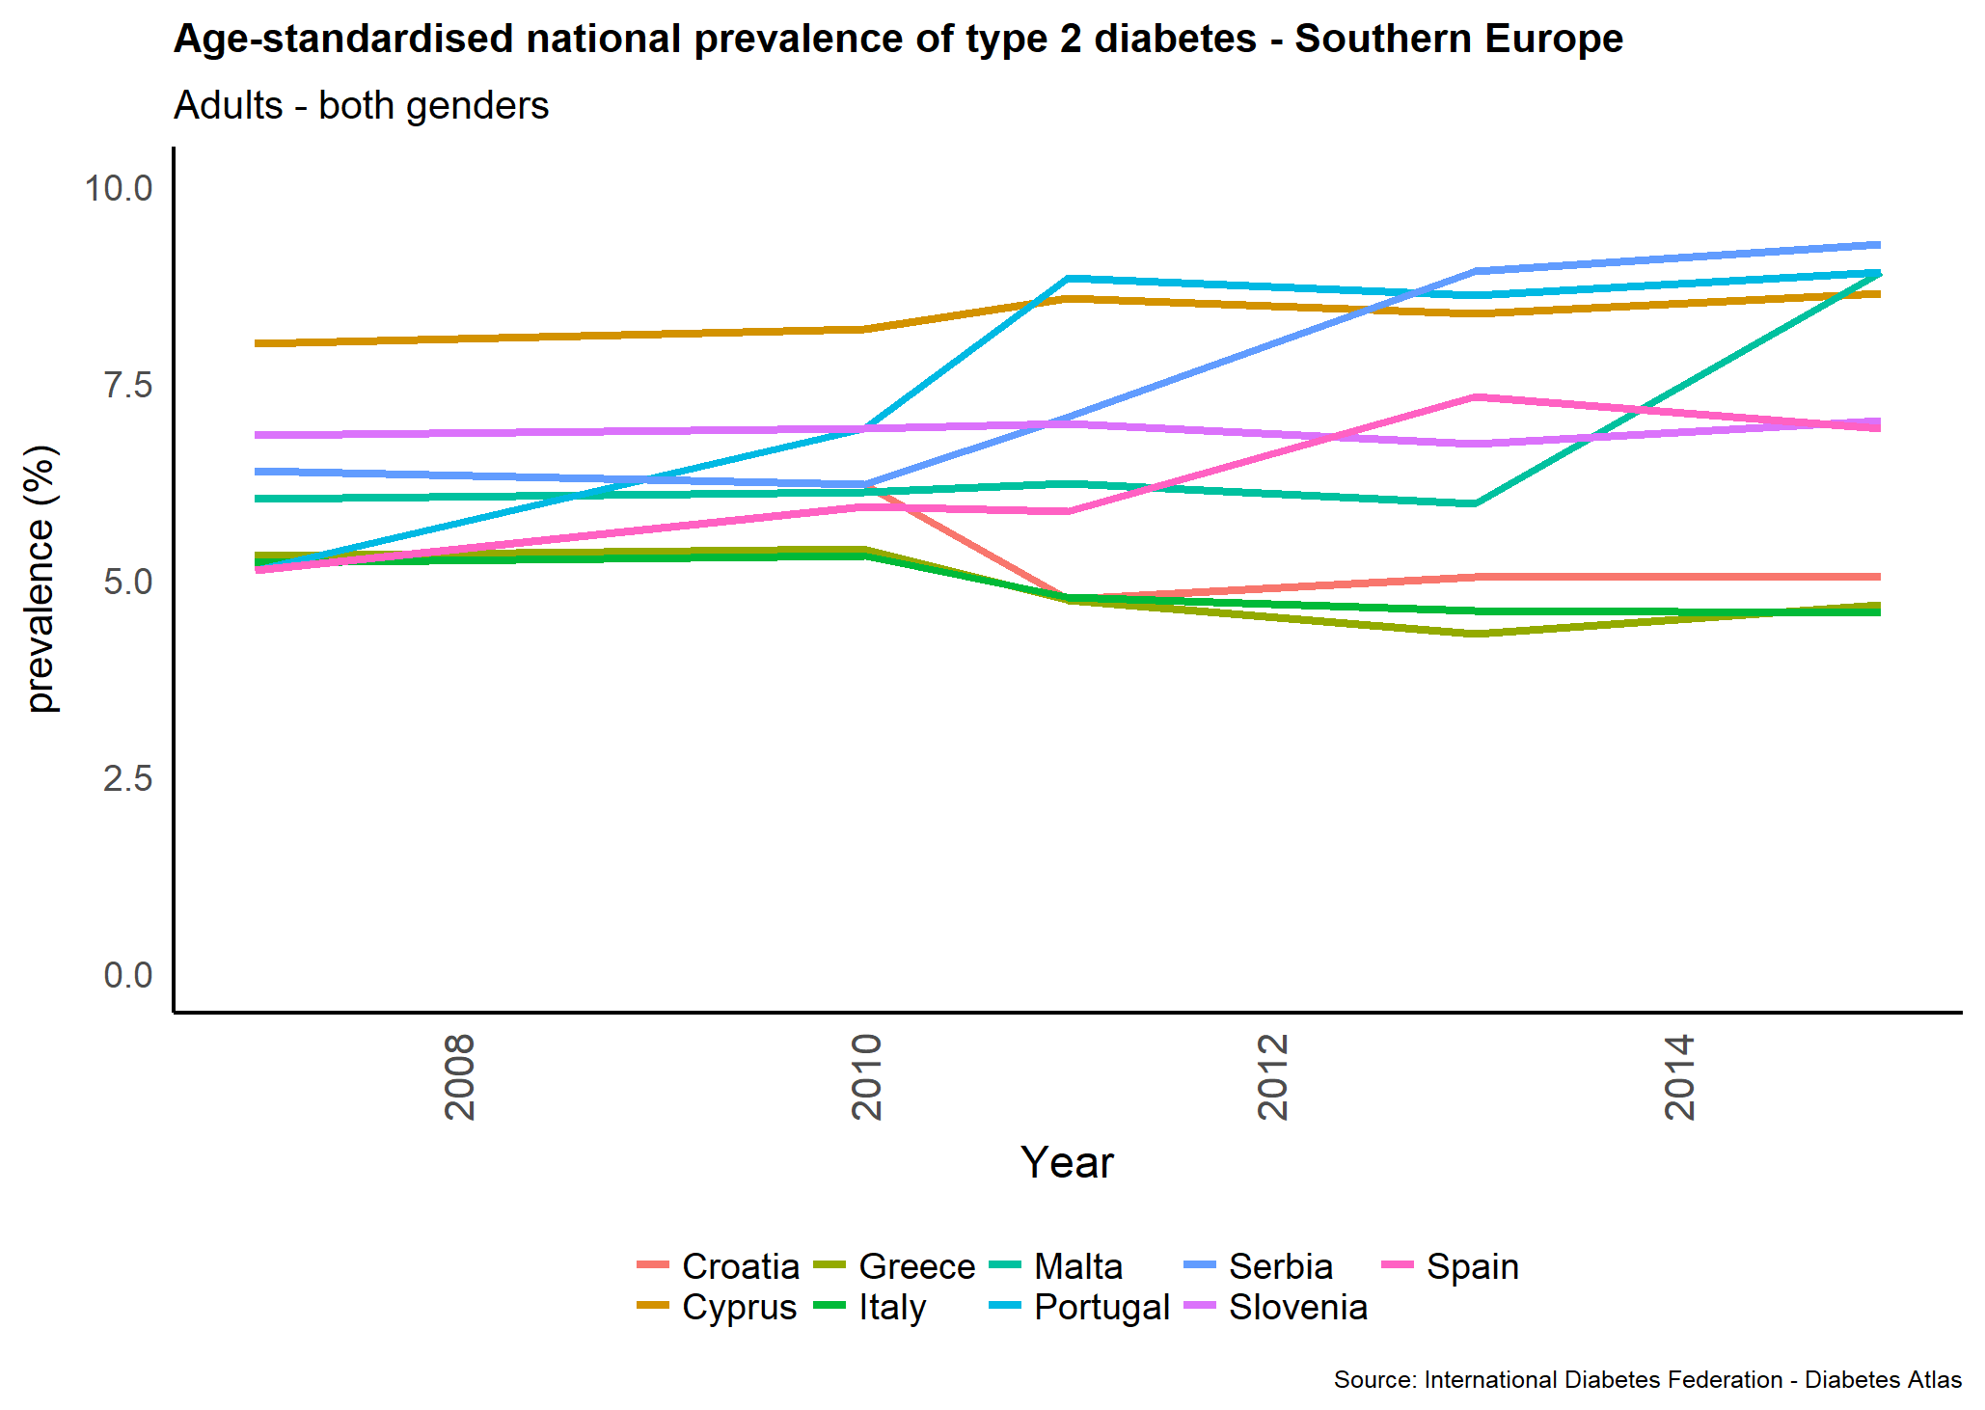c) | 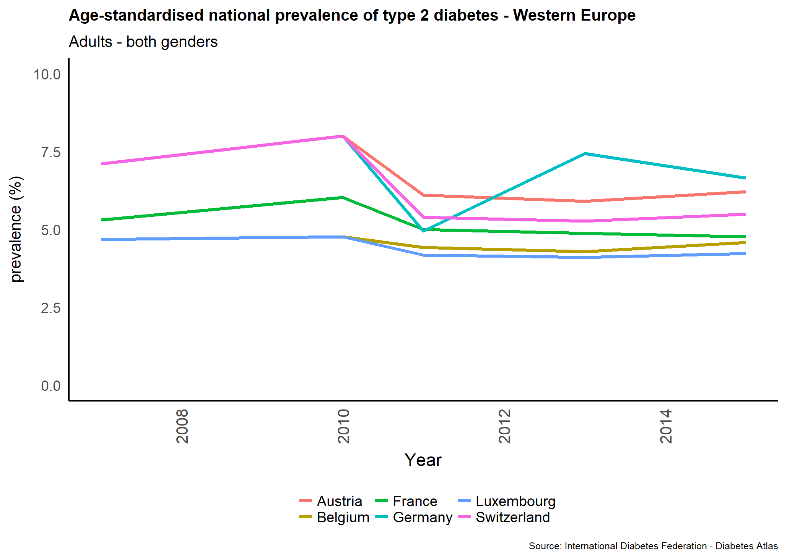d)
Figure 8. Age-standardised prevalence of type 2 diabetes in adults aged 20-79 years over time by region a) Northern b) Eastern, c) Southern, d) Western Europe Note: Estimation methodology was revised in 2011(13)

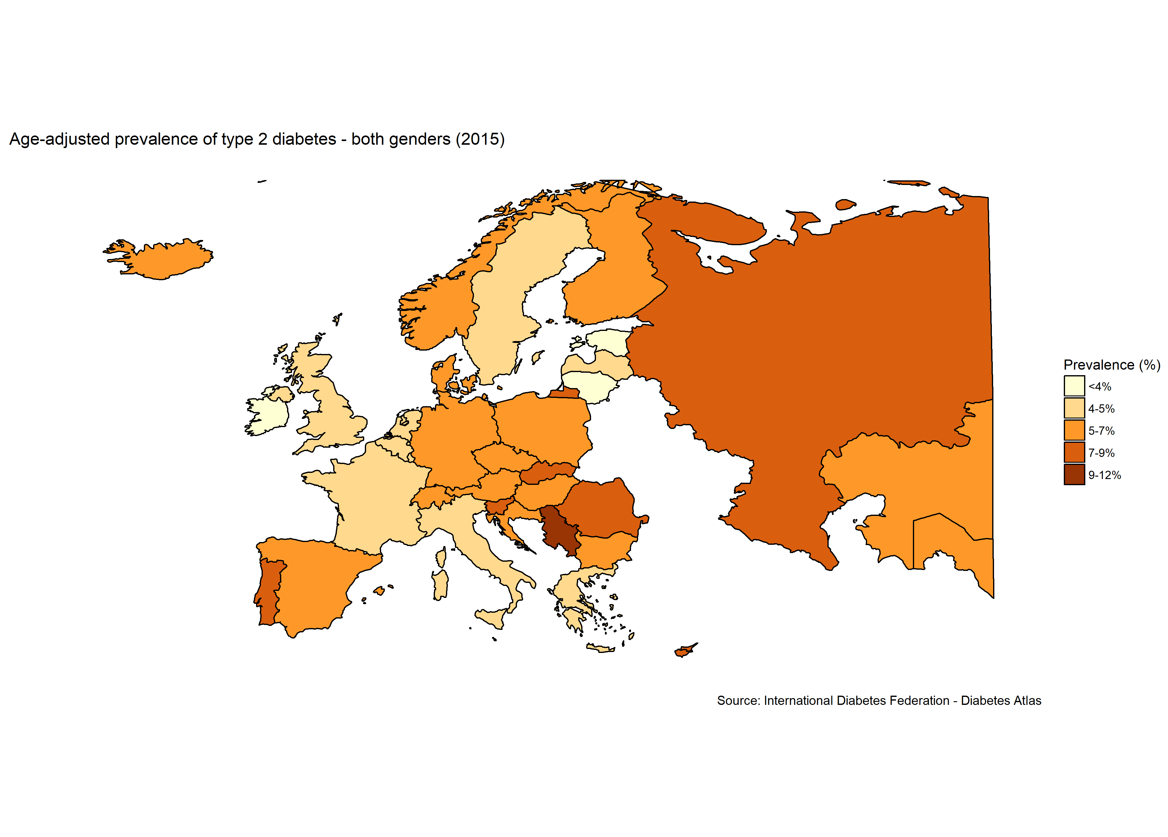
Figure 9. Map of the age-adjusted prevalence of type 2 diabetes in adults, both genders (2015)(13)

