Near-Ideal Xylene Selectivity in Adaptive Molecular Pillar[n]arene Crystals
Kecheng Jie,†⊥ Ming Liu,‡⊥ Yujuan Zhou,† Marc A. Little,‡ Angeles Pulido,§ Samantha Y. Chong,‡ Andrew Stephenson,‡ Ashlea R. Hughes,∥ Fumiyasu Sakakibara,¶ Tomoki Ogoshi,^{¶,ǂ,#} Frédéric Blanc,∥ Graeme M. Day,*§ Feihe Huang*† and Andrew I. Cooper*‡
† State Key Laboratory of Chemical Engineering, Center for Chemistry of High-Performance & Novel Materials, Department of Chemistry, Zhejiang University, Hangzhou 310027, P. R. China; E-mail: fhuang@zju.edu.cn
‡ Materials Innovation Factory and Department of Chemistry, University of Liverpool, 51 Oxford Street, Liverpool, L7 3NY, United Kingdom; E-mail: aicooper@liverpool.ac.uk
§ Computational Systems Chemistry, School of Chemistry, University of Southampton, United Kingdom; E-mail: G.M.Day@soton.ac.uk
∥ Department of Chemistry and Stephenson Institute for Renewable Energy, University of Liverpool, Crown Street, Liverpool, L69 7ZD, United Kingdom.
¶ Graduate School of Natural Science and Technology, Kanazawa University, Kakuma-machi, Kanazawa, 920-1192, Japan.
^{ǂ} WPI Nano Life Science Institute, Kanazawa University, Kakuma-machi, Kanazawa, 920-1192, Japan.
# JST, PRESTO, 4-1-8 Honcho, Kawaguchi, Saitama, 332-0012, Japan.

ABSTRACT: The energy-efficient separation of alkylaromatic compounds is a major industrial sustainability challenge. The use of selectively porous extended frameworks, such as zeolites or metal–organic frameworks, is one solution to this problem. Here, we studied a flexible molecular material, perethylated pillar[n]arene crystals (n = 5, 6), which can be used to separate C8 alkylaromatic compounds. Pillar[6]arene is shown to separate para-xylene from its structural isomers, meta-xylene and ortho-xylene, with 90% specificity in the solid state. Selectivity is an intrinsic property of the pillar[6]arene host, with the flexible pillar[6]arene cavities adapting during adsorption thus enabling preferential adsorption of para-xylene in the solid state. The flexibility of pillar[6]arene as a solid sorbent is rationalized using molecular conformer searches and crystal structure prediction (CSP) combined with comprehensive characterization by X-ray diffraction and ¹³C solid state NMR spectroscopy. The CSP study, which takes into account the structural variability of pillar[6]arene, breaks new ground in its own right and showcases the feasibility of applying CSP methods to understand and ultimately to predict the behaviour of soft, adaptive molecular crystals.

1. INTRODUCTION
With the expanding global demand for petrochemical feedstocks, the development of new materials that reduce the environmental impact of chemical processing is important. Improving the efficiency of the separation and refining of aromatic hydrocarbons is of particular importance, given the large volumes of these compounds that are used as starting materials in the chemical industry.¹ One of the most challenging separations is that of xylene isomers (ortho, meta, and para, hereafter referred to as oX, mX and pX), which was classified by Sholl as one of the “seven chemical separations to change the world”.² These xylene isomers are obtained from crude oil by catalytic reforming, by toluene disproportionation, and by the distillation of pyrolysis gasoline.³ They act as antiknocking additives in gasoline and they also are important chemical feedstocks for phthalic anhydrides and phthalonitriles. pX is the most important isomer: it is primarily used as a feedstock with purity requirement of >99%, for terephthalic acid and dimethyl terephthalate production; these compounds are then used to prepare polyester fibers and polyethylene terephthalate (PET) resins for beverage bottles.⁴⁻⁸ The energy-efficient separation of pX from oX and mX with high purity is therefore important in large-scale plastics production.
pX, oX and mX have similar boiling points (Table S1, Supporting Information) but the difference in their freezing points allows separation by fractional crystallization. pX has the highest melting point because pX molecules can stack more efficiently; pure pX crystals are hence the first to crystallize from the solution. However, the energy requirement for fractional crystallization is high because of the need to cool large quantities of material to about –53 °C.⁹ Selective adsorption of xylene isomers in the pores of ordered crystalline microporous materials is an energy-efficient alternative to fractional crystallization.¹⁰⁻¹⁶ However, identifying a suitable porous material for xylene separation is challenging due to similar molecular sizes of the three isomers. Moreover, most potential candidate crystalline porous frameworks are built using reversible chemistry and they are not stable enough for industrial application: the loss of porosity is typically irreversible and catastrophic for this separation.
Pillar[n]arenes (n = 5−15) have emerged as a novel class of supramolecular hosts since they were first reported in 2008.¹⁷⁻⁴⁰ Their host−guest properties have been investigated using a diverse range of guest molecules, including hydrocarbons.^{32-34,40} For example, we reported the host−guest chemistry between alkyl chains and pillar[5]arenes due to CH/π interactions.^{32,33} Yang et al. reported a biphenyl-extended pillar[n]arene for an efficient selective inclusion of toluene and mX.³⁴ With these unique features, we and other groups found that pillararene crystals can be used for gas storage and hydrocarbon separations.³⁷⁻⁴⁰ For example, we recently reported that a perethylated pillar[6]arene can act as a separation material to purify styrene from a mixture of styrene and ethylbenzene.³⁹ That separation was based on a solid-state recrystallization process, rather than an adsorptive separation that uses a material with permanent, pre-existing pores. Styrene molecules were selectively adsorbed in extrinsic voids in the crystal structure: that is, the host−guest properties of the pillar[n]arene cavity were not directly exploited.
We show here that the intrinsic cavity of pillar[n]arenes can be utilized in molecular separations of important C8 hydrocarbon feedstocks. The shape selectivity of two perethylated pillar[n]arenes with different cavity sizes were investigated (where n = 5 or 6, referred to hereafter as EtP5 and EtP6). We found that EtP6 adsorbs pX selectively from a mixture of xylene isomers, both in solution and in the solid state. Selective adsorption of pX is an intrinsic feature of the EtP6 host with the flexible EtP6 cavities adapting during adsorption, thus enabling preferential adsorption of pX in the crystalline state, unlike our previous styrene study.³⁹ The flexibility of EtP6 can be rationalized computationally by exploring the conformational energy landscape, and this explains the flexibility that we observe by crystallography and solid-state NMR. The observed combination of absorptive separation and guest-induced restructuring is similar to flexible MOFs^{10, 41} but reported here for an adaptive molecular crystal. We exploited this selectivity to develop an adsorption/desorption process where pX could be separated from a 1:1:1 mixture of the three xylene isomers with a purity of 99.1%.
2. RESULTS AND DISCUSSION
Structural analysis of EtP5 with xylene isomers in solution and the solid state. First, the host−guest chemistry of EtP5 with pX, mX, or oX was investigated. These three xylene isomers have different dimensions, and the size of these approach the size of the EtP5 cavity (Figure S1). In the 1:1 host−guest crystal structure of pX@EtP5, the pX guest is only partially accommodated in the EtP5 cavity with the aromatic pillars of EtP5 adopting a bowl shape to accommodate the pX guest (Figure 1b). In the crystal structure of mX@EtP5, we found ordered mX guest molecules with one of the methyl groups pointing towards the center of the EtP5 cavity, while the second, meta substituted, methyl group does not fit in the EtP5 cavity (Figure 1d). When EtP5 was crystallized from oX, no oX was found in the structure. Instead, the structure is guest free and referred hereafter as, EtP5α (Figure 1c). During this study, we activated EtP5 material by desolvating a THF solvate. The experimental powder X-ray diffraction (PXRD) pattern of activated EtP5 material matches the simulated PXRD pattern of EtP5α (Figure 1f). Hence, EtP5α is the structure of the activated material.

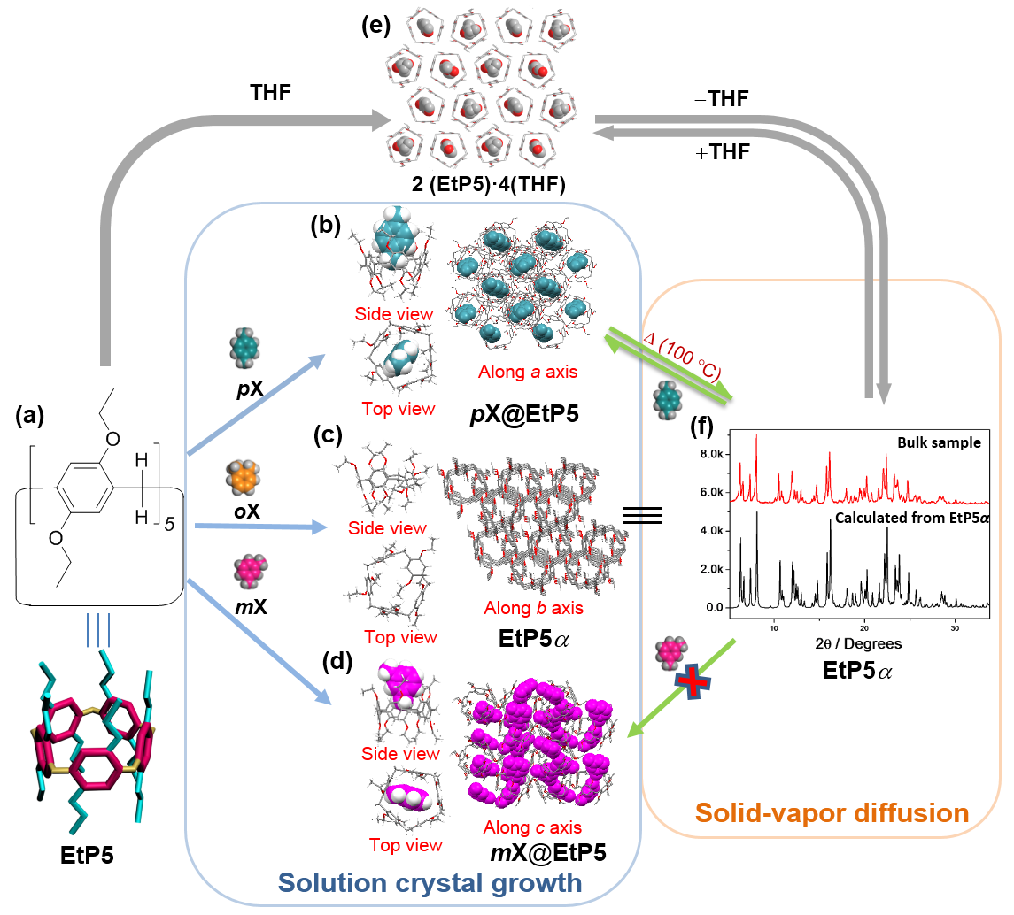

Figure 1. Scheme summarizing the interconversion of the various pillar[5]arene–xylene host−guest crystal structures in solution and the solid state. (a) Chemical structure of perethylated pillar[5]arene (EtP5). Single crystal structure: (b) pX@EtP5, (c) guest free EtP5α, obtained after crystallisation of EtP5 from an oX solution, (d) mX@EtP5, and (e) 2(EtP5)·4(THF). (f) On activation, the EtP5 solvate structures (THF, pX, or mX) transfrom to the guest free, thermally stable phase, EtP5α, as confirmed by powder X-ray diffraction pattern. Bottom: PXRD patterns of EtP5α simulated from desolvated single crystal structure of EtP5α, obtained by slow evaporation of oX from an oX-EtP5 solution; Top: recrystallized from THF and desolvated at 60 °C under dynamic vacuum.

Structural analysis of EtP6 with xylene isomers in solution and the solid state. After determining the solid-state host−guest chemistry of EtP5 and the xylene isomers, we next investigated EtP6. The cavity size of EtP6 is larger; hence, it is more likely that the three xylene isomers can fit within the EtP6 cavity. Single crystal structures of EtP6 with oX, mX, and pX were all obtained. In the 1:1 host−guest crystal structure of pX@EtP6, one pX molecule is located almost perfectly in the center of the EtP6 cavity (Figure 2b). This host−guest complex is stabilized by offset π-π stacking interactions between pX and two aromatic rings of EtP6 (Figure 2b). The hexagonal pillar structure of EtP6 contributes to the formation of infinite 1D channels running through the aligned macrocycles that are filled with ordered pX guests (Figure 2b). The 2:1 solvated crystal structure of EtP6 with

mX, 2(mX)@EtP6, is markedly different. Two opposite aromatic pillars of EtP6 are turned perpendicular with respect to their neighboring pillars (Figure 2d). Hence, in 2(mX)@EtP6, EtP6 has a deformed cavity that is too small to fully accommodate a mX guest (Figure 2d). When crystallized from oX, EtP6 formed a 1:1 host−guest complex, oX@EtP6 (Figure 2c), where the oX molecules are disordered within the EtP6 cavity with the ortho-substituted methyl groups located in the center of the cavity. The hexagonal structure of EtP6 forms infinite intrinsic 1D channels that are full of oX guests, broadly comparable with pX@EtP6, but again, the EtP6 adopts a different conformation. In pX@EtP6, the EtP6 pillars are angled to maximize π-π stacking interactions with the pX guest. By contrast, in oX@EtP6 the pillars are all aligned and the oX guest is disordered.

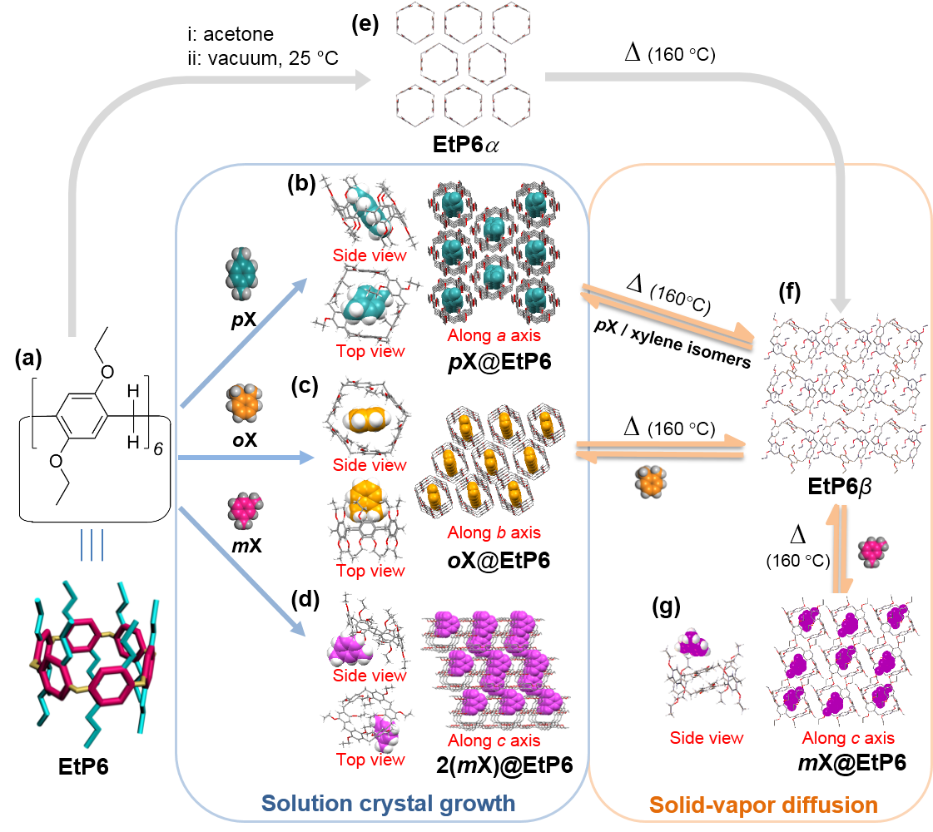
Figure 2. Scheme summarizing the interconversion of the various pillar[6]arene–xylene host−guest crystal structures in solution and the solid state. (a) Chemical structure of perethylated pillar[6]arene (EtP6). Single crystal structures: (b) pX@EtP6, (c) 2(mX)@EtP6 and (d) oX@EtP6. (e) The metastable, EtP6α, which has a 1D pore structure, is obtained by carefully activating the acetone solvate.³² (f) By thermally desolvating EtP6 structures at 160 °C (acetone, pX, oX or mX), a stable phase, referred to as EtP6β, is obtained. (g) When EtP6β is exposed to mX vapor, a new structure, mX@EtP6, is found.

Due to the apparently favorable host−guest interactions (Figure 2b), we speculated that EtP6 might crystallize preferentially with pX in the presence of oX and mX. Indeed, when EtP6 was crystallized from a 1:1:1 (v:v:v) mixture of the three xylene isomers, we only obtained single crystals of pX@EtP6, showing that EtP6 selectively captures pX in its cavity from solution.
These single crystal structure studies suggested that EtP6, with its hexagonal shape and larger cavity than EtP5, might be more efficient for the dynamic separation of pX from oX and mX. To test this, samples of EtP5 and EtP6 were activated and crystallized from tetrahydrofuran and acetone, respectively. We also followed the activation of EtP6 by both single crystal X-ray diffraction (SC-XRD) and PXRD. For EtP6, careful removal of acetone from the EtP6 solvate at room temperature afforded EtP6α, which has been characterized before by PXRD.³⁹ Here, we found that thermal activation of the EtP6 solvate at temperatures of ≥ 140 °C, resulted in the formation of a new phase, EtP6β (Figure 2f, S7−S10). The single crystal structure of EtP6β contains a new EtP6 conformer where the aromatic pillars are no longer aligned, and this rearrangement results in a loss of the EtP6 cavity (Figure S10).
A similar phase transition process was also observed during the desolvation of pX@EtP6. As shown in Figure 3a, peaks related to a new phase started to appear upon heating to around 140 °C in the in situ desolvation PXRD experiment, and the phase transformation was completed at 160 °C. After cooling this sample to 20 °C, the structure of the bulk materials was determined to be EtP6β, which was found to be stable at ambient temperature. This process was studied by thermogravimetric analysis (TGA) and differential scanning calorimetry (DSC), as shown in Figure 3b. In the DSC curve of pX@EtP6, a broad peak between 146 °C and 157 °C represents the loss of one pX molecule from the host−guest complex, in line with the weight loss observed by TGA, followed by a phase transformation. Comparison of the TGA and DSC traces (Figure 3b) suggests that this phase transition occurs when essentially all of the pX guests have been removed.
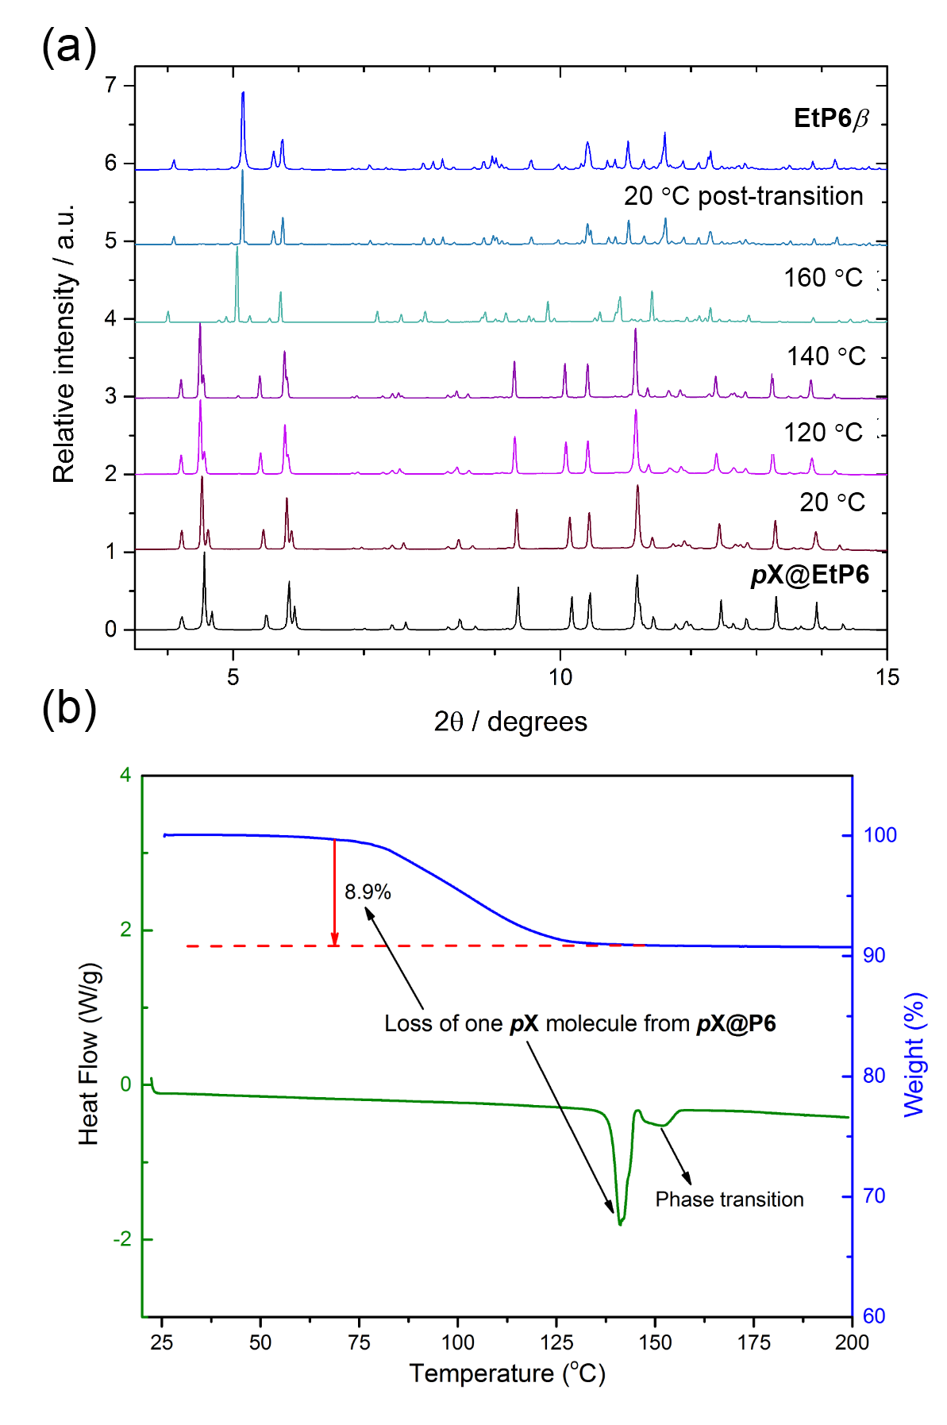
Figure 3. (a) In situ variable temperature PXRD patterns for pX@EtP6 showing thermal transformation at 160 °C. (b) Thermogravimetric analysis (TGA) (blue) and differential scanning calorimetry (DSC) (green) studies of pX@EtP6. The difference in pX desolvation temperature between TGA and DSC experiments is a result of the different heating conditions (open pan under N₂ flow for TGA, and sealed pan for DSC).

The ¹³C cross polarization (CP) magic angle spinning (MAS) NMR spectra of the three guest free pillararenes (EtP5α, EtP6α and EtP6β) are shown in Figure 4 and provide structural information regarding the asymmetric unit. EtP6β shows a range of narrow and well resolved resonances that could be assembled into the six different chemical sub-groups for EtP6, corresponding to the chemically-distinct carbons environments; for example, the quaternary carbon atoms bonded to oxygens in OC^{IV} appear in the 149–155 ppm region. The assignment given is based on ¹³C-editing NMR experiments and known ¹³C chemical shift values from the literature.⁴² With remarkable sharp lines acquired at natural abundance, the carbon connectivities obtained from the two-dimensional ¹³C-¹³C through-bond INADEQUATE⁴³⁻⁴⁵ correlation spectrum (Figure S11a) further confirmed the assignment.

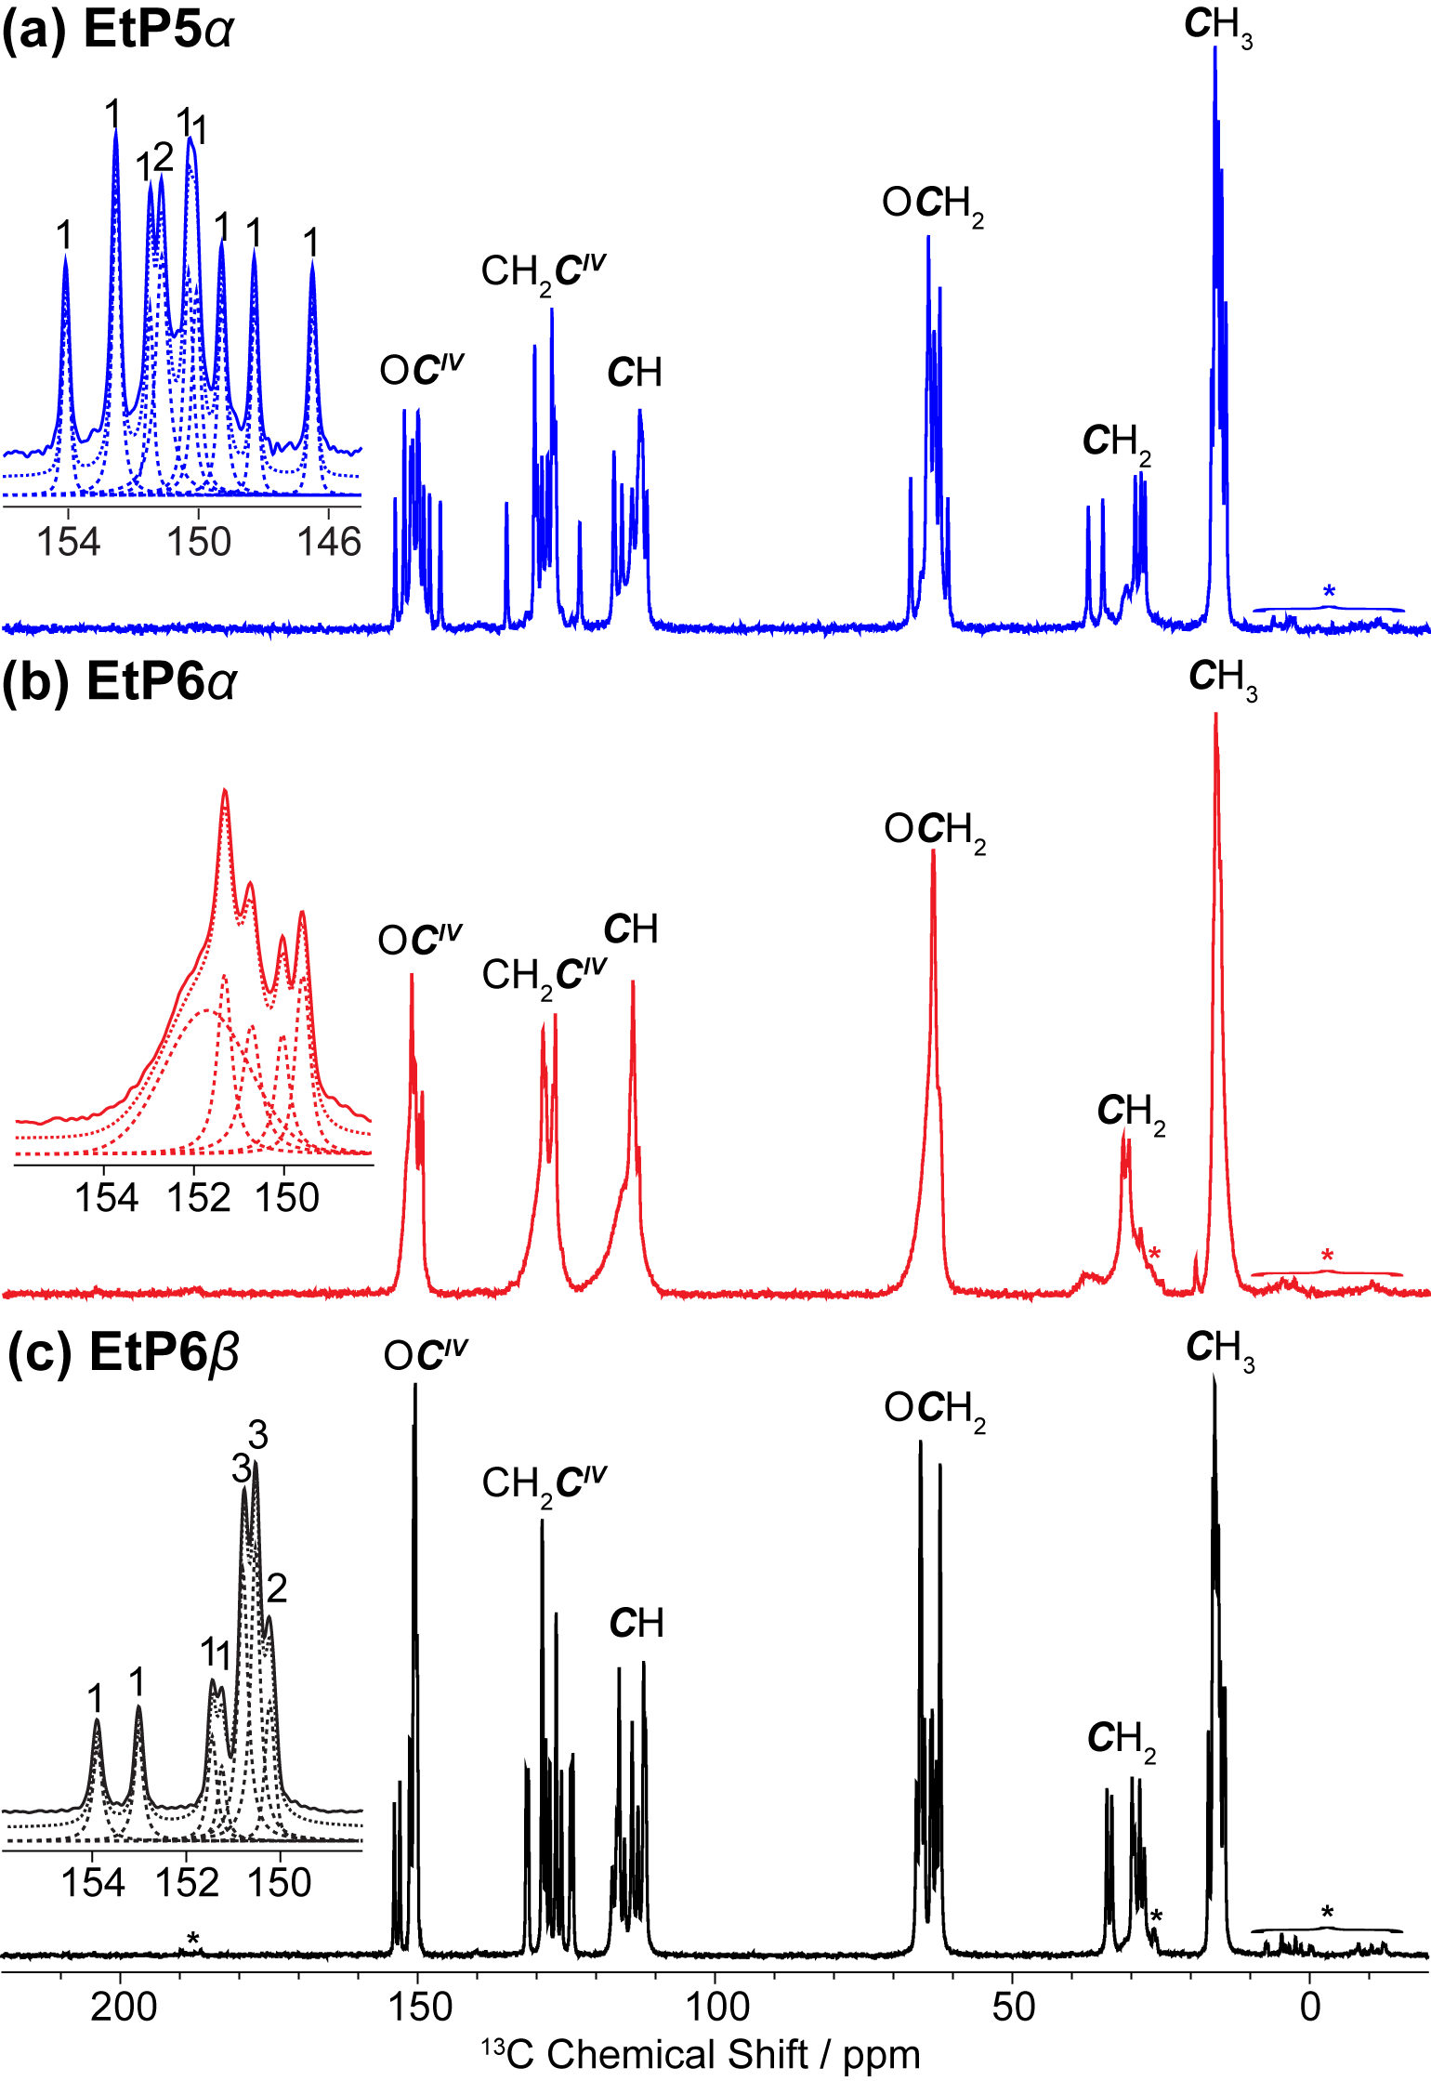
Figure 4. ¹³C CP MAS NMR spectra of (a) EtP5α, (b) EtP6α and (c) EtP6β. Asterisks (*) denote spinning sidebands. The expansion shows the experimental spectrum (full line), total fit (dotted line) and spectral deconvolution (dashed lines) of the OC^{IV} carbons – all other fits are given in the SI (Figures S12-S14).

The insert in Figure 4c (and the full spectral deconvolution in Figure S14) shows that each environment consists of multiple ¹³C peaks whose integrations (see Experimental Section) match well with the expected number of non-equivalent carbon atoms in the asymmetric units, as determined by X-ray diffraction (Figure 2f). For example, seven OC^{IV} resonances are resolved integrating 1:1:1:1:3:3:2 (from high to low frequency) and matching the expected twelve OC^{IV} carbons in EtP6β. Calculations of the ¹³C chemical shifts of EtP6β was also carried out, and the calculated chemical shifts were compared with the experimental chemical shifts (as shown in Figure S11b). The comparison shows to be in excellent agreement, further validating the spectral assignments. It also provides proof of the good match between the experimentally obtained crystal structures and the calculated conformers (see crystal structure prediction section below).
Similarly, the highly resolved ¹³C CP MAS NMR spectrum of EtP5α allows each carbon environment to be observed and quantified; there is a good agreement between the deconvoluted spectra and the expected number of non-equivalent carbon atoms in EtP5α (e.g. ten OC^{IV} carbons, Figure 4a and S12). However, by comparison, the resolution of the EtP6α spectrum is much poorer with broader peaks observed (Figure 4b and S13). This indicates that unlike EtP6β and EtP5α, EtP6α is not phase pure which we attribute to the existence of multiple EtP6 conformers in the metastable EtP6α activated material and highlights the importance of correlating X-ray diffraction studies with solid state NMR measurements.
Xylene vapor-phase adsorption studies. Time-dependent solid–vapor sorption experiments for single-component xylene isomers were carried out for crystalline EtP5α and EtP6β. It was found that EtP5α adsorbed almost the same amount of pX as EtP6β, but a lower amount of mX and oX (Figure S16a). While EtP6β adsorbed similar amounts of each of the three isomers at equilibrium, the uptake of pX was much faster than for oX and mX, at least in non-competitive, single-component experiments (Figure 5a). We also carried out PXRD studies to monitor the adsorption of the single xylene isomers by EtP5α (Figure S16b) and EtP6β (Figure 5b). PXRD data indicated that EtP5α transformed into pX@EtP5 after adsorption of pX (Figure 1f→1b, and S17). EtP5α showed no structural transformation after exposure to oX or mX, suggesting that neither molecule was adsorbed in the bulk by EtP5α. It is possible that crystal surface adsorption accounts for the relatively small uptake of these two isomers (8–10 times lower than pX; Figures S16a). PXRD data indicate that EtP6β, unlike EtP5α, transforms in the solid state after adsorption of oX, mX, and pX (Figure 2 and 5b). After adsorption of pX and oX, the PXRD patterns match the simulated PXRD patterns derived from the single crystal structures of pX@EtP6 (Figure 2f→2b, S18), and oX@EtP6 (Figure 2f→2c, S19), respectively. The PXRD pattern of EtP6β after adsorption of mX (Figure 5b, PXRD pattern IV) showed that the structure was neither EtP6β nor 2(mX)@EtP6 (Figure 5b, PXRD patterns I and V, respectively); rather, EtP6β tranformed to a new phase, that was determined by single crystal X-ray diffraction to be mX@EtP6 (Figure 2f→2g, S20).
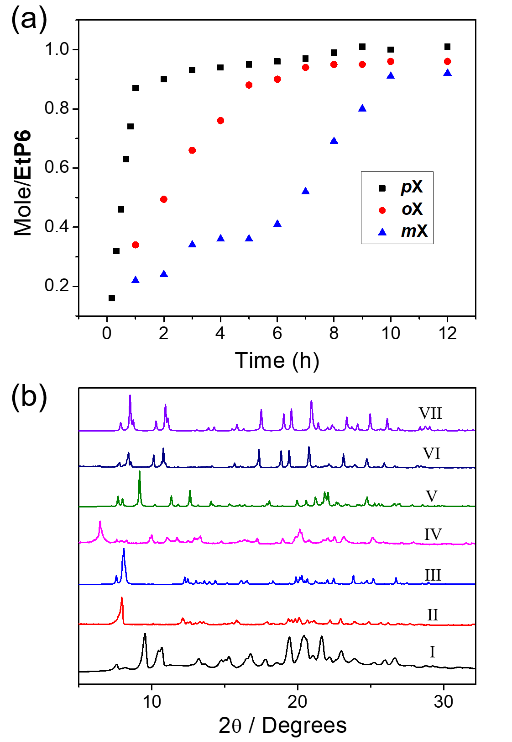
Figure 5. (a) Time-dependent EtP6β solid–vapor sorption plot for single-component xylene isomer vapor. (b) PXRD patterns: (I) EtP6β; (II) EtP6β after uptake of oX vapor; (III) simulated from single crystal structure of oX@EtP6; (IV) EtP6β after uptake of mX vapor; (V) simulated from single crystal structure of 2(mX)@EtP6; (VI) EtP6β after uptake of pX vapor; (VII) simulated from single crystal structure of pX@EtP6.
EtP6 can adsorb all three xylene isomers because of its conformational flexibility, which provides a flexible cavity and adaptability in the crystal packing. To determine if EtP5α or EtP6β can discriminate between a mixture of xylene isomers, we carried out time-dependent solid–vapor sorption experiments using a 1:1:1 volumetric ratio of oX : mX : pX. We found that the uptake of xylene isomers by EtP5α was almost negligible under these conditions (Figure S23). The PXRD pattern of activated EtP5α did not transform after exposure to the xylene isomer mixture for 10 hours (Figure S25). It can be concluded that the mixture of xylene isomers was not adsorbed in the bulk by EtP5α. Instead, we ascribe the small, sub-stoichiometric uptake of xylene isomers by EtP5α to be surface adsorption on the crystals. It is noteworthy that EtP5α adsorbed neat pX, while pX was not adsorbed from the xylene isomers mixture. The uptake of xylene by EtP6β was far greater. In fact, EtP6β adsorbed ten times more pX than oX and mX, before reaching its saturation point, and the oX and mX uptake remained extremely low during the whole experiment (Figure 6a). The PXRD pattern of EtP6β after exposure to this mixture of isomers matched the simulated PXRD pattern for pX@EtP6 (Figure 6b). These results show that EtP6β can selectively capture pX from a mixture of isomers as a crystalline solid via the transformation of EtP6β into pX@EtP6 (Figure 2f→2b). We also used gas chromatography, which showed that the uptake of pX by EtP6β was ~ 90% after 12 hours, while uptake of oX and mX account for the other 10% (Figure 6a and S28). We ascribe the low uptake of oX and mX to crystal surface adsorption. These solid-state adsorption experiments confirmed that EtP6 can selectively capture pX in the solid state as well as from solution. The pX selectively of EtP6 is comparable to the best-performing MOFs/zolites used for this application (Table S8).
We found that the purity of the pX could be further increased by adopting a surface removal procedure after adsorption of a mixed xylene vapor in EtP6β. After adsorption of the vapor mixture, the EtP6 solids were heated at 40 °C for 30 minutes to remove any unbound xylene isomer molecules physisorbed on the crystal surface (Figure S29). pX was then released from the selectively-formed pX@EtP6 phase with a purity of 99.1% (Figure 6c and S30). Interestingly, after the pX was completely removed from the pX@EtP6 crystals, the desolvated pX@EtP6 was shown by PXRD experiments to remain as EtP6β (Figure 3a and S31).
A major problem in porous adsorbent technology is decreased performance over time, either because of fouling or instability of the porous framework. To be practically useful, pX should be separated with an extremely high purity and the adsorbent must perform well over many cycles without any degradation. We proved that the EtP6β crystals could still capture pX selectively from a xylene mixture to form pX@EtP6 in a second cycle (Figure 6d and S32); this process could be cycled at least 5 times without any loss of performance in the selective pX capture (Figure 6d). We believe that the adaptibility of these crystals allows them to ‘self-heal’ over multiple use cycles, and pore collapse is not an issue because the materials are not permanently porous. Commercial grade xylene, produced by the methylation of toluene and benzene, usually contains about 40–65% of mX and up to 20% each of oX, pX and ethylbenzene (EB).⁴⁶ When commercial grade xylene (oX: mX: pX: EB = 20: 20: 20: 40, v:v) was tested, EtP6β adsorbed 80.7% pX after one cycle. This selectivity was found lower than that in the 1:1:1 xylene mixture discussed above, which probably mostly arises from EB competing more effectively with pX than either mX or oX (Figure S35).

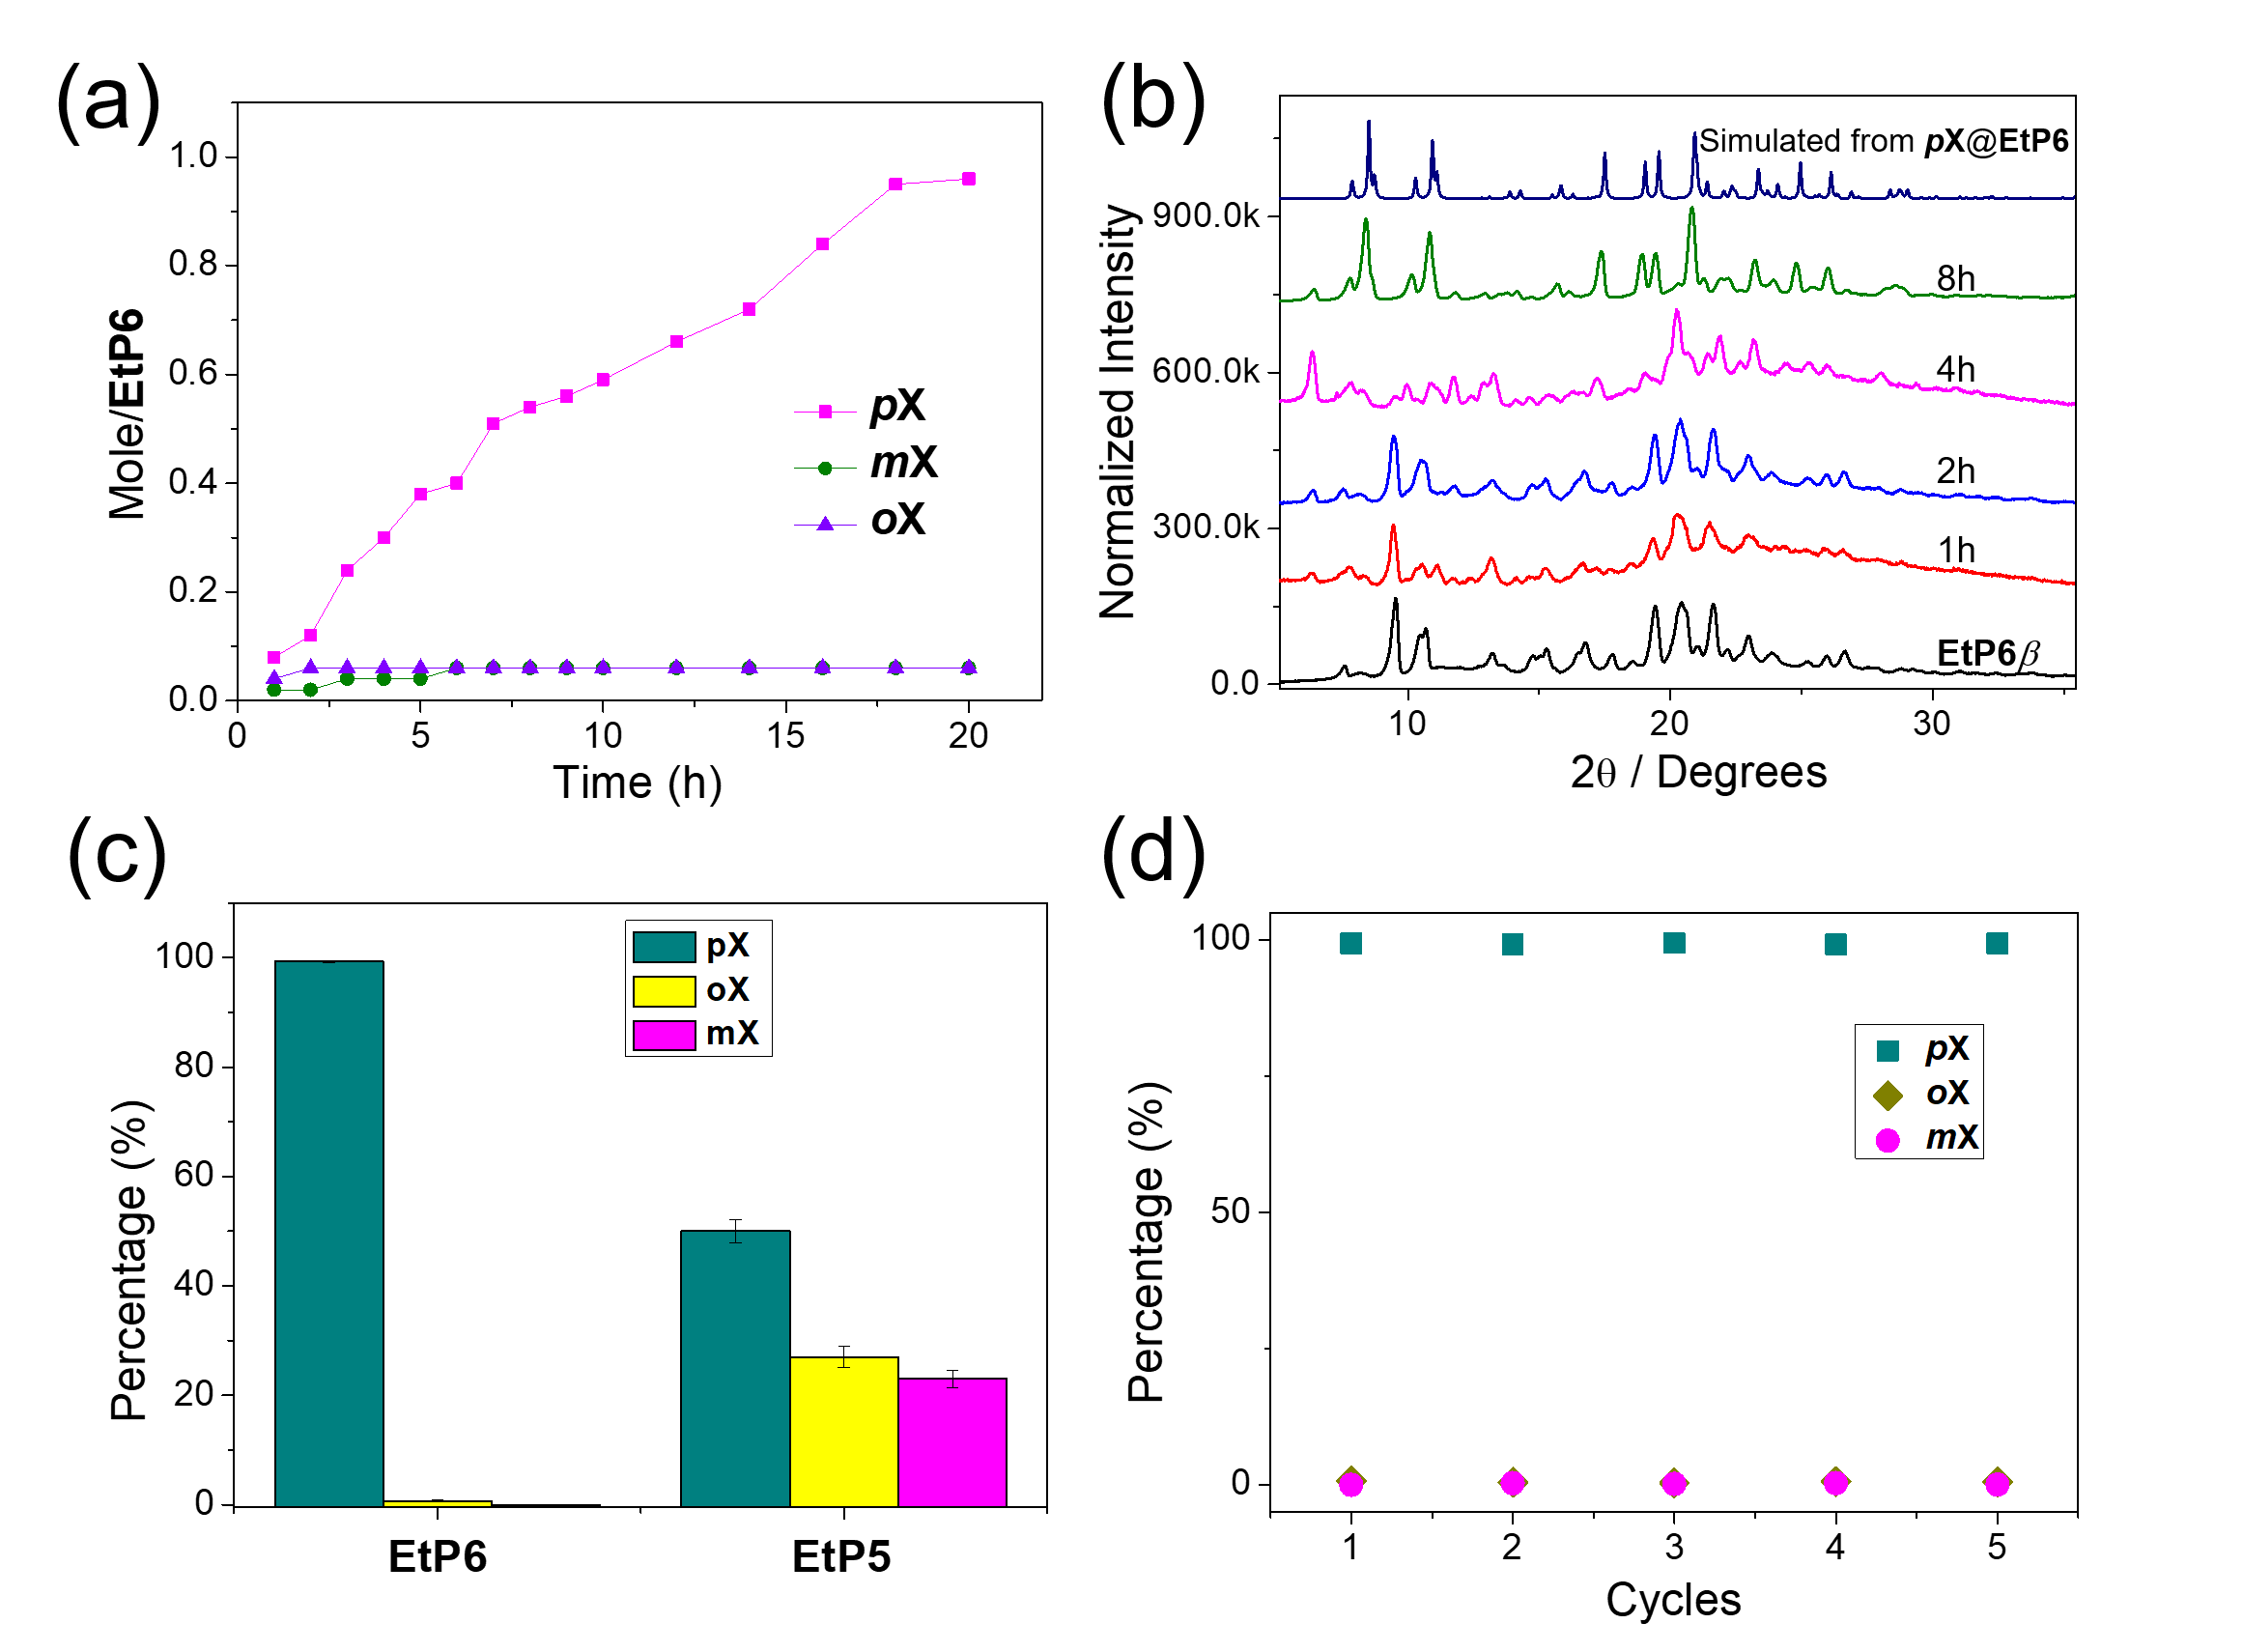
Figure 6. (a) Time-dependent EtP6β solid–vapor sorption plot for 1:1:1 xylene isomers mixture vapor. (b) PXRD patterns of EtP6β after being exposed to xylene isomers (1:1:1, v:v:v). (c) Relative xylene isomer uptake in EtP6 and EtP5 after 12 hours upon surface removal using gas chromatography. (d) Percentage of pX, oX and mX in EtP6 for 12 hours after the same material is recycled 5 times.

Conformation search and crystal structure prediction. Our X-ray diffraction studies suggested that conformational flexibility in EtP6 might be the key to understanding its selective adsorption behaviour. To explore this further, we carried out a computational search of the molecular conformational space, which showed a large number of energetically-accessible conformers (Figure 7a). The lowest energy molecular geometries are characterized by arene and ethyl groups that are folded in to give compact conformers and therefore have a low radius of gyration (Figure 7a). This maximizes stabilizing non-bonded intramolecular contacts. By contrast, all of the observed crystal structures make use of more open conformers that provide fully expanded molecular cavities, as in oX@EtP6, or partially-open cavities, as in pX@EtP6 and mX@EtP6. The calculated gas phase conformers that are geometrically nearest to the conformations in the known phases of EtP6 are indicated in Figure 7a.
To further investigate the energetic relationship between crystal forms, we used crystal structure prediction (CSP) and calculated the possible crystal structures available to each of the conformers found experimentally (Figure 7b, where each point corresponds to a local minimum in the lattice energy surface). All of the observed structures are located on the calculated energy landscapes, as indicated in Figure 7b. This shows that the EtP6 arrangement in each structure corresponds to a local energy minimum, even without including the the xylene guest molecules in the calculations. The EtP6β phase obtained by activation of the xylene solvates is relatively low in energy, but it is not the lowest energy guest-free structure of EtP6 that is possible; several putative crystal structures are calculated to have lattice energies that are lower by up to 30 kJ mol⁻¹, even within this limited set of five molecular conformations. The EtP6α structure, which has the same crystal packing of EtP6 as the oX@EtP6 structure, is one of the lowest energy crystal structures available for the conformation with a fully open molecular cavity and all-parallel arene rings (purple points in Figure 7a). The total lattice energy of this structure is high, but it is likely stabilized in oX@EtP6 through host−guest interactions and entropic stabilization of the disordered oX guest. The conformer corresponding to the pX@EtP6 crystal structure leads to the densest and most stable crystal structures in our computational study (blue points, Figure 7b). However, there is a significant distortion between this gas phase conformer and the experimental conformation found in pX@EtP6; two of the arene rings tilt further into the cavity in the gas phase conformation. Due to this difference in molecular geometries, a close geometric match to pX@EtP6 is not found in the CSP set. The high-energy CSP-generated structure indicated in Figure 7b matches the structure obtained by substituting the experimental EtP6 molecular geometry in pX@EtP6 by the gas phase conformer without pX, followed by lattice energy minimization. To more accurately assess the lattice energy of pX@EtP6, we calculated the lattice energy with the molecular conformation constrained to the in-crystal geometry. The result of this calculation (orange diamond, Figure 7b) shows that the crystal packing of EtP6 in pX@EtP6 is almost equi-energetic to that found in 2(mX)@EtP6. The strong dependence of the energy on the molecular geometry demonstrates that the flexibility of this conformer is important in determining the structure and stability of pX@EtP6. We cannot infer from this that there is no preferential thermodynamic driving force for the formation of pX@EtP6 over 2(mX)@EtP6 because these CSP calculations exclude the guests. However, our kinetic studies for the three individual xylene isomers (Figure 5a) suggest that the preferential formation of pX@EtP6 in the competitive adsorption process might be at least partly kinetic in origin.

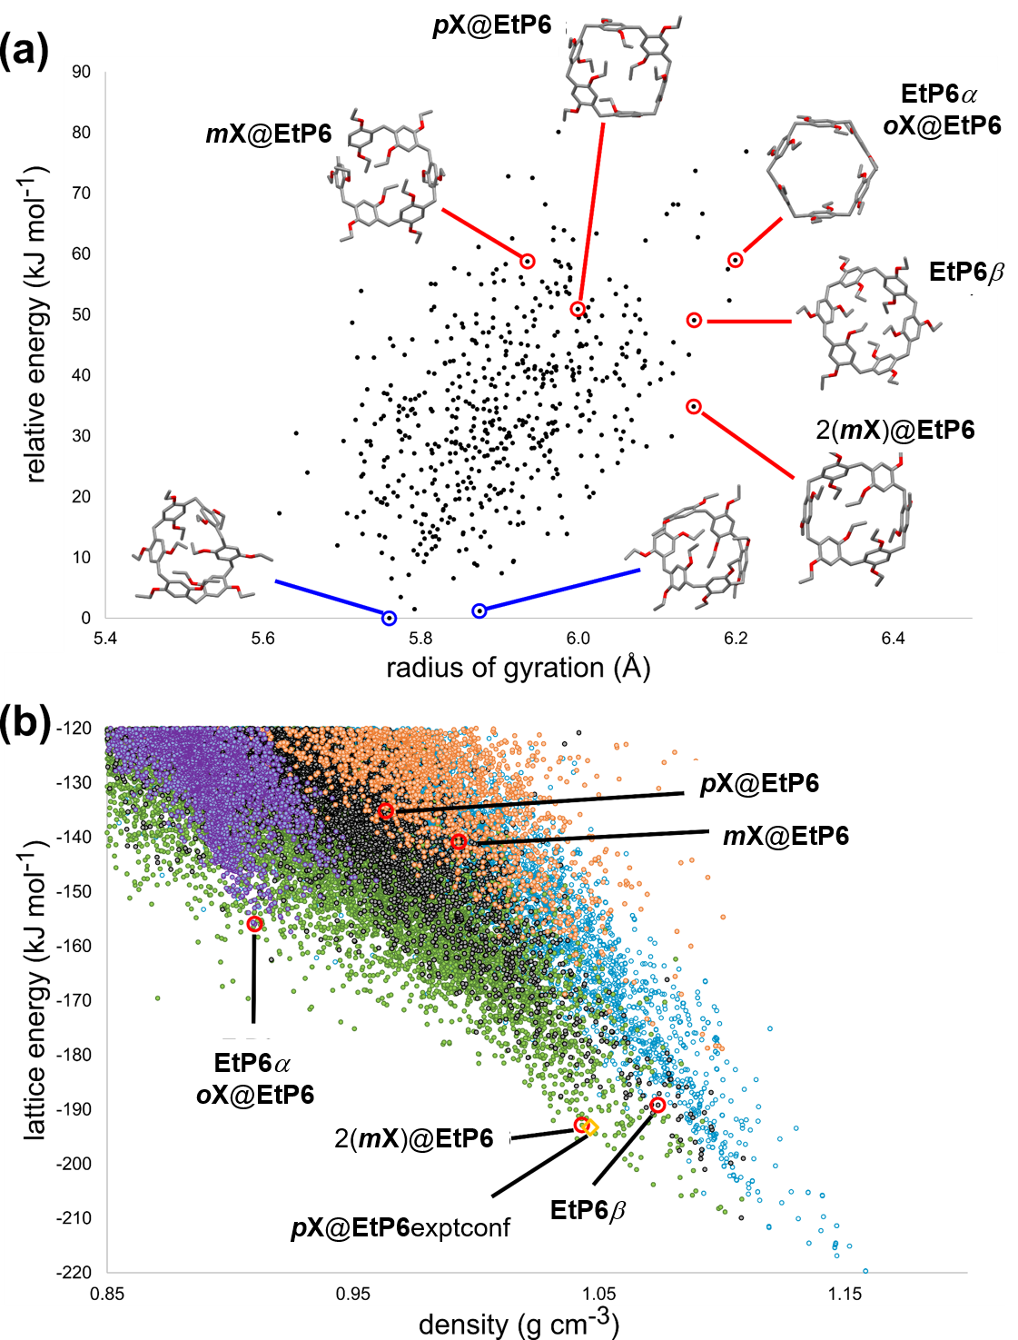
Figure 7. (a) Calculated conformational landscape for EtP6. Each point corresponds to a distinct conformer. Points encircled in red are those with lowest RMSD when compared to the conformations seen in observed crystal structures of EtP6 and are labelled by the crystal form to which they correspond. Diagrams of the two lowest energy predicted, collapsed conformers (circled in blue) are shown. (b) Crystal structure prediction landscapes calculated from five of the observed conformers of EtP6: EtP6β (black points); EtP6α (purple points); mX@EtP6 (orange points); 2(mX)@EtP6 (green points); pX@EtP6 (light blue points). Each point corresponds to a distinct crystal structure (local lattice energy minimum) of pure EtP6 (no guests were included in the calculations) and those corresponding to observed crystal structures are highlighted as red circles. The calculated structure of the artificially desolvated pX@EtP6 with molecular geometry constrained at the in-crystal conformation (pX@EtP6exptconf) is shown as an orange diamond.
Even though both pillararenes undergo rearrangements to closed, cavity-free structures during activation, we have shown experimentally and explained by computation that their conformers are adaptive. Hence, the host molecules can change conformation reversibly in the solid state to enable the selective adsorption of guest molecules. For example, CSP calculations reveal the energetic relationship between the unsolvated EtP6 structures of the two mX solvates (Figure 7): the EtP6 arrangement in the solution-grown 2(mX)@EtP6 is much lower in energy on the landscape of crystal structures. Indeed, the EtP6 packing in mX@EtP6 is calculated to be the highest energy of the experimentally-observed structures, indicating that vapor sorption in crystalline EtP6β leads to a relatively high-energy, kinetically stable structure. mX@EtP6 has a molecular conformation that is very similar to EtP6β, from which it is produced. This may therefore be the best structure that is accessible without a more significant structural rearrangement, which is not possible in the solid state.
CONCLUSIONS
We have investigated the shape selective properties of two easily-obtained pillar[n]arenes, EtP5 and EtP6, towards three xylene isomers. Adaptive EtP6β crystals were found to efficiently capture pX from a xylene isomer mixture with high selectivity. We have used conformer searches and crystal structure prediction methods to understand the flexibility of this molecular crystal. Selectivity is an intrinsic property of the EtP6 host, arising from the suitable size and shape of the EtP6 cavity plus the flexibility of the EtP6 conformer in the solid state. This adaptive behaviour is comparable to certain MOFs, in which the pore structures can adapt in the presence of guest molecules. While the separation of xylene isomers has been achieved in porous extended frameworks, such as zeolites^{47,48} and MOFs,¹⁰⁻¹⁵ this new molecular approach offers potential advantages. For example, EtP6 is soluble, easy to synthesize, and has better chemical stability than many crystalline MOFs and COFs. Also, exposure to xylene transforms the structure of the adaptive material to the desired guest-loaded structure: hence, loss of crystallinity caused from repeat adsorption cycles does not result in a loss in performance, and the separation is almost perfectly repeatable. Although the overall uptake capacity in EtP6β is lower than some porous extended frameworks, and the uptake kinetics are relatively slow, pX can be separated from oX and mX with high purity in just one cycle, which is desirable. Also, it is possible that the adsorption kinetics may become faster at the higher temperatures at which xylenes are typically produced.^{8,46} While EtP5α did not perform well for xylene separation, this molecule may have the potential to separate other hydrocarbons. Hydrocarbon separations using higher members of pillar[n]arenes (n = 7, 8, 9, 10) are also a target for future studies.
EXPERIMENTAL SECTION
Materials. Both EtP5 and EtP6 were synthesized as described previously.²⁸ Activated crystalline EtP5, EtP5α were recrystallized from tetrahydrofuran first and dried under vacuum at 60 °C overnight. Activated crystalline EtP6, EtP6β were obtained by heating up to 160 °C for 1 hour. All xylene isomer mixtures are 1:1:1 (v/v/v).
Single crystal growth. When grown by solvent evaporation, 5 mg portions of dry EtP5 or EtP6 were transfered into small glass sample vials and dissolved in 2 mL of pX, mX, or oX. The resultant homogenous solutions were allowed to slowly evaporate at room temperature over 7 to 10 days to afford colourless crystals. Single crystals of EtP6β, suitable for SC-XRD, were isolated after heating a sample of pX@EtP6 at 160 °C for 1 hour. All other phase transormations were monitored by PXRD.
Xylene vapor adsorption measurements. For each single-component or mixture of xylene isomers vapor-phase experiment, an open 5 mL vial containing 20 mg of guest-free EtP5α or EtP6β adsorbent were placed in a sealed 20 mL vial containing 1 mL of a single component or mixture of xylene isomers. Uptake by EtP5α or EtP6β crystals were measured each hour by completely dissolving the crystals, and measuring the ¹H NMR spectra to determine the ratio of each xylene isomer, with respect to EtP5 or EtP6. In addtion, relative uptake in the EtP5α or EtP6β crystals were measured after 12 hours using gas chromatography using a head-space method.
¹³C solid-state NMR. The ¹³C solid-state NMR spectra were acquired at room temperature on a 9.4 T Bruker Avance III HDNMR spectrometer using a 4 mm HXY triple-resonance MAS probe (in double resonance mode) tuned to ¹H and ¹³C at 400.1 and 100.6 MHz, respectively. The experiments were performed under magic angle spinning (MAS) at 12.5 kHz with a recycle delay of 3.5 s and using cross polarization (CP) with a ¹³C radio-frequency (rf) field amplitude of 41 kHz ramped to obtain maximum signal at a ¹H rf field of approximately 65 kHz and with an optimized contact pulse of 1.5 ms. ¹H pulses and SPINAL-64 heteronuclear decoupling⁴⁹ during ¹³C F₂ acquisition were performed at a rf field amplitude of 96 kHz while the ¹³C pulses in the 2D z-filter refocused INADEQUATE^{43,44} spectrum were performed at a rf field amplitude of 60 kHz. Additionally, the rotor synchronized echo and z-filter delays of the INADEQUATE experiment were experimentally optimized for best efficiency and found to be 3.2 ms and 0.8 ms, respectively. The 1D CP MAS spectrum was obtained with 2048 scans (experimental time 2 hours) while the INADEQUATE spectrum⁴³ was acquired with 78 t₁ increments and the same number of scans (total experimental time 6.5 days). All data were processed with 5 Hz exponential line broadening, unless stated otherwise, and simulated with Topspin. The ¹³C chemical shifts were externally referenced at room temperature to the CH₂ group of adamantane at 29.45 ppm.⁵⁰ Note that although ¹³C CP MAS experiments are not quantitative, only ¹³C integration within a chemically distinct carbon environment is only given as its similar nature allows carbon ratios to be approprietly estimated.
Conformer search. Molecular conformers were generated using a low-mode conformational search (LMCS) method,^{51,52} as implemented in MacroModel.⁵³ In the LMCS algorithm, a starting molecular geometry is initially optimized, subsequently perturbed along a random combination of its calculated normal modes and re-optimised. Newly generated molecular conformers are clustered on the fly. Due to the large number of energy evaluations and minimisations required for an exhaustive search, the initial conformer search was performed using a force field based methodology; we applied the OPLS3⁵⁴ force field, as implemented in Schrödinger.⁵⁵ To ensure conformational search was as complete as possible two sets with a total of 150,000 conformers were generated from two independent searches performed using minimum and maximum move distances of 6 and 12 Å. Conformational searches were started from the crystallographic molecular geometries of 2(mX)@EtP6. Similar conformational space was sampled when the search was started from the unfolded EtP6 conformer of EtP6α. Energy minimization was performed using the PRCG algorithm⁵⁶ and was considered converged when gradients were below 0.05 kJ/mol/Å. Duplicate molecular geometries were removed if all-atom RMS deviation of atomic positions, as implemented in MacroModel, was lower than 1.0 Å; which allows to reduce the vast number of conformers generated without losing completeness of the conformational space.
In our experience, significant inaccuracies in the description of the possible conformers can result from the use of a force field based methodology.⁵⁷ Therefore, a more accurate description was obtained by DFT-D re-optimization of all unique conformers within a 50 kJ/mol window of the OPLS3 global minimum. DFT-D geometry optimization was performed with the Gaussian 09 code⁵⁸ using the B3LYP^{59,60} functional and 6-311G(d,p) basis set, using a tight DFT integration grid. Dispersion energy corrections were included using Grimme's D3 scheme with Becke and Johnson (BJ) damping.^{61,62} The relative energy of a given conformer, at DFT-D level, was defined as the difference between its total gas phase DFT-D energy and the lowest total gas phase DFT-D energy of the molecular conformers. The radius of gyration of each DFT-D optimized conformer was calculated using BIOVIA’s Materials Studio software.
Crystal structure prediction (CSP). Trial crystal structures were generated with one molecule in the asymmetric unit in the 30 most common space groups in which non-polymeric organic molecular crystal structures are reported in the Cambridge Structure Database: P2₁/c; P2₁2₁2₁; P-1; P2₁; Pbca; C2/c; Pna2₁; Cc; Pca2₁; C2; P1; Pbcn; Pc; P2₁2₁2; P4₃2₁2; P4₁; P3₂; Fdd2; Pccn; P2/c; P6₁; I4₁/a; R-3; C222₁; P4₂/n; P3₂21; Aba2; P-32₁c; Iba2 and R3. CSP was performed using a quasi-random sampling procedure, as implemented in the Global Lattice Energy Explorer software.⁶³ The generation of structures involves a low-discrepancy sampling of all structural variables within each space group: unit cell lengths and angles; molecular positions and orientations within the asymmetric unit. Space group symmetry was then applied and a geometric test was performed for overlap between molecules, which was removed by lattice expansion (the SAT-expand method in ref 56). All accepted trial structures were lattice energy minimized and the search was run until a total of 5,000 lattice energy minimizations had been performed in each space group. Crystal structure prediction landscapes were calculated from five EtP6 conformers observed in EtP6α, EtP6β, mX@EtP6, 2(mX)@EtP6, and pX@EtP6 crystal structures. Initial crystallographic molecular geometries were optimized at the aforementioned DFT-D level. Molecular geometries were held rigid during crystal structure generation and lattice energy minimization. Trial structures were minimized following a two-step lattice energy minimization protocol. Structures were initially optimized applying an external pressure of 0.1 GPa, followed by a final lattice energy minimization after removal of the external pressure. Space group symmetry was constrained during both lattice energy minimization steps. Lattice energy minimizations were performed using an anisotropic atom–atom potential using DMACRYS.⁶⁴ Electrostatic interactions were modelled using CHLEPG point charges, as implemented in Gaussian09,⁵⁸ during the first lattice energy minimization and using an atomic multipole description⁶⁵ (up to hexadecapole) of the molecular charge distribution from the B3LYP/6-31G** calculated charge density using a distributed multipole analysis in the second lattice energy minimization. Atom–atom repulsion and dispersion interactions were modelled using the W99 model potential.⁶⁶ Charge–charge, charge–dipole and dipole–dipole interactions were calculated using Ewald summation, while all other intermolecular interactions were summed to a 30 Å cut-off between molecular centres-of-mass. For a given molecule, relative (lattice) energy of a given predicted crystal structure was evaluated as the difference between its calculated lattice energy and lattice energy of the global minima on the energy vs density landscape of that given molecule. Duplicate structures were removed from the set using COMPACK,⁶⁷ based on matching interatomic distances within 30 molecule clusters.
The lattice energy of pX@EtP6 with the molecular geometry constrained at the experimental in-crystal conformation was evaluated by first performing a constrained single molecule geometry optimization with all torsion angles determining the orientation of the arene rings fixed from the X-ray crystal structure. The resulting molecular geometry was substituted into the experimental pX@EtP6 crystal structure (after removal of pX) and a rigid molecule lattice energy minimization was performed. The molecular geometry optimization and lattice energy minimization used identical computational methods (functional, basis set, force field and cutoffs) to those used in the conformer search and CSP.
ASSOCIATED CONTENT
Supporting Information
The Supporting Information is available free of charge via the Internet at http://pubs.acs.org.

Experimental details, crystallography, and other materials, including Figures S1−S35, Table S1−S8 (PDF) and X-ray crystallographic data for EtP5, 2(EtP5)∙3.49(mX), EtP5∙pX, EtP6∙oX, EtP6∙2(mX), EtP6∙pX, EtP6, and EtP6∙mX (CIF).
AUTHOR INFORMATION
Corresponding Author
fhuang@zju.edu.cn
G.M.Day@soton.ac.uk
aicooper@liverpool.ac.uk
Author Contributions
⊥K. J. and M. L. contributed equally.
Notes
The authors declare no competing ﬁnancial interest.
ACKNOWLEDGMENT
This work was supported by the National Natural Science Foundation of China (21434005, 91527301). The authors gratefully acknowledge the Engineering and Physical Sciences Research Council (EP/N004884/1, EP/H000925/1, and Doctoral Training Studentships to A.R.H.), and the European Research Council under the European Union’s Seventh Framework Programme (FP/2007-2013)/ERC through grant agreement numbers 321156 (ERC-AG-PE5-ROBOT) and 307358 (ERC-stG-2012-ANGLE), for funding. We thank Diamond Light Source for access to beamlines I19 (MT15777) and Harriott Nowell for her assistance during this experiment, and I11 (EE12336 and EE17193). We acknowledge the use of the IRIDIS High Performance Computing Facility, and associated support services at the University of Southampton, in the completion of this work. We also acknowledge the ARCHER UK National Supercomputing Service which was accessed via the UK’s HPC Materials Chemistry Consortium membership, which is funded by the EPSRC (EP/L000202).
REFERENCES
- Scheirs, J.; Long, T. E. Industrial Modern Polyesters: chemistry and technology of polyesters and copolyesters, Wiley, Chichester, 2003.
- Sholl, D. S.; Lively, R. P. Nature 2016, 532, 435.
- Flick, E. W. Industrial solvent handbook, 5th ed., Noyes DataCorporation, Westwood, 1998.
- Rao, K. V.; Jayaramulu, K.; Maji, T. K.; George, S. J. Angew. Chem., Int. Ed. 2010, 49, 4218.
- Minceva, M.; Rodrigues, A. E. AIChE J. 2007, 53, 138.
- Mohameed, H. A.; Jdayil, B. A.; Takrouri, K. Chem. Eng. Process. 2007, 46, 25.
- Cottier, V.; Bellat, J.-P.; Simonot-Grange, M.-H.; Methivier, A. J. Phys. Chem. B 1997, 101, 4798.
- Meyers, R. Handbook of Petroleum Refining Processes, 3th ed., McGraw-Hill, New York, 2003, pp. 2.47−2.53.
- Ruthven, D. Principles of Adsorption and Adsorption Processes, Wiley, New York, 1984, pp. 401−405.
- Warren, J. E.; Perkins, C. G.; Jelfs, K. E.; Boldrin, P.; Chater, P. A.; Miller, G. J.; Manning, T. D.; Briggs, M. E.; Stylianou, K. C.; Claridge, J. B.; Rosseinsky, M. J. Angew. Chem., Int. Ed. 2014, 53, 4592.
- Lusi, M.; Barbour, L. J. Angew. Chem., Int. Ed. 2012, 51, 3928.
- Holcroft, J. M.; Hartlieb, K. J.; Moghadam, P. Z.; Bell, J. G.; Barin, G.; Ferris, D. P.; Bloch, E. D.; Algaradah, M. M.; Nassar, M. S.; Botros, Y. Y.; Thomas, K. M.; Long, J. R.; Snurrand, R. Q.; Stoddart, J. F. J. Am. Chem. Soc. 2015, 137, 5706.
- Gu, Z.-Y., Yan, X.-P. Angew. Chem., Int. Ed. 2010, 49, 1477
- Brcia, P. S.; Guimaraes, D.; Mendes, P. A. P.; Silva, J. A. C.; Guillerm, V.; Chevreau, H.; Serre, C.; Rodrigues, A. E. Microporous Mesoporous Mater. 2011, 139, 67.
- Alaerts, L.; Maes, M.; Giebeler, L.; Jacobs, P. A.; Martens, J. A.; Denayer, J. F. M.; Kirschhock, E. A.; De Vos, D. E. J. Am. Chem. Soc. 2008, 130, 14170.
- Mitra, T.; Jelfs, K. E.; Schmidtmann, M.; Ahmed, A.; Chong, S. Y.; Adams, D. J.; Cooper, A. I. Nat. Chem. 2013, 5, 276.
- Ogoshi, T.; Kanai, S.; Fujinami, S.; Yamagishi, T. A.; Nakamoto, Y. J. Am. Chem. Soc. 2008, 130, 5022.
- Xue, M.; Yang, Y.; Chi, X.; Zhang, Z.; Huang, F. Acc. Chem. Res. 2012, 45, 1294.
- Ogoshi, T.; Yamagishi, T.-a.; Nakamoto, Y. Chem. Rev. 2016, 116, 7937.
- Cao, D.; Kou, Y.; Liang, J.; Chen, Z.; Wang, L.; Meier, H. Angew. Chem., Int. Ed. 2009, 48, 9721.
- Li, H.; Chen, D.-X.; Sun, Y.-L.; Zheng, Y.; Tan, L.-L.; Weiss, P. S.; Yang, Y.-W. J. Am. Chem. Soc. 2013, 135, 1570.
- Ji, X.-F.; Xia, D.-Y.; Yan, X.; Wang, H.; Huang, F.-H. Acta Polym. Sin. 2017, 9.
- Zhao, Q.; Dunlop, J. W. C.; Qiu, X.; Huang, F.; Zhang, Z.; Heyda, J.; Dzubiella, J.; Antonietti, M.; Yuan, J. Nat. Commun. 2014, 5, 4293.
- Li, S.-H.; Zhang, H.-Y.; Xu, X.; Liu, Y. Nat. Commun. 2015, 6, 7590.
- Strutt, N. L.; Zhang, H.; Schneebeli, S. T.; Stoddart, J. F. Acc. Chem. Res. 2014, 47, 2631.
- Ogoshi, T.; Kita, K.; Yamagishi, T.-a. J. Am. Chem. Soc. 2012, 134, 20146.
- Jie, K.; Zhou, Y.; Yao, Y.; Shi, B.; Huang, F. J. Am. Chem. Soc. 2015, 137, 10472.
- Hu, X.-B.; Chen, Z.; Chen, L.; Zhang, L.; Hou, J.-L.; Li, Z.-T. Chem. Commun. 2012, 48, 10999.
- Talapaneni, S. N.; Kim, D.; Barin, G.; Buyukcakir, O.; Je, S. H.; Coskun, A. Chem. Mater. 2016, 28, 4460.
- Duan, Q.; Cao, Y.; Li, Y.; Hu, X.; Xiao, T.; Lin, C.; Pan, Y.; Wang, L. J. Am. Chem. Soc. 2013, 135, 10542.
- Jie, K.; Zhou, Y.; Li, E.; Li, Z.; Zhao, R. Huang, F. J. Am. Chem. Soc. 2017, 139, 15320.
- Zhang, Z.; Xia, B.; Han, C.; Yu, Y.; Huang, F. Org. Lett., 2010, 12, 3285.
- Zhang, Z.; Luo, Y.; Chen, J.; Dong, S.; Yu, Y.; Ma, Z.; Huang, F. Angew. Chem., Int. Ed. 2011, 50, 1397.
- Gao, B.; Tan, L.-L.; Song, N.; Li, K.; Yang, Y.-W. Chem. Commun. 2016, 52, 5804.
- Tan, L.-L.; Li, H.; Tao, Y.; Zhang, S. X.-A.; Wang, B.; Yang, Y.-W. Adv. Mater. 2014, 26, 7027.
- Ogoshi, T.; Sueto, R.; Yoshikoshi, K.; Yamagishi, T.-a. Chem. Commun. 2014, 50, 15209.
- Tan, L.-L.; Zhu, Y.; Long, H.; Jin, Y.; Zhang, W.; Yang, Y.-W. Chem. Commun. 2017, 53, 6409.
- Singha, Z. V.; Tan, L.-L.; Cowan, M. G.; Yang, Y.-W.; Zhang, W.; Gina, D. L.; Noble, R. D. J. Membr. Sci. 2017, 539, 224.
- Jie, K.; Liu, M.; Zhou, Y.; Little, M.; Bonakala, S.; Chong, S.; Stephenson, A.; Chen, L.; Huang, F.; Cooper, A. I. J. Am. Chem. Soc. 2017, 139, 2908.
- Jie, K.; Zhou, Y.; Li, E.; Zhao, R. Liu, M.; Huang, F. J. Am. Chem. Soc. 2018, 140, 3190.
- Bennett, T. D.; Cheetham, A. K.; Fuchs, A. H.; Coudert, F-X. Nat. Chem. 2017, 9, 11.
- Silverstein, R. M.; Webster, F. X.; Kiemle, D. J. The Spectrometric Identification of Organic Compounds, John Wiley & Sons, New York, 2005.
- Lesage, A.; Bardet, M.; Emsley, L. J. Am. Chem. Soc. 1999, 121, 10987.
- Harris, R. K.; Cadars, S.; Emsley, L.; Yates, J. R.; Pickard, C. J.; Jetti, R. K. R.; Griesser, U. J. Phys. Chem. Chem. Phys. 2007, 9, 360.
- Perry. A. Operations Research 1978, 26, 1073.
- Fabri, J.; Graeser, U.; Simo, T. A. Xylenes, Ullmann’s Encyclopedia of Industrial Chemistry, Wiley-VCH, Weinheim, 2000.
- Lai, Z.; Bonilla, G.; Diaz, I.; Nery, J. G.; Sujaoti, K.; Amat, M. A.; Kokkoli, E.; Terasaki, O.; Thompson, R. W.; Tsapatsis, M.; Vlachos, D. G. Science 2003, 300, 456.
- Kim, D.; Jeon, M. Y.; Stottrup, B. L.; Tsapatsis, M. Angew. Chem., Int. Ed. 2018, 57, 480.
- Fung, B. M.; Khitrin, A. K.; Ermolaev, K. J. Magn. Reson. 2000, 142, 97.
- Morcombe, C. R.; Zilm, K. W. J. Magn. Reson. 2003, 162, 47.
- Kolossváry, I.; Guida. W. C. J. Am. Chem. Soc. 1996, 118, 5011.
- Kolossváry, I.; Guida. W. C. J. Comp. Chem. 1999, 20, 1671.
- Mohamadi, F.; Richards, N. G. J.; Guida, W. C.; Liskamp, R.; Lipton, M.; Caufield, C.; Chang, G.; Hendrickson, T.; Still, W. C. J. Comput. Chem. 1990, 11, 440.
- Harder, E.; Damm, W.; Maple, J.; Wu, C.; Reboul, M.; Xiang, J. Y.; Wang, L.; Lupyan, D.; Dahlgren, M. K.; Knight, J. L.; Kaus, J. W.; Cerutti, D. S.; Krilov, G.; Jorgensen, W. L.; Abel, R.; Friesner, R. A. J. Chem. Theory Comput. 2016, 12, 281.
- Schrodinger LLC, New York, NY, MacroModel, V10.4.017, Release 2015-4, 2015.
- Perry. A. Operations Research 1978, 26, 1073.
- Thompson, H. P. G.; Day, G. M. Chem. Sci. 2014, 5, 3173.
- Frisch, M. J.; Trucks, G. W.; Schlegel, H. B.; Scuseria, G. E.; Robb, M. A.; Cheeseman, J. R.; Scalmani, G.; Barone, V.; Mennucci, B.; Petersson, G. A.; Nakatsuji, H.; Caricato, M.; Li, X.; Hratchian, H. P.; Izmaylov, A. F.; Bloino, J.; Zheng, G.; Sonnenberg, J. L.; Hada, M.; Ehara, M.; Toyota, K.; Fukuda, R.; Hasegawa, J.; Ishida, M.; Nakajima, T.; Honda, Y.; Kitao, O.; Nakai, H.; Vreven, T.; Montgomery, J. A.; Peralta, J. J. E.; Ogliaro, F.; Bearpark, M.; Heyd, J. J.; Brothers, E.; Kudin, K. N.; Staroverov, V. N.; Kobayashi, R.; Normand, J.; Raghavachari, K.; Rendell, A.; Burant, J. C.; Iyengar, S. S.; Tomasi, J.; Cossi, M.; Rega, N.; Millam, J. M.; Klene, M.; Knox, J. E.; Cross, J. B.; Bakken, V.; Adamo, C.; Jaramillo, J.; Gomperts, R.; Stratmann, R. E.; Yazyev, O.; Austin, A. J.; Cammi, R.; Pomelli, C.; Ochterski, J. W.; Martin, R. L.; Morokuma, K.; Zakrzewski, V. G.; Voth, G. A.; Salvador, P.; Dannenberg, J. J.; Dapprich, S.; Daniels, A. D.; Farkas, O.; Foresman, J. B.; Ortiz, J. V.; Cioslowski, J.; Fox., D. J. Gaussian 09 Revision D.01. Gaussian Inc. Wallingford CT 2009.
- Becke, A. D. J. Chem. Phys. 1993, 20, 5648.
- Lee, C.; Yang, W.; Parr, R. G. Phys. Rev. B 1998, 37, 785.
- Grimme, S.; Antony, J.; Ehrlich, S.; Krieg. H. J. Chem. Phys. 2010, 132, 154104.
- Grimme, S.; Ehrlich, S.; Goerigk. L. J. Comput. Chem. 2011, 32, 1456.
- Case, D. H.; Campbell, J. E.; Bygrave, P. J.; Day, G. M. J. Chem. Theor. Comput. 2016, 12, 910.
- Price, S. L.; Leslie, M.; Welch, G. W. A.; Habgood, M.; Price, L. S.; Karamertzanis, P. G.; Day, G. M. Phys. Chem. Chem. Phys. 2010, 12, 8478.
- Stone, A. J. Chem. Phys. Lett. 1981, 83, 233.
- Williams, D. E. J. Comput. Chem. 2001, 22, 1.
- Chisholm, J. A.; Motherwell, S. J. App. Crystall. 2005, 38, 228.

TOC Graphic:


