Risk thresholds for alcohol consumption: combined analysis of individual-participant data on 599,912 current drinkers in 83 prospective studies

Emerging Risk Factors Collaboration / EPIC-CVD / UK Biobank Alcohol Study Group

Members of the writing committee (manuscript authors): Angela M Wood¹ PhD, Stephen Kaptoge¹ PhD, Adam Butterworth¹ PhD, Peter Willeit^{1,2} MD, Samantha Warnakula¹ PhD, Thomas Bolton¹ MMath, Ellie Paige³ PhD, Dirk S Paul¹ PhD, Michael Sweeting¹ PhD, Stephen Burgess^{1,4} PhD, Steven Bell¹ PhD, William Astle¹ PhD, David Stevens¹ MSc, Albert Koulman⁵ PhD, Randi M Selmer⁶ PhD, Prof Monique Verschuren^{7,8} PhD, Prof Shinichi Sato⁹ MD, Prof Inger Njølstad¹⁰ MD, Prof Mark Woodward^{11,12,13} PhD, Prof Veikko Salomaa¹⁴ MD, Prof Børge G Nordestgaard^{15,16} MD, Prof Bu B Yeap^{17,18,19} MBBS, Prof Astrid Fletcher²⁰ PhD, Prof Olle Melander²¹ MD, Prof Lewis H Kuller²² MD, Beverley Balkau²³ PhD, Prof Sir Michael Marmot²⁴ FMedSci, Prof Wolfgang Koenig^{25,26} MD, Prof Edoardo Casiglia²⁷ MD, Prof Cyrus Cooper²⁸ FMedSci, Volker Arndt²⁹ MD, Prof Oscar H Franco³⁰ MD, Patrik Wennberg³¹ MD, Prof John Gallacher³² PhD, Agustín Gómez de la Cámara³³ MD, Prof Henry Völzke³⁴ MD, Christina C Dahm³⁵ PhD, Caroline E Dale³⁶ PhD, Manuela Bergmann³⁷ PhD, Carlos Crespo³⁸ DrPHD, Prof Yvonne T van der Schouw⁸ PhD, Prof Rudolf Kaaks³⁹ MD, Leon A Simons⁴⁰ MD, Pagona Lagiou^{41,42,43} MD, Josje D Schoufour³⁰ PhD, Jolanda M A Boer⁸ PhD, Prof Timothy J Key⁴⁴ DPhil, Prof Beatriz Rodriguez⁴⁵ MD, Conchi Moreno-Iribas^{46,47} PhD, Karina W Davidson⁴⁸ PhD, James O Taylor⁴⁹ MD, Carlotta Sacerdote⁵⁰ PhD, Prof Robert B Wallace⁵¹ MD, J Ramon Quiros⁵² MD, Prof Rosario Tumino⁵³ MD, Dan G Blazer III⁵⁴ MD, Prof Allan Linneberg¹⁶ MD, Makoto Daimon⁵⁵ MD, Salvatore Panico⁵⁶ MD, Barbara Howard⁵⁷ PhD, Guri Skeie⁵⁸ PhD, Prof Timo Strandberg^{59,60} MD, Prof Elisabete Weiderpass^{61,62,63,64} PhD, Prof Paul J Nietert⁶⁵ PhD, Prof Bruce M Psaty^{66,67} MD, Prof Daan Kromhout^{68,69} PhD, Elena Salamanca-Fernandez^{70,71} MSc, Stefan Kiechl² MD, Prof Harlan M Krumholz⁷² MD, Sara Grioni⁷³ MSc, Domenico Palli⁷⁴ MD, José M Huerta^{75,76} PhD, Prof Jackie Price⁷⁷ MD, Prof Johan Sundström⁷⁸ MD, Larraitz Arriola^{71,79} MD, Prof Hisatomi Arima^{80,80} MD, Ruth C Travis⁴⁴ DPhil, Prof Demosthenes B Panagiotakos⁸² PhD, Anna Karakatsani^{41,42} MD, Prof Antonia Trichopoulou^{41,42} MD, Tilman Kühn²⁹ PhD, Prof Diederick E Grobbee⁸³ MD, Elizabeth Barrett-Connor⁸⁴ MD, Natasja van Schoor⁸⁵ MD, Prof Heiner Boeing³⁷ PhD, Prof Kim Overvad^{86,87} MD, Prof Jussi Kauhanen⁸⁸ MD, Prof Nick Wareham⁸⁹ MD, Claudia Langenberg⁸⁹ MD, Prof Nita Forouhi⁸⁹ PhD, Maria Wennberg³¹ PhD, Prof Jean-Pierre Després⁹⁰ DPhil, Prof Mary Cushman⁹¹ MD, Jackie A Cooper⁹² MSc, Prof Carlos J Rodriguez^{93,94} MD, Masaru Sakurai⁹⁵ MD, Jonathan E Shaw⁹⁶ PhD, Prof Matthew Knuiman^{97,98} PhD, Trudy Voortman³⁰ PhD, Prof Christa Meisinger⁹⁹ MD, Anne Tjønneland¹⁰⁰ MD, Prof Hermann Brenner^{29,101} MD, Luigi Palmieri¹⁰² DrStat, Jean-Pierre Dallongeville¹⁰³ MD, Prof Eric J Brunner²⁴ PhD, Prof Gerd Assmann¹⁰⁴ MD, Maurizio Trevisan¹⁰⁵ MD, Richard F. Gillum¹⁰⁶ MD, Prof Ian Ford¹⁰⁷ PhD, Prof Naveed Sattar¹⁰⁷ FRCP, Mariana Lazo¹³ MD, Prof Simon Thompson¹ FMedSci, Pietro Ferrari¹⁰⁸ PhD, Prof David A Leon²⁰ PhD, Prof George Davey Smith¹⁰⁹ MD, Prof Sir Richard Peto¹¹ FRS, Prof Rod Jackson¹¹⁰ MBChB, Prof Emily Banks³ PhD, Emanuele Di Angelantonio¹ MD, Prof John Danesh¹ FMedSci.
1. University of Cambridge, Cambridge, UK
2. Medical University Innsbruck, Innsbruck, Austria
3. Australian National University, Australia
4. MRC Biostatistics Unit, UK
5. NIHR BRC Nutritional Biomarker Laboratory, University of Cambridge, Cambridge, UK
6. Norwegian Institute of Public Health
7. National Institute for Public Health and the Environment, Bilthoven, The Netherlands
8. University Medical Center Utrecht, Utrecht, The Netherlands
9. Chiba Prefectural Institute of Public Health, JAPAN
10. University of Tromsø, Norway
11. University of Oxford, Oxford, UK
12. University of Sydney, NSW, Australia
13. Johns Hopkins University, Baltimore, MD, USA
14. THL-National Institute for Health and Welfare, Finland
15. Copenhagen University Hospital, Denmark
16. University of Copenhagen, Denmark
17. School of Medicine, University of Western Australia
18. Fiona Stanley Hospital, Perth, Western Australia
19. Harry Perkins Institute of Medical Research, Australia
20. London School of Hygiene and Tropical Medicine, London, UK
21. Dept of Clinical Sciences, Malmö, Lund University, Malmö, Sweden
22. University of Pittsburgh, Pittsburgh, Pennsylvania
23. INSERM UMRS 1018, France
24. University College London, UK
25. 92 Deutsches Herzzentrum München, Technische Universität München, Munich, Germany, DZHK (German Centre for Cardiovascular Research), partner site Munich Heart Alliance, Munich, Germany
26. University of Ulm Medical Center, Ulm, Germany
27. Department of Medicine, University of Padua
28. MRC Lifecourse Epidemiology Unit, University of Southampton, UK
29. German Cancer Research Center, Heidelberg, Germany
30. University Medical Center Rotterdam, The Netherlands
31. Umeå University, Umeå, Sweden
32. Cardiff University, UK
33. 12 de Octubre Research Institute. CIBERESP. Spain
34. Institute for Community Medicine, University Medicine Greifswald, Greifswald, Germany
35. Aarhus University
36. Farr Institute of Health Informatics Research, UCL Institute of Health Informatics, University College London, London, UK
37. German Institute of Human Nutrition, Potsdam–Nuthetal, Germany
38. Portland State University, OR, USA
39. German Cancer Research Center (DKFZ), Heidelberg, Germany
40. St Vincent's Clinical School, University of New South Wales, Australia
41. Hellenic Health Foundation, Athens, Greece
42. National and Kapodistrian University of Athens, Greece
43. Harvard T.H. Chan School of Public Health, Boston, USA
44. University of Oxford, UK
45. University of Hawaii, USA
46. Instituto de Salud Pública de Navarra, IdiSNA - Navarre Institute for Health Research, Pamplona, Spain
47. Red de Investigación en Servicios de Salud en Enfermedades Crónicas (REDISSEC), Pamplona, Spain
48. Columbia College of Physicians and Surgeons, USA
49. East Boston Neighborhood Health Center, MA, USA
50. Città della Salute e della Scienza di Torino Hospital, Turin, Italy
51. The University of Iowa, USA
52. Consejería de Sanidad del Principado de Asturias, Spain
53. Civic - M. Arezzo Hospital, ASP Ragusa, Italy
54. Duke Divinity School, North Carolina, USA
55. Yamagata University, Yamagata 990-9585, Japan
56. Federico II University, Naples, Italy
57. Department of Biology, Tuskegee University, AL, USA
58. The Arctic University of Norway, Tromsø, Norway
59. University of Helsinki and Helsinki University Hospital, Helsinki, Finland
60. University of Oulu, Center for Life Course Health Research, Oulu, Finland
61. UiT The Arctic University of Norway, Tromsø, Norway
62. Cancer Registry og Norway, Institute of Population-Based Cancer Research, Oslo, Norway
63. Karolinska Institutet, Stockholm, Sweden
64. Folkhälsan Research Center, Helsinki, Finland
65. Medical University of South Carolina, USA
66. Cardiovascular Health Research Unit, Departments of Medicine, Epidemiology, and Health Services, University of Washington, Seattle, WA
67. Kaiser Permanente Washington Health Research Institute, Seattle, WA
68. University of Wageningen , Netherlands
69. University of Groningen, Netherlands
70. Escuela Andaluza de Salud Pública. Instituto de Investigación Biosanitaria ibs.GRANADA. Hospitales Universitarios de Granada/Universidad de Granada, Granada, Spain
71. CIBER de Epidemiología y Salud Pública (CIBERESP), Spain
72. Yale University, Connecticut, USA
73. Epidemiology and Prevention Unit, Fondazione IRCCS Istituto Nazionale dei Tumori – Milan
74. Cancer Research and Prevention Institute (ISPO), Florence, Italy
75. Murcia Regional Health Council, IMIB-Arrixaca, Murcia, Spain
76. CIBER Epidemiología y Salud Pública (CIBERESP), Spain
77. Usher Institute, University of Edinburgh, UK
78. Department of Medical Sciences, Uppsala University, Sweden
79. Instituto BIO-Donostia, Basque Government, San Sebastian, Spain
80. The University of Sydney and Royal Prince Alfred Hospital, Sydney, Australia
81. Kyushu University, Fukuoka, Japan
82. Harokopio University, Athens, Greece
83. Erasmus University, Rotterdam, The Netherlands
84. University of California, San Diego, USA
85. EMGO Institute for Health and Care Research, VU University Medical Center, the Netherlands
86. Aalborg University Hospital, Denmark
87. Aarhus University, Denmark
88. University of Eastern Finland
89. Medical Research Council Epidemiology Unit, University of Cambridge, Cambridge, UK
90. Laval University, Quebec, Canada
91. University of Vermont, USA
92. University College London, London, UK
93. Wake Forest University School of Medicine, NC, USA
94. Wake Forest Baptist Medical Center, NC, USA
95. Kanazawa Medical University, Ishikawa, Japan
96. Baker IDI Heart and Diabetes Institute, Melbourne, Australia
97. Busselton Population Medical Research Institute, Australia
98. The University of Western Australia
99. Helmholtz Zentrum München German Research Center for Environmental Health, Germany
100. Danish Cancer Society Research Center, Denmark
101. University of Heidelberg, Germany
102. Istituto Superiore di Sanità, Rome, Italy
103. Institut Pasteur de Lille, France
104. Assmann-Stiftung für Prävention, Germany
105. The City College of New York, USA
106. Howard University Hospital, Washington DC, USA
107. University of Glasgow, UK
108. International Agency for Research on Cancer, France
109. MRC Integrative Epidemiology Unit (IEU), University of Bristol
110. The University of Auckland, New Zealand

Other investigators of the Emerging Risk Factors Collaboration and EPIC-CVD are listed at the end of this manuscript.

Correspondence: Dr Angela Wood or Professor John Danesh
Emerging Risk Factors Collaboration and EPIC-CVD Coordinating Centres
Department of Public Health and Primary Care
University of Cambridge
Strangeways Research Laboratory
Cambridge CB1 8RN
UK
erfc@phpc.cam.ac.uk

Abstract 283 words
Main text: 3308 words
Main display items: 2 tables, and 4 figures
31 supplementary tables and figures
ABSTRACT

Background Low-risk limits recommended for alcohol consumption vary substantially across different national guidelines. To define thresholds associated with lowest risk for all-cause mortality and cardiovascular disease (CVD), we studied individual-participant data on 599,912 current drinkers without prior CVD.
Methods We characterised dose-response associations and calculated hazard ratios (HRs) per 100 grams/week of alcohol (12.5 units/week) across 83 prospective studies in 19 countries, adjusting at least for study/centre, age, sex, smoking, and diabetes. We recorded 40,317 deaths and 39,018 incident CVD events during 5.4 million person-years of follow-up. We corrected HRs for long-term variability in alcohol consumption using 152,640 serial alcohol assessments obtained some years apart (median interval: 5.6 years).

Findings For all-cause mortality, there was a positive and curvilinear association, with minimum risk around or below 100 grams/week. Alcohol consumption was approximately linearly associated with higher risk of: stroke (HR, 95% CI: 1.14, 1.10-1.17); coronary disease excluding myocardial infarction (1.06, 1.00-1.17); heart failure (1.09, 1.03-1.15); fatal hypertensive disease (1.24, 1.15-1.33); and fatal aortic aneurysm (1.15, 1.03-1.28). By contrast, alcohol consumption was log-linearly associated with lower risk of myocardial infarction (0.94, 0.91-0.97). Compared with current low-risk limits in US guidelines (196 grams/week for men), consumption of less than 100 grams/week could increase male life expectancy by about 1-2 years.

Interpretation Among current drinkers, the threshold for lowest risk of all-cause mortality was about 100 grams/week. For CVD subtypes other than myocardial infarction, there were no clear risk thresholds below which lower alcohol consumption stopped being associated with lower disease risk. These data support limits for alcohol consumption that are lower than in current guidelines.

Funding: UK Medical Research Council, British Heart Foundation, National Institute for Health Research, European Union Framework 7, European Research Council
INTRODUCTION
Alcohol consumption guidelines worldwide vary considerably^{1,2}. In the US, for example, an upper limit of 196 grams per week is recommended for men (approximately 11 standard UK glasses of wine or pints of beer per week) and 98 grams per week for women¹. Similar recommendations apply in Canada and Sweden. By contrast, guidelines in Italy, Portugal and Spain recommend low-risk limits almost fifty-percent higher^{1,2}. At the other extreme, UK guidelines recommend low-risk limits for men almost half that recommended by US guidelines^{1,2}.

Such variation in policy may reflect uncertainty about drinking risk thresholds associated with the lowest risk of mortality^{3–15}, as well as uncertainty about specific consequences of alcohol consumption, including those related to cardiovascular disease (CVD) subtypes. For example, recent studies have challenged the concept that moderate alcohol consumption is universally associated with lower CVD risk^{16,17}, but the dose-response associations of alcohol consumption with CVD subtypes remain poorly understood. Hence, to aid formulation of evidence-based alcohol policy, we analysed individual-participant data from 83 long-term prospective studies in 19 countries. Our goal was to characterise risk thresholds for all-cause mortality and CVD subtypes among current drinkers.

METHODS

We focused analyses on current drinkers for three main reasons. First, alcohol guidelines provide recommendations on low-risk limits only for drinkers (we are unware of guidelines that encourage non-drinkers to consume alcohol). Second, a focus on current drinkers should limit potential biases difficult to control in observational studies (eg, reverse causality, residual confounding, unmeasured effect modification) because ex-drinkers include people who may have abstained from alcohol due to poor health itself,^{18–20} as well as those who have changed habits to achieve a healthier lifestyle. Third, never drinkers may differ systematically from drinkers in ways that are difficult to measure, but which may be relevant to disease causation²¹.

Data sources and participant inclusion
We conducted a combined analysis of individual-participant data from three large-scale data sources available to our consortium, each constituting purpose-designed prospective cohort studies with quantitative information on alcohol consumption (eFigure 1). First, the Emerging Risk Factors Collaboration (ERFC) is a collaboration of prospective cohort studies with information on a variety of risk factors, CVD outcomes, and mortality²². Of the 102 studies in the ERFC with information on alcohol status, 81 had information on quantity of consumption. Second, EPIC-CVD, a 10-country case-cohort study nested in the EPIC a prospective cohort study, had quantitative alcohol information from 22 of its 23 contributing centres²³. Third, UK Biobank, a single large prospective study, had cohort-wide data on quantitative alcohol consumption²⁴. Hence, our combined analysis included information from a total of 83 prospective studies that each used broadly similar methods to quantify alcohol consumption, record risk factors, and ascertain cause-specific death and CVD events. We harmonised records of alcohol consumption across contributing studies by conversion of 1 unit=8 grams of pure alcohol (ethanol) to a standard scale of grams/week (Annex 1), enabling a common analytical approach despite variation in methods used (eg, self-administered vs interview-led questionnaires; food frequency questionnaires vs dietary recall surveys), and in consumption scales over different periods of ascertainment. Details of contributing studies are in eTable 1 and Annex 2.

To be eligible for the analysis, participants had to have information recorded on alcohol consumption amount and status (ie, non-drinker, current drinker), plus age, sex, history of diabetes and smoking status, ≥1 year of follow-up after baseline, and no baseline history of CVD (defined as coronary heart disease, other heart disease, stroke, transient ischemic attack, peripheral arterial disease or cardiovascular surgery; eFigure 1). Principal analyses focused on current drinkers, whose baseline alcohol consumption was categorised into eight pre-defined groups: >0-≤25, >25-≤50, >50-≤75, >75-≤100, >100-≤150, >150-≤250, >250-≤350 and >350 grams/week. We assessed alcohol consumption in relation to all-cause mortality, total CVD, and the following CVD subtypes (defined in Annex 3): fatal and non-fatal myocardial infarction (MI); fatal and non-fatal coronary disease excluding MI; fatal and non-fatal stroke (including ischaemic, haemorrhagic, subarachnoid and unclassified subtypes); fatal and non-fatal heart failure; and mortality due to other cardiovascular causes, including cardiac dysrhythmia, hypertensive disease, sudden death, and aortic aneurysm^{7,17,25}. In analyses of CVD subtypes, participants contributed follow-up time to the first outcome recorded (ie, CVD deaths preceded by non-fatal outcomes were not included). Event times were censored at end of follow-up or death from non-CVD causes.

Statistical methods
Hazard ratios (HRs) for alcohol consumption were calculated separately within each study using Cox regression models, stratified by sex and with adjustment for known confounders: age, smoking status (current vs not-current) and history of diabetes. To account for EPIC-CVD’s case-cohort design (used because lipids and other CVD biomarkers were measured only in this subset), the Cox models for CVD events were adapted using Prentice weights and stratified by centre²⁶. For the four case–control studies nested within prospective cohorts, odds ratios were calculated using, when appropriate, conditional or unconditional logistic regression models, taking into account relevant matching factors. Study-specific estimates were then pooled across studies by random-effects meta-analysis²⁷. There was no evidence of violation of the proportional hazards assumption, which was tested by including time interactions with alcohol consumption. To avoid model overfitting, studies with fewer than five incident cases of a particular outcome were excluded from analyses of that particular outcome.
To correct for measurement error and within-person variability in alcohol consumption over time we estimated long-term average alcohol consumption¹⁹ using multi-level regression calibration and information from 152,640 serial assessments in 71,011 individuals from 37 studies. This was achieved either by regressing re-survey measurements (for the repeat alcohol assessments available in the ERFC studies and UK Biobank) or lifetime alcohol consumption measurements (for calculated lifetime alcohol consumption measurements available in EPIC-CVD) on baseline alcohol consumption, adjusted for duration of follow-up and baseline age, sex, smoking status, history of diabetes and other relevant covariate(s) with random effects for study and re-survey^{28,29}. The regression dilution ratio (ie, the calibration slope), which measures the extent of within-person variability²⁸, was extracted from the calibration model.

We assessed the shapes of associations for all-cause mortality and CVD outcomes by calculating study-specific HRs within the pre-defined groups of baseline alcohol consumption, pooled them by multivariate random-effects meta-analysis, and plotted them against mean baseline (and average) alcohol consumption within each group. We estimated 95% confidence intervals (CIs) for each group (including the reference group) that corresponded to the amount of information underlying each group^{30,31}. For each major outcome we determined the best fitting 1st or 2nd order fractional polynomial (FP)³² to describe the relationship with baseline alcohol consumption (using a 1% significance level as evidence for a 2nd order FP over a 1st order FP) using Cox proportional-hazards regression models stratified by sex, study and centre. Further analyses assumed a linear relationship with alcohol consumption, expressing results per 100 grams/week (12.5 units/week) in alcohol consumption. To assess the impact of excluding known current drinkers with missing alcohol consumption, we performed a sensitivity analysis using multiple imputation by study, before combining data in a meta-analysis. We investigated associations with alcohol type (wine, beer and spirits), consumption frequency (dichotomised as infrequent drinkers ≤2 days per week or frequent drinking >2 days per week) and episodic heavy drinking (dichotomised as binge drinkers ≥100 grams/day or non-binge drinkers <100 grams/day).

We used regression calibration methods similar to those described above to estimate and adjust for long-term levels of potential confounders and/or mediators in individuals with available information. HRs were adjusted for usual levels of available potential confounders/mediators, including body-mass index (BMI), systolic blood pressure, high-density-lipoprotein cholesterol (HDL-C), low-density-lipoprotein cholesterol (LDL-C), total cholesterol, fibrinogen and baseline measures for smoking amount in pack years, level of education reached (no schooling/primary, secondary, university), occupation (not working, manual, office, other), self-reported physical activity (inactive, moderately inactive, moderately active active), self-reported general health (scaled 0-1 where low scores indicate poorer health), self-reported red meat consumption, and self-reported use of anti-hypertensive drugs. We investigated effect modification with formal tests for interaction, using a 0.1% significance threshold to make some allowance for multiple testing. Heterogeneity was investigated by grouping studies according to recorded characteristics and through meta-regression, assessed by the I² statistic³³. Evidence of small study effects was assessed visually with funnel plots and by Begg and Mazumdar’s test³⁴ and Egger’s test³⁵.

Methods we used to estimate reductions in life expectancy are in Annex 4. Briefly, estimates of cumulative survival from 40 years of age onwards among categories of baseline alcohol consumption were calculated by applying estimated HRs (specific to age-at-risk) for cause-specific mortality to the detailed mortality component of the US Centers for Disease Control and Prevention’s WONDER database³⁶, which recorded 10 million deaths among >305 million individuals during 2007-2010^{37,38}. Results were modelled from age 40 and enabled estimation of years of life lost between light drinkers (defined as >0-≤100 grams/week) and pre-defined groups of >100-≤200, >200-≤350 and >350 grams/week. This method does not make use of the survival estimates from the modelled data. Instead, it makes inferences by estimating age-at-risk specific HRs, which are then combined with external population age-specific mortality rates³⁹.

Analyses using Stata (version 14) involved 2-sided p-values and 95% CIs.

Role of funders
Funders did not have any role in the design, analysis, or reporting of this manuscript. AW and SK had full access to the combined dataset, who, together with EDA and JD, had responsibility for manuscript submission.
RESULTS
Of the 786,787 participants with sufficient information for inclusion in this consortium, 186,875 (19%) did not report drinking at baseline, leaving 599,912 current drinkers without a history of CVD at baseline for the pre-specified principal analysis. Current drinkers derived from ERFC (247,504 participants), EPIC-CVD (26,036), and UK Biobank (326,372; Table 1). Baseline year of recruitment ranged from 1964 to 2014. Mean age was 57 (SD 9) years. 265,910 (44%) were women, and 128,085 (21%) were smokers (eTable 2). About 50% reported drinking more than 100 grams/week; 8.4% drank more than 350 grams/week (Table 1). During 5.4 million person years at risk (median 7.5, 5th-95th percentiles 5.0-18.4, years of follow-up), there were 40,317 deaths from all causes, (including 11,762 vascular and 15,150 neoplastic deaths), and 39,018 first incident CVD outcomes, including 12,090 stroke cases, 14,539 MI cases, 7990 non-MI coronary disease cases, 2711 heart failure cases, and 1010 other CVD deaths (eTable 3).

Baseline alcohol consumption varied substantially across studies, was lower at more recent calendar periods of recruitment, and was positively skewed (median=96, 5th-95th percentiles 6-448, grams/week; eFigure 2). It was weakly and positively correlated with male sex, smoking status and amount, systolic blood pressure, HDL-C, fibrinogen, and lower socioeconomic status (eFigure 3). 152,640 serial assessments of alcohol consumption were available for 71,011 participants from 37 studies (median interval: 5.6 years). Participants with serial measurements were younger, had slightly higher baseline alcohol consumption, and were more likely to be male than those without serial measurements (eTable 4). The regression dilution ratio for alcohol consumption was 0.50 (95% CI: 0.47-0.52), similar to systolic blood pressure (0.52, 0.50-0.55) but lower than HDL-C (0.74, 0.72-0.76) in a common set of participants.

For all-cause mortality, there was a positive and curvilinear association, with lowest risk around 100 grams/week (Figure 1, eFigure 4). Associations were similar for males and females (eFigure 5), but weaker at older ages (eFigure 6). There was a J-shaped association for the aggregate of CVD outcomes (Figure 1). However, disaggregation revealed two opposing sets of associations (Figure 2). After adjustment for age, sex, smoking and history of diabetes, there were positive and approximately linear associations with stroke (HR per 100 grams/week higher consumption, 1.14, 1.10-1.17); non-MI coronary heart disease (1.06, 1.00-1.11); heart failure (1.09, 1.03-1.15); fatal hypertensive disease (1.24, 1.15-1.33); and fatal aortic aneurysm (1.15, 1.03-1.28; Figures 2-3). By contrast, there was an inverse and approximately log-linear association with MI (0.94, 0.91-0.97; Figure 2). Stroke associations were similar for fatal and non-fatal outcomes (eFigure 7) and across subtypes (eFigure 8). However, for non-MI coronary disease, associations were stronger for fatal than non-fatal outcomes. For MI, inverse associations were possibly more pronounced with non-fatal than fatal outcomes (Figure 3 & eFigure 7).

With the following notable exceptions, further adjustment for additional covariates did not materially change HRs (Table 2, eTable 5 & eFigure 9). First, adjustment for HDL-C weakened alcohol consumption’s inverse association with MI, but strengthened its positive association with coronary disease and heart failure. Second, adjustment for systolic blood pressure strengthened alcohol consumption’s inverse association with MI, but weakened its positive associations with all other CVD outcomes. Our analysis confirmed the established association of alcohol consumption with cancers of the digestive system, which did not alter after additional adjustment for the factors listed above. Furthermore, additional adjustment for smoking amount abolished the apparent association of alcohol consumption with lung cancer (eTable 6), in line with the accepted view that alcohol consumption does not cause lung cancer.⁴⁰

When including never- and ex-drinkers, we reproduced previously reported U-shaped associations of alcohol consumption with total CVD and all-cause mortality (eFigure 10). However, we observed striking differences in baseline characteristics between never drinkers and current drinkers (eg, in relation to sex, ethnicity, smoking and diabetes status: eTable 2) supporting the validity of focusing on current drinkers in the principal analysis. We observed similar findings to those reported above in sensitivity analyses that: used measured baseline or long-term average alcohol consumption levels (eFigures 11 (left panel) & 12); used multiple imputation rather than complete-case analysis (eFigure 11); used fractional polynomials to explore risk thresholds for all-cause mortality (eFigure 13): used fixed-effect analysis (eFigure 14); included studies that recorded fewer than 5 events for a particular outcome (eFigure 15); provided separate analysis of males and females (eTable 7, eFigure 5); omitted outcomes recorded in the initial 5 years of follow-up (eTable 8); excluded participants with diabetes or other known chronic diseases at baseline (eTable 8); and restricted to studies that recorded both non-fatal MI and coronary death (eFigure 16). Associations with all-cause mortality were stronger among drinkers of beer or spirits than of wine, and among those drinking infrequently (when consuming the same weekly amount), including binge drinkers (eFigure 17). However, people showing these behaviours had higher baseline levels of smoking and other indicators of lower socioeconomic status, suggesting the scope for confounding (eTables 9-10). For CVD subtypes, HRs tended to be higher in beer and spirit drinkers than wine drinkers, but not significantly so in direct comparisons involving a common set of participants (eFigure 18).

There was little heterogeneity among the studies contributing results for stroke (I²=12%), MI (I²=12%), non-MI coronary heart disease (I²=26%), heart failure (I²=4%) or deaths from other types of CVD (I²=33%; Figure 3). HRs for the CVD outcomes we studied were broadly similar for different geographical regions, decade of study enrolment, by data source (ie, ERFC, EPIC-CVD and UK Biobank), and alcohol assessment method (eFigure 19). HRs for the CVD outcomes were generally higher at younger ages, but did not vary importantly by sex, history of diabetes, proatherogenic lipids, BMI, smoking status, or other individual-level characteristics (eFigure 20). There was no evidence of small study effects (eFigure 21).

In comparison to those drinking less than 100 grams/week, those drinking between 100-200 grams/week or 200-350 grams/week at age 40 years had lower life expectancy of approximately 6 months or 2 years, respectively (Figure 4). Similarly, men at age 40 years consuming above the UK and US thresholds of 112 grams/week and 196 grams/week had lower life expectancy of 1.6 (95% CI 1.3-1.8) years and 2.7 (2.4-3.1) years, respectively, in comparison to men drinking below these thresholds (eFigure 22). In contrast, women at age 40 years drinking above either the UK (112 grams/week) or US (98 grams/week) thresholds had about 1.3 (1.1-1.5) years reduction in life expectancy in comparison to women drinking below these thresholds (eFigure 22). About 20% of the alcohol-related survival difference for men (and slightly less for women) was attributed to excess death from CVD (eFigure 22). Similar findings to those for the US population were observed when modelling was based on EU mortality rates.
DISCUSSION
We analysed long-term follow-up data on almost 600,000 drinkers without prior CVD. Our main finding was that the threshold for lowest risk for all-cause mortality was about 100 grams/week. For males at age 40 years, we estimated that long-term reduction of alcohol consumption from 196 grams/week (the upper limit recommended in US guidelines) to 100 grams/week or lower was associated with about 1-2 years of greater life expectancy. Exploratory analyses suggested that drinkers of beer or spirits, as well as binge drinkers, were at greatest risk.

Our study has highlighted the complex and diverse potential mechanisms by which alcohol consumption may exert cardiovascular effects^{41,42}. It has shown that the association between alcohol consumption and total CVD risk comprises several distinct and opposite dose-response curves, rather than a single J-shaped relationship. In particular, whereas higher alcohol consumption was approximately linearly associated with higher risk of all stroke subtypes, non-MI coronary disease, heart failure and several less common CVD subtypes, it was approximately log-linearly associated with a lower risk of MI. Our results are concordant with recent observational data and Mendelian randomisation studies.^{16,43–46}

Our results contribute toward understanding of the basis for these directionally divergent CVD associations. For example, our data have suggested that elevated systolic blood pressure could mediate alcohol consumption’s positive association with stroke and non-MI coronary disease.^{44,47,48} By contrast, pathways related to HDL-C (but not necessarily HDL-C itself^{49–52}) could mediate alcohol consumption’s inverse association with MI. Both blood pressure and HDL-C are known to increase in response to alcohol consumption⁵⁰. They have contrasting associations with CVD outcomes: the inverse association of HDL-C with CVD is considerably stronger for coronary disease than stroke^{53,54}, whereas the positive association of systolic blood with CVD is considerably stronger for stroke than coronary disease⁵⁵. However, we did not find good evidence that other known risk factors were important mediators or confounders.

Our study’s access to individual-participant data avoided limitations of previous literature-based reviews⁵⁶. To limit reverse causality, our study focused on current drinkers without baseline CVD and omitted the initial period of follow-up. To limit confounding, our study adjusted for a variety of risk factors. To correct for misclassification in alcohol consumption and covariates, our study used extensive information on serial assessments. Our results were robust to a variety of sensitivity analyses. Generalisability of the findings was enhanced by inclusion of data from 83 prospective studies based in many different Western populations recruited during 1964 and 2014. Although alcohol consumption levels declined during this period, HRs were similar over calendar time.

Nevertheless, our study involved potential limitations. Self-reported alcohol consumption data are prone to bias and are challenging to harmonise across studies conducted over different time periods that used varying instruments^{20,57}. We did not, however, identify major differences in results across studies that used differing alcohol instruments. Despite our study’s access to extensive serial alcohol re-surveys from mid-life, our study could not investigate the entire life-course. Misclassification in outcomes would have diluted dose-response associations, suggesting that true underlying associations of alcohol consumption with CVD subtypes are stronger and more divergent than we observed. Because we did not generally have access to additional alcohol-related adverse outcomes (eg, non-fatal liver disease, injuries, psychiatric comorbidities), we under-estimated potential benefits associated with lowering alcohol consumption. Because some individuals who reduced, but did not cease, alcohol consumption due to health complications were probably included in our analysis, we cannot exclude the impact of reverse causation (especially since some contributing studies did not record baseline chronic disease other than CVD). Alternative study designs including randomised trials⁵⁸ are needed, therefore, to control more completely for residual biases (including those related to studying ex- and never-drinkers).

CONCLUSIONS
Among current drinkers, the threshold for lowest risk of all-cause mortality was about 100 grams/week. For CVD subtypes other than myocardial infarction, there were no clear thresholds below which lower alcohol consumption stopped being associated with lower disease risk. These data support adoption of lower limits of alcohol consumption than in current guidelines.

ERFC Investigators
AFTCAPS: Robert W Tipping; ARIC: David Couper, Elizabeth Selvin, Pamela Lutsey; ATENA, MATISS83, 87 & 93: Chiara Donfrancesco, Luigi Palmieri, Simona Giampaoli; ATTICA: Christina Chrysohoou, Christos Pitsavos, Dimitrios Tousoulis; AUSDIAB: Dianna J. Magliano, Jonathan E. Shaw, Paul Z. Zimmet; BHS: Matthew W Knuiman; Bruneck: Johann Willeit, Marlene Notdurfter, Siegfried Weger; BWHHS: Antoinette Amuzu, Caroline Dale, Juan P. Casas; CAPS: Yoav Ben-Shlomo; CASTEL: Edoardo Casiglia, Valérie Tikhonoff; CHARL: Susan E Sutherland; CHS : Bruce M Psaty, Mary Cushman; COPEN: Anne Tybjærg-Hansen, Janne S Tolstrup, Morten Grønbaek; DESIR: Beverley BALKAU, Fabrice BONNET, Michel MARRE; DRECE: David Lora Pablos, Miguel Menendez Orenga, Pilar Cancelas Navia; DUBBO: John McCallum, Yechiel Friedlander; EAS: Jackie Price, Stela Mclachlan; EPESEBOS: James O. Taylor; EPESEIOW: Robert Wallace; EPESENHA: Harlan Krumholz; EPSENCA: Dan Blazer; ESTHER: Ben Schöttker, Bernd Holleczek, Kai-Uwe Saum; FINRISK92 FINRISK97: Erkki Vartiainen, Kennet Harald, Pekka Jousilahti; FLETCHER: Mark Woodward; FUNAGATA: Takamasa Kayama, Takeo Kato, Toshihide Oizumi; Glostrup: Else Marie Bladbjerg, Jørgen Jespersen; GREPCO, MICOL, NHR: Chiara Donfrancesco, Luigi Palmieri, Simona Giampaoli; HBS: Timo Strandberg; HCS: Cyrus Cooper, Elaine Dennison, Karen Jameson; HIMS: Graeme J. Hankey, Leon Flicker, Osvaldo P. Almeida; HISAYAMA: Toshiharu Ninomiya, Yasufumi Doi, Yutaka Kiyohara; HUBRO, OPPHED, Finnmark and Troms: Anne Johanne Søgaard, Inger Ariansen; IKNS and OSAKA: Akihiko Kitamura, Hiroyasu Iso, Kazumasa Yamagishi; KARELIA: Veikko Salomaa; KIHD: Jukka T. Salonen, Kurl Sudhir, Tomi-Pekka Tuomainen; LASA: Hannie C. Comijs, Renate de Jongh; MCVDRFP/MORGEN: A. Blokstra, H.A. Smit, W.M.M. Verschuren; MESA: Ralph Sacco, Robyn McClelland; MONICA_KORA1, MONICA_KORA2, MONICA_KORA3: Christa Meisinger, Wolfgang Koenig; MRCOLD: Astrid Fletcher; MRFIT: Lewis H Kuller; NHANES1, NHANES III: Richard F Gillum; NPHSII: Jackie A Cooper; NSHS: Jonathan Shaffer, Joseph E. Schwartz, Susan Kirkland; OSLO2: Anne-Lise Lund Håheim; PRHHP: Carlos J. Crespo; PRIME: Dominique Arveiler, Jean Ferrières, Michèle Montaye; PROCAM: Gerd Assmann, Helmut Schulte; Prosper: Stella Trompet, Wouter Jukema; QUEBEC: Benoît Lamarche, Bernard Cantin, Gilles R Dagenais; RANCHO: Deborah Wingard, Gail Laughlin, Kay Tee Khaw; RS-1: Arfan Ikram, Frank van Rooij, Kim V.E. Braun; RS-2: Ester A.L. de Jonge, Jessica Kiefte-de Jong, Maryam Kavousi; RS-3: Henning Tiemeier, Taulant Muka, Zhangling Chen; SHHEC: Hugh Tunstall-Pedoe; TOYAMA: Hideaki NAKAGAWA, Masao ISHIZAKI, Yuko MORIKAWA; ULSAM: Martin Ingelsson, Vilmantas Giedraitis; WCWC: Dietrich Rothenbacher, Heiner Claessen, Hermann Brenner; WHIHABPS: Amanda Fretts, Stacey Jolly, William James Howard; WHITEI: Martin Shipley, Mika Kivimaki; WHITEII: Eric J Brunner, Martin Shipley; WOSCOPS: Michele Robertson, Naveed Sattar; ZUTE: Edith Feskens, Marianne Geleijnse.

Data Management Team: Thomas Bolton, Sarah Spackman and Matthew Walker

Coordinating Centre: Thomas Bolton, Stephen Burgess, Adam S Butterworth, Emanuele Di Angelantonio, Stephen Kaptoge, Lisa Pennells, David Stevens, Sarah Spackman, Simon G Thompson, Matthew Walker, Angela M Wood and John Danesh (principal investigator).

Authors’ contributions: All of the authors contributed to data collection, and the design, analysis, interpretation, and re-drafting of this paper. AW and SK had full access to the combined data and conducted the statistical analysis. AW, EDA, and JD drafted the manuscript and had responsibility for submission of the manuscript.

Funding
The study’s coordinating centre has been underpinned by grants from the UK Medical Research Council (G0800270 and MR/L003120/1), British Heart Foundation (SP/09/002 and RG/08/014 and RG13/13/30194), National Institute for Health Research (through the NIHR Cambridge Biomedical Research Centre), European Commission Framework 7 (through the EPIC-CVD award; HEALTH-F2-2012-279233), and the European Research Council (through an Advanced Investigator Award to J Danesh; 268834). JD holds a BHF Professorship and NIHR Senior Investigator Award.

EPIC Asturias was also supported by the Regional Government of Asturias. EPIC-Greece was also supported by the Hellenic Health Foundation. EPIC-Oxford was also supported by the UK Medical Research Council (MR/M012190/1) and Cancer Research UK (570/A16491). EPIC-Ragusa was also supported by the Sicilian Government, AIRE ONLUS Ragusa and AVIS Ragusa. EPIC-Sweden was also supported by Swedish Cancer Society, Swedish Scientific Council and Regional Government of Skåne and Västerbotten (Sweden). EPIC-Turin was also supported also by the Compagnia di San Paolo and the Human Genetics Foundation-Torino (HuGeF). Funding for the EPIC-InterAct project was provided by the EU FP6 programme (grant number LSHM_CT_2006_037197). A study website (http://www.phpc.cam.ac.uk/ceu/erfc/list-of-studies/) includes a list that investigators have provided of funding agencies that have supported individual cohorts of the ERFC contributing to the present consortium. This research has been conducted using the UK Biobank resource (application 21886).

Acknowledgements
We thank Nicola Kerrison and Stephen Sharp (both from the University of Cambridge MRC Epidemiology Unit) for the former’s data management in the EPIC-InterAct subcohort and the latter’s statistical input into development of the EPIC-CVD’s analytical guidelines.

References
1. Department of Health. Alcohol Guidelines Review: report from the guidelines development group to the UK Chief Medical Officers. 2016.
2. Kalinowski A, Humphreys K. Governmental standard drink definitions and low-risk alcohol consumption guidelines in 37 countries. Addiction 2016;111(7):1293–8.
3. Stampfer MJ, Colditz GA, Willett WC, Speizer FE, Hennekens CH. A prospective study of moderate alcohol consumption and the risk of coronary disease and stroke in women. N Engl J Med 1988;319(5):267–73.
4. Boffetta P, Garfinkel L. Alcohol drinking and mortality among men enrolled in an American Cancer Society prospective study. Epidemiology 1990;1(5):342–8.
5. Thun MJ, Peto R, Lopez AD, et al. Alcohol consumption and mortality among middle-aged and elderly U.S. adults. N Engl J Med 1997;337(24):1705–14.
6. Mukamal K, Conigrave K, Mittleman M, et al. Roles of drinking pattern and type of alcohol consumed in coronary heart disease in men. N Engl J Med 2003;348(2):109–18.
7. Corrao G, Bagnardi V, Zambon A, La Vecchia C. A meta-analysis of alcohol consumption and the risk of 15 diseases. Prev Med (Baltim) 2004;38(5):613–9.
8. Hvidtfeldt UA, Tolstrup JS, Jakobsen MU, et al. Alcohol intake and risk of coronary heart disease in younger, middle-aged, and older adults. Circulation 2010;121(14):1589–97.
9. Patra J, Taylor B, Irving H, et al. Alcohol consumption and the risk of morbidity and mortality for different stroke types--a systematic review and meta-analysis. BMC Public Health 2010;10:258.
10. Ronksley PE, Brien SE, Turner BJ, Mukamal KJ, Ghali W a. Association of alcohol consumption with selected cardiovascular disease outcomes: a systematic review and meta-analysis. BMJ 2011;342:d671.
11. Roerecke M, Rehm J. The cardioprotective association of average alcohol consumption and ischaemic heart disease: a systematic review and meta-analysis. Addiction 2012;107:1246–60.
12. Bergmann MM, Rehm J, Klipstein-Grobusch K, et al. The association of pattern of lifetime alcohol use and cause of death in the European Prospective Investigation into Cancer and Nutrition (EPIC) study. Int J Epidemiol 2013;42(6):1772–90.
13. Leong DP, Smyth A, Teo KK, et al. Patterns of alcohol consumption and myocardial infarction risk: observations from 52 countries in the INTERHEART case-control study. Circulation 2014;130(5):390–8.
14. Ferrari P, Licaj I, Muller DC, et al. Lifetime alcohol use and overall and cause-specific mortality in the European Prospective Investigation into Cancer and nutrition (EPIC) study. BMJ Open 2014;4(7):e005245.
15. Xi B, Veeranki SP, Zhao M, Ma C, Yan Y, Mi J. Relationship of Alcohol Consumption to All-Cause, Cardiovascular, and Cancer-Related Mortality in U.S. Adults. J Am Coll Cardiol 2017;70(8):913–22.
16. Smyth A, Teo KK, Rangarajan S, et al. Alcohol consumption and cardiovascular disease, cancer, injury, admission to hospital, and mortality: a prospective cohort study. Lancet (London, England) 2015;386(10007):1945–54.
17. Bell S, Daskalopoulou M, Rapsomaniki E, et al. Association between clinically recorded alcohol consumption and initial presentation of 12 cardiovascular diseases: population based cohort study using linked health records. BMJ 2017;j909.
18. Jackson R, Broad J, Connor J, Wells S. Alcohol and ischaemic heart disease: Probably no free lunch. Lancet 2005;366(9501):1911–2.
19. Knott CS, Coombs N, Stamatakis E, Biddulph JP. All cause mortality and the case for age specific alcohol consumption guidelines: pooled analyses of up to 10 population based cohorts. BMJ 2015;350(feb10 2):h384–h384.
20. Emberson JR, Bennett DA. Effect of alcohol on risk of coronary heart disease and stroke: Causality, bias, or a bit of both? Vasc Health Risk Manag 2006;2(3):239–49.
21. Ng Fat L, Cable N, Marmot MG, Shelton N. Persistent long-standing illness and non-drinking over time, implications for the use of lifetime abstainers as a control group. J Epidemiol Community Health 2014;68(1):71–7.
22. Danesh J, Erqou S, Walker M, et al. The emerging risk factors collaboration: Analysis of individual data on lipid, inflammatory and other markers in over 1.1 million participants in 104 prospective studies of cardiovascular diseases. Eur J Epidemiol 2007;22(12):839–69.
23. Danesh J, Saracci R, Berglund G, et al. EPIC-Heart: The cardiovascular component of a prospective study of nutritional, lifestyle and biological factors in 520,000 middle-aged participants from 10 European countries. Eur J Epidemiol 2007;22(2):129–41.
24. Sudlow C, Gallacher J, Allen N, et al. UK Biobank: An Open Access Resource for Identifying the Causes of a Wide Range of Complex Diseases of Middle and Old Age. PLoS Med 2015;12(3).
25. Conen D. Alcohol consumption and incident cardiovascular disease: not just one unifying hypothesis. Eur Heart J 2015;36(15):897–8.
26. Prentice RL. A case-cohort design for epidemiologic cohort studies and disease prevention trials. Biometrika 1986;73(1):1–11.
27. Thompson S, Kaptoge S, White I, et al. Statistical methods for the time-to-event analysis of individual participant data from multiple epidemiological studies. Int J Epidemiol 2010;39(5):1345–59.
28. Fibrinogen Studies Collaboration, Wood AM, White I, Thompson SG, Lewington S, Danesh J. Regression dilution methods for meta-analysis: assessing long-term variability in plasma fibrinogen among 27,247 adults in 15 prospective studies. Int J Epidemiol 2006;35(6):1570–8.
29. Wood AM, Thompson SG, Kostis JB, et al. Correcting for multivariate measurement error by regression calibration in meta-analyses of epidemiological studies. Stat Med 2009;28(7):1067–92.
30. Easton DF, Peto J, Babiker AG. Floating absolute risk: an alternative to relative risk in survival and case-control analysis avoiding an arbitrary reference group. Stat Med 1991;10(7):1025–35.
31. Plummer M. Improved estimates of floating absolute risk. Stat Med 2004;23(1):93–104.
32. Royston P, Ambler G, Sauerbrei W. The use of fractional polynomials to model continuous risk variables in epidemiology. Int J Epidemiol 1999;28(5):964–74.
33. Higgins JPT, Thompson SG. Quantifying heterogeneity in a meta-analysis. Stat Med 2002;21(11):1539–58.
34. Begg CB, Mazumdar M. Operating Characteristics of a Rank Correlation Test for Publication Bias. Biometrics 1994;50(4):1088.
35. Egger M, Davey Smith G, Schneider M, et al. Bias in meta-analysis detected by a simple, graphical test. Br Med J (Clin Res Ed) 1997;315(7109):629–34.
36. Centers for Disease Control and Prevention, National Center for Health Statistics. Underlying Cause of Death 1999-2015 on CDC WONDER Online Database, released December. 2016.
37. World Health Organization. WHO Statistical Information System (WHOSIS) Geneva, Switzerland. 2007.
38. UN Population Division. World Population Prospects New York, NY: United Nations. 2005.
39. Emerging Risk Factors Collaboration E, Di Angelantonio E, Kaptoge S, et al. Association of Cardiometabolic Multimorbidity With Mortality. JAMA 2015;314(1):52–60.
40. IARC Working Group on the Evaluation of Carcinogenic Risks to Humans. Personal habits and indoor combustions. Volume 100 E. A review of human carcinogens. IARC Monogr Eval Carcinog risks to humans 2012;100(Pt E):1–538.
41. Lazo M, Chen Y, McEvoy JW, et al. Alcohol consumption and cardiac biomarkers: The atherosclerosis risk in communities (ARIC) study. Clin Chem 2016;62(9):1202–10.
42. Kiechl S, Willeit J. Complex association between alcohol consumption and myocardial infarction: always good for a new paradox. Circulation 2014;130(5):383–6.
43. Holmes M V, Dale CE, Zuccolo L, et al. Association between alcohol and cardiovascular disease: Mendelian randomisation analysis based on individual participant data. BMJ 2014;349:g4164.
44. Cho Y, Shin S-Y, Won S, Relton CL, Davey Smith G, Shin M-J. Alcohol intake and cardiovascular risk factors: A Mendelian randomisation study. Sci Rep 2015;5:18422.
45. Au Yeung SL, Jiang C, Cheng KK, et al. Moderate Alcohol Use and Cardiovascular Disease from Mendelian Randomization. PLoS One 2013;8(7).
46. Yun KE, Chang Y, Yun S-C, et al. Alcohol and coronary artery calcification: an investigation using alcohol flushing as an instrumental variable. Int J Epidemiol 2017;(Ci):dyw237.
47. Taylor AE, Lu F, Carslake D, et al. Exploring causal associations of alcohol with cardiovascular and metabolic risk factors in a Chinese population using Mendelian randomization analysis. Sci Rep 2015;5:14005.
48. Chen L, Smith GD, Harbord RM, Lewis SJ. Alcohol intake and blood pressure: a systematic review implementing a Mendelian randomization approach. PLoS Med 2008;5(3):e52.
49. Zanoni P, Khetarpal SA, Larach DB, et al. Rare variant in scavenger receptor BI raises HDL cholesterol and increases risk of coronary heart disease. Science 2016;351(6278):1166–71.
50. Brien SE, Ronksley PE, Turner BJ, Mukamal KJ, Ghali WA. Effect of alcohol consumption on biological markers associated with risk of coronary heart disease: systematic review and meta-analysis of interventional studies. BMJ 2011;342(feb22 1):d636–d636.
51. Voight BF, Peloso GM, Orho-Melander M, et al. Plasma HDL cholesterol and risk of myocardial infarction: a mendelian randomisation study. Lancet 2012;380(9841):572–80.
52. HPS3/TIMI55-REVEAL Collaborative Group. Effects of Anacetrapib in Patients with Atherosclerotic Vascular Disease. N Engl J Med 2017;NEJMoa1706444.
53. The Emerging Risk Factors Collaboration. Major lipids, apolipoproteins, and risk of vascular disease. Jama 2009;302(18):1993–2000.
54. Woodward M, Barzi F, Feigin V, et al. Associations between high-density lipoprotein cholesterol and both stroke and coronary heart disease in the Asia Pacific region. Eur Heart J 2007;28(21):2653–60.
55. MacMahon S, Peto R, Collins R, et al. Blood pressure, stroke, and coronary heart disease. Part 1, prolonged differences in blood pressure: prospective observational studies corrected for the regression dilution bias. Lancet 1990;335(8692):765–74.
56. Ahmed I, Sutton AJ, Riley RD. Assessment of publication bias, selection bias, and unavailable data in meta-analyses using individual participant data: a database survey. BMJ 2012;344(jan03 1):d7762–d7762.
57. Del Boca FK, Darkes J. The validity of self-reports of alcohol consumption: state of the science and challenges for research. Addiction 2003;98:1–12.
58. Mukamal KJ, Clowry CM, Murray MM, et al. Moderate Alcohol Consumption and Chronic Disease: The Case for a Long-Term Trial. Alcohol. Clin. Exp. Res. 2016;40(11):2283–91.

Tables and Figures

Table 1. Study- and participant-level characteristics of the contributing data sources.
 | ERFC | EPIC-CVD | UK Biobank
Study level characteristics
Location | 81 studies in 19 countries | 22 centres in 10 European countries | England, Scotland and Wales
Years of recruitment | 1964-2008 | 1990-2002 | 2008-2014
Year of most recent endpoint follow-up | 2013 | 2009 | 2016
Participant level characteristics
Total participants, n | 356,819 | 30,702 | 358,833
Known current drinkers, n | 247,504 | 26,036 | 326,372
>0-≤25g/wk, n (%) | 53,418 (21.6%) | 7,906 (30.4%) | 39,641 (12.2%)
>25-≤50g/wk, n (%) | 33,953 (13.7%) | 3,704 (14.2%) | 39,334 (12.1%)
>50-≤75g/wk, n (%) | 26,656 (10.8%) | 2,748 (10.6%) | 42,907 (13.2%)
>75-≤100g/wk, n (%) | 16,557 (6.7%) | 2,446 (9.4%) | 36,780 (11.3%)
>100-≤150g/wk, n (%) | 36,236 (14.6%) | 2,602 (10.0%) | 55,815 (17.1%)
>150-≤250g/wk, n (%) | 31,645 (12.8%) | 3,090 (11.9%) | 60,025 (18.4%)
>250-≤350g/wk, n (%) | 23,607 (9.5%) | 1,744 (6.7%) | 26,669 (8.2%)
≥350g/wk, n (%) | 25,432 (10.3%) | 1,796 (6.9%) | 25,201 (7.7%)
Characteristics restricted to current drinkers
Alcohol consumption g/wk, median (5-95th percentiles) | 87.7 (2.2-522.4) | 61.9 (2.6-404.0) | 103.9 (11.8-420.8)
Age in years at baseline, mean (SD) | 57.1 (8.7) | 55.0 (9.2) | 56.5 (8.0)
Sex, n (%)
Male | 162,685 (65.7%) | 13,508 (51.9%) | 157,809 (48.4%)
Female | 84,819 (34.3%) | 12,528 (48.1%) | 168,563 (51.6%)
Smoking status, n (%)
Not current | 161,037 (65.1%) | 17,608 (67.6%) | 293,182 (89.8%)
Current | 86,467 (34.9%) | 8,428 (32.4%) | 33,190 (10.2%)
History of diabetes, n(%)
No | 237,685 (96.0%) | 24,875 (95.5%) | 315,090 (96.5%)
Yes | 9,819 (4.0%) | 1,161 (4.5%) | 11,282 (3.5%)
BMI in kg/m², mean (SD) | 26.1 (3.8) | 26.4 (4.1) | 27.0 (4.4)
HDL-C in mmol/l, mean (SD) | 1.40 (0.41) | 1.40 (0.42) | not available*
Total cholesterol in mmol/l, mean (SD) | 5.80 (1.17) | 6.11 (1.16) | not available*
Systolic blood pressure in mmHg, mean(SD) | 136.5 (19.0) | 138.4 (21.3) | 137.9 (18.5)
Major outcomes restricted to current drinkers
All-cause mortality events, n  CVD | 32,813 | 784 | 6,720
All cardiovascular disease, n | 18,791 | 12,758 | 7,469

SD = standard deviation, BMI = body mass index, HDL-C = high density lipoprotein cholesterol. Measurements of HDL-C and total cholesterol are not available for analysis in UK Biobank.

Table 2. Hazard ratios for major cardiovascular outcomes amongst current drinkers, without and with adjustment for usual levels of systolic blood pressure, HDL cholesterol or body mass index.

Level of adjustment | HR (95% CI) per 100 grams/week higher average alcohol consumption
Level of adjustment | All stroke | Myocardial infarction | Coronary disease  non-MI | Heart failure | Deaths from other types of cardiovascular disease
No. of cohorts / events | 69 / 6,434 | 72 / 8,387 | 45 / 5,882 | 39 / 2,668 | 43 / 1,086
Basic adjustment* | 1.17 (1.11, 1.27) | 0.95 (0.91, 1.00) | 1.07 (1.00, 1.14) | 1.10 (1.04, 1.17) | 1.17 (1.07, 1.27)
+ systolic blood pressure | 1.11 (1.06, 1.16) | 0.91 (0.87, 0.94) | 1.04 (0.97, 1.12) | 1.08 (1.02, 1.15) | 1.14 (1.03, 1.25)
No. of cohorts / events | 55 / 3,531 | 60 / 4,747 | 35 / 1,633 | 29 / 1,886 | 33 / 685
Basic adjustment* | 1.17 (1.10, 1.25) | 0.91 (0.86, 0.97) | 1.08 (0.97, 1.19) | 1.08 (1.00, 1.18) | 1.21 (1.06, 1.37)
+ plus HDL cholesterol | 1.18 (1.11, 1.25) | 1.00 (0.95, 1.05) | 1.15 (1.06, 1.26) | 1.14 (1.01, 1.27) | 1.23 (1.07, 1.41)
No. of cohorts / events | 67 / 6,249 | 69 / 8,311 | 42 / 5,722 | 37 / 2,551 | 41 / 1,035
Basic adjustment* | 1.15 (1.10, 1.20) | 0.94 (0.90, 0.98) | 1.07 (1.00, 1.14) | 1.10 (1.03, 1.18) | 1.17 (1.08, 1.25)
+ body mass index | 1.16 (1.11, 1.21) | 0.94 (0.91, 0.98) | 1.08 (1.01, 1.15) | 1.09 (1.03, 1.16) | 1.17 (1.11, 1.23)

Analyses restricted to individuals with basic adjustment variables plus the additional variable. Studies with fewer than five events were excluded from the analysis of each outcome. *Basic adjustment includes age, smoking and history of diabetes, and stratified by sex and EPIC centre.

Figure 1. Shape of association of baseline alcohol consumption with all-cause mortality and the aggregate of cardiovascular disease amongst current drinkers.

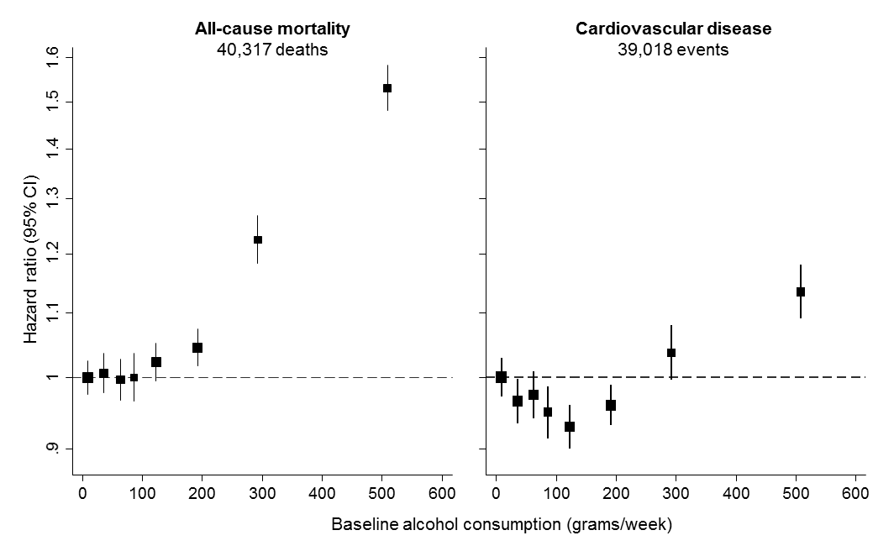

Cardiovascular disease was defined as an aggregate of MI, coronary heart disease, and stroke. Adjusted for age, smoking and history of diabetes, and stratified by sex and EPIC centre. The reference category is the lowest alcohol consumption category (>0 and <25g/week). Sizes of the boxes are proportional to the inverse of the variance of the log-transformed hazard ratios.
Best fitting fractional polynomial Cox models on the log scale were: all-cause mortality, non-linear (ie powers 0.5 and 1); cardiovascular disease, non-linear (ie powers 0 and 0).

Figure 2. Shapes of associations of baseline alcohol consumption with cardiovascular subtypes amongst alcohol drinkers.
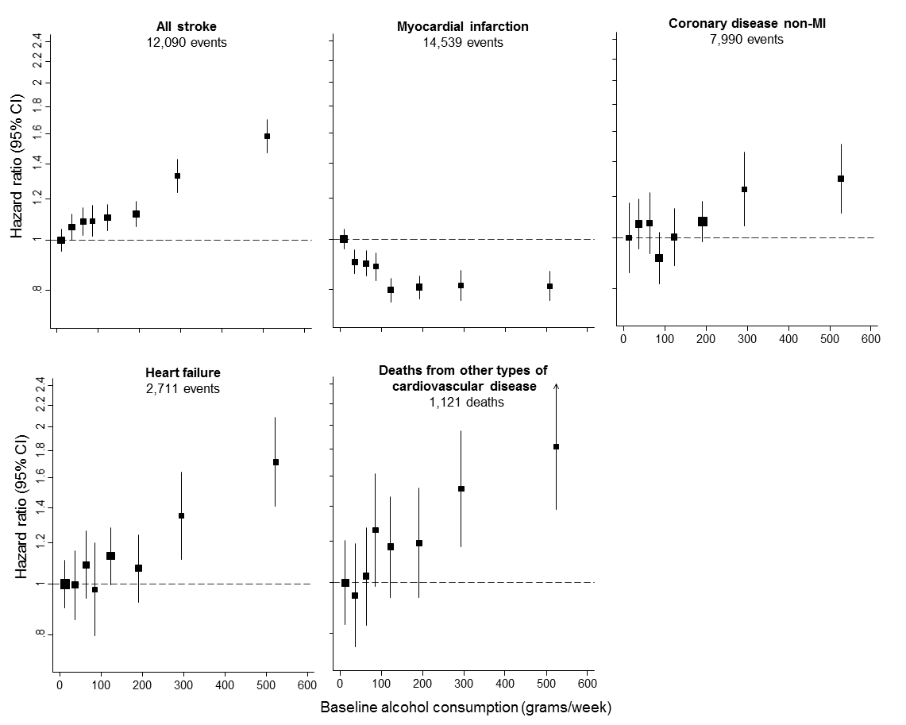
Adjusted for age, smoking and history of diabetes, and stratified by sex and EPIC centre. The reference category is the lowest alcohol consumption category (>0 and <25g/week). Studies with fewer than five events of any outcome were excluded from the analysis of that outcome. Sizes of the boxes are proportional to the inverse of the variance of the log-transformed hazard ratios. Deaths from other cardiovascular disease include the following outcomes: cardiac dysrhythmia, hypertensive disease, sudden death and aortic aneurysm.
Best fitting fractional polynomial Cox models on the log scale were: all stroke, linear (ie, powers 1); MI, log-linear (powers 0); coronary disease non-MI, linear (ie, powers 1); heart failure, linear (ie, powers 1); and deaths from other cardiovascular disease, linear (ie, powers 1).

Figure 3. Hazard ratios for subtypes of cardiovascular outcomes amongst current drinkers, per 100 grams/week higher average alcohol consumption.
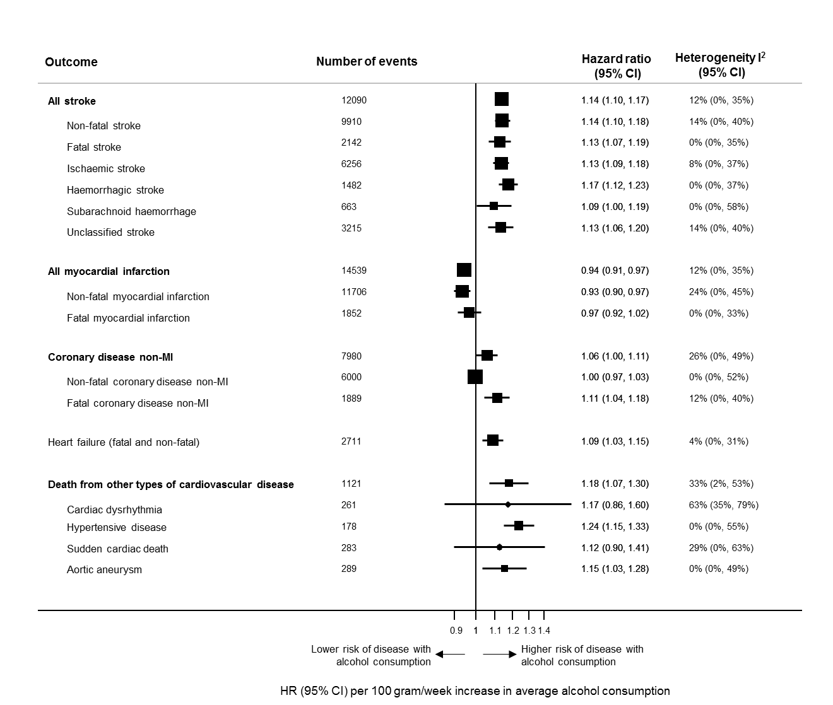

Adjusted for age, smoking and history of diabetes, and stratified by sex and EPIC centre. Studies with fewer than five events of any outcome were excluded from the analysis of that outcome.
Numbers of events for disease subtypes, including fatal and non-fatal events, may not add up to totals due to unknown information.
Figure 4. Estimated future years of life lost by extent of baseline alcohol consumption compared to those who consume >0- ≤100 grams/week.
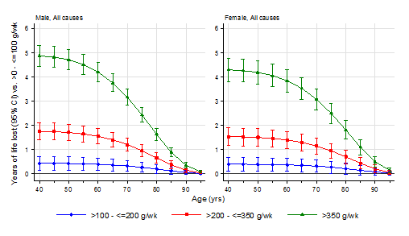

The estimates of cumulative survival from 40 years of age onward among the drinking groups were calculated by applying hazard ratios (specific to age at risk) for all-cause mortality associated with categorized baseline alcohol consumption to US death rates at the age of 40 years or older.

