Cost-effectiveness of maintained physical activity and physiotherapy in the management of distal arm pain: an economic evaluation of data from a randomised controlled trial
Aileen R Neilson¹, Gareth T Jones^{2,3}, Gary J Macfarlane^{2,3}, Karen Walker-Bone^{3,4}, Kim Burton⁵, Peter J Heine⁶, Candy S McCabe^{7,8}, Alex McConnachie⁹, Keith T Palmer^{3,4}, David Coggon^{3,4} and Paul McNamee¹

Affiliations
- Health Economics Research Unit, University of Aberdeen, UK
- Musculoskeletal Research Collaboration (Epidemiology Group), University of Aberdeen, UK
- Arthritis Research UK / MRC Centre for Musculoskeletal Health and Work
- MRC Lifecourse Epidemiology Unit, University of Southampton, UK
- Centre for Applied Research in Health, University of Huddersfield, UK
- Warwick Clinical Trials Unit, University of Warwick, Coventry, UK
- The Royal National Hospital for Rheumatic Diseases NHS Foundation Trust, Bath, UK
- University of West of England, Bristol, UK
- Robertson Centre for Biostatistics, University of Glasgow, UK

Address for correspondence: A. R. Neilson
Health Economics Research Unit (HERU)
Institute of Applied Health Sciences
School of Medicine, Medical Sciences and Nutrition
University of Aberdeen
Polwarth Building, Foresterhill
Aberdeen, AB25 2ZD, UK
Tel: 01224 437 281
E-mail: aileen.neilson@abdn.ac.uk

Key words: arm pain, physiotherapy, economic evaluation, cost-effectiveness, trial, QALYs
ABSTRACT
Background. Arm pain is common, costly to health services and society. Physiotherapy referral is standard management, and while awaiting treatment, advice is often given to rest, but the evidence base is weak.
Objective. To assess the cost-effectiveness of advice to remain active (AA) vs advice to rest (AR); and immediate physiotherapy (IP) vs normally timed physiotherapy (NTP).
Methods. 26-week within-trial economic evaluation (538 participants aged ≥18 years randomised to usual care i.e. AA(n=178), AR(n=182) or IP(n=178)). Regression analysis estimated differences in mean costs and Quality Adjusted Life Years (QALYs). Incremental cost-effectiveness ratios (ICERs) and cost-effectiveness acceptability curves were generated. Primary analysis comprised the 193 patients with complete resource use (UK NHS perspective) and EQ-5D data. Sensitivity analysis investigated uncertainty.
Results. Baseline adjusted cost differences were £88[95%CI:-14,201]) AA vs AR; -£14[95%CI:-87,66]) IP vs NTP. Baseline adjusted QALY differences were 0.0095[95% CI:-0.0140,0.0344]) AA vs AR; 0.0143[95%CI:-0.0077,0.0354]) IP vs NTP. There was a 71 % and 89% probability that AA (vs AR) and IP (vs NTP) were the most cost-effective option using a threshold of £20,000 per additional QALY. The results were robust in the sensitivity analysis.
Conclusion. The difference in mean costs and mean QALYs between the competing strategies was small and not statistically significant. However, decision-makers may judge that IP was not shown to be any more effective than delayed treatment, and was no more costly than delayed physiotherapy. AA is preferable to one that encourages AR, as it is more effective and more likely to be cost-effective than AR.

INTRODUCTION
Upper limb disorders are common in western populations. They may arise from specific abnormalities in the neck or arm (e.g. tendonitis, nerve compression), but often occur in the absence of identifiable underlying pathology (non-specific arm pain). They frequently cause significant disability, and therefore impose a substantial economic burden. In the UK, the prevalence rate of self-reported work-related upper limb disorders (WRULDs), from the Labour Force Survey, an annual survey of 38,000 households, was 222,000 total cases (case rate of 690 per 100,000 people employed) in 2015/16.¹ In addition, there were 3,138,000 days lost due to WRULDs (representing 36% of the total number of days lost due to work related ill health from work related musculoskeletal disorders of 8,784,000 days). Annual general practice consultation prevalence for upper limb problems amount to 467 per 10,000 registered persons (shoulder 199, hand 132, elbow 78, wrist 58); i.e. 268 for distal upper limb specifically per 10,000 persons.²
Early intervention in general, and early treatment by physiotherapists in particular, for common musculoskeletal problems such as low back pain can reduce the amount of time people are off sick and can prevent acute problems becoming chronic.³ In the management of low back pain, patients are advised to remain active because evidence from randomised controlled trials (RCTs) indicates that this improves prognosis (compared to the previous practice for many years of managing low back pain with bed rest).⁴ In contrast, patients with upper limb conditions are often advised to rest the arm, while awaiting physiotherapy. Thus for example, in the UK, guidance from the National Health Service (NHS) website recommends that for repetitive strain injury and tennis elbow, it is important to rest the injured limb, and/or to stop doing the activity that is causing the problem.^{5, 6} However, we can identify no published evidence to support this advice.
Written information providing evidence-based advice to patients (The Back Book) has proved effective in promoting positive beliefs and contributing to better clinical outcomes from back pain.⁷ As distal arm pain (affecting the elbow, forearm, writs or hand) shares many risk factors with back pain, it seemed plausible that it might benefit from a similar approach. It was possible also that prognosis could be improved by earlier delivery of physiotherapy, an approach that has been advocated, but with little supporting evidence.³
An RCT (the ARM trial) was therefore carried out to compare the effectiveness of different approaches to the management of distal arm pain in reducing long term disability. The trial found among participants awaiting physiotherapy, advice to remain active (AA) was superior to advice to rest (AR) in producing a long-term reduction in arm pain and disability; but that outcomes following immediate physiotherapy (IP) were no better than from usual care (normally timed physiotherapy).⁸ It does not necessarily follow, however, that AA pending normally timed physiotherapy is the most cost-effective form of clinical management. To compare the cost-effectiveness of the three approaches to treatment (AA, AR and IP), we conducted a parallel economic evaluation, which we report in this paper.

METHODS
Study design and interventions
The methods of the ARM trial have been described in detail elsewhere.^{8,9} Briefly, the study was an RCT in which 538 adults (aged 18 years and older) who had been newly referred to physiotherapy departments with an episode of distal arm pain were randomly assigned to receive one of three interventions:
Normally-timed physiotherapy (NTP) with advice to remain active (AA)—The advice was delivered through a booklet advocating maintained activity and a self-management approach as generally helpful in promoting more rapid recovery (and earlier return to work).
Normally-timed physiotherapy (NTP) with advice to rest (AR)—Participants in this arm of the trial received an advice booklet advocating rest and avoidance of activities that might aggravate symptoms.
Participants assigned to the two NTP interventions (AA and AR) were invited to attend physiotherapy, as per usual clinical care, after a period on a waiting list (median ICR days: 45 (34·5-63·5) and 47 (35-63) for AA and AR respectively).⁸
Immediate physiotherapy (IP)—Participants in this arm of the trial received an out-patient appointment to attend physiotherapy at their earliest convenience, within a few days following randomisation.
Data collection
Participants completed questionnaires including the EQ-5D-3L health status instrument,^{10,11} at baseline, and 6, 13 and 26 weeks post-randomisation. Over the same period they recorded use of health care related to elbow, forearm, wrist, and hand pain— including contacts with providers of primary and secondary care and hospital stays, both within the NHS and in the private sector. Non-responders received a reminder questionnaire after two weeks. After a further two weeks, non-responders were followed up by telephone, and were asked brief questions on the primary outcome only, using a standardised pro forma.
Costs
Standard unit costs from published UK sources were used to value the NHS resources that were used, and information from the published literature to value the care obtained from private providers (Table 1). Resource use included primary care visits (general practitioner, practice nurse, community physiotherapist, complementary therapist and other community health care professionals), hospital outpatient visits and inpatient stays. These aforementioned types of costs to the NHS were calculated using the Personal and Social Service Research Unit (PSSRU) costs¹² for primary care contacts and the NHS Reference Costs for outpatient appointments and inpatient hospitalisations.¹³ Private care was costed using estimates of treatments from published UK studies.^{14,15} All costs were expressed in UK pounds sterling (£) at 2013/14 prices. Advice leaflet production costs (applied to the AA and AR groups) were estimated directly from the trial finance documents.
Health outcomes
The effects of the three treatments were expressed as gain in quality-adjusted life years (QALYs) based on the EQ-5D^{10,11} generic preference-based measure of health-related quality of life data collected in the trial. Published UK general population tariffs were used to assign each participant a health state utility weight for the EQ-5D¹¹ at baseline and at each follow-up time point. QALYs between baseline and 26 weeks were calculated for each participant using the area under the curve (AUC) method (i.e. implemented by summing the areas of the geometrical shapes obtained by linearly interpolating between utility scores over the study period).
It was not necessary to discount the costs and outcomes, as the time horizon of the study was less than one year. All analyses were carried out using STATA 14.0 and Microsoft Excel.
Cost-utility analysis
The primary economic analysis was conducted on an intention-to-treat basis and was performed for participants with complete data on resource use and health utilities at baseline, 6, 13, and 26 weeks follow-up from the NHS cost perspective. Complete resource use and EQ-5D data from questionnaires was available for 193 patients: AA (n=53), AR (n=60), and IP (n=80). Regression analyses were used to estimate the differences (and associated 95% CIs) in mean total costs and differences in mean total QALYs comparing: i) AA vs AR, and ii) IP vs v NTP per patient, while adjusting for baseline differences in cost, utility and other patient characteristics (e.g. age, gender, employment status, disability – based on a modified DASH, Disabilities of the Arm Shoulder and Hand score). In addition, a secondary analysis was conducted from the perspective of both NHS and private health care perspectives.
A generalised linear model, with a γ family distribution and a log link function, was specified to account for skewed cost data. For QALYs, a Gaussian family distribution and an identity link function was used. Cost-effectiveness acceptability curves (CEACs) were constructed by non-parametric bootstrapping, using 1,000 replications of each incremental cost-effectiveness ratio (ICER) and the net monetary benefit framework, to determine the probability of the alternative interventions being considered cost-effective at different willingness to pay (WTP) per QALY values (a range of £20,000-£30,000 per QALY was used, as these are commonly applied ceiling ratios in the UK).
We performed two sensitivity analyses to explore the impact on the results of uncertainty in assumptions or estimates made. First, we imputed missing QALY and cost data (assumed to be missing at random) using chained equations (i.e., 193 out of 538 patients with complete; 345 patients with incomplete data, so imputed) including age, sex, baseline mDASH, baseline EQ-5D, baseline work status, and baseline cost as predictors, covariates. Secondly, we excluded cost “outliers” (defined as participants whose costs exceeded £1,000 - more than five times the median cost).

RESULTS
Participants
In the primary economic analysis, the baseline mean (SD) age of participants was 53 (13) years, and 37% were male. The percentage in employment was 64% and the baseline mean (SD) EQ-5D and mDASH scores were 0.708 (0.188) and 5.8 (2.7) respectively.
Resource use and cost
Table 2 presents disaggregated data on mean resource use and (unadjusted) total costs—for both NHS and private health care over 26 weeks. The mean (unadjusted) total NHS costs per participant were estimated to be AA £309.91 (SD £321.45), AR £223.15 (SD £225.39), and IP £221.46 (SD £220.54). Whereas NHS costs were generally similar between AR and IP, AA participants used more NHS primary care and secondary care services. These additional costs arose from extra community physiotherapist visits, CT visits, and hospital physiotherapist and rheumatology outpatient visits. All other resource use was similar across the three groups. The mean private health care costs were also highest in the AA group (£78.85, SD £194.35) as compared with AR (£31.25, SD £97.22) and IP (£18.93, SD £102.31).
Health outcomes
Table 3 shows the EQ-5D scores and (raw unadjusted) mean total QALYs over 26 weeks. IP generated slightly more QALYs than either of the advice groups, and AA slightly more than AR, but the magnitude of QALY gains from AA relative to AR and from IP relative to NTP were small (0.006 and 0.019 extra QALYs respectively).
Incremental cost-utility analysis
For the primary analysis (complete data, NHS health care perspective, baseline adjusted), relative to AR, AA generated a mean of 0.0095 (95% CI −0.0140 to 0.0344) more QALYs per participant at an additional cost of £87.87 (95%CI −14.33 to 200.83), yielding an incremental cost effectiveness ratio of £9,256 (Table 4). Relative to NTP, IP generated a mean of 0.0143 (95% CI −0.0077 to 0.0354) more QALYs per participant and a cost saving of -£14.22 (95% CI −87.14 to 66.01). Based on the results of the non-parametric bootstrap, AA was found to have a 71.3% chance of being the preferred strategy at a ceiling ratio of £20,000 per QALY gained (see Figure 1a, and 75.6% at £30,000 per QALY gained). IP was cost-effective across a range of thresholds (see Figure 1b which illustrates ceiling ratios up to £60,000 per QALY gained). In the secondary analysis (complete data, NHS and private health care perspective, baseline adjusted), for AA vs AR the incremental mean QALY difference was 0.0095 (95% CI -0.0140 to 0.0344) with a mean cost difference of £124.69 (-19.13 to 266.21). For IP vs NTP, the incremental mean QALY difference was 0.0143 (95% CI -0.0077 to 0.0354) with a mean cost difference of -£39.02 (-124.28 to 55.92). The ICERs were £13,134 for AA vs AR, and NTP was dominated by IP, which means the comparator (IP) was more effective (more QALYs) and less expensive than the intervention against which it was compared (NTP).
Sensitivity analysis
Re-running the main analysis with multiple imputation (MI) for missing cost and QALY data indicated that the cost-effectiveness results were somewhat sensitive to missing data, but the conclusions essentially remained unchanged (Table 4). The imputed data suggested smaller non-significant cost advantages of AR over AA, (reduced by around 62%), and of IP over NTP. Mean cost differences were £33.06 (95% CI 1.14 to 65.38) and -£18.39 (95% CI -109.57 to 85.97) for AA vs AR and IP vs NTP respectively. The mean difference in QALYs was lower using the imputed data compared to the complete case analysis (0.0001 (95% CI -0.0119 to 0.0110) for AA vs AR; 0.0088 (−0.0082 to 0.0338) for IP vs NTP).
To assess the impact on the main results of cost “outliers”, we excluded the 6 participants (4, 1, and 1 from AA, AR, and IP respectively) whose health care costs exceeded £1,000. This led to AA having an ICER of £2,053 compared with AR. IP remained costing less and gained more QALYS compared with NTP.

DISCUSSION
This economic evaluation supports and extends the clinical evaluation of the ARM trial reported in an earlier paper.⁸ For decision-makers applying a WTP threshold of £20,000 per QALY gained to judge the cost-effectiveness of competing interventions, there was less difference in costs and QALYs between the competing strategies, and assuming patients prefer to be seen earlier rather than later, IP would be the preferred strategy (vs NTP). If patients need to wait then AA (£9,256 per QALY) was a more cost-effective strategy than AR.
The results from the clinical effectiveness trial using mDASH as the primary clinical outcome are consistent with these findings on QALYs in terms of direction, although the magnitude of QALYs is slightly smaller. Two possible explanations might be offered as to why the QALYs outcomes diverge somewhat from the primary clinical outcome. First, in the main clinical paper⁸, the main difference was in the proportion of participants reporting full recovery (i.e. mDASH = 0) at 26 weeks (i.e. determined only at the time of the final follow-up), which was 12.9% (95% CI: 2.3%, 23.7%) higher amongst people receiving AA compared with AR. In addition, there was a smaller non-significant difference in mDASH between IP and NTP (-2.8%, 95% CI: -11.3%, 6.5%). The QALYs on the other hand, were assessed over six months of follow-up, which is perhaps reflected in the very small difference in QALYs reported here. Assuming an EQ-5D health utility of 1.0 = perfect health at 26 weeks to be equivalent to fully recovered/no disability, the increase in probability of full recovery as measured by EQ-5D was 18.9% (0.3774 with AA and 0.1887 with AR). Thus, we know from the main results paper⁸, that the differences between AA and AR in DASH =0 only become apparent at the final follow-up, and so we might reasonably expect any differences in QALYs to be smaller. A second reason might be due to the fact that the main economic analysis was restricted to a relatively small subset of participants with complete data (around 36%), although these results were generally shown to be robust after conducting a secondary analysis with imputation for missing data. Moreover, in relation to the analysis of the primary clinical outcome, when this was restricted to participants with complete data, the results were similar. So, the missing data are unlikely to have caused any major discrepancies in either outcomes.
Higher health care costs with AA were driven by more community physiotherapy visits and a range of visits to private providers. It is possible that the advice to remain active led some respondents to seek extra information or reassurance that the particular forms of activity that they were undertaking or planning were safe. Further, the content of advice leaflets may have had some influence on care-seeking behaviour in the AA group: the leaflet stated “Sometimes, of course, people need additional help. If things are not improving in a few weeks, you may need treatment. A physiotherapist can use massage and exercises to help improve the pain and get you going. If you get some relief, it may be repeated a number of times while you recover, if you get no relief a different type of treatment may be tried”. The advice to rest leaflet did not contain this statement. We did not collect data during the trial on how people engaged with the advice leaflet, so these explanations can only be speculative.

While IP was not associated with superior outcomes in terms of QALY gains, compared to physiotherapy delivered after a median of 45-47 days on a waiting list, there was a non-significant reduction in costs. Previously published research on back pain points to potential cost savings associated with early intervention.¹⁶⁻¹⁹ For instance, in a large national (employer-sponsored health plans) database study in the US involving 32,070 patients with a new primary care lower back pain consultation, ¹⁷ initiation of early physical therapy (referred to as physical therapy within 14 days of the index consultation) as compared with delayed physical therapy (occurring between 15 and 90 days from the index consultation) was associated with reduced risk of surgery, injections, physician visits, opioid use, and advanced imaging during an 18 month follow-up period, along with a corresponding reduction in overall lower back pain-related medical costs. Total annual health care costs for patients receiving early care from a physical therapist were on average US $2,736.23 lower per patient. Similar results were obtained in an even larger study (753,450 patients with a primary care visit for lower back pain) carried out in 2015 by the same authors.¹⁸

In conclusion, our economic analysis suggests small non-significant differences in costs and QALYs between the competing strategies for clinical management. The level of uncertainty associated with the estimated differences is however large (and this points to a need for further larger studies). Decision-makers may judge that a strategy of advice to remain active is preferable to one that encourages advice to rest, as there is a greater probability of full recovery. Further, immediate physiotherapy appears a preferable strategy, on the grounds that it may deliver some cost savings, and is likely to align better with patient preference. To reduce decision uncertainty, we recommend that future estimates of the cost-effectiveness of arm pain management strategies be based on larger sample sizes.

Declarations/ Acknowledgements/Interests:
Funding: Arthritis Research UK (Clinical Studies Grant, reference: 19231)
Clinical trial registration: www.controlled-trials.com, reference: ISRCTN 79085082
Ethical approval: UK South Central (Hampshire A) Research Ethics Committee, reference: 11/SC/0107
Professor Kim Burton has been involved in the development of The Arm Book (ISBN: 978-0117069145), to which the experimental leaflet in this trial is related, and may receive future royalties on the booklet
References
- Health and Safety Executive: Work Related Musculoskeletal Disorder Statistics (WRMSDs) in Great Britain 2016. Available at: http://www.hse.gov.uk/statistics/causdis/musculoskeletal/msd.pdf
- Jordon KP, Kadam UT, Hayward R, Porcheret M, Young C, Croft P. Annual consultation prevalence of regional musculoskeletal problems in primary care: and observational study. BMC Musculoskeletal Disorders 2010; 11:144.
- Black C. Working for a healthier tomorrow. The Stationery Office; 2008.
- Savigny P, Watson P, Underwood M. Early management of persistent non-specific low back pain: summary of NICE guidance. BMJ 2009;338:b1805
- NHS Choices Repetitive strain injury (RSI). 27-1-2016. Ref Type: Online Source
- NHS choices. Tennis elbow. 27-9- 2014 Ref Type: Online Source
- Coudeyre E, Givron P, Vanbiervliet W, Benaim C, Pelissier J et al. [The role of an information booklet or oral information about back pain in reducing disability and fear-avoidance beliefs with subacute and chronic low back pain. A randomized controlled trial in a rehabilitation unit]. Ann Readapt Med Phys 2006; 49(8): 600-608.
- Jones GT, Macfarlane GJ, Walker-Bone K, Burton K, Heine PJ, McCabe C, McNamee P, McConnachie A, Zhang R, Whibley D, Palmer KT, Coggon D. Maintained physical activity and physiotherapy in the management of distal upper limb pain – a randomised trial (submitted to BMJ journal).
- Jones GT, Mertens K, McFarlane GJ, Palmer KT, Coggon D, Walker-Bone K, Burton K, Heine PJ, McCabe C, McNamee P, McConnachie A. Maintained physical activity and physiotherapy in the management of distal upper limb pain – a protocol for a randomised controlled trial (the arm pain trial). BMC Musculoskeletal Disorders 2014; 15:71.
- Dolan P, Gudex C, Kind P, Williams, A. A social tariff for EuoQoL: results from a UK general population survey. York: Centre for Health Economics. 1995 https://www.york.ac.uk/che/pdf/DP138.pdf
- Kind P, Hardman G, Macran S. UK Population norms for EQ-5D York Centre for Health Economics Discussion Paper pp. 172. 1999 Nov.
- Curtis L. Unit costs of health and social care (2014). Personal Social Services Research Unit, University of Kent, 2014.
- NHS Reference Costs 2013-14, Department of Health, November 2014.
- United Kingdom back pain exercise and manipulation (UK BEAM) randomised trial: cost-effectiveness of physical treatments for back pain in primary care. UK BEAM Trial Team, BMJ Online First BMJ, doi:10. 1136/bmj.3282.607859.AE, 2004.
- Wonderling D, Vickers AJ, Grieve R, McGarney R. Cost effectiveness analysis of a randomised trial of acupuncture for chronic headache in primary care. BMJ Online First BMJ, doi:10. 1136/bmj.38033.896505.EB, 2004.
- Gatchel RJ, Polatin PB, Noe C, Gardea M, Pulliam C, Thompson J. Treatment- and cost-effectiveness of early intervention for acute low-back pain patients: A one-year prospective study. Journal of Occupational Rehabilitation 2003; 13(1) March.
- Fritz JM, Childs JD, Wainner RS, Flynn TW. Primary care referral of patients with low back pain to physical therapy. Spine 2012; 37:2114-2121.
- Childs J, Fritz JM, Wu SS, Flynn TW, Wainner RS, Robertson, Kim FS, George SZ. Implications of early and guideline adherent physical therapy for low back pain on utilization and costs. BMC Health Service Research 2015; 15: 150 DOI 10.1186/s12912-015-0830-3
- Ojha HA et al. Timing of Physical Therapy Initiation for Nonsurgical Management of Musculoskeletal Disorders and Effects on Patients Outcomes: A systematic Review. Journal of Orthopaedic & Sports Physical Therapy 2016; 46(2) pp56-70.
Table 1 Unit costs applied to value health care resource use (£, 2013/14 UK prices)
Resource | Unit | Source | Basis of estimate | Cost (£)
NHS health care resource use
GP Surgery
GP | Visit | Curtis | 11.7 minutes surgery consultation | 46
Practice nurse | Visit | Curtis | Surgery consultation 15.5 minutes | 14
Community physiotherapist | Visit | Curtis | assumes visit lasts 30 minutes | 18
Other community | Visit | Curtis | Assumes cost of physiotherapy | 18
CT – Chiropractor | Visit | Curtis | Assumes cost of physiotherapy | 18
CT – Osteopath | Visit | Curtis | Assumes cost of physiotherapy | 18
CT – Other | Visit | Curtis | Assumes cost of physiotherapy | 18
Outpatient clinic – Rheumatology | Visit | NHS Reference Costs | WF01A Non-admitted Face to Face Follow-up Attendance, Rheumatology, 410, WF01B Non-admitted Face to Face First, 410, Rheumatology (mean over these two categories) | 168
Outpatient – Orthopaedics | Visit | NHS Reference Costs | WF01A Non-admitted Face to Face Attendance, First attendance, Trauma & Orthopaedics, 110, WF01B, Non-admitted Face to Face Attendance, Single, 410, Trauma & Orthopaedics (mean cost over these two categories) | 113
Outpatient – Other | Visit | NHS Reference Costs | WF01A Non-admitted Face to Face Attendance, Follow-up, 191, Pain Management, WF01B Non-admitted Face to Face Attendance, First, Pain Management (mean cost over these two categories) | 154
Other HCP – Physiotherapist | Visit | NHS Reference Costs | WF01B Non-admitted Face to Face Attendance, First, 650, Physiotherapy. WF01A Non-admitted Face to Face Attendance, Follow-up, 650, Physiotherapy. (mean cost over these two categories) | 47
Other HCP – Other | Visit | NHS Reference Costs | Assumes cost of a physiotherapy attendance | 47
Emergency admission | Day | NHS Reference Costs | AB04Z Pain Procedures, Accident & Emergency, 181 (mean cost per patient over Intermediate and Minor categories) | 561
Planned (elective) admission | Day | NHS Reference Costs | HD26G Musculoskeletal Signs and Symptoms, Pain Management, 191 (mean cost over CC Score 0-3 and 4-7 categories) | 341
Private (non-NHS) treatment resource use
HCP – Doctor | Visit | UK Beam Trial | Mean cost of private specialist visit - uprated | 177
HCP – Physiotherapist | Visit | UK Beam Trial | Mean cost of private physiotherapist outpatient attendance – uprated. | 112
HCP – Chiropractor | Visit | Wonderling et al 2004 | Mean cost of a private visit chiropractor or osteopath – uprated | 38
HCP – Osteopath | Visit | Wonderling et al 2004 | Mean cost of a private visit chiropractor or osteopath – uprated | 38
HCP – Other (e.g. acupuncturist) | Visit | UK Beam Trial | Assumes mean cost of a private physiotherapist outpatient attendance – uprated. | 112
HCP – Other | Visit | UK Beam Trial | Assumes mean cost of a private physiotherapist outpatient attendance – uprated. | 112
Hospital admission | Day | UK Beam Trial | Mean cost of private hospital admission/ day uprated | 584
GP = General practitioner; HCP = Health care professional; CT=Complementary therapist
Table 2 Mean resource use and costs per patient over 26 weeks follow-up (complete case analysis n=193)
Resource use item |  |  | Active advice (AA), n=53 |  |  | Advice to rest (AR), n=60 |  |  | Immediate physiotherapy (IP), n=80
 |  |  | Resource users,  n (%)¹ | Mean resource use (SD) | Mean cost,  £ (SD) | Resource users,  n (%)¹ | Mean resource use (SD) | Mean cost,  £ (SD) | Resource, users, n (%)¹ | Mean resource use (SD) | Mean cost,  £ (SD)
NHS Primary care |  | Patient advice booklet¹ | 53 (100) | 1 (-) | £1·09 (-) | 60 (100) | 1 (-) | £1·09 (-) | na | na | na
 |  | GP visits | 14 (26) | 0·70 (1·58) | £32·11 (£72·5) | 21 (35) | 0·67 (1·32) | £30·67 (£60·88) | 19 (24) | 0·54 (1·38) | £24·73 (£63·36)
 |  | Practice nurse visits | 1 (2) | 0·02 (0·14) | £0·26 (£1·92) | 6 (10) | 0·13 (0·43) | £1·87 (£6·03) | 1 (1) | 0·03 (0·22) | £0·35 (£3·13)
 |  | Community physiotherapist visits | 32 (60) | 2·25 (2·73) | £40·42 (£49·16) | 36 (60) | 1·40 (1·60) | £25·2 (£28·74) | 35 (44) | 1·26 (1·93) | £22·73 (£34·69)
 |  | Other community visits | 6 (11) | 0·11 (0·32) | £2·04 (£5·76) | 6 (10) | 0·13 (0·47) | £2·40 (£8·43) | 6 (8) | 0·14 (0·57) | £2·48 (£10·22)
 |  | CT visits – Chiropractor | 0 | - | - | 0 | - | - | 0 | - | -
 |  | CT visits – Osteopath | 1 (2) | 0·02 (0·14) | £0·34 (£2·47) | 0 | - | - | 0 | - | -
 |  | CT visits – Other | 12 (27) | 0·83 (1·92) | £14·94 (£34·54) | 3 (5) | 0·12 (0·58) | £2·1 (£10·53) | 4 (5) | 0·13 (0·60) | £2·25 (£10·89)
Total NHS primary care costs (unadjusted) |  |  |  |  | £90.11 (£105.18) |  |  | £62.23 (£71.79) |  |  | £52.53 (£80.67)
NHS hospital care |  | Outpatient visits – Rheumatology | 3 (6) | 0·11 (0·58) | £19·02 (£96·96) | 1 (2) | 0·02 (0·13) | £2·8 (£21·69) | 3 (4) | 0·05 (0·27) | £8·4 (£45·52)
 |  | Outpatient visits – Orthopaedics | 3 (6) | 0·11 (0.47) | £12·79 (£57·72) | 3 (5) | 0·12 (0·52) | £13·18 (£59·18) | 6 (8) | 0·09 (0·33) | £9·89 (£36·82)
 |  | Outpatient visits – Other | 5 (9) | 0·15 (0·53) | £23·25 (£82·14) | 7 (12) | 0·17 (0·53) | £25·67 (£81·03) | 5 (6) | 0·08 (0·31) | £11·55 (£47·61)
 |  | Other HCP visits – Physiotherapist | 36 (68) | 2·98 (3·38) | £140·11 (£158·71) | 48 (80) | 2·32 (2·57) | £108·88 (£120·99) | 52 (65) | 2·56 (2·71) | £120·44 (£127·53)
 |  | Other HCP visits – Other | 3 (6) | 0·11 (0·51) | £5·32 (£23·79) | 4 (5) | 0·10 (0·40) | £4·7 (£18·76) | 7 (9) | 0·13 (0·46) | £5·88 (£21·64)
 |  | Emergency admission days | 0 | - | - | 0 | - | - | 0 | -
 |  | Planned (elective) admission days | 3 (6) | 0·06 (0·23) | £19·30 (£79·55) | 1 (2) | 0·02 (0·13) | £5·68 (£44·02) | 2 (3) | 0·04 (0·25) | £12.79 (£84·82)
Total NHS hospital costs (unadjusted) |  |  |  |  | £219.79 (£266.36) |  |  | £160.92 (£178.47) |  |  | £168.94 (£187.44)
Total NHS costs (unadjusted) |  |  | 53 |  | £309.91 (£321.45) | 60 |  | £223.15 (£225.39) | 80 |  | £221.46 (£220.54)
Private (non-NHS) treatment |  | HCP consultations – Doctor | 2 (4) | 0·09 (0·56) | £16·70 (£99·79) | 2 (3) | 0·05 (0·29) | £8·85 (£50·75) | 1 (1) | 0·03 (0·22) | £4·43 (£39·58)
 |  | HCP consultations – Physiotherapist | 8 (15) | 0·47 (1·49) | £52·83 (£166·71) | 7 (12) | 0·2 (0·61) | £22·4 (£67·77) | 2 (3) | 0·11 (0·81) | £12·6 (£90·86)
 |  | HCP consultations – Chiropractor | 0 | - | - | 0 | - | - | 0 | - | -
 |  | HCP consultations – Osteopath | 1 (2) | 0·02 (0.14) | £0·72 (£5·22) | 0 | - | - | 0 | - | -
 |  | HCP consultations – Other | 2 (4) | 0·23 (1·17) | £8·60 (£44·49) | 0 | - | - | 2 (3) | 0·05 (0·31) | £1·9 (£11·94)
 |  | Hospital admission days | 0 | - | - | 0 | - | - | 0 | - | -
Total private treatment costs (unadjusted) |  |  | 53 | £78.85 (£194.35) |  | 60 | £31.25 (£97.22) |  | 80 | £18.93 (£102.31)
Total NHS + private costs (unadjusted) |  |  | 53 | £388·75 (£422·39) |  | 60 | £254·4 (266·65) |  | 80 | £240.39 (£253.28)
1 | The advice booklet cost is not included in the comparison of differences in total costs for advice active versus advice rest, but is included in the comparison of differences in immediate physiotherapy versus normally timed physiotherapy
 | GP, general practitioner; CT, Complementary therapist; HCP, Health care professional; AA, Active Advice; AR, Advice to rest; IP. Immediate physiotherapy; NTP, Normally timed physiotherapy
 | Note. Total NHS costs for ‘normally timed physiotherapy’ (NTP) = £263.84 (276.82).

Table 3 Mean EQ-5D health utility scores and QALYs over 26 weeks follow-up (complete case analysis n=193)
EQ-5D utility (SD) | Active advice (AA), n=53 | Advice to rest (AR), n=60 | Immediate physiotherapy (IP), n=80
Baseline | 0.699 (0·231) | 0·709 (0·188) | 0·714 (0·156)
6 weeks | 0·711 (0·270) | 0·694 (0·244) | 0·759 (0·205)
13 weeks | 0·740 (0·258) | 0·739 (0·149) | 0·792 (0·214)
26 weeks | 0·808 (0·247) | 0·768 (0·195) | 0·796 (0·228)
QALYs over 26 weeks | 0·372 (0·111) | 0·366 (0·077) | 0·388 (0·089)
QALYs, quality-adjusted life-years; IP, Immediate physiotherapy; NTP, normally timed physiotherapy. Note. Total QALYs for ‘normally timed physiotherapy’ (NTP) = 0.369 (0.094)

Table 4 Adjusted¹ mean incremental costs, incremental QALYs, and incremental cost-effectiveness ratio over 26 weeks (complete case analysis n=193)
Analysis |  | Incremental mean cost, £ (95% CI)^{2,3} | Incremental mean QALYs (95% CI)^{2,4} | Mean ICER (£/QALY)
AA v AR |  | 87.87 (-14.33 to 200.83) | 0.0095 (-0.0140 to 0.0344) | 9,256
IP v NTP |  | -14.22 (−87.14 to 66.01) | 0.0143 (-0.0077 to 0.0354) | IP dominant (cost per QALY gained < 0)
Secondary (NHS + private perspective)
AA v AR |  | 124.69 (-19.13 to 266.21) | 0.0095 (-0.0140 to 0.0344) | 13,134
IP v NTP |  | -39.02 (-124.28 to 55.92) | 0.0143 (-0.0077 to 0.0354) | IP dominant (cost per QALY gained < 0)
SA: Imputed dataset (NHS)
AA v AR |  | 33.06 (1.14 to 65.38) | 0.0001 (-0.0119 to 0.0110) | 264,049
IP v NTP |  | -18.39 (−109.57 to 85.97) | 0.0088 (-0.0082 to 0.0338) | IP dominant (cost per QALY gained < 0)
SA: excluding cost “outliers” (NHS)
AA v AR |  | 36.51 (-54.11 to 127.27) | 0.0178 (-0.0050 to 0.0412) | 2,053
IP v NTP |  | -2.38 (-61.25 to 58.62) | 0.0109 (-0.0097 to 0.0323) | IP dominant (cost per QALY gained < 0)
1 | Adjusted for baseline differences (age, gender, work status (full or part-time/ other), modified dash (=0 no disability/>=1 disability), EQ-5D health utility score, and baseline NHS cost)
2 | Bootstrapped non-parametric 95% confidence interval
3 | Generalised linear model with γ distribution and log link function to estimate incremental costs and generalised linear model with gauss distribution and identity link function to estimate incremental QALYs (complete cases).
 | QALYs, quality-adjusted life-years; IP, Immediate physiotherapy; NTP, normally timed physiotherapy; ICER, incremental cost-effectiveness ratio; WTP, willingness-to-pay; CE, cost effectiveness. AA, Active Advice; AR, Advice to rest; IP. Immediate physiotherapy; NTP, Normally timed physiotherapy

Figure 1 Cost-effectiveness planes and cost-effectiveness acceptability curves for ARM pain trial treatment groups (complete case dataset, NHS perspective). Cost-effectiveness planes were based on 1000 bootstrap cost-effect pairs (adjusted for baseline age, gender, work status, modified dash, EQ-5D health utility score and NHS cost). AA, advice active; AR, advice to rest; IP, immediate physiotherapy; NTP, normally timed physiotherapy; QALY, quality adjusted life year.
- AA - AR
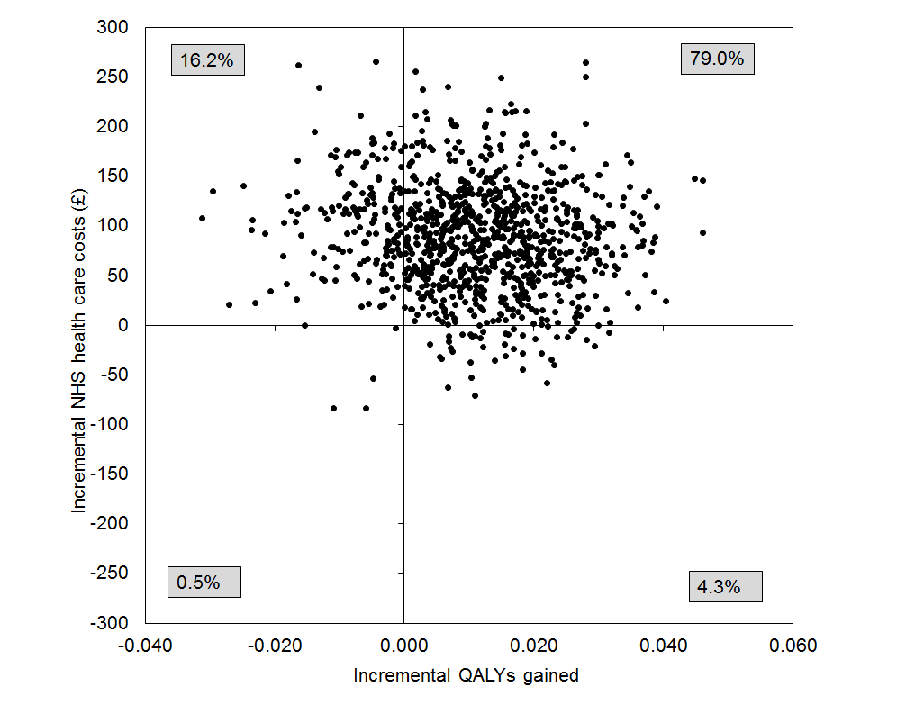 | 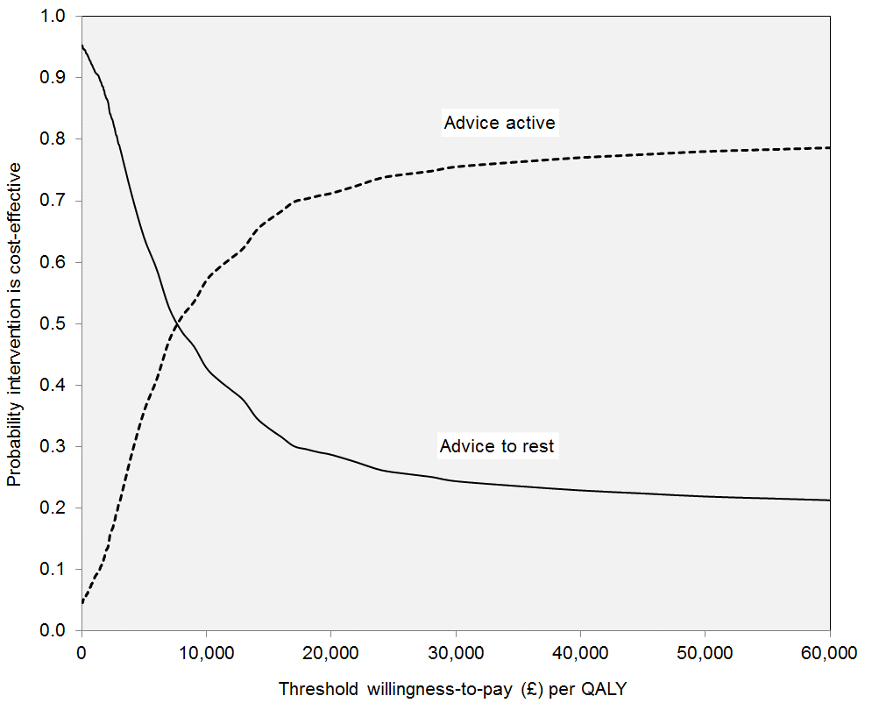
- IP - NTP
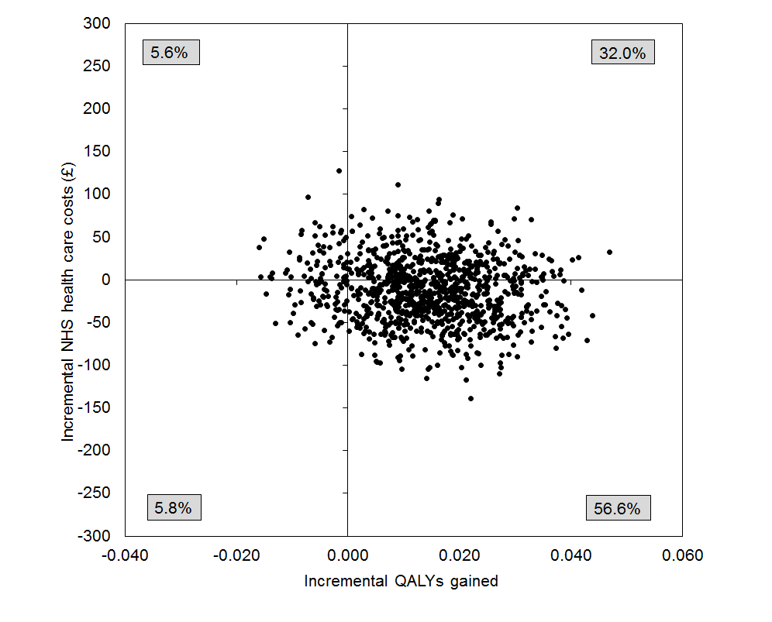 | 