Artificial molecular machines

**Changing places**

A new molecular machine has been designed in which two rings on a molecular axle are able to switch places by the smaller one slipping through the cavity of the larger one.

Steve Goldup

Many of the synthetic molecular machines[1] developed by chemists over the last 40 years are based on rotaxanes, molecules in which a ring-shaped component encircles a linear axle unit which is terminated with large “stopper” groups that prevent the ring from slipping off. The threading of the axle through the ring limits their relative motion to a shuttling movement of the ring up and down the axle. By learning to control this motion chemists have developed a range of molecular machines including switches[2], ratchets[3], pumps,[4] and molecular synthesisers[5]. It is also possible to create more complex rotaxanes in which more than one ring encircles the dumbbell[6], reminiscent of an abacus in the macroscopic world. However, as with their macroscopic analogue, the rings in all multi-ring rotaxanes reported to date have been unable to pass one another on the axle. Writing in *Nature Chemistry*, Steve Loeb and co-workers from the University of Windsor have now demonstrated that it is possible to design systems in which the rings can slip past one another. This discovery opens the way to developing multi-ring rotaxanes for new types of molecular machines.

To achieve the ring-through-ring shuttling motion multi-ring rotaxane **IV** was assembled with two different sized rings, one of which (**I**) has 24 atoms around its circumference (red), about as small as a ring can be in a rotaxane, and the other of which (**II**) is almost twice as large, with 42 atoms around the ring (blue). These rings were wrapped around axle **III** to form rotaxane **IV**. In rotaxane **IV** both rings hydrogen bond to an N-H unit (highlighted in green) of the axle and this allowed the authors to probe their movement using nuclear magnetic resonance. At room temperature, the authors observed two distinct N-H signals in the nuclear magnetic resonance spectrum of rotaxane **IV** because the N-H unit hydrogen bonded to the small ring appears at a different frequency to the N-H unit hydrogen bonded to the larger ring. This told Loeb and co-workers that at room temperature the rings are exchanging places slowly or not at all. However, as the sample of rotaxane **IV** was heated, the signals first broadened and then merged to give a single peak. This confirmed that at elevated temperatures the rings change places quickly. The only way this can be achieved is by the smaller of the two rings passing through the larger one, demonstrating that the authors had achieved their goal of ring-through-ring shuttling.

The authors determined the energy barrier for the rings to change places to be about 52 kJ mol-1, corresponding to a shuttling rate of about 3,600 times per second. For comparison, in an analogue of rotaxane **IV** that contained only the smaller red ring, it hops between the N-H groups approximately 80,000 times per second, approximately 20 times faster than in **IV**. Based on this comparison, the authors were able to estimate that the ring-through-ring process “costs” about 11 kJmol-1, which although significant, is not as high as might have been expected.

That this is the first time that such a ring-through-ring shuttling process has been observed might seem surprising; rotaxane **IV** is remarkably simple compared to some of the complex systems that have been produced over the last 40 years. However, to achieve their breakthrough the authors needed to bring together a number of key structural features. Firstly, the dramatic difference in size of the macrocycles is important to allow the shuttling process to occur. Simple molecular models of **IV** before and during shuttling demonstrate this clearly. Before shuttling the large blue ring is relaxed and flexible, whereas the smaller red ring is relatively rigid as the axle only just fits through the cavity (Figure 1c). In the structure of **IV** during shuttling (Figure 1d), it is clear that the blue ring has been forced open by the smaller red ring – it only just fits despite the significant size difference! Secondly, when large rings are employed as components of rotaxanes the bulky end groups (stoppers) on the axle must be very large to prevent the rings slipping off. This raises synthetic issues and here the authors made use of T-shaped stoppers they developed as part of their programme of rotaxane-based metal organic frameworks[7]. This also highlights a limitation of this newly-identified dynamic process; if the structures of rotaxanes that display ring-through-ring shuttling must be so contrived, is it possible to use this process for the development of molecular machines?

It must be hoped that the answer is “yes” because ring-through-ring shuttling brings a new dimension to rotaxane-based switches. One hypothetical application raised by the authors is molecular level weaving by using the ring-through-ring shuttling process to control the entanglement of molecular threads, essentially using a small ring to pull a thread through a larger ring like threading a macroscopic needle. Another potentially application is in storing information. Multi-ring rotaxanes could be used for storage of information by using the order of the rings on the axle to encode data. However, because up until now the order of rings on the axle was fixed at the point of synthesis there were no significant advantages of this approach compared with storing the data in simpler molecule. Now that the order of the rings can be reprogrammed, multi-ring rotaxanes have the potential to have order of their rings, and the information this encodes, written and re-written in response to external stimuli.

Steve Goldup is at the University of Southampton, Southampton, Hampshire, UK, SO17 1BJ ([s.goldup@soton.ac.uk)](mailto:s.goldup@soton.ac.uk)).



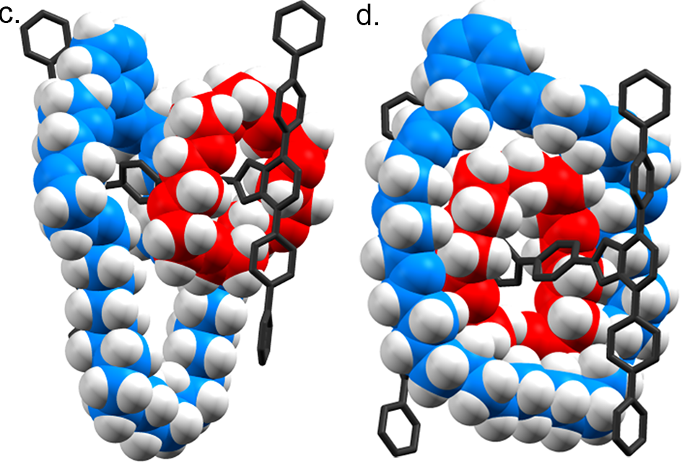

**Figure 1.** a. The individual components of rotaxane IV: a small ring (**I**, red), a large ring (**II**, blue) and an axle with large groups on the end to prevent the macrocycles from escaping (**III**, black). b. Rotaxane **IV** in which Loeb and co-workers demonstrated a ring through ring shuttling process that allows the macrocycles to exchange their positions on the axle as shown. c. A simple molecular model (truncated for clarity) of rotaxane IV before ring-through-ring shuttling. As can be seen the red ring is relatively rigid as the axle only just fits through its cavity. The blue ring is much more flexible. d. A simple molecular model showing a possible structure of the rotaxane as the red ring passes through the blue ring. As can be seen, the red ring has to force the blue ring open in order to pass through its cavity.

**References**

1. . Erbas-Cakmak, S., Leigh, D. A., McTernan, C. T. & Nussbaumer, A. L. Artificial Molecular Machines. *Chem. Rev.* **115,** 10081–10206 (2015).
2. . Bissell, R., Córdova, E., Kaifer, A. & Stoddart, J. A chemically and electrochemically switchable molecular shuttle. *Nature* **369,** 133–137 (1994).
3. . Serreli, V., Lee, C.-F., Kay, E. R. & Leigh, D. A. A molecular information ratchet. *Nature* **445,** 523–527 (2007).
4. . Cheng, C. *et al.* An artificial molecular pump. *Nat. Nanotechnol.* **10,** 547–553 (2015).
5. . Lewandowski, B. *et al.* Sequence-specific peptide synthesis by an artificial small-molecule machine. *Science* **339,** 189–193 (2013).
6. . Lewis, J. E. M., Winn, J., Cera, L. & Goldup, S. M. Iterative Synthesis of Oligo[ n ]rotaxanes in Excellent Yield. *J. Am. Chem. Soc.* **138,** 16329–16336 (2016).
7. Zhu, K., O’Keefe, C. a, Vukotic, V. N., Schurko, R. W. & Loeb, S. J. A molecular shuttle that operates inside a metal-organic framework. *Nat. Chem.* **7,** 514–519 (2015).