Progress in Electrochemical Flow Reactors for Laboratory and Pilot Scale Processing

Frank C. Walsh* and Carlos Ponce de León
Electrochemical Engineering Laboratory, Department of Mechanical Engineering
University of Southampton, Highfield, Southampton, SO17 1BJ, UK.
*Author for correspondence; f.c.walsh@soton.ac.uk

Abstract
The principles governing the selection of an appropriate type of electrochemical flow reactor for use at laboratory or pilot scale are reviewed. Good practice in electrochemistry and electrochemical engineering must be incorporated, together with practical aspects, such as the form of reactants and products, the required performance, ease of assembly, the maintenance schedule and scale-up plans. Diverse electrode forms and reactor designs are illustrated by examples from the authors’ laboratories. The versatile parallel plate geometry, often in modular, filter-press format, occupies a prominent position, both in the laboratory and in industry. The simple parallel plate geometry is readily enhanced by inclusion of porous, 3-dimensional electrodes, structured electrode surfaces and bipolar electrical connections, with necessary consideration of the reaction environment, especially potential- and current-distributions, uniformity of flow and mass transport rates, electrode activity, side reactions and current leakage. More specialised electrode geometries, such as concentric reactors, rotating cylinder electrodes, porous electrodes, packed beds, fluidised beds and bipolar trickle towers, are sometimes chosen. Applications span materials recycling, environmental treatment and electrosynthesis. A decision tree to aid the choice of reactor design features is provided. Recent trends, such as fast prototyping of reactors via 3-D printing of flow channels, miniaturisation and use of multi-physics modelling, are highlighted. Future research and development needs are suggested.
Keywords: 3D printing, electrochemical engineering, electrode material, porous electrode, reaction environment, reactor, three-dimensional electrode.
Contents
1. Introduction
2. Principles of electrochemical reactor design
2.1 General considerations
2.2 Electrode materials
2.3 Cell potential difference
2.4 Rate control of an electrode process
3. Decisions during the process of reactor design or selection
3.1 Strategic decisions
3.2 Divided and undivided reactors
3.3 Monopolar and bipolar electrical connections to electrodes
3.4 Porous, 3-D electrode structures
4. Examples of reactor designs and their performance
4.1 The planar electrode in a rectangular flow channel (in laboratory pilot-reactors)
4.2 An in-house rectangular channel flow reactor (for electrode studies)
4.3 A pilot-scale bipolar filter-press reactor stack (in reaction environment studies)
4.4 A porous, 3-dimensional electrode in a flow channel (for a redox flow battery)
4.5 Rotating cylinder electrode reactors (in metal deposition and current distribution studies)
4.6 A bipolar trickle tower reactor (for metal ion and cyanide ion removal studies)
4.7 Hybrid reactors (combining geometrical features or functions in a single device)
5. Technological developments in the design, construction and simulation of reactors
5.1 Computational modelling of reaction environment in reactors
5.2 3-D printing of reactor components
5.3 Microflow channel reactors
6. Closure
7. Future research and development needs
List of Symbols
Note: As requested by referees, the authors have been guided by a) G. Gritzner, G. Kreysa, Nomenclature, symbols and definitions In electrochemical engineering, Pure & Appl. Chem., 65, 1009-1020, (1993), b) R. Guidelli, R.G. Compton, J.M. Feliu-Martinez, E. Gileadi, J. Lipkowski, W. Schmickler and S. Trasatti, Defining the transfer coefficient in electrochemistry: An assessment (IUPAC Technical Report), Pure Appl. Chem. 2014, 86(2) 245–258 and c) R. Parsons, IUPAC Manual of symbols And terminology for physicochemical quantities and units Appendix III Electrochemical nomenclature recommendations approved 1973. The older method of referring to cell voltage (cell potential difference) is by the symbol E_{cell} = -U.
Symbol Meaning Units
A Geometrical electrode area m²
A_{E} Electrode area per unit electrode volume m⁻¹
B Breadth of rectangular flow channel m
c Reactant concentration mol m⁻³
c_{b} Reactant concentration in the bulk electrolyte mol m⁻³
d_{e} Equivalent (hydraulic) diameter of a rectangular flow channel m
D Diffusion coefficient of an aqueous species m² s⁻¹
E Electrode potential vs. a reference electrode V
Ue Equilibrium cell potential difference V
Eº Standard electrode potential V
F Faraday constant C mol⁻¹
G Gibbs free energy J mol⁻¹
I Current A
I_{L} Limiting current due to convective-diffusion A
j Current density A m⁻²
j_{o} Exchange current density A m⁻²
k First order apparent rate constant s⁻¹
k_{m} Mass transfer coefficient m s⁻¹
L Length of rectangular flow channel in the direction of flow m
n Amount of a species mol
Q Volumetric flow rate of electrolyte m³ s⁻¹
R Electrical resistance ohm
S Separation between the electrode and membrane (divided reactor)
or between the electrodes (undivided reactor) m
t Time s
T Temperature K
U Cell potential difference under non-equilibrium conditions V
v Mean linear flow velocity of electrolyte m s⁻¹
V Volume of reactor m³
V_{E} Overall volume of electrode m³
V_{R} Volume of electrolyte in the reactor m³
V_{T} Volume of electrolyte in the tank m³
ω Velocity exponent in equation (14) Dimensionless
x Distance along electrode m
Y_{ST} Space time yield mol m⁻³ s⁻¹
z Electron stoichiometry Dimensionless

Greek
α Charge transfer coefficient Dimensionless
ε Surface roughness of electrode m
γ Limiting current enhancement factor compared to a smooth surface Dimensionless
η Overpotential (η = E – E_{e}) V
ν Kinematic viscosity of the electrolyte m² s⁻¹
Φ Current efficiency (charge yield) Dimensionless
ρ Electrical resistivity ohm m
τ_{T} Mean residence time in the tank (τ_{T} = V_{T} /Q) s

Subscripts
a Anode
act Activation (under charge transfer control)
c Cathode
conc Concentration (under mass transfer control)
cell Cell
e At equilibrium
E Electrode
R Reactor
T Tank (reservoir)
(0) At time zero
(t) At time t

Dimensionless groups
Le Dimensionless length (Le = ε/d_{e}) Dimensionless
Re Reynolds number (Re = v.d_{e}/ν) Dimensionless
Sc Schmidt number (Sc = ν/D) Dimensionless
Sh Sherwood number (Sh = k_{m .}d_{e}/D) Dimensionless

Abbreviations
ABS Acrylonitrile butadiene styrene
BTTR Bipolar trickle tower reactor
FBE Fluidised bed electrode
GDE Gas diffusion electrode
HDPE High density polyethylene
PEM Proton exchange membrane
PVC Poly(vinylchloride)
PTFE Poly(tetrafluoroethylene)
RFB Redox flow battery
RVC Reticulated vitreous carbon
RCE Rotating cylinder electrode
RCH Rotating cylinder Hull
SCE Saturated calomel electrode
SHE Standard hydrogen electrode
2-D; 3-D Two-dimensional; three-dimensional
1. Introduction
Electrochemical Engineering emerged as a recognised academic discipline in the late 1960s, drawing on earlier, and international developments in electrochemical science, industrial electrochemical technology and many other disciplines, especially chemical engineering. Early pioneers have included Levich, Wagner, MacMullin, Mantell, Tobias, Newman, Hine and Ibl [1]. A continuing, core need of electrochemical engineering is the selection of a suitable reactor design, incorporating appropriate electrode and separator materials, offering a good reaction environment and integrating practical features [1, 2]. The reactor should be considered as the heart of any electrochemical process and flow cell design has been the focus of much electrochemical engineering effort over the last forty years, e.g., [2-4].

The possibility to use new materials, additional improvements in their understanding, and the work of electrochemical engineers throughout the 1970s, 1980s and 1990s has led to substantial enhancements in reactor performance, at both academic and industrial levels [1-4] as well as many books and monographs [5-17]. This review illustrates some of the advances in flow reactor design using various electrode materials and reactor geometries for a variety of applications, considers emerging trends, highlights critical needs and takes a look at possible future developments.

Due to the requirement of a uniform current and potential distribution in most electrolysis reactors, the use of a cell geometry with a constant inter-electrode gap between anode and cathode, is a characteristic alternative employed in parallel plate electrochemical reactors; Decreasing the inter-electrode gap distance between anode and cathode can, however, create problems with hold up of gaseous or two-phase solid-liquid electrode products. For a particular application, differences in design arise from the desire to minimise energy consumption, increase reactor productivity, and maintain high selectivity. In processes in which the electroactive species is diluted or the conductivity of the solution is low, different measures such as refurbishment of the electrolyte or the use of three dimensional electrodes have to be considered. For a particular application, differences in design arise from the desire to minimise energy consumption, increase reactor productivity, and maintain high selectivity. For processes in which the electroactive species is diluted or the conductivity of the solution is low, different measures such as adjusting the concentration of different species in the electrolyte or the use of three dimensional electrodes have to be considered. The reactor designs are, however, a consequence of a number of earlier academic approaches seasoned by practical experience in academia and industry. In this paper, these approaches are introduced and particular examples and applications are provided with discussion. In order to rationalise reactor design or to help in the selection of a particular type of reactor geometry, a simple binary decision tree can be adopted and this review attempts a broad summary of the field of reactor design together with suggestions for critical, remaining research topics.

This review mainly concerns electrolytic reactors for chemical synthesis, electrochemical processing and environmental remediation although examples of galvanic reactors, such as flow batteries and fuel cells, are briefly considered. A brief recap of the major principles of reactor design leads towards a consideration of key decisions during the selection or development of a particular reactor design. This approach is illustrated by examples of reactor types and their performance. Some of the major developments aiding reactor design and fabrication over the last decade are considered. Finally, an attempt to summarise progress in the field of electrochemical reactor design is made, followed by suggestions for important research and development needs.

2. Principles of electrochemical reactor design
2.1 General considerations
Although a particular reactor design is typically used for a specialised, well-defined application, some general features and their significance are [18]:
- Moderate capital and running costs, require low cost components, a low cell potential difference and a low pressure drop over the entire cell including the inlet and outlet flow manifolds for the electrolyte; where possible, an undivided reactor that will simplify the engineering design and will lower the capital and running costs.
- Convenience and reliability, adequate design, installation, operation and maintenance and monitoring procedures.
- Appropriate engineering equipment for controlling and monitoring concentration, potential, current density and adequate mass transport regime to provide and remove reactants and products respectively, via flow distributions.
- Simplicity and versatility are perhaps the least quantified and most overlooked, yet perhaps the most important, factors for achieving an elegant and long-lasting design to attract users.
- Provision for the future by designing a modular configuration that can be scale-up by adding unit cells or by increasing the size of each unit.

The history of electrochemical reactor design is complex and evolving. An attempt is made in Figure 1 to highlight some of the important developments over the last forty years, which include selected literature, specialised materials as reactor components and types of reactor geometry.

The scale of operation of electrochemical reactors is extremely wide, from a few milliamperes in the laboratory, through pilot-scale reactors, typically involving 10 A-100 A, to a full commercial scale which might involve 10 kA-1000 kA. This diverse scale is shown in Figure 2, indicating electrode area and cell current together with ranges of subject areas. The reactor will be selected, or constructed, according to the particular application but an attempt is made to outline important decisions during reactor design in the form of a decision tree in Figure 3. While many of these classical choices are illustrated in the literature, e.g. [2, 4, 18, 19], the widening of possible approaches to flow reactor design is exemplified by the recent emergence of fast prototyping of materials [20]. While the authors originally applied 3-D printing to flow reactor bodies [21], it is now possible, using modern, fast prototype printers, to 3-D print all reactor components, including metallic electrodes, ion exchange membranes, flow channels and current feeders (section 5.2).

The academic and patent literature contains a very diverse range of reactor geometries and electrode types. However, this panoply of reactor designs may be rationalised into a few generic types shown in Figure 4. Common types of reactor design include a) parallel plate electrodes in a rectangular flow channel, b) concentric cylindrical electrodes, c) rotating cylinder electrodes, d) bipolar trickle towers containing 3-D electrode layers and e) active fluidised bed electrodes.

2.2 Electrode materials
One of the continuing features of electrochemistry over the last 30 years has been the multitude of diverse electrode materials available in bulk or coated form. Examples are given elsewhere for electrosynthesis [22], the form of porous, 3-D electrodes [23], metal ion removal from dilute liquors [24] and in environmental remediation [25]. To illustrate the varied form and morphology of electrode materials, Figure 5a) shows pore sizes (and shapes) in porous carbon electrode materials while Figure 5b) indicates the diverse morphology of five different porous carbon electrodes used in laboratory and pilot-scale flow reactors: A is an activated cloth (used in an electrochemically-assisted potable water filter) which has very small pores (< 10 μm). B is medium porosity felt, C is an activated cloth and D is reticulated vitreous carbon, RVC, i.e., an open-reactor carbon foam which has seen a wide use as a bulk material on the small scale [26] and E is a microporous support material for many catalysts in batteries and specialised fuel cells [27].

An example of a gas diffusion electrode, GDE, is shown in image E) of Figure 5b). Such electrodes are designed to provide a support offering an effective triple-phase junction among gaseous species, solid electrode catalyst layer and liquid electrolyte. The preparation of the GDE requires adequate attention to hydrophobicity; too low a wettability causes poor electrode/electrolyte contact while too high a wettability can result in electrode flooding. Important applications for GDEs include gas sensors, PEM fuel cells and air electrodes in metal-air batteries and regenerative fuel cells. Classically, carbon supports and catalyst coatings containing carbon black inks have been used in hydrogen and oxygen GDEs, although the use of high current density is known to lead to problems with oxidation and degradation of carbon components. PTFE-treated carbon paper or carbon cloth have traditionally served as inert, microporous supports for electrocatalyst layers. Porous Ni felt and foam with mixed nickel-cobalt oxide catalysts have recently been introduced for the challenging task of carbon-free, bifunctional oxygen electrodes (i.e., those involving oxygen evolution during charge and oxygen reduction during discharge) in rechargeable zinc-air flow batteries due to their superior corrosion resistance to carbon substrates in the strongly alkaline (8 mol dm⁻³ KOH) electrolyte at moderately high current densities (<100 mA cm⁻²) [28, 29].
Figure 6 outlines the diverse choices of general electrode forms and surface morphology which are possible. The form of the electrode material as well as its surface morphology determine the active electrode area and are important properties in the whole cell performance. In the case of the structure (form) of the electrode, a recess into the plate that holds the electrode, will accommodate the electrode and provide a continuous smooth planar surface for the electrolyte to flow undisturbed from an inert surface into an active electrode surface which is close to the geometrical value. The surface of the electrode morphology can be optimised by mechanical or chemical treatments like, abrasion, grinding, polishing, or etching or coating by electrodeposition. Nanostructured deposits will enhance the active surface area [30], for example nanostructured Ni has been electrodeposited to form a sufficiently rough surface able to increase the rate of mass transport to the surface [31]. Typically, the enhancement of the limiting current I_{L}, due to platinising or nanostructured nickel plating might achieve 5 to 50 times the current density at a planar electrode. At constant current density j, the current flowing I, hence the reactor duty, is effectively given by the current for the desired reaction as I = j.A, so the active electrode area, A should be as high as possible as long as potential distribution, pressure drop and economics are not unduly compromised.

The pressure drop, flow regime and mass transport via turbulence promoters can be affected by the form of the electrode which can also govern the fluid flow providing a complex three dimensional porous matrix for through flow of the electrolyte. Monolithic 3-D electrodes materials can be achieved by stacking together metal meshes, metal or carbon felts, textiles and foams or by carbon or metal spheroids particulates, fibres and tubes [32, 33].

The importance of electrode area per unit electrode volume (A_{e}) and mass transport coefficient (k_{m}) in porous, 3-D electrodes are readily seen by considering the maximum performance of an electrolytic reactor having a uniformly available electrode. Under complete mass transport control of the reaction over the entire electrode surface in the presence of a fixed bulk concentration of electroactive species, c_{b}, the limiting current for the reaction may be simplified to [15]:
I_{L} = k_{m}.A_{E}.V_{E}.c_{b} (1)

It is important to achieve a suitable value of mass transport (hence k_{m}), volumetric electrode area (A_{E}) and electrode size (hence V_{E}). In the case of nickel, samples are readily available as thin, open cell foam, felts, sintered cloths, fibrous mats, expanded meshes, flat plates, foils and perforated meshes, plates and cylindrical rods. Porous nickel has been used, in our laboratory, as a substrate for mixed metal oxide electrocatalysts in alkaline metal-air flow batteries, e.g., as a bifunctional electrode in Zn-air batteries [34] and for oxygen evolution in water electrolysers [29].

The performance of the electrochemical cell can be increased by adopting a strategy to optimise both, form and surface morphology in combination. A typical example is the deposition of a high surface area metal on a porous, flow distributing electrode scaffold, e.g., Au on RVC [33] and Pt on carbon felt for vanadium redox flow batteries [35].

2.3 Cell potential difference
The ideal, thermodynamically available energy of an electrochemical reactor at equilibrium (open-circuit or zero current) is related to the Gibbs free energy change for the cell reaction, ΔG_{cell} which is directly related to the equilibrium cell potential difference$,$U

${∆G}_{cell}=zFU=-zFE_{cell}$ (2)

where F the Faraday constant, z is the electron stoichiometry and E_{cell} is the equilibrium cell potential difference. The older style of expressing cell potential difference is cell voltage, E_{cell}.
Away from equilibrium, when current flows, the cell potential difference can be expressed as:

$-U={-U}_{e} -\sum{\left| \right|}-\sum{\left|IR\right|}$ (3)

The first term on the right hand side is set by selecting the electrode reactions and their thermodynamics, the second one by the electrode kinetics and mass transport to and from the electrodes and the third term by ohmic losses. Expanding the expression gives:

$-U={-U}_{e} -\left| _{c,act}^{}\right|-\left| _{a,act}^{}\right|- \left| _{c,conc}^{}\right|-\left| _{a,conc}^{}\right|-\sum{\left|IR\right|}$ (4)

(The modulus of values is taken to allow for negative cathode current values indicating a reduction process. By arbitrary convention, positive overpotentials give rise to positive oxidation currents and negative overpotentials give rise to negative reduction currents. So, for spontaneous overall reactions in fuel cells and batteries, equations (3) and (4) predict that the cell potential difference, U becomes progressively less positive with increasing current density. Conversely, for (non-spontaneous) electrolytic processes, equations (3) and (4) predict that the cell potential difference, U is negative and becomes progressively more negative with increasing current density).

η_{c,act} and η_{a,act} are the activation (charge transfer) polarisation at the cathode and anode, respectively, representing kinetic charge transfer limitations which dominate at low current densities. These overpotential can be minimised using the appropriate catalysts for a particular reaction and using higher temperature. The concentration polarisations (which occur under convective-diffusion) terms η_{c,conc} and η_{a,conc} are important at high current densities. Since they cause a potential drop due to mass transport limitations of electroactive species reaching, or leaving, the electrode surface and can be minimised employing high surface area electrodes and high mass transport flow regimes or turbulence promoters. The IR term is the sum of all ionic resistances across the reactor and the electrodes as well as that of the electronic connections. These includes all ohmic drops in the system, i.e. the external electrical contacts, the current collectors and electrodes, electrolyte(s) and membrane. Minimisation of these resistances lowers energy loss and can be achieved by: (a) reducing the overpotentials of the reactions at the electrodes using a suitable catalyst and (b) reducing the resistances through the membrane, across the electrolyte(s) and the electrodes. For an electrolytic reactor, such as those used in electrosynthesis, minimising potential losses in the reactor minimises the cell potential difference required; for a galvanic reactor, such as a fuel cell or flow battery, minimising potential losses ensures that the maximum cell potential difference is available on discharge. Equation (3) is illustrated graphically in Figure 7 by considering the components of cell potential difference in the case of a galvanic reactor, a Nafion 117 Na⁺ membrane-divided alkaline borohydride-acidic peroxide fuel cell [36] operating at 20 ºC and a current density of 31.2 mA cm⁻². The desired anode reaction in this direct borohydride fuel cell:

BH₄⁻ + 4H₂O → B(OH)₄⁻ + 8H⁺ + 8e⁻ Eº = -1.24 V vs. SHE (5)
is accompanied by reduction of hydrogen peroxide at the cathode:

4H₂O₂ + 8H⁺ + 8e⁻ → 8H₂O Eº = 1.77 V vs. SHE (6)

with a standard cell potential difference of 3.01 V. The cell reaction is then:

BH₄⁻ + 4H₂O₂ → B(OH)₄⁻ + 4H₂O (7)

The reactor used 64 cm² projected area electrodes. The cathode was a porous carbon paper printed with a Pt loaded (4.0 mg cm⁻²) carbon black within a Nafion base ink (Johnson Matthey). The anode was a carbon cloth electrode impregnated with a gold-loaded carbon black catalyst, resulting in a 0.5 mg cm⁻² Au loading. The anolyte was 1 dm³ 25 % NaBH₄ in 6 mol dm⁻³ NaOH and the catholyte was 1 dm³ of 1 mol dm⁻³ H₂O₂ in a 1 mol dm⁻³ HCl + 3 mol dm⁻³ NaCl solution. The electrode-membrane gap was 5.5 mm. The electrolytes were recirculated from a reservoir through the reactor at a mean electrolyte linear flow velocity of 12.0 cm s⁻¹ past the electrode surfaces.

The cell potential difference, U may be expressed as:
$-U= E_{c}- E_{a}- \sum{\left|I\right|.R}$ (8)

where the summation term on the right hand side corresponds to the sum of all the potential drops due to ionic resistances across the reactor and the electrical resistance of the electrodes and the electronic connections, except the overpotentials due to the electrode reactions. This overpotential is considered within the electrode potential of the anodic reaction E_{a}, and the cathodic reaction E_{c}, respectively, and can be expressed as:

(9)
(10)

where andare potentials of the anodic and cathodic reactions at the equilibrium according to equations (5) and (6), respectively and η_{a} and η_{c} are the anode and cathode overpotentials. Figure 7 shows the development of the U, E_{a}, E_{c}, and (E_{c} – E_{a}) vs. time when a constant current density of ca. 31 mA cm⁻² was drawn from the reactor. The figure shows that the anode E_{a} and the cathode E_{c} potentials remained constant over an hour of the duration of the experiment. Therefore the calculated cell potential difference value from the two electrode reactions (E_{c} – E_{a}) remained constant however the cell potential difference, U started to decrease after 500 s from the start of the experiment. This suggested an increasing ohmic losses through the membrane or in the electrolyte as the electrode potential of the two reactions maintained a constant value while the calculated cell potential difference, U dropped.

2.4 Rate control of an electrode process
In the case of a synthesis reactor, the overall rate of an electrode process can be described by Faraday’s laws of electrolysis, which may be written as a space-time yield for an electrochemical reactor, Y_{ST}, i.e., the amount of material produced per unit reactor volume per unit time:
$$Y_{ST}=\frac{1}{V} \frac{dn}{dt}=\frac{Φ.I}{z.F{.V}_{R}}$$ (11)

Where the current efficiency, $Φ$ allows for a fraction of the current being used in secondary reactions. The common units of mol m⁻³ h⁻¹ can be obtained on multiplying the right hand side by 3600.

The current density at an electrode, j is the reactor current per unit electrode area, A:

$$j=\frac{I}{A}$$ (12)
It is important to highlight that the differences between the conditions that control the reaction rate. Under pure charge transfer control, the rate of electron supply and removal dominates, the electrode should be selectively catalytic, its microscopic area should be high and the rate is very sensitive to potential changes. For example, in a charge transfer controlled anodic oxidation, the partial current I, for the desired reaction, varies exponentially with the overpotential η:

$I=zFAk_{a}c\exp\left(\frac{{}_{a}F}{RT}\right)$ (13)
The use of high surface area, A together with a electrocatalyst which ensures a high rate constant, k_{a} for the desired anodic reaction (k_{a} is related to the exchange current density, j_{o}) while minimising secondary processes, as well as a sufficiently high concentration of reactant, c, is important.

Under complete mass transport control due to convective-diffusion or species to (or from) the electrode surface, the maximum current for a given reaction is equal to the limiting current, I_{L} as seen in equation (1). The limiting current, I_{L}, is directly affected by the relative velocity, v between the electrode and the electrolyte:

$I_{L}=z.F.c.A. k_{m}$= K.v^{w} (14)

Where K and ω, are constants which depend on the electrode geometry, electrolyte composition and transport properties and temperature and c is the reactant concentration. v is a characteristic velocity, e.g., the mean linear velocity in a flow channel or the peripheral velocity of a rotating cylinder. The velocity power index, w depends on geometry: typical values are 0.33 for developed laminar flow in a channel, w > 0.5 for turbulent flow in a channel, w = 0.5 for a smooth RDE in laminar flow, w = 0.7 for a smooth RCE in turbulent flow and w = 1.0 for a roughness rotating cylinder electrode. So, it is important to seek: a high electrode area (A) and high mass transport coefficient (k_{m}) by using a sufficiently high relative velocity between electrode and electrolyte, (v) as well as a sufficiently high reactant concentration; (c).

Under complete mass transport control, the rate of reactant supply or product removal dominates, the electrode must experience effective flow, its macroscopic area should be high and, ideally, the rate is independent of potential. In practice, it is common to experience a range of electrode potentials over which a reaction shows both charge transfer and mass transfer control, i.e., ‘mixed control’.

3. Decisions process during reactor design or selection
3.1 Strategy
In order to rationalise reactor design or aid the selection of a particular type of reactor geometry, a binary decision is suggested in Figure 3. This simple strategy can be customised and used in two different ways. Retrospectively, it serves to rationalise a variety of existing reactor designs considering their major characteristics. Alternatively, the methodology can aid the future selection of a particular design which might be either available in the marketplace or needing to be developed in-house. The benefits and compromises involved in making some of these choices is briefly considered.
3.2 Divided and undivided reactors
Where possible, an undivided reactor geometry with a single electrolyte compartment is favoured since this configuration considerably simplifies the construction and operation. This arrangement also reduce the need to refurbish the electrolyte and the flow circuit maintenance, and avoids potential drop and mass balance problems, typically associated with ion exchange membranes and microporous separators. Although more expensive, division of the reactor into two compartments with two separated electrolyte circuits offers a number of benefits; it can separate hazardous mixtures, prevent reactant or product loss at the electrodes, allow for controlled migration of ions, i.e., electrodialysis, and the use of different electrolytes and corrosion protection to the electrodes from aggressive chemicals.

In all cases, the ionic species that transport the charge through the membrane need to be determined. This is important in order to keep the overall mass balance across the reactor and to minimise the voltage drop across the membrane and anticipate membrane lifetime/failure modes. The restricted availability of certain membranes, particularly high stability anionic ones and the contrasting stability and high current density capability of cationic perfluorocarbon membranes, developed since the early 1970s (widely used in the chloralkali, water electrolysis and PEM fuel cells), constrains choice. Considerable research now aims to develop more chemically tailored membranes with high ionic conductivity and selectivity and mechanical stable despite being thin (e.g., the use of 25 μm or thinner proton exchange membranes in some fuel cells).

3.3 Monopolar and bipolar electrical connections to electrodes
Many electrode structures, especially porous, 3-D meshes, foams or carbon composites [15] can present problems of making good electrical connections or non-uniform potential and current distributions on scale-up. It also becomes important to match the cell potential difference requirements of a reactor stack to available output, direct current, power sources. These factors favour bipolar electrical connections to a reactor stack, where only the end feeder electrodes are connected to the power supply while intermediate electrodes become bipolar. The typical strategy is to use electrodes of similar size with the same interelectrode gap, which experience the same current density. Appropriate attention is needed to the electrolyte manifolds to achieve uniform velocity profiles along each electrode and the stack. Examples of such bipolar connections are provided in the case of series gravity flow down a trickle tower and upward parallel flow in the electrolyte channels of a filter-press stack. Care must be taken to minimise leakage currents through the internal and external electrolyte manifolds of the reactor stack. Such uncontrolled current flow can be particularly problematic in bipolar reactor stacks and constitute a possible source of corrosion as well as a loss of poor reaction rate distribution, electrode lifetime and energy efficiency.

3.4 Porous, 3-D electrode structures
Porous, 3-D electrodes can possess a high surface area (10-500 cm² cm⁻³) and offer reasonable rates of mass transport. For example, a review of reticulated vitreous carbon electrodes (RVC) is available [26]. RVC has proved to be a useful support for electrochemical coatings [32]. The material has a reasonable surface area per unit volume (ca. 7 cm⁻¹ - 65 cm⁻¹) together with a high volumetric porosity (20-98%), and low pressure drops however, has a mediocre conductivity (0.1 to 10 S cm⁻¹) compared to most metals and the potential distribution is poor. Another disadvantage is the difficulty in making effective electrical connections to a current collector, especially to monopolar electrodes [26]. This last characteristic has favoured applications as a bipolar electrode, particularly in batteries [27].

The importance of specialised gas diffusion electrodes using an inert microporous support such as carbon or nickel with attention to controlled wetting by the electrolyte but good three-phase aqueous electrolyte-solid electrode-gaseous fuel of oxygen has been stressed in section 2.2.

4. Examples of reactor designs and their performance
An attempt to summarise the many variants of reactor design has been made in Table 1 and Figure 4, according to electrode dimensions (2-D or 3-D) and electrode movement (static or dynamic). In an engineering compromise, a move to 3-D electrodes [15] or moving electrodes demands more attention to reactor engineering, hence increases cost and complexity, but may bring particular benefits such as a higher performance or ease of product removal.

Electrode materials for synthesis are considered in more detail elsewhere [22] as are reactor designs for metal ion removal from low concentration aqueous liquors and wastewaters [24].

4.1 The planar electrode in a rectangular flow channel (in laboratory pilot-reactors)
The parallel plate geometry is a classic example of reactor design that offers uniform current density and potential distribution. The incorporation of this electrode geometry into a plate and frame reactor body (particularly in a modular filter-press format, provides the versatile workhorse for many electrochemical reactors due to the following advantages:

- availability of a wide range of electrode materials that can easily be modified to fit into the cell,
- clear and widely understood reaction environment for the fluid flow characteristics, mass transport conditions and concentration distributions and gradients,
- easily scale-up by increasing the size of each electrode, therefore higher area, larger number of electrodes or interconnected reactor stacks and,
- well documented experience in several areas of electrochemical engineering processes such as electrosynthesis, redox flow batteries for energy storage, electrochemical processing and environmental treatment.

Several variants of this geometry will be considered. The FM01-LC electrolyser developed by ICI [37] provides an example of a well-used rectangular flow channel in a versatile laboratory reactor. Its applications [38] and reaction environment [39] have been the subject of two extensive reviews in this journal. Examples of FM01-LC characterisation include:

- mass transport to planar electrodes [40-42] and pressure drop over the flow channel [43],
- effect of turbulence promoters and localised mass transport characterisation and current distribution, [44] and, more recently, computational flow modelling to rationalise behaviour [45],
- enhancement of mass transport and area by using 3-D electrodes [46],
- electrosynthesis mediated by nickel oxide/oxyhydroxide electrode coatings [47-49] and
- analysis of the flow dispersion in the channel using both experimental residence time distribution [50, 51] and computational fluid dynamics. Mass transport [52] studies, including the effect of manifolds [53].

4.2 An in-house rectangular channel flow reactor (for electrode studies)
During the early evaluation of reactor materials for electrochemical processing, a versatile flow reactor is often sought to evaluate electrode forms and material, membrane types and turbulence promoting polymer meshes, as the effect of current density and electrolyte flow rate. A well-used example of a rectangular flow channel, unit filter-press reactor for organic electrosynthesis [54] and mass transport studies [55] is shown in Figure 8a). This reactor has been used extensively for the development of an industrial process for synthesis of L-cysteine hydrochloride. An example of its performance is shown in Figure 8b), which illustrates the effect of mean linear electrolyte flow velocity on the concentration of L-cystine hydrochoride during its reduction in an aqueous, acidic electrolyte at a planar lead cathode in the presence of a polymer mesh turbulence promoter in the catholyte channel at a current density of 2 kA m⁻². The dotted lines show the behaviour and the solid data point shows the critical time predicted by a batch recirculation model [55]. Data points represent v = 12.3 cm s⁻¹and v = 6.6 cm s⁻¹. The predicted (c_{(t)},t) points for transition from charge transfer to mass transfer controlled reduction of reactant are indicated for 1. 12.3 cm s⁻¹ and 2. 6.6 cm s⁻¹.

Parallel plate flow reactors have seen use as a convenient design for a redox flow reactor [56], palladium recovery from automotive catalysts [57] and degradation of organic dyes via an electrochemical Fenton approach [58].

In the case of a traditionally constructed reactor, the body, which incorporated the electrodes and electrolyte flow channels, is normally made by machining a readily available polymer, such as PVC, poly(methylmethacrylate) or polypropylene, the second having the advantages of transparency and the first two the ability to be solvent bonded; all three can be thermally shaped or joined. The parts of the reactor body are then compressed together using elastomeric ‘O’ ring or flat gasket seals to prevent electrolyte leakage. An example of such an ‘in-house’ acrylic bodied flow reactor with a rectangular channel, is shown in Figure 9a).

Surface area enhancement for a completely mass transport controlled reaction due to a nanostructured nickel electrode [32] surface has recently been considered in this type of reactor. There are now many methods available to produce higher electrode areas by nanostructured coatings. For example such nickel structures can be deposited from a ‘high chloride’ bath containing 100 cm³ dm⁻³ of concentrated HCl and 240 g dm⁻³ of NiCl₂ at 100 mA cm⁻² current density for 60 seconds followed by nickel electrodeposition from a Watts bath that contains 260 g dm⁻³ NiSO₄, 50 g dm⁻³ NiCl₂ and 30 g dm⁻³ of H₃BO₃, at 100 mA cm⁻² for 180 seconds. The nanostructured nickel surface is shown in the scanning electron micrograph of Figure 9b). Figure 9c) shows limiting current vs. mean linear electrolyte flow velocity data for reduction of ferricyanide ion, i.e., hexacyanoferrate(III) ion, in 1 mmol dm⁻³ Fe(CN)₆³⁻ and 10 mmol dm⁻³ Fe(CN)₆⁴⁻ in 1 mol dm⁻³ Na₂CO₃ at 25 ºC , showing the enhanced performance of a high surface area nanostructured nickel deposit [32] is shown in Figure 9d). The authors reported an 11 fold increase of the mass transfer coefficient associated with the active electrode area, k_{m}A for the nanostructured nickel electrode when compared to a polished flat electrode. The authors also reported the mass transport characteristics in the presence of turbulence promoters which could increase k_{m}A by up to 23 times.

4.3 A pilot-scale bipolar filter-press reactor stack (in reaction environment studies)
At a larger scale, pilot filter-press frames routinely use electrodes <1 m² in geometrical area with modern bipolar chlor-alkali electrodes reaching 1.0-2.5 m². In this section, we consider a large industrial pilot-scale reactor, the obsolete, but instructive, XL module developed by Regenesys in the late 1990s [59] for use in large-scale energy storage [60, 61] using a bromine-polysulphide redox flow battery [62]. This modular reactor was conceived with production engineering in mind and had the benefit of detailed reaction environment studies [63, 64]. Figure 10a) shows a photograph of a XL 200 module stack rated at 100 kW while studies on this large flow cell shown here were carried out in the Department of Chemical Engineering at the University of Bath and in industry. Figure 10b) shows a photograph of a 10 bipolar cell stack XL reactor fitted with instruments to evaluate the fluid flow and mass transport characteristics. A single, composite carbon-polymer electrode (0.72 m²) was used and a 1.8 mm thick polymer mesh was placed between each electrode and the ion exchange membrane. The general specification of reactor details is summarised in Table 2.

A line drawing of a single electrode frame is shown in Figure 10c), while Figure 10d) illustrates a side view of a 10-bipolar cell stack. Figure 10e) represents a diagram of the electrolyte circuit connected to the 10-bipolar cell stack arrangement, for reaction environment studies. This configuration was used for mass transport and flow dispersion studies and for the evaluation of the pressure drop Δp, across the stack of the ten positive electrode compartments with the mean linear flow velocity v, see Figure 10f). The empirical relationship between these variables was Δp = 0.13 + 0.017(v/cm s⁻¹)^{1.9} which included the inlet and outlet spirals in the manifolds. The 10 positive electrode compartments of the reactor stack were fed with electrolyte in parallel at a mean linear flow velocity in the range of 0.13 to 6.5 cm s⁻¹. It was found that the pressure drop was relatively high compared with data from the much smaller FM01-LC filter-press reactor, available in the literature, due to the highly restricted electrolyte flow imposed by the spirals that are necessary to increase electrolyte resistance in the manifolds hence reduce bypass currents. This represents an important compromise made during reactor design.

The electrolytes for the mass transport studies were 1 mol dm⁻³ Na₂SO₄ at pH 2 and 1 mol dm⁻³ NaBr in 1 mol dm⁻³ Na₂SO₄ at pH 2 in the negative and positive electrode compartments, respectively. Although the concentration of bromide ion was nominally 1 mol dm⁻³, it was found that approximately 10% was adsorbed onto the activated carbon composite electrode, resulting in a bromide ion concentration ≈ 0.9 mol dm⁻³. The electrolysis of these solutions was carried out at a constant current of 100 A (corresponding to a current density of 139 mA cm⁻²) using a regulated direct current power supply. The positive electrode compartment containing the bromide ions was the anolyte while the negative electrode compartment, the ‘polysulfide’ compartment, contained only the Na₂SO₄ electrolyte at pH 2. Dissolved bromine and hydrogen gas were formed in the positive and negative electrode compartments, respectively during the electrolysis. After one hour electrolysis, the electrodes were disconnected from the power supply and were carefully short circuited causing the spontaneous reduction of dissolved bromine to bromide ions and the oxidation hydrogen gas, which was stored in the porous structure of the activated carbon electrode during the electrolysis. By short-circuiting the electrodes the rate of the oxidation and reduction reactions depended solely on the mean linear velocity of the electrolyte. Regular samples from the electrolyte were taken to evaluate the concentration of bromide ions employing a combined ion selective electrode. The averaged mass transport coefficients were calculated from the normalised concentration of bromide ions, c_{(t)}/c₍₀₎, at different times t, using the ‘plug flow reactor in batch recycle’ model:

(15)

where A, , t, τ_{T}, c and Q are the geometrical electrode area, mass transport coefficient, time, mean residence time in the tank, reactant concentration and volumetric flow rate, respectively. The term t/τ_{T} represents the number of recycles of electrolyte through the tank while the term in square parenthesis in equation (15) is the fractional reactant conversion in a single pass through the reactor. The averaged mass transport coefficient, k_{m}, can be correlated to the pressure drop across the reactor stack. Ideally high rates of mass transport would be desirable at low pressure drops. Taking the values of the mass transport coefficient and the pressure drop at the same mean linear flow velocity, it is possible to analyse how the mass transport is influenced by the pressure drop, this data is presented in Figure 10g). The curve shows that the redox flow reactor stack had a moderate pressure drop of ca. 0.21 bar across the 10 “bromine” compartments of the reactor stack at 2 cm s⁻¹ [63] (which was the typical operating value of the mean linear flow velocity in this reactor). Studies of XL5 (five bipolar electrode stack) reactors [64] gave broadly similar results.

These studies are unusual in considering (a) a reduced length stack of 5 or 10 bipolar electrodes from a large, industrial-scale reactor stack directly taken from a practical modular redox flow battery stack, (b) mass transport and fluid flow in such a small gap (ca. 2 mm) production engineered reactor and (c) the decay of in-situ generated bromine concentration as a means of measuring mass transport.

Activated carbon has played an important role in the development of electrodes for redox flow batteries and in supercapacitors. Radford et al. used linear sweep voltammetry and constant current to determine the specific capacitance of several activated carbons used to manufacture electrodes for redox flow batteries in sulfuric acid and sodium polysulfide [65]. The authors demonstrated that although the specific capacitance varied with the electrolyte, large values were due to the presence of micropores on the activated carbon whereas the Faradaic processes occurred in larger meso/macropores. In a related study, Zhou et al. prepared electrodes for the sodium polysulfide/bromine redox flow battery (PSB) based on carbon felt (CF) and activated carbon (AC) [66]. The structure of the electrodes was characterised by a filamentary analog, BET approach, while their performance was evaluated. Although carbon felt displayed lower surface area, it presented even discharge voltages and stable cycling (81% energy efficiency over 50 cycles) performance due to a larger electrochemical activity per catalyst coating than activated carbon (64.7% energy efficiency over 16 cycles). The authors suggested that poor mass transport and sulfur accumulation on the activated carbon electrode caused poor energy efficiencies.

4.4 A porous, 3-dimensional electrode in a flow channel (for a redox flow battery)
The all-vanadium flow battery has been the most studied type of redox flow battery for energy storage on a utility scale [67]. An example of a laboratory pilot reactor is given, which has been scaled from a unit 100 cm² geometrical electrode area to a reactor stack containing 40 bipolar carbon felt electrodes, each 500 mm × 250 mm. The laboratory filter-press cell is shown in Figures 11a) and 11b). It utilises uncoated porous carbon felt electrodes 100 mm × 100 mm × 5 mm thick, as indicated in Figure 11c), and has formed the basis of a multi-physics redox flow battery computational model [68] and description of reactor monitoring [69]. Figure 11d) shows a successful redesign and scale-up of the reactor to a bipolar stack of <5 kW maximum power consisting of 40 (500 mm × 250 mm) electrodes, each operating at < 200 A in a pilot-scale facility at Red T Ltd, Finchampstead, UK. During processing of 37.5 dm³ electrolyte containing 1.6 mol dm⁻³ vanadium ions in 4 mol dm⁻³ H₂SO₄ in each tank at 25-35 ºC, a cell potential difference of 1.3-1.5 V (52-60 V per stack) was shown during constant current charge-discharge cycling at 100 mA cm⁻² with an energy efficiency up to 70%. Such reactor designs have undergone semicontinuous redevelopment, e.g., [70].

4.5 Rotating cylinder electrode reactors (in metal deposition and current distribution studies)
The rotating cylinder electrode, RCE has not enjoyed the routine success of the rotating disc electrode, RDE for hydrodynamically controlled laboratory electrode studies; rather the RCE has developed as a speciality tool for uniform fast electrodeposition [71, 72] in turbulent flow and metal powder removal industrially in scraped cathode reactors [71]. In the 1970s and 1980s, RCE reactors saw two major, parallel developments. In the first, small units of RCE cathodes became the major instrument for removing silver from photographic fixer solutions [72] enabling recycling of fixer electrolyte and resale of over 98% wt. silver at high purity after thermal refining. Typically, such reactors operated at a current from 1.0 A to 50 A, with stainless RCE cathodes of 100-200 mm diameter operating at rotating rates of up to 1400 rpm coupled with stationary graphite plate or rod anodes.

The second development is an engineered membrane divided RCE reactor with a controlled cathode potential to enable metal deposition in powder form. The most sophisticated of these ‘Eco-cells’ was fitted with scraping devices in order to continuously remove the metal powder from a potentiostatically controlled RCE reactor. The constant potential operation allowed control of the metal growth morphology, the current efficiency and the selective noble metal deposition, up to some degree [73, 74]. Applications of the “Eco-cells” were focussed on hydrometallurgical metal extraction and remediation of effluents and process liquors from the chemical industry. The RCE operated at a maximum current of 10 kA with the ability to recover metallic copper at a 40 kg h⁻¹ rate [75, 76]. A multi-compartment, cascade flow version was able to convert 99 % of materials in a single pass [77].

Figure 12 illustrates some of the RCE reactor designs offering uniform current distribution in controlled, turbulent flow conditions around a central rotating cylinder cathode which have been described in the literature. Simple RCE reactors find continuing use in controlled flow electrodeposition of metal matrix composite coatings and the arrangement in Figure 12a) facilitates rapid removal of hollow cylindrical samples using simple equipment [78]. Controlled metal reclamation has become a well-established use of the RCE; the reactor in Figure 12b) shows a composite of operational faults from many devices over a twenty year period [12]. More sophisticated RCE reactors, e.g., divided cells with scraped cathode surfaces, have been designed for continuous metal powder recovery (Figure 12c) [79]. A recent laboratory study has involved the recovery of precious metals from spent automobile exhaust catalysts [80]. Palladium catalyst was recovered at a stainless steel RCE with a 57% current efficiency and a volumetric energy consumption of 4 kW h m⁻³. The energy consumption compares well with other metal recovery processes such as those for copper, tin, cadmium and zinc.

In this section, a modified RCE reactor is briefly considered due to its importance in laboratory studies of the electrodeposition of materials. The reactor has a deliberately non-uniform potential- and current distribution during copper deposition from acid sulphate solutions [81] along a vertical cathode experiencing controlled turbulent flow via a controlled rotation speed of the rotating cylinder Hull cell RCH). The current distributions have been computed by a finite element model and confirmed by experiments on copper deposition from an acid sulphate solution. Figure 13a) shows the geometry of the RotaHull® cell [81]. The modified RCH comprises a 316 stainless steel rotating cylinder working electrode of 80 mm height and 6 mm diameter surrounded by a stationary concentric Pt/Ti, counter electrode of 10 mm thickness, 25 mm height and 52 mm inside diameter. The equipment has cylindrical PTFE insulators of 23 mm diameter at the top and 45 mm or 25 mm length at the bottom as well as a concentric polycarbonate insulator (44 mm inner diameter, 50 mm outside diameter, 150 mm length), a stationary bottom polycarbonate support, and a cylindrical glass electrolyte container (110 mm inside diameter, 200 mm height). The working electrode was positioned centrally; the top and bottom insulator protrude by 8.5 mm from the working electrode and at 90 degrees to it while the counter electrode was located outside the concentric polycarbonate insulator. The current and potential distributions in the electrolyte were provided via an opening in the bottom of the concentric polycarbonate insulator. The distance from the circumferential face of the bottom PTFE insulator to the inner face of the concentric polycarbonate insulator was 10.5 mm.

The RCH cell is deliberately designed to control the non-uniform, current-potential-concentration distribution that occur along the cathode length due its varying distance to the anode. The nearest position to the anode at x = 0 mm, has the highest current density and electrode potential whereas the furthest position to the anode at x = 80 mm, has the lowest current density and the least negative cathode potential. The polycarbonate support at the bottom, has a minor shielding effect on the current and potential distribution on the cathode which has uniform distribution of current and potential in the radial direction. It is assumed that the copper coating has uniform thickness circumferentially, being time-averaged by cathode rotation.

To generate a computational model, 2-D triangular meshes (Figure 13b) were generated over the shaded area in Figure 13a). The enlarged circle in Figure 13b) shows the meshes generated by the modelling inside the diffusion layer and the free electrolyte regions. The thicker lines represent the electrode surfaces while any other surfaces, the insulators. A comparison of primary, secondary and tertiary current distribution is shown in Figure 13c). The modelling of the primary dimensionless current density (dotted line) along the electrode length, shows that it is the one with the least uniform distribution. The secondary current density (dashed line) and the tertiary current density (line-dot-dot-dot-line) distributions are more uniform being the tertiary, the one with the closest profile to the uniformity (solid line). The authors suggested that when the effect of the concentration cannot be neglected, the simulation of the tertiary current distribution was appropriate. A number of electroplating high speed electrodepositions on the RCH cell, can be modelled, including alloy coatings, such as Cu-Sn (bronze) [82]. The RCH cell would be particularly useful for modelling mass transport effects under turbulent flow conditions using a compact laboratory cell. The deliberately non-uniform distribution allows the collection of many data points in a single experiment or simulation. While the RCH cell was developed for electroplating of single metals, it is well suited to the characterisation of other coating processes including metal alloys, conducting polymers and composites used in corrosion protection [83].

4.6 A bipolar trickle tower reactor (for metal ion and cyanide ion removal)
The bipolar trickle tower reactor was developed as a simple porous, 3-D bipolar electrode stack in a vertical column, early designs using hollow carbon cylinders (Raschig rings) as the packing, arranged in vertical layers and mutually insulated by plastic meshes. Electrolyte flow is by gravity down the tower, a relatively high voltage (equivalent to typically 1.5-2.5 V per layer) being applied between the top and bottom electrode feeders. The electrolyte flow is restricted to a thin film to discourage internal leakage currents and the device is suited to the processing of dilute solutions such as effluents and rinse-waters (Figure 14a) [84]. Typical applications have been metal ion removal or remediation of organic contaminants from environmental process streams.

The effect of the voltage applied on the tower (stack) was analysed for single pass and batch recirculation modes of operation and typical data are shown in Figure 14b). The k_{m}A values were calculated in two ways; by the concentration difference at the inlet and outlet and from the slopes of the two linear decays from Figure 14b); the values were less than 10 % in comparison to the batch recycle model. The reactor was characterised by applying 1.5, 2, 2.5, and 3 volts per layer, corresponding to k_{m}A values of ca. 5.0 cm³ s⁻¹ obtaining reasonable agreement with the k_{m}A values from the results of single pass and batch recycle experiments. The authors mentioned that the results from batch recycle mode of operation were used to calculate the reported k_{m}A parameters as this method provided more accurate values. The performance of the reactor increased at higher potential differences across the column due to a reduction in the inactive zones between cathode and anode. This gave rise to an increase in both the rate of mass transport and the active electrochemical surface area of the electrodes. It has been demonstrated that, over a single layer, the potential distribution depends on the applied voltage across the column [85]. One disadvantage of using large voltages is the increased degradation of the carbon packing material which results in losing of particulate carbon from the Raschig. These particulate tend to block the spray nozzle at the top of the tower (reactor inlet) causing non-uniform flow dispersion.

A prototype commercial reactor, developed in collaboration with industry has been used to remove gold from an alkaline, cyanide-based electroplating dragout (i.e., a static water rinse) solution using the reactor in Figure 14c) consisting of 74 hexagonal, one-piece layers of 4 mm thick, 75 cm² area carbonised perforated fibreboard, in a column having a central carbon or platinised titanium mesh positive feeder and a top and bottom negative feeder giving a total projected cathode packing area of 4,600 cm² [24]. Typically, the tower was operated with a stack voltage of 86 V, equivalent to 2.3 V per layer and a reactor current of 1.8 A to 2.8 A The volumetric flow rate was 1.0 dm³ min⁻¹ during recycling of a 5 dm³ volume of a static electroplating rinse water at ca. pH 10 and 17 mS cm⁻¹ conductivity at 15 ºC to 60 ºC. Operation in the batch recycle mode, according to equation (15), at a constant reactor potential difference, resulted in removal of both gold at cathodic sites:

Au(CN)₂⁻ + 2e⁻ = Au + 2CN⁻ (16)

while cyanide ion can be oxidised at anodic sites:

CN⁻ + 2OH⁻ - 2e⁻ = CNO⁻ + H₂O (17)
followed by
2CNO⁻ + 8OH⁻ - 6e⁻ = 2CO₃²⁻ + N₂ + 4H₂O (18)

At high pH (> 10.4), HCN_{(g)} formation is avoided and CO₃²⁻ ions in solution predominate. Cyanate ions could also hydrolyse to ammonia:

CNO⁻ + 2H₂O = NH₄⁺ + CO₃²⁻ (19)

The batch decay performance is shown in Figure 14d). The current efficiency for gold removal being relatively low (ca. 10%) at the low metal concentrations involved.

Recent examples of the bipolar trickle tower reactor include removal of organic dyes [86] and oxidation of a textile dye on boron-doped diamond anodes [87] The importance of the type of electrode packing material in the bipolar trickle tower reactor is illustrated in Table 3, which indicates the variety of carbon materials which have been used to remove cupric ions from a dilute sulphate solution and gold from a static rinse in electroplating [24]. Developments in other electrodes and designs for columnar BTTRs used in metal ion removal from dilute aqueous solutions are considered elsewhere [24]. Early BTTR studies were aimed at metal ion removal from dilute solution but the device is often well suited to remediation of waters containing microbial contamination, particularly when in-situ chlorine-containing or peroxy species are generated.

4.7 Hybrid reactors (combining geometrical features or functions in a single device)
The geometrical features or functions of an electrochemical reactor may be combined to improve its utility. Older examples include the bipolar electrochemical pump cell (combining a constrained rotating disc with a magnetically coupled drive motor to provide self-pumping [88], EIX (combining) [89] and the Eco-cell (combining high mass transport in turbulent flow with metal powder removal from a rotating cylinder electrode) [90].

Several trends in electrochemical reactor design are evident in recent papers, e.g.:
a) some rediscovery of known features such as slurry electrodes, in the form of carbon or metal particles through flow battery [91]. An example is provided by Campos et al. [92] in the form of an electrochemical flow capacitor (EFC) for energy storage that combines a flow battery and a supercapacitor for rapid charge discharge cycles. A carbon slurry operating as an electrode at neutral pH, stores the electrical charge, the authors analysed the effects of shape, particle solid fraction and the rheological properties of the slurry on the electrochemical behaviour. Intermediate-sized spherical particles exhibited long self-discharge time, high rate capabilities and capacitances which were attributed to the large surface areas of the carbon and its percolation through the network. Spherical particles are a better option for electrolyte circulation since they provide a lower viscosity than suspensions which helps to minimise pumping costs and increases the energy density. The electrochemical performance of carbon slurries needs additional detailed experimental and theoretical studies to understand the role of particle type, shape, and size,
b) miniaturisation, which follows sensor trends, and has been aided by improved availability of fabrication techniques to manufacture and,
c) a redevelopment of computational techniques to predict, simulate or rationalise performance, facilitated by modern software and the prevalence of personal computers. The use of enhanced reactor features is well illustrated by improvements in our understanding of ultrasonic fields leading to sonoelectrochemical cells to enhance mass transport and control gas bubble characteristics [93].

One of the critical aspects of electrochemical reactor performance is electrode stability and lifetime. Activated carbon particle bed reactors have been utilised by several groups, particularly for removal of organic contaminants from wastewaters. Over the last decade, the possibility of electrochemical regeneration of the bed by adsorption-desorption processes coupled to electrochemical ones have been demonstrated. Brown et al., [94] in studies at Manchester University, have described the in-situ reactivation of carbon granules in a flow through electrochemical reactor in the same reactor used to electrosorb contaminants and anodically oxidise organic contaminants including chlorinated organics and oils. Electrochemical approaches can rival the classical thermal or steam regeneration but can provide more control while offering a lower specific energy cost.

Narbaitz and Chen [95] investigated the feasibility of electrochemical regeneration of granular activated carbon in 1994. The carbon particles were loaded with phenol in a batch chemical reactor, after the adsorption of phenol, the particles were electrochemically regenerated and reloaded with phenol with a 1% w/v NaCl electrolyte. The authors compared the cathodic and anodic regeneration and reported cathodic was more efficient by 5–10% but required higher currents and longer regeneration times. The regeneration efficiency achieved up to 95% at 100 mA and for 5 hours. The regeneration efficiencies were not affected by the loadings of phenol but by the electrolyte concentration, electrolyte type and carbon particle size. Multiple regenerations only reduced the efficiency by 2% per cycle. No apparent carbon losses were reported. A 2009 paper describes a columnar electrochemical reactor for regeneration of carbon granules used for phenol removal [96]. Both undivided and divided columnar designs of reactor were considered by Narbaitz and Karimi-Jashni in 2012 [97].

Zhang studied the electrochemical regeneration efficiency of coconut shell activated carbon contaminated with phenol at several operating conditions at room temperature (ca. 20 ºC) [98]. The efficiency depended on electrolyte concentration, current and time and reached 85% after 5 hours of operation in a stirred electrochemical reactor. The authors reported that the residual phenol concentration in solution was much lower after the regeneration.

Brown and Roberts [99] performed a systematic study of activated carbon particles in a tailored laboratory reactor, resulting in a patent and the formation of a spinout company. They demonstrated the preferential removal of chlorinated organic compounds using carbon-based highly electrically conducting and non-porous adsorbent material. After a number of cycles the authors reported high regeneration rates when applying a specific charge of 25 C g⁻¹ at a current density of 20 mA cm⁻² for 10 min through a bed of adsorbent particles. They reported that 1 kilogram of chemical oxygen demand (COD) from an industrial waste water, was removed at an estimated energy consumption of 27 kW h and suggested that the electrochemical regeneration of the carbon particles is a quick and relatively low cost easy process. Later papers considered removal of atrazine to below 1.0 μg dm⁻³ [99] and crystal violet dye [100] followed by regeneration of the activated carbon particle bed. The process has been developed in both batch and continuous reactor modes, at an industrial pilot scale by Arvia Technology Ltd, Daresbury, UK.

A 2012 patent due to University of Alicante [100] has claimed an electrochemical regeneration of activated carbon saturated with phenol has an efficiency of 85%, over 2-3 hours at a specific energy consumption of 0.20-1.80 kW h kg⁻¹ in contrast to thermal regeneration, which can consume over 200 kW h kg⁻¹ to achieve a similar efficiency.

5. Technological developments in the design, construction and simulation of reactors
Two generic developments are helping to transform modern approaches to the conceptual design and performance of modern electrochemical reactors, namely computational modelling of reaction environment and fast prototyping of components (particularly by 3-D printing). There is also a strong trend towards miniaturisation of reactors. This section provides a concise illustration of design, fabrication and performance tools using material from the laboratories of the authors and their collaborators.

5.1 Computational modelling of reaction environment in reactors
In order to adequately describe the reaction environment in a reactor, quantitative information on the global and local values of several interrelated parameters are needed:
- Fluid flow and pressure drop.
- Mass transport rates to and from the electrodes.
- Current density as a function of reactor and process conditions.
- The components of cell potential difference.
- The concentration of reactant(s) and product(s).

The mathematical modelling of such parameters has been practised since early pioneering work by, e.g., Wagner [102] and Newman [5]. The last forty years has seen a progressive improvement in our ability to perform the necessary calculations, particularly with readily available personal computers to perform and graphically illustrate numerical computations, including time evolution of parameters and complex interactions between variables [103].

As an example of the power of computational modelling and simulation, the quantitative description of charge-discharge performance of a divided, rectangular flow reactor for the all vanadium redox flow battery (section 5.4) may be considered. Such reactors have been used since the early 1970s, with plane parallel carbon felt being a favoured electrode geometry since it provides good energy efficiency from uncoated electrodes and facilitates bipolar electrode configurations in filter-press modules on scale-up [104].

The availability of desktop personal computers loaded with spreadsheets containing mathematical solver routines has enabled the rapid advancement of multi-physics models to simulate and rationalise the performance of electrochemical reactors using electrochemical rate expressions coupled to the physical and chemical engineering properties of electrolyte, electrode and membrane materials. Recent examples have included dynamic [68], approximate [105] and oxygen evolution affected [106] models for the all vanadium redox flow battery. Figure 15a) shows a comparison between the actual and predicted charge-discharge reactor potential difference [69] of the reactor shown in Figure 11a).

Models based on the approach used in [68] also enable microscopic reaction environment to be predicted. For example Figure 15b) shows simulated concentration distributions in a vanadium redox flow battery, RFB [69]. A modified approach has facilitated simulations of the performance of other RFBs, such as the undivided soluble lead acid battery [107].

5.2 3-D printing of reactor components
Traditional manufacturing methods using heavy duty CNC (computer numerical control), milling and lathe devices have traditionally been used to produce rapid prototypes of solid materials. The movement away from mass manufacturing of identical components to the tailored production of customised components has started to transform engineering manufacture. In particular, the introduction of low cost 3-D printers in recent years, has accelerated this change. Manufacturing of complex solid polymeric foams, plastic or metallic designs that would require long and intricate processes by traditional methods are now possible by 3-D printing technology or adding manufacturing which helps to reduce cost and material waste [108, 109, 110].

Typical 3-D printers operate by binding together grains of metals or alloys a laser or by depositing melting polymer as thin filaments on a base, layer by layer [109, 110]. Complex designs can be easily generated and modified with a computer program. Many advantages exist with this technology that include: recyclability of materials, fast and automated manufacturing prototypes, low cost, and fewer manufacturing processes and tools. The process becomes more versatile as more and more readily available materials are available and it is portable for small polymer manufacture applications. However there are limitations such as the residual stress generated by the temperature difference around the nozzle laying the polymer filaments or the metal been melted which could result in loss in accuracy of the final prototype. Accurate equipment with a heat chamber to minimise the temperature difference and multi-material manufacturing are expensive but other simple 3-D printers have moderate cost [111]. A recent review has attempted to cover the emerging field of printed 2-D and 3-D materials [112] although few electrochemical applications are evident.

Recent examples of electrochemical reactors manufactured by 3-D printing include fuel cells [113]. Traditional manufacture of these cells has typically been on a one-by-one basis due to the complexity and the number of components included in a single electrochemical cell that requires careful alignment of the parts making the operation labour intensive and requires skilled workshop techniques. After the characterisation of an electrochemical cell, there are often a number of new ideas and modifications that require redesigning, which is costly and time consuming of labour and materials. 3-D printing offer the possibility to reduce time, labour and materials to implement the new redesigns features even if they are complex or involve parts that could not be implemented by traditional CNC manufacturing. It might be possible to realise the electrochemical cell in a single, facile process. Although not yet common, the technology has been shown in a number of examples such as a miniature PEMFC stack of 10 cells connected in series at 70 ºC feed with air and hydrogen and providing a 99 mW cm⁻² power density at 0.425 V [113] and in an iron-air battery with nanocomposite electrodes, which achieved a specific electrical energy production of 453 W h kg⁻¹ [114]. Other examples include a honeycomb shaped reservoir and a flow distributor for a direct methanol by Chen et al. [115,] which would have been very difficult to manufacture via traditional manufacturing and CNC machining. Thermal spray has also been used in combination with rapid prototyping to minimise cost and materials of bipolar cells manufacturing and are able to meet the requirements of a PEMFC [113].

Flow distributors can also be designed and manufactured by 3D printing. They are important since they contribute to the overall efficiency. For example, Rodríguez et al. [116] used CFD and particle image velocimetry (PIV) analysis to demonstrate that different inlet configurations in a filter press parallel reactors improves the efficiency. The authors also calculated the mass transport coefficients, which compare well with those reported for the FM01-LC electrolyser.

The use of rapid prototyping technology in electrochemistry have been restricted to scale fuel cell applications. A recent paper [21], propose the manufacture of a larger undivided flow reactor for a number applications that include; corrosion and electrodeposition, redox flow batteries for energy storage, waste water treatment (metal ion removal, organic oxidation) and electrochemical synthesis. The authors characterised the reactor in terms of its mass transport properties, using the typical K₄Fe(CN)₆/K₃Fe(CN)₆ redox couple. The performance of the reactor was similar to other reactors manufactures by traditional CNC techniques, as indicated in Figure 16c).

Figure 16a) shows the undivided reactor [21, 117] while Figure 16b) shows one of the flow compartments designed in SolidWorks CAD software and converted into a digital format able to read by the 3-D printer. The electrolyte channel was manufactured using a selective deposition printer while, for the end plates, a more accurate printer with higher quality surface finish that provide stronger mechanical properties, was preferred.

The flow reactor was printed in ABS (acrylonitrile butadiene styrene) polymer and consisted on a middle compartment of 100 mm length × 85 mm width and 14 mm thickness with two 14 mm thick endplates of 165 mm length × 125 mm width. The assembly was held together with 10 M6 stainless steel tie-bolts. The central flow compartment had a 70 × 70 mm void space in the centre that formed the electrolyte channel, providing an exposed an area of 49 cm² for nickel electrodes of 0.1 mm thickness and 99.9% wt. purity used as anode and cathode. In order to prevent leaks, silicone rubber flat gaskets were placed between the compartments and the electrodes. Figure 16a) [21, 117] and Figure 16b) show an expanded view of the flow reactor and a SolidWorks® visualisation. A Luggin capillary tube of was inserted in the exit manifold to facilitate measurement of the electrode potentials against an Ag/AgCl reference electrode. The composition of the electrolyte was 1 mmol dm⁻³ K₃Fe(CN)₆ and 10 mmol dm⁻³ K₄Fe(CN)₆ in 1 mol dm⁻³ Na₂CO₃. Table 4 shows the characteristics of the flow reactor and the electrolyte as well as defining the dimensionless groups Re, Sc and Sh which describe mass transport towards the electrode surface, electrolyte transport properties and electrolyte flow.

Limiting current measurements from linear sweep voltammetry and limiting current vs. time measurements on reduction of ferricyanide ion, involving the parameters of Table 4, were used to establish a dimensionless group correlation of the form:

Sh = a.Re^{b..}Sc^{d..}Le^{e} (20)

where the dimensionless length group, Le is the ratio of surface roughness of the electrode to the equivalent diameter of the flow channel:
$Le=\frac{ε}{d_{e}}$ (21)
Figure 16c) shows a graphical plot of mass transport data vs. electrolyte flow rate for the printed reactor. The Figure shows the comparison of Sherwood vs. Reynolds correlations taken from the literature for parallel plate configuration reactors like the FM01-LC laboratory electrolyser and the ElectroSynCell and the 3-D printed reactor. The plots correspond to the mass transport correlations of the reactors fitted with high surface area nanostructured nickel surfaces or Ni flat plate electrodes [30]. The Sh vs. Re relationship in an empty rectangular channel for a fully developed laminar flow is: Sh = 1.85γ (Re.Sc.Le)^{0.33} (where γ is a cell geometrical correction factor) while for a completely developed turbulent flow is: Sh = 0.45Re^{0.66.}Sc^{0.33.}Le^{0.25}. Within the 150 < Re < 800 range studied, the relationship from the 3-D printed reactor is similar to data from the literature showing a Sh vs. Re relationship of Sh = 1.22Re^{0.65..}Sc^{0.33..}Le^{0.25}. At the Reynolds numbers studied, a laminar flow is expected (Re exponent of 0.33) but the 3-D printer reactor shows turbulent flow with a Re exponent of 0.65. The authors suggest that this is because in the 3-D printed reactor, the fluid flow is unable to reach laminar flow conditions due to the absence of calming zone at the entrance of the cell. Further prototypes are being evaluated by both computational and experimental techniques in order to improve the reactor design. A recent study has shown a 3-D printed rectangular channel flow reactor, designed as a reversible metal-air battery, to have uniform and high potential and mass transport distributions along the electrode surface [21]. The present authors have described 3-D printed flow channels for a Zn-Ce redox flow battery together with their pressure drop vs. linear flow velocity of electrolyte [118]. When using such rapid printing techniques, it is important to avoid excessive porosity in polymer reactor bodies (which can lead to electrolyte leakage) or rough surfaces (which are likely to generate excessive friction hence a high pressure drop over the flow channel). It is also important to avoid residual stress during printing and subsequent curing, as deformation and bending can cause sealing problems.

The use of digital software for design, modelling and 3-D printing of electrochemical flow reactors allows, in an iterative fashion (Figure 17), design, moderation of design, reactor component printing, fabrication of flow channels then assembly by printing with object visualisation by digitised software and computer aided drawing, structural checks by computed tomography and flow/mass transport/current distribution by multi-physics software followed by conventional testing, all stages being possible on screen in an integrated, digital, computational fashion with links to computational modelling of mass transport and fluid flow.

This section has considered conventional reactor geometries fabricated by 3-D printing; the speed and convenience of this approach has also been recognised in the production of miniature flow reactors which are briefly considered in the next section. It is important to realise some of the shortcomings of 3-D printer technology. For example, common printers can produce microscopic voids between the filaments of the polymer and such porosity in fabricated reactor frames can lead to liquid and gas leakage. Overcoming this problem requires, e.g., reformulation of the polymer, thermal sealing or the use of more expensive laser printing.

Based on 3-D printing technology, 4-D printing structures can respond to a stimulus or evolve with time [119]. This emerging technology allows the combination of smart materials, built in 3-dimensional space that can sense and respond under certain circumstances, by adapting or self-repairing, which is particularly important for gradient composition structures or living ecosystems. Advances in 3D printing are blossoming. Among many examples are coaxial extrusion printing of fibres with multi-layered biomaterials for applications in bioelectronics [120], hierarchical nanoporous/mesoporous/microporous/macroporous structures [121] and the focused application of bioactive materials for nerve, cartilage bone repair and replacement [122].

5.3 Microflow channel reactors
Over the last two decades, a massive expansion of interest in the fabrication and characterisation of miniaturised electrochemical flow reactors has taken place. Application areas of microflow channel reactors have involved sensing and monitoring, including disposable cells, and integration of microfluidics with analysis [123] as well as green synthesis [124] sometimes in the absence of a supporting electrolyte. The rapid growth of this field has been enabled by improved knowledge of microfluidics, developments in combinatorial techniques and implementation of more friendly and non-vacuum chamber microfabrication techniques suited to scale-up, including 3-D printing [125].

A recent example of electrosynthesis in microflow rectangular channel reactors is provided by the studies of Pletcher et al. [125, 126] while there are already several examples of electrochemical energy conversion devices such as fuel cells [127] and miniature (e.g., paper) batteries [128]. Another example is the microfluidic co-laminar flow cell proposed by Ibrahim et al. [129]. The cell consists of two electrolyte streams running in parallel and having flow-through porous electrodes that can be used for in-situ diagnostics and reactant utilization efficiency. The cell can provide optimisation and understanding of dual-pass reactant conversion and crossover reactants in flow cells. In practice, such an approach suffers from restricted scale-up, poor and the limited mass transport rates offered by laminar rather than turbulent flow. It is difficult, however, to imagine the use of such a cell on a large industrial scale due to the constraints on cell manufacture and operation.

6. Closure
Several general features of designs for electrochemical controlled flow reactors may be noted.
1. Following its earlier origins and rapid developments in the late 1960s, electrochemical reactor design has become a mature sub-discipline of electrochemical engineering, yet it remains poorly featured in many modern electrochemistry courses, research or industrial training programmes.
2. The choice of a particular design is usually very tailored to the laboratory technique or process application required.
3. Well established designs include the parallel plate, often modified by high surface area electrodes or turbulence promoters in the flow channel together with speciality designs such as rotating electrode, narrow gap and porous electrode reactors.
4. Design features such as electrode geometry and motion, reactor division, mode of electrical connection, product form are important considerations and must be carefully evaluated.
5. The scale of operation, reaction environment within the reactor as well as the need for fast electrode, reactant mixing, form of the product and product extraction are important considerations.
6. It is important to characterise the reactor geometry, size and scale of operation together with appropriate figures of merit describing their performance.
7. Applications illustrated in this brief review include inorganic and organic synthesis, characterisation of reaction environment, energy storage in redox flow batteries, metal ion removal, removal of environmental contaminants from wastewaters and electroplating of metal alloys.

7. Future research and development needs
Suggestions for further R & D aspects of controlled flow electrochemical reactor design and performance can be broadly classified as those involving a) reactor components, b) reaction environment in reactors or c) improved relevance to technology and industry:
a) reactor components
1. High performance electrode type, composition and structure for particular reactions, followed by a quantitative comparison of performance via established figures of merit.
2. Improvement of strategically important and robust reactor materials such as electrode coatings, electrode support materials and ion exchange membranes.
3. As non-vacuum chamber microfabrication techniques advance and become more accepted, it should become possible to fabricate all reactor components, including electrode structures and ion permeable separators, by advanced 3-D printing as well as simulating their performance via digital computational modelling.

b) reaction environment in reactors
4. Electrode potential-, current- concentration- and flow distributions in industrially important reactors using both user friendly multi-physics modelling arising from, and verified by, direct experimental techniques.
5. Macro- and micro- reaction environment and its time development, including pressure drop, flow dispersion, mass transport and active electrode area of industrially important reactors, at various scales using a diverse range of electrode processes.
6. Computational modelling of practical systems using simple and user-friendly multi- physics models which are easy to implement but sufficient, accessible, easily customised using readily available software, and part of an integrated suite of analysis tools for electrochemical reactor performance, are long overdue.

c) improved relevance to technology and industry
7. Practical scale-up exercises using electrochemical engineering tools to characterise forward and reverse scale-up of reactions involving gaseous or solid products and two-phase (liquid-liquid, gas-liquid and solid-liquid electrolyte flow.
8. A compendium of electrode materials and reactor designs together with documented case studies of successful electrochemical reactors, scale-up challenges and electrochemical process systems would be timely additions to the literature.
9. Advances in microfabrication have made microflow channel reactors, used for decades in analytical electrochemistry, a developing tool for laboratory electrosynthesis. It is important to realise such devices fabricated by non-porous 3-D printing techniques, particularly for a reactor stack on a larger scale. It is important to realise that such reactors, which are best suited to single phase liquid electrolytes, must have a sufficiently low pressure drop by the use of sufficiently porous electrodes and smooth flow channels.
10. More cost-effective, versatile, rapid and scale-able production techniques capable of integrating the components of an electrochemical reactor in a design-friendly and software compatible fashion, particularly 3-D printing equipped with metal, ceramic and composite feeds together with nanostructured electrode materials, rather than the single polymer feed which is common in simple, low budget printers.

Acknowledgements
The authors acknowledge the diligence of their research students and postdoctoral workers together with fruitful collaborations involving international university colleagues over many years. Thanks are due to Prof. Derek Pletcher for many informative discussions and to the many industrial colleagues who improved our experience of reactor design through challenging joint developments, scale-up, consultancy and short course assignments over many years of translating the principles of electrochemical science and engineering into operational reality. The authors are grateful for provision of laboratory facilities at the Universities of Portsmouth, Bath and Southampton. Dr Luis Fernando Arenas made helpful comments on an early version of the manuscript.

We are grateful to the referees of this review for discussions on symbols and conventions in use in the subject area of electrochemistry and electrochemical engineering.

This paper is dedicated to the memory of our fellow electrochemical engineer and applied electrochemist, Dr José González-Garcia (1967-2012), University of Alicante whose collaborative work on flow manifolds, mass transport and processing in electrochemical filter-press reactors is valued.

References
1) R.W. Alkire, T.W. Chapman, Electrochem. Soc. Interface, 12, No. 4, Winter (2003).
2) D. Pletcher, F.C. Walsh, Industrial Electrochemistry, 2nd Edn, Chapman and Hall, London, 1990; ISBN 0-412-30410-4.
3) V. Stankovich, J. Electrochem. Sci. Eng., 2 (2012) 53.
4) S. Bebelis, K. Bouzek, A. Cornell, G.H. Kelsall, M.G.S. Ferreira, F. Lapicque, C. Ponce de León, M.A. Rodrigo, F.C. Walsh, Chem. Eng. Res. & Des., 91 (2013) 1998.
5) J.S. Newman, Electrochemical Systems, Prentice-Hall, Englewood Cliffs, New Jersey, 1973.
6) R.C. Alkire, T.R. Beck, D.T. Chin (Eds), A.I.Ch.E J., 1981.
7) N. Ibl, in Comprehensive Treatise of Electrochemistry, Vol. 6, E. Yeager, J.O’M. Bockris, B.E. Conway, S. Sarangapani, Eds, Plenum, New York, 1983.
8) F. Hine. Electrode Processes and Electrochemical Engineering, Plenum, New York, 1985.
9) I. Rousar, K. Micka, A. Kimla, Electrochemical Engineering, Vols. 1 and 2, Elsevier, 1986.
10) G. Kreysa, Principles of Electrochemical Engineering, VCH, Weinheim, 1986.
11) F. Coeuret, A. Storck, Eleménts de Génie Electrochimique, Lavoisier, Paris, 1989.
12) D.J. Pickett, Electrochemical Reactor Design, 2nd edn, Elsevier, Amsterdam, 1979.
13) M.I. Ismail (Ed.), Electrochemical Reactors – Their Science and Technology - Fundamentals, Electrolysers, Batteries and Fuel Cells, Elsevier, Amsterdam and New York, 1989.
14) K. Scott, Electrochemical Reaction Engineering, Academic Press, London 1991.
15) F.C. Walsh, A First Course in Electrochemical Engineering, The Electrochemical Consultancy, Romsey, (1993).
16) F. Goodridge, K. Scott, Electrochemical Process Engineering. A Guide to the Design of Electrolytic Plant, Springer, New York, 1995.
17) H. Wendt, G. Kreysa, Electrochemical Engineering, Springer-Verlag, Berlin, 1999.
18) F.C. Walsh, Pure & Appl. Chem., 73 (2001) 1819.
19) R.J. Marshall, F.C. Walsh, Surf. Technol., 24, (1985), 45.
20) P.K. Wright, (2001). 21st Century Manufacturing. New Jersey: Prentice-Hall Inc.
21) C. Ponce de León, W. Hussey, F. Frazao, D. Jones, E. Ruggeri, S. Tzortzatos, R.D. McKerracher, S. Yang, R.G.A. Wills, F.C. Walsh, Chemical Engineering Transactions, 41 (2014) 1.
22) A.M. Couper, D. Pletcher, F.C. Walsh, Chem. Revs, 90 (1990) 837.
23) D. Pletcher, F.C. Walsh, Three-Dimensional Electrodes, in J.D. Genders, N.L. Weinberg (Eds.), Electrochemical Technology for a Cleaner Environment, The Electrosynthesis Company Inc., Lancaster, New York, (1992).
24) F.C. Walsh, G.W. Reade, Electrochemical techniques for the treatment of dilute metal ion solutions”, in “Environmental Oriented Electrochemistry, in C.A.C. Sequeira, Ed), Elsevier, Amsterdam, (1994); Studies in Environmental Science, 59 (1994) 03-44.
25) F.C. Walsh, C. Ponce de León, Electrochemical cell design for water treatment, in R. Savinell, K. Ota, G. Kreysa (Eds.), Encyclopedia of Applied Electrochemistry (2012), Springer-Verlag, Berlin.
26) J.M. Friedrich, C. Ponce de León, G.W. Reade, F.C. Walsh, J. Electroanal. Chem., 561 (2003) 203.
27) A. Czerwinski, Z. Rogulski, S. Obrebpwski, H. Siwek, I, Paleska, M. Chotkowski, M. Lukaszeswski, J. Appl. Electrochem., 39 (2009) 559.
28) X. Li, D. Pletcher, A.E. Russell, F.C. Walsh, R.G.A. Wills, S.F. Gorman, S.W.T. Price. S.J. Thompson, Electrochem. Comms, 34 (2013) 228.
29) X. Li, F.C. Walsh, D. Pletcher, Phys. Chem. Chem. Phys., 13 (2010) 1162.
30) F.J. Recio, P. Herrasti, I. Sires, A.N. Kulak, D.V. Bavykin, C. Ponce de León, F.C. Walsh, Electrochim. Acta, 56 (2011) 5158.
31) W. Zhao, O. Trass, Int. J. Heat Mass Transfer, 40 (1997) 2785.
32) F.J. Recio, P. Herrasti, L. Vasquez, C. Ponce de León, F.C. Walsh, Electrochim. Acta, 90 (2013) 507.
33) A. Kulak, S. Williams, I. Merino-Jiménez, C. Ponce de León, F.C. Walsh, Catalysis Today, 70 (2011) 149.
34) S.W. Price, S.J. Thompson, X. Li, S.F. Gorman, D. Pletcher, A.E. Russell, F.C. Walsh, R.G.A. Wills, J. Power Sourc., 259 (2014) 43.
35) T.M. Tseng, R.H. Huang, C.Y. Huang, K.L. Hsueh, F.S. Shieu, J. Electrochem. Soc., 160 (2013) A690.
36) C. Ponce de León, F.C. Walsh, A. Rose, J.B. Lakeman, D.J. Browning, R.W. Reeve, 164 (2007) 441.
37) F.C. Walsh, D. Robinson, Chem. Technol. Europe, May/June, (1995) 16.
38) F.F. Rivera, C. Ponce de León, F.C. Walsh, J.L. Nava, Electrochim. Acta, 163, (2015), 338-354.
39) F.F. Rivera, C. Ponce de León, F.C. Walsh, J.L. Nava, Electrochim. Acta, 163, (2015), 436.
40) C.J. Brown, D. Pletcher, F.C. Walsh, D. Robinson, J.K. Hammond, J. Appl. Electrochem., 22 (1992) 613.
41) C.J. Brown, J.K. Hammond, D. Pletcher, D. Robinson, F.C. Walsh, Dechema Monograph, (G. Kreysa - Ed.), VCH, Weinheim, 123 (1992) 299-315; 279.
42) M. Griffiths, C. Ponce de León, F.C. Walsh, A.I.Ch.E. J., 51 (2005) 682.
43) C.J. Brown, F.C. Walsh, D. Pletcher, Trans. I. Chem. E., 73A (1995) 196.
44) C.J. Brown, D. Pletcher, F.C. Walsh, D. Robinson, J.K. Hammond, J. Appl. Electrochem., 22 (1992) 613.
45) L. Vázquez, A. Alvarez-Gallegos, F.Z. Sierra, C. Ponce de León, F.C. Walsh, J. Appl. Electrochem, 43 (2013) 453.
46) C.J. Brown, D. Pletcher, F.C. Walsh, J.K. Hammond, D. Robinson, J. Appl. Electrochem, 23 (1993) 38.
47) C.J. Brown, D. Pletcher, F.C. Walsh, J.K. Hammond, D. Robinson, J. App. Electrochem, 24 (1994) 95.
48) D.A. Szánto, P. Trinidad, F.C. Walsh, J. Appl. Electrochem, 28 (1998) 251.
49) D.A. Szánto, P. Trinidad, I. Whyte, F.C. Walsh. Electrosynthesis and mass transport measurements in a laboratory filter-press electrolyser. 4th European Symposium on Electrochemical Engineering. 25-30 August (1996), Prague, p. 273.
50) P. Trinidad, F.C. Walsh, Electrochim. Acta, 41 (1996) 491.
51) P. Trinidad, C. Ponce de León, F.C. Walsh, Electrochim. Acta, 52 (2007) 604.
52) L. Vázquez, A. Alvarez-Gallegos, F.Z. Sierra, C. Ponce de León, F.C. Walsh, Electrochim. Acta, 55 (2010) 3437.
53) L. Vázquez, A. Alvarez-Gallegos, F.Z. Sierra, C. Ponce de León, F.C. Walsh, Electrochim. Acta, 55 (2010) 3446.
54) T.R. Ralph, M.L. Hitchman, J.P. Millington, F.C. Walsh, J. Electroanal. Chem., 462 (1999) 97.
55) T.R. Ralph, M.L. Hitchman, J.P. Millington, F.C. Walsh, J Electrochem. Soc., 152 (2005) D54.
56) R.G.A. Wills, J. Collins, D. Stratton-Campbell, C.T.J. Low, D. Pletcher, F.C. Walsh, J. Appl. Electrochem., 40 (2010) 955.
57) J.E. Terrazas-Rodríguez, S. Gutiérrez-Granados, M.A. Alatorre-Ordaz, C. Ponce de León, F.C. Walsh, Electrochim. Acta, 56 (2011) 9357.
58) R. Chaiyont, C. Badoe, C. Ponce de León, J.L. Nava, F.J. Recio, I, Sires, P, Herrasti, F.C. Walsh, Chem. Eng. Technol., 36 (2013) 123.
59) A. Price, S. Bartley, S. Male and G. Cooley, Power Eng. J., 13 (1999) 122.
60) C. Ponce de León, A. Frías-Ferrer, J. González-García, D.A. Szánto, F.C. Walsh, J. Power Sourc., 160 (2006) 716.
61) D. Pletcher, ECS Transactions, 28 (2010) 1.
62) P.K. Leung, X. Li, C. Ponce de León, L. Berlouis, C.T.J. Low, F.C. Walsh, RSC Advances, 2 (2012) 10125.
63) C. Ponce de León, G.W. Reade, I. Whyte, S.E. Male, F.C. Walsh, Electrochim. Acta, 52 (2007) 5815.
64) C. Ponce de León, I. Whyte, G.W. Reade, S.E. Male, F.C. Walsh, Australian J. Chem., 61 (2008) 797.
65) G.J.W. Radford, J. Cox, R.G.A. Wills, F.C. Walsh. J. Power Sourc. 185 (2008) 1499.
66) H. Zhou, H. Zhang, P. Zhao, B. Yi. Electrochim. Acta, 51 (2006) 6304.
67) G. Kear, A.A. Shah, F.C. Walsh, Int. J. Energy, 36 (2011) 1105.
68) A.A. Shah, M.J. Watt-Smith, F.C. Walsh. Electrochim. Acta, 53 (2008) 8087.
69) M.J. Watt-Smith, H. Al-Fetlawi, P. Ridley, R.G.A. Wills, A.A. Shah, F.C. Walsh, J. Chem. Technol. Biotechnol., 88 (2012) 126.
70) R.L. Underwood, P.J. Ridley, European Patent EP 548 256 B1, 11 March 2011(assigned to REDT Ltd).
71) F.C. Walsh, The role of the rotating cylinder electrode in metal ion removal, in J.D. Genders, N.L. Weinberg (Eds.), Electrochemical Technology for a Cleaner Environment, The Electrosynthesis Company Inc., Lancaster, New York, 1992.
72) D.R. Gabe, F.C. Walsh, G.D. Wilcox, J. Gonzalez-Garcia, J. Appl. Electrochem., 28 (1998) 759.
73) C.T. Low, C. Ponce de León, F.C. Walsh, Australian J. Chem., 58 (2005) 246.
74) F.C. Walsh, I. Chem. E. Symp. Ser, 98 (1986) 139.
75) D.R. Gabe, F.C. Walsh, I. Chem. E. Symp. Ser., 116 (1990) 219.
76) F.C. Walsh, The role of the rotating cylinder electrode in metal ion removal, Ch. 5 in J.D. Genders, N.L. Weinberg (Eds.), Electrochemical Technology for a Cleaner Environment, The Electrosynthesis Company Inc., Lancaster, New York, (1992).
77) F.C. Walsh, N.A. Gardner, D.R. Gabe, J. Appl. Electrochem, 12 (1982) 299.
78) F.C. Walsh, C. Ponce de León, Trans. Inst. Mats. Finish, 92 (2014) 83.
79) D. Robinson, F.C. Walsh, Hydrometallurgy, 26 (1990) 93.
80) J.E. Terrazas-Rodríguez, S. Gutiérrez-Granados, A. Alatorre-Ordaz, C. Ponce de León. J. Appl. Electrochem., 41 (2011) 89.
81) C.T.J. Low, E.P.L. Roberts, F.C. Walsh, Electrochim. Acta, 52 (2007) 3831.
82) C.T.J. Low, F.C. Walsh, Trans. Inst. Metal Finish, 86 (2008) 315.
83) F.C. Walsh, G. Kear, A.H. Nahlé, L.F. Arenas, J.A. Wharton. Corr. Sc., 123 (2017) 1.
84) P. Trinidad, F.C. Walsh, S.A. Sheppard, S.P. Gillard, S.A. Campbell, J. Chem. Technol. Biotechnol, 79 (2004) 954.
85) E.A. El-Ghaoui, R.E.W. Jansson, C. Moreland. J. Appl. Electrochem, 12 (1982) 69.
86) A.S. Koparal, Y. Yavuz, C. Gürel, U.B. Oğütveren, J. Haz. Mats, 145 (2007) 100.
87) Y. Yavuz, R. Shahbazi, Separation and Purification Technology, 85 (2012) 130.
88) R.E.W. Janson, R.J. Marshall, J.E.J. Rizzo J. Appl. Electrochem. 8 (1978) 281.

89) N.J. Bridger, C.P. Jones, M.D. Neville, J. Chem. Technol. Biotechnol, 50 (1991) 469.
90) F.S. Holland, Chemistry and Industry, July (1978) 453.
91) T. Tantisakon, K. Holasut, Adv. Materials Research, 931 (2014) 1083.
92) J.W. Campos, M. Beidaghi, K.B. Hatzell, C.R. Dennison, B. Musci, V. Presser, E.C. Kumbur, Y. Gogotsi. Electrochim. Acta 98 (2013) 123.
93) E. Brillas, S. Ignasi, M. A. Oturan, Chemical Reviews, 109 (2009) 6570.
94) N. Brown, E.P.L. Roberts, J. Appl. Electrochem., 37 (2007) 1329.
95) R.M. Narbaitz, J. Cen, Water Research, 28 (1994) 1771.
96) R.M. Narbaitz, A. Karimi‐Jashni, Environmental Technology, 30 (2009) 27.
97) R.M. Narbaitz, A. Karimi-Jashni, Chemical Engineering J., 197 (2012) 414.
98) H. Zhang, Chemical Engineering J., 85 (2002) 81.
99) N. Brown, E.P.L. Roberts, A. Chasiotis, T. Cherdron, N. Sanghrajka, Water Research, 38 (2004) 3067.
100) N. Brown, E.P.L. Roberts, A.A. Garforth, R.A.W. Dryfe, Electrochim. Acta, 49 (2004) 3269.
101) University of Alicante, Electrochemical method for adsorption of contaminants and regeneration in porous materials, Patent app number: P201201256, 19 December 2012.
102) C. Wagner, The Scope of Electrochemical Engineering, in Advances in Electrochemistry and Electrochemical Engineering, Vol. 2, Ch. 1, pp 1-14, C.W. Tobias (Ed), Wiley-Interscience, New York, 1962.
103) J.S. Newman, K.E. Thomas-Alyea, Electrochemical Systems, 3rd Edn, Wiley, Hoboken, NJ, 2004.
104) D. Pletcher, F.C. Walsh, Electrochemical Engineering & Cell Design, in D. Pletcher, Z.-Q. Tian, D.E. Williams, Eds, Developments in Electrochemistry–Science Inspired by Martin Fleischmann, Wiley, London, (2014), p 95.
105) A.A. Shah, R. Tangirala, R.G.A. Wills, R. Singh, F.C. Walsh, J. Electrochem. Soc., 158 (2011) A671.
106) H. Al-Fetlawi, A.A. Shah, F.C. Walsh, Electrochim. Acta, 55 (2010) 3192.
107) A.A. Shah, X. Li, R.G.A. Wills, F.C. Walsh, J. Electrochem. Soc., 157 (2010) A589.
108) R. Critchley, I. Corni, J.A. Wharton, F.C. Walsh, R.J.K. Wood, K.R. Stokes. Phys. Status Solidi B, 250 (2013) 1963.

109) J.Y. Choi, S. Das, N.D. Theodore, I. Kim, C. Honsberg, H.W. Choi, T.L. Alford, J. Solid State. Sci. Tech., 4 (2015) 3001.
110) D.T. Pham, R.S. Gault, Int. J. Mach. Tool Manufact, 38 (1998) 1257.
111) H. Lipson, M. Kurman, Fabricated: The New World of 3D Printing, Wiley, Indianapolis, 2013.
112) B. Lyons, M. Batalov, P. Mohanty, S. Das. Solid Freeform Fabrication Symp. Proc., (2005) 446.
113) C.Y. Chen, W.H. Lai, B.J. Weng, H.J. Chuang, C.Y. Hsieh, C.C. Kung, J. Power Sourc., 179 (2008) 147.
114) H.A. Figueredo-Rodrıguez, R.D. McKerracher, M. Insausti, A. Garcia Luis, C. Ponce de Leon, C. Alegre, V. Baglio, A.S. Arico, F.C. Walsh. J. Electrochem. Soc. 164 (2017) A1148.
115) C.-Y. Chen, Y.-C. Wen, W.-H. Lai, M.-C. Chou, B.-J. Weng, C.-Y. Hsieh, C.-C. Kung, J. Fuel Cell Sci. Technol., 8 (2010) 014502.
116) G. Rodríguez, F.Z. Sierra-Espinosa, A. Álvarez, F. Carrillo. Desalination and Water Treatment 73 (2017) 127.
117) H.A Figueredo Rodriguez, R. Mckerracher, C. Ponce de Leon, F.C. Walsh. AIChE J. 63 (2017) 1144.
118) L.F. Arenas, F.C. Walsh, C. Ponce de León, J. Solid State Sci. Technol., 4 (2015) P3080.
119) F. Momeni, S.M.M. Hassani.N, X. Liu, J. Ni Materials and Design 122 (2017) 42–79
120) R. Cornock, S. Beirne, B Thompson, G. G. Wallace. Biofabrication 6 (2014) 025002
121) M.R. Sommer, M. Schaffner, D. Carnelli, A.R. Studart. Appl. Mater. Interfaces, 8 (2016) 34677.
122) S. Yang, J. Wang, L. Tang, H. Ao, H. Tan, T. Tang, C. Liu. Colloids and Surfaces B: Biointerfaces 116 (2014) 72.
123) W. Satoh, H. Hosono, H. Yomomaku, K. Morimoto, S. Upadhyay, H. Suzuki, Sensors, 8 (2008) 1111.
124) J. Yoshida, S. Suga, Synthesis assisted by electricity, in C.T.J. Li (Ed), Green Synthesis. Vol. 7, p. 369, Wiley, Weinheim, 2012.
125) J. Kuleshova, J.T. Hill-Cousins, P.R. Birkin, R.C.D. Brown, D. Pletcher, T.J. Underwood, Electrochim. Acta. 69 (2012) 197.
126) J.T. Hill-Cousins, J. Kuleshova, R.A. Green, P.R. Birkin, D. Pletcher, T. Underwood, S.G. Leach, R.C.D. Brown, (2012), ChemSusChem, 5 (2012) 326.
127) S.W. Cha, R. O’Hayre, Y. Park, F.B. Prinz, J. Power Sourc, 161 (2006) 138. 2
128) T.H. Nguyen, A. Fraiwan, S. Choi, Biosens. Bioelectron., 54 (2014) 640.
129) O.A. Ibrahim, M. Goulet, E. Kjeang. Electrochim. Acta 187 (2016) 277.

Electrode  movement | Type of electrode geometry
Static  Dynamic | 2-dimensional | 3-dimensional
Static  Dynamic | Parallel plate  - plate-in-tank  - filter press  Concentric cylinder  - cyclonic flow reactor  Stacked discs  - capillary gap cell  - perforated plate  bipolar trickle tower  Inert fluidised bed  - mesh electrodes | Porous electrodes  - stacked mesh  - reticulated  - cloth  - felt  Packed bed electrodes  - fibres  - granules  - spheres/rods  - flakes  Particulate trickle tower  - fibres  - granules  - spheres/rods/hollow cylinders  - flakes  Swiss Roll (helically scrolled electrode, narrow gap) flow reactor
Static  Dynamic | Moving sheet or wire  - reciprocating plate  - vibrating electrode  Rotating disc  - e.g., Pump cell  Rotating cylinder  - e.g., Eco-cell | Active fluidised beds  Moving beds  - moving bed electrode  - slurry electrodes  - tumbled bed reactor

Table 1. A simple, generic classification of electrochemical reactor designs according to electrode dimensions (2-D or 3-D) and electrode motion (static or dynamic).

Feature of reactor | Characteristics
Electrode material | PVdF-activated carbon particle composite laminated on a HDPE-carbon core
Membrane material | Nafion® 115 homogeneous proton exchange
Inter-electrode gap, S | 1.95±0.15 mm
Electrode to membrane (channel) gap, S | 1.95±0.15 mm
Length of electrode, L | 1080±2.0 mm
Breadth of electrode, B | 668±1.0 mm
Geometrical area of the electrode, A | 7200 cm²
Equivalent diameter of flow channel, d_{e} | 1.9 mm
Nominal channel volume, V = L.B.S | 700 cm³
Nominal reactor electrolyte volume (‘bromine’ compartment), V_{R} | 7,000 cm³
Volumetric flow rate through each ‘bromine’ compartment, Q | 0 – 24,000 cm³ min⁻¹  0 – 1.44 m³ h⁻¹
Mean linear flow velocity of the electrolyte past the electrode, υ | 0.5 - 6.2 cm s⁻¹
Mean residence time in the ‘bromine’ reactor compartment, τ_{R} = V_{R}/Q | 17 – 84 s
Volume of (bromine) electrolyte in the tank, V_{T} | 50,000 cm³
Mean residence time in the bromine tank, τ_{T} = V_{T}/Q | 127 – 1500 s

Table 2. Reactor and electrolyte characteristics for mass transport and fluid flow studies in a vertical XL10 bipolar filter-press redox flow reactor stack of 10 electrodes [63]. HDPE: high density polyethylene; PVDF: polyvinylidenefluoride.

Reactor type according to electrode material packing in the column | Total  number  of  layers | Number of  elements  per layer | Internal cross-  sectional  area of tower  / cm² | Length  of the  tower  /mm | Total  weight  of packing  / g | Indicative cost  per unit  electrode packing  weight  / £ kg⁻¹
Raschig  Ring  (hollow, vertical cylinders) | 58 | 30 | 49 | 750 | 3,200 | 2,160
Rectangular  rods | 20 | 23 | 185 | 250 | 4,295 | 630
Carbon  cloth | 91 | 1 | 17.4 | 110 | 42 | 14,600
Solid fuel  particles | 19 | numerous | 17.4 | 113 | 115 | 0.3
Granulated  carbon | 24 | numerous | 26 | 140 | 272 | 6

Table 3. A summary of carbon electrode packing materials used in bipolar trickle tower reactors and the averaged performance during mass transport controlled cupric ion removal from an acid sulphate solution initially containing 100 ppm copper at 295 K [24].

Property | Value
Electrode width, B | 70 mm
Electrode spacing, S | 14 mm
Electrode geometric area, A = BL | 49 cm²
Equivalent diameter of flow channel,  d_{e} = 2BS/(B+S) | 23.3 mm
Length of the electrolyte compartment, L | 70 mm
Kinematic viscosity of electrolyte, v | 9.56 × 10⁻³ cm² s⁻¹
Diffusion coefficient of Fe(CN)₆³⁻, D | 6.4 × 10⁻⁶ cm² s⁻¹
Density of the electrolyte, ρ | 1.0985 g cm⁻³
Sh | k_{m}d_{e}/D
Re | vd_{e}/ν
Schmidt number, Sc = v/D | 1494
Dimensionless length, L_{e} = d_{e}/L | 0.125
Electrolyte composition | 1 mmol dm⁻³ K₃Fe(CN)₆  + 10 mmol dm⁻³ K₄Fe(CN)₆  + 1 mol dm⁻³ Na₂CO₃
Mean linear electrolyte flow velocity, v | 0.5 to 3.0 cm s⁻¹
Temperature, T | 302 K

Table 4. Dimensions of the 3-D printed rectangular flow channel reactor and electrolyte characteristics used for mass transport measurements [21, 117].

Figure captions
Figure 1. Selected highlights during the development of electrochemical engineering and reactor designs, including literature and materials developments.
1930 Mantell book on electrochemical cells (2nd edn 1940, 3rd edn 1950).
1947 Agar and Hoar note the factors affecting the scale dependence of electrodes.
1954 Eisenberg, Tobias and Wilke paper on mass transport to a smooth RCE.
1959 Ibl paper on dimensionless groups in electrochemistry.
1959 Juda describes a diaphragm cell with oxygen depolarised cathode for chlor-alkali.
1960 Mantell book on electrochemical engineering, 4th edn.
1962 Newman 1st edn of book on the engineering science of electrochemical systems.
1962 Wagner paper on the coming age of electrochemical engineering.
1962 Jottrand and Grunchard fluidised bed electrode, FBE paper.
1963 Ibl paper on electrochemical mass transport.
1966 DuPont patent on Nafion perfluorocarbon ion exchange membranes.
1968 de Beer DSA anode coatings to replace massive graphite electrodes in chlor-alkali
1971 Kuhn book on industrial electrochemistry.
1973 McMullin paper on scale-up of technological electrochemical cells.
1977 Pickett book on principles of electrochemical reactors.
1980-1993 books on electrochemical engineering.
1982 Marshall and Walsh review of modern electrolytic cell designs.
1983 1st edn. of Pletcher book on industrial electrochemistry.
1985 Hine book on electrochemical reactors.
1989. Ismail edited book on electrochemical reactors.
1990 Pletcher and Walsh, 2nd edn of industrial electrochemistry book.
1991 Scott book on electrochemical reaction engineering.
1995 Goodridge & Scott book on electrochemical process engineering.
1999 Wendt and Kreysa book on electrochemical engineering.
2011 Bayer plant including oxygen depolarised cathodes as a possible replacement for hydrogen evolution cathodes in water electrolysis and chlor-alkali cells.
2013 3-D printed electrochemical cell.

Figure 2. The diverse scale of electrochemical reactors, indicating electrode area and reactor current together with the typical ranges of subject areas.
Figure 3. A simple binary decision tree to aid the process of selecting a reactor design and its major features; a) reactor features (after Walsh [18] with modifications) and b) construction routes.

Figure 4. Common types of reactor design (undivided reactors are shown for simplicity).
a) parallel plate electrodes in a rectangular flow channel, b) concentric cylindrical electrodes, c) rotating cylinder. d) trickle tower containing 3-D electrode layers and e) active fluidised bed electrode.
Figure 5. Selected porous, 3-D carbon electrode materials.
a) Pore sizes (and shapes) in porous carbon electrode materials and b) The diverse morphology of porous, 3-D carbon electrode. A) graphite felt (as used in all vanadium redox flow batteries), B) activated powder (as used in redox flow reactor composite electrodes), C) activated cloth (used in an electrochemically-assisted water filter), D) reticulated vitreous carbon and E) porous paper (a PEM fuel cell electrode substrate).
Figure 6. The diverse choice of possible electrode form and surface morphology.

Figure 7. The main components of cell potential difference as a function of time. The cell components in equation (3) are illustrated graphically for a borohydride-peroxide fuel cell at 20 ºC discharging at a constant current of 2 A (corresponding to a current density of 31.2 mA cm⁻²). The cathode potential, E_{c}, anode potential, E_{a} , their difference, (E_{c}-E_{a}) and the cell potential difference, U are shown as a function of time. After Ponce de León et al. [36].

Figure 8. A versatile laboratory divided, rectangular channel flow reactor for electrode, membrane and mesh turbulence promoter studies in electrosynthesis and electrochemical processing. a) Exploded view of the parallel plate electrochemical reactor [54], showing the reactor components. a. reactor housing (PVC), b. disc spring compressors, c. planar cathode (100 × 100 mm), d. glass reservoir containing SCE, e. PTFE tube salt bridge for reference electrode, f. catholyte frame (PVC), g. anolyte frame (PVC), h. electrolyte inlet ports, i. electrolyte outlet ports, j. PTFE flexible seal, k. expanded plastic mesh turbulence promoter (type Expamet PV876), l. plastic mesh spacer (known as Netlon Garden Mesh), m. Nafion 324 cation exchange membrane, n. nylon mesh, o. anode, p. end plate, q. screw to compress reactor assembly. b) The effect of mean linear electrolyte flow velocity on the concentration of L-cystine hydrochoride during its reduction at a planar lead cathode in the presence of a polymer mesh turbulence promoter in the catholyte channel at a current density of 2 kA m⁻². The dotted lines show the behaviour and the solid data point shows the critical time predicted by a batch recirculation model [55]. Open circles: v = 12.3 cm s⁻¹; closed squares: v = 6.6 cm s⁻¹. The predicted (c_{(t)},t) points for transition from charge transfer to mass transfer controlled reduction of reactant are indicated for 1. 12.3 cm s⁻¹ and 2. 6.6 cm s⁻¹

Figure 9. A machined acrylic rectangular channel flow reactor for electrode area studies. a) A simple, acrylic, rectangular channel flow, b) surface roughness profiles of nanostructured nickel deposit on stainless steel (top profile) electrode compared to a polished nickel plate [30] and c) log-log plot of the product of mass transfer coefficient and active electrode area per unit electrode volume, k_{m}A vs. linear electrolyte flow velocity at a potential sweep rate of 5 mV s⁻¹ for the reduction of 0.01 mol dm⁻³ Fe(CN)₆³⁻at 25 ºC; ) nanostructured nickel in the presence of a turbulence promoter (TP), ▲) nanostructured nickel in the absence of a turbulence promoter, ) solid mirror polished flat plate nickel in the presence of a TP and ) solid mirror polished flat plate nickel in the absence of a TP. Potential sweep rate: 5 mV s⁻¹ in 1 mmol dm⁻³ Fe(CN)₆³⁻ and 10 mmol dm⁻³ Fe(CN)₆⁴⁻ in 1 mol dm⁻³ Na₂CO₃ at 25 ºC [30]; d). Area enhancement factor vs. linear electrolyte flow velocity for: ▲ nanostructured nickel electrodes in the presence of a TP, nanostructured nickel electrodes in the absence of a TP and solid flat plate nickel electrode.

Figure 10. A pilot-scale bipolar reactor stack for energy storage in redox flow batteries. a) A photograph of the XL 200 redox flow battery module stack for energy storage, b) a photograph of a bipolar electrode reactor stack involving a single activated carbon-HDPE polymer electrode of overall size 750 × 1000 mm, undergoing mass transport, pressure drop and fluid dispersion studies at the University of Bath [64] c) a single electrode compartment, d) side view of an XL 10 reactor stack, showing the location of the flanges and manifolds (not to scale), e) the reactor stack instrumented for reaction environment studies. P, T and G are the pressure, temperature and conductivity ports, respectively, f) Pressure drop vs. mean linear flow velocity of the electrolyte in the stack, corresponding to the positive electrode compartment of the redox flow reactor, and h) Averaged mass transport coefficient vs. pressure drop over the positive electrode compartment of the reactor stack. The electrolyte was 1 mol dm⁻³ NaBr in 0.5 mol dm⁻³ Na₂SO₄ at pH 2 in the positive electrode compartment while Na₂SO₄ at pH 2 was used in the negative electrode compartment.

Figure 11. A laboratory pilot-scale plate and frame vanadium flow reactor for energy storage. a) Plan view of a laboratory 100 cm² cell, b) exploded view of the reactor, c) SEMs to show the structure of the carbon felt electrodes and d) A redesigned and scaled-up pilot reactor stack at Red T Ltd, Finchampstead, UK. The 40 cell stack contained 40 bipolar felt electrodes, each of geometrical area 500 mm × 250 mm = 0.125 m² [69].

Figure 12. Examples of rotating cylinder electrode (RCE) reactor designs offering uniform potential and current distributions.
a) a laboratory RCE for electrodeposition of composite metal-ceramic or metal-polymer composite coatings [78], b) an undivided laboratory reactor for removal of silver from photographic fixer solution [12] summarising fault conditions: 1) slipping or broken drive belts or pulleys, 2) high friction bearings, 3) high-resistance electrical brush/slip ring connections, 4) vibration at eccentric rotating shaft, 5) non-uniform mixing of the electrolyte, 6) anode connection problems, 7) vortexing of electrolyte, 8) uneven deposit build-up near the top and bottom of the RCE, 9) an eccentric or vibrating cathode, 10) poor fabrication of the inlet and tank joints and welds, 11) wear of the (carbon plate) anodes, 12) siphoning of the electrolyte, 13) redissolution of silver product removed from the cathode, 14) overheating of the anode/tank zone, 15) unwanted deposition on RCE surfaces, 16) eccentric RCE/shaft coupling, and c) a scraped RCE in a divided reactor for pilot-scale continuous removal of metal, as powder, from a hydrometallurgical liquor [79].

Figure 13. A laboratory rotating cylinder Hull cell electrode for current distribution in metal alloy deposits. a) The rotating cylinder Hull (RCH) cell, [81]. The cathode is a rotating cylindrical electrode (316 stainless steel, 6 mm diameter, 80 mm length and the counter electrode is a concentric cylindrical anode (Pt/Ti, 1 mm thickness, 52 mm inside diameter, 25 mm height). The highlighted 2-D planar area is the computational domain used in a numerical simulation, b) Generation of 2-D triangular meshes for the shaded area in Figure 11a). The enlarged circle shows the meshes generated inside the diffusion layer region and free electrolyte region. The bold lines indicate the electrode surfaces, all other surfaces are insulators. c) Dimensionless current density vs. distance profiles for three types of current distribution at 750 rpm. ⎯⎯ uniform current distribution; ……… primary current distribution; --------­ secondary current distribution; and ⎯…⎯ tertiary current distribution.

Figure 14. A laboratory bipolar trickle tower reactor (1980) for environmental treatment of dilute, aqueous electrolytes. a) Raschig rings (hollow cylinders) in glass column design together with the electrolyte flow circuit. a. magnetically-coupled pump, b. by-pass valve, c. water-cooled glass coil condenser, d. flow control valve, e. rotameter, f. carbon electrode packing material, g. electrolyte reservoir (3 dm³), h. direct current power supply (200 V/10 A), and i. bipolar trickle tower reactor containing 57 layers of carbon Raschig rings. b) Inlet and outlet concentrations from the tower for Cu(II) ion removal from acid sulphate solution at pH 2 vs. time for 2.0 V per layer. Q = 33.3 cm³ s⁻¹. c₍₀₎ = 100 ppm [85]. c) A later (1982) design of bipolar trickle tower for industrial gold removal from a cyanide-containing electroplating static rinse-water, using perforated carbonised fibreboard (‘pegboard’) plates, a central feeder to reduce leakage currents and a disposable cartridge of electrode packing [24]. d) concentration decay of dissolved gold and cyanide ion during the processing of 5 dm³ of a cyanide ion containing gold electroplating static rinse having an initial concentration of 42 ppm gold, at 22 ºC.

Figure 15. The predicted and actual performance of the vanadium electrolyte (1.2 mol dm⁻³ vanadium ions in 4 mol dm⁻³ H₂SO₄) over 12 cycles [69]. Charge-discharge cycles corresponding to electrolyte flow rates of (a) 1.5 and (b) 3 mL min⁻¹ using a vanadium concentration of 1.5 mol dm⁻³ in 4 mol dm⁻³ . The current density was maintained at 100 mA cm⁻² during charge and discharge. Cut-off values for the open-circuit cell potential difference of 1.5 V during charge and 1.3 V during discharge were used to define the charge and discharge times, respectively contained 100 × 100 × 4 mm ‘GFA’ felt electrodes in each half-cell compartment of the reactor shown in Figure 11a).

Figure 16. A 3-D printed reactor body for a laboratory rectangular channel flow reactor. a) Expanded view of the 3-D printed reactor. (Not to scale) [21, 117], b) SolidWorks digital image of the flow channel and c) Log-log plot of Sh vs. Re for various rectangular flow channel reactors containing nickel electrodes. The solid lines show fully developed laminar and turbulent flow relationships in an empty rectangular channel. ) Ni in a 3-D printed flow reactor, ◇) Ni in the FM01-LC electrolyser and▲). ) Ni in the ElectroSynCell, ) bulk Ni surface and ) nanostructured Ni electrodeposit [30]. After Ponce de León et al. [21, 117].

Figure 17. The use of digital software for design, modelling and 3-D printing of electrochemical flow reactors. The stages of design, moderation of design, reactor component printing, fabrication of flow channels then assembly by 3-D printing with object visualisation by digitised software and computer aided drawing, structural checks by computed tomography and flow/mass transport/current distribution by multi-physics software followed by conventional testing, all stages being possible on screen in an integrated fashion with links to computational modelling of mass transport and fluid flow.

Hine book on electrochemical reactors.

K. Scott book on electrochemical reaction engineering
1991.

Goodridge & Scott book on electrochemical process engineering, 1995

Bayer plant using O₂ depolarised cathodes to replace H₂ cathodes in H₂O electrolysis and chlor-alkali cells.

3-D printed electrochemical cell paper.
Marshall and Walsh review on modern electrolytic cell designs.
Kuhn book on industrial electrochemistry.

DuPont patent on Nafion perfluorocarbon ion exchange membranes.
Newman book: 1st ed. of engineering science of electrochemical systems.

Wagner paper on the coming age of electrochemical engineering,
Jottrand & Grunchard FBE paper.
Ibl paper on dimensionless groups in electrochemistry.
Juda paper on diaphragm cell with oxygen depolarised cathode for chlor-alkali.
Agar and Hoar paper on the factors affecting the scale dependence of electrodes.
Pickett book on principles of electrochemical reactors.

Pletcher and Walsh, book: 2nd ed. of industrial electrochemistry.
Pletcher book on industrial electrochemistry 1st ed.

Electrochemical reactors edited by Ismael, 1989

Books on electrochemical engineering by e.g., Kreysa, Coeuret, Rousar, Goodridge, Scott, Walsh.
McMullin paper on scale-up of technological electrochemical cells.
De Beer DSA anode coatings to replace massive graphite electrodes in chlor-alkali.
Eisenberg, Tobias and Wilke paper on dimensionless group mass transport to a smooth RCE in turbulent flow.
Ibl paper on electrochemical mass transport.
Mantell book on electrochemical engineering, 4th ed.
Mantell book on electrochemical cells. (2nd ed. 1940; 3rd ed. 1950).
1930 | 1947 | 1954 | 1959 | 1960 | 1962 | 1963 | 1966 | 1968 | 1971 | 1973 | 1977 | 1980-1993 | 1982 | 1983 | 1985 | 1990 | 2011 | 2013

Fig.1

Laboratory and pilot-scale studies
 | 10⁻⁹ A |  | 10⁻⁶ A |  | 10⁻³ A |  | 10⁰ A |  | 10³ A |  | 10⁶ A
 | nA |  | μA |  | mA |  | A |  | kA |  | MA
Imaging techniques |  |  |  |  |  |  |  | Tonnage chemicals
 |  | Electrode kinetics
 |  | Analysis and sensors |  |  |  |  |  | Fuel reactors and redox flow batteries

Fig. 2
Current, I /A
Current
Type of cell?
Filter-press cell
Monopolar electrodes
Undivided
Divided
Rotating electrode
Thin film
Porous electrode
More specialised cell
2-D electrodes
Commercial cell
In-house cell
3-D electrodes
e.g. rotating cylinder reactor
Bipolar electrodes
e.g. trickle tower reactor
e.g. packed bed or reticulated electrode reactor
Filter-press cell
Fast prototyping, such as 3-D printing
Conventional manufacturing by machining or moulding
Commercial cell
In-house cell

Fig. 3

+
-
Flow
(a)
+
-
Flow
(c)
+
(b)
+
-
-
Flow
(d)
+
+
+
+
+
+
+
-
-
-
-
-
-
+
-
Current distributor
(e)
+
Fluidised conductive particles
Porous support
Flow
Fig. 4

Fig. 5a)

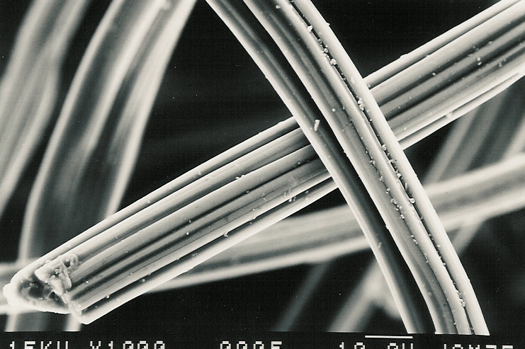  10 μm  A)  Felt | 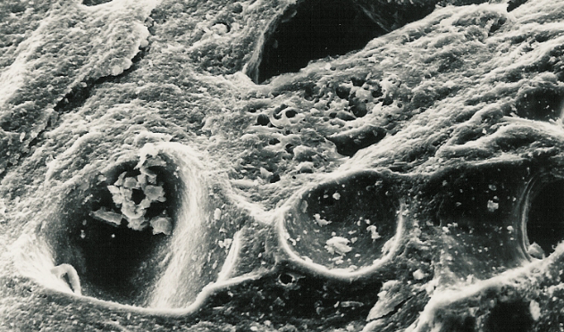  Powder  B)  10 μm
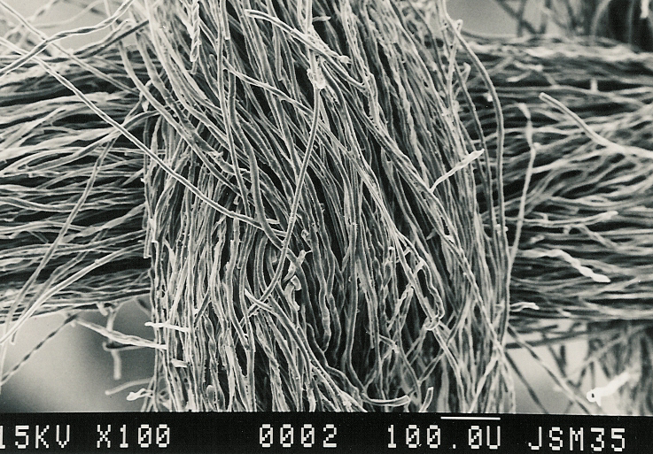  C)  Woven cloth  100 μm | 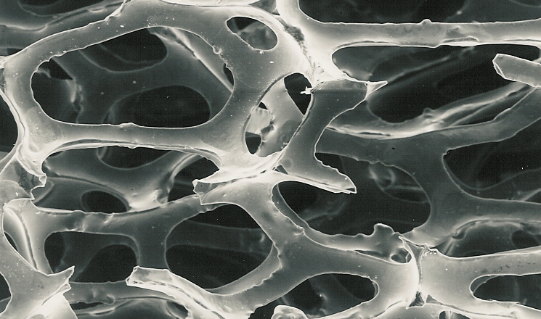  Foam  100 μm  D)
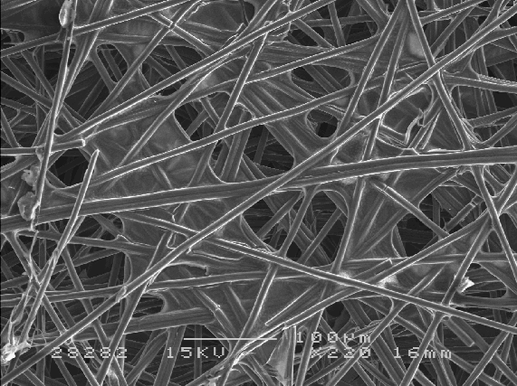
Porous carbon
paper
E)
100 μm

Fig. 5b)

Types of electrode
Single piece
Flat plate
Metal mesh
Packed or fluidised beds
Dispersed particle
Multiple particle
Carbon or metal foam
Perforated or louvered plate

Fig. 6

Fig. 7

Fig. 8a)

Fig. 8b)

70 mm
90 mm
Electrolyte inlet (10 mm diameter)
Electrolyte channel
Silicone rubber gaskets

Nickel electrode cavity
Carbon electrode
Electrolyte exit (10 mm diameter)
Acrylic plates
150 mm
90 mm
130 mm
S = 40 mm
90 mm
Flow direction
B =6.6 mm

Fig. 9a)

Fig. 9b)

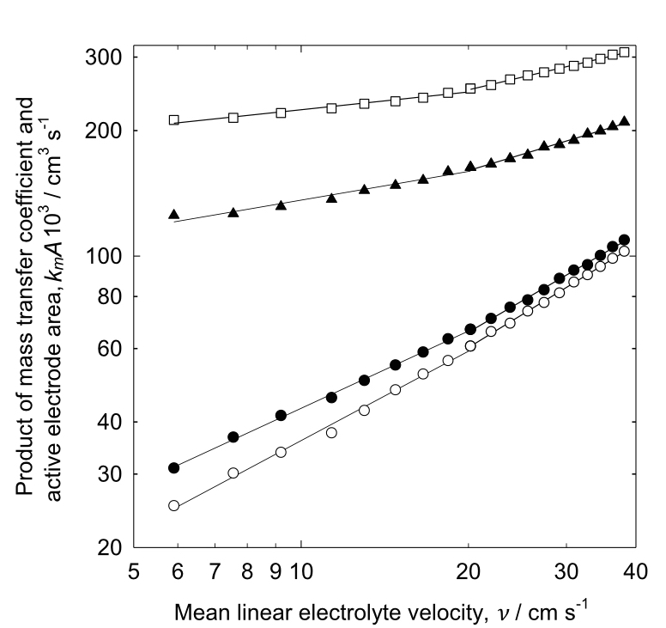
Fig. 9c)

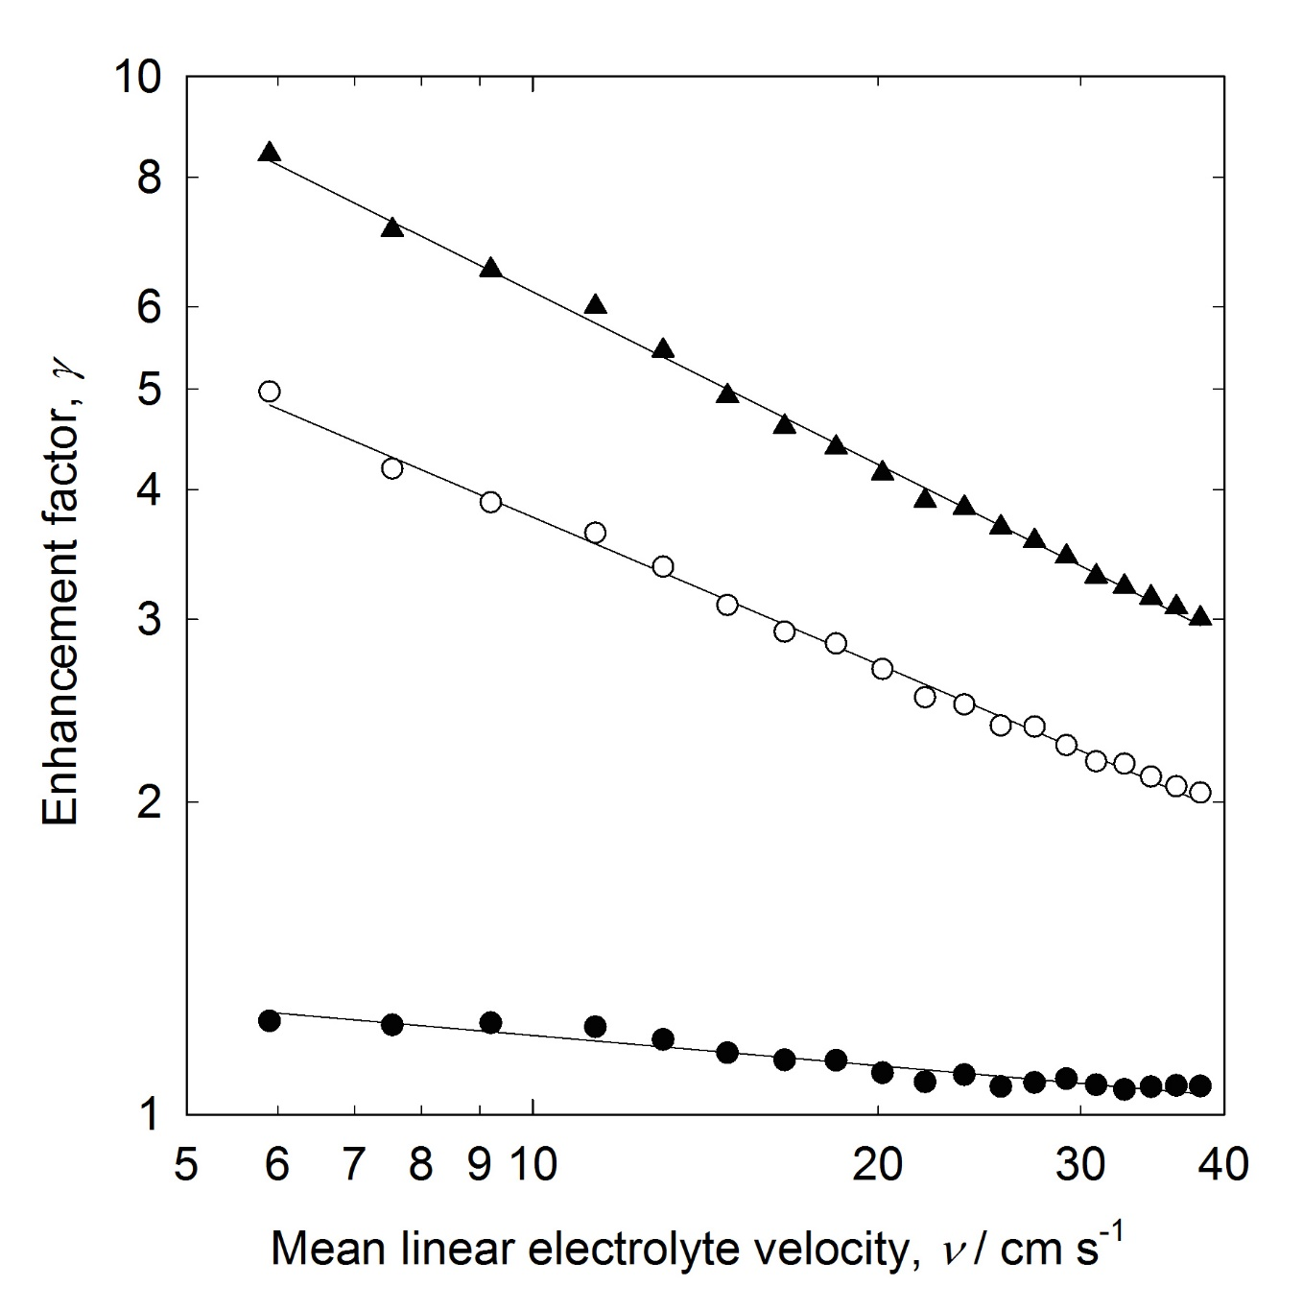
Fig. 9d)

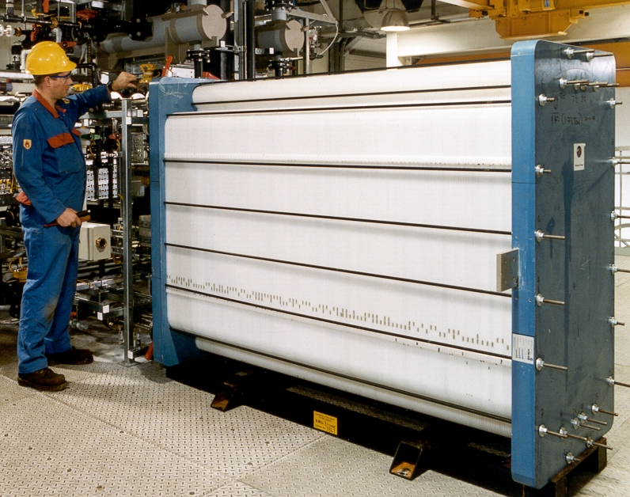

Fig. 10a)

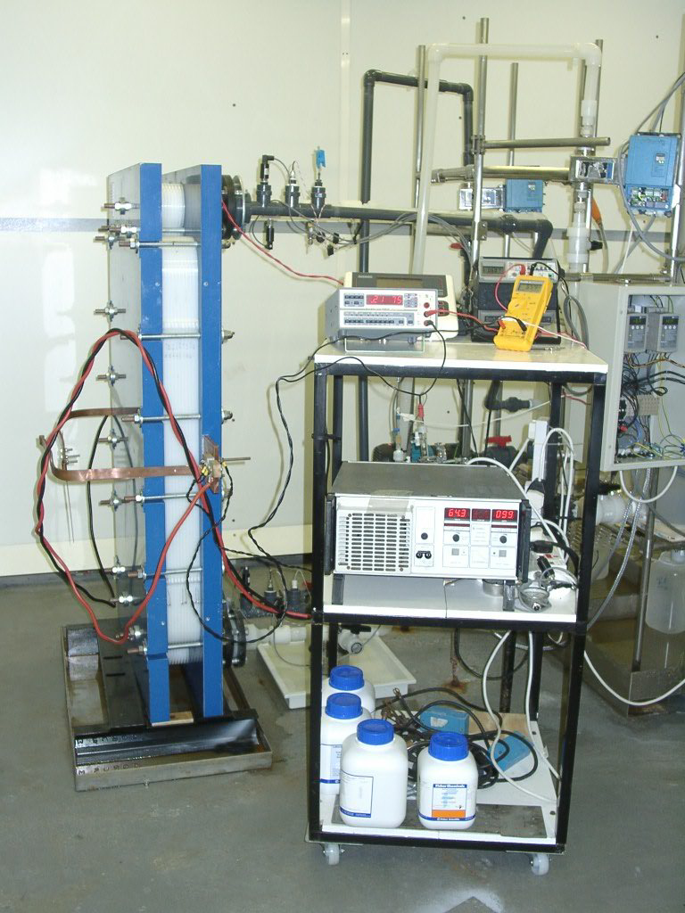

Fig. 10b)

Negative electrolyte outlet
outlet
Negative electrolyte inlet
Positive electrolyte inlet
Positive electrolyte outlet
Electrode area
1080 mm
668 mm
1400 mm
750 mm

Fig. 10c)

Fig. 10d)

Fig. 10e)

10 bipolar cells in a redox flow cell stack
Electromagnetic flow meters
P
T
G
P
T
G
Positive electrolyte inlet
Negative electrolyte
inlet
Positive electrolyte outlet
Negative electrolyte outlet
P
T
G

P
G

Positive electrolyte reservoir. 1 M NaBr in 0.5 M H₂SO₄ at pH 2.
Pump

Luggin capillary
ports
Negative electrolyte reservoir. 0.5 M Na₂SO₄ at pH 2.
T
Pump

Fig. 10f)

Figure 10g)

Grafoil
Copper backplate
Polyvinyl chloride frame
M5 stainless steel tie-bar
Carbon polymer feeder
PTFE gasket
Carbon felt electrode
20 mm
180 mm
24 mm
9 mm
64 mm
Nafion 115 membrane
Positive plate
Negative plate

Fig. 11a)

Outlet manifold
Copper backplate
Grafoil
Carbon-polymer feeder
PTFE gasket
Nafion 115 membrane
Inlet manifold

10mm
100 mm
Carbon felt electrode
electrode
Negative frame
Positive plate
Fig. 11b)

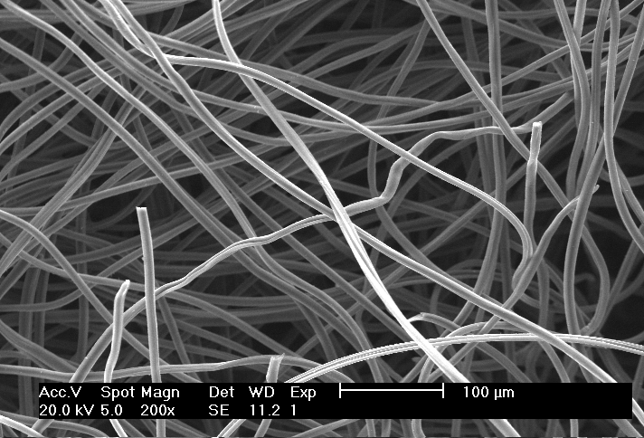
_________100 μm

Fig. 11c)

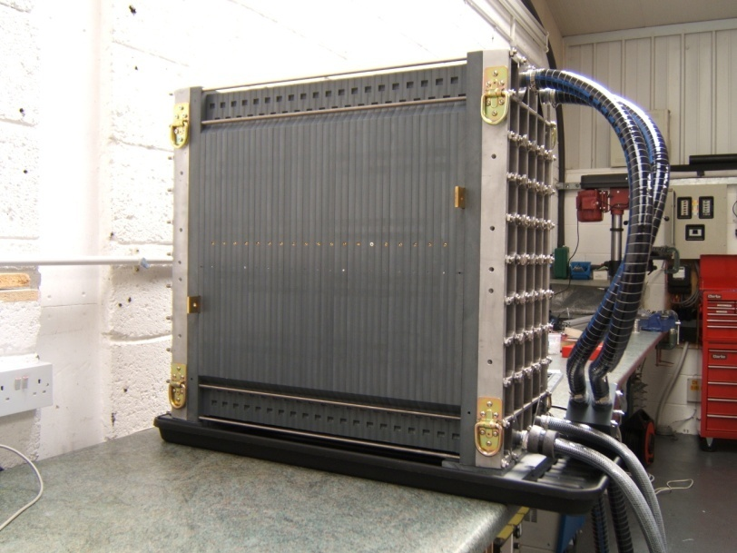
Fig. 11d)

-
Cylindrical foil of metal to be deposited or inert metal anode
Controlled speed motor
50 rpm < ω < 1550 rpm
Silver filled graphite
brush

Liquid level
Suspended particles
18 mm i.d.
19 mm o.d.
Optional magnetic stirrer
Ni-inert particle composite deposit
Mild steel or copper tube connected to the electrically insulated copper wire feeder
Pyrex glass beaker
Rubber stopper wrapped by Cu wire loops
Rubber stopper
Electrically insulated copper rod
+

+

Cylindrical foil of metal to be deposited or inert metal anode

Silver-plated copper slip ring

Chuck

Fig. 12a)

Fig. 12b)

Metal powder deposit
Reciprocating point scraper
Outlet manifold
Anolyte compartment
Inlet manifold
Reciprocating tufnol scraper shaft
Stainless steel RCE
Bearing
Cation exchange membrane
Seal
Catholyte
compartment
Polypropylene cell body
Perforated Ni anode
Reference electrode probe

Polypropylene end caps

Fig. 12c)

2-D planar area used in simulation
Top insulator (PTFE)

Bottom insulator (PTFE)
Bottom support (polycarbonate)
RCE working electrode (AISI 316 stainless steel)
Concentric cylindrical mesh counter electrode (Pt/Ti)
Concentric cylindrical insulator (polycarbonate)
Cylindrical electrolyte container (glass)
110 mm
200 mm
8.0 cm
25 mm

6 mm
44 mm
x = 80 mm cm
x = 0 mm cm
Axis of rotation
Fig. 13a)

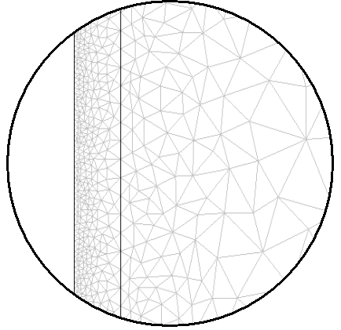
y = 0
y = δ_{N}
Counter electrode boundary
Working electrode boundary
Diffusion region
Free electrolyte region
Axis of rotation

Top insulator (PTFE)
Bottom insulator (PTFE)
Inner concentric cylindrical insulator (polycarbonate)
Cylindrical electrolyte container (glass)
55 mm
200 mm
x = 0 cm
x = 80 mm
16 mm
Fig. 13b)

Fig. 13c)

e
c
i
h
d
a
g
b
+
-

Fig. 14a)

Fig. 14b)

Spray jet
Electrolyte inlet
Carbonised perforated pegboard
Electrolyte flowing as
a thin film
Polymer mesh
Porous upper
cathode
feeder,
Pt-Ti
Electrolyte outlet

+
-
+
-
+
-
+
-
+
-
+
-
+
-
+
-
+
-
+
-
+
-
+
-
+
-
+
-
+
-
+
Central, back to back porous anode feeder, C or Pt-Ti

-
Porous lower
cathode feeder,
Pt-Ti
Stainless steel upper cup (earthed)
Replaceable upper cartridge
-
Stainless steel lower cup (earthed)
Replaceable lower cartridge
Fig. 14c)

Fig. 14d)

-U

Fig. 15a)

-U

Fig.15b)

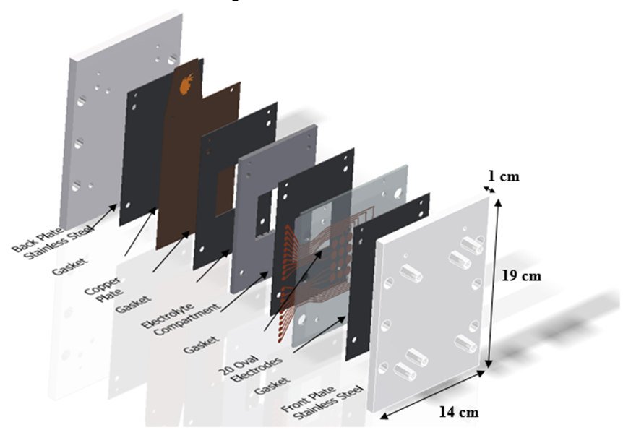

Figure 16a)

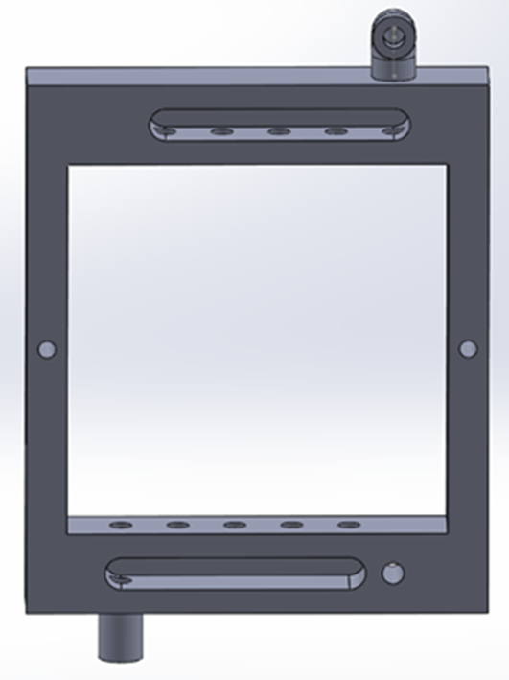

Figure 16b)

Figure 16c)
Figure 17

