**Supplementary Information**

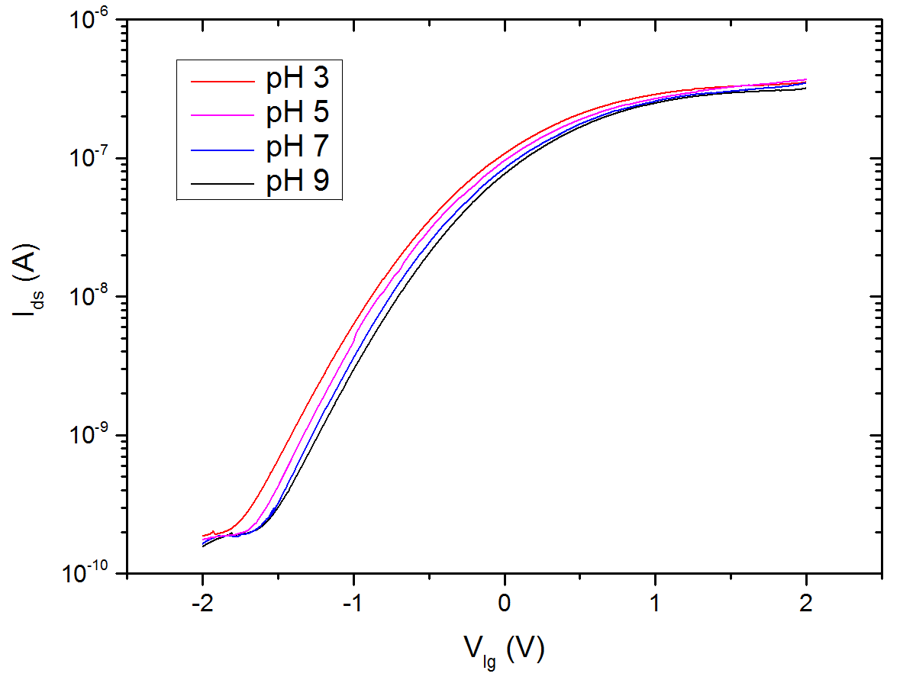

**Figure S1:** TFT nanoribbon sensor source-drain current (Ids) vs liquid gate voltage (Vlg) measured for four different pH buffer solutions (3, 5, 7, and 9). The sensitivity on threshold voltage change is around 32 mV/pH.



**Figure S2:** Data showing pH change due to isothermal amplification of DNA by RPA measured with a commercial pH microelectrode for 9,000 initial copies. The black curve is the pH change measured in the NR sensor well, and the red curve is the pH change measured in a commercial plastic microwell for the same reaction. Differential pH changes are similar at 0.93 ± 0.06 and 1.02 ± 0.04 respectively. Data are the mean ± S.D (three individual measurements were performed in two different NR sensor wells, and three individual measurements were done in three different microwells).



**Figure S3:** *DNA amplification curves for for real time benchtop assays, based on fluorescence measurement. (a) Average of triplicate RPA reaction for NCTC13441 E.Coli DNA containing blaCTX-M-15 gene. (b) Average of a triplicate RPA reaction for NCTC13443 K.Pneumoniae DNA containing blaNDM-1 gene.*

**pH calculation:**

During DNA synthesis, for every base added, pyrophosphate and H+ are generated. The maximum concentration of H+ generated will be equal to the initial concentration of primers x length of the amplicon (DNA being amplified). In our case this is: 20 μM x 260 = 5.2 mM. In addition, during the RPA ATP is hydrolysed releasing a proton. However, this cannot be quantified owing to the presence of creatine and phosphocreatine in the solution which serves to create additional ATP.

The change in pH of the solution can be calculated as follows:

Given the buffer pKa (association constant) and the concentration of buffer, The [Henderson-Hasselbalch equation](https://en.wikipedia.org/wiki/Henderson%E2%80%93Hasselbalch_equation) gives the expected change of pH of the buffer.

$$pH=pKa+ \log_{10}\left(\frac{[A^{-}]}{[HA]}\right)$$

The initial pH of the RPA solution was measured with commercial pH probe to be is 8.25. The buffer concentration is unknwon but is in the range 10 to 20mM (1).

The pKa was measured to be apprximately 8.0 by absorption spectroscopy by titration using phenol red pH indicator. Assuming the buffer to be 20 mM and a suspension volume is 50 μL, then the initial values of [A-] and [HA] are 0.64 and 0.36 μMoles.

The maximum concentration of H+ generated is 5.2 mM and the volume is 50 μL, thus the amount of H+ generated is 0.26 μMoles. Therefore the value of [A-] and [HA] are changed to 0.38 and 0.62 μMole giving a final pH change (from the [Henderson-Hasselbalch equation](https://en.wikipedia.org/wiki/Henderson%E2%80%93Hasselbalch_equation)) of 7.79, a pH change of 0.46 pH units. Assuming the buffer to be 10mM predicts a pH change of 1.12 pH units.

[1] O. Piepenburg, C. H. Williams, D. L. Stemple, and N. A. Armes, "DNA detection using recombination proteins," *Plos Biology,* vol. 4, pp. 1115-1121, Jul 2006