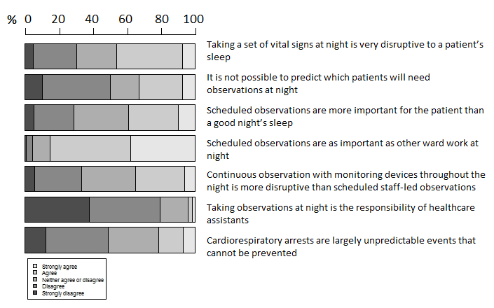
Fig. 1. Beliefs influencing monitoring at night

