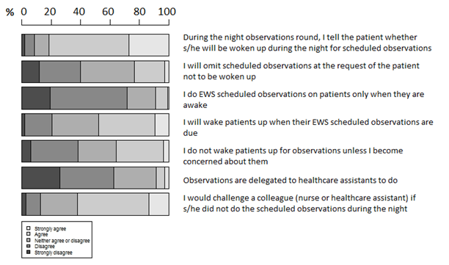
Fig. 2 Behaviours influencing compliance with EWS scheduled observations at night

