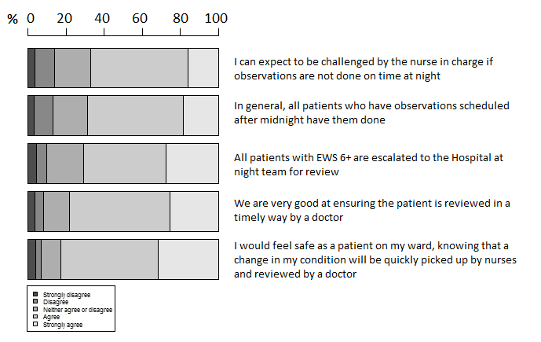

Fig. 4. Beliefs of ward efficiency at night to conduct observations

