Development of Breast Cancer Choices: A decision support tool for young women with breast cancer deciding whether to have genetic testing for BRCA1/2 mutations

Chloe Grimmettª (Orcid ID: 0000-0002-7540-7206), Charlotte Brooksª, Alejandra Recio-Saucedo^{b}, Anne Armstrong^{c}, Ramsey I Cutress^{d}, D Gareth Evans^{e}, Ellen Copson^{d}, Lesley Turner^{f}, Bettina Meiser^{g}, Claire E. Wakefield^{h,i}, Diana Eccles^{d} & Claire Fosterª (Orcid ID: 0000-0002-4703-8378)

- Faculty of Health Sciences, University of Southampton, Southampton, UK
- National Institute for Health Research (NIHR) Collaboration for Applied Health Research and Care (CLAHRC) Wessex, University of Southampton, Southampton, UK
- Christie Hospital NHS Foundation Trust and Faculty of Biology, Medicine and Health, The University of Manchester, Manchester, UK
- Cancer Sciences, Faculty of Medicine, University Hospital Southampton NHS Foundation Trust, Southampton, UK
- Genomic Medicine, Division of Evolution and Genomic Sciences, University of Manchester, Manchester, UK
- Research Partner
- Faculty of Medicine, University of New South Wales, New South Wales 2033, Australia
- Kids Cancer Centre, Sydney Children’s Hospital, Randwick, New South Wales 2031, Australia
- School of Women’s and Children’s Health, UNSW Sydney, New South Wales 2031, Australia

Corresponding authors at:
- Professor Claire Foster, Faculty of Health Sciences, University of Southampton, Southampton, UK. Email: C.L.Foster@soton.ac.uk, Telephone: +44 (0)23 8059 6885, Fax: +44 (0)23 8059 7967
- Professor Diana Eccles, Cancer Sciences, Faculty of Medicine, University Hospital Southampton NHS Foundation Trust, Southampton, UK. Email: D.M.Eccles@soton.ac.uk, Telephone: +44 (0)23 8120 8537, Fax: +44 (0)23 8120 4346
Acknowledgements
We thank all the participants involved in the study and the staff involved in recruitment. We also wish to acknowledge the time and expertise provided by the members of the Expert Design Team and Study Advisory Group; Munaza Ahmed, Emma Bourne, Jackie Harris, Rebecca Petch, Saskia Sanderson, Bjoern Schukowsky and Irma Verdonck de Leeuw.

Funding
Development of this decision support tool was funded by Breast Cancer Now.
Claire Wakefield is supported by a Career Development Fellowship from the National Health and Medical Research Council of Australia (APP1067501).

Abstract
Purpose: To develop a decision support tool for young women with breast cancer considering genetic testing for BRCA1/2 mutations soon after cancer diagnosis.
Methods: A four-staged iterative development process was employed; stage 1 – literature review exploring the availability and efficacy of empirically tested decision support tools, stage 2 – in-depth interviews with 29 young women (<50 years) recently diagnosed with breast cancer, exploring information requirements and experiences of genetic testing decision making, stage 3 – three focus groups (N = 21) exploring preferences for information presentation and prioritisation of content, stage 4 - Think-aloud interviews to refine the prototype (N=16).
Results: Participants wanted information regarding the pros and cons of testing, the testing process and implications for their family, presented in a way that allowed them to choose the level of detail they required. They preferred the term ‘altered gene’, valued a medical word definition function and warnings before accessing sensitive information.
Conclusion: Participants valued the decision support tool, the accessibility of the information and its clinical endorsement. The decision support tool has considerable clinical utility as an adjunct to genetic counselling or for use in busy oncology clinics where formal genetic counselling may be unavailable.

Keywords
Decision aid; BRCA; genetic testing; breast cancer

- Introduction
Young women (<40 years) with breast cancer are more likely to have inherited a mutation in the breast cancer susceptibility genes BRCA1 and BRCA2 compared to their older counterparts [1]. In the past, genetic testing has been available only to women with a family history of cancer and has been offered most often some years after active treatment/s have been completed. However technological advances have increased the speed and reduced the cost of genetic testing. Research testing in large cohorts of breast cancer patients has also confirmed the relatively high prevalence of deleterious mutations amongst young women even with no selection for family history of breast or ovarian cancer [2]. In addition, there is an emergence of targeted drug therapies for women with BRCA mutations [3], as well as adding platinums to chemotherapy regimens [4]. Furthermore, as women with BRCA mutations are more likely to develop a future contralateral breast cancer, knowledge of BRCA1/2 status can inform decision making about surgery, primarily between breast conserving surgery and therapeutic mastectomy and/or contralateral mastectomy. Treatment directed genetic testing (TDGT) is therefore increasingly being offered to young women with breast cancer.
With growing demand on genetic counselling and testing services, the time and expertise to fully inform women about the risks and benefits of genetic testing are often limited, particularly if the option of genetic testing is raised in a busy oncology treatment clinic. There is a paucity of data on the information needs of young women about TDGT [5], therefore, there is a need to better understand these needs and to develop educational resources to support women to make informed decisions about genetic testing at the time of their cancer diagnosis [6]. Decision support tools can provide information to patients, communicate the risks and benefits of the options available and help to clarify patients’ values by evaluating the outcomes that matter most to them [7]. A Cochrane review of decision support tools for medical treatment or screening choices concluded that compared to usual care, patients were better informed about medical treatment and screening choices and had more clarity as to what matters most for them when making such decisions [8]. A number of decision aids to support decision making around genetic testing have been developed for those at high risk of breast cancer and those considering testing after treatment completion [9-11]. However, resources designed specifically for younger women around the time of diagnosis are scarce. This paper describes the development and pilot testing of a web-based decision support tool ‘Breast Cancer Choices’ designed for young women choosing whether to have genetic testing around the time of breast cancer diagnosis.

- Methods
2.1 Development
The development of the decision support tool was informed by the Medical Research Council’s guidance [12] for the development of complex interventions. It consisted of four key phases;
Phase 1: A systematic literature review to explore the availability and efficacy of empirically tested decision support tools was conducted [13]. A scoping review of the information needs of women with breast cancer considering genetic testing around the time of diagnosis, and of publically available patient resources was also conducted.
Phase 2: Cross-sectional semi-structured in-depth interviews to explore views, experiences and information requirements of young women about genetic testing.
Phase 3: Focus groups to explore how information can be most usefully presented, and how best to interrogate and prioritise content of the decision support tool.
Phase 4: Think-aloud interviews to refine the prototype decision support tool using feedback from ‘real life’ use.
See Fig. 1 for study flowchart and a brief description of the purpose of each study phase. Multiple stakeholder involvement was embedded at all stages of development through a Study Advisory Group (comprising the research team, clinicians, patients, and a web developer) and Expert Design Team (surgeon, consultant oncologists, consultants in clinical and medical genetics, academics with expertise in decision aid development and charity organisations).
The International Patient Decision Aids Standards (IPDAS) collaboration provide a quality assessment framework for the development of patient decision aids. This includes criteria for both content and development processes [14]. This framework guided the development of our tool. The tool was also informed by Fuzzy Trace Theory [15], the Ottawa Decision Support Framework [16] and Coulter et al.’s (2013) [17] development process for decision support tools.
2.2 Recruitment and sampling
The study received ethical approval from the NRES Committee South West – Cornwall and Plymouth (Reference: 14/SW/1181).
Participants for in-depth interviews, focus groups and think-aloud interviews were recruited from two hospitals in the UK between September 2015 and June 2016, both were tertiary cancer centres.
Participants were able to take part in more than one phase of the study. Women were eligible for inclusion if they had been diagnosed with invasive, early stage breast cancer in the previous 18 months and were aged <50 years at the time of diagnosis. Patients unable to read English, under 18 years of age and unable to give informed consent were excluded from the study. Those with metastatic disease were also excluded as it was felt their experiences and priorities regarding genetic testing were likely to be different to those with local disease.
2.3 In-depth interview, focus group and think-aloud interview procedures
In-depth interviews: Semi-structured interviews were conducted using an interview guide, either by telephone or in person at the participant’s home by one of two researchers (CG and CB). Interviews were tailored according to whether or not participants had experience of genetic counselling and/or testing. Participants were asked about their personal experiences of genetic counselling/testing and how they reached their decision, information needs prior to deciding about counselling/testing, how information should be presented within a decision support tool and the timing of information delivery. Interviews were audio recorded and transcribed verbatim. The data were interrogated using framework analysis, coded inductively and used NVIVO software to manage the data. A seven stage process was used [18]: 1. transcription, 2. familiarisation with the interview, 3. coding, 4. developing a working analytical framework, 5. applying the analytical framework, 6. charting data into the framework matrix, and 7. interpreting the data. Interviews were conducted until data saturation was reached. Author CB coded the data and CG and ARS independently coded three of the transcripts.
Focus groups: The aim of the focus groups was to explore key topics to be included in the tool and prioritisation of the provisional content, preferences for the depth of information, presentation of risk and numerical data. The focus group participants were shown options for visually presenting information on probability (i.e. probability of developing a second primary breast cancer depending on genetic mutation status), and to describe how mutations in the BRCA genes are passed down through families.
A third focus group was held to review the first iteration of the prototype. Participants were emailed a link to the prototype to review in advance.
All focus groups were audio recorded and transcribed verbatim. Transcripts were interrogated using a framework approach [18].
Think-aloud interviews: Think-aloud interviews were used to test the second and third drafts of the prototype [19]. This method of user testing allowed the research team to observe user interactions with the resource, assess usability issues, user satisfaction and acceptability. Participants were briefed as to the purpose of the interviews and critical feedback was encouraged. Interviews were audio recorded and notes taken throughout, ensuring details of the pages and functionalities referred to were linked to descriptions of the subject’s experience. Audio recordings were revisited along with notes and content analysis used to identify necessary modification.
After each review of the prototype, suggested modifications needed to be prioritised. The MoSCoW prioritisation model was used to manage these revisions [20]. This provides a methodology for managing feedback, allowing developers to prioritise the essential aspects leading to successful completion of a project in a given time. The research team collated feedback and coded each suggested amendment as M – Must have; S – Should have; C – Could have; W – Would like if time allows. Where opposite views were expressed regarding suggested modifications, the issue was re-visited during the next development phase.

- Results
  - Phase 1 – literature reviewing
A systematic literature review was conducted to identify existing resources to support decision making regarding BRCA1/2 testing at the time of breast cancer diagnosis [13]. In brief, six resources were identified with only two targeted toward young women [21, 22]. Other resources included a tool for those with low literacy [23], women with low/moderate risk of carrying a BRCA mutation [24] and those recently diagnosed with high-risk of BRCA mutation [25]. Finally a novel home-based genetic counselling model for women referred to genetic services was identified [26]. Where these resources were evaluated, they were well received. Women preferred the use of simple language as well as inclusion of pictures, patient stories and diagrams to support risk presentation. None of the resources identified were web-based.
Qualitative interviews with young women with breast cancer conducted by Meiser and colleagues (2012) [22] to inform the development of their educational leaflet found that women favoured brief information that included the following details: data on the chances of carrying a BRCA mutation; subsequent impact on future cancer risk, possible impact of the results on the patient’s treatment options, how the test is carried out and how long the results would take.
In the main, these resources were designed as educational aids to increase knowledge and understanding of hereditary breast cancer, and they tended not to have a theoretical underpinning or include value-based exercises to support decision making. Furthermore, none of the resources were developed in the UK and therefore did not consider the UK’s health care system. Tailoring to the national context in relation to health care provision is important to patients to ensure its relevance [27]. We concluded that there was a need for a robustly developed, theoretically informed decision support tool, designed specifically for young women around the time of breast cancer diagnosis, and relevant to the UK health system, to support decision making about genetic testing.
A number of publically available patient resources were also identified within our scoping review and helped to inform tool content. These included publications from the Royal Marsden NHS Foundation Trust UK [28], University Hospital Southampton NHS Foundation Trust UK [29] and Royal North Shore Hospital, Australia [30]. Information available online from charity organisations including Macmillan Cancer Support, Breast Cancer Now, and Breast Cancer Campaign were also consulted. Patient decision aids available through the Ottawa Patient Decision Aid website (www.decisionaid.ohri.ca) also provide examples of structuring values-based exercises.
  - Sample characteristics
Two hundred and twenty-nine eligible women were sent patient information packs. Sixty-eight reply slips were received (30% response) and 45 went on to take part in at least one phase of the study development. Women could take part in more than one phase. Twenty nine women took part in in-depth interviews, 21 took part in focus groups (11 of whom had also participated in the in-depth interviews), and 16 participated in think-aloud interviews (10 of whom had participated in either in-depth interviews or a focus group).Table 1 presents participant demographic and clinical characteristics.
  - Phase 2 - In-depth interviews
Twenty-nine in-depth interviews were conducted, 20 by telephone and 9 at participants’ homes. Key themes and sub-themes from the interviews are presented in Table 2 with accompanying quotes.
Data from the in-depth interviews and literature reviews informed the development of an initial draft of the content of the decision support tool. This was reviewed and refined by the Study Advisory Group.
3.4 Phase 3 - Focus groups
Initially two focus groups, one with women who had undergone genetic testing (n=7, 4 of these had also taken part in interviews) and another with women who had not (n=7, 1 had also taken part in an interview) were conducted. The first two group discussions usefully guided the content and structure of the decision support tool (see Table 3 for summary of results).
Women suggested the ‘gist’ of each section of information be presented first, followed by further details, providing flexibility as to the level of detail accessed. They also highlighted the importance of warning the user before accessing potentially sensitive information on actual risk of BRCA associated cancers. Women also preferred the term ‘altered gene’ in favour of ‘mutation’ or ‘faulty gene’.
Following these focus groups, the content was refined, graphs/diagrams selected and a schematic outline of the structure of the website proposed. This was then passed to a web-developer to construct a prototype decision aid (first iteration).
The purpose of the third group (n=7, 6 having taken part in previous interviews) was to examine the content, structure/layout, aesthetics, functions and activities embedded in the website. All areas apart from details for accessing private genetic testing (rather than through the National Health Service) were felt to be important by the three focus groups and therefore were included in the decision support tool.
At the same time as conducting the third focus group, the prototype underwent review by the Expert Design Team. Key findings from the third focus group and first Expert Design Team review are presented in Table 3. Participants approved the simple language and medical word definition function, but highlighted that there was too much text (although they valued the structure of providing the main points of each section, followed by further details). Participants also felt that the tool needed a ‘friendlier’ look and feel with more colour and pictures, with a number of participants describing the presentation as ‘dry’. Comments from the Expert Design Team mostly focused on clarifying content. A page detailing ‘what happens next’ was also suggested; that is, what the user could do once they have worked through the decision support tool.
3.5 Phase 3 - Think-aloud interviews
After seven interviews assessing usability of the second draft of the prototype it became apparent that the navigation of the website was problematic and users were not working through the decision support tool as intended. Interviews were halted and modifications made. Further Think-aloud interviews of the third draft revealed the need for only minor modifications and interviews were stopped after a further nine interviews, when data saturation was reached. During these last nine interviews participants found the revised navigation intuitive and gave a positive appraisal of the tool. Key findings relating to some suggested minor revisions are presented in Table 3.
3.6 The finalised decision support tool
Table 4 describes the content of the final decision support tool and how the content/functions relate to the IPDAS checklist. Screenshots of three pages of the decision support tool are presented in Fig. 2. Where visual diagrams are included, words and numbers to describe probabilities are also provided.
Navigation was kept as simple as possible. Users are directed through the five core pages in order, with ‘next’ and ‘previous’ buttons. There is an option to print the entire website as a PDF document. Results of the values-based exercise can also be printed as a separate document to discuss with family/friends or a health care provider. Logos at the bottom of the website demonstrate endorsement by National Health Service organisations, academic institutions, a third charity organisation (project funder), as well as Independent Cancer Patients’ Voice, a patient advocate group, a representative of which was included as a member of the Study Advisory Group and Expert Design Team.
The content and design of the decision support tool considers those with lower health literacy. This includes the use of diagrams/pictographs and text to explain risk and genetic inheritance, simple language and presentation of essential information first, use of narrative (patient stories) to increase the salience of the information presented, avoidance of negative framing, providing definitions for complex terms and ensuring sentences are short [31]. Readability of the tool was equivalent to 7th grade level as assessed by the SMOG readability formula [32], meeting the IPDAS guidelines of grade 8 or below [14].

4. Discussion and conclusion
This article describes the development of Breast Cancer Choices, a web-based decision support tool for young women with breast cancer considering genetic testing for BRCA1 and/or BRCA2 mutations. A rigorous design and development process was used. Extensive use of in-depth interviews, focus groups and Think-aloud activities ensured that the tool was tailored to the needs and preferences of young women with breast cancer, and it was positively reviewed during the final Think-aloud interviews. Coupled with evidence from existing literature, theory and input from our Expert Design Team, we ensured the included information reflected the current state of evidence and was relevant for use in the chosen health care system.
Adherence to the IPDAS guidelines provided a guide and ensured the tool met the quality criteria. Patient input also shaped the theoretical underpinning of the tool. Women described wanting to ‘get the gist’ of the information on each page and then access further details if they wished to do so. This aligns with Fuzzy Trace Theory, a theory of medical decision making grounded in basic research on memory and probabilistic reasoning. It holds that people make decisions, often based on a vague gist, rather than verbatim details [15]. This informed the structure of the pages, providing a ‘main points’ box, followed by more in-depth information. As a result, the decision support tool was developed with basic information presented first and the option to read further details if desired.
Findings from the initial in-depth interviews regarding content and presentation requirements bore similarities to those described by Meiser et al. (2012) [22]. Women’s preferences in this study included the provision of details concerning their chances of carrying the BRCA gene and the impact of a mutation on their future cancer risk, as well as how the test is carried out and the impact of results on treatment. In contrast to Meiser et al. [22], who reported a preference for brief information, participants in this study described how their desire for depth of information varied; sometimes only wishing to read an overview of the information and at other times wanting to explore issues in more detail. The current tool facilitates both types of engagement.
This study is subject to limitations. The majority of participants were White British, well-educated and recruited through two research active hospitals in the UK, thus potentially limiting the generalisability of findings. Similarly, the fact that some women participated in more than one phase of the study may have limited expression of opinions regarding the content and functionality of the tool. Representation of those with BRCA mutations was limited with three participants known to carry a confirmed BRCA mutation and one carrying a variant of unknown significance (VUS). Furthermore, the response rate was relatively low, with 20% of those eligible taking part in at least one stage of the project. However, this is comparable to previous studies [33] and likely reflects that fact that this is a difficult and busy time for these women. Finally,
4.1 Practice implications:
With specialist genetic counselling services unlikely to meet the increasing demands for BRCA testing surgeons, medical oncologists and other health professionals are increasingly having to provide support for patients. These professionals may lack genetics experience for providing such support. The health professionals (consultant in clinical genetics, consultant oncologist, surgeon and clinical nurse specialist) involved in the development of Breast Cancer Choices supported the practical utility of the tool to support these conversations. The tool was designed to be accessed independently by patients, outside of clinical consultations and could then be used as the basis of discussion within genetic counselling consultations. Equally it could support decision making in an oncology clinic or for patients undergoing genetic testing for BRCA1/2 as part of a clinical trial when support for decision making is most often absent.
Recent evidence suggests that without adequate understanding of genetic testing results patients may receive inappropriate treatment. Kurian et al. (2017) [34] conducted a population-based study of breast cancer patients surveyed about genetic testing experiences. They report that despite no survival benefit of bilateral mastectomy (BLM) for women with VUS results, half of the surgeons in their study did not recognise the difference between VUS and known pathogenic mutations (such as BRCA1/2) and managed the patients in the same way. It is therefore imperative that women (and surgeons) understand possible genetic test results and are aware that BLM would not be recommended for women who are found to be negative or have a VUS. Breast Cancer Choices presents a tool that can provide this information.
Future research: The need for tools to support decision making in the rapidly changing arena of genetic testing is clear and these should be evidence-based. It is therefore intended that the tool presented here be evaluated in a pragmatic trial to explore its impact on genetic testing and surgical decision making as well as psychological morbidity. Furthermore, this decision support tool could provide a platform for a suite of tools for other treatment decisions in this population such as surgery and chemotherapy.

Conflict of interest
The authors declare that there is no conflict of interest.

Ethical approval
All procedures performed in studies involving human participants were in accordance with the ethical standards of the institutional and/or national research committee and with the 1964 Helsinki declaration and its later amendments or comparable ethical standards.

Informed consent
Informed consent was obtained from all individual participants included in the study.

References
1. Trainer AH, Lewis CR, Tucker K, et al (2010) The role of BRCA mutation testing in determining breast cancer therapy. Nat Rev Clin Oncol 7:708-717. doi:10.1038/nrclinonc.2010.175
2. Couch FJ, Hart SN, Sharma P et al (2015) Inherited mutations in 17 breast cancer susceptibility genes among a large triple-negative breast cancer cohort unselected for family history of breast cancer. J Clin Oncol 33:304-311. doi:10.1200/JCO.2014.57.1414
3. Scott CL, Swisher EM, Kaufmann SH (2015) Poly (ADP-Ribose) Polymerase Inhibitors: Recent Advances and Future Development. J Clin Oncol 33:1397-1406. doi:10.1200/jco.2014.58.8848
4. Tutt A, Ellis P, Kilburn L et al (2014) TNT: A randomized phase III trial of carboplatin compared with docetaxel for patients with metastatic or recurrent locally advanced triple negative or BRCA 1/2 breast cancer. San Antonio Breast Cancer Symposium 2014; 9-13 December 2014; San Antonio, Texas, USA
5. Recio-Saucedo A, Gerty S, Foster C et al (2016) Information requirements of young women with breast cancer treated with mastectomy or breast conserving surgery: A systematic review. Breast 25:1-13. doi:10.1016/j.breast.2015.11.001
6. Meiser B, Tucker K, Friedlander M et al (2008) Genetic counselling and testing for inherited gene mutations in newly diagnosed patients with breast cancer: a review of the existing literature and a proposed research agenda. Breast Cancer Res 10:216. doi:10.1186/bcr2194
7. O'Connor AM, Bennett C, Stacey D et al (2007) Do patient decision aids meet effectiveness criteria of the international patient decision aid standards collaboration? A systematic review and meta-analysis. Med Decis Making 27:554-574. doi:10.1177/0272989X07307319
8. The Cochrane Collaboration (2017). Decision aids to help people who are facing health treatment or screening decisions (http://www.cochrane.org/CD001431/COMMUN_decision-aids-help-people-who-are-facing-health-treatment-or-screening-decisions)
9. Wakefield CE, Meiser B, Homewood J et al (2008) A randomized trial of a breast/ovarian cancer genetic testing decision aid used as a communication aid during genetic counseling. Psychooncology 17:844-854. doi:10.1002/pon.1353
10. Wakefield CE, Meiser B, Homewood J et al (2007) Development and pilot testing of two decision aids for individuals considering genetic testing for cancer risk. J Genet Couns 16:325-39. doi:10.1007/s10897-006-9068-x
11. Wakefield CE, Meiser B, Homewood J et al (2008) A randomized controlled trial of a decision aid for women considering genetic testing for breast and ovarian cancer risk. Breast Cancer Res Treat 107:289-301. doi:10.1007/s10549-007-9539-2
12. Craig P, Dieppe P, Macintyre S et al (2008) Developing and evaluating complex interventions: the new Medical Research Council guidance. BMJ 337:a1655. doi:10.1136/bmj.a1655
13. Grimmett C, Pickett K, Shepherd J et al (2017) Systematic review of the empirical investigation of resources to support decision-making regarding BRCA1 and BRCA2 genetic testing in women with breast cancer.
doi: 10.1016/j.pec.2017.11.016
14. Elwyn G, O'Connor AM, Bennett C et al (2009) Assessing the Quality of Decision Support Technologies Using the International Patient Decision Aid Standards instrument (IPDASi). Plos One 4:e4705. doi:10.1371/journal.pone.0004705
15. Reyna VF (2008) A theory of medical decision making and health: fuzzy trace theory. Med Decis Making. 28:850-865. doi:10.1177/0272989X08327066
16. Ottawa Decision Support Framework https://decisionaid.ohri.ca/odsf.html
17. Coulter A, Stilwell D, Kryworuchko Jet al (2013) A systematic development process for patient decision aids. BMC Med Inform Decis 13:S2. doi:10.1186/1472-6947-13-s2-s2
18. Gale NK, Heath G, Cameron E (2013) Using the framework method for the analysis of qualitative data in multi-disciplinary health research. BMC Med Res Methodol 13:117. doi:10.1186/1471-2288-13-117
19. Yardley L, Morrison LG, Andreou P et al (2010) Understanding reactions to an internet-delivered health-care intervention: accommodating user preferences for information provision. BMC Med Inform Decis 10:52. doi:10.1186/1472-6947-10-52
20. Kuhn J (2009) Decrypting the MoSCoW analysis (DITY weekly newsletter). itSM solutions http://www.itsmsolutions.com/newsletters/DITYvol5iss44.pdf
21. Permuth-Wey J, Vadaparampil S, Rumphs A et al (2010) Development of a culturally tailored genetic counseling booklet about hereditary breast and ovarian cancer for Black women. Am J Med Genet A 152A:836-845. doi:10.1002/ajmg.a.33187
22. Meiser B, Gleeson M, Watts K et al (2012) Getting to the point: what women newly diagnosed with breast cancer want to know about treatment-focused genetic testing. Oncol Nurs Forum 39:E101-111. doi:10.1188/12.ONF.E101-E111
23. Thompson HS, Wahl E, Fatone A et al (2004) Enhancing the readability of materials describing genetic risk for breast cancer. Cancer Control 11:245-253. doi:10.1177/107327480401100406
24. Venne VL, Hamann HA (2007) Successful use of peer educators for sharing genetic information. J Genet Couns 16:515-525. doi:10.1007/s10897-007-9087-2
25. Vadaparampil ST, Malo TL, Nam KM et al (2014) From observation to intervention: development of a psychoeducational intervention to increase uptake of BRCA genetic counseling among high-risk breast cancer survivors. J Cancer Educ 29:709-719. doi:10.1007/s13187-014-0643-9
26. Sie AS, van Zelst-Stams WA, Spruijt L et al (2014) More breast cancer patients prefer BRCA-mutation testing without prior face-to-face genetic counseling. Fam Cancer 13:143-151. doi:10.1007/s10689-013-9686-z
27. Rapport F, Iredale R, Jones W et al (2006) Decision aids for familial breast cancer: exploring women's views using focus groups. Health Expect 9:232-244. doi:10.1111/j.1369-7625.2006.00392.x
28. The Royal Marsden NHS Foundation Trust UK (2013 – revised 2016) A beginner's guide to BRCA\1 and BRCA\2 https://www.royalmarsden.nhs.uk/sites/default/files/files_trust/beginners-guide-to-brca1-and-brca2.PDF
29. University Hospital Southampton NHS Foundation Trust UK (2016) BRCA genes and inherited breast and ovarian cancer, information for patients http://www.uhs.nhs.uk/Media/Controlleddocuments/Patientinformation/Genetics/BRCA-Genes-Inherited-Breast-and-ovarian-Cancer.pdf
30. Understanding genetic tests for breast and ovarian cancer that runs in the family. Information and decision aid (2014) http://www.genetics.edu.au/publications-and-resources/booklets-and-pamphlets/understanding-genetic-tests-for-breast-and-ovarian-cancer-that-runs-in-the-family-information-and-decision-aid
31. McCaffery K, Holmes-Rovner M, Smith S et al (2013) Addressing health literacy in patient decision aids. BMC Med Inform Decis 13:S10. doi:10.1186/1472-6947-13-S2-S10
33. McLaughlin GH (1969) SMOG grading: a new readability formula. J Reading. 12:639-646.
33. Culver J, Macdonald D, Thornton A et al (2011) Development and evaluation of a decision aid for BRCA carriers with breast cancer. J Genet Couns 20:294-297. Doi:10.1007/s10897-011-9350-4
34. Kurian AW, Li Y, Hamilton AS et al (2017) Gaps in Incorporating Germline Genetic Testing Into Treatment Decision-Making for Early-Stage Breast Cancer. J Clin Oncol 35:2232-2239. doi:10.1200/JCO.2016.71.6480.
Fig. 1
Literature reviewing
Patient interviews n=29
Focus groups 1&2
Development and evaluation of Breast Cancer Choices decision aid
Prototype design: 1st changes iteration
Design team review
Focus group 3
Think-aloud interviews n=7
Prototype design: 2nd changes iteration
Design team review 2
Prototype design: 3rd changes iteration
Think-aloud interviews n=9
Information needs of young women with breast cancer offered genetic testing
Resources around genetic testing for breast cancer
Explore patients understanding and expectations of genetic testing and information important for decision making about genetic testing
Explore prioritisation of the provisional content, preferences for graphical illustrations, discussion of possible inclusion of a values based exercise
Stakeholders involvement (clinicians, academics and third sector organisations). Review accuracy of clinical content. Advice on functionality and suitability for use in clinical settings
1st prototype review by patients. Design: name/logo and title, layout, graphs and diagrams. Feedback on quiz and values-based exercise
Patient assessment of usability, navigation, satisfaction and comprehension of the prototype
Second review by stakeholders group
Phase 4
Phase 4
Phase 4
Phase 3
Phase 3
Phase 3
Phase 2
Phase 1

Fig. 2
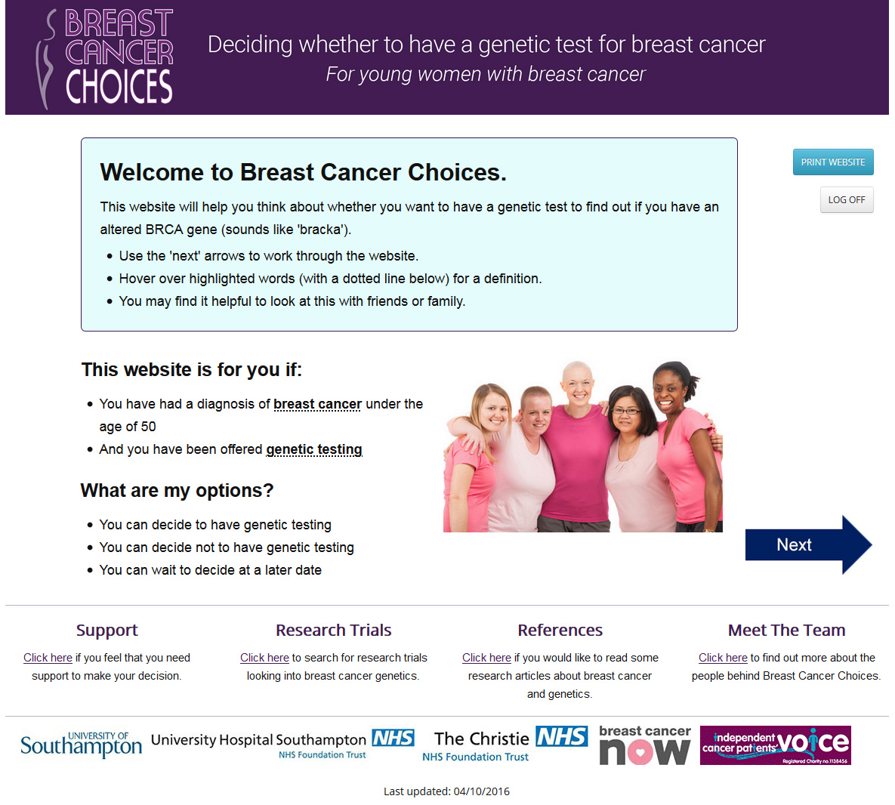
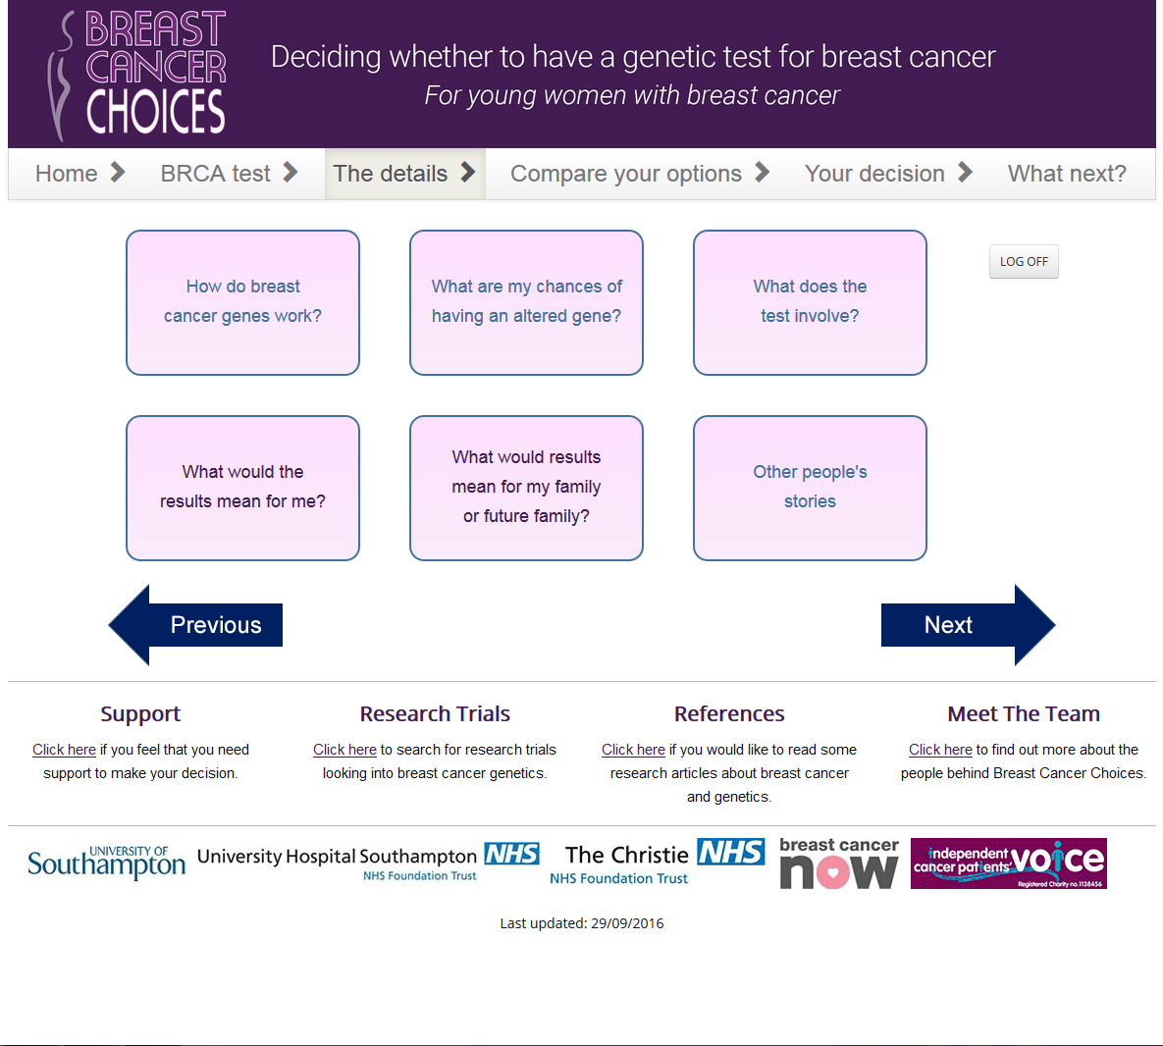

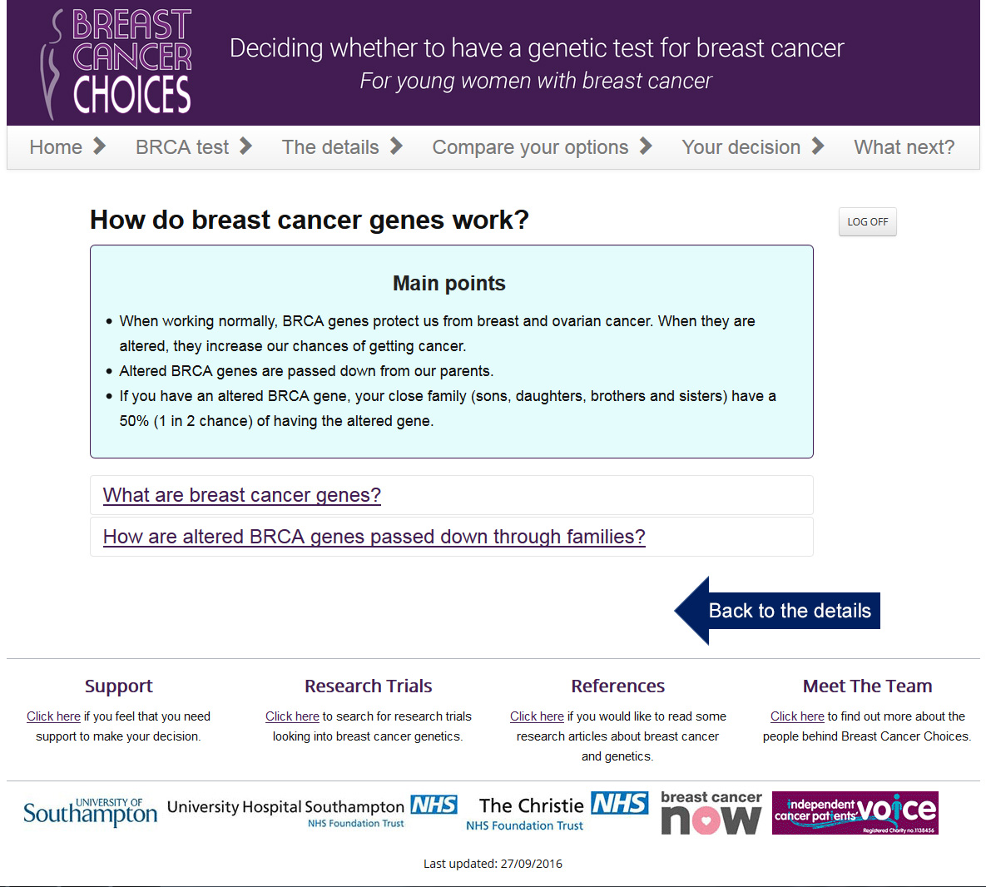
Table 1 Participant characteristics
N = 45
Age | Range 27-49 (mean 38)
Ethnicity  White British  Mixed white and black Caribbean  Chinese  Mixed white and black African  Asian or Asian British Indian  White British Jewish | 39 (87%)  2 (5%)  1 (2%)  1 (2%)  1 (2%)  1 (2%)
Marital status  Married  Single  Living with partner  Divorced or separated | 30 (67%)  6 (13%)  7 (15%  2 (5%)
Children  No children  Children | 11 (24%)  34 (76%)
Employment status  Full-time  Part-time  Sick leave/unpaid leave  Unemployed  Self-employed | 21 (47%)  6 (13%)  8 (18%)  6 (13%)  4 (9%)
Level of education  No formal qualifications  Secondary education  Sixth form/college  Undergraduate degree, postgraduate, or other professional qualification | 2 (5%)  7 (15%)  9 (20%)  27 (60%)
Received genetic counselling | 20 (44%)
Received genetic testing | 19 (42%)
BRCA1/2 mutation carrier | 3 (7%)
Variant of unknown significance | 1 (2%)

Table 2 Key themes and sub-themes from in-depth semi-structured interviews
Theme | Sub theme | Quotes
Content / knowledge requirements | Acknowledge personal attitudes and values | Everyone’s different, but I’m a bit... I like to plan and have an A, B and C. Umm... but that’s just the way I am.  So I decided that, you know, I could sit there with the weight on my shoulders knowing, yes, I have the gene or, no, I didn’t but... I could be hit by a bus tomorrow basically and you know, even if I found the faulty gene, I wasn’t gonna go for any of the preventative surgery because I still wanted to have that family.
 | Describe the pros and cons of having genetic testing | I’d like to know what the benefits would be as well as the disadvantages. Because there’s also the disadvantages of it because some people might not want to know if it was umm a hereditary factor. Some people close their eyes to these things don’t they? And if they did have that information what would they do with it?  All I can think of at the minute is kind of positive in that, you know, knowing is better than not knowing. But there must be a reason why people don’t take the test. They don’t want to know. So what are those reasons as well? And is there, apart from it being a sort of personal thing to want to know, is there a typical reason why you wouldn’t want to have it done? Is there a psychological thing of knowing that people then leave in paranoia about developing a disease again?
 | Describe the genetic testing processes, i.e. how the test is performed, how long before results are provided | I didn’t even know what was going to happen... so I felt really nervous. I knew it was bloods but I didn’t know if they were going to do anything else... so I was really nervous actually going for the actual testing. But if I would have just known, it’s just bloods and a chat with a counsellor I think I’d felt more at ease about the whole thing. So I couldn’t sleep then because I kept thinking I’ve this appointment.  And I think what the test is... what’s involved in the test? Because... it’s very simple and I was a little bit worried about what it was going... before I knew what it was, I was thinking what am I going to have to have done for the test?
 | Implications of genetic testing for the patient, i.e. treatment options and risk of future cancers and for their family, i.e. chances of passing on genetic mutations | Again possible procedures or operations to limit the risk of cancers. Umm and medication that can, I don’t know even if there is, I have no idea. Umm... if you can take anything that can limit the risk.  You need to know what the answer might mean. Because I don’t think you can make a decision on whether or not to do it if you don’t understand what that might mean, I don’t think you can make a full informed decision.  I think you should obviously mention about people’s children, you know, like obviously your family. Because if I have it then there’s a risk that the kids will have it. So it that needs to be mentioned. That [is] part of making the decision whether to have the testing or not.  So I wouldn’t have wanted to have the test [if] it come back positive knowing then that we have to wait all that time for the children to find out knowing that there wouldn’t be any support for them to prepare them for the possibilities.
Design requirements | Fluctuating information preferences; sometimes women want detailed explanation, other times they may just want ‘the gist’ | There are days when you feel able to cope with things and then the next day you might not be able to. I think the further along you get the more it’s a consistent approach. But definitely at the very beginning you have kind of days where you want to know everything and then you’ve got a day where you think, you know what, I can’t cope with that.
 | Warnings prior to accessing sensitive information | ...it’s about almost having a little warning that this information includes statistics on survival rates and things. So you know, am I ready to read that?  I think that information needs to be provided [sensitive information]... but in a way that people can chose to view or read what they want to at any given time.
 | Use of patient stories describing their decision making process | I think that can be quite useful. Umm it’s hearing a story of somebody who’s been in the exact same position that you have and how they made their decision.
 | Ability to dip in and out of the tool | I’d almost imagine you can click on something and you kind of like get the information in your own time. So you might log into it a few times and get some info... the info... a piece of information that might lead to another piece of information. You might think, oh, I don’t wanna and then go back to it.  For me as an individual, I would probably want to read it once... go away, think about it, talk about it with my husband and then maybe just go back and read it again one more time just to clarify I’ve got the points right in my head and then decide.
Language requirements | Clear information, easy to understand and free of ‘jargon’ | ...for me personally, the leaflets that have made the most sense to me are possibly the ones that are less detailed and have diagrams and bullet points rather than chunky, chunky paragraphs.  I sort of get the idea from going through my treatment that different people want different levels of information. I’m one of these that wants a lot of information but probably in easy sort of terms to understand. None of these... long scientific type words that I would then have to go and look up and find the meaning of.
Accessing decision aid | Signposting to the tool by the clinical team, ensuring patients can trust to source of the information | I’m very attached to my oncologist. So if my oncologist said, it would be really good just to do this, I would probably do it (laughter) even if it just ends up confirming what you were thinking anyway.  I think healthcare providers directing you to it... really, really, really important. So it’s not just some random tool on the internet.
 | Accessible on multiple devices such as tablets and mobile phones. | ...all of a sudden it would just pop into my head... I could be nowhere near it [a laptop or iPad]. And so to be able to have access on your ‘phone would be probably the ideal.  Well my mobile should be in a museum really... I would use my laptop.
 | Environment; mostly patients wished to access the tool at home | ...you just wouldn’t want to be disturbed [while completing DA], would you? You just want to be at home in your own time when you felt comfortable. Err a time of your choosing.  I don’t know if there would be anything that might be a bit thought provoking? Or a little bit upsetting, you know, you’d want to be at home wouldn’t you on the on the sofa.
 | Secure and confidential | There’s the security of it and there’s the confidentiality of information. But as long as that was covered. You weren’t just hosting your private details on the internet somewhere.
 | A place for trusted information, as opposed to a ‘Google’ search | It’s an awful lot to think about, especially with everything else and you know having that kind of support there or help in filling in the gaps of what they do or don’t know, is massive, and something where they can actually rely on the answers that they get given rather than being left to just Google things for themselves.

Table 3 Key findings from focus groups, think-aloud interviews and Expert Design Team review
Phase | Purpose | Key findings
Focus groups 1 & 2 | Explore prioritisation of the provisional content, preferences for graphical illustrations, discussion of possible inclusion of a values based exercise | - All proposed areas of content were valued, highest priority items: Information on consequences of genetic testing results for future cancer risk, information on likelihood of having a genetic mutation, basic information on options after results and impact of genetic testing on treatment  - Avoid the terms ‘faulty’ or ‘mutated’ genes  - Provide ‘gist’ of the information first, then offer further details  - Provide warnings prior to accessing sensitive information on risk of future cancers  - Use human-shaped figures in graphs and diagrams explain gene inheritance  - Supported the notion of including a values-based exercise
First iteration developed
Expert Design  review 1 | Involvement of key stakeholders including expert clinicians, academics and third sector organisations. To ensure clinical content is accurate and advise on functionality refinement and its suitability for use in clinical settings | Examples of feedback received  - Suggested addition of a ‘what next?’ page at the end of the decision support tool  - Identified inconsistency where some key words were highlighted but no definition provided  - Provide a more welcoming introduction on the homepage and reduce amount of text  - Identification of typographic errors  - Addition of Breast Cancer Care support line  - Update/check hyperlinks that were not working  - Clarification of text e.g. in label of diagram describing genetic inheritance add comment that those children who did not receive the BRCA gene mutation from their affected parent will not pass the mutation to future children and reword ‘personal’ and ‘family’ history of cancer i.e. ‘having had cancer yourself’  - Change ordering of text to improve clarity, e.g. ‘how likely is it that I have an altered gene’ section to come before ‘who can have testing’ section  - Clarify that a strong family history doesn’t only arise due to altered genes  - Acknowledge that some patients are offered genetic testing by an oncologist  - Clarify that risk-reducing mastectomy does not reduce risk of current breast cancer returning somewhere else in the body  - When describing behavioural modifications to reduce risk of breast cancer, rephrase from ‘drinking little alcohol’ to ‘drinking little or no alcohol’  Where suggestions from design team conflicted with those from focus groups/interviews the query was explored in further focus group/think aloud interviews
Focus group 3 | First review of a prototype by patients. Review name/logo and title, layout, graphs and diagrams and quiz and values-based exercise | - Participants unanimously disliked the original name YoDA BRCA (Young Decision Aid for Breast Cancer) and logo  - Participants did not know what was meant be the term ‘decision aid’, a term used in the original title  - Participants valued the approach of offering the main points or ‘gist’ followed by more details but still felt there was too much text and it could be ‘friendlier’ with more pictures of young women with breast cancer  - Participants valued the warnings prior to accessing statistics on risk, i.e. future cancer risk  - Review of graphs/diagrams was mixed, participants noted the importance of written explanation with all graphs/diagrams. Also suggested changing the colours used to accommodate those who are colour-blind/colour vision deficiency  - Suggested the addition of Macmillan Cancer Support helpline and the FORCE website in the ‘support’ page  - Participants valued the page describing ‘other people’s experiences’ but requested a vignette from someone in their 40’s (all were currently younger than this)  - Participants valued the simple language and medical word definition function  - Participants valued the knowledge-based quiz but recommended removing ticks/crosses and results of number answered correctly to make it feel less like a test  - Participants felt the value-based exercise was very useful and asked if it would be possible to print results to use in discussion with HCPs /family and friends
Second iteration developed
Think-aloud interviews  N = 7 | To assess usability (particularly ease of navigation), satisfaction and comprehension of the prototype | - The majority of participants liked the new name ‘Breast Cancer Choices’  - Suggested having a picture of a young women on the homepage  - Participants struggled with navigation of the website and did not work through the decision support tool in the way intended. Participants felt the layout could be simplified  - Participants did not notice the link to the ‘support page’  - At the end of the values-based exercise there was a space for users to add a value of their own if they felt something was missing from the existing list. Users did not feel this was a useful addition and found it confusing
Expert Design Team  review 2 | Involvement of key stakeholders including expert clinicians, academics and third sector organisations. To ensure clinical content is accurate and advise on functionality refinement and its suitability for use in clinical settings | - Suggested some expansion on the section describing how having the test may make women feel in order to acknowledge some may find waiting for results very stressful and to provide suggestions of where to access psychological support  - Suggested rephrasing a section which describes communicating the test results to family members, it was felt it was important to be clear that if the result is positive the patient will be strongly encouraged to tell family members and there is support available for this  - Suggested making link to the support page more prominent
Third iteration developed
Think-aloud Interviews  N = 9 | To assess usability (particularly ease of navigation), satisfaction and comprehension of the prototype | Very minor points raised during this phase of testing.  - Some errors found, e.g. a link directing to the wrong page  - Some text edits suggested for clarity  - Suggested including an additional sentence on the homepage instructing users to use the ‘next’ arrows to work through the website and that they may wish to use it with family  - Suggested changing the average waiting time for results from 4-8 weeks to 4-12 weeks

Table 4 Decision support tool content
Section/features | Content | IPDAS guideline checklist for content
CORE PAGES
Home page (see Fig. 3 Breast Cancer Choice example screenshots in colour for screenshot) | Introduces the purpose of the decision support tool and the concept of genetic testing related to breast cancer  Describes how to work through the decision support tool  Describes the options available; decide to have genetic testing, decide not to have genetic testing, decide to wait | 2.1 describe the health condition  2.2 List the options  2.3 list the option of doing nothing
BRCA test at a glance | Describes the BRCA test and possible results  Describes population risk of having the genetic mutation and factors that increase this risk  Having a BRCA mutation increases risk of new cancers  Introduces options to reduce cancer risk if an altered gene is found | 2.5 describes procedures  2.8 describes test and what it’s designed to measure
The details (see Fig. 3 Breast Cancer Choice example screenshots in colour for screenshot) | This page links to 6 other pages providing further information on specific areas identified as important for decision making in in-depth interviews:  - How do breast cancer genes work? States that everyone has the BRCA genes which when they work normally, protect us from cancer, but when the genes are altered they increase the chance of getting cancer. A genetics diagram and written explanation of how genes are passed down through families  - What are my chances of having an altered gene? Population risk of carrying the altered gene and factors that increase risk  - What does the test involve? What happens at the genetic clinic, how the test is performed, how long to wait for results, how results will be given, what the different result options are.  - What would the results mean for me? Possible impact of the test results of breast cancer treatment, how mutation status affects risk of future cancers, options if you have a positive results, options if you choose not to have the test, how the test may make you feel and impact of insurance  - What would the results mean for my family? Risk of family members having the altered gene if an altered gene is found, options for family members if an altered gene is found, what options are available for men in the family if an altered gene is found, how can I discuss genetic testing with my family? and what options are available for planning a family if I have an altered gene?  - Other people’s stories Six vignettes describing a range of experiences including having the test, not having the test, waiting until after treatment has finished, a positive result, negative results and VUS result | 2.5 describe procedure  2.6 describe positive features  2.7 describe negative features  2.8 describe changes of positive/negative outcomes  2.9 describe what the test is designed to measure  2.11 describe possible next steps based on  3.1 use event rates specifying the population and time period  3.2,3.3,3.6 compare outcomes probabilities using the same denominator, time period, scale.  3.5 use visual diagrams  3.7 use multiple methods to view probabilities  3.8 allow the patient to select a way of viewing probabilities
Compare your options | An option grid listing the benefits and harms of each of the decision options (have the test/don’t have the test/wait to decide later) | 2.6 describe positive features  2.7 describe negative features  4.4 describe the procedures and outcomes to help patients image what it is like to experience their physical , emotional, social effects
Your decision | A knowledge quiz. Five true/false questions  A values-based exercise presenting pros and cons of having/not having the test  Answers to the values based exercise are presented including tailored feedback that says ‘your answers suggest you are [unsure/leaning towards having the test/leaning towards not having the test]. This can be printed as a single page to discuss with family/friends or health care professionals. | 4.2 ask patients to consider which positive and negative features matter most  4.3 suggest ways for patients to share what matters most with others  6.2 suggest ways to talk about the decision with a health professional.  6.3 include tools to discuss options with others
What next | Users are advised to discuss their decision with a health care provider. They are encouraged to write down any questions they have after using the decision support tool. | 6.2 suggest ways to talk about the decision with a health professional.  6.1 provide steps to make a decision
ADDITIONAL PAGES

Support | Links to external organisation who offer support for women with breast cancer
Research trials | Links to Cancer Research UK ‘find a clinical trial’ page and UK Clinical Trials Gateway. Users are advised to speak to a member of their healthcare team if they are interested in taking part in a trial, and that strict eligibility criteria usually apply
References | Citing key publications used to inform the design and content of the decision support tool
Meet the team | Photos, names and title of all members of the Study Advisory and Design Team

