**Nitrate measurement in droplet flow: gas-mediated crosstalk and correction**

Adrian M. Nightingalea,b, Sammer-ul Hassana,b , Gareth W. H. Evansa,b, Sharon Coleman,a and Xize Niua,b,†

a. Faculty of Engineering and the Environment, University of Southampton, Southampton, U.K. SO17 1BJ.

b. Institute for Life Sciences, University of Southampton, Southampton, U.K. SO17 1BJ.

† Email: [x.niu@soton.ac.uk](mailto:x.niu@soton.ac.uk)

Abstract:

In droplet microfluidics, droplets have traditionally been considered discrete self-contained reaction chambers, however recent work has shown that dissolved solutes can transfer into the oil phase and migrate into neighbouring droplets under certain conditions. The majority of reports on such inter-droplet “crosstalk” have focused on surfactant-driven mechanisms, such as transport withinmicelles. While trialling a droplet-based system for quantifying nitrate in water, we encountered crosstalk driven by a very different mechanism: conversion of the analyte to a gaseous intermediate which subsequently diffused between droplets. Importantly we found that the crosstalk occurred predictably, could be experimentally quantified, and measurements rationally post-corrected. This showed that droplet microfluidic systems susceptible to crosstalk such as this can nonetheless be used for quantitative analysis.

INTRODUCTION:

Droplet microfluidics is a powerful tool for analytical science that has been exploited in a wide range of applications such as (bio)chemical assaying,1 single-cell testing,2 DNA analysis and drug screening.3 Aqueous samples and reagents are carried as discrete droplets within an immiscible oil, removing dispersion effects, surface interactions at channel walls, and increasing measurement throughput. Droplets have traditionally been thought of as self-contained reaction chambers, however recent research has shown solutes can leave droplets under routine conditions, travelling into the oil phase4, 5 and on into neighbouring droplets.6, 7 For applications such as materials production,8-11 inter-droplet migration of molecules is not problematic as all droplets have identical compositions. However for analytical applications and other applications where droplet composition will change, crosstalk leads to sample contamination and can severely compromise the reliability of a given procedure.4

Molecules can leave droplets *via* several different mechanisms. The simplest route involves hydrophobic molecules partitioning into the oil phase.12-14 The widespread use of perfluorinated oils in microfluidics, however, makes this mechanism relatively uncommon as most non-fluorinated molecules display negligible solubility in perfluorinated oils.15, 16 The most commonly reported mechanism is the movement of molecules through the oil phase within micelles, generated by surfactants included to stabilise the droplet-oil interface.17 The dynamics of this process, reviewed in more detail elsewhere,18 can be controlled by tuning parameters such as the composition of the droplet,5, 6, 17, 19 the choice and concentration of surfactant,6, 19 and the hydrophobicity of the migrating species.4, 7 In addition to forming micelles, surfactants can also drive droplet leakage by direct chemical bonding and extraction of droplet contents. Surfactants that have carboxylate groups within their hydrophilic moiety can form strong hydrogen bonds with amines16 rendering amine-containing molecules oil-soluble and allowing them to partition into the oil phase.20, 21

A less common mechanism, which bypasses the requirement for the surfactant, is diffusion through the oil as a gas. This has been previously reported by Kreutz *et al.* who designed it into a droplet-based system for catalyst screening.22 There they tested new catalysts by pairing catalyst-containing droplets with neighbouring “indicator” droplets within polytetrafluoroethylene (PTFE) tubing. Methane and oxygen were introduced through the tubing walls and diffused into the catalyst-containing droplets where they reacted to form methanol. On heating, methanol vapour then diffused through the oil to the neighbouring indicator droplets where they reacted with a reagent to produce a coloured product – thus reporting successful catalytic activity. This report is, to the best of our knowledge, the only previous description of solutes leaving a droplet *via* a gas.

Here we describe an instance of gas-based inter-droplet crosstalk that was unexpectedly encountered whilst measuring nitrate in water samples. Nitrate is a key nutrient in natural waters (rivers, lakes, oceans etc.) and must be monitored in rivers susceptible to anthropogenic pollution to give early warning of algal blooms and eutrophication.23 There are numerous reports of field-deployable microfluidic analysers based on continuous-microfluidics,24, 25 however, droplet-based systems could offer several advantages,25 most notably reducing carryover and the accompanying need to flush the system between samples. This would, in principle, increase power efficiency and reduce the amount of fluid used in each measurement from millilitres to microlitres.

With a long-term goal of producing a field-deployable droplet-based system for *in situ* nitrate analysis, we first aimed to demonstrate the use of a standard laboratory colorimetric assay (the Griess reaction)26 in droplet flow. Here we describe how the assay was implemented, how analyte was found to migrate between droplets, and how the underlying cause was determined to be its conversion into an intermediary gas which could diffuse between droplets. We demonstrate that under fixed reaction conditions, the gas-mediated crosstalk can be counteracted by using an arithmetic method which corrects crosstalk-compromised measurements to give reliable readings that can be used for quantitative measurement of nitrate in droplets, irrespective of crosstalk.

RESULTS

A droplet microfluidic system was designed for nitrate measurement, as shown in Fig. 1a, with a key feature being the generation of alternating droplets of sample and a standard. Interspersing standard droplets between sample droplets allows continuous calibration of the sample measurement, an approach that has been successfully demonstrated in (low-throughput) continuous-phase microfluidic analysers.27, 28 The system operated by drawing a sample into the system using a peristaltic pump and delivering it into a polydimethylsiloxane (PDMS) microfluidic chip where it met a stream of reagent (1:1 volumetric ratio) at a Y-shaped junction. The reagent was a variant of the well-documented Griess reagent, a mixture of sulfanilamide and N-naphthyl-ethylenediamine (NEDD),26 which featured an additional reducing agent, vanadium (III) chloride.29-31 When heated, the vanadium reduces nitrate (NO3-) to nitrite (NO2-) which then reacts with the standard Griess reagent to produce a coloured diazonium product. After the sample and reagent met, they co-flowed into a T-junction to meet a fluorous oil (Fluorinert FC-40, with 1.8 wt% non-ionic triblock co-polymer surfactant) which broke the co-flow into droplets (which we will refer to as “sample” droplets). While fluorous capillary tubing and T-connectors could have been feasibly used for droplet generation, we used a microfluidic chip here as it offered advantages in space-saving and the ability to tailor fluid paths as required. The pump and chip were designed such that droplets of a nitrate standard mixed with reagent (“standard” droplets) were also produced in alternation with the sample droplets.

Droplet generation was achieved using the "anti-phase pulsed flow" method we previously reported32 which takes advantage of the pulsatile nature of peristaltic pumping. A custom-built peristaltic pump delivered the oil and aqueous phases into the T-junction in alternating, temporally separate pulses. Droplets were thus generated by a robust “chopping” mechanism, with their volume solely determined by the volume of the corresponding aqueous pulses, independent of fluid composition and total flow rate.32 In this way the size of each droplet and, crucially, the precise timing of its generation can be hard-coded into the pump design. This allows the generation of repeated sequences of droplets with different compositions.32 Here the system produced alternating droplets of sample and standard, each of which were monodisperse and had an identical average volume of 1.47 µL (see Fig. S1).

After generation, the droplets exited the chip into PTFE tubing (500 µm inner diameter) which passed through an electrical heater (50 °C, 8 minutes residence time) to accelerate the reduction of nitrate to nitrite by the vanadium (which is much slower than the subsequent Griess reaction which can complete in seconds at room temperature29-31). The reagent was in excess such that the quantity of product, and hence the colour of the droplet, was directly proportional to the initial quantity of nitrate. It should be noted that the assay will also account for any nitrite in the sample, however nitrite concentrations are typically orders of magnitude lower than nitrate in oxygenated waters.27 The droplet colour was quantified downstream using an absorption flow cell fabricated in-house.33, 34 Fig. 1b shows typical raw data from the flow cell. The signal, representing the light transmitted through the fluidic channel, remains high while clear oil segments pass through the light path but drops when the coloured droplets pass through and absorb light.

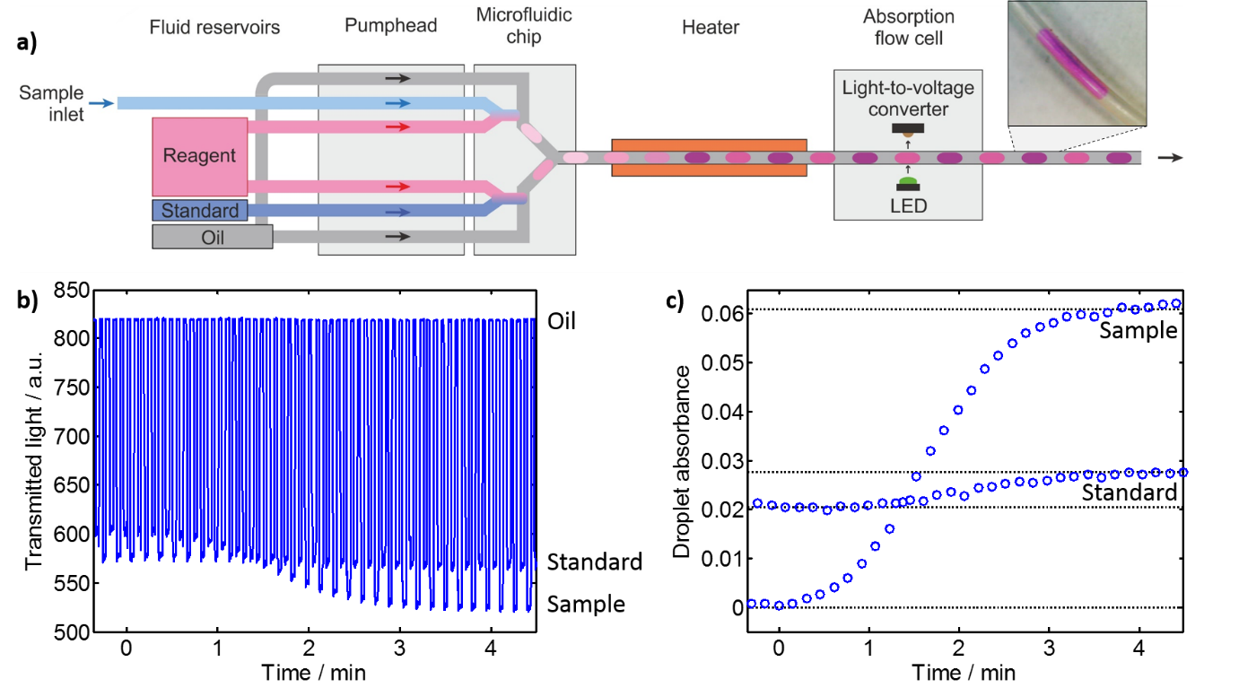

Figure : a) Schematic of the experimental setup for measuring nitrate in droplets. The pumphead and microfluidic chip generate alternating droplets of sample and reagent, and standard and reagent which then travel downstream through a heater to accelerate reaction and an absorption flow cell to quantify the generated colour. A photograph of an example droplet in PTFE tubing (500 µm inner diameter) is shown top right. b) Raw data from the flow cell where the standard is held constant at 100 µM NO3- while the incoming sample changes from 0 to 200 µM NO3-. c) Conversion of the raw data shown in (b) into droplet absorbance.

This system was designed such that sample could be continuously drawn in and measured while the standard can be used to quantify and compensate for any drift in the system such as degradation of the reagent. In Fig. 1b, for example, the sample was swapped from 0 to 200 µM nitrate while the standard was kept constant at 100 µM. The sample response increased as the change to higher nitrate concentration gave increased reaction product and thus stronger light absorbance, while the standard response remained seemingly flat. On closer inspection, however, the standard did not remain exactly constant as expected. This is more obvious when the raw data is converted to absorbance (relative to blank droplets of reagent and ultrapure water) as shown in Fig. 1c. As the absorbance of the sample increased from 0 to ~0.06, the standard droplet absorbance is clearly seen to shift in sympathy from 0.021 to 0.028. Inter-droplet crosstalk such as this was repeatedly and consistently observed, with the standard’s absorbance typically changing by ~12 % of the change in the sample absorbance.

As most reports of droplet crosstalk have been driven by surfactant-related mechanisms,18 we began to address the crosstalk problem here by reducing the surfactant content. As the droplet generation method used here is independent of interfacial tension,32 and the droplets travelled through the PTFE tubing evenly spaced, we found that the surfactant concentration could be reduced to zero without compromising the droplet flow. This had no effect on the crosstalk, however, with standard droplet absorption values changing by approximately 12 % of the change in sample absorption as before (see for example Fig. S2). Likewise, changing the oil to an alternative (non-fluorous) silicone oil was found to offer no improvement (see Fig. S3). These observations suggested that crosstalk was not occurring *via* the surfactant-dependent mechanisms commonly reported.18

To remove any possibility that the crosstalk could be due to wetting of the walls within the PDMS microfluidic chip, a major failure mode for droplet microfluidics,35 we temporarily changed the method of droplet generation to manual aspiration of droplets. Oil and aqueous segments were aspirated using a standard commercial peristaltic pump (Ismatec ISM597D) to individually draw discrete volumes of fluid into PTFE tubing, segment-by-segment (Fig. 2a). The aqueous segments naturally form droplets upon entering the tubing without interdroplet cross-contamination36, 37 due to the preferential wetting of the PTFE walls by the fluorous oil. Following droplet aspiration, the tubing was attached to the PTFE tubing passing through the heater and absorption flow cell, and the pump flow reversed to push the droplets through (Fig. 2b).

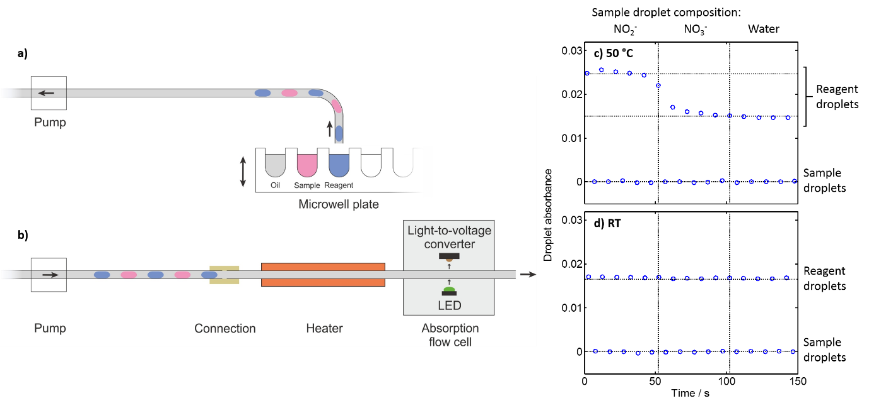

Figure : a) Schematic showing how alternating droplets of reagent and sample were generated by manual aspiration and then b) flowed through the heater and flow cell. c & d) Absorbance of alternating droplets of sample and reagent generated by manual aspiration. The sample composition was changed from nitrite (NO2-) to nitrate (NO3-) to water. The experiment was conducted both with (c) and without (d) heating.

Assuming that cross-contamination *via* channel walls was not a contributing cause, we also needed to identify which solute was moving between droplets. To ascertain the migrating species, the content of the aspirated droplets was alternated between a) sample (either 400 μM nitrate, 400 μM nitrite or a blank) and b) reagent. With the reagent separated from the nitrate and nitrite, we would not expect colour development in the absence of crosstalk. If nitrate or nitrite were migrating we would expect colour development in the reagent droplets, while if the reagent were migrating colour development would occur in the sample droplets. Fig. 2c shows the absorbance of alternating droplets of sample and reagent (using water droplets as the absorbance blank), with the composition of the sample droplets varying between nitrate, nitrite and ultrapure water (5 droplets of each aspirated in turn). When the sample droplets contained only water they exhibited zero absorbance, as expected, while their associated reagent droplets showed an absorbance of 0.015 corresponding to the native colour of the reagent (a pale blue colour due to the presence of vanadium ions). Similar results were obtained when the sample was swapped to nitrate, indicating that neither the nitrate nor reagent was migrating. When the sample was swapped to nitrite, however, the absorbance of the reagent droplets increased to 0.025, indicating that some nitrite had left the sample droplets, migrated to the reagent droplets and reacted to form the coloured product. When the experiment was repeated but omitting the heating step by flowing the droplets straight through the flow cell, (Fig. 2d) no change in the reagent droplet absorbance was observed indicating elevated temperatures were required for droplet migration. Moreover, this demonstrated that the crosstalk was occurring specifically in the heated section of PTFE and not, for example, within the PDMS chip. The specificity of the crosstalk problem to nitrite was confirmed by implementing a similar mix-and-read assay for phosphate (PO43-, an analogous anionic analyte important for water quality) using the same aspirated-droplet experimental setup. No colour development was observed in the reagent droplets (Fig. S4), indicating no droplet crosstalk when measuring phosphate.

It was interesting to note that the crosstalk only occurred for nitrite and not nitrate or phosphate. Each is a negatively charged ion of similar size, hence we might expect to observe similar behaviour. This suggested that the crosstalk might not be due to the nitrite itself but that it underwent a chemical change to a more labile species. To test this theory we devised a simple experiment to ascertain whether changing the pH of the nitrite-containing droplet could affect the crosstalk. As pH can have a profound effect on aqueous reaction dynamics, if the nitrite was undergoing a chemical transformation it would likely be affected by a change in pH. Nitrite solutions at acidic, basic and neutral pH were crudely formulated by mixing 400 μM nitrite at a 1:1 volumetric ratio with 1 M HCl, 1 M NaOH and ultrapure water respectively. They were then aspirated into droplets, alternating with reagent droplets as before (Fig. 2a), and flowed immediately through the flow cell without heating. The water and neutral nitrite sample droplets showed no absorbance (Fig. 3a) while the sample droplets containing NaOH or HCl both showed small apparent increases in absorbance (~0.002) attributable to the change in refractive index caused by the high concentration of acid/base (see Fig. S5). Again, the baseline for the reagent droplets (0.017) was higher than the sample droplets due to the native colour of the reagent. No increase in absorbance was seen in reagent droplets neighbouring neutral nitrite (nitrite + water) droplets, (consistent with Fig. 2d) or in those neighbouring the basic nitrite droplets. However the reagent neighbouring the acidic droplets showed a marked increase to 0.023 indicating colour development due to nitrite migration from the sample droplets.

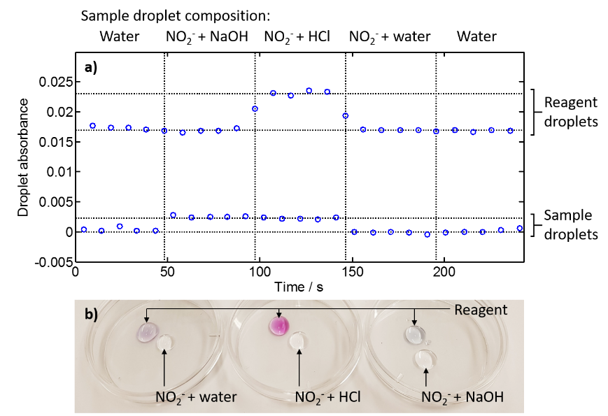

Figure : a) Absorbance of alternating droplets of sample and reagent generated by manual aspiration. The sample composition was changed from water, to basic nitrite (NO2- + NaOH), to acidified nitrite (NO2- + HCl), to neutral nitrite (NO2- + water) and then water. b) Photographic image of droplets of nitrite solutions and reagent placed in covered petri dishes in the absence of oil. The image was taken ~20 minutes after the droplets were deposited.

The enhanced crosstalk at low pH pointed to the root cause of the droplet crosstalk. Under acidic conditions nitrite reversibly decomposes to nitrate and nitric oxide:38, 39

3 NO2‑ ⇌ NO3- + 2 NO

Nitric oxide is a gas and will be able to diffuse out of droplets through the oil to neighbouring droplets where it can undergo reaction to regenerate nitrite, either by the reverse reaction or by reaction with dissolved oxygen.40 This gas-based crosstalk mechanism was confirmed by placing 0.5 ml droplets of nitrite solution into covered petri dishes, alongside droplets of Griess reagent (Fig. 3b). This was carried out with acidified, basic and neutral nitrite solutions (as for Fig. 3a) and in contrast to previous experiments was carried out in the absence of any oil. Care was taken to ensure that while the droplets were placed close to each other (a gap of ~3 mm), they did not physically contact each other. No colour was initially observed apart from the native pale blue colour of the reagent droplets. After being left covered for 20 minutes at room temperature a strong deep purple colour developed in the reagent neighbouring the acidified nitrite solution (Fig. 3b, centre) with the colour strongest on the side of the droplet adjacent to the nitrite solution – consistent with the generation of nitric oxide and its diffusion across the air gap into the reagent. The purple colour was absent in the reagent neighbouring the basic nitrite solution (Fig. 3b, right) while the reagent neighbouring the neutral nitrite solution (Fig. 3b, left) exhibited a very pale purple colour, consistent with the generation of a limited quantity of nitric oxide. The droplets remained static throughout, with a clear airgap between the nitrite and reagent droplets meaning that the analyte could have only reached the reagent by travelling across the air gap as a gas.

This mechanism is consistent with previous observations of crosstalk within the original experimental setup (Fig. 1a). Griess reagent is inherently acidic, with pH typically less than 3,41 hence nitric oxide will be generated within each droplet as soon as the nitrate has been reduced to nitrite. The nitric oxide will then be able to diffuse through the droplet/oil barrier aided by the enhanced solubility of nitric oxide in fluorocarbon oils over water.42 This is a competitive process however, as shown in Fig. 4a which illustrates the various reaction, diffusion, and convection processes occurring within the system. Following nitric oxide generation there will be an ensuing competition between the chemical reactions that can remove nitric oxide (regenerating nitrite and then converting to the diazonium dye) and transport of nitric oxide from the droplet. This competition determines how much nitric oxide leaves the droplet and thus the extent of the crosstalk. As the crosstalk was observed to be more pronounced at higher temperatures (Fig.s 2c,d) it seems likely that the increased generation of nitric oxide39 and raised diffusivity expected at higher temperature prevails over the increased Griess reaction rate30, 31 and encourages loss of nitric oxide from the droplet. In the oil phase the nitric oxide will be transported within each segment *via* convection43, 44 and will have opportunity to diffuse into the neighbouring droplet. The lower gas diffusion coefficients of PTFE relative to FC40 oil (e.g. oxygen diffusion coefficients 2.8 x 10‑7 cm2/s at 25 °C for PTFE45 *versus* 5.7 x 10-5 cm2/s at 37 °C for a similar low-viscosity fluorocarbon oil22) ensures negligible nitric oxide is lost through the tubing walls. The nitric oxide that enters the oil will, in time, re-enter a droplet, at which point it can be converted back into nitrite and then on into the coloured diazo product (see Fig. 4a). If the nitric oxide re-enters the droplet it was generated from, there is no perceived crosstalk, however if it enters a neighbouring droplet then extra diazonium dye is generated and crosstalk arises. As a finite quantity of nitric oxide is produced, we would expect the concentration within the oil to ultimately return to zero. This is confirmed by reproducing the experiment shown in Fig. 2c using different quantities of oil (see Fig. S6). The same level of crosstalk was observed, indicating that no nitric oxide is retained within the oil at the point of measurement.

We then looked to calibrate the inter-droplet crosstalk and ascertain whether it might be possible to mathematically correct for it in our original experimental setup. This was done by measuring the absorption of both sample and standard droplets (Fig. 4b and 4c respectively) whilst running through different concentrations of nitrate in the sample droplets (0 – 600 μM) with the standard set at 0 μM, 200 μM, and 600 μM nitrate. When ultrapure water (blank) was used as the standard, the sample absorbance (Fig. 4b, red triangles) increased linearly with nitrate concentration with the y-intercept at the origin as expected. In the absence of crosstalk we would expect the corresponding standard droplets (Fig. 4c, red triangles) to be constant, however the absorbance increased with sample concentration, with the linear trend indicating that the crosstalk was a fixed proportion of the sample droplet concentration.

As the standard was increased to 200 μM (blue squares) and 600 μM (green circles) the absorbance of the standard droplets increased, as expected (Fig. 4c). So too, however, did the corresponding sample droplets (Fig. 4b) - consistent with crosstalk from the standard droplets into the neighbouring sample droplets. It is important to note that while the standard concentrations changed, the gradients of the lines of best fit for both the sample and standard droplets (i.e. the change in absorbance with respect to sample droplet concentration) remained constant. This indicates that the amount of nitric oxide transferring from the sample droplets into the standard droplets depended only on the concentration within the source (sample) droplet and was not affected by the concentration within the destination (standard) droplet.

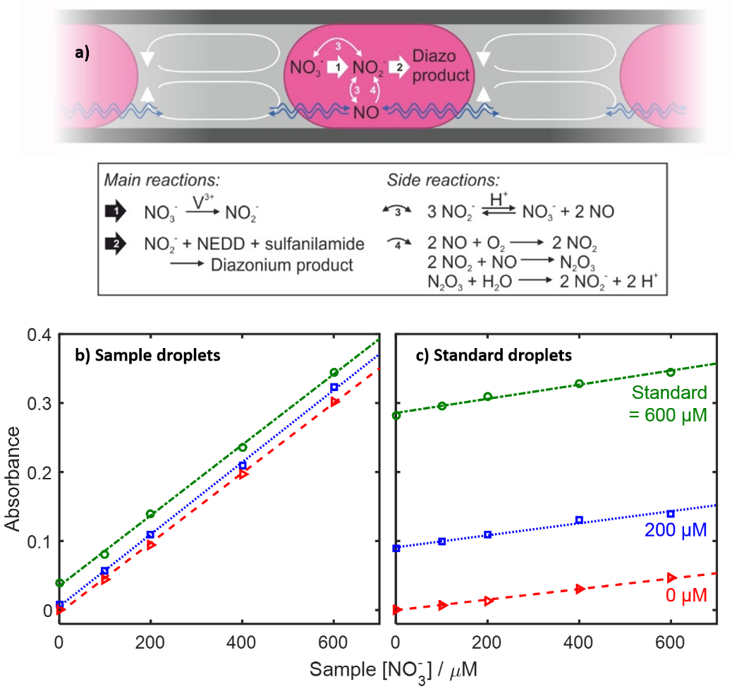

Figure : a) Schematic illustrating the processes occuring within each droplet in the original experimental setup (Fig. 1a). b) Absorbance of sample droplets within a flow of alternating sample and standard droplets (Fig. 1a). The droplets were measured with the introduction of different sample concentrations (0 – 600 μM, x-axis) and standard concentrations (0 μM, red triangles; 200 μM, blue squares; 600 μM, green circles). c) Absorbance of standard droplets measured at the same time.

The observations that the magnitude of the crosstalk is a fixed proportion of the source droplet, and that it is independent of the destination droplet concentration suggested that we could derive an expression to correct for the crosstalk. Previous mathematical descriptions of surfactant driven crosstalk have used diffusion-based models,6, 46 however the empirical model we developed means that minimal prior knowledge of the mechanistic process of the crosstalk and its associated kinetics was required.

We first defined crosstalk as the ratio of the amount of analyte that transfers to neighbouring droplets relative to that which remains in the source droplet (henceforth referred to as the crosstalk ratio, *α*). This ratio is defined by the quantities found in the droplets *after* crosstalk has occurred, and as such can be experimentally determined. The crosstalk ratio can be measured in two different ways: If one of the droplets is a blank, it is simply given by the ratio of measured concentration in the two droplet populations. For the data shown in Fig. 4b and c, for example, it would be given by the ratio of the standard absorbance (Fig. 4c**,** red triangles) to sample absorbance (Fig. 4b**,** red triangles) for the same sample concentration (e.g. when the sample was 600 µM, *α* = 0.046 / 0.302 = 0.15). This method is dependent on one droplet having zero analyte concentration before crosstalk. When both droplets initially contain analyte, an alternative method must be used. In this case the crosstalk ratio can be measured experimentally if one droplet population (sample or standard) is kept constant while the analyte concentration in the other is varied. This assumes that the constant population would not vary for the duration of the measurements in the absence of crosstalk. In the data shown in Fig. 4, for example, the crosstalk ratio is given by the ratio of the gradients of the lines of best fit for the standard (Fig. 4c) and sample (Fig. 4b) absorbances (e.g. when the standard was 400 µM, *α* = 8.723x10-5 µM-1 / 5.224x10-4 µM-1 = 0.17). This second method requires multiple measurements and as such is likely to be more accurate than the first as experimental errors will be reduced by averaging. Given the gas-mediated crosstalk mechanism, the crosstalk ratio will change with reaction temperature, however for fixed reaction conditions we would expect it to remain constant and we note anecdotally that this was found to be the case.

Using the crosstalk ratio we can derive an expression for the absorbance we would expect if there were no crosstalk (i.e. a corrected absorbance) based on the measured absorbance of the two sets of droplets:

$A_{a, corrected}=\left(\frac{1+α}{1-α^{2}}\right)(A_{a}-{αA}_{b})$ [1]

Where *Aa* is the measured absorbance of droplet “a” (sample or standard), *Ab* is the measured absorbance of the neighbouring droplets, “b” (standard or sample) and *α* is the crosstalk ratio as described earlier. The full derivation is given in the ESI. The equation is derived assuming that the residence time is long enough that no nitric oxide remains at the point of measurement, having been converted to first nitrite and then diazonium dye within the droplets (see Fig. 4a). Our system, which featured a residence time of 8 minutes in the heated section and approximately one minute from the heater to the flow cell, was found to be sufficient (see Fig. S6) without requiring further optimisation. If *α* = 0, (i.e. there is no crosstalk) equation [1] simply reduces to *Aa,corrected = Aa*, as we might expect, while if *α* is very large (in the practically unfeasible case that almost all analyte transfers to neighbouring droplets) it reduces to *Aa,corrected = Ab*. In practice we would expect 0 ≤ *α* ≤ 1, in which case the equation accounts for the partial migration of analyte from the droplet, while also accounting for any incoming analyte that originated from the neighbouring droplets.

Applying equation [1] to the data shown in Fig.s 4b,c gives the combined set of corrected data shown in Fig. 5a. Again the data obtained using standard concentrations of 0, 200 and 600 µM are shown as red triangles, blue squares and green circles respectively. The absorbance of the standards are constant with respect to the sample concentration, while the sample responses all overlay each other irrespective of the concentration standard with a shared y-intercept at the origin. Importantly, this is the behaviour we would expect in the absence of crosstalk.

As a further test of the mathematical correction, we measured five river water samples and quantified their concentration using two separate methods: Firstly using a calibration curve determined by running standards through the sample inlet before testing (calibrations shown in Fig. S7). Secondly by using an inline calibration which uses the absorbance of the inline standard droplets:

${[{NO}_{3}^{-}]}_{sample}=\frac{A_{sample}}{A_{standard}} .{[{NO}_{3}^{-}]}_{standard}$ [2]

Where [*NO3-*]*sample* is the measured sample concentration, [*NO3-*]*standard* is the known concentration of the standard (320 µM in this case) and *Ax* is the absorbance of the droplet (sample or standard). In the absence of crosstalk absorbances can be used as measured,27, 47 but corrected absorbances (as determined by equation [1]) will be required with crosstalk. This second method in effect performs a new single-point calibration for each individual sample and can compensate for calibration drift.27, 28, 47 While unnecessary for laboratory-based testing, inline calibration is critical for field-deployable microfluidic chemical analysers where aging reagents and/or changing ambient conditions can shift the calibration. This method relies on the fidelity of the inline standard droplets and as such is particularly vulnerable to crosstalk.

The five river samples were taken at different positions along the River Itchen in Southampton (Fig. 5b) during a ninety minute period at high tide. During this sampling period the tidal height did not change appreciably (see Fig. S8) so that any measured differences in nitrate concentration is attributable to the relative sampling locations, not tidal variation. River water typically has nutrient levels two orders of magnitude higher than surface seawater27 so we would expect to see a range of nitrate concentrations in the samples, with lower concentrations in the downstream samples.

Fig. 5c shows the concentrations as quantified using the two methods, with the value obtained from the calibration curve (method one) on the x-axis and the value obtained from inline calibration (method two) on the y-axis. Both methods give the same expected qualitative trend with the freshwater-rich upstream samples having higher concentrations of nitrate. Locations 1 and 2 had identical nitrate concentrations and there was a distinct step-change between location 2 and 3, indicating poor mixing between the influx of seawater from Southampton Water and the river flow. There were notable discrepancies between the absolute values obtained from the two methods when using uncorrected absorbance values (green triangles) however. Where the sample concentration was higher than the standard, inline calibration gave anomalously low values. This is due to crosstalk decreasing the measured sample concentration while increasing the standard concentration – decreasing the concentration as calculated using equation [2]. For the same reason inline calibration gave slightly high values when the sample concentration was lower than the standard, due to crosstalk raising the sample concentration and decreasing the standard. Using corrected values (red squares) removed this problem, however, resulting in concentrations that perfectly matched the values obtained using the calibration curve as we would expect in the absence of crosstalk.

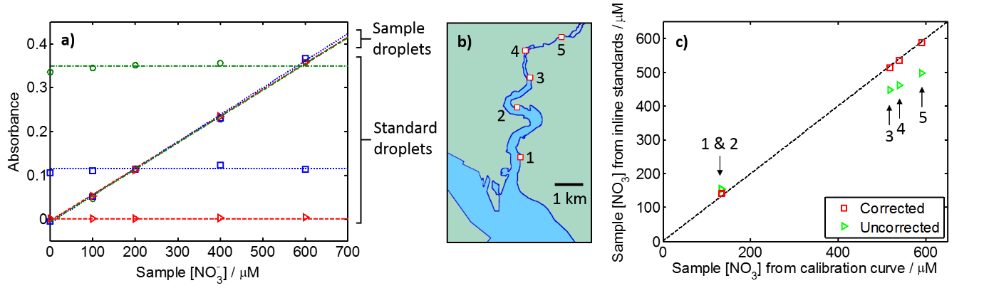

Figure : a) Data from Fig.s 4b,c with absorbance corrected using equation [1]. The red triangles, blue squares and green circles correspond to standard droplets of nitrate concentrations of 0, 200 and 600 μM respectively. b) Positions where water samples were taken on the tidal River Itchen in Southampton. c) Quantification of the nitrate content of the river samples measured in droplet flow. Nitrate concentrations were calculated using a calibration curve (x-axis) and using inline standard droplets (y-axis). Values were calculated using data which was either corrected (red squares) or uncorrected (green triangles) for crosstalk using equation [1].

**Discussion and conclusion**

The crosstalk found in this droplet-based assay resulted from the conversion of nitrite to gaseous nitric oxide at low pH. Such a transfer of analyte *via* a gaseous intermediate species is in contrast with most previously reported mechanisms concerning direct partitioning or surfactant-driven mechanisms.18 An obvious way to eliminate the crosstalk would have been to conduct the assay at elevated pH, however this was not an option as the Griess reagent requires low pH to render its constituent reactants soluble.26 We could have tried removing the heating step and thus reducing the diffusion rate of the nitric oxide, however the vanadium-based reduction step is slow (several hours at room temperature31) hence, if conducted at room temperature, much longer channels would be required with high accompanying backpressures. Alternative nitrate assays exist, but these either use highly caustic48 or unstable reagents.49, 50 These methods weren’t required however, as we showed that an arithmetic method can be used to correct for the crosstalk. We note that while mathematical methods have previously been used to model and describe crosstalk in droplet microfluidics,46 this is, to the best of our knowledge, the first case where they have been used to accurately correct for crosstalk in experimental data.

It is interesting to note that loss of analyte *via* nitric oxide has not been previously highlighted in reports of nitrate analysis using the Griess assay.26, 31 Given the low pH intrinsic to the Griess assay, the generation of nitric oxide must also be present, however it is likely that the higher surface area to volume ratios and juxtaposition of droplets of different concentrations contributed to its prevalence in this study. This highlights, however, the suitability of droplet flow for transferring solutes between droplets *via* gas intermediates, which could be exploited in assays where it is favourable to convert constituents to gases. One such example is in ammonium assays, where the analyte can be extracted as gaseous ammonia to remove it from potential interferences, as demonstrated by Sraj *et al.*51 Another example is in alkalinity measurements using the “single-point” method,52 where gaseous CO2 needs to be removed from an acidified sample before the alkalinity can be gauged *via* the final sample pH. We anticipate that these kinds of measurements, which currently still rely on continuous fluidics, might benefit from the high throughput and low fluid use in droplet flows as demonstrated here.

In summary we have shown novel droplet fluidics that can continuously measure nitrate in water, with each measurement only requiring sub-microlitre sample and reagent. Inline calibration was achieved by interspersing sample droplets with standard droplets. Interestingly we found that the standard Griess assay generated notable inter-droplet crosstalk due to the generation of gaseous nitric oxide which then diffused between droplets, in contrast to the majority of previous reports of crosstalk which are surfactant-driven. An arithmetic method was developed which corrected for crosstalk, giving the concentrations we would expect in the absence of crosstalk.

**Acknowledgments**

We thank the funding from the Engineering and Physical Sciences Research Council UK (EP/M012425/1) and the Natural Environment Research Council UK (NE/P004016/1).

**EXPERIMENTAL**

*Chemicals.*

Hydrochloric acid (37 %), sulfuric acid (95 – 98 %), tin (II) chloride (98 %), glycerol (≥99 %), potassium nitrate (≥99 %), vanadium (III) chloride (97.0 %), sulphanilamide (≥99.0 %), N-(1-napthyl)ethylenediamine dihydrochloride (NEDD, >98 %), sodium nitrite (99.0 %), potassium phosphate monobasic (99.0 %) and silicone oil (Dow Corning 200, 50 cSt at 25 °C) were obtained from Sigma Aldrich, UK. Ammonium molybdate tetrahydrate (99 %) was obtained from Alfa Aesar, UK. Unless otherwise stated, water was ultrapure grade (18.2 MΩ, Barnstead EASYpure RODI). Fluorinert FC40 oil was obtained from Acota Ltd, UK. The tri-block co-polymer surfactant (perfluorinated polyether / polyethylene glycol / perfluorinated polyether) was synthesised in-house using the previously reported protocol.53

*Nitrate assay reagent formulation.*

The modified Griess reagent was formulated by first weighing out 2.5 g of vanadium (III) chloride and adding to a 250 ml volumetric flask along with 50ml of ultrapure water to form a dark brown solution. 15 ml of concentrated (37 %) hydrochloric acid was added which caused the solution to turn a dark turquoise colour. 1.25 g of sulfanilamide and 0.125 g of NEDD was added, dissolved and the solution finally made up to the volumetric mark using ultrapure water.

*Phosphate assay reagent formulation.*

A 2.5 wt% solution of ammonium molybdate in 3 M concentrated sulfuric acid was formed by dissolving 6.125 g of ammonium molybdate in approximately 200 ml of water in a 250 ml volumetric flask. 40 ml concentrated sulfuric acid was added and then the solution made up to the volumetric mark. A 2.5 wt% solution of tin chloride in glycerol was formulated by dissolving 2.5 g of tin (II) chloride in 100 ml glycerol in a volumetric flask. Before the assay was performed the reagent was made by mixing 2 drops (approximately 100 µL) of the tin chloride solution in 2 ml of ammonium molybdate solution, and then used immediately.

*Nitrate, nitrite and phosphate standards.*

A 100 mM stock solution of potassium nitrate was made by dissolving 2.528 g of potassium nitrate in ultrapure water in a 250 ml volumetric flask. A 100 mM stock solution of sodium nitrite was made by dissolving 1.725 g of sodium nitrite in ultrapure water in a 250 ml volumetric flask. A 10 mM stock solution of potassium phosphate was made by dissolving 0.136 g potassium phosphate monobasic in ultrapure water in a 100 ml volumetric flask. All stock solutions were further diluted as required for each specific experiment.

*Microfluidic chip.*

PDMS microfluidic chips were replica moulded from a 3D-printed master. The master was designed in 3D CAD software (SolidWorks, Dassault Systemes) and printed in “VeroClear” material using an Objet500 Connex3 polyjet printer (Stanford Marsh Ltd). The channel design had nominal channel dimensions of 600 µm height for all channels, with a main channel of 200 µm width and inlets of 100 µm width (as shown schematically in Fig. S9a). Limitations in printing resolution and feature shrinkage with post-treatment resulted in final channels with a Gaussian profile and dimensions of 590/350 µm height/full-width-half-maximum for the 200 µm nominal-width channels and 480/320 µm for the 100 µm nominal-width channels. The entry/exit points featured enlarged channels (660 µm nominal width and 550 µm nominal height) so that tubing could be later inserted. After printing, the mould was baked overnight at 65 °C to remove any uncured precursor materials and then treated with a non-stick coating by wiping with a lint free wipe dipped in “Aquapel” (PPG Industries). PDMS was added to the mould (Sylgard 184, 10:1 ratio of elastomer to curing agent) and baked at 65 °C for a minimum of one hour. After removal from the mould, the chips were cut to shape and then sealed to a flat piece of PDMS using the “half-cure” method.54-56 To allow reliable droplet generation, the channels were treated to ensure preferential wetted by the fluorous oil. This was done by filling the channels with Aquapel (PPG Industries) using a syringe and blunt dispensing needle, waiting for approximately 5 minutes, and then flushing the channels with air. The chips were then left overnight in an oven at 70 °C. PTFE tubing (inner diameter, ID, 500 µm; outer diameter, OD, 700 µm; Adtech Polymer Engineering, UK) was inserted into the inlet/outlet sections and then fixed in place by placing the chip and tubing on a hotplate at 110 °C and applying uncured PDMS to the join. An image of a finished chip is shown in Fig. S9b.

*In-house pump and droplet generation.*

Fluid was pumped using a peristaltic pump built in-house which has previously been described in detail elsewhere.32 Briefly, it operated using a DC motor (Pololu 1000:1 Micro Metal Gearmotor) which turned a 3D-printed rotor contacting a microfluidic channel. The patterning of features on the rotor determined the timing and magnitude of the fluidic pulses induced in the channel. The main pump chassis and the rotor were 3D printed in “VeroClear” material using an Objet500 Connex3 polyjet printer (Stanford Marsh Ltd). Six fluidic lines were used, with the pump outlets connected to the microfluidic chip, as indicated in Fig. S9a, using PTFE tubing (ID 500 µm, OD 700 µm). Droplets were generated by the previously described “anti-phased peristaltic pumping” method,32 whereby oil and aqueous phases are injected alternately. To achieve the alternating sample/standard droplets, the rotor was designed to pump the fluids in the order: 1. Sample and reagent (lines 2 and 3 in Fig. S9a); 2. Oil (line 1); 3. Standard and reagent (lines 4 and 5); 4. Oil (line 6). The motor was run at 1.5 V, which produced a total flowrate of 22 µL/min.

*Flow cell.*

Droplet absorbance was measured using an inline spectrophotometric flow cell which has been previously reported in detail elsewhere.33 Briefly, black polymethylmethacrylate (PMMA) was micromilled with two channels: one to hold a short length of PTFE tubing (ID 500 µm, OD 700 µm, Adtech Polymer Engineering, UK) and another to define a light path to directly transect the tubing. An LED (Cree CLM4B-GKW-CWBYA693, Farnell Onecall, for the nitrate assay; Avago HSMH-A100-N00J1, RS, for the phosphate assay) and light-to-voltage converter (TSL257, Texas Advance Optical Solutions, UK) were positioned at either end of the light path using a 3D-printed support (polylactic acid, printed on an Ultimaker 2 fused deposition modelling printer). The LED was powered by a benchtop power supply (Tenma 72-7245) operating on constant current mode while the light-to-voltage converter was powered from a microcontroller (Arduino Nano) which also continuously measured the signal voltage and passed it back to a benchtop computer running Labview 2012 (National Instruments) which processed and saved the data.

*Heater*

The heater was fabricated in-house by winding 120 cm of PTFE tubing (500 µm ID, 700 µm OD) around a 1 cm length of copper tubing. 3D-printed end-pieces (polylactic acid, Ultimaker 2) were attached to each end of the tube to help keep the PTFE tubing in place. A resistive polyimide thin film heater (Watlow Kapton K05711980AL-L 1/2” x 1.1/8”) was placed on the inside surface of the tubing and a digital thermometer (Maxim DS18b20) was placed in the centre of the tubing. The whole assembly was wrapped in an approximately 3 cm-thick blanket of cotton wool. The heater was powered by a 9 V battery *via* a metal oxide semiconductor field emission transistor (MOSFET, Vishay TO-220AB) controlled by the same microcontroller used to transfer the flow cell data. The microcontroller was programmed with custom pulse width modulation (PWM) code to control the power supplied to the heater and maintain its temperature (as determined by the digital thermometer) at 50 °C.

*Aspirating droplets*

Droplets were aspirated using a commercial peristaltic pump (Ismatec ISM597D) fitted with PVC tubing (250 µm ID, 2 mm OD). A 30 cm length of PTFE tubing (500 µm ID, 700 µm OD) was attached to the “pull” end of the PVC tubing and all tubing first flushed with FC40 oil. The pump was then set to pump a specific volume (0.95 µL at a flow rate of 5 µL/min) at the push of a button. Droplets were aspirated by placing the mouth of the tubing into a reservoir of aqueous fluid, activating the pump, waiting for it to pump the set volume, then moving the tubing mouth to an oil reservoir, activating the pump and waiting for it to pump the set volume. This procedure, which produced a single discrete droplet, was repeated until the desired droplet train was produced. The mouth of the PTFE tubing was then attached to the same heater and flow cell used for the standard setup (Fig. 1a), the pump direction reversed and flowed through at a rate of 20 uL/min.

*River water sampling protocol.*

The sampling protocol was developed with literature recommendations for good sampling and storage practice.26 Prior to sampling, five 60 ml Nalgene bottles (VWR, UK) were cleaned by first soaking in a solution of 2 % detergent (Decon 90) for 24 hours, rinsing with ultrapure water, then soaking in 10 vol% solution of concentrated hydrochloric acid, rinsing with ultrapure water and then drying. For each sample collection, a 10 ml plastic disposable syringe (Normject luer-lock, Henke Sans Wolf) was rinsed with river water 3 times. The syringe was then used to rinse a syringe filter (Millipore Millex GP, 0.22 µm pore polyethersulfone membrane) with 5 ml of river water. A sample bottle was rinsed 3 times with ~2.5 ml of filtered river water and then filled with filtered river water taken from immediately under the surface at the riverbank. All samples were obtained on 7th June, 2017 between 1138 and 1304 (British Summer Time) at the locations specified in Fig. 5b and then immediately frozen for later analysis.

***Nitrate measurement in droplet flow: gas-mediated crosstalk and correction***

Electronic Supplementary Information

Adrian M. Nightingalea,b, Gareth W. H. Evansa,b, Sharon Coleman,a Sammer-ul Hassana,b and Xize Niua,b,†

a. Faculty of Engineering and the Environment, University of Southampton, Southampton, U.K. SO17 1BJ.

b. Institute for Life Sciences, University of Southampton, Southampton, U.K. SO17 1BJ.

† Email: [x.niu@soton.ac.uk](mailto:x.niu@soton.ac.uk)

**Supplementary figures**



*Figure S1: Lengths of sample droplets, standard droplets and separating oil slugs, generated by the setup shown in Fig. 1, flowing through 500 µm ID PTFE tubing at a mean linear flow rate of 2.75 mm/s. In each case n=100 and the error bars indicate the standard deviation of each measurement.*

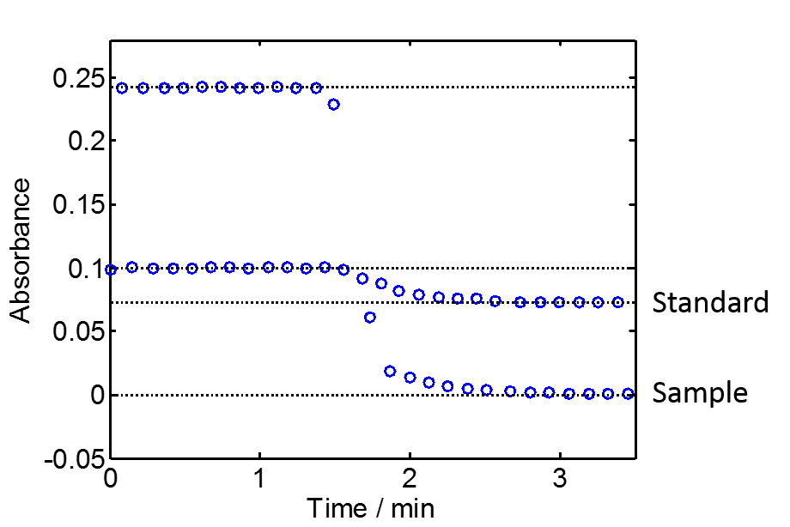

*Figure S2: Representative droplet absorbance data showing the absorbance of standard droplets (200 µM NO3-) shifting in sympathy with a change in sample (from 600 µM to 0 µM NO3-) in the absence of any surfactant.*

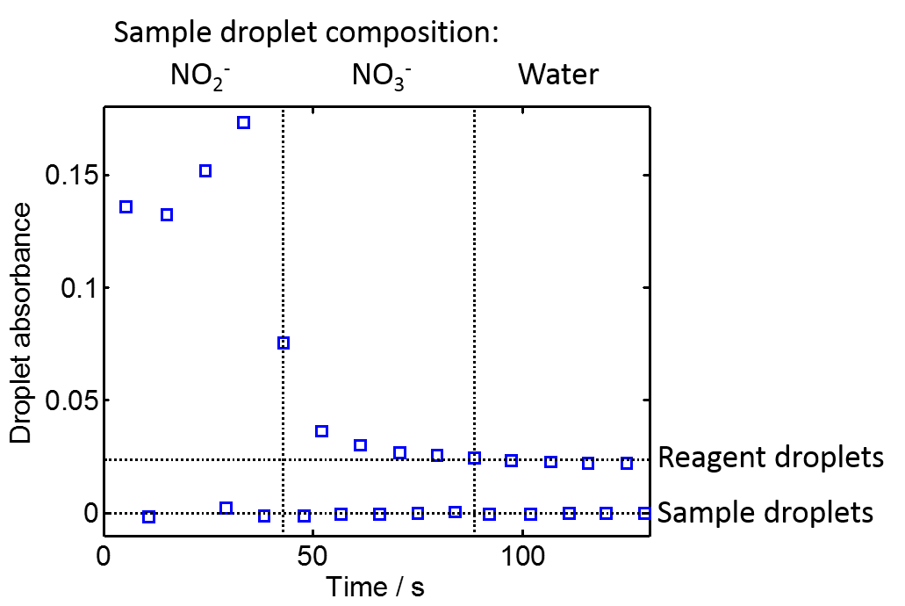

*Figure S3: Absorbance of alternating droplets of sample and reagent generated by the manual aspiration method (see Fig. 2 and accompanying text for explanation of the method) using silicone oil as the continuous (non-droplet) phase. The sample composition was changed from nitrite (NO2-) to nitrate (NO3-) to water. Inter-droplet crosstalk was seen from nitrite droplets only, as previously seen in experiments using perfluorinated oil (Fig.s 2,3).*

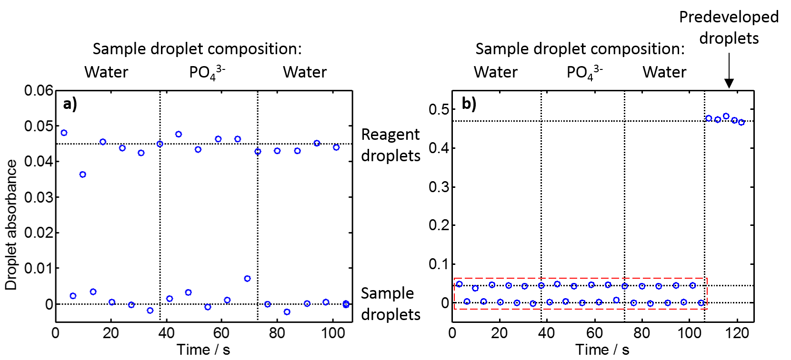

*Figure S4: a) Absorbance of alternating droplets of sample and (phosphate-specific) reagent generated by manual aspiration. The sample composition was changed from water (left) to 100 µM phosphate (PO43-, centre) to water (right), with no colour development evident in the reagent droplets. b) The same data (highlighted in the red dashed box) shown alongside a series of predeveloped droplets (formed by mixing the phosphate solution with the reagent at a volumetric ratio of 1:1) – showing the colour development that can be attained when phosphate reaches the reagent.*

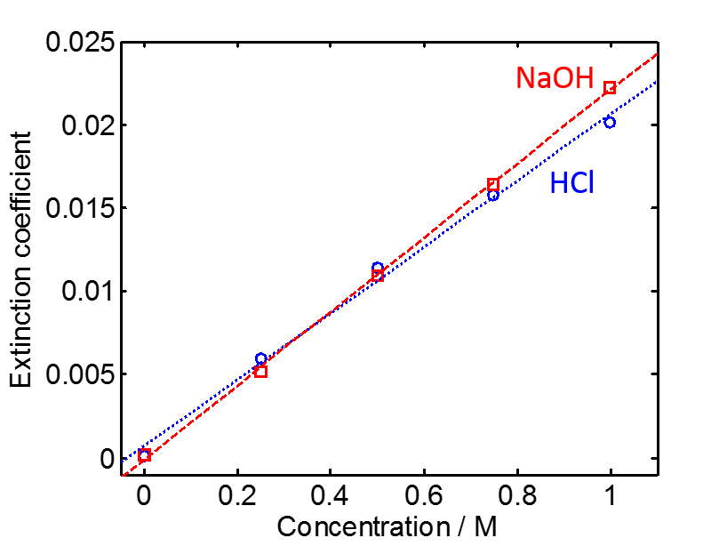

*Figure S5: Extinction coefficient of different concentrations of NaOH and HCl flowed through a flow cell, similar to that used in the setup shown in Fig. 1. Both give an increase in extinction coefficient of similar magnitude, consistent with the data shown in Fig. 3. In contrast to Fig. 3, here we label the y-axis as the more formally correct “Extinction coefficient” rather than “Absorbance” as the increase here is solely attributable to the change in refractive index.*

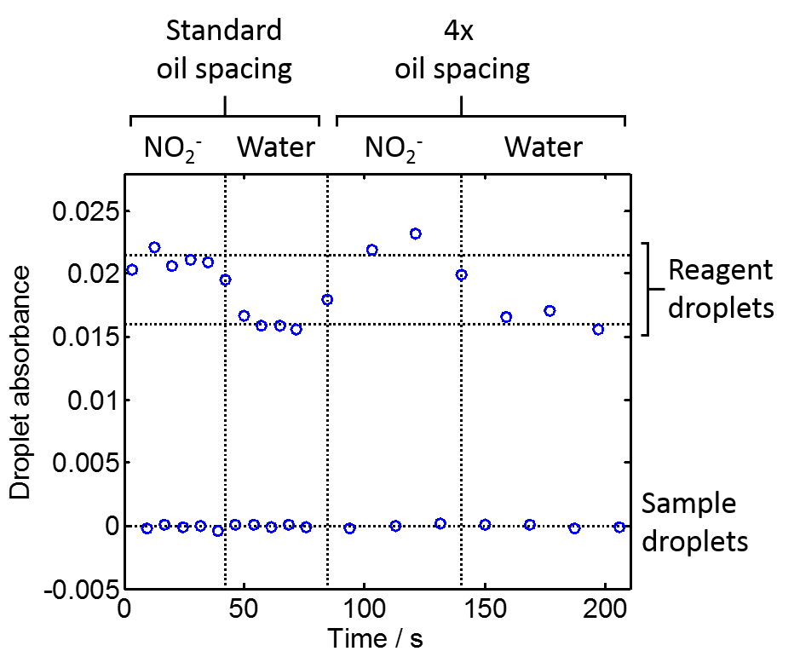

*Figure S6: Absorbance of alternating aspirated droplets of sample and reagent generated by manual aspiration. The sample composition was alternated between water and nitrite (NO2-) with the spacing between droplets changing from standard (same volume as the droplets) to 4 times greater. The colour development evident in the reagent droplets is the same regardless of oil spacing, consistent with all NO in the oil having been consumed (in the droplets) in each case. As the drops were aspirated and then flowed through the heater and flow cell (as shown in Fig. 2), each set of droplets will have undergone an identical residence time in the heated section.*

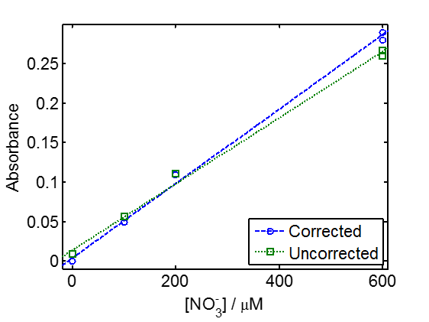

*Figure S7: Calibrations for measuring river samples, using uncorrected (green squares) and corrected (blue circles) measurement of 0, 100, 200, and 600 µM NO3- standards.*

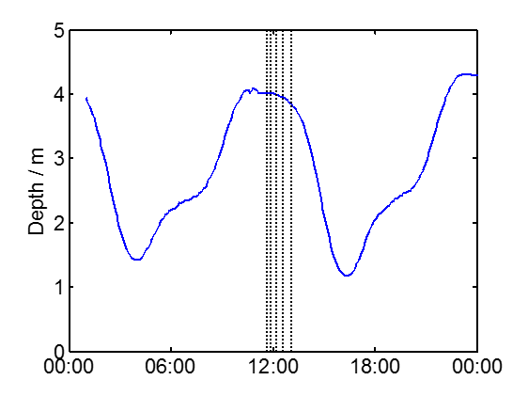

Figure S8: The tide state in Southampton on the day that samples were taken from the River Itchen (7th June, 2017). The vertical dashed lines indicate the time each sample was taken from the sampling positions (shown in Fig. 5 in the main text) in the order: 4, 5, 3, 2, 1. The depth (y-axis) represents the tide height as measured at Southampton docks (50 53.01N, 1 23.66W), data obtained from www.sotonmet.co.uk.

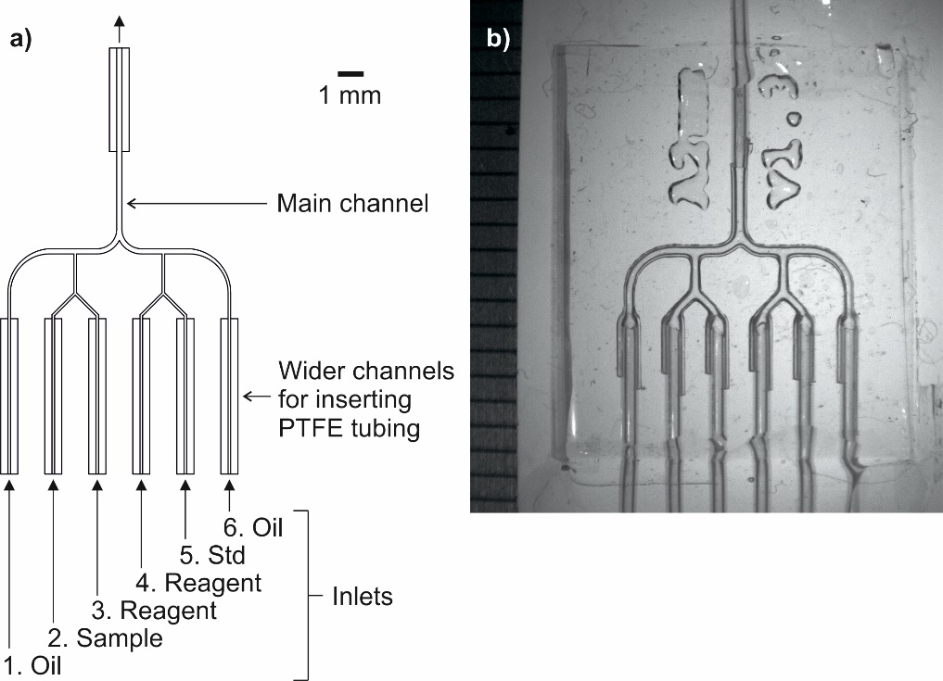

Figure S9: a) Channel design of the microfluidic chip. b) Image of a fabricated chip with PTFE tubing inserted and fixed. A ruler with millimetre divisions is shown on the left edge of the image.

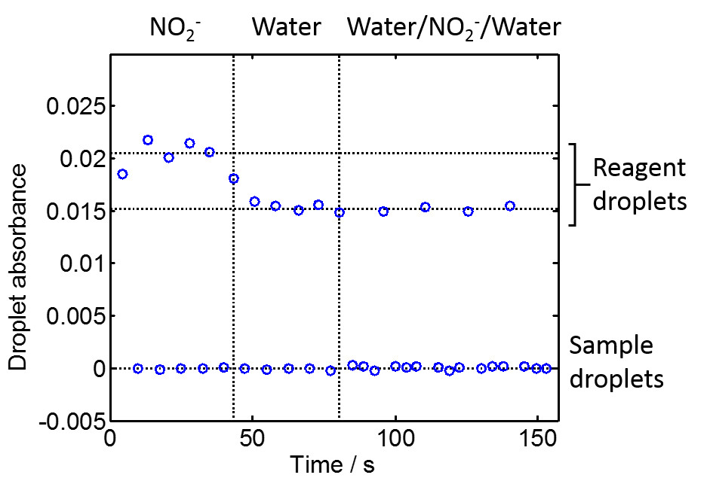

*Figure S10: Absorbance of alternating sample and reagent droplets generated by manual aspiration. The sample composition was changed from nitrite (NO2-, left) to water (centre) to a three-droplet sequence composed of water-nitrite-water. Colour development is seen where the sample droplets are nitrite alone, but no colour is seen when the sample is water or the water-nitrite-water sequence - indicating that the nitrite only migrated as far as the neighbouring droplets.*

**Derivation of crosstalk correction equation**

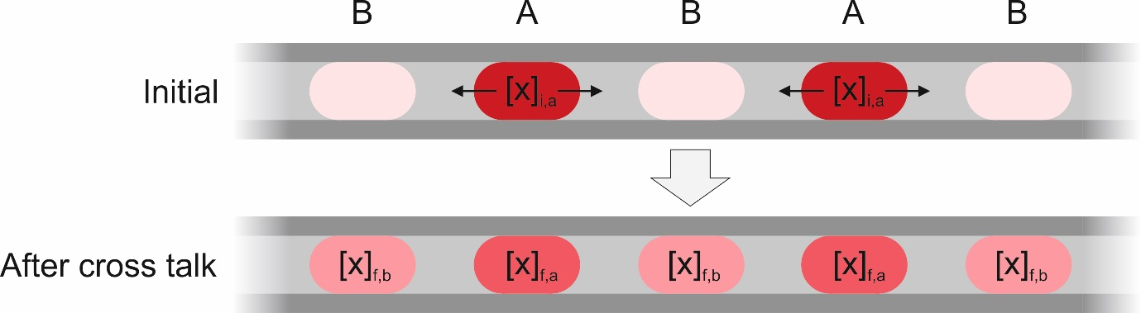

*Figure S11: Cartoon illustrating migration of an analyte, x, in a sequence of alternating droplets, A and B. We only consider the analyte initially present in population A (top), a proportion of which subsequently migrates into population B (bottom).*

Consider a stream of alternating droplets (A and B). We are concerned with the migration of an analyte “*x*” from droplet A to the neighbouring droplets, B. The analyte is at an initial concentration of [*x*]*i,a*in droplet A and gives final concentrations of [*x*]*f,a*in droplet A and [*x*]*f,b*in droplet B.

We assume that: a) The concentration remaining in the oil is negligible. b) Analyte cannot travel further than the immediately neighbouring droplet.

These assumptions are reasonable as: a) The diffusion constant of diatomic gases within fluorous oil is high22, 57 and thus it is likely any nitric oxide that enters the oil will diffuse to a droplet and be captured within it by chemical reaction (as illustrated in Fig. 4a) before measurement. b) In the aspiration experiments (e.g. Fig.s 2 & 3 in the main text) it was generally observed that reagent droplets were only affected by crosstalk from neighbouring sample droplets. This is most effectively shown in the experiment shown in Fig. S10, where blank droplets were introduced in between nitrite and reagent droplets and stopped crosstalk by capturing any migrating species.

First we define the “cross talk parameter”, *α*, which specifies the ratio of *x* that has left the droplet to the quantity of *x* that remains following crosstalk:

$α=\frac{{[x]}_{f,b}}{{[x]}_{f,a}}$ [1]

This parameter can be experimentally determined as described in the main text, and in our experimental setup typically had a value of 0.1 ≤ α ≤ 0.2.

To be able to correct for crosstalk we must relate how the final droplet concentrations relate to the initial concentration. Assuming no analyte is lost through the tubing and the concentration left in oil is negligible,

$${\left[x\right]}_{i,a}={[x]}_{f,a}+{[x]}_{f,b}$$

which rearranges to:

${[x]}_{f,a}={[x]}_{i,a}-{[x]}_{f,b}$ [2]

${[x]}_{f,b}={[x]}_{i,a}-{[x]}_{f,a}$ [3]

Putting [2] into [1] gives:

$$α=\frac{{[x]}_{f,b}}{{[x]}_{i,a}-{[x]}_{f,b}}$$

which rearranges to:

${[x]}_{f,b}= \frac{α{[x]}_{i,a}}{1+α}$ [4]

Likewise, putting [3] into [1] and rearranging gives:

${[x]}_{f,a}= \frac{{[x]}_{i,a}}{1+α}$ [5]

Equations [4] and [5] allow us to relate the starting concentration of a droplet (i.e. the concentration we would expect in the absence of crosstalk) to the concentration found in each droplet population after crosstalk.

We now consider a more general experimental setup (such as that shown in Fig. 1a) where both droplets have an initial concentration of analyte and where the final analyte concentrations are measured by colorimetry (though we note that the final derived equation should apply to other methods where the measured property is proportional to analyte concentration). In colorimetric assays we measure the absorption of a coloured product produced from an analyte-specific reaction using the Beer-Lambert law:

$A=εl[product]$ [6]

where *ε* is the extinction coefficient of the product and *l* is the optical path length. In reactions such as the Griess reaction the reaction kinetics are pseudo first-order when the reagent is in excess. At a given reaction time the concentration of reaction product is proportional to the starting concentration of the analyte.27, 28, 47 Therefore we can rewrite [6] in terms of the analyte:

$A=εlk\left[x\right]=k^{'}[x]$ [7]

where *k* is a constant and *k’=εlk*. If we measure the contents of droplets A and B after crosstalk has occurred, each will be a sum of absorption resulting from analyte that was retained from the initial concentration, and analyte that has travelled from neighbouring droplets. So using equations [4], [5] and [7] we can write the absorbance, $A_{a}$, of droplet A and the absorbance, $A_{b}$, of droplet b as:

$A_{a}=k'\left(\frac{{[x]}_{i,a}}{1+α}+\frac{α{[x]}_{i,b}}{1+α}\right)$ [8]

$A_{b}=k'\left(\frac{{[x]}_{i,b}}{1+α}+\frac{α{[x]}_{i,a}}{1+α}\right)$ [9]

[8] rearranges to:

$${[x]}_{i,a}=(1+α)\left(\frac{A_{a}}{k'}-\frac{α{[x]}_{i,b}}{1+α}\right)$$

If we insert into [9] and rearrange, we obtain:

$$k^{'}{\left[x\right]}_{i,b}=\left(\frac{1+α}{1-α^{2}}\right)(A_{b}-{αA}_{a})$$

Considering [7], the expression on the left here constitutes the absorbance measurement we would expect from the initial concentration (i.e. if there had been no cross talk), hence this equation allows us to correct for crosstalk:

$$A_{b, corrected}=\left(\frac{1+α}{1-α^{2}}\right)(A_{b}-{αA}_{a})$$

and similarly

1. E. Y. Basova and F. Foret, *Analyst*, 2015, **140**, 22-38.

2. E. Brouzes, M. Medkova, N. Savenelli, D. Marran, M. Twardowski, J. B. Hutchison, J. M. Rothberg, D. R. Link, N. Perrimon and M. L. Samuels, *Proceedings of the National Academy of Sciences of the United States of America*, 2009, **106**, 14195-14200.

3. M. Courtney, X. M. Chen, S. Chan, T. Mohamed, P. P. N. Rao and C. L. Ren, *Analytical Chemistry*, 2017, **89**, 910-915.

4. J. W. Janiesch, M. Weiss, G. Kannenberg, J. Hannabuss, T. Surrey, I. Platzman and J. P. Spatz, *Analytical Chemistry*, 2015, **87**, 2063-2067.

5. P. A. Sandoz, A. J. Chung, W. M. Weaver and D. Di Carlo, *Langmuir*, 2014, **30**, 6637-6643.

6. P. Gruner, B. Riechers, B. Semin, J. Lim, A. Johnston, K. Short and J. C. Baret, *Nature Communications*, 2016, **7**.

7. G. Woronoff, A. El Harrak, E. Mayot, O. Schicke, O. J. Miller, P. Soumillion, A. D. Griffiths and M. Ryckelynck, *Analytical Chemistry*, 2011, **83**, 2852-2857.

8. C. A. Serra and Z. Q. Chang, *Chemical Engineering & Technology*, 2008, **31**, 1099-1115.

9. J. T. Wang, J. Wang and J. J. Han, *Small*, 2011, **7**, 1728-1754.

10. A. M. Nightingale, J. H. Bannock, S. H. Krishnadasan, F. T. F. O'Mahony, S. A. Haque, J. Sloan, C. Drury, R. McIntyre and J. C. deMello, *Journal of Materials Chemistry A*, 2013, **1**, 4067-4076.

11. W. K. Wong, S. K. Yap, Y. C. Lim, S. A. Khan, F. Pelletier and E. C. Corbos, *Reaction Chemistry & Engineering*, 2017, **2**, 636-641.

12. H. Chen, Q. Fang, X. F. Yin and Z. L. Fang, *Lab on a Chip*, 2005, **5**, 719-725.

13. F. Courtois, L. F. Olguin, G. Whyte, A. B. Theberge, W. T. S. Huck, F. Hollfelder and C. Abell, *Analytical Chemistry*, 2009, **81**, 3008-3016.

14. P. Mary, V. Studer and P. Tabeling, *Analytical Chemistry*, 2008, **80**, 2680-2687.

15. A. Studer, S. Hadida, R. Ferritto, S. Y. Kim, P. Jeger, P. Wipf and D. P. Curran, *Science*, 1997, **275**, 823-826.

16. K. L. O'Neal and S. G. Weber, *Journal of Physical Chemistry B*, 2009, **113**, 149-158.

17. Y. Skhiri, P. Gruner, B. Semin, Q. Brosseau, D. Pekin, L. Mazutis, V. Goust, F. Kleinschmidt, A. El Harrak, J. B. Hutchison, E. Mayot, J. F. Bartolo, A. D. Griffiths, V. Taly and J. C. Baret, *Soft Matter*, 2012, **8**, 10618-10627.

18. P. Gruner, B. Riechers, L. A. C. Orellana, Q. Brosseau, F. Maes, T. Beneyton, D. Pekin and J. C. Baret, *Current Opinion in Colloid & Interface Science*, 2015, **20**, 183-191.

19. G. Caldero, M. J. GarciaCelma, C. Solans, M. Plaza and R. Pons, *Langmuir*, 1997, **13**, 385-390.

20. K. L. O'Neal, S. Geib and S. G. Weber, *Analytical Chemistry*, 2007, **79**, 3117-3125.

21. C. Palomo, J. M. Aizpurua, I. Loinaz, M. J. Fernandez-Berridi and L. Irusta, *Organic Letters*, 2001, **3**, 2361-2364.

22. J. E. Kreutz, A. Shukhaev, W. B. Du, S. Druskin, O. Daugulis and R. F. Ismagilov, *Journal of the American Chemical Society*, 2010, **132**, 3128-3132.

23. T. P. Burt, N. J. K. Howden, F. Worrall and M. J. Whelan, *Journal of Environmental Monitoring*, 2010, **12**, 71-79.

24. U. Bende-Michl and P. B. Hairsine, *Journal of Environmental Monitoring*, 2010, **12**, 127-134.

25. A. M. Nightingale, A. D. Beaton and M. C. Mowlem, *Sensors and Actuators B: Chemical*, 2015, **221**, 1398-1405.

26. K. Grasshoff, K. Kremling and M. Ehrhardt, *Methods of Seawater Analysis*, Wiley-VCH, 1999.

27. A. D. Beaton, C. L. Cardwell, R. S. Thomas, V. J. Sieben, F. E. Legiret, E. M. Waugh, P. J. Statham, M. C. Mowlem and H. Morgan, *Environmental Science & Technology*, 2012, **46**, 9548-9556.

28. G. S. Clinton-Bailey, M. M. Grand, A. D. Beaton, A. M. Nightingale, D. R. Owsianka, G. J. Slavikt, D. P. Connelly, C. L. Cardwell and M. C. Mowlem, *Environmental Science & Technology*, 2017, **51**, 9989-9995.

29. E. Garcia-Robledo, A. Corzo and S. Papaspyrou, *Marine Chemistry*, 2014, **162**, 30-36.

30. K. M. Miranda, M. G. Espey and D. A. Wink, *Nitric Oxide-Biology and Chemistry*, 2001, **5**, 62-71.

31. B. Schnetger and C. Lehners, *Marine Chemistry*, 2014, **160**, 91-98.

32. A. M. Nightingale, G. W. H. Evans, P. X. Xu, B. J. Kim, H. Sammer-ul and X. Z. Niu, *Lab on a Chip*, 2017, **17**, 1149-1157.

33. S. U. Hassan, A. M. Nightingale and X. Z. Niu, *Micromachines*, 2017, **8**.

34. S. U. Hassan, A. M. Nightingale and X. Z. Niu, *Analyst*, 2016, **141**, 3266-3273.

35. A. P. Debon, R. C. R. Wootton and K. S. Elvira, *Biomicrofluidics*, 2015, **9**.

36. F. Gielen, L. van Vliet, B. T. Koprowski, S. R. A. Devenish, M. Fischlechner, J. B. Edel, X. Niu, A. J. deMello and F. Hollfelder, *Analytical Chemistry*, 2013, **85**, 4761-4769.

37. J. Wu, M. Zhang, X. Li and W. Wen, *Analytical Chemistry*, 2012, **84**, 9689-9693.

38. N. N. Greenwood and A. Earnshaw, *Chemistry of the Elements*, Oxford, 1997.

39. H. H. Sisler, in *Comprehensive Inorganic Chemistry*, eds. M. C. Sneed and R. C. Brasted, D. Van Nostrand Company Inc., 1956, vol. 5.

40. E. M. Hetrick and M. H. Schoenfisch, in *Annual Review of Analytical Chemistry*, 2009, vol. 2, pp. 409-433.

41. D. Giustarini, R. Rossi, A. Milzani and I. Dalle-Donne, in *Nitric Oxide, Part F: Oxidative and Nitrosative Stress in Redox Regulation of Cell Signaling*, eds. E. Cadenas and L. Packer, 2008, vol. 440, pp. 361-380.

42. D. Ortiz, P. Cabrales and J. C. Briceno, *Biotechnology Progress*, 2013, **29**, 1565-1572.

43. M. T. Kreutzer, A. Gunther and K. F. Jensen, *Analytical Chemistry*, 2008, **80**, 1558-1567.

44. A. Günther, M. Jhunjhunwala, M. Thalmann, M. A. Schmidt and K. F. Jensen, *Langmuir*, 2005, **21**, 1547-1555.

45. N. T. S. Evans and T. H. Quinton, *Respiration Physiology*, 1978, **35**, 89-99.

46. Y. Chen, A. Wijaya Gani and S. K. Y. Tang, *Lab on a Chip*, 2012, **12**, 5093-5103.

47. M. Yucel, A. D. Beaton, M. Dengler, M. C. Mowlem, F. Sohl and S. Sommer, *Plos One*, 2015, **10**.

48. D. Cogan, J. Cleary, T. Phelan, E. McNamara, M. Bowkett and D. Diamond, *Analytical Methods*, 2013, **5**, 4798-4804.

49. C. J. Patton, A. E. Fischer, W. H. Campbell and E. R. Campbell, *Environmental Science & Technology*, 2002, **36**, 729-735.

50. W. H. Campbell, P. F. Song and G. G. Barbier, *Environmental Chemistry Letters*, 2006, **4**, 69-73.

51. L. O. Sraj, M. Almeida, S. E. Swearer, S. D. Kolev and I. D. McKelvie, *Trac-Trends in Analytical Chemistry*, 2014, **59**, 83-92.

52. Q. Li, F. Wang, Z. A. Wang, D. Yuan, M. Dai, J. Chen, J. Dai and K. A. Hoering, *Environmental Science & Technology*, 2013, **47**, 11139-11146.

53. V. Chokkalingam, J. Tel, F. Wimmers, X. Liu, S. Semenov, J. Thiele, C. G. Figdor and W. T. S. Huck, *Lab on a Chip*, 2013, **13**, 4740-4744.

54. J. S. Go and S. Shoji, *Sensors and Actuators a-Physical*, 2004, **114**, 438-444.

55. M. A. Eddings, M. A. Johnson and B. K. Gale, *Journal of Micromechanics and Microengineering*, 2008, **18**.

56. S. L. Peng, M. Y. Zhang, X. Z. Niu, W. J. Wen, P. Sheng, Z. Y. Liu and J. Shi, *Applied Physics Letters*, 2008, **92**.

57. R. M. Navari, W. I. Rosenblum, H. A. Kontos and J. L. Patterson, *Research in Experimental Medicine*, 1977, **170**, 169-180.