Mutations in TYR and OCA2 associated with oculocutaneous albinism in Pakistani families.
Muhammad Waqar Arshad¹, Gaurav V Harlalka², Siying Lin², Ilaria D’Atri², Sarmad Mehmood³, Muhammad Shakil⁴, Muhammad Jawad Hassan³, Barry A Chioza², Jay E Self⁵, Sarah Ennis⁶, Luke O’Gorman⁷, Chelsea Norman⁵, Tahir Aman¹, Shaheer Sabz Ali¹, Haiba Kaul⁸, Emma L Baple², Andrew H Crosby², Muhammad Ikram Ullah⁴, Muhammad Imran Shabbir¹

1. Department of Bioinformatics and Biotechnology, International Islamic University Islamabad, Pakistan
2. RILD Wellcome Wolfson Centre, Royal Devon & Exeter NHS Foundation Trust, Barrack Road, Exeter, EX2 5DW, UK
3. Atta ur Rahman School of Applied Biosciences, National University of Sciences & Technology, Sector H-12, Islamabad, 44000, Pakistan
4. Department of Biochemistry, University of Health Sciences, Lahore-54600, Pakistan.
5. Clinical and Experimental Sciences, Faculty of Medicine, University of Southampton
6. Human Genetics & Genomic Medicine, Faculty of Medicine, University of Southampton
7. Human Development and Health, Faculty of Medicine, University of Southampton
8. Genetics Division, Department of Livestock Production, Faculty of Animal Production and Technology, University of Veterinary and Animal Sciences, Ravi Campus, Pattoki, Pakistan

Abstract
Background: Oculocutaneous albinism (OCA) is a genetically heterogeneous disorder of abnormal melanin synthesis, resulting in decreased or absent pigmentation of eyes, skin and hair. OCA has been classified based on genetic findings into seven subtypes (OCA 1-7). OCA1 is the most common subtype, accounting for 50% of cases worldwide (Hutton and Spritz, 2008; Rooryck et al., 2008), and is caused by mutations in the tyrosinase (TYR) gene. This study describes genetic investigations in 11 families from Pakistan with individuals with OCA.
Methods: Whole genome SNP genotyping for autozygosity mapping was undertaken using the Illumina Human CytoSNP-12 array, and exome sequencing performed using the Illumina TruSight One sequencing panel. For individuals putatively linked to the TYR gene, dideoxy sequencing of TYR was performed using primers targeting all five coding exons and intron-exon splice sites to identify mutations in individuals diagnosed with OCA. Dideoxy sequencing was also performed to confirm the presence and cosegregation of TYR and OCA2 variants identified via exome sequencing.
Results: We identified new and previously reported variations in TYR and OCA2 genes in 11 OCA families from Pakistan. One novel missense variant in TYR (c.240G>C; p.Trp80Cys), and three novel variants in OCA2 (missense variants c.2458T>C; p.Ser820Pro and c.1762C>T; p.Arg588Trp, as well as a frameshift variant c.408_409delTT; p.Arg137Ilefs*83), were observed in five OCA families. In addition, four previously identified variants in TYR (c.649C>T; p.Arg217Trp, c.1255G>A; p.Gly419Arg, c.832C>T; p.Arg278Term, and c.132T>A p.Ser44Arg) and three previously identified variants in OCA2 (c.1045-15T>G, c.2020C>G; p.Leu674Val and c.1327G>A; p.Val443Ile) were identified in nine OCA families. All affected individuals displayed the cardinal features of OCA with white hair, pale skin, nystagmus and decreased vision.
Conclusions: Our findings broaden the molecular spectrum associated with TYR and OCA2 mutations in Pakistani families, aiding the development and refinement of genetic diagnostic and counselling services in Pakistan.

Key words: TYR; oculocutaneous albinism; OCA; OCA2; Pakistan; mutations

Background
Oculocutaneous albinism (OCA) is a genetically heterogeneous disorder of abnormal melanin synthesis, resulting in absent or decreased pigmentation of eyes, skin and hair. OCA can be further classified into syndromic and non-syndromic forms with various inheritance patterns displayed. Over 450 different pathogenic sequence variants have been documented to cause the nonsyndromic form of OCA [HGMD Professional 2017.1, https://portal.biobase-international.com/hgmd/pro/search_gene.php], with the majority of these mutations located in the TYR gene responsible for the commonest OCA1 subtype.

TYR (MIM# 606933) encodes the enzyme tyrosinase, which has a central role in regulating the biosynthesis of melanin in melanocytes. Tyrosinase catalyses multiple steps in melanin synthesis, including the critical first and second reactions: the hydroxylation of tyrosine to L-DOPA and the oxidation of L-DOPA to DOPA quinone. Mutations in TYR can cause complete (tyrosine-negative) or partial (tyrosine-positive) OCA depending on residual enzyme activity (Simeonov et al., 2013). The severe clinical phenotype of OCA1A (MIM# 203100), characterised by an almost complete absence of hair, iris and skin pigmentation, correlates with pathogenic or null alleles in TYR (Schnur et al., 1996). Hypomorphic TYR mutations instead cause OCA1B (MIM# 606952), where residual (albeit reduced) tyrosinase activity results in a milder phenotype with reduced levels of pigmentation in affected individuals (Norman et al., 2017).

The OCA2 gene (MIM# 203200) encompasses 23 coding exons along encoding a polypeptide product of ~110 kDa, with 12 transmembrane helices. The molecule belongs to the Na+/H+ antiporter family and functions in maintaining the pH of melanosomes, resulting in the regulation of tyrosinase activity (Gershoni-Baruch et al., 1994; Matsunaga et al., 1998; Puri et al., 2000; Preising et al., 2007). The OCA2 protein also participates in the sorting and transportation of tyrosinase and tyrosinase-related protein 1 (TYRP1) to the plasma membrane (Rosemblat et al., 1998; Orlow and Brilliant, 1999; Chen et al., 2002).

TYRP1 mutations (MIM# 115501) have also been shown to cause OCA (OCA3; MIM 203290). This gene has seven coding exons (GenBank NM_000550) encoding a tyrosinase-related protein of ~61 kDa in size, displaying 58% similarity and 41% sequence identity to tyrosinase. The TYRP1 gene has a dual role in the oxidation of 5,6-dihydroxyindole-2-carboxylic acid in melanin biosynthesis as well as in tyrosinase hydroxylase activity (Cruz-Inigo et al., 2011). Mutations in the SLC45A2 gene (MIM# 606202) cause OCA4 (MIM# 606574). This gene has seven coding exons transcribed alternatively into four alternatively spliced variants, with 108 pathogenic variants reported in HGMD® Professional 2017.1 database. The longest spliced isoform (GenBank NM_016180) codes for a solute carrier family 45. The function of the SLC45A2 protein, which comprises of 530 amino acids with a molecular weight of ~58 kDa, is currently unclear but it is assumed to be a melanosomal protein with a role in subcellular transportation (Fukamachi et al., 2001; Fernandez et al., 2008).

In community settings, founder mutations are often present at increased allele frequency. Identifying the spectrum and frequency of disease-causing variants is important to enable the development of population-specific genetic testing strategies targeting variants common to the local population. This will permit rapid and cost efficient screening and diagnostic assays that will allow accurate disease diagnosis, improved carrier detection and appropriate counselling for affected families. Here we report our genetic findings regarding the causes of OCA in families from several communities in Pakistan, which advance our understanding of the relative contribution of pathogenic TYR and OCA2 variants to OCA in Pakistan

Methods

Patients and family members
This report describes genetic and clinical investigations in 11 Pakistani families, undertaken with informed consent according to appropriate regional ethical approvals. The 11 families, belonging to different ethnic groups (Pathan, Afridi, Khatak, Yousafzai, Punjabi, Rajpoot, Saraki, Virk and Niazi) were recruited from several different provinces of Pakistan. Medical histories from all 11 families were taken and a diagnosis of OCA in all the affected individuals was established (Fig 1 and 2). Following results from genetic analyses and the identification of pathogenic variants in the TYR and OCA2 genes, affected members of all families were revisited, and a detailed medical history was ascertained including documentation of symptoms. Facial photographs and videos were used to document clinical features and confirm disease status. Visual acuity testing using Snellen charts, colour vision testing using Ishihara charts and funduscopic examination by direct ophthalmoscopy was performed in the affected individuals examined.

Molecular genetic analysis
Peripheral blood samples were taken from each participating individual for genomic DNA extraction using standard procedures. In order to identify the homozygous regions shared by the affected individuals from each family, a whole genome scan was undertaken using an Illumina Human CytoSNP-12 array comprising of ~330,000 genetic markers, as described previously (Zollo et al., 2017). Families in which affected individuals displayed homozygosity at the TYR locus (families 1-5) were used for targeted dideoxy sequencing (ABI3730 sequencer) of all the five coding exons, and associated intron-exon junctions in TYR gene.
Next generation sequencing was performed on an affected individual in families 6-11 using the Illumina TruSight One clinical exome sequencing panel as described previously (Norman et al., 2017). This panel provides targeted sequencing for over 4800 genes associated with clinical phenotypes, and includes 17 of the known causative genes for OCA (Table 1). (Ammann et al., 2016). Sequence reads were aligned to the human genome reference sequence [hg19] to observe base pair changes using CLC sequence viewer (https://www.qiagenbioinformatics.com/products/clc-sequence-viewer/) and Chromas Lite (http://technelysium.com.au/wp/chromas/) software. Variants identified via next generation sequencing within genes of interest were filtered using 1000 Genomes Project Minor Allele Frequency (MAF)(<0.05) and the in silico pathogenicity prediction tools SIFT (<0.05), PolyPhen2 HumVar (possibly damaging and probably damaging) and GERP++ (>2) as previously described (Norman et al., 2017). Dideoxy sequencing was performed to confirm the presence and cosegregation of TYR and OCA2 variants identified in these families via clinical exome sequencing.

Results

Clinical findings
Study subjects from 11 families with congenital nonsyndromic OCA were enrolled from different provinces in Pakistan (families 1, 2, 8 and 10 from the Khyber Pakhtunkhwah province, families 3-5, 7, 9 and 11 from the Punjab province and family 6 from the Balochistan province). All affected individuals were born to consanguineous unaffected parents, and all pedigrees were consistent with an autosomal recessive mode of inheritance. All affected individuals displayed the cardinal clinical features of OCA with white hair, pale skin and nystagmus, and reported symptoms of photophobia and decreased visual acuity. Clinical examination in all affected individuals examined demonstrated features of foveal hypoplasia and a hypopigmented albinotic fundus on direct ophthalmoscopy. Clinical findings are summarised in Tables 5 and 6.

Genetic findings
Sequencing of the coding regions of TYR gene revealed a novel missense mutation c.240G>C; p.Trp80Cys in the first coding exon of TYR in two families (families 1 and 2) which co-segregated appropriately. Exome sequencing identified three novel OCA2 variants (missense variants c.2458T>C; p.Ser820Pro and c.1762C>T; p.Arg588Trp, as well as a frameshift variant c.408_409delTT; p.Arg137Ilefs*83) in five families. In silico analyses were undertaken using various mutation prediction tools such as SIFT, PolyPhen-2, Mutation Taster and PROVEAN, which suggested that these variants were deleterious (Table 2).
Three further missense mutations (c.649C>T; p.Arg217Trp in family 3, c.1255G>A; p.Gly419Arg in family 4 and c.132T>A; p.Ser44Arg in family 6), and a nonsense mutation (c.832C>T; p.Arg278Term in family 5), were identified in the coding regions of TYR (Table 3).
Exome sequencing identified three previously described OCA2 variants (c.1045-15T>G, c.2020C>G; p.Leu674Val and c.1327G>A; p.Val443Ile) in a further four families (families 7, 8, 10 and 11)(Table 4) (Lee et al., 1994; Jaworek et al., 2012; Mondal et al., 2012; Zhang et al., 2013; Shahzad et al., 2017). This is the first time that two of the three previously described OCA2 variants identified here (c.2020C>G; p.Leu674Val and c.1327G>A; p.Val443Ile) have been reported in Pakistan.
None of the TYR variants are listed in homozygous form in online gnomAD genomic database (http://gnomad.broadinstitute.org). The OCA2 variants c.1045-15T>G, c.2458T>C; p.Ser820Pro and c.408_409delTT; p.Arg137Ilefs*83 were also absent in homozygous form in the online gnomAD genomic database. The OCA2 variants c.2020C>G; p.Leu674Val, c.1327G>A; p.Val443Ile and c.1762C>T; p.Arg588Trp are present in homozygous form in gnomAD in one, four and five individuals respectively. Minor allele frequencies for the above variants are listed in Tables 3 and 4. Localisation of missense variants within TYR and OCA2 are shown in figure 3.
Discussion:
Tyrosinase is an oxidase enzyme, and is the rate-limiting step in regulating the synthesis of melanin. This enzyme catalyses two reactions in melanin synthesis; firstly the hydroxylation of a monophenol, and secondly the conversion of an o-diphenol to the corresponding o-quinone, which is subsequently converted to melanin. TYR and OCA2 variants are common causes of OCA in Pakistan, each accounting for approximately a third of all known OCA variants in this community (Shahzad et al., 2017). In this study, we report known and novel mutations in TYR and OCA2 in families from Pakistan. The two families in which a novel TYR (c.240G>C;p.Trp80Cys) mutation was observed were of Pakhtoon origin, located in different geographical localities within the same province (Khyber Pakhtunkhwa) in North West Pakistan. Affected individuals in both families presented with typical features including white hair, reddish white to white skin, nystagmus and de-pigmented irides with decreased visual acuity. Two other variants affecting the p.Trp80 amino acid residue have previously been reported; p.Trp80Term and p.Trp80Arg (rs61753188), for which only a single heterozygous gene carrier is listed in gnomAD browser database. Neither variant, nor the p.Trp80Cys variant defined here, is listed as present in the South Asian population in online genome databases indicating that these are likely to be very rare variants in this population. Our study further identified three novel OCA2 variants (missense variants c.2458T>C; p.Ser820Pro and c.1762C>T; p.Arg588Trp, as well as a frameshift variant c.408_409delTT; p.Arg137Ilefs*83) in five families, as well as three previously described OCA2 variants in a further four families, and all families displayed the cardinal features of OCA (Tables 5 and 6).
Several of the TYR and OCA2 variants described in our study appear to be commonly associated with OCA in Pakistan, and likely represent regional founder mutations. For example, the c.832C>T;p.Arg278Term, c.1255G>A;p.Gly419Arg and c.649C>T;p.Arg217Trp variants in TYR identified in families 3-5, as well as the c.1045-15T>G variant in OCA2 identified in families 7 and 8, account for 12.9%, 9.5%, 4.3% and 11.3% of all known OCA variants in Pakistan respectively (Shahzad et al., 2017).

This is the also the first time that two of the OCA2 variants identified in this study have been reported in Pakistani families. The c.2020C>G; p.Leu674Val variant has only previously been reported in an Indian family and the c.1327G>A; p.Val443Ile variant has only been reported in Caucasian and Chinese individuals (Lee et al., 1994; Mondal et al., 2012; Zhang et al., 2013).

Three of the heterozygous OCA2 variants identified in our study (c.2020C>G; p.Leu674Val, c.1327G>A; p.Val443Ile and c.1762C>T; p.Arg588Trp) are present in gnomAD in homozygous form in one, four and five individuals respectively in the South Asian population only. The c.2020C>G; p.Leu674Val OCA2 variant has previously been described in association with OCA in 2 Indian individuals in both homozygous and compound heterozygous form (Mondal et al., 2012). Both individuals exhibited an incomplete albinism phenotype, with the individual heterozygous for the c.2020C>G; p.Leu674Val as well as a c.775_776insG variant showing clinical features of nystagmus, hazel irides, light golden-brown hair and pinkish skin. The individual homozygous for the c.2020C>G; p.Leu674Val variant showed clinical features of, brown irides with iris transillumination, silky-brown hair and very fair pinkish skin with no apparent nystagmus (Mondal et al., 2012). We detected the same c.2020C>G; p.Leu674Val variant in compound heterozygous form in family 10, together with a novel frameshift variant with affected individuals displaying an incomplete OCA phenotype with nystagmus, blue irides, light brown hair and pink skin. The c.2020C>G; p.Leu674Val variant may therefore represent a milder OCA2 mutation contributing to incomplete OCA phenotype in when occurring in conjunction in compound heterozygous form with a more deleterious OCA variant, and with homozygotes exhibiting a mild phenotype, which may account for the single homozygous individual in gnomAD.
Hypomorphic TYR variants are well defined in the aetiology of the OCA1B subtype, where reduced tyrosinase activity results in a milder phenotype with reduced level of pigmentation in affected individuals. The c.1327G>A; p.Val443Ile and c.1762C>T; p.Arg588Trp variants identified here may represent hypomorphic variants that cause only a partial loss of OCA2 gene function, accounting for the four and five homozygous individuals respectively present in the gnomAD database. The c.1327G>A; p.Val443Ile variant has been previously described in individuals with OCA in two different populations (Northern European and Chinese), suggesting that this is indeed likely a pathogenic variant, and in the individual heterozygous for this variant there were no other candidate variants in any of the known OCA associated genes apart from the c.1762C>T; p.Arg588Trp variant. Ultimately functional characterisation of the variant would be helpful to determine the nature of the mutation and the extent of its biological impairment (Kamaraj and Purohit, 2014).
In family 8, the previously described disease-associated OCA2 c.1045-15T>G splice variant was detected in six out of seven affected individuals in the family, and in heterozygous form in the seventh affected individual in which there were no other candidate variants in any of the known OCA associated genes detected. Interestingly, this heterozygous OCA2 c.1045-15T>G individual displayed a somewhat different phenotype compared to affected individuals who were homozygous for the variant; with a darker hair colour (golden brown instead of blonde). There is a high level of missing heritability in OCA, with 25% of patients investigated only having detectable mutations in a single OCA allele (Simeonov et al., 2013). It is known that the phenotype of OCA2 can be modified by MC1R or TYRP1 mutations, demonstrating a synergistic interaction between genes throughout this pigment pathway (King et al., 2003; Chiang et al., 2008). Consequently the missing heritability in this individual may reflect an undetected mutation in a pigment pathway gene that interacts with OCA2, or in the OCA2 gene promoter or other regulatory region. Interestingly, a causal tri-allelic genotype where a combination of two common hypomorphic TYR variants in trans to a known TYR deleterious mutation has recently been hypothesised to account for cases of OCA1 with apparent missing heritability; this theory may similarly explain the missing heritability in OCA2 our family (Norman et al., 2017).
In summary, these studies expand current knowledge of the molecular spectrum and specific genetic causes of OCA, which while specific population frequency is lacking, appears to be relatively common in Pakistani communities. In combination with existing datasets, these studies enable accurate genetic testing and provide valuable information to aid the diagnosis and counselling of affected individuals and family members throughout Pakistan.

Ethics approval and consent to participate
This study was approved by the ethical approval committee institutional review board of the International Islamic University, Islamabad, Pakistan.

Consent for publication
Written consent was obtained from all patients or their relatives for publication.

Availability of data and materials
Data supporting the conclusions of this article are included within the article.

Competing interest
The authors declare that they have no competing interests.

Author contributions
MWA, MS, MJH, TA, SSA, HK, MIU and MIS provided samples and clinical details. GH, MWA, SM, BAC, ID, SL, JES, CN, LO and SE performed genetic studies, and analysed data alongside SL, ID and BAC. MIS, JES, AHC, ELB and MIU designed and conceived studies. SL aided compilation and analysis of clinical information, and edited the manuscript with AHC, ELB and JES.

Acknowledgements
Authors would like to thank the family members for their involvement in this study. The authors are also grateful to the Department of Bioinformatics and Biotechnology, IIU, Islamabad, Pakistan, the Higher Education Commission (HEC), Pakistan and the Warman Foundation for funding this research study.

Web resources (URLs)
DNA Nexus, https://dnanexus.com
UCSC Genome Browser, http://genome.ucsc.edu/
Ensembl, http://www.ensembl.org/Homo_sapiens/Info/Index
Primer3, http://primer3.ut.ee/
PolyPhen-2, http://genetics.bwh.harvard.edu/pph2/
SIFT, http://sift.jcvi.org/www/SIFT_enst_submit.html
PROVEAN, http://provean.jcvi.org/seq_submit.php
UniProt, http://www.uniprot.org/
Exome Variant Server, http://evs.gs.washington.edu/EVS/
The Human Gene Mutation Database, http://www.hgmd.cf.ac.uk/ac/index.php
Exome Aggregation Consortium, http://exac.broadinstitute.org/
dbSNP, http://www.ncbi.nlm.nih.gov/SNP/
PROTTER, http://wlab.ethz.ch/protter/start/

Form of oculocutaneous albinism | Gene | Associated patterns of inheritance | Chromosome location | Mutations
OCA1 | TYR | Autosomal recessive | 11q14-q21 | 379
OCA2 | OCA2 | Autosomal recessive | 15q11.2-q12 | 205
OCA3 | TYRP1 | Autosomal recessive | 9p23 | 29
OCA4 | SLC45A2 | Autosomal dominant/recessive | 5p13.3 | 108
OCA5 | Unidentified | Autosomal recessive | 4q24 | 0
OCA6 | SLC24A5 | Autosomal recessive | 15q21.1 | 13
OCA7 | C10ORF11 | Autosomal recessive | 10q22.2-q22.3 | 8
CHS | LYST | Autosomal recessive | 1q42.1-q42.2 | 79
HPS1 | HPS1 | Autosomal recessive | 10q23.1-q23.3 | 42
HPS2 | AP3B1 | Autosomal recessive | 5q14.1 | 24
HPS3 | HPS3 | Autosomal recessive | 3q24 | 13
HPS4 | HPS4 | Autosomal recessive | 22cen-q12.3 | 15
HPS5 | HPS5 | Autosomal recessive | 11p14 | 14
HPS6 | HPS6 | Autosomal recessive | 10q24.32 | 25
HPS7 | DTNBP1 | Autosomal recessive | 6p22.3 | 3
HPS8 | BLOC1S3 | Autosomal recessive | 19q13.32 | 2
HPS9 | BLOC1S6 | Autosomal recessive | 15q21.1 | 1
HPS10 | AP3D1 | Autosomal recessive | 19p13.3 | 1
Source: HGMD® Professional 2017.1, 14 June 2017.

Table 1: Various forms of oculocutaneous albinism, list of respective OCA genes, associated inheritance patterns, chromosomal locations and number of mutations identified in each gene (compiled 14 June 2017).

Family | Family 1 | Family 2 | Family 9 | Family 10 | Family 11
Gene | TYR | TYR | OCA2 | OCA2 | OCA2
Nucleotide variant | c.240G>C | c.240G>C | c.2458T>C | c.408_409delTT | c.1762C>T
Protein variant | p.Trp80Cys | p.Trp80Cys | p.Ser820Pro | p.Arg137Ilefs*83 | p.Arg588Trp
Status | Homozygous | Homozygous | Homozygous | Heterozygous | Heterozygous
Type of Mutation | Missense | Missense | Missense | Frameshift | Missense
PolyPhen-2 | Probably Damaging | Probably Damaging | Probably damaging | - § | Benign
Mutation Taster | Disease Causing | Disease Causing | Disease causing | - § | Polymorphism
SIFT | Damaging | Damaging | Damaging | - § | Damaging
PROVEAN | Deleterious | Deleterious | Deleterious | - § | Deleterious
Homozygous form in gnomAD | Not present | Not present | Not present | Not present | 5 homozygotes
gnomAD MAF | Not present | Not present | Not present | Not present | 0.001021

Table 2: Novel TYR and OCA2 variants identified as a part of this study.
§In silico predictions not available for frameshift variant

Family | Family 1 | Family 2 | Family 3 | Family 4 | Family 5 | Family 6
Nucleotide variant | c.240G>C | c.240G>C | c.649C>T | c.1255G>A | c.832C>T | c.132T>A
Protein variant | p.Trp80Cys | p.Trp80Cys | p.Arg217Trp | p.Gly419Arg | p.Arg278Term | p.Ser44Arg
Status | Homozygous | Homozygous | Homozygous | Homozygous | Homozygous | Homozygous
Type of Mutation | Missense | Missense | Missense | Missense | Nonsense | Missense
Previously reported | Novel  (this study) | Novel  (this study) | Yes (Tripathi et al., 1992) | Yes (Chaki et al., 2011) | Yes (Wang et al., 2016) | Yes (Shah et al., 2015)
PolyPhen-2 | Probably Damaging | Probably Damaging | Probably Damaging | Probably Damaging | Probably Damaging | Probably Damaging
Mutation Taster | Disease Causing | Disease Causing | Disease Causing | Disease Causing | Disease Causing | Disease Causing
SIFT | Damaging | Damaging | Damaging | Damaging | Damaging | Damaging
PROVEAN | Deleterious | Deleterious | Deleterious | Deleterious | Deleterious | Deleterious
Homozygous form in gnomAD | Not present | Not present | Not present | Not present | Not present | Not present
gnomAD MAF | Not present | Not present | 0.0001917 | 0.00006155 | 0.0001770 | 0.00001625

Table 3: TYR variants identified as a part of this study.

Family | Family 7 | Family 8 | Family 9 | Family 10 | Family 11
Nucleotide variant | c.1045-15T>G | c.1045-15T>G | c.2458T>C | c.2020C>G  c.408_409delTT | c.1327G>A  c.1762C>T
Protein variant | Splice site mutation | Splice site mutation | p.Ser820Pro | p.Leu674Val  p.Arg137Ilefs*83 | p.Val443Ile  p.Arg588Trp
Status | Homozygous | Homozygous  Heterozygous in 1 individual | Homozygous | Heterozygous | Heterozygous
Type of Mutation | Splice site mutation | Splice site mutation | Missense | Missense  Frameshift | Missense  Missense
Previously reported | Yes (Jaworek et al., 2012; Shahzad et al., 2017) | Yes (Jaworek et al., 2012; Shahzad et al., 2017) | Novel (this study) | Yes (Mondal et al., 2012)  Novel (this study) | Yes (Lee et al., 1994; Zhang et al., 2013)  Novel (this study)
PolyPhen-2 | - $ | - $ | Probably damaging | Possible damaging  - § | Probably damaging  Benign
Mutation Taster | - $ | - $ | Disease causing | Disease causing  - § | Disease causing automatic  Polymorphism
SIFT | - $ | - $ | Damaging | Damaging  - § | Damaging  Damaging
PROVEAN | - $ | - $ | Deleterious | Neutral  - § | Neutral  Deleterious
Homozygous form in gnomAD | Not present | Not present | Not present | 1 homozygote  Not present | 4 homozygotes  5 homozygotes
gnomAD MAF | 0.00002445 | 0.00002445 | Not present | 0.0003333  Not present | 0.003024  0.001021

Table 4: OCA2 variants identified as a part of this study.
§In silico predictions not available for frameshift variant
$In silico predictions for splice variant not available for PolyPhen-2, Mutation Taster, SIFT and PROVEAN. Instead in silico predictions using MaxEnt and NNSPLICE show variation scores of -15.3% and -0.4% respectively.
Parameters | Family 1:  II:4 | Family 2:  II:1 | Family 3:  V:2 | Family 4:  IV:2 | Family 5:  IV:5 | Family 6:  II:2
Age (years) | 12 | 10 | 12 | 5 | 26 | 9
Gender | Female | Male | Male | Female | Male | Male
Region, Province | Khyber Pakhtunkhwa | Khyber Pakhtunkhwa | Punjab | Punjab | Punjab | Balochistan
Caste | Pathan | Pathan | Rajpoot | Virk | Punjabi | Khatak
Hair color | White | White | White | Light blonde | White | White
Skin color | Reddish-white | White | White | White | White | White
Skin rashes | Absent | Absent | Absent | Absent | Absent | Absent
Visual acuity | Decreased | Decreased | Decreased | Decreased | Decreased | Decreased
Iris color | De-pigmented | De-pigmented | De-pigmented | De-pigmented | De-pigmented | De-pigmented
Photophobia | Not Present | Not Present | Present | Present | Present | Present
Nystagmus | Yes | Yes | Yes | Yes | Yes | Yes
Foveal hypoplasia | Unable to determine | Unable to determine | Present | Present | Present | Unable to determine
Fundus | Unable to determine | Unable to determine | Albinotic | Albinotic | Albinotic | Unable to determine

Table 5: Summary of clinical features observed in families 1-6 with pathogenic TYR variants
Parameters | Family 7:  IV:4 | Family 8:  VI:5 | Family 9:  V:3 | Family 10:  III:1 | Family 11:  III:1
Age (years) | 4 | 5 |  | 2 | 8
Gender | Male | Male | Female | Female | Male
Region, Province | Punjab | Khyber Pakhtunkhwa | Punjab | Khyber Pakhtunkhwa | Punjab
Caste | Niaz | Afridi | Niaz | Yousafzai | Saraiki
Hair color | Golden/blonde | White/brown | Golden | White/brown | White/brown
Skin color | White | White | Reddish-white | White | White
Skin rashes | Present | Absent | Absent | Absent | Absent
Visual acuity | Decreased | Decreased | Decreased | Decreased | Decreased
Iris color | De-pigmented | De-pigmented | De-pigmented | De-pigmented | De-pigmented
Photophobia | Present | Present | Present | Present | Present
Nystagmus | Yes | Yes | Yes | Yes | Yes
Foveal hypoplasia | Present | Unable to determine | Present | Unable to determine | Unable to determine
Fundus | Albinotic | Unable to determine | Albinotic | Unable to determine | Unable to determine

Table 6: Summary of clinical features observed in families 7-11 with pathogenic OCA2 variants
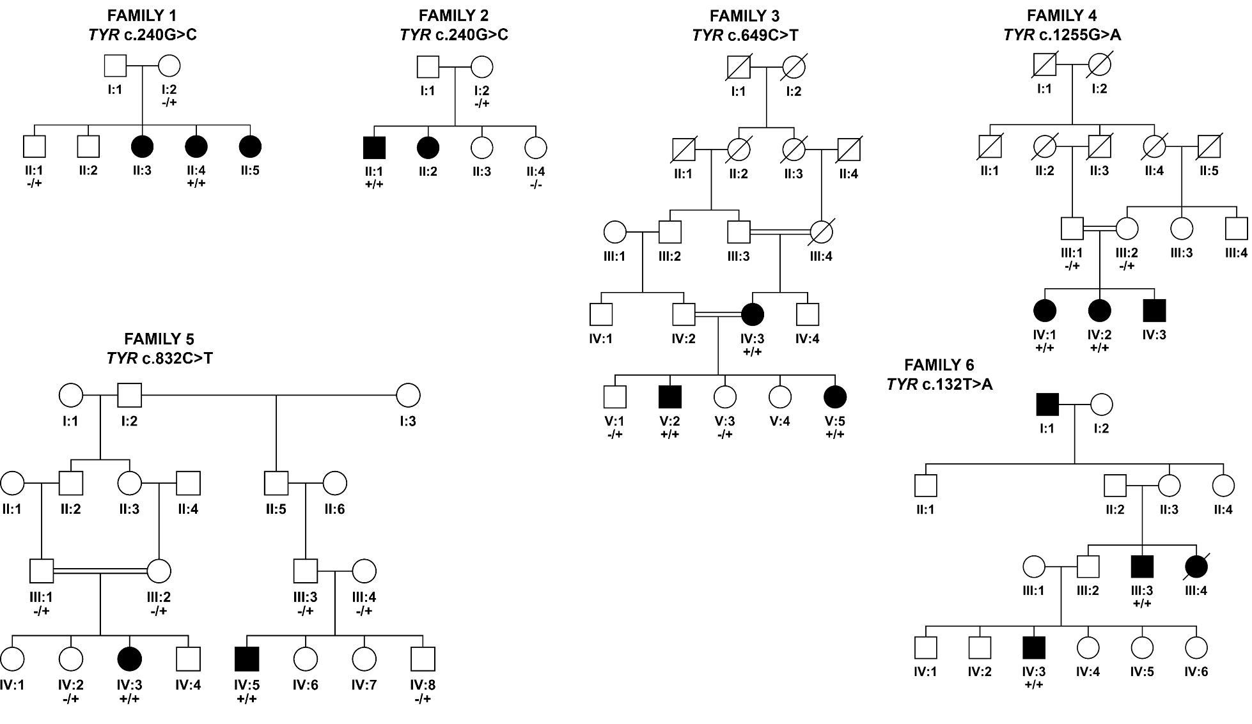
Figure 1: Pedigrees of 6 families with oculocutaneous albinism co-segregating for TYR mutations. Presence or absence of the variant is indicated by a + or - sign respectively.
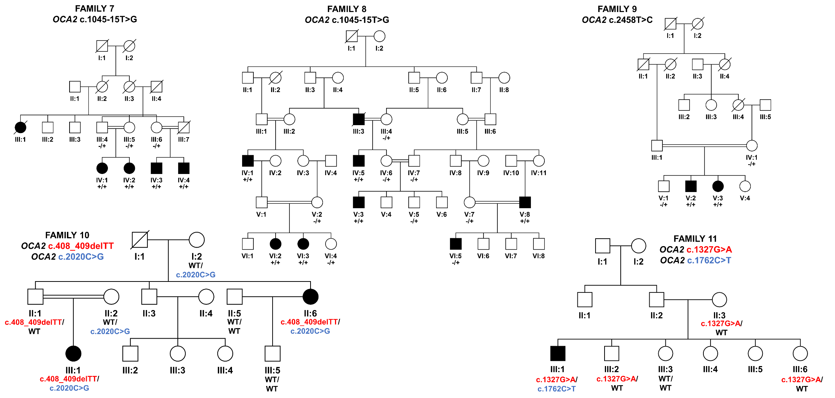
Figure 2: Pedigrees of 5 families with oculocutaneous albinism co-segregating for OCA2 mutations. Presence or absence of the variant is indicated by a + or - sign respectively. For compound heterozygous mutations, the different OCA2 variants within the same family are displayed in different colours.
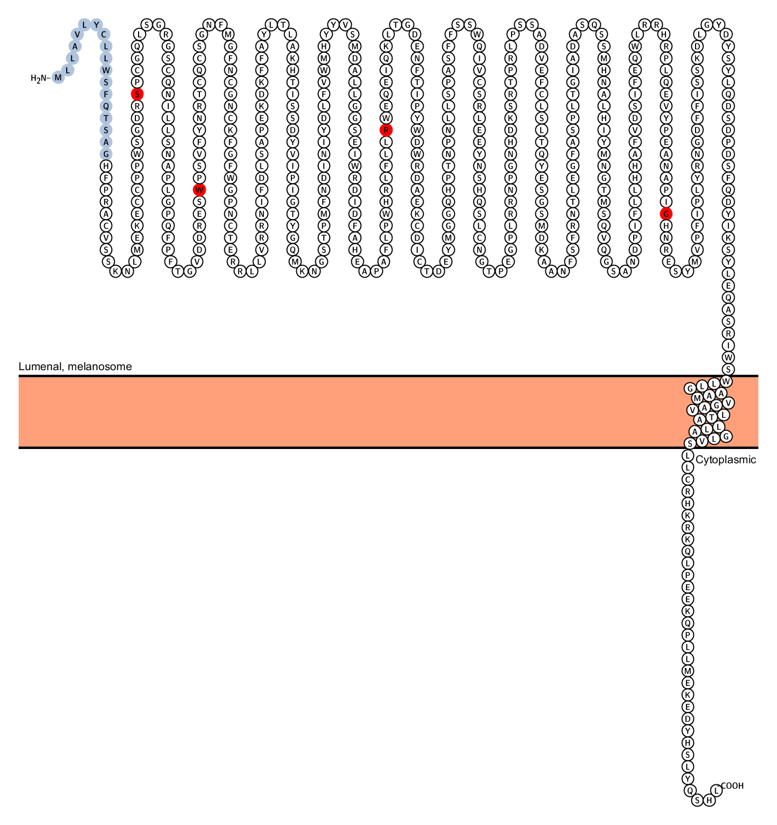
OCA2 variants
TYR variants
TYR
OCA2

Figure 3: Localisation of the TYR and OCA2 missense variants identified in the study
REFERENCES

Ammann, S., Schulz, A., Krageloh-Mann, I., Dieckmann, N.M., Niethammer, K., Fuchs, S., Eckl, K.M., Plank, R., Werner, R., Altmuller, J., Thiele, H., Nurnberg, P., Bank, J., Strauss, A., von Bernuth, H., Zur Stadt, U., Grieve, S., Griffiths, G.M., Lehmberg, K., Hennies, H.C. and Ehl, S., 2016. Mutations in AP3D1 associated with immunodeficiency and seizures define a new type of Hermansky-Pudlak syndrome. Blood 127, 997-1006.
Chaki, M., Sengupta, M., Mondal, M., Bhattacharya, A., Mallick, S., Bhadra, R., Indian Genome Variation, C. and Ray, K., 2011. Molecular and functional studies of tyrosinase variants among Indian oculocutaneous albinism type 1 patients. J Invest Dermatol 131, 260-2.
Chen, K., Manga, P. and Orlow, S.J., 2002. Pink-eyed dilution protein controls the processing of tyrosinase. Mol Biol Cell 13, 1953-64.
Chiang, P.W., Fulton, A.B., Spector, E. and Hisama, F.M., 2008. Synergistic interaction of the OCA2 and OCA3 genes in a family. Am J Med Genet A 146A, 2427-30.
Cruz-Inigo, A.E., Ladizinski, B. and Sethi, A., 2011. Albinism in Africa: stigma, slaughter and awareness campaigns. Dermatol Clin 29, 79-87.
Fernandez, L.P., Milne, R.L., Pita, G., Aviles, J.A., Lazaro, P., Benitez, J. and Ribas, G., 2008. SLC45A2: a novel malignant melanoma-associated gene. Hum Mutat 29, 1161-7.
Fukamachi, S., Shimada, A. and Shima, A., 2001. Mutations in the gene encoding B, a novel transporter protein, reduce melanin content in medaka. Nat Genet 28, 381-5.
Gershoni-Baruch, R., Rosenmann, A., Droetto, S., Holmes, S., Tripathi, R.K. and Spritz, R.A., 1994. Mutations of the tyrosinase gene in patients with oculocutaneous albinism from various ethnic groups in Israel. Am J Hum Genet 54, 586-94.
Hutton, S.M. and Spritz, R.A., 2008. Comprehensive analysis of oculocutaneous albinism among non-Hispanic caucasians shows that OCA1 is the most prevalent OCA type. J Invest Dermatol 128, 2442-50.
Jaworek, T.J., Kausar, T., Bell, S.M., Tariq, N., Maqsood, M.I., Sohail, A., Ali, M., Iqbal, F., Rasool, S., Riazuddin, S., Shaikh, R.S. and Ahmed, Z.M., 2012. Molecular genetic studies and delineation of the oculocutaneous albinism phenotype in the Pakistani population. Orphanet J Rare Dis 7, 44.
Kamaraj, B. and Purohit, R., 2014. Mutational analysis of oculocutaneous albinism: a compact review. Biomed Res Int 2014, 905472.
King, R.A., Willaert, R.K., Schmidt, R.M., Pietsch, J., Savage, S., Brott, M.J., Fryer, J.P., Summers, C.G. and Oetting, W.S., 2003. MC1R mutations modify the classic phenotype of oculocutaneous albinism type 2 (OCA2). Am J Hum Genet 73, 638-45.
Lee, S.T., Nicholls, R.D., Bundey, S., Laxova, R., Musarella, M. and Spritz, R.A., 1994. Mutations of the P gene in oculocutaneous albinism, ocular albinism, and Prader-Willi syndrome plus albinism. N Engl J Med 330, 529-34.
Matsunaga, J., Dakeishi-Hara, M., Miyamura, Y., Nakamura, E., Tanita, M., Satomura, K. and Tomita, Y., 1998. Sequence-based diagnosis of tyrosinase-related oculocutaneous albinism: successful sequence analysis of the tyrosinase gene from blood spots dried on filter paper. Dermatology 196, 189-93.
Mondal, M., Sengupta, M., Samanta, S., Sil, A. and Ray, K., 2012. Molecular basis of albinism in India: evaluation of seven potential candidate genes and some new findings. Gene 511, 470-4.
Norman, C.S., O'Gorman, L., Gibson, J., Pengelly, R.J., Baralle, D., Ratnayaka, J.A., Griffiths, H., Rose-Zerilli, M., Ranger, M., Bunyan, D., Lee, H., Page, R., Newall, T., Shawkat, F., Mattocks, C., Ward, D., Ennis, S. and Self, J.E., 2017. Identification of a functionally significant tri-allelic genotype in the Tyrosinase gene (TYR) causing hypomorphic oculocutaneous albinism (OCA1B). Sci Rep 7, 4415.
Orlow, S.J. and Brilliant, M.H., 1999. The pink-eyed dilution locus controls the biogenesis of melanosomes and levels of melanosomal proteins in the eye. Exp Eye Res 68, 147-54.
Preising, M.N., Forster, H., Tan, H., Lorenz, B., de Jong, P.T. and Plomp, A.S., 2007. Mutation analysis in a family with oculocutaneous albinism manifesting in the same generation of three branches. Mol Vis 13, 1851-5.
Puri, N., Gardner, J.M. and Brilliant, M.H., 2000. Aberrant pH of melanosomes in pink-eyed dilution (p) mutant melanocytes. J Invest Dermatol 115, 607-13.
Rooryck, C., Morice-Picard, F., Elcioglu, N.H., Lacombe, D., Taieb, A. and Arveiler, B., 2008. Molecular diagnosis of oculocutaneous albinism: new mutations in the OCA1-4 genes and practical aspects. Pigment Cell Melanoma Res 21, 583-7.
Rosemblat, S., Sviderskaya, E.V., Easty, D.J., Wilson, A., Kwon, B.S., Bennett, D.C. and Orlow, S.J., 1998. Melanosomal defects in melanocytes from mice lacking expression of the pink-eyed dilution gene: correction by culture in the presence of excess tyrosine. Exp Cell Res 239, 344-52.
Schnur, R.E., Sellinger, B.T., Holmes, S.A., Wick, P.A., Tatsumura, Y.O. and Spritz, R.A., 1996. Type I oculocutaneous albinism associated with a full-length deletion of the tyrosinase gene. J Invest Dermatol 106, 1137-40.
Shah, S.A., Raheem, N., Daud, S., Mubeen, J., Shaikh, A.A., Baloch, A.H., Nadeem, A., Tayyab, M., Babar, M.E. and Ahmad, J., 2015. Mutational spectrum of the TYR and SLC45A2 genes in Pakistani families with oculocutaneous albinism, and potential founder effect of missense substitution (p.Arg77Gln) of tyrosinase. Clin Exp Dermatol 40, 774-80.
Shahzad, M., Yousaf, S., Waryah, Y.M., Gul, H., Kausar, T., Tariq, N., Mahmood, U., Ali, M., Khan, M.A., Waryah, A.M., Shaikh, R.S., Riazuddin, S., Ahmed, Z.M. and University of Washington Center for Mendelian Genomics, C., 2017. Molecular outcomes, clinical consequences, and genetic diagnosis of Oculocutaneous Albinism in Pakistani population. Sci Rep 7, 44185.
Simeonov, D.R., Wang, X., Wang, C., Sergeev, Y., Dolinska, M., Bower, M., Fischer, R., Winer, D., Dubrovsky, G., Balog, J.Z., Huizing, M., Hart, R., Zein, W.M., Gahl, W.A., Brooks, B.P. and Adams, D.R., 2013. DNA variations in oculocutaneous albinism: an updated mutation list and current outstanding issues in molecular diagnostics. Hum Mutat 34, 827-35.
Tripathi, R.K., Strunk, K.M., Giebel, L.B., Weleber, R.G. and Spritz, R.A., 1992. Tyrosinase gene mutations in type I (tyrosinase-deficient) oculocutaneous albinism define two clusters of missense substitutions. Am J Med Genet 43, 865-71.
Wang, X., Zhu, Y., Shen, N., Peng, J., Wang, C., Liu, H. and Lu, Y., 2016. Mutation analysis of a Chinese family with oculocutaneous albinism. Oncotarget 7, 84981-84988.
Zhang, L., Xu, B., Zhong, Y., Chen, X., Zheng, H., Jiang, W. and Li, H., 2013. [A de novo mutation of P gene causes oculocutaneous albinism type 2 with prenatal diagnosis]. Zhonghua Yi Xue Yi Chuan Xue Za Zhi 30, 318-21.
Zollo, M., Ahmed, M., Ferrucci, V., Salpietro, V., Asadzadeh, F., Carotenuto, M., Maroofian, R., Al-Amri, A., Singh, R., Scognamiglio, I., Mojarrad, M., Musella, L., Duilio, A., Di Somma, A., Karaca, E., Rajab, A., Al-Khayat, A., Mohan Mohapatra, T., Eslahi, A., Ashrafzadeh, F., Rawlins, L.E., Prasad, R., Gupta, R., Kumari, P., Srivastava, M., Cozzolino, F., Kumar Rai, S., Monti, M., Harlalka, G.V., Simpson, M.A., Rich, P., Al-Salmi, F., Patton, M.A., Chioza, B.A., Efthymiou, S., Granata, F., Di Rosa, G., Wiethoff, S., Borgione, E., Scuderi, C., Mankad, K., Hanna, M.G., Pucci, P., Houlden, H., Lupski, J.R., Crosby, A.H. and Baple, E.L., 2017. PRUNE is crucial for normal brain development and mutated in microcephaly with neurodevelopmental impairment. Brain 140, 940-952.

