Recent Sediment Flux to the Ganges-Brahmaputra-Meghna Delta System

Md. Munsur Rahman¹, Md. Maruf Dustegir¹, Rezaul Karim¹, Anisul Haque¹, Robert J Nicholls², Stephen E Darby³ , Hajime Nakagawa⁴, Motahar Hossain⁵, Frances E. Dunn⁶ and Marin Akter¹
¹ Institute of Water and flood Management (IWFM), Bangladesh University of Engineering & Technology (BUET), Dhaka, Bangladesh.
² Geography and Environment, University of Southampton, Highfield, Southampton SO17 1BJ, UK.
³ Engineering and the Environment and Tyndall Centre for Climate Change Research, University of Southampton, Highfield, Southampton, SO17 1BJ, UK.
⁴ Ujigawa Open Laboratory, Kyoto University, Japan
⁵ Bangladesh Water Development Board (BWDB), Bangladesh.
⁶ GeoData, University of Southampton, Highfield, Southampton, SO17 1BJ, UK

Email: munsurbuet1989@gmail.com
Abstract. The physical sustainability of deltaic environments is very much dependent on the volume of water and sediment coming from upstream and the way these fluxes recirculate within the delta system. Based on several past studies, the combined mean annual sediment load of the Ganges-Brahmaputra-Meghna (GBM) systems has previously been estimated to vary from 1.0 to 2.4 BT/yr which can be separated into components flowing from the Ganges (260 to 680 MT/yr) and Brahmaputra (390 to 1160 MT/yr). Due to very limited data and small contribution of the Meghna system (6-12 MT/yr) to the total sediment flux of the GBM system, the data of the Meghna is not considered in the analysis assuming the sediment flux from GB system as the sediment flux of GBM. However, in this paper our analysis of sediment concentration data (1960-2008) collected by Bangladesh Water Development Board shows that the sediment flux is much lower: 150 to 590 MT/yr for the Ganges versus 135 to 615 MT/yr for the Brahmaputra, with an average total flux around 500 MT/yr. Moreover, the new analysis provides a clear indication that the combined sediment flux delivered through these two major river systems is following a declining trend. In most of the planning documents in Bangladesh, the total sediment flux is assumed as a constant value of around 1 billion tons, while the present study indicates that the true value may be around 50% lower than this (with an average decreasing trend of around 10 MT/yr).

Keywords: Sediment flux, GBM system, GBM Delta, Ganges, Brahmaputra

- Introduction

Deltas are home to over half a billion people, many of whom are poor and live with a high dependency on ecosystem services (Ericson et al., 2006; Nicholls et al., 2018). The ecosystem resources in these areas are experiencing multiple stresses from climate change, sea level rise, subsidence, changing catchment management and land use change (Nicholls et al., 2016). The flows of water and sediment into these deltaic environments from their feeder catchments upstream is one of the most important factors for shaping deltas. Recent evidence shows that many deltas are experiencing a severe shortage of sediment because of different types of anthropogenic interventions that intercept significant volumes of sediment flux (Gupta et al., 2012; Kondolf et al., 2014; Syvitski et al., 2009; Syvitski and Kettner, 2011; Syvitski and Saito, 2007). A continuous reduction of sediment flux means there is much less potential for the formation of new sedimentary layer (Syvitski et al., 2009) over the delta plain and the ability to counterbalance sea level rise and subsidence (Brown and Nicholls, 2015; Tessler et al., 2017) is diminished, resulting in the reality that many of the world’s deltas are sinking.

On the contrary, the Ganges-Brahmaputra-Meghna (GBM) delta has been gaining new land by 17 km²/yr for the last five decades (Sarker et al., 2013). The above fact leads the policy makers, implementing agencies and even the local community to implicitly think that the system is receiving sufficient sediment that would lead to continued future delta building processes. The secondary literature revealed that estimates of the total sediment load reaching the GBM delta vary at the order of 1~2.4 billion metric tons per year (detailed references have been reviewed in section 2.1). In reality, the rivers within the GBM basin are also being affected by anthropogenic activity including the development of water control structures (both at basin scale and local scale) such as dams, barrages, and embankments (Gain and Giupponi, 2014; Gupta et al., 2012; Rahaman, 2009). These structures might have some adverse impact on the downstream transmission of sediment. In addition, the coarse fraction of the incoming sediment load (which is the most significant in terms of the potential for delta-building process) may be more susceptible to being trapped than the fine fraction, leading to an increase in the ratio of the fine/coarse fraction of sediment (Okada et al., 2016). The change in the total sediment load and its calibre are critical for understanding the formation of the river planform and the opportunities and threats for sustainable river and delta management which are the two major hotspots (out of 6) identified in Bangladesh Delta Plan 2100 (BDP 2100, 2015). However, the information related to the amount of sediment load is available in the major rivers (e.g. impact of upstream developments) and the amount reaching to the deltaic system and its trend of changes are not clear in the long term delta planning documents. Therefore, it is important to have clear understanding on the incoming sediment flux and its trend of change to GBM system.

Due to future changes in climatic factors such as temperature and rainfall, future sediment generation is expected to increase based on the HydroTrend model for both the Ganges (34% to 37%) and the Brahmaputra (52% and 60%) system by the end of the 21st century (Darby et al., 2015) depending on the climate scenarios. While, Fischer et al., (2017) estimated (using HEC-RAS) around 40% increase of sediment load along the Brahmaputra/Jamuna by 21st century because of the future climate change. However, the estimated sediment load would not be realized under the different planned anthropogenic interventions. Following the above two studies, introducing the upstream planned dams in the global hydrological model WBMsed, it is found (Dunn et. al., in this issue) that, under 12 potential future scenarios of environmental change and socio-economic development pathways, the modelled fluvial sediment flux to the Ganges delta showed a large decrease over time from 566 MT/yr in the ‘recent’ past, to 79-92 MT/yr by the end of the 21st century (a total decline of 88% on average; while yearly decreasing rate is around 5 MT/yr) which is consistent with other deltas in anthropocene. However, the above estimated changes of sediment flux has some inherent uncertainties with the uncertain nature of climatic factors as well socio-economical pathway factors. Moreover, the past trend of changes are also unknown. Under the above circumstances, it is important to understand the recent sediment flux and its trend of changes using the data available from secondary sources (summarized in section 2.1) as well as data measured by the national agency, Bangladesh Water Development Board (BWDB). It is worth mentioning here that depending on the methodology followed during data collection and analysis, the results may vary significantly. Therefore, the aim of the present study is, to understand the past, recent past and projected trend of sediment flux in the GB system from two sources of information: (1) Chronological documentation of sediment flux in the published literature during 1958-2010; (2) Analysing the available long-term measured sediment transport rate in the two major distributaries (Ganges and Brahmaputra) of the Ganges-Brahmaputra rivers from BWDB.

The paper is structured as follows:
1. Demonstration of the historical sediment flux from different published papers and BWDB measured data;
2. Trend analysis of the historical sediment flux in the Ganges and Brahmaputra; and
3. Projection of the sediment influx to the GBM delta systems at different time scales and implications for the river and delta management.
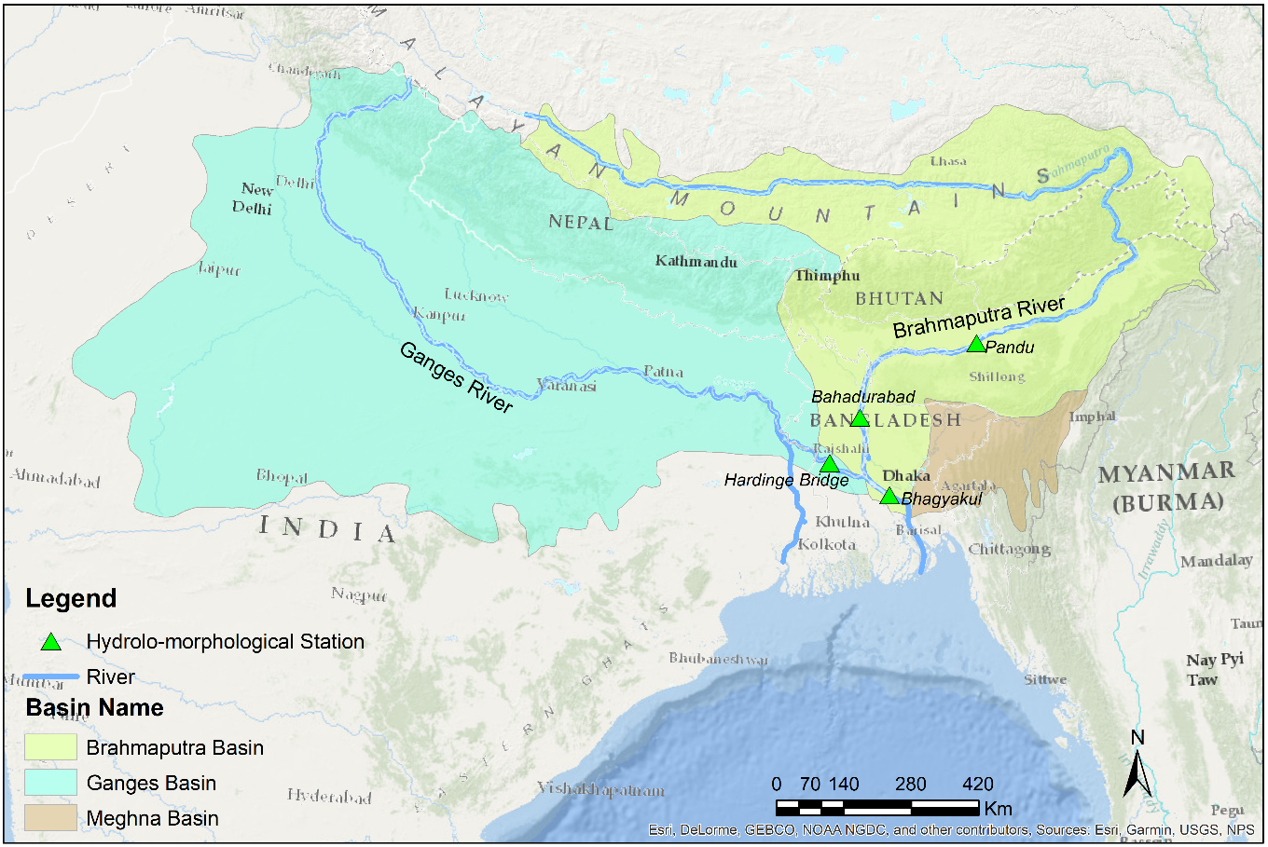

Figure 1: Map of the GBM basin showing the locations of gauging stations and significant upstream interventions. Green triangles indicate BWDB gauging stations.

- Methodology
The methodology of this article is segmented in to three parts as follows:
Firstly, we have thoroughly reviewed the literature for the investigation of the sediment flux in the Ganges-Brahmaputra system. After the extraction of the sediment flux, all the datasets have been organized corresponding to their measurement period. It is important to note that the source of secondary data are diverse that includes several project base measurements and often mentioning the BWDB source as well. In many cases, only the value of the yearly sediment flux is quoted without mentioning the methodology of the data collection and calculation procedure. However, it can be assumed (after consultation with the BWDB senior officials) that all the data sources are following the similar basic approach practicing in BWDB for the collection of suspended sediment transport.

Secondly, BWDB datasets have been analysed to investigate the total suspended sediment flux. The datasets of sediment load collected from the BWDB are in sediment transport rate (kg/s) along the cross-section of the channel for a specific time. Generally, BWDB collects data at 15 day intervals, sometimes data for several months in a certain year are not available. To derive the total suspended load of a particular year, this available data set are summed up using trapezoidal method (see section 2.2). For the calculation of yearly sediment flux, those years have been considered, when most of the datasets are available round the year. However, the variability of the sediment transport processes within the collected sediment samples have been tested in terms of Q vs Qs graphs.

Thirdly, the yearly sediment flux data, extracted from the secondary literature together with estimated values using BWDB data sources, have been assembled chronologically to understand the sediment dynamics in the GB systems. The rationale of using the data from secondary sources and BWDB data within a single platform is that both data sources are representing the total suspended sediment flux. Although the chances of double counting between the data from secondary sources and BWDB data cannot be ignored fully as some of the secondary sources are mentioning BWDB as data source. But as we assembled all the data chronologically, the impact of such unavoidable errors will be minimum while estimating the trend of change of sediment flux through linear regression.
Finally, Several statistical test have been conducted (see section 2.3) to examine whether the trends of change of sediment flux is significant or not.

2.1 Review of Published Sediment Load Data

Previous studies of the total sediment loads along the Brahmaputra and Ganges at Bahadurabad and Hardinge Bridge, respectively, exhibit large variability in the estimated sediment fluxes due to the variability of measurement techniques and analysis periods. Holeman (1968) was the first to provide an approximate estimation of sediment load in the Ganges and Brahmaputra river systems, suggesting that the total load of the Ganges and Brahmaputra Rivers combined 2.4 billion tonnes per year, with the Ganges contributing 1600 MT/yr and the Brahmaputra 800 MT/yr. Holeman’s (1968) study, however, includes no details concerning the methodology employed to derive this estimate, albeit it was likely based on considerations of the basin erosion rates.

Coleman (1969) conducted the first comprehensive study on the Brahmaputra River, estimating the sediment load based on measurements undertaken during the period of 1958-1962. For the Ganges, the suspended sediment concentration (SSC) was shown to range between 190-1600 mg/1, and for the Brahmaputra the SSC was 220-1400 mg/1. The estimated combined sediment load was around 1100 MT/yr. Based on some measurement in the 1960s conducted by International Engineering Company (1964) and FAO, Coleman (1969) mentioned that the combined peak suspended sediment discharge may rise to the order of 13 MT per day. Milliman and Meade (1983) estimated the total sediment flux based on a sediment rating curve using 53 sediment samples collected in the Padma River at Bhagyakul (downstream of the confluence of the Ganges and Brahmaputra) during the period 1966-67. Their study estimated the total sediment of the GBM basin to be around 1670 MT/yr.

The Netherlands Engineering Consultants (NEDECO, 1967) conducted a detailed survey for the East Pakistan Inland Water Transport Authority (IWTA) in 1960 and reported a total sediment flux of 1125 MT/yr. Islam et al. (1999) attempted to quantify the sediment load discharged into the Bay of Bengal based on sediment rating curves for the Ganges and the Brahmaputra using suspended sediment data collected by BWDB during 1979-1995 and 1989-1994 respectively, deriving an estimated value of 1137 MT/yr. Wasson (2003) tried to prepare an approximate sediment budget of the GBM system (Figure 2). Hossain (1992) estimated the sediment data at Hardinge and Bahadurabad point for the Ganges and the Brahmaputra respectively, for the periods of measurement 1980-1988 by BWDB. The range of sediment flux obtained for the Ganges was 350-600 MT/yr and for the Brahmaputra it was 400-850 MT/yr, that stands for 750-1450 MT/yr for the combined GB system with an average value of 1100 MT/yr.

Based on the field measurement during the monsoon of 1981, Abbas and Subramanian (1984) estimated that the suspended load of the Bangladesh part of the Ganges at Farakka point was 401 MT/yr, while the sediment load for Hoogly channel amounted to 328 MT/year. Though there is no indication of the time period, MPO (1987) estimated sediment transport rate by using a hybrid sediment rating curve of the combined flow of the Ganges and the Brahmaputra at Mawa and Baruria respectively. French Engineering Company (1989) prepared sediment balances at Hardinge Bridge and Bahadurabad based on sediment rating curves and found the combined load was 680 MT/yr. Using BWDB data during the year ranging 1965-1988, China Bangladesh Joint Expert Team-CBJET (1991) made an estimation of total suspended load for the Ganges of 200 MT/yr and 500 MT/yr for the Brahmaputra.

Kabir and Ahmed (1996) calculated total load at Bahadurabad to be 541 MT/yr using FAP data measured in 1993. In 1985, based on sediment rating curve using 1955-1979 data of the Brahmaputra at Pandu, Assam, Goswami (1985) estimated that total suspended load was 402 MT/yr. Rice (2010) estimated suspended sediment flux was 262 MT/yr and 387 MT/yr for the Ganges and the Brahmaputra, respectively, based on field data collected during the 2006 monsoon. All the above sediment fluxes along the Ganges and the Brahmaputra are summarized in Table 1, showing the variety of techniques applied to these rivers and the range of sediment flux estimates over time. Note that it was not clear how the sediment flux was estimated in many of the above references.

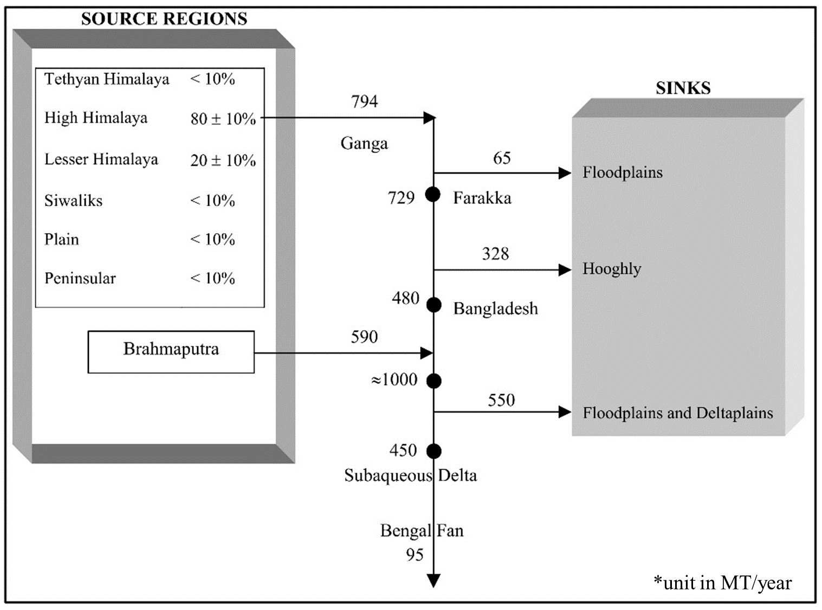

Figure 2: Sediment flux budget for GBM basin by Wasson (2003).

Table 1: Historical Sediment Fluxes of the Ganges and the Brahmaputra from the published literature.

Name of Basin | Sediment Flux (MT/yr) | Gauging Station/Location | Periods of Measurement | Source | Methodology
Ganges | 1600 | Hardinge Point | 1874-1879 | Holeman (1968) | Not mentioned
Ganges | 520 | Hardinge Point | 1966-1969 | BWDB (1972) in Islam et al. (1999) | Sediment sample Data
Ganges | 375 | Bangladesh | 1960 | NEDECO (1967) in Islam et al. (1999) | Not mentioned
Ganges | 478.9 | Hardinge Point | 1958-1962 | Coleman (1969) | Field Measurement
Ganges | 390 | Not mentioned | 2004-2010 | Lupker et al. (2011) | ADCP Data and Sediment Sample Data Collection
Ganges | 680 | Hardinge Point | Not mentioned | Milliman & Meade (1983) in Islam et al. (1999) | Sediment rating curve mentioned in ECI and ACE (1970)
Ganges | 594 | Hardinge Point | 1980 | Hossain (1992) in FAP24 | Sediment rating curve
Ganges | 350-600 | Hardinge Point | 1980-1986 | Hossain (1992) in FAP24 | Sediment rating curve
Ganges | 420 | Hardinge Point | 1983 | Hossain (1992) in FAP24 | Sediment rating curve
Ganges | 423 | Hardinge Point | 1984 | Hossain (1992) in FAP24 | Sediment rating curve
Ganges | 348 | Hardinge Point | 1985 | Hossain (1992) in FAP24 | Sediment rating curve
Ganges | 381 | Hardinge Point | 1986 | Hossain (1992) in FAP24 | Sediment rating curve
Ganges | 316 | Hardinge Point | 1979-1995 | Islam et al. (1999) | Sediment rating curve
Ganges | 502 | Not mentioned | Not mentioned | Barua et al. (1994) | Not mentioned
Ganges | 550 | Not mentioned | Not mentioned | CEGIS (2010) | Not mentioned
Ganges | 430-729 | Not mentioned | Not mentioned | Thakkar (2006) | Not mentioned
Ganges | 262 | Hardinge Point | 2006 | Rice (2010) | Field measurement
Ganges | 548 | Hardinge Point | 1966-1970 | FAP24 (1996) | Sediment rating curve
Ganges | 200 | Hardinge Point | 1965–1988 | China‐Bangladesh Joint Expert Team-CBJET (1991) | Not mentioned
Ganges | 340 | Hardinge Point | Not mentioned | French Engineering Consortium (1989) | Sediment rating curve
Ganges | 210 | Hardinge Point | Not mentioned | Master Plan Organization (1987) | Sediment rating curve
Ganges | 401 | Farakka | 1981 | Abbas & Subramanian (1984) | Field measurement (SS)
Brahmaputra | 800 | Bengal Delta | 1874-1879 | Holeman (1968) | Not mentioned
Brahmaputra | 1157 | Bahadurabad | Not mentioned | Milliman and Meade (1983) in Islam et al. (1999) | Sediment rating curve mentioned in ECI and ACE (1970)
Brahmaputra | 607.7 | Bahadurabad | 1958-1962 | Coleman (1969) | Field Measurement
Brahmaputra | 541 | Bahadurabad | 1967-1969 | BWDB (1972) in Islam et al. (1999) | Sediment sample Data
Brahmaputra | 750 | Bangladesh | 1960 | NEDECO (1967) in Islam et al. (1999) | Not mentioned
Brahmaputra | 541 | Bahadurabad | 1993 | Kabir and Ahmed (1996) | Field Measurement (FAP) in the dominant channel
Brahmaputra | 721 | Bahadurabad | 1989-1994 | Islam et al. (1999) | Sediment rating curve
Brahmaputra | 650 | Bahadurabad | 1982-1988 | Hossain (1992) | Sediment rating curve
Brahmaputra | 390 | Bahadurabad | Not mentioned | Master Plan Organization (1987) | Sediment rating curve
Brahmaputra | 500 | Bahadurabad | 1965–1988 | CBJET (1991) | Not mentioned
Brahmaputra | 1028 | Not mentioned | Not mentioned | Barua et al 1994 | Not mentioned
Brahmaputra | 590 | Not mentioned | Not mentioned | CEGIS (2010) | Not mentioned
Brahmaputra | 430 | Bahadurabad | Not mentioned | French Engineering Consortium (1989) | Sediment rating curve
Brahmaputra | 387 | Sirajganj | 2006 | Rice (2010) | Field measurement (SS)
Brahmaputra | 402 | Pandu, Asam | 1955-1979 | Goswami (1985) | Sediment rating curve (SS)
Brahmaputra | 710 | Not mentioned | Not mentioned | Subramanian(1987) | Not mentioned

2.2 New Sediment Load Data from BWDB

The Bangladesh Water Development Board (BWDB) operates around 110 discharge and 25 sediment gauging stations. However, data from these stations are not collected continuously over the years as some of the stations are only operated for limited periods of the year. There are time series data from the flow discharge and sediment gauging stations along the Ganges and the Brahmaputra at Hardinge Point and Bahadurabad Transit, respectively (see Figure 1). Continuous daily flow discharge data is available for the year 1960-2006, whereas monthly data is available for the year 2008-2014. Sediment data for the Bahadurabad transit station is available from 1968 to 2001 (except for missing periods in 1971, 1975-1977, 1996-1999), while complete sediment data for the Ganges is available for the years 2001, 2004 and 2008 only. For the Meghna, a very limited sediment data is available (2000, 2001 and 2004) in BWDB measurement where total yearly sediment flux ranges between 6-12 MT/yr (nearly 1% of the total sediment flux). Due to the limited data and very small contribution (FAP24, 1996) to the total sediment flux of the GBM system, the data of the Meghna is not considered in the analysis assuming the sediment flux from GB system as the sediment flux of GBM.

The River Survey Project (RSP or FAP24) was introduced in 1992 (FAP24, 1996) and was executed by the Flood Plan Coordination Organization (FPCO), later merged with Water Resource Planning Organization (WARPO). The period of data collection was 1993-1996.

For the collection of water sample to measure suspended sediment load by BWDB, the entire cross section of the river is divided in to at least 25 pockets satisfying the condition that discharge within any pocket area should not exceed 10% of the total discharge. Flow velocity (using current meter) is measured at 20% and 80% depth of each of the verticals. Sediment samples (undisturbed) using Binklay silt sampler are collected from alternate pocket area at the points where flow velocities are measured. Immediately after the collection of the water sample, it is kept in a container for around 100 seconds and the amount of sediment deposited within this time is considered as coarse fraction, while rest of the sediment is considered as fine fraction (determined in the laboratory later). However, average sediment concentration within a particular vertical is assessed providing appropriate weightage (based on BWDB experience) to the concentration values obtained at 20% and 80% depths. The obtained sediment concentration is then multiplied by the discharge within that pocket area to obtain sediment flux within that pocket area. The summation of the sediment discharge of all the pocket areas within that cross section is considered as the sediment transport rate usually expressed in kg/sec.
Generally, the above exercise is done at 15 days interval to capture the temporal variation of sediment load. After the collection of above data (kg/sec) from BWDB, we calculated the daily sediment discharge assuming the sediment load is remaining constant for that particular day. This assumption is reasonable as the water level/discharge changes slowly at the gauging station of the Ganges and the Jamuna/Brahmaputra rivers and BWDB reasonably expresses the average of water level/discharge value for a particular day (http://www.ffwc.gov.bd/). The estimated daily sediment fluxes are then plotted round the year and yearly sediment flux is calculated using the trapezoidal rule of integration where the daily values of sediment fluxes and dates of measurement are considered as ordinates and abscissa, respectively (Sastry, 2006).
However, using all the received raw data from BWDB, the variability of the suspended sediment transport rate, Qs (kg/s) in relation with the flow discharge variability, Q (m3/s) both for the Ganges and the Brahmaputra have been plotted in Figure 3. It can be seen that the discharge variability of the Ganges and the Brahmaputra ranging between 1000-60000 m3/s and 3000-90000 m3/s, respectively. While, the variability of suspended sediment transport rate remains between 5-95000 kg/s and 70-180000 kg/s, respectively for the Ganges and the Brahmaputra. The above variation of the discharge and sediment transport indicate that both the Ganges and the Brahmatutra/Jamuna are very dynamic in terms of flow and sediment transport, while the Brahmaputra is more dynamic than the Ganges.

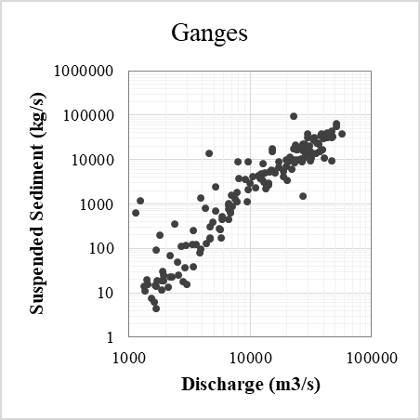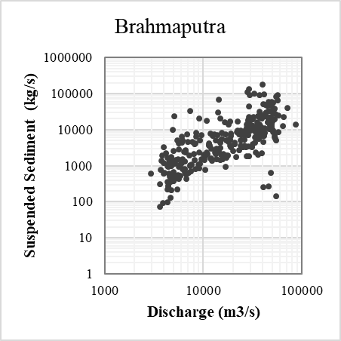

Figure 3: Variability of flow discharge, Q and sediment discharge, Qs using the raw data collected from BWDB both for the Ganges and the Brahmaputra/Jamuna.

2.3 Statistical Testing of Sediment Data

To examine whether there is a significant trend in sediment flux, statistical tests have been performed. For the detection of statistically significant trend in the datasets, Mann-Kendall, t-test and F-test have been adopted (Yue and Pilon, 2004). For these test, a hypothesis has been considered as followed by:

(1)

The nonparametric Mann-Kendall test has been used to detect statistically significant trends. In the Mann-Kendall test each value …, are compared with all available values. For a positive difference between the data points the so-called S-statistics increases with +1 while it decreases with -1 for a negative difference. The S-statistics remains unchanged for ties (see equation 2 and 3).
$S=\sum_{i=1}^{n−1}{\sum_{j=i+1}^{n}{\text{sign}(k_{j}−k_{i})}}$ (2)
$\text{sign}(k_{j}−k_{i})=$ (3)
$\text{var}(s)=\frac{1}{\text{18}}\left[n(n−1)(2n+5)−\sum_{p=1}^{q}{t_{p}(t_{p}−1)(2t_{p}+5)}\right]$ (4)
$Z=$ (5)
Where n = sample size;
q = number of tied groups in the data set and
tj = number of data points in the j-th tied group.

Positive Z values indicate an upward trend in the historical sediment data; negative values indicate a negative trend. If 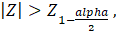 the null hypothesis ( is rejected which results in the acceptance of alternative hypothesis , and means that there is a statistically significant trend in the historical sediment flux.

For t-statistics,
$t_{\text{cal}}=\frac{\bar{y}−0}{s\sqrt{n}}$ (6)
Where $\bar{y}$ is the average of yearly sediment flux data, n is the total number of observations and s is standard error of sediment fluxes. If ( is a critical value, depending on confidence level corresponding to different degrees of freedom), null hypothesis ( is rejected which resembles the acceptance of alternative hypothesis i.e. there is a statistically significant trend.

For F- statistics,
$F_{\text{cal}}=\frac{s_{1^{2}}}{s_{2^{2}}}$ (7)
Where $s_{1}$ is standard deviation of time variables in year and $s_{2}$ is standard deviation of yearly sediment flux data.

$s_{1}=\frac{\sum{(}y_{i}−\bar{y})^{2}}{n−1}$ (8)
and

$s_{2}=\frac{\sum{(}x_{i}−\bar{x})^{2}}{n−1}$ (9)
Where x is time variable in years and y is total yearly sediment flux in MT/yr. If , null hypothesis ( is rejected which results in the acceptance of alternative hypothesis i.e. there is a statistically significant trend. Using the linear regression a simple linear trend has been devised to project the sediment flux in 2015 and 2030. In this linear regression, α is intercept and β is slope, x time variable in year and y is sediment flux in MT/yr.

- Results and Discussions

3.1 Sediment Flux for the Ganges

The historical records of total annual sediment flux of the Ganges at Hardinge Bridge are shown in Figure 4.

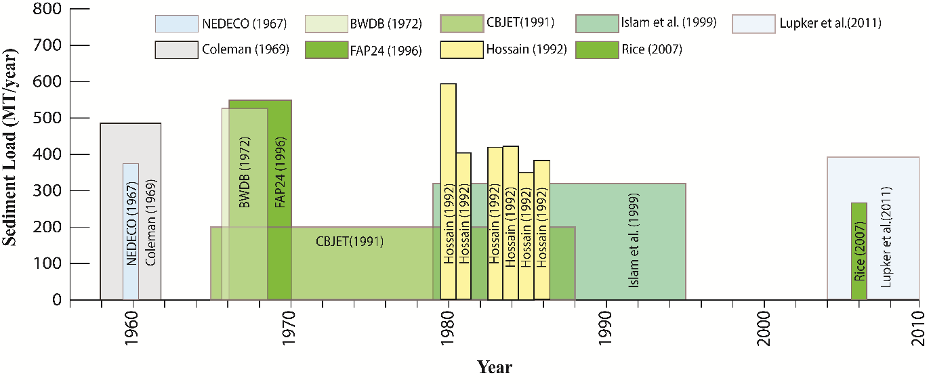
Figure 4: Recent historical records of total sediment flux estimation for the Ganges.

It is seen in Table 1 that the measurement period of the data provided by Holeman (1968) is quite old (1874-1879) after which there was no record of sediment flux for about 80 years. Moreover, the sampling method for the data from Holeman (1968) is not clear. Excluding the data (in Figure 4) of Holeman (1968), the sediment flux does not exhibit any clear temporal trend. However, examining the data from 1981 onwards, the sediment flux is slowly decreasing. To examine whether the total volume of water is changing during the period 1958-2008, the yearly total volume of water flow (BWDB data) and yearly sediment flux data (secondary literature) are plotted in Figure 5. The Figure shows that both the total yearly water volume and total sediment volume is decreasing, while sediment volume is decreasing at a much greater rate than water volume.

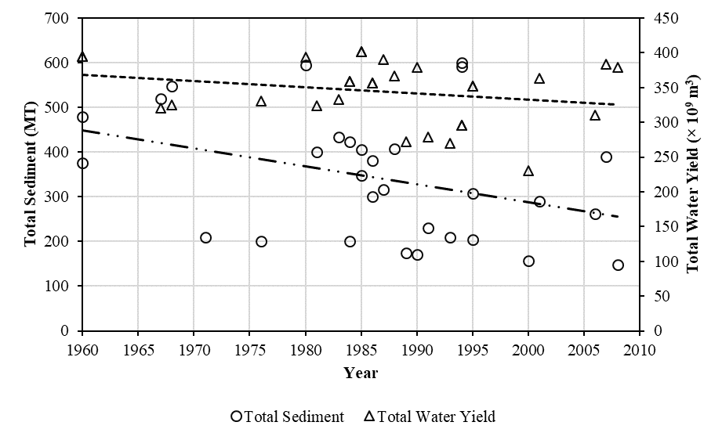
Figure 5: Comparison of total yearly sediment volume (secondary literature, BWDB and FAP data) and water flow volume at Hardinge Bridge (BWDB data) on the Ganges River.

Analysing secondary sources (literature), BWDB (period: 1994-2008) and FAP24 (period: 1994-1995) data for the sediment flux and plotting together with the secondary data (Figure 6), it is found that the sediment flux from all sources is experiencing a downward trend of 4 MT/yr. It is important to note that BWDB data beyond 2008 are not useful here because of its poor quality and discontinuous nature. Therefore, the average sediment flux at Hardinge Bridge is estimated using the above trend (-4 MT/yr) which gives around ~220 MT/year and ~160 MT/year for 2015 and 2030, respectively.

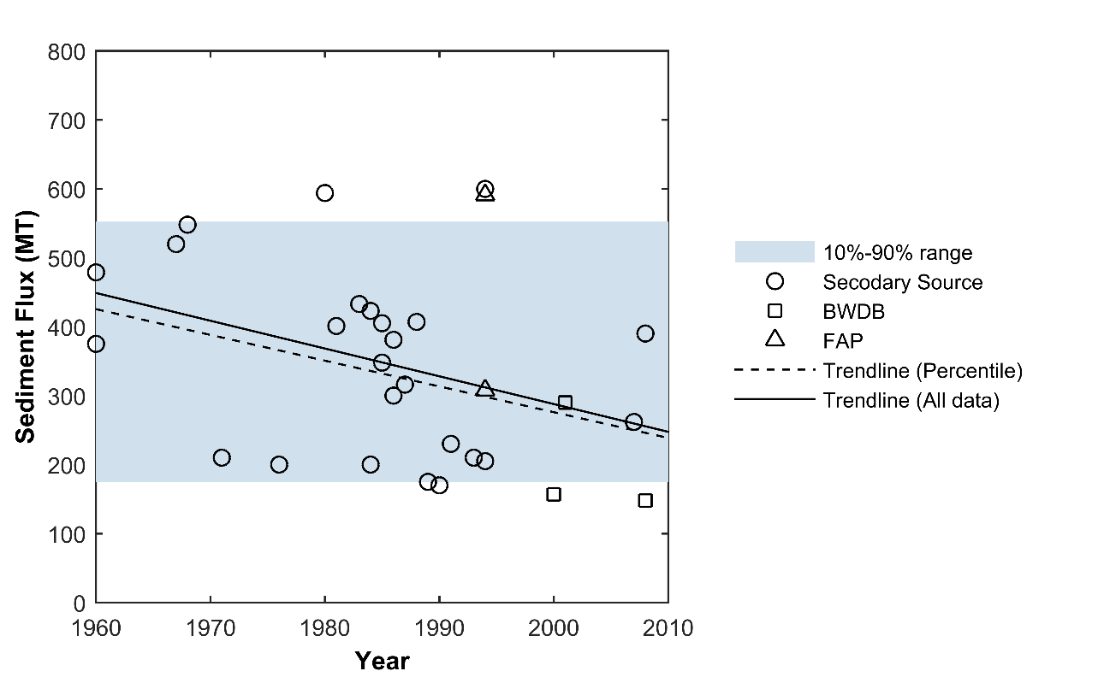

Figure 6: Trend lines of sediment flux along the Ganges during different time periods using secondary data, BWDB and FAP data. The regression using all the scattered data is with , while for the datasets ranging between 10 percentile 90 percentile data this regression is with .

Table 2 presents the results of the Mann-Kendall test, t-test and F test for the trend in the Ganges sediment data at the 95% confidence level. In terms of the Mann-Kendall test, the null hypothesis (H₀ = no trend) is rejected which denotes a significant trend for the 95% confidence level. For t-test and F-test calculated values are 2.145 and 4.233 respectively, which are greater than their respective critical values. These tests also suggest that the data are linearly associated at the 95% confidence level with the decreasing rate of 4.00 MT/year.

Table 2: Statistical tests for the Ganges sediment flux data, showing a significant trend at the 95% confidence level
Statistic | Value
Confidence level | 95%
P-value | 0.022
alpha | 0.05
RMSE | 132.38
t- calculated value | 2.145
t- critical value | 1.311
F-calculated value | 4.233
F- critical value | 3.33

3.2 Sediment Flux along the Brahmaputra

The historical records of total annual sediment flux of the Brahmaputra at Bahadurabad are shown in Figure 7.
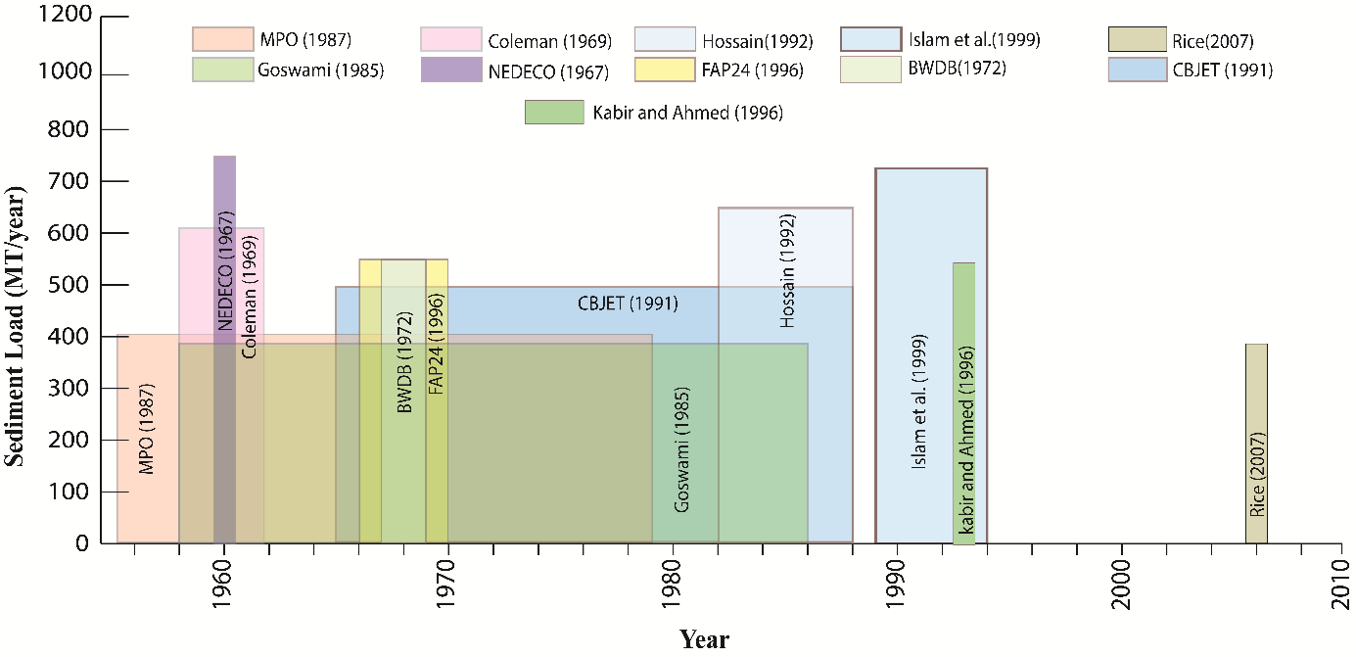
Figure 7: Historical records of total sediment flux estimation for the Brahmaputra.
Due to the uncertainty in sediment collection technique and calculation methodology, and discontinuous data since the 19th century, estimated data of Holeman (1968) has been excluded from this Figure. Excluding data of Holeman (1968), it seems that the sediment flux is not changing with any trend before 1990 (Figure 7). However, if we look at the data from the 1990s onward, it appears that the sediment flux is changing gradually with decreasing trend. To examine whether the total volume of water is changing during the period 1958-2006, the yearly total volume of water flow (BWDB data) and yearly sediment flux data (secondary literature) are plotted in Figure 8. The Figure shows that the total yearly water volume is not changing much (slightly increasing), whereas total sediment volume is decreasing.

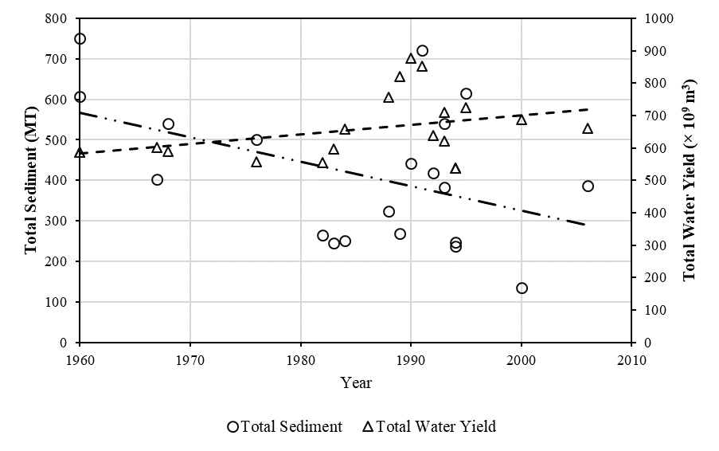

Figure 8: Comparison of total yearly sediment volume and water flow volume at Bahadurabad on the Brahmaputra River.

Analysing BWDB (period: 1982-2000) and FAP24 (period: 1993-1995) data for total sediment flux and plotting together with the secondary data (Figure 9), it is found that the sediment flux is experiencing a downward trend of 6 MT/yr. It is important to note that BWDB data beyond 2001 are not useful here because of its poor quality and discontinuity. Therefore, the average sediment flux at Bahadurabad is estimated using the above trend (-6 MT/yr) which gives around ~250 MT/year and ~160 MT/year for 2015 and 2030 respectively.

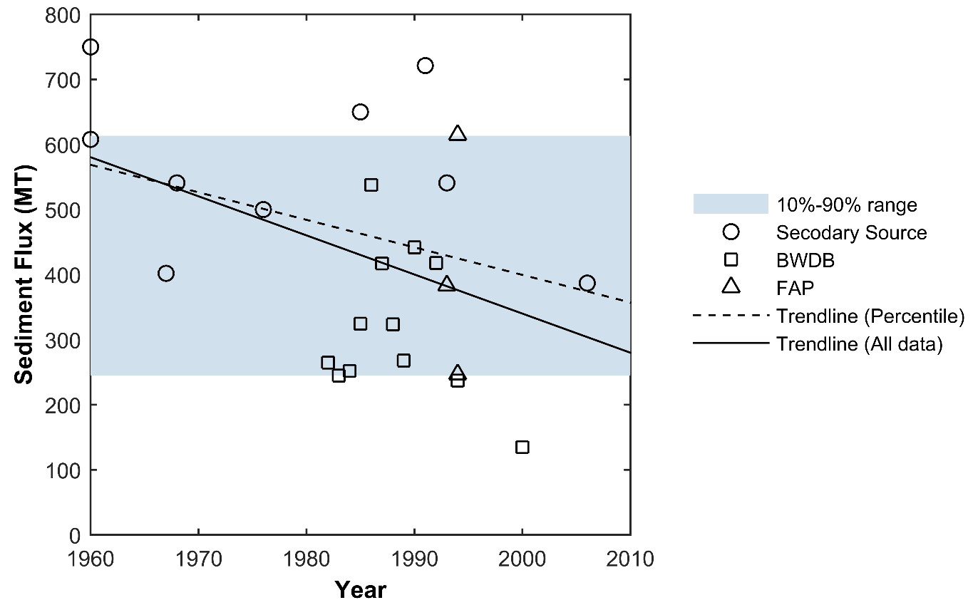

Figure 9: Trend lines of sediment flux along the Brahmaputra during different time periods using secondary data, BWDB and FAP data. The regression using all the scattered data is with , while for the datasets ranging between 10 percentile 90 percentile data this regression is with

Table 3 presents the Mann-Kendall test, t-test and F test for the sediment flux along the Brahmaputra. For the datasets of the Brahmaputra we reject the null Hypothesis (H0 = no trend) for the 80% confidence level. For t-test and F-test calculated values are 2.145 and 4.233, respectively, and those are greater than their respective critical values. These tests also suggest that, with a likelihood of 80%, the data are linearly associated with the decreasing rate of ~ 6.00 MT/year.

Table 3: Statistical test for the Brahmaputra sediment flux data, showing a significant trend at the 80% confidence level
Statistic | Value
Confidence level | 80%
P-value | 0.195
alpha | 0.2
RMSE | 151.564
t- calculated value | 2.29
t- critical value | 1.321
F- calculated value | 4.895
F- critical value | 3.44

3.3 Total Sediment Flux of the Ganges and Brahmaputra Rivers

The total annual sediment flux of the Ganges and the Brahmaputra varies significantly (Ganges: 262- 680 MT/yr; Brahmaputra: 387 to 1157 MT/yr) within studies in the literature that have been published over the last 60 years (1958 – 2006). Therefore, the total sediment flux through the two major rivers has been estimated to range from 655-1850 MT/yr with an average value of above 1250 MT/yr, which is at the lower end of the range of sediment flux often cited in delta planning documents (1100 MT/yr).

As sediment datasets are inherently scattered, two linear regression have been prepared using all the scattered datasets and using the refined dataset between 10-90 percentiles. Both the trend line represents a close decreasing rate for the Ganges and the Brahmaputra (in Figure 6 and Figure 9). Due to the inherent nature of scatteredness, for the future projection all the datasets have been considered.

However, analysing the time series of BWDB sediment concentration data (1960-2008: discontinuous), we have found that the sediment flux through the Ganges varies between 150 and 590 MT/yr, while for the Brahmaputra it varies between 135 and 615 MT/yr, respectively, with an average total flux of 750 MT/yr (range of around 300-1200 MT/yr). It is important to note that for the Ganges, the BWDB data beyond 2008 are not useful because of poor data quality and the discontinuous nature of the time series data. Therefore, the recent (for the year 2015) average sediment flux at Hardinge Bridge is estimated using an assumed overall decreasing trend (-4.0 MT/yr), giving a likely value of around 220 MT/yr with its minimum and maximum values 125 and 500 MT/yr, respectively. Similarly, BWDB data beyond 2001 are not useful here for the Brahmaputra. Therefore, the average sediment flux at Bahadurabad is estimated using a decreasing trend (-6.0 MT/yr), giving a 2015 estimated value of around 250 MT/year with its minimum and maximum values are 175 and 800 MT/yr, respectively. Therefore, the contemporary sediment flux in the GB system is approximated (for 2015) as around 500 MT/yr.

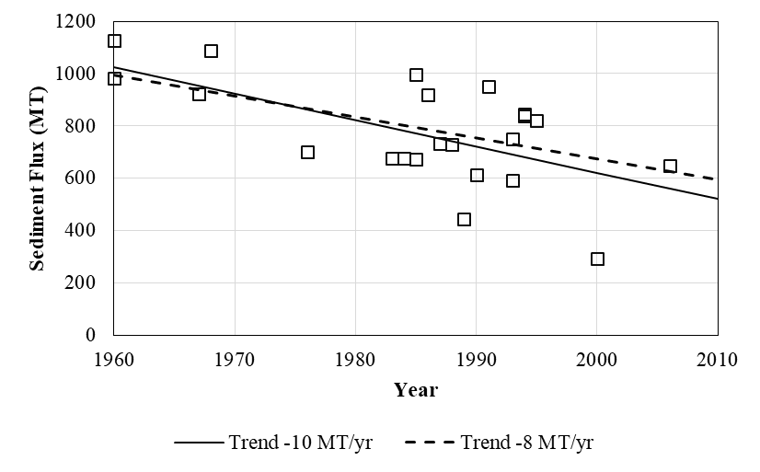

Figure 10: Trend lines of the combined sediment flux along the Ganges and Brahmaputra (secondary data, BWDB and FAP data). All the scattered data presents a decreasing trend of 10 MT/year while 10-90 percentile data shows a decreasing rate of 8 MT/year.

Table 4: Summary of the decreasing trend of sediment flux within GBM system.
 |  | Total load* | Remark
Ganges | In 1958 | 442 | Overall decreasing trend 4 MT/yr
Ganges | Estimated for 2015 (Avg) | 220 | Overall decreasing trend 4 MT/yr
Ganges | Estimated for 2030 (Avg) | 160 | Overall decreasing trend 4 MT/yr
Brahmaputra | In 1958 | 580 | Overall decreasing trend 6 MT/yr
Brahmaputra | Estimated for 2015 (Avg) | 249 | Overall decreasing trend 6 MT/yr
Brahmaputra | Estimated for 2030 (Avg) | 159 | Overall decreasing trend 6 MT/yr
GBM** | In 1958 | 1022 | Overall decreasing trend 10 MT/yr
GBM** | Estimated for 2015 (Avg) | 470 | Overall decreasing trend 10 MT/yr
GBM** | Estimated for 2030 (Avg) | 320 | Overall decreasing trend 10 MT/yr
* From the linear regression of all the scattered data
** Ganges and Brahmaputra contribute almost 99% sediment flux to the GBM system, assuming that the combined load of the Ganges and Brahmaputra can be estimated for the GBM delta.

There is a clear indication that the combined sediment flux delivered through the GBM delta’s major river systems is following a decreasing trend with a wide range of variability (Table 4). Using the trend line constructed from the measured sediment flux in the Ganges, Brahmaputra and combined GB system, the projected data for 2015 and 2030 have been demonstrated in the Table 4. In most of the planning documents in Bangladesh, the total sediment flux is assumed to have a constant value of around 1 billion tonnes, whereas our new study estimates a value that is around 50% lower, with clear evidence of a recent declining trend of approximately 10 MT/yr (Figure 10). It is important to note that the effect of the anthropogenic interventions together with the climate change effect is accounted for in the time series data, however there is no reason to believe that the same effects (both climatic and socio-economic development pathway) would continue in the future. The draft Bangladesh delta Plan 2100 (BDP 2100) documents provided clear indication of the rise in temperature during last 63 years (1948-2011) by around 0.85 °C, while the average increase in rainfall is around 10% during this time. The above changes have the potential to increase the overall flow and sediment discharge within the GBM system. However, due to different kinds of anthropogenic interventions (which intercept both water and sediment), the sediment discharge reaching to the GBM delta is decreasing. This fact implies that the effect of anthropogenic interventions within the system (to trap sediment) is exceeding the effect of climate change (to increase sediment discharge), at least up to the present day.

The future of the climatic situation and socio-economic development pathways are quite uncertain. However considering four different climatic scenarios and three different Shared Socio-economic Development pathways (SSPs), the simulated sediment discharge reaching the GBM delta is showing the declining trend of around 5.0 MT/yr (Dunn, 2018, in this issue) to the end of 21st century which indicates the sediment trapping through anthropogenic interventions would continue to exceed the extra sediment generation due to climate change (increase in rainfall).

Sediment load along with high flow is important for channel maintenance, bird breeding, high benthic productivity and creating spawning habitat for fish (Leopold et al., 1965). During floods sediment propagates into large areas of the basin and deposits on the floodplain, which replenishes nutrients in top soils and makes agricultural lands more fertile (Cuny, 1991). Any interventions could change the biochemical process of the river and floodplain by altering the fluvial regime (Poff and Hart, 2002). If current reduction in sediment flux continues in the Bengal delta, the equilibrium state in maintaining in delta development and subsidence will be disrupted (Broadus et al., 1986). As life and livelihood in the GBM delta is mostly dependent on its ecosystem and fluvial regime, the regime between water and sediment should be maintained in a sustainable state. Therefore, it is important to note that the sediment is projected to have decreasing trend in the GBM delta which should be taken into account in future development interventions, along both the major rivers and coastal hotspots identified in the long term planning processes (BDP 2100) in Bangladesh. The decreasing sediment load along the Ganges and the Brahmaputra implies that both the rivers are gradually moving towards the shrinking phase and will eventually proceed towards having more stable meandering planforms (Schumm, 1985). The long term stabilization program by BWDB (until 2040s) to modify the braided Brahmaputra/Jamuna from braided to meandering would be supportive. However, the decreasing sediment load would have less potential to counter the sinking (due to sea level rise and subsidence) of delta which would pose more challenges in delta management.
- Concluding Remarks

Sediment flux in many deltas worldwide is decreasing due to increased anthropogenic interventions (to meet the needs of development) causing a sediment deficit for the deltas where erosion and subsidence are dominating over accretion. However, delta-building processes within the GBM delta system are still continuing due to the incoming sediment flux. In most of the planning documents, the total incoming sediment flux in the GBM system is considered as a constant rate of 1 billion tonnes/year. However, our analysis revealed that the sediment load is not constant and is decreasing at rate of 4-10 MT/yr, with the average flux in 2015 of about 500 MT/yr. As sediment data collected by BWDB for the last 15 years is discontinuous and of limited use for the estimation of yearly sediment flux, the sediment flux in the GBM system is estimated using the above decreasing trend, the result of which is around 50% less (500 MT/yr) than the earlier estimates.

The sediment input in GBM system still exceeds the combined effects of subsidence and sea level rise and thus additional land mass is forming in the delta system. However, the decreasing trend of total sediment load may cause further subsidence/erosion in the estuarine regions of Bangladesh, making climate change adaptation a more difficult and challenging task for Bangladesh, especially for the long-term planning such as the Bangladesh Delta Plan 2100 (BDP 2100). Sediments also deliver nutrients for aquatic life and play a crucial role in sustaining the complex deltaic ecosystems. Continued reduction of sediment flux into the GBM system will degrade the quality of ecosystem services in the region, adversely affecting livelihoods of millions of dependent people. Finally, it is recommended to continue precise and continuous sediment monitoring through BWDB to support long-term planning.

Acknowledgements

The research has been supported by the DECCMA Project on ‘DEltas, vulnerability and Climate Change: Migration and Adaptation’ which is part of Collaborative Adaptation Research Initiative in Africa and Asia (CARIAA), with financial support from the UK Government’s Department for International Development (DfID) and the International Development Research Centre (IDRC), Canada and SATREPS (funded by JST-JICA) through ‘Research on Disaster Mitigation against Strom surges and floods in Bangladesh’ is gratefully acknowledged.

Reference
Abbas, N., Subramanian, V., 1984. Erosion and sediment transport in the Ganges river basin (India). J. Hydrol. 69, 173–182. https://doi.org/10.1016/0022-1694(84)90162-8
Broadus, J., Milliman, S., Edwards, S., Aubrey, D.G. and Gable, F., 1986. Rising sea level and damming of rivers: possible effects in Egypt and Bangladesh. Effects of changes in stratospheric ozone and global climate, 4, pp.165-189.
Brown, S., Nicholls, R.J., 2015. Subsidence and human influences in mega deltas: The case of the Ganges-Brahmaputra-Meghna. Sci. Total Environ. 527–528, 362–374. https://doi.org/10.1016/j.scitotenv.2015.04.124
BDP2100, 2015. Bangladesh Delta Plan: Coast and Polder Issue. General Economic Division, Bangladesh Planning commission.
CBJET, 1991. Study report on flood control and river training project on the Brahmaputra River in Bangladesh. Vol. I, Anal. Hydrol. River Morphol. Brahmaputra River.
CEGIS, 2010. Impact of Climate Change on Morphological Processes in Different river of Bangladesh, prepared for Asian Development Bank, Dhaka, Bangladesh.
Coleman, J.M., 1969. Brahmaputra river: Channel processes and sedimentation. Sediment. Geol. 3, 129–239. https://doi.org/10.1016/0037-0738(69)90010-4
Cuny, F.C., 1991. Living with floods:Alternatives for riverine flood mitigation. JLUP L. Use Policy 8, 331–342.
Darby, S.E., Dunn, F.E., Nicholls, R.J., Rahman, M., Riddy, L., 2015. A first look at the influence of anthropogenic climate change on the future delivery of fluvial sediment to the Ganges–Brahmaputra–Meghna delta. Environ. Sci. Process. Impacts 17, 1587–1600. https://doi.org/10.1039/C5EM00252D
Dunn, F.E., Nicholls, R.J., Darby, S.E., Cohen, S., and Zarfl, C., 2018. Projections of Historical and 21st Century Fluvial Sediment Delivery to the Ganges, Mahanadi, and Volta Deltas. Science of the Total Environment, this issue.
Ericson, J.P., Vörösmarty, C.J., Dingman, S.L., Ward, L.G., Meybeck, M., 2006. Effective sea-level rise and deltas: Causes of change and human dimension implications. Glob. Planet. Change 50, 63–82. https://doi.org/10.1016/j.gloplacha.2005.07.004
FAP24, 1996. Sediment Rating Curves and Balances, Special Report No. 18 River Survey Project. Water Resources Planning Organization (WARPO), Dhaka, Bangladesh.
Fischer, S., Pietroń, J., Bring, A., Thorslund, J., Jarsjö, J., 2017. Present to future sediment transport of the Brahmaputra River: reducing uncertainty in predictions and management. Reg. Environ. Chang. 17, 515–526. https://doi.org/10.1007/s10113-016-1039-7
French Engineering Consortium (FEC), 1989. Feasibility study for flood control in Bangladesh. Vol. 2. Present conditions.
Gain, A.K., Giupponi, C., 2014. Impact of the Farakka Dam on thresholds of the hydrologic: Flow regime in the Lower Ganges River Basin (Bangladesh). Water (Switzerland) 6, 2501–2518. https://doi.org/10.3390/w6082501
Goswami, D.C., 1985. Brahmaputra River, Assam, India: Physiography, Basin Denudation, and Channel Aggradation. Water Resour. Res. 21, 959–978. https://doi.org/10.1029/WR021i007p00959
Gupta, H., Kao, S.J., Dai, M., 2012. The role of mega dams in reducing sediment fluxes: A case study of large Asian rivers. J. Hydrol. 464–465, 447–458. https://doi.org/10.1016/j.jhydrol.2012.07.038
Holeman, J.N., 1968. The Sediment Yield of Major Rivers of the World. Water Resour. Res. 4, 737–747. https://doi.org/10.1029/WR004i004p00737
Hossain, M.M., 1992. Total sediment load in the lower Ganges and Jamuna. J. IEB 20, 1–8.
International Engineering Company, 1964. East Pakistan Water and Power Development Authority Master Plan, (2 volumes). San Francisco, Calif.
Islam, M.R., Begum, S.F., Yamaguchi, Y., Ogawa, K., 1999. The Ganges and Brahmaputra rivers in Bangladesh: Basin denudation and sedimentation. Hydrol. Process. 13, 2907–2923. https://doi.org/10.1002/(SICI)1099-1085(19991215)13:17<2907::AID-HYP906>3.0.CO;2-E
Kabir, M.R., Ahmed, N., 1996. Bed shear stress for sediment transportation in the River Jamuna. J. Civ. Eng. Inst. Eng. Bangladesh 55–68.
Kondolf, G.M., Gao, Y., Annandale, G.W., Morris, G.L., Jiang, E., Zhang, J., Cao, Y., Carling, P., Fu, K., Guo, Q., Hotchkiss, R., Peteuil, C., Sumi, T., Wang, H.-W., Wang, Z., Wei, Z., Wu, B., Wu, C., Yang, C.T., 2014. Sustainable sediment management in reservoirs and regulated rivers: Experiences from five continents. Earth’s Futur. 2, 256–280. https://doi.org/10.1002/2013EF000184
Leopold, L.B., Wolman, M.G., Miller, J.P., 1965. Fluvial processes in geomorphology. J. Hydrol. https://doi.org/10.1016/0022-1694(65)90101-0
Lupker, M., France-Lanord, C., Lavé, J., Bouchez, J., Galy, V., Métivier, F., Gaillardet, J., Lartiges, B., Mugnier, J.L., 2011. A Rouse-based method to integrate the chemical composition of river sediments: Application to the Ganga basin. J. Geophys. Res. Earth Surf. 116. https://doi.org/10.1029/2010JF001947
Master Plan Organization (MPO), 1987. Technical Report No.11. Floods and Storms. HAZRA Engineering Company International.
Milliman, J.D., Meade, R.H., 1983. World-Wide Delivery of River Sediment to the Oceans. J. Geol. 91, 1–21. https://doi.org/10.1086/628741
NEDECO, 1967. East Pakistan Inland Water Transport Authority: Surveys of Inland Waterways and Ports 1963-1967. Hydrographic manual. NEDECO.
Nicholls, R.J., Hutton, C.W., Lázár, A.N., Allan, A., Adger, W.N., Adams, H., Wolf, J., Rahman, M., Salehin, M., 2016. Integrated assessment of social and environmental sustainability dynamics in the Ganges-Brahmaputra-Meghna delta, Bangladesh. Estuar. Coast. Shelf Sci. 183, 370–381. https://doi.org/10.1016/j.ecss.2016.08.017
Nicholls, R.J., Hutton, C.W., Adger, W.N., Hanson, S.E., Rahman, M. and Salehin, M. (Eds), 2018. Ecosystem services in deltas - Integrated assessment for policy analysis, Palgrave, forthcoming.
Okada, S., Yorozuya, A., Koseki, H., Kudo, S., Muraoka, K., 2016. Comprehensive measurement techniques of water flow, bedload and suspended sediment in large river using Acoustic Doppler Current Profiler.
Poff, N.L., Hart, D.D., 2002. How Dams Vary and Why It Matters for the Emerging Science of Dam Removal: An ecological classification of dams is needed to characterize how the tremendous {…}. Bioscience 52, 659. https://doi.org/10.1641/0006-3568(2002)052[0659:HDVAWI]2.0.CO;2
Rahaman, M.M., 2009. Integrated Ganges basin management: Conflict and hope for regional development. Water Policy 11, 168–190. https://doi.org/10.2166/wp.2009.012
Rice, S.K., 2010. Suspended Sediment Transport in the Ganges-Brahmaputra River System, Bangladesh.
Sarker, M.H., Akter, J., Rahman, M.M., 2013. Century-Scale Dynamics of the Bengal Delta and Future Development. 4th Int. Conf. Water Flood Manag. 91–104.
Sastry, S.S., 2006. Introductory methods of numerical analysis. chapter 5, pp.187-239. New Delhi: PHI Learning Pvt. Ltd.
Schumm, S.A., 1985. Patterns of alluvial rivers. Annual Review of Earth and Planetary Sciences, 13(1), pp.5-27.
Subramanian, V., 1987. Environmental geochemistry of Indian river basins: a review. J. Geol. Soc. India 29, 205–220.
Syvitski, J.P.M., Kettner, A., 2011. Sediment flux and the Anthropocene. Philos. Trans. R. Soc. A Math. Phys. Eng. Sci. 369, 957–975. https://doi.org/10.1098/rsta.2010.0329
Syvitski, J.P.M., Kettner, A.J., Overeem, I., Hutton, E.W.H., Hannon, M.T., Brakenridge, G.R., Day, J., Vörösmarty, C., Saito, Y., Giosan, L., Nicholls, R.J., 2009. Sinking deltas due to human activities. Nat. Geosci. 2, 681–686. https://doi.org/10.1038/ngeo629
Syvitski, J.P.M., Saito, Y., 2007. Morphodynamics of deltas under the influence of humans. Glob. Planet. Change 57, 261–282. https://doi.org/10.1016/j.gloplacha.2006.12.001
Tessler, Z.D., Vörösmarty, C.J., Overeem, I., Syvitski, J.P.M., 2017. A model of water and sediment balance as determinants of relative sea level rise in contemporary and future deltas. Geomorphology. https://doi.org/10.1016/j.geomorph.2017.09.040
Thakkar, H., 2006. What, who, how and when of experiencing floods as a disaster. Issues 20, 1–37.
Wasson, R.J., 2003. A sediment budget for the Ganga-Brahmaputra catchment. Curr. Sci. https://doi.org/10.2307/24107666
Yue, S. and Pilon, P., 2004. A comparison of the power of the t test, Mann-Kendall and bootstrap tests for trend detection/Une comparaison de la puissance des tests t de Student, de Mann-Kendall et du bootstrap pour la détection de tendance. Hydrological Sciences Journal, 49(1), pp.21-37.

