Online only supplementary material

METHODS

Primary ciliary dyskinesia diagnosis
The diagnostic criteria for PCD have evolved over many years [1]. Initially, diagnosis was based on the Kartagener triad [2] and transmission electron microscopy findings (EM).Then, light microscopy and, later, high frequency video microscopy (HVM) were introduced into the diagnostic algorithm. Recent recommendations include combining EM, HVM, nasal nitric oxide (nNO), and genetic testing [3], but availability of tests differs between countries [4] so not all PCD patients have been diagnosed according to current standards. Patients diagnosed years ago and patients who live in countries with limited resources are least likely to have been diagnosed according to these recommendations. The iPCD Cohort includes patients diagnosed since 1964, so we divided patients into three diagnostic subgroups based on the results of the tests available. The first subgroup included patients with definite PCD defined, based on recent guidelines of the ERS PCD Diagnostics Task Force [3], as hallmark EM findings and/or pathogenic biallelic PCD genetic mutations. The second subgroup, probable PCD, included patients with abnormal HVM findings and/or low nNO (we used a cut-off of 77nl/min [5]). The third subgroup included patients with clinical PCD diagnosis; these were patients for whom the PCD diagnostic algorithm had not yet been completed, or whose test results were negative or ambiguous. Patients in this latter group were followed up and treated as PCD at the collaborating centres based on a combination of several of the following features: situs anomalies, persistent cough, persistent rhinitis, chronic or recurrent upper or lower respiratory infections, and history of neonatal respiratory symptoms in term infants [3]. Other possible more common diseases such as cystic fibrosis and immunodeficiency were excluded.

FEV1 and FVC
We checked data quality to identify outliers and implausible values, and contacted data contributors to resolve any unclear issues. We used the Global Lung Function Initiative (GLI) reference values to calculate age, sex, ethnicity, and height-adjusted z-scores of forced expiratory volume in one second (FEV1) and forced vital capacity (FVC) [6].

Determinants of lung function
We investigated the association of lung function with sex, age, country of residence, level of diagnostic certainty, organ laterality, BMI, and ultrastructural defect at time of lung function measurement. Despite having calculated age, height, and sex-specific z-scores, impairment of lung function might differ between male and female PCD patients. Analysis of different age groups helps to find whether PCD affects lung growth in children, or whether it accelerates lung function decline in adults. To facilitate comparison with available published cystic fibrosis (CF) data [7], we categorised patients into the same 12 age groups (6-9, 10-13, 14-17, 18-21, 22-25, 26-29, 30-33, 34-37, 38-41, 42-45, 46-49 and ≥50 years). Patients with situs inversus might have less severe disease because they are diagnosed and treated earlier, sometimes even before symptoms develop [4]. We categorised organ laterality into three groups (situs solitus totalis, situs inversus, and heterotaxia). BMI as an indicator of nutrition has been associated with lung function in many chronic respiratory diseases. We identified national growth references by contacting collaborating centres and searching the literature. For each centre, we chose one of the following methods to calculate z-scores based on national references: 1) an LMS approach using tables that contained L, M, and S parameters needed to generate exact z-scores [8]; 2) direct calculation via online national z-score or percentile growth calculators; or 3) interpolating exact z-scores from plotted percentile boundaries on growth curves. Available references for BMI were intended for use with children only. For paediatric patients aged <18 years, we calculated age- and sex-adjusted BMI z-scores based on available reference values, preferably national where they were available (the sources are listed in the online supplement, Table S1), and we defined underweight as a BMI z-score less than or equal to -1.96, and overweight as a BMI z-score ≥1.96. For patients aged ≥18 years we used the WHO international BMI classification for adults, which define underweight as BMI < 18.5 and overweight as BMI ≥ 25.0 [9]. Differences between countries could show ethnic variations, or differences in age at diagnosis or disease management. We categorised ultrastructural defects into non-diagnostic, dynein arm defects (outer and/or inner dynein arm defects), microtubular defects (central pair, tubulus disorganisation, tubular transposition and/or nexin link defect), and acilia.

Table S1. National references used for calculations of BMI z-scores
Country | Growth reference source | Year of publication
Australia | Centre for Disease Control and Prevention [10] |  | 2000
Belgium | Flemish growth study (Roelants et al.) [11] |  | 2009
Cyprus | Growth curves for Greek children 0-5 years (Papadimitriou et al.) [12]  Growth curves for Cypriot children 6-17 years (Savva et al.) [13] |  | 2000  2001
Denmark | Danish growth references (Tinggaard et al.) [14] |  | 2014
France | French references for Height (Sempé et al.) [15]  French references for BMI (Rolland-Cachera et al.) [16] |  | 1979  1991
Germany | KiGGS study [17] |  | 2006
Israel | Centre for Disease Control and Prevention [10] |  | 2000
Italy | Centre for Disease Control and Prevention [10] |  | 2000
Netherlands | Fifth Dutch Growth Study [18] |  | 2009
Norway | Growth charts for Norwegian children (Júlíusson et al.) [19] |  | 2009
Poland | Growth references (Kulaga et al.) [20] |  | 2010
Serbia | Not available* |  | -
Switzerland | Swiss growth curves (Braegger et al.) [21] |  | 2011
Turkey | Growth references for Turkish children (Neyzi et al.) [22] |  | 2006
United Kingdom | Royal College of Paediatrics and Child Health [23,24] |  | 1990
* No national growth references were available in Serbia, for which the WHO references are used instead. Table adapted from Goutaki et al. [25]

Patients <6 years old
(N=176)
Data delivered and standardised by the time of analysis
(N=2667 from 21 centres)
April 2016

No lung function data contributed
by centre
(N=519)
Data of patients ≥6 years old
(N=2491 from 19 centres)

Data from centres contributing lung function data
(N=1972 from 19 centres)

Insufficient information to calculate z-scores
(N=981)

Patients included in situs analysis
(N=860)

Patients included in main analyses
(N=991)

Patients included in analysis of BMI
(N=920)

Patients included in age at diagnosis analysis
(N=167)
Patients with definite PCD diagnosis
(N=611)

Figure S1. Flow chart showing the patients included for the different analyses performed.

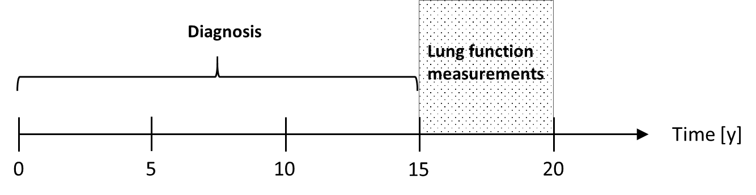
Figure S2. Study design on patient inclusion to assess the association of age at diagnosis with lung function.

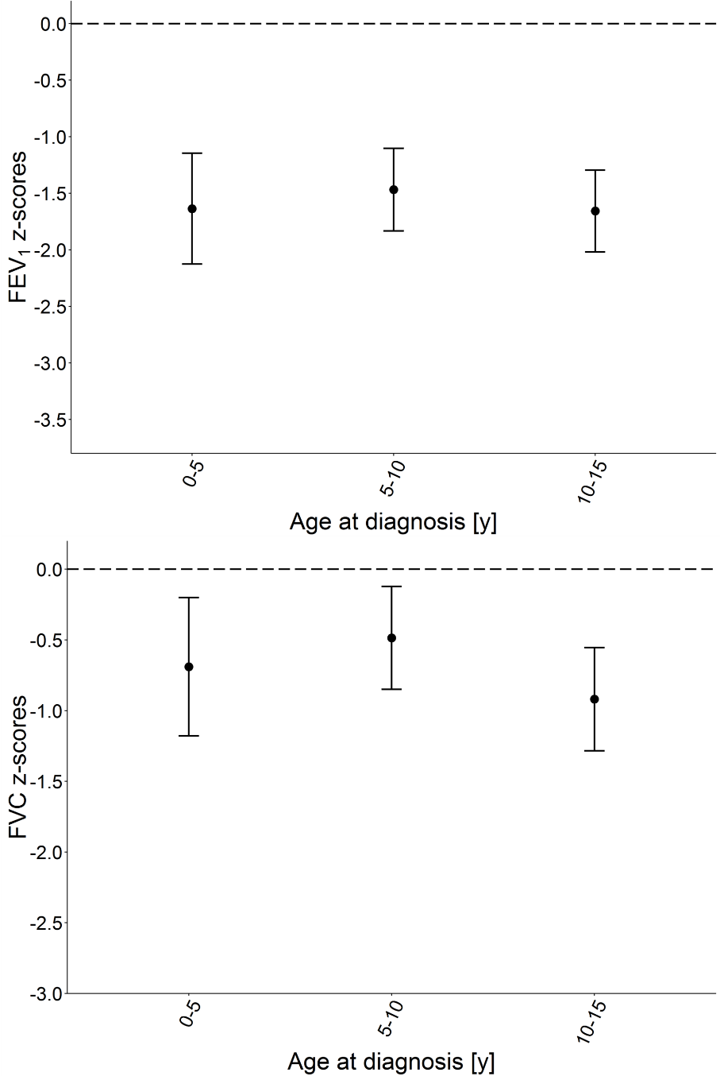
Fig S3. FEV1 and FVC in PCD patients aged 15 to 20 years by age of diagnosis compared to GLI 2012 reference values. FEV1 and FVC are presented as mean z-score (95%CI).

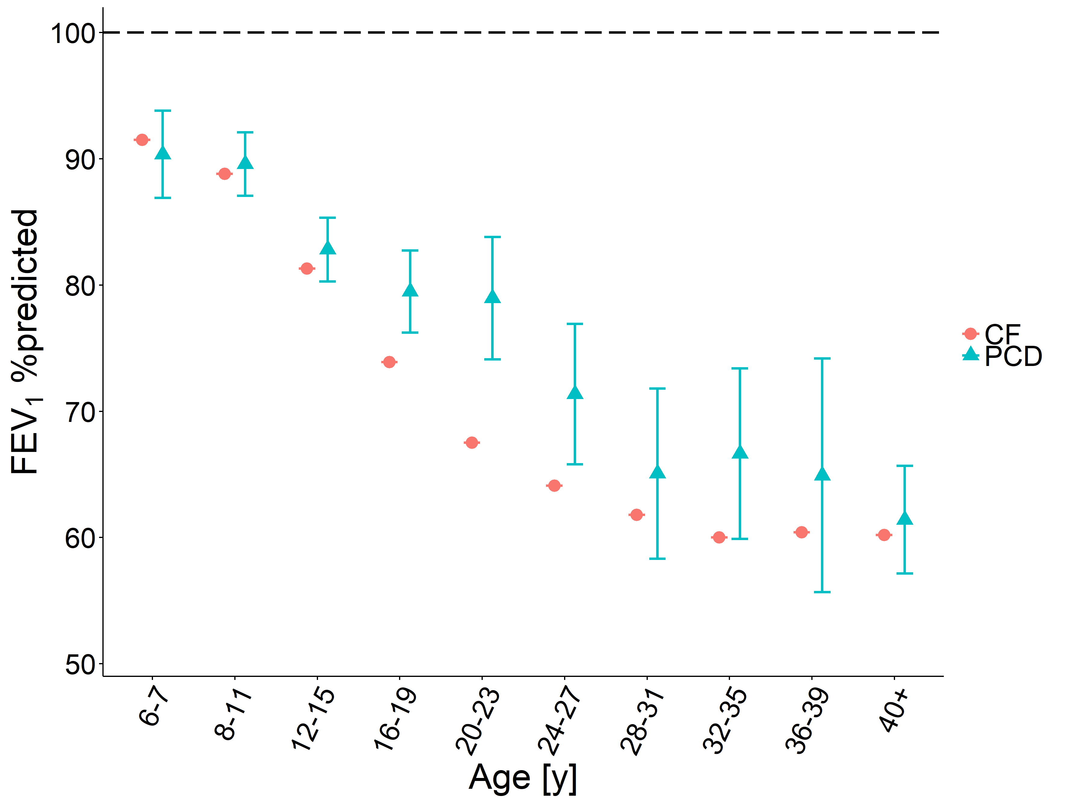
Fig S4. Association of FEV1 of PCD patients with CF patients using GLI 2012 references values. FEV1 of PCD patients are presented as mean %predicted and 95%CI, and FEV1 of CF patients are presented as mean, without adjusting for other factors. The dashed line shows the mean of the normal population.

Table S2. Characteristics of PCD patients included in this study compared to those who were excluded
Characteristic | Study Participants  (n=991) | Insufficient information on lung function  (n=981) | Comparison  with participants  p-value¶ | No lung function data contributed  (n=519) | Comparison  with participants  p-value¶
 | n (%) | n (%) |  | n (%)
Sex |  |  | 0.91 |  | 0.01
Male | 487 (49) | 481 (49) |  | 290 (56)
Female | 504 (51) | 491 (50) |  | 228 (44)
Missing | 0 (0) | 9 (1) |  | 1 (0)
Country of residence* |  |  | <0.001 |  | <0.001
Australia | 34 (3) | 42 (4) |  | 0 (0)
Northern Europe | 306 (31) | 145 (15) |  | 0 (0)
Western Europe | 392 (40) | 731 (75) |  | 0 (0)
Eastern Europe | 74 (7) | 8 (1) |  | 0 (0)
Southern Europe | 42 (4) | 5 (1) |  | 0 (0)
Western Asia | 143 (14) | 50 (5) |  | 0 (0)
North America | 0 (0) | 0 (0) |  | 418 (81)
South America | 0 (0) | 0 (0) |  | 101 (19)
Current age# |  |  | <0.001 |  | <0.001
6-9 years | 15 (2) | 213 (22) |  | 44 (8)
10-19 years | 445 (45) | 354 (36) |  | 218 (42)
20-29 years | 248 (25) | 146 (15) |  | 122 (24)
30-39 years | 129 (13) | 100 (10) |  | 34 (7)
40-49 years | 64 (6) | 70 (7) |  | 43 (8)
>50 years | 90 (9) | 76 (8) |  | 57 (11)
Missing | 0 (0) | 22 (2) |  | 1 (0)
* Based on the United Nations Statistics Division
¶ Chi-squared tests
# In April 2016

Table S3. FEV₁ and FVC of PCD patients of the iPCD Cohort with available situs information compared to GLI 2012 references (N=860)
 |  | FEV1 |  |  |  |  | FVC
Characteristic | N | mean  z-score | 95% CI |  | p-value¶ | N | mean  z-score | 95% CI |  | p-value¶
Total | 860 | -1.52 | -1.63 | -1.41 |  | 853 | -0.79 | -0.90 | -0.67
Sex |  |  |  |  | 0.10 |  |  |  |  | 0.51
Male | 417 | -1.47 | -1.62 | -1.32 |  | 413 | -0.75 | -0.90 | -0.60
Female | 443 | -1.56 | -1.71 | -1.42 |  | 440 | -0.82 | -0.96 | -0.67
Age group |  |  |  |  | <0.001 |  |  |  |  | <0.001
6-9 years | 164 | -0.80 | -1.04 | -0.56 |  | 163 | -0.29 | -0.53 | -0.05
10-13 years | 188 | -1.05 | -1.28 | -0.83 |  | 187 | -0.50 | -0.72 | -0.27
14-17 years | 184 | -1.48 | -1.71 | -1.26 |  | 182 | -0.77 | -0.99 | -0.54
18-21 years | 85 | -1.58 | -1.91 | -1.25 |  | 85 | -0.63 | -0.96 | -0.30
22-25 years | 60 | -1.80 | -2.19 | -1.40 |  | 59 | -0.89 | -1.29 | -0.49
26-29 years | 42 | -2.29 | -2.76 | -1.82 |  | 41 | -1.32 | -1.80 | -0.84
30-33 years | 27 | -2.61 | -3.19 | -2.03 |  | 26 | -1.42 | -2.02 | -0.83
34-37 years | 23 | -2.75 | -3.37 | -2.12 |  | 24 | -1.76 | -2.38 | -1.15
38-41 years | 14 | -2.47 | -3.28 | -1.66 |  | 14 | -1.25 | -2.06 | -0.43
42-45 years | 14 | -3.24 | -4.05 | -2.42 |  | 14 | -2.74 | -3.55 | -1.92
46-49 years | 20 | -2.90 | -3.59 | -2.22 |  | 20 | -1.95 | -2.64 | -1.26
≥50 years | 39 | -2.41 | -2.90 | -1.92 |  | 38 | -1.48 | -1.97 | -0.98
Country |  |  |  |  | <0.001 |  |  |  |  | <0.001
Australia | 34 | -1.79 | -2.31 | -1.27 |  | 34 | -1.17 | -1.69 | -0.65
Belgium | 69 | -1.18 | -1.56 | -0.81 |  | 69 | -0.05 | -0.42 | 0.33
Cyprus | 27 | -1.89 | -2.48 | -1.30 |  | 27 | -1.74 | -2.34 | -1.15
Denmark | 72 | -1.21 | -1.57 | -0.86 |  | 72 | -0.19 | -0.55 | 0.16
France | 11 | -1.36 | -2.28 | -0.45 |  | 11 | -0.85 | -1.78 | 0.07
Germany | 104 | -1.21 | -1.51 | -0.91 |  | 99 | -0.64 | -0.95 | -0.33
Israel | 85 | -1.57 | -1.89 | -1.24 |  | 82 | -1.09 | -1.43 | -0.76
Italy | 35 | -1.45 | -1.97 | -0.93 |  | 35 | -0.67 | -1.20 | -0.15
Netherlands | 65 | -0.50 | -0.88 | -0.12 |  | 65 | 0.67 | 0.29 | 1.05
Norway | 14 | -1.36 | -2.17 | -0.56 |  | 14 | -0.79 | -1.60 | 0.03
Poland | 74 | -1.93 | -2.29 | -1.57 |  | 74 | -0.98 | -1.34 | -0.61
Serbia | 7 | -2.34 | -3.49 | -1.20 |  | 7 | -2.58 | -3.73 | -1.42
Switzerland | 29 | -1.87 | -2.43 | -1.31 |  | 29 | -1.23 | -1.79 | -0.67
Turkey | 29 | -1.91 | -2.51 | -1.31 |  | 29 | -1.65 | -2.25 | -1.04
UK | 205 | -1.85 | -2.07 | -1.64 |  | 206 | -1.16 | -1.37 | -0.94
Diagnostic certainty |  |  |  |  | 0.58 |  |  |  |  | 0.50
Definite PCD diagnosis+ | 554 | -1.55 | -1.68 | -1.42 |  | 551 | -0.78 | -0.91 | -0.65
Probable PCD diagnosis# | 195 | -1.58 | -1.80 | -1.35 |  | 191 | -0.88 | -1.11 | -0.65
Clinical diagnosis only | 111 | -1.27 | -1.58 | -0.97 |  | 111 | -0.66 | -0.97 | -0.34
Situs anomalies |  |  |  |  | 0.67 |  |  |  |  | 0.35
Situs solitus totalis | 499 | -1.52 | -1.66 | -1.38 |  | 496 | -0.83 | -0.98 | -0.69
Situs inversus | 348 | -1.46 | -1.63 | -1.29 |  | 344 | -0.77 | -0.94 | -0.59
Heterotaxia | 13 | -1.82 | -2.68 | -0.96 |  | 13 | -1.40 | -2.29 | -0.51
Mean z-scores (95%CI) for each group after adjusting for the remaining characteristics
¶ Likelihood ratio test p-value indicating whether the characteristic explains differences in FEV₁ or FVC within the study population
⁺ Defined as hallmark PCD electron microscopy findings and/or biallelic gene mutation identified based on the ERS PCD Diagnostics Task Force guidelines [26]
# Abnormal light or high frequency video microscopy finding and/or low nasal NO value
Table S4. FEV₁ and FVC of PCD patients of the iPCD Cohort with available BMI information compared to GLI 2012 references (N=927)
 |  | FEV1 |  |  |  |  | FVC
Characteristic | N | mean  z-score | 95% CI |  | p-value¶ | N | mean  z-score | 95% CI |  | p-value¶
Total | 927 | -1.47 | -1.58 | -1.37 |  | 924 | -0.73 | -0.84 | -0.62
Sex |  |  |  |  | 0.08 |  |  |  |  | 0.31
Male | 458 | -1.39 | -1.52 | -1.25 |  | 458 | -0.68 | -0.82 | -0.54
Female | 469 | -1.56 | -1.69 | -1.42 |  | 466 | -0.78 | -0.92 | -0.65
Age group |  |  |  |  | <0.001 |  |  |  |  | <0.001
6-9 years | 182 | -0.76 | -0.97 | -0.54 |  | 181 | -0.19 | -0.41 | 0.04
10-13 years | 220 | -1.03 | -1.23 | -0.83 |  | 217 | -0.44 | -0.65 | -0.24
14-17 years | 207 | -1.42 | -1.63 | -1.22 |  | 210 | -0.70 | -0.90 | -0.49
18-21 years | 90 | -1.53 | -1.84 | -1.22 |  | 90 | -0.56 | -0.88 | -0.25
22-25 years | 54 | -1.75 | -2.16 | -1.35 |  | 53 | -0.85 | -1.27 | -0.44
26-29 years | 37 | -2.21 | -2.70 | -1.72 |  | 36 | -1.23 | -1.73 | -0.72
30-33 years | 25 | -2.84 | -3.43 | -2.25 |  | 25 | -1.84 | -2.45 | -1.24
34-37 years | 22 | -2.98 | -3.61 | -2.36 |  | 23 | -1.85 | -2.48 | -1.23
38-41 years | 15 | -2.72 | -3.48 | -1.97 |  | 15 | -1.53 | -2.31 | -0.75
42-45 years | 14 | -3.43 | -4.22 | -2.65 |  | 15 | -2.96 | -3.74 | -2.18
46-49 years | 20 | -3.03 | -3.70 | -2.36 |  | 19 | -2.04 | -2.75 | -1.34
≥50 years | 41 | -2.59 | -3.06 | -2.11 |  | 40 | -1.66 | -2.15 | -1.17
Country |  |  |  |  | <0.001 |  |  |  |  | <0.001
Australia | 34 | -1.73 | -2.24 | -1.23 |  | 34 | -1.12 | -1.63 | -0.60
Belgium | 69 | -1.14 | -1.50 | -0.78 |  | 69 | -0.03 | -0.40 | 0.34
Cyprus | 25 | -1.73 | -2.33 | -1.13 |  | 25 | -1.53 | -2.14 | -0.91
Denmark | 70 | -1.15 | -1.50 | -0.80 |  | 70 | -0.13 | -0.49 | 0.23
France | 75 | -1.45 | -1.79 | -1.10 |  | 72 | -0.55 | -0.91 | -0.19
Germany | 123 | -1.27 | -1.54 | -1.00 |  | 123 | -0.68 | -0.96 | -0.41
Israel | 75 | -1.57 | -1.91 | -1.23 |  | 74 | -1.14 | -1.48 | -0.79
Italy | 35 | -1.52 | -2.02 | -1.02 |  | 35 | -0.72 | -1.24 | -0.21
Netherlands | 66 | -0.52 | -0.88 | -0.15 |  | 66 | 0.58 | 0.21 | 0.95
Norway | 14 | -1.30 | -2.08 | -0.52 |  | 14 | -0.73 | -1.52 | 0.07
Poland | 74 | -1.90 | -2.24 | -1.55 |  | 74 | -0.98 | -1.34 | -0.63
Serbia | 7 | -2.39 | -3.49 | -1.29 |  | 7 | -2.70 | -3.83 | -1.57
Switzerland | 40 | -1.72 | -2.18 | -1.26 |  | 40 | -0.97 | -1.44 | -0.49
Turkey | 29 | -1.79 | -2.35 | -1.23 |  | 29 | -1.56 | -2.13 | -0.98
UK | 191 | -1.77 | -1.98 | -1.55 |  | 192 | -1.09 | -1.31 | -0.87
Diagnostic certainty |  |  |  |  | 0.45 |  |  |  |  | 0.54
Definite PCD diagnosis⁺ | 574 | -1.50 | -1.62 | -1.37 |  | 574 | -0.73 | -0.86 | -0.60
Probable PCD diagnosis# | 191 | -1.53 | -1.74 | -1.31 |  | 190 | -0.82 | -1.05 | -0.60
Clinical diagnosis only | 162 | -1.33 | -1.58 | -1.09 |  | 160 | -0.64 | -0.89 | -0.38
BMI |  |  |  |  | <0.001 |  |  |  |  | <0.001
Underweight | 59 | -2.54 | -2.92 | -2.16 |  | 60 | -1.94 | -2.33 | -1.55
Normal | 752 | -1.48 | -1.58 | -1.37 |  | 750 | -0.74 | -0.85 | -0.63
Overweight | 116 | -0.91 | -1.20 | -0.62 |  | 114 | -0.07 | -0.37 | 0.23
Mean z-scores (95%CI) for each group after adjusting for the remaining characteristics
¶ Likelihood ratio test p-value indicating whether the characteristic explains differences in FEV₁ or FVC within the study population
⁺ Defined as hallmark PCD electron microscopy findings and/or biallelic gene mutation identified based on the ERS PCD Diagnostics Task Force guidelines [26]
# Abnormal light or high frequency video microscopy finding and/or low nasal NO value; patients from Serbia were excluded from this analysis as there are no available national references
Table S5. FEV₁ and FVC of PCD patients of the iPCD Cohort with a definite PCD diagnosis compared to GLI 2012 references (sensitivity analysis) (N=611)
 |  | FEV1 |  |  |  |  | FVC
Characteristic | N | mean  z-score | 95% CI |  | p-value¶ | N | mean z-score | 95% CI |  | p-value¶
Total | 611 | -1.54 | -1.68 | -1.41 |  | 606 | -0.75 | -0.89 | -0.61
Sex |  |  |  |  | 0.07 |  |  |  |  | 0.17
Male | 301 | -1.35 | -1.52 | -1.17 |  | 299 | -0.72 | -0.90 | -0.54
Female | 310 | -1.58 | -1.75 | -1.41 |  | 309 | -0.78 | -0.96 | -0.60
Age group |  |  |  |  | <0.001 |  |  |  |  | <0.001
6-9 years | 180 | -0.92 | -1.16 | -0.68 |  | 113 | -0.25 | -0.55 | 0.05
10-13 years | 118 | -1.04 | -1.31 | -0.76 |  | 136 | -0.45 | -0.72 | -0.18
14-17 years | 105 | -1.48 | -1.78 | -1.19 |  | 130 | -0.78 | -1.05 | -0.50
18-21 years | 51 | -1.56 | -1.98 | -1.13 |  | 63 | -0.56 | -0.96 | -0.17
22-25 years | 40 | -1.63 | -2.11 | -1.14 |  | 47 | -0.72 | -1.19 | -0.26
26-29 years | 30 | -2.10 | -2.65 | -1.54 |  | 28 | -1.13 | -1.73 | -0.53
30-33 years | 17 | -3.07 | -3.80 | -2.34 |  | 17 | -1.55 | -2.31 | -0.80
34-37 years | 14 | -3.08 | -3.88 | -2.28 |  | 16 | -2.01 | -2.79 | -1.23
38-41 years | 10 | -2.64 | -3.59 | -1.68 |  | 9 | -0.99 | -2.04 | 0.05
42-45 years | 12 | -3.47 | -4.35 | -2.60 |  | 9 | -3.07 | -4.12 | -2.02
46-49 years | 10 | -2.93 | -3.89 | -1.98 |  | 13 | -2.43 | -3.32 | -1.55
≥50 years | 24 | -2.18 | -2.80 | -1.56 |  | 27 | -1.37 | -1.98 | -0.77
Country |  |  |  |  | <0.001 |  |  |  |  | <0.001
Australia | 31 | -1.86 | -2.40 | -1.32 |  | 31 | -1.11 | -1.67 | -0.55
Belgium | 58 | -1.21 | -1.62 | -0.81 |  | 58 | 0.00 | -0.42 | 0.41
Cyprus | 22 | -1.78 | -2.42 | -1.14 |  | 22 | -1.64 | -2.33 | -0.96
Denmark | 45 | -0.95 | -1.41 | -0.50 |  | 45 | -0.21 | -0.67 | 0.25
France | 46 | -1.27 | -1.72 | -0.83 |  | 46 | -0.50 | -0.97 | -0.04
Germany | 58 | -1.36 | -1.76 | -0.97 |  | 55 | -0.66 | -1.08 | -0.23
Israel | 50 | -1.34 | -1.77 | -0.91 |  | 49 | -0.91 | -1.35 | -0.46
Italy | 33 | -1.25 | -1.78 | -0.73 |  | 33 | -0.61 | -1.16 | -0.06
Netherlands | 35 | -0.21 | -0.72 | 0.29 |  | 35 | 0.90 | 0.38 | 1.43
Norway | 12 | -1.44 | -2.30 | -0.58 |  | 12 | -0.78 | -1.68 | 0.12
Poland | 28 | -2.20 | -2.77 | -1.63 |  | 28 | -1.30 | -1.89 | -0.71
Serbia | 2 | -1.77 | -3.88 | 0.35 |  | 2 | -2.41 | -4.61 | -0.21
Switzerland | 24 | -1.48 | -2.11 | -0.86 |  | 24 | -1.05 | -1.69 | -0.42
Turkey | 7 | -2.31 | -3.45 | -1.18 |  | 7 | -2.28 | -3.45 | -1.10
UK | 160 | -1.86 | -2.11 | -1.61 |  | 161 | -1.19 | -1.44 | -0.94
Mean z-scores (95%CI) for each group after adjusting for the remaining characteristics
¶ Likelihood ratio test p-value indicating whether the characteristic explains differences in FEV₁ or FVC within the study population
⁺ Defined as hallmark PCD electron microscopy findings and/or biallelic gene mutation identified based on the ERS PCD Diagnostics Task Force guidelines [26]
# Abnormal light or high frequency video microscopy finding and/or low nasal NO value

Table S6. FEV₁ and FVC of PCD patients of the iPCD Cohort using the latest available measurement instead of the earliest compared to GLI 2012 references (sensitivity analysis) (N=991)
 |  | FEV1 |  |  |  |  | FVC
Characteristic | N | mean  z-score | 95% CI |  | p-value¶ | N | mean  z-score | 95% CI |  | p-value¶
Total | 991 | -1.53 | -1.63 | -1.42 |  | 981 | -0.77 | -0.88 | -0.67
Sex |  |  |  |  | 0.11 |  |  |  |  | 0.26
Male | 487 | -1.45 | -1.59 | -1.31 |  | 483 | -0.71 | -0.85 | -0.56
Female | 504 | -1.61 | -1.74 | -1.47 |  | 498 | -0.83 | -0.97 | -0.68
Age group |  |  |  |  | <0.001 |  |  |  |  | <0.001
6-9 years | 185 | -0.80 | -1.03 | -0.57 |  | 187 | -0.25 | -0.48 | -0.01
10-13 years | 237 | -1.12 | -1.32 | -0.92 |  | 232 | -0.53 | -0.74 | -0.31
14-17 years | 204 | -1.55 | -1.77 | -1.33 |  | 200 | -0.80 | -1.02 | -0.57
18-21 years | 107 | -1.54 | -1.84 | -1.25 |  | 107 | -0.64 | -0.95 | -0.33
22-25 years | 59 | -1.68 | -2.09 | -1.28 |  | 57 | -0.58 | -1.00 | -0.15
26-29 years | 45 | -2.24 | -2.70 | -1.77 |  | 44 | -1.20 | -1.69 | -0.71
30-33 years | 31 | -2.65 | -3.21 | -2.09 |  | 32 | -1.68 | -2.25 | -1.11
34-37 years | 27 | -2.82 | -3.42 | -2.23 |  | 26 | -1.74 | -2.36 | -1.11
38-41 years | 15 | -2.56 | -3.36 | -1.76 |  | 15 | -1.31 | -2.14 | -0.49
42-45 years | 20 | -3.15 | -3.85 | -2.46 |  | 20 | -2.54 | -3.26 | -1.83
46-49 years | 20 | -3.07 | -3.77 | -2.37 |  | 21 | -2.24 | -2.95 | -1.53
≥50 years | 41 | -2.39 | -2.88 | -1.90 |  | 40 | -1.38 | -1.89 | -0.87
Country |  |  |  |  | <0.001 |  |  |  |  | <0.001
Australia | 34 | -1.83 | -2.36 | -1.30 |  | 34 | -0.99 | -1.54 | -0.44
Belgium | 69 | -1.18 | -1.56 | -0.81 |  | 69 | -0.07 | -0.46 | 0.32
Cyprus | 27 | -1.67 | -2.28 | -1.07 |  | 27 | -1.62 | -2.24 | -0.99
Denmark | 74 | -1.29 | -1.65 | -0.93 |  | 74 | -0.21 | -0.59 | 0.16
France | 75 | -1.44 | -1.80 | -1.07 |  | 72 | -0.61 | -1.00 | -0.23
Germany | 142 | -1.43 | -1.69 | -1.16 |  | 137 | -0.82 | -1.10 | -0.55
Israel | 87 | -1.58 | -1.91 | -1.25 |  | 84 | -1.10 | -1.45 | -0.75
Italy | 35 | -1.46 | -1.99 | -0.94 |  | 35 | -0.63 | -1.17 | -0.08
Netherlands | 66 | -0.62 | -1.00 | -0.24 |  | 66 | 0.54 | 0.14 | 0.93
Norway | 14 | -1.21 | -2.03 | -0.39 |  | 14 | -0.78 | -1.63 | 0.07
Poland | 74 | -1.89 | -2.26 | -1.53 |  | 74 | -0.96 | -1.34 | -0.58
Serbia | 7 | -2.08 | -3.25 | -0.92 |  | 7 | -2.35 | -3.56 | -1.14
Switzerland | 40 | -1.61 | -2.10 | -1.12 |  | 40 | -0.77 | -1.27 | -0.26
Turkey | 29 | -1.75 | -2.34 | -1.16 |  | 29 | -1.51 | -2.12 | -0.89
UK | 218 | -1.85 | -2.06 | -1.64 |  | 219 | -1.13 | -1.35 | -0.91
Diagnostic certainty |  |  |  |  | 0.71 |  |  |  |  | 0.78
Definite PCD diagnosis⁺ | 611 | -1.55 | -1.68 | -1.42 |  | 608 | -0.77 | -0.90 | -0.63
Probable PCD diagnosis# | 207 | -1.54 | -1.76 | -1.32 |  | 203 | -0.83 | -1.06 | -0.60
Clinical diagnosis only | 173 | -1.43 | -1.68 | -1.18 |  | 170 | -0.70 | -0.97 | -0.44
Mean z-scores (95%CI) for each group after adjusting for the remaining characteristics
¶ Likelihood ratio test p-value indicating whether the characteristic explains differences in FEV₁ or FVC within the study population
⁺ Defined as hallmark PCD electron microscopy findings and/or biallelic gene mutation identified based on the ERS PCD Diagnostics Task Force guidelines [26]
# Abnormal light or high frequency video microscopy finding and/or low nasal NO value

References
1. Lucas JS, Paff T, Goggin P, Haarman E. Diagnostic Methods in Primary Ciliary Dyskinesia. Paediatric Respiratory Reviews 2015.
2. Kartagener M. Zur pathogenese der bronkiectasien: bronkiectasien bei situs viscerum inversus. . Beitr Klin Tuberk 1933;82::489–501.
3. Lucas J, Barbato A, Collins S, Goutaki M, Behan L, Caudri D, Dell S, Eber E, Escudier E, Hirst R, Hogg C, Jorissen M, Latzin P, Legendre M, Leigh M, Midulla F, Nielsen K, Omran H, Papon J, Pohunek P, Redfern B, Rigau D, Rindlisbacher B, Santamaria F, Shoemark A, Snijders D, Tonia T, Titieni A, Walker W, Werner C, Bush A, Kuehni C. ERS Task Force guideline for the diagnosis of primary ciliary dyskinesia. Eur Respir J in press 2016.
4. Strippoli MP, Frischer T, Barbato A, Snijders D, Maurer E, Lucas JS, Eber E, Karadag B, Pohunek P, Zivkovic Z, Escribano A, O'Callaghan C, Bush A, Kuehni CE. Management of primary ciliary dyskinesia in European children: recommendations and clinical practice. Eur Respir J 2012;39:1482-91.
5. Leigh MW, Hazucha MJ, Chawla KK, Baker BR, Shapiro AJ, Brown DE, Lavange LM, Horton BJ, Qaqish B, Carson JL, Davis SD, Dell SD, Ferkol TW, Atkinson JJ, Olivier KN, Sagel SD, Rosenfeld M, Milla C, Lee HS, Krischer J, Zariwala MA, Knowles MR. Standardizing nasal nitric oxide measurement as a test for primary ciliary dyskinesia. Ann Am Thorac Soc 2013;10:574-81.
6. Quanjer PH, Stanojevic S, Cole TJ, Baur X, Hall GL, Culver BH, Enright PL, Hankinson JL, Ip MS, Zheng J, Stocks J. Multi-ethnic reference values for spirometry for the 3-95-yr age range: the global lung function 2012 equations. Eur Respir J 2012;40:1324-43.
7. Goss CH, MacNeill SJ, Quinton HB, Marshall BC, Elbert A, Knapp EA, Petren K, Gunn E, Osmond J, Bilton D. Children and young adults with CF in the USA have better lung function compared with the UK. Thorax 2015;70:229-36.
8. Cole TJ. The LMS method for constructing normalized growth standards. Eur J Clin Nutr 1990;44:45-60.
9. Group WHOMGRS. WHO Child Growth Standards based on length/height, weight and age. Acta Paediatr Suppl 2006;450:76-85.
10. Kuczmarski RJ, Ogden CL, Guo SS, Grummer-Strawn LM, Flegal KM, Mei Z, Wei R, Curtin LR, Roche AF, Johnson CL. 2000 CDC Growth Charts for the United States: methods and development. Vital Health Stat 11 2002:1-190.
11. Roelants M, Hauspie R, Hoppenbrouwers K. References for growth and pubertal development from birth to 21 years in Flanders, Belgium. Ann Hum Biol 2009;36:680-94.
12. Papadimitriou A, Chiotis D, Tsiftis G, Hatzisimeon M, Maniati M, Krikos X, Tzonou A, Dacou-Voutetakis C. Secular growth changes in the Hellenic population in the twentieth century. Hormones (Athens) 2002;1:245-50.
13. Savva SC, Kourides Y, Tornaritis M, Epiphaniou-Savva M, Tafouna P, Kafatos A. Reference growth curves for cypriot children 6 to 17 years of age. Obes Res 2001;9:754-62.
14. Tinggaard J, Aksglaede L, Sorensen K, Mouritsen A, Wohlfahrt-Veje C, Hagen CP, Mieritz MG, Jorgensen N, Wolthers OD, Heuck C, Petersen JH, Main KM, Juul A. The 2014 Danish references from birth to 20 years for height, weight and body mass index. Acta Paediatr 2014;103:214-24.
15. Sempé M, G. P, Roy-Pernot MP. Auxologie méthode et séquences. . Paris: Théraplix; 1979.
16. Rolland-Cachera M, Castetbon K, Arnault N, Bellisle F, Romano M, Lehingue Y, Frelut M, Hercberg S. Body Mass Index in 7 to 9 year-old French children: frequency of obesity, overweight, and thinness. . Int J Obesity 2002;26:1610-6.
17. Kurth BM, Kamtsiuris P, Holling H, Schlaud M, Dolle R, Ellert U, Kahl H, Knopf H, Lange M, Mensink GB, Neuhauser H, Rosario AS, Scheidt-Nave C, Schenk L, Schlack R, Stolzenberg H, Thamm M, Thierfelder W, Wolf U. The challenge of comprehensively mapping children's health in a nation-wide health survey: design of the German KiGGS-Study. BMC Public Health 2008;8:196.
18. Schonbeck Y, Talma H, van Dommelen P, Bakker B, Buitendijk SE, Hirasing RA, van Buuren S. Increase in prevalence of overweight in Dutch children and adolescents: a comparison of nationwide growth studies in 1980, 1997 and 2009. PLoS One 2011;6:e27608.
19. Juliusson PB, Roelants M, Eide GE, Moster D, Juul A, Hauspie R, Waaler PE, Bjerknes R. [Growth references for Norwegian children]. Tidsskr Nor Laegeforen 2009;129:281-6.
20. Kulaga Z, Litwin M, Tkaczyk M, Palczewska I, Zajaczkowska M, Zwolinska D, Krynicki T, Wasilewska A, Moczulska A, Morawiec-Knysak A, Barwicka K, Grajda A, Gurzkowska B, Napieralska E, Pan H. Polish 2010 growth references for school-aged children and adolescents. Eur J Pediatr 2011;170:599-609.
21. Braegger C, Jenni O, Konrad D, Molinari L. Neue Wachstumskurven für die Schweiz. Paediatrica 2011;22:9-11.
22. Neyzi O, Furman A, Bundak R, Gunoz H, Darendeliler F, Bas F. Growth references for Turkish children aged 6 to 18 years. Acta Paediatr 2006;95:1635-41.
23. Cole TJ, Freeman JV, Preece MA. Body mass index reference curves for the UK, 1990. Arch Dis Child 1995;73:25-9.
24. Freeman JV, Cole TJ, Chinn S, Jones PR, White EM, Preece MA. Cross sectional stature and weight reference curves for the UK, 1990. Arch Dis Child 1995;73:17-24.
25. Goutaki M, Halbeisen FS, Spycher BD, Maurer E, Belle F, Amirav I, Behan L, Boon M, Carr S, Casaulta C, Clement A, Crowley S, Dell S, Ferkol T, Haarman EG, Karadag B, Knowles M, Koerner-Rettberg C, Leigh MW, Loebinger MR, Mazurek H, Morgan L, Nielsen KG, Phillipsen M, Sagel SD, Santamaria F, Schwerk N, Yiallouros P, Lucas JS, Kuehni CE, Consortium PCDI, Swiss PCDG, French Reference Centre for Rare Lung D. Growth and nutritional status, and their association with lung function: a study from the international Primary Ciliary Dyskinesia Cohort. Eur Respir J 2017;50.
26. Lucas JS, Barbato A, Collins SA, Goutaki M, Behan L, Caudri D, Dell S, Eber E, Escudier E, Hirst RA, Hogg C, Jorissen M, Latzin P, Legendre M, Leigh MW, Midulla F, Nielsen KG, Omran H, Papon JF, Pohunek P, Redfern B, Rigau D, Rindlisbacher B, Santamaria F, Shoemark A, Snijders D, Tonia T, Titieni A, Walker WT, Werner C, Bush A, Kuehni CE. European Respiratory Society guidelines for the diagnosis of primary ciliary dyskinesia. Eur Respir J 2017;49.

