Table 1. Characteristics of the study population (N=991)
Characteristic | n | %
Sex
Male | 487 | 49
Female | 504 | 51
Country of residence*
Australia | 34 | 3
Northern Europe | 306 | 31
Western Europe | 392 | 40
Eastern Europe | 74 | 8
Southern Europe | 42 | 4
Western Asia | 143 | 14
Organ laterality
Situs solitus | 499 | 51
Situs inversus | 348 | 35
Heterotaxia | 13 | 1
Situs status not reported | 131 | 13
Time period of birth
Earlier than 1976 | 151 | 15
1977-1996 | 363 | 37
1997-2015 | 477 | 48
Diagnostic information
Definite PCD diagnosis+ | 611 | 62
Probable PCD diagnosis# | 207 | 21
Clinical diagnosis only | 173 | 17
Age at diagnosis
0-9 years | 448 | 45
10-19 years | 317 | 32
20-29 years | 98 | 10
30-39 years | 61 | 6
40-49 years | 36 | 4
≥50 years | 31 | 3
BMI¶
Underweight | 59 | 6
Normal | 752 | 81
Overweight | 116 | 13

* Based on geographical region definitions of the United Nations Statistics Division (March 2017). Northern Europe: Denmark, Norway, United Kingdom; Western Europe: Belgium, France, Germany, Switzerland, the Netherlands; Eastern Europe: Poland; Southern Europe: Italy, Serbia; Western Asia: Cyprus, Israel, Turkey. ⁺ Defined as hallmark PCD electron microscopy findings and/or biallelic gene mutation identified based on the ERS PCD Diagnostics Guidelines [21]. # Abnormal light or high frequency video microscopy finding and/or low (≤ 77nl/min) nasal NO value. ¶ BMI z-scores <=-1.96 underweight:, >-1.96 & <1.96 normal, >=1.96 overweight.

Table 2. FEV₁ and FVC in patients with primary ciliary dyskinesia from the iPCD Cohort, compared to GLI 2012 references (N=991)
 |  | FEV1 |  |  |  |  | FVC
Characteristic | N | mean  z-score | 95% CI |  | p-value* | N | mean  z-score | 95% CI |  | p-value*
Total | 991 | -1.52 | -1.62 | -1.41 |  | 981 | -0.77 | -0.88 | -0.66
Sex |  |  |  |  | 0.03 |  |  |  |  |  | 0.20
Male | 487 | -1.36 | -1.49 | -1.22 |  | 483 | -0.70 | -0.84 | -0.56
Female | 504 | -1.57 | -1.70 | -1.43 |  | 498 | -0.83 | -0.97 | -0.69
Age group |  |  |  |  | <0.001 |  |  |  |  |  | <0.001
6-9 years | 271 | -0.84 | -1.03 | -0.65 |  | 272 | -0.31 | -0.51 | -0.11
10-13 years | 207 | -1.00 | -1.21 | -0.79 |  | 203 | -0.48 | -0.70 | -0.26
14-17 years | 191 | -1.51 | -1.73 | -1.29 |  | 186 | -0.84 | -1.07 | -0.61
18-21 years | 81 | -1.71 | -2.05 | -1.37 |  | 82 | -0.72 | -1.07 | -0.37
22-25 years | 55 | -1.70 | -2.12 | -1.29 |  | 53 | -0.73 | -1.17 | -0.29
26-29 years | 41 | -2.19 | -2.67 | -1.72 |  | 40 | -1.16 | -1.66 | -0.66
30-33 years | 28 | -3.14 | -3.71 | -2.56 |  | 28 | -1.91 | -2.51 | -1.31
34-37 years | 27 | -2.87 | -3.45 | -2.28 |  | 25 | -2.10 | -2.72 | -1.47
38-41 years | 17 | -2.72 | -3.45 | -1.98 |  | 17 | -1.51 | -2.27 | -0.75
42-45 years | 23 | -3.03 | -3.66 | -2.39 |  | 24 | -2.23 | -2.87 | -1.58
46-49 years | 15 | -2.87 | -3.66 | -2.08 |  | 16 | -2.02 | -2.81 | -1.24
≥50 years | 35 | -2.30 | -2.82 | -1.78 |  | 35 | -1.45 | -1.99 | -0.91
Country |  |  |  |  | <0.001 |  |  |  |  |  | <0.001
Australia | 34 | -1.87 | -2.39 | -1.34 |  | 34 | -1.26 | -1.80 | -0.72
Belgium | 69 | -1.11 | -1.49 | -0.74 |  | 69 | -0.03 | -0.42 | 0.36
Cyprus | 27 | -1.84 | -2.43 | -1.25 |  | 27 | -1.81 | -2.42 | -1.20
Denmark | 74 | -1.19 | -1.55 | -0.82 |  | 74 | -0.58 | -0.95 | -0.20
France | 75 | -1.30 | -1.66 | -0.94 |  | 72 | -0.36 | -0.74 | 0.02
Germany | 142 | -1.36 | -1.62 | -1.10 |  | 137 | -0.79 | -1.06 | -0.52
Israel | 87 | -1.53 | -1.86 | -1.20 |  | 84 | -1.08 | -1.43 | -0.74
Italy | 35 | -1.29 | -1.81 | -0.78 |  | 35 | -0.35 | -0.89 | 0.18
Netherlands | 66 | -0.39 | -0.77 | -0.02 |  | 66 | 0.74 | 0.35 | 1.13
Norway | 14 | -1.42 | -2.23 | -0.61 |  | 14 | -1.00 | -1.83 | -0.16
Poland | 74 | -1.84 | -2.20 | -1.48 |  | 74 | -0.91 | -1.28 | -0.54
Serbia | 7 | -2.22 | -3.36 | -1.07 |  | 7 | -2.38 | -3.56 | -1.19
Switzerland | 40 | -1.69 | -2.17 | -1.20 |  | 40 | -1.05 | -1.55 | -0.55
Turkey | 29 | -1.72 | -2.30 | -1.14 |  | 29 | -1.50 | -2.10 | -0.90
UK | 218 | -1.78 | -2.00 | -1.57 |  | 219 | -1.11 | -1.33 | -0.89
Diagnostic certainty |  |  |  |  | 0.52 |  |  |  |  |  | 0.23
Definite PCD diagnosis+ | 611 | -1.47 | -1.59 | -1.34 |  | 608 | -0.74 | -0.87 | -0.60
Probable PCD diagnosis# | 207 | -1.55 | -1.76 | -1.33 |  | 203 | -0.94 | -1.16 | -0.71
Clinical diagnosis only | 173 | -1.36 | -1.60 | -1.11 |  | 170 | -0.67 | -0.93 | -0.41
Mean z-scores (95%CI) for each group after adjusting for the remaining characteristics. * likelihood ratio test p-value indicating whether the characteristic explains differences in FEV₁ within the study population. ⁺ defined as hallmark PCD electron microscopy findings and/or biallelic gene mutation identified based on the ERS PCD Diagnostics Guidelines [25].
# abnormal light or high frequency video microscopy finding and/or low nasal NO value

Table 3. FEV₁ and FVC of PCD patients of the iPCD Cohort with available ultrastructural defect information compared to GLI 2012 references
 |  | FEV1 |  |  |  |  | FVC
Characteristic | N | mean  z-score | 95% CI |  | p-value¶ | N | mean  z-score | 95% CI |  | p-value¶
Total | 689 | -1.52 | -1.65 | -1.40 |  | 683 | -0.79 | -0.92 | -0.66
Sex |  |  |  |  | 0.25 |  |  |  |  | 0.52
Male | 344 | -1.46 | -1.62 | -1.29 |  | 341 | -0.76 | -0.93 | -0.58
Female | 345 | -1.59 | -1.75 | -1.43 |  | 342 | -0.83 | -1.00 | -0.66
Age group |  |  |  |  | <0.001 |  |  |  |  | <0.001
6-9 years | 127 | -0.77 | -1.04 | -0.49 |  | 126 | -0.25 | -0.54 | 0.03
10-13 years | 148 | -1.19 | -1.44 | -0.94 |  | 147 | -0.65 | -0.91 | -0.39
14-17 years | 152 | -1.51 | -1.76 | -1.26 |  | 151 | -0.84 | -1.10 | -0.58
18-21 years | 69 | -1.53 | -1.89 | -1.17 |  | 68 | -0.62 | -1.00 | -0.23
22-25 years | 51 | -1.66 | -2.09 | -1.23 |  | 50 | -0.61 | -1.05 | -0.16
26-29 years | 35 | -2.14 | -2.66 | -1.63 |  | 34 | -1.17 | -1.71 | -0.63
30-33 years | 23 | -2.47 | -3.10 | -1.84 |  | 22 | -1.42 | -2.09 | -0.76
34-37 years | 20 | -2.67 | -3.34 | -1.99 |  | 21 | -1.74 | -2.43 | -1.06
38-41 years | 10 | -2.37 | -3.33 | -1.41 |  | 10 | -1.00 | -2.00 | -0.01
42-45 years | 10 | -3.24 | -4.20 | -2.28 |  | 11 | -2.86 | -3.81 | -1.91
46-49 years | 17 | -3.00 | -3.74 | -2.25 |  | 16 | -2.05 | -2.84 | -1.25
≥50 years | 27 | -2.34 | -2.93 | -1.75 |  | 27 | -1.29 | -1.90 | -0.68
Country |  |  |  |  | <0.001 |  |  |  |  | <0.001
Australia | 31 | -1.82 | -2.36 | -1.28 |  | 31 | -1.18 | -1.74 | -0.62
Belgium | 66 | -1.20 | -1.59 | -0.82 |  | 66 | 0.03 | -0.36 | 0.43
Cyprus | 27 | -2.02 | -2.62 | -1.43 |  | 27 | -1.79 | -2.40 | -1.17
Denmark | 23 | -1.36 | -1.99 | -0.72 |  | 23 | -0.60 | -1.26 | 0.05
France | 59 | -1.28 | -1.68 | -0.87 |  | 59 | -0.45 | -0.87 | -0.03
Germany | 83 | -1.21 | -1.54 | -0.87 |  | 79 | -0.69 | -1.05 | -0.33
Israel | 67 | -1.46 | -1.83 | -1.08 |  | 64 | -0.89 | -1.28 | -0.49
Italy | 35 | -1.46 | -1.98 | -0.95 |  | 35 | -0.65 | -1.19 | -0.12
Netherlands | 30 | -0.45 | -1.01 | 0.11 |  | 30 | 0.66 | 0.08 | 1.24
Norway | 13 | -1.43 | -2.27 | -0.60 |  | 13 | -0.84 | -1.71 | 0.03
Poland | 39 | -1.80 | -2.30 | -1.30 |  | 39 | -0.89 | -1.41 | -0.37
Serbia | 2 | -1.77 | -3.97 | 0.44 |  | 2 | -2.39 | -4.68 | -0.11
Switzerland | 24 | -1.45 | -2.10 | -0.81 |  | 24 | -0.83 | -1.50 | -0.16
Turkey | 7 | -2.12 | -3.28 | -0.96 |  | 7 | -2.13 | -3.33 | -0.92
UK | 183 | -1.90 | -2.13 | -1.67 |  | 184 | -1.19 | -1.43 | -0.96
Ultrastructural defect* |  |  |  |  | 0.01 |  |  |  |  | 0.18
Non-diagnostic | 123 | -1.19 | -1.48 | -0.91 |  | 120 | -0.74 | -1.04 | -0.44
Dynein arm defects | 425 | -1.50 | -1.65 | -1.35 |  | 422 | -0.73 | -0.88 | -0.57
Microtubular defects | 134 | -1.91 | -2.20 | -1.63 |  | 134 | -1.08 | -1.37 | -0.78
Acilia | 7 | -1.44 | -2.64 | -0.24 |  | 7 | -0.40 | -1.64 | 0.85
Mean z-scores (95%CI) for each group after adjusting for the remaining characteristics
¶ Likelihood ratio test p-value indicating whether the characteristic explains differences in FEV₁ or FVC within the study population
⁺ Defined as hallmark PCD electron microscopy findings and/or biallelic gene mutation identified based on the ERS PCD Diagnostics Task Force guidelines [26]
# Abnormal light or high frequency video microscopy finding and/or low nasal NO value
* Dynein arm defects: Outer and/or inner dynein arm defects, Microtubular defects: central pair, tubulus disorganisation, tubular transposition and/or nexin link defect.
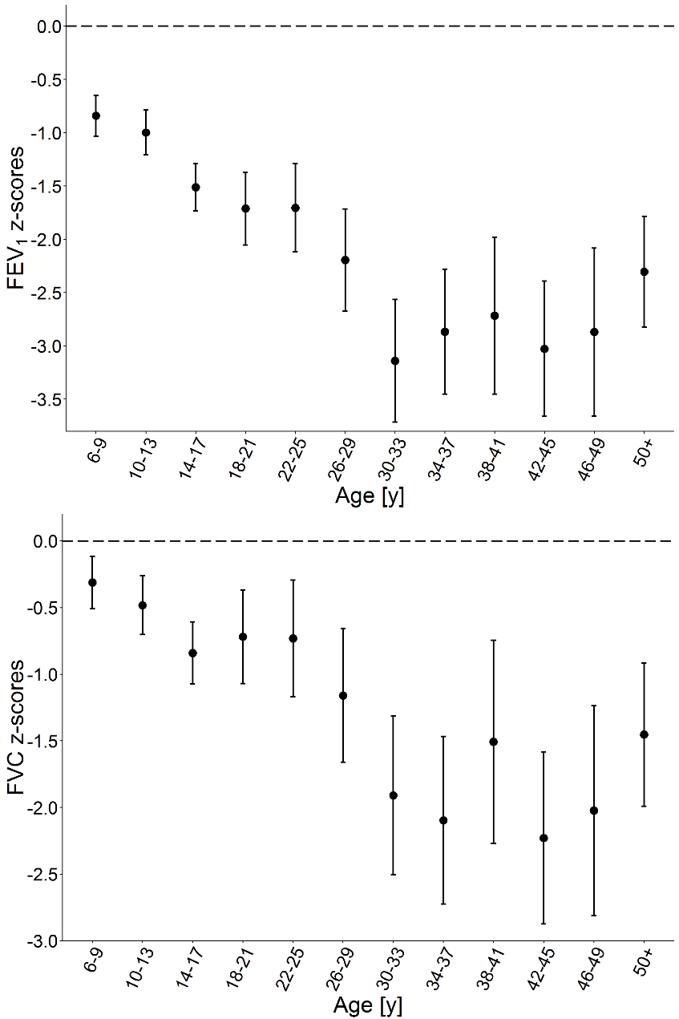

Fig 1. FEV1 and FVC in PCD patients by age group compared to GLI 2012 reference values. FEV1 and FVC are presented as mean z-score (95%CI) after adjusting for sex, country, and level of diagnostic certainty. The dashed line shows the mean z-score of the normal population.

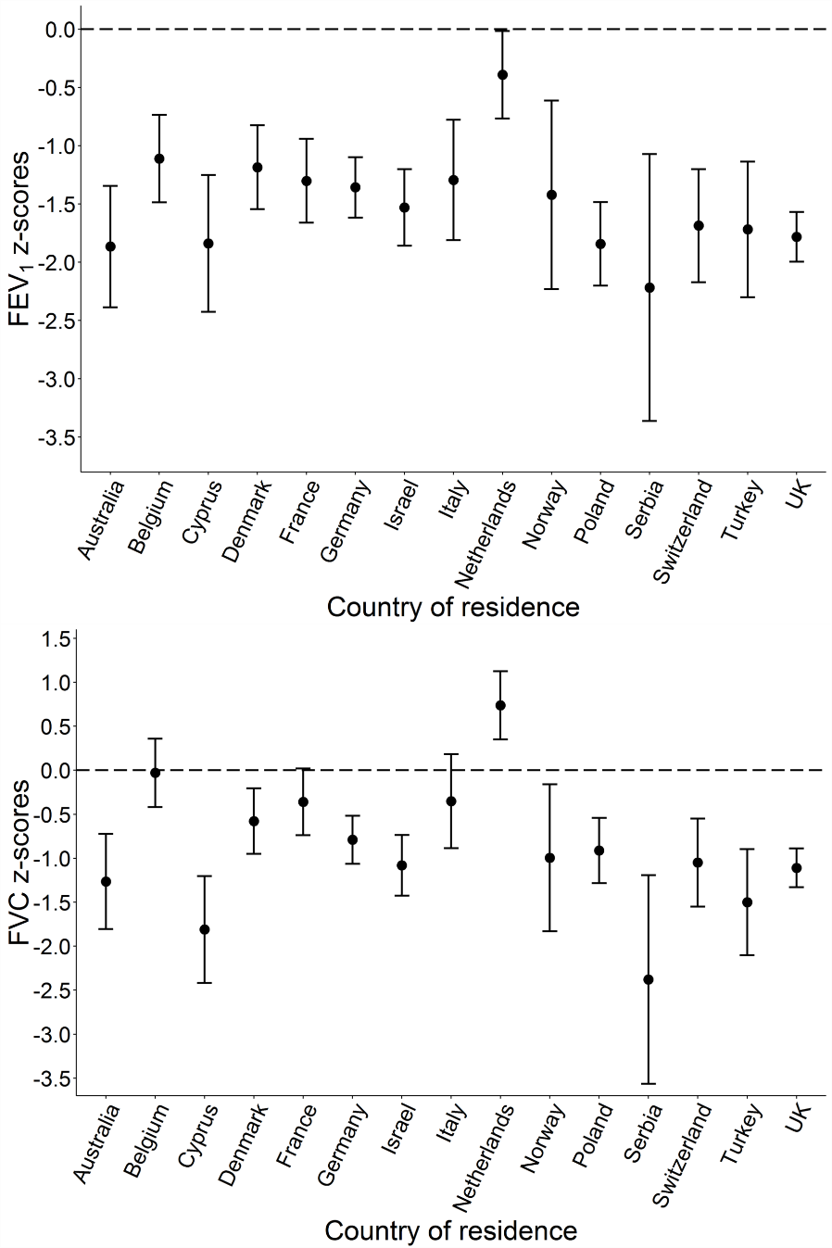

Fig 2. FEV1 and FVC in PCD patients by country compared to GLI 2012 reference values. FEV1 and FVC are presented as mean z-score (95%CI) after adjusting for sex, age group, and level of diagnostic certainty. The dashed line shows the mean z-score of the normal population.

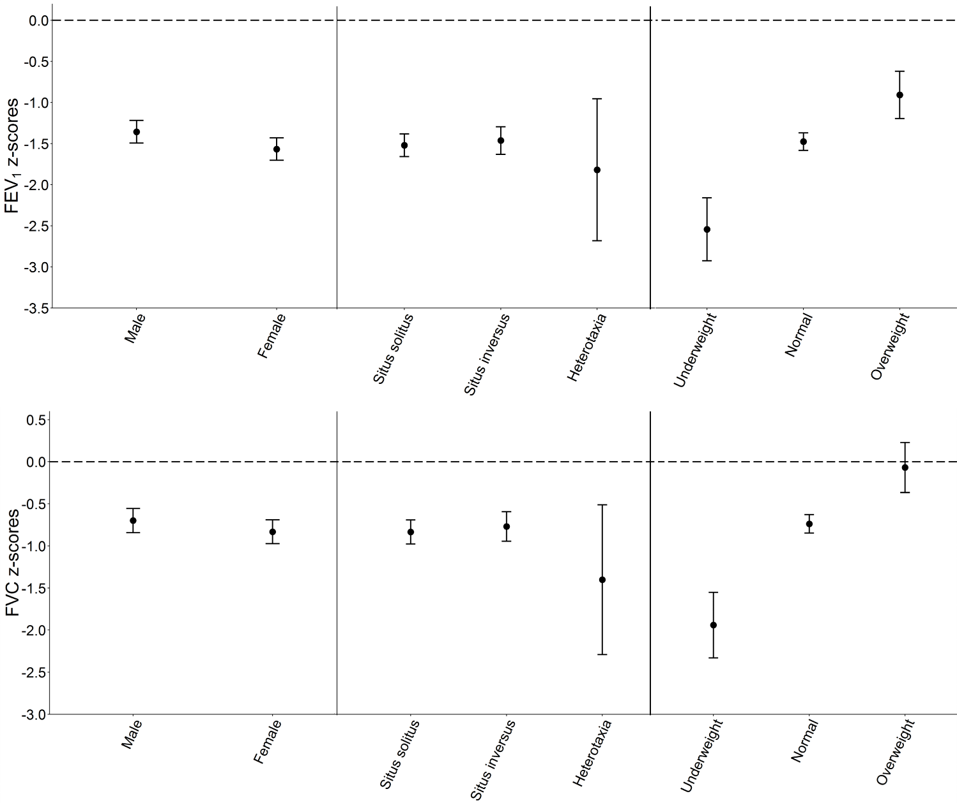
Fig 3. FEV1 and FVC in PCD patients by sex, situs anomalies, and BMI compared to GLI 2012 reference values. FEV1 and FVC are presented as mean z-score (95%CI) after adjusting for age, country, and level of diagnostic certainty. The dashed line shows the mean z-score of the normal population.

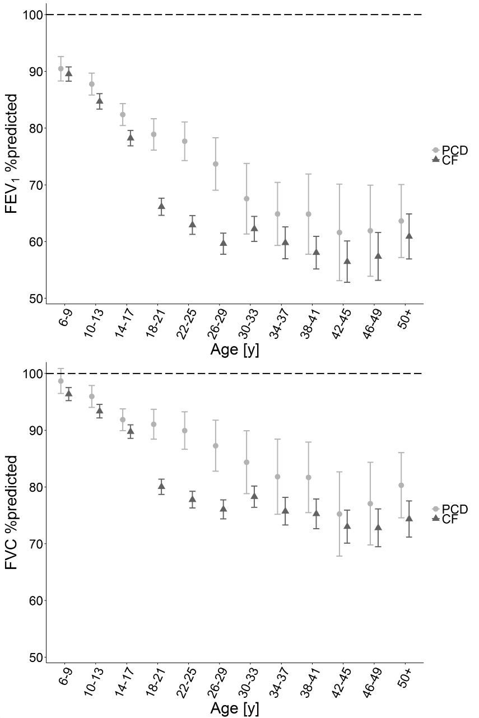

Fig 4. Association of FEV1 and FVC of PCD patients with CF patients. FEV1 and FVC are presented as mean %predicted (95% CI), without adjusting for other factors. The dashed line shows the mean of the normal population.

