Chalcogenide Materials: Novel Compositions and New Applications

Andrea Ravagli, Bruno Moog, Fernando Guzman, Chris Craig and Daniel W Hewak*
Optoelectronics Research Centre, University of Southampton, Southampton, SO17 1BJ, UK
Ajoy Kar, Mark Mackenzie and James Morris
Institute of Photonics and Quantum Sciences, School of Engineering and Physical Sciences, David Brewster Building, Heriot-Watt University, Edinburgh, EH11 4AS, UK
* Corresponding author: dh@orc.soton.ac.uk

In this talk, we describe our recent work on selenium modified Ga:La:S glasses. The addition of Se improves the infrared transmission sufficiently to capture enough of the 8-12 micron window to allow thermal imaging, while at the same time, allowing sufficient visible transmission for object recognition using conventional image capturing. The addition of Se has other implications, increasing the optical nonlinearity, providing longer fluorescent lifetimes when doped with rare earth ions and expanding the transmission window in the important 3-5 micron region. Ga:La:S glasses are superior to commercially available chalcogenides based on alloys of Ga and/or As with S, Se and/or Te. They offer significantly higher alkaline resistance, greater mechanical strength and over 300ºC higher working temperature (Tg > 500ºC). All of these new features suggest Ga:La:S-Se may be a material suitable for the next generation of mid-IR sources through supercontinuum or rare earth doping.

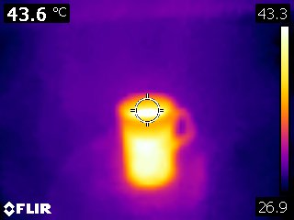
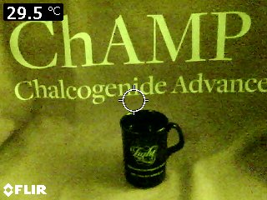
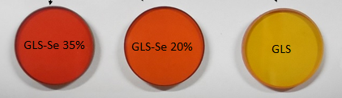

Figure 1 (a) Compositional modification of Ga:La:S glass1, (b) thermal imaging in the 8-12 micron band2 and (c) supercontinuum generation GLS.

REFERENCES
- Ravagli, Andrea, Craig, Christopher, Alzaidy, Ghadah, Abdulrahman, Bastock, Paul and Hewak, Daniel (2017) Optical, thermal, and mechanical characterization of Ga2Se3-Added GLS glass Advanced Materials (doi:10.1002/adma.201606329)
- Ravagli, Andrea, Craig, Christopher, Lincoln, John and Hewak, Daniel (2017) Ga-La-S-Se glass for visible and thermal imaging Advanced Optical Technologies (doi:10.1515/aot-2016-0069).

