Non-destructive microscopic characterization of optical fiber preforms

M. Vivona, M. N. Zervas
Optoelectronics Research Centre, University of Southampton B53, SO17 1BJ Southampton, UK
m.vivona@soton.ac.uk

Abstract: We present a non-destructive optical technique, based on luminescence spectroscopy measurements and optical computerized tomography, to measure Yb³⁺ single ion and Yb³⁺-Yb³⁺ cluster distributions inside the core of optical fiber preforms. The core refractive index distribution was also measured and used to define the actual active dopant distributions within the core.
OCIS codes: 060.2310 Fiber optics; 100.6950 Tomographic image processing; 140.3615 Lasers, ytterbium;

1. Introduction
High-power fiber lasers (FL) are key devices for a number of scientific and industrial sectors [1]. Optimum FL performance relies on accurate refractive index profile (RIP) and active dopant profile (ADP) control and characterization. Although a number of different techniques have already been developed for accurate RIP characterization in fibers [2] and preforms [3], there is a limited number of reports on ADP characterization on preforms. More importantly, so far preform ADP techniques are destructive [4]. In this work, we modify a non-destructive emission computerized-tomography (e-CT) technique [5] for Yb³⁺-doped preform characterization and combine it with a RIP measurement technique [3]. Such a measurement technique provides the Yb³⁺ distribution within the preform core with respect to the refractive index distribution. In addition, the method provides the distribution Yb³⁺-Yb³⁺ clusters, which can be important in heavily doped FLs [2]. This technique is particularly useful for the development of novel fibers with complex dopant distributions within the core area, such as confined dopants [7] or doped rings [8].
In this paper, we present a case study in which this combined method is applied to the microscopic characterization of Yb³⁺-doped aluminosilicate optical fiber preform. The Yb³⁺ and Yb³⁺-Yb³⁺ cluster distribution and refractive index Δn of the optical core were studied by imaging photoluminescence (PL) of the spontaneous emission (SE) signal and the beam deflection function, respectively, and analyzed using e-CT principles.
2. Experimental Set-Up
The combined ADP and RIP preform characterization experimental set-up is shown in Fig.1. For the PL detection and ADP characterization, two pump laser sources at 976 nm illuminate the optical preform from opposite sides in order to have a uniform excitation over the core. The light emitted by the sample is collected at 90° with respect to the excitation arms. Specifically, the infrared (IR) emission of Yb³⁺-ions and the visible (VIS) cooperative luminescence of Yb³⁺-Yb³⁺ clusters were acquired by a charge-coupled device (CCD) equipped with pass-band filters centered at ~1050nm or at ~500nm, respectively. A MATLAB script was encoded to calculate the Yb³⁺ spontaneous emission distribution using an inverse Abel transform, implemented by a Fourier transform followed by a Hankel transform of the projected PL curves [9]. For the refractive index characterization, parallel rays from a white light (WL) transversally illuminate the sample and their effective beam deflection, obtained by inserting a knife-edge spatial filter, is measured by the CCD and it is related to the refractive index of the sample [3]. During the measurements, the preform was kept immersed in an index-matching oil.
Fig. 1: Combined ADP and RIP preform characterization experimental set-up

3. Results and discussion
The CCD images for the two types of measurement (effective beam deflection and IR/VIS PL) are shown in Fig. 2(a), (b) and (c). The first image shows the sample illuminated by the WL source with about half-part blocked by the knife-edge filter, while the second and third images display the IR Yb³⁺ single ion and the VIS Yb³⁺-Yb³⁺ cluster emission under lateral excitation at 976 nm. The effective deflection of light rays emerging from the preform as a function of the radial point of incidence is visible in the core region in Fig. 2(a). The profiles extracted from these images are plotted in Fig. 2(d). From these curves, we have derived the refractive-index (calculated by an integration of the deflection) and the SE-profile of Yb³⁺ ions and of the Yb³⁺-Yb³⁺ clusters (calculated by an inverse Abel transform of the PL). The Δn (difference between core-cladding refractive indices) and PL-emitter curves so derived are shown in Figs. 2e and 2f-2g, respectively. The core edges, obtained from the deflection measurement, are also marked by dashed lines for guidance.

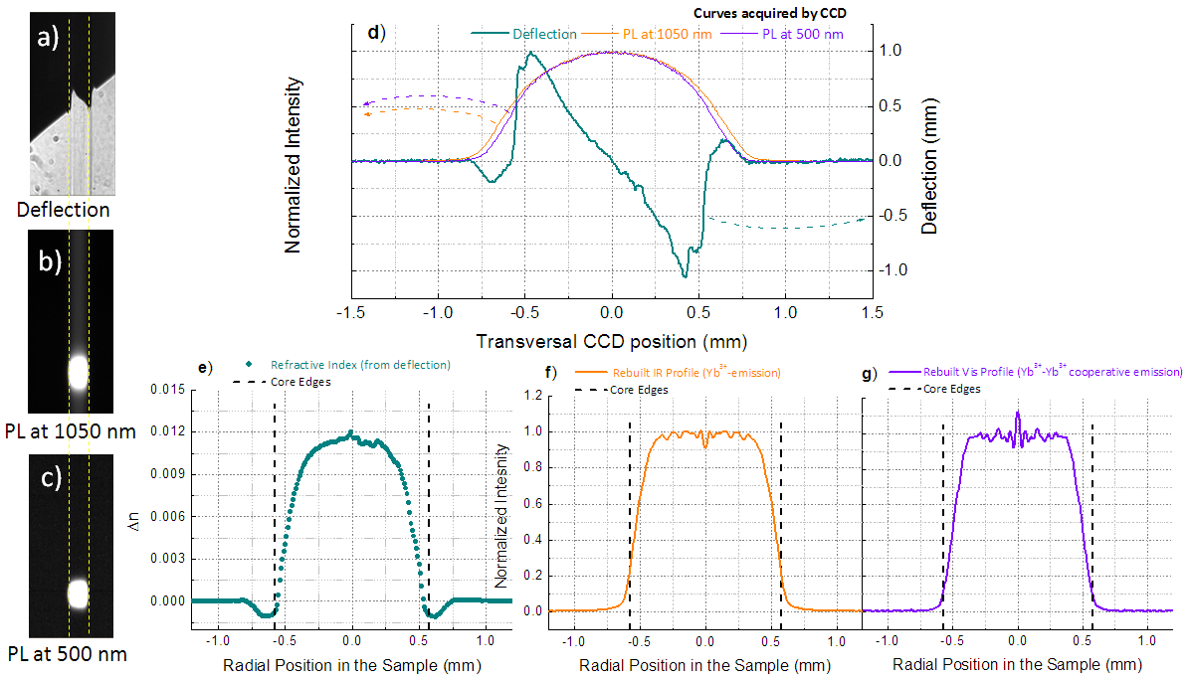
Fig. 2: CCD images for the refractive-index (a), IR-(b) and VIS-(c) emission. d) Transversal profile of the PL images and the deflection derived from image a). Refractive-index e) and Yb³⁺-spontaneous emission (SE) profiles related to Yb³⁺-ions f) and to the Yb³⁺-Yb³⁺ cluster g) emission.

The obtained refractive-index profile is highly symmetric and in very good agreement with PK2600 measurements. The Yb³⁺ ion and Yb³⁺-Yb³⁺ cluster distributions appear very similar, following a flat distribution, except for a small region in the center, where the Yb³⁺ distribution shows a dip whereas there is a peak for the Yb³⁺- Yb³⁺ distribution. More results and detailed comparisons, obtained from the study of different samples, will be presented at the conference.
4. Conclusions
The Yb³⁺ single ion and Yb³⁺-Yb³⁺ cluster distributions inside the core of optical fiber preforms were evaluated by a non-destructive technique for the first time. The core refractive index distribution was also measured and used to define the actual active dopant distributions within the core. This technique represents a powerful tool for easy and quick microscopic evaluation of optical fiber preform quality and can be used for detailed preform characterization and optimization.
Funding: EPSRC (EP/M020770/1); RAEng Research Chairs and Senior Research Fellowships scheme.
5. References
- M. N. Zervas and C. A. Codemard, "High power fiber lasers: a review", IEEE J. Select. Topics Quantum Electron. 20, 0904123 (2014).

A.D. Yablon, et al, “Hyperspectral optical fiber refractive index measurement spanning 2.5 octaves,” Proc. SPIE 8601, 86011V (2013).

T. Okoshi et al, “Nondestructive measurement of axially non-symmetric refractive index distribution of optical fiber preforms,” Electron. Lett., 16, 722 (1980).

J. Kirchhof, et al, “Spatial distribution effects and laser efficiency in Er/Yb doped fibers,” Proc. SPIE 5350, 222 (2004).

A.D. Yablon, “Measuring the spatial distribution of rare-earth dopants in high-power optical fibers,” Proc. SPIE, 7914, 79141N (2011).

S. Jetschke et al., "Efficient Yb laser fibers with low photodarkening by optimization of core composition", Opt. Express 16, 15540 (2008).

J.R. Marciante et al ,“Near-diffraction-limited operation of step-index large-mode-area fiber lasers via gain filtering” Opt. Lett. 35, 1828 (2010)

Y. Yung et al, “Three mode Er³⁺ ring-doped fiber amplifier for mode-division multiplexed transmission,” Opt. Express 21, 10383 (2013).

S. R. Deans, "Radon and Abel Transforms" in The Transforms and Applications Handbook: 2nd Edition, (CRC Press LLC, 2000).

