Temperature effects on larval development in the lithodid crab Lithodes maja

Alastair Brown^{1*}, Sven Thatje¹, Andrew Oliphant^{1,2,} Catriona Munro^{1,3}, Kathryn E. Smith^{1,4}

¹Ocean and Earth Science, University of Southampton, National Oceanography Centre Southampton, European Way, Southampton, SO14 3ZH, UK
²present address Institute of Biological, Environmental & Rural Sciences, Aberystwyth University, Penglais, Aberystwyth, Ceredigion, SY23 3FG, UK
³present address Department of Ecology and Evolutionary Biology, Brown University, Providence, RI 02912, USA
⁴present address College of Life and Environmental Sciences, University of Exeter, Exeter EX4 4QD, UK
*alastair.brown@noc.soton.ac.uk
ABSTRACT
Physiological adaptations enabling tolerance of low temperature, as well as adaptations in larval development, are thought to be critical to the global radiation of deep-water lineages of lithodine crabs. However, global climate change is warming the oceans, potentially impacting the biogeographic distributions of these large predatory crabs. To date, larval thermal scope has only been explored in a few deep-water lineage lithodines. We assessed larval development parameters in the northern stone crab Lithodes maja. We examined larval survival, duration of development, energetic reserve utilisation, and respiration rate at temperatures ranging from 1°C to 15°C. L. maja larvae displayed a narrow thermal tolerance window and metamorphosed successfully at 6°C only. Differential uses of energetic reserves among temperatures during development in L. maja support the interpretation of a narrow larval thermal scope and indicate that 6°C is the optimum temperature for development in this species. Consequently, continued ocean warming is likely to force biogeographic range shifts in L. maja.

Key words: bioenergetics; early ontogeny; lecithotrophy; lithodid; per-offspring investment; respiration
1. Introduction
The cold-adapted lithodine crabs are distributed globally throughout the deep sea and in shallow waters at subpolar latitudes. Lithodine phylogeography indicates that the group originated in the shallow Northeast Pacific, before colonising the deep sea and dispersing globally (see Hall and Thatje 2018). Lithodine taxa occurring deeper than 300 m appear to result from at least three phylogenetically distinct and relatively rapid radiations beginning in the late Miocene, approximately 15 Mya (Makarov 1962, Zaklan 2002a,b, Hall and Thatje 2009, Snow 2010, Bracken-Grissom et al. 2013, Hall and Thatje 2018). Adaptations in larval development mode are considered one of the key features that enabled deep-sea colonisation by the Lithodinae and their re-emergence in polar environments (Thatje et al. 2005). Lithodine species that remain restricted to shallow water (<300 m depth) in the North Pacific are predominantly planktotrophic, whereas deep-sea and polar species (deep-water lineages) are obligate lecithotrophs (see Hall and Thatje 2009).
Larval thermal tolerances also affect lithodine biogeography (Hall and Thatje 2009). In the North Pacific, the species distributions of shallow-water lithodines are limited to regions with water temperatures below 16°C during periods of larval development, despite adult tolerance of in situ water temperatures up to 25°C (Hall and Thatje 2009). Similarly, the ranges of some Southern Ocean lithodines are limited by larval intolerance of low temperature (Hall and Thatje 2011). Larval thermal scope for development appears to match adult biogeographic limits more closely in lithodines from deep-water lineages (e.g. Anger et al. 2003, 2004). Consequently, changing climate may have greater impacts on the biogeography of deep-water lineage lithodines.
Between 1971 and 2010 the average warming of the upper 75 m of the ocean was 0.11°C decade⁻¹ (Rhein et al. 2013). Isotherms have shifted polewards in almost all regions in response to widespread long-term warming (Sen Gupta et al. 2015). The incidence of extreme temperature events (sea surface temperature exceeding the 95th percentile of daily sea surface temperatures from the 1982 to 2010) has also increased significantly (Lima and Wethey 2012). Since marine ectotherms tend to fully occupy their thermal niches (Sunday et al. 2012) their biogeographic ranges are shifting in response to climate change (Pinsky et al. 2013). Continuing changes in global climate are expected to result in further latitudinal and bathymetric range shifts (Brown and Thatje 2015). Although, the whole ocean will warm up reasonably uniformly eventually (Li et al. 2013), global average sea surface temperature is predicted to rise faster than temperature in deeper waters, reaching between 1°C and 3°C higher in the period 2081-2100 than in the period 1986-2005 (Collins et al. 2013). Although all deep-water lineage lithodines will therefore eventually be exposed to greater temperatures than at present, those inhabiting shallow coastal waters will experience the greatest temperature changes in the short-term.
Larval thermal scope in deep-water lineage lithodines has only been assessed in the southern hemisphere species Lithodes santolla and Paralomis granulosa (Anger et al. 2003, 2004). Both species thrive in relatively warm and variable subantarctic shallow waters where temperatures range between 3°C and 18°C (Anger et al. 2004). Therefore, L. santolla and P. granulosa may not be representative of other deep-water lineage lithodines. In contrast, the northern stone crab Lithodes maja occurs at temperatures between 0°C and 10°C (see Brown et al. 2017), which is representative of deep-water lineage lithodines (Zaklan 2002b). L. maja is known to inhabit depths from 4–790 m and is distributed from 40°N along the North American coast to Newfoundland, across to the west and east coasts of Greenland, the coasts of Iceland, and south along the Norwegian coast to the British Isles and the Netherlands (see Zaklan 2002b). L. maja’s larval thermal scope remains uncertain, but larval development in L. maja is known to be lecithotrophic, proceeding through 3 zoea stages and the megalopa in approximately 7 weeks at 9°C (Anger 1996). The aim of this study was to assess larval thermal scope, and the effect of temperature on larval duration, energetic reserve utilisation, and respiration rate in L. maja.

2. Materials and Methods
2.1 Capture and maintenance of Lithodes maja
Adult specimens of L. maja were collected using baited traps from depths of approximately 60 m in Gullmarsfjord, Sweden. Collection took place during late September and October 2011, and March and early April 2012. Individuals were maintained in an open aquarium system at the Sven Lovén Centre for Marine Sciences – Kristineberg (salinity ∼35, temperature 6-10 ºC; natural light cycle) for several weeks. Actively moving specimens of L. maja without extensive necrosis or externally visible parasites were then relocated to a recirculating aquarium (salinity 32.7, temperature 6 ºC; 24-h darkness) at the National Oceanography Centre Southampton (NOCS, UK) in November 2011 and April 2012. Animals were starved for 3 days prior to relocation to reduce the potential for adverse impact of increased metabolic activity (e.g. feeding and digestion). Each specimen was isolated in a polystyrene box lined with a towel wetted with seawater. Although air exposure may induce oxidative stress (Romero et al. 2007, 2011) and water loss (Urbina et al. 2013), recovery can be relatively rapid in lithodids; Paralomis granulosa’s antioxidant enzyme activities recovered to control values within 24 hours after 6 hour exposure to dry air at 7ºC (Romero et al. 2011). Specimens were transported using a temperature-controlled van (6ºC; <24 h), The 6 ºC maintenance temperature was selected to match field temperatures during sampling, and this in situ temperature served as a baseline for experimental temperature treatments. 24-h darkness was maintained to simulate deep-sea conditions. Specimens were fed squid mantle weekly, and excess food was removed after 24 hours. Ovigerous females (including both wild- and captive-mated females; see section 2.3 below) were maintained in isolation in aquaria during brooding and larval hatching, with mesh filters preventing larval loss through the outflow from the aquaria.

2.2 Mating
Carapace lengths (CL: measured from the baseline of the orbit to the posterior edge of the carapace excluding any protruding crests or spines, after Hall and Thatje 2010) were measured to the nearest 0.1 mm using vernier callipers. Non-ovigerous females were each isolated with a male which had approximately 30 % greater CL (mean ± SD = 29.9 ± 1.8 %; female CL range 62.2-79.4 mm and male CL range 82.1-103.6 mm). Similar size ratios are reported as maximal size ratios in other lithodine precopulatory pairings (see Webb 2014, and references cited therein). Larger males may have higher reproductive potential than small males, as reported in Paralithodes brevipes (assessed as number of sperm ejaculated per mating; Sato et al. 2005), therefore maximising reproductive potential in captive mating pairings. Males were not offered further mates to avoid the potential for reduced sperm transfer in successive matings and consequent reductions in spawning and egg fertilisation rates, as reported in P. brevipes (Sato et al. 2005). Mating was attempted with 8 females: 3 females that were ovigerous when captured and that had spawned in captivity (A-C), and 5 females that were non-ovigerous when captured (D-H). Female moulting and mating occurred between 3rd April and 31st August 2012; individuals had been maintained in the aquarium for at least 1 month prior to moulting. All 5 females that were non-ovigerous when collected, moulted and mated successfully. Only 1 of 3 females that were ovigerous when collected and that had spawned in captivity, moulted and mated successfully: female B moulted successfully but was crushed during mating and died, and female C moulted unsuccessfully and died.
Females ceased feeding at least 14 days prior to moulting. Mating behaviour and copulation proceeded as known for other lithodid crab species (see Webb 2014, and references cited therein). The male engaged the female in precopulatory embrace, facing the female and grasping her chelae meropodites, 3-10 days prior to the female moulting. The period between the end of larval hatching and the post-hatching maternal moult in females that were ovigerous when captured and that had spawned in captivity was 133.7 ± 9.5 days (n = 3; range 124-143 days). Moulting occurred at night and copulation followed immediately, inferred from oviposition, which occurs after spermatophore transfer, as reported in other lithodids (Webb 2014), and within few hours. The male released the female following copulation and was subsequently removed from the isolation aquarium. Females resumed feeding within 21 days of oviposition.

2.3 Larval hatching and fecundity
Henceforth, broods are labelled with a letter denoting mother (A-H) and a superscript W or C to indicate wild or captive mating, respectively. Larval hatching began between 9th January 2012 and 2nd April in 2012 in females that were ovigerous when captured, and between 26th February 2013 and 4th August in 2013 in females that mated in captivity: in the latter larval hatching began 342.3 ± 18.5 days (range = 327-367 days; n = 6) after oviposition.
Although maintained in 24-h darkness, larval hatching predominantly occurred at night and haphazard inspections suggested hatching was typically prior to midnight. Aquaria and mesh filters were inspected every morning and any larvae were removed; therefore, larval age was accurate to within 24 h of hatching. Larvae were counted daily to assess hatching rhythms and realised fecundity. For comparison, the theoretical number of larvae (TL) for each female was calculated according to the fecundity-CL relationship established for a Greenland population of L. maja (TL = 0.0048CL^{3.1186}; Woll and Burmeister 2002).

2.4 Intraspecific hatchling variability
Five freshly hatched and actively swimming larvae from each brood were randomly sampled for dry mass and elemental composition (carbon, nitrogen) determination (one individual per replicate). Energetic reserve can be assessed by examining carbon (C) and nitrogen (N) content of larvae (proxies for lipid and protein reserves) (Anger and Harms 1990). Following Anger and Harms (1990), larvae were rinsed in distilled water, blotted on fluff-free paper, transferred individually to a pre-weighed tin capsule, and frozen at -80°C. Dry mass was determined to the nearest 1 µg after freeze-drying samples (24 h). C and N composition (% dry mass) were determined using a CHNS-O EA1108-elemental analyser (Carlo ERBA Instruments) calibrated using chitin as a standard. C and N mass were calculated from dry mass and elemental composition data (respectively, C × dry mass and N × dry mass).

2.5 Larval development in larvae from wild and captive mating
Differences in larval development between wild and captive broods were examined in larvae from female A. 96 freshly hatched, actively swimming larvae were randomly selected from wild (A^{w}) and captive (A^{c}) broods, from larvae hatched during a single 24 hour period. Larvae were isolated individually in 100 ml plastic beakers filled with ~80 ml seawater (1 µm filtered seawater: salinity 32.7, temperature 6 ºC) and transferred to an incubator set at 6 ºC. From each brood, 48 larvae were allocated to developmental duration and survival assessment, and 48 larvae were allocated to respiration rate, mass, and elemental composition assessment. Larval and juvenile rearing was conducted according to established protocols (e.g. Calcagno et al. 2003, Lovrich et al. 2003), but in 24 h darkness. Larvae were inspected daily for moults or mortalities, and water was changed every second day; larval mortality was typically associated with moulting. L. maja larvae are obligate lecithotrophs and therefore were not fed (Anger 1996). Larvae invariably passed through 3 zoeal stages and the megalopa before metamorphosis, as observed by Anger (1996). Transitions between stages were indicated by the appearance of exuvia (exoskeleton cast at moult) and morphological changes; conspicuous small pleopodal buds − present on abdominal somites − appear in zoea II and are further developed in zoea III. Upon reaching megalopa stage, a piece of nylon mesh was placed in the beaker as an artificial substrate to facilitate settlement and metamorphosis. Five individuals were sampled randomly for respiration rate, dry mass, and elemental composition determination (one individual per replicate) within 24 h post moult.
Metabolic rate is the fundamental biological rate (Brown et al. 2004). Since energy is obtained by oxidising carbon compounds, aerobic metabolic rate is equivalent to the rate of respiration; therefore respiration can be used as a proxy for metabolism (Brown et al. 2004). Respiration rates were measured and calculated following an established protocol (Thatje et al. 2010). Individuals were isolated in 2.8 ml plastic vials containing seawater (1 µm filtered seawater: salinity 32.7, acclimated to treatment temperature). Each vial was closed underwater to ensure the absence of air bubbles and incubated for 4 h. Subsequently, the vial was inverted gently 3 times to ensure the seawater oxygen content was homogenous. The vial lid was removed and the oxygen saturation of the water determined using an oxygen micro-optode connected to a Microx TX3 array (PreSens, Germany), calibrated according to the manufacturer’s instructions. Subsequently, the animal was removed from the vial, rinsed in distilled water, blotted on fluff-free paper, transferred individually to a pre-weighed tin capsule, and frozen at -80°C for later mass determination and elemental analysis. Microbial respiration was discounted by comparison with empty vials exposed to treatment conditions. Respiration rate (MO₂) was determined from oxygen consumption, calculated from the difference between mean oxygen saturation in empty vials and the oxygen saturation in each individual’s vial using Benson and Krause’s (1984) formula for determining the oxygen concentration of air-saturated seawater.
Energetic reserve utilisation can be assessed by examining changes in carbon (C) and nitrogen (N) content of larvae (proxies for lipid and protein reserves) throughout development (Anger and Harms 1990). Elemental analysis was performed as described in section 2.4 above.
Differences in biomass parameters between larvae from A^{W} and A^{C} were analysed using one-way ANOVA with mating as the factor (i.e wild vs. captive): significant differences were explored using the post-hoc Holm-Sidak multiple comparisons test. Changes in biomass parameters in A^{W} and A^{C} larvae were described with linear regressions as functions of mean larval duration, and compared using ANCOVA (Sokal & Rohlf 1995): crab I (first stage post-metamorphosis) data were excluded due to low survivorship.

2.5.1 Exuvial and metabolic losses
To determine biomass losses during successive moults, exuviae were sampled from each larval stage of A^{W} larvae (zoea I, II, II, and megalopa). 3 replicates were taken for each larval stage, with 10 exuviae pooled per replicate for zoeal stages and 5 exuviae pooled per replicate for megalopa (Lovrich et al. 2003). Exuvial mass and elemental composition were determined as described in section 2.4 above. Metabolic losses were calculated by deducting the total mass of exuviae from the total biomass decrease between hatching and metamorphosis to crab I (after Calcagno et al. 2003, Lovrich et al. 2003).

2.6 Temperature effects on larval development
Temperature effects on larval development were explored using larvae from a single captive-mated female (A^{C}; ^{C} = captive-mated). A total of 576 freshly hatched and actively swimming larvae were isolated individually in 100 ml plastic beakers filled with ~80 ml seawater (1 µm filtered seawater: salinity 32.7, temperature 6 ºC). 96 larvae were allocated at random to each temperature treatment (1, 3, 6, 9, 12, and 15 ºC) and transferred to incubators (LMS series 1A, model 201) set at experimental temperatures. Of the 96 larvae allocated to each temperature, 48 larvae were allocated to developmental duration and survival assessment, and 48 larvae were allocated to respiration rate, dry mass, and elemental composition assessment.
Larval rearing was conducted as described in section 2.5 above. Five individuals were sampled randomly for respiration rate, dry mass, and elemental composition determination (one individual per replicate) as described in section 2.5 above, 24 h after allocation to each temperature treatment, and from each subsequent larval stage at each temperature, within 24 h post moult.
The effect of temperature on the mean duration of each larval stage was assessed using non-linear power regression and ANCOVA with larval stage as the factor and temperature as the covariate (Sokal and Rohlf 1995). C and N proportions were arcsine-square-root transformed prior to analysis (Underwood 1997). Dry mass, C:N ratio, C and N mass, and MO₂ were normally distributed and homoscedastic (Shapiro-Wilk and Levene’s tests, p > 0.05) and were, therefore, analysed without transformation (Underwood 1997). Differences in biomass parameters among different temperature treatments were analysed using one-way ANOVA with temperature as the factor: significant differences were explored using the post-hoc Holm-Sidak multiple comparisons test. Changes in biomass parameters in larvae during development to megalopa at 6 and 9°C were described with linear regressions as functions of mean larval duration, and compared using ANCOVA (Sokal and Rohlf 1995): crab I data were excluded due to low survivorship. The effect of temperature on respiration rate in different zoeal stages was analysed using non-linear power regression and ANCOVA. The effect of temperature on respiration rate in megalopa was assessed using one-way ANOVA.

2.7 Intraspecific comparisons
The literature was searched using the keywords “temperature”, “lecithotroph”, “larval”, “development”, “lithodid”, and “lithodine” to guide the search in the ISI Web of Science database and the Google Scholar search engine. Developmental duration, dry mass, C mass, N mass, C:N ratio, and respiration rate data were extracted from a single paper reporting larval development at 9°C in L. maja from the Kattegat and off the Norwegian coast (Anger 1996). Differences in the duration of L. maja’s larval stages at 9°C between studies were not compared statistically because Anger’s (1996) larval duration data were presented without an associated measure of dispersion or identifiable n. However, both measure of dispersion and indication of n were available for biomass parameters and respiration rates which were therefore compared with 9°C data from the present study using ANOVA (assuming n = 5 for biomass parameters). Changes in biomass parameters in larvae from each study were described with linear regressions as functions of mean larval duration and compared using ANCOVA. Whilst these statistical comparisons may reveal significant differences in larval development, these cannot be attributed unequivocally to intraspecific differences: differences may result from contrasting environmental or experimental conditions.

3. Results
3.1 Larval hatching and fecundity
Mean hatching period was 27.1 ± 8.6 days (Fig. 1) (range = 18-41 days; n = 7). Mean fecundity was 2185 ± 568 larvae (range = 1480-2834; n = 7) and the realised fecundity-CL relationship was: larvae = 0.048CL^{2.487}; r² = 0.461 (Fig. 2). Realised fecundity ranged from 56 to 90% of theoretical fecundity.

3.2 Intraspecific hatchling variability
Dry mass, C and N content (% dry mass), C:N and C and N mass did not differ between freshly hatched larvae from wild and captive mating of female A (Fig. 3; Supplementary Material (SM) Table S1) (p > 0.05). In contrast, dry mass, C and N, C:N and C and N mass all differed among freshly hatched larvae from different females (Fig. 3; SM Table S1) (p < 0.05). Female CL had no effect on dry mass, C and N, C:N or C and N mass (Fig. 4) (p > 0.05).

3.3 Larval development in larvae from wild and captive mating
Larval mortality was similar between larvae from A^{W} and A^{C} (Table 1). The mean durations of zoea I and zoea II were shorter in larvae from A^{W} (respectively, 7.7 ± 1.3 and 8.5 ± 1.4 days) than in larvae from A^{C} (respectively, 8.5 ± 1.5 and 9.6 ± 1.3 days) (Table 2) (respectively, W = 366.5, p = 0.043 and W = 100.0, p = 0.044). The duration of zoea III did not differ between larvae from A^{W} (11.4 ± 1.7 days) and A^{C} (14.0 ± 3.5 days) (W = 18.0, p = 0.109), likely as a result of the low statistical power due to low n. The duration of megalopa was similar in larvae from A^{W} (52.5 ± 7.8 days) and A^{C} (53.0). Statistical differences in duration of larval stages must be interpreted with caution due to the low sampling resolution (24 h interval), but differences in larval stage durations resulted in mean total larval duration of 80.1 days in larvae from A^{W} and 85.1 days in larvae from A^{C}.
Dry mass decreased continuously from hatching to metamorphosis (Fig. 5; SM Table S1). C content (% dry mass) decreased throughout development whilst N content (% dry mass) increased slightly, resulting in a decreasing C:N ratio and indicating decreasing lipid/protein ratio during development (Anger and Harms 1990). Both C and N mass decreased continuously throughout development.
Zoea I and zoea II dry mass did not differ among larvae from A^{W} and A^{C} (Fig. 5; Table 3; SM Table S2), but zoea III and megalopa dry mass were lower in larvae from A^{W}. The rate of decrease in dry mass was greater in larvae from A^{W} than in larvae from A^{C} (F_{1,36} = 21.979, p < 0.001).
Zoea I and zoea II C content did not differ among larvae from A^{W} and A^{C} (Fig. 5; Table 3; SM Table S2), and although zoea III C was lower in larvae from A^{W}, megalopa C did not differ either. Rates of decrease in C content did not differ among larvae from A^{W} and A^{C} (F_{1,36} = 0.006, p = 0.939) and neither did C overall (F_{1,37} = 2.196, p = 0.147). Similarly, zoea I and zoea II N content did not differ among larvae from A^{W} and A^{C} (Fig. 5; Table 3; SM Table S2) and although zoea III N was greater in larvae from A^{W}, megalopa N did not differ either. However, the rate of increase in N content was greater in larvae from A^{W} than in larvae from A^{C} (F_{1,36} = 6.896, p = 0.013).
Zoea I and zoea II C:N ratios did not differ among larvae from A^{W} and A^{C} (Fig. 5; Table 3; SM Table S2) and, although zoea III C:N ratio was lower in larvae from A^{W}, megalopa C:N ratios did not differ either. The rate of decrease in C:N ratio was greater in larvae from A^{W} than in larvae from A^{C} (F_{1,36} = 5.732, p = 0.022).
Zoea I and zoea II C and N mass did not differ between larvae from A^{W} and A^{C} (Fig. 5; Table 3; SM Table S2), but zoea III and megalopa C mass and N mass were lower in larvae from A^{W}. Rates of decrease in C mass and N mass were greater in larvae from A^{W} than in larvae from A^{C} (respectively, F_{1,36} = 15.140, p < 0.001 and F_{1,36} = 17.196, p < 0.001). Furthermore, respiration rates of all larval stages were greater in larvae from A^{W} than in larvae from A^{C} (Fig. 5; Table 3; SM Table S2).

3.3.1 Exuvial and metabolic losses
Exuvial losses were similar among A^{W} zoea moults, accounting for 3.9%, 4.2%, and 5.5% of the initial dry mass of successive larval stages, but were larger at the megalopa moult which accounted for 31.8% of initial dry mass of the megalopa (Fig. 6; SM Table S3). Zoea exuviae were very thin, with low contents of C and N content (% dry mass), and with lower C:N ratio than whole larvae (SM Tables 2 and 3). Megalopa exuviae also had low contents of C and N and lower C:N than megalopa, but were thicker. Metabolic losses were responsible for only 20% of the decrease in dry mass during larval development, but 90% of C depletion and 76% of N depletion (Fig. 6).

3.4 Temperature effects
Larval mortality varied among temperatures (Table 1). Development to zoea II was successful at all experimental temperatures, but survival to zoea II was greatest at 9°C, intermediate at 3 and 6°C, and lowest at 1, 12, and 15°C. In contrast, development to zoea III was successful only at 3, 6, and 9°C, and development to megalopa was successful only at 6 and 9°C. Metamorphosis was successful at 6°C only. Durations of developmental stages depended on temperature (Table 2), increasing exponentially as temperature decreased in zoea I (F_{1,4} = 399.212, p < 0.0001, r² = 0.99; duration = 37.756T^{-0.811}) and zoea II (F_{1,2} = 236.913, p = 0.0413, r² = 0.99; duration = 82.765T^{-1.169}). Zoea II duration increased more steeply with decreasing temperature than zoea I duration (F_{1,5} = 9.221, p = 0.0288).
Zoea I and II dry mass did not differ among temperatures (Fig. 7, Table 4, SM Table 2), but zoea III dry mass was lower at 3°C than at 6 or 9°C, which did not differ. Megalopa dry mass did not differ between 6 or 9°C either. The rate of decrease in dry mass between zoea I and megalopa did not differ between 6 and 9°C (F_{1,35} = 0.046, p = 0.832) and neither did dry mass overall (F_{1,36} < 0.001, p = 0.998).
Zoea I C content (% dry mass) did not differ among temperatures (Fig. 7, Table 4, SM Table 2), but zoea II C was lower at 1°C than at all other temperatures. Zoea III and megalopa C did not differ among temperatures. The rate of decrease in C between zoea I and megalopa was greater at 9°C than at 6°C (F_{1,35} = 25.620, p < 0.001). Similarly, zoea I N content (% dry mass) did not differ among temperatures (Fig. 7, Table 4, SM Table 2), but zoea II N was lower at 1°C than at all other temperatures. However, zoea III N was lower at 3°C than at 6 or 9°C, which did not differ, and megalopa N was lower at 9 than at 6°C. The rate of and direction change in N between zoea I and megalopa differed between 6 and 9°C (F_{1,35} = 22.719, p < 0.001), with N differing little during development at 6°C but decreasing at 9°C.
Zoea I C:N ratios did not differ among temperatures (Fig. 7, Table 4, SM Table 2), but the zoea II C:N ratio was lower at 1°C than at all other temperatures except 9°C. The zoea III C:N ratio was lower at 3 than at 9°C and the megalopa C:N ratio was lower at 6 than at 9°C. Rates of decrease in C:N ratio between zoea I and megalopa did not differ between 6 and 9°C (F_{1,35} = 2.251, p = 0.143), and neither did C:N overall (F_{1,36} = 1.169, p = 0.287).
Zoea I and zoea II C mass did not differ among temperatures (Fig. 7, Table 4, SM Table 2), but zoea III C mass was lower at 3°C than at 6 or 9°C, which did not differ. Megalopa C mass did not differ between 6 and 9°C either. Rates of decrease in C mass between zoea I and megalopa did not differ between 6 and 9°C (F_{1,35} = 3.990, p = 0.054) and neither did C mass overall (F_{1,36} = 2.381, p = 0.132). In contrast, the rate of decrease in N mass between zoea I and megalopa was greater at 9 than at 6°C (Fig. 7, Table 4, SM Table 2) (F_{1,35} = 9.983, p = 0.003). Zoea I N mass did not differ among temperatures but zoea II N mass was lower at 1 than at 15°C. Zoea III N mass did not differ among temperatures, but megalopa N mass was lower at 9 than at 6°C.
Respiration rate increased with increasing temperature in zoea I (Fig. 7, Table 4, SM Table 2) (F_{1,28} = 92.173, p < 0.001; MO₂ = 0.004T^{0.721}, r² = 0.759), zoea II (F_{1,28} = 129.315, p < 0.001; MO₂ = 0.006T^{0.671}, r² = 0.816), and zoea III (F_{1,13} = 16.223, p = 0.001; MO₂ = 0.007T^{0.632}, r² = 0.521). Consequently, respiration rates differed among some temperatures (Fig. 7, Table 4, SM Table 2). Respiration rate temperature response curves differed between zoea I and zoea II (F_{2,56} = 7.264, p = 0.002), and zoea I and zoea III (F_{2,41} = 4.861, p = 0.013), but did not differ between zoea II and zoea III (F_{2,41} = 0.119, p = 0.888): respiration rate was more sensitive to temperature in zoea II and zoea III, than in zoea I.

3.5 Intraspecific comparisons
The duration of all larval zoeal stages at 9°C in this study was longer than reported previously in larvae from adults sampled in the Kattegat and off the Norwegian coast (respectively, ~31, ~25, and ~26%). Zoea I dry mass, C mass, N mass, and C:N ratio were within the range reported previously for Lithodes maja (Anger 1996).
Zoea I dry mass, C mass, and C:N ratio were lower in this study than in larvae previously followed through development (Fig. 8) (respectively, F_{1,8} = 18.827, p = 0.002; F_{1,8} = 75.366, p < 0.001; F_{1,8} = 43.762, p < 0.001); N mass was not different (Fig. 8) (F_{1,8} = 5.177, p = 0.052). The rates of decrease in dry mass, C mass, and C:N ratio at 9°C were greater in the previous study than in the present study (respectively, F_{1,4} = 35.091, p = 0.004, F_{1,4} = 26.879, p = 0.007, and F_{1,4} = 14.839, p = 0.018), but the rate of decrease in N mass was not different (F_{1,4} = 2.838, p = 0.167). However, N mass overall was higher in the previous study (F_{1,5} = 28.807, p = 0.003). Respiration rate at 9°C was higher in the previous study than in this study in zoea I (Fig. 8) (F_{1,11} = 48.106, p < 0.001), zoea II (F_{1,11} = 35.306, p < 0.001), and zoea III (F_{1,11} = 34.289, p < 0.001), but lower in megalopa (F_{1,10} = 50.506, p < 0.001).

4. Discussion
Lithodes maja appears representative of other lithodines from deep-water lineages, displaying similar ecological adaptations such as extended hatching periods (cf. Paul and Paul 2001, Thatje et al. 2003, Reid et al. 2007, Fig. 1) and relatively low fecundity (cf. Webb 2014 and references cited therein, Smith et al. 2017, Fig. 2). Whether significant variation in energetic reserves at hatching among larvae from different females reported previously in L. maja (Anger 1996) and again here (Fig. 3) is representative of other deep-water lineage lithodines is unknown because studies reporting energetic reserves at hatching in deep-water lineage lithodines have either examined only larvae from a single female (Calcagno et al. 2003; Lovrich et al. 2003; Thatje and Mestre 2010) or have pooled larvae from multiple females (Shirley & Zhou, 1997), making direct comparison difficult.
Differential survival among temperature treatments and the success of metamorphosis at only 6°C in this study – and 9°C in a previous study (Anger 1996) – suggest that larval thermal scope in L. maja is relatively narrow: larval thermal scope in both Lithodes santolla and Paralomis granulosa is 3°C to 15°C (Anger et al. 2003, 2004). Larval thermal scope typically reflects the thermal regimes species inhabit and are acclimatised to (see Ravaux et al. 2012) and the monthly mean temperature range within L. maja’s bathymetric range in Gullmarsfjord (≥60 m depth) ranges from 5.95°C to 8.80°C (Fig. 9). However, L. maja’s thermal distribution ranges from ∼0°C to ∼10°C globally (see Brown et al. 2017), suggesting that larval thermal tolerance may be narrower than adult thermal tolerance in L. maja. Since thermal tolerance in the present study was assessed using larvae from a single female, replication with larvae from different females and with different levels of energetic reserves at hatching will be required to confirm whether the larval thermal tolerance indicated by the present study is representative of the species. For example, variation in food resource availability can affect metabolic rate and growth rate in ectotherms (Auer et al. 2015) and differences in energetic reserves at hatching (Fig. 3) may therefore affect the rate of larval development. Further, although there was no significant difference in energetic reserves between larvae from wild and captive mating of female A (Fig. 3), there were significant differences in metabolic rate and the rate of larval development (Fig. 5). Such differences may have resulted from genetic differences, energetic reserve composition related to diet, or environmental differences in e.g. temperature (variable temperature vs. constant 6°C) during embryonic development. Nonetheless, whilst larval survival varies intraspecifically in other lithodines from deep-water lineages (cf. Anger et al. 2003, 2004, Calcagno et al. 2004), intraspecific larval thermal tolerance typically remains similar (Anger et al. 2003, 2004), and the results presented here do, therefore, likely provide an indication of larval thermal tolerance in L. maja.
Differential use of energetic reserves among temperatures in L. maja (Fig. 7) supports the narrow larval thermal scope interpretation and identifies 6°C as the optimum temperature for development. Increased use of C reserves at temperatures below 6°C reflects greater lipid utilisation (see Anger 1998). Despite lower metabolic rates at lower temperatures, the prolonged duration of larval development results in greater overall degradation of lipid reserves (e.g. Oliphant and Thatje 2014). In contrast, increased use of N reserves at temperatures above 6°C indicates enhanced degradation of protein (see Anger 1998) as an energy source under high metabolism (e.g. Weiss et al. 2009). Increasing respiratory sensitivity to temperature during ontogeny (Fig. 7) and decreasing survival at suboptimal temperatures indicate that thermal scope decreases during development in L. maja. Ontogenetic shifts in larval environmental tolerances, including decreasing hyperbaric tolerance in L. maja (Munro et al. 2015, Brown et al. 2017), are well known (Anger 2001) and are proposed to result from increasing biological complexity and size with development (Mestre et al. 2013).
Covariation in metabolic rate and developmental rate observed here in response to temperature (Fig. 7, Table 2) are also well known in the larvae of decapods (e.g. cf. Weiss et al. 2009, Weiss et al. 2012). However, intraspecific variation in metabolic rate in L. maja at 9°C among studies (Fig. 8) and at 6˚C in this study (Fig. 5) is also associated with differences in developmental rate, suggesting that metabolic rate determines developmental duration (for review, see Glazier 2014). Lower metabolic rate at a given temperature, and lower developmental rate, is also associated with lower depletion of energetic resources in L. maja (Figs. 5 & 8), suggesting that slower larval development is more energetically efficient.
The thermodynamic effects of temperature may explain temperature-dependent metabolism, but not differences observed at a given temperature (i.e. at 9°C or 6°C). These differences may instead be explained by responses in metabolic rate to resource availability (e.g. Auer et al. 2015), where larval energetic reserves at hatching differ among larvae from different females (i.e. at 9°C; Fig. 8). Indeed, larger marine bryozoan offspring have greater metabolic rates and use more maternally derived energy than smaller offspring throughout the dependent, non-feeding larval phase (Pettersen et al. 2015). Differences in metabolic rate in the absence of significant differences in larval energetic reserves (i.e. at 6°C; Fig. 5) may instead result from maternal or paternal effects (Burgess and Marshall 2011, Guillaume et al. 2016), contrasting environmental conditions (e.g. constant vs. fluctuating temperatures), or from genetic differences.
The relatively stenothermic larval thermal scope and thermal effects on larval development observed in L. maja, suggest that changing climate may rapidly impact the biogeography of this species. Between 1982 and 2010 coastal areas in the Skagerak adjacent to Gullmarsfjord experienced a significant increase in both average sea surface temperature (0.45 ± 0.2 °C decade⁻¹) and the annual number of extreme hot days (13 ± 5.13 days decade⁻¹) (Lima and Wethey 2012). Continued warming is likely to force poleward shifts in L. maja’s latitudinal range and/or downward shifts in L. maja’s bathymetric range. Alternatively, L. maja may adapt to warming conditions. Whether adaptation in deep-water lineage lithodines such as L. maja can match rapidly changing climate over time is unclear. However, exploring temperature adaptation in larval development of lithodine crabs from deep-water lineages may elucidate the potential to adapt to a warmer and increasingly variable shallow water environment and should be considered a priority for understanding potential biogeographic impacts of a changing climate.

Acknowledgements
AB and ST conceived the work; AB, CM, AO, and KS reared the larvae and measured respiration rates; KS performed biochemical analysis; AB analysed data; AB drafted the manuscript; all authors contributed to manuscript writing. AB was supported through a Natural Environment Research Council PhD studentship and this study was supported by a grant from ASSEMBLE (FP7) to ST and AB. Special thanks go to Bengt Lundve for organising the sampling of crabs and their maintenance prior to transportation, and to Tony Roysson for leading the fieldwork. The authors thank Adam J. Reed for detailed advice on aquarium construction, which enabled successful long-term maintenance of adult crabs at the NOCS. The authors are grateful to Connor Dunbar for assistance in preparing samples for elemental analysis.

Ethical approval
All applicable international, national, and/or institutional guidelines for the care and use of animals were followed.
References
Anger, K., 1996. Physiological and biochemical changes during lecithotrophic larval development and early juvenile growth in the northern stone crab, Lithodes maja (Decapoda: Anomura). Mar. Biol 126, 283-296.
Anger, K., 1998. Patterns of growth and chemical composition in decapod crustacean larvae. Inver. Rep. Dev. 33,159-176.
Anger, K., 2001. The biology of decapod crustacean larvae. AA Balkema, Lisse.
Anger, K., Harms, J., 1990. Elemental (CHN) and proximate biochemical composition of decapod crustacean larvae. Comp. Biochem. Phys. 97B, 69-80.
Anger, K., Thatje, S., Lovrich, G., Calcagno, J., 2003. Larval and early juvenile development of Paralomis granulosa reared at different temperatures: tolerance of cold and food limitation in a lithodid crab from high latitudes. Mar. Ecol. Prog. Ser. 253, 243-251.
Anger, K., Lovrich, G.A., Thatje, S., Calcagno, J.A., 2004. Larval and early juvenile development of Lithodes santolla (Molina, 1782) (Decapoda: Anomura: Lithodidae) reared at different temperatures in the laboratory. J. Exp. Mar. Biol. Ecol. 306, 217-230.
Auer, S.K., Salin, K., Rudolf, A.M., Anderson, G.J., Metcalfe, N.B., 2015. Flexibility in metabolic rate confers a growth advantage under changing food availability. J. Anim. Ecol., 84, 1405-1411.
Bracken-Grissom, H.D., Cannon, M.E., Cabezas, P., Feldmann, R.M., Schweitzer, C.E., Ahyong, S.T., Felder, D.L., Lemaitre, R., Crandall, K.A., 2013. A comprehensive and integrative reconstruction of evolutionary history for Anomura (Crustacea: Decapoda). B.M.C. Evol. Biol. 13, 1-28.
Brown, A., Thatje, S., Morris, J.P.M., Oliphant, A., Morgan, E.A., Hauton, C., Jones, D.O.B., Pond, D.W., 2017. Metabolic costs imposed by hydrostatic pressure constrain bathymetric range in the lithodid crab Lithodes maja. J . Exp. Biol. 220, 3916-3926.
Brown, A., Thatje, S., 2015. The effects of changing climate on faunal depth distributions determine winners and losers. Glob. Change Biol. 21, 173-180.
Brown, J.H., Gillooly, J.F., Allen, A.P., Savage, V.M., West, G.B., 2004. Toward a metabolic theory of ecology. Ecology 85, 1771-1789.
Burgess, S.C., Marshall, D.J., 2011. Temperature-induced maternal effects and environmental predictability. J. Exp. Biol. 214, 2329-2336.
Calcagno, J.A., Thatje, S., Anger, K., Lovrich, G.A., Kaffenberger, A., 2003. Changes in mass and chemical composition during lecithotrophic larval development of the southern stone crab Paralomis granulosa. Mar. Ecol. Prog. Ser. 257, 189-196.
Calcagno, J.A., Anger, K., Lovich, G., Thatje, S., Kaffenberger, A., 2004. Larval development of the subantarctic king crabs Lithodes santolla and Paralomis granulosa reared in the laboratory. Helgol. Mar. Res. 58, 11-14.
Collins, M., Knutti, R., Arblaster, J., Dufresne, J.-L., Fichefet, T., Friedlingstein, P., Gao, X., Gutowski, W.J., Johns, T., Krinner, G., Shongwe, M., Tebaldi, C., Weaver, A.J., Wehner, M., 2013. Long-term climate change: projections, commitments and irreversibility. In: Stocker, T.F., Qin, D., Plattner, G.K., Tignor, M., Allen, S.K., Boschung, J., Nauels, A., Xia, Y., Bex, V., Midgley, P.M. (eds) Climate Change 2013: The Physical Science Basis. Contribution of Working Group I to the Fifth Assessment Report of the International Panel on Climate Change. Cambridge University Press, Cambridge, p. 1029-1136.
Glazier, D.S., 2014. Is metabolic rate a universal ‘pacemaker’ for biological processes? Biol. Rev. 90, 377-407.
Guillaume, A.S., Monro, K., Marshall, D.J., 2016. Transgenerational plasticity and environmental stress: do paternal effects act as a conduit or a buffer? Funct. Ecol. 30, 1175-1184.
Hall, S., Thatje, S., 2009. Global bottlenecks in the distribution of marine Crustacea: temperature constraints in the family Lithodidae. J. Biogeogr. 36, 2125-2135.
Hall, S., Thatje, S., 2010. King crabs up-close: ontogenetic changes in ornamentation in the family Lithodidae (Decapoda: Anomura), with a focus on the genus Paralomis. Zoosystema, 32(3), 495-524.
Hall, S., Thatje, S., 2011. Temperature-driven biogeography of the deep-sea family Lithodidae (Crustacea: Decapoda: Anomura) in the Southern Ocean. Polar Biol. 34, 363-370.
Hall, S., Thatje, S., 2018. Evolution through cold and deep waters: the molecular phylogeny of the Lithodidae (Crustacea: Decapoda). Sci. Nat. 105, 19.
Li, C., von Storch, J.-S., Marotzke, J., 2013. Deep-ocean heat uptake and equilibrium response. Clim. Dynam. 40, 1071-1086.
Lima, F.P., Wethey, D.S., 2012. Three decades of high-resolution coastal sea surface temperatures reveal more than warming. Nat. Comm. 3, 704.
Lovrich, G.A., Thatje, S., Calcagno, J.A., Anger, K., Kaffenberger, A., 2003. Changes in mass and chemical composition during lecithotrophic larval development of the southern king crab, Lithodes santolla (Molina). J. Exp. Mar. Biol. Ecol. 288, 65-79.
Makarov, V.V., 1962. Fauna of the USSR (Crustacea). Israel Program for Scientific Translations, Jerusalem.
Mestre, N.C., Brown, A., Thatje, S., 2013. Temperature and pressure tolerance of larvae of Crepidula fornicata suggest thermal limitation of bathymetric range. Mar. Biol. 160, 743-750.
Munro, C., Morris, J.P., Brown, A., Hauton, C., Thatje, S., 2015. The role of ontogeny in physiological tolerance: decreasing hydrostatic pressure tolerance with development in the northern stone crab Lithodes maja. Proc. Roy. Soc. B 282, 20150577.
Oliphant, A., Thatje, S., 2013. Per offspring investment implications for crustacean larval development: evolutionary insights into endotrophy and abbreviated development. Mar. Ecol. Prog. Ser. 493, 207-217.
Oliphant, A., Thatje, S., 2014. Energetic adaptations to larval export within the brackish-water palaemonine shrimp, Palaemonetes varians. Mar. Ecol. Prog. Ser. 505, 177-191.
Paul, A.J., Paul, J.M., 2001. The reproductive cycle of golden king crab Lithodes aequispinus (Anomura: Lithodidae). J. Shellfish Res. 20, 369-371.
Pettersen, A.K., White, C.R., Marshall, D.J., 2015. Why does offspring size affect performance? Integrating metabolic scaling with life-history theory. Proc. Roy. Soc. B 282, 20151946.
Pinsky, M.L., Worm, B., Fogarty, M.J., Sarmiento, J.L., Levin, S.A., 2013. Marine taxa track local climate velocities. Science 341, 1239-1242.
Ravaux, J., Leger, N., Rabet, N., Morini, M., Zbinden, M., Thatje, S., Shillito, B. (2012) Adaptation to thermally variable environments: capacity for acclimation of thermal limit and heat shock response in the shrimp Palaemonetes varians. J. Comp. Physiol. B 182, 899-907.
Reid, W.D.K., Watts, J., Clarke, S., Belchier, M., Thatje, S., 2007. Egg development, hatching rhythm and moult patterns in Paralomis spinosissima (Decapoda: Anomura: Paguroidea: Lithodidae) from South Georgia waters (Southern Ocean). Polar Biol. 30, 1213-1218.
Rhein, M., Rintoul, S.R., Aoki, S., Campos, E., Chambers, D., Feely, R.A., Gulev, S., Johnson, G.C., Josey, S.A., Kostianoy, A., Mauritzen, C., Roemmich, D., Talley, L.D., Wang, F, 2013. In: Stocker, T.F., Qin, D., Plattner, G.-K., Tignor, M., Allen, S.K., Boschung, J., Nauels, A., Xia, Y., Bex, V., Midgley, P.M. (eds) Climate Change 2013: The Physical Science Bases. Contribution of Working Group I to the Fifth Assessment Report of the Intergovernmental Panel on Climate Change. Cambridge University Press, Cambridge and New York, p. 255-315.
Romero, M.C., Ansaldo, M., Lovrich, G.A., 2007. Effect of aerial exposure on the antioxidant status in the subantarctic stone crab Paralomis granulosa (Decapoda: Anomura). Comp. Biochem. Physiol. C 146, 54-59.
Romero, M.C., Tapella, F., Sotelano, M.P., Ansaldo, M., Lovrich, G.A., 2011. Oxidative stress in the subantarctic false king crab Paralomis granulosa during air exposure and subsequent re-submersion. Aquaculture 319, 205-210.
Sato, T., Ashidate, M., Wada, S., Goshima, S., 2005. Effects of male mating frequency and male size on ejaculate size and reproductive success of female spiny king crab Paralithodes brevipes. Mar. Ecol. Prog. Ser. 296, 251-262.
Sen Gupta, A., Brown, J.N., Jourdain, N.C., van Sebille, E., Ganachaud, A., and Vergés, A., 2015. Episodic and non-uniform shifts of thermal habitats in a warming ocean. Deep-Sea Res. II 113, 59-72.
Shirley, T.C., Zhou, S., 1997. Lecithotrophic development of the golden king crab Lithodes aequispinus (Anomura: Lithodidae). J. Crust. Biol. 17, 207-216.
Smith, K.E., Aronson, R., Thatje, S., Lovrich, G.A., Amsler, M.O., Steffel, B.V., McClintock, J.B., 2017. Biology of the king crab Paralomis birsteini on the continental slope off the western Antarctic Peninsula. Polar Biol 11, 2313-2322.
Snow, S., 2010. The evolutionary history and phylogeny of the Lithodidae (Decapoda: Anomura: Lithodidae). PhD thesis, University of Southampton, UK, 275 p
Sokal, R.R., Rohlf, F.J., 1995. Biometry: the principles and practices of statistics in biological research. WH Freeman, New York.
Strathmann, R.R., 1978. The evolution and loss of feeding larval stages of marine invertebrates. Evolution 32, 894-906.
Sunday, J.M., Bates, A.E., Dulvy, N.K., 2012. Thermal tolerance and the global redistribution of animals. Nat. Clim. Change 2, 686-690.
Thatje, S., Hall, S., 2016. The effect of temperature on the evolution of per offspring investment in a globally distributed family of marine invertebrates (Crustacea: Decapoda: Lithodidae). Mar. Biol. 163-48. doi:10.1007/s00227-015-2776-8.
Thatje, S., Mestre, N.C., 2010. Energetic changes throughout lecithotrophic larval development in the deep-sea lithodid crab Paralomis spinosissima from the Southern Ocean. J. Exp. Mar. Biol. Ecol. 386, 119-124.
Thatje, S., Calcagno, J.A., Lovrich, G.A., Sartoris, F.J., Anger, K., 2003. Extended hatching periods in the subantarctic lithodid crabs Lithodes santolla and Paralomis granulosa (Crustacea: Decapoda: Lithodidae). Helgol. Mar. Res. 57, 110-113.
Thatje, S., Anger, K., Calcagno, J.A., Lovrich, G.A., Pörtner, H.-O., Arntz, W.E., 2005. Challenging the cold: crabs reconquer the Antarctic. Ecology 86, 619-625.
Thatje, S., Casburn, L., Calcagno, J.A., 2010. Behavioural and respiratory response of the shallow-water hermit crab Pagurus cuanensis to hydrostatic pressure and temperature. J. Exp. Mar. Biol. Ecol. 390, 22-30.
Thorson, G. 1950. Reproductive and larval ecology of marine bottom invertebrates. Biol. Rev. 25, 1-45.
Underwood, A.J., 1997. Experiments in ecology: their logical design and interpretation using analysis of variance. Cambridge University Press, Cambridge University Press, UK.
Urbina, M.A., Paschke, K., Gebauer, P., Cumillaf, J.P., Rosas, C., 2013. Physiological responses of the southern king crab, Lithodes santolla (Decapoda: Lithodidae), to aerial exposure. Comp. Biochem. Physiol. C 166, 538-545.
Webb, J., 2014. Reproductive ecology of commercially important lithodid crabs. In: Stevens, B.G. (ed) King crabs of the world Biology and fisheries management. CRC Press, Boca Raton, p 285-314.
Weiss, M., Heilmayer, O., Brey, T., Thatje, S., 2009. Influence of temperature on the zoeal development and elemental composition of the cancrid crab, Cancer setosus Molina, 1782 from Pacific South America. J. Exp. Mar. Biol. Ecol. 376, 48-54.
Weiss, M., Heilmayer, O., Brey, T., Lucassen, M., Pörtner, H.-O., 2012. Physiological capacity of Cancer setosus larvae – Adaptation to El Niño Southern Oscillation conditions. J. Exp. Mar. Biol. Ecol. 413, 100-105.
Woll, A.K., Burmeister, A., 2002. Occurrence of Northern Stone Crab (Lithodes maja) at Southeast Greenland. In: Paul, A.J., Dawe, E.G., Elner, R., Jamieson, G.S., Kruse, G.H., Otto, R.S., Sainte-Marie, B., Shirley, T.C., Woodby, D. (eds) Crabs in Cold Water Regions: Biology, Management, and Economics. Alaska Sea Grant Program, Fairbanks, p 733-749.
Zaklan, S.D., 2002a. Evolutionary history and phylogeny of the family Lithodidae. PhD thesis, University of Alberta, Canada, 275 p.
Zaklan, S.D. 2002b. Review of the family Lithodidae (Crustacea: Anomura: Paguroidea): distribution, biology, and fisheries. In: Paul, A.J., Dawe, E.G., Elner, R., Jamieson, G.S., Kruse, G.H., Otto, R.S., Sainte-Marie, B., Shirley, T.C., Woodby, D. (eds) Crabs in Cold Water Regions: Biology, Management, and Economics. Alaska Sea Grant Program, Fairbanks, p 751-845.
FIGURES AND FIGURE LEGENDS
Fig. 1 Lithodes maja. Daily and total hatching of larvae (zoea I) in wild- and captive-mated females (respectively, ^{W} and ^{C}) of different carapace length (CL).
Fig. 2 Lithodes maja. Dependence of realised fecundity (total hatching of zoea I larvae) on carapace length. Statistical analysis indicated larval biomass parameters were independent of captive or wild mating, consequently data from wild-mated females (open circles; temperature at sampling approximately 6°C) and captive-mated females (closed circles; maintenance temperature 6°C) were pooled. Theoretical fecundity for a population from Southeast Greenland (temperature at sampling approximately 4°C) shown for comparison (open squares; calculated from Woll and Burmeister 2002).
Fig. 3 Lithodes maja. Comparison of dry mass, contents of carbon (C) and nitrogen (N) (% dry mass), C:N ratio, C mass (C × dry mass) and N mass (N × dry mass), of larvae at hatching (mean ± SD, n = 5) from different wild- and captive-mated females (respectively, ^{W} and ^{C}). Dates indicate the onset of hatching and the vertical dashed line separates years, and therefore larvae from wild- and captive-mated females. Data that do not share a common letter are significantly different.
Fig. 4 Lithodes maja. Independence of mean dry mass, contents of carbon (C) and nitrogen (N) (% dry mass), C:N ratio, C mass (C × dry mass) and N mass (N × dry mass) at hatching from maternal carapace length (mean ± SD, n = 5). Statistical analysis indicated larval biomass parameters were independent of captive or wild mating, consequently data from wild-mated females (open circles; temperature at sampling approximately 6°C; hatching 2012) and captive-mated females (closed circles; maintenance temperature 6°C; hatching 2013) were pooled.
Fig. 5 Lithodes maja. Comparison of dry mass, contents of carbon (C) and nitrogen (N) (% dry mass), C:N ratio, C mass (C × dry mass) and N mass (N × dry mass), respiration rate (MO₂), and stage-specific MO₂, of larval stages (Z = zoea, M = megalopa) reared at 6°C from wild and captive mating of female A (mean ± SD, n = 5). Significant differences within larval stages are indicated by: a = zoea I, A = zoea II, 1 = zoea III, * = megalopa.
Fig. 6 Lithodes maja. Exuvial and metabolic losses of dry mass, carbon mass (C mass), and nitrogen mass (N mass), in µg ind.⁻¹ and in % of the initially present biomass values at hatching) (after Calcagno et al. 2003, Lovrich et al. 2003).
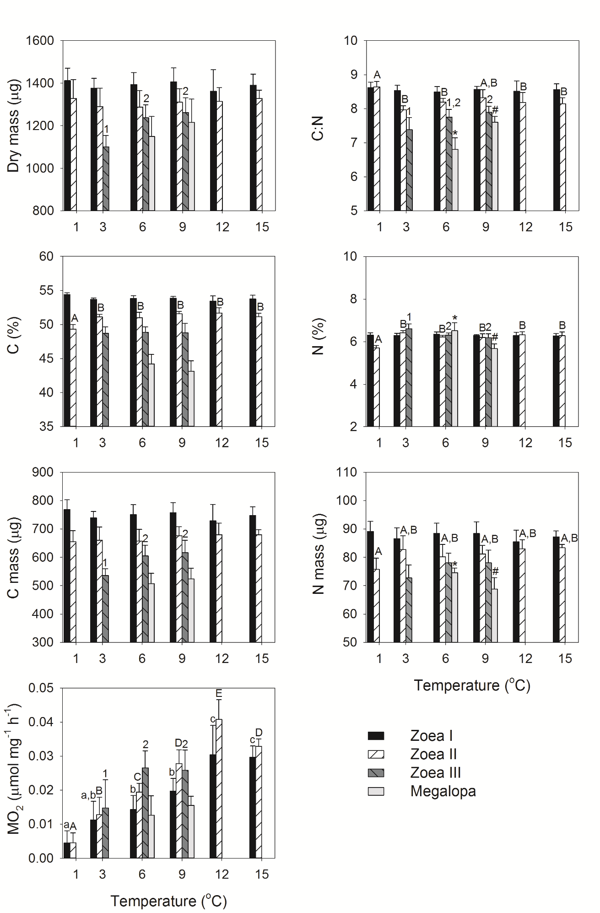
Fig. 7 Lithodes maja. Comparison of dry mass (DM), contents of carbon (C) and nitrogen (N) (% dry mass), C:N ratio, C mass (C × dry mass) and N mass (N × dry mass), and respiration rate (MO₂) of larval stages reared at different temperatures (mean ± SD, n = 5 except 9°C megalopa where n = 4). Significant differences within larval stages are indicated by lower case letters (zoea I), upper case letters (zoea II), numbers (zoea III), or symbols (megalopa): data that do not share a common letter, number, or symbol are significantly different.
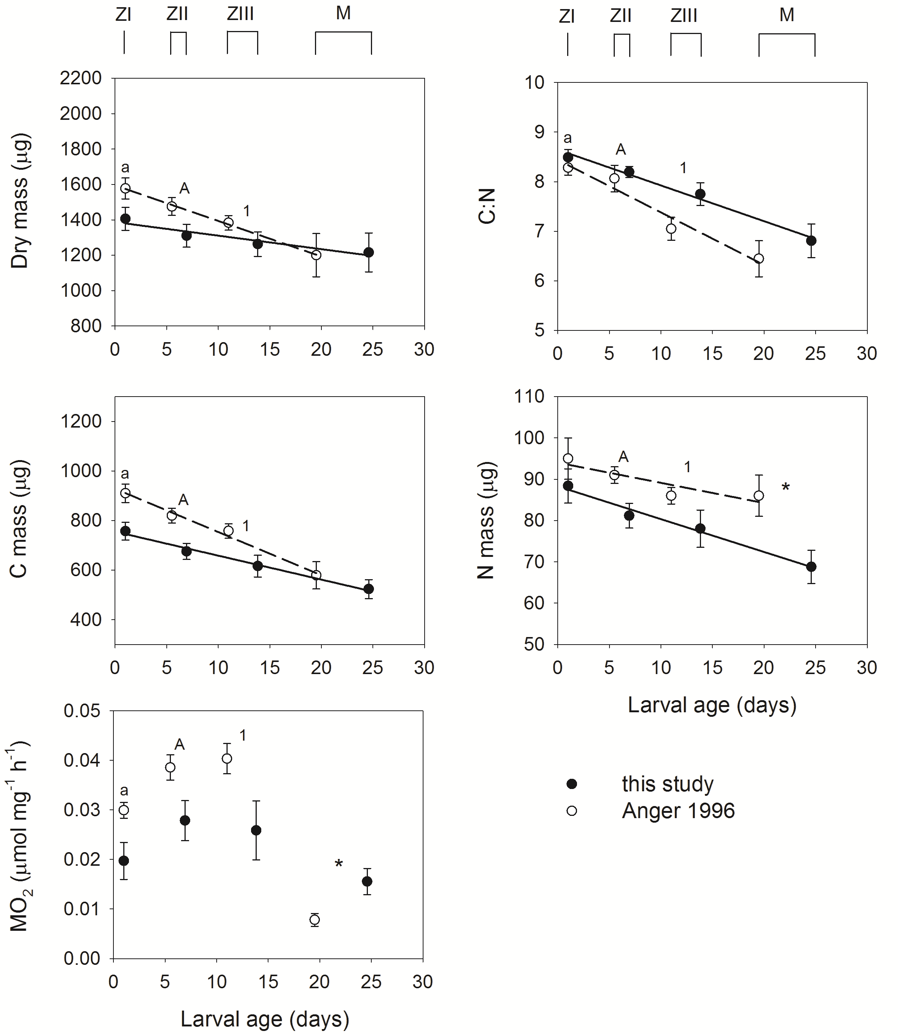
Fig. 8 Lithodes maja. Comparison of dry mass (DM), ratio of carbon to nitrogen contents (C:N), C mass (C × dry mass), and N mass (N × dry mass) of larval stages (Z = zoea, M = megalopa) reared at 9°C from this study and Anger (1996) (mean ± SD, n = 5 for this study except megalopa where n = 4; n assumed to equal 5 for Anger 1996, except MO₂ where n = 8). Significant differences within larval stages are indicated by: a = zoea I, A = zoea II, 1 = zoea III, * = megalopa.
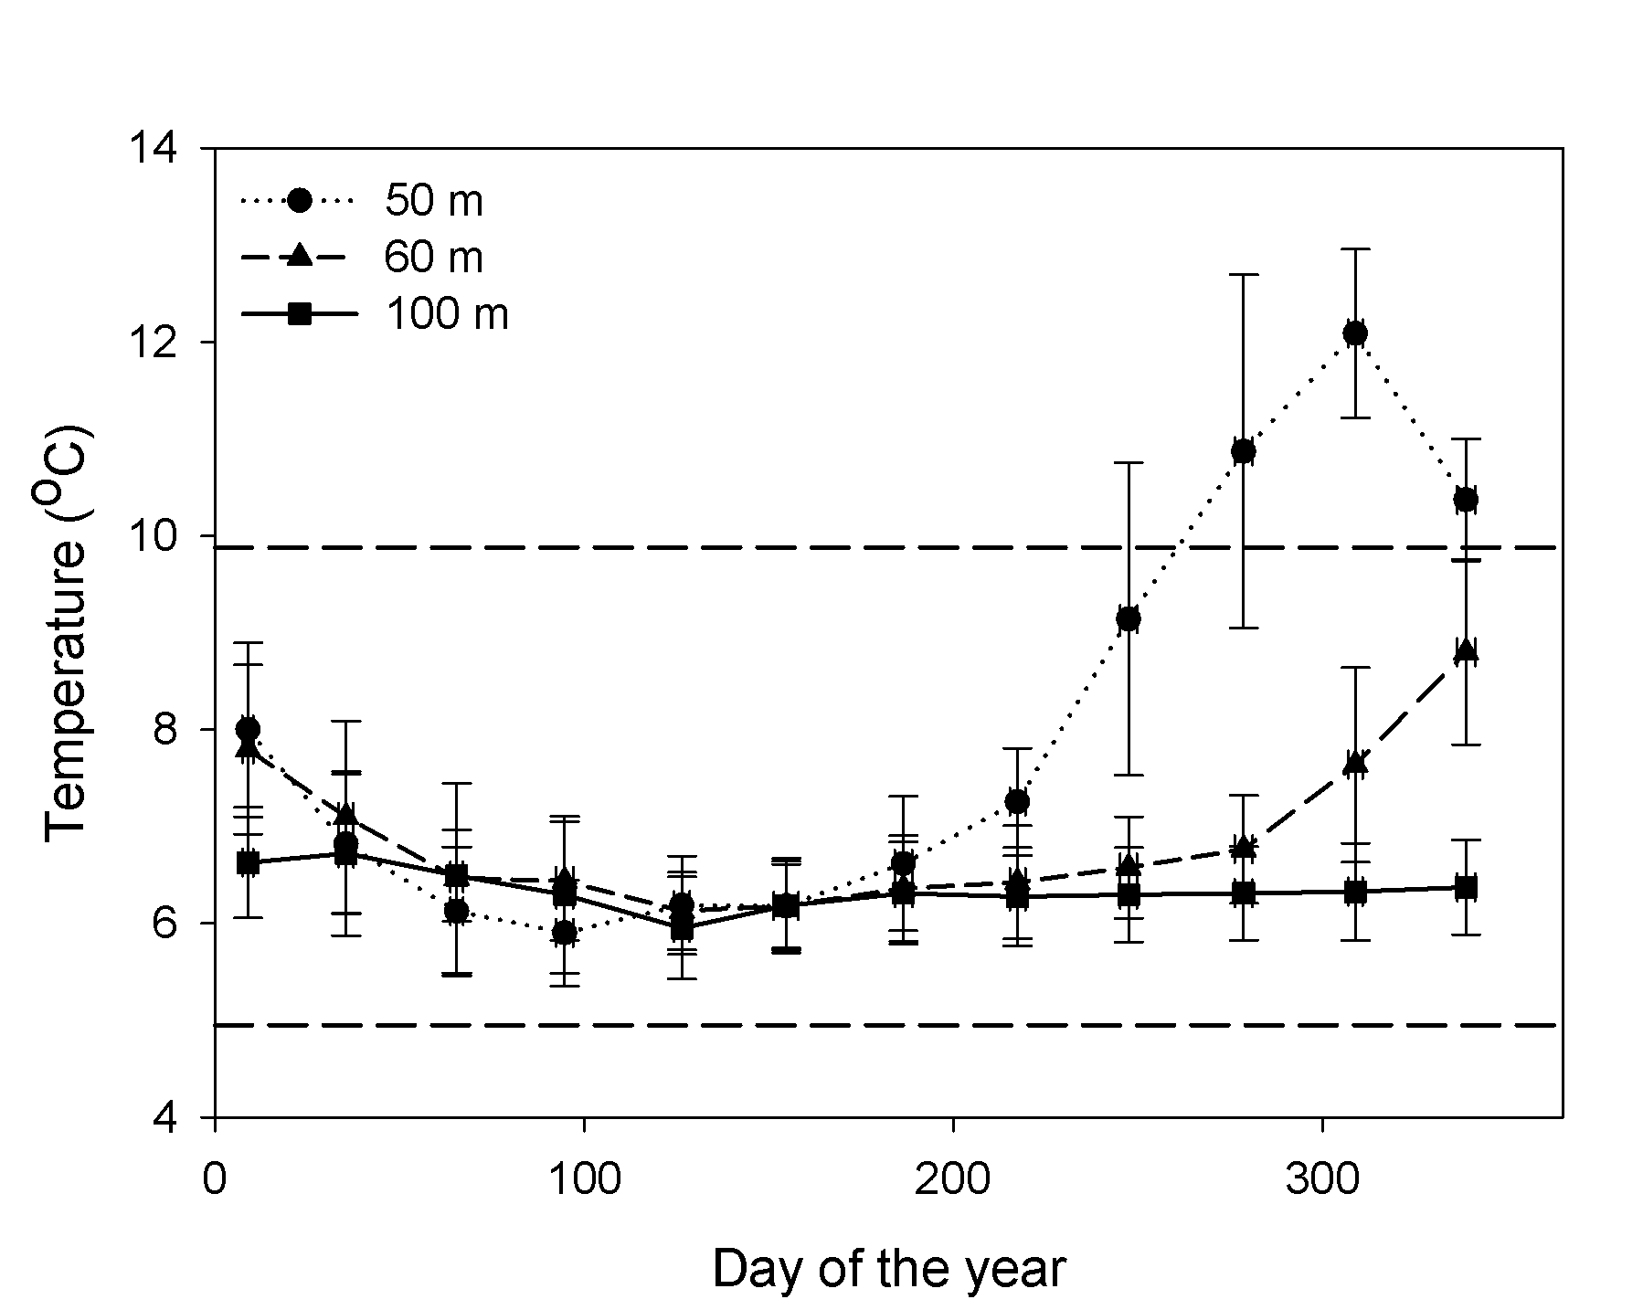
Fig. 9 Mean temperature (± SD) at different depths in Gullmarsfjord across a 10 year period (2003-2012). Dashed lines indicate maximum (9.88°C) and minimum temperatures (4.95°C) over this period within the bathymetric distribution of Lithodes maja in Gullmarsfjord (≥60 m depth). Data are from the Swedish Meteorological and Hydrological Institute’s database SHARK.

TABLES
Table 1 Lithodes maja. Rates of survival in individual developmental stages (% surviving to the next stage) in larvae at different temperatures (T), and cumulative (cum.) survival from hatching through a given stage (as % of initial number at hatching; italics and bold face) in larvae from female A (^{W} = wild-mated, ^{C} = captive-mated). Initial n = 48 for all treatments.
Female | T (°C) | Zoea I | Zoea II |  | Zoea III |  | Megalopa
 |  | % | % | cum. % | % | cum. % | % | cum. %
A^{C} | 1 | 17 | 0 | 0
A^{C} | 3 | 38 | 17 | 6 | 0 | 0
A^{W} | 6 | 44 | 52 | 23 | 45 | 10 | 40 | 4
A^{C} | 6 | 40 | 58 | 23 | 27 | 6 | 33 | 2
A^{C} | 9 | 63 | 33 | 21 | 40 | 8 | 0 | 0
A^{C} | 12 | 15 | 0 | 0
A^{C} | 15 | 13 | 0 | 0

Table 2 Lithodes maja. Duration of development (d) of successive larval stages in larvae from female A (^{W} = wild-mated, ^{C} = captive-mated) at different temperatures (T).
Female | T (°C) | Zoea I  mean ± SD (n) | Zoea II  mean ± SD (n) | Zoea III  mean ± SD (n) | Megalopa  mean ± SD (n)
A^{C} | 1 | 37.3 ± 4.4 (8)
A^{C} | 3 | 17.8 ± 3.9 (18) | 23.0 ± 3.6 (3)
A^{W} | 6 | 7.7 ± 1.3 (21) | 8.5 ± 1.4 (11) | 11.4 ± 1.7 (5) | 52.5 ± 7.8 (2)
A^{C} | 6 | 8.5 ± 1.5 (19) | 9.6 ± 1.3 (11) | 14.0 ± 3.5 (3) | 53.0 (1)
A^{C} | 9 | 5.9 ± 0.9 (30) | 6.9 ± 1.5 (10) | 10.8 ± 1.7 (4)
A^{C} | 12 | 3.7 ± 0.5 (7)
A^{C} | 15 | 3.2 ± 0.4 (6)

Table 3 Lithodes maja. Statistical analysis of differences in dry mass, contents of carbon (C) and nitrogen (N) (% dry mass), C:N ratio, C mass (C × dry mass), N mass (N × dry mass), and respiration rate (MO₂) during development at 6°C in larvae from wild and captive mating of female A. Significant differences are identified in bold.
 | Dry mass | C | N | C:N | C mass | N mass | MO₂
Zoea I | F_{1,8} = 0.085,  p = 0.778 | F_{1,8} = 1.177,  p = 0.310 | F_{1,8} = 2.831,  p = 0.131 | F_{1,8} = 4.569,  p = 0.065 | F_{1,8} = 0.260,  p = 0.624 | F_{1,8} = 0.162,  p = 0.698 | F_{1,8} = 8.354,  p = 0.020,
Zoea II | F_{1,8} = 0.093,  p = 0.769 | F_{1,8} < 0.001,  p = 0.987 | F_{1,8} = 0.939,  p = 0.361 | F_{1,8} = 1.011,  p = 0.344 | F_{1,8} = 0.073,  p = 0.794 | F_{1,8} = 0.019,  p = 0.894 | F_{1,8} = 9.596,  p = 0.015,
Zoea III | F_{1,8} = 15.272,  p = 0.004 | F_{1,8} = 5.648,  p = 0.045 | F_{1,8} = 34.155,  p < 0.001 | F_{1,8} = 23.192,  p = 0.001 | F_{1,8} = 13.810,  p = 0.006 | F_{1,8} = 5.300,  p = 0.050 | F_{1,8} = 5.381,  p = 0.049,
Megalopa | F_{1,8} = 18.687,  p = 0.003 | F_{1,8} = 0.741,  p = 0.414 | F_{1,8} = 4.469,  p = 0.067 | F_{1,8} = 2.609,  p = 0.145 | F_{1,8} = 14.045,  p = 0.006 | F_{1,8} = 42.321,  p < 0.001 | F_{1,8} = 9.038,  p= 0.017

Table 4 Lithodes maja. Statistical analysis of differences in dry mass, contents of carbon (C) and nitrogen (N) (% dry mass), C:N ratio, C mass (C × dry mass), N mass (N × dry mass), and respiration rate (MO₂) in larvae during development at different temperatures. Significant differences are identified in bold.
 | Dry mass | C | N | C:N | C mass | N mass | MO₂
Zoea I | F_{5,24} = 0.390,  p = 0.851 | F_{5,24} = 2.508,  p = 0.058 | F_{5,24} = 0.235,  p = 0.943 | F_{5,24} = 0.302,  p = 0.907 | F_{5,24} = 0.681,  p = 0.642 | F_{5,24} = 0.709,  p = 0.622 | F_{5,24} = 20.035,  p < 0.001
Zoea II | F_{5,24} = 0.303,  p = 0.906 | F_{5,24} = 10.036,  p < 0.001 | F_{5,24} = 17.421,  p < 0.001 | F_{5,24} = 6.829,  p < 0.001 | F_{5,24} = 0.480,  p = 0.788 | F_{5,24} = 3.153,  p = 0.025 | F_{5,24} = 55.434,  p < 0.001
Zoea III | F_{2,12} = 9.954,  p = 0.003 | F_{2,12} = 0.0385,  p = 0.962 | F_{2,12} = 7.395,  p = 0.008 | F_{2,12} = 4.910,  p = 0.028 | F_{2,12} = 7.312,  p = 0.008 | F_{2,12} = 2.686,  p = 0.109 | F_{2,12} = 16.123,  p < 0.001
Megalopa | F_{1,7} = 0.945,  p = 0.363 | F_{1,7} = 1.231,  p = 0.304 | F_{1,7} = 15.323,  p = 0.006 | F_{1,7} = 18.035,  p = 0.004 | F_{1,7} = 0.400,  p = 0.547 | F_{1,7} = 8.441,  p = 0.023 | F_{1,7} = 0.864,  p = 0.384

