Figure S1: Interaction plots of adiposity rebound and sex for selected outcomes. (a) refers to the association between BMI-derived adiposity rebound and systolic blood pressure according to sex. (b), (c) and (d) refer to the associations of skinfold-derived adiposity rebound with fat mass, HOMA-IR and fasting insulin respectively. All cardio-metabolic markers were measured at 13.5 years. P-values for the interaction term are reported within each plot.
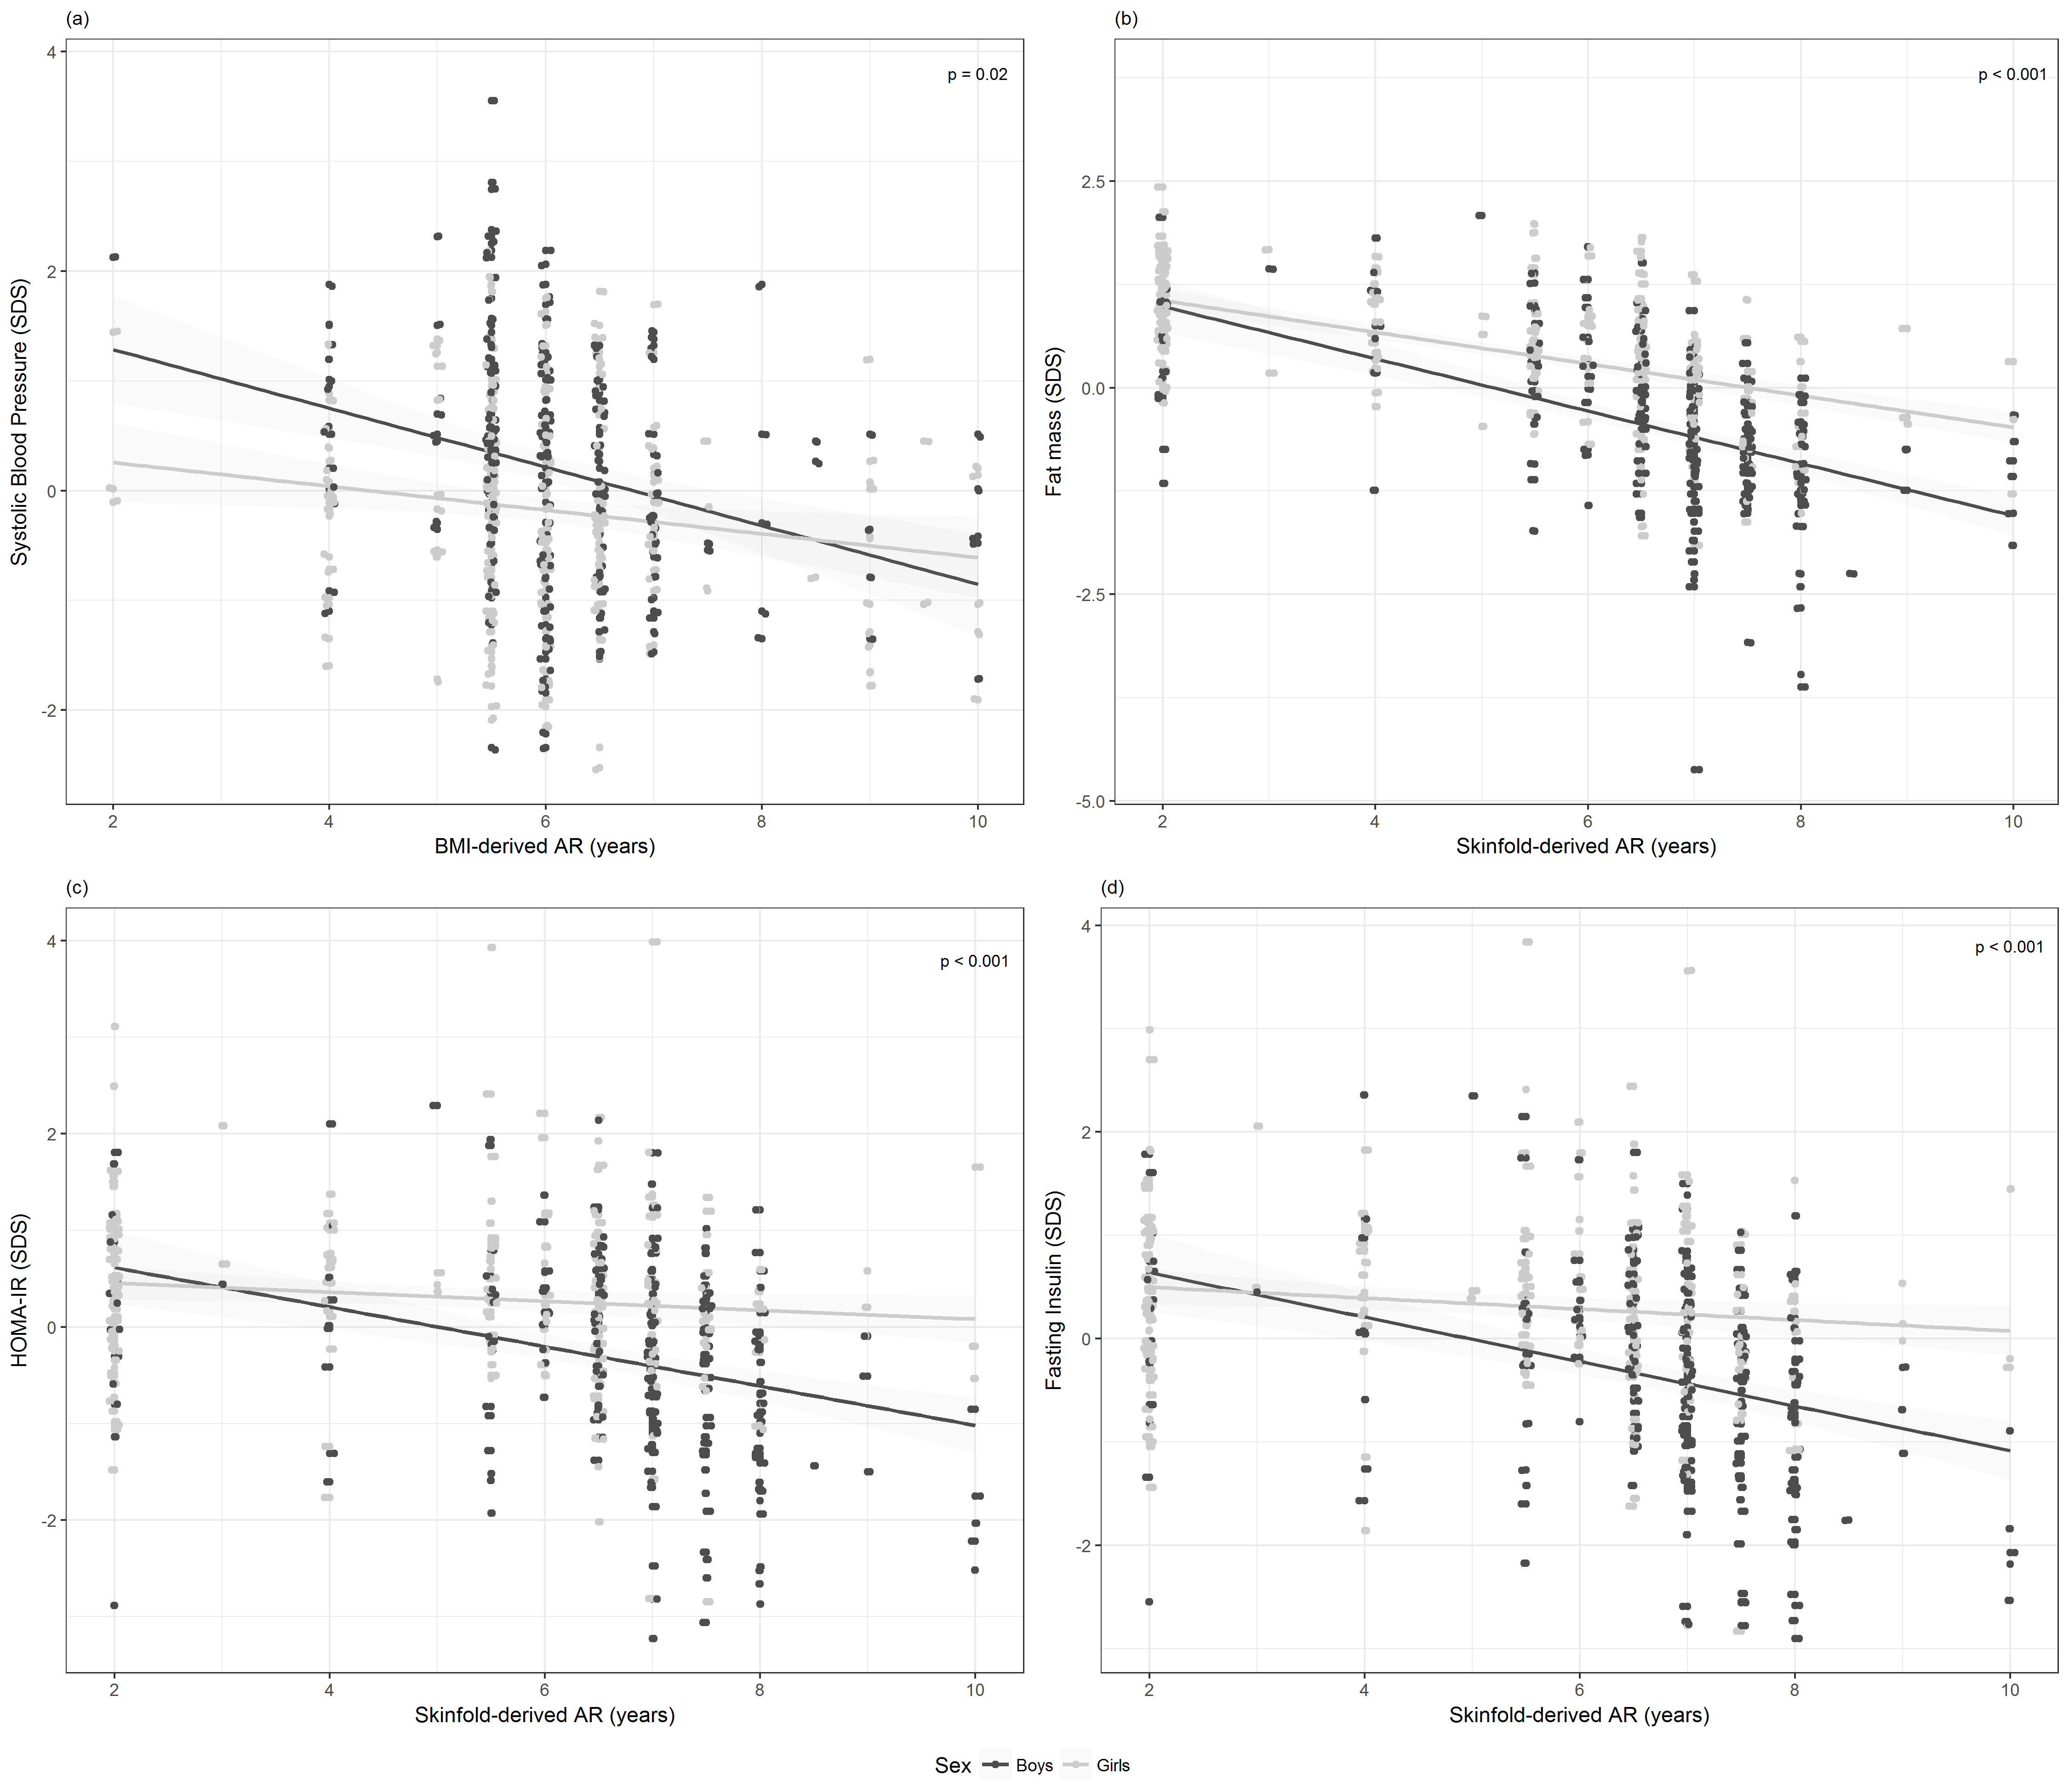
AR, adiposity rebound. SDS, standard deviation score.

