# Bevan et al Figures

**Figure 1: Recruitment**

Recruited:

55 children

32 parents

Completed ≥ 1 night of actigraphy in hospital:

46 children

24 Caregivers

Completed ≥ 1 of sound level monitoring in hospital:

**10 children**

Completed ≥ 1 night of actigraphy in hospital and ≥1 night of actigraphy at home

**40 children**

**16 Caregivers**

Completed ≥ 1 of sound level monitoring in hospital and ≥1 night of sound level monitoring at home

**8 children**

**Figure 2: Mean total sleep time of children and their co-sleeping parents during hospital admission compared to at home .**

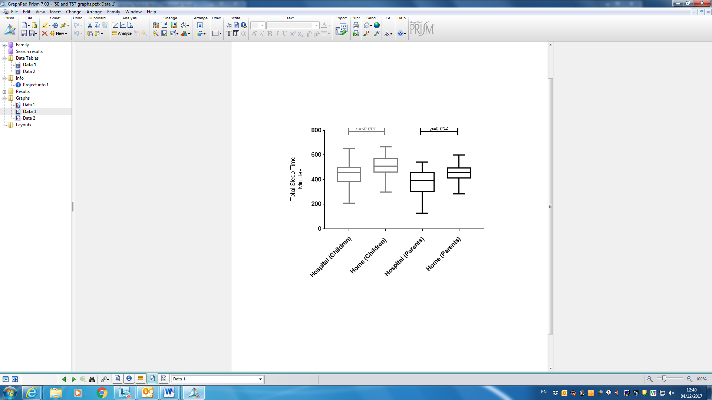

Figure 3: Mean Sleep efficiency of children and their co-sleeping parents during hospital admission compared to at home.

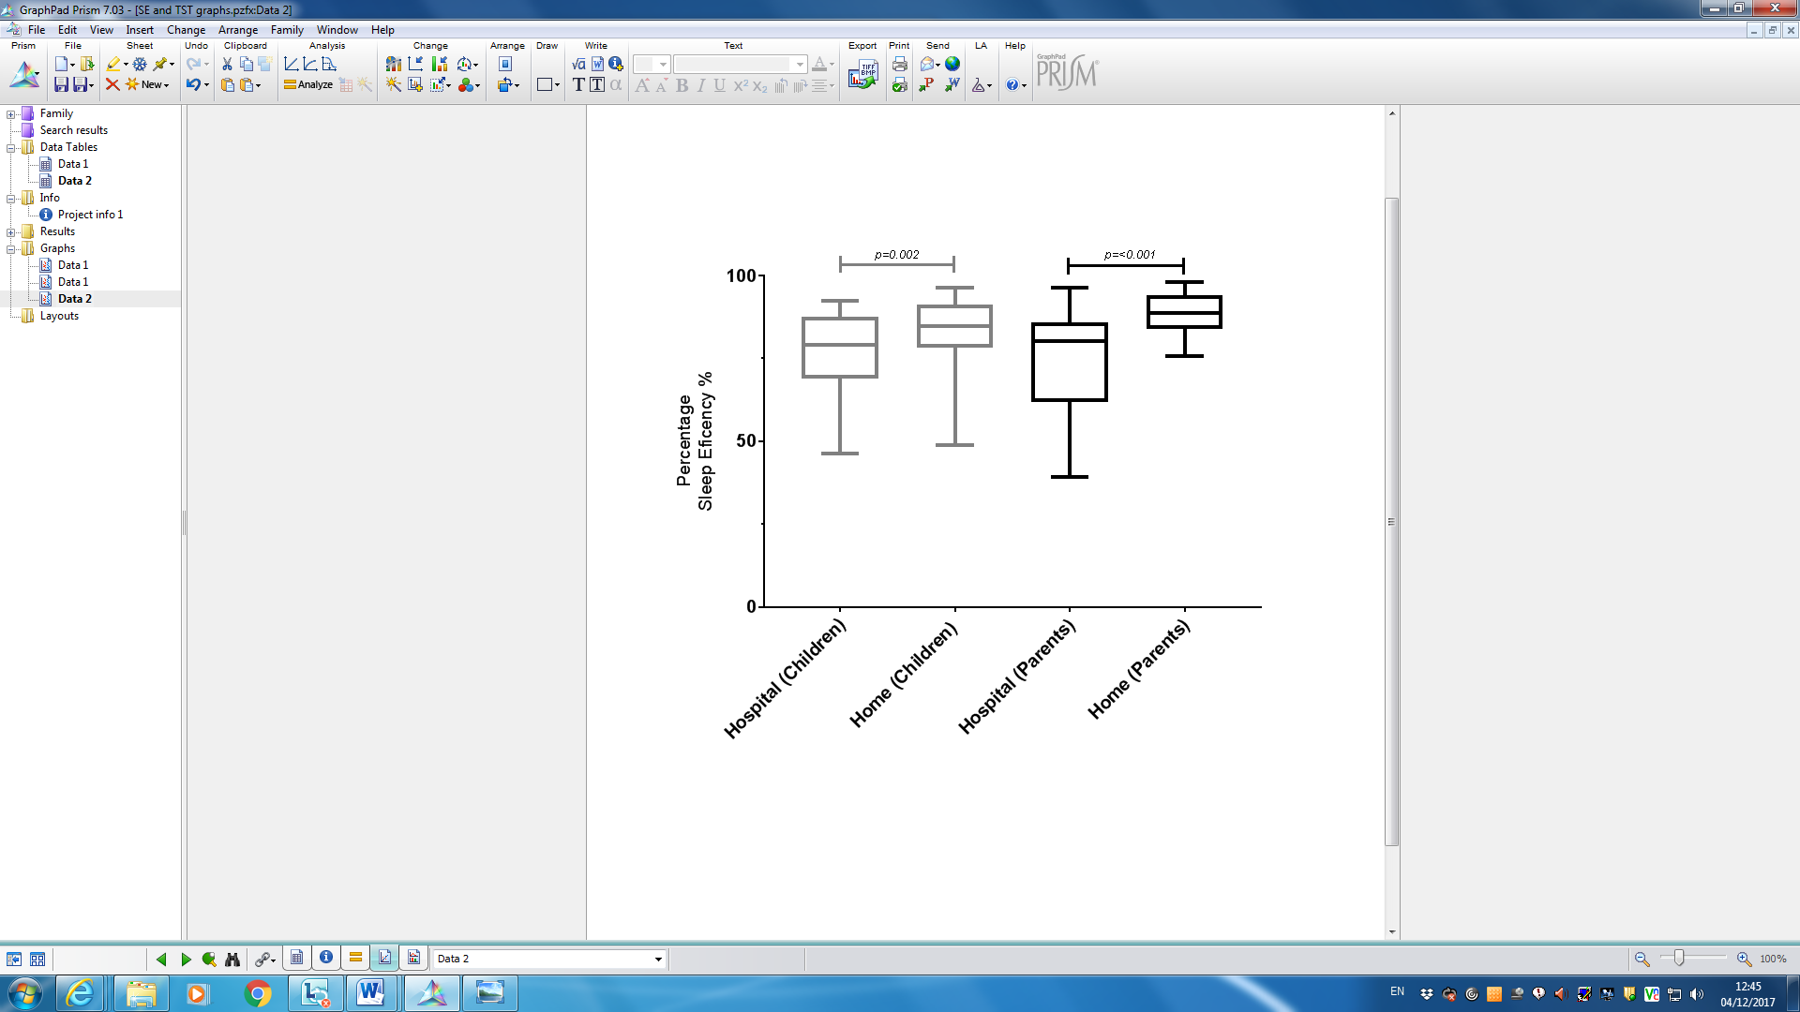

**Figure 4: Median sound levels (dBA) during children’s sleep period in hospital compared to nights spent at home.**



(Note each point represents one night and dashed horizontal line represents WHO recommeded thresholds in hospital )