56 Gb/s GeSi Optical Modulator

L. Mastronardi,^{1,*} M. Banakar,¹ A.Z. Khokhar, ¹ N. Hattasan, ¹ T. Rutirawut, ¹ T. Domínguez Bucio, ¹ K. M. Grabska, ¹ C. Littlejohns, ^{1,2} A. Bazin, ¹ G. Mashanovich, ¹ And F.Y. Gardes¹
¹ORC, University of Southampton, University Road Southampton SO17 1BJ.
²Silicon Technologies Centre of Excellence, Nanyang Technological University, 50 Nanyang Avenue, Singapore, 639798
*l.mastronardi@soton.ac.uk
Abstract: We present experimental measurements of an EAM modulator developed on an 800 nm GeSi platform. Measurements show a dynamic ER of 5.2 dB at 56 Gb/s at 1566 nm and power consumption of 44 fJ/bit.
OCIS codes: (250.7360) Waveguide modulators; (230.2090) Electro-optical devices; (200.4650) Optical interconnects.

1. Introduction
Integration of silicon photonics transceivers into telecommunication arrays can only be possible if a viable way to realize fast, efficient, and compact modulators is achieved. In the past years several designs [1-3] have been proposed to enhance the modulation efficiency of silicon-based modulators by using interferometric [4] and resonant structures [5] on silicon-compatible materials [6,7]. Among them, GeSi has demonstrated to be suitable for large scale integration of electro-absorption modulators working in the C and L band of the telecommunication window, thanks to the implementation of the Franz-Keldysh effect [8,9] and the possibility of fine tuning the operation wavelength [10]. In this paper, we present an innovative Si/GeSi hetero-structure waveguide modulator developed on an 800 nm SOI platform, that achieves a dynamic ER of 5.2 dB at a data rate of 56.2 Gb/s with a modulator power of 44 fJ/bit and 3 dB bandwidth of 56 GHz [11].
2. Modulator design
We propose a wrap-around PIN hetero-structure device realized in a rib waveguide, with dimensions of 1.5 µm x 40 µm, etched on selectively grown Si-GeSi cavity in 800 nm SOI wafer. The advantage of this heterostructure design, shown in Fig. 1, relies on the electric field distribution independency from the waveguide width which can also be tailored to improve, if required, the optical mode confinement and propagation of both polarizations.
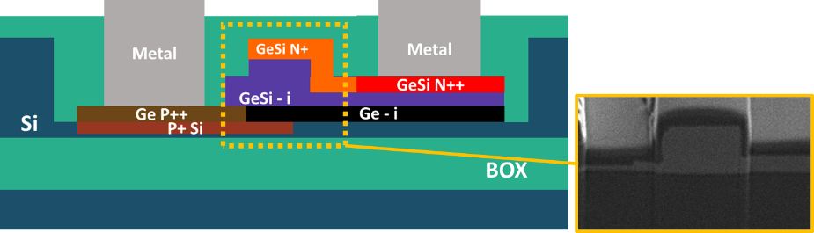
Fig. 1. Cross-section design (left) and cross-section FIB cut (right).
3. DC and high-speed measurements
The static device performances have been measured before the High-speed tests.
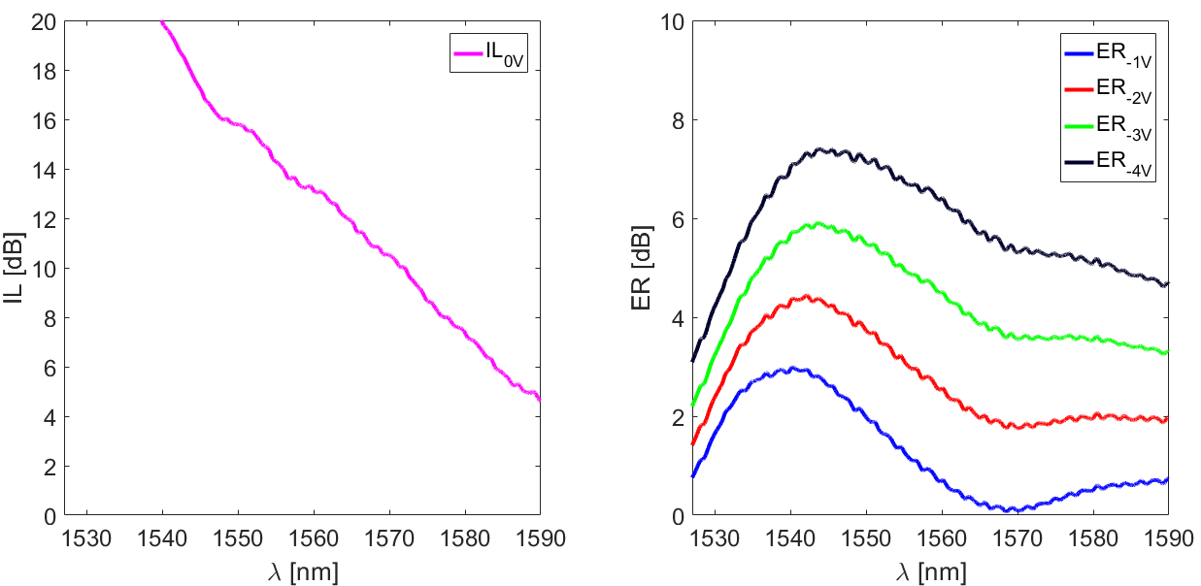
Fig. 2. Measured Insertion Loss (left) and Extinction Ratio (right) for different reverse biases.
In Fig. 2 the IL shows an extra loss due to the presence of the Ge buffer layer, used for the GeSi growth. As a result, the ER has a second peak above 1570 nm. It is expected a lower IL by improving the epitaxial growth recipe. The measured ER peak, however, ranges between 3 dB and 7.5 dB, around 1540 nm for biases from -1 V to -4 V.
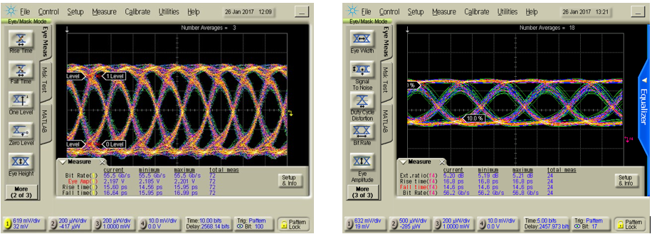
Fig. 3. 56 Gbps input electrical eye (left), measured 56.2 Gb/s device eye diagram (right). [11]
The RF signal, used in high-speed measurements, is generated with a 56 Gbps pseudorandom binary sequence (PRBS) generator with a voltage swing of 2.2 V peak-to-peak or ~2.7 V rail-to-rail, a DC reverse bias of 2.7 V is also applied. The voltage at the device ports, however, is estimated to be ~4 V peak-to-peak, because the GS probes at our disposal are not 50 ohms terminated. Fig. 3 shows the input electrical eye diagram (left) and the measured optical eye diagram from the device working at 1566 nm (right). It is recorded a wide opened eye with a dynamic ER of 5.2 dB at a speed of 56.2 Gbps. The data rate is, only, limited by the setup at our disposal. We calculated the device time riseto estimate an analogue EO modulation bandwidth that ranges between 42 GHz and 66 GHz, with a current value of 56 GHz. Finally, from S11 measurements and simulation fitting we calculated the equivalent electrical circuit and retrieved the power of the EAM at 56 Gbps to bewith the swing voltage Vpp = 4 V.
4. Conclusion
We have developed a high-speed GeSi waveguide EAM on an 800 nm SOI platform, operating at 1566 nm, with a data rate, limited by the measurement setup, of 56.2 Gb/s, and dynamic ER of 5.2 dB. Having a compact footprint (60 µm²), a power consumption of 44 fJ/bit and EO modulation bandwidth of 56 GHz, this wrap-around junction design permits, a simple, customizable and tolerant fabrication of compact-high-speed electro absorption modulators. This work was funded by EPSRC First Grant (EP/K02423X/1), EPSRC Platform Grant (EP/N013247/1) and H2020 project COSMICC (688516). This work had support from the Optoelectronic research Centre (ORC) and the Southampton nanofabrication centre. CGL acknowledges support from National Research Foundation of Singapore (NRFCRP12-2013-04).
5. References
- F. Y. Gardes, G. T. Reed, N.G. Emerson, and C.E. Png, “A sub-micron depletion-type photonic modulator in Silicon On Insulator,” Opt. Express 13, 8845-8854 (2005).
- D. Marris-Morini et al., “Recent progress in high-speed silicon-based optical modulators,” in Proceedings of the IEEE 97(7), 1199-1215 (2009).
- G. T. Reed, G. Mashanovich, F. Y. Gardes, and D. J. Thomson, “Silicon optical modulators,” Nat Photon. 4(8), 518–526 (2010).
- D. J. Thomson et al., “50-Gb/s silicon optical modulator,” IEEE Photonics Technology Letters, 24(4), 234-236 (2012).
- F. Y. Gardes et al., “High-speed modulation of a compact silicon ring resonator based on a reverse-biased pn diode,” Opt. Express 17(24), 21986–21991 (2009).
- C.G. Littlejohns et al., “Next generation device grade silicon-germanium on insulator,” Scientific Reports 5, 8288 (2015).
- T. D. Bucio et al., “Material and optical properties of low-temperature NH3-free PECVD SiNx layers for photonic applications,” J. Phys. D: Appl. Phys. 50 025106 (2016).
- W. Franz, “Einfluß eines elektrischen feldes auf eine optische Absorptionskante,” Zeitschrift Naturforschung Teil A 13, 484– 489 (1958).
- L. V. Keldysh, “Behavior of non-metallic crystals in strong electric fields,” Soviet Journal of Experimental and Theoretical Physics 6, 763 (1958).
- L. Mastronardi et al, “SiGe bandgap tuning for high speed eam,” in transactions of 231st ECS Meeting, 77(6), 59-63 (2017).
- L. Mastronardi et al, “High-speed Si/GeSi hetero-structure Electro Absorption Modulator,” Opt. Express 26(4), 2018.

