Laser direct-write of microfluidic flow channels via additive manufacturing for paper-based rapid diagnostics

R. W. Eason, I. Katis, P. J. W. He, P. Galanis, C. L. Sones
Optoelectronics Research Centre, University of Southampton, Southampton, SO171BJ, U.K.

rwe@orc.soton.ac.uk

There is a growing need to provide low-cost, easy-to-use, sensitive, specific and reliably robust diagnostic solutions for improved global healthcare. In both the developed and developing world, point-of-care devices are the diagnostic tool of choice, where an answer is provided in a matter of minutes to questions that currently address the relatively straightforward conditions relating to pregnancy or diabetes. Moving beyond a simple binary yes/no result, as for a pregnancy test, to tests that provide a (semi-)quantitative result is a global imperative where greatly enhanced sensitivity and limit of detection are the holy-grail for the diagnostics industry. Paper and other porous membranes can wick fluids via capillary forces, which provides immediate benefits in terms of cost and manufacturability as well as simplifying their distribution and use in potentially remote and inaccessible under-resourced settings.
Over the past few years we have developed a laser-based approach for writing walls and barriers in such porous media, and have developed the technique for planar devices [1], 3D or stacked-devices [2] and for fluid delay architectures [3]. The technique involves local deposition of a liquid monomer which is absorbed within the porous material and subsequently polymerized via exposure to laser light of the correct wavelength and intensity. By carefully optimizing the laser parameters, photo-polymer structures can be created that produce either liquid-impermeable walls, or permeable barriers which have a lower overall porosity, and act as fluid delays or filters to control the rate of wicking and delivery of samples or reagents to the correct region in the test strip.
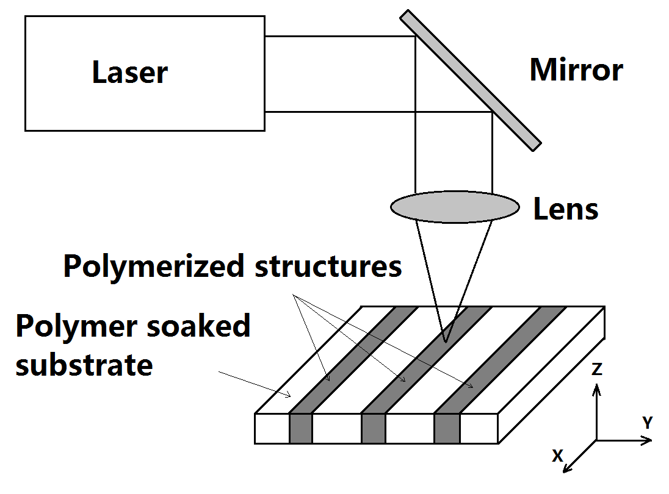
The basic laser writing procedure is shown in Figure 1, where multiplexed channels can be written in a single paper strip via scanning of the laser beam (a c.w. 405nm diode laser source) together with synchronized movement of the substrate. Figure 2 shows examples of multiplexed test strips which allow diagnosis of multiple conditions or semi-quantitative diagnosis of one.

Figure 1: Schematic of the laser writing process for Figure 2: Incorporation of multiple channels within a single test strip to
polymerisation within the paper substrate. allow diagnosis of multiple conditions or semi-quantitative diagnosis of one.
I will discuss the range of possibilities offered by this direct-write technique for 2D and 3D structuring within these porous substrates and their application to rapid and semi-quantitative diagnostics, where fluid flow can be routed, delayed, mixed, filtered and, in future, gated using optical control of smart polymers.

[1] C. L. Sones, I. N. Katis, P. J. W. He, B. Mills. M. F. Namiq, P. Shardlow, M. Ibsen, R. W. Eason, (2014) ‘Laser-induced photo-polymerisation for creation of paper-based fluidic devices’, Lab on a Chip, Vol 14, pp.4567-4574.
[2] P. J. W. He, I. N. Katis, R. W. Eason, C .L. Sones, (2016), ‘Laser direct-write for fabrication of three-dimensional paper-based devices’ Lab on a Chip, Vol 16, pp. 3296-3303.
[3] P. J. W .He, I. N. Katis, R. W. Eason, C. L. Sones, (2015), ‘Engineering fluidic delays in paper-based devices using laser direct-writing’ Lab on a Chip, Vol 15, pp. 4054-4061.

